LAB Manual

PART A

(PART A : TO BE REFFERED BY STUDENTS)

**Experiment No.05**

**A.1 Aim:**

Write a program to detect edges in the image using Robert, Prewitt and Sobel operators.

**A.2 Prerequisite:**

1 MATLAB programming syntax (Refer the MATLAB manual).

2. Knowledge of fundamentals of image segmentation and edge detection.

2. Availability of Soft copy of medical image.

**A.3 Outcome:**

**After successful completion of this experiment students will be able to**

1. Apply Robert, Prewitt and Sobel operators on given image.
2. Differentiate the outputs of different edge detection operators.
3. Identify applications of operators studied.

**A.4 Theory:**

**A.4.1. Edge Detection**

Edge detection is one of the most frequently used techniques in digital image processing. The boundaries of object surfaces in a scene often lead to oriented localized changes in intensity of an image, called edges. This observation combined with a commonly held belief that edge detection is the first step in image segmentation, has fueled a long search for a good edge detection algorithm to use in Image processing. Edge is nothing but a boundary between two regions having distinct intensity levels. The goal of edge detection is to select the pixels in a digital image at which the intensity level changes sharply. For image processing system to interpret an image, it must be able to detect the edges of each object in the image. Edge representation drastically reduces the amount of data to be processed by retaining the important information in an image such as the shape of objects. This description of an image is easy to integrate into a large number of object recognition algorithms. Edge detection generates an edge map that contains vital information of the image.

Image segmentation is an essential step in image analysis. The objective of segmentation is to simplify and/or change the representation of an image in to something that is more meaningful and easier to analyze. It divides (segments) an image into its constituent regions or objects. Generally, it is used to locate objects and boundaries in image. Image Segmentation is used when we need to automate a particular activity. Image segmentation methods are categorized on the basis of two properties discontinuity and similarity. The choice of image segmentation technique depends on the nature of the problem under consideration. Edge detection is a part of image segmentation. The effectiveness of image segmentation depends on the perfection of detecting meaningful edges.

**EDGE DETECTION TECHNIQUES**

Edge detection techniques try to locate points with abrupt changes in an image. Edge is nothing but boundary between two regions having distinct intensity levels.

1. Robert Edge Detection

It is very simple computation technique, introduced by Lawrence Roberts. Here high frequency spatial frequency region corresponds to an edge. 2-D mask for Robert edge detection is as shown in Fig.1.

Fig.1. Roberts Edge Operator

In this technique the output represents pixels of every point which estimated complete magnitude of spatial gradient of the image at that point.

2. Sobel Edge Detection

The Sobel edge detection method is introduced by Sobel in 1970. This method of edge detection for image segmentation finds edges using the Sobel approximation to the derivative. The Sobel masks are as shown in Fig. 2. The first mask is responsible for computing horizontal edges and the other one is responsible for computing vertical edges. One mask is simply the other rotated by 90o.

Fig.2. Sobel Operator

3. Prewitt Edge Detection

This edge detection technique was introduced by J.M.S. Prewitt in 1970. The Prewitt operator assigns similar weights to all the neighbors of the candidate pixel whose edge strength is being calculated. The Prewitt operator is as shown in Fig. 3.

Fig.3. Prewitt Operator

Similar to Sobel operator, The first mask is responsible for computing horizontal edges and the other one is responsible for computing vertical edges and one mask is simply the other rotated by 90o.

**A.5 Procedure/Algorithm:**

**A.5.1:**

**TASK 1:**

1. Read the i/p image

2. Apply Roberts, Sobel and Prewitt operator to the image as per following and

obtain the 3 outputs separately.

1. X gradient
2. Y gradient
3. Combined of both X and Y gradient.

3. Display the original and the output image.

4. Observe the output and complete PART B of lab manual.

5. Save and close the file and name it as **EX5_Task1_your Roll no.m**

**********************

PART B

(PART B : TO BE COMPLETED BY STUDENTS)

***(Students must submit the soft copy as per following segments within two hours of the practical. The soft copy must be uploaded on the Blackboard or emailed to the concerned lab in charge faculties at the end of the practical in case the there is no Black board access available)***

|  |  |
| --- | --- |
| **Roll No. :** N230 | **Name:** Rishul Ghosh |
| **Class :** MBA Tech CS 3rd Yr. Div. B | **Batch :** Batch-B |
| **Date of Experiment:** 25-8-21 | **Date of Submission:** 25-8-21 |
| Grade : | Time of Submission: |
| Date of Grading: |  |

**B.1 Software Code written by student:**

**TASK-1: Robert Edge detection: -**

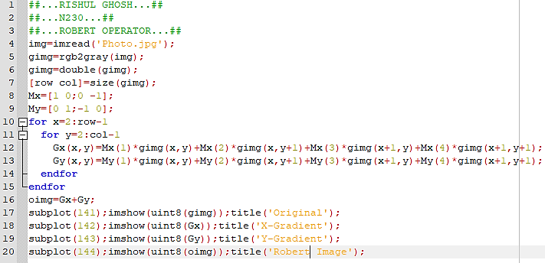

**TASK-2: Sobel Edge detection: -**

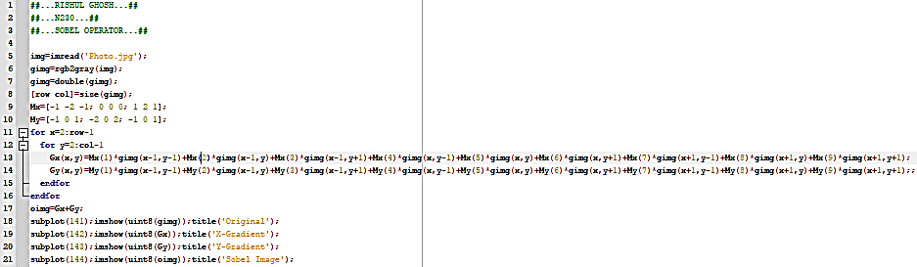

**TASK-3: Prewitt Edge detection: -**

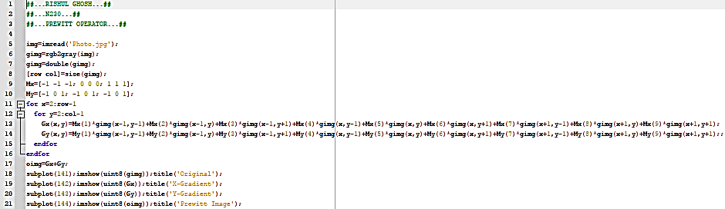

**B.2 Input and Output:**

**Input Images:**

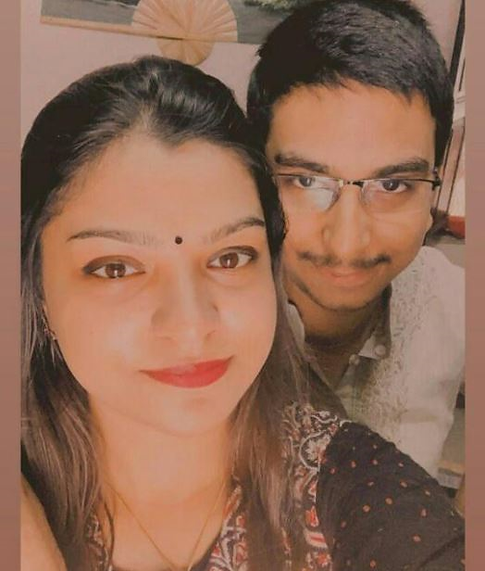

**Output Images:**

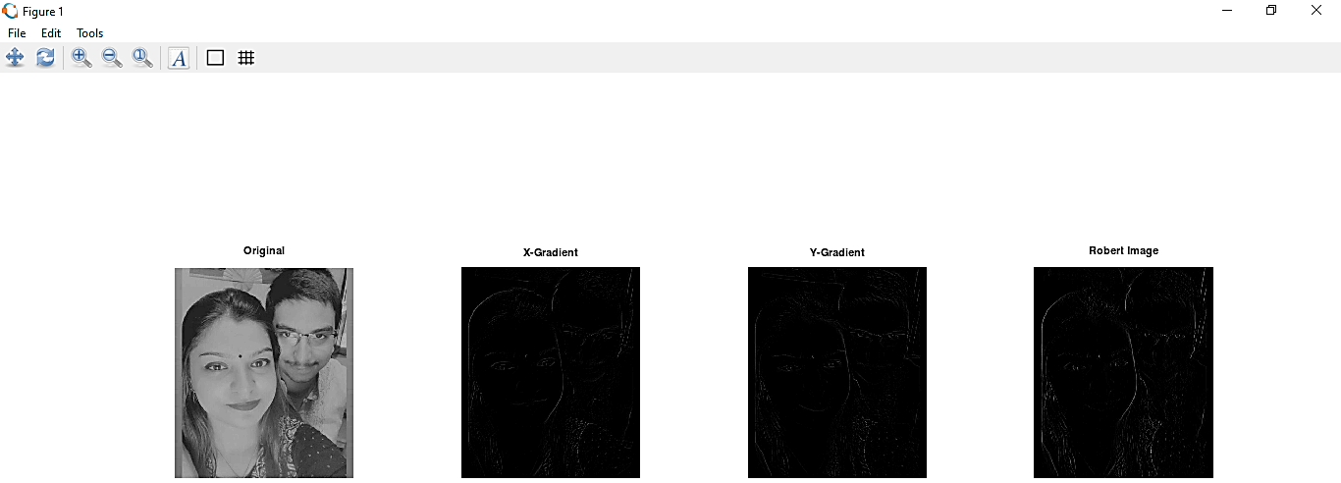

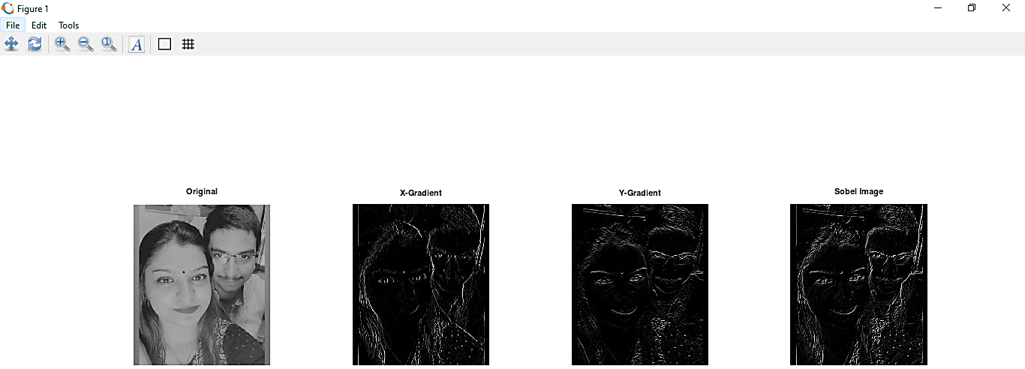

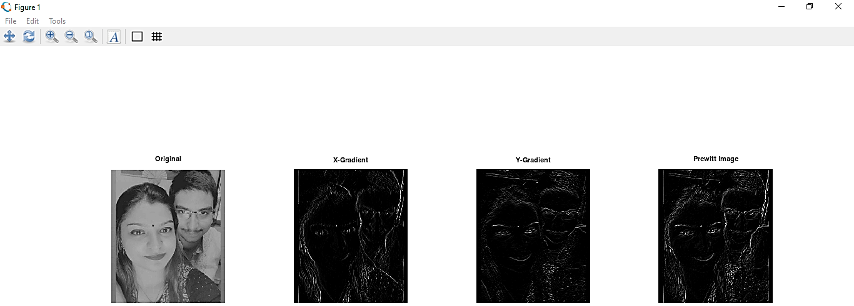

**B.3 Observations and learning:**

From the above experiment, we observed and learned various edge-detection operators in image processing. We implemented the same in octave, and performed the operations on our own image.

**B.4 Conclusion:**

Thus, the aim of writing a program to detect edges in the image using Robert, Prewitt and Sobel operators is completed.

**B.5 Question of Curiosity**

**Q1. How segmentation of the image is achieved using Edge detectors?**

1. ***Sobel Operator*:** It is a discrete differentiation operator. It computes the gradient approximation of image intensity function for image edge detection. At the pixels of an image, the Sobel operator produces either the normal to a vector or the corresponding gradient vector. It uses two 3 x 3 kernels or masks which are convolved with the input image to calculate the vertical and horizontal derivative approximations respectively –

1. ***Prewitt Operator*:** This operator is almost similar to the Sobel operator. It also detects vertical and horizontal edges of an image. It is one of the best ways to detect the orientation and magnitude of an image. It uses the kernels or masks –

1. ***Robert Operator*:** This gradient-based operator computes the sum of squares of the differences between diagonally adjacent pixels in an image through discrete differentiation. Then the gradient approximation is made. It uses the following 2 x 2 kernels or masks –

************************