LAB Manual

PART A

(PART A : TO BE REFFERED BY STUDENTS)

**Experiment No. 06**

**A.1 Aim:**

Write a program to apply following morphological operations on binary image.

Task 1: Dilation and Erosion on binary image

Task 2: Opening and Closing on binary image

Task 3: Dilate, Erosion, Opening ,Closing on Image Matrix

Task 4: Opening followed by closing

Task 5: Closing followed by opening

**A.2 Prerequisite:**

1 Matlab programming syntax (Refer the Matlab manual).

2. Knowledge of fundamentals of morphological operations.

2. Availability of Soft copy of finger print image.

**A.3 Outcome:**

**After successful completion of this experiment students will be able to**

1. Apply Eroison , dilation Opening and closing operations on given image.
2. Differentiate the outputs of different methods of opening and closing.
3. Identify applications of morphological operations studied.

**A.4 Theory:**

**A.4.1. Morphological operations**

**Morphological operations**

**1. Dilation**





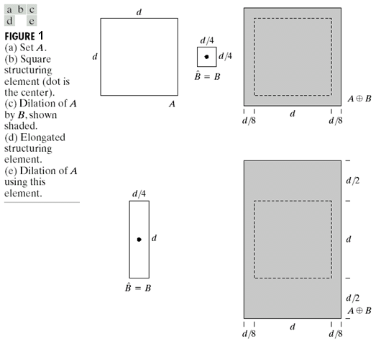

**2. Erosion**

Erosion can be defined as:

…… Eq (2)

E= {z| (B)z subset of A}

For example:

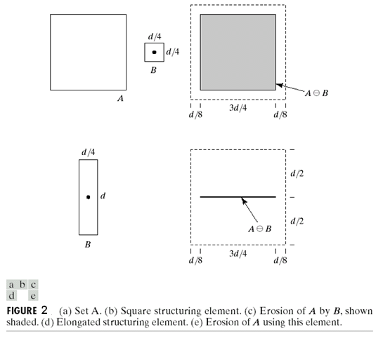

The figure is taken from Text book: “The fundamentals of Image processing” by Gonzalez Woods

**3. Opening:**

Opening is defined as

A ○ B = (A erode B) dilate B ….. Eq (3)

**4. Closing:**

Closing is defined as

A ● B = (A dilate B) erode B …… Eq (4)

**A.5 Procedure/Algorithm:**

**A.5.1:**

**TASK 1:**

1. Read the input image.

2. Apply morphological operations following order and obtain 4 outputs

Separately.

1. Opening
2. Closing
3. Opening followed by closing.
4. Closing followed by opening

3. Display the original and the output images.

4. Observe/compare all outputs and complete PART B of lab manual.

5. Save and close the file and name it as **EX7_Task1_your Roll no.m**

**********************

PART B

(PART B : TO BE COMPLETED BY STUDENTS)

***(Students must submit the soft copy as per following segments within two hours of the practical. The soft copy must be uploaded on the Blackboard or emailed to the concerned lab in charge faculties at the end of the practical in case the there is no Black board access available)***

|  |  |
| --- | --- |
| **Roll No. :** N230 | **Name:** Rishul Ghosh |
| **Class :** MBA Tech CS 3rd Yr. Div. A | **Batch :** B |
| **Date of Experiment:** 1-9-21 | **Date of Submission:** 1-9-21 |
| **Grade :** | **Time of Submission:** 11:59pm |
| **Date of Grading:** |  |

**B.1 Software Code written by student:**

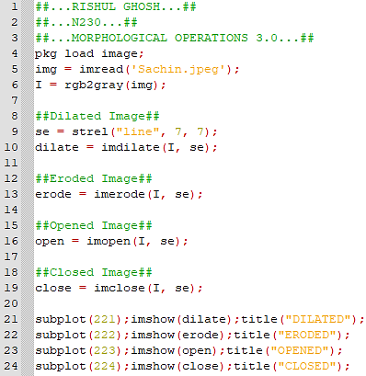

**B.2 Input and Output:**

**Input Images:**

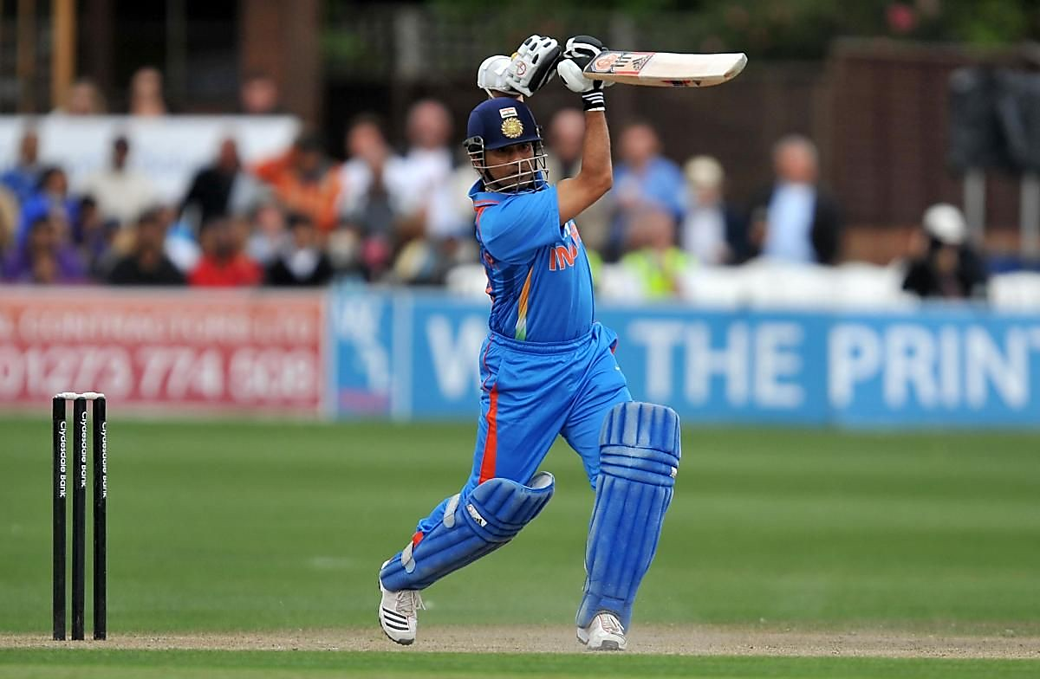

**Output Images:**

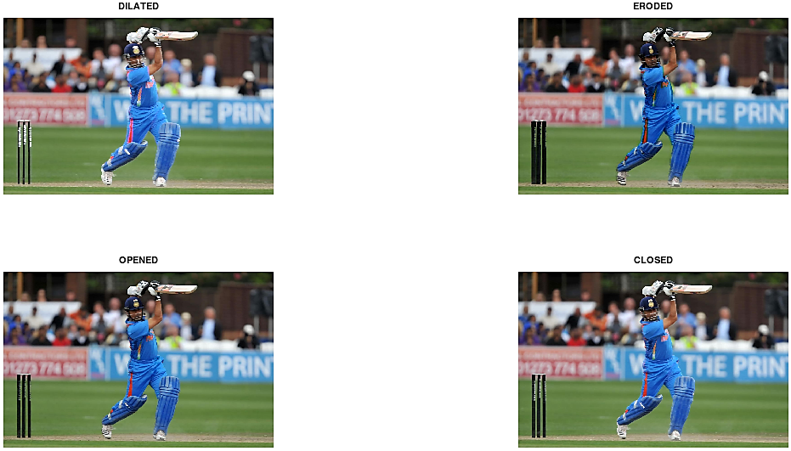

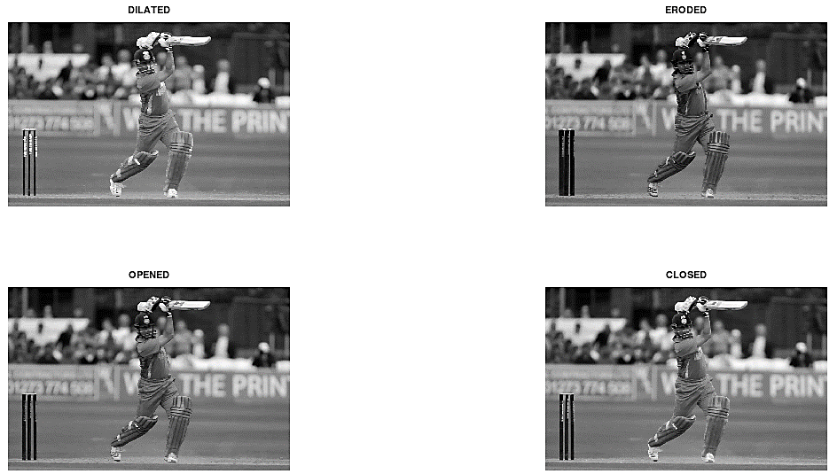

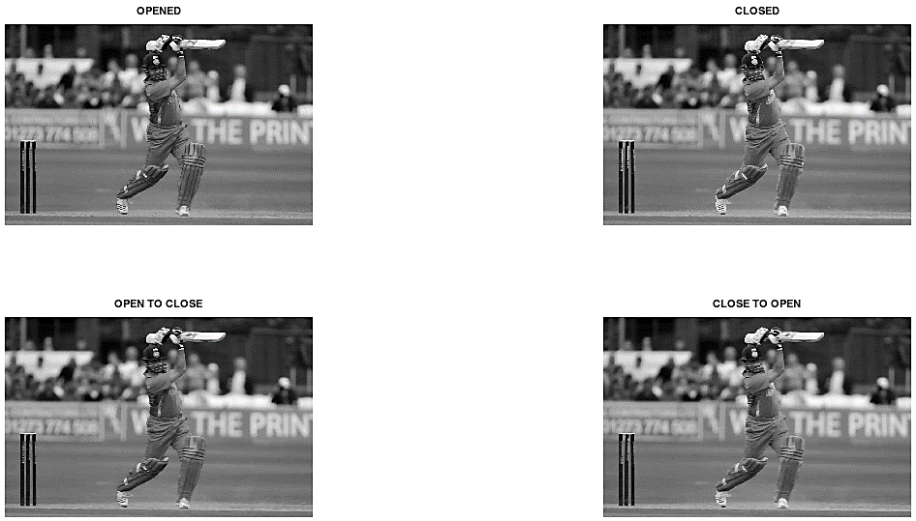

**B.3 Observations and learning:**

From the above experiment, we observed and learned the various morphological operations that can be implemented in image processing. We did the same using an image of our own, imported and performed the experiment on it.

**B.4 Conclusion:**

Thus, the aim of implementation of morphological operations on a given binary image is completed.

**B.5 Question of Curiosity**

**List of out real life applications of morphological operations.**

These applications include scanning process analysis, real mechanical surface reconstruction, freeform surface deviation evaluation, open surface and roundness filtration, form approximation, contact phenomenon simulation, establishment of uncertainty zone for continuous surface reconstruction and stratified functional.

Morphological operations, e.g. dilation, erosion, closing and opening, are also useful tools in surface metrology and dimensional metrology.

************************