CPSC390 Homework #2

1. (20 pts) Give the name of the algorithm that results from each of the following special cases:
a. Local beam search with $k = 1$.
Hill Climbing

b. Simulated annealing with T = 0 at all times for a fixed number of iterations
Greedy Hill Climbing

c. Simulated annealing with T= $∞$ at all times for a fixed number of iterations
Random Walk

d. Genetic algorithm with population size $N = 1$.
Stochastic Hill Climbing

2. Perform a Simulated Annealing search to maximize value in the following search space.
Recall that a good move (increases value) is always accepted (P = 1.0); a bad move (decreases value) is accepted with probability P = $e^{ΔVAL/T}$ , where $ΔVAL = VAL(Next) - VAL(Current).$ The initial state is A, and the search in each iteration can only move to one of the neighboring states or stay in the same state.

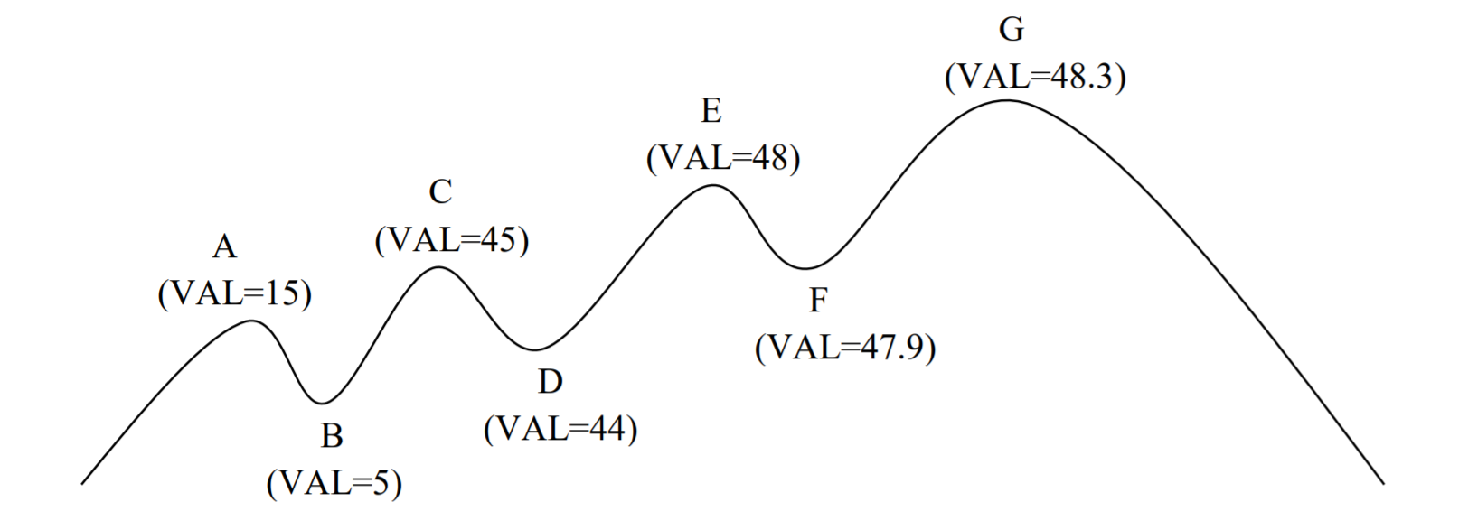
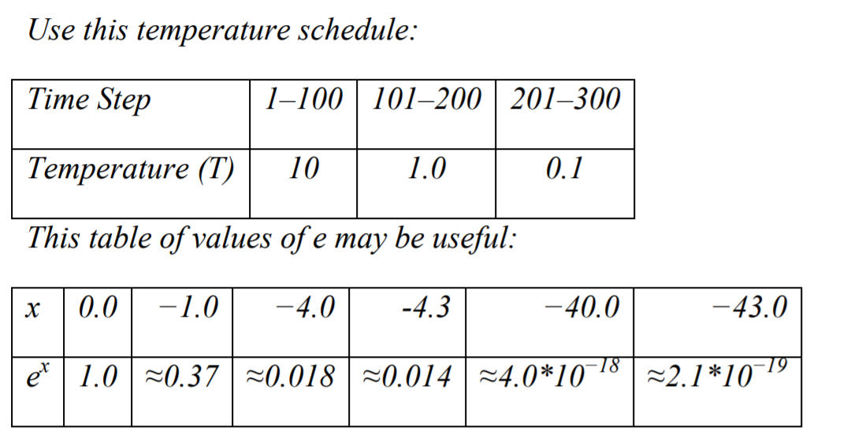

- (21 pts) Assume the following search moves over time have been observed. Analyze these moves in the search. The first one is done for you as an example.

Time | From | TO | T | $$ΔVAL$$ | $$ΔVAL/T$$ | P
57 | A | B | 10 | -10 | -1 | 0.37
99 | C | B | 10 | -40 | -4 | 0.018
132 | C | B | 1.0 | -40 | -40 | 4.0x10^-18
158 | C | D | 1.0 | -1 | -1 | 0.37
176 | E | D | 1.0 | -4 | -4 | 0.018
238 | E | D | 0.1 | -4 | -40 | 4.0x10^-18
253 | E | F | 0.1 | -0.1 | -1 | 0.37
269 | G | F | 0.1 | -0.4 | -4 | 0.018

Given these observations, please reason about the following unobserved events in this process:

b. (3 pts) At Time=100, is the search more likely to be in state A or in state C? (ignore E, G)
C
c. (3 pts) At Time=200, is the search more likely to be in state A, C, or E? (ignore G).
E
d. (3 pts) At Time=300, is the search more likely to be in state A, C, E, or G?
G

3. Assume that you get an intern position in the next presidential race for one of the presidential candidates. This is again a tight race, and your candidate plans to do a last-minute tour around the seven swing states: AZ, GA, MI, NV, PA, SC, and WI to have a rally at each state capital. The tour will start from Washington D.C. (DC) and must return to DC. Since time is of the essence, it is critical for the tour to minimize the flight path, hence time. The campaign manager asks you to plan out the optimal route. You decide to show off your AI skills by solving this with a genetic algorithm. (Note: You are encouraged to search the web for a solution, but you must provide a reference to your source if you do.)

- (5 pts) How do you represent an “individual” in your algorithm? Please provide an example.
An individual is one possible order of the 7 locations.
Ex [AZ, GA, MI, NV, PA, SC, WI]
This would represent the route
DC > AZ > GA > MI > NV > PA > SC > WI > DC
- (10 pts) Based on your representation, how will you perform a “crossover” to generate two children from two selected parents? Please provide an example.
The cross over formula is when we section two cut points form the Parent 1 (any chosen order to start with). We will then fill in the blank positions from the second Parent using the locations that do not match any in the cut section from parent 1.
Example:
Parent 1: [PA, MI, WI, GA, SC, AZ, NV]
Parent 2: [MI, AZ, PA, SC, NV, WI, GA]

Our cut section from Parent 1 can be _ _ WI GA SC _ _.
We fill in the blank spots with the remaining stops (left to right) from Parent 2 which are (MI, AZ, PA, NV)

Child 1 = [MI, AZ, WI, GA, SC, PA, NV]

Then to get the second Child we do the same thing but switch Parent 1 and Parent 2.

Once we have both children, we do it again.
- (10 pts) How will you implement the “mutation”? Please provide an example.
https://jaketae.github.io/study/genetic-algorithm/
https://www.geeksforgeeks.org/dsa/traveling-salesman-problem-using-genetic-algorithm/
Mutation is when two positions in the individual are swapped to form a new configuration. It is done to keep diversity in the population and help the algorithm avoid getting stuck in poor solutions.

Before Mutation
[PA, MI, WI, GA, SC, AZ, NV]

If we mutation 2 and 6 (chosen randomly)

After Swapping
[PA, AZ, WI, GA, SC, MI, NV]

4. (25 pts) In the N-Queens problem, we want to place N queens on an N × N board with no two queens on the same row, column, or diagonal. Use the number of attacking queen pairs as the value function (assume two queens on the same row/column/diagonal can attack each other regardless whether there is another queen in-between) and use hill climbing to solve the problem by minimizing this value function. Start with the configuration below. Generate the successors by moving a single queen vertically. Illustrate your search by showing the steps to reach the solution and the value function for all possible moves at each step.

 | A | B | C | D
1 |  |  | Q3 | Q4
2
3
4 | Q1 | Q2

The goal is for each move, reduce the # of queens that can see each other. Let’s represent this by ‘V = number of attacking queen pairs

So Move 1: We examine all possible single queen moves compared to their current Values which are:
Queens | Value (V)
Q1 | 2
Q2 | 1
Q3 | 1
Q4 | 2

We see that Q1 and Q4 have the highest H value. So lets choose Q1. Then we look at all possible vertical moves that Q1 can make and we find that Q1 -> A2 is the best move.

We then have this board
 | A | B | C | D
1 |  |  | Q3 | Q4
2 | Q1
3
4 |  | Q2

Then we repeat the same thing and find that Q4 to D3 is the best move and we find the final board:
 | A | B | C | D
1 |  |  | Q3
2 | Q1
3 |  |  |  | Q4
4 |  | Q2

Bonus Question (10 pts) – Can you devise a configuration of the 4-queen problem where it is NOT the end goal, but there is no way for the hill climb algorithm to improve the value function? Show the board configuration and the value function of all possible moves to prove it.

 | A | B | C | D
1 | Q1
2 |  |  |  | Q4
3 |  | Q2
4 |  |  | Q3

Queens | Value (V)
Q1 | 0
Q2 | 1
Q3 | 1
Q4 | 0

The hill climbing algorithm gets stuck here because it only accepts moves that strictly improve the value function. In this configuration, the only move that leads toward a solution is moving Q2 from B3 to B1, but that move keeps the value at h = 1, so it is not considered an improvement. Since every other vertical move makes the value worse and the best move does not reduce h, hill climbing refuses to move and stops, even though taking that sideways step would allow the next move to reduce h to 0.

