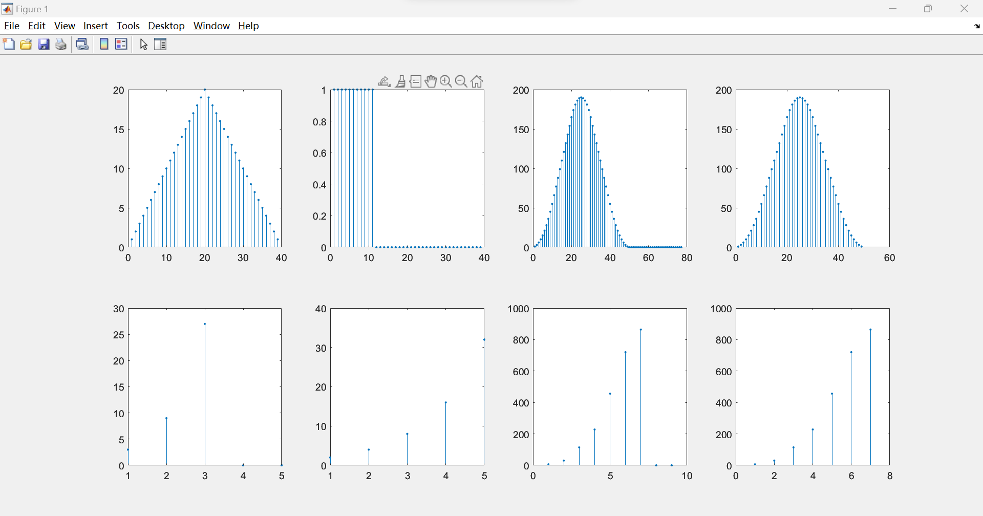

1. 2. 3. 4.

5. 6. 7. 8.

1. figure for Problem (a)

2. figure for Problem (a)

3. figure for Problem (b)

4. figure for Problem (c)

5. figure for Problem (d)

6. figure for Problem (d)

7. figure for Problem (d)

8. figure for Problem (d)