**\*Part I (a):**

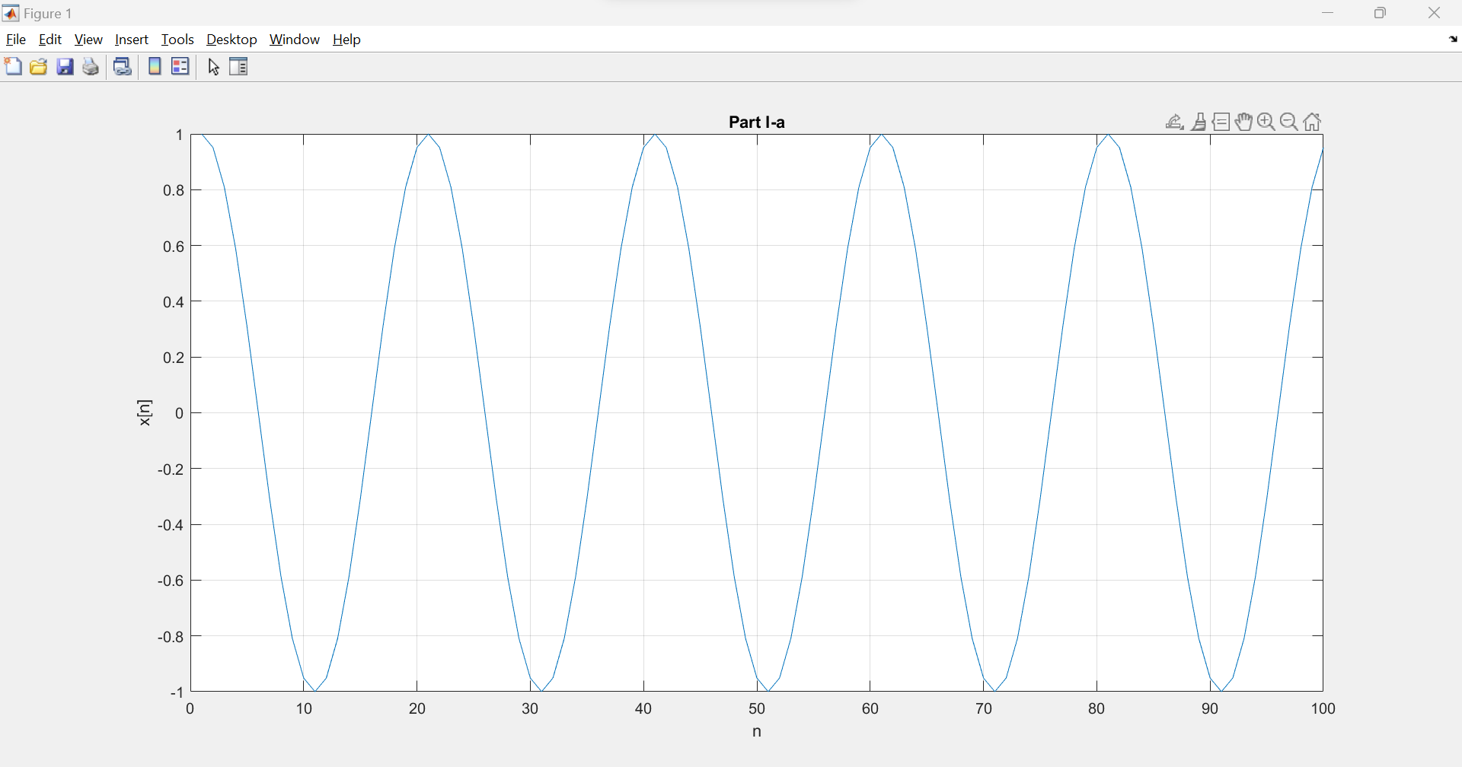

**\*Part I:**

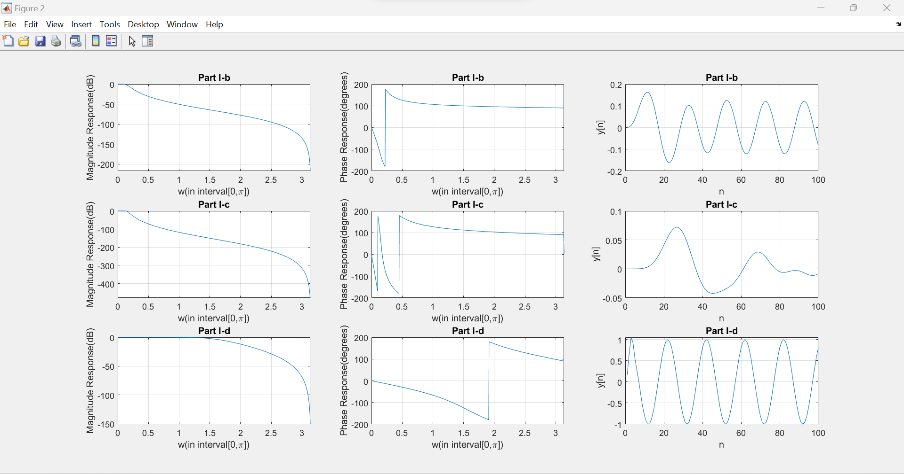

(b):

$$H\left(e^{jw}\right)=\frac{0.00042+0.0012e^{-jw}+0.0012e^{-j2w}+0.00042e^{-j3w}}{1-2.6862e^{-jw}+2.4197e^{-j2w}-0.7302e^{-j3w}}$$

(c):

$$H\left(e^{jw}\right)={10}^{-8}\frac{1.3+9.2e^{-jw}+27.6e^{-j2w}+46e^{-j3w}+46e^{-j4w}+27.6e^{-j5w}+9.2e^{-j6w}+1.3e^{-j7w}}{1-6.3e^{-jw}+17e^{-j2w}-25.6e^{-j3w}+23e^{-j4w}-12.6e^{-j5w}+3.8e^{-j6w}-0.5e^{-j7w}}$$

(d):

$$H\left(e^{jw}\right)=\frac{0.1667+0.5e^{-jw}+0.5e^{-j2w}+0.1667e^{-j3w}}{1-5{*10}^{-16}e^{-jw}+0.3333e^{-j2w}-1.9*{10}^{-17}e^{-j3w}}$$

(e):

The rate at which a filter's response falls in the transition band is determined by the filter's order. The higher the order of a filter, the faster the rolloff rate is. Comparing the graph of Magnitude Response to w in question b and c, we can notice that the one in c rolls off approximately 7/3 as fast as the one in b. As for cutoff frequency, we may take a comparison between the graph of Magnitude Response to w in question b and d. It displays that the one in d starts decreasing at higher frequency than that in b. This is because the cutoff frequency represents the frequency at which the gain is 3dB lower than the gain at passband. As a result, lowpass filters with higher cutoff frequency will attenuate at higher frequency.

**\*Part II:**

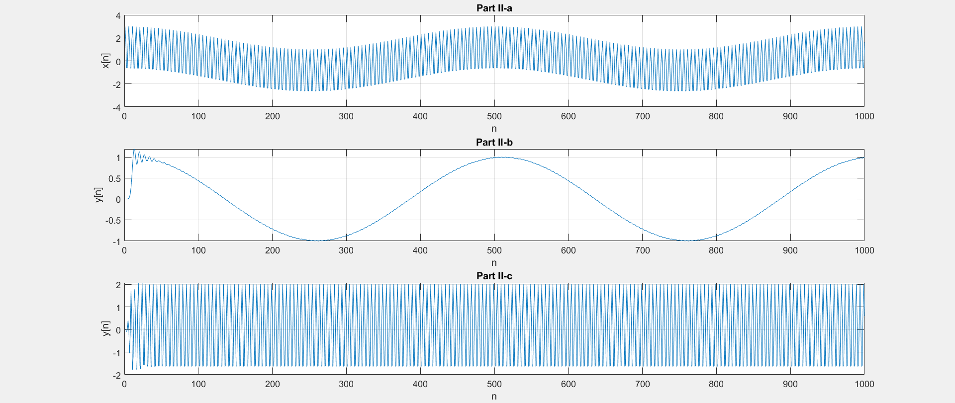

(b):

$H(e^jw )=(1.3*{10}^{-7}+2.1*{10}^{-6}e^{-jw}+1.6*{10}^{-5}e^{-j2w}+7.3*{10}^{-5}e^{-j3w}+2.4*{10}^{-4}e^{-j4w}+5.7*{10}^{-4}e^{-j5w}+0.001e^{-j6w}+0.0015e^{-j7w}+0.0017e^{-j8w}+0.0015e^{-j9w}+0.001e^{-j10w}+5.7*{10}^{-4}e^{-j11w}+2.4*{10}^{-4}e^{-j12w}+7.3*{10}^{-5}e^{-j13w}+1.6*{10}^{-5}e^{-j14w}+2.1*{10}^{-6}e^{-j15w}+1.3*{10}^{-7}e^{-j16w})/(1-6.4e^{-jw}+20.6e^{-j2w}-43.9e^{-j3w}+68e^{-j4w}-81e^{-j5w}+76.1e^{-j6w}-57.3e^{-j7w}+34.9e^{-j8w}-17.2e^{-j9w}+6.8e^{-j10w}-2.1e^{-j11w}+0.5e^{-j12w}-0.1e^{-j13w}+0.0126e^{-j14w}-0.001e^{-j15w}+4*{10}^{-5}e^{-j16w})$

Cutoff frequency = 0.3 (Normalized)

(c):

$H\left(e^{jw}\right)=(0.0033-0.0267e^{-j2w}+0.0933e^{-j4w}-0.1867e^{-j6w}+0.2333e^{-j8w}-0.1867e^{-j10w}+0.0933e^{-j12w}-0.0267e^{-j14w}+0.0033e^{-j16w})/(1+0.46e^{-jw}+1.3e^{-j2w}+0.6e^{-j3w}+1.8e^{-j4w}+0.7e^{-j5w}+1.1e^{-j6w}+0.4e^{-j7w}+0.7e^{-j8w}+0.2e^{-j9w}+0.2e^{-j10w}+0.04e^{-j11w}+0.1e^{-j12w}+0.0078e^{-j13w}+0.0075e^{-j14w}+5.6*{10}^{-4}e^{-j15w}+5.1*{10}^{-4}e^{-j16w})$

Bandpass Frequency = 0.3 (Normalized), 0.725 (Normalized)