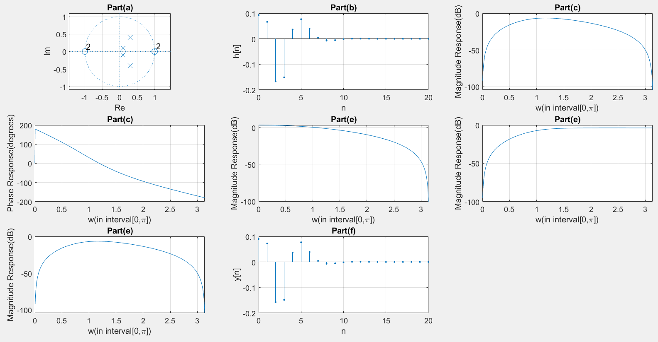

(a)：

Zeros：1(double root), -1(double root)

Poles：0.3+j0.4, 0.3-j0.4, 0.1+j0.1, 0.1-j0.1

ROC：|z|>0.5

(b)：

r=

0.542745358090180 + 1.28342506631299i

0.542745358090180 - 1.28342506631299i

-9.49774535809018 - 13.3632095490716i

-9.49774535809018 + 13.3632095490716i

p=

0.300000000000000 + 0.400000000000000i

0.300000000000000 - 0.400000000000000i

0.100000000000000 + 0.100000000000000i

0.100000000000000 - 0.100000000000000i

k=

18

Thus, real h[n] can be denoted as：

18δ[n]+u[n][2.78\*(0.5)^n\*cos((53.1\*n+67.1)\*pi/180)-32.78\*(0.14)^n\*cos((45\*n+54.6)\*pi/180)]

(d)：

H1(z)= $0.3\frac{1+2z^{-1}+z^{-2}}{1-0.2z^{-1}+0.02z^{-2}}$

H2(z)= $0.3\frac{1-2z^{-1}+z^{-2}}{1-0.6z^{-1}+0.25z^{-2}}$

(e)：

Figure in (c)：

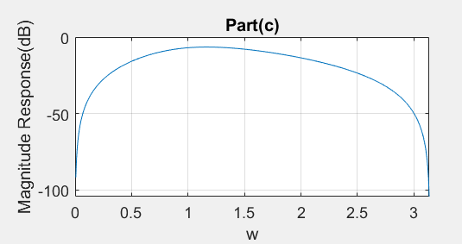

Figure in (e)：

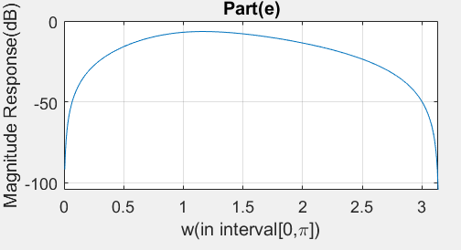

We can notice that the trend of the plot concerning magnitude versus ω is the same. By further checking several points of the two graphs can also discover that they are the same, which is in accord with the equation H(z)=H1(z)\*H2(z) theoretically.

(f)：

Figure in (b)：

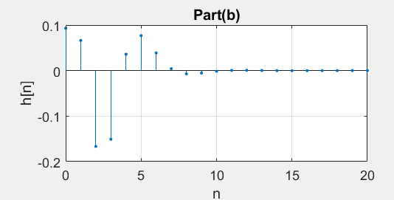

Figure in (f)：

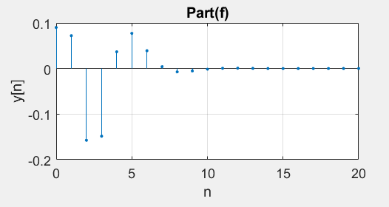

The two graphs are literally the same. This is because that the z-transform of δ[n]is 1, and H(z)multiplied by 1 is still the same.