**Flink-on-yarn(per-job与session)**[](#flink-on-yarnper-jobsession)

* 1、面试题：
* 2、简介
* 3、Session-Cluster模式：
* 4、Per-Job-Cluster模式：

**1、面试题目**[](" \l "1" \o "Permanent link)

1. 听说你熟悉Flink-on-yarn的部署模式？
2. 讲讲flink-on-yarn？flink与yarn的关系？部署在yarn上比standalone的优点？

**2、简介**[](" \l "2" \o "Permanent link)

Flink提供了两种在yarn上运行的模式，分别为Session-cluster和Per-Job-Cluster模式，本文分析两种模式及启动流程。

下面展示了Flink-On-Yarn模式下涉及到的相关类图结构：

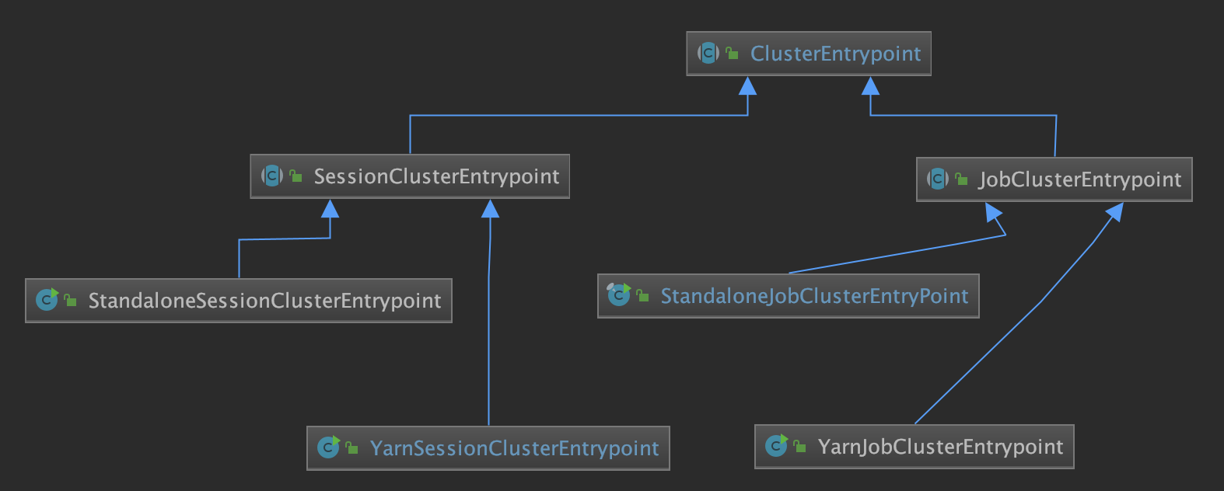

**3、Session-Cluster模式：**[](" \l "3session-cluster" \o "Permanent link)

session-Cluster模式 ***需要先启动集群，然后再提交作业***，接着会向yarn申请一块空间后，资源永远保持不变。如果资源满了，下一个作业就无法提交，只能等到yarn中的其中一个作业执行完成后，释放了资源，下一个作业才会正常提交。***所有作业共享Dispatcher和ResourceManager***；共享资源，适合规模小执行时间短的作业。

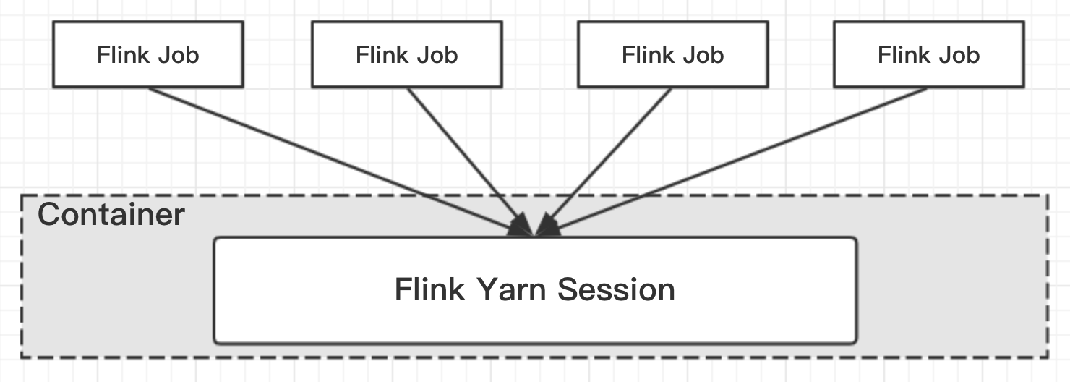

**3.1、启动集群**[](" \l "31" \o "Permanent link)

运行bin/yarn-session.sh，即可默认启动包含一个TaskManager(内存大小为1024MB),一个JobMaster(内存大小为1024MB)，当然可以通过指定参数控制集群的资源，如-n执行taskManager个数，-s指定每个TaskManager中slot的个数；

下面以bin/yarn-session.sh为例，分析Session-Cluster启动流程

**3.2、流程分析**[](" \l "32" \o "Permanent link)

下面分为 ***本地和远程***分析启动流程，其中本地表示客户端的启动流程，远程则表示通过Yarn拉起Container的流程；

**3.2.1、本地流程**[](" \l "321" \o "Permanent link)

Session启动入口为FlinkYarnSessionCli#main

FlinkYarnSessionCli**.**java

**public** **static** **void** **main(final** String**[]** args**)** **{**

**final** String configurationDirectory **=** CliFrontend**.**getConfigurationDirectoryFromEnv**();**

**final** Configuration flinkConfiguration **=** GlobalConfiguration**.**loadConfiguration**();**

**int** retCode**;**

*//new FlinkYarnSessionCli对象*

★ **final** FlinkYarnSessionCli cli **=** **new** FlinkYarnSessionCli**(**

flinkConfiguration**,**

configurationDirectory**,** ""**,**""**);** *// no prefix for the YARN session*

SecurityUtils**.**install**(new** SecurityConfiguration**(**flinkConfiguration**));**

retCode **=** SecurityUtils**.**getInstalledContext**().**runSecured**(**

*//执行FlinkYarnSessionCli#run方法启动 Flink Session Client*

★ **()** **->** cli**.**run**(**args**));**

System**.**exit**(**retCode**);**

**}**

执行FlinkYarnSessionCli#run

**public** **int** **run(**String**[]** args**)** **throws** CliArgsException**,** FlinkException **{**

*// Command Line Options*

**final** CommandLine cmd **=** parseCommandLineOptions**(**args**,** **true);**

**final** Configuration configuration **=** applyCommandLineOptionsToConfiguration**(**cmd**);**

*//ClusterClientFactory: 集群Client工厂模式*

**final** ClusterClientFactory**<**ApplicationId**>** yarnClusterClientFactory **=** clusterClientServiceLoader**.**getClusterClientFactory**(**configuration**);**

*//The descriptor with deployment information for deploying a Flink cluster on Yarn:*

★ **final** YarnClusterDescriptor yarnClusterDescriptor **=** **(**YarnClusterDescriptor**)** yarnClusterClientFactory**.**createClusterDescriptor**(**configuration**);**

**try** **{**

*// Query cluster for metrics*

**if** **(**cmd**.**hasOption**(**query**.**getOpt**()))** **{**

**final** String description **=** yarnClusterDescriptor**.**getClusterDescription**();**

System**.**out**.**println**(**description**);**

**return** 0**;**

**}** **else** **{**

**final** ClusterClientProvider**<**ApplicationId**>** clusterClientProvider**;**

**final** ApplicationId yarnApplicationId**;**

**if** **(**cmd**.**hasOption**(**applicationId**.**getOpt**()))** **{**

yarnApplicationId **=** ConverterUtils**.**toApplicationId**(**cmd**.**getOptionValue**(**applicationId**.**getOpt**()));**

clusterClientProvider **=** yarnClusterDescriptor**.**retrieve**(**yarnApplicationId**);**

**}** **else** **{**

**final** ClusterSpecification clusterSpecification **=** yarnClusterClientFactory**.**getClusterSpecification**(**configuration**);**

*//deploy yarn Cluster集群*

★ clusterClientProvider **=** yarnClusterDescriptor**.**deploySessionCluster**(**clusterSpecification**);**

*//创建与集群交互的ClusterClient*

★ ClusterClient**<**ApplicationId**>** clusterClient **=** clusterClientProvider**.**getClusterClient**();**

*//--- ClusterClient deployed, handle connection details*

★ yarnApplicationId **=** clusterClient**.**getClusterId**();**

System**.**out**.**println**(**"JobManager Web Interface: " **+** clusterClient**.**getWebInterfaceURL**());**

writeYarnPropertiesFile**(**

yarnApplicationId**,**

dynamicPropertiesEncoded**);**

**}**

**if** **(!**configuration**.**getBoolean**(**DeploymentOptions**.**ATTACHED**))** **{**

YarnClusterDescriptor**.**logDetachedClusterInformation**(**yarnApplicationId**,** LOG**);**

**}** **else** **{**

ScheduledExecutorService scheduledExecutorService **=** Executors**.**newSingleThreadScheduledExecutor**();**

**final** YarnApplicationStatusMonitor yarnApplicationStatusMonitor **=** **new** YarnApplicationStatusMonitor**(**

yarnClusterDescriptor**.**getYarnClient**(),**

yarnApplicationId**,**

**new** ScheduledExecutorServiceAdapter**(**scheduledExecutorService**));**

Thread shutdownHook **=** ShutdownHookUtil**.**addShutdownHook**(**

**()** **->** shutdownCluster**(**

clusterClientProvider**.**getClusterClient**(),**

scheduledExecutorService**,**

yarnApplicationStatusMonitor**),**

getClass**().**getSimpleName**(),**

LOG**);**

**try** **{**

runInteractiveCli**(**

yarnApplicationStatusMonitor**,**

acceptInteractiveInput**);**

**}** **finally** **{**

shutdownCluster**(**

clusterClientProvider**.**getClusterClient**(),**

scheduledExecutorService**,**

yarnApplicationStatusMonitor**);**

**if** **(**shutdownHook **!=** **null)** **{**

ShutdownHookUtil**.**removeShutdownHook**(**shutdownHook**,** getClass**().**getSimpleName**(),** LOG**);**

**}**

tryRetrieveAndLogApplicationReport**(**

yarnClusterDescriptor**.**getYarnClient**(),**

yarnApplicationId**);**

**}**

**}**

**}**

**}** **finally** **{**

yarnClusterDescriptor**.**close**();**

**}**

**return** 0**;**

**}**

上述代码中：yarnClusterClientFactory.createClusterDescriptor(configuration)–=》yarnClusterClientFactory#getClusterDescription()—》创建、初始化YarnClient并start

**private** YarnClusterDescriptor **getClusterDescriptor(**Configuration configuration**)** **{**

*//初始化yarn*

★ **final** YarnClient yarnClient **=** YarnClient**.**createYarnClient**();**

**final** YarnConfiguration yarnConfiguration **=** **new** YarnConfiguration**();**

★ yarnClient**.**init**(**yarnConfiguration**);**

★ yarnClient**.**start**();**

**return** **new** YarnClusterDescriptor**(**

configuration**,**

yarnConfiguration**,**

yarnClient**,**

YarnClientYarnClusterInformationRetriever**.**create**(**yarnClient**),**

**false);**

**}**

部署集群YarnClusterDescriptor#deploySessionCluster()->YarnClusterDescriptor#deployInternal()

YarnClusterDescriptor**.**java

*/\*\**

*\* deployInternal()方法将一直被阻塞直到ApplicationMaster/JobManager被部署到YARN之前*

*\* @param clusterSpecification*

*\* @param applicationName 将要启动的集群的名字*

*\* @param yarnClusterEntrypoint 类名关于：Yarn cluster entry point*

*\* @param jobGraph*

*\* @param detached 是否是分离模式*

*\*/*

**private** ClusterClientProvider**<**ApplicationId**>** **deployInternal(**

ClusterSpecification clusterSpecification**,**

String applicationName**,**

String yarnClusterEntrypoint**,**

@Nullable JobGraph jobGraph**,**

**boolean** detached**)** **throws** Exception **{**

*//判断部署yarn集群的配置参数是否已经配置好*

isReadyForDeployment**(**clusterSpecification**);**

*//检查当前的yarn session是否已经存在yarnQueue*

checkYarnQueues**(**yarnClient**);**

*// Create application via yarnClient*

**final** YarnClientApplication yarnApplication **=** yarnClient**.**createApplication**();**

**final** GetNewApplicationResponse appResponse **=** yarnApplication**.**getNewApplicationResponse**();**

Resource maxRes **=** appResponse**.**getMaximumResourceCapability**();**

**final** ClusterResourceDescription freeClusterMem**;**

freeClusterMem **=** getCurrentFreeClusterResources**(**yarnClient**);**

**final** **int** yarnMinAllocationMB **=** yarnConfiguration**.**getInt**(**YarnConfiguration**.**RM\_SCHEDULER\_MINIMUM\_ALLOCATION\_MB**,** 0**);**

**final** ClusterSpecification validClusterSpecification**;**

validClusterSpecification **=** validateClusterResources**(**

clusterSpecification**,**

yarnMinAllocationMB**,**

maxRes**,**

freeClusterMem**);**

**final** ClusterEntrypoint**.**ExecutionMode executionMode **=** detached **?**

ClusterEntrypoint**.**ExecutionMode**.**DETACHED

**:** ClusterEntrypoint**.**ExecutionMode**.**NORMAL**;**

flinkConfiguration**.**setString**(**ClusterEntrypoint**.**EXECUTION\_MODE**,** executionMode**.**toString**());**

*//启动AppMaster*

★ ApplicationReport report **=** startAppMaster**(**

flinkConfiguration**,**

applicationName**,**

yarnClusterEntrypoint**,**

jobGraph**,**

yarnClient**,**

yarnApplication**,**

validClusterSpecification**);**

*// 如果是分离模式则取出ApplicationID并打印*

**if** **(**detached**)** **{**

**final** ApplicationId yarnApplicationId **=** report**.**getApplicationId**();**

logDetachedClusterInformation**(**yarnApplicationId**,** LOG**);**

**}**

*//AppMaster启动成功后将对应的ip和port写入flinkConfiguration中*

setClusterEntrypointInfoToConfig**(**report**);**

**return** **()** **->** **{**

*//创建与集群交互的ClusterClient*

*//通过ClusterClient获取到appId信息并写入本地临时文件*

★ **return** **new** RestClusterClient**<>(**flinkConfiguration**,** report**.**getApplicationId**());**

**};**

*// 经过上述步骤，整个客户端的启动流程就结束了，下面分析yarn拉起Session集群的流程，*

*// 入口类在申请Container时指定为YarnSessionClusterEntrypoint*

**}**

YarnClusterDescriptor**.**java

**private** ApplicationReport **startAppMaster(**

Configuration configuration**,** String applicationName**,**

String yarnClusterEntrypoint**,** JobGraph jobGraph**,**

YarnClient yarnClient**,** YarnClientApplication yarnApplication**,**

ClusterSpecification clusterSpecification**){**

*//1. 初始化文件系统（HDFS）*

org**.**apache**.**flink**.**core**.**fs**.**FileSystem**.**initialize**(**

configuration**,**

PluginUtils**.**createPluginManagerFromRootFolder**(**configuration**));**

**final** FileSystem fs **=** FileSystem**.**get**(**yarnConfiguration**);**

**final** Path homeDir **=** fs**.**getHomeDirectory**();**

*//2. 创建appContext 提交启动yarn集群的上下文ApplicationSubmissionContext*

ApplicationSubmissionContext appContext **=** yarnApplication**.**getApplicationSubmissionContext**();**

*// The files need to be shipped and added to classpath.*

Set**<**File**>** systemShipFiles **=** **new** HashSet**<>(**shipFiles**.**size**());**

*// The files only need to be shipped.*

Set**<**File**>** shipOnlyFiles **=** **new** HashSet**<>();**

**for** **(**File file **:** shipFiles**)** **{**

systemShipFiles**.**add**(**file**.**getAbsoluteFile**());**

**}**

*//2. 将log4j、logback、flink-conf.yaml、jar包上传至HDFS*

**final** String logConfigFilePath **=** configuration**.**getString**(**YarnConfigOptionsInternal**.**APPLICATION\_LOG\_CONFIG\_FILE**);**

**if** **(**logConfigFilePath **!=** **null)** **{**

systemShipFiles**.**add**(new** File**(**logConfigFilePath**));**

**}**

addLibFoldersToShipFiles**(**systemShipFiles**);**

addPluginsFoldersToShipFiles**(**shipOnlyFiles**);**

*// 3. 生成ApplicationID*

**final** ApplicationId appId **=** appContext**.**getApplicationId**();**

*// -- Add Zookeeper namespace to local flinkConfiguraton ----*

String zkNamespace **=** getZookeeperNamespace**();**

configuration**.**setString**(**HighAvailabilityOptions**.**HA\_CLUSTER\_ID**,** zkNamespace**);**

**if** **(**HighAvailabilityMode**.**isHighAvailabilityModeActivated**(**configuration**))** **{**

*// activate re-execution of failed applications*

appContext**.**setMaxAppAttempts**(**

configuration**.**getInteger**(**

YarnConfigOptions**.**APPLICATION\_ATTEMPTS**.**key**(),**

YarnConfiguration**.**DEFAULT\_RM\_AM\_MAX\_ATTEMPTS**));**

activateHighAvailabilitySupport**(**appContext**);**

**}** **else** **{**

appContext**.**setMaxAppAttempts**(**

configuration**.**getInteger**(**

YarnConfigOptions**.**APPLICATION\_ATTEMPTS**.**key**(),**

1**));**

**}**

**final** Set**<**File**>** userJarFiles **=** **(**jobGraph **==** **null)**

*// not per-job submission*

**?** Collections**.**emptySet**()**

*// add user code jars from the provided JobGraph*

**:** jobGraph**.**getUserJars**().**stream**().**map**(**f **->** f**.**toUri**()).**map**(**File**::new).**collect**(**Collectors**.**toSet**());**

*// only for per job mode*

**if** **(**jobGraph **!=** **null)** **{**

**for** **(**Map**.**Entry**<**String**,** DistributedCache**.**DistributedCacheEntry**>** entry **:** jobGraph**.**getUserArtifacts**().**entrySet**())** **{**

org**.**apache**.**flink**.**core**.**fs**.**Path path **=** **new** org**.**apache**.**flink**.**core**.**fs**.**Path**(**entry**.**getValue**().**filePath**);**

*// only upload local files*

**if** **(!**path**.**getFileSystem**().**isDistributedFS**())** **{**

Path localPath **=** **new** Path**(**path**.**getPath**());**

Tuple2**<**Path**,** Long**>** remoteFileInfo **=**

Utils**.**uploadLocalFileToRemote**(**fs**,** appId**.**toString**(),** localPath**,** homeDir**,** entry**.**getKey**());**

jobGraph**.**setUserArtifactRemotePath**(**entry**.**getKey**(),** remoteFileInfo**.**f0**.**toString**());**

**}**

**}**

jobGraph**.**writeUserArtifactEntriesToConfiguration**();**

**}**

*// local resource map for Yarn*

**final** Map**<**String**,** LocalResource**>** localResources **=** **new** HashMap**<>(**2 **+** systemShipFiles**.**size**()** **+** userJarFiles**.**size**());**

*// list of remote paths (after upload)*

**final** List**<**Path**>** paths **=** **new** ArrayList**<>(**2 **+** systemShipFiles**.**size**()** **+** userJarFiles**.**size**());**

*// ship list that enables reuse of resources for task manager containers*

StringBuilder envShipFileList **=** **new** StringBuilder**();**

*// upload and register ship files, these files will be added to classpath.*

List**<**String**>** systemClassPaths **=** uploadAndRegisterFiles**(**

systemShipFiles**,** fs**,** homeDir**,** appId**,** paths**,**

localResources**,** Path**.**CUR\_DIR**,** envShipFileList**);**

*//上传和注册ship-only files*

uploadAndRegisterFiles**(**

shipOnlyFiles**,** fs**,** homeDir**,** appId**,**

paths**,** localResources**,** Path**.**CUR\_DIR**,** envShipFileList**);**

**final** List**<**String**>** userClassPaths **=** uploadAndRegisterFiles**(**

userJarFiles**,** fs**,** homeDir**,**

appId**,** paths**,** localResources**,**

userJarInclusion **==** YarnConfigOptions**.**UserJarInclusion**.**DISABLED **?**

ConfigConstants**.**DEFAULT\_FLINK\_USR\_LIB\_DIR **:** Path**.**CUR\_DIR**,**

envShipFileList**);**

**if** **(**userJarInclusion **==** YarnConfigOptions**.**UserJarInclusion**.**ORDER**)** **{**

systemClassPaths**.**addAll**(**userClassPaths**);**

**}**

*// normalize classpath by sorting*

Collections**.**sort**(**systemClassPaths**);**

Collections**.**sort**(**userClassPaths**);**

*// classpath assembler*

StringBuilder classPathBuilder **=** **new** StringBuilder**();**

**if** **(**userJarInclusion **==** YarnConfigOptions**.**UserJarInclusion**.**FIRST**)** **{**

**for** **(**String userClassPath **:** userClassPaths**)** **{**

classPathBuilder**.**append**(**userClassPath**).**append**(**File**.**pathSeparator**);**

**}**

**}**

**for** **(**String classPath **:** systemClassPaths**)** **{**

classPathBuilder**.**append**(**classPath**).**append**(**File**.**pathSeparator**);**

**}**

*// Setup jar for ApplicationMaster*

Path remotePathJar **=** setupSingleLocalResource**(**

flinkJarPath**.**getName**(),** fs**,** appId**,** flinkJarPath**,**

localResources**,** homeDir**,** ""**);**

paths**.**add**(**remotePathJar**);**

classPathBuilder**.**append**(**flinkJarPath**.**getName**()).**append**(**File**.**pathSeparator**);**

*// Upload the flink configuration*

*// write out configuration file*

File tmpConfigurationFile **=** **null;**

**try** **{**

tmpConfigurationFile **=** File**.**createTempFile**(**appId **+** "-flink-conf.yaml"**,** **null);**

BootstrapTools**.**writeConfiguration**(**configuration**,** tmpConfigurationFile**);**

String flinkConfigKey **=** "flink-conf.yaml"**;**

Path remotePathConf **=** setupSingleLocalResource**(**

flinkConfigKey**,**

fs**,**

appId**,**

**new** Path**(**tmpConfigurationFile**.**getAbsolutePath**()),**

localResources**,**

homeDir**,**

""**);**

envShipFileList**.**append**(**flinkConfigKey**).**append**(**"="**).**append**(**remotePathConf**).**append**(**","**);**

paths**.**add**(**remotePathConf**);**

classPathBuilder**.**append**(**"flink-conf.yaml"**).**append**(**File**.**pathSeparator**);**

**}** **finally** **{**

**if** **(**tmpConfigurationFile **!=** **null** **&&** **!**tmpConfigurationFile**.**delete**())** **{**

LOG**.**warn**(**"Fail to delete temporary file {}."**,** tmpConfigurationFile**.**toPath**());**

**}**

**}**

**if** **(**userJarInclusion **==** YarnConfigOptions**.**UserJarInclusion**.**LAST**)** **{**

**for** **(**String userClassPath **:** userClassPaths**)** **{**

classPathBuilder**.**append**(**userClassPath**).**append**(**File**.**pathSeparator**);**

**}**

**}**

*// write job graph to tmp file and add it to local resource*

*// TODO: server use user main method to generate job graph*

**if** **(**jobGraph **!=** **null)** **{**

File tmpJobGraphFile **=** **null;**

**try** **{**

tmpJobGraphFile **=** File**.**createTempFile**(**appId**.**toString**(),** **null);**

**try** **(**FileOutputStream output **=** **new** FileOutputStream**(**tmpJobGraphFile**);**

ObjectOutputStream obOutput **=** **new** ObjectOutputStream**(**output**);){**

obOutput**.**writeObject**(**jobGraph**);**

**}**

**final** String jobGraphFilename **=** "job.graph"**;**

flinkConfiguration**.**setString**(**JOB\_GRAPH\_FILE\_PATH**,** jobGraphFilename**);**

Path pathFromYarnURL **=** setupSingleLocalResource**(**

jobGraphFilename**,** fs**,** appId**,** **new** Path**(**tmpJobGraphFile**.**toURI**()),** localResources**,** homeDir**,** ""**);**

paths**.**add**(**pathFromYarnURL**);**

classPathBuilder**.**append**(**jobGraphFilename**).**append**(**File**.**pathSeparator**);**

**}** **catch** **(**Exception e**)** **{**

LOG**.**warn**(**"Add job graph to local resource fail"**);**

**throw** e**;**

**}** **finally** **{**

**if** **(**tmpJobGraphFile **!=** **null** **&&** **!**tmpJobGraphFile**.**delete**())** **{**

LOG**.**warn**(**"Fail to delete temporary file {}."**,** tmpConfigurationFile**.**toPath**());**

**}**

**}**

**}**

**final** Path yarnFilesDir **=** getYarnFilesDir**(**appId**);**

FsPermission permission **=** **new** FsPermission**(**FsAction**.**ALL**,** FsAction**.**NONE**,** FsAction**.**NONE**);**

fs**.**setPermission**(**yarnFilesDir**,** permission**);** *// set permission for path.*

**final** **boolean** hasLogback **=** logConfigFilePath **!=** **null** **&&** logConfigFilePath**.**endsWith**(**CONFIG\_FILE\_LOGBACK\_NAME**);**

**final** **boolean** hasLog4j **=** logConfigFilePath **!=** **null** **&&** logConfigFilePath**.**endsWith**(**CONFIG\_FILE\_LOG4J\_NAME**);**

*//5. 构造AppMaster的的container(确定container进程的入口类YarnSessionClusterEntrypoint)构造相应的Env*

★ **final** ContainerLaunchContext amContainer **=** setupApplicationMasterContainer**(**yarnClusterEntrypoint**,** hasLogback**,** hasLog4j**,** hasKrb5**,**

clusterSpecification**.**getMasterMemoryMB**());**

amContainer**.**setLocalResources**(**localResources**);**

fs**.**close**();**

*// Setup CLASSPATH and environment variables for ApplicationMaster*

**final** Map**<**String**,** String**>** appMasterEnv **=** **new** HashMap**<>();**

*// set user specified app master environment variables*

appMasterEnv**.**putAll**(**

BootstrapTools**.**getEnvironmentVariables**(**ResourceManagerOptions**.**CONTAINERIZED\_MASTER\_ENV\_PREFIX**,** configuration**));**

*// set Flink app class path*

appMasterEnv**.**put**(**YarnConfigKeys**.**ENV\_FLINK\_CLASSPATH**,** classPathBuilder**.**toString**());**

*// set Flink on YARN internal configuration values*

appMasterEnv**.**put**(**YarnConfigKeys**.**FLINK\_JAR\_PATH**,** remotePathJar**.**toString**());**

appMasterEnv**.**put**(**YarnConfigKeys**.**ENV\_APP\_ID**,** appId**.**toString**());**

appMasterEnv**.**put**(**YarnConfigKeys**.**ENV\_CLIENT\_HOME\_DIR**,** homeDir**.**toString**());**

appMasterEnv**.**put**(**YarnConfigKeys**.**ENV\_CLIENT\_SHIP\_FILES**,** envShipFileList**.**toString**());**

appMasterEnv**.**put**(**YarnConfigKeys**.**ENV\_ZOOKEEPER\_NAMESPACE**,** getZookeeperNamespace**());**

appMasterEnv**.**put**(**YarnConfigKeys**.**FLINK\_YARN\_FILES**,** yarnFilesDir**.**toUri**().**toString**());**

appMasterEnv**.**put**(**YarnConfigKeys**.**ENV\_HADOOP\_USER\_NAME**,** UserGroupInformation**.**getCurrentUser**().**getUserName**());**

**if** **(**remotePathKeytab **!=** **null)** **{**

appMasterEnv**.**put**(**YarnConfigKeys**.**KEYTAB\_PATH**,** remotePathKeytab**.**toString**());**

String principal **=** configuration**.**getString**(**SecurityOptions**.**KERBEROS\_LOGIN\_PRINCIPAL**);**

appMasterEnv**.**put**(**YarnConfigKeys**.**KEYTAB\_PRINCIPAL**,** principal**);**

**}**

*//To support Yarn Secure Integration Test Scenario*

**if** **(**remoteYarnSiteXmlPath **!=** **null)** **{**

appMasterEnv**.**put**(**YarnConfigKeys**.**ENV\_YARN\_SITE\_XML\_PATH**,** remoteYarnSiteXmlPath**.**toString**());**

**}**

**if** **(**remoteKrb5Path **!=** **null)** **{**

appMasterEnv**.**put**(**YarnConfigKeys**.**ENV\_KRB5\_PATH**,** remoteKrb5Path**.**toString**());**

**}**

*// set classpath from YARN configuration*

Utils**.**setupYarnClassPath**(**yarnConfiguration**,** appMasterEnv**);**

*//6. 设置env*

★ amContainer**.**setEnvironment**(**appMasterEnv**);**

*// Set up resource type requirements for ApplicationMaster*

Resource capability **=** Records**.**newRecord**(**Resource**.**class**);**

capability**.**setMemory**(**clusterSpecification**.**getMasterMemoryMB**());**

capability**.**setVirtualCores**(**flinkConfiguration**.**getInteger**(**YarnConfigOptions**.**APP\_MASTER\_VCORES**));**

**final** String customApplicationName **=** customName **!=** **null** **?** customName **:** applicationName**;**

appContext**.**setApplicationName**(**customApplicationName**);**

appContext**.**setApplicationType**(**applicationType **!=** **null** **?** applicationType **:** "Apache Flink"**);**

appContext**.**setAMContainerSpec**(**amContainer**);**

appContext**.**setResource**(**capability**);**

*// Set priority for application*

**int** priorityNum **=** flinkConfiguration**.**getInteger**(**YarnConfigOptions**.**APPLICATION\_PRIORITY**);**

**if** **(**priorityNum **>=** 0**)** **{**

Priority priority **=** Priority**.**newInstance**(**priorityNum**);**

appContext**.**setPriority**(**priority**);**

**}**

**if** **(**yarnQueue **!=** **null)** **{**

appContext**.**setQueue**(**yarnQueue**);**

**}**

setApplicationNodeLabel**(**appContext**);**

setApplicationTags**(**appContext**);**

*// add a hook to clean up in case deployment fails*

Thread deploymentFailureHook **=** **new** DeploymentFailureHook**(**yarnApplication**,** yarnFilesDir**);**

Runtime**.**getRuntime**().**addShutdownHook**(**deploymentFailureHook**);**

LOG**.**info**(**"Submitting application master " **+** appId**);**

*//7. 通过yarnClient创建Application*

★ yarnClient**.**submitApplication**(**appContext**);**

LOG**.**info**(**"Waiting for the cluster to be allocated"**);**

**final** **long** startTime **=** System**.**currentTimeMillis**();**

ApplicationReport report**;**

YarnApplicationState lastAppState **=** YarnApplicationState**.**NEW**;**

*// yarnCluster部署成功之前 一直阻塞*

★ loop**:** **while** **(true)** **{**

**try** **{**

report **=** yarnClient**.**getApplicationReport**(**appId**);**

**}** **catch** **(**IOException e**)** **{**

**throw** **new** YarnDeploymentException**(**"Failed to deploy the cluster."**,** e**);**

**}**

YarnApplicationState appState **=** report**.**getYarnApplicationState**();**

LOG**.**debug**(**"Application State: {}"**,** appState**);**

*//跟踪ApplicationReport状态（确定是否启动成功，可能会由于资源不够，一直等待）*

**switch(**appState**)** **{**

**case** FAILED**:**

**case** KILLED**:**

**throw** **new** YarnDeploymentException**(**"The YARN application unexpectedly switched to state "

**+** appState **+** " during deployment. \n" **+**

"Diagnostics from YARN: " **+** report**.**getDiagnostics**()** **+** "\n" **+**

"If log aggregation is enabled on your cluster, use this command to further investigate the issue:\n" **+**

"yarn logs -applicationId " **+** appId**);**

*//break ..*

**case** RUNNING**:**

LOG**.**info**(**"YARN application has been deployed successfully."**);**

**break** loop**;**

**case** FINISHED**:**

LOG**.**info**(**"YARN application has been finished successfully."**);**

**break** loop**;**

**default:**

**if** **(**appState **!=** lastAppState**)** **{**

LOG**.**info**(**"Deploying cluster, current state " **+** appState**);**

**}**

**if** **(**System**.**currentTimeMillis**()** **-** startTime **>** 60000**)** **{**

LOG**.**info**(**"Deployment took more than 60 seconds. Please check if the requested resources are available in the YARN cluster"**);**

**}**

**}**

lastAppState **=** appState**;**

Thread**.**sleep**(**250**);**

**}**

*// since deployment was successful, remove the hook*

ShutdownHookUtil**.**removeShutdownHook**(**deploymentFailureHook**,** getClass**().**getSimpleName**(),** LOG**);**

**return** report**;**

**}**

AbstractYarnClusterDescriptor#startAppMaster启动AppMaster

**上述deployInternal()方法主要做了如下几件事：**[](" \l "deployinternal" \o "Permanent link)

1. 初始化文件系统（HDFS）、 创建appContext 提交启动yarn集群的上下文ApplicationSubmissionContext
2. 将log4j、logback、flink-conf.yaml、jar包上传至HDFS
3. 生成ApplicationID
4. 上传和注册ship-only files
5. 构造AppMaster的的container(确定container进程的入口类YarnSessionClusterEntrypoint)构造相应的Env
6. 设置env
7. 通过yarnClient创建Application：yarnClient.submitApplication(appContext);
8. 通过while循环实现yarnCluster部署成功之前 一直阻塞

接下来就是创建与集群交互的ClusterClient(创建基于Netty的RestClient)

通过ClusterClient获取到appId信息并写入本地临时文件 return new RestClusterClient<>(flinkConfiguration, report.getApplicationId());

RestClusterClient**.**java

**private** **RestClusterClient(** Configuration configuration**,**

@Nullable RestClient restClient**,** T clusterId**,** WaitStrategy waitStrategy**,**

ClientHighAvailabilityServices clientHAServices**)** **{**

**this.**configuration **=** checkNotNull**(**configuration**);**

**this.**restClusterClientConfiguration **=** RestClusterClientConfiguration**.**fromConfiguration**(**configuration**);**

**if** **(**restClient **!=** **null)** **{**

**this.**restClient **=** restClient**;**

**}** **else** **{**

*//创建基于Netty的RestClient*

★ **this.**restClient **=** **new** RestClient**(**restClusterClientConfiguration**.**getRestClientConfiguration**(),** executorService**);**

**}**

**this.**waitStrategy **=** checkNotNull**(**waitStrategy**);**

**this.**clusterId **=** checkNotNull**(**clusterId**);**

*// 判断客户端的HAService是否为空，为空抛出异常*

★ **this.**clientHAServices **=** checkNotNull**(**clientHAServices**);**

*//Get the leader retriever for the cluster's rest endpoint.*

① **this.**webMonitorRetrievalService **=** clientHAServices**.**getClusterRestEndpointLeaderRetriever**();**

**this.**retryExecutorService **=** Executors**.**newSingleThreadScheduledExecutor**(new** ExecutorThreadFactory**(**"Flink-RestClusterClient-Retry"**));**

② **startLeaderRetrievers();**

**}**

①关于获取client retriever的逻辑如下：

ZooKeeperClientHAServices**.**java

@Override

*//REST\_SERVER\_LEADER\_PATH = "/rest\_server\_lock"*

**public** LeaderRetrievalService **getClusterRestEndpointLeaderRetriever()** **{**

★ **return** ZooKeeperUtils**.**createLeaderRetrievalService**(**client**,** configuration**,** REST\_SERVER\_LEADER\_PATH**);**

**}**

ZooKeeperUtils**.**java

**public** **static** ZooKeeperLeaderRetrievalService **createLeaderRetrievalService(**

**final** CuratorFramework client**,**

**final** Configuration configuration**,**

**final** String pathSuffix**)** **{**

*//如果在配置文件中不设置HA\_ZOOKEEPER\_LEADER\_PATH 默认为/leader*

*//leaderPath = /leader/rest\_server\_lock*

String leaderPath **=** configuration**.**getString**(**

HighAvailabilityOptions**.**HA\_ZOOKEEPER\_LEADER\_PATH**)** **+** pathSuffix**;**

★ **return** **new** ZooKeeperLeaderRetrievalService**(**client**,** leaderPath**);**

**}**

*/\*\**

*\* Creates a leader retrieval service which uses ZooKeeper to retrieve the leader information.*

*\* @param client ：连接到 ZooKeeper quorum 的curator客户端*

*\* @param retrievalPath： 代表leader information的路径*

*\*/*

**public** **ZooKeeperLeaderRetrievalService(**CuratorFramework client**,** String retrievalPath**)** **{**

**this.**client **=** Preconditions**.**checkNotNull**(**client**,** "CuratorFramework client"**);**

★ **this.**cache **=** **new** NodeCache**(**client**,** retrievalPath**);**

**this.**retrievalPath **=** Preconditions**.**checkNotNull**(**retrievalPath**);**

**this.**leaderListener **=** **null;**

**this.**lastLeaderAddress **=** **null;**

**this.**lastLeaderSessionID **=** **null;**

**}**

② 启动leader retrieval服务，并对新的leader节点进行监听(Starts the leader retrieval service with the given listener to listen for new leaders. This method can only be called once.)

RestClusterClient**.**java

**private** **void** **startLeaderRetrievers()** **throws** Exception **{**

**this.**webMonitorRetrievalService**.**start**(**webMonitorLeaderRetriever**);**

**}**

@Override

**public** **void** **start(**LeaderRetrievalListener listener**)** **throws** Exception **{**

Preconditions**.**checkNotNull**(**listener**,** "Listener must not be null."**);**

Preconditions**.**checkState**(**leaderListener **==** **null,** "ZooKeeperLeaderRetrievalService can " **+** "only be started once."**);**

LOG**.**info**(**"Starting ZooKeeperLeaderRetrievalService {}."**,** retrievalPath**);**

**synchronized** **(**lock**)** **{**

leaderListener **=** listener**;**

client**.**getUnhandledErrorListenable**().**addListener**(this);**

*//启动监听节点的变化(主备切换)*

cache**.**getListenable**().**addListener**(this);**

cache**.**start**();**

client**.**getConnectionStateListenable**().**addListener**(**connectionStateListener**);**

running **=** **true;**

**}**

**}**

经过上述步骤，整个客户端的启动流程就结束了，下面分析yarn拉起Session集群的流程，入口类是申请Container时指定为YarnSessionClusterEntrypoint。

*//构造AppMaster的的container(确定container进程的入口类YarnSessionClusterEntrypoint)构造相应的Env*

**final** ContainerLaunchContext amContainer **=** setupApplicationMasterContainer**(**

★ yarnClusterEntrypoint**,** hasLogback**,** hasLog4j**,** hasKrb5**,**

clusterSpecification**.**getMasterMemoryMB**());**

**客户端流程总结**[](" \l "_1" \o "Permanent link)

画图总结：

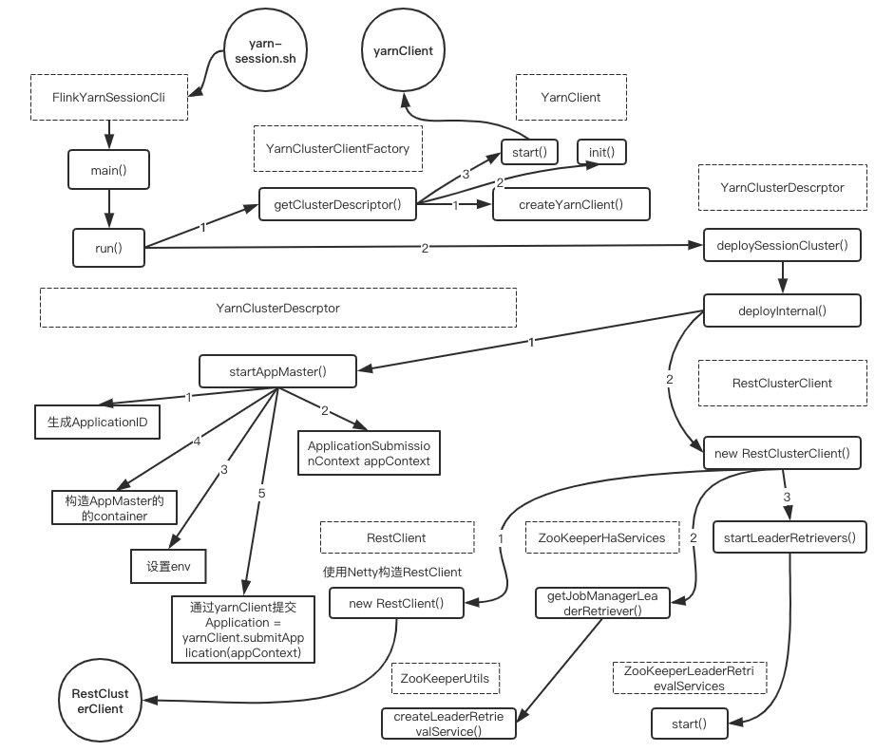

**3.2.2、远端流程**[](" \l "322" \o "Permanent link)

远端宿主在Container中的集群入口为YarnSessionClusterEntrypoint#main

Yarn Session集群的Entry point为YarnSessionClusterEntrypoint#main

point为YarnSessionClusterEntrypoint**.**java

**public** **static** **void** **main(**String**[]** args**)** **{**

*// startup checks and logging*

EnvironmentInformation**.**logEnvironmentInfo**(**LOG**,** YarnSessionClusterEntrypoint**.**class**.**getSimpleName**(),** args**);**

SignalHandler**.**register**(**LOG**);**

JvmShutdownSafeguard**.**installAsShutdownHook**(**LOG**);**

Map**<**String**,** String**>** env **=** System**.**getenv**();**

**final** String workingDirectory **=** env**.**get**(**ApplicationConstants**.**Environment**.**PWD**.**key**());**

Preconditions**.**checkArgument**(**

workingDirectory **!=** **null,**"Working directory variable (%s) not set"**,**

ApplicationConstants**.**Environment**.**PWD**.**key**());**

YarnEntrypointUtils**.**logYarnEnvironmentInformation**(**env**,** LOG**);**

Configuration configuration **=** YarnEntrypointUtils**.**loadConfiguration**(**workingDirectory**,** env**);**

YarnSessionClusterEntrypoint yarnSessionClusterEntrypoint **=** **new** YarnSessionClusterEntrypoint**(**configuration**);**

*//启动集群*

★ ClusterEntrypoint**.**runClusterEntrypoint**(**yarnSessionClusterEntrypoint**);**

**}**

ClusterEntrypoint #runClusterEntrypoint -> ClusterEntrypoint#startCluster->ClusterEntrypoint#runCluster启动集群

ClusterEntrypoint**.**java

**public** **static** **void** **runClusterEntrypoint(**ClusterEntrypoint clusterEntrypoint**)** **{**

**final** String clusterEntrypointName **=** clusterEntrypoint**.**getClass**().**getSimpleName**();**

*//启动Flink集群*

★ clusterEntrypoint**.**startCluster**();**

**}**

**public** **void** **startCluster()** **throws** ClusterEntrypointException **{**

configureFileSystems**(**configuration**);**

SecurityContext securityContext **=** installSecurityContext**(**configuration**);**

securityContext**.**runSecured**((**Callable**<**Void**>)** **()** **->** **{**

*//通过回调启动集群runCluster();*

★ runCluster**(**configuration**);**

*//至此经过上述步骤就完成了集群的启动*

**return** **null;**

**});**

**}**

**经过上述步骤开始集群的启动：**[](" \l "_2" \o "Permanent link)

**private** **void** **runCluster(**Configuration configuration**)** **throws** Exception **{**

**synchronized** **(**lock**)** **{**

*//1. 首先会初始化相关服务(这里会涉及到一系列的服务)*

initializeServices**(**configuration**);**

*// write host information into configuration*

configuration**.**setString**(**JobManagerOptions**.**ADDRESS**,** commonRpcService**.**getAddress**());**

configuration**.**setInteger**(**JobManagerOptions**.**PORT**,** commonRpcService**.**getPort**());**

*//2. 创建DispatcherResourceManagerFactory*

**final** DispatcherResourceManagerComponentFactory dispatcherResourceManagerComponentFactory **=** createDispatcherResourceManagerComponentFactory**(**configuration**);**

*//3. 创建DispatcherResourceManagerComponent这个对象(用于启动Dispatcher、ResourceManager、WebMonitorEndpoint)*

clusterComponent **=** dispatcherResourceManagerComponentFactory**.**create**(**

configuration**,** ioExecutor**,** commonRpcService**,** haServices**,** blobServer**,** heartbeatServices**,** metricRegistry**,** archivedExecutionGraphStore**,**

**new** RpcMetricQueryServiceRetriever**(**metricRegistry**.**getMetricQueryServiceRpcService**()),** **this);**

**}**

**}**

集群启动时会初始化一些Services，还会创建一些组件：创建DispatcherResourceManagerComponentFactory(SessionDispatcherResourceManagerCompontFactory), 并使用Factory创建DispatcherResourceManagerComponent（用于启动Dispatcher、ResourceManager、WebMonitorEndpoint）

初始化Services逻辑具体如下：

ClusterEntrypoint**.**java

*// 启动集群时候初始化的相关的服务*

**protected** **void** **initializeServices(**Configuration configuration**)** **{**

**synchronized** **(**lock**)** **{**

**final** String bindAddress **=** configuration**.**getString**(**JobManagerOptions**.**ADDRESS**);**

**final** String portRange **=** getRPCPortRange**(**configuration**);**

*// 1.创建RPCService（AkkaRpcService）*

commonRpcService **=** createRpcService**(**configuration**,** bindAddress**,** portRange**);**

*// update the configuration used to create the high availability services*

*//根据当前创建的RPC服务信息在configuration中增加配置信息（之前设置的端口可能是一个range）*

configuration**.**setString**(**JobManagerOptions**.**ADDRESS**,** commonRpcService**.**getAddress**());**

configuration**.**setInteger**(**JobManagerOptions**.**PORT**,** commonRpcService**.**getPort**());**

*// 2.创建用于IO的线程池*

ioExecutor **=** Executors**.**newFixedThreadPool**(**

Hardware**.**getNumberCPUCores**(),**

**new** ExecutorThreadFactory**(**"cluster-io"**));**

*// 3.创建HA Service（跟用户配置有关，可以是NONE、ZooKeeper也可以自定义的类）*

haServices **=** createHaServices**(**configuration**,** ioExecutor**);**

*// 4.初始化Blob Server*

blobServer **=** **new** BlobServer**(**configuration**,** haServices**.**createBlobStore**());**

blobServer**.**start**();**

*// 5.启动heartbeat service*

heartbeatServices **=** createHeartbeatServices**(**configuration**);**

*// 6.创建了一个Flink内部的metrics rpc service*

metricRegistry **=** createMetricRegistry**(**configuration**);**

*// 7.启动MetricQuerService*

**final** RpcService metricQueryServiceRpcService **=** MetricUtils**.**startMetricsRpcService**(**configuration**,** bindAddress**);**

metricRegistry**.**startQueryService**(**metricQueryServiceRpcService**,** **null);**

**final** String hostname **=** RpcUtils**.**getHostname**(**commonRpcService**);**

processMetricGroup **=** MetricUtils**.**instantiateProcessMetricGroup**(**

metricRegistry**,**

hostname**,**

ConfigurationUtils**.**getSystemResourceMetricsProbingInterval**(**configuration**));**

*// 8.创建了一个ArchiveExectionGraphStore对象，用于存储用户作业的物理graph*

archivedExecutionGraphStore **=** createSerializableExecutionGraphStore**(**configuration**,** commonRpcService**.**getScheduledExecutor**());**

**}**

**}**

上述初始化服务：创建RPCService(akkaRpcService)、创建HAService、创建并启动BlobService、创建HeartbeatServices、创建指标服务并启动、创建本地存储ExecutionGraph的stroe

使用前面在initializeServices中已经初始化的services,创建DispatcherResourceManagerComponent逻辑如下：

DefaultDispatcherResourceManagerComponentFactory**.**java

*//创建DispatcherResourceManagerComponent对象*

@Override

**public** DispatcherResourceManagerComponent **create(**

Configuration configuration**,** Executor ioExecutor**,**

RpcService rpcService**,** HighAvailabilityServices highAvailabilityServices**,** BlobServer blobServer**,**

HeartbeatServices heartbeatServices**,** MetricRegistry metricRegistry**,**

ArchivedExecutionGraphStore archivedExecutionGraphStore**,**

MetricQueryServiceRetriever metricQueryServiceRetriever**,**

FatalErrorHandler fatalErrorHandler**){**

*//---创建DispatcherResourceManagerComponent对象需要的service组件--*

*//dispatcher的Leader retrieval服务*

LeaderRetrievalService dispatcherLeaderRetrievalService **=** **null;**

*//resourceManager retrieval服务*

LeaderRetrievalService resourceManagerRetrievalService **=** **null;**

*//它主要使用web前端的rest接口调用、Zk listener for leader retrieval*

WebMonitorEndpoint**<?>** webMonitorEndpoint **=** **null;**

*//resourceManager组件*

ResourceManager**<?>** resourceManager **=** **null;**

ResourceManagerMetricGroup resourceManagerMetricGroup **=** **null;**

*//dispatcher*

DispatcherRunner dispatcherRunner **=** **null;**

*//用于Dispatcher leader选举 即在ZK在创建/dispatcher\_lock节点*

dispatcherLeaderRetrievalService **=** highAvailabilityServices**.**getDispatcherLeaderRetriever**();**

*//用于Resource Manager leader 选举（对于使用ZK的HA模式来说，与上面的区别是使用的路径不同）/resource\_manager\_lock节点*

resourceManagerRetrievalService **=** highAvailabilityServices**.**getResourceManagerLeaderRetriever**();**

*//创建DispatcherGateway的Retriever*

**final** LeaderGatewayRetriever**<**DispatcherGateway**>** dispatcherGatewayRetriever **=** **new** RpcGatewayRetriever**<>(**

rpcService**,** DispatcherGateway**.**class**,** DispatcherId**::**fromUuid**,**

10**,** Time**.**milliseconds**(**50L**));**

*// 创建ResoureManagerGateway的Retriever*

**final** LeaderGatewayRetriever**<**ResourceManagerGateway**>** resourceManagerGatewayRetriever **=** **new** RpcGatewayRetriever**<>(**

rpcService**,** ResourceManagerGateway**.**class**,** ResourceManagerId**::**fromUuid**,** 10**,** Time**.**milliseconds**(**50L**));**

*//它主要使用web前端的rest接口调用*

**final** ExecutorService executor **=** WebMonitorEndpoint**.**createExecutorService**(**

configuration**.**getInteger**(**RestOptions**.**SERVER\_NUM\_THREADS**),**

configuration**.**getInteger**(**RestOptions**.**SERVER\_THREAD\_PRIORITY**),**

"DispatcherRestEndpoint"**);**

**final** **long** updateInterval **=** configuration**.**getLong**(**MetricOptions**.**METRIC\_FETCHER\_UPDATE\_INTERVAL**);**

**final** MetricFetcher metricFetcher **=** updateInterval **==** 0

**?** VoidMetricFetcher**.**INSTANCE

**:** MetricFetcherImpl**.**fromConfiguration**(**

configuration**,** metricQueryServiceRetriever**,**

dispatcherGatewayRetriever**,** executor**);**

*//【重点】创建WebMonitorEndpoint，并启动*

*// 在standalone模式下，这里创建的是DispatcherRestEndpoint对象*

webMonitorEndpoint **=** restEndpointFactory**.**createRestEndpoint**(**

configuration**,** dispatcherGatewayRetriever**,**

resourceManagerGatewayRetriever**,** blobServer**,** executor**,**

metricFetcher**,** highAvailabilityServices**.**getClusterRestEndpointLeaderElectionService**(),**

fatalErrorHandler**);**

*//启动DispatcherRestEndpoint*

log**.**debug**(**"Starting Dispatcher REST endpoint."**);**

webMonitorEndpoint**.**start**();**

**final** String hostname **=** RpcUtils**.**getHostname**(**rpcService**);**

*//创建ResourceManager的指标组*

resourceManagerMetricGroup **=** ResourceManagerMetricGroup**.**create**(**metricRegistry**,** hostname**);**

*//【重点】创建resourceManager并启动(Standalone/session模式，这里创建的是StandaloneResourceManager对象)*

★ resourceManager **=** resourceManagerFactory**.**createResourceManager**(**

configuration**,** ResourceID**.**generate**(),** rpcService**,**

highAvailabilityServices**,** heartbeatServices**,** fatalErrorHandler**,**

**new** ClusterInformation**(**hostname**,** blobServer**.**getPort**()),**

webMonitorEndpoint**.**getRestBaseUrl**(),** resourceManagerMetricGroup**);**

**final** HistoryServerArchivist historyServerArchivist **=** HistoryServerArchivist**.**createHistoryServerArchivist**(**configuration**,** webMonitorEndpoint**);**

*//创建dispatcher对象*

★ **final** PartialDispatcherServices partialDispatcherServices **=** **new** PartialDispatcherServices**(** configuration**,** highAvailabilityServices**,**

resourceManagerGatewayRetriever**,** blobServer**,** heartbeatServices**,**

**()** **->** MetricUtils**.**instantiateJobManagerMetricGroup**(**metricRegistry**,** hostname**),**

archivedExecutionGraphStore**,** fatalErrorHandler**,** historyServerArchivist**,**

metricRegistry**.**getMetricQueryServiceGatewayRpcAddress**());**

log**.**debug**(**"Starting Dispatcher."**);**

*//启动Dispatcher并进行ZK选举*

dispatcherRunner **=** dispatcherRunnerFactory**.**createDispatcherRunner**(**

highAvailabilityServices**.**getDispatcherLeaderElectionService**(),**

fatalErrorHandler**,**

**new** HaServicesJobGraphStoreFactory**(**highAvailabilityServices**),**

ioExecutor**,** rpcService**,** partialDispatcherServices**);**

*// 启动ResourceManager并进行ZK选举*

log**.**debug**(**"Starting ResourceManager."**);**

resourceManager**.**start**();**

*//使用resourceManagerGatewayRetriever去监听zk的/resource\_manager\_lock节点*

resourceManagerRetrievalService**.**start**(**resourceManagerGatewayRetriever**);**

*//使用dispatcherGateWayRetriever去监听zk的/dispatcher\_lock节点*

dispatcherLeaderRetrievalService**.**start**(**dispatcherGatewayRetriever**);**

*//返回sessionDidpatcherResourceManagerComponent*

**return** **new** DispatcherResourceManagerComponent**(**

dispatcherRunner**,**resourceManager**,**

dispatcherLeaderRetrievalService**,**

resourceManagerRetrievalService**,**webMonitorEndpoint**);**

**}**

上述代码实现：

1. 在zk中创建/dispatcher\_lock节点、/resource\_manager\_lock节点
2. 创建dispatcherGatewayRetriever、resourManagerGatewayRetrieval( rpc gateway接口)
3. 创建dispatcher、resourceManager并启动

**服务端总结**[](" \l "_3" \o "Permanent link)

**错误!未指定文件名。**

**3.3、启动作业**[](" \l "33" \o "Permanent link)

当启动集群后，即可使用./flink run -c mainClass /path/to/usr/jar向集群提交任务

**3.4、启动作业流程分析–客户端**[](" \l "34-" \o "Permanent link)

***----开始：yarn Session-Cluster 与 yarn per-job-Cluster模式公共部分----*** flink.sh–>程序入口CliFrontend#main

CliFrontend**.**java

**public** **static** **void** **main(final** String**[]** args**)** **{**

EnvironmentInformation**.**logEnvironmentInfo**(**LOG**,** "Command Line Client"**,** args**);**

*// 1. find the configuration directory*

**final** String configurationDirectory **=** getConfigurationDirectoryFromEnv**();**

*// 2. load the global configuration*

**final** Configuration configuration **=** GlobalConfiguration**.**loadConfiguration**(**configurationDirectory**);**

*// 3. load the custom command lines*

**final** List**<**CustomCommandLine**>** customCommandLines **=** loadCustomCommandLines**(**

configuration**,**

configurationDirectory**);**

**final** CliFrontend cli **=** **new** CliFrontend**(**

configuration**,**

customCommandLines**);**

SecurityUtils**.**install**(new** SecurityConfiguration**(**cli**.**configuration**));**

**int** retCode **=** SecurityUtils**.**getInstalledContext**()**

★ **.**runSecured**(()** **->** cli**.**parseParameters**(**args**));**

System**.**exit**(**retCode**);**

**}**

解析处理参数：

CliFrontend**.**java

**public** **int** **parseParameters(**String**[]** args**)** **{**

String action **=** args**[**0**];**

*// remove action from parameters*

**final** String**[]** params **=** Arrays**.**copyOfRange**(**args**,** 1**,** args**.**length**);**

*// do action*

**switch** **(**action**)** **{**

**case** ACTION\_RUN**:**

★ run**(**params**);**

**return** 0**;**

**}**

**}**

**protected** **void** **run(**String**[]** args**)** **throws** Exception **{**

**final** Options commandOptions **=** CliFrontendParser**.**getRunCommandOptions**();**

**final** Options commandLineOptions **=** CliFrontendParser**.**mergeOptions**(**commandOptions**,** customCommandLineOptions**);**

**final** CommandLine commandLine **=** CliFrontendParser**.**parse**(**commandLineOptions**,** args**,** **true);**

**final** ProgramOptions programOptions **=** **new** ProgramOptions**(**commandLine**);**

**final** PackagedProgram program**;**

*//根据用户jar、main程序参数、savepoint信息生成PackagedProgram*

*//主要是找到用户程序的入口类+一些配置*

LOG**.**info**(**"Building program from JAR file"**);**

★ program **=** buildProgram**(**programOptions**);**

**final** List**<**URL**>** jobJars **=** program**.**getJobJarAndDependencies**();**

**final** Configuration effectiveConfiguration **=**

getEffectiveConfiguration**(**commandLine**,** programOptions**,** jobJars**);**

LOG**.**debug**(**"Effective executor coniguration: {}"**,** effectiveConfiguration**);**

*//执行用户程序*

★ executeProgram**(**effectiveConfiguration**,** program**);**

**}**

//执行用户写的程序

**public** **static** **void** **executeProgram(**

PipelineExecutorServiceLoader executorServiceLoader**,**

Configuration configuration**,** PackagedProgram program**){**

checkNotNull**(**executorServiceLoader**);**

**final** ClassLoader userCodeClassLoader **=** program**.**getUserCodeClassLoader**();**

**final** ClassLoader contextClassLoader **=** Thread**.**currentThread**().**getContextClassLoader**();**

**try** **{**

Thread**.**currentThread**().**setContextClassLoader**(**userCodeClassLoader**);**

ContextEnvironmentFactory factory **=** **new** ContextEnvironmentFactory**(**

executorServiceLoader**,**

configuration**,** userCodeClassLoader**);**

ContextEnvironment**.**setAsContext**(**factory**);**

**try** **{**

*//使用反射执行用户代码的main()方法*

*//执行main方法之前是假定contextEnvironment已经准备好*

★ program**.**invokeInteractiveModeForExecution**();**

**}** **finally** **{**

ContextEnvironment**.**unsetContext**();**

**}**

**}** **finally** **{**

Thread**.**currentThread**().**setContextClassLoader**(**contextClassLoader**);**

**}**

**}**

**调起用户main()方法**[](" \l "main" \o "Permanent link)

**public** **class** **RandomWordCount** **{**

**public** **static** **void** **main(**String**[]** args**)** **throws** Exception **{**

★ env**.**execute**(**"Random WordCount"**);**

**}}**

**public** JobExecutionResult **execute(**String jobName**){**

*// 先生成StreamGraph然后执行*

★ **return** execute**(**getStreamGraph**(**jobName**));**

**}**

StreamExecutionEnvironment**.**java

@Internal

**public** JobExecutionResult **execute(**StreamGraph streamGraph**)** **throws** Exception **{**

*//异步的执行streamGraph*

★ **final** JobClient jobClient **=** executeAsync**(**streamGraph**);**

**final** JobExecutionResult jobExecutionResult**;**

**if** **(**configuration**.**getBoolean**(**DeploymentOptions**.**ATTACHED**))** **{**

jobExecutionResult **=** jobClient**.**getJobExecutionResult**(**userClassloader**).**get**();**

**}** **else** **{**

jobExecutionResult **=** **new** DetachedJobExecutionResult**(**jobClient**.**getJobID**());**

**}**

jobListeners**.**forEach**(**jobListener **->** jobListener**.**onJobExecuted**(**jobExecutionResult**,** **null));**

**return** jobExecutionResult**;**

**}**

StreamExecutionEnvironment**.**java

**public** JobClient **executeAsync(**StreamGraph streamGraph**)** **throws** Exception **{**

checkNotNull**(**streamGraph**,** "StreamGraph cannot be null."**);**

checkNotNull**(**configuration**.**get**(**DeploymentOptions**.**TARGET**),** "No execution.target specified in your configuration file."**);**

*//PipelineExecutorFactory有两种：*

*// YarnJobClusterExecutorFactory for executing jobs on dedicated(per-job)clusters*

*// YarnSessionClusterExecutorFactory for executing jobs on an existing(session) clusters*

**final** PipelineExecutorFactory executorFactory **=**

executorServiceLoader**.**getExecutorFactory**(**configuration**);**

*//其中executorFactory.getExecutor()获取的是 YarnSessionClusterExecutorFactory*

CompletableFuture**<**JobClient**>** jobClientFuture **=** executorFactory

★ **.**getExecutor**(**configuration**)**

★★ **.**execute**(**streamGraph**,** configuration**);**

JobClient jobClient **=** jobClientFuture**.**get**();**

jobListeners**.**forEach**(**jobListener **->** jobListener**.**onJobSubmitted**(**jobClient**,** **null));**

**return** jobClient**;**

**}**

***----截止 ：yarn Session-Cluster 与 yarn per-job-Cluster模式公共部分---***

PipelineExecutorFactory有两种：

1. YarnJobClusterExecutorFactory for executing jobs on dedicated(per-job)clusters
2. YarnSessionClusterExecutorFactory for executing jobs on an existing(session) clusters

AbstractSessionClusterExecutor

@Override

**public** CompletableFuture**<**JobClient**>** **execute(**@Nonnull **final** Pipeline pipeline**,** @Nonnull **final** Configuration configuration**)** **throws** Exception **{**

**final** JobGraph jobGraph **=** ExecutorUtils**.**getJobGraph**(**pipeline**,** configuration**);**

**final** ClusterDescriptor**<**ClusterID**>** clusterDescriptor **=** clusterClientFactory**.**createClusterDescriptor**(**configuration**))** **{**

**final** ClusterID clusterID **=** clusterClientFactory**.**getClusterId**(**configuration**);**

checkState**(**clusterID **!=** **null);**

①*//从yarnClient中获取RestClusterClient*

**final** ClusterClientProvider**<**ClusterID**>** clusterClientProvider **=** clusterDescriptor**.**retrieve**(**clusterID**);**

★★ ClusterClient**<**ClusterID**>** clusterClient **=** clusterClientProvider**.**getClusterClient**();**

**return** clusterClient

②*//提交jobGraph到yarn Cluster*

★★ **.**submitJob**(**jobGraph**);**

**}**

①从yarnClient中获取RestClusterClient的具体逻辑如下

YarnClusterDescriptor**.**java

@Override

**public** ClusterClientProvider**<**ApplicationId**>** **retrieve(**ApplicationId applicationId**)** **throws** ClusterRetrieveException **{**

**try** **{**

*// check if required Hadoop environment variables are set. If not, warn user*

**if** **(**System**.**getenv**(**"HADOOP\_CONF\_DIR"**)** **==** **null** **&&**

System**.**getenv**(**"YARN\_CONF\_DIR"**)** **==** **null)** **{**

LOG**.**warn**(**"Neither the HADOOP\_CONF\_DIR nor the YARN\_CONF\_DIR environment variable is set." **+**

"The Flink YARN Client needs one of these to be set to properly load the Hadoop " **+**

"configuration for accessing YARN."**);**

**}**

★ **final** ApplicationReport report **=** yarnClient**.**getApplicationReport**(**applicationId**);**

setClusterEntrypointInfoToConfig**(**report**);**

**return** **()** **->** **{**

★ **return** **new** RestClusterClient**<>(**flinkConfiguration**,** report**.**getApplicationId**());**

**};}**

经过上述步骤，客户端提交任务过程就完成了，主要就是通过RestClusterClient将用户程序的JobGraph通过Rest接口提交至集群中。

上述过程流程图如下：

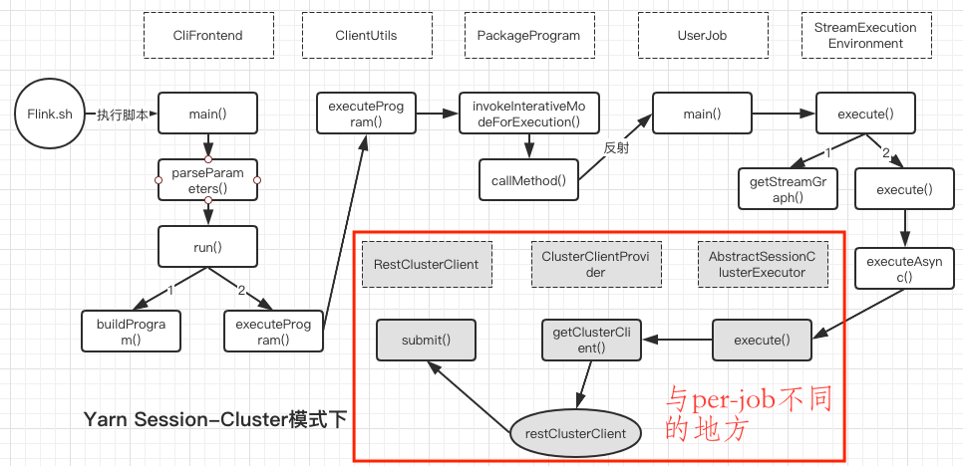

**3.4、启动作业流程分析–远端**[](" \l "34-_1" \o "Permanent link)

在Yarn Session Cluster中响应客户端提交作业请求(RestClusterClient.submit(jobGraph))的是：RestServerEndpoint，其中包含了多个Handler，其中JobSubmitHandler用户处理任务提交的请求；

RestServerEndpoint:An abstract class for netty-based REST server endpoints.

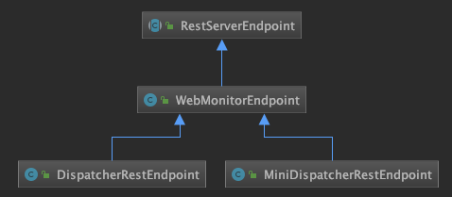

处理请求入口：RestServerEndpoint中 JobSubmitHandler#handleRequest

RestServerEndpoint的启动入口：

ClusterEntrypoint#.runCluster()–>DefaultDispatcherResourceManagerComponentFactory#create()–>webMonitorEndpoint.start();

DispatcherRestEndpoint **extends** WebMonitorEndpoint **extends** RestServerEndpoint

@Override

**protected** List**<**Tuple2**<**RestHandlerSpecification**,** ChannelInboundHandler**>>** **initializeHandlers(final** CompletableFuture**<**String**>** localAddressFuture**)** **{**

List**<**Tuple2**<**RestHandlerSpecification**,** ChannelInboundHandler**>>** handlers **=** **super.**initializeHandlers**(**localAddressFuture**);**

*// Add the Dispatcher specific handlers*

**final** Time timeout **=** restConfiguration**.**getTimeout**();**

*// jobSubmitHandler 用来处理客户端submit(jobgraph)请求*

★ JobSubmitHandler jobSubmitHandler **=** **new** JobSubmitHandler**(**

leaderRetriever**,**

timeout**,**

responseHeaders**,**

executor**,**

clusterConfiguration**);**

**}**

JobSubmitHandler**.**java

@Override

**protected** CompletableFuture**<**JobSubmitResponseBody**>** **handleRequest(**@Nonnull HandlerRequest**<**JobSubmitRequestBody**,** EmptyMessageParameters**>** request**,** @Nonnull DispatcherGateway gateway**)** **throws** RestHandlerException **{**

**final** Collection**<**File**>** uploadedFiles **=** request**.**getUploadedFiles**();**

**final** Map**<**String**,** Path**>** nameToFile **=** uploadedFiles**.**stream**().**collect**(**Collectors**.**toMap**(**

File**::**getName**,**

Path**::**fromLocalFile

**));**

*//进行相关验证*

**if** **(**uploadedFiles**.**size**()** **!=** nameToFile**.**size**())** **{**

**throw** **new** RestHandlerException**(**

String**.**format**(**"The number of uploaded files was %s than the expected count. Expected: %s Actual %s"**,**

uploadedFiles**.**size**()** **<** nameToFile**.**size**()** **?** "lower" **:** "higher"**,**

nameToFile**.**size**(),**

uploadedFiles**.**size**()),**

HttpResponseStatus**.**BAD\_REQUEST

**);**

**}**

**final** JobSubmitRequestBody requestBody **=** request**.**getRequestBody**();**

*//1. 进行相关验证*

**if** **(**requestBody**.**jobGraphFileName **==** **null)** **{**

**throw** **new** RestHandlerException**(**

String**.**format**(**"The %s field must not be omitted or be null."**,**

JobSubmitRequestBody**.**FIELD\_NAME\_JOB\_GRAPH**),**

HttpResponseStatus**.**BAD\_REQUEST**);**

**}**

*//2. 从文件中取出JobGraph*

CompletableFuture**<**JobGraph**>** jobGraphFuture **=** loadJobGraph**(**requestBody**,** nameToFile**);**

Collection**<**Path**>** jarFiles **=** getJarFilesToUpload**(**requestBody**.**jarFileNames**,** nameToFile**);**

Collection**<**Tuple2**<**String**,** Path**>>** artifacts **=** getArtifactFilesToUpload**(**requestBody**.**artifactFileNames**,** nameToFile**);**

*//3. 通过BlobClient将jar及JobGraph文件上传至BlobServer*

CompletableFuture**<**JobGraph**>** finalizedJobGraphFuture **=** uploadJobGraphFiles**(**gateway**,** jobGraphFuture**,** jarFiles**,** artifacts**,** configuration**);**

*//4. 通过Dispatcher#submitJob提交JobGraph*

★ CompletableFuture**<**Acknowledge**>** jobSubmissionFuture **=**

★ finalizedJobGraphFuture**.**thenCompose**(**jobGraph **->** gateway**.**submitJob**(**jobGraph**,** timeout**));**

**return** jobSubmissionFuture**.**thenCombine**(**jobGraphFuture**,**

**(**ack**,** jobGraph**)** **->** **new** JobSubmitResponseBody**(**"/jobs/" **+** jobGraph**.**getJobID**()));**

**}**

Handler接受到请求后的主要逻辑：

1. 进行相关验证
2. 从文件中取出JobGraph
3. 通过BlobClient将jar及JobGraph文件上传至BlobServer
4. 通过Dispatcher#submitJob提交JobGraph

handler通过gateway.submitJob提交作业给JobMaster

Dispatcher**.**java

*// 【重点】提交作业*

@Override

**public** CompletableFuture**<**Acknowledge**>** **submitJob(**JobGraph jobGraph**,** Time timeout**)** **{**

★ **return** internalSubmitJob**(**jobGraph**);**

**}**

注意：下面的代码中将作业Job的持久化和运行放在了一个方法中**--**persistAndRunJob**()**

**private** CompletableFuture**<**Acknowledge**>** **internalSubmitJob(**JobGraph jobGraph**)** **{**

*//this::persistAndRunJob其实是调用persistAndRunJob()方法*

★★ **final** CompletableFuture**<**Acknowledge**>** persistAndRunFuture **=** waitForTerminatingJobManager**(**jobGraph**.**getJobID**(),**

jobGraph**,** **this::**persistAndRunJob**)**

**.**thenApply**(**ignored **->** Acknowledge**.**get**());**

**return** persistAndRunFuture**.**handleAsync**((**acknowledge**,** throwable**)** **->** **{**

**return** acknowledge**;**

**},** getRpcService**().**getExecutor**());**

**}**

Dispatcher**.**java

*//【重点】持久化作业*

**private** CompletableFuture**<**Void**>** **persistAndRunJob(**JobGraph jobGraph**)** **{**

*//先将作业进行持久化*

jobGraphWriter**.**putJobGraph**(**jobGraph**);**

*//通过Dispatcher#runJob 运行jobGraph*

**final** CompletableFuture**<**Void**>** runJobFuture **=** runJob**(**jobGraph**);**

**}**

Dispatcher**.**java

**private** CompletableFuture**<**Void**>** **runJob(**JobGraph jobGraph**)** **{**

Preconditions**.**checkState**(!**jobManagerRunnerFutures**.**containsKey**(**jobGraph**.**getJobID**()));**

*//1. 启动JobMaster*

★★① **final** CompletableFuture**<**JobManagerRunner**>** jobManagerRunnerFuture **=** createJobManagerRunner**(**jobGraph**);**

*//2. 将<jobID，JobManagerRunner>保存至Map*

jobManagerRunnerFutures**.**put**(**jobGraph**.**getJobID**(),** jobManagerRunnerFuture**);**

**return** jobManagerRunnerFuture

*// 通过this::startJobManagerRunner即调用startJobManagerRunner()方法*

*//3. 启动JobMaster*

★★② **.**thenApply**(**FunctionUtils**.**uncheckedFunction**(this::**startJobManagerRunner**))**

**.**thenApply**(**FunctionUtils**.**nullFn**())**

**.**whenCompleteAsync**(**

**(**ignored**,** throwable**)** **->** **{**

**if** **(**throwable **!=** **null)** **{**

jobManagerRunnerFutures**.**remove**(**jobGraph**.**getJobID**());**

**}**

**},**

getMainThreadExecutor**());**

**}**

在Dispatcher#runJob(jobGraph)的逻辑中主要做了以下几件事：

1. 启动JobMaster
2. 将（jobID，JobManagerRunner）保存至Map
3. 启动JobMaster

**创建并启动JobManager(jobMaster)**[](#jobmanagerjobmaster)

Dispatcher**.**java

*//①【重点】创建对应的JobManager（处理leader选举）*

**private** CompletableFuture**<**JobManagerRunner**>** **createJobManagerRunner(**JobGraph jobGraph**)** **{**

**final** RpcService rpcService **=** getRpcService**();**

**return** CompletableFuture**.**supplyAsync**(**

CheckedSupplier**.**unchecked**(()** **->**

*//创建JobMaster*

★★ jobManagerRunnerFactory**.**createJobManagerRunner**(**

jobGraph**,** configuration**,**

rpcService**,** highAvailabilityServices**,**

heartbeatServices**,** jobManagerSharedServices**,**

**new** DefaultJobManagerJobMetricGroupFactory**(**jobManagerMetricGroup**),** fatalErrorHandler**)),**

rpcService**.**getExecutor**());**

**}**

*//②【重点】启动对应的JobManager(JobMaster)*

**private** JobManagerRunner **startJobManagerRunner(**JobManagerRunner jobManagerRunner**){**

**final** JobID jobId **=** jobManagerRunner**.**getJobID**();**

*//启动JobMaster（会进行leader选举，ZK目录为leader/${jobId}/job\_manager\_lock）*

★★ jobManagerRunner**.**start**();**

**return** jobManagerRunner**;**

**}**

JobManagerRunnerImpl**.**java

@Override（会进行leader选举，ZK目录为leader**/**$**{**jobId**}/**job\_manager\_lock）

**public** **void** **start()** **throws** Exception **{**

*//start the leader election service*

*//（会进行leader选举，ZK目录为leader/${jobId}/job\_manager\_lock）*

leaderElectionService**.**start**(this);**

**}**

当某个jobManager称为leader的时候，会调用ZooKeeperLederElectionService#isLeader()

@Override

**public** **void** **isLeader()** **{**

**synchronized** **(**lock**)** **{**

**if** **(**running**)** **{**

issuedLeaderSessionID **=** UUID**.**randomUUID**();**

clearConfirmedLeaderInformation**();**

**if** **(**LOG**.**isDebugEnabled**())** **{**

LOG**.**debug**(**

"Grant leadership to contender {} with session ID {}."**,**

leaderContender**.**getDescription**(),**issuedLeaderSessionID**);**

**}**

★ leaderContender**.**grantLeadership**(**issuedLeaderSessionID**);**

**}** **else** **{**

LOG**.**debug**(**"Ignoring the grant leadership notification since the service has " **+**"already been stopped."**);**

**}**

**}**

@Override

**public** **void** **grantLeadership(final** UUID leaderSessionID**)** **{**

**synchronized** **(**lock**)** **{**

**if** **(**shutdown**)** **{**

log**.**info**(**"JobManagerRunner already shutdown."**);**

**return;**

**}**

leadershipOperation **=** leadershipOperation**.**thenCompose**(**

**(**ignored**)** **->** **{**

**synchronized** **(**lock**)** **{**

*//调起JobMaster*

★★ **return** verifyJobSchedulingStatusAndStartJobManager**(**leaderSessionID**);**

**}**

**});**

handleException**(**leadershipOperation**,** "Could not start the job manager."**);**

**}**

**}**

JobManagerRunnerImpl**.**java

**private** CompletableFuture**<**Void**>** **verifyJobSchedulingStatusAndStartJobManager(**UUID leaderSessionId**)** **{**

**final** CompletableFuture**<**JobSchedulingStatus**>** jobSchedulingStatusFuture **=** getJobSchedulingStatus**();**

**return** jobSchedulingStatusFuture**.**thenCompose**(**

jobSchedulingStatus **->** **{**

**if** **(**jobSchedulingStatus **==** JobSchedulingStatus**.**DONE**)** **{**

**return** jobAlreadyDone**();**

**}** **else** **{**

★ **return** startJobMaster**(**leaderSessionId**);**

**}**

**});**

**}**

**private** CompletionStage**<**Void**>** **startJobMaster(**UUID leaderSessionId**)** **{**

runningJobsRegistry**.**setJobRunning**(**jobGraph**.**getJobID**());**

**final** CompletableFuture**<**Acknowledge**>** startFuture**;**

*//开始调度任务JobMaster#startJobExecution*

★★ startFuture **=** jobMasterService**.**start**(new** JobMasterId**(**leaderSessionId**));**

**final** CompletableFuture**<**JobMasterGateway**>** currentLeaderGatewayFuture **=** leaderGatewayFuture**;**

**return** startFuture**.**thenAcceptAsync**(**

**(**Acknowledge ack**)** **->** confirmLeaderSessionIdIfStillLeader**(**

leaderSessionId**,** jobMasterService**.**getAddress**(),**

currentLeaderGatewayFuture**),** executor**);**

**}**

至此JobMaster真正启动，并通过 jobMasterService.start()调用JobMaster#startJobExecution，执行任务。接下来就进行任务具体调度（构造ExecutionGraph、申请Slot等）流程，本篇文章不再展开介绍。

**总结**[](" \l "_5" \o "Permanent link)

session模式后端逻辑如下：

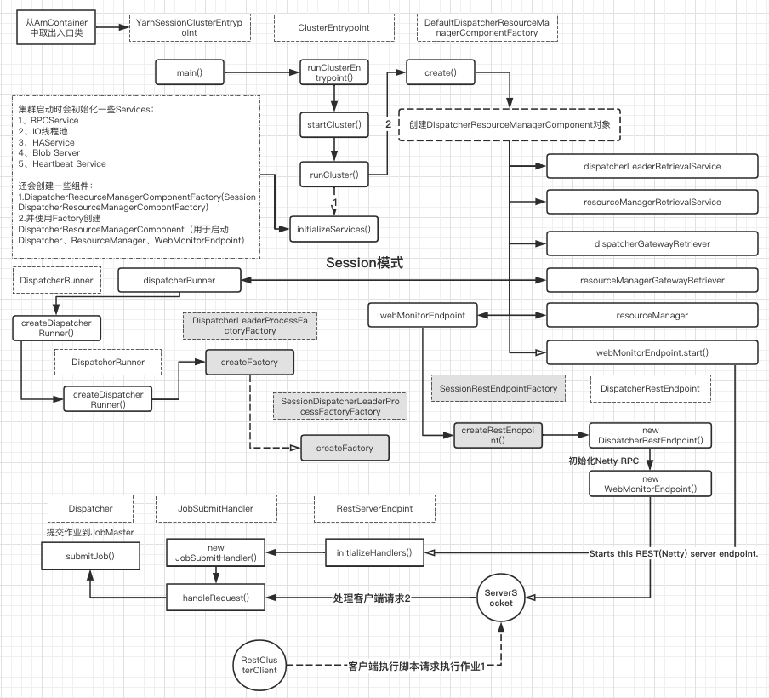

**4、Per-Job-Cluster模式：**[](" \l "4per-job-cluster" \o "Permanent link)

一个任务会对应一个Job，每提交一个作业会根据自身的情况，都会向yarn申请资源，知道作业执行完成。一个作业的失败与否并不会影响下一个作业的正常提交和运行。独享Dipatcher和ResourceManager,按需接收资源申请；适合规模大长时间运行的作业。

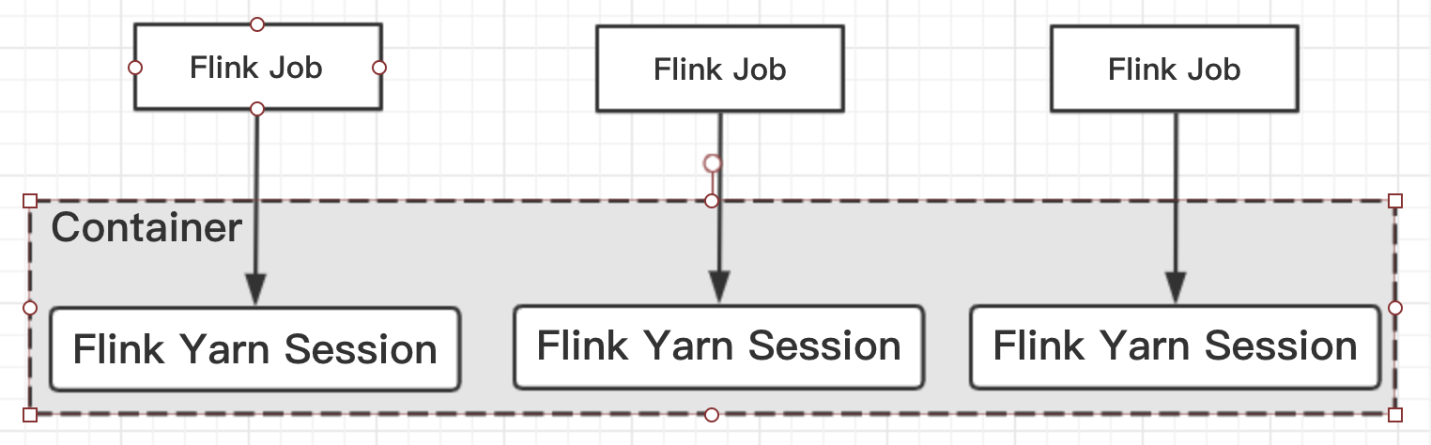

Session-cluster模式需要先启动集群，然后再提交作业。但是per-job不需要先启动集群，直接提交任务即可。

**4.1、启动任务**[](" \l "41" \o "Permanent link)

启动Per-job-Cluster任务，可通过./bin/flink run -m yarn-cluster -d -c mainClass /path/to/jar命令使用分离模式启动一个集群，即单任务单集群；

**4.2、流程分析**[](" \l "42" \o "Permanent link)

与Session-Cluster类似，我们对Per-Job-Cluster模式也分为本地和远端。

**4.2.1、本地流程**[](" \l "421" \o "Permanent link)

与Session-Cluster模式类似，入口也为CliFrontend#main。接下来解析处理参数，根据jar、main、程序参数、savepoint信息生成PackagedProgram，根据PackageProgram创建JobGraph,获取集群资源信息都与Session-Cluster类似。

从执行脚本开始经过如下步骤都是与Session-Cluster是类似的：

flink.sh–>程序入口CliFrontend#main–>CliFrontend#run()–>CliFrontend#executeProgram()–>UserFlinkCode#main()–>StreamExecutionEnvironment#execute()–>StreamExecutionEnvironment#executeAsync()–>PipelineExecutor#execute()

PipelineExecutor是 ***一个负责执行Job的对象***，PipelineExecutor的实现类有两种如下：

1. AbstractJobClusterExecutor for executing jobs on dedicated(per-job)clusters
2. AbstractSessionClusterExecutor for executing jobs on an existing(session) clusters

**YarnSessionCluster与YarnJobCluster的区别1**[](#yarnsessionclusteryarnjobcluster1)

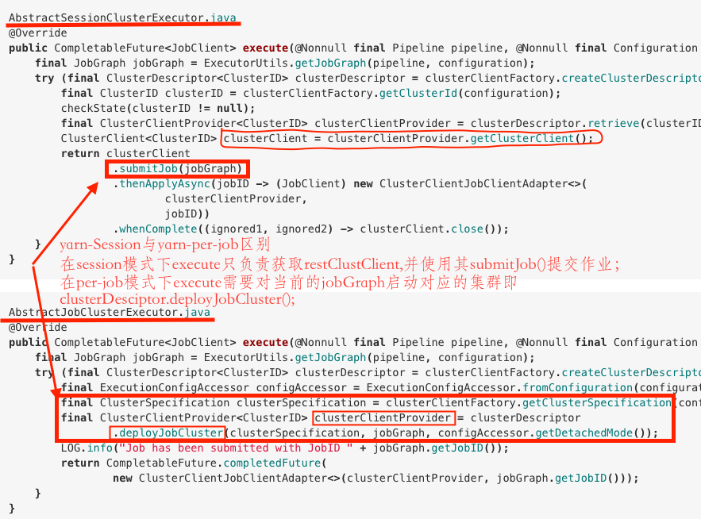

接下来会调用ClusterDescriptor#deployJobCluster() –>YarnClusterDescriptor#deployJobCluster() – –>YarnClusterDescriptor#deployInternal() – – –>YarnClusterDescriptor#startAppMaster()

YarnClusterDescriptor**.**java

*//在startAppMaster方法中只展示了per-job(jobGraph!=null的情况下)与session模式的区别：*

**private** ApplicationReport **startAppMaster(){**

**final** Set**<**File**>** userJarFiles **=** **(**jobGraph **==** **null)**

*// not per-job submission*

**?** Collections**.**emptySet**()**

*// add user code jars from the provided JobGraph*

**:** jobGraph**.**getUserJars**().**stream**().**map**(**f **->** f**.**toUri**()).**map**(**File**::new).**collect**(**Collectors**.**toSet**());**

*//值得注意的是在startAppMaster中per-job cluster与session cluster的一个显著的区别：*

*//就是其会将任务的JobGraph上传至Hdfs供后续服务继续使用（即）only for per job mode*

**if** **(**jobGraph **!=** **null)** **{**

**for** **(**Map**.**Entry**<**String**,** DistributedCache**.**DistributedCacheEntry**>** entry **:** jobGraph**.**getUserArtifacts**().**entrySet**())** **{**

org**.**apache**.**flink**.**core**.**fs**.**Path path **=** **new** org**.**apache**.**flink**.**core**.**fs**.**Path**(**entry**.**getValue**().**filePath**);**

*// only upload local files*

**if** **(!**path**.**getFileSystem**().**isDistributedFS**())** **{**

Path localPath **=** **new** Path**(**path**.**getPath**());**

Tuple2**<**Path**,** Long**>** remoteFileInfo **=**

Utils**.**uploadLocalFileToRemote**(**fs**,** appId**.**toString**(),** localPath**,** homeDir**,** entry**.**getKey**());**

jobGraph**.**setUserArtifactRemotePath**(**entry**.**getKey**(),** remoteFileInfo**.**f0**.**toString**());**

**}}**

jobGraph**.**writeUserArtifactEntriesToConfiguration**();**

**}}**

值得注意的是在startAppMaster中per-job cluster与session cluster的一个显著的区别： 就是其会将任务的JobGraph上传至Hdfs供后续服务继续使用，即不需要像Session Cluster那样启动cluster 的AppMaster后使用restClusterClient.submit(jobGraph)；而只需要在当前jobGraph对应的yarn cluster从HDFS取出jobGraph进行处理；

上述流程图如下：

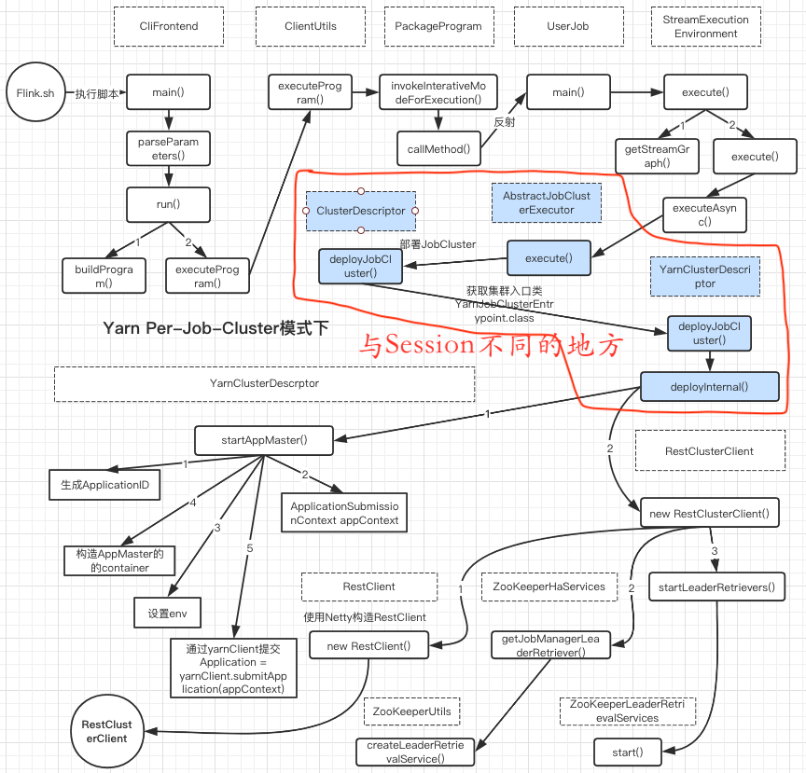

**4.2.2、远端流程**[](" \l "422" \o "Permanent link)

Flink per-job-Cluster模式的入口是YarnJobClusterEntrypoint#main

**cluster 启动流程大致如下：**[](" \l "cluster" \o "Permanent link)

YarnJobClusterEntrypoint#main**()**

**-->**ClusterEntrypoint#runClusterEntrypoint**()**

**--** **-->**ClusterEntrypoint#startCluster**()**

**--** **--** **-->**ClusterEntrypoint#runCluster**()**

**--** **--** **--** **-->**DispatcherResourceManagerComponentFactory#create**()**

**--** **--** **--** **--** **-->**DefaultDispatcherResourceManagerComponentFactory#create**()**f

①**--** **--** **--** **--** **--** **-->**dispatcherRunner **=** dispatcherRunnerFactory**.**createDispatcherRunner**()**

上述流程与Flink session cluster模式的启动流程一致，那么不同点在哪呢？前面已经讲到了在客户端的时候，客户端只是将JobGraph发送只HDFS，而并没有像session模式下客户端会在启动AppMaster之后再次调用restClusterClient.submit(jobGraph); 那么在Flink per-job-Cluster模式下启动AppMaster的时候在那一步（被遗漏了）其实已经从HDFS中读取出jobGraph供dispatcher发送给JobMaster呢？

答案其实就在下面：

在DefaultDispatcherResourceManagerComponentFactory#create()方法中会有一个 **创建dispatcher的逻辑：**

dispatcherRunner **=** dispatcherRunnerFactory**.**createDispatcherRunner**()**

上面的方法会启动Dispatcher并进行ZK选举、及创建JobGraph

DispatcherRunnerFactory**.**java

DispatcherRunner **createDispatcherRunner(**

LeaderElectionService leaderElectionService**,**

FatalErrorHandler fatalErrorHandler**,**

JobGraphStoreFactory jobGraphStoreFactory**,**

Executor ioExecutor**,**

RpcService rpcService**,**

PartialDispatcherServices partialDispatcherServices**)** **throws** Exception**;**

DefaultDispatcherRunnerFactory**.**java

@Override

**public** DispatcherRunner **createDispatcherRunner(**

LeaderElectionService leaderElectionService**,**

FatalErrorHandler fatalErrorHandler**,**

JobGraphStoreFactory jobGraphStoreFactory**,**

Executor ioExecutor**,**

RpcService rpcService**,**

PartialDispatcherServices partialDispatcherServices**)** **throws** Exception **{**

*//创建JobGraph*

*//createFactory分为JobDispatcherLeaderProcessFactoryFactory和SessionDispatcherLeaderProcessFactoryFactory*

★★ **final** DispatcherLeaderProcessFactory dispatcherLeaderProcessFactory **=**

★★ dispatcherLeaderProcessFactoryFactory**.**createFactory**(**

jobGraphStoreFactory**,** ioExecutor**,**

rpcService**,** partialDispatcherServices**,**

fatalErrorHandler**);**

**return** DefaultDispatcherRunner**.**create**(**leaderElectionService**,** fatalErrorHandler**,** dispatcherLeaderProcessFactory**);**

**}**

DispatcherLeaderProcessFactoryFactory的子类有 **JobDispatcherLeaderProcessFactoryFactory和SessionDispatcherLeaderProcessFactoryFactory**

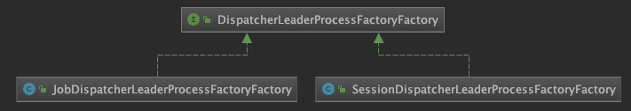

JobDispatcherLeaderProcessFactoryFactory**.**java

@Override

**public** DispatcherLeaderProcessFactory **createFactory(**

JobGraphStoreFactory jobGraphStoreFactory**,**

Executor ioExecutor**,** RpcService rpcService**,**

PartialDispatcherServices partialDispatcherServices**,**

FatalErrorHandler fatalErrorHandler**)** **{**

**final** JobGraph jobGraph**;**

*//创建jobGraph*

★★ jobGraph **=** jobGraphRetriever**.**retrieveJobGraph**(**partialDispatcherServices**.**getConfiguration**());**

**final** DefaultDispatcherGatewayServiceFactory defaultDispatcherServiceFactory **=** **new** DefaultDispatcherGatewayServiceFactory**(**JobDispatcherFactory**.**INSTANCE**,**

rpcService**,**partialDispatcherServices**);**

**return** **new** JobDispatcherLeaderProcessFactory**(**

defaultDispatcherServiceFactory**,**

jobGraph**,**fatalErrorHandler**);**

**}**

SessionDispatcherLeaderProcessFactoryFactory**.**java

@Override

**public** DispatcherLeaderProcessFactory **createFactory(**

JobGraphStoreFactory jobGraphStoreFactory**,**

Executor ioExecutor**,** RpcService rpcService**,**

PartialDispatcherServices partialDispatcherServices**,**

FatalErrorHandler fatalErrorHandler**)** **{**

**final** AbstractDispatcherLeaderProcess**.**DispatcherGatewayServiceFactory dispatcherGatewayServiceFactory **=** **new** DefaultDispatcherGatewayServiceFactory**(** dispatcherFactory**,**

rpcService**,** partialDispatcherServices**);**

**return** **new** SessionDispatcherLeaderProcessFactory**(**

dispatcherGatewayServiceFactory**,**

jobGraphStoreFactory**,** ioExecutor**,** fatalErrorHandler**);**

**}**

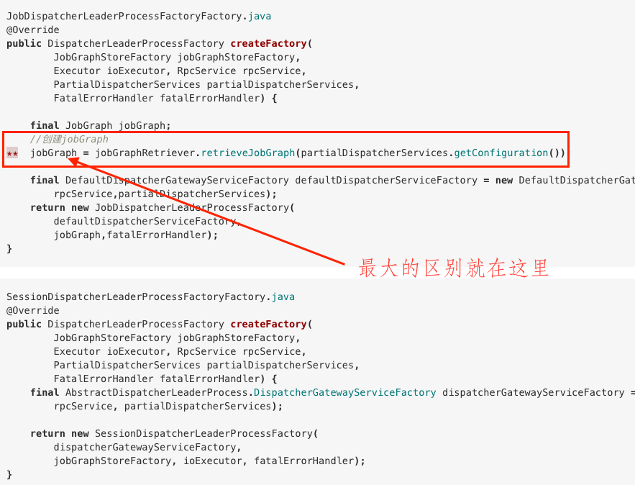

这里需要补充一点的就是在per-job-Cluster模式下jobGraph = jobGraphRetriever.retrieveJobGraph(）是如何实现从HDFS中获取JohGraph

JobGraphRetriever**.**java

JobGraph **retrieveJobGraph(**Configuration configuration**)** **throws** FlinkException**;**

FileJobGraphRetriever**.**java

*//implementation which retrieves the JobGraph}from a file on disk.*

@Override

**public** JobGraph **retrieveJobGraph(**Configuration configuration**)** **throws** FlinkException **{**

**final** File fp **=** **new** File**(**jobGraphFile**);**

**try** **(**FileInputStream input **=** **new** FileInputStream**(**fp**);**

ObjectInputStream obInput **=** **new** ObjectInputStream**(**input**))** **{**

★ **final** JobGraph jobGraph **=** **(**JobGraph**)** obInput**.**readObject**();**

addUserClassPathsToJobGraph**(**jobGraph**);**

**return** jobGraph**;**

**}** **catch** **(**FileNotFoundException e**)** **{**

**throw** **new** FlinkException**(**"Could not find the JobGraph file."**,** e**);**

**}** **catch** **(**ClassNotFoundException **|** IOException e**)** **{**

**throw** **new** FlinkException**(**"Could not load the JobGraph from file."**,** e**);**

**}**

**}**

**总结**[](#_7)

per-job模式后端逻辑如下：

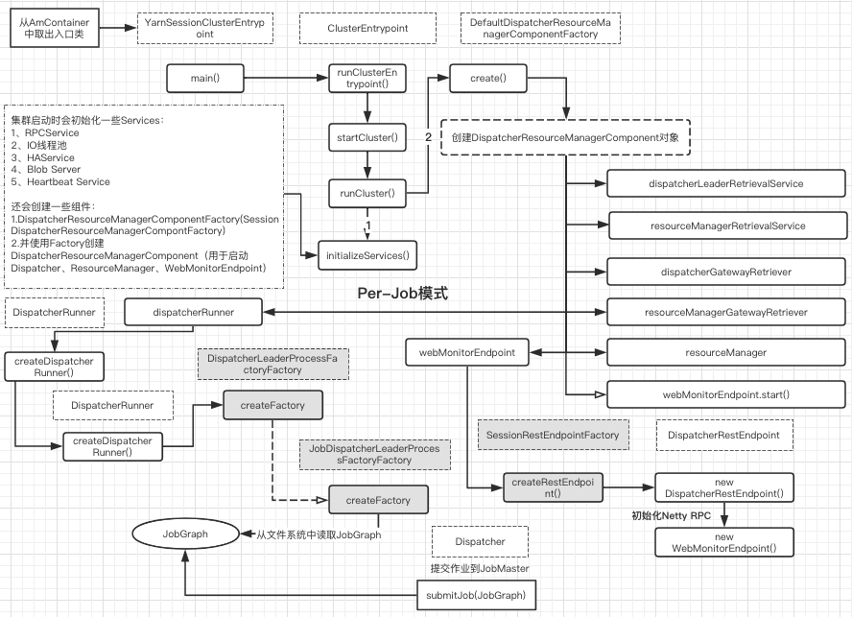

**总结**[](#_8)