1. change html to text

1.1 use code I gave you (if you have real html)

1.2 use pdf tools provided by EY (if you only have pdf)

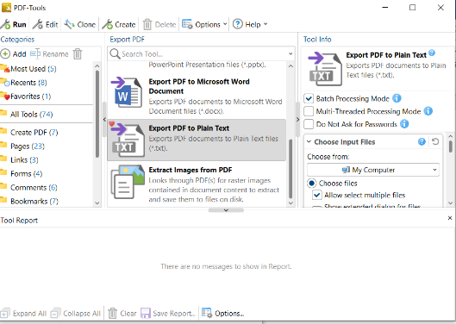

* 1. if you meet 2 columns issue, please check ‘code-package’. I recommend comparing manually.

1. Compare two data with ‘word comparison’

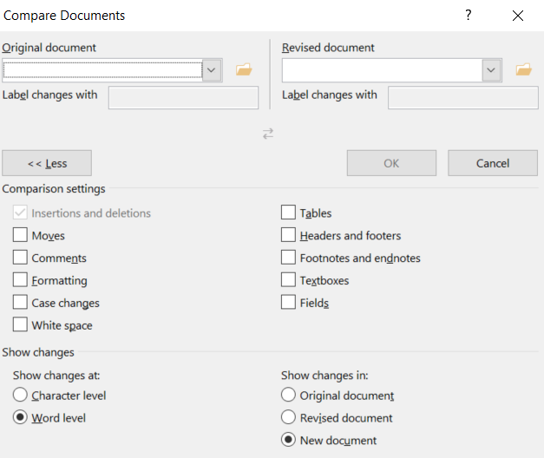

1. Check the pdf with ‘red hacken’