Basic installation and usage:

- When you install the APK, you will receive a warning, but click install anyway.
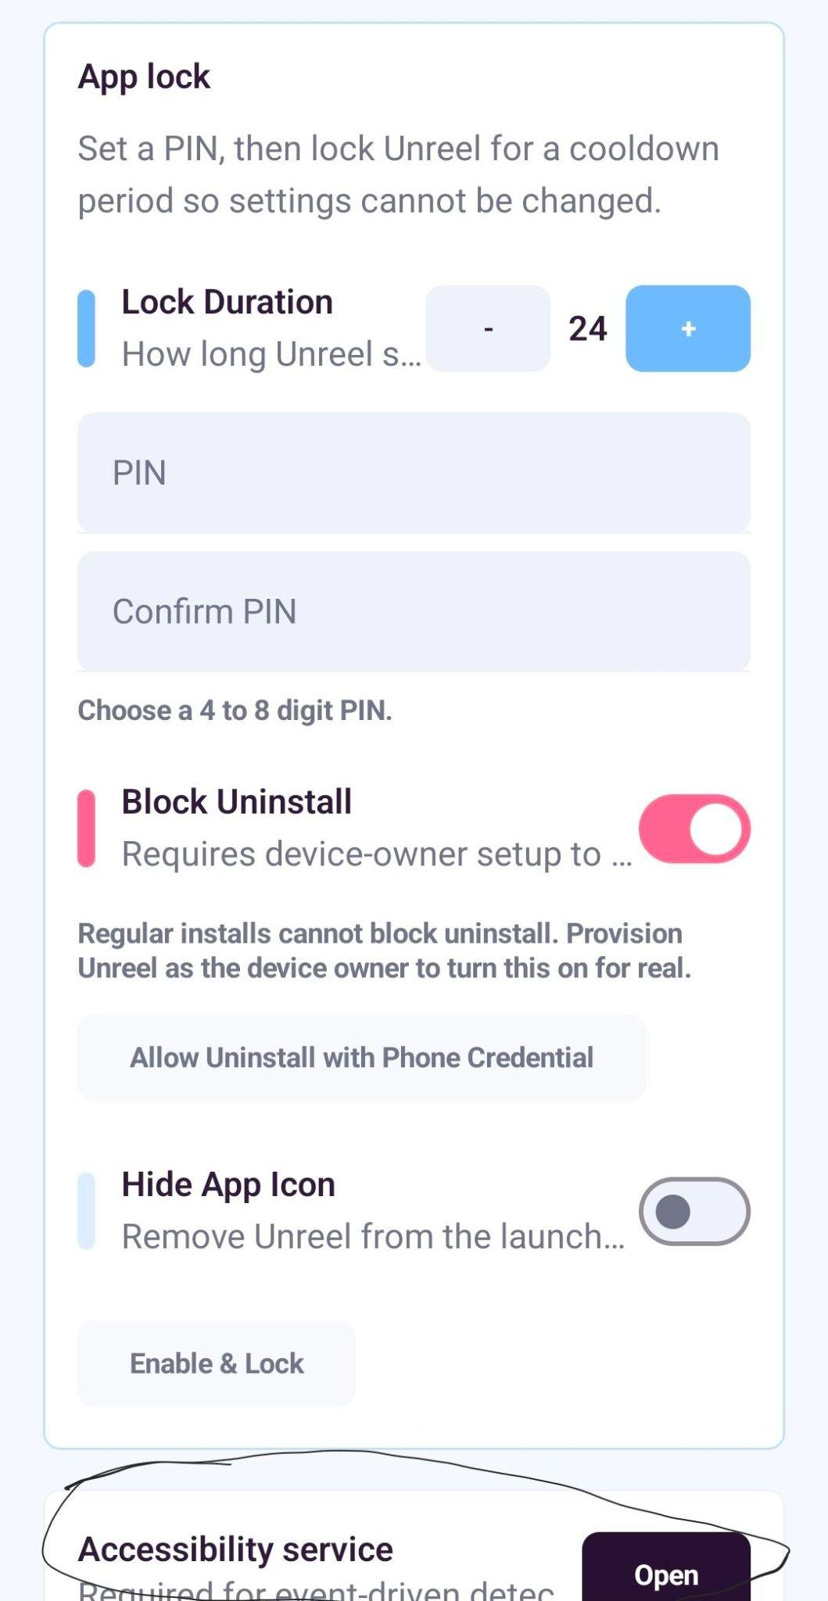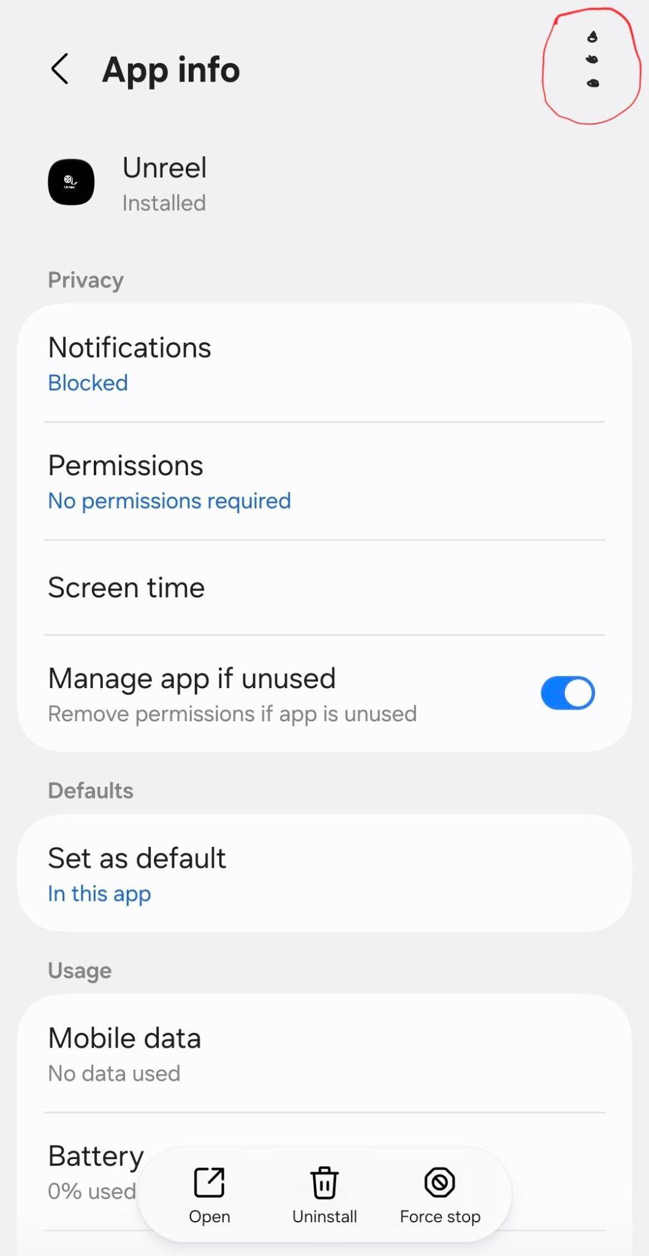
- Once the app is installed, follow the quick setup intro, and then go to the security tab and scroll down to accessibility access as seen in the first image. When you click that, it will take you to a page where you need to click on downloaded apps. From there, Unreel may be greyed out. If it is, click the 3 dots (in the second image above) in app settings and enable special permissions. Then, enable the Unreel app in accessibility.

- You will be immediately kicked out of accessibility because now Unreel is able to prevent its own uninstall. If you don’t want that, you can turn it off in security. Once your settings are the way you like them, ask a friend to put in a pin and not tell you or generate a random pin that is easy to forget and lock down Unreel. You have now entered a contract with yourself.

