Chapter 1

Introduction

Nowadays technology is changing day by day. Society as we know it depends on this fact. That which we take for granted today would have been the staff of science ﬁction as little as ﬁfth years go. In the early years of twenty ﬁrst century, it is computer and internet that have captured the public imagination and found their way into not just the working environments but increasingly into domestic spaces.

In this modern world, if we are not capable to cope up with those changes than we are not going to stand anywhere in this technical world. Today there is no place for error. Therefore, to make system more effective and efficient we need such technologies where error prone changes must be least.

In this scenario, we need to develop a web-based application and mobile based apps for Online newspaper. In this time everyone interested to get any information staying in their own home or using their mobile apps Like android or IOs.

The vision of this project is to deliver the world news in front of the door without wasting time.

1.1 Objective of the Work

The objective of this application is to develop a system where people can read newspaper with in sort time. A newspaper Processing System where people can read news and journalist can modify and update or insert appropriate Data from Admin panel.

  - Scope

The scope for the system is as followed:

- Maintain newspaper record.
- Maintain update newspaper.
- Get the newspaper through the mobile apps.

  - Organization of the Report

This project has been organized as follows:

- Chapter one shows the introduction of the infrastructure, motivation and goal of this project, how many and what kind of hardware will be needed.

- Chapter two shows our background study of our project.

- Chapter three shows the requirement analysis.

- Chapter four discusses about the software design.

- Chapter ﬁve discusses the conclusion and future work.

Chapter 2

Process model

2. Introduction

To solve actual problems a software engineer or a team of engineers must incorporate a development strategy that encompasses the process, methods and tools and some generic phases. In this section, a number of mostly used process models and the Data .In this chapter we have discussed about software process model and design pattern of our software.

2.1 Software Processes model

First of all, We can start from a very interesting question “Can software engineering principles, concept and methods be applied to website development?” The answer is many of them can but their application may require a somewhat different span.
Now we can go to the software process model. A software process model is an abstract representation of a process that is a structured set of activities required to develop a software process models are:

- Specification what the system should do and its development constraints?
- Design and implementation –production of the software system.
- Validation –Checking that the software is what the customer wants.
- Evaluation-changing the software in response to changing demands

There are different types of software processing model such as waterfall model, prototype model, spiral model etc. We have discussed shortly about these software process model.

2.2 Waterfall Model

The waterfall model is a systematic and sequential approach to software development that begins with customer specification of requirements and progress through planning , modeling, construction and deployment, culminating in ongoing support of the completed software. The phases of waterfall model are :

- Requirement analysis
- System and software design
- Implementation and unit testing
- Integration and system testing

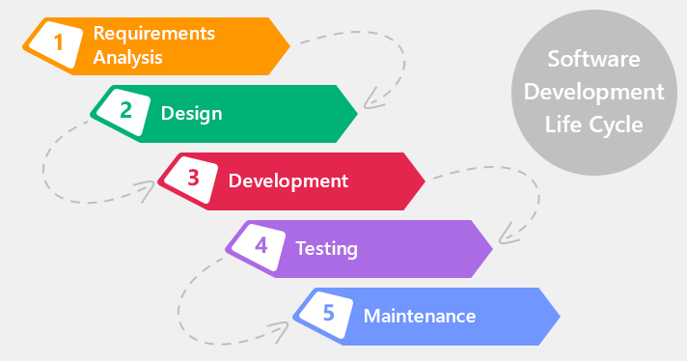

Figure 2.3 : waterfall model

In Fig 2.3, We can see the phase of waterfall model. Real projects rarely follow it as it is difficult to establish all requirements explicitly, no room for uncertainty. When the requirements of a problem are reasonably well understood and project duration is very short then waterfall model is suitable. The main drawback of the waterfall model is the difficulty of accommodating change after the process is underway. One phase has to be completed before moving onto the next phase.

Chapter 3

Background Study

3. Introduction

Burners-Lee was the ﬁrst to combine Internet communication (which has been carrying email and the Usenet for decades) with hypertext (which had been around for decades, but limited to browsing information stored on a single computer such as interactive CD-ROM design). Websites are written in a markup language called HTML, and early versions of html were very basic, only giving websites basic structure (headlines and paragraphs), and the ability to link. This was new and different to existing forms of communication-users could easily negative to other pages by design progressed hyperlinks from page to page.

As the Web and web design progressed, the markup language changed to become more complex and ﬂexible, giving the ability to add objectives like images and tables to a page. Features like tables, which were originally intended to be used to display tabular information, were soon subverted for use as invisible layout devices. With the advent of Cascading Style Sheet (CSS), table-based layout is increasingly regarded as outdated. Database integration technologies such as server—side scripting and design standards like CSS further changed and enhanced the way the web is made. As times change websites are changing inside (scripting) and out (design) because of the way programs and utilities are created and further developed.

For typical web sites, the basic aspects of design are [1]:

The content: The substance and information on the site should be relevant to be the site and should target the area of the public that the website is concerned with.

The usability: the site should be user-kindly, with the interface and navigation simple and reliable.

The appearance: the graphics and text should include a single style that ﬂows throughout, to show consistency. The style should professional, appealing and relevant.

The visibility: the site must also be easy to ﬁnd via most, if not all, major search engines and advertisement media.

A web site typically consists of text, sounds and images. The ﬁrst page of a website is known as the home page or index. Some websites use what is commonly called a splash page. Splash page
might include a welcome message, language /region selection, or disclaimer. Each web page
within a web is an html ﬁle which has its own URL. After each web page is created, they are typically linked together using a navigation menu composed of hyperlinks. Faster browsing weeds have led to shorter attention spans and more demanding online visitors and this has resulted in less use of splash pages, particularly where commercial websites are concerned.

Once a website is completed, it must be published or uploaded in order to be Viewable to the public over the internet. This may be done using an FTP client. Once published, the web master may use a, variety if technologies to increase the traffic, or hits, that the websites receives. This may include submitting the website to a search engine such as GOOGLE or YAHOO, exchanging links with web sites, creating affiliations with similar web sites, etc.

3.1 Laravel Description
Taylor Otwell created Laravel as an attempt to provide a more advanced alternative to the CodeIgniter framework, which did not provide certain features such as built-in support for user authentication and authorization. Laravel's first beta release was made available on June 9, 2011, followed by the Laravel 1 release later in the same month. Laravel 1 included built-in support for authentication, localisation, models, views, sessions, routing and other mechanisms, but lacked support for controllers that prevented it from being a true MVC framework.
Laravel 2 was released in September 2011, bringing various improvements from the author and community. Major new features included the support for controllers, which made Laravel 2 a fully MVC-compliant framework, built-in support for the inversion of control (IoC) principle, and a templating system called Blade. As a downside, support for third-party packages was removed in Laravel 2.
Laravel 3 was released in February 2012 with a set of new features including the command-line interface (CLI) named Artisan, built-in support for more database management systems, database migrations as a form of version control for database layouts, support for handling events, and a packaging system called Bundles. An increase of the Laravel's userbase and popularity lined up with the release of Laravel 3.
Laravel 4, codenamed Illuminate, was released in May 2013. It was made as a complete rewrite of the Laravel framework, migrating its layout into a set of separate packages distributed through Composer, which serves as an application-level package manager. Such a layout improved the extendibility of Laravel 4, which was paired with its official regular release schedule spanning six months between minor point releases. Other new features in the Laravel 4 release include database seeding for the initial population of databases, support for message queues, built-in support for sending different types of email, and support for delayed deletion of database records called soft deletion.
Laravel 5 was released in February 2015 as a result of internal changes that ended up in renumbering the then-future Laravel 4.3 release. New features in the Laravel 5 release include support for scheduling periodically executed tasks through a package called Scheduler, an abstraction layer called Flysystem that allows remote storage to be used in the same way as local file systems, improved handling of package assets through Elixir, and simplified externally handled authentication through the optional Socialite package. Laravel 5 also introduced a new internal directory tree structure for developed applications.
Laravel 5.1, released in June 2015, is the first release of Laravel to receive long-term support (LTS), with planned availability of bug fixes for two years and security patches for three years. LTS releases of Laravel are planned to be released every two years.
Laravel 5.3, released in August 23, 2016,The new features in 5.3 are focused on improving developer speed by adding additional out of the box improvements for common tasks.

3.2 Bootstrap
Bootstrap is a free and open-source front-end web framework for designing websites and web applications. It contains HTML- and CSS-based design templates for typography, forms, buttons, navigation and other interface components, as well as optional JavaScript extensions. Unlike many web frameworks, it concerns itself with front-end development only.Bootstrap, originally named Twitter Blueprint, was developed by Mark Otto and Jacob Thornton at Twitter as a framework to encourage consistency across internal tools. Before Bootstrap, various libraries were used for interface development, which led to inconsistencies and a high maintenance burden. According to Twitter developer Mark Otto:
"A super small group of developers and I got together to design and build a new internal tool and saw an opportunity to do something more. Through that process, we saw ourselves build something much more substantial than another internal tool. Months later, we ended up with an early version of Bootstrap as a way to document and share common design patterns and assets within the company."
After a few months of development by a small group, many developers at Twitter began to contribute to the project as a part of Hack Week, a hackathon-style week for the Twitter development team. It was renamed from Twitter Blueprint to Bootstrap, and released as an open source project on August 19, 2011. It has continued to be maintained by Mark Otto, Jacob Thornton, and a small group of core developers, as well as a large community of contributors.
On January 31, 2012, Bootstrap 2 was announced. This release added the twelve-column grid layout and responsive design components, as well as changes to many of the existing components. The Bootstrap 3 release was announced on 19 August 2013, moving to a mobile first approach and using a flat design.
On October 29, 2014, Mark Otto announced Bootstrap 4 was in development. The first alpha version of Bootstrap 4 was deployed on August 19, 2015

3.3 User Interface Design

User Interface (UI) Design focuses on anticipating what users might need to do and ensuring that the interface has elements that are easy to access, understand, and use to facilitate those actions. UI brings together concepts from interaction design, visual design, and information architecture .

Users have become familiar with interface elements acting in a certain way, so try to be consistent and predictable in your choices and their layout. Doing so will help with task completion, efficiency, and satisfaction.

Interface elements include but are not limited to:

- Input Controls: buttons, text ﬁelds, checkboxes, radio buttons, dropdown lists, list boxes, toggles, date ﬁeld
- Navigational Components: breadcrumb, slider, search ﬁeld, pagination, slider, tags, icons
- Informational Components: tooltips, icons, progress bar, notiﬁcations, message boxes, modal windows
- Containers: accordion

There are times when multiple elements might be appropriate for displaying content. When this happens, it’s important to consider the trade-offs. For example, sometimes elements that can help save you space, put more of a burden on the user mentally by forcing them to guess what is within the dropdown or what the element might be.

Everything stems from knowing your users, including understanding their goals, skills, preferences, and tendencies. Once you know about your user, make sure to consider the following when designing your interface:

- Keep the interface simple. The best interfaces are almost invisible to the user. They avoid unnecessary elements and are clear in the language they use on labels and in messaging.

- Create consistency and use common UI elements. By using common elements in your UI, users feel more comfortable and are able to get things done more quickly. It is also important to create patterns in language, layout and design throughout the site to help facilitate efficiency. Once a user learns how to do something, they should be able to transfer that skill to other parts of the site.

- Be purpose full in page layout. Consider the spatial relationships between items on the page and structure the page based on importance. Careful placement of items can help draw attention to the most important pieces of information and can aid scanning and readability.

- Strategically use color and texture. You can direct attention toward or redirect attention away from items using color, light, contrast, and texture to your advantage.

- Use typography to create hierarchy and clarity. Carefully consider how you use typeface. Different sizes, fonts, and arrangement of the text to help increase scan ability, legibility and readability.

- Make sure that the system communicates what’s happening. Always inform your users of location, actions, changes in state, or errors. The use of various UI elements to communicate status and, if necessary, next steps can reduce frustration for your user.

- Think about the defaults. By carefully thinking about and anticipating the goals people bring to your site; you can create defaults that reduce the burden on the user. This becomes particularly important when it comes to form design where you might have an opportunity to have some ﬁelds pre-chosen or ﬁlled out.

3.4 JAVA SCRIPT

JAVA SCRIPT is a dynamic computer programming language. It is most commonly used as part of web browsers, whose implementations allow client-side scripts to interact with the user, control the browser, communicate asynchronously, and alter the document content that is displayed. It is also used in server-side network programming with frameworks such as Node.js, game development and the creation of desktop and mobile applications.

JavaScript is classiﬁed as a prototype-based scripting language with dynamic typing and ﬁrst- class functions. This mix of features makes it a multi-paradigm language, supporting object- oriented, imperative, and functional programming styles.

Despite some naming, syntactic, and standard library similarities, JavaScript and Java are otherwise unrelated and have very different semantics. The syntax of JavaScript is actually derived from C, while the semantics and design are inﬂuenced by Scheme programming languages.

JavaScript is also used in environments that aren't web-based, such as PDF documents, site- speciﬁc browsers, and desktop widgets. Newer and faster JavaScript virtual machines (V Ms) and platforms built upon them have also increased the popularity of JavaScript for server-side we
applications . On the client side, JavaScript has been traditionally implemented as an interpreted language, but more recent browsers perform just-in-time compilation .

3.5 Mysql
MySQL was created by a Swedish company, MySQL AB, founded by David Axmark, Allan Larsson and Michael "Monty" Widenius. Original development of MySQL by Widenius and Axmark began in 1994. The first version of MySQL appeared on 23 May 1995. It was initially created for personal usage from mSQL based on the low-level language ISAM, which the creators considered too slow and inflexible. They created a new SQL interface, while keeping the same API as mSQL. By keeping the API consistent with the mSQL system, many developers were able to use MySQL instead of the mSQL antecedent. MySQL is written in C and C++. Its SQL parser is written in yacc, but it uses a home-brewed lexical analyzer. MySQL works on many system platforms, including AIX, BSDi, FreeBSD, HP-UX, eComStation, i5/OS, IRIX, Linux, OS X, Microsoft Windows, NetBSD, Novell NetWare, OpenBSD, OpenSolaris, OS/2 Warp, QNX, Oracle Solaris, Symbian, SunOS, SCO OpenServer, SCO UnixWare, Sanos and Tru64. A port of MySQL to OpenVMS also exists.
The MySQL server software itself and the client libraries use dual-licensing distribution. They are offered under GPL version 2, beginning from 28 June 2000 (which in 2009 has been extended with a FLOSSLicense Exception) or to use a proprietary license.
Support can be obtained from the official manual. Free support additionally is available in different IRC channels and forums. Oracle offers paid support via its MySQL Enterprise products. They differ in the scope of services and in price. Additionally, a number of third party organizations exist to provide support and services, including MariaDB and Percona.
MySQL has received positive reviews, and reviewers noticed it "performs extremely well in the average case" and that the "developer interfaces are there, and the documentation (not to mention feedback in the real world via Web sites and the like) is very, very good". It has also been tested to be a "fast, stable and true multi-user, multi-threaded sql database server".

3.6 Android
Android is a mobile operating system (OS) currently developed by Google, based on the Linux kernel and designed primarily for touch screen mobile devices such as smart phones and tablets. Android's user interface is mainly based on direct manipulation, using touch gestures that loosely correspond to real-world actions, such as swiping, tapping and pinching, to manipulate on-screen objects, along with a virtual keyboard for text input. In addition to touch screen devices, Google has further developed Android TV for televisions, Android Auto for cars, and Android Wear for wrist watches, each with a specialized user interface. Variants of Android are also used on notebooks, game consoles, digital cameras, and other electronics. As of 2015, Android has the largest installed base of all operating systems.

Initially developed by Android, Inc., which Google bought in 2005, Android was unveiled in 2007, along with the founding of the Open Handset Alliance – a consortium of hardware, software, and telecommunication companies devoted to advancing open standards for mobile devices. As of July 2013, the Google Play store has had over one million Android applications ("apps") published, and over 50 billion applications downloaded. An April–May 2013 survey of mobile application developers found that 71% of developers create applications for Android,^{[15]} and a 2015 survey found that 40% of full-time professional developers see Android as their priority target platform, which is comparable to Apple's iOS on 37% with both platforms far above others. At Google I/O 2014, the company revealed that there were over one billion active monthly Android users, up from 538 million in June 2013.

Chapter 4

Requirement Analysis

In this chapter, we are going to analysis different types of requirement for our project. We can divide our requirement into three parts: functional requirement, Hardware requirement and software requirement. We will discuss about these topics in this chapter.

4 Functional Requirement

In our project, we have three types of functional requirement: Admin, People and mobile apps.

4.1 Admin
- Admin login
- Manage the News paper
- Insert and update news paper

4.2 People

- People will search the news in website

4.3 Mobile apps

- This is the another part of people where they can read through their mobile apps

4.4 Non-Functional Requirements

- Secure access by confidential data by username and password. This application is secure for every kind of its users because nobody can access the admin panel without his or her password. As a result the news will remain secure by authority.
- The database used here is robust, reliable and fast .Therefore, users will have to wait for the output very short time
- This application can access from any type of platform

4.5 Hardware Requirements

- Processor : 2.6 GHz Intel core i5
- Memory : 6 GB
- Disk space : 2 GB of free disk space

4.6 Software Requirements

Software plays an important role in any project development .One should know which software to use to develop the project. Our application is developed using

- Operating system : Windows 10
- Database : Mysql
- Tools : Sublimetext2 , Android Studio

Chapter 5

Software Design

5 Choosing the Appropriate Process Model

The choice of a relevant and effective development model is one of the key factors in determining the success or failure of a software company. Key factors that influence the decision are the type of product being created, time restraints, and the resources available to support the chosen model.
We have chosen the waterfall model to implement our project. The Waterfall Model involves planning the entire development of a project from the initial idea to its completion in a step-by-step sequential process. Each phase cannot begin before the previous phase is completed. The model is best used in smaller projects where the product is extremely well understood from the outset, with well-laid-out timelines. .Under this consideration we found that waterfall model fulfills most of the requirements of our system. That is why we have chosen this model.

5.1 Manual

In this section we will give the overview of all the pages which we have developed for our software “Online News Processing System With mobile app”.

5.2 Home Page

People can read every day news from this page shown in figure 5.2, in addition there are international, sports and economy etc page . People can easily read foreigners news and sports news and economy news etc in those page.

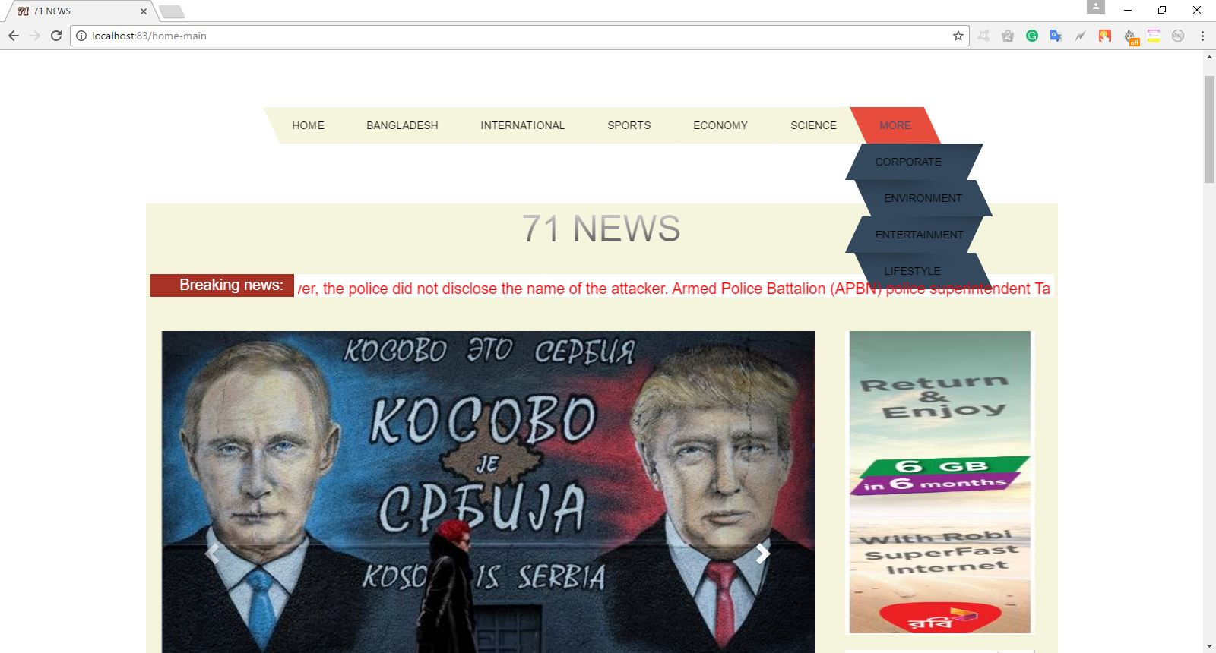
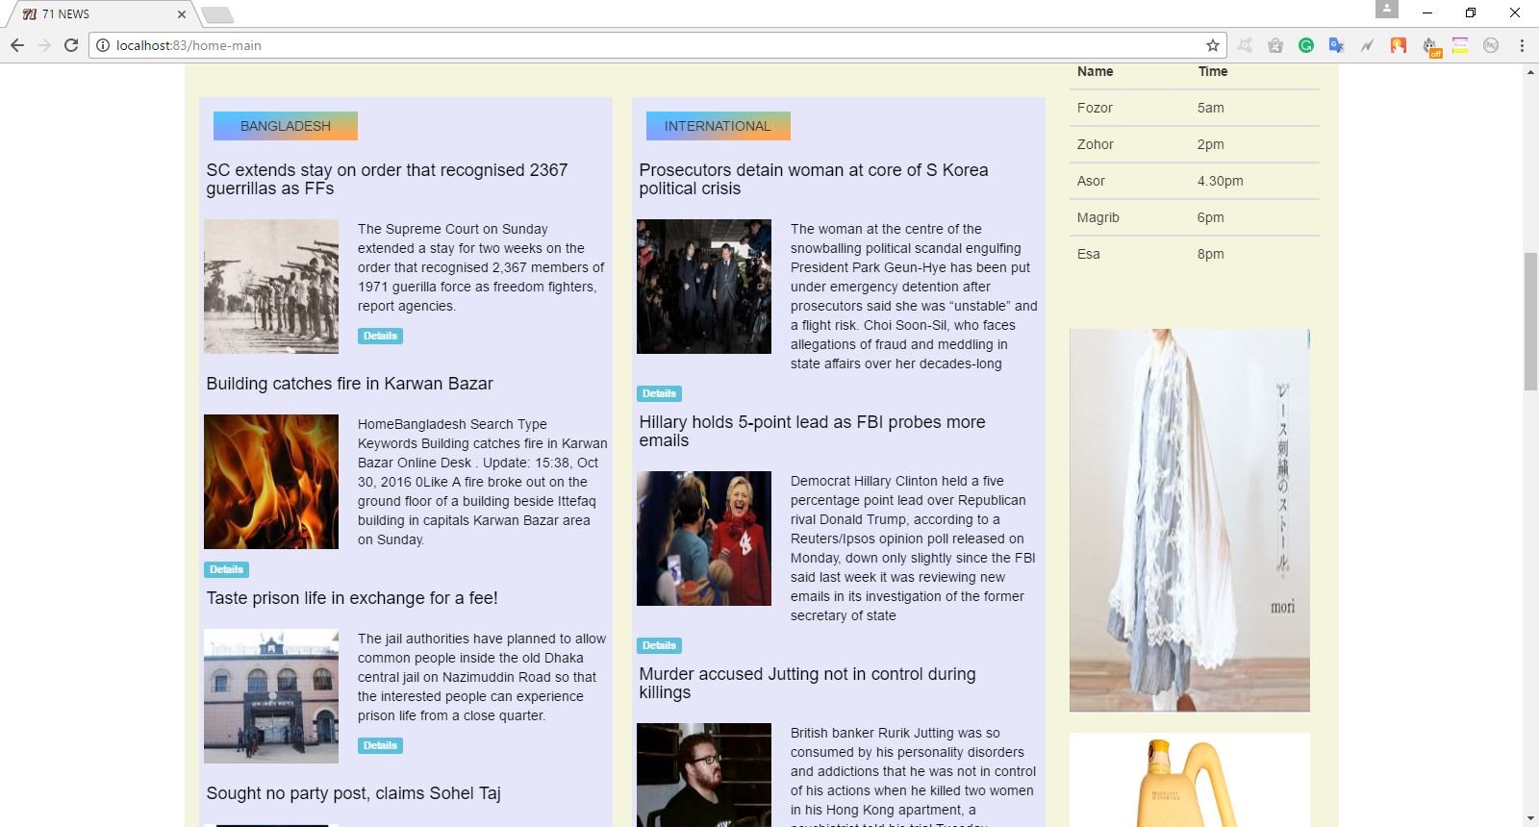

Figure 5.2 : Home Page

5.3 Admin Login Page

To insert, update, search and publication admin has to access Admin login page shown in figure 5.3 of the web page where admin can login the website for any modification or update.

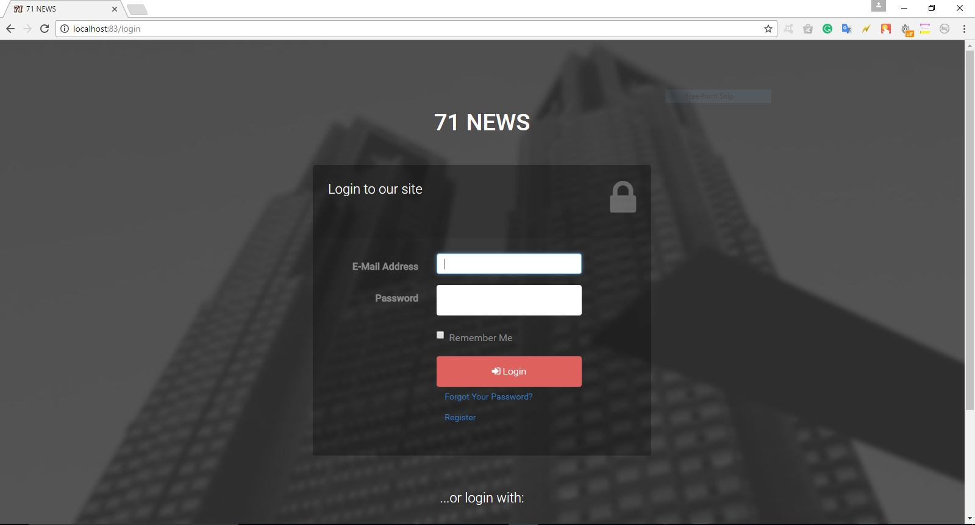

Figure 5.3: Login Page

5.4 Insert Page

After successfully login the admin or authority can insert the news result giving the proper information of individual news . After giving the information in the form shown in figure 5.4 admin have to press insert button to insert the result successfully. If the result is inserted successfully there will be message about data insertion.

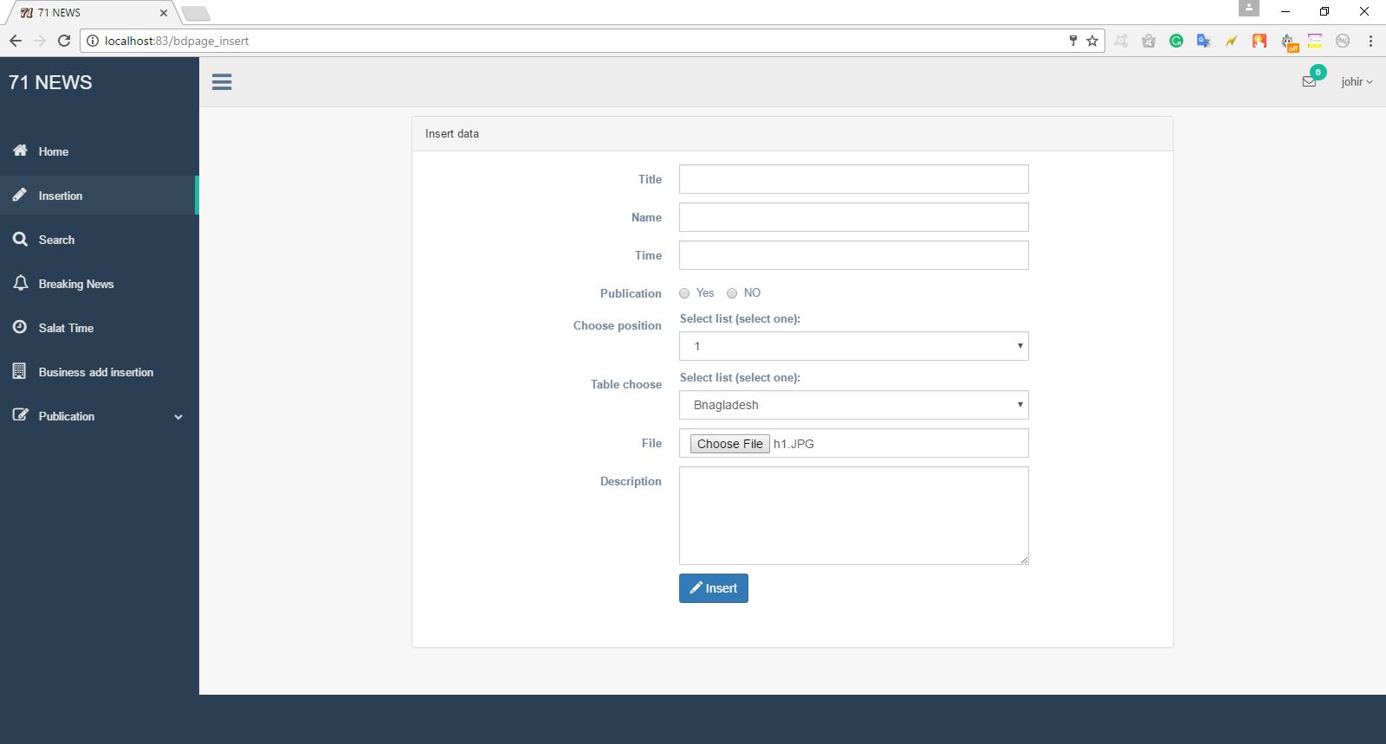

Figure 5.4: Insert Page

5.5 Publication page

Admin easily can publish or un-publish every day news in the database of table Bangladesh, international, sports and economy column using the page shown in figure 5.5.

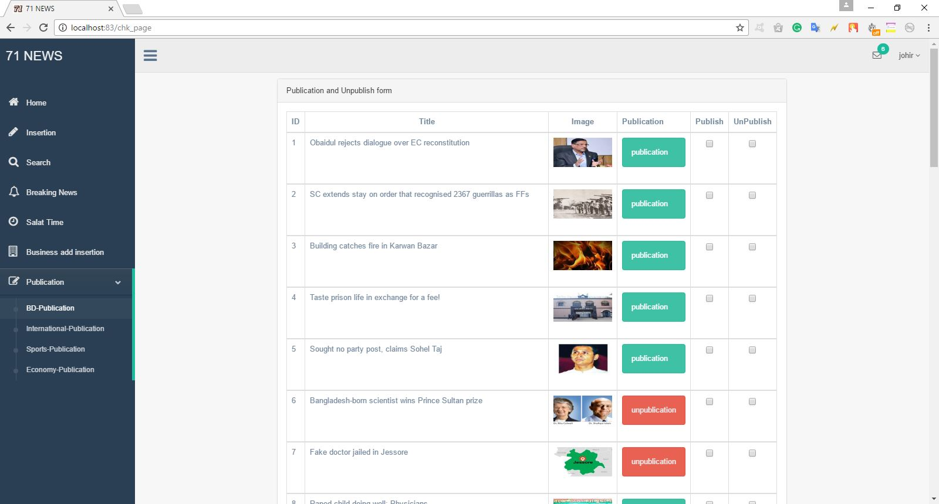

Figure 5.5: Publication Page

5.6 Mobile App for Android

The front view of the project is android based mobile application. People can get their news to the android device. In this section we are going to discuss the android application of this project.

5.7 Splash Screen Activity

This the splash screen of the Online news of 71 news logo which shows while the apps starts. Figure 4.9 show the splash screen activity of this mobile application.

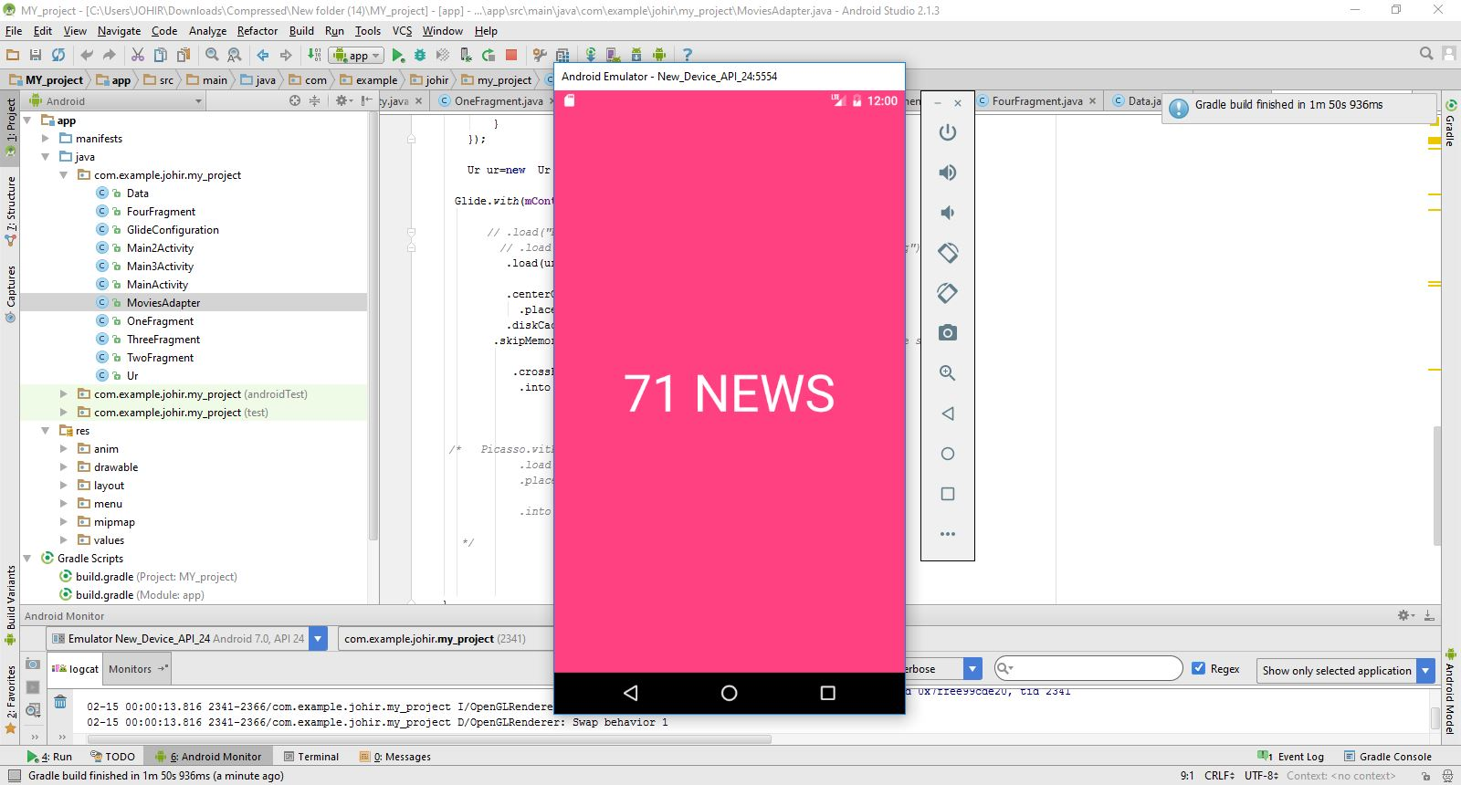

Figure 5.7: Splash Screen Activity

5.8 Home Activity

This is a activity that have a navigation drawer .There are Bangladesh , economy , sport etc. button on navigation drawer. On click this button shown in figure 5.8 user can go Bangladesh page, economy page and sports page etc.

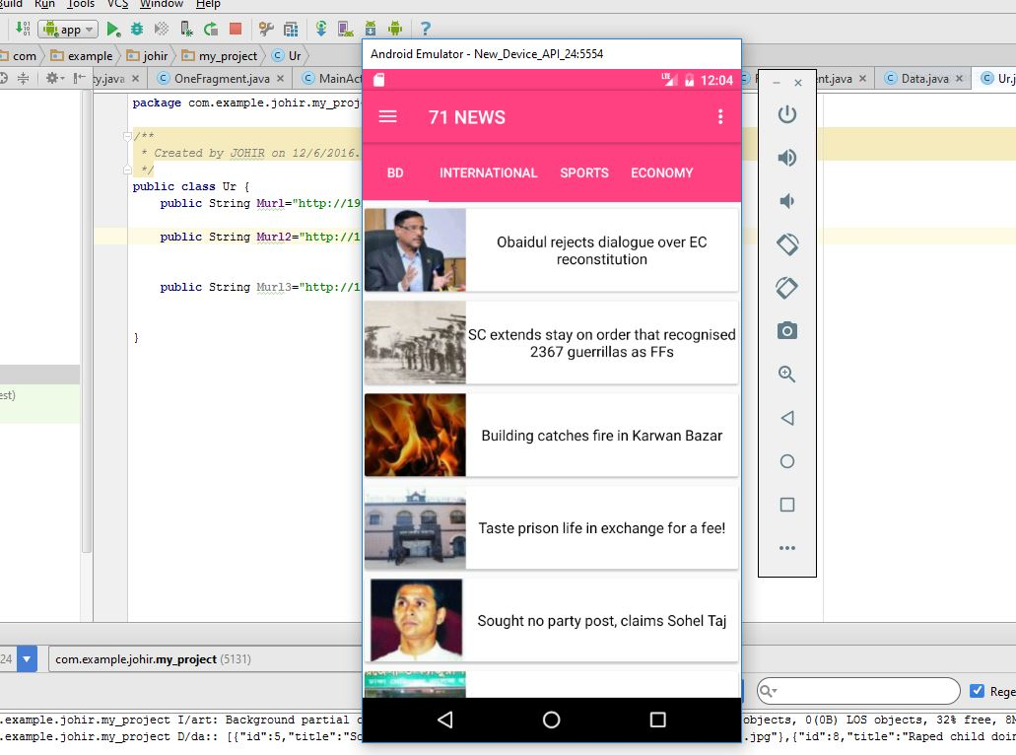

Figure 5.8: Home Activity

5.9 Result Fragment

Figure 5.9 shows the Fragment page which is used of endless Scrolling view. When user scrolled this page user can look new row are available in this page.

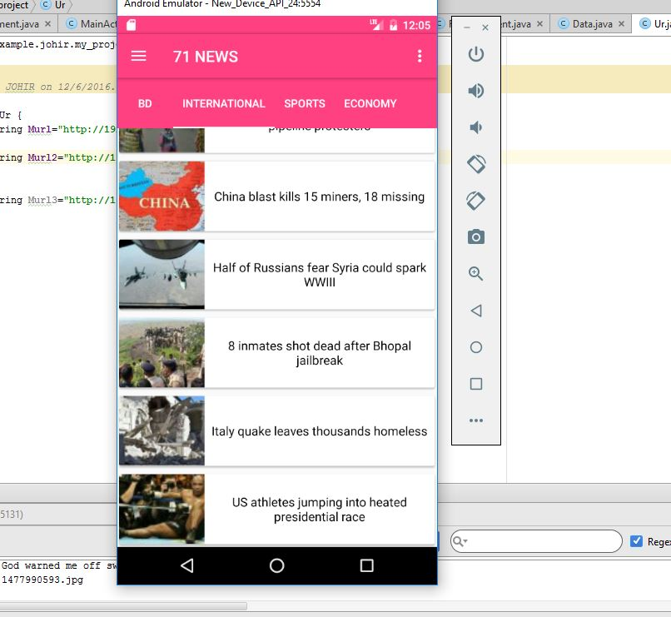

Figure 5.9: Result Fragment

5.10.1 DFD Basic Design

Fig 5.10.1:Shows the basic design of data flow diagram

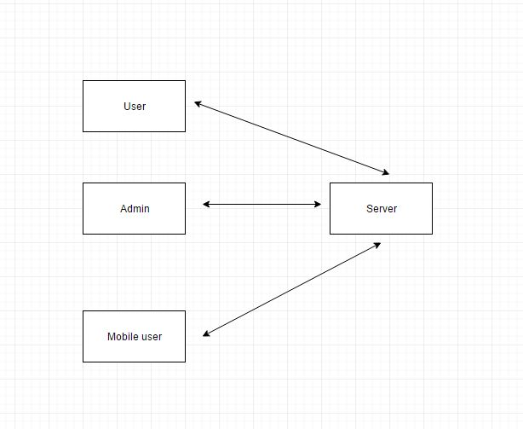

Figure 5.10.1: Basic design of data flow diagram

5.10.2 DFD Detail Design

Figure 5.10.2 Describe the detail Data flow Diagram

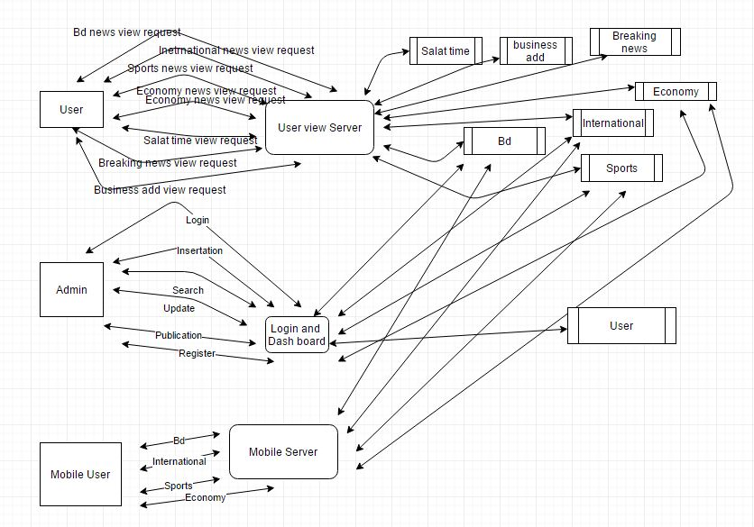
Figure 5.10.2: Data flow Diagram

5.10.3 Use case Design

Use Case Diagram is shown in figure 5.10.3
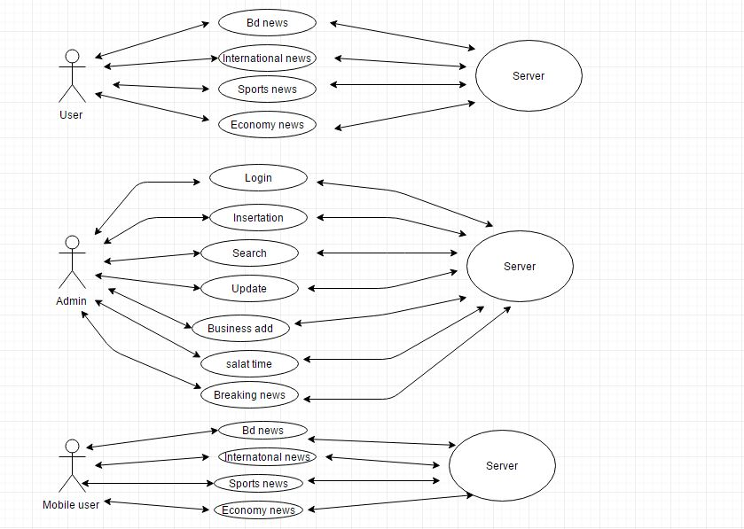

Figure 5.10.3: Use Case Diagram

Chapter 6

Implementations

6. Introduction

Restful Web Services are REST architecture based web services. In REST Architecture everything is a resource. RESTful web services are light weight, highly scalable and maintainable and are very commonly used to create APIs for web based applications.

6.1 REST
REST stands for Representational State Transfer. REST is web standards based architecture and uses HTTP Protocol for data communication. It revolves around resource where every component is a resource and a resource is accessed by a common interface using HTTP standard methods. REST was first introduced by Roy Fielding in 2000.
In REST architecture, a REST Server simply provides access to resources and REST client accesses and presents the resources. Here each resource is identified by URIs/ global IDs. REST uses various representations to represent a resource like text, JSON and XML. Now days JSON is the most popular format being used in web services.

6.2 HTTP Methods
Following well known HTTP methods are commonly used in REST based architecture.
- GET - Provides a read only access to a resource.
- PUT - Used to create a new resource.
- DELETE - Used to remove a resource.
- POST - Used to update a existing resource or create a new resource.

6.3 Restful Web Services
A web service is a collection of open protocols and standards used for exchanging data between applications or systems. Software applications written in various programming languages and running on various platforms can use web services to exchange data over computer networks like the Internet in a manner similar to inter-process communication on a single computer. This interoperability (e.g., between Java and Python, or Windows and Linux applications) is due to the use of open standards.
Web services based on REST Architecture are known as RESTful web services. These web services use HTTP methods to implement the concept of REST architecture. A RESTful web service usually defines a URI, Uniform Resource Identifier a service, provides resource representation such as JSON and set of HTTP Methods.
6.4 Lumen

Lumen is a new project from Laravel creator Taylor Otwell. It's a "micro-framework", meaning it's a smaller, faster, leaner version of a full web application framework. PHP has two other popular micro-frameworks, Slim and Silex. Lumen has the same foundation as Laravel, and many of the same components. But Lumen is built for microservices, not so much for user-facing applications (although it can be used for anything.) As such, frontend niceties like Bootstrap and Elixir and the authentication bootstrap and sessions don't come enabled out of the box, and there's less flexibility for extending and changing the bootstrap files. Laravel comes out of the box with a bit more features then Lumen. While Lumen is really for microservices and api's and Laravel more for web applications.

6.5 Software Validation
Validation is process of examining whether or not the software satisfies the user requirements. It is carried out at the end of the SDLC. If the software matches requirements for which it was made, it is validated.
- Validation ensures the product under development is as per the user requirements.
- Validation answers the question – "Are we developing the product which attempts all that user needs from
- this software?".
- Validation emphasizes on user requirements.

6.6 Software Verification
Verification is the process of confirming if the software is meeting the business requirements, and is developed adhering to the proper specifications and methodologies.
- Verification ensures the product being developed is according to design specifications.
- Verification answers the question– "Are we developing this product by firmly following all design specifications?"
- Verifications concentrates on the design and system specifications.
Target of the test are -
- Errors - These are actual coding mistakes made by developers. In addition, there is a difference in output of software and desired output, is considered as an error.
- Fault - When error exists fault occurs. A fault, also known as a bug, is a result of an error which can cause system to fail.
- Failure - failure is said to be the inability of the system to perform the desired task. Failure occurs when fault exists in the system.

6.7 Manual Vs. Automated Testing
Testing can either be done manually or using an automated testing tool:
- Manual - This testing is performed without taking help of automated testing tools. The software tester prepares test cases for different sections and levels of the code, executes the tests and reports the result to the manager.
Manual testing is time and resource consuming. The tester needs to confirm whether or not right test cases are used. Major portion of testing involves manual testing.
- Automated This testing is a testing procedure done with aid of automated testing tools. The limitations with manual testing can be overcome using automated test tools.
A test needs to check if a webpage can be opened in Internet Explorer. This can be easily done with manual testing. But to check if the web-server can take the load of 1 million users, it is quite impossible to test manually.
There are software and hardware tools which helps tester in conducting load testing, stress testing, regression testing.

6.8 Testing Approaches
Tests can be conducted based on two approaches –
- Functionality testing
- Implementation testing
When functionality is being tested without taking the actual implementation in concern it is known as black-box testing. The other side is known as white-box testing where not only functionality is tested but the way it is implemented is also analyzed.
Exhaustive tests are the best-desired method for a perfect testing. Every single possible value in the range of the input and output values is tested. It is not possible to test each and every value in real world scenario if the range of values is large.

6.9 Black-box testing
It is carried out to test functionality of the program. It is also called ‘Behavioral’ testing. The tester in this case, has a set of input values and respective desired results. On providing input, if the output matches with the desired results, the program is tested ‘ok’, and problematic otherwise.
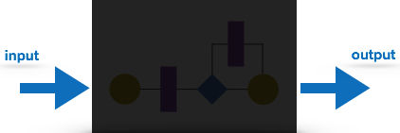
In this testing method, the design and structure of the code are not known to the tester, and testing engineers and end users conduct this test on the software[9].
Black-box testing techniques:
- Equivalence class - The input is divided into similar classes. If one element of a class passes the test, it is assumed that all the class is passed.
- Boundary values - The input is divided into higher and lower end values. If these values pass the test, it is assumed that all values in between may pass too.
- Cause-effect graphing - In both previous methods, only one input value at a time is tested. Cause (input) – Effect (output) is a testing technique where combinations of input values are tested in a systematic way.
- Pair-wise Testing - The behavior of software depends on multiple parameters. In pairwise testing, the multiple parameters are tested pair-wise for their different values.
- State-based testing - The system changes state on provision of input. These systems are tested based on their states and input.

6.10 White-box testing
It is conducted to test program and its implementation, in order to improve code efficiency or structure. It is also known as ‘Structural’ testing.
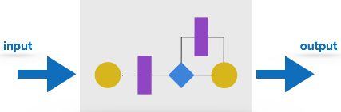
In this testing method, the design and structure of the code are known to the tester. Programmers of the code conduct this test on the code[9].
The below are some White-box testing techniques:
- Control-flow testing - The purpose of the control-flow testing to set up test cases which covers all statements and branch conditions. The branch conditions are tested for both being true and false, so that all statements can be covered.
- Data-flow testing - This testing technique emphasis to cover all the data variables included in the program. It tests where the variables were declared and defined and where they were used or changed.

Chapter 7
Conclusions

This project has been developed successfully incorporate all the requirements. Appropriate care has taken during database design and maintain database integrity and to avoid redundancy of data.

7. Advantages
- Extremely fast news
- Completely Free
- No personal information required
- Interactive news
- Environment friendly

7.1 Disadvantages
- The newspaper companies are not receiving as much money
- People will use their computers more and more
- This could become the only source of newspapers
- More jobs are being cut

7.2 Limitation
This project is designed provide service for student in mobile apps. But Teacher can access their admin panel through the mobile apps.

7.3 Future works
We have some goals that we will fulfill in future.
- Making I phone app-based Online newspaper.
- Add a registration section for People through they can comment in website

We hope that in future we can add many useful features to our site to make it more promising for the users.

7.4 Conclusions
Online news is more useful than powerbase news. Online news pepper is more popular from last some years. Online news is being read by people by using electric device like mobile, computer and laptop.

Bibliography

- https://en.wikipedia.org/wiki/PHP

- https://en.wikipedia.org/wiki/JavaScript

- http://developer.android.com/index.html

- https://en.wikipedia.org/wiki/Laravel

- https://en.wikipedia.org/wiki/Bootstrap_(front-end_framework)

- https://en.wikipedia.org/wiki/MySQL

- https://www.w3schools.com/html/

- Head First PHP & MySQL – by Lynn Beighley & Michael Morrison

- Programming PHP – by Kevin Tatroe, Peter MacIntyre & Rasmus Lerdorf , “Foreword By: Michael Bourque.

- Pressman, Roger (2010) Software Engineering: A Practitioner's Approach, McGraw Hill , New York, NY.

