SIP Component Factory
TTCN Test Client

Technical specification

DocMan location

DocMan: | n/a
Server: | n/a
Database: | n/a
Name | n/a

Continuus location

 | Server: | n/a
 | Database: | n/a
 | Directory: | n/a
 | Instance: | n/a
Revision history

Version | Date | Author | Revision comment
0.1 | 29.12.2003 | Heikki Pora | Initial draft
0.2 | 04.02.2004 | Heikki Pora | Added TesterCore, updated diagrams and class lists. Draft.
0.3 | 23.02.204 | Heikki Pora | Added WatcherClient and WatcherServer. Updated all diagrams and class lists. Added chapters “Required services”, “Resources” and “Error conditions and run-time memory strategy”. Draft
0.4 | 25.02.2004 | Heikki Pora | Added chapter “Behaviour model”. Proposal.
0.5 | 14.09.2004 | Jani Ärväs | Updated diagrams and class lists. Draft.

CONTENTS
Technical specification 1
Glossary 4
Abbreviations 4
Terminology 4
1. Introduction 5
1.1 About this Document 5
1.2 Overview 5
1.3 Notation and colors 5
2. Architecture 6
2.1 Components 6
2.2 Required services (from Symbian OS subsystems) 7
3. Class Design 8
3.1 Application classes 8
3.2 Tester Core classes 10
3.3 SIP Tester classes 12
3.4 Connection classes 14
3.5 Watcher client classes 16
3.6 Watcher server classes 16
4. Behaviour model 18
4.1 Network states 18
4.2 Execution 19
5. Resources 20
5.1 Files 20
5.1.1 Log file 20
5.1.2 Settings file 20
5.2 Databases 20
6. Error conditions and run-time memory strategy 21
6.1 Exception handling 21
6.2 Memory strategy 21

REFERENCES
[1] | SIP Feature List, Release 2, DSR01490-EN-1.0
[2] | Implementation Notes and Specification of an IUT Control Protocol
[3] | SIP Release 3 Test Client SW Requirement Specification

Glossary

Abbreviations
SIP | Session Initiation Protocol
API | Application programming interface
NSO | Nokia Symbian Operations
CF | Component Factory
IUTCP | IUT Control Protocol

Terminology
Static memory allocation strategy | Memory is only allocated at the application / module constuction phase.
Dynamic memory allocation strategy | Memory is allocated in a few known steps and locations, if needed.

Introduction

About this Document
This document specifies the SIP test client and reporting functionality for testing the SIP R3 component developed by the SIP Component Factory. The SIP R3 component implements features described in /1/.

Overview
The SIP test client will use SIP Codec API for coding/decoding SIP messages and SIP Client API for sending /receiving SIP messages. SIP test client will receive test cases using IUTCP /2/ from TTCN client, construct a SIP message according to the received parameters using SIP Codec API and invoke function on SIP Client API as instructed. Any incoming SIP requests and replies are sent back to the TTCN in IUTCP form.

Notation and colors
Diagrams are presented using the UML notation.
Colors used in the diagrams are presented in table below.
Beige | Internal modules and classes
Grey | External (~system) modules and classes
Light blue | Internal module interfaces
Green | Internal interface classes (i.e. abstract classes)

Architecture
See chapter 1 in /3/ for a high-level architectural view of the system.

Components
The essential components are illustrated in Figure 1. The structure is designed so that the parts are only loosely coupled together (via abstract interfaces) making extension and modification more trivial. The architecture also allows the testing of other API families in addition to SIP by allowing the replacement of the tester module (SIPTester.dll).
TestClient.app contains the application framework implementation (i.e normal Symbian application classes). It provides the user with a UI for connecting, disconnecting, changing settings and observing execution state. See 3.1 for class design.
TesterCore.dll contains generic TTCN/CTRL testing functionality that is not tied to any particular API under test. TesterCore implements the CTRL codec and associated data containers. Tester implementatios may also use TesterCore’s services. See 3.2 for class design.
SIPTester.dll contains the SIP API tester implementation (of the abstract tester interfaces). It is a collection of command implementations that are executed under the control of a SIP test context and ultimately TesterCore. See 3.3 for class design.
TestClientNet.dll contains all network related implementation (e.g. Bluetooth RFCOMM and TCP/IP socket operations). It also provides access to the Internet Access Points in Comm Db. See 3.4 for class design.
WatcherClient.dll contains the client interface of the Watcher Server (see below). See 3.5 for class design.
WatcherServ.exe contains the server-side implementation of the Watcher Server. Its responsibility is to keep TestClient up and running nicely. Technically, WatcherServ observes the TestClient main thread, and upon death, restarts it automatically. It is also able to detect a stall in the TestClient, in which case TestClient is also restarted. See 3.6 for class.
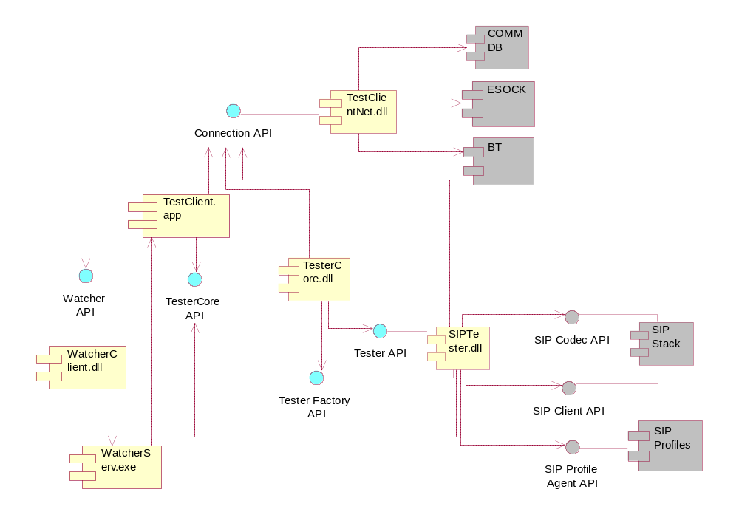
Figure 1 - Primary modules/components

Required services (from Symbian OS subsystems)
Component | Role
AVKON | Series 60 UI components
BAFL | File system utilities
Bluetooth | Bluetooth specific sockets functionality
CKON | Series 90 UI components
Comm Db | Access to Internet Access Point information
Common UI | Error UI on Series 60
CONE | Provides framework for UI controls.
ESOCK | Base sockets operations
INSOCK | TCP/IP specific sockets functionality
SDP Db | Bluetooth service advertisement
Store Streams | High-level file access (streams).
UIKON | Base dialogs and controls

Class Design

Application classes
The classes and their relationships are illustrated in Figure 2.
CTcApplication implements the Application class required by the Application Framework. Its main task is to create the application document.
CTcAppUi implements the AppUi class required by the Application Framework. Its main task is to handle user originated events. It is also responsible for owning the test case runner CTcTestRunner and launching the settings dialog CTcSettingsDialog.
CTcBacklight implements a simple Active Object that keeps the LCD backlight always on.
CTcContainer implements the application main view control. It is responsible for displaying application state information (e.g. test case name and CTRL request).
CTcDocument implements the Document class required by the Application Framework. Its main task is to create the application UI.
CTcSettingsDialog implements a UI dialog component for changing the application settings (e.g. connection type and log file name). This is the only class that needs modification across platforms (e.g. S60->S90), in addition to CTcAppUi. Note that the the class diagram shows only the S60 variant.
TTcSettings implements a simple container for application settings. It is able to load and store the settings items to/from a binary file.
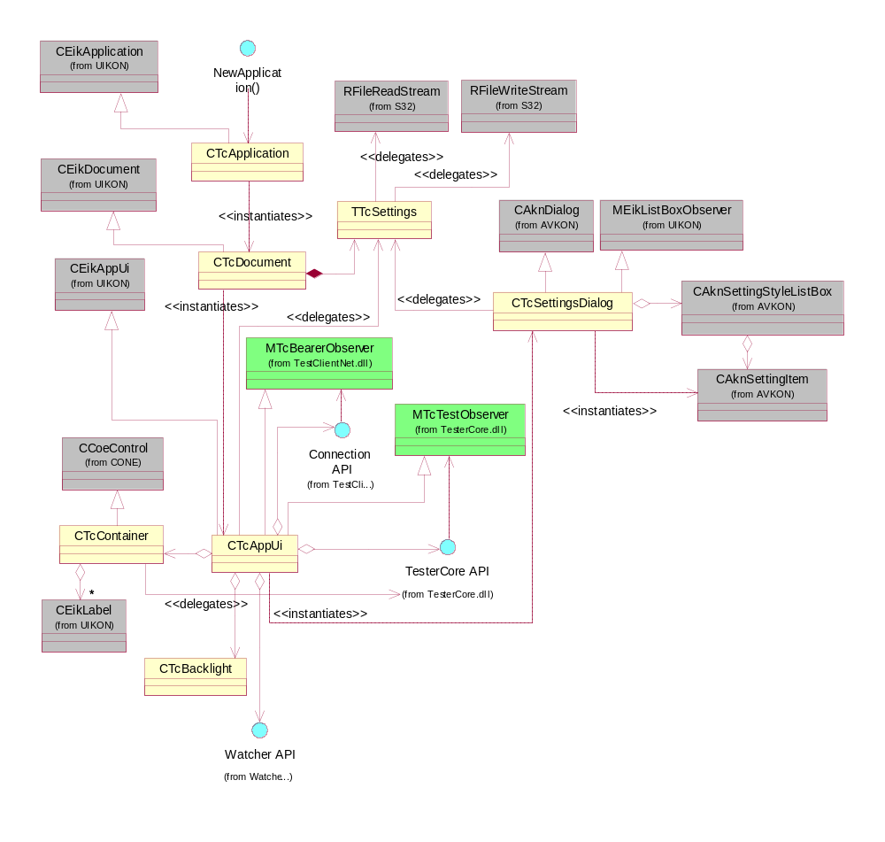
Figure 2 - Application classes

Tester Core classes
The classes and their relationships are illustrated in Figure 3.
CTcArray implements a container for textual items. However, items can also be inserted and fetched as integer values.
CTcContextBase implements a generic test context base class and an implementation of MTcTestContext.
CTcCTRLCodec implements a parser for the request/response/error PDUs of the IUTCP control protocol. It is able to both parse existing requests and construct new responses.
CTcNameValue implements a name-value pair container. Both name and value are stored as strings. The value field can also be accessed as integer.
CTcParameterList implements a container for objects of type CTcArray, CTcStructure and CTcNameValue (all derived from MTcTyped)
CTcRegistry implements a generic object registry. It usually owns contained objects but it also supports externally owned objects. All objects in the registry are associated with a textual name which is automatically generated. Names are based on the object memory address and can be converted to integer values.
CTcStructure implements a container for a set of name-value (CTcNameValue) items.
CTcTestRunner is responsible for co-ordinating CTRL communication using CTcBearer and test execution using test contexts (MTcTestContext). It owns the request and response buffers used in communication. Its task is also to load and manage an arbitrary number of test context plugin DLLs.
MTcContextFactory defines a factory interface for creating test contexts.
MTcTestContext defines interface for test context implementations.
MTcTestObserver defines an interface for observing test execution in CTcTestRunner.
MTcTyped defines an interface for querying type of objects used in CTRL parameter lists.
TcLog implements a file-based logger. All of its functions are static. It uses c:\logs\TC\TestClient.log as its log file.
TTcCommandBase implements the base class for all tester commands. It provides common functionality for accessing request and creating responses.
TTcIdentifier implements a thin container for request/response identifiers. An identifier is of form "function" or "container.function". Please note that TTcIdentifier does not own nor copy any data. The lifetime of any TTcIdentifier instances must be shorter than the descriptors given as constructor arguments.

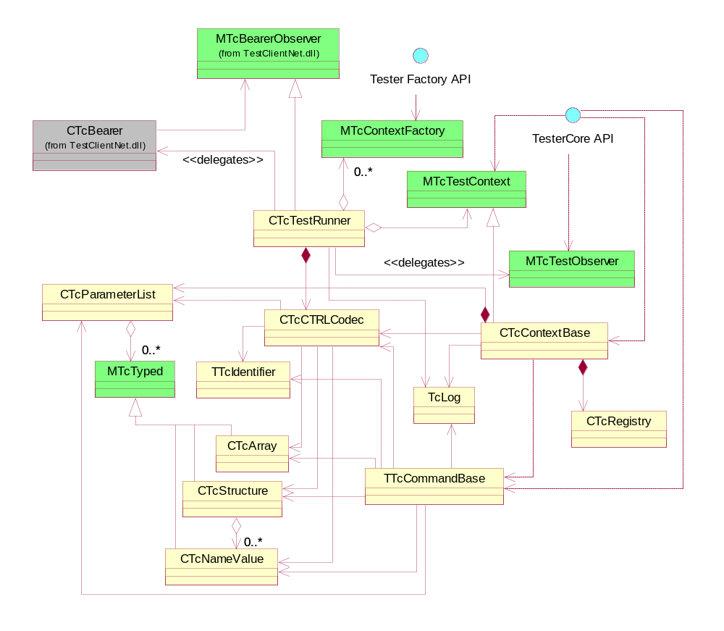
Figure 3 - TesterCore classes

SIP Tester classes
The classes and their relationships are illustrated in Figure 4.
CTcSIPConnectionContainer implements a container for a single CSIPConnection object. Its task is also to observe and queue SIP notifications for f uture use.
CTcSIPContext implements the test context (MTcTestContext) for SIP testing.
TTcProfileReceived implements a container class for profile notification messages.
TTcSIPCommandBase implements the base class for all SIP commands. It provides common SIP related functionality for accessing request and creating responses.
TTcSIPFactory implements the test context factory (MTcContextFactory) for SIP API testing. It is resonposible for creating the SIP test context and the individual SIP test commands.
TTcSIPReceived implements a container class for SIP notification messages. Objects of this class are created and stored in CSIPConnection observer functions.
TCmdSendRegister and TCmdCreateConnection are taken as examples of command implementations. Rest of the commands is not presented here, as that would only make the maintenance of this document a pain.
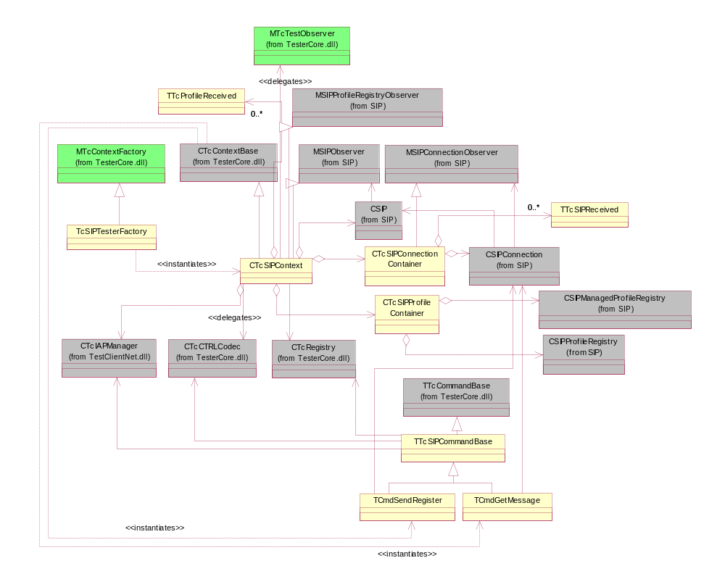
Figure 4 - SIP tester classes

Connection classes
The classes and their relationships are illustrated in Figure 5.
CTcBearer acts as a façade to the rest of the connection services. This is the only exported class in the module (in addition to the factories, of course). The factory classes are used to select a bearer and this class is then responsible for providing the connection services through a bearer-independent interface.
CTcBaseConnection implements a base class for socket connections. Basically provides core send and receive operations. Send and receive cannot be used at the same time (this is a design choice; those are not actually ever needed simultaneously with the TestClient).
CTcBtConnection implements Bluetooth RFCOMM specific connection initialization on top of CTcBaseConnection.
CTcIAPManager provides easy access to the Internet Access Points available in the system.
CTcTcpConnection implements TCP/IP specific connection initialization on top of the CTcBaseConnection class.
CTcBtManager implements Bluetooth specific connection management, like security settings and service advertisement. It also owns and controls the CTcBtConnection instance.
CTcTcpManager implements TCP/IP specific connection management, like Internet access point settings. It also owns and controls the CTcTcpConnection instance.
TTcBtFactory implements a factory class for creating CTcBtManager instances.
TTcTcpFactory implements a factory class for creating CTcTcpManager instances.
MTcBearerFactory defines an interface for bearer factories (abstract factory design pattern). Implemented by TTcBtFactory and TTcTcpFactory.
MTcBearerManager defines an interface for bearer managers. Implemented by CTcBtManager and CTcTcpManager. Managers are used for governing the connections and performing non-connection related bearer initialization tasks.
MTcBearerObserver defines an interface for receiving bearer related events such as transfer completion notifications. Implemented by CTcBtManager. Additionally, users of MTcBearerManager should implement this interface.

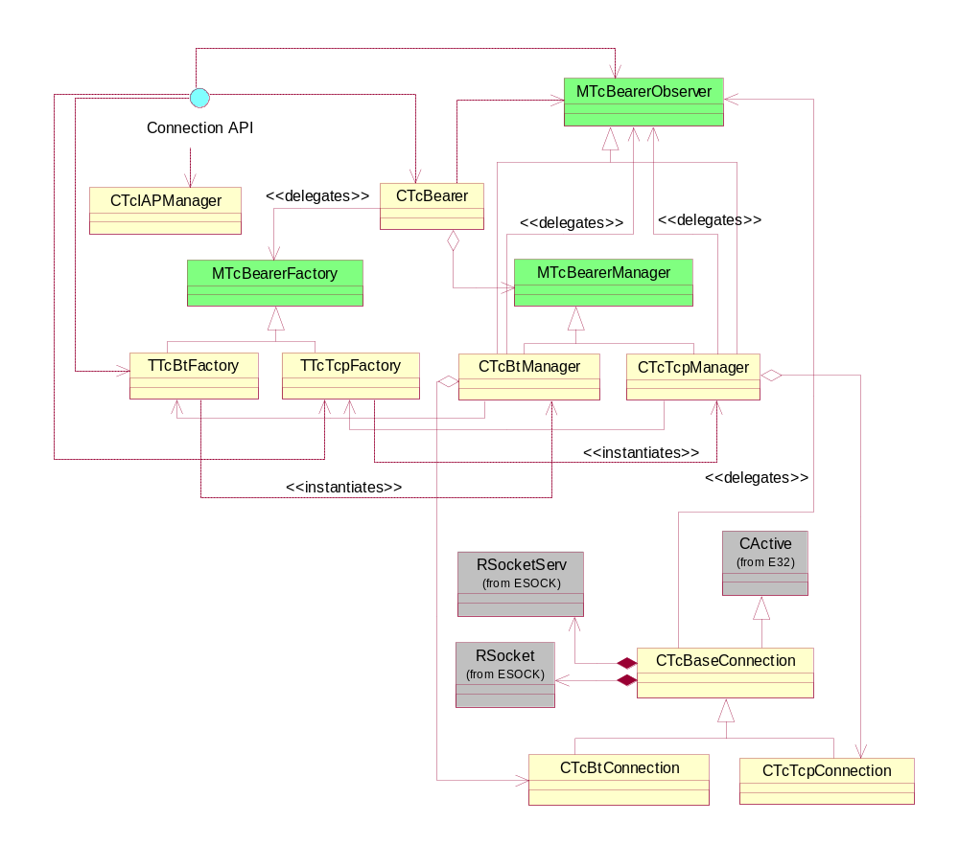
Figure 5 - Connection classes

Watcher client classes
The classes and their relationships are illustrated in Figure 6.
CTcWatcher implements a wrapper on top of RTcWatcher providing a timer for automatically calling RTcWatcher::Ping(). This class should be preferred by clients instead of RTcWatcher.
RTcWatcher implements the client-side endpoint of a Watcher client-server session. A connected client must call Ping() at intervals shorter than aTimeout specified in Connect(). Failing to do that will result in the application specified in Connect() being terminated and restarted.
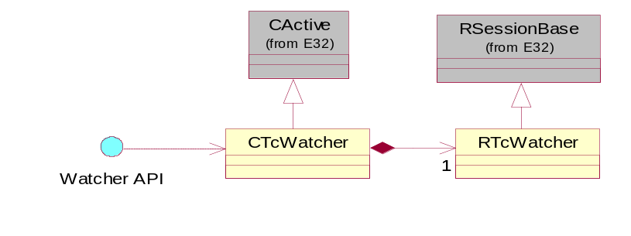
Figure 6 - Watcher client classes

Watcher server classes
The classes and their relationships are illustrated in Figure 7.
CTcAppLauncher is used to relaunch terminated applications. It is also able to dismiss any error note dialogs from the UI.
CTcCoroner acts as a thread death observer. Its task is to notify a registered MTcDeathObserver about the death and also write a log entry about the event.
CTcGrimreaper is responsible for killing a thread that has not reported to the Watcher server withing the specified timeout time (i.e. it seems to be hanging).
CTcWatcher is the main server class responsible for starting and running the server process/thread.
CTcWatcherSession implements the client-server session of the Watcher. One object instance of this class is created for each connected client.
MTcDeathObserver defines a simple abstract interface for receiving thread death notifications from CTcCoroner.

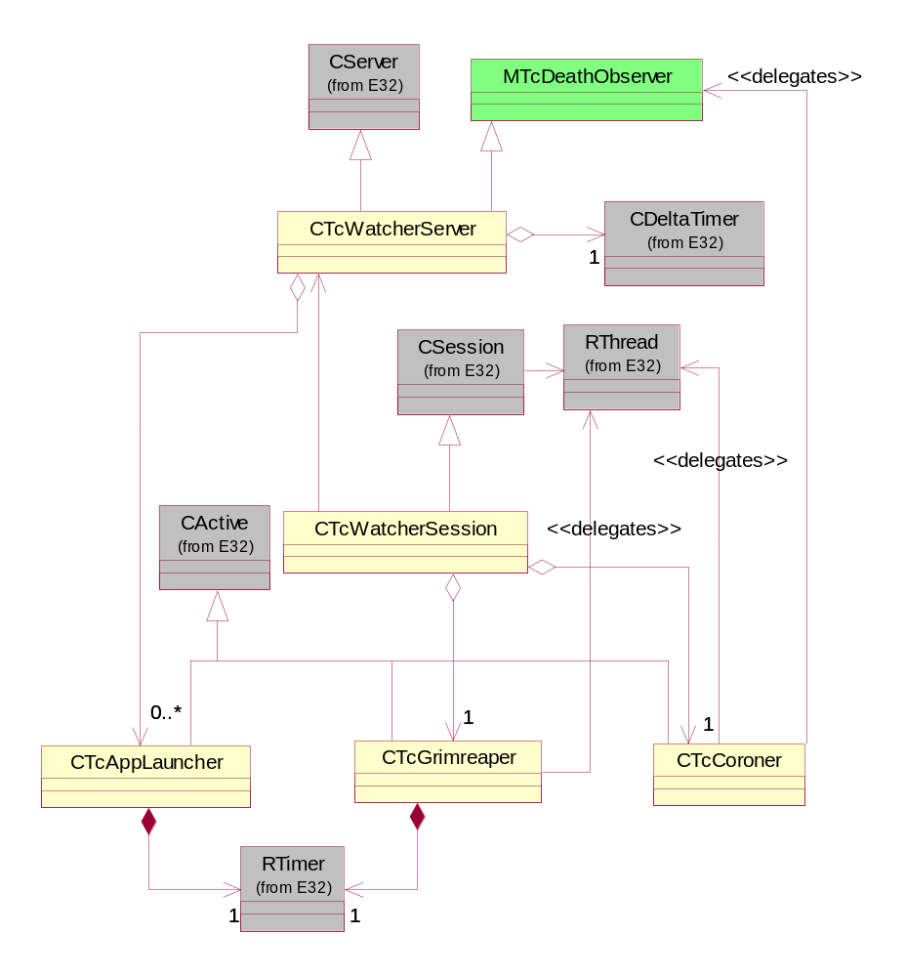
Figure 7 - Watcher server classes

Behaviour model
This chapter describes the internal high-level states of TestClient. Components are treated as a whole and no component boundaries are visualized. It must also be noted that the described states do not necessarily exists in the implementation as anything concrete (i.e. a state variable or class).

Network states
The high-level statechart of the TestClient network activity is presented in Figure 8 below. The “Execution” state is visualized with more detail in Figure 9.
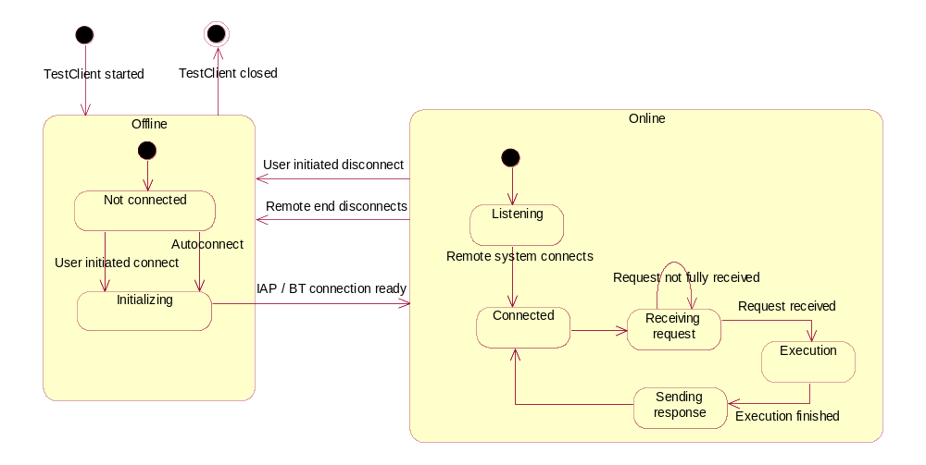
Figure 8 - Network states

Execution
The “Function execution” state is visualized with more detail in Figure 10.
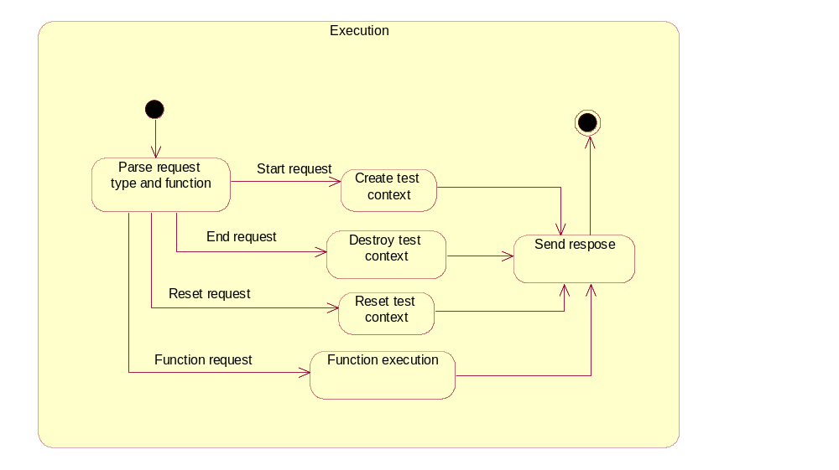
Figure 9 - High-level execution flow

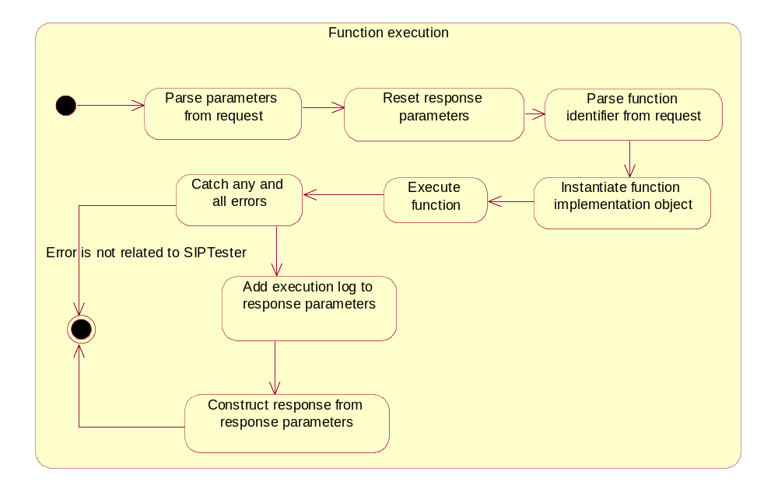
Figure 10 - Function execution

Resources

Files
TestClient does not observe free disk space in any way. It just tries to keep its dynamically created very small.

Log file
The TestClient execution log is placed in c:\logs\TC\TestClient.log. The execution log is cleared at the beginning of every test case and also at the beginning of each executed command to keep it small. The content of the log is sent to the remote TTCN system on execution failure.
Additionally, the Watcher server creates a log in c:\logs\TC\TestClientWatcher.log in case it has acted to kill and/or restart the TestClient thread.
Note that no logs are written if the folder c:\logs\TC does not exist.

Settings file
The TestClient settings file is placed in c:\system\data\TestClient.ini. The file is created automatically if it does not exist. Deleting an existing file has the effect that default settings are used and the settings dialog is shown the user next time TestClient is started. Changes to settings are permanently saved when the Settings Dialog is closed in the UI.
The settings data is version numbered, so it is safe to upgrade the application without deleting the settings file. A settings file with an incompatible version is treated like a non-existing settings file.

Databases
TestClient does not itself create or modify any databases. However, it reads information from the Comm Db via the CCommsDatabase class.

Error conditions and run-time memory strategy

Exception handling
TestClient uses the Symbian Leave mechanism to report and propagate errors. All user-initiated actions propagate leaves to the application framework. Errors that are related to incoming TTCN/CTRL requests are reported using the CTRL protocol back to the remote system. Errors that cannot be reported (such as fatal out-of-memory conditions) are reported using Symbian PANIC mechanism. TRAPs are used a few places to categorise errors to different levels (e.g. incoming CTRL message parsing and SIP tester execution are reported differently to the remote end).

Memory strategy
TestClient and its components follow static memory allocation strategy as much as possible. For example, all network communication and message parsing is done using pre-allocated fixed size buffers. However, especially in SIP tester commad implementations it is necessary to allocate SIP stack objects dynamically.

