TestClient
TTCN TestClient
User guide

Owner: | Heikki Pora
Function: | NMP/MSW/TSW/SIPCF
Approver: | Janne Vauhkonen
Document ID: | TBD
Version: | 0.4
Status: | Draft
Date: | 02.04.2004

Change history:

Version | Date | Status | Comments
0.1 | 25.02.2004 | Draft | Document created.
0.2 | 26.03.2004 | Draft | Updated SIP error ranges, removed SIP error table.
0.3 | 02.04.2004 | Draft | Updated TestClient/Siptester build instructions. Added FAQ chapter.
0.4 | 16.04.2004 | Draft | Updated build instructions.

Table of contents:

1. Document control 4
1.1 References 4
1.2 Documentation conventions 4
1.3 Abbreviations 4
1.4 Definitions 4
2. General 5
3. Environment and TestClient setup 6
3.1 Symbian 6
3.2 TTCN 6
3.3 SIP stack 6
3.4 TestClient 6
3.5 Tester modules (e.g. SIPTester) 6
4. Using TestClient UI 7
4.1 Launching the application 7
4.2 Connecting 7
4.3 Disconnecting 8
4.4 Viewing the local IP address 8
4.5 Changing settings 9
4.6 Closing the application 9
5. Dealing with errors 10
5.1 TestClient internal errors 11
5.2 SIP stack synchronous errors 12
5.3 SIP stack asynchronous errors 12
5.4 SIP status codes 12
6. D-I-Y debugging (Visual C++ 6.0) 13
6.1 Quick method 13
6.2 Thorough method 13
7. Troubleshooting / FAQ 14
7.1 SIPTester doesn’t compile (compiler/linker errors) 14
7.2 How do I compile SIPTester for SIP R3.1? 14
7.3 TestClient closes network connection immediately when I try to run a test case. 14

Document control

References
 | Typhoon Installation | N/A
 | Network Access Guide For Typhoon Emulator | N/A

Documentation conventions
Code and file names are shown with the “Courier New” font.

Abbreviations
SDK | Software Development Kit
SIP | Session Initiation Protocol
UI | User Interface

Definitions

General
This document describes the installation, setup and use of the TestClient application and related environment. Introductory information is also provided for error detection and debugging performed by test engineers.
Should you have any suggestions for improvement, please do not hesitate to contact the responsible person.

Environment and TestClient setup

Symbian
Install and configure a Symbian/Nokia platform release (e.g. Series 60 v2.1) to a subst’ed drive. See [1]. Configure the emulator for LAN network access. See [2].
Currently supported platforms are Series 60 v2.0-v2.1 , Series 90 v1.x and TechView 8.0a-8.1b.

TTCN
Install and configure Telelogic Tau. Details not provided in this document.

SIP stack
- Extact SIP_SIP_3.0_2004_wk13.zip (version may be different) to the root of you Symbian installation drive.
- Cd to “\SIP_3.0\Src\Group\”
- Execute “perl Makefile.pl”
- Use the text-based UI to select and build all SIP components for your platform of choice (e.g. S60 wins udeb).

TestClient
- Extract TestClient_xxx.zip to the root of your Symbian installation drive.
- Cd to “\testclient\group\”
- Execute “bldmake bldfiles”
- Execute “abld reallyclean” if you are updating your TestClient installation.
- Execute “abld build wins udeb” or “abld build winscw udeb”
- Execute “abld build thumb urel” and “makesis TestClient.pkg” if you want to create an installation package for hardware testing.

Tester modules (e.g. SIPTester)
This information applies to all *Tester modules. SIPTester is only taken as an example.
- Extract SIPTester_xxx.zip to the root of your Symbian installation drive.
- Cd to “\siptester\group\”
- Execute “bldmake bldfiles”
- Execute “abld reallyclean” if you are updating your TestClient installation.
- Execute “abld build wins udeb” or “abld build winscw udeb”
- Execute “abld build thumb urel” and “makesis SIPTester.pkg” if you want to create an installation package for hardware testing.

Using TestClient UI
Note that the information and images in this chapter refer to the Series 60 version of TestClient. However, the exact same functionality is also present in the Series 90 / TechView versions.

Launching the application
Select TESTCLIENT from the application grid. Note that when launching TestClient for the first time (or if the settings file has been deleted), the Settings dialog is automatically shown (see 4.4).
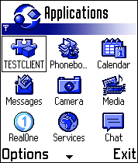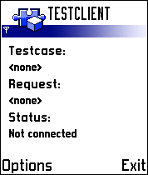

Connecting
Select “Connect” from the Options menu. TestClient will establish an Internet connection and start waiting for incoming connections from a TTCN system. Note that TestClient will establish a network connection automatically if AutoConnect is enabled in the Settings (see 4.4).
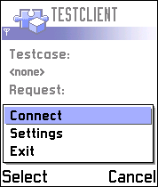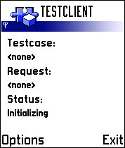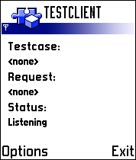

Disconnecting
Select “Disconnect” from the Options menu.
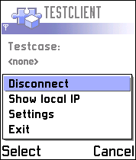

Viewing the local IP address
Select “Show local IP” from the Options menu. Note that this option is only available after “Connect” has finished successfully. If “0.0.0.0” is displayed as the local IP, retry “Show local IP” after e.g. 15 seconds.
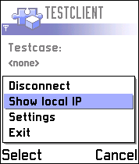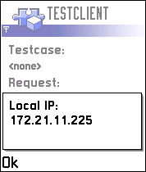

Changing settings
Select “Settings” from the Options menu. Note that new settings take effect next time a new connection is established. The setting values can be changed by pressing the Select key or selecting “Change” from the Options menu. Settings are permanently saved when the Settings dialog is closed by selecting “Exit” from the Options menu or by selecting “Back”.
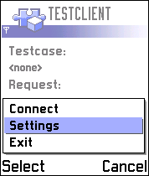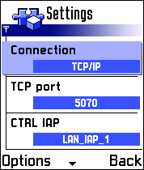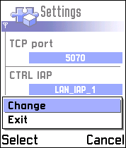
The setting items and their values are defined in the table below.
Setting item | Values | Default value | Description
Connection | Bluetooth  TCP/IP | Bluetooth | CTRL connection bearer. TCP/IP uses GPRS, CSD or LAN (depending on the chosen CTRL IAP). Bluetooth uses BT RFCOMM.
TCP port | 1024… | 5070 | Local TCP/IP port used when Connection is TCP/IP
CRL IAP | <varies> | First IAP (typically LAN_IAP_1 on emulator) | Internet Access Point to be used for the CTRL connection in TCP/IP mode
Connection Startup | Manual  Automatic | Manual | Manual = user must select “Connect” to start a connection.  Automatic = A connection is started automatically when TestClient is started.

Closing the application
Select “Exit” from the Options menu. An active network connection is closed automatically, no need to use “Disconnect” first.
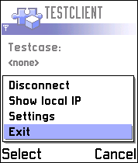

Dealing with errors
There are four categories of errors. Note that Telelogic/Tau specific compiler/run-time errors are not described here.

- TestClient internal errors
- SIP stack synchronous errors
- SIP stack asynchronous errors
- SIP status codes

Only category #1 errors are always treated as test case failures. Other errors might just be what are expected in a test case. Generally an error code with value 0 means that no error occurred. This equals to the (SIP) status code value 200.
Error codes are defined in C++ header files as constants or enumerations. Refer to the table below when trying to find a name (or even a description) for an error code.

Value range | Look from header file | Belongs to
-3000…-2998 | \sip_3.0\src\sigcomp\sigcompengine\api\sigcomp.h | SigComp
-46…0 | \epoc32\include\e32std.h | Symbian, system-wide
-17723…-17700 | \sip_3.0\src\sip\sipapi\api\sip.h | SIP stack
-17840…-17750 | \sip_3.0\src\sip\codec\inc\sipmessageparser.h | SIP message parser

Hint: more exotic (negative) error codes not listed in the table might be presented in this page: http://www.newlc.com/article.php3?id_article=117&var_recherche=error+codes

TestClient internal errors

TestClient internal errors are reported by sending the ERR response to TTCN system. ERR response always contains a textual description of the error. The description may also be followed by a TC execution log trace. TC internal errors typically indicate defects in the TTCN scripts (test case, functions, and templates).

Error message | Reason
No active test case. | TC received a request to execute a command before a test case start request was received.
Start failed, unknown test context. | TC received a start request but was unable to find a matching tester plugin.
Unrecognized or malformed request. | TC received a request (any request) but it was not able to parse its content fully.
Not enough memory to perform operation. | The Symbian system running TC is running out of RAM.
Receive buffer full. | TC received a request that did not fit into the 5120 characters long receive buffer.
Mandatory TestClient ID not found in request. | TC received a request that was missing a mandatory TestClient ID.
Mandatory Parameter not found in request. | TC received a request that was missing a mandatory Parameter.
Mandatory Header not found in request. | TC received a request that was missing a mandatory Header.
Mandatory Structure item not found in request. | TC received a request that was missing a mandatory structure item (inside an existing structure Parameter).
Header not allowed. | TC received a request that contained a header that is not allowed (i.e. it’s private to the API under test).
Invalid TestClient ID (object not found). | TC received a request with a TestClient ID. However, no matching object was found in its internal registry.
Internal error %d in CTcTestRunner::ExecuteL(), or test context creation failed. | Any other TC errors are reported with this message

SIP stack synchronous errors
SIP stack synchronous errors are reported by delivering the error code in the returnCode field of a TTCN response sent by TC. Errors of this category typically indicate missing or malformed information in the specified Headers. The most common error code is KErrArgument( -6 ), which indicates that a SIP API function either did not understand one of its arguments or that an empty argument was given (unexpectedly).

SIP stack asynchronous errors
SIP stack synchronous errors are reported by delivering the error code in the returnCode field of a TTCN GetMessage() response sent by TC. Note that TC is able to provide a textual description with all or most of the errors in this category. Look for a StackErrorMsg output parameter in the TTCN response message. Errors of this category typically indicate errors or failures in the SIP stack network transactions.

SIP status codes
SIP protocol status codes are reported by delivering the code in the recvMsg.respCode of a TTCN GetMessage() response sent by TC.

D-I-Y debugging (Visual C++ 6.0)
This chapter presents two methods for finding the root cause for an unexpected error (a software crash or a an error in categories #1 or #2).
Pre-requisites: Knowledge of C++, Visual Studio and the Symbian platform is recommended.

Quick method
Steps:
- Open the command C++ file you are interested in any text editor
- e.g. for the “SendRegister” command the file is “\siptester\src\TCmdSendRegister.cpp”, and so forth.
- Look at the execution log your TTCN system received from TestClient. If there was none, forget this method.
- Try to identify the place in C++, which was executed last (according to the log). Note that the log is not very precise, it only shows accesses to the CTRL request.
- For example:
- ExtractContactHeaderLC() function generates a “-- Extract optional header “Contact” ==> OK” if it is successful, and so forth.
- In the SendRegister case, if the execution log listed getting a “Refresh” parameter” as the last successfully executed line, it is probable that CSIPRegistration::NewL() caused the failure – meaning that it did not like one or more of its parameters.

Thorough method

Steps:
- Construct a VC++ workspace for SIPTester
- cd \siptester\group
- bldmake bldfiles
- abld makefile vc6 SIPTester
- Open the workspace into VC++
- It can be found from \epoc32\BUILD\SIPTESTER\GROUP\SIPTESTER\WINS
- Choose the “Win32 uni debug” configuration from the “Build \ Set active configuration…” menu item.
- Open the command C++ file you are interested in
- e.g. for the “SendAck” command the file is “TCmdSendAck.cpp”, and so forth.
- Place a breakpoint at the beginning of the ExecuteL() function
- Move the cursor to the first code line after “{“ and press F9.
- Start the debugger
- Press F5
- Enter “E:\epoc32\release\wins\udeb\EPOC.EXE” as the Executable file name if asked for it. Replace “E:” with your subst’ed drive letter.
- Start TestClient and TTCN test case as normally once the emulator has fully started.
- Once the execution reached the breakpoint, you can step the code line-by-line by pressing F10.
- If the execution suddenly “jumps” out of the file under debugging, you know that the problem you were searching for was related to the last line executed.

Troubleshooting / FAQ

SIPTester doesn’t compile (compiler/linker errors)
SIPTester expects to find a full SIP stack installation from \SIP_3.0\.
You have to modify these include paths in \siptester\group\siptester.mmp to point whereever you have installed the Sip source tree:
SYSTEMINCLUDE \SIP_3.0\Src\SIP\Client\Inc \SIP_3.0\Src\SIP\Codec\Inc
SYSTEMINCLUDE \SIP_3.0\Src\SIP\Codec\Api \SIP_3.0\Src\SIP\SipApi\api
SYSTEMINCLUDE \SIP_3.0\Src\SIP\ClientInstaller\Engine\inc
SYSTEMINCLUDE \SIP_3.0\Src\ProfileAgent\Client\Api
Remember to recompile SIPTester after correcting the paths.

How do I compile SIPTester for SIP R3.1?
SIPTester for SIP R3.1 can be built by renaming \siptester\group\siptester_SIP31.mmp as siptester.mmp. Proceed with the normal build process after that.

TestClient closes network connection immediately when I try to run a test case.
Make sure you have compiled SIPTester properly. Verify that SIPTester.dll is present in \epoc32\release\wins\udeb\z\system\apps\TestClient\plugins\ (or equivalent folder in the winscw system).
Correct location on HW is \system\apps\TestClient\plugins\ (on the same drive TestClient was installed on).

