

RESTAURANT MANAGEMENT SYSTEM

By Group No. 6

## Supervised By:

Md. Mamun Hossain Lecturer

Department of Computer Science & Engineering Bangladesh University of Business & Technology

## Team Members

Pias Miah-19201103054 Mrityunjoy Biswas-19201103064 Asha Akter-19201103077

# Abstract

This report is meant for describing all the features and procedures that were followed while developing the project. This report specially mentions the details of the project how it was developed, the primary requirement as well as various features and functionalities of the project and the procedures followed in achieving these objectives. This system helps in conducting information quickly and can thus help in saving time and the operations will be carried out efficiently. With the objectives used any business can apply the “Restaurant Management System” for conducting quick operations and getting better results in less time.

# Certificate

This is to certify that we are students of B.Sc. in CSE have completed the report work titled “Restaurant Management System” satisfactory in partial for the requirement of B.Sc. in CSE Bangladesh university of Business and Technology in the year 2019.

Project Report Supervisor

Md. Mamun Hossain Lecturer

Department of Computer Science and Engineering (CSE) Bangladesh University of Business and Technology (BUBT

# Acknowledgements

First of all, we are thankful and expressing our gratefulness to almighty Allah who has given us his divining blessing, patient, mental and physical strength to complete this project work. We are deeply indebted to our project supervisor, Md. Mamun Hossain, his scholarly guidance, important suggestions, work for going through and correcting them, and generating courage from the beginning to the end of the research work has made the completion of this report possible. It was fantastic to get help from him and without him support it would be tough for us to reach the accurate goal. A very special gratitude goes to all our friends for their support and help to implement our works. The discussion with them on various topics of our work has been very helpful for us to enrich our knowledge and conception regarding the work. Last but not least, we are highly grateful to our parents and family members for supporting us spiritually throughout this project and our life in general.

# Approval

This project report submitted by our team, Department of Computer Science and Engineering (CSE), Bangladesh University of Business and technology (BUBT) under the supervision of c, lecturer of Department CSE has been accepted as satisfactory for the partial fulfillment of the requirement for the degree of bachelor of Science (B.Sc. Eng.) in Computer Science and approved as to its style and contents.

## Supervisor:

Md. Mamun Hossain

Department of Computer Science and Engineering (CSE)

Bangladesh University of Business &Technology (BUBT)

Mirpur - 2, Dhaka - 1216, Bangladesh.

## Chairman:

Dr. Muhammad Firoz Mridha

Associate Professor and Chairman Department of CSE, Bangladesh University of Business and Technology (BUBT), Mirpur - 2, Dhaka - 1216, Bangladesh.

# Introduction

The project **Restaurant Management System** is a web base application for giving order foods and managing food information. The project **Restaurant Management System** is developed on php language which mainly focuses on basic operation and MySQL for database management system for an online food marketplace like - adding new food item, updating information of food, searching food menu of ordering food online and managing order of customers and calculate total sales amount of the website. **Restaurant Management System** is a web application designed to help admin to maintain and organize online market system. Our system is easy to use for both beginners and advanced users. It features a familiar and well thought-out, an attractive user interface, combined with strong searching, insertion and deletion capabilities.

# Projective Objectives

1. **Tracking Orders** A good system will help you keep track of your online orders and offer a centralized view
2. **Reduce the Time for managing orders:** With a good order management solution, you can reduce the time taken to keep track of all the orders you have on hand. Additionally, you save the time taken up in inventory recounts if your records are in place.
3. **Easy access to information:** In this system any one can easily access food

information whenever they need, All the information are available to all visitors.

# Motivations

The main objective of the project is to provide a friendly environment to receive online orders, maintain orders details of food and manage food information. The main purpose of this project is to replace the manual work. Restaurant Management System is a project which aims is developing a online marketplace for food and maintain all the work of a delivery and record previous orders. We can easily add new item and new users can register easily. It has secured database and moderators and users can only login with a unique ID and a password.

# System Features

1. **Multiple Users:** This system supports multiple moderators. Each moderator has to create their account by giving their details. They have to use their username and password when logging in. They manage all the food item, users and online orders.
2. **Add, Update and Delete item:** Moderators can update any food information. They can also delete information of any item. The process is very simple. Users have to type in the information and press the update or delete button. They can also add new food item.
3. **User registration:** One can easily create an account and order foods online. The process is very easy and user friendly.
4. **Receive online orders:** Users can place orders online and they can update or delete existing orders.
5. **Update and Delete user:** Moderators can update existing user’s information and delete them is necessary.
6. **Food details:** This site has all the necessary information about foods for all types of users. Users can see the available item and can order which they want.
7. **Orders history:** This system keeps detailed record of each sell. It is very helpful to find out which products are doing well and which products are not. By keeping track of this, a business can be decided which products should they stock more and which products they should stock less. It will reduce cost and prevents shortage of demanded products.

**E-R DIAGRAM**

An entity relationship diagram (ERD) shows the relationships of entity sets stored in a database. An entity in this context is an object, a component of data. An entity set is a collection of similar entities. These entities can have attributes that define its properties. The ER or (Entity Relational Model) is a high-level conceptual data model diagram. Entity-Relation model is based on the notion of real-world entities and the relationship between them. E-R diagram shows us the entire relationship between all the entities those are used in our project. Here we used total seven entities and each entity has several attributes for example, User has user id as primary key in this entity, user name, phone no, password, email & address. Here, dishes provide us the information about all food items. Users order help us to show the orders details.

# Front-end Designs:

We have used PHP for front-end development. We have designed this site as user friendly as we could.

## Home page:

This is the landing page of our project. It shows all the popular dishes of the month. It has

* + Log in and sign up option. Restaurant option that contains all the details about restaurant.

**Admin Home page**

This page is only for admin. Here an admin can

* See all details of any user
* Add any restaurant
* Add any new food item
* See all orders details

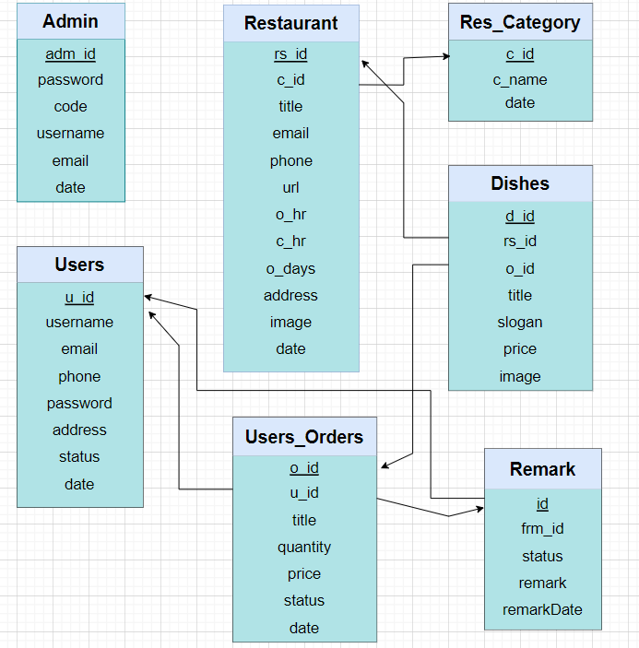

**Figure-1:** Restaurant Management System Schema Diagram

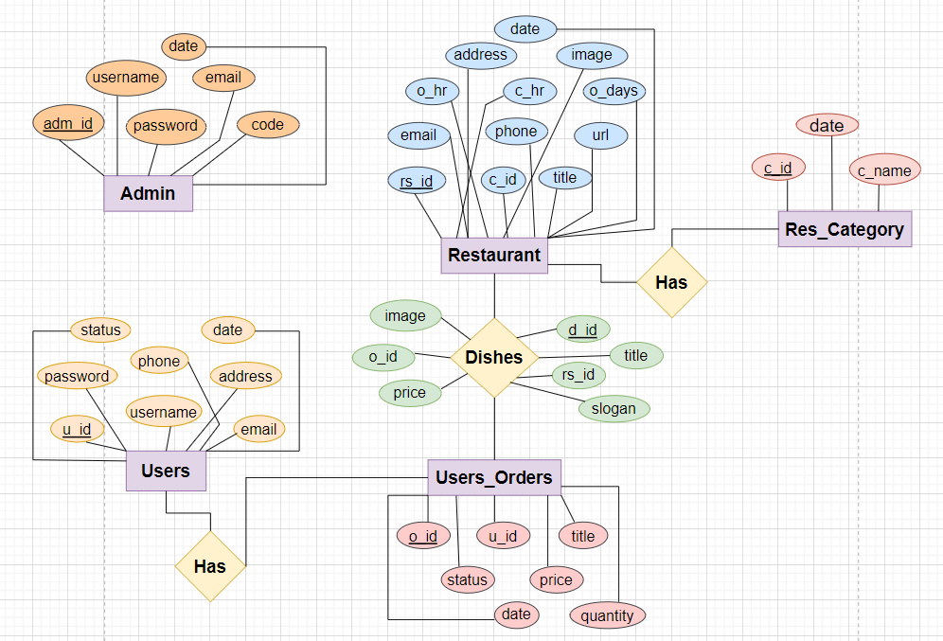

**Figure-2:** Restaurant Management System ER Diagram

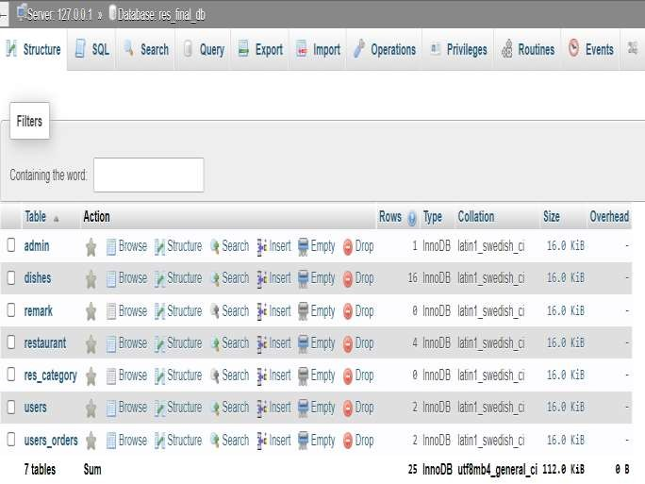

**Figure-3:** Restaurant Management System Database

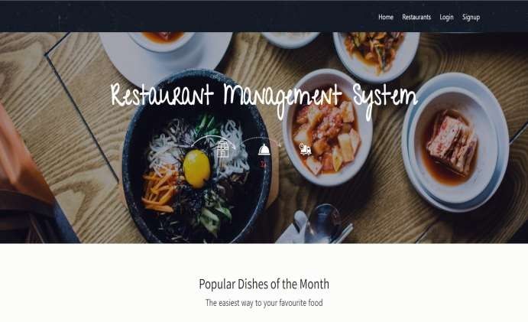

**Figure-4:** Home page

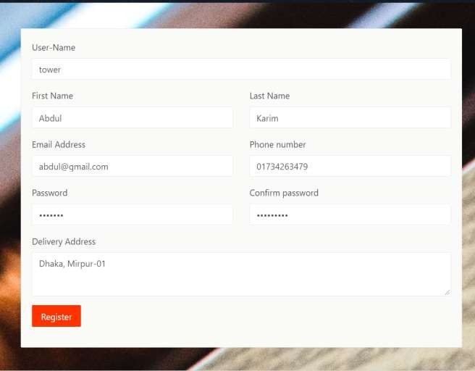

**Figure-5:** Sign Up page

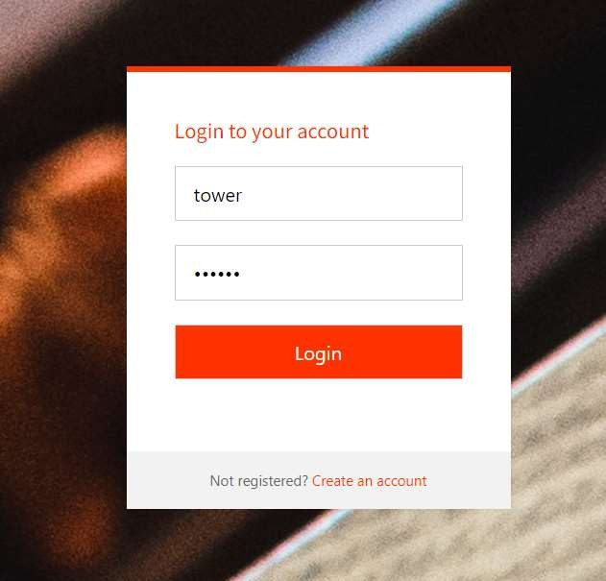

**Figure-6:** Login page

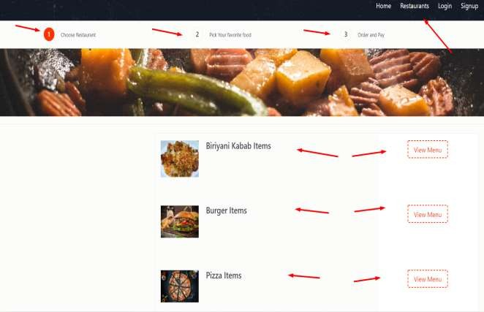

**Figure-7:** Restaurants page

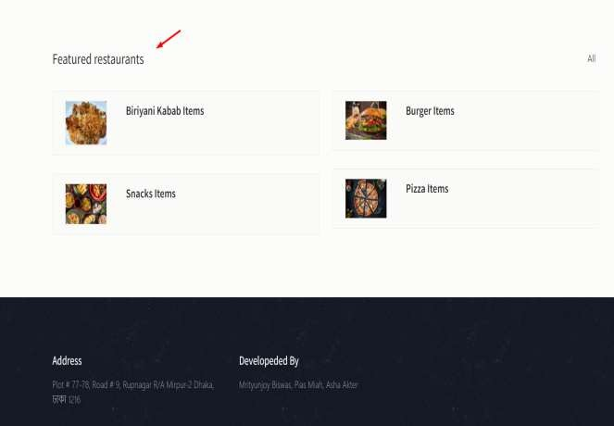

**Figure-8:** Restaurant Featured page

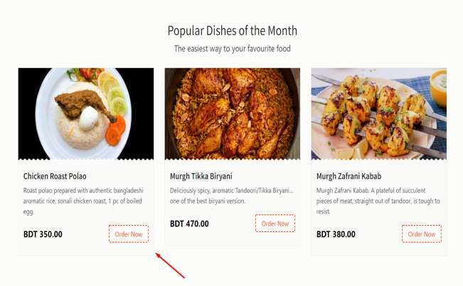

**Figure-9.1:** Order page

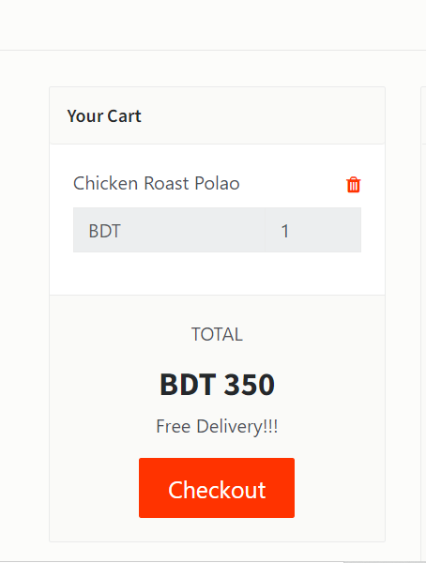

**Figure-9.2:** Add to cart order page

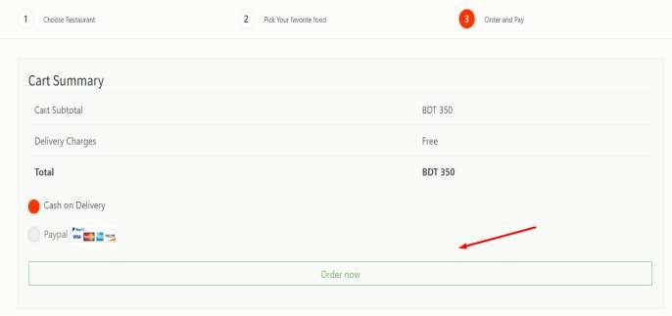

**Figure-9.3:** Confirm order page

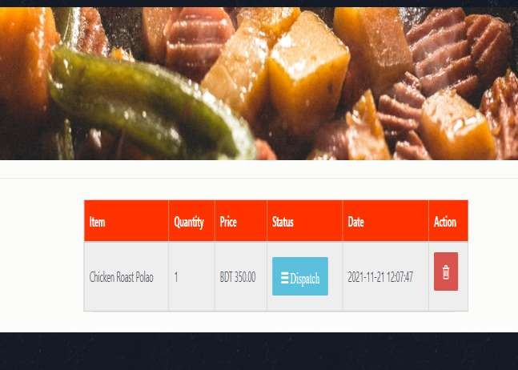

**Figure-9.4:** Order confirmed page

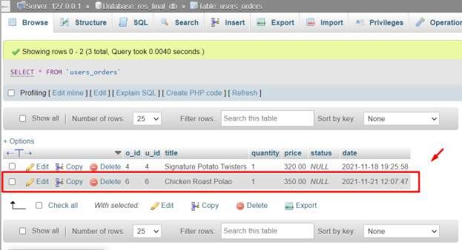

**Figure-9.5:** Order added to database

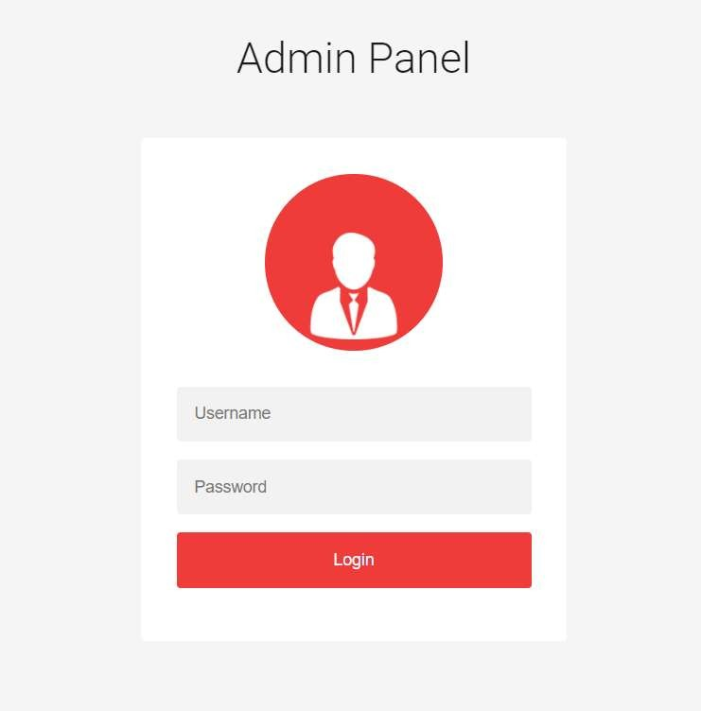

**Figure-10:** Admin Login panel

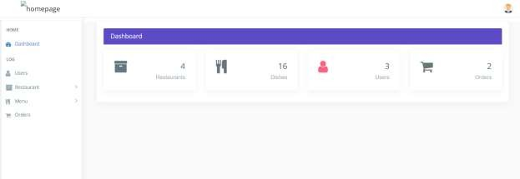

**Figure-11:** Admin home page

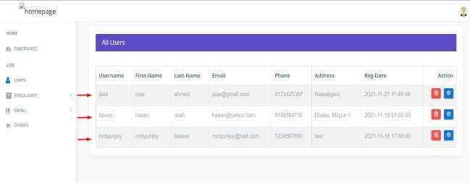

**Figure-12:** User section

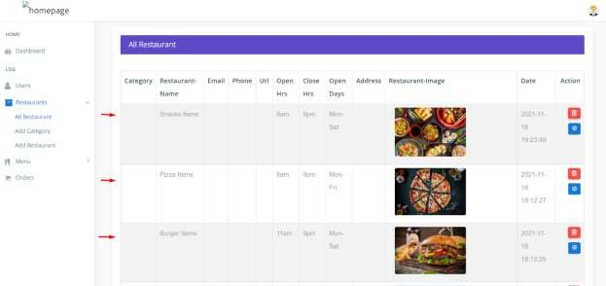

**Figure-13:** All Restaurant section

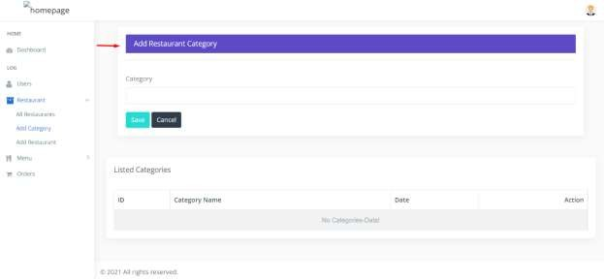

**Figure-14:** Restaurant add category section

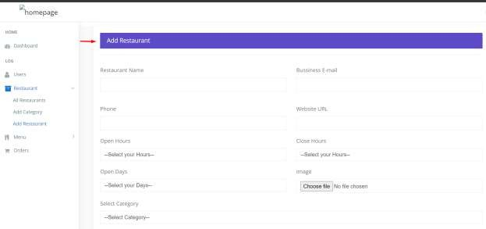

**Figure-15:** Restaurant add section

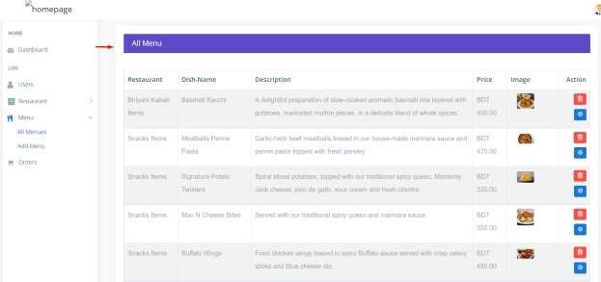

**Figure-16:** All Menu section

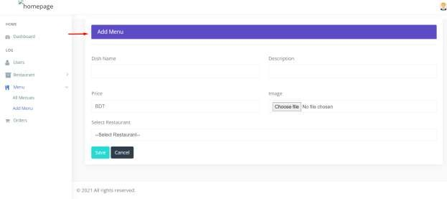

**Figure-17:** Add menu section

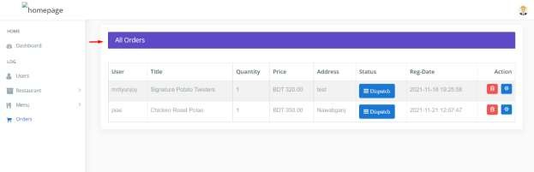

**Figure-18:** All Order section

# Conclusion

The “Restaurant Management System” process made computerized to reduce human errors & to increase the efficiency. The main focus of this project is to less the human efforts. The maintenance of the records is made efficient, as all the records are stored in the Access Database, through which data can be retrieved easily. The editing is also made simples. The user has to just type in the required field & process the update button to update the desired field. The items & moderators are given a particular unique id no. so that they can be access correctly & without error. The aim of this project is to reduce the error of manual functionalities.