**Setup:** Navigate to file mario1_1.py and run with a python interpreter (pygame module is required along with MySQLdb).

1) start the game and you should be greeted by the below title screen. The level, score (zero) and number of coins (also zero) are displayed like below:

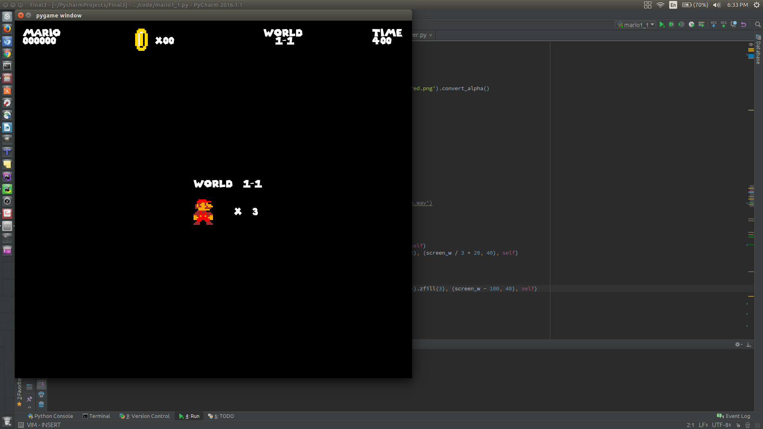

2) note the background music that start immediately the level starts, and stops whenever the title screen or the game end screen appears.

3) note that mario dies after losing three lives. Try this by touching an enemy repeatedly.

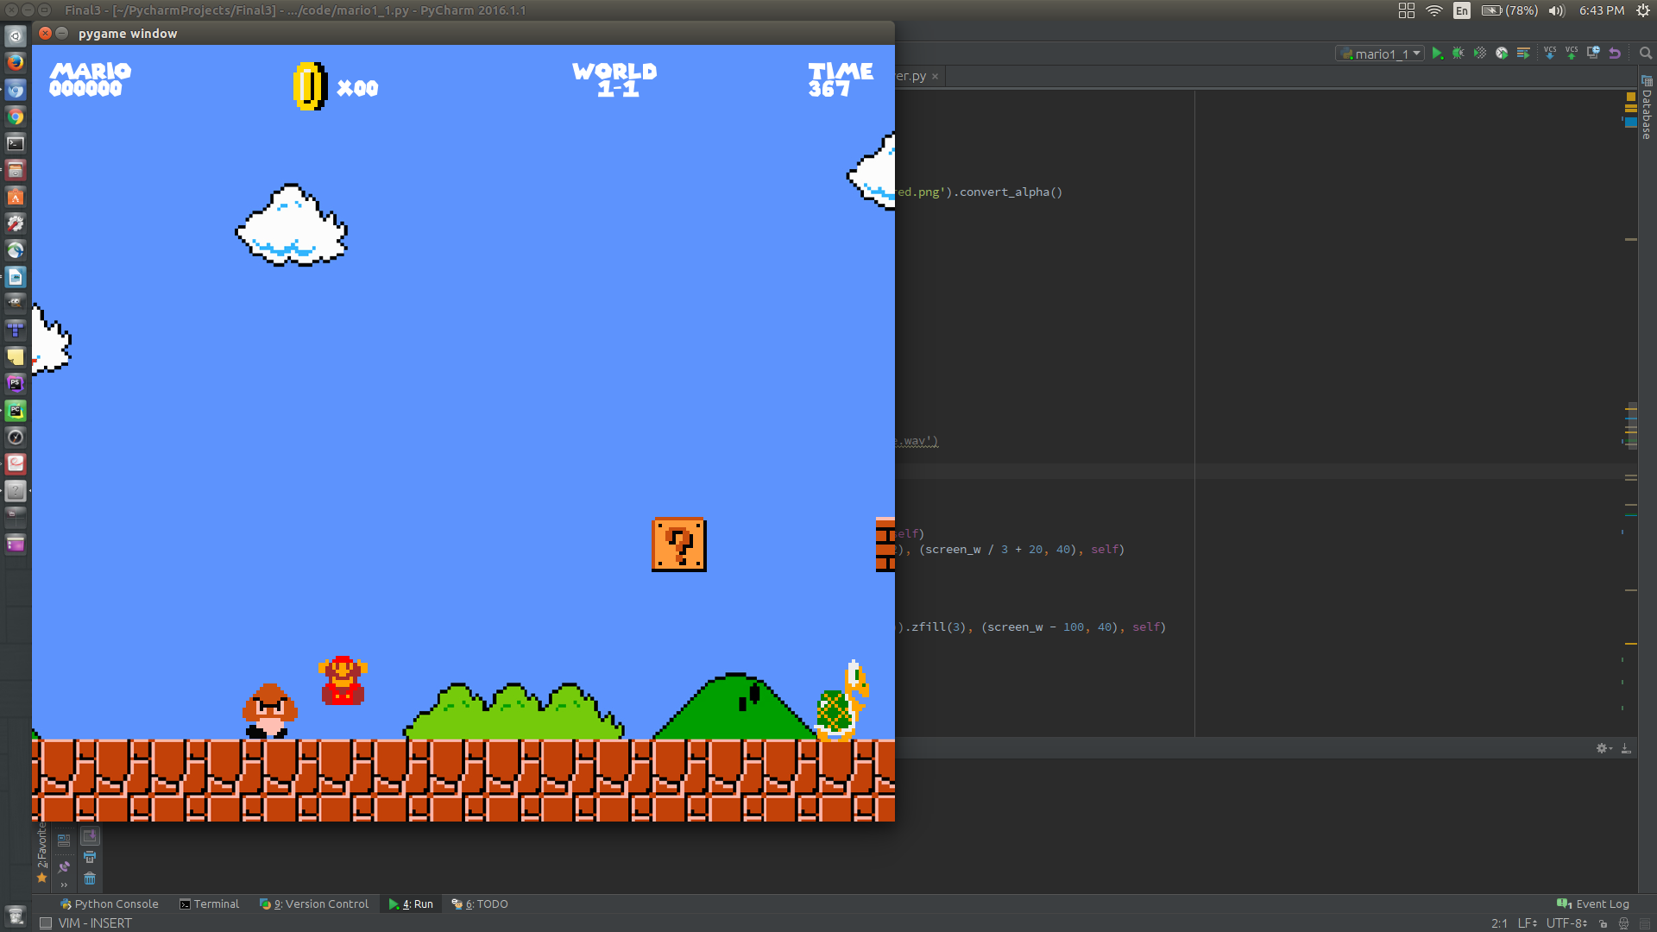

4) Check that the score, the number of coins, and time all update properly.

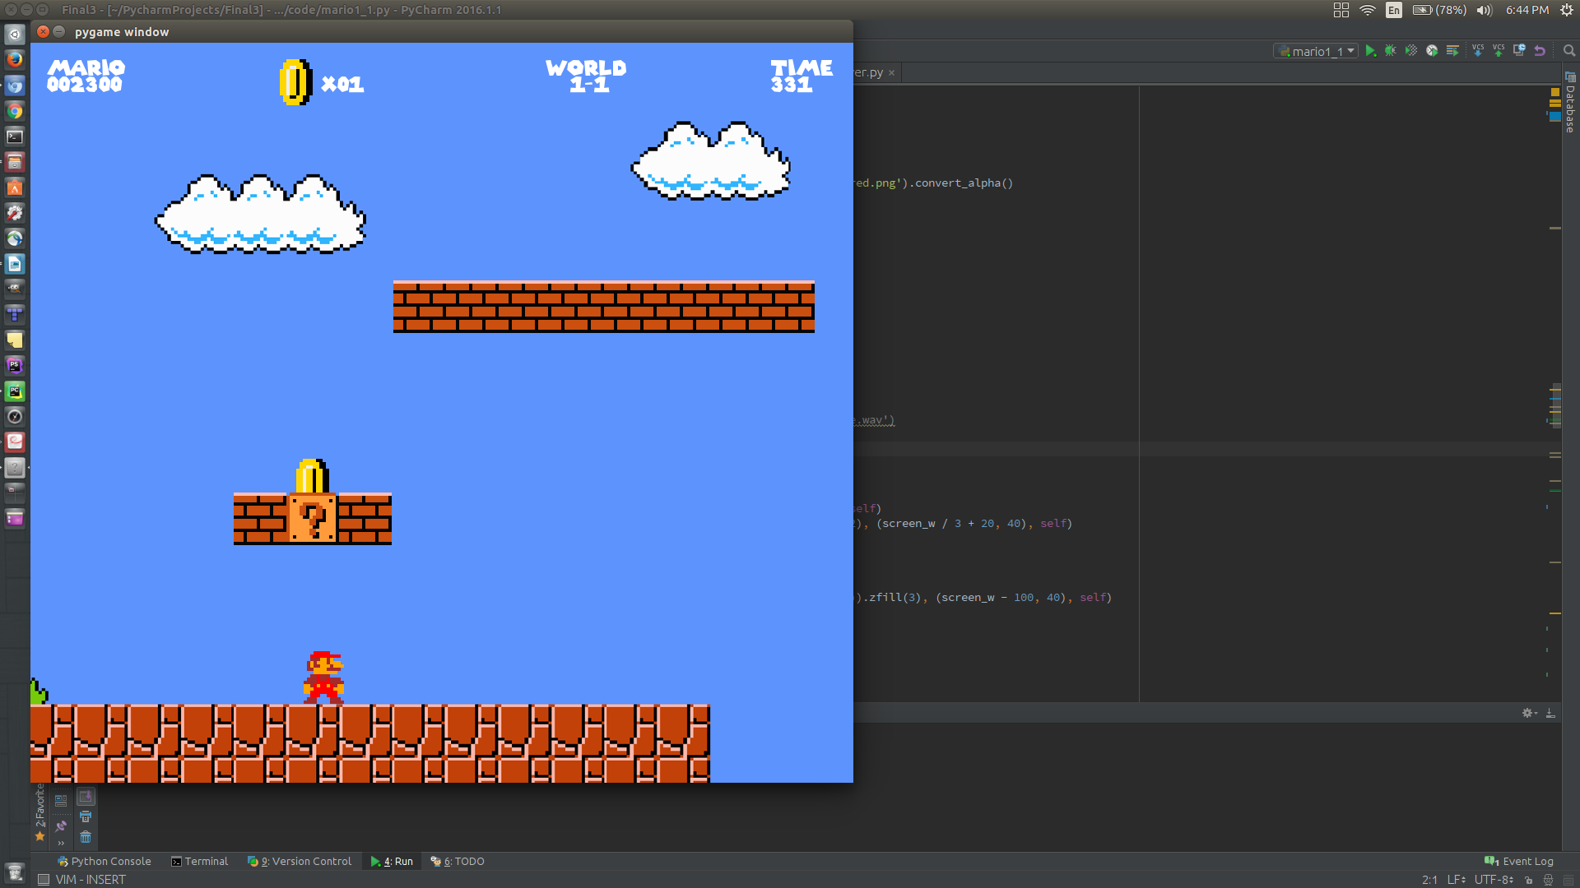

5) Check that when a consumable is consumed, or an enemy killed, the earned score pops and updates properly.

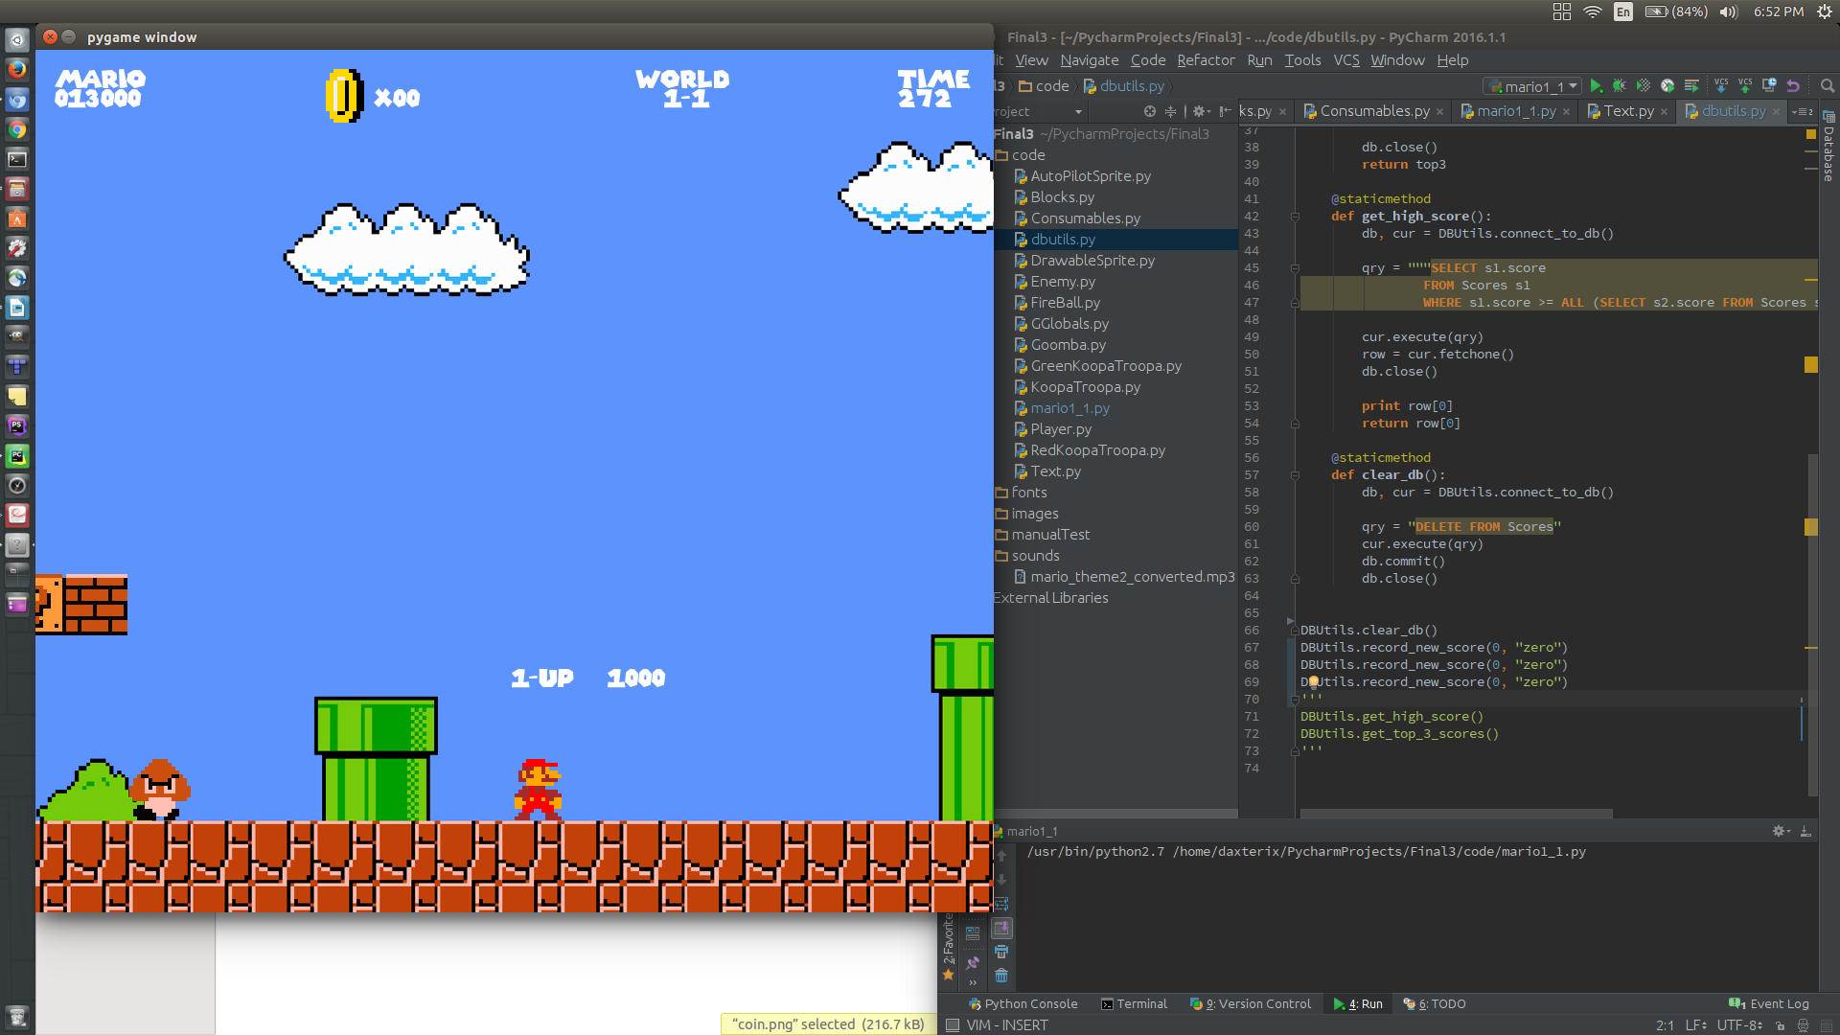

6) Check that the flagpole animation runs properly. When mario collides with the pole, the player should loose control of the game as mario goes through the routine of going down the flagpole, and entering the castle to end the level, leading to the level-complete screen.

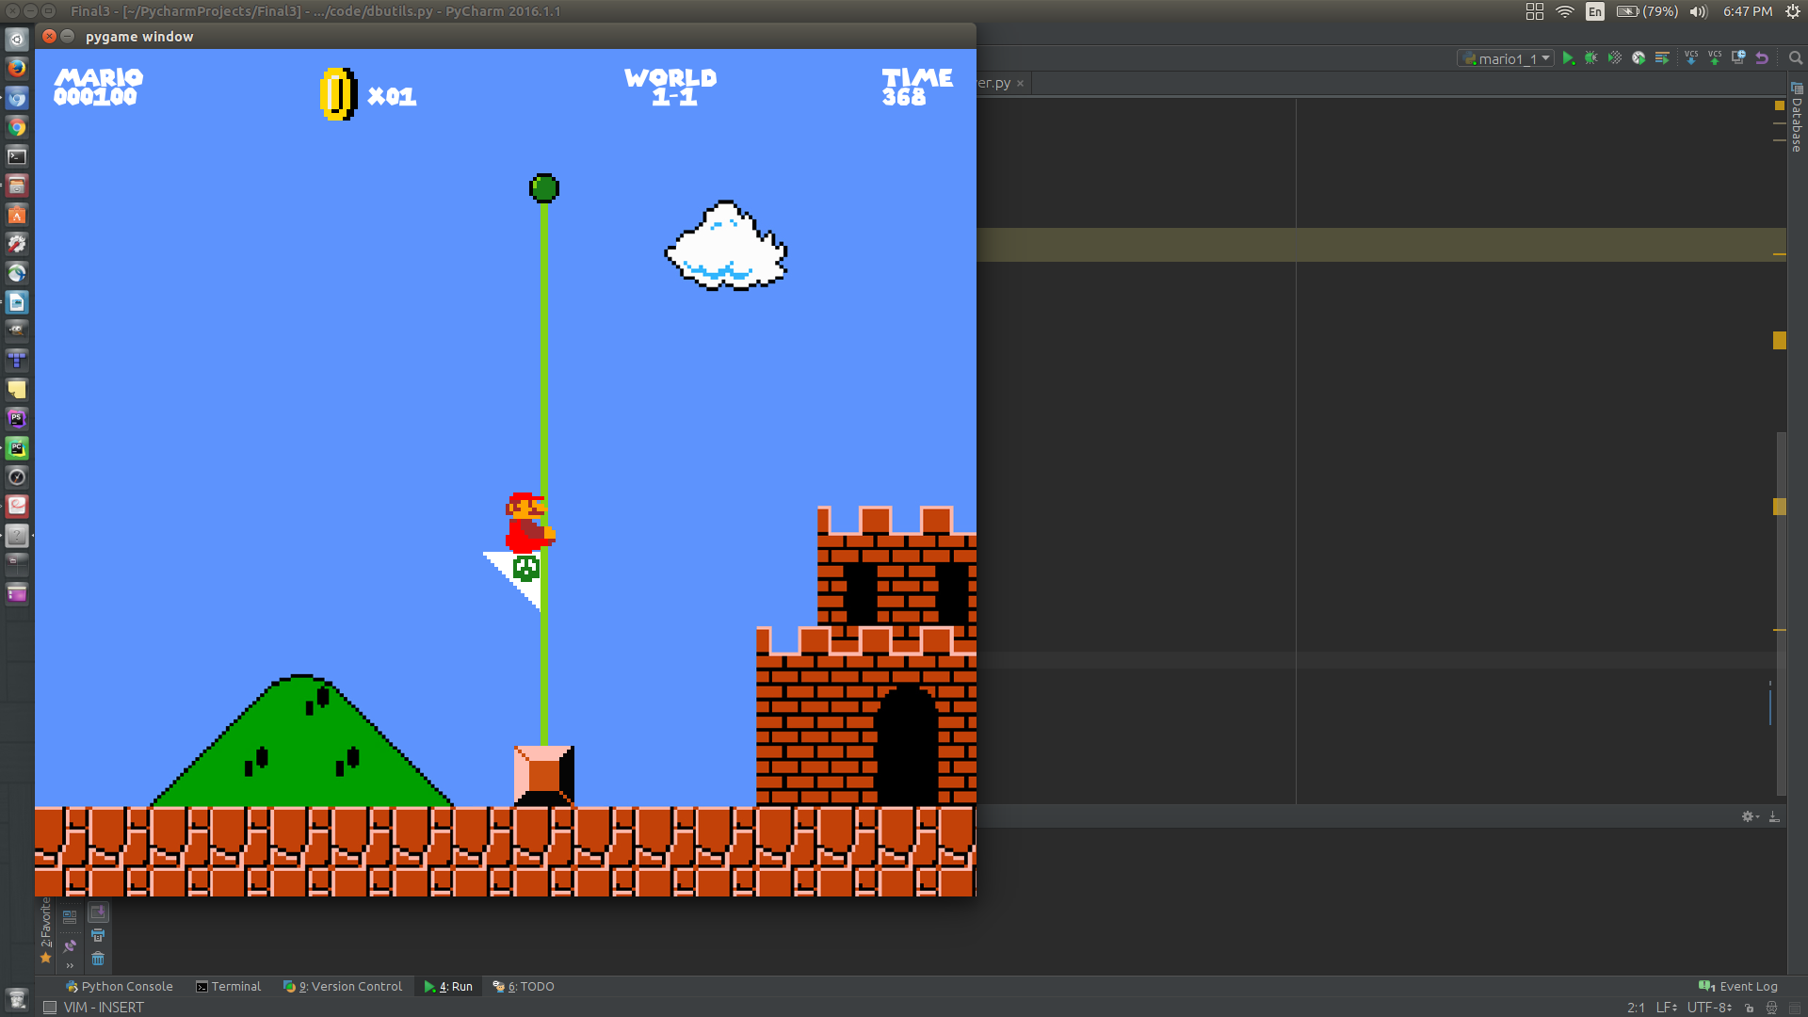

5) After the game check that the high-scores are updated. You can ensure this by running the dbutils.py file which clears the database and inserts dummy low scores. Then play the level, and your score should appear in the leader board along with two others. Your name will be under “Prime User”. Note that I did not clear the database; The dummy scores will be under the name “Zero”

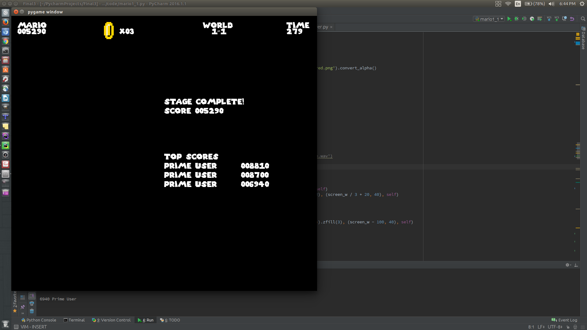

6) also check that running out of time ends the game.