VISITOR CONTROL | 
CLIENT SUPPLIER OTHER
Visitor Identification: |  | Date: |  | Time:
Name: | Passport: |  | Number of visitors:
Company:
Authorization to visit:
Unit | Contact | Received by  (legible name and signature) | Exit time
Suggestions:
For ITAL Reception Use: Exit time: Visitor System (Date and signature):
FQ-08.14 (attached to IT-06.01.13) – RA - revision 09 de 02/18/25 – Page 1/2

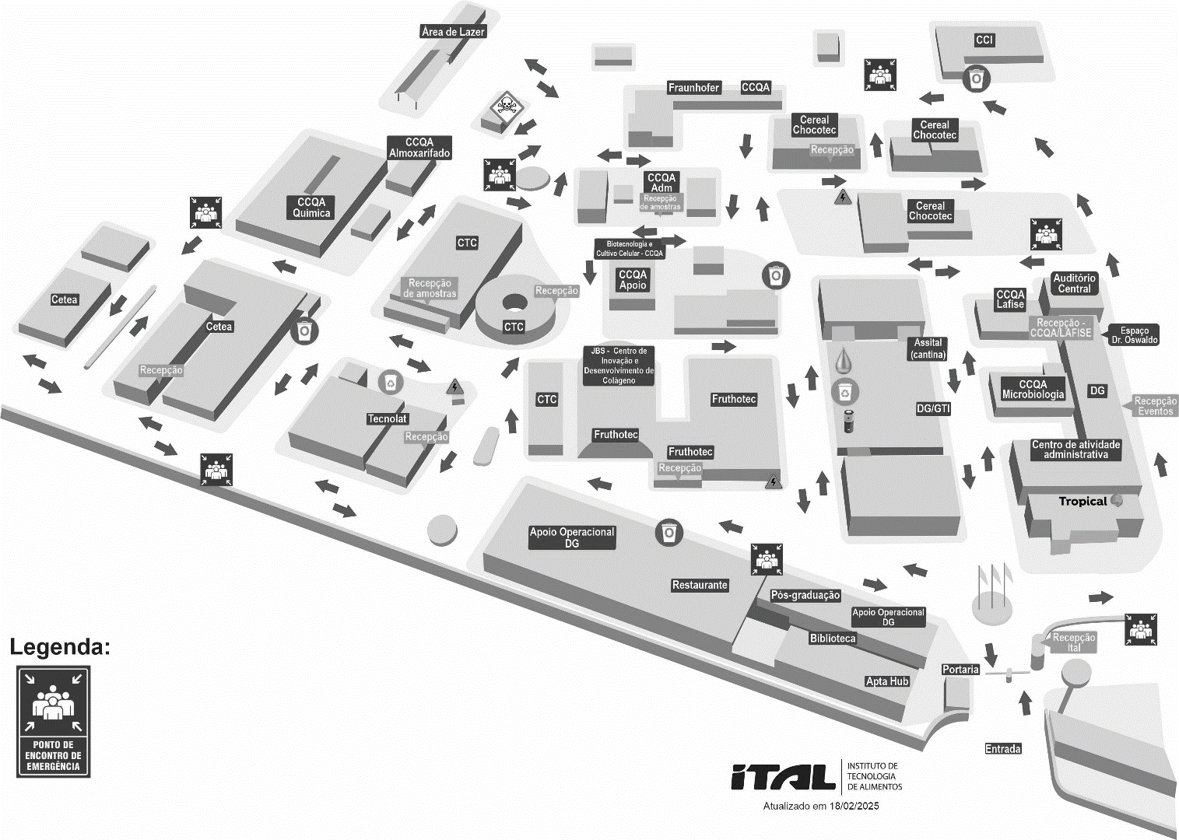
FQ-08.14 (attached to IT-06.01.13) – RA - revision 09 de 02/18/25 – Page 2/2

