OMC-bench and AtomBit-OMC: task-aligned benchmarks and robust, interpretable machine-learned interatomic potentials for organic molecular crystals

Muyu Lu^{1,†}, Chengxi Zhao^{1,†}, Siyu Hu^{2,3,†}, Danyang Chen^{4,†}, Yixi Zhang¹, Man Luo¹, Yaolong Zhang⁷, Zhuoying Zhu^{1,}*, Bin Jiang^{1,5,}*, Fan Yu^{4,}*, Guangming Tan^{2,3,}*, Weile Jia^{2,3,}*, Jun Jiang^{1,5,}*, & Linjiang Chen^{1,6,}*

¹ State Key Laboratory of Precision and Intelligent Chemistry, Hefei National Research Center for Physical Sciences at the Microscale, School of Chemistry and Materials Science, University of Science and Technology of China, Hefei, China
² State Key Laboratory of Processors, Institute of Computing Technology, Chinese Academy of Sciences, Beijing, China
³ University of Chinese Academy of Sciences, Beijing, China
⁴ MindSpore open source project, Huawei Technologies Co. Ltd., Hangzhou, China
⁵ Hefei National Laboratory, University of Science and Technology of China, Hefei, China
⁶ School of Chemistry, School of Computer Science, University of Birmingham, Birmingham, UK
⁷ Department of Chemistry and Chemical Biology, University of N ew Mexico, Albuquerque, NM 87131, USA

† These authors contributed equally: M.L., C.Z., S.H., & D.C.
* Corresponding authors: zyzhuq@ustc.edu.cn (Z.Z.), bjiangch@ustc.edu.cn (B.J.), fan.yu@huawei.com (F.Y.), tgm@ict.ac.cn (G.T.), jiaweile@ict.ac.cn (W.J.), jiangj1@ustc.edu.cn (J.J.), linjiangchen@ustc.edu.cn (L.C.)

Abstract
Organic molecular crystals (OMCs) underpin key applications in pharmaceuticals and functional materials, but accurate atomistic simulation remains difficult because OMC stability depends on subtle noncovalent interactions, conformational flexibility, and polymorphism. Although machine-learned interatomic potentials (MLIPs) have advanced rapidly for inorganic materials, progress for OMCs has been limited by two bottlenecks: the lack of large, physically realistic training data and the lack of task-aligned benchmarks that probe deployment-relevant behaviour. Here we introduce OMC-bench, a benchmark spanning four practical tasks—size extrapolation, lattice dynamics, cocrystal relaxation, and polymorph energy ranking—and an extensive OMC training corpus sampled from near-equilibrium to strongly perturbed regimes. Benchmarking off-the-shelf MLIPs reveals a clear transfer gap, with improved but still task-dependent performance at foundation scale. We then train OMC-specialized models and develop AtomBit-OMC, a new efficient E(3)-equivariant model with physics-informed gating and coupled scalar–equivariant updates. AtomBit-OMC-l achieves strong cross-task performance on OMC-bench, including leading robustness on cocrystal relaxation and polymorph ranking, while yielding chemically interpretable interaction hierarchies, explicably distinguishing covalent, hydrogen-bond, halogen-bond, and weak intermolecular contacts. Together, OMC-bench, the OMC training corpus, and AtomBit-OMC provide a practical foundation for accelerating MLIP development in OMC modelling and discovery.

Main
Machine-learned interatomic potentials (MLIPs) are reshaping atomistic modelling by delivering quantum chemical accuracy at a fraction of the computational cost¹⁻⁴. By learning potential energy surfaces from electronic-structure data, modern graph neural networks and transformer-based architectures enable routine structure optimisation and molecular dynamics at time and length scales that are prohibitive for density functional theory (DFT)¹⁻⁴. These advances have in turn accelerated high-throughput or large-scale atomistic modelling and catalysed the development of foundation-style MLIPs intended to generalise across broad regions of chemical and materials space⁵⁻⁷.

For inorganic materials, MLIPs have progressed rapidly and are now widely used, driven by advances in model design and the availability of large-scale training data. A broad range of architectures—spanning invariant models (e.g., CHGNet⁸, DeepMD⁹) and E(3)-equivariant networks (e.g., SevenNet¹⁰, MACE¹¹)—is routinely applied to problems such as ionic diffusion in electrolyte^{12,13} and crystalline phase transformations^{14,15}. This momentum is underpinned by extensive first-principles datasets, ranging from academic resources (e.g., MPtrj¹⁶, Alexandria¹⁷, OQMD¹⁸) to industrial-scale collections (e.g., OMat24¹⁹, OCx24²⁰, OC25²¹). More recently, trajectory-centric resources such as MatPES and LeMat-Traj have broadened training corpora beyond “snapshot” structures by providing diverse configurations sampled along geometry relaxation and molecular dynamical pathways. MatPES²² offers a carefully sampled, high-fidelity potential-energy-surface dataset together with a property-focused evaluation suite. LeMat-Traj²³ aggregates and standardizes large-scale relaxation trajectories across repositories and DFT functionals, providing dense coverage from far-from-equilibrium states to near-equilibrium, low-force configurations.

There is growing recognition that aggregate regression metrics on random splits are, on their own, inadequate to assess MLIPs’ real-world performance, because random splits can place highly similar structures in both the training and test sets, inflating apparent performance. Therefore, task-aligned, deployment-relevant benchmarks are essential. For example, Matbench Discovery²⁴ evaluates whether MLIPs can accelerate stability screening from unrelaxed input structures using decision-centric metrics (e.g., F1 score and discovery acceleration), rather than relying solely on mean absolute errors. Similarly, benchmarks such as LAMBench²⁵, MLIP Arena²⁶, and MOFSimBench²⁷ also emphasise physically grounded tasks—such as dynamical stability and finite-temperature behaviour—that better reflect how MLIPs are used in practice.

In contrast, organic molecular crystals (OMCs) remain significantly under-served by both datasets and benchmarks, despite their central importance in pharmaceuticals and functional molecular materials^{28,29}. OMCs sit on complex energy landscapes, where conformational flexibility of the molecules and a delicate balance of weak interactions between them—directional hydrogen/halogen bonds alongside non-directional dispersion—jointly determine packing and polymorph stability^{28,29}. Consequently, OMCs often exhibit large, low-symmetry unit cells alongside rich polymorphism and cocrystallization behaviour. Typical computational tasks³⁰⁻³³ in this domain include experimental structure refinement, polymorph energy ranking, cocrystal prediction, and the assessment of thermodynamic stability via molecular dynamics or vibrational analysis.

To help close the data gap for OMCs, the Open Molecular Crystals 2025 (OMC25)³⁴ dataset provides over 25 million structures sampled along geometry-relaxation trajectories. The corpus was generated from more than 230,000 randomly constructed crystals assembled from ~50,000 organic molecules, with intermediate configurations collected during relaxation. Despite its scale, the chemical diversity is capped at ~50,000 distinct molecules, and the dataset excludes multi-component crystals. Importantly, these hypothetical crystals are biased relative to experimental crystals, showing systematically lower mass densities and higher potential energies. Moreover, unlike comprehensive MLIP benchmarks such as Matbench Discovery, OMC25 functions primarily as a static dataset: its evaluation is confined to energy and force regression, without task-aligned evaluations.

As a result, an end-to-end, experimentally grounded data and benchmarking infrastructure for OMCs is still lacking, which is essential for training MLIPs and their subsequent rigorous, task-driven evaluation. Moreover, reliable pretrained models that can serve as practical “drop-in” surrogates for quantum-chemical methods remain scarce. This raises three central questions:

(i) To what extent do MLIPs trained on inorganic materials or isolated organic molecules transfer to OMCs under comprehensive out-of-distribution evaluation?
(ii) Can OMC-trained MLIPs robustly recover experimental packings, resolve polymorph orderings, and predict thermodynamic observables for plug-and-play deployment?
(iii) Can MLIPs be made more transparent, revealing chemically meaningful interaction motifs that govern stability in these delicate lattices?

Here we address these challenges by presenting an MLIP development platform tailored to OMCs. We introduce a carefully curated OMC dataset derived from the Cambridge Structural Database³⁵, together with OMC-bench—an experimentally motivated, task-aligned benchmark designed to stress-test state-of-the-art MLIPs developed for, or applied to, complex and flexible organic lattices. We further present AtomBit-OMC, a new E(3)-equivariant potential trained on this dataset, which achieves improved accuracy, robustness, and interpretability on the thermodynamic and structural targets in OMC-bench compared with general-purpose foundation models. Finally, we release the dataset, the OMC-bench suite, and pretrained models to enable reproducible evaluation and lower the barriers to high-fidelity OMC simulation, helping to bridge machine learning with experimental crystallography and accelerate molecular-crystal discovery.

Results
Curating OMCs from the Cambridge Structural Database (CSD)
In the CSD³⁵, each deposited structure is assigned a unique REFCODE, consisting of a six-letter root plus a two-digit suffix; entries that share the same six-letter root form a REFCODE family, which can include polymorphs and redeterminations of the same molecule. From the CSD, we collected 339,137 experimentally determined OMCs that contain only the elements H, B, C, N, O, F, P, S, Cl, Br, and I, and have fewer than 400 atoms in the crystallographic unit cell. We then applied successive filtering and standardisation steps, concerning crystallographic quality checks, chemical constraints, and deduplication (Fig. 1a), to obtain a curated dataset that broadly reflects experimentally determined OMCs. Finally, we performed DFT-level geometry relaxation for all the 339k OMCs (see Methods for details); ~29,000 entries were removed due to relaxation failures, for example non-converging optimization or structures with unreasonable hydrogen positions.

Elemental diversity in the final curated dataset is summarised in Figs. 1b,c. Each element appears in at least 10,180 structures (with iodine being the least frequent), while the least frequent two-element co-occurrence (I–B) is 502 times. Most element pairs occur thousands to tens of thousands of times. At the molecular level, the dataset comprises 286,872 unique molecules, identified by comparing canonical SMILES generated with RDKit³⁶. This molecular diversity markedly exceeds that of OMC25 (≈50,000 unique molecules). The size distribution shows molecules containing up to 150 atoms (including hydrogens) or 100 heavy atoms (Fig. 1d), while the corresponding crystal structures include up to 400 atoms (including hydrogens) or 250 heavy atoms per unit cell (Fig. 1e). Additional statistics, including space-group distributions, crystal systems, and Z values, are provided in Figs. S1–S5.

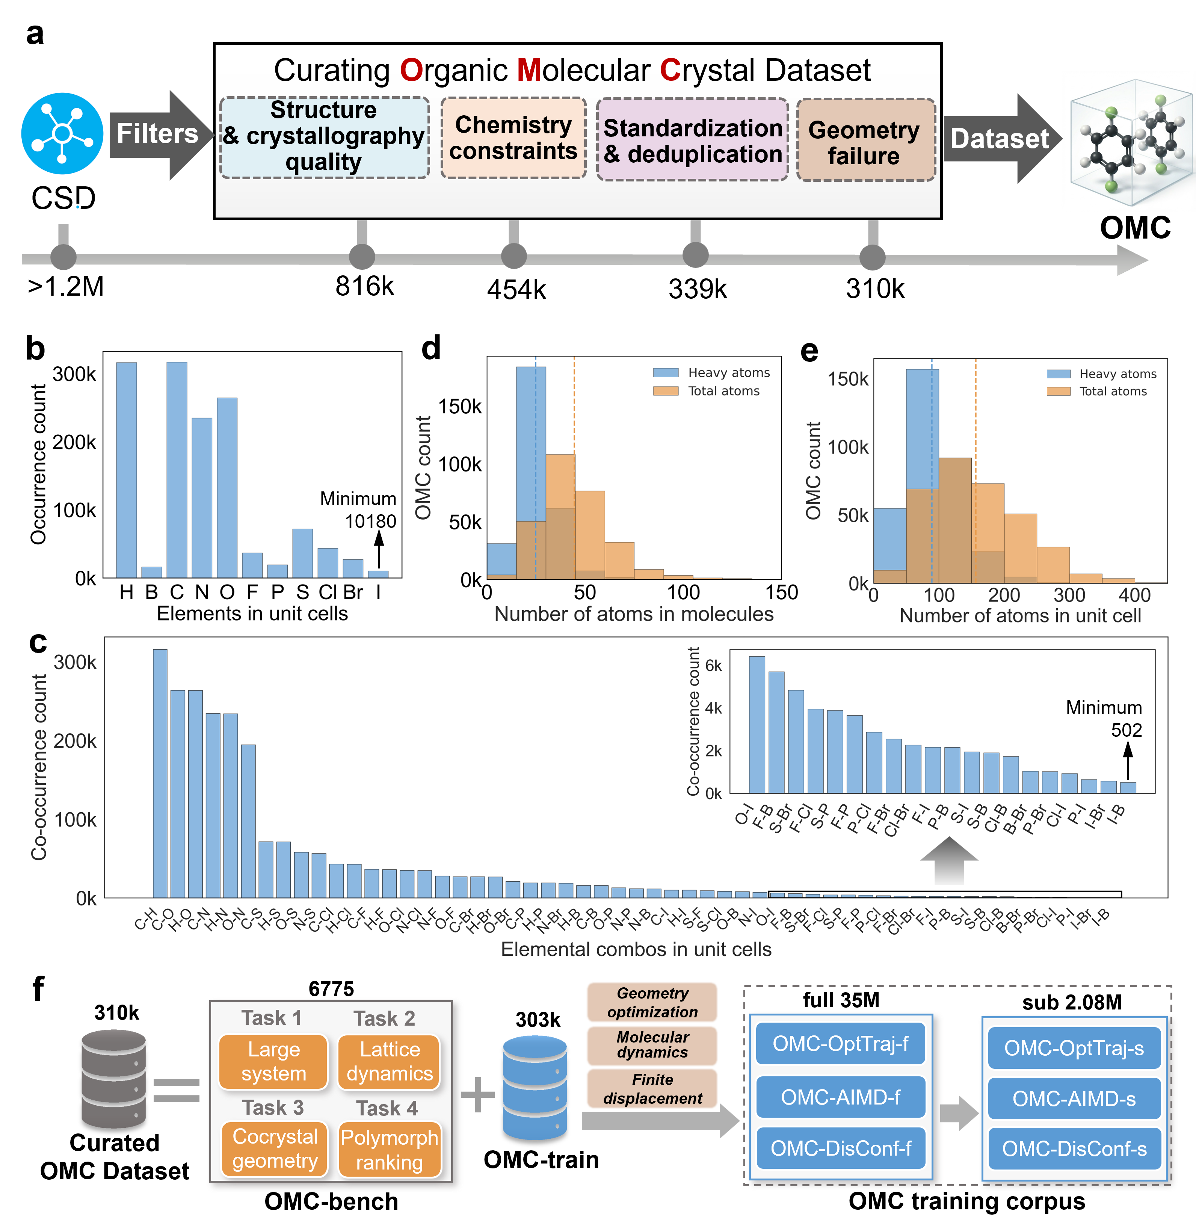
Fig. 1: Overview of the curated organic molecular crystal (OMC) dataset and its OMC-bench and OMC-train subsets. a, Curation pipeline for the OMC dataset. b, Occurrence counts of individual elements in the curated OMCs (element present in the crystallographic unit cell). c, Co-occurrence counts for element pairs in the curated OMCs; inset shows a magnified view of low-frequency pairs. d,e, Distributions of atom counts per molecule (d) and per crystallographic unit cell (e), shown for total atoms and heavy atoms (excluding H atoms); vertical dashed lines indicate the corresponding median values. f, Schematic partitioning of the curated dataset: 6,775 structures were selected to define the OMC-bench subset, comprising four MLIP evaluation tasks, while the remaining ~303k structures form the OMC-train subset, which was used as starting structures to generate a training configuration corpus of nearly 35 million configurations via geometry optimization, molecular dynamics, and finite-displacement perturbations. The suffix “-f” denotes the full dataset, whereas “-s” denotes the sampled subset.

Building OMC-bench
From the curated OMC dataset (310k entries), we selected OMCs to establish OMC-bench (6,775 entries), a rigorous suite of four task-aligned, out-of-distribution (OOD) evaluations; structures not included in OMC-bench instead formed OMC-train (303k), which was used to construct a million-scale training configuration corpus (Fig. 1f). As summarized in Fig. 2, the four tasks probe complementary physical regimes and practical use cases for MLIPs: size extrapolation (Task 1), lattice dynamics (Task 2), cocrystal relaxation (Task 3), and polymorph energy ranking (Task 4). Below we describe the design rationale, candidate-selection pipelines, and evaluation metrics for each task.

Task 1: size extrapolation
Task 1 benchmarks atomic-force and stress-tensor predictions for both off-the-shelf MLIPs and the ones trained here on the OMC training corpus derived from structures with fewer than 300 atoms per unit cell, evaluated on OOD large-cell OMCs with 300–400 atoms per unit cell (Fig. 2a–c). This setting is challenging because many MLIPs show degraded force generalization when extrapolating to larger, previously unseen unit cells. Furthermore, Task 1 emphasizes forces and stresses rather than absolute total energies: direct energy comparisons across models are often ill-posed, since models trained with different exchange–correlation functionals and/or atomic reference energies can differ by arbitrary additive offsets^{37,38}. By contrast, forces and stresses are energy derivatives and are invariant to such offsets, enabling fair cross-model benchmarking without baseline re-alignment.

To build Task 1, we selected 8,357 crystals (300–400 atoms per unit cell) from the curated dataset, spanning 6,285 distinct molecules (Fig. 2b). A 2D SOAP embedding shows these large-cell structures are well separated from OMC-train, consistent with OOD selection (Fig. 2c). Geometry optimizations of these 8,357 structures produced ~440,000 intermediate configurations. We then selected the final evaluation set of Task 1 using a dual-objective farthest-point sampling (FPS) strategy that (i) maximizes distance from OMC-train and (ii) minimizes redundancy within the selected set, yielding 3,099 configurations (all remaining configurations were discarded).

Task 2: lattice dynamics
Lattice dynamics govern the thermodynamic, spectroscopic, and transport behaviour of crystalline materials, such as heat capacity and phonon-mediated thermal conductivity^{39,40}. In OMCs, however, first-principles phonon calculations are often computationally prohibitive because of large, low-symmetry unit cells, and they are especially sensitive in the soft low-frequency regime associated with weak intermolecular interactions and anharmonicity⁴¹. In this setting, MLIPs, once validate, can act as efficient surrogates of their training DFT reference and provide rapid and consistent evaluations of interatomic force constants (IFCs), making large-scale convergence testing, dense sampling, and finite-temperature anharmonic analysis practical.

Task 2 (Fig. 2d–f) evaluates phonon band structures, phonon density of states (PDOS), and PDOS-derived thermodynamic observables. The maximum phonon frequency, 𝜔_{max}, sets the spectral bandwidth and reflects the stiffest intramolecular bonding. For PDOS comparison, the Wasserstein distance is adopted, which penalizes both peak shifts and intensity changes. Benchmarked PDOS-derived thermodynamic quantities include vibrational entropy S(T), Helmholtz free energy A(T), and heat capacity C_{v}(T).

To build Task 2, 600 OMCs with compact asymmetric units (≤8 atoms) were first selected. Following the calculation workflow depicted in Fig. S7, we computed second-order IFCs using finite-displacement phonon calculations and retained 200 systems with dynamically stable DFT-level phonon spectra (Fig. 2e). These spectra capture the characteristic dual nature of OMC vibrations: dispersive, low-frequency intermolecular lattice modes coexisting with localized, high-frequency intramolecular vibrations (Fig. 2f).

Task 3: cocrystal geometry
Organic cocrystals, which contain multiple distinct molecular species, present a more heterogeneous and difficult interaction landscape than single-component crystals^{29,42}. Mixing different molecules can introduce strongly directional interactions and create diverse local environments. As a result, the potential-energy surface is often shallow, with many near-degenerate minima, making geometry optimization highly sensitive to model robustness. Accordingly, Task 3 (Fig. 2g–i) assesses MLIP performance for cocrystal geometry relaxation using two metrics: (i) the optimization failure rate (P) over the full Task 3 set, and (ii) the overall RMSD between MLIP-relaxed structures and their DFT-relaxed references, computed over structures that successfully converge.

The curated OMC dataset (310k entries) contained 70,449 multi-component crystals with 2–7 distinct components (Figs. S8–S9). Because solvates and hydrates can confound cocrystal analysis, we compiled a blacklist of common small-molecule solvents (e.g., methanol, ethanol; Table S2) and excluded binary entries that contain any listed solvent. For higher-order cocrystals (≥3 components), solvent molecules were removed and we retained only entries that still contained at least two distinct components after solvent removal. This filtering yielded 21,020 candidates; the resulting component-count distribution is shown in Fig. S10, with binary cocrystals dominating and progressively fewer higher-order systems.

To select challenging evaluation cases, we performed GFN2-xTB relaxations in parallel with DFT reference optimizations and quantified structural divergence using COMPACK⁴³ (via the CSD Python API). As the selection criterion, we used the number of molecules (out of 15) that remained matched between the two relaxed structures. Fig. 11 shows the distribution of molecule-matching counts across all 21,020 candidates. We then retained systems with large deviations, yielding 2,401 cocrystals for Task 3; that is, cases that are difficult to relax reliably. Fig. 2h shows the distribution of component counts, and Fig. 2i shows the distribution of molecule-matching counts, for the final Task 3 set of 2,401 OMCs.

Task 4: polymorph ranking
Polymorphism is widespread in molecular solids and can strongly affect properties, especially in pharmaceuticals²⁸. Ranking polymorphs^{44,45} is challenging because competing packings of the same composition are often separated by only a few kJ·mol⁻¹, requiring high precision from MLIPs. Task 4 therefore evaluates polymorph energy ranking: whether a model can correctly order competing polymorphs for a given molecule. This task considers two performance metrics: Kendall Pairwise Error (KPE), which quantifies pairwise order inversions, and Full Ranking Accuracy (FRA), which measures exact recovery of the complete ranking.

To obtain robust ranking statistics, we selected REFCODE families with ≥3 genuinely distinct crystal forms; that is, excluding entries that represent essentially the same packing with minor variations, such as different data-collection temperatures. This produced 779 candidate families (≈10,000 entries) from the curated OMC dataset. For each family, all forms were DFT-relaxed, and relative energies (ΔE) were referenced to the lowest-energy form. We retained families with at least three successfully converged forms and removed families containing any form with ΔE > 100 kJ mol⁻¹, yielding a final set of 319 polymorph families. Fig. 2k illustrates this filtering workflow, and Fig. 2l shows the lattice-energy span of each retained family (highest minus lowest energy), grouped by the number of polymorphs in the family.

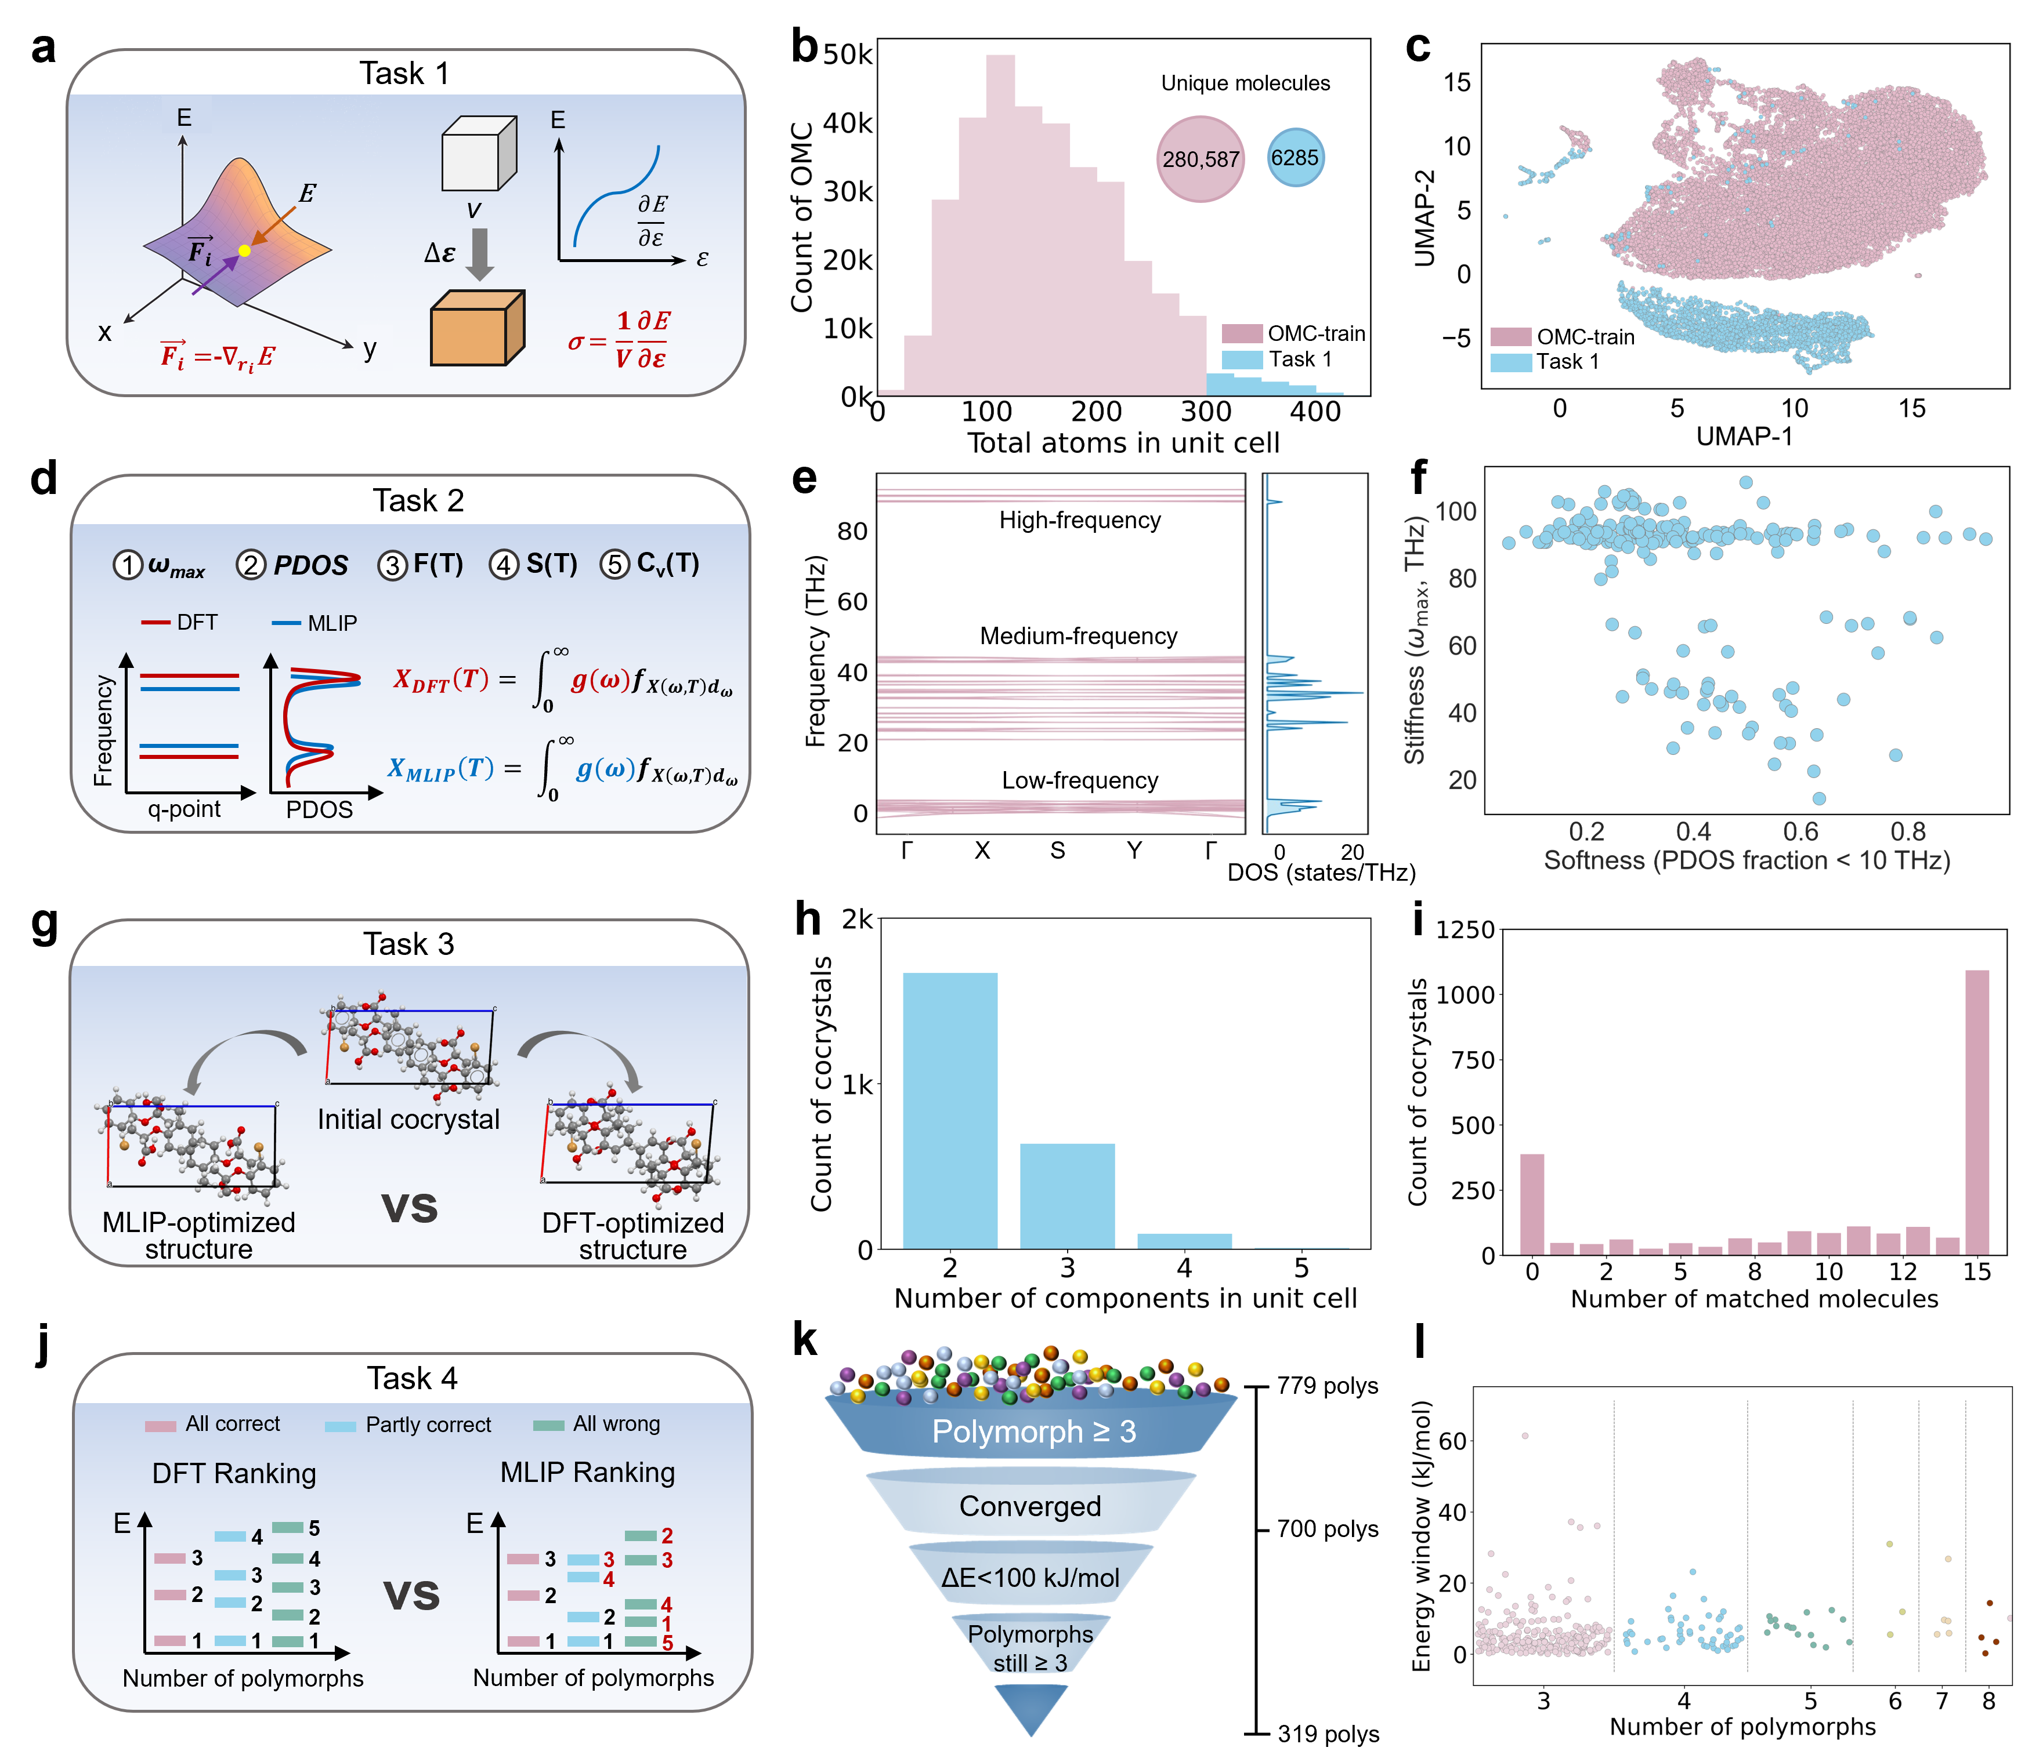

Fig. 2: OMC-bench: four task-aligned out-of-distribution benchmark tasks. a–c, Task 1 (3,099 OMCs): benchmarking MLIPs on atomic forces and crystal stresses; b, unit-cell size distribution (total atoms in unit cell) for the OMCs of Task 1 (in blue) and those of OMC-train (in pink); inset shows numbers of unique molecules in each case; c, UMAP embedding of SOAP descriptors of the OMCs, showing Task 1 OMCs separated from OMC-train OMCs. d–f, Task 2 (200 OMCs): phonon band structures, PDOS, and PDOS-derived thermodynamic properties compared with DFT; e, representative phonon band structure and PDOS for a Task 2 OMC; f, softness–stiffness map for all Task 2 OMCs. g–i, Task 3 (2401 OMCs): geometry optimization of multicomponent cocrystals against DFT references; h, distribution of the number of components per cocrystal unit cell; i, COMPACK-determined molecule-matching statistics between GFN2-xTB and DFT relaxations for Task 3 OMCs. j–l, Task 4 (1097 OMCs): polymorph energy ranking within REFCODE families against DFT; k, filtering funnel defining the selection of polymorph families for Task 4; l, energy-window distribution versus the number of polymorphs per family.

Physically grounded construction of the OMC training corpus
The OMC training corpus was constructed from OMC-train, which contains ~303k entries and is strictly non-overlapping with OMC-bench at both the crystal and molecular levels (Fig. 1f). OMC-train provides quantum-chemically optimized experimental structures, and it alone is insufficient for training robust MLIPs, which requires coverage of both near-equilibrium and off-equilibrium configurations⁴⁶. Therefore, OMC-train was used as seeds with their potential-energy surfaces sampled using different protocols under a unified DFT setup (see Methods for details): geometry-optimization trajectories, high-temperature molecular dynamics, and symmetry-aware finite displacements.

First, we relaxed raw, experimental CSD structures and retained trajectories that converged within the computational setting, yielding ~303k valid trajectories and ~14.4 million configurations. Most structures were straightforward to geometry-optimize, with a mean molecular RMSD of 0.15 Å (Fig. S16), consistent with generally short relaxation paths (Fig. S12); some older CSD deposits contain incomplete crystallographic information (for example, missing H atoms), resulting in optimization failures. Following evidence^{46,47} that curated subsets can outperform indiscriminate full-data training, we subsampled the ~303k trajectories to define OptTraj-OMCs (Figs. 3a,b). For each trajectory, sampling was anchored at the final converged frame, and the remaining frames were selected iteratively by farthest-point sampling (Fig. 3b): at each step, we chose the configuration with the largest minimum distance (in descriptor space) to the already selected set. This strategy enforced diversity of the subsampled set and preserved representative near-equilibrium and off-equilibrium states.

Second, for each system we initiated ab initio molecular dynamics (AIMD) from its final DFT-relaxed structure and ran simulations at 600 K and 1 GPa in the isothermal–isobaric (NPT) ensemble to sample thermally distorted configurations, generating 19.4 million frames. To reduce temporal correlation and account for slower heavy-atom motion, trajectories were downsampled to approximately one frame every 110 fs, yielding the AIMD-OMCs subset (Fig. 3c,d). Third, we generated systematically perturbed configurations by applying symmetry-aware, fixed all-atom displacements (Fig. 3e). Unlike stochastic perturbation approaches⁴⁸, displacement amplitudes were systematically chosen under symmetry constraints to sample both harmonic and anharmonic regions. To remove nonphysical structures (for example, unrealistic bond lengths and large energy spikes; Fig. 3f), we applied a strict CSD-based covalent-bond filter, eliminating ~67% of generated frames (Fig. 3g) and yielding DisConf-OMCs. These sampling protocols produced a 35-million-configuration OMC corpus. The four subsets—OMC-bench, OptTraj-OMCs, AIMD-OMCs, and DisConf-OMCs—contain 6775, 1,218,025, 170,103, and 686,093 structures, respectively. Together, they span both near-equilibrium and strongly perturbed regions of configuration space.

As shown in Fig. 3h–j, the three training subsets are complementary. Relative to OptTraj-OMCs, AIMD-OMCs and DisConf-OMCs are shifted to higher energies (Fig. 3h), consistent with increasing departure from relaxed minima. The force distribution broadens markedly across subsets, with median |F|_{max} rising from 0.25 (OptTraj) to 5.49 (AIMD) and 8.92 eV Å⁻¹ (DisConf), and DisConf-OMCs contributing the widest high-force tail (Fig. 3i). Stress distributions are centered near zero but become progressively broader from OptTraj to AIMD to DisConf (Fig. 3j), with DisConf-OMCs showing an extended positive-stress tail consistent with fixed-cell atomic displacements. Together, these subsets provide balanced coverage from near-equilibrium to far-from-equilibrium OMC configurations.

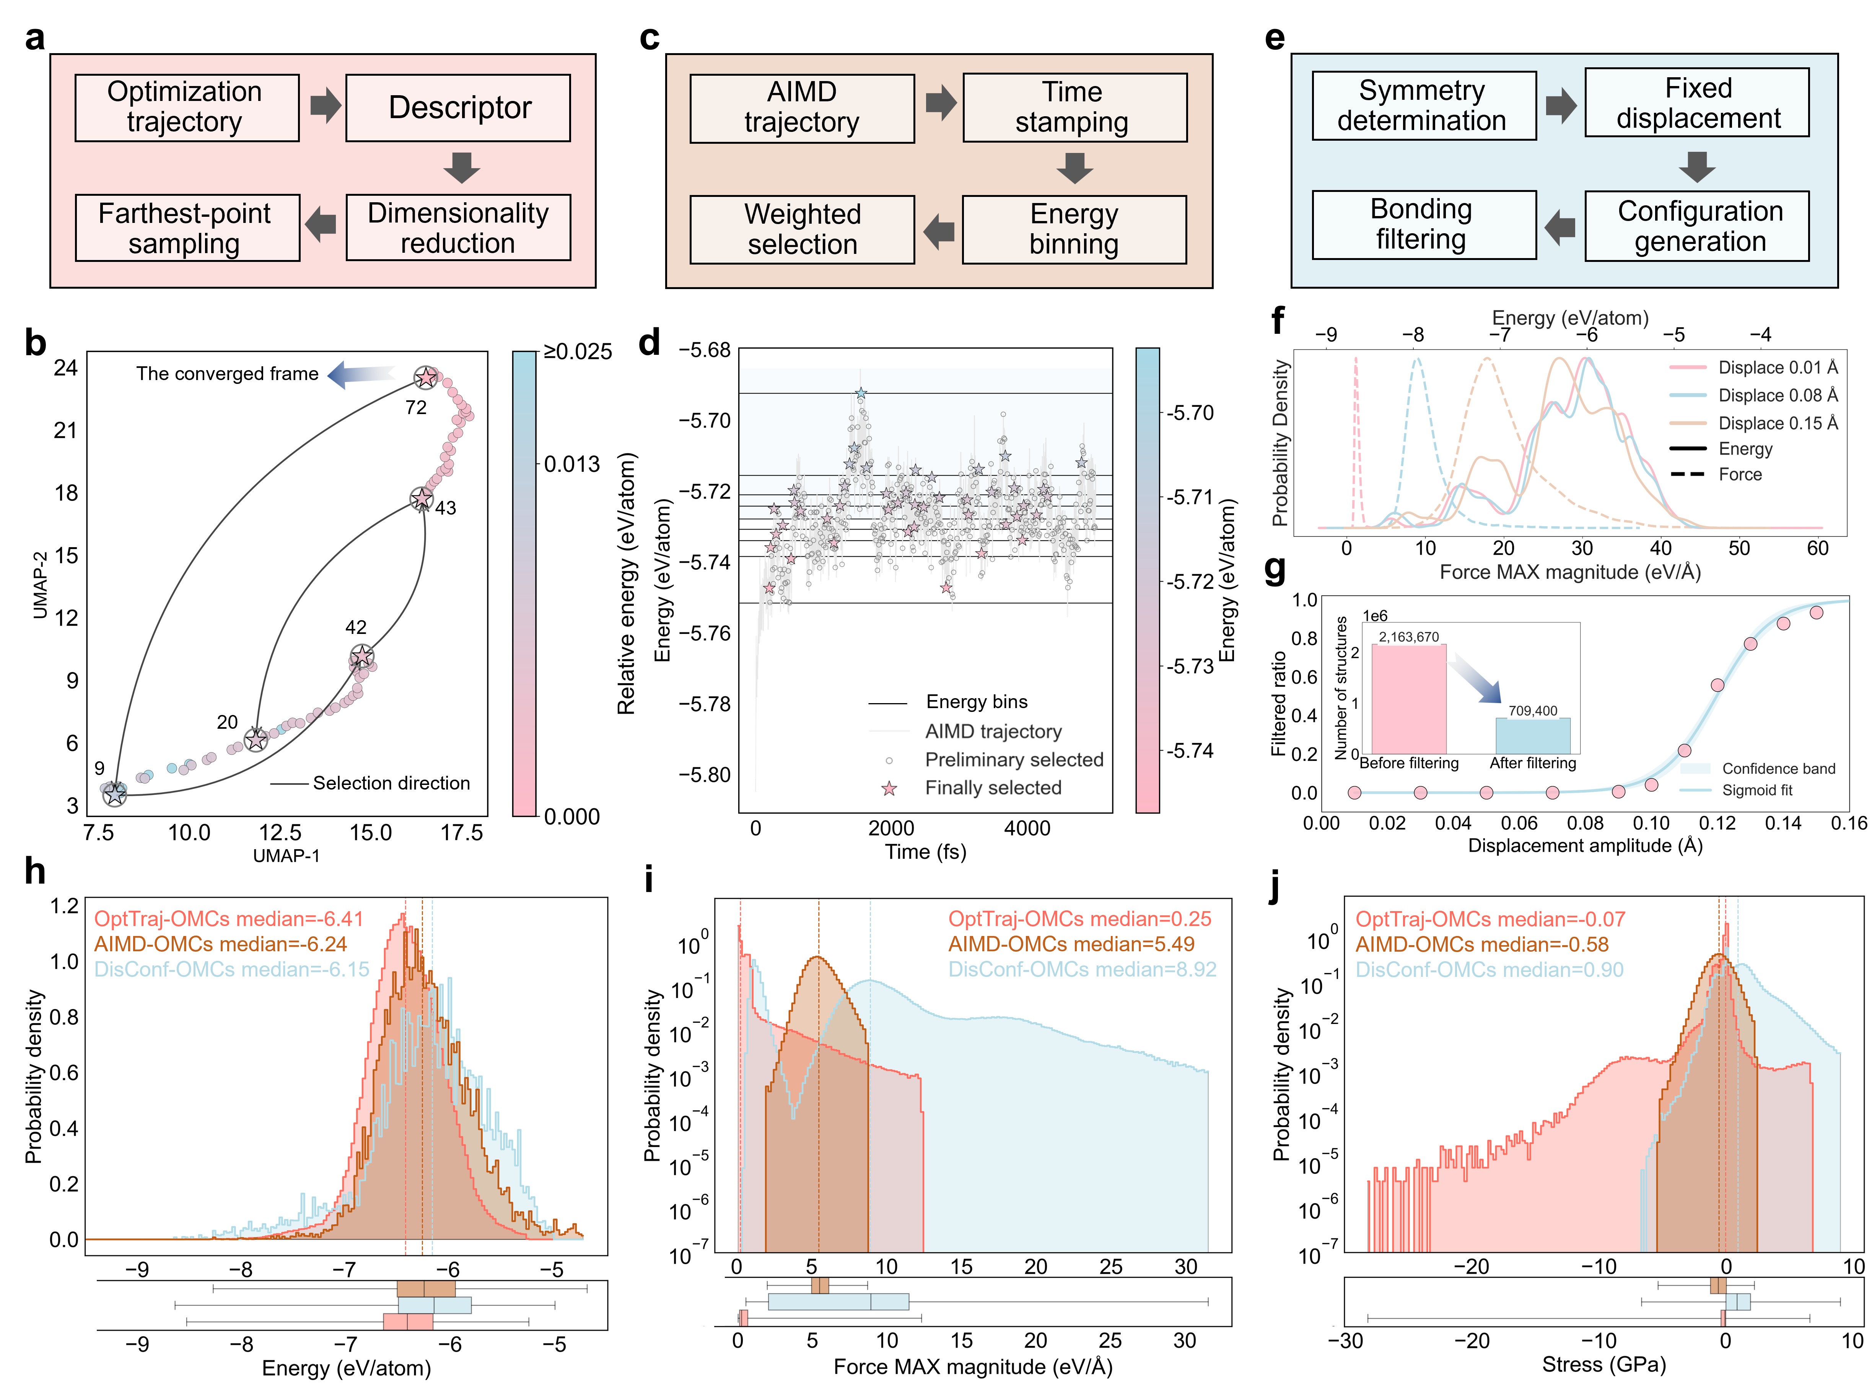
Fig. 3: Multi-regime configuration sampling for the OMC training corpus. a,b, Sampling from geometry-optimization trajectories: the pipeline (a) and an example optimization trajectory in 2D UMAP descriptor space (b). c,d, Sampling from high-temperature AIMD: the pipeline (c) and an example AIMD trajectory (energy vs time), with preliminary candidate frames, energy bins, and final selected frames (d). e–g, Sampling from symmetry-aware finite displacements: the pipeline (e), energy and maximum-force distributions for representative displacement amplitudes (f), and retention ratio after bond-length filtering as a function of displacement amplitude (g), with sigmoid fit and confidence band (the inset shows total frame counts before and after filtering). h–j, Distributions for the three sampled subsets (OptTraj-OMCs, AIMD-OMCs, and DisConf-OMCs): per-atom energy (h), per-configuration maximum force magnitude (i), and stress (j), with median values indicated.

Benchmarking off-the-shelf MLIPs and developing OMC-specialized models
To establish baseline transfer performance, we first evaluated off-the-shelf MLIPs on OMC-bench and then introduced OMC-specialized training motivated by the observed gaps. All models were assessed on the same four OMC-bench tasks (Table 1). For external pretrained baselines, overlap between their original training sets and OMC-bench cannot be fully excluded; this potential concern applies only to UMA-md, whose pretraining corpora include OMCs (Fig. S19).

A useful interpretation of the off-the-shelf results is to separate models into two groups: smaller MLIPs (GRACE-1L-OAM to DPA-3.1-MPtrj in Table 1), which have lower parameter counts and/or smaller training corpora, and larger foundation-type MLIPs (ORB v3 to UMA-md), which combine greater capacity with broader pretraining data. Across OMC-bench, larger models are generally more robust under OOD conditions, whereas smaller models show sharper performance degradation. However, this should be viewed as an empirical trend rather than a strict scaling law, because model size, training objective, data composition, and potential overlap are confounded.

Training on the OMC corpus substantially changes this picture. Domain-specialized models (NEMP-OMC to AtomBit-OMC-l) significantly improve performance across all tasks: Matris-OMC is strongest on large-system force and stress prediction, whereas AtomBit-OMC-l is strongest on robustness-oriented tasks, including cocrystal relaxation and polymorph ranking. Lattice-dynamics metrics also improve with OMC-specialized models, indicating that domain training better captures the physical regimes probed by OMC-bench.

Overall, the results support two complementary routes. First, substantially scaling general-purpose foundation MLIPs can narrow the OMC transfer gap: UMA-md shows consistently strong performance across OMC-bench, indicating that sufficiently large model size and training data scale can transfer effectively to this domain (UMA’s train corpus included OMCs). Second, OMC-specialized training still provides targeted gains, improved interpretability (discussed below), and competitive performance at more manageable model sizes for practical deployment.

Table 1: Task-wise performance of off-the-shelf and OMC-specialized MLIPs on OMC-bench.
MLIP | Parameters /  Training data | F  ↓ | σ  ↓ | ω_{max}  ↓ | W₁  ↓ | S(T)  ↓ | A(T)  ↓ | C_{v}(T)  ↓ | P  ↓ | RMSD  ↓ | KPE  ↓ | FRA  ↑
GRACE-1L-OAM⁴⁹ | 3.45M/113M | 134.7 | 0.68 | 3.73 | 10.1 | 24.19 | 19.15 | 8.03 | 41.1 | 1.00 | 0.48 | 16.4
MACE-MP-0⁵ | 4.69M/1.58M | 121.4 | 0.55 | 3.20 | 10.6 | 42.78 | 25.57 | 13.90 | 29.5 | 0.79 | 0.43 | 18.5
AlphaNet-v1-OMA⁵⁰ | 4.65M/113M | 120.1 | 0.84 | 2.70 | 9.6 | 31.05 | 16.96 | 10.25 | 16.4 | 0.53 | 0.48 | 17.0
MACE-MPA-0⁵ | 9.06M/12M | 103.4 | 1.09 | 2.23 | 9.5 | 20.35 | 11.73 | 7.35 | 24.5 | 0.69 | 0.46 | 14.8
CHGNet⁸ | 413k/1.58M | 113.6 | 0.53 | 8.17 | 10.4 | 29.31 | 29.34 | 10.80 | 16.6 | 0.54 | 0.43 | 17.9
SevenNet-13i5¹⁰ | 1.17M/1.58M | 97.9 | 0.67 | 2.18 | 9.1 | 26.95 | 12.86 | 5.99 | 14.4 | 0.48 | 0.45 | 17.6
Eqnorm MPtrj⁵¹ | 1.31M/1.58M | 91.8 | 0.62 | 2.32 | 9.6 | 34.94 | 16.45 | 7.09 | 15.2 | 0.50 | 0.43 | 17.3
Nequix MP⁵² | 708k/1.58M | 86.9 | 0.73 | 2.00 | 11.0 | 33.61 | 15.47 | 6.48 | 8.2 | 0.36 | 0.42 | 22.5
DPA-3.1-MPtrj⁵³ | 4.81M/1.58M | 85.5 | 0.61 | 3.66 | 10.2 | 32.57 | 21.02 | 9.38 | 18.5 | 0.56 | 0.42 | 21.6
ORB v3⁵⁴ (conserve) | 25.5M/133M | 76.0 | 0.70 | 19.82 | 49.7 | 198.19 | 99.06 | 99.03 | 66.4 | 1.39 | 0.44 | 6.8
Matris-OAM⁵⁵ | 10M/113M | 51.7 | 0.62 | 7.10 | 21.4 | 81.21 | 38.82 | 34.41 | 8.1 | 0.28 | 0.46 | 15.1
eSEN-30m-OAM⁵⁶ | 30.2M/113M | 24.5 | 0.75 | 1.30 | 9.7 | 33.17 | 12.28 | 4.17 | 13.8 | 0.47 | 0.42 | 20.4
UMA-md⁵⁷ | 50M active/484M | 22.9 | 0.36 | 0.87 | 8.5 | 9.81 | 3.96 | 2.31 | 0.8 | 0.07 | 0.26 | 39.8
NEMP-OMC | 630k/2.08M | 29.1 | 0.15 | 2.90 | 9.8 | 16.24 | 8.62 | 4.15 | 1.1 | 0.12 | 0.30 | 35.2
MACE-OMC | 975k/2.08M | 36.9 | 0.29 | 0.89 | 10.0 | 18.24 | 8.94 | 1.95 | 1.0 | 0.10 | 0.27 | 35.5
Matris-OMC | 4.3M/2.08M | 13.9 | 0.09 | 4.49 | 10.0 | 39.35 | 21.20 | 19.33 | 2.8 | 0.12 | 0.24 | 39.2
AtomBit-OMC-s | 400k/2.08M | 41.5 | 0.13 | 1.59 | 9.9 | 14.02 | 7.36 | 4.93 | 0.9 | 0.10 | 0.25 | 39.8
AtomBit-OMC-l | 1.1M/2.08M | 35.6 | 0.12 | 1.45 | 8.6 | 8.99 | 5.93 | 3.46 | 0.5 | 0.08 | 0.23 | 41.7
Task 1: MAE of atomic forces F (meV Å⁻¹) and stress σ (GPa). Task 2: MAE of maximum phonon frequency ω_{max} (THz); PDOS Wasserstein-1 distance W₁; MAE of entropy S(T) and heat capacity C_{v}(T) (J mol⁻¹ K⁻¹); and MAE of Helmholtz free energy A(T) (kJ mol⁻¹). Task 3: geometry-optimization failure rate P (%) and structural RMSD (Å). Task 4: Kendall pairwise error (KPE) and full-ranking accuracy (FRA, %). AtomBit suffixes “s” and “l” denote small and large variants, respectively. In ORB, “conserve” denotes force evaluation from energy derivatives. In UMA-md, “active” denotes 50M model parameters activated for each structure. The node-equivariant message-passing (NEMP) MLIP is adopted from ref. ⁵⁸. Arrows indicate desirable direction: ↑ indicates higher is better; ↓ indicates lower is better. Best value in each metric is shown in bold; second-best is shown with underline.

AtomBit-OMC: robust optimization and chemically interpretable interactions
Motivated by the transfer gaps identified on OMC-bench, we developed AtomBit-OMC, an E(3)-equivariant model designed for robust optimization and chemically interpretable predictions. AtomBit combines a physics-informed gating mechanism, which conditions message passing on local chemical and geometric context, with a coupled update scheme linking scalar and equivariant channels to preserve expressive directional information (Extended Data Fig. 1). AtomBit models were trained from scratch on the OMC training corpus, using a cost-aware dynamic sampler designed to balance variable graph workloads and thereby maximizing training throughput (Extended Data Fig. 2).

Across OMC-bench, AtomBit-OMC-l delivered the strongest overall performance, with particularly clear gains on cocrystal relaxation and polymorph ranking. Fig. 4a further shows the optimization robustness of both AtomBit variants: they typically converged in fewer steps, with a much weaker long-tail in step counts than baseline models (including UMA-md). This behavior indicates stable optimization across chemically and structurally diverse OMCs, including large-unit-cell systems and higher-order cocrystals.

A key strength of AtomBit is the interpretability of its learned interactions. In the porous HOF example (Fig. 4b), the learned interaction strengths follow a chemically intuitive hierarchy: covalent bonds are strongest, weak intermolecular contacts are weakest, and hydrogen bonds are intermediate. Similarly, in the system containing both hydrogen and halogen bonding (Fig. 4c), AtomBit assigns the nearly linear C–I···N halogen bond a strength greater than generic dispersion contacts but lower than the hydrogen bond in the same structure. Together, these results show that the gating mechanism captures physically meaningful interaction patterns—rather than only opaque statistical correlations—and provides a mechanistic basis for AtomBit’s strong task-level performance (see also Fig. S22).

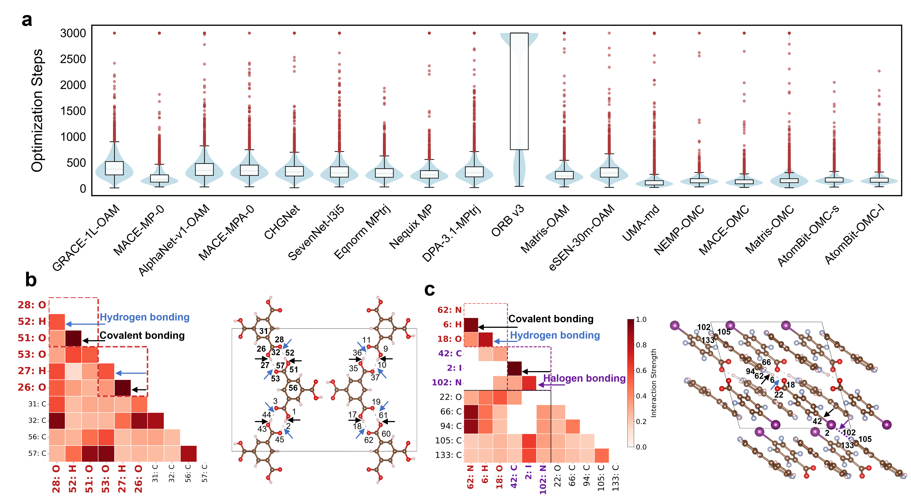
Fig. 4: Robustness and chemical interpretability of AtomBit-OMC. a, Distribution of geometry-optimization steps to convergence across OMC-bench tasks for all compared models (violin + box plots; red points indicate long tails). AtomBit variants show concentrated low-step distributions and reduced long-tail behavior, consistent with robust convergence. b,c, Interaction-strength maps from AtomBit-OMC-l gating in representative OMCs: a hydrogen-bonded organic framework (b) and a structure containing both hydrogen and halogen bonding (c). The learned gate weights recover chemically meaningful hierarchies, distinguishing covalent bonds, directional noncovalent motifs (H and halogen bonds), and weaker intermolecular contacts.

Discussion
This study establishes a benchmark-first framework for evaluating MLIPs in organic molecular crystals. By design, OMC-bench probes four distinct deployment regimes—size extrapolation, lattice dynamics, cocrystal geometry, and polymorph ranking. The benchmark also reveals a clear domain gap and an empirical scale trend for off-the-shelf models: larger foundation-level models are generally more robust, and UMA-md demonstrates that sufficiently large model size and training data corpus can transfer strongly to OMC tasks.

At the same time, model and/or data scaling is not the only route. OMC-specialized training on a physically grounded corpus provides significant gains even for small models, particularly in tasks where subtle noncovalent competition and shallow energy landscapes dominate outcomes. Within this setting, AtomBit-OMC-l offers a strong practical balance of robustness, ranking fidelity, and interpretability at manageable deployment cost (at only 1.1M model parameters). The interaction patterns learned by AtomBit are consistent with established chemical intuition, which is particularly important for linking model predictions to physically meaningful bonding motifs and enabling more trustworthy application to unseen systems.

Finally, this work provides foundational resources for MLIP development in OMCs, including (i) a large, physically grounded training corpus spanning near-equilibrium to strongly perturbed configurations, (ii) a task-aligned OOD benchmark that stress-tests models against deployment-relevant failure modes, (iii) and OMC-specialized models, particularly AtomBit-OMC-l that combine strong robustness with chemically interpretable interaction patterns. Together, these components form a practical closed-loop framework—train on realistic data, diagnose with task-level metrics, and refine architectures using interpretable chemical signals—that can accelerate reliable MLIP development for OMC modelling and discovery.

Methods
CSD filtering
The raw dataset was queried from the Cambridge Structural Database (CSD) using ConQuest and the CSD Python API. In total, 339,137 OMC entries were retained after sequential filtering. Entries were required to have determined 3D coordinates, no disorder, no reported errors, non-polymeric chemistry, single-crystal provenance, and organic composition with fewer than 400 atoms per unit cell. Hydrogen positions were normalized with default settings. Entries containing deuterium were removed. Allowed elements were restricted to H, B, C, N, O, F, P, S, Cl, Br, and I. Duplicate structures were then removed with the CSD Python API.

General DFT settings
DFT calculations were performed with the Vienna Ab initio Simulation Package (VASP v6.4.3)⁵⁹ using the plane-wave pseudopotential framework. Electron-ion interactions were treated with the projector augmented-wave (PAW) method⁶⁰. Exchange-correlation energies were described by the Perdew–Burke–Ernzerhof (PBE) ⁶¹ functional with D3 dispersion correction and Becke-Johnson damping⁶²⁻⁶⁴. Sensitivity and convergence analyses are provided in Figs. S13-S14. A plane-wave cutoff of 600 eV was used throughout. Brillouin-zone sampling used a Gamma-centered k-point mesh with KSPACING = 0.4 Å⁻¹. Electronic self-consistency was reached when the total-energy change between iterations was below 10⁻⁶ eV.

Phonon and thermodynamic properties
The crystal potential energy can be expanded as a Taylor series with respect to atomic displacements. Second-order interatomic force constants (IFCs) define the dynamical matrix D(q), whose eigenvalues and eigenvectors yield phonon frequencies and modes at each wavevector q (see Note S2 for details).

Following Fig. S7, reference structures were fully relaxed until the maximum residual force was below 0.001 eV Å⁻¹. Harmonic IFCs were computed with finite displacements and a displacement amplitude of 0.01 Å (using Phonopy³⁹). Supercells were constructed to ensure a minimum lattice-vector length of 12 Å. Non-analytical corrections were included by calculating Born effective charges and dielectric tensors. The phonon calculation parameters followed the default settings in atomate2^{40,65}, a high-throughput workflow framework.

Phonon band structures were generated with SeeK-path⁶⁶ to define high-symmetry reciprocal-space paths. For PDOS and thermodynamic properties, Brillouin-zone integration used a uniform 20 × 20 × 20 q-mesh, verified for convergence. From converged phonon frequencies ω(q,j), we computed PDOS and harmonic vibrational thermodynamic functions: Helmholtz free energy A(T) (kJ mol⁻¹), entropy S(T) (J mol⁻¹ K⁻¹), and constant-volume heat capacity C_{v}(T) (J mol⁻¹ K⁻¹).

Cocrystals and polymorphs
Cocrystal and polymorph structures were optimized with DFT until the maximum residual force on any atom was below 0.01 eV Å⁻¹. Cocrystals were also optimized with GFN2-xTB, a self-consistent tight-binding method with multipole electrostatics and density-dependent dispersion, using DFTB+^{67,68}. Electronic self-consistency used an SCF tolerance of 10⁻⁶ electrons. Ionic relaxations used GradElem = 1.94 × 10⁻⁴ au (about 0.01 eV Å⁻¹, consistent with DFT), with the rational optimizer in the DFTB+ driver.

Optimized cocrystals were compared with their DFT references using the CSD COMPACK algorithm. Structural agreement was evaluated by best-matching superpositions of up to 15 molecules with a distance tolerance of 0.2 Å and an angular tolerance of 20 degrees (default COMPACK settings).

Training corpus generation
For training-corpus generation, geometry optimizations were run until the maximum residual force on any atom was below 0.05 eV Å⁻¹. AIMD simulations were performed at 600 K and 1 GPa for 5 ps with a Langevin thermostat (friction coefficient 10 ps⁻¹ per atom). Single-point energy calculations used NSW = 0.

Fixed all-atom displacements and bonding filters
To generate additional off-equilibrium configurations, fixed all-atom displacements were applied at amplitudes {0.01, 0.08, 0.15, 0.20, 0.30} Å. The number of perturbation seeds N for each structure was chosen according to point-group symmetry following Zhu et al.⁴⁰:

$N=round\left({\sqrt{{48}/{N_{symm}}}}/2\right)$. (eq. 1)

where N is the number of point-group symmetry operations (48 for the highest symmetry, for example O_{h}). Division by 2 accounts for site multiplicity (approximately half the number of atoms in the primitive cell), so highly symmetric cells receive fewer seeds.

Atomic connectivity from fully relaxed equilibrium structures was used as the reference topology. A CSD covalent-radii bond-length filter was then applied to remove unphysical perturbed structures, including unrealistic overlaps and broken bonds. For atoms A and B with covalent radii r_{A} and r_{B}, the nominal covalent contact distance was defined as:

$S=r_{A}+r_{B}$. (eq. 2)

Chemically motivated bounds were then imposed on any putative covalent A−B contact:

$d_{min}=ατS=0.70τ\left(r_{A}+r_{B}\right)$, $d_{max}=βτS=1.15τ\left(r_{A}+r_{B}\right),$ (eq. 3)

where the lower bound controls excessive short-range repulsion, the upper bound allows environment-driven bond expansion, and delta is a tolerance factor. Any perturbed structure containing an A-B pair with a distance outside these bounds was rejected.

Computational costs for data generation
Data generation consumed about 1.3 × 10⁷ CPU core-hours and 2.0 × 10⁵ GPU-hours in total. CPU core-hours and GPU-hours are defined as wall-clock time multiplied by the number of CPU cores and GPUs used, respectively.

Subsampling for OMC-bench tasks
Crystal structures were featurized with the Smooth Overlap of Atomic Positions (SOAP)⁶⁹ descriptors computed with DScribe⁷⁰ in the “outer” setting. We used a cutoff radius of 6 Å, l_{max} = 6, and 8 radial basis functions to capture relevant non-covalent interactions; other hyperparameters were kept at default values. For each configuration, the SOAP vector was concatenated with a global composition fingerprint to form a joint descriptor. For Task 1, the joint descriptor was first reduced by principal component analysis (PCA)⁷¹, retaining the minimum number of components required to preserve at least 99% variance. The reduced features were then embedded into 2D with Uniform Manifold Approximation and Projection (UMAP)⁷².

Dual-objective farthest-point sampling (FPS) was performed on this manifold; at each iteration, the next sample was chosen from the remaining pool by maximizing a dual-objective score. This favors points that are far from the training corpus and well separated from already selected samples, producing a validation set that stresses generalization while maintaining broad coverage.

AtomBit model architecture
The AtomBit architecture is shown in Extended Data Fig. 1. It contains an initialization block, N equivariant interaction layers, and a readout block. Atomic systems are represented as geometric graphs with atoms as nodes and pairwise interactions within a cutoff as edges. Periodic boundary conditions are handled via lattice shifts.

In initialization, atomic numbers are mapped to learnable scalar embeddings to initialize node features at each layer, while higher-order tensor channels are initialized to zero:

$h_{i}^{0,l=0}=embedding\left(Z_{i}\right)$, $h_{i}^{0,1}=0$, $h_{i}^{0,2}=0$, (eq. 4)

where h denotes node features of rank L possessing F feature channels.

For each pairwise interaction i-j, relative position vectors $r_{ij}=r_{j}-r_{i}$ and interatomic distances $d_{ij}=\left\|r_{ij}\right\|$ are encoded into a geometric basis set $B_{ij}=\left\{B_{n,ij}^{0}+B_{n,ij}^{1}+B_{n,ij}^{2}\right\}$. The scalar basis $B_{n,ij}^{0}$ is constructed via radial Bessel functions multiplied by a polynomial envelope to ensure continuous differentiability at r_{cut}. Higher-order basis functions are subsequently derived from the scalar basis and the normalized direction vector ${\hat{r}}_{ij}$:

$B_{n,ij}^{1}=B_{n,ij}^{0}∙{\hat{r}}_{ij}$, $B_{n,ij}^{2}=B_{n,ij}^{0}∙\left({\hat{r}}_{ij}⊗{\hat{r}}_{ij}-\frac{1}{3}I\right)$. (eq. 5)

Node features are updated iteratively through a stack of N interaction layers. Each layer comprises three sequential operational blocks: coupling, gating, and density blocks (Extended Data Fig. 1b-d).

The coupling block computes raw messages $m_{ij}$ by coupling source node features $h_{i}^{L_{in}}$ with the edge geometric basis $B_{n,ij}^{edge}$ via tensor products, preserving E(3)-equivariance. A message of target rank $L_{out}$ is computed as:

$m_{ij}^{\left(L_{out}\right)}=\sum_{p∈paths\left(L_{out}\right)}{{TensorProd}_{p}\left(\left(W_{p}h_{i}^{\left(L_{in, p}\right)}\right),B_{n,ij}^{\left(L_{edge, p}\right)}\right)}$, (eq. 6)

where $W_{p}$ denote learnable linear projections. TensorProd includes operations such as dot products, cross products, outer products, and matrix-vector products to transfer information across tensor ranks.

Subsequently, raw messages are modulated by a scalar gate $g_{ij}$ in the gating block⁷³, designed to explicitly disentangle chemical affinities from geometric constraints. The gate is calculated via a sigmoid activation applied to the summation of a chemical score (computed via dot-product attention over node embeddings) and a physical score (derived from an MLP applied to geometric projections):

$s_{chem}={\left(W_{Q}h_{i}^{\left(0\right)}\right)}^{T}\left(W_{K}h_{j}^{\left(0\right)}\right)$,
$s_{phys}={MLP}_{phys}\left(concat\left[B_{n,ij}^{0},{\hat{r}}_{ij}∙W_{P}h_{j}^{\left(1\right)},{\hat{r}}_{ij}∙W_{P}h_{i}^{\left(1\right)}\right]\right)$, and (eq. 7)
$g_{ij}=C_{scale}∙sigmoid\left(s_{chem}+s_{phys}\right)$.

The final gated message is given by ${\tilde{m}}_{ij}^{L}=g_{ij}∙m_{ij}^{L}$. This mechanism suppresses interactions that may be chemically favourable but geometrically disallowed.

In the density block, incoming messages from neighbours $i∈N\left(j\right)$ are aggregated at the target node j to constitute local atomic “densities” $ρ_{j}^{L}$:

$ρ_{j}^{L} = \sum_{i ∈ N\left(j\right)}{{\tilde{m}}_{ij}^{L}}$. (eq. 8)

To facilitate feature updates, rotationally invariant scalars $I_{j}$ are derived from these densities (e.g., $I_{j} = \left[ρ_{j}^{\left(0\right)}∥|ρ_{j}^{\left(1\right)}|∥|ρ_{j}^{\left(2\right)}|\right]$). A scalar MLP computes the update for $L=0$ features, which subsequently modulates the updates for higher-order features:

${∆h}_{j}^{\left(0\right)}={MLP}_{scalar}\left(I_{j}\right)$, ${∆h}_{j}^{\left(L>0\right)}={MLP}_{scale}({∆h}_{j}^{\left(0\right)})⊙{(W}_{L}ρ_{j}^{L})$. (eq. 9)

Finally, node features are updated via a residual connection:

$h_{j}^{\left(L\right),l+1}=h_{j}^{\left(L\right),l}+{∆h}_{j}^{\left(L\right)}$. (eq. 10)

The total potential energy of the system, $E_{total}$, is determined by summing element-specific reference energies $E_{0}\left(Z_{i}\right)$ and contributions from the scalar features aggregated at each layer:

$E_{total}=\sum_{i}{E_{0}\left(z_{i}\right)}+\sum_{l=1}^{N_{layers}}{\sum_{i}{{\text{ReadoutMLP}}^{\left(l\right)}\left(h_{i}^{\left(0\right),l+1}\right)}}$. (eq. 11)

This layer-wise readout captures energy contributions across different scales of local atomic environments.

Training procedure
Random batching causes severe workload imbalance for variable-size graphs. We therefore used a cost-aware dynamic sampler that constructs compute-balanced batches with a cost proxy instead of a fixed number of graphs. The procedure has two steps (Extended Data Fig. 2). First, the cost C_{i} of sample i is estimated from its numbers of nodes N_{i} and edges E_{i}:

$C_{i}=N_{i}+γE_{i}$, (eq. 12)

where $γ$ is the dataset-specific atom-to-edge normalization ratio. Samples are sorted by descending cost C_{i} (Extended Data Fig. 2a). Second, batches are formed with a greedy First-Fit Decreasing strategy under a maximum per-GPU cost. Samples are packed into the current batch until the limit is reached (Extended Data Fig. 2b,c), improving memory utilization (Fig. S23).

AtomBit-OMC-s (64 channels, 3 layers, $r_{cut}=6$ Å) and AtomBit-OMC-l (128 channels, 2 layers, $r_{cut}=7$ Å) were trained in FP32 on 8 H100 GPUs for 15 epochs in PyTorch, with an exponential moving average (decay 0.999) and OneCycle learning-rate scheduling (LR 10-5 to 10-3 to 10-6, 10% warmup). AtomBit training and inference is also supported on Ascend NPU with MindSpore (Fig. S24). The loss jointly optimized energies, forces, and stresses with equal weights (10:10:10); additional settings are provided in Note S4.

Evaluation metrics
Implementation information for OMC-bench reported in Table 1 is provided in Note S3. Model accuracy for scalar properties (e.g., ω_{max} and thermodynamic properties) and vector/tensor quantities was evaluated with mean absolute error (MAE). Unless noted otherwise, units are: meV Å⁻¹ for forces F, GPa for stress σ, THz for phonon frequency ω, J mol⁻¹ K⁻¹ for entropy S and heat capacity C_{v}, and kJ mol⁻¹ for Helmholtz free energy A. Force MAE was computed by aggregating component-wise errors over all atoms in each structure and averaging across M test structures:

$\text{MA}{\text{E}}_{\text{force}}=\frac{1}{M}\sum_{i=1}^{M}{\left(\frac{1}{3N_{i}}\sum_{a=1}^{N_{i}}{\sum_{k∈x,y,z}{\left|{\hat{F}}_{i,a,k}-F_{iac}\right|}}\right)}$, (eq. 13)

where a indexes the atoms, and k denotes the Cartesian components. Similarly, crystal stress MAE was computed by averaging over the six independent Voigt components (σ_{xx}, σ_{yy}, σ_{zz}, σ_{yz}, σ_{xz}, σ_{xy}) for each structure.

To compare predicted and reference PDOS, we used the 1-Wasserstein (W₁) distance (Earth Mover's Distance) between normalized spectral distributions. For cumulative distribution functions $U\left(f\right)$ and $V\left(f\right)$, the distance W₁ is defined as:

$W_{1}=\int_{-∞}^{+∞}{\left|U\left(f\right)-V\left(f\right)\right|df}$. (eq. 14)

For cocrystal relaxation, structural recovery was assessed using CSD COMPACK. The unmatched, or geometry-optimization failure, rate P is the percentage of structures that fail to match DFT references within preset tolerances. Geometric deviation was quantified by root mean squared deviation (RMSD, Å) after optimal atom mapping:

$\text{RMSD}=\sqrt{\frac{1}{N}\sum_{a=1}^{N}{{\left|x_{a}-x_{a}^{'}\right|}^{2}} }$, (eq. 15)

where N is the number of atoms, and $x_{a}$ and $x_{a}^{'}$ are the Cartesian coordinates of the matched atoms in the reference and predicted structures, respectively.

For polymorph energy ranking, preservation of relative stability is evaluated using the Kendall pairwise error (KPE)⁷⁴ and full-ranking accuracy (FRA). KPE is the fraction of discordant pairs (ranking inversions) within a polymorph family:

$KPE=\frac{D}{n\left(n-1\right)/2}$, (eq. 16)

where D is the number of discordant pairs and n is the total number of polymorphs in the family.

To analyze overlap in model failure modes, we computed pairwise Jaccard similarity on high-error subsets. Let $S_{m}⊂\{1,…,N$} denote the difficult-sample set for model m, identified as samples above the 95th percentile of task-specific errors. The overlap between two models m and n is quantified as:

$J\left(m,n\right)=\frac{\left|S_{m}∩S_{n}\right|}{\left|S_{m}∪S_{n}\right|}∈\left[0,1\right]$. (eq. 17)

Pairwise overlaps form a Jaccard matrix $J∈R^{K×K}$, where each entry measures how often two MLIPs fail on the same samples. Larger values indicate stronger concentration of errors on shared difficult cases.

Data availability
Data supporting the findings of this study are available in the paper and its Supplementary Information. A leaderboard reporting MLIP performance on OMC-bench, detailed descriptions of OMC-bench tasks, descriptions of the benchmarked MLIP models, and the OMC-bench dataset (6,775 DFT-optimized CSD entries) are available at https://aisci.ustc.edu.cn/mlip-omcs/#/. The 35-million-configuration OMC training corpus and the OMC-train dataset (~303k DFT-optimized CSD entries) are available from the Cambridge Crystallographic Data Centre (CCDC) at https://www.ccdc.cam.ac.uk/free-products/csd-omc-mlip-collection/ (to be activated upon publication). We acknowledge the CCDC for access to CSD data; the shared datasets were reviewed and approved by the CCDC, and permission to share these data was obtained from the CCDC.

Code availability
All code and scripts developed and used in this study are available at https://github.com/pic-ai-robotic-chemistry/OMC-bench.

References
1 Omranpour, A., Elsner, J., Lausch, K. N. & Behler, J. Machine learning potentials for heterogeneous catalysis. ACS Catalysis 15, 1616-1634 (2025).
2 Kalita, B., Gokcan, H. & Isayev, O. Machine learning interatomic potentials at the centennial crossroads of quantum mechanics. Nature Computational Science 5, 1120-1132 (2025).
3 Yang, H. et al. A Deep Learning Atomistic Model Across Elements, Temperatures and Pressures. arXiv preprint arXiv:2405.04967 (2024).
4 Xia, J., Zhang, Y. & Jiang, B. The evolution of machine learning potentials for molecules, reactions and materials. Chemical Society Reviews (2025).
5 Batatia, I. et al. A foundation model for atomistic materials chemistry. The Journal of chemical physics 163 (2025).
6 Plé, T. et al. A Foundation Model for Accurate Atomistic Simulations in Drug Design. ChemRxiv 2025.
7 Wood, B. M. et al. UMA: A Family of Universal Models for Atoms. arXiv preprint arXiv:2506.23971 (2025).
8 Deng, B. et al. CHGNet as a pretrained universal neural network potential for charge-informed atomistic modelling. Nature Machine Intelligence 5, 1031-1041 (2023).
9 Zhang, D. et al. DPA-2: a large atomic model as a multi-task learner. npj Computational Materials 10, 293 (2024).
10 Park, Y., Kim, J., Hwang, S. & Han, S. Scalable parallel algorithm for graph neural network interatomic potentials in molecular dynamics simulations. Journal of chemical theory and computation 20, 4857-4868 (2024).
11 Batatia, I., Kovacs, D. P., Simm, G., Ortner, C. & Csányi, G. MACE: Higher order equivariant message passing neural networks for fast and accurate force fields. Advances in neural information processing systems 35, 11423-11436 (2022).
12 Wang, F., Tang, Y.-H., Ma, Z.-B., Jin, Y.-C. & Cheng, J. Domain oriented universal machine learning potential enables fast exploration of chemical space of battery electrolytes. Nature Communications (2025).
13 Angeletti, A. et al. Hydrogen diffusion in magnesium using machine learning potentials: a comparative study. npj Computational Materials 11, 85 (2025).
14 Zhao, C., Liu, H., Qu, D.-H., Cooper, A. I. & Chen, L. A machine learned potential for investigating single crystal to single crystal transformations in complex organic molecular systems. Chemical science 16, 2363-2372 (2025).
15 Lu, M. et al. Efficient fine‑tuning of foundation atomistic models for reversible polymorphic phase transitions in organic molecular crystals. ChemRxiv 2025.
16 Jain, A. et al. Commentary: The Materials Project: A materials genome approach to accelerating materials innovation. APL materials 1 (2013).
17 Schmidt, J. et al. Improving machine-learning models in materials science through large datasets. Materials Today Physics 48, 101560 (2024).
18 Saal, J. E., Kirklin, S., Aykol, M., Meredig, B. & Wolverton, C. Materials design and discovery with high-throughput density functional theory: the open quantum materials database (OQMD). Jom 65, 1501-1509 (2013).
19 Barroso-Luque, L. et al. Open materials 2024 (omat24) inorganic materials dataset and models. arXiv preprint arXiv:2410.12771 (2024).
20 Abed, J. et al. Open catalyst experiments 2024 (OCx24): Bridging experiments and computational models. arXiv preprint arXiv:2411.11783 (2024).
21 Sahoo, S. J. et al. The Open Catalyst 2025 (OC25) Dataset and Models for Solid-Liquid Interfaces. arXiv preprint arXiv:2509.17862 (2025).
22 Kaplan, A. D. et al. A foundational potential energy surface dataset for materials. arXiv preprint arXiv:2503.04070 (2025).
23 Ramlaoui, A. et al. LeMat-Traj: A Scalable and Unified Dataset of Materials Trajectories for Atomistic Modeling. arXiv preprint arXiv:2508.20875 (2025).
24 Riebesell, J. et al. A framework to evaluate machine learning crystal stability predictions. Nature Machine Intelligence 7, 836-847 (2025).
25 Peng, A. et al. LAMBench: a benchmark for large atomistic models. npj Computational Materials (2026).
26 Yuan Chiang, T. K., Elizabeth Weaver, Ishan Amin, Matthew Kuner, Christine Zhang, Aaron Kaplan, Daryl Chrzan, Samuel M. Blau, Aditi S. Krishnapriyan, and Mark Asta. in AI for Accelerated Materials Design - ICLR 2025 (2025).
27 Kraß, H., Huang, J. & Moosavi, S. M. MOFSimBench: evaluating universal machine learning interatomic potentials in metal-organic framework molecular modeling. NPJ Computational Materials 12, 4 (2025).
28 Gentili, D., Gazzano, M., Melucci, M., Jones, D. & Cavallini, M. Polymorphism as an additional functionality of materials for technological applications at surfaces and interfaces. Chemical Society Reviews 48, 2502-2517 (2019).
29 Jiang, J. H., Zhao, S., Sun, Y. & Wang, X. D. From Binary to Higher‐Order Organic Cocrystals: Design Principles and Performance Optimization. Angewandte Chemie 137, e202507102 (2025).
30 Nikhar, R. & Szalewicz, K. A Reliable and Inexpensive Flexible Molecule Crystal Structure Prediction Protocol Based on First Principles. Journal of Chemical Theory and Computation 21, 10588-10603 (2025).
31 Yang, Y., Tom, R., Wui, J. A. G. L., Moussa, J. E. & Marom, N. Genarris 3.0: Generating close-packed molecular crystal structures with rigid press. Journal of Chemical Theory and Computation 21, 11318-11332 (2025).
32 Peluzo, B. M. T. C., Meena, R., Catalano, L., Schweicher, G. & Ruggiero, M. T. Exploring the Interplay of Lattice Dynamics and Charge Transport in Organic Semiconductors: Progress Toward Rational Phonon Engineering. Angewandte Chemie International Edition 64, e202507566 (2025).
33 Pulido, A. et al. Functional materials discovery using energy–structure–function maps. Nature 543, 657-664 (2017).
34 Gharakhanyan, V. et al. Open Molecular Crystals 2025 (OMC25) Dataset and Models. arXiv preprint arXiv:2508.02651 (2025).
35 Groom, C. R., Bruno, I. J., Lightfoot, M. P. & Ward, S. C. The Cambridge Structural Database. Acta Crystallographica Section B 72, 171-179 (2016).
36 Bento, A. P. et al. An open source chemical structure curation pipeline using RDKit. Journal of Cheminformatics 12, 51 (2020).
37 Huang, X. et al. Cross-functional transferability in foundation machine learning interatomic potentials. npj Computational Materials 11, 313 (2025).
38 Stevanović, V., Lany, S., Zhang, X. & Zunger, A. Correcting density functional theory for accurate predictions of compound enthalpies of formation: Fitted elemental-phase reference energies. Physical Review B—Condensed Matter and Materials Physics 85, 115104 (2012).
39 Togo, A. First-principles phonon calculations with phonopy and phono3py. Journal of the Physical Society of Japan 92, 012001 (2023).
40 Zhu, Z. et al. A high-throughput framework for lattice dynamics. npj Computational Materials 10, 258 (2024).
41 Soprani, L., Giunchi, A., Bardini, M., Meier, Q. N. & D’Avino, G. Accurate and Efficient Phonon Calculations in Molecular Crystals via Minimal Molecular Displacements. Journal of Chemical Theory and Computation (2025).
42 Liu, H. et al. Data-Driven Discovery of Polar Organic Cocrystals: Integration of Machine Learning and Automated Screening. Journal of the American Chemical Society (2025).
43 Motherwell, S. & Chisholm, J. A. COMPACK: a program for identifying crystal structure similarity using distances. Journal of Applied Crystallography 38, 228-231 (2005).
44 Hunnisett, L. M. et al. The seventh blind test of crystal structure prediction: structure generation methods. Structural Science 80 (2024).
45 Hunnisett, L. M. et al. The seventh blind test of crystal structure prediction: structure ranking methods. Structural Science 80 (2024).
46 Deng, B. et al. Systematic softening in universal machine learning interatomic potentials. npj Computational Materials 11, 9 (2025).
47 Dohmatob, E., Pezeshki, M. & Askari-Hemmat, R. Why less is more (sometimes): A theory of data curation. arXiv preprint arXiv:2511.03492 (2025).
48 Yang, C., Wu, C., Xie, W., Xie, D. & Hu, P. General reactive element-based machine learning potentials for heterogeneous catalysis. Nature Catalysis, 1-14 (2025).
49 Bochkarev, A., Lysogorskiy, Y. & Drautz, R. Graph Atomic Cluster Expansion for Semilocal Interactions beyond Equivariant Message Passing. Physical Review X 14, 021036 (2024).
50 Yin, B. et al. AlphaNet: Scaling Up Local-frame-based Atomistic Interatomic Potential. arXiv preprint arXiv:2501.07155 (2025).
51 Batzner, S. et al. E (3)-equivariant graph neural networks for data-efficient and accurate interatomic potentials. Nature communications 13, 2453 (2022).
52 Koker, T. & Smidt, T. Training a Foundation Model for Materials on a Budget. arXiv preprint arXiv:2508.16067 (2025).
53 Zhang, D. et al. Graph neural network model for the era of large atomistic models. arXiv preprint arXiv:2506.01686 (2025).
54 Rhodes, B. et al. Orb-v3: atomistic simulation at scale. arXiv preprint arXiv:2504.06231 (2025).
55 Anonymous. in The Fourteenth International Conference on Learning Representations (2026).
56 Fu, X. et al. Learning smooth and expressive interatomic potentials for physical property prediction. arXiv preprint arXiv:2502.12147 (2025).
57 Wood, B. et al. UMA: A Family of Universal Models for Atoms. (2025).
58 Zhang, Y. & Guo, H. Node-equivariant message passing for efficient and accurate machine learning interatomic potentials. Chemical Science (2026).
59 Kresse, G. & Furthmüller, J. Efficient iterative schemes for ab initio total-energy calculations using a plane-wave basis set. Physical review B 54, 11169 (1996).
60 Blöchl, P. E. Projector augmented-wave method. Physical review B 50, 17953 (1994).
61 Perdew, J. P., Burke, K. & Ernzerhof, M. Generalized gradient approximation made simple. Physical review letters 77, 3865 (1996).
62 Grimme, S., Ehrlich, S. & Goerigk, L. Effect of the damping function in dispersion corrected density functional theory. Journal of computational chemistry 32, 1456-1465 (2011).
63 Becke, A. D. & Johnson, E. R. A density-functional model of the dispersion interaction. The Journal of chemical physics 123 (2005).
64 Grimme, S., Antony, J., Ehrlich, S. & Krieg, H. A consistent and accurate ab initio parametrization of density functional dispersion correction (DFT-D) for the 94 elements H-Pu. The Journal of chemical physics 132 (2010).
65 Ganose, A. M. et al. Correction: Atomate2: modular workflows for materials science. Digital Discovery 4, 2639-2640 (2025).
66 Hinuma, Y., Pizzi, G., Kumagai, Y., Oba, F. & Tanaka, I. Band structure diagram paths based on crystallography. Computational Materials Science 128, 140-184 (2017).
67 Bannwarth, C., Ehlert, S. & Grimme, S. GFN2-xTB—An Accurate and Broadly Parametrized Self-Consistent Tight-Binding Quantum Chemical Method with Multipole Electrostatics and Density-Dependent Dispersion Contributions. Journal of Chemical Theory and Computation 15, 1652-1671 (2019).
68 Deshaye, M., Dumitrică, T. & Dominguez, A. DFTB+, a software package for efficient approximate density functional theory based atomistic simulations. The Journal of chemical physics 152 (2020).
69 Bartók, A. P., Kondor, R. & Csányi, G. On representing chemical environments. Physical Review B—Condensed Matter and Materials Physics 87, 184115 (2013).
70 Laakso, J. et al. Updates to the DScribe library: New descriptors and derivatives. The Journal of Chemical Physics 158 (2023).
71 Pedregosa, F. et al. Scikit-learn: Machine Learning in Python. J. Mach. Learn. Res. 12, 2825–2830 (2011).
72 McInnes, L., Healy, J. & Melville, J. Umap: Uniform manifold approximation and projection for dimension reduction. arXiv preprint arXiv:1802.03426 (2018).
73 Qiu, Z. et al. Gated Attention for Large Language Models: Non-linearity, Sparsity, and Attention-Sink-Free. arXiv preprint arXiv:2505.06708 (2025).
74 Kendall, M. G. A new measure of rank correlation. Biometrika 30, 81-93 (1938).

Acknowledgements
The AI-driven experiments, simulations and model training were performed on the robotic AI-Scientist platform of Chinese Academy of Sciences (CAS). LC acknowledges the National Natural Science Foundation of China (Grant 22573101) and the University of Science and Technology of China (USTC) Startup Program for funding. J.J. acknowledges the CAS Strategic Priority Research Program (Grant XDB0450302), the National Natural Science Foundation of China (Grants 22025304, 22033007), and the CAS Project for Young Scientists in Basic Research (Grant YSBR-005) for funding. W.J. and G.T. acknowledge the National Natural Science Foundation of China (Grants 92270206, T2125013) for funding. Z.Z. acknowledges the University of Science and Technology of China (USTC) Startup Program for funding. M.L. acknowledges the USTC’s Graduate Basic Research Training Project of the National Center for High-level Talent Cultivation in Chemistry (GCCA25015) and Bihe Youth Program for Interdisciplinary Innovation (BH-202521) for financial support.

Author contributions
L.C. conceived and supervised the project, J.J., W.J., G.T., F.Y., B.J., and Z.Z. M.L. and C.Z. performed the CSD data curation and generated the training corpus. M.L. developed the AtomBit architecture, built the codebase, and implemented the training and benchmarking infrastructure. M.L., S.H., D.C., and Y.Z. trained and/or implemented MLIP models; M.L. benchmarked all MLIPs. D.C. and F.Y. implemented AtomBit models on Ascend NPU with MindSpore. M.L., C.Z., L.C., and M.L. conducted data analysis. M.L. and L.C. led the manuscript preparation, with input from all authors.

Competing interests
The authors declare no competing interests.

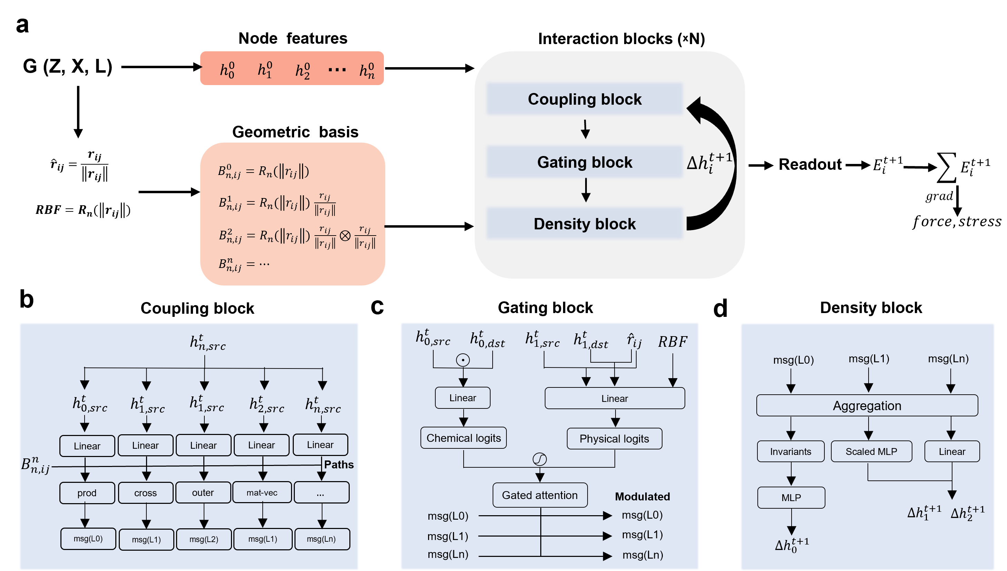
Extended Data Fig. 1: Schematics of the AtomBit model architecture. a, Overall architecture. b–d, Structures of the coupling, gating, and density blocks, respectively.

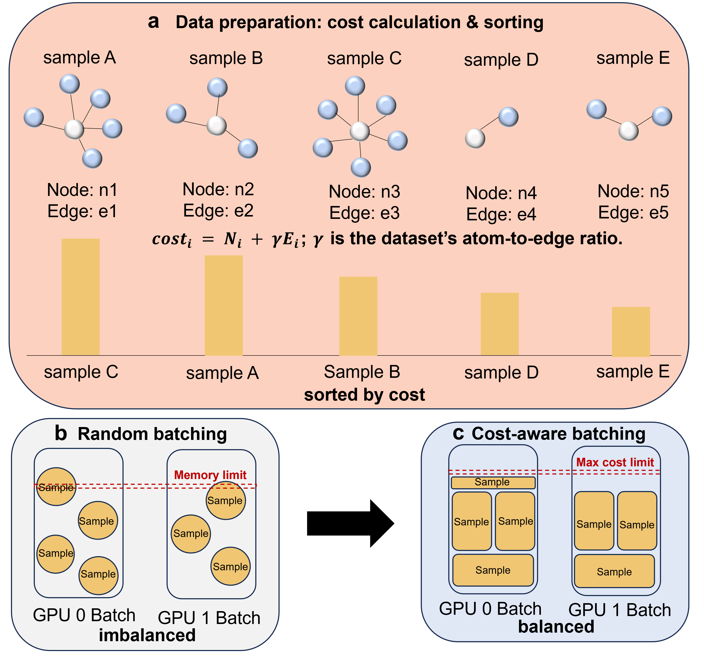
Extended Data Fig. 2: Schematics of the cost-aware dynamic sampler. a, Data preparation for cost estimation. b, Per-GPU data loading and sampling. c, Cost-aware data loading and sampling.

