Revealing the activity of different iron carbides for Fischer-Tropsch synthesis
Fangxu Lu, Xin Chen, Zhigang Lei, Lixiong Wen*, Yi Zhang*
College of Chemical Engineering, Beijing University of Chemical Technology, 15 Beisanhuan East Road, Beijing 100029, PR China

Figure S1. The XRD patterns of fresh catalysts.

Figure S2. XPS spectra of Fe 2p on the fresh catalysts.

Figure S3. N₂ adsorption-desorption isotherms of the fresh α-Fe₂O₃ catalyst.

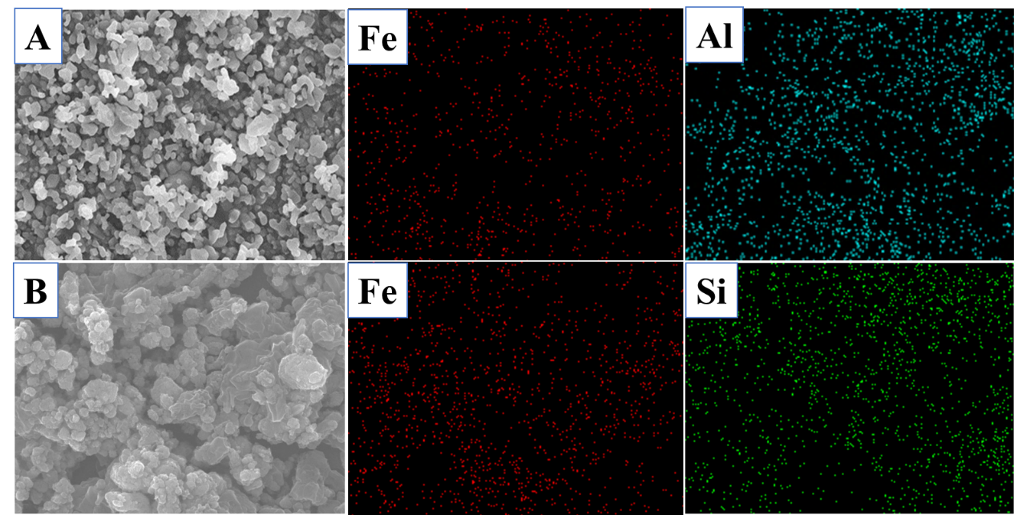
1 um
1 um
Figure S4 A) SEM-EDX elemental mapping of Fe and Al for the fresh Al₂O₃/α-Fe₂O₃=1 catalyst; B) SEM-EDX elemental mapping of Fe and Si for the fresh SiO₂/α-Fe₂O₃=1 catalyst.

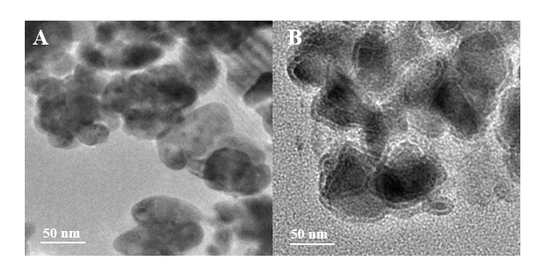
Figure S5 TEM images of the pure α-Fe₂O₃ catalyst before (A) and after (B) FTS reaction.

Figure S6 The CO-TPR profiles of various fresh catalysts for CO consumption.

Figure S7 CO-DRIFT spectrum of the Al₂O₃.

(b)
(a)
Figure S8 NH₃-TPD (a) and CO₂-TPD (b) of SiO₂ and Al₂O₃.

Table S1. The results of in-situ XPS for Fe 2p 3/2
catalysts | Binding energy (eV)  Fe 2p3/2 |  |  |  | Iron carbide (atom%)  Fe 2p3/2
 | Fe₂C | Fe₅C₂ | Fe₃C | Fe₂O₃ | Fe₂C | Fe₅C₂ | Fe₃C | Fe₂O₃
α-Fe₂O₃ | 706.1 | 707.0 | 707.9 | 709.9 | 1.2 | 22.2 | 15.5 | 61.1
SiO₂/α-Fe₂O₃=1 | 706.7 | 707.3 | 708.3 | 710.4 | 7.1 | 19.3 | 11.7 | 61.9
Al₂O₃/α-Fe₂O₃=1 | 706.7 | 707.2 | 708.2 | 710.2 | 13.2 | 18.0 | 10.3 | 58.5

Table S2. The location and content of linear adsorbed CO on different iron carbides from in-situ CO-DRIFT.
catalysts | Wavenumber (cm⁻¹) |  |  | Content of the adsorbed CO (%)
 | Fe₂C | Fe₅C₂ | Fe₃C | Fe₂C | Fe₅C₂ | Fe₃C
α-Fe₂O₃ | - | 2013 | 2027 | - | 63.2 | 36.8
SiO₂/α-Fe₂O₃=1 | 2004 | 2014 | 2032 | 18.6 | 57.3 | 24.1
Al₂O₃/α-Fe₂O₃=1 | 2006 | 2016 | 2033 | 27.7 | 49.3 | 23.0

