Supplementary Material for
Study on CaO-promoted Co/AC catalysts for synthesis of higher alcohols from syngas
Hong Du,^{a,c} Hejun Zhu,ª* Xingkun Chen,^{a,c} Wenda Dong,ª Wei Lu,ª Wenting Luo,^{a,c} Miao Jiang,^{a,c} Tao Liu, ª Yunjie Ding ^{a,b}*
ª Dalian National Laboratory for Clean Energy, Dalian Institute of Chemical Physics, Chinese Academy of Sciences, Dalian, 116023, China
^{b} State Key Laboratory of catalysis, Dalian Institute of Chemical Physics, Chinese Academy of Sciences, Dalian, 116023, China
^{c} University of Chinese Academy of Sciences, Beijing 100039, China

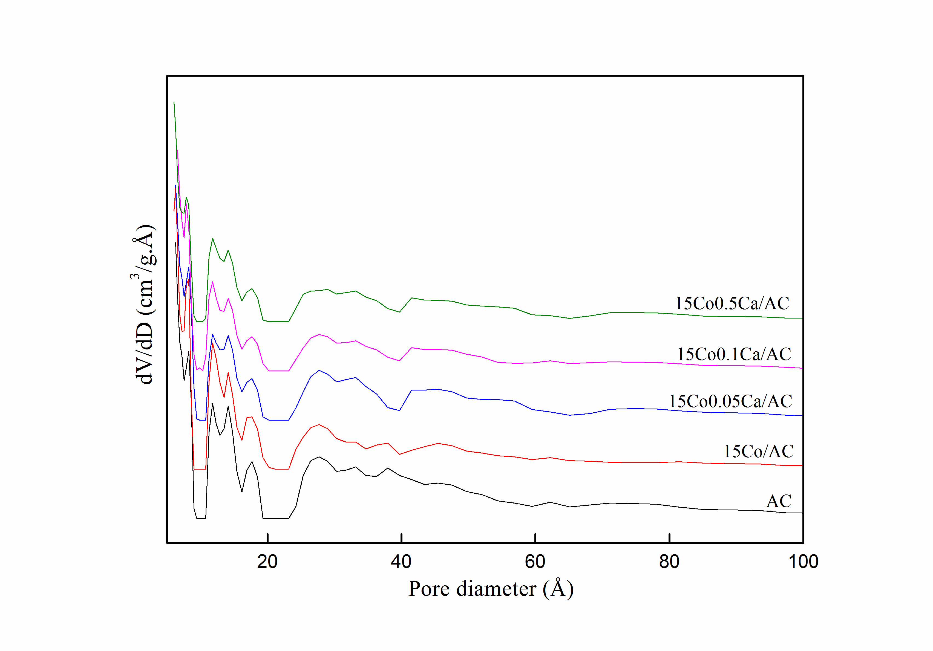
Figure S1. Pore size distribution curves of the AC support and corresponding catalysts calculated from non-local density functional theory (NLDFT).

Figure S2. XRD patterns for the spent 15Co0.5Ca/AC and 15Co0.5Ca/γ-Al₂O₃ catalysts.
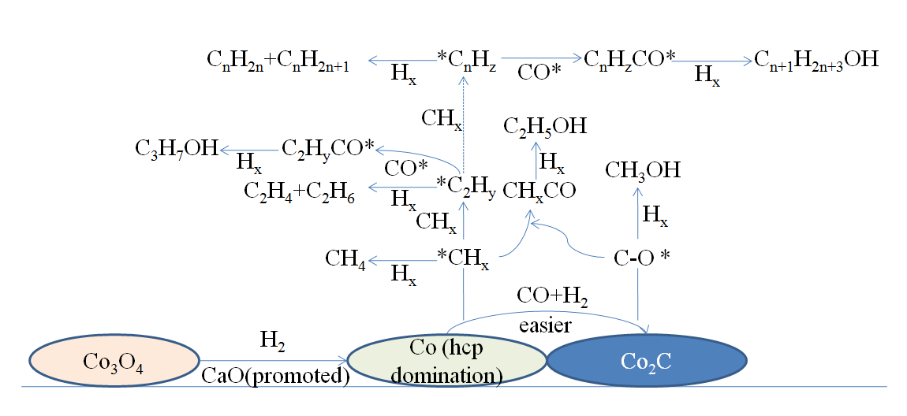
Figure S3. Scheme of CO hydrogenation reaction pathway over the 15Co-xCa/AC catalysts.

Table S1 The performance of CO hydrogenation over the 15Co0.5Ca/AC and 15Co0.5Ca/γ-Al₂O₃ catalysts ª
Catalyst | CO Conversion  /% | Selectivity/C % |  |  |  | Alcohol  Yield,  % | Alcohol distribution/wt %
 |  | HC₁₋₄ ^{b} | CO₂ | HC₅₊ ^{c} | ROH ^{d} |  | C₁OH ^{e} | C₂₊OH ^{f}
15Co0.5Ca/AC | 24.7 | 48.0 | 1.3 | 21.4 | 29.3 | 7.2 | 4.2 | 95.8
15Co0.5Ca/γ-Al₂O₃ | 16.5 | 56.9 | 0.6 | 34.1 | 8.4 | 1.4 | 6.2 | 93.8
ª Reaction conditions: P = 3.0 MPa, T = 493 K, GHSV = 900 h⁻¹.
^{b} Hydrocarbons with carbon numbers of 1-4.
^{c} Hydrocarbons with carbon numbers more than 4.
^{d} Alcohols with carbon numbers of 1-18.
^{e} CH₃OH
^{f} Alcohols with carbon numbers more than one..

