SUPPLEMENTARY INFORMATION

K-promoted NiMo catalysts supported on activated carbon for the hydrogenation reaction of CO to higher alcohols: Effect of support and active metal
E.T. Liakakou^{1,2}, E. Heracleous^{1,3*}, K.S. Triantafyllidis^{1,4}, A.A. Lemonidou^{1,2}

¹ Chemical Process & Energy Resources Institute (CPERI),
Centre for Research and Technology Hellas (CERTH),
6th km Charilaou - Thermi Road, P.O. Box 361, 57001 Thessaloniki, Greece
² Department of Chemical Engineering, Aristotle University of Thessaloniki,
P.O.Box 1517, 54124 Thessaloniki, Greece
³ School of Science & Technology, International Hellenic University (IHU),
14th km Thessaloniki – Moudania, 57001 Thessaloniki, Greece
⁴ Department of Chemistry, Aristotle University of Thessaloniki, P.O. Box 116, 54124 Thessaloniki, Greece

* Corresponding Authors
Eleni Heracleous
e-mail: eheracle@cperi.certh.gr
phone: +30 2310 498345
fax: +30 2310 498380

S1. Textural characterization of the activated carbon supports
Figure S1 illustrates the nitrogen adsorption-desorption isotherms of the activated carbon supports.
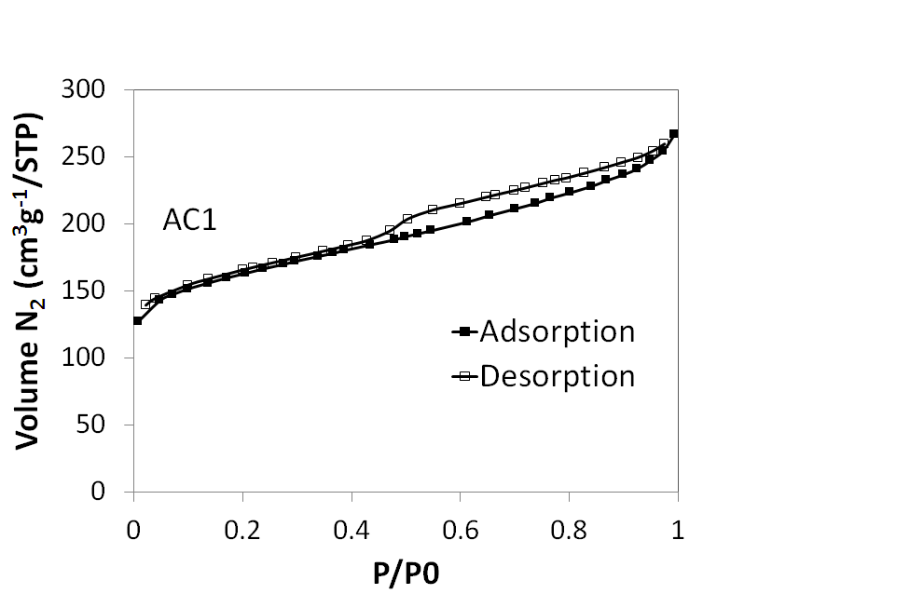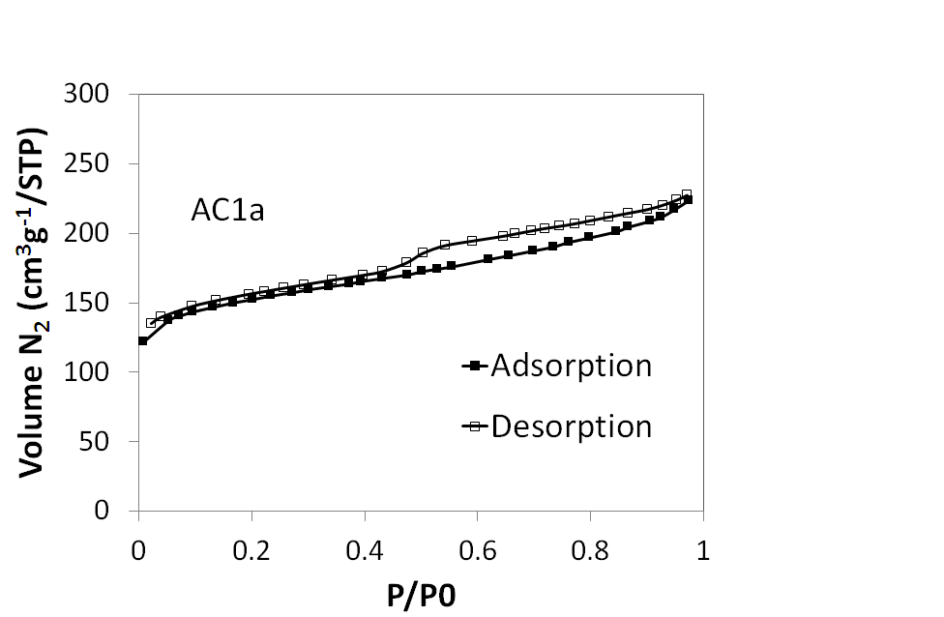
(a)
(b)
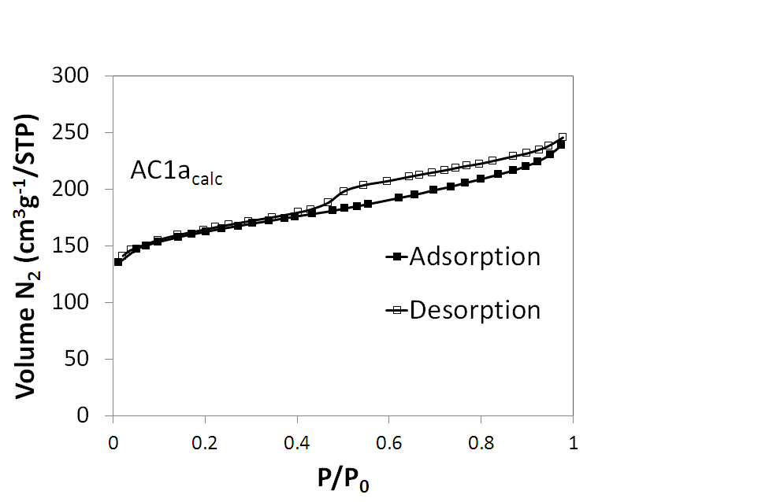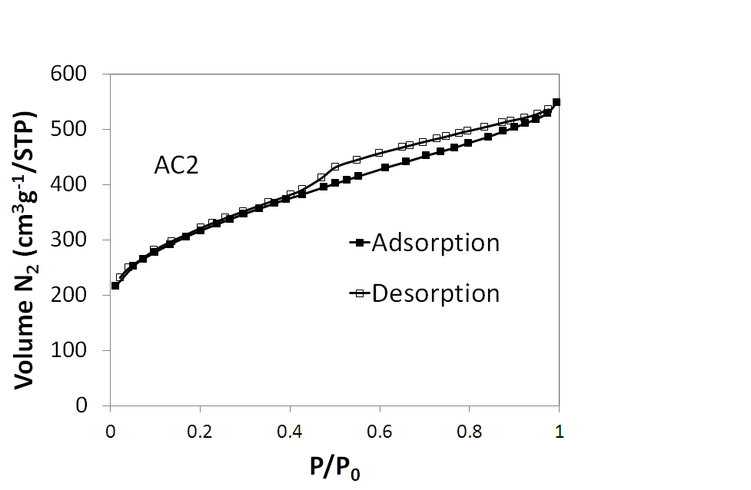
(d)
(c)
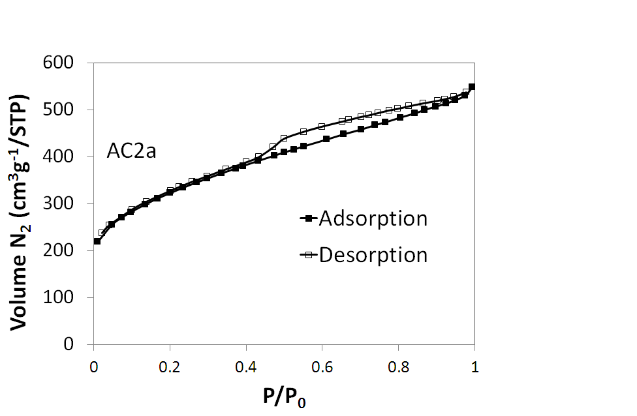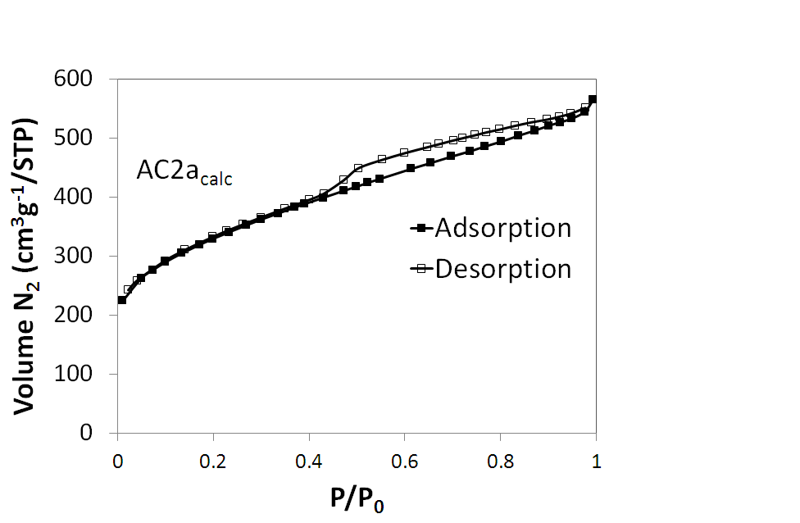
(f)
(e)
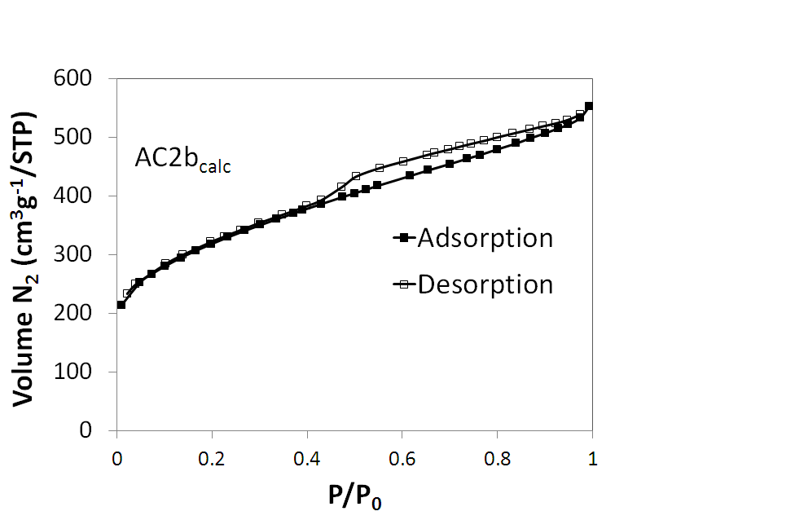
(g)

Figure S1. Nitrogen adsorption-desorption isotherms of the activated carbon supports: AC1 (a), AC1a (b), AC1a_{calc} (c), AC2 (d), AC2a (e), AC2a_{calc} (f), AC2b_{calc} (g)

S2. Thermogravimetric and ICP analysis of the activated carbon supports
S2.1 Experimental
An SDT Q600 (TA Instrument) thermal gravimetric analysis (TGA) instrument was employed for the characterization of the materials. A small quantity of the sample was placed in an aluminium sample cap and the temperature was raised from room temperature to 800°C at a rate of 10°C/min in synthetic air flow (100 cm³/min).
Inductive coupled plasma-atomic emission spectroscopy (ICP-AES) was used for the determination of the chemical composition of the materials, using a Plasma 400 (Perkin Elmer) spectrometer, equipped with Cetac6000AT+ ultrasonic nebulizer.

S2.2 Results
Acid treatment was performed in order to remove the inorganic constituents (ash) in the supports. In order to confirm the expected outcome, we initially performed TGA analysis of the samples prior and after acid treatment under air flow up to 800°C. The weight loss curves of the AC supports with temperature are compiled in Fig S2. The minor weight loss observed at temperatures up to 100°C can be attributed to H₂O desorption from the materials, while the sharp weight loss up from ~500°C to 600°C is attributed to the total oxidation of carbon to CO₂. The remaining weight can be attributed to ash. The high surface area activated carbon AC2 was found to have a much higher ash content than AC1 in the untreated form (15.2 wt% compared to 5.5 wt%). The acid treatment was found to lead to 60% and 27% ash removal in AC1 and AC2 respectively.
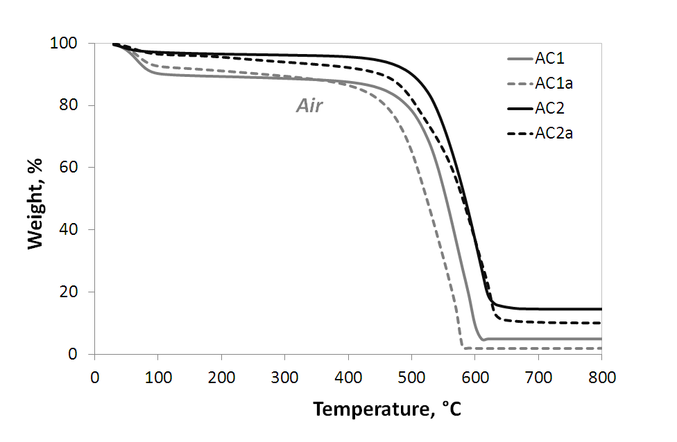 Figure S2. Thermal gravimetric analysis profiles, under air, of the activated carbon supports before and after acid treatment

Moreover, the content and composition of the ash was determined with ICP, based on determination of the most frequents elements contained in inorganic ash. These results, tabulated in Table S1, show that Mo, Fe, Ca and Mg are the main ash components in AC1 and Al, Ca, Fe, Na and Ti in AC2. The ICP measurements agree qualitatively with the TGA results and clearly show that ash is drastically reduced after acid treatment on both samples (75% reduction for AC1 and 51% for AC2). It should be noted that the content of inorganics determined by ICP is significantly lower than the one found with TGA. This could be attributed to the fact that it was not possible to quantify Si, a main ash component, by ICP analysis.

Table S1. Ash composition of the activated carbon supports before and after HNO₃ treatment determined by ICP
Ash Composition (ppm) | AC1 | AC1a | AC2 | AC2a
K | 1087 | 0 | 0 | 0
Na | 830 | 75 | 1410 | 189
Fe | 5985 | 3157 | 5090 | 1930
Ni | 15 | 0 | 48 | 16
Mg | 3760 | 1588 | 4305 | 1167
Mn | 35 | 16 | 283 | 172
Ca | 5132 | 1531 | 11610 | 1318
Al | 1070 | 482 | 18460 | 14570
Cr | 10 | 0 | 57 | 37
Cu | 12 | 6 | 0 | 0
As | 0 | 0 | 0 | 0
Se | 0 | 0 | 0 | 0
Ti | 71 | 0 | 1662 | 1145
Mo | 11580 | 61 | 16 | 16
Total, wt% | 2.96 | 0.70 | 4.29 | 2.05

