Tuning Direct CO Hydrogenation Reaction over Fe-Mn Bimetallic Catalysts toward Light Olefins: Effects of Mn Promotion
State Key Laboratory of Chemical Engineering, School of Chemical Engineering, East China University of Science and Technology, Shanghai 200237, China

* Corresponding author phone: (+86)21-64251938; fax: (86)21-64253528;
E-mail: xujing@ecust.edu.cn

&: These authors contributed equally to this work and should be considered co-first authors.
† Current address: State Key Laboratory of Green Chemical Engineering and Industrial Catalysis, Shanghai Research Institute of Petrochemical Technology, SINOPEC Corp., Shanghai 201208, China

Fig. S1. Diffuse reflectance UV-Vis spectra of Fe/FeO_{x} standards (a), MnO_{x} standards (b), and the as-prepared Fe-Mn bimetallic catalysts (c).

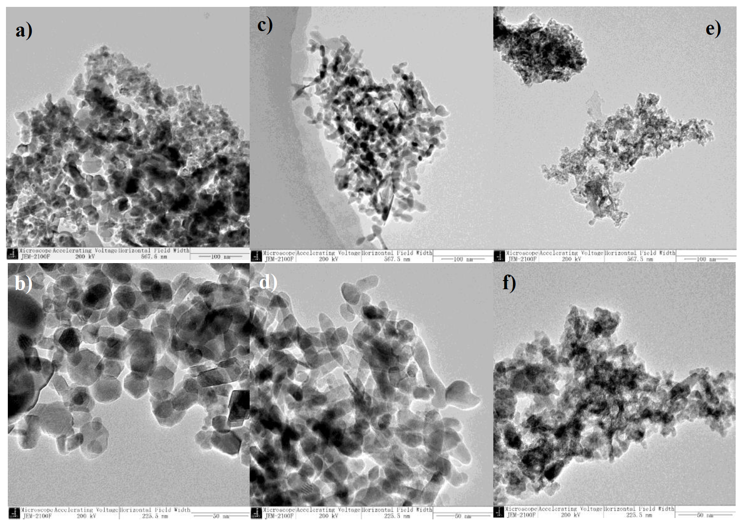
Fig. S2. TEM images of the as-prepared Fe (a, b), FeMn(4:1) (c, d), FeMn(1:1) (e, f) catalysts

Table S1. CO conversion and product selectivity of FTS over different Fe-Mn bimetallic catalysts. Reduction conditions: H₂ (99.999 vol. %), 25 ml/min, 350 °C, 0.1 MPa, 5 h. Reaction conditions: catalyst diluted with SiC (mixing ratio=1:3), 260 °C, 2.0 MPa, H₂/CO=1, gas flow=25ml/min, TOS=20 h.

Catalysts | Conv.%  (20 h) | Carbon Selectivity (%) |  |  |  |  |  |  |  | O/P ratio |  | α | FTY (${μmol}_{CO}⋅g_{Fe}^{-1}⋅s^{-1}$) | C₂-C₄⁼ selectivity, CO₂ free
 |  | CH₄ | C₂⁼ | C₃⁼ | C₄⁼ | C₂-C₄⁼ | C₅+ | CO₂ | Oxy | C₂ | C₂-C₇
Pure Fe | 2.62 | 11.76 | 8.29 | 11.82 | 6.00 | 26.11 | 10.93 | 44.10 | 1.35 | 3.17 | 4.04 | 0.67 | 9.75 | 46.7
FeMn(10:1) | 4.62 | 14.60 | 10.06 | 16.26 | 8.73 | 35.05 | 10.76 | 27.64 | 2.05 | 2.12 | 3.11 | 0.53 | 18.9 | 48.4
FeMn(4:1) | 5.49 | 15.02 | 9.55 | 18.95 | 10.13 | 38.63 | 10.48 | 20.72 | 2.42 | 1.55 | 2.89 | 0.48 | 25.5 | 48.7
FeMn(2:1) | 3.52 | 11.36 | 10.79 | 17.13 | 8.16 | 36.08 | 15.33 | 24.80 | 3.02 | 2.98 | 3.66 | 0.71 | 19.5 | 47.9
FeMn(1:1) | 1.98 | 11.81 | 10.06 | 15.59 | 7.83 | 33.48 | 15.86 | 26.47 | 3.15 | 2.96 | 3.44 | 0.72 | 14.7 | 45.5

Fig. S3. Catalytic performance over Fe-Mn bimetallic catalysts with 20h time on stream. C2-C4 olefin selectivity is calculated on a carbon basis including CO₂.

Table S2. Brief comparison of catalytic performance over the FeMn catalysts for Fischer-Tropsch to olefins
FeMn catalysts | Preparation Methodª | CO Conv % | FTY, μmol_{CO}·g_{Fe·}·s⁻¹ | CO₂ Sel % | Product distributions, % |  |  | O/P ratio^{b}
 |  |  |  |  | CH₄ | C₂-C₄⁼ | C₅₊
FeMnCuSiO₂(100/10/3/12)[1]^{c} | Prec.+Imp. | 96.9 | 5.3^{d} | 23.0 | 20.0 | 40.1 | 9.5 | 1.32
FeMn(3/1)-2wt%K[2]^{e} | Prec.+Imp. | 97.65 | - | 29.86 | 14.59 | 26.36 | 53.78 | 5.00
100Fe/33Mn/2.8Na[3, 4]^{f} | Prec.+Imp. | 96.2 | - | 26.8 | 16.7 | 30.6 | 44.3 | 3.6
Fe₂₀-Mn_{1.0}/SiO₂[5]^{g} | Imp. | 14.4 | - | 23.3 | 21.6 | 40.3 | 19.4 | 2.6
Al-Fiber@meso-Al₂O₃@Fe-Mn-K[6]^{h} | Imp. | 90.0 | 126.3 | 31.1 | 15.7 | 38.8 | 35.5 | 3.9
Fe_{2.86}Mn_{0.14}O4/CNT[7]^{i} | Thermo.+ULA | 43.9 | 275 | 37.2 | 6.1 | 31.5 | 53.8 | 3.62
Fe/MnK-CNTs[8]^{j} | Redox.+Prec. | 31.8 | 261.2 | 36.9 | 32.4 | 50.4 | 9.1 | 6.2
Mn-07[9]^{k} | Prec. | 45.1 | - | 19.2 | 12.0 | 33.2 | 44.2 | 3.17
0.5Mn/γ-Fe₂O₃[10]^{l} | Prec.+Imp. | 55.1 | 14.8 | 31.7 | 11.7 | 61.2 | 18.2 | 6.9
6%Mn/Fe₃O₄[11]^{m} | Solv.+Imp. | 41.5 | 9.9 | 37.8 | 9.7 | 60.1 | 23.7 | 9.2
Fe-13Mn[12]^{n} | Solv. | 7.1 | 16.9 | 25.2 | 17.0 | 54.4 | 13.3 | 3.6
FeMn(4:1)º | Prec. | 5.5 | 25.5 | 20.7 | 18.9 | 48.7 | 16.1 | 3.04

ª Methods: Imp.=impregnation, Prec.=precipitation, Solv.=Solvothermal, Redox.=reduction-oxidation, Themo.=thermal decomposition, ULA= ultrasonic assembly
^{b} C₂-C₄ olefins/paraffins
^{c} Reaction conditions:573K, H₂/CO=2.0, 2.0MPa, 1500h⁻¹
^{d} Estimated from FTY=3.09μmol_{CO}·g_{cat·}·s⁻¹
^{e} Reaction conditions:593K, H₂/CO=2.0, 1.5MPa, 1000h⁻¹
^{f} Reaction conditions: 598K, H₂/CO=3.5, 1.0MPa, 2000h⁻¹, 36h
^{g} Reaction conditions: 533K, H₂/CO=1.0, 2.0MPa, 4000h⁻¹
^{h} Reaction conditions: 623K, H₂/CO=2.0, 4.0MPa, 6000ml/(h g_{cat})
^{i} Reaction conditions: 573K, H₂/CO=1.0, 2.0MPa, 6000ml/(h g_{cat}), 12h
^{j} Reaction conditions: 543K, H₂/CO=1.0, 2.0MPa, 24000ml/(h g_{cat})
^{k} Reaction conditions: 523K, H₂/CO=2.0, 1.5MPa, 2000h⁻¹
^{l} Reaction conditions: 523K, H₂/CO=2.0, 1.5MPa, 2000h⁻¹, 20h
^{m} Reaction conditions: 593K, H₂/CO=1.0, 1.0MPa, 0.1mol/(h g_{cat})
^{n} Reaction conditions: 533K, H₂/CO=1.0, 2.0MPa, 4000h⁻¹
º Reaction conditions: 533K, H₂/CO=1.0, 2.0MPa, 15000ml/(h g_{cat}) (This work)

Table S3. EXAFS fitting parameters at the Fe K-edge for various samples ª.
Sample | Shell | CN | R(Å) | σ² (Å²) | ΔE₀ (eV) | R factor
Fe foil | Fe-Fe (1st) | 8 | 2.46±0.01 | 0.0049 | 5.2±1.0 | 0.0051
 | Fe-Fe (2nd) | 6 | 2.84±0.01
Spent Fe | Fe-C | 3.6±0.5 | 1.99±0.02 | 0.0087 | -6.1±1.5 | 0.0114
 | Fe-Fe | 8.4±0.4 | 2.59±0.01 | 0.0139
Spent FeMn(4:1) | Fe-C | 1.9±0.9 | 1.81±0.06 | 0.0032 | -4.5±4.7 | 0.0140
 | Fe-O | 2.9±0.8 | 1.97±0.05 | 0.0053
 | Fe-Fe (1st) | 4.1±0.5 | 2.59±0.03 | 0.0078
 | Fe-Fe (2nd) | 2.8±0.8 | 3.11±0.05
ªCN: coordination numbers; R: bond distance; σ²: Debye-Waller factors; ΔE₀: the inner potential correction. R factor: goodness of fit. Ѕ₀² was set to 0.71, according to the experimental EXAFS fit of Fe foil reference by fixing CN as the known crystallographic value.

Fig. S4. Fourier transformed Fe K-edge EXAFS data of the spent FeMn catalysts and the Fe foil standard. The lines represent experimental data, and the circles are fitted data.

Fig. S5. CO/H₂-TPSR profiles of H₂-reduced catalysts. (a) CH₄, (b) CO₂, (c) C₂H₄, (d) H₂O, Fe, FeMn(4:1), and FeMn(1:1) are denoted by black, red, and blue solid lines, respectively.

Syngas temperature programmed surface reaction (CO/H₂-TPSR) was performed to investigate the surface activities of the H₂-reduced catalysts. Desorption profiles of CH₄ (m/z=15), CO₂ (m/z=44), C₂H₄ (m/z=25), and H₂O (m/z=18) are shown in Fig. S3. CH₄ desorption occurs in two major temperature regions, where the lower temperature (300-500 °C) desorption is attributed to the hydrogenation of the iron carbides, and the high temperature (>600 °C) is related to the hydrogenation of coke deposition on catalyst surface [13]. The first desorption peak locates at 414, 261 and 385 °C for Fe, FeMn(4:1) and FeMn(1:1), respectively, suggesting that CH₄ is more easily desorbed from the Mn-containing catalyst surface. The flat desorption profile of FeMn(1:1) suggests that excess Mn restrains the transformation of iron oxides to iron carbides, and therefore disfavors the formation of CH₄. Direct CO dissociation gives chemisorbed oxygen atoms that desorb as CO₂. The CO₂ desorption profiles show that the first desorption peak appears at 406, 437, and 512 °C for FeMn(4:1), FeMn(1:1) and Fe catalysts, respectively, further confirming that the addition of Mn promotes the direct CO dissociation ability of the catalysts. Moreover, the lower C₂H₄ desorption temperature on Fe-Mn bimetallic catalyst surface indicates that the addition of Mn favors the desorption of olefins. An intense water desorption peak appears in the region of 700-800 °C, corresponding to the removal of lattice oxygen in the oxides. The water desorption temperature shows an increasing tendency as the Mn content increases, indicating that high Mn level increases the stability of the Fe/Mn oxides. These results confirm that the surface activity of the Fe catalyst can be enhanced by adding appropriate amount of Mn. It is reported that appropriate amount of Mn can improve the surface basicity of the catalysts, which exhibit excellent CO dissociation ability while suppressing the hydrogenation ability [14].

Fig. S6. Stability test of FeMn(4:1) catalyst. The catalyst is pelleted, crushed, and sieved, physically mixed with SiO₂ in 40-60 mesh. Activation Conditions: 5%CO/5%H₂/Ar, 100mL/min, 2ºC/min, T=350ºC, 5h. Reaction Conditions: T=260ºC, P=2.0 MPa, Syngas(H₂/CO/N₂=45/45/10), GHSV=21600 h⁻¹. The selectivities of hydrocarbons are calculated on carbon mole percent excluding CO₂ in the product stream.

References
[1] W. Gong, R.-P. Ye, J. Ding, T. Wang, X. Shi, C.K. Russell, J. Tang, E.G. Eddings, Y. Zhang, M. Fan, Effect of copper on highly effective Fe-Mn based catalysts during production of light olefins via Fischer-Tropsch process with low CO₂ emission, Appl Catal B-Environ, 278 (2020) 119302.
[2] J.-l. Zhang, L.-h. Ma, S.-b. Fan, T.-S. Zhao, Y.-h. Sun, Synthesis of light olefins from CO hydrogenation over Fe–Mn catalysts: Effect of carburization pretreatment, Fuel, 109 (2013) 116-123.
[3] J.-B. Li, H.-F. Ma, H.-T. Zhang, Q.-W. Sun, W.-Y. Ying, D.-Y. Fang, Sodium promoter on iron-based catalyst for direct catalytic synthesis of light alkenes from syngas, Fuel Process. Technol., 125 (2014) 119-124.
[4] J.-B. Li, H.-F. Ma, H.-T. Zhang, Q.-W. Sun, W.-Y. Ying, D.-Y. Fang, Comparison of FeMn, FeMnNa and FeMnK catalysts for the preparation of light olefins from syngas, Acta Physico-Chimica Sinica, 30 (2014) 1932-1940.
[5] Z. Zhang, W. Dai, X.-C. Xu, J. Zhang, B. Shi, J. Xu, W. Tu, Y.-F. Han, MnOx promotional effects on olefins synthesis directly from syngas over bimetallic Fe-MnO_{x}/SiO₂ catalysts, AIChE Journal, 63 (2017) 4451-4464.
[6] L. Han, C. Wang, G. Zhao, Y. Liu, Y. Lu, Microstructured Al-fiber@meso-Al₂O₃@Fe-Mn-K Fischer-Tropsch catalyst for lower olefins, AIChE J, 62 (2016) 742-752.
[7] J.-D. Xu, K.-T. Zhu, X.-F. Weng, W.-Z. Weng, C.-J. Huang, H.-L. Wan, Carbon nanotube-supported Fe-Mn nanoparticles: A model catalyst for direct conversion of syngas to lower olefins, Catal. Today, 215 (2013) 86-94.
[8] D. Wang, J. Ji, B. Chen, W. Chen, G. Qian, X. Duan, X. Zhou, D. Wang, A. Holmen, D. Chen, J.C. Walmsley, Novel Fe/MnK-CNTs nanocomposites as catalysts for direct production of lower olefins from syngas, AIChE J, 63 (2016) 154-161.
[9] T. Li, H. Wang, Y. Yang, H. Xiang, Y. Li, Effect of manganese on the catalytic performance of an iron-manganese bimetallic catalyst for light olefin synthesis, J. Energ. Chem., 22 (2013) 624-632.
[10] Y. Liu, F. Lu, Y. Tang, M. Liu, F.F. Tao, Y. Zhang, Effects of initial crystal structure of Fe2O3 and Mn promoter on effective active phase for syngas to light olefins, Appl. Catal. B: Environ., 261 (2020) 118219.
[11] Y. Liu, J.-F. Chen, J. Bao, Y. Zhang, Manganese-Modified Fe3O4 Microsphere Catalyst with Effective active phase of forming light olefins from syngas, ACS Catal., 5 (2015) 3905-3909.
[12] B. Shi, Z. Zhang, Y. Liu, J. Su, X. Liu, X. Li, J. Wang, M. Zhu, Z. Yang, J. Xu, Y.-F. Han, Promotional effect of Mn-doping on the structure and performance of spinel ferrite microspheres for CO hydrogenation, J. Catal., 381 (2020) 150-162.
[13] J. Xu, C.H. Bartholomew, Temperature-Programmed Hydrogenation (TPH) and in Situ Mössbauer spectroscopy studies of carbonaceous species on silica-supported iron Fischer−Tropsch catalysts, J. Phys. Chem. B, 109 (2005) 2392-2403.
[14] T. Li, Y. Yang, C. Zhang, X. An, H. Wan, Z. Tao, H. Xiang, Y. Li, F. Yi, B. Xu, Effect of manganese on an iron-based Fischer–Tropsch synthesis catalyst prepared from ferrous sulfate, Fuel, 86 (2007) 921-928.

