Supplementary material
Long-chain α-olefins production over Co-MnO_{x} catalyst with optimized interface
Min-Li Zhuª, Xingwu Liu^{b}, Yiming Niu^{c}, Guo-Qing Yangª, Jun Bao^{d}, Yong-Hong Songª, Yi-Fan Yanª, Ning Duª, Mei-Ling Shui^{d}, Kaiyu Zhu^{b}, Bingsen Zhang^{c}, Zhao-Tie Liuª, Ding Ma^{b,}*, and Zhong-Wen Liu^{a,}*
ª Key Laboratory of Syngas Conversion of Shaanxi Province, School of Chemistry & Chemical Engineering, Shaanxi Normal University, Xi’an, 710119, China.
^{b} Beijing National Laboratory for Molecular Sciences, College of Chemistry and Molecular Engineering, Peking University, Beijing, 100871, China.
^{c} Shenyang National Laboratory for Materials Science, Institute of Metal Research, Chinese Academy of Sciences, Shenyang, 110016, China.
^{d} Hefei National Laboratory for Physical Sciences at the Microscale, Key Laboratory of Strongly-Coupled Quantum Matter Physics of Chinese Academy of Sciences, National Synchrotron Radiation Laboratory, Key Laboratory of Surface and Interface Chemistry and Energy Catalysis of Anhui Higher Education Institutes, Department of Chemical Physics, University of Science and Technology of China, Hefei, Anhui, 230026, China.
*Corresponding authors: Ding Ma, Zhong-Wen Liu
E-mail address: dma@pku.edu.cn (D. Ma), zwliu@snnu.edu.cn (Z.-W. Liu).

Table of Contents
1. Experimental methods······································································································S3
1.1 Evaluation of catalytic performance in FTS·············································································S3
1.2 Mass transport limitation···································································································S14
2. Supplementary Figures·····································································································S17
Fig. S1·····························································································································S17
Fig. S2·····························································································································S18
Fig. S3·····························································································································S19
Fig. S4·····························································································································S20
Fig. S5·····························································································································S21
Fig. S6·····························································································································S22
Fig. S7·····························································································································S23
Fig. S8·····························································································································S24
Fig. S9·····························································································································S25
Fig. S10···························································································································S26
Fig. S11···························································································································S27
Fig. S12···························································································································S28
Fig. S13···························································································································S29
Fig. S14···························································································································S30
Fig. S15···························································································································S31
Fig. S16···························································································································S32
Fig. S17···························································································································S33
3. Supplementary Tables······································································································S34
Table S1···························································································································S34
Table S2···························································································································S35
Table S3···························································································································S36
Table S4···························································································································S37
Table S5···························································································································S38
Table S6···························································································································S39
Table S7···························································································································S40
4. Supplementary References································································································S41

1. Experimental methods
1.1 Experimental details of the FTS tests and product analyses
The schematic diagram of the reaction system for the FTS experiments along with the online analysis devices is given in Fig. SE1. The FTS reactions were performed in a high-pressure stainless-steel fixed-bed reactor with an inner diameter of 9 mm. Typically, 0.5 g catalyst (40-60 mesh) diluted with an equal volume of quartz sands (40-60 mesh) was loaded at the isothermal zone of the reactor. Before the FTS test, the catalyst was reduced at 400 °C and 0.1 MPa for 5 h in a pure H₂ flow of 50 mL·min⁻¹. After the reduction, the reactor was cooled to 120 °C in the same H₂ flow. Then, the syngas with the volumetric composition of 32% CO, 64% H₂, and 4% Ar as the internal standard was switched, and pressurized to 1.0 MPa. The catalytic test was conducted at the reactor temperature range from 210 to 230 °C and gas hourly space velocity (GHSV) from 2.4 to 9.6 L·g_{cat}⁻¹·h⁻¹. The tail gas of the reactor was depressurized before entering an online gas chromatograph (GC), and the entire pipeline was insulated at 300 °C to avoid the product condensation. The heated flow was firstly introduced to a HP-PONA capillary column via a six-way valve, and the hydrocarbons (C₁–C₁₈) were seperated and analyzed using an FID. The representative chromatograms are given in Fig. SE2 and SE3. The pipelines, valves, and chromatographic injection port were insulated at 300 °C, and the temperature of the HP-PONA capillary column was increased from 25 to 280 °C at a ramp of 10 °C/min and held at 280 °C for 20 minutes. The flow out of the six-way valve was cooled in a cold trap (0 °C) to collect liquid products. The CO, CH₄, Ar, and CO₂ gases in the effluent from the cold trap were separated using the PROPAK Q and CST-TDX-01 packed columns at 50 °C and analyzed on a thermal conductivity detector (TCD), and the typical chromatograms are shown in Fig. SE4. All the catalytic results were obtained at a time on stream of no less than 24 h and each catalyst was tested at least for three times for calculating the experimental errors. After the reaction, the reactor was purged with N₂ (200 mL/min) for 15 min and cooled naturally in the N₂ flow to the room temperature (20-25 °C). Then the catalyst was passivated for 1 h in a 1 vol % O₂/Ar flow of 20 mL/min before unloading from the reactor. The unloaded spent catalyst was sealed in the polyester sample tube after eliminating the air in a glove box under an Ar protection.
The catalytic activity is expressed as the CO conversion, cobalt-time yield (CTY) and turnover frequency (TOF), respectively. The CO conversion (X_{CO}) is defined according to Eq. S1, where F_{CO,in} and F_{CO,out} are the molar flow rate of CO at the inlet and outlet of the reactor, respectively.
CTY is defined as moles of CO converted to hydrocarbons over per gram of cobalt per second as expressed in Eq. S2, where m_{Co} is the mass of cobalt in the reactor.
TOF is defined according to Eq. S3, where the “moles of exposed Co⁰ atoms” is calculated based on the H₂-chemisorption.
The selectivity of hydrocarbon (S_{CxHy}) is defined according to Eq. S4, where F_{CxHy} represents the molar flow rate of the hydrocarbon at the outlet of the reactor.
To reveal the accuracy of the online GC analyses and determine the carbon balance of the FTS experiment, longer test (TOS>100 h) was performed over Co-MnO_{x}-(C)/SiO₂ catalyst under the conditions of 210 °C and 7.2 L·g_{cat}⁻¹·h⁻¹ with CO conversion of ~10%. The products were collected in the cold trap under the steady state (after a TOS of ~24 h). After statically leaving the sample tube for about 1 h, the products were spontaneously separated into an aqueous phase and an oil phase. To determine the amount of oxygenate products, the aqueous phase sample was dissolved in acetone (HPLC grade, Sigma Aldrich) and analyzed on an offline GC (Shimadzu 2010) equipped with a capillary column (DB-5, 30 m × 0.32 mm) and an FID. From the representative chromatogram (Fig. SE5), C₁₋₄ alcohols were detected and their molar concentrations in the aqueous phase were determined by the external standard method. The selectivity of oxygenate (S_{oxy.}) was calculated according to Eq. S5, where n_{oxy.} represents the moles of carbon in the oxygenates within the aqueous phase, and n_{CO,consumed} represents the moles of consumed CO during the product collecting process. The selectivity of C₁₋₄ alcohols was determined to be less than 2%. This is consistent with the common fact that oxygenates are much less produced for the Co-based catalysts under FTS conditions with a low pressure.
$$S_{oxy.}= \frac{n_{oxy.}}{n_{CO,consumed}} ×100\% (Eq. S5)$$
After a strong blending, a small amount of the oil sample was dissolved in 15.0 mL CS₂ (A.R. grade, Aladdin). The hydrocarbons dissolved in CS₂ were subjected to a full analysis on an offline GC (Agilent 7890B) equipped with a capillary column (RIPP GSD-1, 10 m × 530 μm × 0.15 μm), FID, and an analysis software of the simulated distillation method (Provided by the Sinopec Research Institute of Petroleum Processing Co., Ltd.). The temperature of the column furnace was programmed to rise from 50 to 430 °C at a temperature ramp of 10 °C/min and hold at 430 °C for 20 minutes. The representative FID signals of the oil phase are displayed in Fig. SE6. Since that the selectivity of C₇ hydrocarbons calculated based on the online GC analyses is reasonably the same to that based on the offline GC analyses of the oil products, the selectivity of hydrocarbons in the collected oil is determined. Results indicate that the discrepancy for the selectivity of C₅-C₁₈ hydrocarbons between the online and offline GC analyses is below ± 3%. To confirm the accuracy, the FTS reaction was also operated for a higher CO conversion of ~30% under the conditions of 220 °C and 4.8 L·g_{cat}⁻¹·h⁻¹. The representative FID signals of the oil phase are displayed in Fig. SE7. The selectivity of C₁₋₄ alcohols is still below 2% and the difference in the selectivity of C₅-C₁₈ hydrocarbons determined based on the online and offline GC analyses is still within ± 3%. Thus, the online GC analyses of the hydrocarbons with a carbon number up to 18 are practically accurate within the experimental errors.
Based on the FTS results with the full analyses of the condensed products, the carbon balances were also estimated according to Eq. S6. The carbon balance is defined as the total amount of carbon in all of the products divided by the amount of converted CO. Since that the selectivity of FTS products is calculated based on carbon number, the carbon balance can also be expressed as the sum of the selectivity of CO₂, C₁-C₅ hydrocarbons based on the online GC analyses, and C₆₊ hydrocarbons and the oxygenates based on offline GC analyses. From the FTS results obtained under the two sets of conditions, i.e., 210 °C and 7.2 L·g_{cat}⁻¹·h⁻¹ vs. 220 °C and 4.8 L·g_{cat}⁻¹·h⁻¹, the carbon balances are reproducibly determined to be within 100 ± 10%. Thus, the experimental errors of the FTS reaction used in our case are accurate within 100 ± 10% of the carbon balances.
$${ C}_{balance}= \frac{n_{{CO}_{2}}+ n_{HC}+n_{oxy.}}{n_{CO,consumed}} ×100\%$$
$$=S_{{CO}_{2}, online}+S_{C1-C5, online}+S_{C6+, offline}+S_{oxy., offline} (Eq. S6)$$

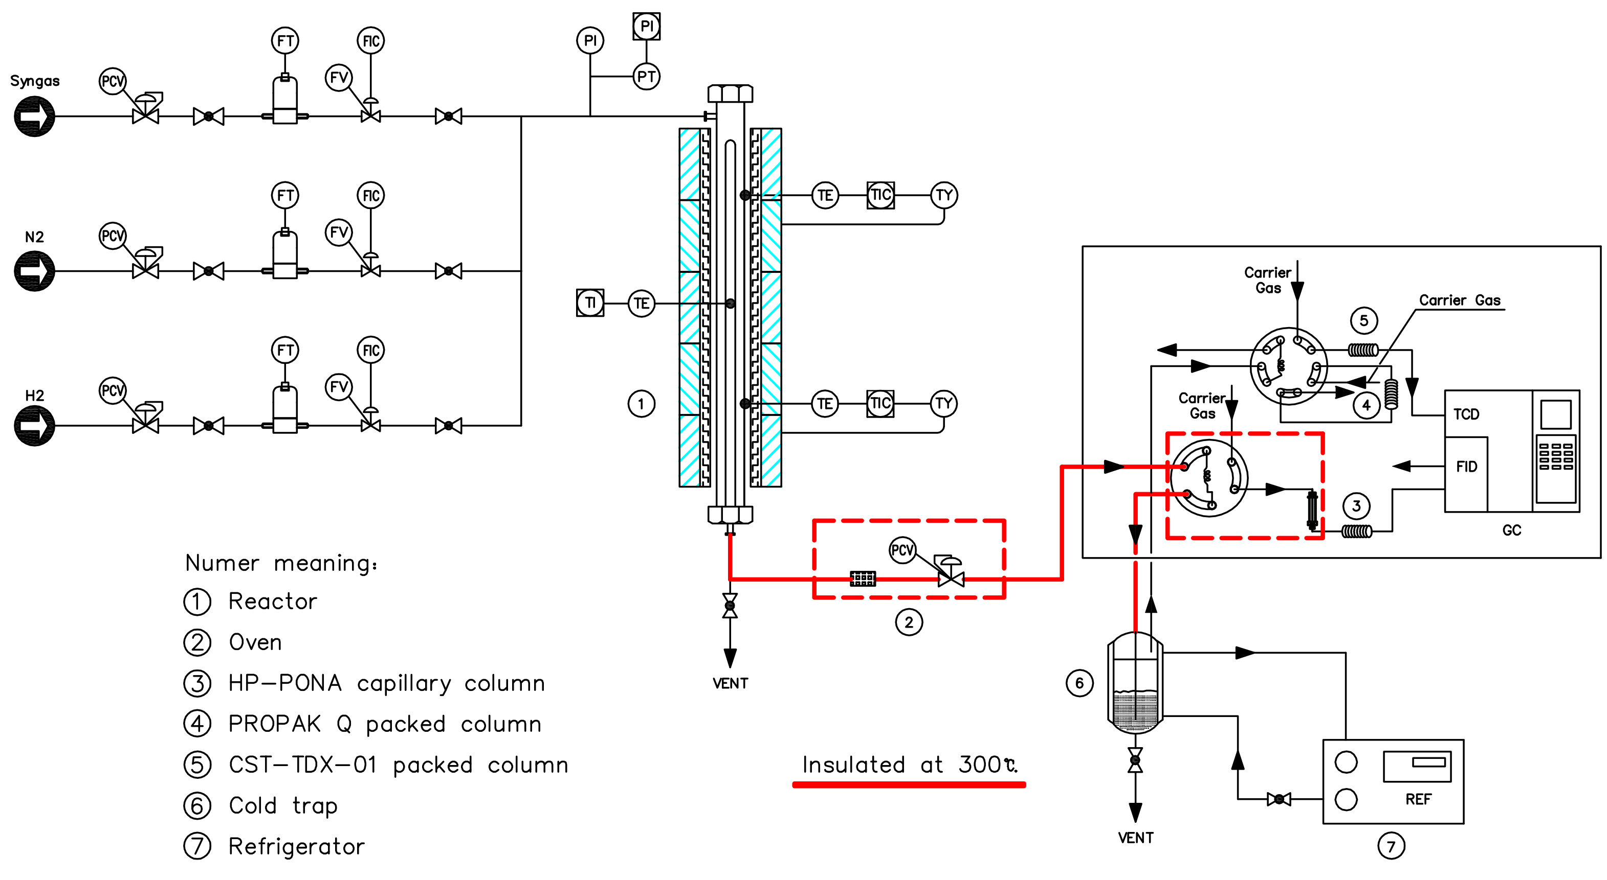
Fig. SE1. Schematic diagram of the FTS reaction system including the online GC analysis.

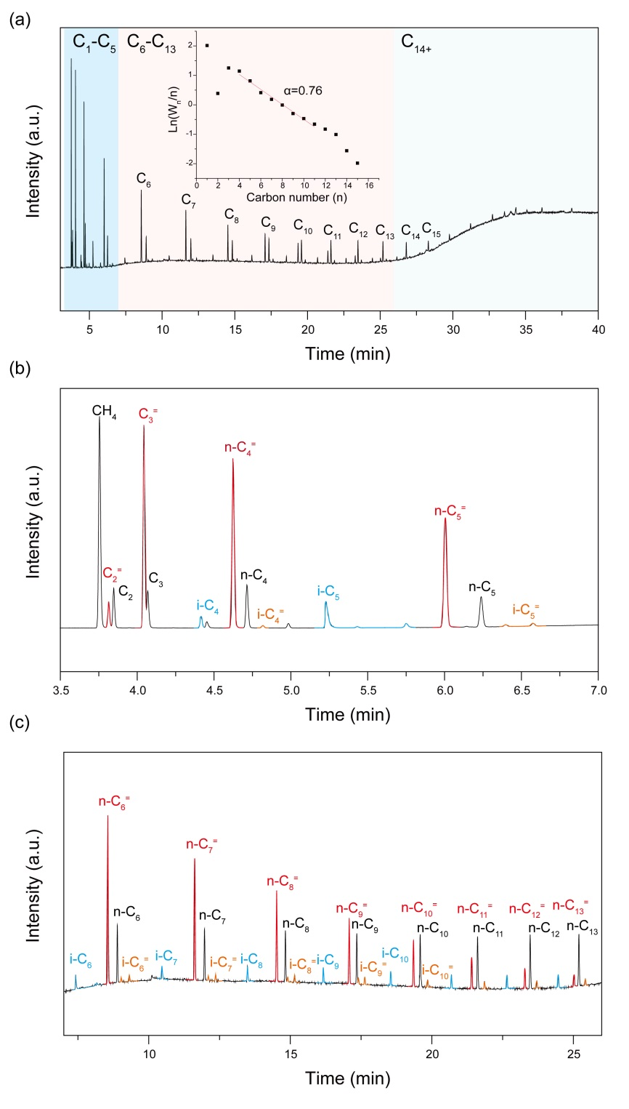
Fig. SE2. Chromatogram of hydrocarbon products from a HP-PONA capillary column. (a) FID signals of a representative online hydrocarbon products from a fixed-bed FTS catalytic test of Co-MnO_{x}-(C)/SiO₂ at CO conversion of ~10%. Inset: ASF plot and the chain growth probability (α = 0.76) obtained in the C₃-C₁₆ hydrocarbon range. Detail view of hydrocarbons: (b) C₁-C₅, and (c) C₆-C₁₃. Color code: black (n-paraffin products, n-C_{n}), red (n-olefin products, n-C_{n}⁼), blue (isomeric paraffin products, i-C_{n}), orange (isomeric olefin products, i-C_{n}⁼). Reaction conditions: 210 °C, 1.0 MPa, GHSV=7.2 L·g_{cat}⁻¹·h⁻¹, H₂/CO = 2 and the data is collected after more than 24 h on stream.

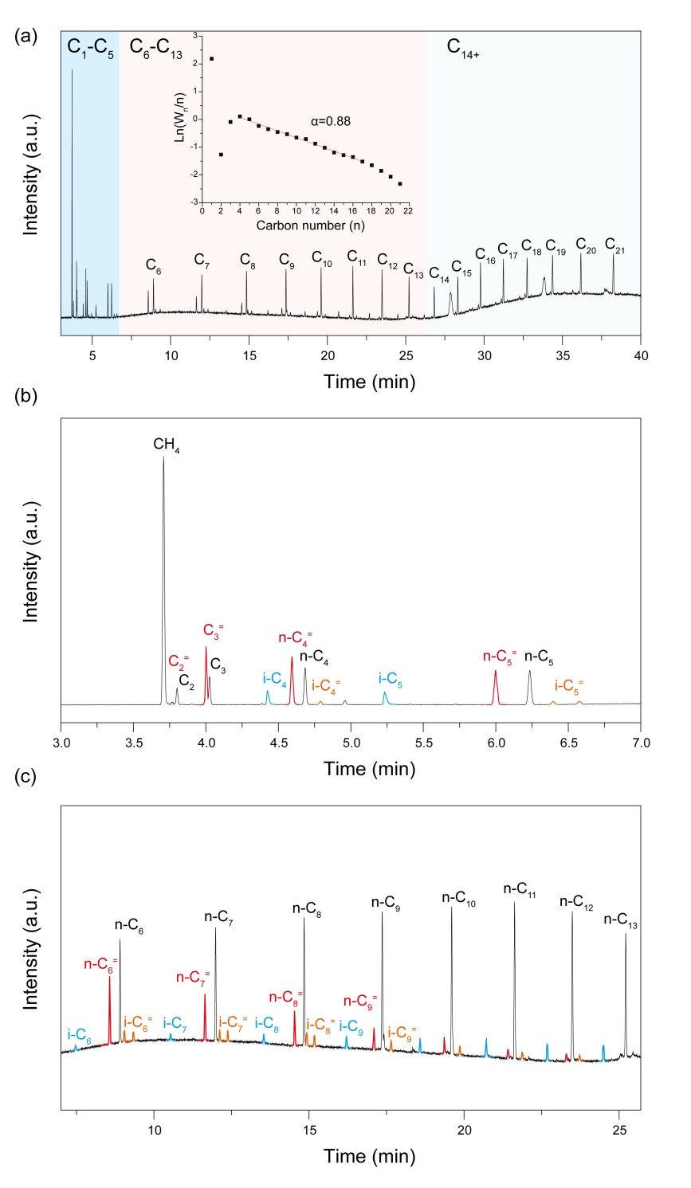
Fig. SE3. Chromatogram of hydrocarbon products from a HP-PONA capillary column. (a) FID signals of a representative online hydrocarbon products from a fixed-bed FTS catalytic test of Co-(C)/SiO₂ at CO conversion of ~10%. Inset: ASF plot and the chain growth probability (α = 0.88) obtained in the C₃-C₁₆ hydrocarbon range. Detail views of hydrocarbons: (b) C₁-C₅, and (c) C₆-C₁₃. Color code: black (n-paraffin products, n-C_{n}), red (n-olefin products, n-C_{n}⁼), blue (isomeric paraffin products, i-C_{n}), orange (isomeric olefin products, i-C_{n}⁼). Reaction conditions: 210 °C, 1.0 MPa, GHSV=4.8 L·g_{cat}⁻¹·h⁻¹, H₂/CO = 2 and the data is collected after more than 24 h on stream.

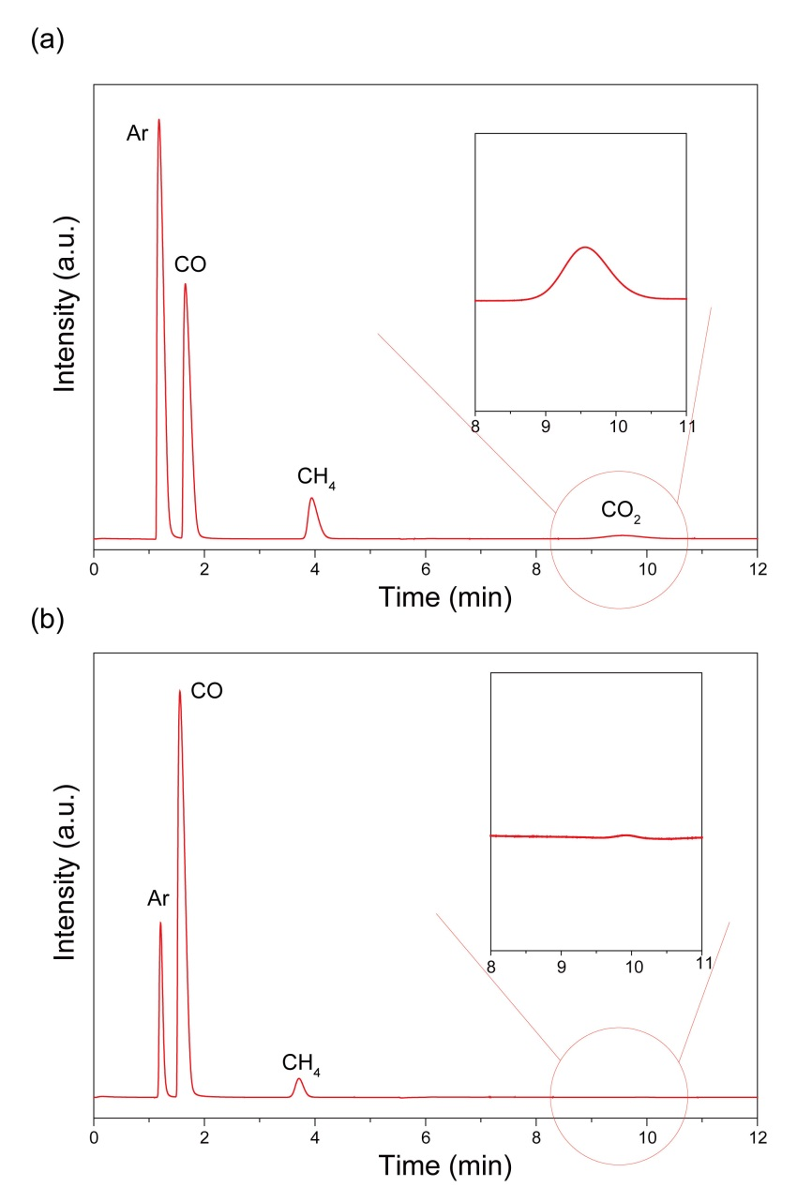
Fig. SE4. TCD signals of permanent gases eluting from the PROPAK Q and CST-TDX-01 packed columns. (a) TCD signals of the standard mixed gases of Ar (30%), CO (20%), CH₄ (5%), and CO₂ (2%). (b) TCD signals of a representative online test of Co-MnO_{x}-(C)/SiO₂ at CO conversion of ~40%. The invisible CO₂ signal suggests the negligible CO₂ selectivity (<1%). Reaction conditions: 220 °C, 1.0 MPa, GHSV = 4.8 L·g_{cat}⁻¹·h⁻¹, H₂/CO =2.

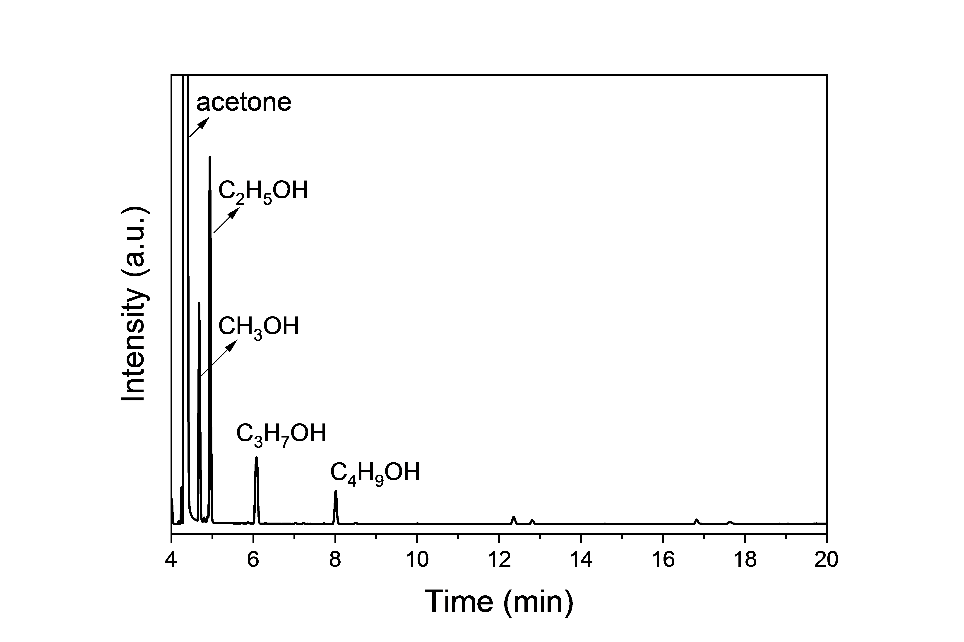
Fig. SE5. The representative chromatogram of the aqueous phase products obtained from the offline GC analysis.

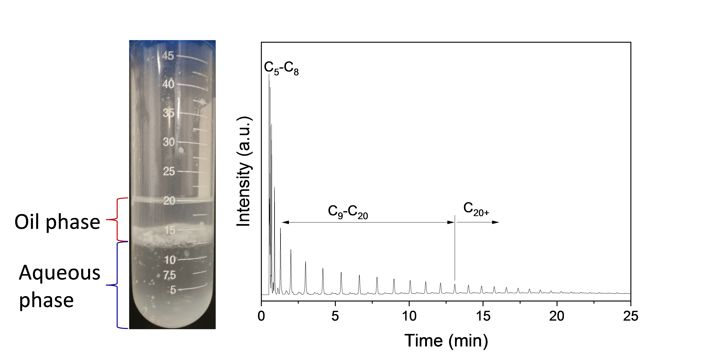
Fig. SE6. FTS products collected from a stability test over Co-MnO_{x}-(C)/SiO₂ at 210 °C, 7.2 L·g_{cat}⁻¹·h⁻¹ at the quasi steady-state conditions (after 24 h on-stream) (left). The FID signals of the oil phase products obtained from the offline GC analysis (right).

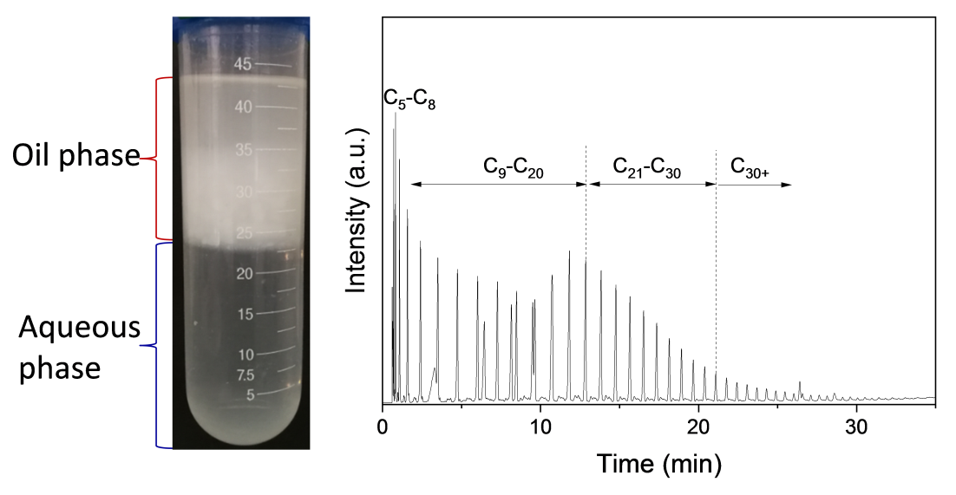
Fig. SE7. FTS products collected from a stability test over Co-MnO_{x}-(C)/SiO₂ at 220 °C, 4.8 L·g_{cat}⁻¹·h⁻¹ at the quasi steady-state conditions (after 24 h on-stream) (left). The FID signals of the oil phase products obtained from the offline GC analysis (right).

1.2 Mass transport limitation
The influence of the interphase diffusion limitation of reactants on the tested catalysts with particle diameter of 350 μm was estimated based on the reaction results in Table S2 (220 °C) and Table S3 (210 °C). The occurrence of internal diffusion limitation was determined according to the Weisz–Prater criterion (Eq. S7) [1, 2], where if C_{WP} (dimensionless parameter) is less than 1, internal diffusion limitation is absent.
r_{A}: reaction rate (mol_{CO}·kg_{Co}⁻¹·s⁻¹).
ρ_{Co}: Co density over the catalyst (kg_{Co}·m_{particle}⁻³).
R_{c}: average radius of the catalyst particle.
ε_{p}: porosity of the catalyst bed.
D_{CO, wax}: diffusion coefficient of CO in wax [3].
H_{CO,wax}: Henry coefficient, 2 × 10⁻² MPa·m³·mol⁻¹.
P_{CO}: CO partial pressure, 0.32 MPa.
Table SE1. The related parameters estimated by Weisz–Prater criterion
Catalyst | -r_{A}  (×10⁻²mol_{CO}·kg_{Co}⁻¹·s⁻¹) | ρ_{Co}  (kg_{Co}·m_{particle}⁻³) | R_{c}^{[c]}  (×10⁻⁴ m) | D_{CO, wax}  (10⁻⁸ m² s⁻¹) | C_{wp}
Co/SiO₂^{[a]} | 1.7 | 46.4 | 1.75 | 1.5 | 0.06
Co-MnO_{x}/SiO₂^{[a]} | 1.5 | 46.4 | 1.75 | 1.5 | 0.05
Co-(C)/SiO₂^{[a]} | 1.6 | 46.4 | 1.75 | 1.5 | 0.06
Co-MnO_{x}-(C)/SiO₂^{[a]} | 2.6 | 46.4 | 1.75 | 1.5 | 0.09
Co/SiO₂^{[b]} | 2.1 | 46.4 | 1.75 | 1.7 | 0.07
Co-MnO_{x}/SiO₂^{[b]} | 2.6 | 46.4 | 1.75 | 1.7 | 0.09
Co-(C)/SiO₂^{[b]} | 2.4 | 46.4 | 1.75 | 1.7 | 0.08
Co-MnO_{x}-(C)/SiO₂^{[b]} | 5.6 | 46.4 | 1.75 | 1.7 | 0.18
^{[a]} The reaction data is acquired from Table S2 under the FTS reaction condition of 210 °C, 1.0 MPa.
^{[b]} The reaction data is acquired from Table S3 under the FTS reaction condition of 220 °C, 1.0 MPa.
^{[c]} The granular-sizes of catalysts (40-60 mesh) are about 350 μm, thus average radius of 175 μm are used to calculate C_{wp}.
According to the calculated effectiveness factors listed in Table SE1, C_{WP} value is substantially less than 1 for the four tested catalysts under the reaction conditions of 210 ºC with CO conversion of 10 ± 1.4%, implying no diffusion limitations of the reactants on the surface reactions. Therefore, the measured intrinsic activity can be safely correlated with the chemical and structural properties of catalysts. When increasing reaction temperature to 220 ºC, the internal diffusion limitation still can be ignored in the cases of Co/SiO₂, Co-MnO_{x}/SiO₂, and Co-(C)/SiO₂ with CO conversion less than 35%. But for the catalyst of Co-MnO_{x}-(C)/SiO₂ with extremely high CO conversion of ~80% at 220 ºC, the relatively high C_{wp} value suggests some extent of the internal diffusion limitation on the rates of surface reactions.
In order to estimate the influence of external diffusion on the catalyst performance of Co-MnO_{x}-(C)/SiO₂ at 210 °C, the CO conversions were sequentially measured by increasing the reactant flow rate (volume of reactant per unit time) and catalyst volume (V) while keeping their ratio (space velocity, WHSV) constant [4]. The CO conversion and hydrocarbon product selectivity as function of flow rate were plotted and shown in Fig. SE8. Note that the flow rate has no influence on the CO conversion and product selectivity, as well as the chain growth probability, suggesting the external mass diffusion limitation is negligible for Co-MnO_{x}-(C)/SiO₂ with CO conversion less than 15% at 210 °C, 1.0 MPa.
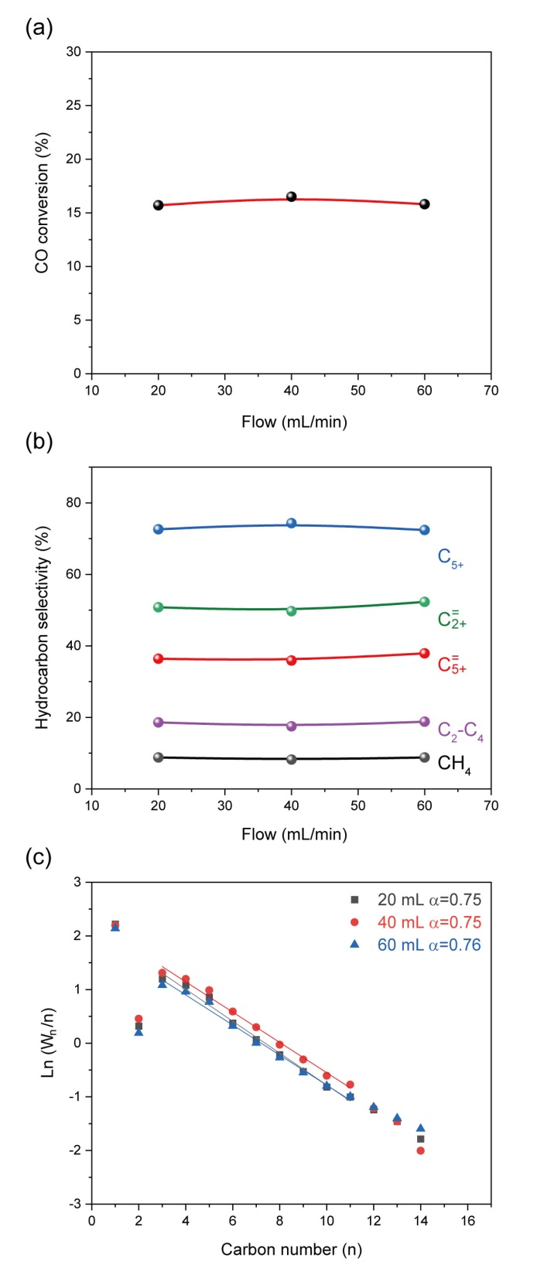
Fig. SE8. Flow rate test of Co-MnO_{x}-(C)/SiO₂ by keeping WHSV constant. The influences of flow rate on (a) CO conversion and (b) hydrocarbon product selectivity. (c) ASF plots with the corresponding chain growth probabilities in the C₃-C₁₁ hydrocarbon range derived from online product analysis. Reaction conditions: 210 °C, 1.0 MPa, H₂/CO = 2, and the data is collected after more than 24 h on stream. Cat. = 0.25 g for 20 mL/min, 0.50 g for 40 mL/min, and 0.75 g for 60 mL/min.

2. Supplementary Figures
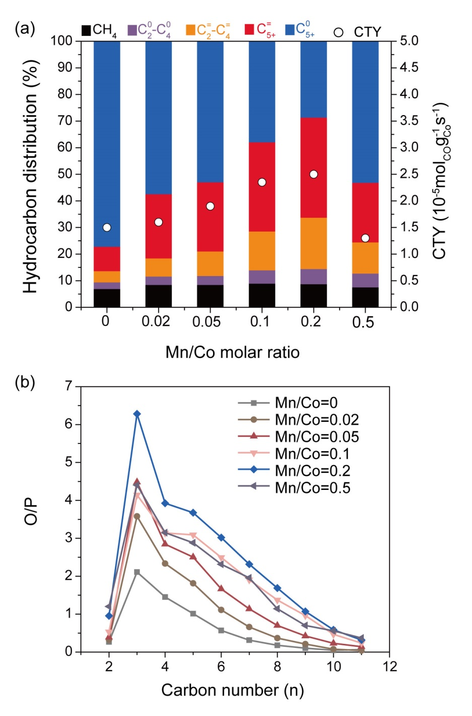
Fig. S1. FTS results over Co-MnO_{x}-(C)/SiO₂ with different Mn/Co molar ratios. (a) CTY and product distributions. (b) Olefin/paraffin (O/P) ratio of the products. Reaction conditions: 0.50 g catalyst, 1.0 MPa, 210 °C, H₂/CO = 2.0, GHSV = 4.8 L·g_{cat}⁻¹·h⁻¹, and the data was collected after more than 24 h on stream.

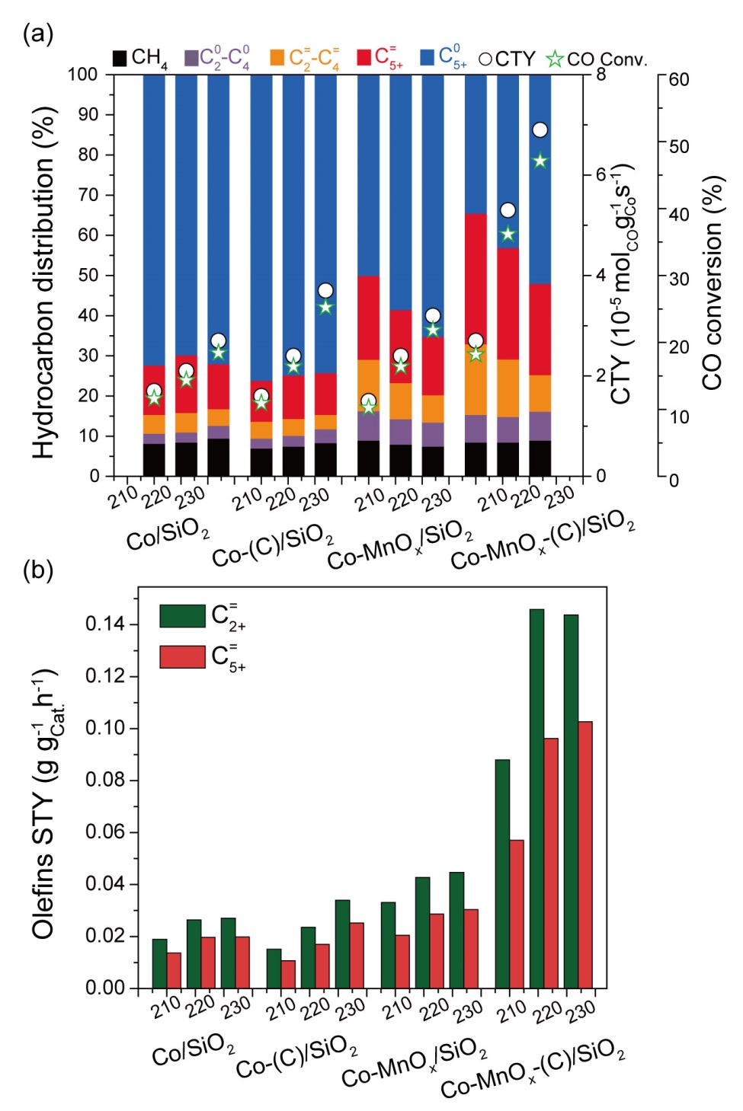
Fig. S2. FTS results of the four catalysts at different reaction temperatures. (a) CTY, CO conversion and product distributions. (b) Space-time yield (STY) of C₂₊⁼ and C₅₊⁼. Reaction conditions: 0.50 g catalyst, 1.0 MPa, 4.8 L·g_{cat}⁻¹·h⁻¹, H₂/CO = 2.0, and the data was collected after more than 24 h on stream.

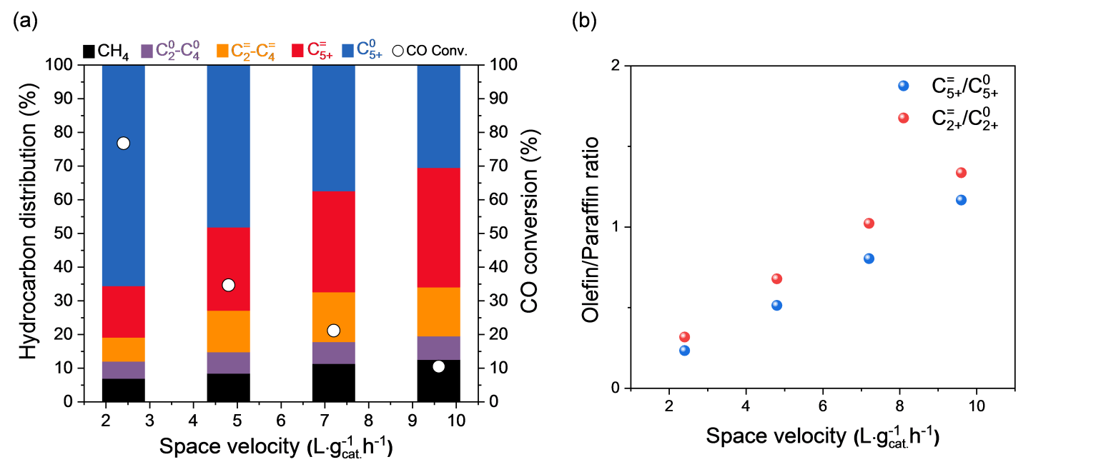
Fig. S3. (a) CO conversion and product distribution, and (b) O/P ratio of C₂₊ and C₅₊ over Co-MnO_{x}-(C)/SiO₂ at different GHSV. Reaction conditions: 0.50 g catalyst, 1.0 MPa, 220 °C, GHSV = 2.4 ~ 9.6 L·g_{cat}⁻¹·h⁻¹, H₂/CO = 2.0, and the data was collected after 24 h on stream.

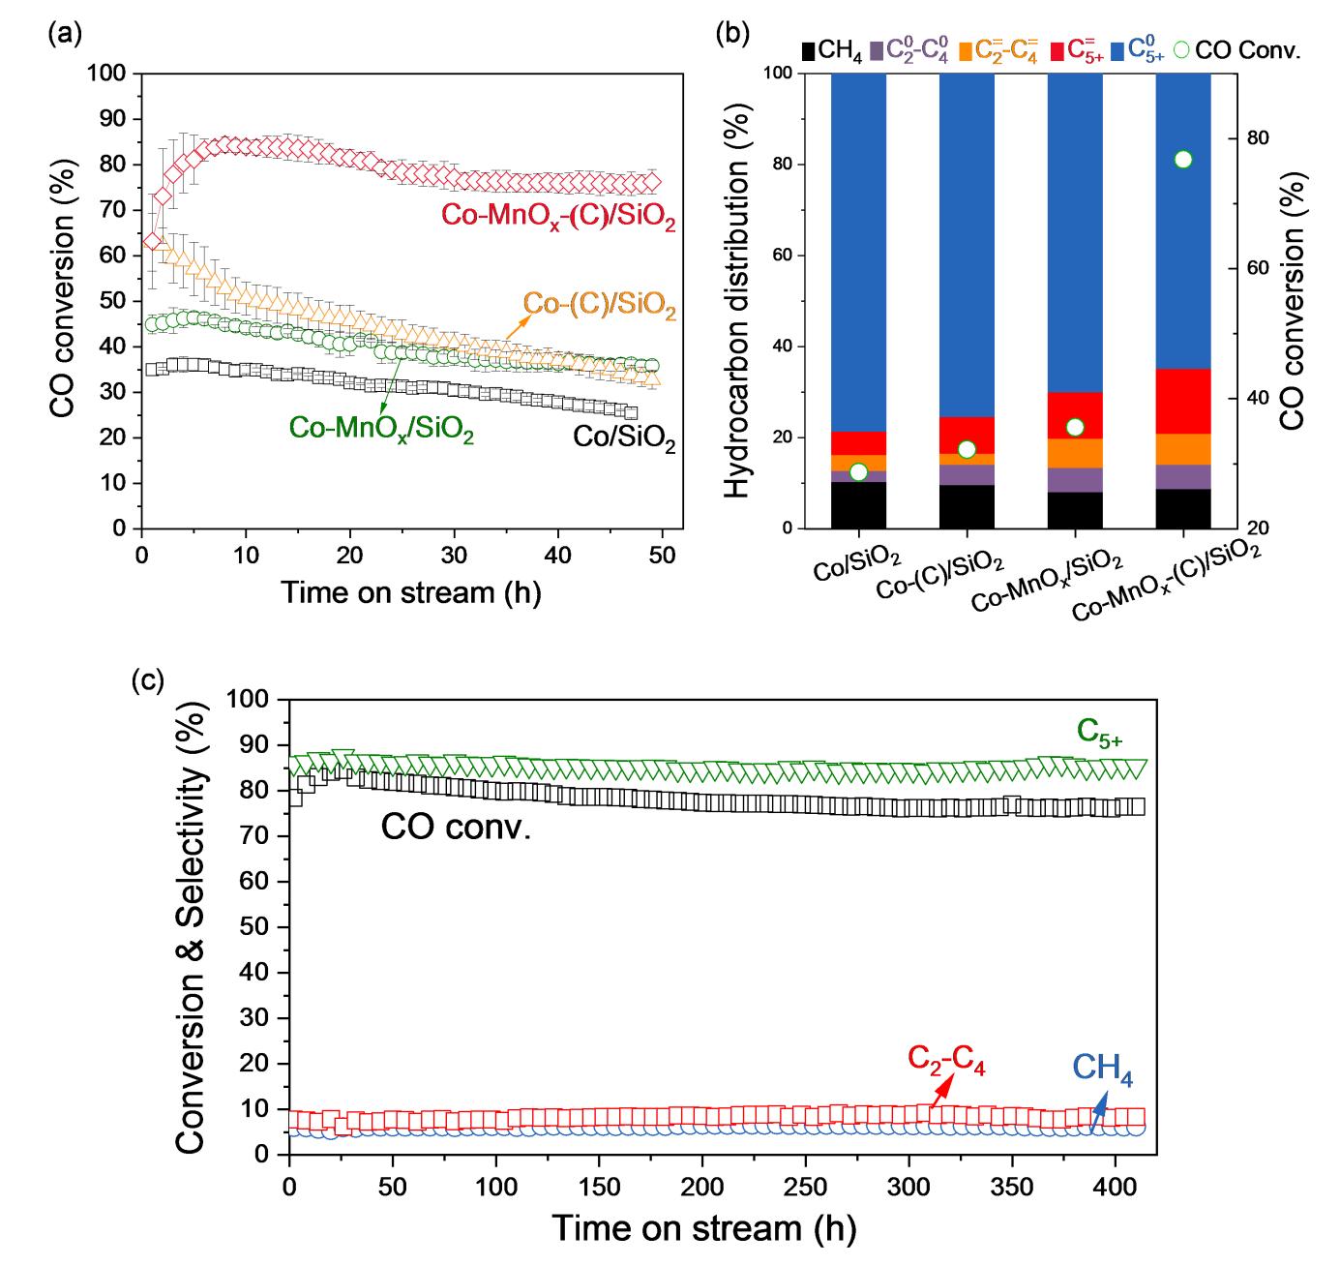
Fig. S4. Catalyst stability tests, (a) CO conversion as a function of the time-on-stream for the catalysts. (b) CO conversion and product distribution at the stable stage. (c) Long-term stability results over Co-MnO_{x}-(C)/SiO₂. Reaction conditions: 0.50 g catalyst, 1.0 MPa, 220 °C, H₂/CO = 2.0, and GHSV = 2.4 L·g_{cat}⁻¹·h⁻¹.

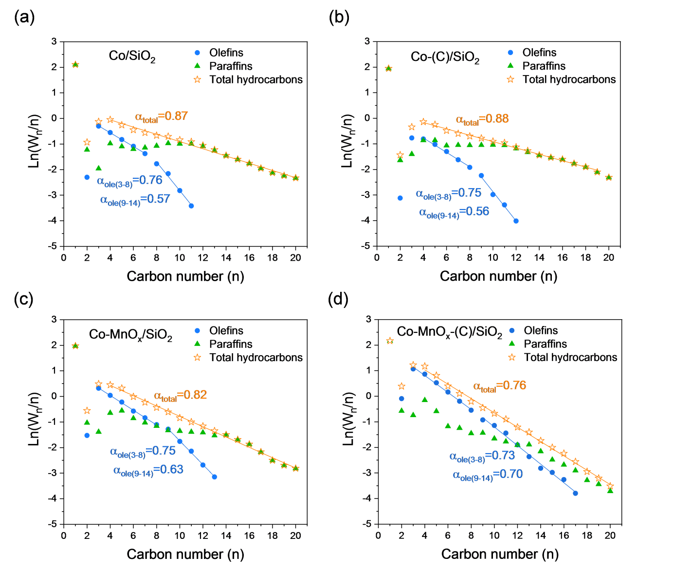
Fig. S5. ASF distribution of olefins and total hydrocarbons. (a) Co/SiO₂, (b) Co-(C)/SiO₂, (c) Co-MnO_{x}/SiO₂, and (d) Co-MnO_{x}-(C)/SiO₂. Reaction conditions: 0.50 g catalyst, 210 ºC, 1.0 MPa, H₂/CO = 2.0, GHSV of 4.8 to 7.2 L·g_{cat}⁻¹·h⁻¹ for achieving the CO conversion at 10.0 ± 1.4%.

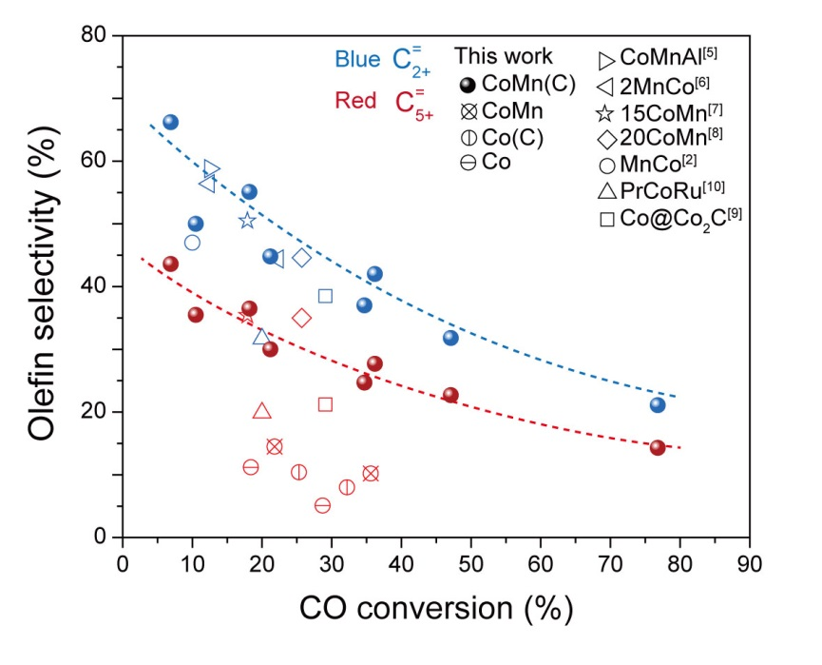
Fig. S6. The dependences of olefin selectivity on the CO conversion over Co-MnO_{x}-(C)/SiO₂ related catalysts and those reported in the references.

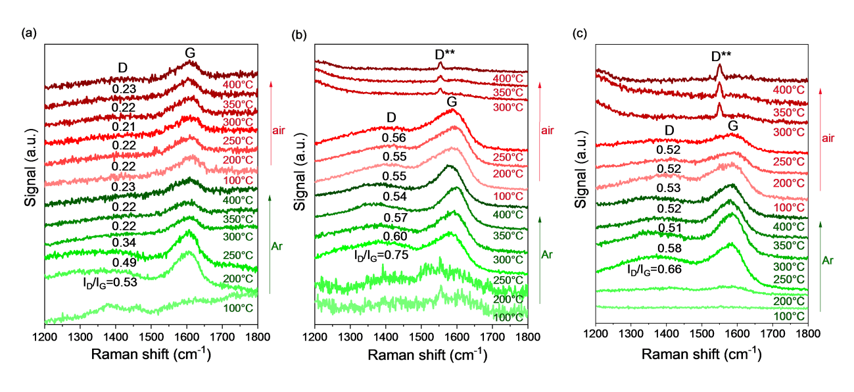
Fig. S7. In situ Raman spectra of the dried samples of (a) Glu/SiO₂, (b) Co-Glu/SiO₂, and (c) Co-Mn-Glu/SiO₂ during the consecutive treatments in the flow of Ar and air with increasing temperature.
In order to monitor the evolution of carbon species during heating process, the dried samples of SiO₂ impregnated with glucose (Glu/SiO₂), co-impregnation of Co(NO₃)₂ and glucose (Co-Glu/SiO₂), and co-impregnation of Co(NO₃)₂, Mn(CH₃COO)₂ and glucose (Co-Mn-Glu/SiO₂) were tested by in situ Raman technique during the consecutive treatments in a flow of Ar and air with increasing temperature. Specifically, 50 mg sample was loaded in the in situ cell (Harrick, HVC-DR2) and heated in a flow of Ar (20 mL/min) at atmospheric pressure with stepwise increasing temperature to 400 °C (5 °C/min). The corresponding spectrum at the 1200-1800 cm⁻¹ region was recorded at 100, 200, 250, 300, 350 and 400 °C, respectively. After cooled down to room temperature, the sample was switched to a flow of air (20 mL/min) and heated again with stepwise increasing temperature to 400 °C (5 °C/min). The corresponding spectrum at the 1200-1800 cm⁻¹ region was recorded at 100, 200, 250, 300, 350 and 400 °C, respectively.

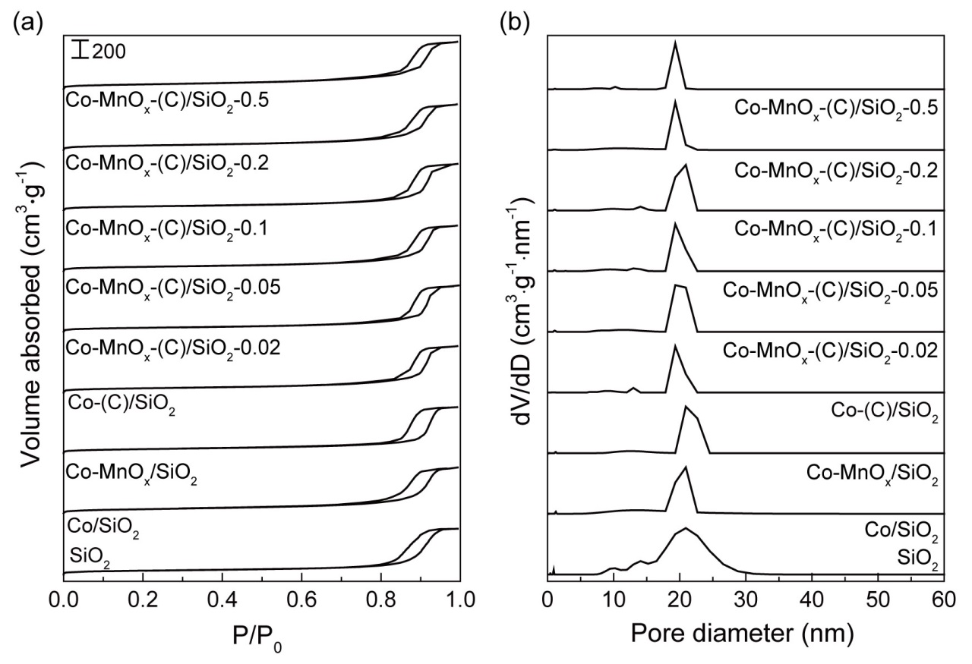
Fig. S8. Textural properties of the calcined catalysts. (a) N₂ adsorption-desorption isotherms. (b) Pore size distributions calculated by BJH mesopore model.

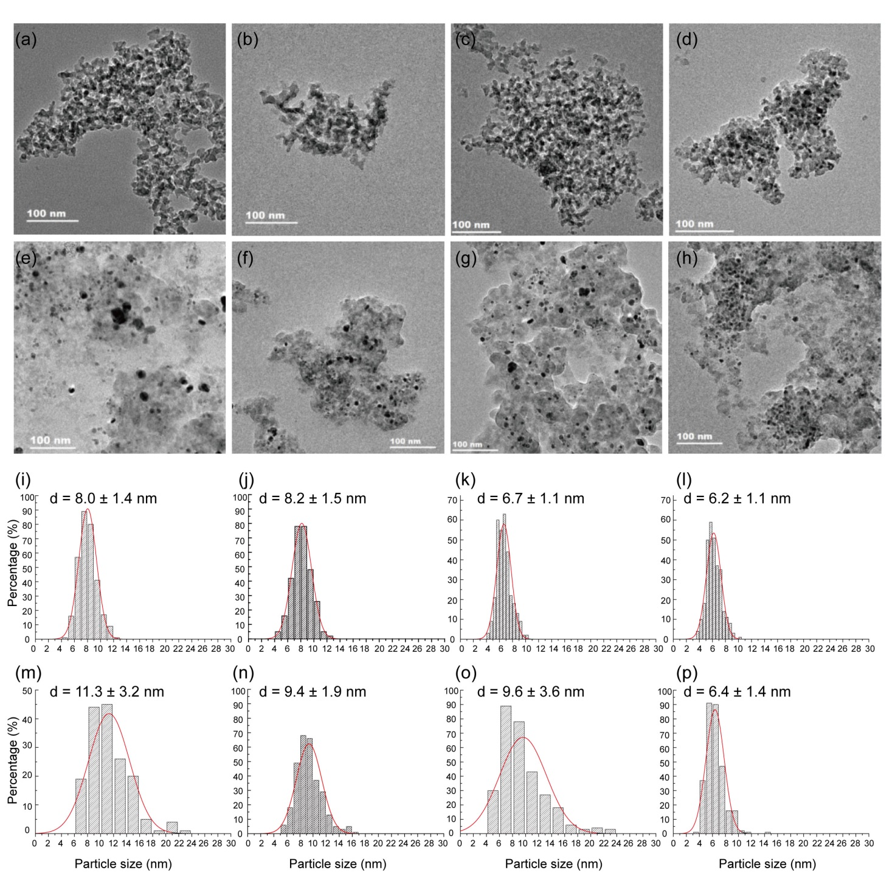
Fig. S9. TEM images, particle size distributions, and the average particle sizes of the calcined and used catalysts. Calcined catalysts: (a, i) Co/SiO₂, (b, j) Co-MnO_{x}/SiO₂, (c, k) Co-(C)/SiO₂, and (d, l) Co-MnO_{x}-(C)/SiO₂. Used catalysts: (e, m) Co/SiO₂, (f, n) Co-MnO_{x}/SiO₂, (g, o) Co-(C)/SiO₂, and (h, p) Co-MnO_{x}-(C)/SiO₂.

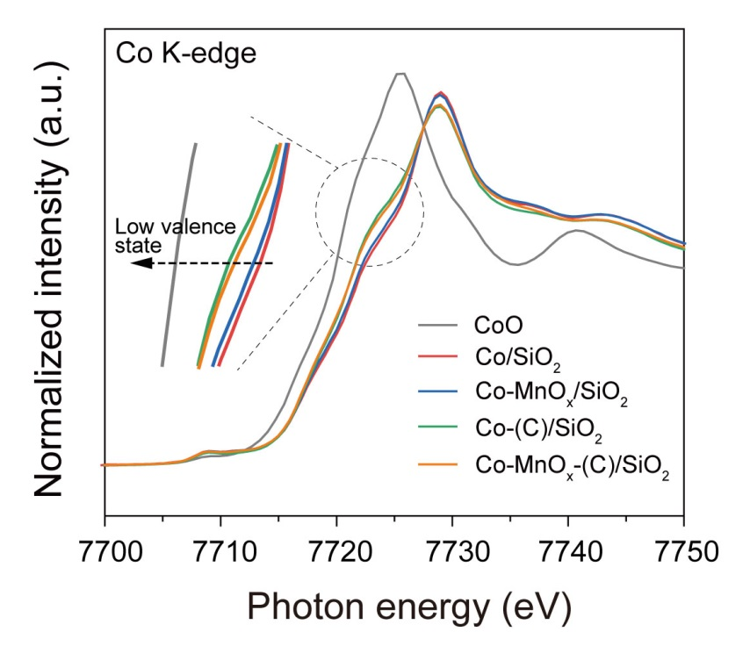
Fig. S10. Normalized XANES spectra of calcined catalysts at the Co K-edge with the standard CoO.

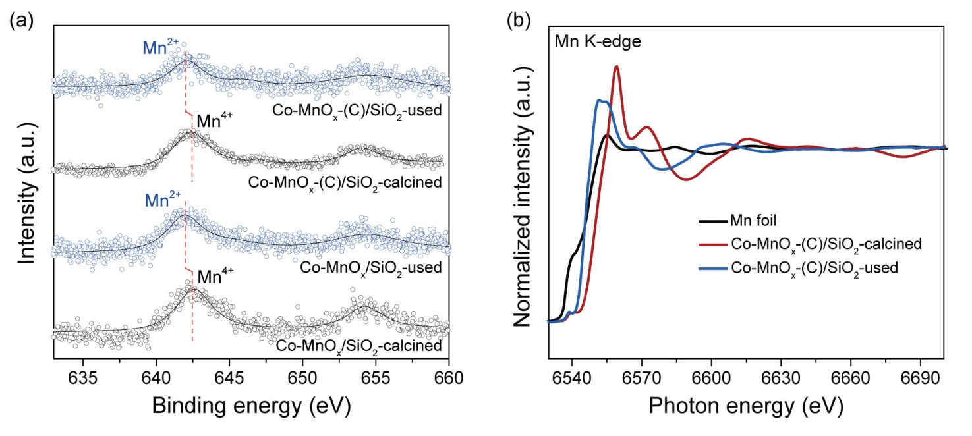
Fig. S11. (a) Mn 2p XPS spectra for the calcined and used catalysts. (b) Normalized Mn K-edge XANES spectra of the calcined and used Co-MnO_{x}-(C)/SiO₂ with the reference of Mn foil.

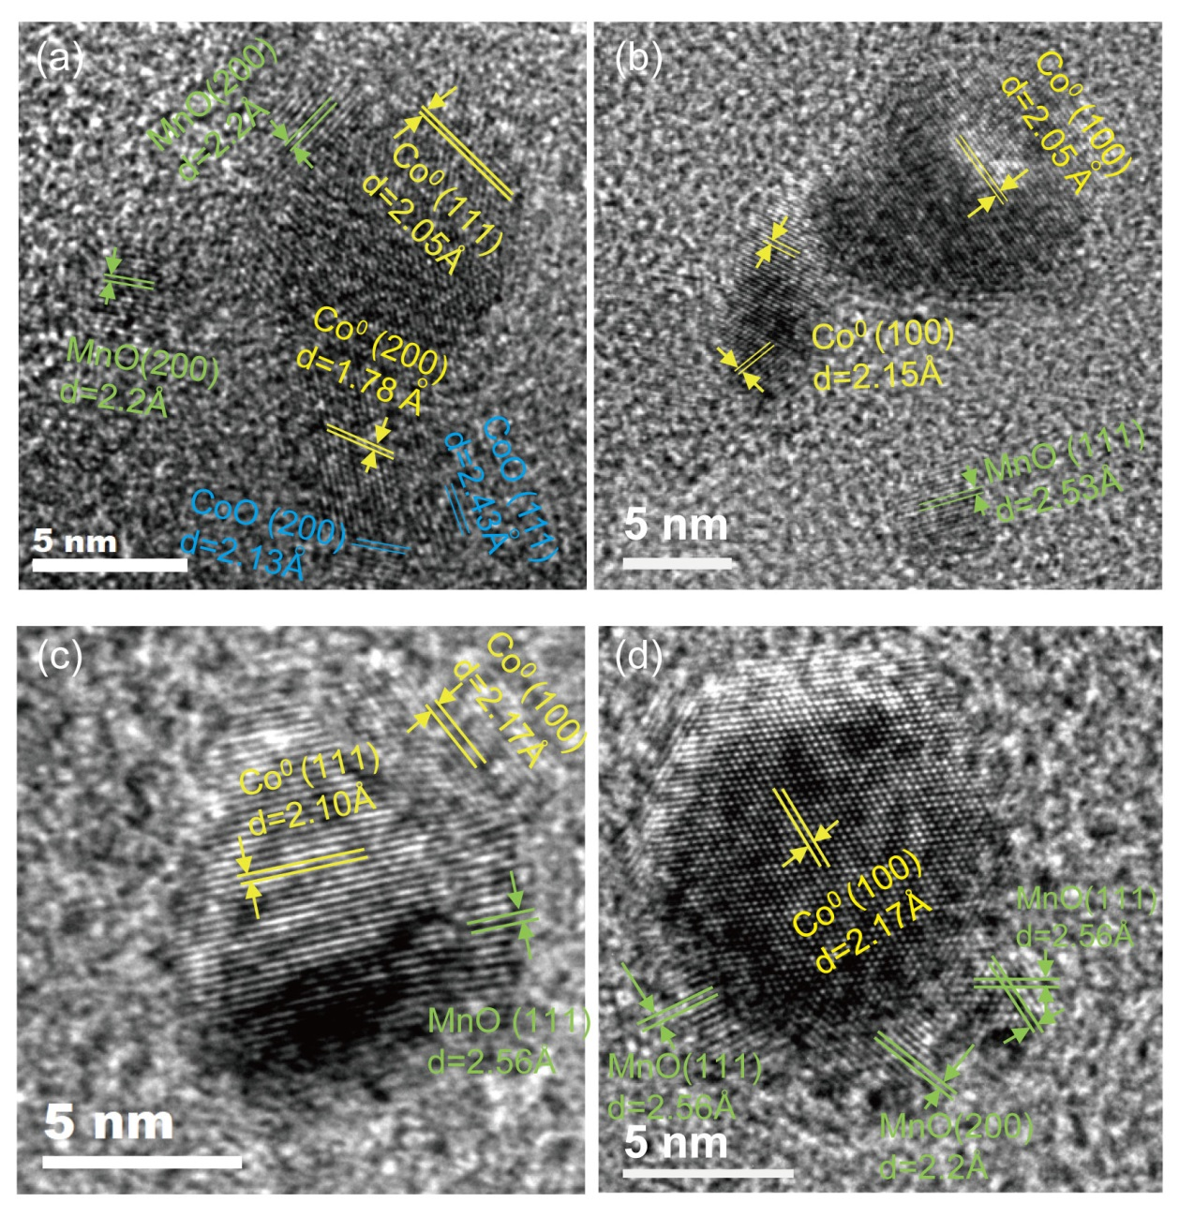
Fig. S12. HR-STEM images of the used catalysts. (a-b) Co-MnO_{x}/SiO₂, (c-d) Co-MnO_{x}-(C)/SiO₂. The spatial segregation of MnO_{x} and Co NPs is clearly seen on the used Co-MnO_{x}/SiO₂. In contrast, MnO_{x} is found in a close spatial proximity with Co NPs on the used Co-MnO_{x}-(C)/SiO₂.

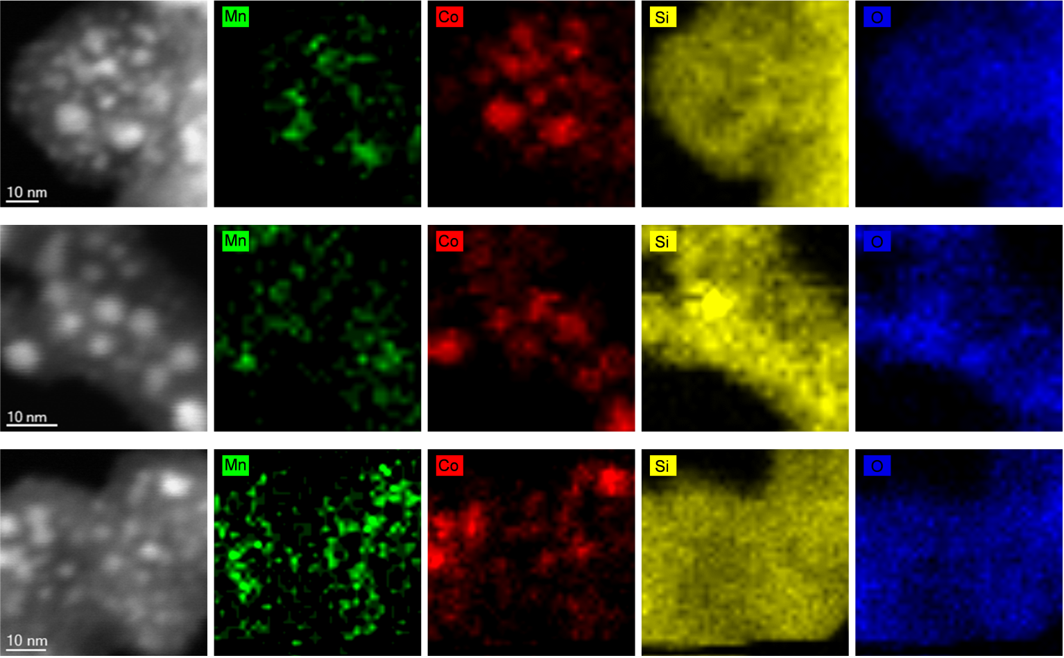
Fig. S13. High-magnification STEM-HAADF images on the random thin sample specimens of the used Co-MnO_{x}-(C)/SiO₂ and the corresponding EDS elemental maps of Mn (green), Co (red), Si (yellow), and O (blue).

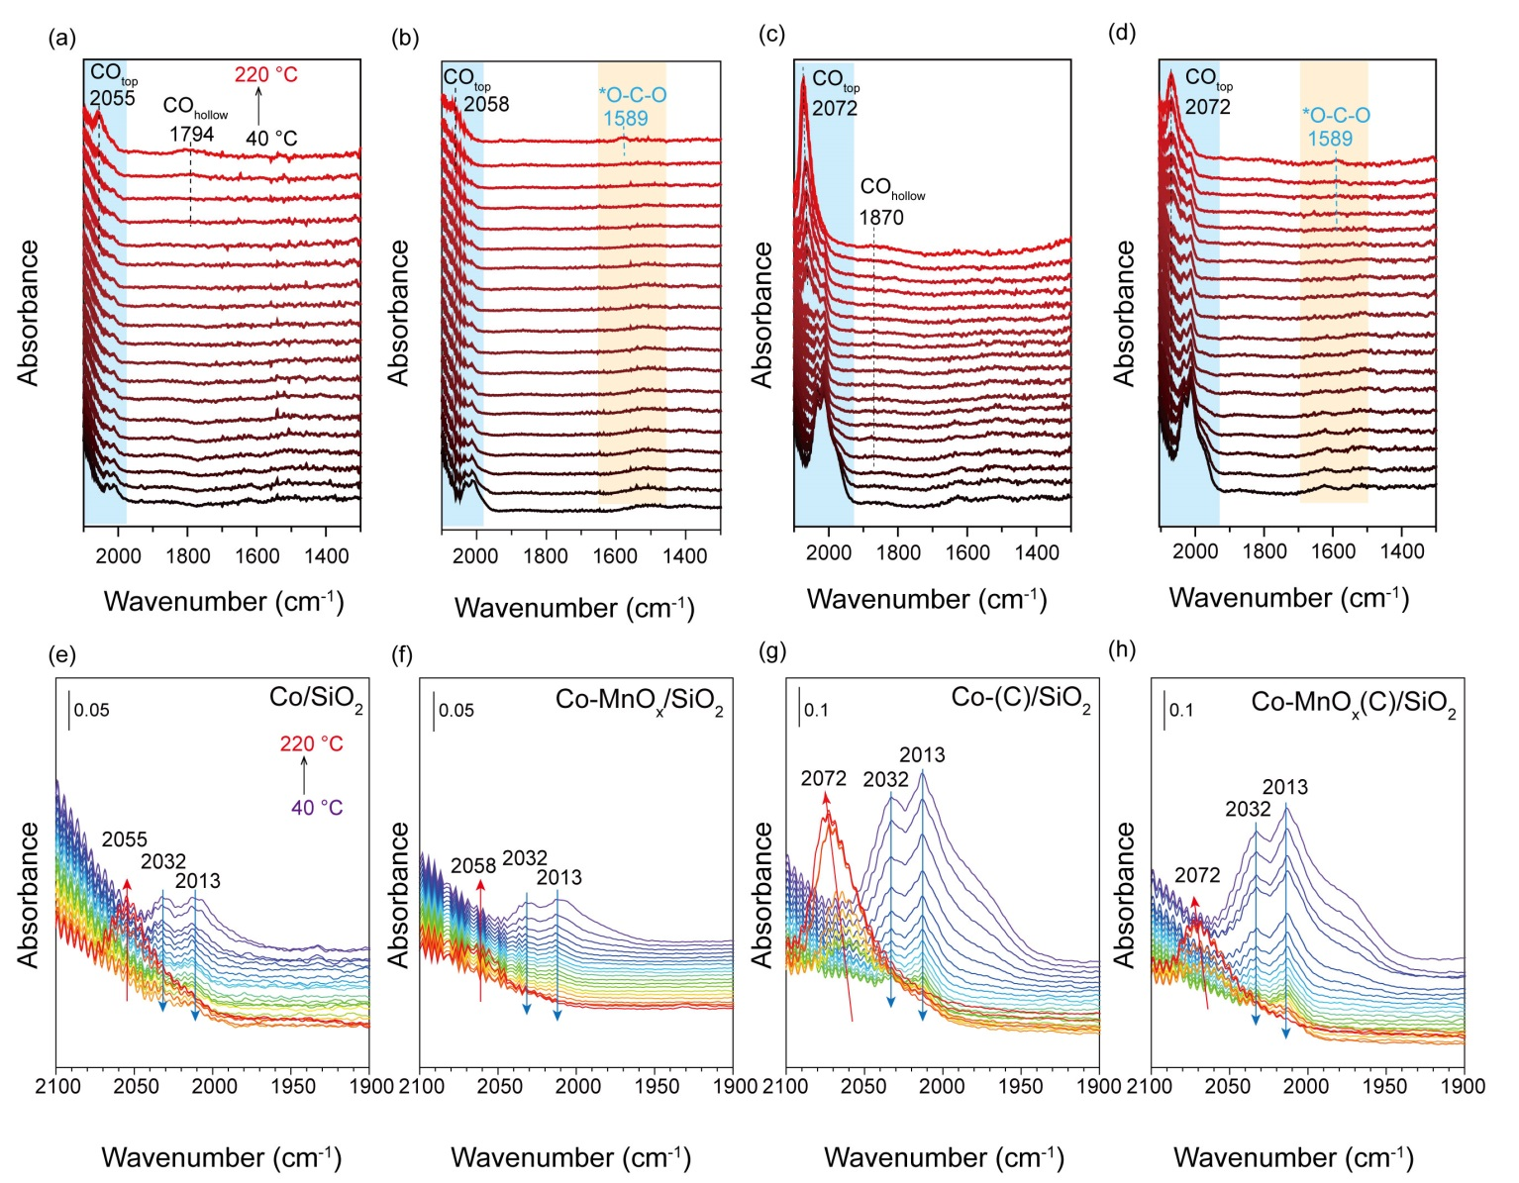
Fig. S14. In situ DRIFTS of CO as a function of temperature (40-220 °C) over the reduced catalysts: (a) Co/SiO₂, (b) Co-MnO_{x}/SiO₂, (c) Co-(C)/SiO₂ and (d) Co-MnO_{x}-(C)/SiO₂. Evolutions of CO_{top} with temperature in the wavenumber range of 2100-1900 cm⁻¹: (e) Co/SiO₂, (f) Co-MnO_{x}/SiO₂, (g) Co-(C)/SiO₂ and (h) Co-MnO_{x}-(C)/SiO₂. The spectra were collected from 40 to 220 °C under the conditions of 20 mL/min flow of 30%CO/Ar at the atmospheric pressure.

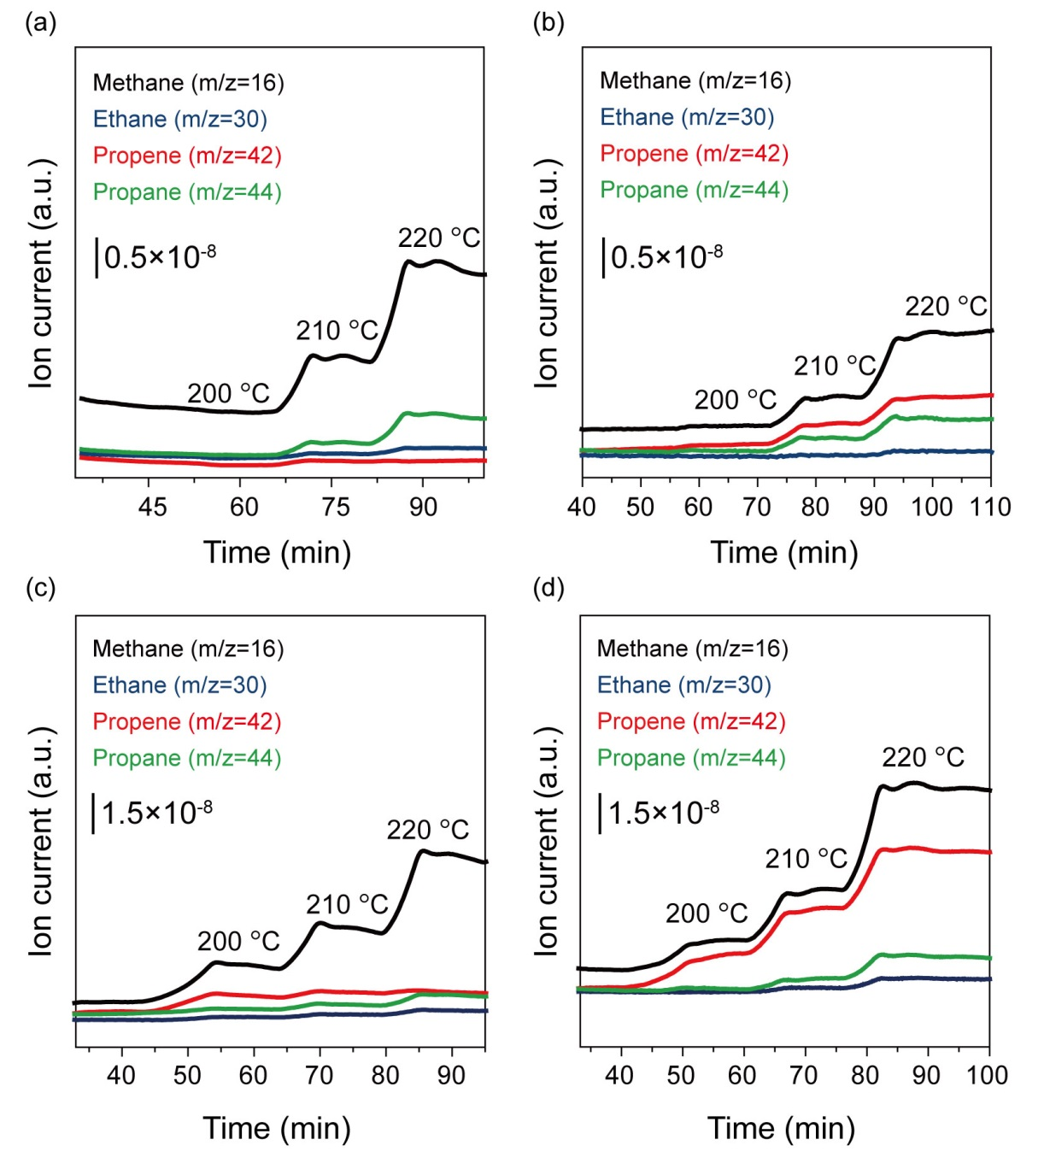
Fig. S15. The MS patterns of the gaseous hydrocarbons evolved during in situ DRIFTS of CO hydrogenation over (a) Co/SiO₂, (b) Co-MnO_{x}/SiO₂, (c) Co-(C)/SiO₂, and (d) Co-MnO_{x}-(C)/SiO₂.

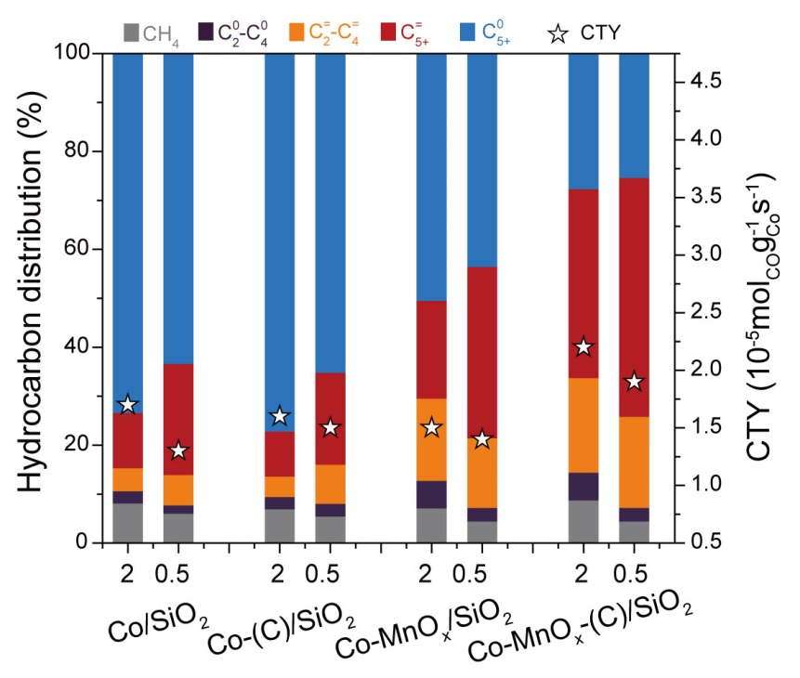
Fig. S16. Catalytic performances of the catalysts at different H₂/CO ratio of feed gas. Reaction conditions: 0.50 g catalyst, 1.0 MPa, 4.8 L·g_{cat}⁻¹·h⁻¹. In order to achieve the similar CTY for each catalyst, the reaction temperature is adjusted, e.g., 210 ºC for H₂/CO = 2.0 and 220 ºC for H₂/CO = 0.5. The data was collected after more than 24 h on stream.

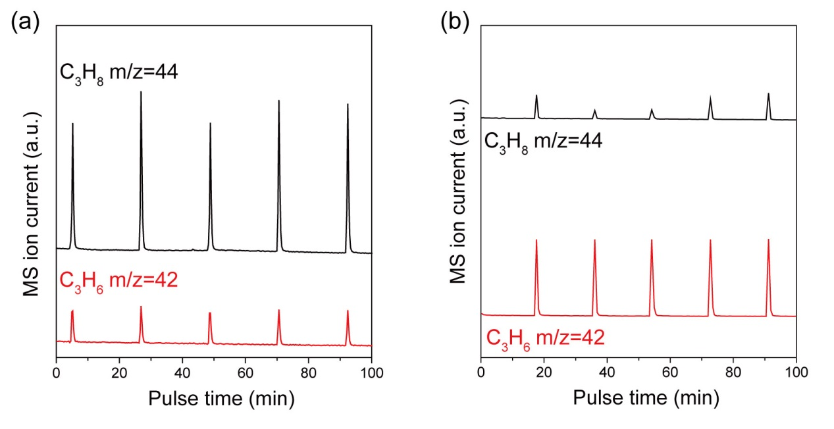
Fig. S17. Characterization of hydrogenation ability of (a) Co-(C)/SiO₂, (b) Co-MnO_{x}-(C)/SiO₂ on olefins by the experiment of pulsing propylene (20% C₃H₆ in Ar) into a flow of 10% H₂ in Ar. Before the pulse reaction, the catalysts (100 mg) were in situ reduced with 10% H₂ in Ar at 400 ºC for 2 h, then cooled down to 220 ºC. The C₃H₆ with m/z = 42 and C₃H₈ with m/z = 44 were detected by the mass spectrometry.

3. Supplementary Tables
Table S1. Metal loadings and the calculated textural properties
Catalyst | Co^{[a]}  (wt.%) | Mn^{[a]}  (wt.%) | Mn/Co  molar ratio | Surface area^{[b]}  (m²/g) | Pore volume^{[c]}  (cm³/g) | Pore size^{[d]}  (nm)
SiO₂ | n.a.^{[e]} | n.a.^{[e]} | n.a.^{[e]} | 223.4 | 1.11 | 19.9
Co/SiO₂ | 13.0 | n.a.^{[e]} | n.a.^{[e]} | 180.5 | 0.80 | 17.7
Co-MnO_{x}/SiO₂ | 12.9 | 2.5 | 0.21 | 211.8 | 1.06 | 19.7
Co-(C)/SiO₂ | 13.0 | n.a.^{[e]} | n.a.^{[e]} | 209.5 | 0.95 | 18.3
Co-MnO_{x}-(C)/SiO₂-0.02 | 13.1 | 0.2 | 0.02 | 203.3 | 1.01 | 19.8
Co-MnO_{x}-(C)/SiO₂-0.05 | 13.0 | 0.5 | 0.04 | 212.8 | 0.94 | 17.7
Co-MnO_{x}-(C)/SiO₂-0.1 | 12.6 | 1.0 | 0.09 | 198.4 | 0.97 | 19.4
Co-MnO_{x}-(C)/SiO₂-0.2 | 12.8 | 2.9 | 0.24 | 201.4 | 0.89 | 17.7
Co-MnO_{x}-(C)/SiO₂-0.5 | 12.3 | 5.6 | 0.49 | 221.1 | 0.93 | 16.7
^{[a]} Measured by ICP-OES.
^{[b]} Calculated by the Brunaue-Emmett-Teller (BET) method based on the adsorption branch of the N₂ adsorption/desorption isotherms.
^{[c]} The total pore volume determined by the Barrett-Joyner-Halenda (BJH) method at a relative pressure of 0.99.
^{[d]} The average pore diameter evaluated by the BJH method.
^{[e]} n.a.: not available.

Table S2. Catalytic performances over prepared catalysts
Catalyst | Catalytic activity |  | Product selectivity (%)
 | Conversion  (%) | CTY  10⁻⁵ mol_{CO}·g_{Co}⁻¹·s⁻¹ | CH₄ | CO₂ | C₂-C₄ | C₅₊ | C₂₊⁼ | C₅₊⁼
Co/SiO₂ | 28.7 | 2.1 | 9.3 | 1.0 | 6.0 | 83.7 | 8.6 | 5.1
Co-MnO_{x}/SiO₂ | 35.6 | 2.6 | 7.2 | 0.9 | 11.8 | 80.1 | 16.7 | 10.2
Co-(C)/SiO₂ | 32.2 | 2.4 | 8.5 | 1.2 | 6.9 | 83.4 | 10.5 | 8.0
Co-MnO_{x}-(C)/SiO₂ | 76.8 | 5.6 | 7.0 | 1.8 | 12.1 | 79.1 | 21.1 | 14.3
Reaction conditions: 0.50 g catalyst, 220 ºC, 1.0 MPa, GHSV = 2.4 L·g_{cat}⁻¹·h⁻¹ and H₂/CO = 2.0. All the reaction data is collected after more than 24 h on stream.

Table S3. Catalytic performances over prepared catalysts
Catalyst | Catalytic activity |  |  |  | Hydrocarbon selectivity (%) |  |  |  |  | α^{[b]}
 | Conversion (%) | CTY  10⁻⁵mol_{CO}·g_{Co}⁻¹·s⁻¹ | TOF^{[a]}  (10⁻²s⁻¹) |  | CH₄ | C₂-C₄ | C₅₊ | C₂₊⁼ | C₅₊⁼
Co/SiO₂ | 11.4 | 1.7 | 3.3 |  | 8.2 | 7.2 | 84.6 | 16.1 | 11.3 | 0.87
Co-MnO_{x}/SiO₂ | 9.1 | 1.5 | 3.6 |  | 7.2 | 22.3 | 70.5 | 35.8 | 19.0 | 0.82
Co-(C)/SiO₂ | 11.2 | 1.6 | 3.9 |  | 7.0 | 6.8 | 86.2 | 13.4 | 9.2 | 0.88
Co-MnO_{x}-(C)/SiO₂ | 11.5 | 2.6 | 6.4 |  | 8.8 | 25.8 | 65.4 | 55.8 | 36.9 | 0.76
Reaction conditions: 0.50 g catalyst, 210 °C, 1.0 MPa, GHSV = 4.8~7.2 L·g_{cat}⁻¹·h⁻¹, H₂/CO = 2.0. All the reaction data is collected after more than 24 h on stream. The CO₂ selectivity is ignored as it is less than 1% for each tested catalyst.
^{[a]} The turnover frequency (TOF) was calculated based on the reaction results at an initial TOS of 1-3 h.
^{[b]} The carbon-chain growth probability of α is calculated based on C₃-C₁₀ products.

Table S4. Comparison of catalytic performances with the typical Co-based FTS catalysts published in references for long-chain olefins
Catalyst | H₂/CO | Temp. | Pressure | GHSV^{[a]} | CO Conv. | CTY^{[b]} | Selectivity (%) |  |  |  | STY  (g/g_{Cat}/h) | STY  (g/g_{Co}/h)
 |  | (°C) | (MPa) |  | (%) |  | CH₄ | CO₂ | C₂₊⁼ | C₅₊⁼ | C₅₊⁼ | C₅₊⁼
1.5Mn10Co-SiO₂^{[2]} | 2.0 | 220 | 2.0 | n.a. | 10~15 | 1.6 | 11.0 | <1 | 47.0 | n.a. | n.a. | n.a.
CoMnAl@SiO₂^{[5]} | 0.5 | 260 | 1.0 | 4.0 | 12.5 | n.a. | 6.5 | 15.1 | 58.8 | n.a. | n.a. | n.a.
2Mn-Co@C^{[6]} | 0.5 | 250 | 0.5 | 2.0 | 12.4 | 0.4 | 12.8 | 5.8 | 56.4 | n.a. | n.a. | n.a.
2Mn-Co@C^{[6]} | 1.0 | 250 | 0.5 | 2.0 | 22.3 | 0.7 | 16.2 | 4.2 | 44.4 | n.a. | n.a. | n.a.
15CoMn/SiO₂^{[7]} | 2.0 | 230 | 1.0 | 4.5 | 17.9 | 2.1 | 7.7 | 1.0 | 50.5 | 35.4 | 0.056 | 0.37
20Co5Mn/SiO₂^{[8]} | 2.0 | 230 | 1.0 | 4.5 | 25.7 | 2.3 | 7.1 | 0.5 | 44.6 | 35.0 | 0.080 | 0.40
Co@Co₂C^{[9]} | 2.0 | 220 | 3.0 | 2000^{[c]} | 29.1 | 2.5 | 8.1 | 2.4 | 38.5 | 21.2 | 0.040 | 0.26
1.0PrCoRu/Al₂O₃^{[10]} | 2.0 | 200 | 2.0 | n.a. | 20±3 | 1.0 | 8.4 | 0.9 | 31.7 | 19.9 | 0.015 | 0.10
Co-MnO_{x}-(C)/SiO₂  (This work) | 2.0 | 200 | 1.0 | 4.8 | 6.9 | 1.0 | 8.9 | 0.1 | 22.6 | 43.6 | 0.029 | 0.22
 | 2.0 | 210 | 1.0 | 4.8 | 18.6 | 2.7 | 8.5 | 0.5 | 50.1 | 32.5 | 0.057 | 0.45
 | 2.0 | 220 | 1.0 | 4.8 | 36.2 | 5.3 | 8.5 | 0.5 | 42.0 | 27.7 | 0.096 | 0.74
 | 2.0 | 230 | 1.0 | 4.8 | 47.1 | 6.9 | 9.0 | 1.0 | 31.8 | 22.7 | 0.103 | 0.79
^{[a]} GHSV, L·g_{cat}⁻¹·h⁻¹
^{[b]} CTY, 10⁻⁵ mol_{CO}·g_{Co}⁻¹·s⁻¹.
^{[c]} GHSV of 2000 h⁻¹ is used.
n.a.: not available.

Table S5. Summary of the binding energies for different forms of Co from the deconvoluted XPS spectra
Catalyst | Calcined catalyst |  |  | Reduced catalyst^{[a]} |  |  | Used catalyst^{[b]}
 | Co 2p_{3/2} (eV) |  | Atomic ratios | Co 2p_{3/2} (eV) |  | Atomic ratios | Co 2p_{3/2} (eV) |  | Atomic ratios
 | Co³⁺ | Co²⁺ | Co²⁺/Co³⁺ | Co²⁺ | Co⁰ | Co⁰/(Co⁰+Co²⁺) | Co²⁺ | Co⁰ | Co⁰/(Co⁰+Co²⁺)
Co/SiO₂ | 779.1 | 780.8 | 1.8 | 780.8 | 778.4 | 0.36 | 780.8 | 778.3 | 0.52
Co-MnO_{x}/SiO₂ | 779.0 | 780.6 | 2.4 | 781.4 | 778.8 | 0.35 | 781.4 | 778.3 | 0.77
Co-(C)/SiO₂ | 779.2 | 780.9 | 7.4 | 782.2 | 778.2 | 0.04 | 781.1 | 778.3 | 0.25
Co-MnO_{x}-(C)/SiO₂ | 779.4 | 781.0 | 7.9 | 782.6 | 778.4 | 0.03 | 781.5 | 778.6 | 0.51
^{[a]} After reduction in 10%H₂ in Ar (10 mL/min) at 400 ºC for 3 h.
^{[b]} After reaction in syngas flow (32%CO/64%H₂/4%Ar, 10 mL/min) at 220 ºC for 10 h.

Table S6. Co K-edge EXAFS fitting results for calcined samples and the reference Co₃O₄
Sample | Scattering pair | CN | R(Å) | σ² (10⁻³Å²) | ΔE₀(eV) | R-factor
Co₃O₄ | Co-O1 | 6 | 1.91±0.01 | 1.2±0.9 | -0.97±1.4 | 0.0028
 | Co-Co1 | 6 | 2.86±0.01 | 4.0±0.8 | 2.38±1.0
 | Co-Co2 | 6 | 3.35±0.02 | 4.3±1.3 | 2.38±1.0
 | Co-O1 | 4 | 1.82±0.04 | 4.0±0.8 | -0.97±1.4
 | Co-Co1 | 12 | 3.35±0.03 | 4.0±0.8 | 2.38±1.0
Co/SiO₂ | Co-O1 | 4.6±1.2 | 1.93±0.01 | 1.3±1.8 | 3.17±1.7 | 0.0012
 | Co-Co1 | 5.5±1.5 | 2.86±0.01 | 3.4±1.5 | 3.17±1.7
 | Co-Co2 | 5.5±1.5 | 3.36±0.01 | 4.4±0.9 | 3.17±1.7
 | Co-O1 | 2.8±1.1 | 1.86±0.03 | 3.4±1.5 | 3.17±1.7
 | Co-Co1 | 2.8±1.1 | 3.29±0.05 | 3.4±1.5 | 3.17±1.7
Co-MnO_{x}/SiO₂ | Co-O1 | 4.4±0.9 | 1.91±0.03 | 2.4±1.3 | 4.03±1.2 | 0.0009
 | Co-Co1 | 5.6±1.1 | 2.87±0.01 | 4.0±1.3 | 4.03±1.2
 | Co-Co2 | 5.6±1.1 | 3.37±0.01 | 4.5±0.6 | 4.03±1.2
 | Co-O1 | 2.5±0.8 | 1.93±0.09 | 4.0±1.3 | 4.03±1.2
 | Co-Co1 | 2.5±0.8 | 3.33±0.05 | 4.0±1.3 | 4.03±1.2
Co-(C)/SiO₂ | Co-O1 | 4.0±0.6 | 1.90±0.06 | 3.8±6.2 | 1.54±1.3 | 0.0006
 | Co-Co1 | 3.2±0.8 | 2.84±0.01 | 2.5±1.4 | 1.54±1.3
 | Co-Co2 | 3.2±0.8 | 3.36±0.01 | 3.9±0.9 | 1.54±1.3
 | Co-O1 | 2.2±0.6 | 1.94±0.01 | 2.5±1.4 | 1.54±1.3
 | Co-Co1 | 2.2±0.6 | 3.26±0.12 | 2.5±1.4 | 1.54±1.3
Co-MnO_{x}-(C)/SiO₂ | Co-O1 | 4.1±0.6 | 1.90±0.01 | 2.7±1.2 | 2.66±1.0 | 0.0004
 | Co-Co1 | 4.4±0.8 | 2.86±0.01 | 4.4±1.1 | 2.66±1.0
 | Co-Co2 | 4.4±0.8 | 3.37±0.01 | 5.3±0.5 | 2.66±1.0
 | Co-O1 | 2.3±0.5 | 1.95±0.04 | 4.4±1.1 | 2.66±1.0
 | Co-Co1 | 2.3±0.5 | 3.31±0.03 | 4.4±1.1 | 2.66±1.0
CN, coordination number; R, interatomic distance; σ, disorder parameter; ΔE₀, energy shift. All the fitting analysis were performed in the R space, ΔR = 1.0-3.4 and ΔK = 3.2-12.8. S₀² = 0.59 was obtained from fitting the Co₃O₄ standard sample.

Table S7. The calculated reduction degree, H₂ uptake and particle size of different catalysts
Catalyst | Reduction degree^{[a]}  (%) | H₂-chemisorption |  |  |  |  | TEM |  | XRD
 |  | H₂ uptake^{[b]}  (μmol·g_{cat}⁻¹) | Dispersion^{[c]}  (%) | Particle size^{[d]}  (nm) |  |  | Particle size^{[e]} (nm) |  | Co₃O₄ size^{[f]}  (nm) | Co⁰ size^{[g]}  (nm)
Co/SiO₂ | 85.7 | 32.9 | 6.9 | 13.8 |  |  | 9.0 |  | 17.8 | 13.4
Co-MnO_{x}/SiO₂ | 71.5 | 30.5 | 7.8 | 12.3 |  |  | 8.2 |  | 12.4 | 9.3
Co-(C)/SiO₂ | 59.5 | 41.2 | 12.6 | 7.6 |  |  | 6.7 |  | 6.9 | 5.2
Co-MnO_{x}-(C)/SiO₂ | 42.8 | 25.6 | 11.3 | 8.5 |  |  | 6.2 |  | 6.3 | 4.7
^{[a]} Determined by the O₂ titration method.
^{[b]} Calculated based on the H₂-chemisorption.
^{[c]} Dispersion percentage calculated from D = 1.179X/(W·f), where X-H₂ uptake, f-reduction degree and W-the weight percentage of cobalt.
^{[d]} Determined by H₂-chemisorption and calibrated by reduction degree.
^{[e]} Determined from TEM images of calcined catalysts and calculated upon the measurement of random 300 particles.
^{[f]} Calculated by Scherrer equation applied to the most intense diffraction (2θ = 36.8°) from XRD results of the calcined catalysts.
^{[g]} Calculated according to d(Co⁰) = 0.75d(Co₃O₄).

4. Supplementary References
[1] C. Márquez‐Alvarez, N. Žilková, J. Pérez‐Pariente, J. Čejka, Synthesis, Characterization and Catalytic Applications of Organized Mesoporous Aluminas, Catal. Rev. 50 (2008) 222-286.
[2] D. Schröder, J. Thiessen, A. Jess, J. Scholz, Influence of the formation of short-chain olefins by manganese/cobalt-catalyzed Fischer–Tropsch synthesis on the selectivity and effective reaction rate, Catal. Sci. Technol. 10 (2020) 475-483.
[3] C. Erkey, J.B. Rodden, A. Akgerman, Diffusivities of synthesis gas and n-alkanes in Fischer-Tropsch wax, Energ. Fuel. 4 (1990) 275-276.
[4] M. Zhang, M. Wang, B. Xu, D. Ma, How to Measure the Reaction Performance of Heterogeneous Catalytic Reactions Reliably, Joule, 3 (2019) 2876-2883.
[5] T. Lin, P. Liu, K. Gong, Y. An, F. Yu, X. Wang, L. Zhong, Y. Sun, Designing silica-coated CoMn-based catalyst for Fischer-Tropsch synthesis to olefins with low CO₂ emission, Appl. Catal. B Environ. 299 (2021) 120683.
[6] K. Gong, Y. Wei, Y. Dai, T. Lin, F. Yu, Y. An, X. Wang, F. Sun, Z. Jiang, L. Zhong, Carbon-encapsulated metallic Co nanoparticles for Fischer-Tropsch to olefins with low CO₂ selectivity, Appl. Catal. B Environ. 316 (2022) 121700.
[7] J. Zheng, J. Cai, F. Jiang, Y. Xu, X. Liu, Investigation of the highly tunable selectivity to linear α-olefins in Fischer–Tropsch synthesis over silica-supported Co and CoMn catalysts by carburization–reduction pretreatment, Catal. Sci. Technol. 7 (2017) 4736-4755.
[8] Q. Lin, B. Liu, F. Jiang, X. Fang, Y. Xu, X. Liu, Assessing the formation of cobalt carbide and its catalytic performance under realistic reaction conditions and tuning product selectivity in a cobalt-based FTS reaction, Catal. Sci. Technol. 9 (2019) 3238-3258.
[9] Z. Zhao, W. Lu, R. Yang, H. Zhu, W. Dong, F. Sun, Z. Jiang, Y. Lyu, T. Liu, H. Du, Y. Ding, Insight into the formation of Co@Co₂C catalysts for direct synthesis of higher alcohols and olefins from syngas, ACS Catal. 8 (2017) 228-241.
[10] K. Jeske, A.C. Kizilkaya, I. López-Luque, N. Pfänder, M. Bartsch, P. Concepción, G. Prieto, Design of cobalt Fischer–Tropsch catalysts for the combined production of liquid fuels and olefin chemicals from hydrogen-rich syngas, ACS Catal. 11 (2021) 4784-4798.

