Supporting Information

Effect of sulfur on α-Al₂O₃-supported iron catalyst for Fischer-Tropsch synthesis
Jing-Dong Xu^{a, b}, Ze-Ying Changª, Kong-Tao Zhuª, Xue-Fei Wengª, Wei-Zheng Weng*, ª, Yan-Ping Zhengª, Chuan-Jing Huangª, Hui-Lin Wan*, ª

ª State Key Laboratory of Physical Chemistry of Solid Surfaces, National Engineering Laboratory for Green Chemical Productions of Alcohols, Ethers and Esters, Department of Chemistry, College of Chemistry and Chemical Engineering, Xiamen University, Xiamen 361005, China
^{b} Sinochem Energy Technology Co. LTD, Xiamen 361026, China

Table S1. Peak deconvolution results of the H₂-TPR profile of Fe/-Al₂O₃ catalyst.
Catalysts | Peak areas (×10⁶)
Catalysts | Peak 1(< 700 K) | Peak 2 (700-940 K) | Peak 3 (> 940 K)
Fe/α-Al₂O₃ | 1.2 | 2.2 | 2.1

Table S2. Peak deconvolution results of the CO-TPR profiles of S_{x}Fe/-Al₂O₃ catalysts.
Catalysts | Peak areas (×10⁻⁸)
Catalysts | Peak 1 | Peak 2
Fe/α-Al₂O₃ | 1.2 | 14.6
S_{0.001}Fe/α-Al₂O₃ | 1.0 | 12.7
S_{0.002}Fe/α-Al₂O₃ | 1.1 | 15.0
S_{0.005}Fe/α-Al₂O₃ | 0.9 | 8.8
S_{0.01}Fe/α-Al₂O₃ | 1.0 | 6.0
S_{0.02}Fe/α-Al₂O₃ | 1.1 | 4.5
S_{0.05}Fe/α-Al₂O₃ | 1.2 | 4.0

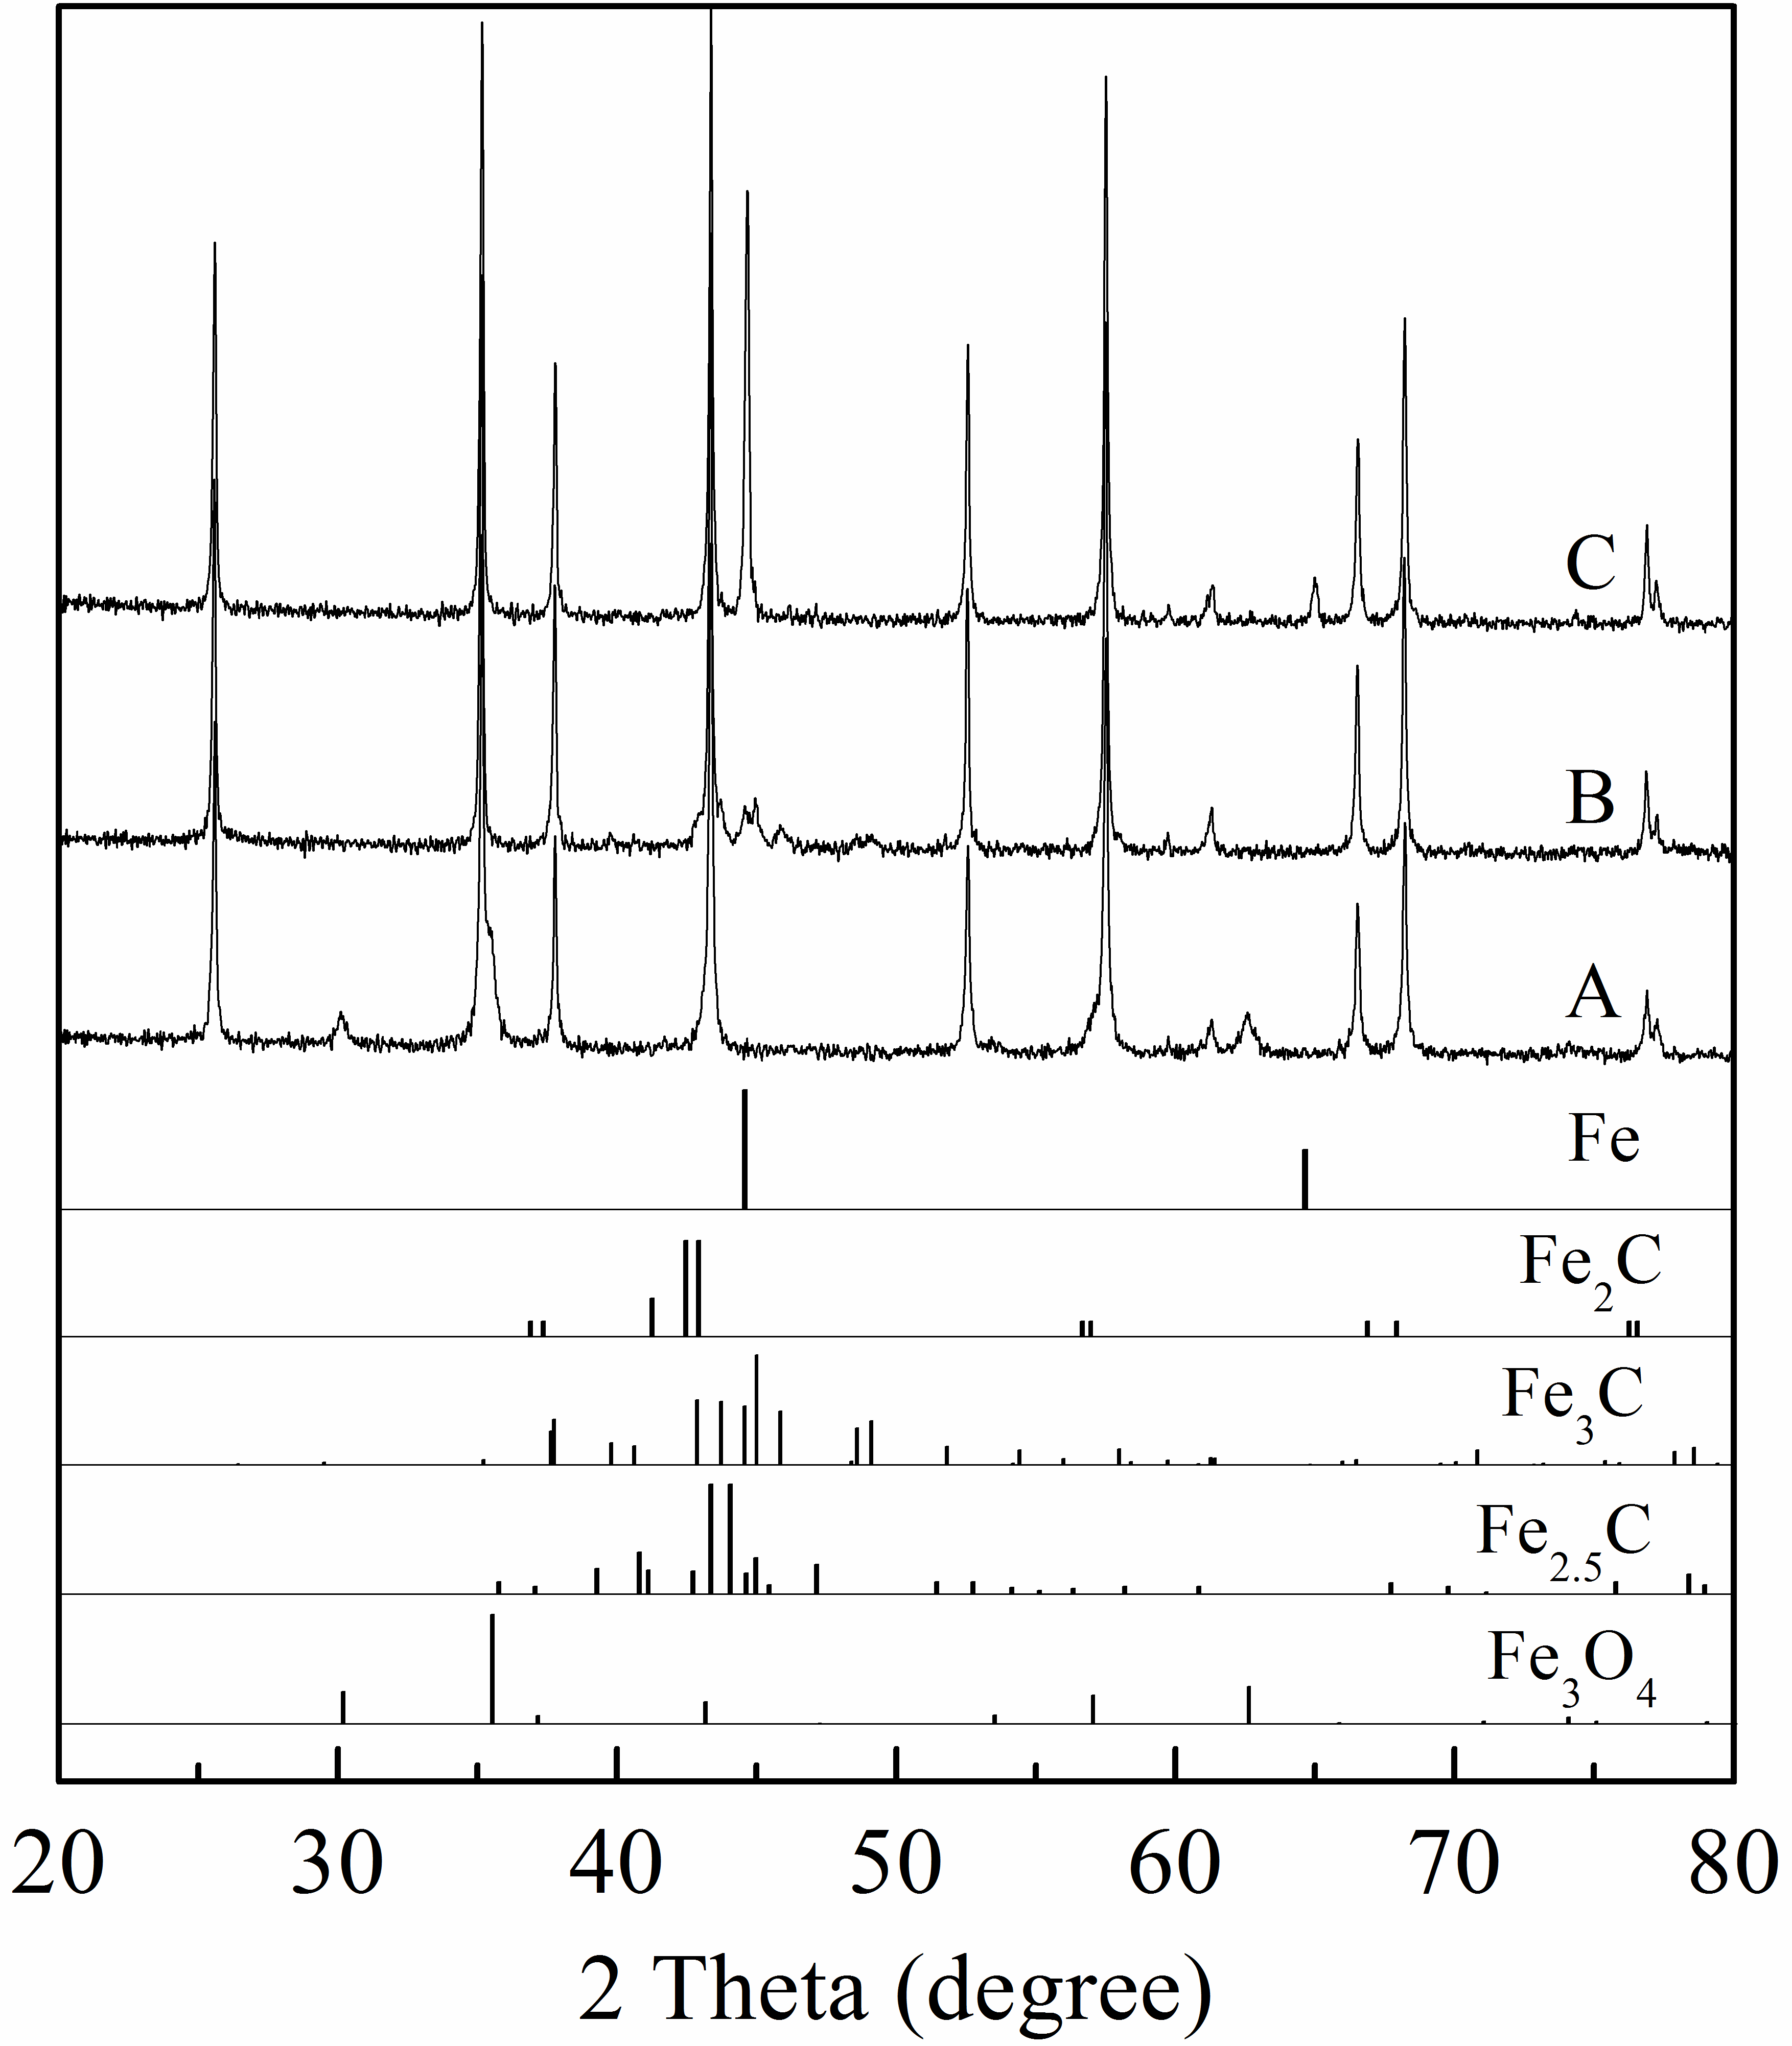
Fig. S1. XRD patterns recorded on the (A) Fe/α-Al₂O₃ catalyst after treating in a flow of CO/He = 5/95 mixture (v/v, 50 mL/min) at 573 K, (B) Fe/α-Al₂O₃ catalyst after treating in a flow of CO/He = 5/95 mixture (v/v, 50 mL/min) at 1073 K and (C) S_{0.05}Fe/α-Al₂O₃ catalyst after treating in a flow of CO/He = 5/95 mixture (v/v, 50 mL/min) at 1073 K.

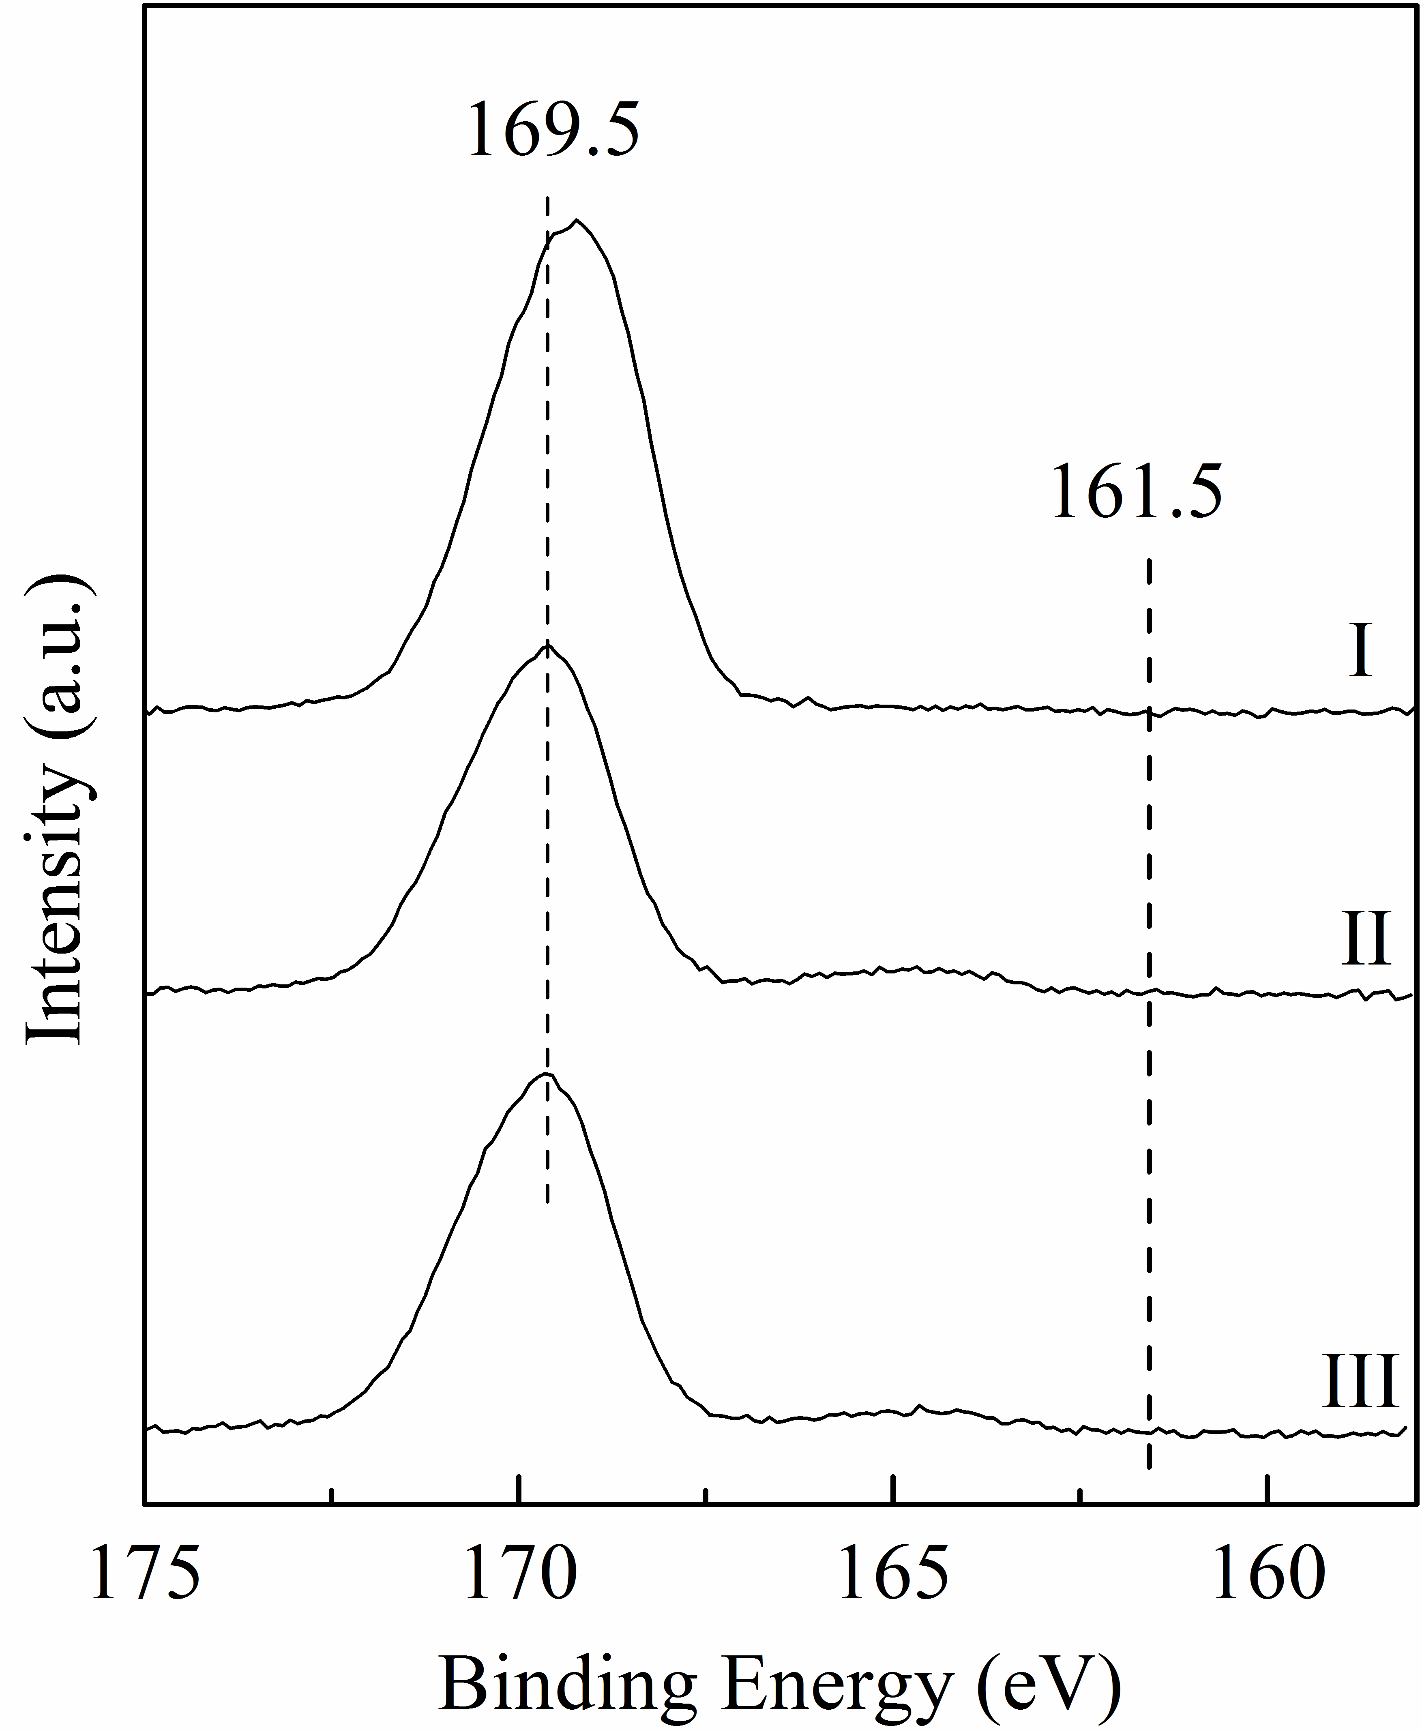
Fig. S2. S 2p XPS spectra of the 5wt% S/α-Al₂O₃ catalyst prepared by heating the sample (I) in a flow of O₂/N₂ = 21/79 mixture (v/v, 50 mL/min) at 673 K for 20 min, (II) in a flow of H₂ (50 mL/min) at 703 K for 120 min, (III) in a flow of H₂/CO = 1 mixture (v/v, 10 mL/min) at 573 K for 60 min.

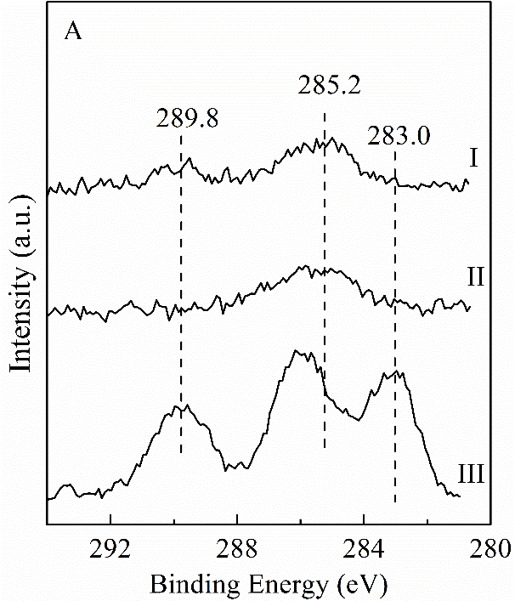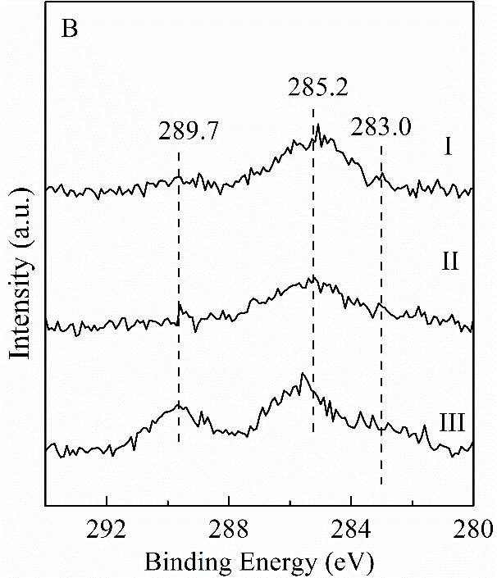
Fig. S3. C 1s XPS spectra of the (A) Fe/α-Al₂O₃ and (B) S_{0.05}Fe/α-Al₂O₃ catalysts prepared by heating the samples (I) in a flow of O₂/N₂ = 21/79 mixture (v/v, 50 mL/min) at 673 K for 20 min, (II) in a flow of H₂ (50 mL/min) at 703 K for 120 min, (III) in a flow of H₂/CO = 1 mixture (v/v, 10 mL/min) at 573 K for 60 min.

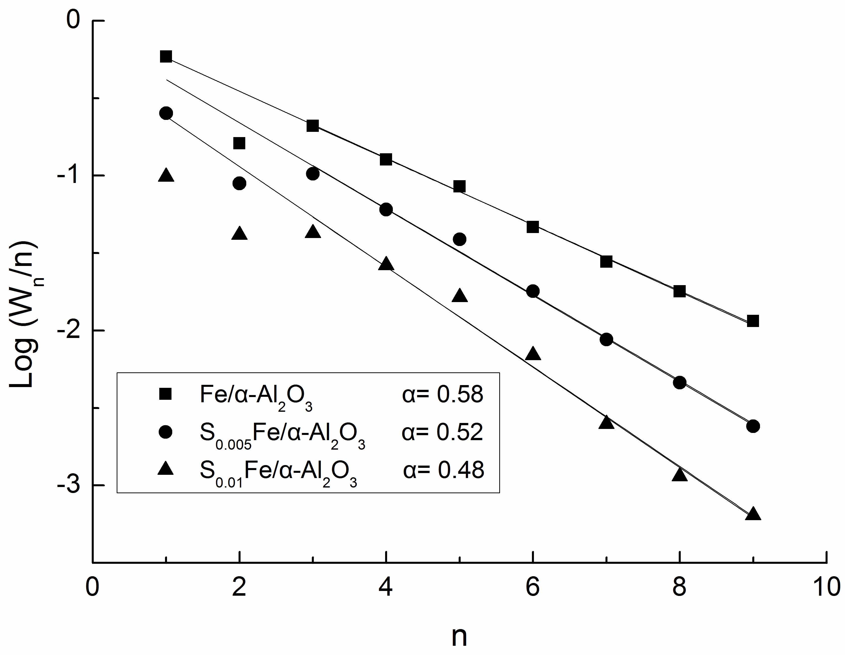
Fig. S4. Anderson-Schulz-Flory plots of the product distribution.
Reaction conditions: H₂/CO=1, 2.0 MPa, 24000 mL/(h⋅g_{cat}), 573 K, TOS = 7 h.

* Corresponding author. Fax: +86-592-2185192 E-mail address: wzweng@xmu.edu.cn (W.Z. Weng); hlwan@xmu.edu.cn (H.L. Wan)

