Supplementary material

Effect of Copper on Highly Effective Fe-Mn Based Catalysts During Production of Light Olefins via Fischer-Tropsch Process with Low CO₂ Emission

Weibo Gongª, Runping Ye^{b}, Jie Ding^{c}, Tongtong Wangª, Xiufeng Shi^{d}, Christopher K. Russell^{e}, Jinke Tang^{f}, Eric G. Eddings^{g}, Yulong Zhang^{h} and Maohong Fan^{a, i, j*}

ª Department of Chemical Engineering, University of Wyoming, Laramie, WY 82071, USA.
^{b} State Key Laboratory of Catalysis, Dalian Institute of Chemical Physics, Chinese Academy of Science, Dalian 116023, Liaoning, China.^{c} School of Chemical Engineering, Nanjing University of Science and Technology, Nanjing, Jiangsu 210094, P.R. China.
^{d} Institute of Special Chemicals, Taiyuan University of Technology, Taiyuan, 030024, PR China.
^{e} Davidson School of Chemical Engineering, Purdue University, West Lafayette, IN 47907, USA.
^{f} Department of Physics & Astronomy, University of Wyoming, Laramie, WY 82071, USA.
^{g} Department of Chemical Engineering, University of Utah, Salt Lake City, UT 84112, USA.
^{h} College of Chemistry and Chemical Engineering, Henan Polytechnic University, Jiaozuo 454000, PR China.
^{i} Department of Petroleum Engineering, University of Wyoming, Laramie, WY, 82071, USA
^{j} School of Civil and Environmental Engineering, Georgia Institute of Technology, Atlanta, GA, 30332, USA

Table of Contents

Materials 3
Figure S1. The schematic diagram of the FTO examination system 3
Figure S2. BJH-pore size distribution of catalysts with different Cu loadings 4
Figure S3. Morphology of catalysts with different Cu loadings 5
Figure S4. The TEM-EDX images of catalysts with different Cu loadings 6
Figure S5. XRD patterns of as-prepared catalyst with different Cu loadings 7
Figure S6 TGA profiles of the fresh catalysts with different Cu loadings 7
Table S1. Quantitative results of CO₂ uptake for reduced catalyst samples in CO₂-TPD 8
Table S2. Catalytic results from the literature for production of light olefins directly from syngas 8
References: 9

Materials
Iron nitrate (III) nonahydrate (Fe(NO₃)₃⋅9H₂O, Sigma-Aldrich ACS reagent, >98%), Manganese (II) nitrate tetrahydrate (Mn(NO₃)₂∙4H₂O, purum p.a., >97.0%, KT) and Copper (II) nitrate hemi(pentahydrate) (Cu(NO₃)₂∙2.5H₂O, Sigma-Aldrich ACS reagent, >98%) were used to provide the appropriate amount metal loading in the catalyst. Silica gel (Sigma-Aldrich high-purity grade, pore size 6 nm, 200-400 mesh particle size) was used as a binder material in the catalyst. Ammonium hydroxide (NH₄OH, Fisher Chemical, Certified ACS Plus, 28-30%) and Nitric acid (HNO₃, Sigma-Aldrich, ACS reagent, 70%) were used to prepare the appropriate precipitation environment during the preparation process.
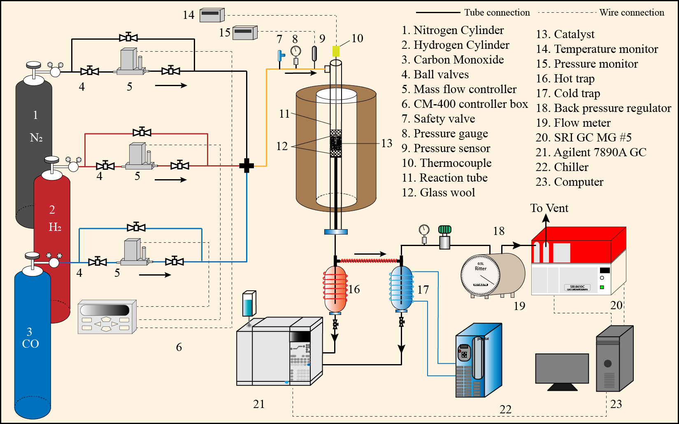
Figure S1. The schematic diagram of the FTO examination system

Figure S2. BJH-pore size distribution of catalysts with different Cu loadings
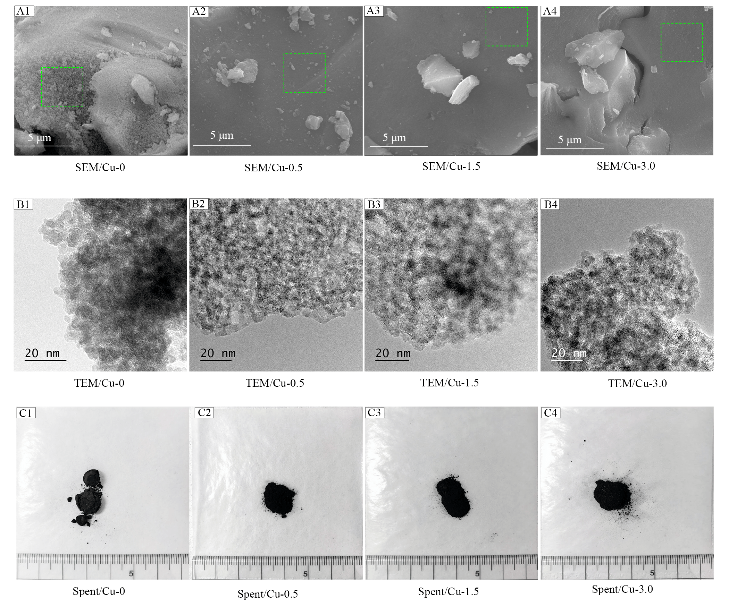
Figure S3. Morphology of catalysts with different Cu loadings. A1-A4: SEM images, B1-B4: TEM images, C1-C4: Spent catalyst
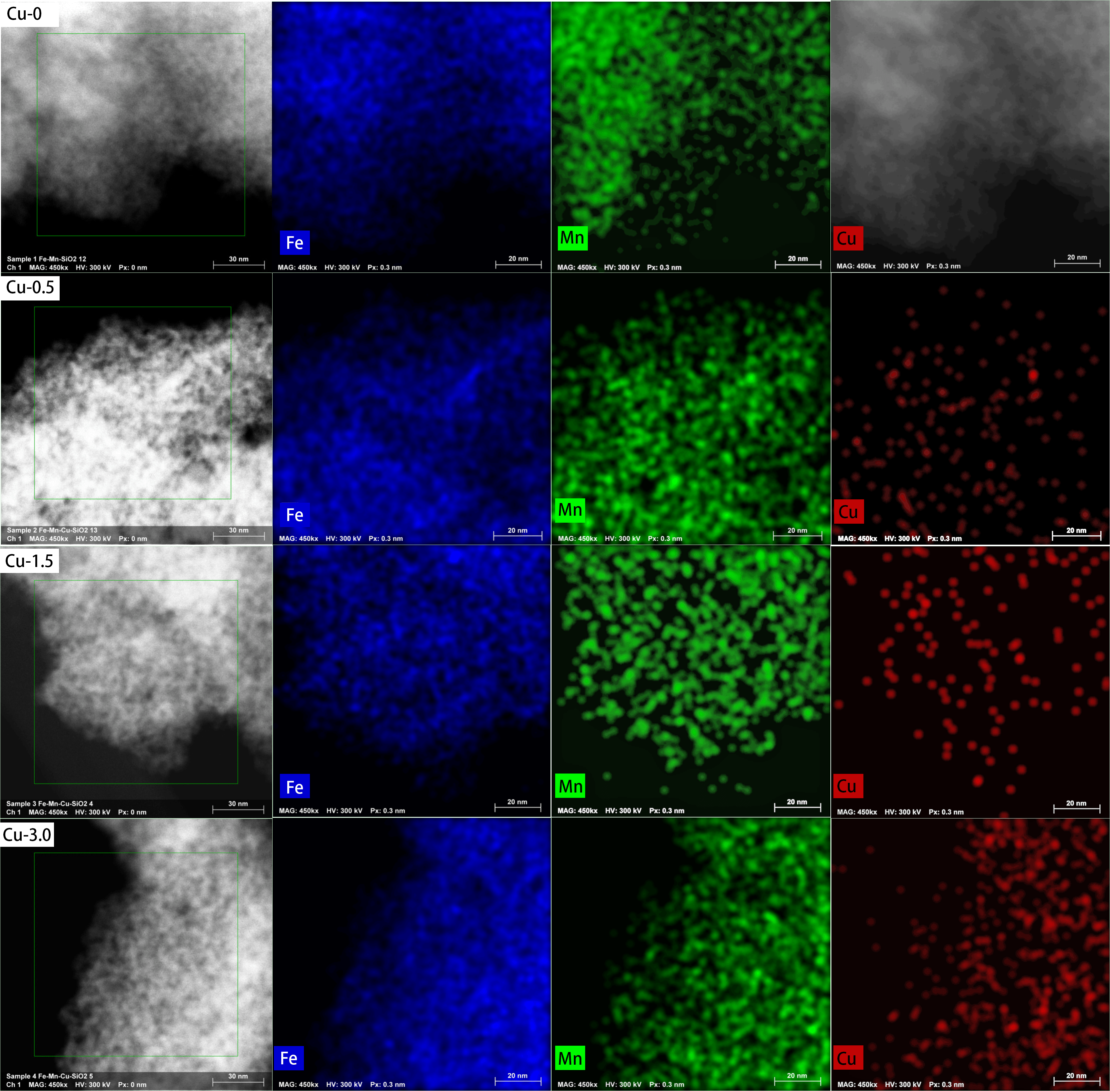
Figure S4. The TEM-EDX images of catalysts with different Cu loadings

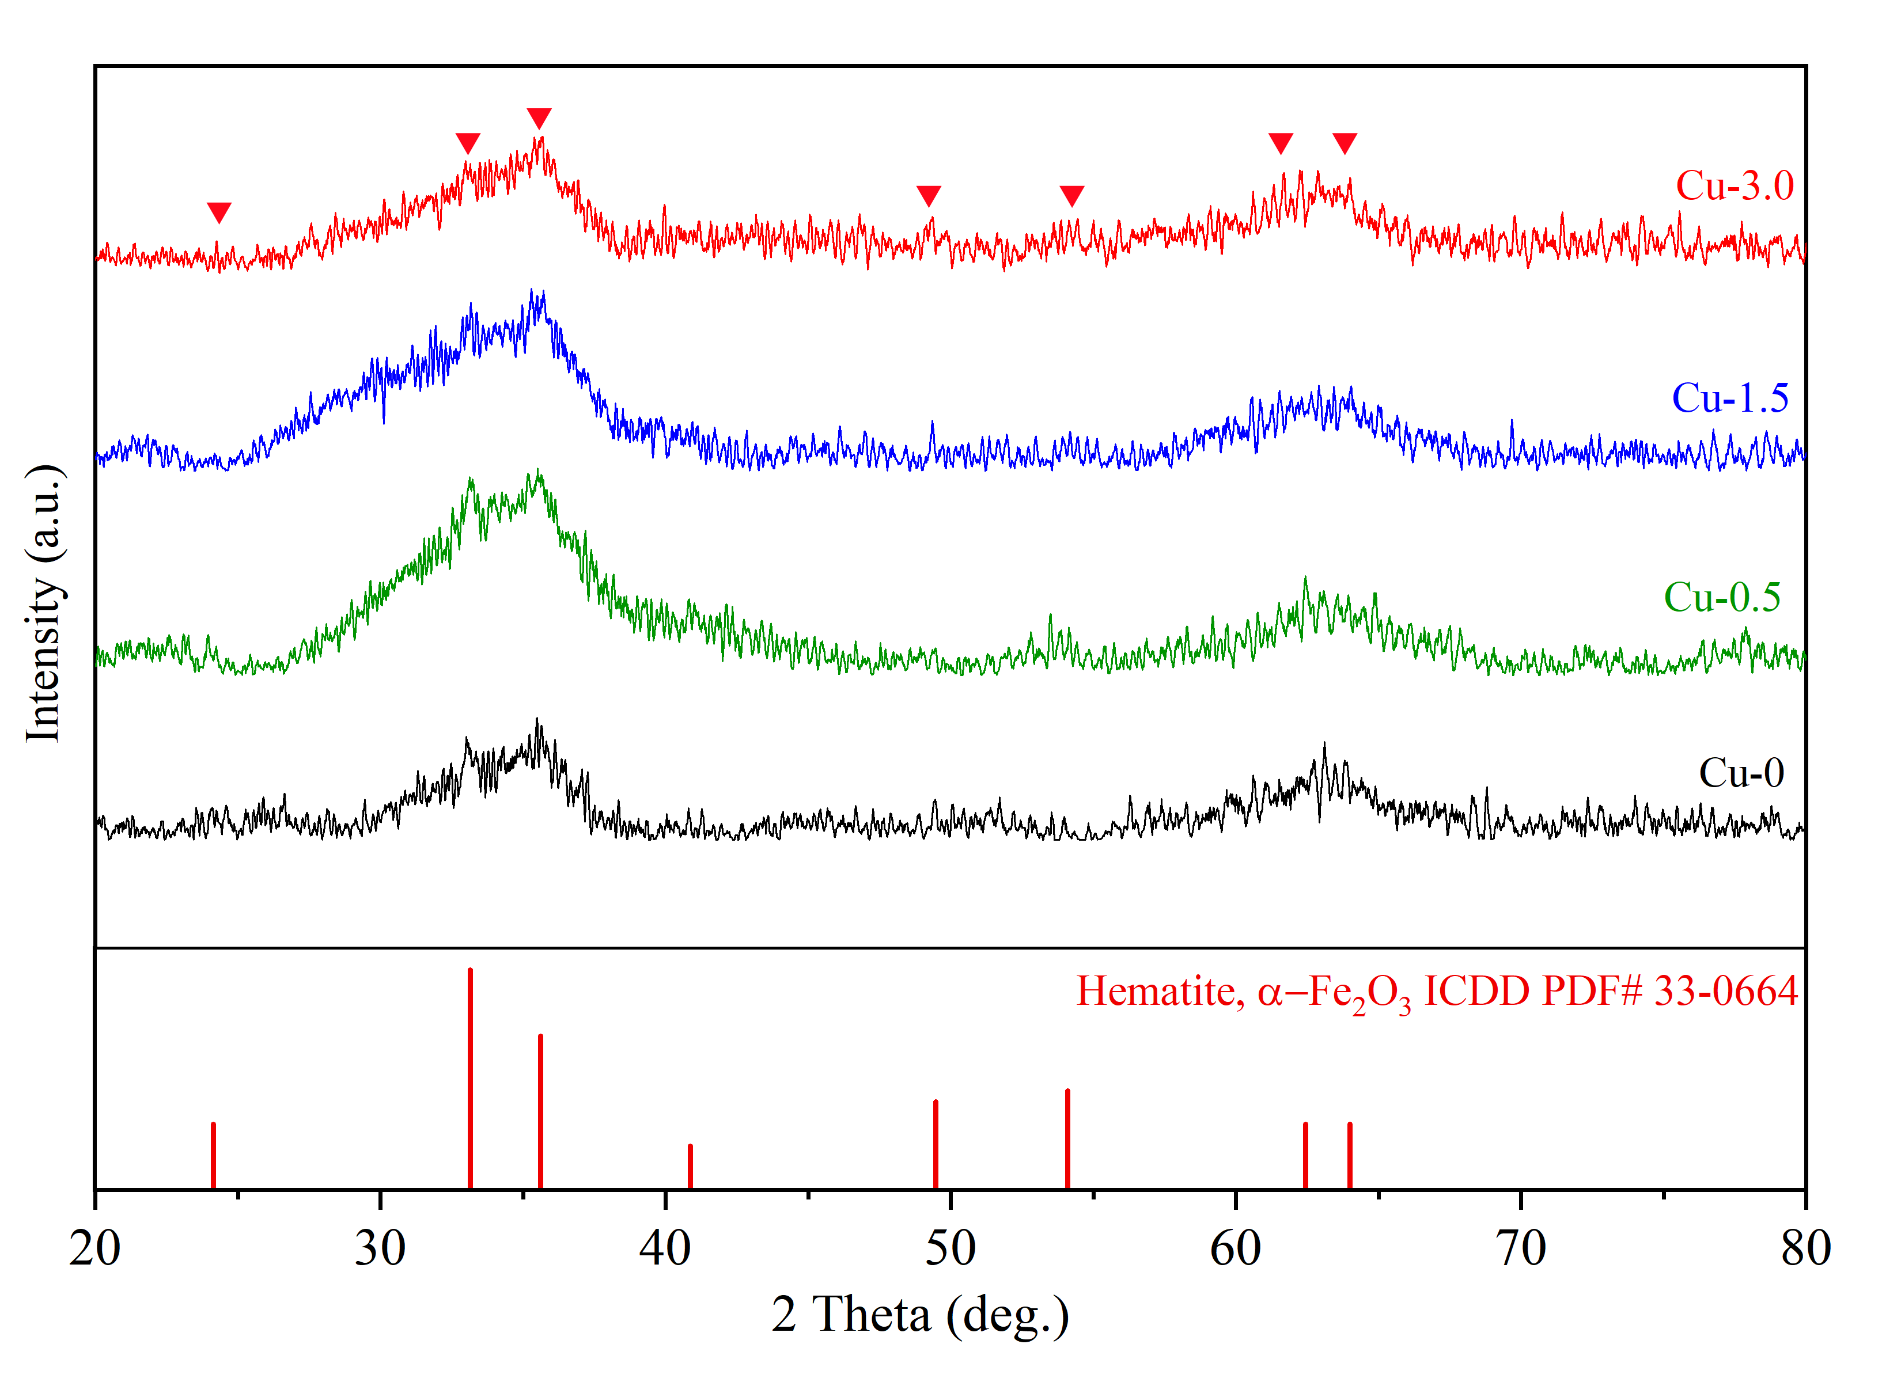
Figure S5. XRD patterns of as-prepared catalyst with different Cu loadings
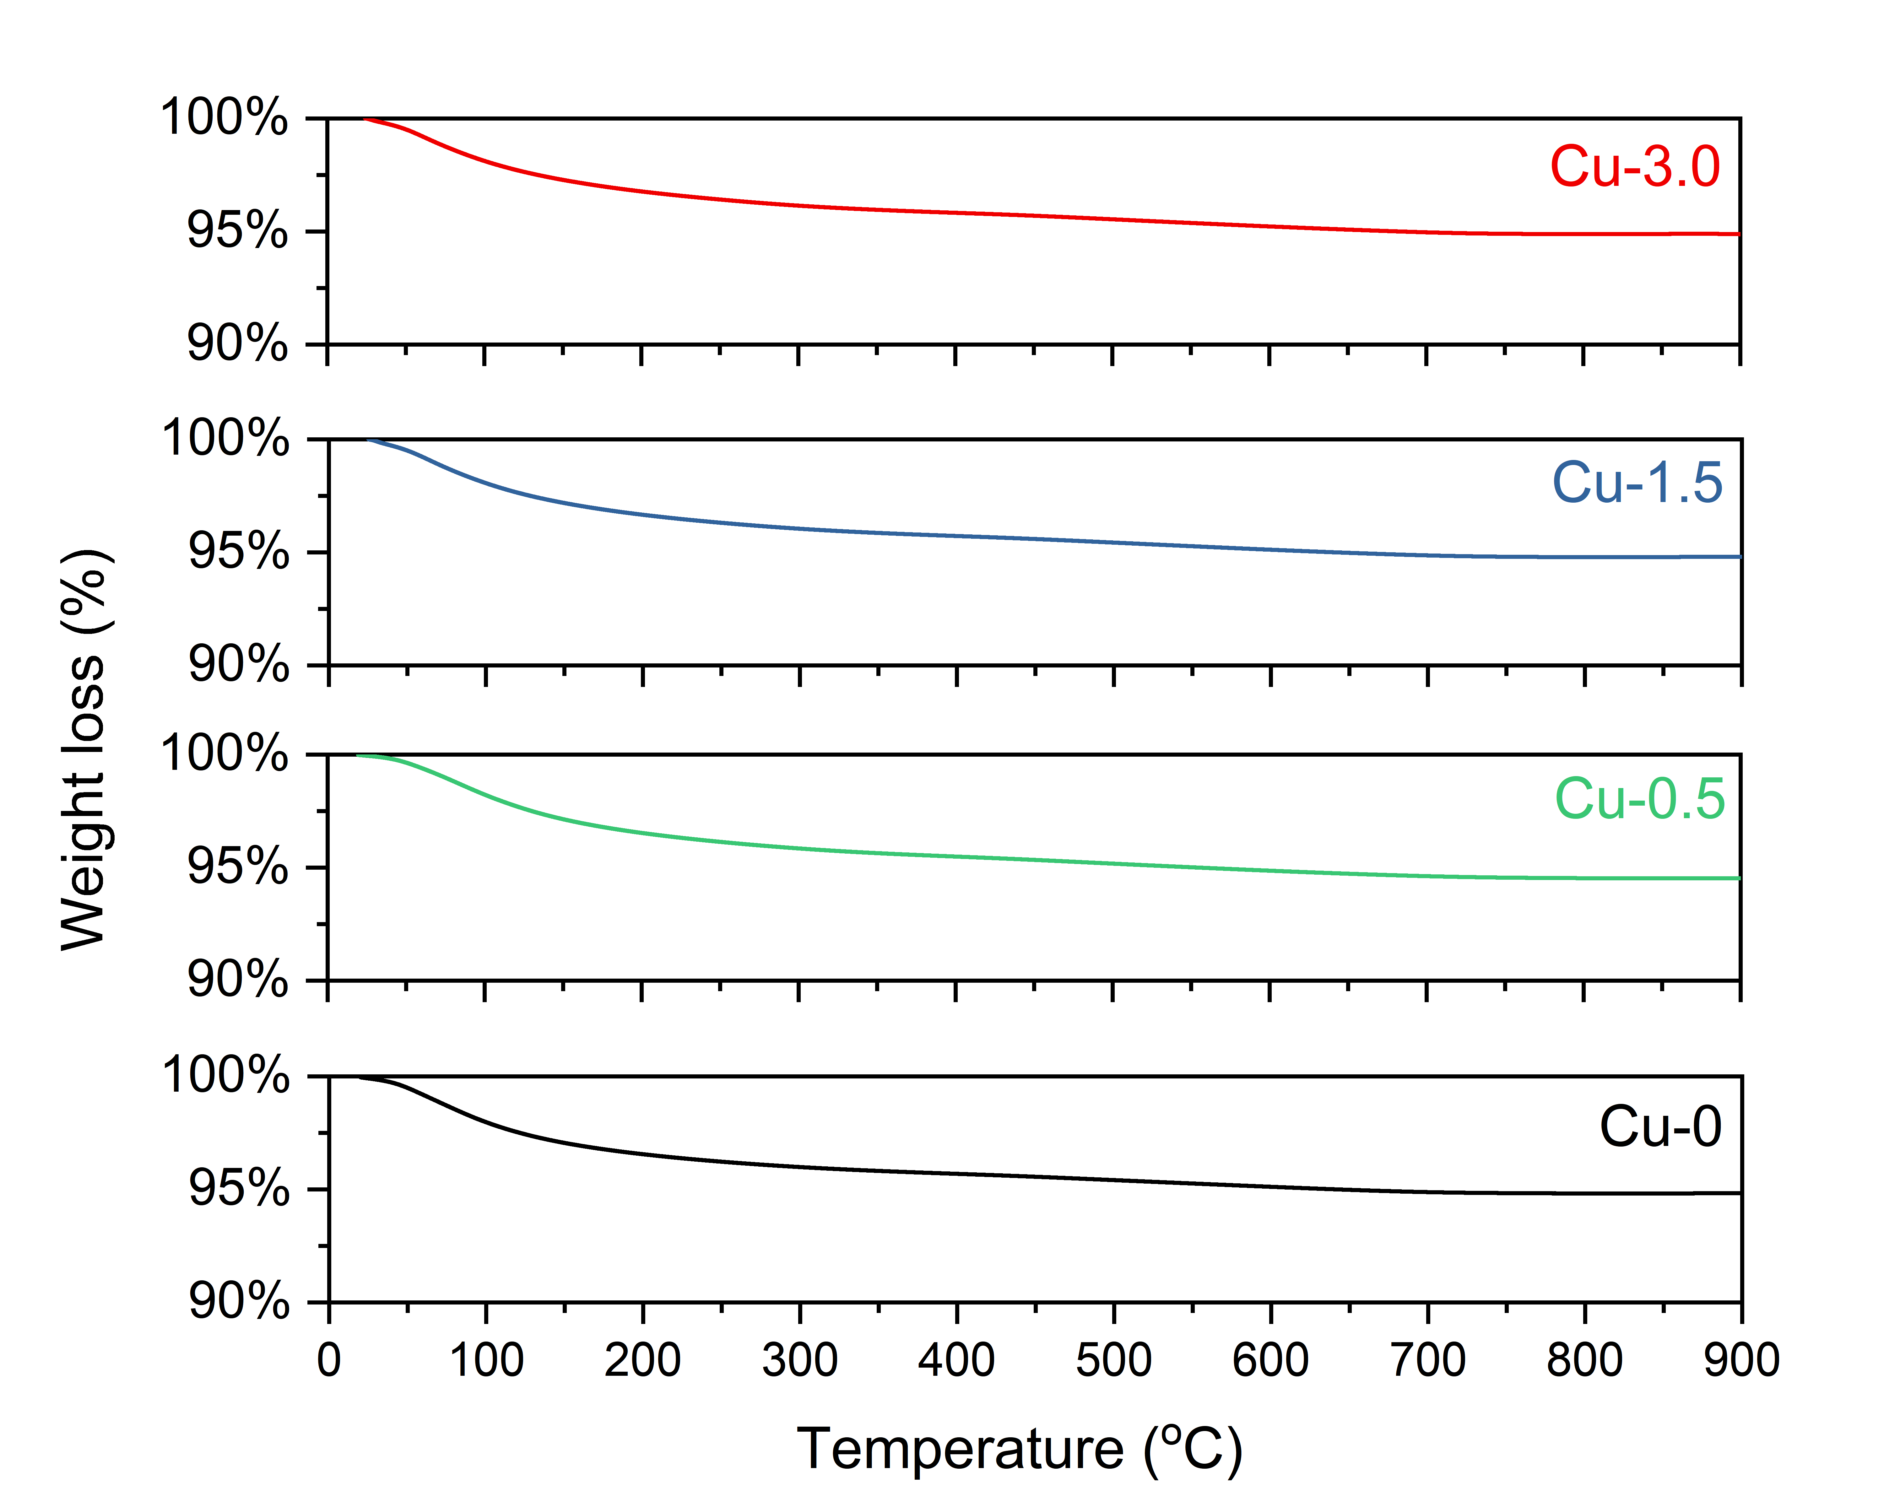
Figure S6 TGA profiles of the fresh catalysts with different Cu loadings (50 mg of catalyst, 10 °C/min to 900 °C)

Table S1. Quantitative results of CO₂ uptake for reduced catalyst samples in CO₂-TPD
Catalysts | Peak (°C) | CO₂ desorption (μmol CO₂/g) | Total CO2 uptake (μmol CO₂/g)
Cu-0 | 142 | 60.38 | 67.06
 | 562 | 6.68
Cu-0.5 | 150 | 27.97 | 36.22
 | 583 | 8.25
Cu-1.5 | 144 | 15.11 | 36.59
 | 640 | 21.48
Cu-3.0 | 147 | 13.16 | 35.94
 | 650 | 22.78

Table S2. Catalytic results from the literature for production of light olefins directly from syngas
Catalyst | T (°C) | P (bar) | H₂/CO | CO conv. (%) | CO₂ sel. (%) | Product distribution (%)
 |  |  |  |  |  | CH₄ | C₂⁼-C₄⁼ | C₅₊
Fe/CNF [1] | 300 | 20 | 2 | 88.0 | 42.0 | 13.0 | 52.0 | 18.0
ZnCrOx/MSAPO [2] | 400 | 25 | 2.5 | 17.0 | 41.0 | 2.0 | 80.0 | 4.0
CoMn [3] | 250 | 1 | 2 | 31.8 | 47.3 | 5.0 | 60.8 | 31.4
FeZn [4] | 350 | 20 | 2.7ª | 95.1 | 15.8 | 25.6 | 53.32 | 13.36
Mn/γ-Fe2O3 [5] | 320 | 10 | 1 | 57.1-55.1 | 31.7 | 11.7 | 61.2 | 18.2
MnO2/MSAPO [6] | 400 | 25 | 2.5 | 8.5 | 41.0 | 2.0 | 79.2 | <5.9%
FeBi/CNT [7] | 350 | 10 | 1 | 78.3 | 47 | 26.1 | 35.2 | 14.1
Fe-MnK-AC [8] | 320 | 20 | 1 | 85.0 | 48.0 | 22.7 | 39.4 | 29.7
FeMnLi [9] | 320 | 15 | 2 | 85.6 | 34.6 | 14.2 | 36.7 | 36.1
Fe3O4@MnO2 [10] | 340 | 15 | 2 | 91.8 | 37.9 | 12.0 | 37.4 | 45.7
FeZn [11] | 340 | 15 | 2 | 95.9 | 21.8 | 21.4 | 40.9 | 29.2
FeMnCu [current work] | 300 | 20 | 2 | 96.9 | 23.0 | 20.0 | 40.1 | 9.5
ª: Feeding with CO₂

References:
[1] H. M. Torres Galvis, J. H. Bitter, C. B. Khare, M. Ruitenbeek, A. I. Dugulan, and K. P. de Jong, "Supported iron nanoparticles as catalysts for sustainable production of lower olefins," Science, vol. 335, no. 6070, pp. 835-8, Feb 17 2012.
[2] F. Jiao et al., "Selective conversion of syngas to light olefins," Science, vol. 351, no. 6277, pp. 1065-8, Mar 4 2016.
[3] L. Zhong et al., "Cobalt carbide nanoprisms for direct production of lower olefins from syngas," Nature, vol. 538, no. 7623, pp. 84-87, Oct 6 2016.
[4] M. Zhao, C. Yan, S. Jinchang, and Z. Qianwen, "Modified iron catalyst for direct synthesis of light olefin from syngas," Catalysis Today, vol. 316, pp. 142-148, 2018.
[5] Y. Liu, F. Lu, Y. Tang, M. Liu, F. F. Tao, and Y. Zhang, "Effects of initial crystal structure of Fe2O3 and Mn promoter on effective active phase for syngas to light olefins," Applied Catalysis B: Environmental, vol. 261, p. 118219, 2020.
[6] Y. Zhu et al., "Role of manganese oxide in syngas conversion to light olefins," ACS catalysis, vol. 7, no. 4, pp. 2800-2804, 2017.
[7] B. Gu et al., "Effects of the promotion with bismuth and lead on direct synthesis of light olefins from syngas over carbon nanotube supported iron catalysts," Applied Catalysis B: Environmental, vol. 234, pp. 153-166, 2018.
[8] Z. Tian et al., "Fischer-Tropsch synthesis to light olefins over iron-based catalysts supported on KMnO 4 modified activated carbon by a facile method," Applied Catalysis A: General, vol. 541, pp. 50-59, 2017.
[9] X. Wu et al., "Li-decorated Fe-Mn nanocatalyst for high-temperature Fischer–Tropsch synthesis of light olefins," Fuel, vol. 257, p. 116101, 2019.
[10] X. Wu et al., "High-Temperature Fischer–Tropsch Synthesis of Light Olefins over Nano-Fe3O4@ MnO2 Core–Shell Catalysts," Industrial & Engineering Chemistry Research, vol. 58, no. 47, pp. 21350-21362, 2019.
[11] X. Gao et al., "Effects of zinc on Fe-based catalysts during the synthesis of light olefins from the Fischer-Tropsch process," Chinese Journal of Catalysis, vol. 37, no. 4, pp. 510-516, 2016.

