Supplementary Material
Effects of Mn Promotion on the Activity and Selectivity of Co/SiO₂ for Fischer-Tropsch Synthesis
Arne Dinse^{a,c}, Max Aigner^{b}, Markus Ulbrich^{b}, Gregory R. Johnsonª, Alexis T. Bell^{a,*}
ªDepartment of Chemical and Biomolecular Engineering, University of California, Berkeley, Berkeley, CA 94720, USA
^{b}Department of Chemistry, TU München, D-85748 Garching, Germany
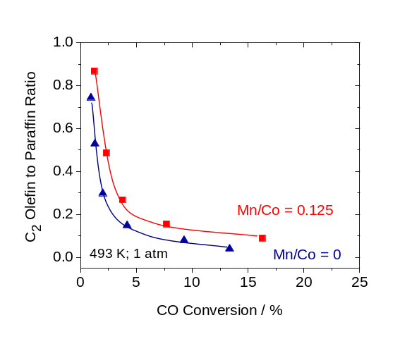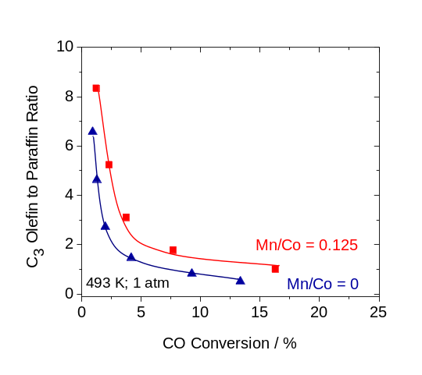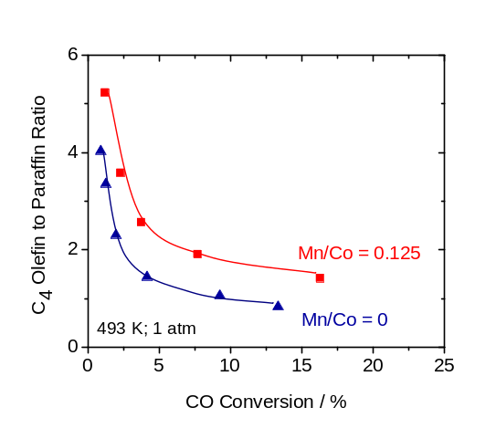
Fig. S1: Effect of CO conversion on C₂ (left), C₃ (right) and C₄ (bottom) olefin to paraffin ratios at 493 K and 1 atm for catalyst with Mn/Co ratios of 0 and 0.125. Feed ratio H₂/CO/Ar = 2/1/0.2, flows = 2.5 to 100 ml/min, catalyst mass = 100 mg.

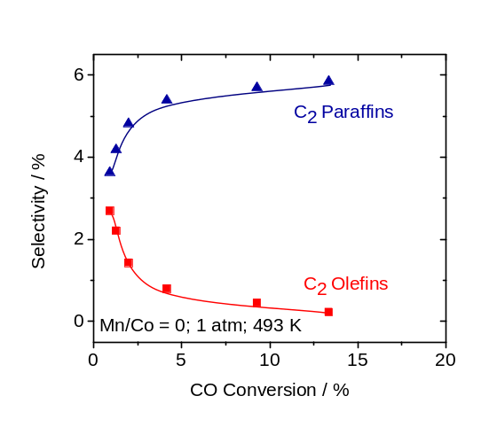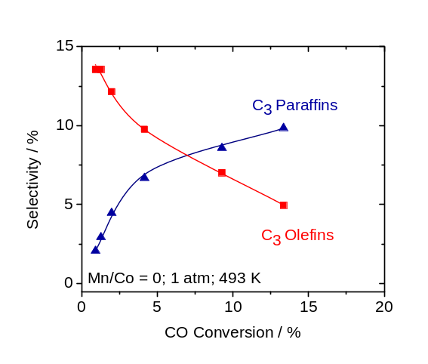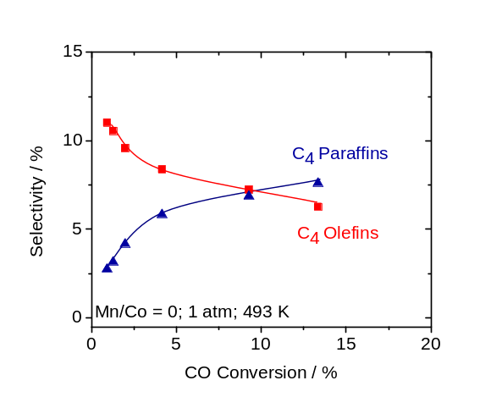
Fig. S2: C₂ (left) C₃ (right) and C₄ (bottom) olefin and paraffin selectivity as a function of increasing CO conversion at 473 K and 1 atm for catalysts without Mn promotion. Feed ratio H₂/CO/Ar = 2/1/0.2, flows = 2.5 to 100 ml/min, catalyst mass = 100 mg.
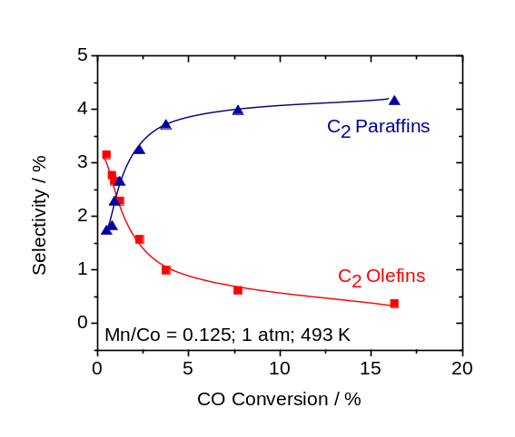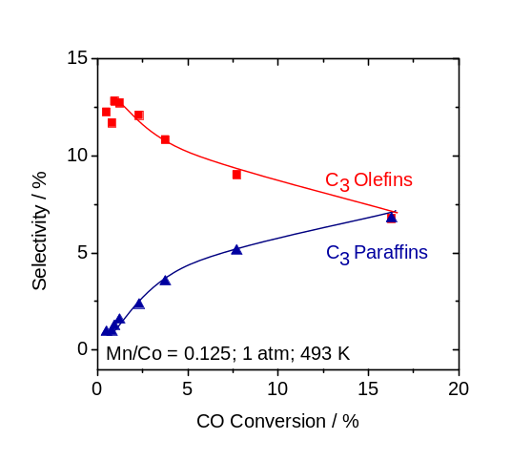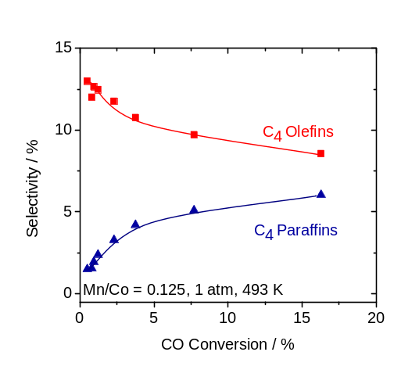
Fig. S3: C₂ (left) C₃ (right) and C₄ (bottom) olefin and paraffin selectivity as a function of increasing CO conversion at 473 K and 1 atm for Co/SiO₂ with a Mn/Co ratio of 0.125 (right). Feed ratio H₂/CO/Ar = 2/1/0.2, flows = 2.5 to 100 ml/min, catalyst mass = 100 mg.

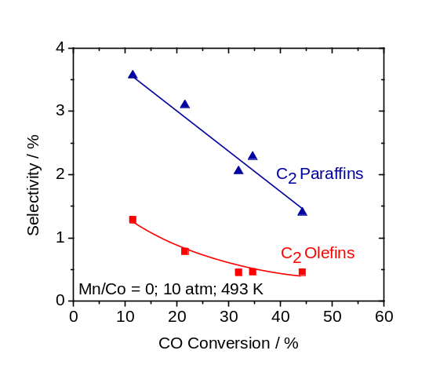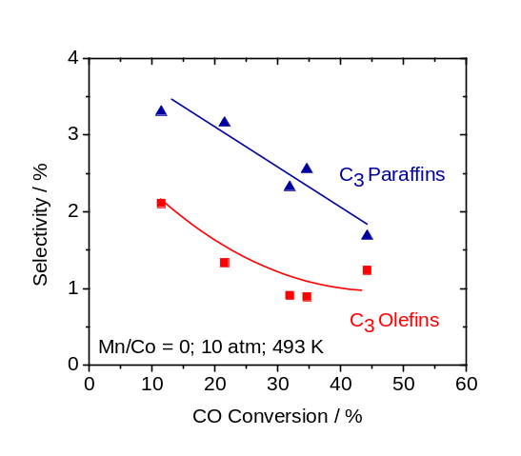
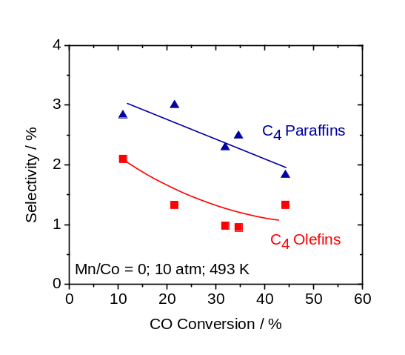
Fig. S4: Effect of pressure on olefin and paraffin selectivities within the C₂ C₃ and C₄ fraction at varying degrees of CO conversion for unpromoted Co/SiO₂. Temperature = 493 K, feed ratio H₂/CO/Ar = 2/1/0.2, flows = 20 to 120 ml/min, catalyst mass = 100 mg.

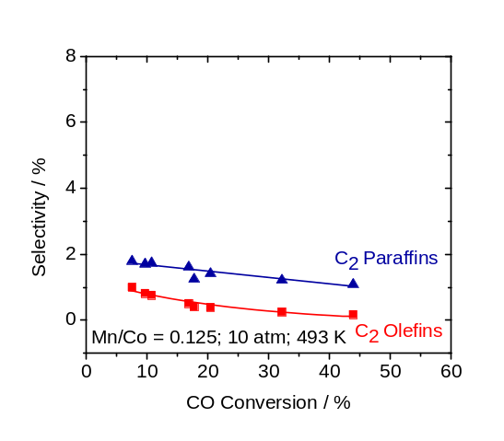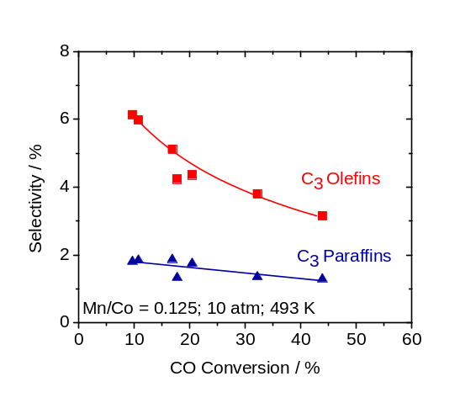
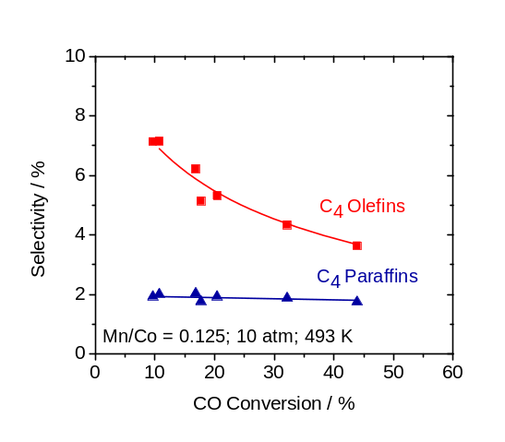
Fig. S5: Effect of pressure on olefin and paraffin selectivities within the C₂ C₃ and C₄ fraction at varying degrees of CO conversion for Mn promoted Co/SiO₂ with Mn/Co ratios of 0.125. Temperature = 493 K, feed ratio H₂/CO/Ar = 2/1/0.2, flows = 20 to 120 ml/min, catalyst mass = 100 mg.

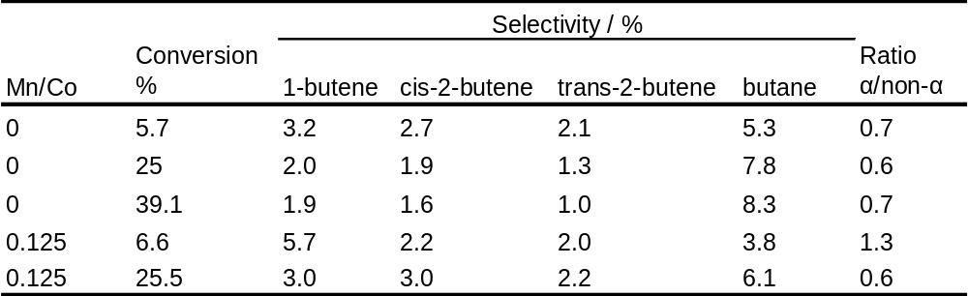
Table S1: Effect of CO conversion on the formation of α and internal olefins within the C₄ fraction for unpromoted and Mn promoted Co/SiO₂ with Mn/Co ratios of 0.125 at 1 atm. Temperature = 493 K, feed ratio H₂/CO/Ar = 2/1/0.2, flows = 20 to 120 ml/min, catalyst mass = 100 mg.

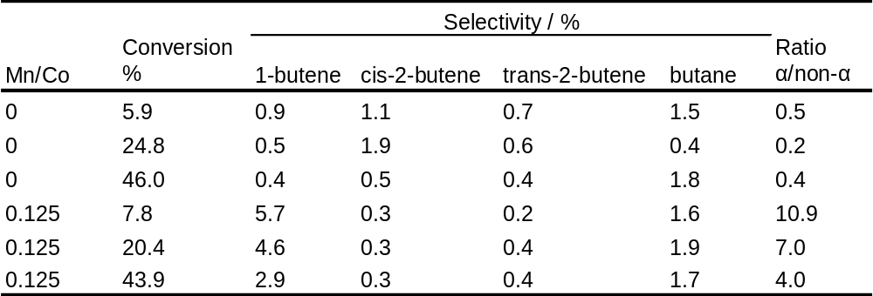

Table S2: Effect of CO conversion on the formation of α and internal olefins within the C₄ fraction for unpromoted and Mn promoted Co/SiO₂ with Mn/Co ratios of 0.125 at 10 atm. Temperature = 493 K, feed ratio H₂/CO/Ar = 2/1/0.2, flows = 20 to 120 ml/min, catalyst mass = 100 mg

