Supplementary Materials

Effects of gallium as an additive on activated carbon-supported cobalt catalysts for the synthesis of higher alcohols from syngas

Shan Gaoª, Xiaoyun Li^{b}, Yuyang Liª, Haibing Yu^{b}, Fanfan Zhangª, Yanmin Sun^{b}, Huihuang Fangª, Xuebin Zhang^{b}, Xuelian Liangª, and Youzhu Yuanª*
ª State Key Laboratory of Physical Chemistry of Solid Surfaces and National Engineering Laboratory for Green Chemical Production of Alcohols-Ethers-Esters, College of Chemistry and Chemical Engineering, Xiamen University, Xiamen 361005, China
^{b} CenerTech Tianjin Chemical Research and Design Institute Co., Ltd., Tianjin 300131, China
Corresponding author: Prof. Youzhu Yuan, E-mail: yzyuan@xmu.edu.cn

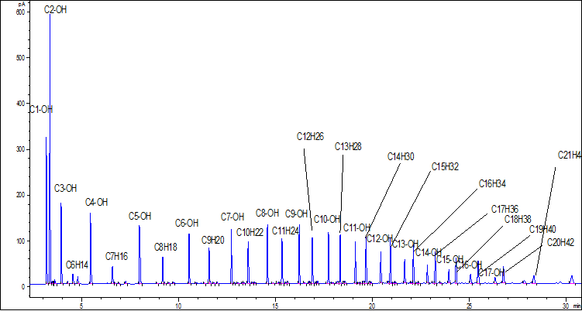
Fig. S1. Off-line GC chart of liquid products collected from cold trap over 15Co‒2.0Ga/AC.

Fig. S2. TPR profiles of a: 15Co–3.0Ga/AC; b: 3.0Ga/AC; c: AC.

Fig. S3. XRD profiles for the reduced catalysts: a. 15Co/AC and b. 15Co–2.5Ga/AC.

Fig. S4. CO₂-TPD profiles for the fresh catalysts: a. 15Co/AC; b. 15Co–2.5Ga/AC; c. Ga₂O₃.

Fig. S5. NH₃-TPD profiles for the fresh catalysts: a. 15Co/AC; b. 15Co–2.5Ga/AC; c. Ga₂O₃.

Fig. S6. XRD patterns of the 15Co–xGa/AC catalysts after reaction: (a) 15Co/AC, (b) 15Co–1.5Ga/AC, (c) 15Co–2.0Ga/AC, (d) 15Co–2.5Ga/AC, (e) 15Co–3.0Ga/AC and (f) 15Co–3.5Ga/AC.

Fig. S7. XPS profiles of C 1s for the spent catalysts: a 15Co/AC and b 15Co–2.5Ga/AC.

Fig. S8. Plausible reaction mechanism for CO hydrogenation: (a) carbide chain growth mechanism and (b) CO insertion chain growth mechanism.

