Supporting Information

In situ encapsulated Co/MnO_{x} nanoparticles inside quasi-MOF-74 for the higher alcohols synthesis from syngas

Wen-Gang Cuiª, Yan-Ting Liª, Hongbo Zhangª, Zheng-Chang Weiª, Bo-Hai Gaoª, Jing-Jing Daiª, Tong-Liang Hu^{a,b,c,}*

a School of Materials Science and Engineering, Tianjin Key Laboratory of Metal and Molecule-Based Material Chemistry, National Institute for Advanced Materials, Nankai University, Tianjin 300350, China. E-mail: tlhu@nankai.edu.cn
b State Key Laboratory of Coordination Chemistry, Nanjing University, Nanjing 210023, China.
c Tianjin Key Lab for Rare Earth Materials and Applications, Nankai University, Tianjin 300350, China.

Table of Contents
S1. Experimental section 4
S1.1. Materials 4
S1.2. Catalyst Preparation 4
S2. Supplementary Figures 5
Figure S1. Schematic diagram of the reaction system for syngas conversion. 5
Figure S2. Illustration of loading of catalyst in reactor. 5
Figure S3. Optical photographs of liquid product obtained from cold trap and hot trap. 6
Figure S4. Typical GC-TCD spectrum of gas products. 7
Figure S5. Typical GC-FID spectrum of gas products. 7
Figure S6. Typical GC-FID spectrum of aqueous phase products. 8
Figure S7. Typical GC-TCD spectrum of aqueous phase products. 8
Figure S8. Typical GC-FID spectrum of oil phase products. 9
Figure S9. Typical GC-FID spectrum of wax phase products. 10
Figure S10. The low-magnification FESEM images of (a) CoMn-MOF-74, the derived (b) Co/MnO_{x}@quasi-MOF-74, (c) Co/MnO_{x}@C-500, (d) Co/MnO_{x}@C-600, (e) Co/MnO_{x}@C-700, and (f) Co/MnO_{x}@C-800. 11
Figure S11. XRD patterns of Mn-MOF-74, Co-MOF-74, MnO_{x}@quasi-MOF-74, Co@quasi-MOF-74, Co/MnO_{x}@C-700, and Co/MnO_{x}@C-800. 12
Figure S12. The high-magnification FESEM images of (a₁₋₃) CoMn-MOF-74, the derived (b₁₋₃) Co/MnO_{x}@quasi-MOF-74, (c₁₋₃) Co/MnO_{x}@C-500, (d₁₋₃) Co/MnO_{x}@C-600, (e₁₋₃) Co/MnO_{x}@C-700, and (f₁₋₃) Co/MnO_{x}@C-800. 13
Figure S13. The pore diameter distribution of CoMn-MOF-74, Co/MnO_{x}@quasi-MOF-74 and Co/MnO_{x}@C-500, 600 catalysts. 14
Figure S14. HAABF-STEM (a), HAADF-STEM (b), bright field (d) and dark field (e) TEM images of the Co/MnO_{x}@quasi-MOF-74 catalyst; Size distribution of nanoparticles (c) and (f) in (a) and (d), respectively. 15
Figure S15. HRTEM image (a) and corresponding elements mapping (c, d, e and f), (b) Elemental analysis results of Co/MnO_{x}@quasi-MOF-74. 16
Figure S16. HAADF-STEM (a) and HAABF-STEM (b) images of Co/MnO_{x}@quasi-MOF-74. Enlarged high-resolution HAADF images taken from the selected areas indicated by (c) red, (d) green, (e) blue, and (f) black, rectangles in (b). 17
Figure S17. TEM and corresponding EDS elemental mapping images of (a) Co/MnO_{x}@C-500, (b) Co/MnO_{x}@C-600, (c) Co/MnO_{x}@C-700, and (d) Co/MnO_{x}@C-800. 18
Figure S18. The results of deconvolution and quantitative evaluation of the Co 2p of CoMn-MOF-74, Co@quasi-MOF-74, Co/MnO_{x}@quasi-MOF-74, and Co/MnO_{x}@C-X catalysts. 19
Figure S19. (a) TGA and (b) differential thermal analysis (DTA) plots of Co-MOF-74, Mn-MOF-74, and CoMn-MOF-74 measured from 30 to 800 °C in N₂ atmosphere at a heating rate of 5 °C∙min⁻¹. 19
Figure S20. The schematic diagram of temperature-programmed pyrolysis (TPP) apparatus. 20
Figure S21. Plots for elucidating the produced gaseous species during the temperature programming pyrolysis of the CoMn-MOF-74. 21
Figure S22. TGA plots of Co/MnO_{x}@quasi-MOF-74, Co/MnO_{x}@C-600, and CoMn-MOF-74 measured from 30 to 800 °C in air atmosphere at a heating rate of 10 °C∙min⁻¹. 22
Figure S23. The ROH distribution and corresponding ASF plots of (a) Co@quasi-MOF-74, (b) Co/MnO_{x}@C-500, (c) Co/MnO_{x}@C-600, and (d) Co/MnO_{x}@C-700 catalysts. 23
Figure S24. The RH distribution and corresponding ASF plots of (a) Co@quasi-MOF-74, (b) Co/MnO_{x}@C-500, (c) Co/MnO_{x}@C-600, and (d) Co/MnO_{x}@C-700 catalysts. 24
Figure S25. Semi-in situ XPS analysis of Co/MnO_{x}@quasi-MOF-74. 25
Figure S26. Elemental composition of the surface of Co/MnO_{x}@quasi-MOF-74 catalyst observed from semi-in situ survey XPS spectrum. 25
Figure S27. H₂-TPR plots for Co@quasi-MOF-74, and CoMn-MOF-74 and its derived catalysts. 26
Figure S28. C1s XPS spectra of Co/MnO_{x}@quasi-MOF-74 catalyst before and after 2.0 h of reaction. 26
Figure S29. In situ Raman spectra of CO hydrogenation reaction on the pretreated Co/MnO_{x}@quasi-MOF-74 catalyst at 230 ºC, 0.1 MPa, 30 mL∙min⁻¹ of H₂/CO = 2 mixture. 27
Figure S30. In situ DRIFT spectra of the CO hydrogenation reaction on the pretreated Co/MnO_{x}@C-600 catalyst in the regions (a) 3900-1800 cm⁻¹ and (b) 1800-1200 cm⁻¹ 28
Figure S31. Proposed mechanism of ROH syntheses from CO hydrogenation over Co/MnO_{x}@quasi-MOF-74 catalyst. 29
S3. Supplementary Tables 30
Table S1 N₂ sorption measurements of catalysts. 30
Table S2 The overall composition of the CoMn-MOF-74, Co/MnO_{x}@quasi-MOF-74 and Co/MnO_{x}@C-X catalysts. 31
Table S3 The surface composition of the CoMn-MOF-74 Co/MnO_{x}@quasi-MOF-74 and Co/MnO_{x}@C-X catalysts detected by XPS. 32
Table S4 Effect of GHSV on the CO hydrogenation using Co/MnO_{x}@quasi-MOF-74. 33
Table S5 Effect of reaction temperature on the CO hydrogenation using Co/MnO_{x}@quasi-MOF-74. 34
Table S6 Effect of GHSV on the CO hydrogenation using Co/MnO_{x}@C-600 catalyst. 35
Table S7 Catalytic performance of state of the art catalysts in the selective conversion of syngas to C₂₊OH. 36
S4. References 37

S1. Experimental section

S1.1. Materials
All the reagents and solvents used in this study were analytical grade and used directly without any further purification. Cobalt nitrate hexahydrate (Co(NO₃)₂·6H₂O) and 2,5-dihydroxyterephthalic acid (H₄DOT) were obtained from Meryer (Shanghai) Chemical Technology Co., Ltd. Manganese chloride (MnCl₂·4H₂O) was obtained from Aladdin Industrial Corporation, China. Ethanol, methanol and N,N-dimethylformamide were obtained from Tianjin Hengshan Chemical Technology Co. The syngas H₂/CO/N₂ = 63.5/31.5/5.0, N₂ (99.99%), Ar (99.999%) and H₂ (99.99%) were provide by Air Liquide (Tianjin) Co., Ltd.

S1.2. Catalyst Preparation
Synthesis of Co-MOF-74. Co(NO₃)₂·6H₂O (0.713 g, 2.450 mmol) and H₄DOT (0.20 g, 1.009 mmol) were dispersed in 60 mL of a mixed solvent (DMF/ethanol/water = 1:1:1 (v/v/v)), put into a 100 mL Teflon-lined autoclave, stirred well and kept at 120 °C for 24.0 h. Then it was cooled to room temperature, and the powder product was washed with fresh MeOH for 6-8 times over a 3 days period, dried at 40 °C under vacuum overnight.
Synthesis of Mn-MOF-74. MnCl₂·4H₂O (0.66 g, 3.335 mmol) and H₄DOT (0.20 g, 1.009 mmol) were dissolved in a mixed solvent (DMF/ethanol/water = 55.0/3.5/3.5 mL), put into a 100 mL Teflon-lined autoclave, kept at 135 °C for 24.0 h, and then cooled to room temperature. The resulting powder was washed with fresh MeOH for 6-8 times over a 3 days period, dried at 40 °C under vacuum overnight.

S2. Supplementary Figures
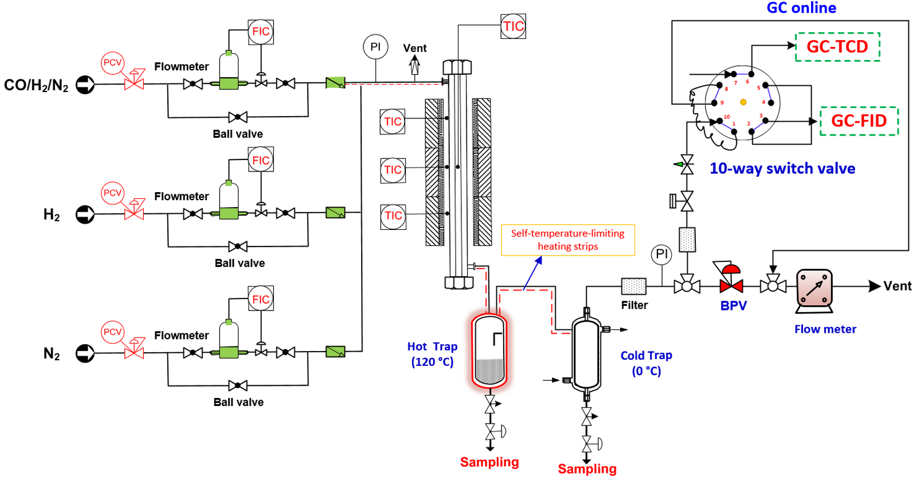

Figure S1. Schematic diagram of the reaction system for syngas conversion. PI: pressure indicator; TIC: temperature indicator control; BPV: back pressure valve; BCV: pressure control valve; FIC: flow indicating controller.
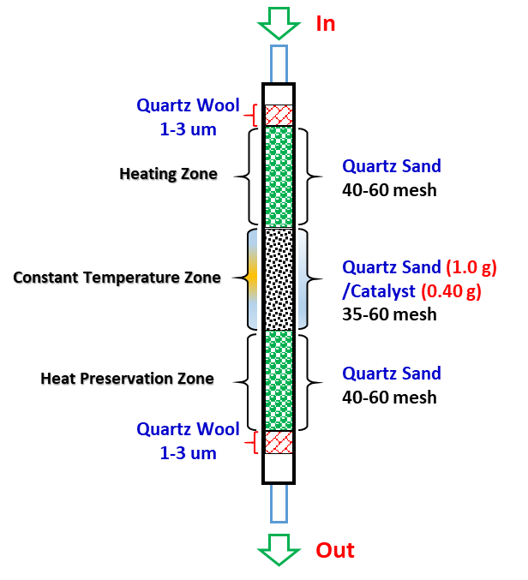

Figure S2. Illustration of loading of catalyst in reactor.

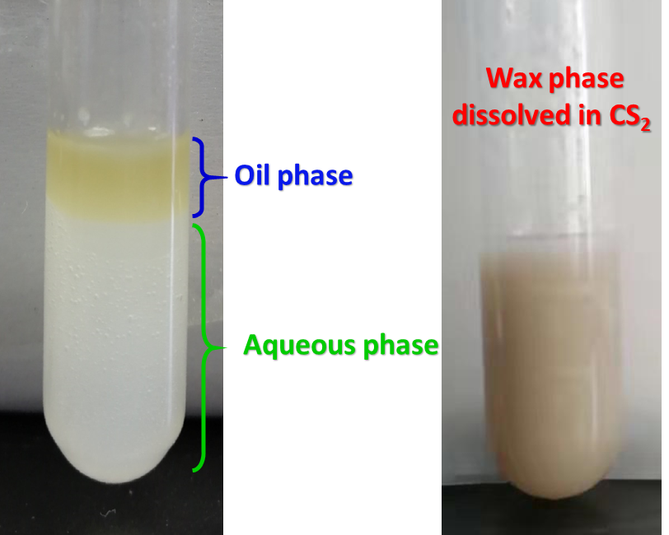

Figure S3. Optical photographs of liquid product obtained from cold trap and hot trap. It consists mainly of three phases (oil phase, aqueous phase (left) and wax phase (right, dissolved in carbon disulfide)).
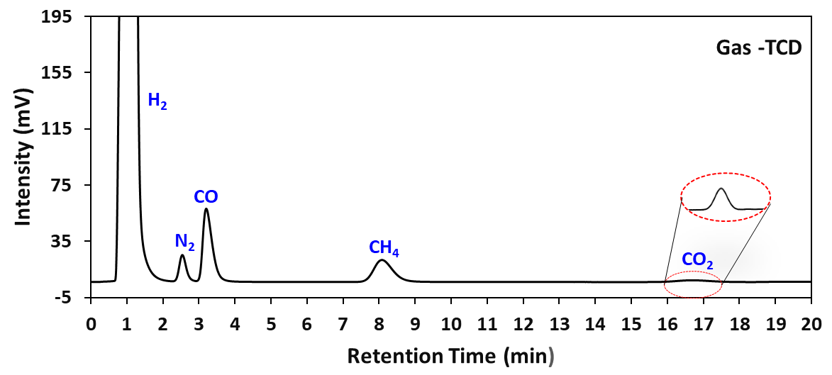

Figure S4. Typical GC-TCD spectrum of gas products.
Gas Chromatographic Conditions: Chromatographic column: TDX-01 packed column; Injection temperature: 120 °C; Detector temperature: 150 °C; Column temperature: 100 °C kept for 19.0 min; Carrier gas: Ar (purity > 99.999%). Quantitative method: External standard method using the peak areas. Instrument model: Huifen GC-6890; Sampling method: On-line.

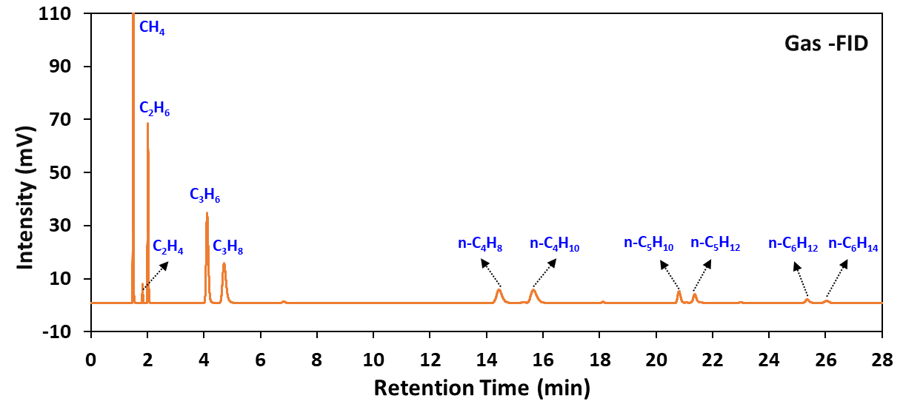

Figure S5. Typical GC-FID spectrum of gas products.
Gas Chromatographic Conditions: Chromatographic column: HT-PLOT Q (30 m * 0.53 mm * 40 um) capillary column; Injection temperature: 120 °C; Detector temperature: 220 °C; Column temperature: 100 °C kept for 19 min, then rise up to 200 °C at a speed of 10 °C/min; Carrier gas: Ar (purity > 99.999%). Quantitative method: External standard method using the peak areas. Instrument model: Huifen GC-6890; Sampling method: On-line.

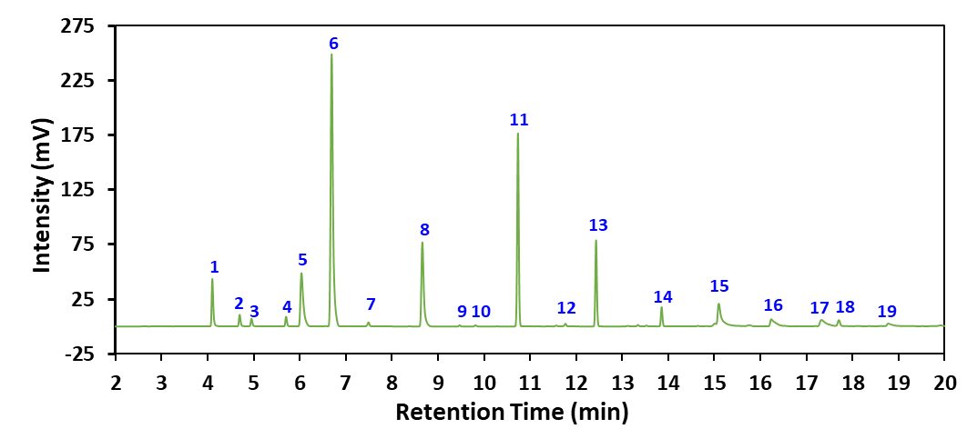
Peak | Compound | Peak | Compound | Peak | Compound | Peak | Compound
1 | Ethanal | 6 | Ethanol | 11 | n-Butanol | 16 | Acetic acid
2 | Propanal | 7 | Pentanal | 12 | Isoamylol | 17 | Propionic acid
3 | Acetone | 8 | Propanol | 13 | Pentanol | 18 | Butyric acid
4 | n-Butanal | 9 | Hexanal | 14 | sec-Pentanol | 19 | Pentanoic acid
5 | Methanol | 10 | sec-Butanol | 15 | n-Hexanol

Figure S6. Typical GC-FID spectrum of aqueous phase products.
Gas Chromatographic Conditions: Chromatographic column: DB-WAX (30 m * 0.25 mm * 0.25 um) capillary column; Injection temperature: 250 °C; Detector temperature: 260 °C; Column temperature: 100 °C kept for 60 min. Carrier gas: N₂ (purity > 99.999%). Quantitative method: External standard method using the peak areas. Instrument model: Shimadzu 2014C; Sampling method: Off-line.
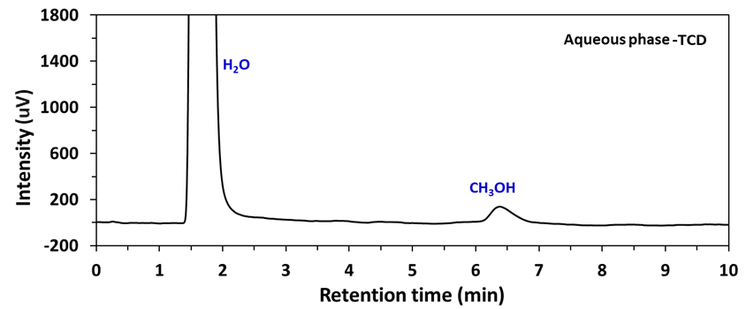

Figure S7. Typical GC-TCD spectrum of aqueous phase products.
Gas Chromatographic Conditions: Chromatographic Column: Porapak Q (2 m * 4 mm * 40 um) capillary column; Injection temperature: 220 °C; Detector temperature: 180 °C; Column temperature: 50 °C kept for 30 min; Carrier gas: H₂ (purity > 99.999%). Quantitative method: External standard method using the peak areas. Instrument model: Shimadzu 2014C; Sampling method: Off-line.
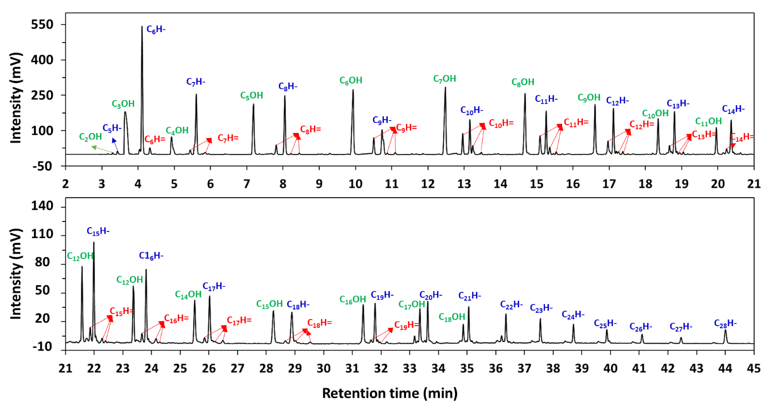

Figure S8. Typical GC-FID spectrum of oil phase products. C_{x}OH, C_{x}H= and C_{x}H- represented alcohols, olefins, and paraffins containing x carbon atoms, respectively.
Gas Chromatographic Conditions: Chromatographic Column: WondaCap (30 m * 0.25 mm * 25 um) capillary column; Injection temperature: 300 °C; Detector temperature: 320 °C; Column temperature: 50 °C kept for 5 min, then rise up to 200 °C at a speed of 10 °C/min and kept for 10 min, finally rise up to 300 °C at a speed of 20 °C/min and kept for 10 min; Carrier gas: N₂ (purity > 99.999%). Quantitative method: Area normalization. Instrument model: Shimadzu 2014C; Sampling method: Off-line.

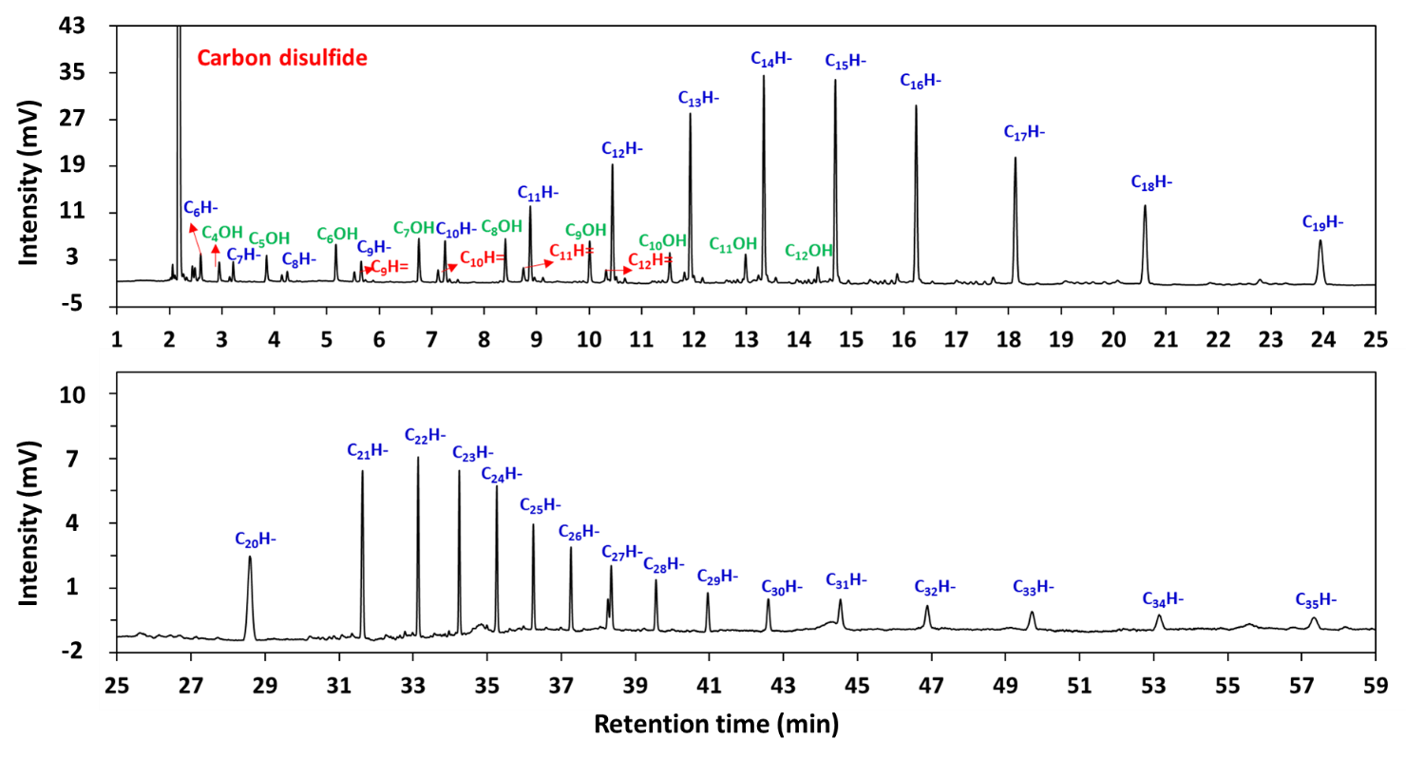

Figure S9. Typical GC-FID spectrum of wax phase products. C_{x}OH, C_{x}H= and C_{x}H- represented alcohols, olefins, and paraffins containing x carbon atoms, respectively.
Chromatographic Columns: Chromatographic column: WondaCap (30 m * 0.25 mm * 25 um) capillary column; Injection temperature: 320 °C; Detector temperature: 330 °C; Column temperature: 80 °C kept for 2 min, then rise up to 200 °C at a speed of 10 °C/min and kept for 15 min, finally rise up to 300 °C at a speed of 20 °C/min and kept for 40 min; Carrier gas: N₂ (purity > 99.999%). Quantitative method: Area normalization. Instrument model: Shimadzu 2014C; Sampling method: Off-line.

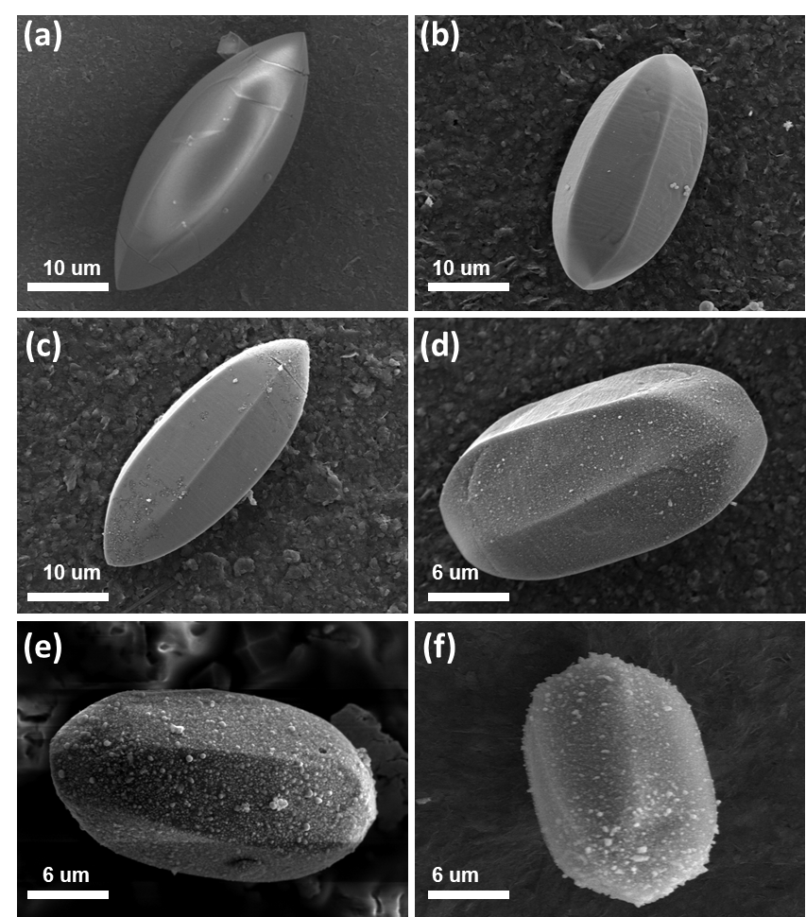

Figure S10. The low-magnification FESEM images of (a) CoMn-MOF-74, the derived (b) Co/MnO_{x}@quasi-MOF-74, (c) Co/MnO_{x}@C-500, (d) Co/MnO_{x}@C-600, (e) Co/MnO_{x}@C-700, and (f) Co/MnO_{x}@C-800.

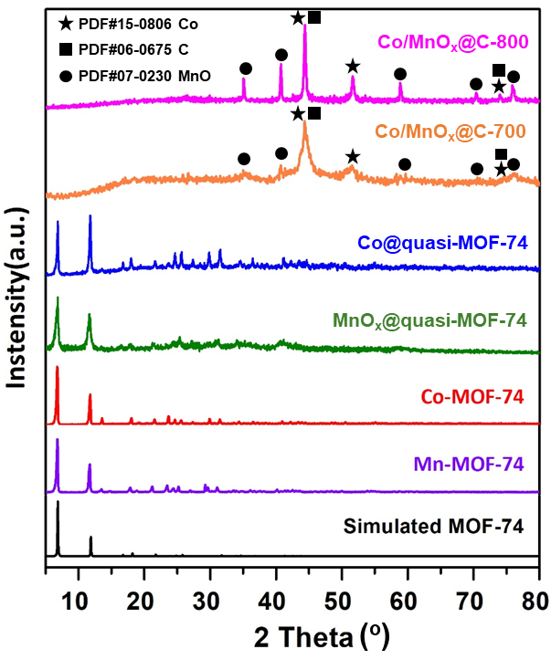

Figure S11. XRD patterns of Mn-MOF-74, Co-MOF-74, MnO_{x}@quasi-MOF-74, Co@quasi-MOF-74, Co/MnO_{x}@C-700, and Co/MnO_{x}@C-800.

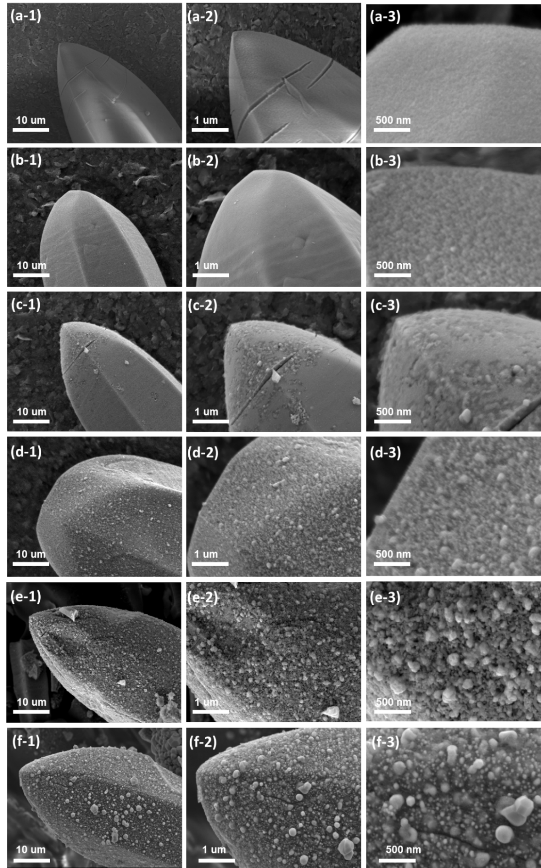

Figure S12. The high-magnification FESEM images of (a₁₋₃) CoMn-MOF-74, the derived (b₁₋₃) Co/MnO_{x}@quasi-MOF-74, (c₁₋₃) Co/MnO_{x}@C-500, (d₁₋₃) Co/MnO_{x}@C-600, (e₁₋₃) Co/MnO_{x}@C-700, and (f₁₋₃) Co/MnO_{x}@C-800.

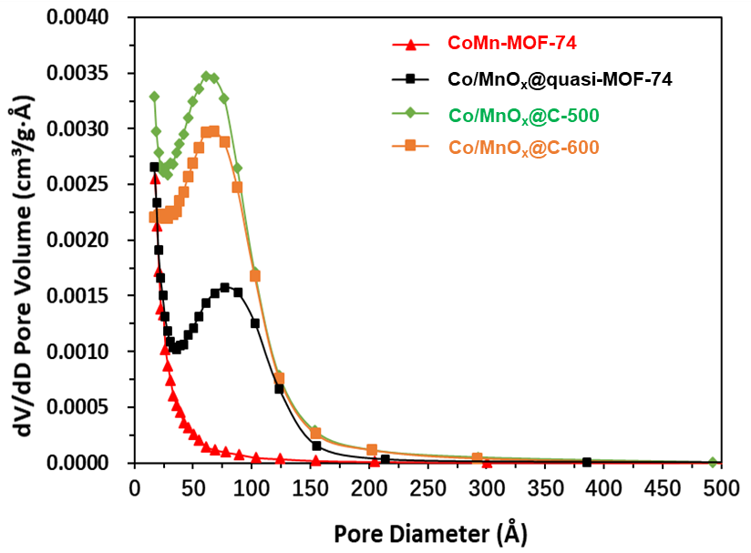

Figure S13. The pore diameter distribution of CoMn-MOF-74, Co/MnO_{x}@quasi-MOF-74 and Co/MnO_{x}@C-500, 600 catalysts.

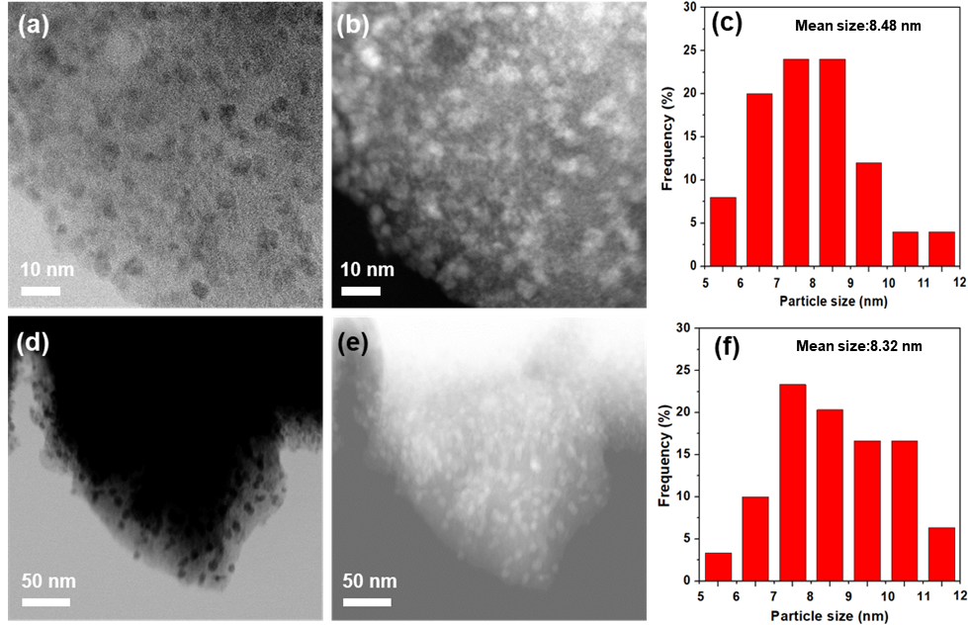

Figure S14. HAABF-STEM (a), HAADF-STEM (b), bright field (d) and dark field (e) TEM images of the Co/MnO_{x}@quasi-MOF-74 catalyst; Size distribution of nanoparticles (c) and (f) in (a) and (d), respectively.

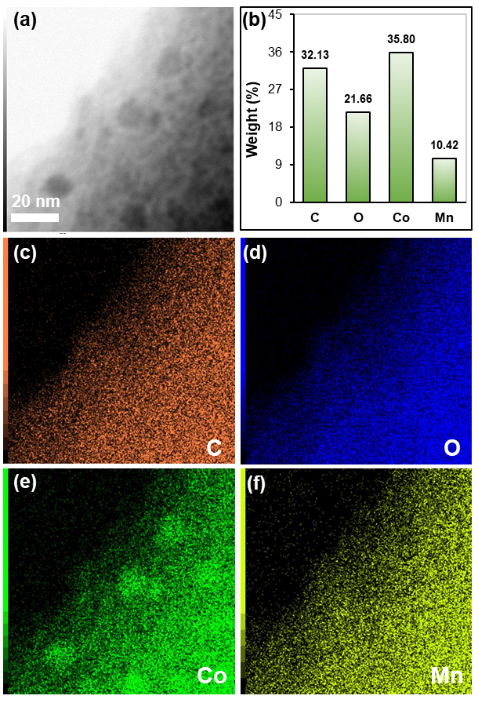

Figure S15. HRTEM image (a) and corresponding elements mapping (c, d, e and f), (b) Elemental analysis results of Co/MnO_{x}@quasi-MOF-74.

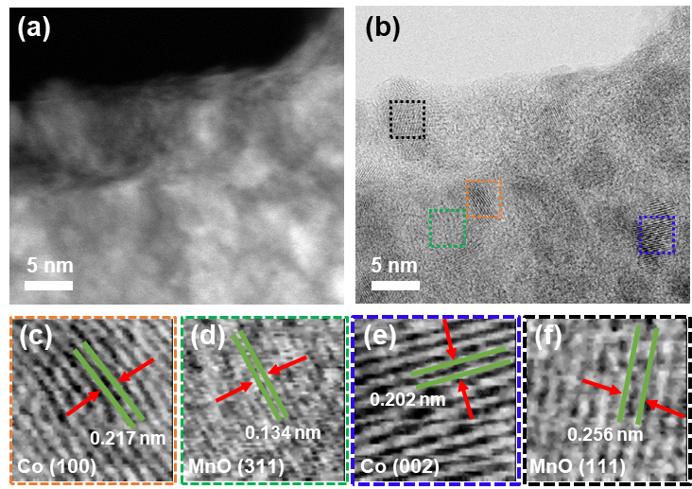

Figure S16. HAADF-STEM (a) and HAABF-STEM (b) images of Co/MnO_{x}@quasi-MOF-74. Enlarged high-resolution HAADF images taken from the selected areas indicated by (c) red, (d) green, (e) blue, and (f) black, rectangles in (b).

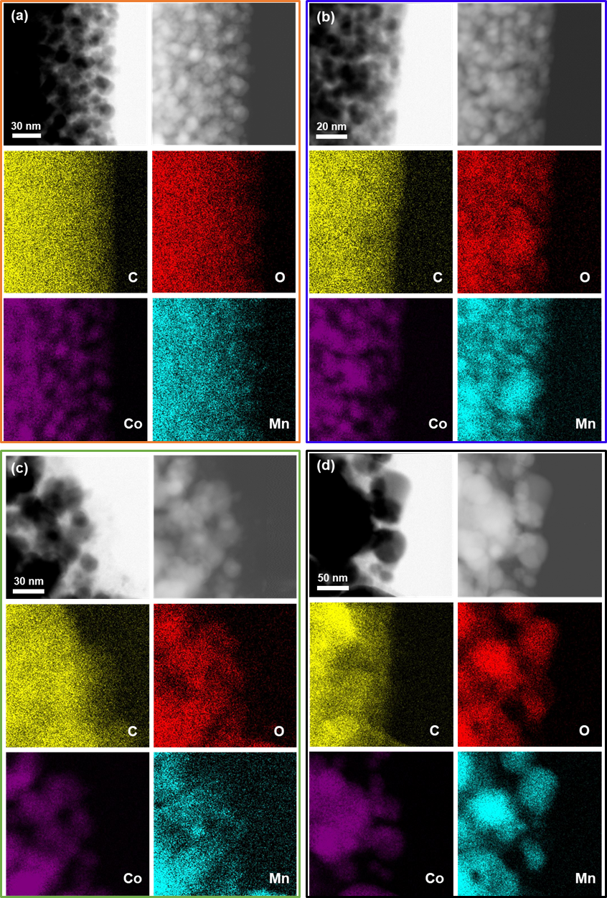

Figure S17. TEM and corresponding EDS elemental mapping images of (a) Co/MnO_{x}@C-500, (b) Co/MnO_{x}@C-600, (c) Co/MnO_{x}@C-700, and (d) Co/MnO_{x}@C-800.

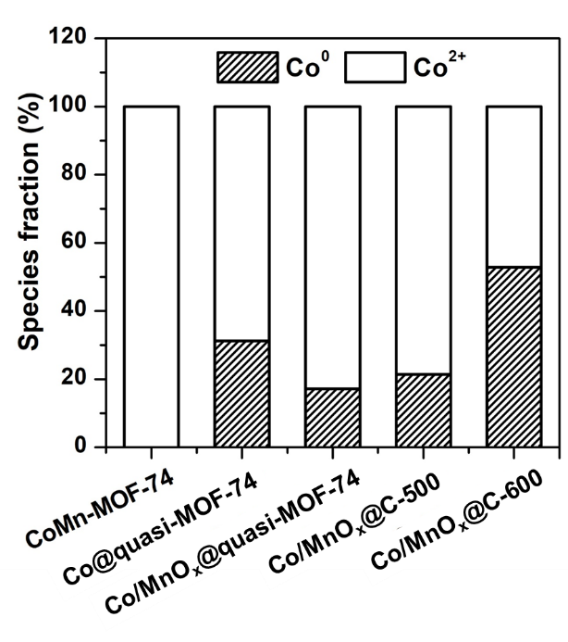

Figure S18. The results of deconvolution and quantitative evaluation of the Co 2p of CoMn-MOF-74, Co@quasi-MOF-74, Co/MnO_{x}@quasi-MOF-74, and Co/MnO_{x}@C-X catalysts.

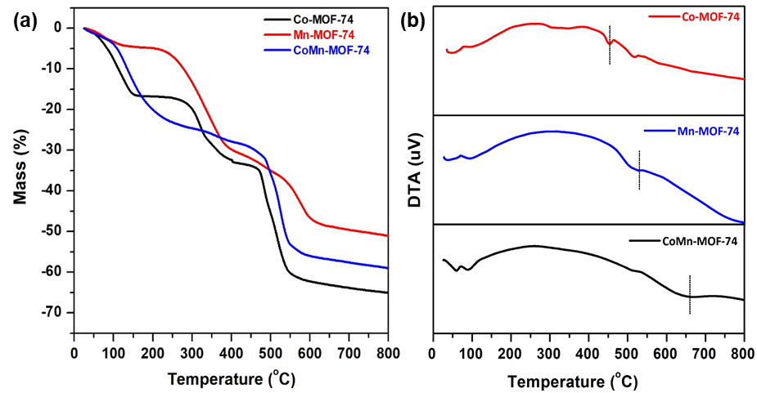

Figure S19. (a) TGA and (b) differential thermal analysis (DTA) plots of Co-MOF-74, Mn-MOF-74, and CoMn-MOF-74 measured from 30 to 800 °C in N₂ atmosphere at a heating rate of 5 °C∙min⁻¹.

Figure S20. The schematic diagram of temperature-programmed pyrolysis (TPP) apparatus.

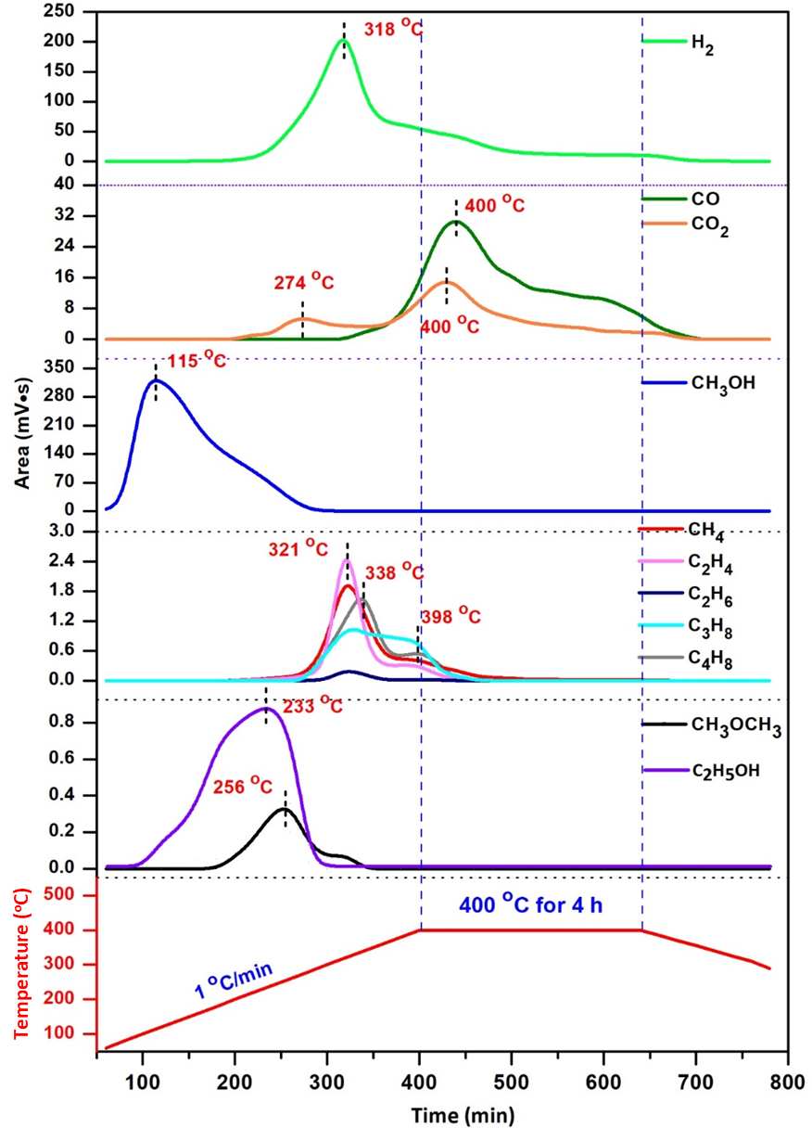

Figure S21. Plots for elucidating the produced gaseous species during the temperature programming pyrolysis of the CoMn-MOF-74.

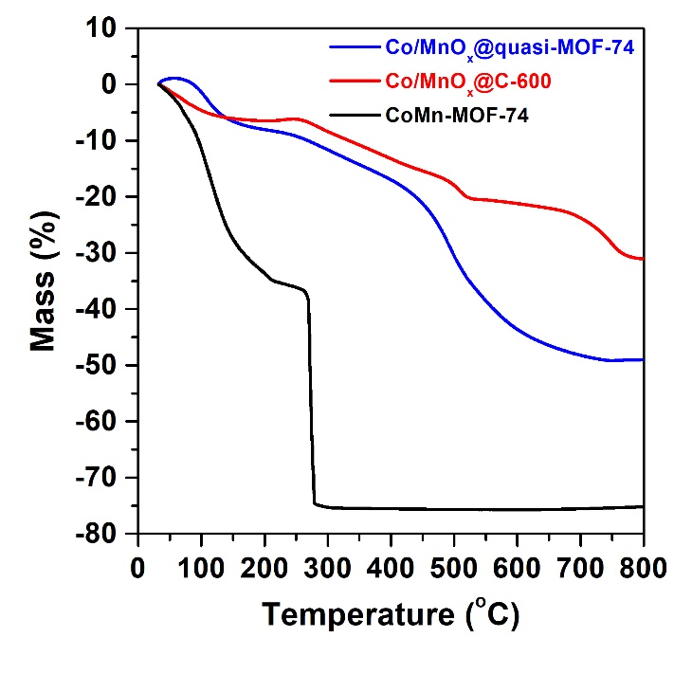

Figure S22. TGA plots of Co/MnO_{x}@quasi-MOF-74, Co/MnO_{x}@C-600, and CoMn-MOF-74 measured from 30 to 800 °C in air atmosphere at a heating rate of 10 °C∙min⁻¹.

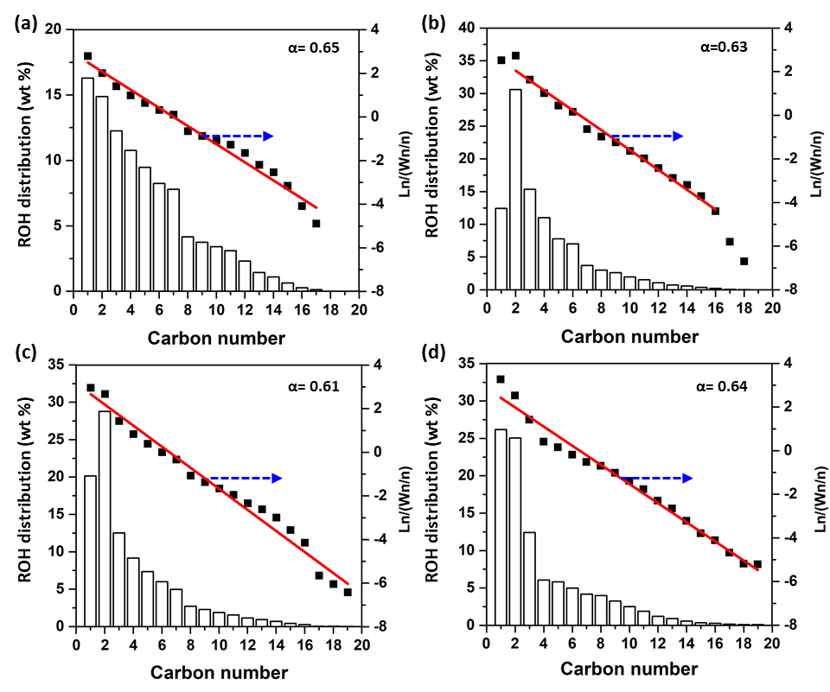

Figure S23. The ROH distribution and corresponding ASF plots of (a) Co@quasi-MOF-74, (b) Co/MnO_{x}@C-500, (c) Co/MnO_{x}@C-600, and (d) Co/MnO_{x}@C-700 catalysts. Reaction conditions: 230 ºC, 3.0 MPa, CO/H₂ = 1/2, GHSV=4500 mL·g⁻¹·h⁻¹. TOS = 24 h.

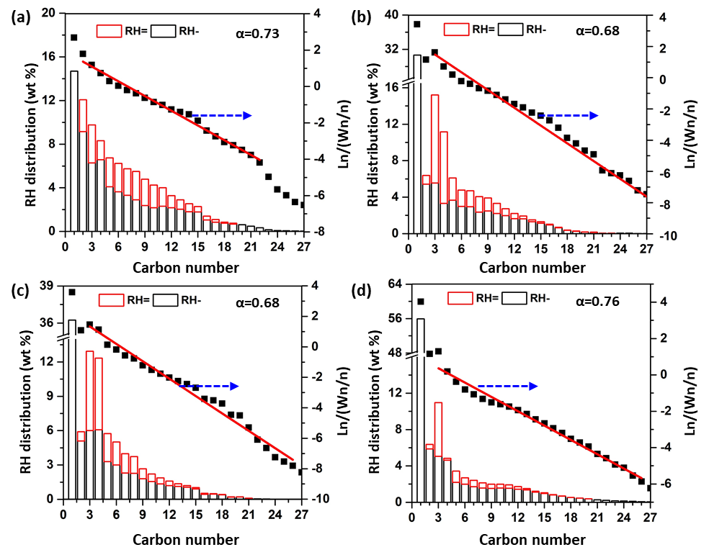

Figure S24. The RH distribution and corresponding ASF plots of (a) Co@quasi-MOF-74, (b) Co/MnO_{x}@C-500, (c) Co/MnO_{x}@C-600, and (d) Co/MnO_{x}@C-700 catalysts. Reaction conditions: 230 ºC, 3.0 MPa, CO/H₂ = 1/2, GHSV=4500 mL·g⁻¹·h⁻¹.TOS = 24 h.

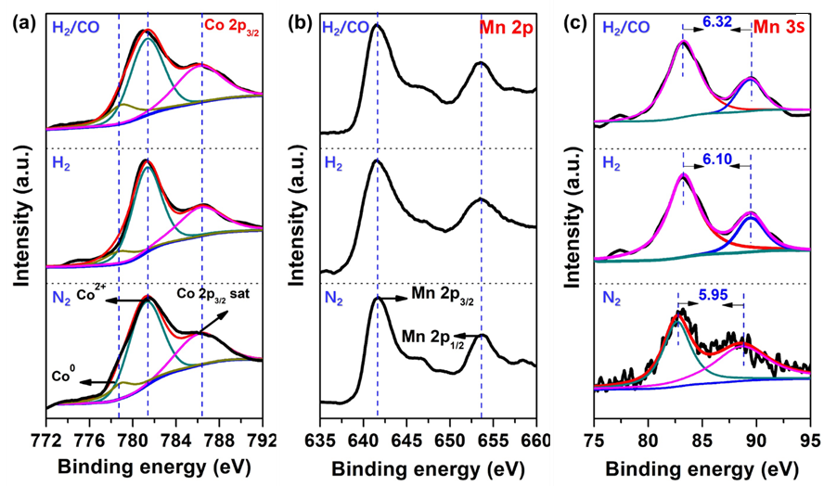

Figure S25. Semi-in situ XPS analysis of Co/MnO_{x}@quasi-MOF-74. The catalyst was dried at 250 ºC in N₂ for 1.0 h (labeled as N₂), then pretreated with a H₂/N₂ of 30/70 (v/v) at 300 ºC for 2.0 h (labeled as H₂), and finally treated with syngas (H₂/CO = 2) at 230 ºC for 2.0 h (labeled as H₂/CO). The whole process was not exposed to air.

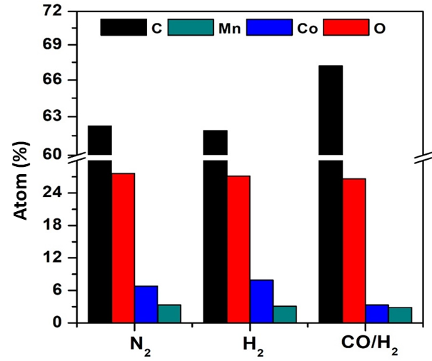

Figure S26. Elemental composition of the surface of Co/MnO_{x}@quasi-MOF-74 catalyst observed from semi-in situ survey XPS spectrum. The catalyst was dried at 250 ºC in N₂ for 1.0 h, then pretreated with a H₂/N₂ of 30/70 (v/v) at 300 ºC for 2.0 h, and finally treated with syngas (H₂/CO = 2) at 230 ºC for 2.0 h. The whole process was not exposed to air.
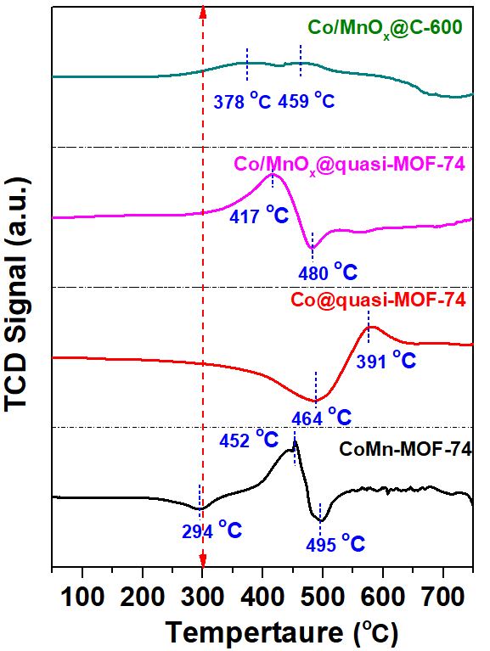

Figure S27. H₂-TPR plots for Co@quasi-MOF-74, and CoMn-MOF-74 and its derived catalysts.

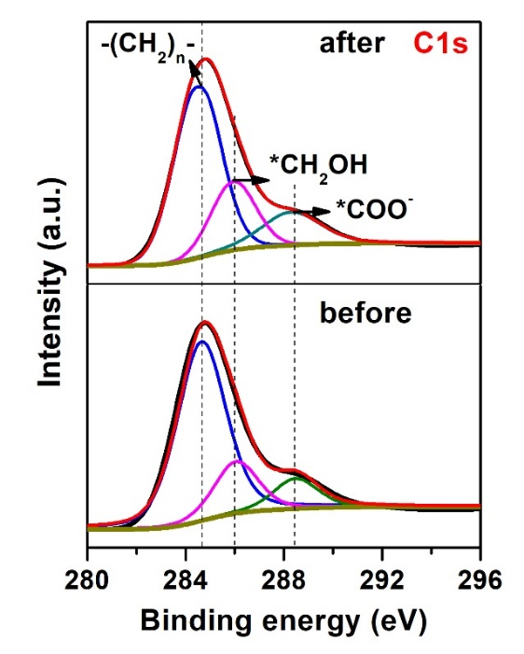

Figure S28. C1s XPS spectra of Co/MnO_{x}@quasi-MOF-74 catalyst before and after 2.0 h of reaction.
Note: The most intense line at 284.8 eV is associated with an elementary carbon intercalated into the bulk of catalyst and/or with hydrocarbon residues adsorbed on the surface. Two weak peaks at 286.2 and 289.6 eV are assigned to the carbon atoms bonded with several oxygen atoms (e.g. carboxyl or carbonate groups) [1].

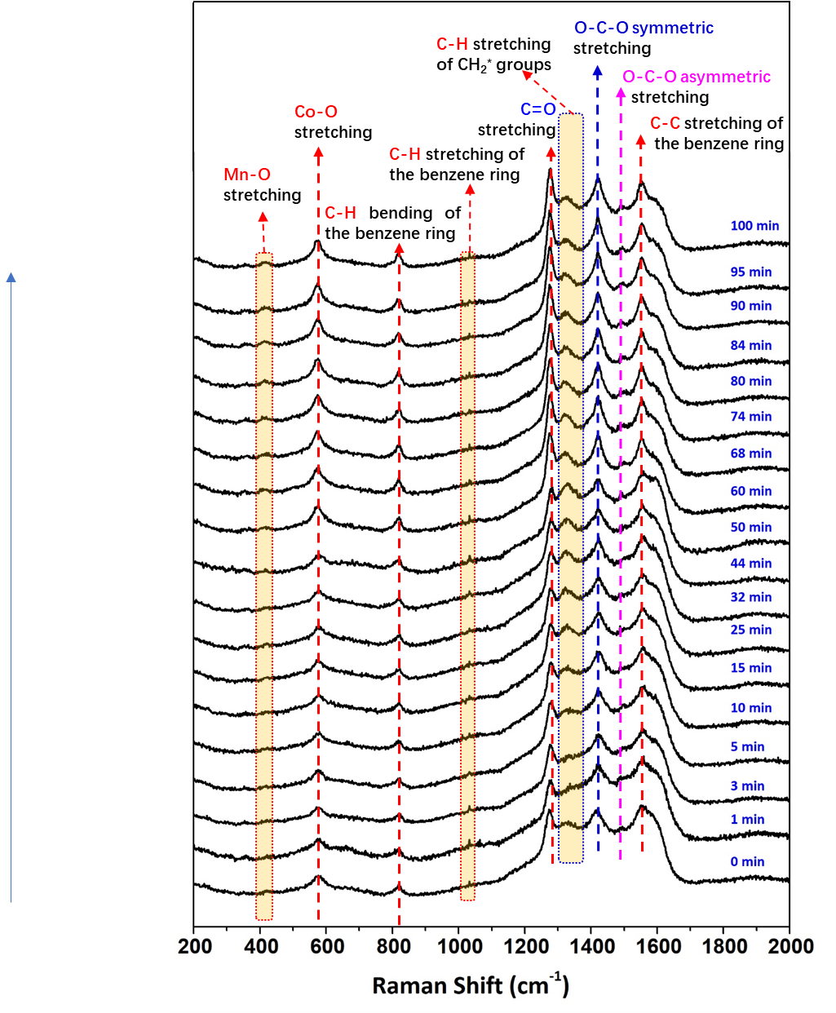

Figure S29. In situ Raman spectra of CO hydrogenation reaction on the pretreated Co/MnO_{x}@quasi-MOF-74 catalyst at 230 ºC, 0.1 MPa, 30 mL∙min⁻¹ of H₂/CO = 2 mixture.

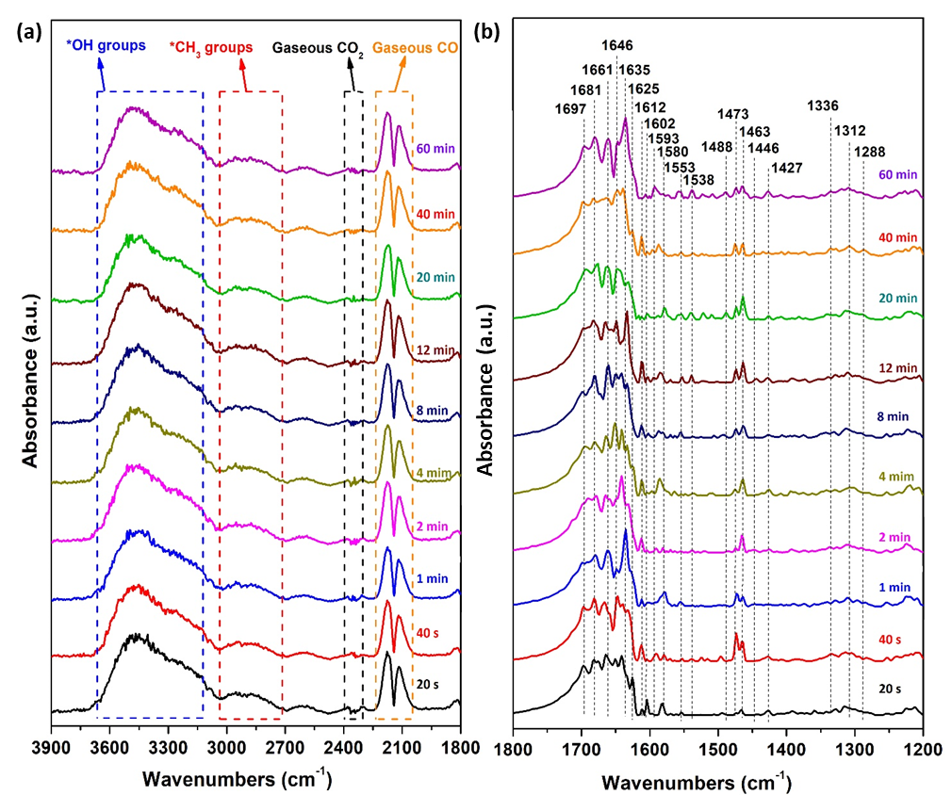

Figure S30. In situ DRIFT spectra of the CO hydrogenation reaction on the pretreated Co/MnO_{x}@C-600 catalyst in the regions (a) 3900-1800 cm⁻¹ and (b) 1800-1200 cm⁻¹ (Reaction conditions: 10 mL∙min⁻¹ CO + 20 mL∙min⁻¹ H₂, 0.1 MPa, 230 °C).

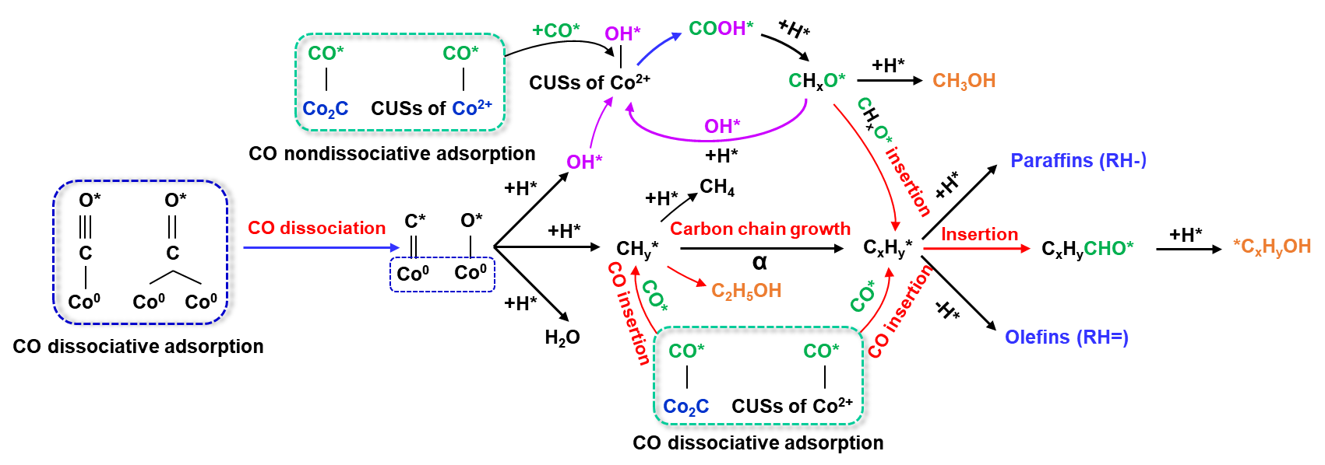

Figure S31. Proposed mechanism of ROH syntheses from CO hydrogenation over Co/MnO_{x}@quasi-MOF-74 catalyst.

S3. Supplementary Tables

Table S1 N₂ sorption measurements of catalysts.
 | CoMn-MOF-74 | Co/MnO_{x}@quasi-MOF-74 | Co/MnO_{x}@C-500 | Co/MnO_{x}@C-600
S_{BET}ª (m²∙g⁻¹） | 640.48 | 552.71 | 273.74 | 202.56
S_{meso}^{b} (m²∙g⁻¹） | 73.82 | 132.78 | 202.69 | 242.55
S_{micro}^{c} (m²∙g⁻¹） | 566.66 | 419.93 | 71.05 | 40.01
S_{meso}/S_{micro} | 0.13 | 0.32 | 2.85 | 12.12
D_{average}^{d} (Å) | 30.81 | 55.16 | 55.29 | 48.82
V_{micro}^{e} (cm³∙g⁻¹) | 0.30 | 0.18 | 0.02 | 0.015
V_{meso}^{f} (cm³∙g⁻¹) | 0.04 | 0.11 | 0.23 | 0.19
V_{meso} /V_{micro} | 0.13 | 0.61 | 11.50 | 19.30
a: Specific surface area calculated by the BET method; b: Mesoporous surface area evaluated by the BJH method from the adsorption branches of isotherms. c: Microporous surface area determined by S_{BET}−S_{meso}. d: Average pore diameter evaluated by the BJH method. e: V_{micro}: micropore volume determined by t-plot method. f: V_{meso}: mesopore volume determined by V_{total}−V_{micro}.

Table S2 The overall composition of the CoMn-MOF-74, Co/MnO_{x}@quasi-MOF-74 and Co/MnO_{x}@C-X catalysts.
Catalyst | Co (wt%) | Mn (wt%) | C (wt%) | H (wt%) | O (wt%) | Co/Mn | C/O
CoMn-MOF-74 | 25.52 | 7.47 | 30.85 | 4.18 | 31.98 | 3.42 | 0.96
Co/MnO_{x}@quasi-MOF-74 | 32.12 | 10.52 | 28.94 | 3.86 | 24.56 | 3.05 | 1.18
Co/MnO_{x}@C-500 | 40.72 | 13.91 | 24.99 | 0.96 | 19.43 | 2.93 | 1.28
Co/MnO_{x}@C-600 | 49.50 | 16.14 | 20.56 | 0.62 | 13.18 | 3.07 | 1.56
Note: The contents of Co and Mn elements were detected by ICP-OES, C and H elements were detected by elemental analyzer, while O element in the table was calculated by the subtraction method in the percentage of weight.

Table S3 The surface composition of the CoMn-MOF-74 Co/MnO_{x}@quasi-MOF-74 and Co/MnO_{x}@C-X catalysts detected by XPS.
Catalyst | Co (wt%) | Mn (wt%) | C (wt%) | O (wt%) | Co/Mn | C/O
CoMn-MOF-74 | 38.13 | 23.44 | 19.68 | 18.75 | 1.63 | 1.05
Co/MnO_{x}@quasi-MOF-74 | 25.71 | 15.36 | 33.93 | 25.00 | 1.67 | 1.36
Co/MnO_{x}@C-500 | 22.18 | 14.74 | 47.99 | 15.09 | 1.50 | 3.18
Co/MnO_{x}@C-600 | 18.85 | 13.49 | 55.93 | 11.76 | 1.34 | 4.76

Table S4 Effect of GHSV on the CO hydrogenation using Co/MnO_{x}@quasi-MOF-74.
GHSV/  (mL·g·h⁻¹) | Conv. (%) | Product distribution (wt%) |  |  |  |  |  |  | ROH+RH⁼ | C₂₊OH/ROH | CTY/  (mg_{CO}·g_{cat}·h⁻¹) | STY/  (mg_{ROH+RH}·g_{cat}·h⁻¹) | α_{ROH} | α_{RH}
 |  | CH₄ | C₂₊H | RH⁼ | CH₃OH | C₂₊OH | ROH | CO₂
15000 | 10.5 | 8.2 | 34.1 | 20.1 | 3.8 | 33.9 | 37.7 | 0.0 | 57.7 | 90.0 | 619.9 | 206.0 | 0.57 | 0.65
12000 | 11.1 | 8.9 | 34.9 | 21.2 | 5.0 | 29.7 | 34.7 | 0.0 | 55.9 | 85.6 | 525.2 | 166.8 | 0.60 | 0.69
7500 | 14.9 | 10.1 | 29.4 | 24.7 | 4.4 | 31.4 | 35.8 | 0.0 | 60.5 | 87.6 | 439.4 | 152.2 | 0.63 | 0.70
4500 | 21.4 | 10.0 | 28.6 | 21.6 | 3.0 | 35.9 | 39.0 | 0.8 | 60.5 | 92.2 | 379.7 | 91.3 | 0.64 | 0.72
Other conditions: P = 3.0 MPa, H₂/CO = 2, and T = 230 ºC. TOS = 24 h.

Table S5 Effect of reaction temperature on the CO hydrogenation using Co/MnO_{x}@quasi-MOF-74.
Temp./  (ºC) | Conv. (%) | Product distribution (wt%) |  |  |  |  |  |  | ROH+RH⁼ | C₂₊OH/ROH | CTY/  (mg_{CO}·g_{cat}·h⁻¹) | STY/  (mg_{ROH+RH}·g_{cat}·h⁻¹) | α_{ROH} | α_{RH}
 |  | CH₄ | C₂₊H | RH⁼ | CH₃OH | C₂₊OH | ROH | CO₂
200 | 6.7 | 3.8 | 30.9 | 20.4 | 3.4 | 45.4 | 48.7 | 0.0 | 69.1 | 93.1 | 117.8 | 47.8 | 0.62 | 0.70
220 | 12.1 | 7.0 | 29.3 | 20.6 | 3.2 | 39.3 | 42.5 | 0.0 | 64.1 | 92.5 | 214.2 | 74.0 | 0.63 | 0.71
230 | 21.4 | 10.0 | 28.6 | 21.6 | 3.0 | 35.9 | 39.0 | 0.8 | 60.5 | 92.2 | 383.2 | 91.3 | 0.64 | 0.72
250 | 38.7 | 18.2 | 33.1 | 14.3 | 1.1 | 25.2 | 26.3 | 8.1 | 40.6 | 93.8 | 686.4 | 136.0 | 0.66 | 0.78
Other conditions: P= 3.0 MPa, H₂/CO = 2, and GHSV = 4500 mL·g⁻¹·h⁻¹. TOS = 24 h.

Table S6 Effect of GHSV on the CO hydrogenation using Co/MnO_{x}@C-600 catalyst.
GHSV/  (mL·g·h⁻¹) | Conv. (%) | Product distribution (wt%) |  |  |  |  |  |  | ROH+RH= | C₂₊OH/ROH | CTY/  (mg_{CO}·g_{cat}·h⁻¹) | STY/  (mg_{ROH+RH}·g_{cat}·h⁻¹) | α_{ROH} | α_{RH}
 |  | CH₄ | C₂₊H | RH= | CH₃OH | C₂₊OH | ROH | CO₂
4500 | 49.9 | 29.8 | 32.7 | 18.9 | 2.8 | 10.7 | 13.5 | 5.1 | 32.4 | 79.2 | 88.4 | 163.9 | 0.62 | 0.67
7500 | 23.3 | 27.1 | 33.9 | 16.8 | 3.3 | 12.2 | 15.5 | 6.8 | 32.3 | 78.6 | 68.7 | 128.5 | 0.68 | 0.70
12000 | 13.9 | 23.5 | 35.4 | 16.1 | 5.1 | 17.6 | 22.8 | 2.3 | 38.9 | 77.5 | 65.6 | 145.2 | 0.70 | 0.73
15000 | 10.7 | 21.0 | 34.0 | 16.0 | 6.1 | 21.6 | 27.7 | 1.4 | 43.7 | 78.0 | 62.9 | 157.1 | 0.73 | 0.74
Other conditions: P = 3.0 MPa, H₂/CO = 2, and T = 230 ºC. TOS = 24 h.

Table S7 Catalytic performance of state of the art catalysts in the selective conversion of syngas to C₂₊OH.
Catalyst | T  (ºC) | P  (MPa) | GHSV  (mL·g_{cat}⁻¹·h⁻¹) | H₂/CO | X_{CO}  (%) | CH₄  (%) | S_{ROH}  (%) | C₂₊OH/ROH  (%) | S_{CO2}  (%) | Ref.
Co/MnO_{x}@quasi-MOF-74 | 200 | 3.0 | 4500 | 2 | 6.65 | 3.4 | 45.4 | 93.1 | 0.0 | This work
Co/MnO_{x}@quasi-MOF-74 | 220 | 3.0 | 4500 | 2 | 12.1 | 7.0 | 42.4 | 92.5 | 0.0 | This work
Co/MnO_{x}@quasi-MOF-74 | 230 | 3.0 | 4500 | 2 | 21.4 | 9.98 | 39.0 | 92.1 | 0.8 | This work
CoMn|CuZnAlZr^{(a)} | 220 | 6.0 | 2000 | 2 | 12.4 | 4.4 | 54.5 | 93.1 | 6.3 | [2]
Cu₄Fe₁ | 260 | 1.0 | 2400 | 2 | 53.2 | 3.7 | 29.8 | 49.1 | 30.0 | [3]
Co₁/CeO₂ | 260 | 5.0 | N/A | 2 | 1.0 | 23.8 | 21.7 | 73.4 | 0.8 | [4]
CuCoAl | 270 | 2.5 | 7500 | 2 | 36.2 | 24.0 | 40.7 | 54.9 | 0.5 | [5]
Cs₂O-Cu/ZnO/Al₂O₃ | 320 | 5.4 | 3750 | 2 | 12.0 | N/A | 23.3 | N/A | 20 | [6]
Co−Co₂C/AC | 200 | 3.0 | 3665 | 2 | 25.3 | N/A | 37.0 | 87 | 4.6 | [7]
Co1Mn/AC | 220 | 3.0 | 2000 | 2 | 29.1 | 8.1 | 21.4 | N/A | 2.4 | [8]
LKCG-0.1 | 290 | 4.0 | 6000 | 2 | 13.2 | 30.9 | 43.6 | 69.1 | 5.8 | [9]
Rh/MnO/SiO₂ | 250 | 2.0 | N/A | 2 | N/A | 26.0 | N/A | 56.1 | N/A | [10]
Co0.5Mn1La/AC | 220 | 3.0 | 2000 | 2 | 18.3 | N/A | 26.8 | N/A | 2.5 | [11]
CoMn-0.6Na | 240 | 2.0 | 6000 | 2 | 11.6 | 18.2 | 19.8 | N/A | 31.6 | [12]
3Cu−5Co/(Mn−Al) | 260 | 5.0 | 5000 | 2 | 33.4 | N/A | 39.7 | 57.3 | 14.1 | [13]
15Co3Fe/AC | 220 | 3.0 | 4000 | 3 | 14.8 | N/A | 22.3 | N/A | 1.7 | [14]
10K-Co₃O₄ | 270 | 4.0 | N/A | N/A | 0.17 | 10.9 | 16.0 | N/A | N/A | [15]
Co₈P/SiO₂ | 280 | 5.0 | 5000 | 2 | 6.7 | 38.8 | 39.6 | 87.6 | 4.8 | [16]
Cu@(CuCo-alloy)/Al₂O₃ | 220 | 2.0 | 2000 | 2 | 32.9 | N/A | 36.2 | 58.3 | 7.2 | [17]
Co–Cu | 270 | 2.0 | 18000 | 2 | 1.0 | 17.2 | 18.0 | 63.3 | 48.8 | [18]
Cu@Co₃O₄ | 270 | 1.0 | 18000 | 2 | N/A | 9.8 | 20.9 | 23.4 | 59.6 | [19]
(Cu₁Co₂)₂Al-LDHs | 250 | 3.0 | 3900 | 2 | 53.6 | N/A | 39.2 | 91.0 | 2.2 | [20]
2Co–2Pd/SiO₂ | 230 | 1.0 | 24000 | 2 | 0.05 | 11.7 | 20.2 | 22.27 | N/A | [21]
K-Co-β-Mo₂C | 300 | 8.0 | 2000 | 1 | 51.0 | N/A | 27.4 | N/A | N/A | [22]
K-Co-MoS₂/AC | 330 | 5.0 | 4800 | 2 | 14.3 | N/A | 26.7 | 81.3 | N/A | [23]
K-Co-MoS₂/CNTs | 350 | 5.0 | 3600 | 1 | 21.6 | N/A | 45.9 | 34.8 | 28.3 | [24]
K-Co-MoP/SiO₂ | 275 | 5.0 | 3600 | 1 | 11.2 | 12.5 | 30.7 | 93.3 | N/A | [25]
15Co5Fe/AC | 220 | 3.0 | 4000 | 2 | 16.4 | N/A | 20.6 | 87.2 | 1.6 | [26]
(a) Calculated on a CO₂-free basis.

S4. References
- Z. He, M. Cui, Q. Qian, J. Zhang, H. Liu, B. Han, Synthesis of liquid fuel via direct hydrogenation of CO₂, Proc. Natl. Acad. Sci. USA 116 (2019) 12654-12659.
- T. Lin, X. Qi, X. Wang, L. Xia, C. Wang, F. Yu, H. Wang, S. Li, L. Zhong, Y. Sun, Direct production of higher oxygenates by syngas conversion over a multifunctional catalyst, Angew. Chem. Int .Ed. 58 (2019) 4627-4631.
- Y. Li, W. Gao, M. Peng, J. Zhang, J. Sun, Y. Xu, S. Hong, X. Liu, X. Liu, M. Wei, B. Zhang, D. Ma, Interfacial Fe₅C₂-Cu catalysts toward low-pressure syngas conversion to long-chain alcohols, Nat. Commun. 11 (2020) 61.
- T.-Y. Chen, J. Su, Z. Zhang, C. Cao, X. Wang, R. Si, X. Liu, B. Shi, J. Xu, Y.-F. Han, Structure evolution of Co–CoO_{x} interface for higher alcohol synthesis from syngas over Co/CeO₂ Catalysts, ACS Catal. 8 (2018) 8606-8617.
- K. Sun, Y. Wu, M. Tan, L. Wang, G. Yang, M. Zhang, W. Zhang, Y. Tan, Ethanol and higher alcohols synthesis from syngas over CuCoM (M=Fe, Cr, Ga and Al) nanoplates derived from hydrotalcite-like precursors, ChemCatChem 11 (2019) 2695-2706.
- J. Sun, Q. Cai, Y. Wan, S. Wan, L. Wang, J. Lin, D. Mei, Y. Wang, Promotional effects of cesium promoter on higher alcohol synthesis from syngas over cesium-promoted Cu/ZnO/Al₂O₃ catalysts, ACS Catal. 6 (2016) 5771-5785.
- Y.-P. Pei, J.-X. Liu, Y.-H. Zhao, Y.-J. Ding, T. Liu, W.-D. Dong, H.-J. Zhu, H.-Y. Su, L. Yan, J.-L. Li, W.-X. Li, High alcohols synthesis via Fischer–Tropsch reaction at cobalt metal/carbide interface, ACS Catal. 5 (2015) 3620-3624.
- Z. Zhao, W. Lu, R. Yang, H. Zhu, W. Dong, F. Sun, Z. Jiang, Y. Lyu, T. Liu, H. Du, Y. Ding, Insight into the formation of Co@Co₂C catalysts for direct synthesis of higher alcohols and olefins from syngas, ACS Catal. 8 (2018) 228-241.
- S.X. Guo, G.L. Liu, T. Han, Z.Y. Zhang, Y. Liu, K-modulated Co nanoparticles trapped in La-Ga-O as superior catalysts for higher alcohols synthesis from syngas, Catalysts 9 (2019) 218.
- N. Yang, J.S. Yoo, J. Schumann, P. Bothra, J.A. Singh, E. Valle, F. Abild-Pedersen, J.K. Nørskov, S.F. Bent, Rh-MnO interface sites formed by atomic layer deposition promote syngas conversion to higher oxygenates, ACS Catal. 7 (2017) 5746-5757.
- Z. Zhao, W. Lu, H. Zhu, W. Dong, Y. Lyu, T. Liu, X. Chen, Y. Wang, Y. Ding, Tuning the Fischer–Tropsch reaction over Co_{x}MnyLa/AC catalysts toward alcohols: Effects of La promotion, J. Catal. 361 (2018) 156-167.
- Y. Yang, T. Lin, X. Qi, F. Yu, Y. An, Z. Li, Y. Dai, L. Zhong, H. Wang, Y. Sun, Direct synthesis of long-chain alcohols from syngas over CoMn catalysts, App. Catal. A: Gen. 549 (2018) 179-187.
- L. Zhao, J. Duan, Q. Zhang, Y. Li, K. Fang, Preparation, structural characteristics, and catalytic performance of Cu–Co alloy supported on Mn–Al oxide for higher alcohol synthesis via syngas, Ind. Eng. Chem. Res. 57 (2018) 14957-14966.
- H. Du, H. Zhu, T. Liu, Z. Zhao, X. Chen, W. Dong, W. Lu, W. Luo, Y. Ding, Higher alcohols synthesis via CO hydrogenation on Fe-promoted Co/AC catalysts, Catal. Today 281 (2017) 549-558.
- Z. Wang, G. Laddha, S. Kanitkar, J.J. Spivey, Metal organic framework-mediated synthesis of potassium-promoted cobalt-based catalysts for higher oxygenates synthesis, Catal. Today 298 (2017) 209-215.
- X. Song, Y. Ding, W. Chen, W. Dong, Y. Pei, J. Zang, L. Yan, Y. Lu, Synthesis and characterization of silica-supported cobalt phosphide catalysts for CO hydrogenation, Energ Fuel. 26 (2012) 6559-6566.
- W. Gao, Y. Zhao, H. Chen, H. Chen, Y. Li, S. He, Y. Zhang, M. Wei, D.G. Evans, X. Duan, Core–shell Cu@(CuCo-alloy)/Al₂O₃ catalysts for the synthesis of higher alcohols from syngas, Green. Chem. 17 (2015) 1525-1534.
- N.D. Subramanian, G. Balaji, C.S.S.R. Kumar, J.J. Spivey, Development of cobalt–copper nanoparticles as catalysts for higher alcohol synthesis from syngas, Catal. Today 147 (2009) 100-106.
- N.D. Subramanian, C.S.S.R. Kumar, K. Watanabe, P. Fischer, R. Tanaka, J.J. Spivey, A DRIFTS study of CO adsorption and hydrogenation on Cu-based core–shell nanoparticles, Catal. Sci. Technol. 2 (2012) 621-631.
- Q. Yang, A. Cao, N. Kang, H. Ning, J. Wang, Z.-T. Liu, Y. Liu, Bimetallic nano Cu–Co based catalyst for direct ethanol synthesis from syngas and its structure variation with reaction time in slurry reactor, Ind. Eng. Chem. Res. 56 (2017) 2889-2898.
- N. Kumar, M.L. Smith, J.J. Spivey, Characterization and testing of silica-supported cobalt–palladium catalysts for conversion of syngas to oxygenates, J. Catal. 289 (2012) 218-226.
- M. Xiang, D. Li, W. Li, B. Zhong, Y. Sun, Synthesis of higher alcohols from syngas over K/Co/β-Mo₂C catalysts, Catal Commun. 8 (2007) 503-507.
- Z. Li, Y. Fu, J. Bao, M. Jiang, T. Hu, T. Liu, Y.-N. Xie, Effect of cobalt promoter on Co–Mo–K/C catalysts used for mixed alcohol synthesis, Appl. Catal. A: Gen. 220 (2001) 21-30.
- X. Ma, G. Lin, H. Zhang, Co-Mo-K Sulfide-based catalyst promoted by multiwalled carbon nanotubes for higher alcohol synthesis from syngas, Chinese J .Catal. 27 (2006) 1019-1027.
- R. Xu, Y. Li, Z. Cao, J. Zheng, N. Zhang, B. Chen, W. Wang, Higher alcohol synthesis from syngas over KCoMoP catalysts, Catal Commun, 51 (2014) 63-67.
- H. Du, H. Zhu, Z. Zhao, W. Dong, W. Luo, W. Lu, M. Jiang, T. Liu, Y. Ding, Effects of impregnation strategy on structure and performance of bimetallic CoFe/AC catalysts for higher alcohols synthesis from syngas, Appl. Catal. A: Gen. 523 (2016) 263-271.

