Supporting Information

Efficient Fischer-Tropsch to light olefins over iron-based catalyst with low methane selectivity and high olefin/paraffin ratio
Zhenxin Liu, Gaopeng Jia, Chenxi Zhao, Yu Xing*
Henan Provincial Key Laboratory of Surface and Interface Science, School of Materials and Chemical Engineering, Zhengzhou University of Light Industry, Zhengzhou, 450002, China.
* To whom correspondence should be addressed. E-mail address: yuxing@zzuli.edu.cn (Y. Xing). Tel/Fax: +86 371 86608700.

Detailed description about materials syntheses
Support SP1 and catalyst N1: The nominal composition of support SP1 is 100%(ZnAl₂O₄•1Al₂O₃). Support SP1 is synthesized by coprecipitation. Zinc nitrate and aluminum nitrate are employed, while the dosages are according to the ratios of elemental compositions in Table 1. Zinc nitrate and aluminum nitrate are dissolved together in DI water to form a solution with a weight ratio of metal (i.e., Zn & Al) sources to water of 1:5. Sodium bicarbonate is dissolved in water to form a precipitant solution with a weight ratio of sodium bicarbonate to water of 1:13. Support SP1 is synthesized by dropping the metal (i.e., Zn & Al) source solution and the precipitant solution together at 40°C under stirring, filtered after 1 h aging period, washed by water to a neutral pH, half-dried at 80°C, kneaded, extruded, air-dried at RT, oven-dried at 110°C for 2 h, and then annealed at 1200°C for 24 h in air. Above is the procedure for support SP1. The nominal composition of catalyst N1 is 15%Fe/2%K₂O/83%(ZnAl₂O₄•1Al₂O₃). Unreduced catalyst N1 is synthesized by incipient wetness of support SP1 with a K₂CO₃ solution, desiccation at 110°C for 2 h, another incipient wetness with an ammonium iron citrate solution, another desiccation at 110°C for 2 h, and then anneal at 350°C for 4 h in air. Reduced catalyst N1 is prepared by a subsequent reduction at 550°C for 6 h in an atmosphere of 50%H₂/50%Ar. Generally, K₂O% is employed to simplify the expression of potassium content in the catalyst composition of potassium carbonate application.
Support SP5 and catalyst N5: The nominal composition of support SP5 is 100%(ZnAl₂O₄•5Al₂O₃). Support SP5 is synthesized by coprecipitation. Zinc nitrate and aluminum nitrate are dissolved together in DI water to form a solution with a weight ratio of metal (i.e., Zn & Al) sources to water of 1:5. Sodium bicarbonate is dissolved in H₂O to form a precipitant solution with a weight ratio of sodium bicarbonate to water of 1:13. Support SP5 is synthesized by dropping the metal (i.e., Zn & Al) source solution and the precipitant solution together at 40°C under stirring, filtered after 1 h aging period, washed by water to a neutral pH, half-dried at 80°C, kneaded, extruded, air-dried at RT, oven-dried at 110°C for 2 h, and then annealed at 1200°C for 24 h in air. Above is the procedure for support SP5. The nominal composition of catalyst N5 is 15%Fe/2%K₂O/83%(ZnAl₂O₄•5Al₂O₃). Unreduced catalyst N5 is synthesized by incipient wetness of support SP5 with a K₂CO₃ solution, desiccation at 110°C for 2 h, another incipient wetness with an ammonium iron citrate solution, another desiccation at 110°C for 2 h, and then anneal at 350°C for 4 h in air. Reduced catalyst N5 is prepared by a subsequent reduction at 550°C for 6 h in an atmosphere of 50%H₂/50%Ar.
Support SP∞ and catalyst REF∞: The nominal composition of support SP∞ is 100%(Al₂O₃). Support SP∞ is synthesized by precipitation. Aluminum nitrate is employed is dissolved in H₂O to form a solution with a weight ratio of metal (i.e., Al) source to DI water of 1:5. Sodium bicarbonate is dissolved in water to form a precipitant solution with a weight ratio of sodium bicarbonate to water of 1:13. Support SP∞ is synthesized by dropping the metal (i.e., Al) source solution and the precipitant solution together at 40°C under stirring, filtered after 1 h aging period, washed by water to a neutral pH, half-dried at 80°C, kneaded, extruded, air-dried at RT, oven-dried at 110°C for 2 h, and then annealed at 1200°C for 24 h in air. Above is the procedure for support SP∞. The nominal composition of catalyst REF∞ is 15%Fe/2%K₂O/83%(Al₂O₃). Unreduced catalyst REF∞ is synthesized by incipient wetness of support SP∞with a K₂CO₃ solution, desiccation at 110°C for 2 h, another incipient wetness with an ammonium iron citrate solution, another desiccation at 110°C for 2 h, and then anneal at 350°C for 4 h in air. Reduced catalyst REF∞ is synthesized by a subsequent reduction at 550°C for 6 h in an atmosphere of 50%H₂/50%Ar.
Support SP0 and catalyst REF0: The nominal composition of support SP0 is 100%(ZnAl₂O₄). Support SP0 is synthesized by coprecipitation. Zinc nitrate and aluminum nitrate are employed, while the dosages are according to the ratios of elemental compositions in Table 1. Zinc nitrate and aluminum nitrate are dissolved together in DI water to form a solution with a weight ratio of metal (i.e., Zn & Al) sources to water of 1:5. Sodium bicarbonate is dissolved in water to form a precipitant solution with a weight ratio of sodium bicarbonate to water of 1:13. Support SP0 is synthesized by dropping the metal (i.e., Zn & Al) source solution and the precipitant solution together at 40°C under stirring, filtered after 1 h aging period, washed by water to a neutral pH, half-dried at 80°C, kneaded, extruded, air-dried at RT, oven-dried at 110°C for 2 h, and then annealed at 1200°C for 24 h in air. Above is the procedure for support SP0. The nominal composition of catalyst REF0 is 15%Fe/2%K₂O/83%(ZnAl₂O₄). Unreduced catalyst REF0 is synthesized by incipient wetness of support SP0 with a K₂CO₃ solution, desiccation at 110°C for 2 h, another incipient wetness with an ammonium iron citrate solution, another desiccation at 110°C for 2 h, and then anneal at 350°C for 4 h in air. Reduced catalyst REF0 is prepared by a subsequent reduction at 550°C for 6 h in an atmosphere of 50%H₂/50%Ar.

Characterization of materials
The structure analysis of materials are performed with powder X-ray diffraction (XRD) using a Panalytical X’Pert Pro diffractometer with Cu Kα radiation. The morphologies of materials are observed with Field-emission scanning electron microscopy (FESEM) using a JSM-7001F FESEM. Elemental contents were measured with an Agilent 725 ICP-OES. The mesoporosity property is analyzed with nitrogen physisorption using a Quantachrome NOVA1000 surface area and pore size analyzer. Surface basicity of materials is measured with CO₂-TPD (CO₂ temperature-programmed desorption) using a Quantachrome ChemStarTM chemisorption analyzer (Detector: Chem-Bet). Samples for CO₂-TPD tests are loaded, in-situ reduced at 550°C and then cooled down to 50°C. Adsorption of CO₂ is conducted at 50°C with a mixed gas of 2000 ppm CO₂ in Ar, followed by helium flushing at 50°C for the removal of physisorbed CO₂. The CO₂-TPD data were collected in the temperature range of 50～800°C at atmospheric pressure. The weight of each CO₂-TPD sample is 0.1000 g.
Catalytic Performance Tests
Catalytic CO hydrogenation reactions are carried out with a fixed-bed tubular reactor. Catalysts (i.e., in oxide status, 40-60 mesh) are loaded and then in-situ reduced at 550°C for 6 h by 50%H₂/50%Ar at 0.1 MPa. A pre-mixed syngas (H₂/CO/Ar = 45/45/10, by mole%) is applied over the in-situ reduced catalysts for CO hydrogenation reaction at a total pressure of 2.0 MPa as well as a space velocity (SV) of 1500 mL•g cat⁻¹•h⁻¹. Syngas passes through the reactor in one way. Catalytic data are determined after the reactions reach steady state. Reaction temperature is changed from low to high during catalytic tests. UHP argon is utilized as the internal standard of syngas in GC analysis. CO, CH₄ and CO₂ are analyzed using a GC with a TCD detector equipped with a packed column (TDX-01, 6 m in length). Incondensable gaseous hydrocarbons are analyzed using a GC with a FID detector equipped with a capillary column (PLOT Al₂O₃/S, 50 m * 0.53 mm * 25 μm). Water phase is analyzed by a GC with a TCD detector equipped with a packed column (GDX-102, 2 m * 3 mm). Oxygenates in water phase are negligible and thus not counted in calculations. Condensed wax and oil (dissolved in cyclohexane) are analyzed by a GC with a FID detector equipped with a capillary column (OV-101, 50 m * 0.25 mm * 0.5 μm).

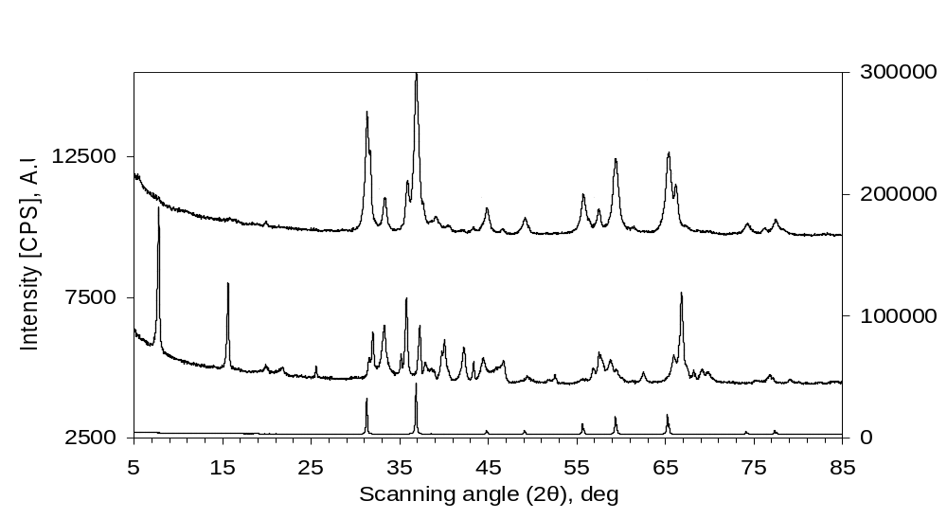

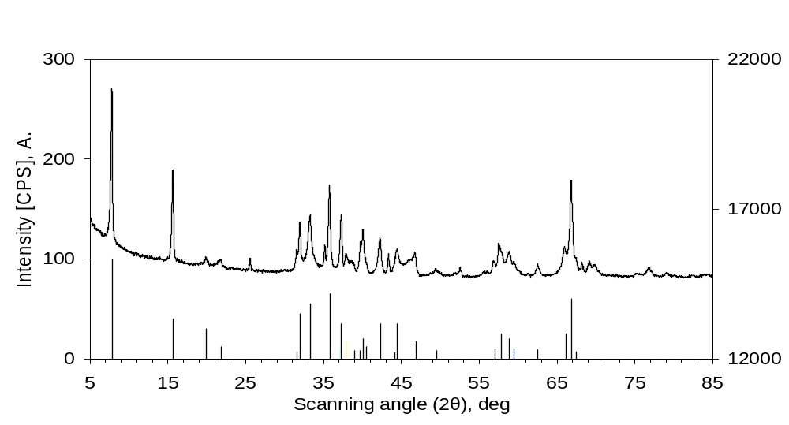
Supporting Information Fig.S1. Enlarged X-ray diffraction (XRD) patterns of some support samples. SP1: 100%(ZnAl₂O₄•1Al₂O₃). SP∞: 100%(Al₂O₃). SP0: 100%(ZnAl₂O₄). a): Pattern “SP0” follows the scale of the right ordinate axis, while others follow the left ordinate axis. b): Pattern “SP∞” follows the scale of the right ordinate axis. The column curve shows the standard diffraction lines of β-Al₂O₃ (i.e., NaAl₁₁O₁₇ or Na₂Al₂₂O₃₄, JCPDS No. 31-1263).

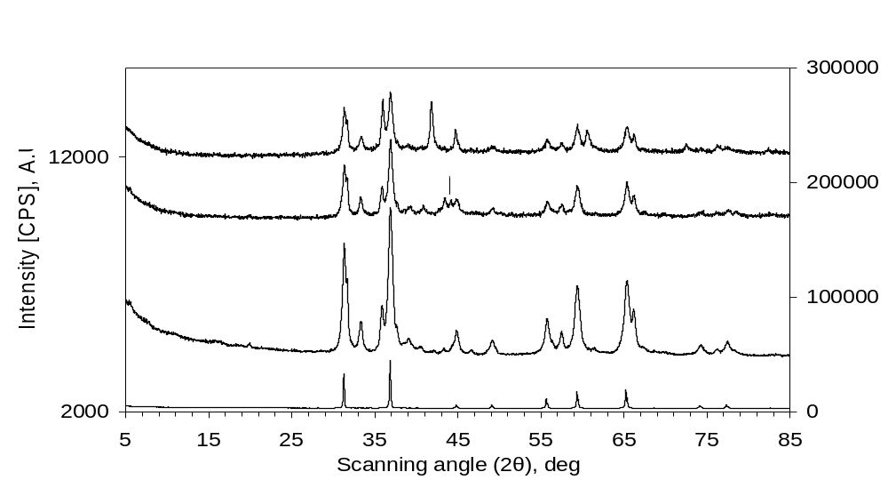
Supporting Information Fig.S2. Enlarged X-ray diffraction (XRD) patterns of freshly reduced N1 and used N1. N1: 15%Fe/2%K₂O/83%(ZnAl₂O₄•1Al₂O₃). SP1: 100%(ZnAl₂O₄•1Al₂O₃). SP0: 100%(ZnAl₂O₄). Pattern “SP0” follows the scale of the right ordinate axis, while others follow the left ordinate axis.

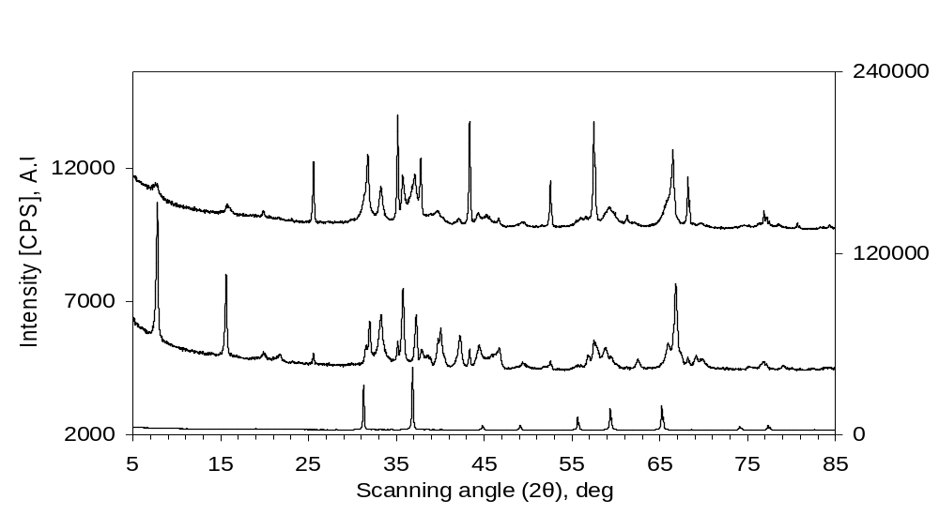
Supporting Information Fig.S3. Enlarged X-ray diffraction (XRD) patterns of some support samples. SP5: 100%(ZnAl₂O₄•5Al₂O₃). SP∞: 100%(Al₂O₃). SP0: 100%(ZnAl₂O₄). Pattern “SP0” follows the scale of the right ordinate axis, while others follow the left ordinate axis.

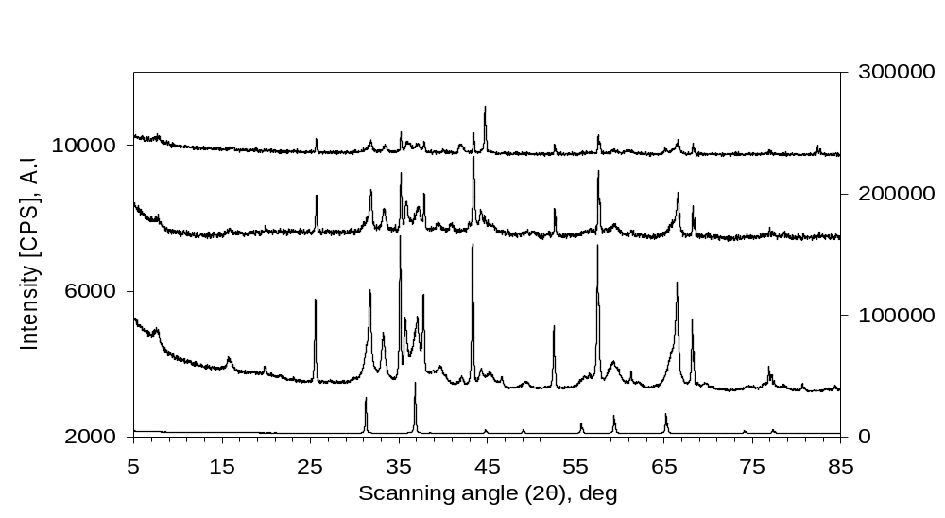
Supporting Information Fig.S4. Enlarged X-ray diffraction (XRD) patterns of freshly reduced N5 and used N5. N5: 15%Fe/2%K₂O/83%(ZnAl₂O₄•5Al₂O₃). SP5: 100%(ZnAl₂O₄•5Al₂O₃). SP0: 100%(ZnAl₂O₄). Pattern “SP0” follows the scale of the right ordinate axis, while others follow the left ordinate axis.

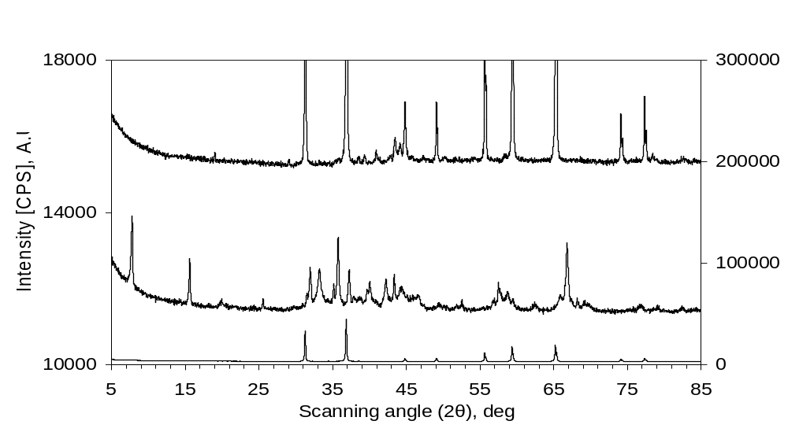
Supporting Information Fig.S5. Enlarged X-ray diffraction (XRD) patterns of used REF0 and used REF∞. REF0: 15%Fe/2%K₂O/83%(ZnAl₂O₄). REF∞: 15%Fe/2%K₂O/83%(Al₂O₃). SP0: 100%(ZnAl₂O₄). Pattern “SP0” follows the scale of the right ordinate axis, while others follow the left ordinate axis.

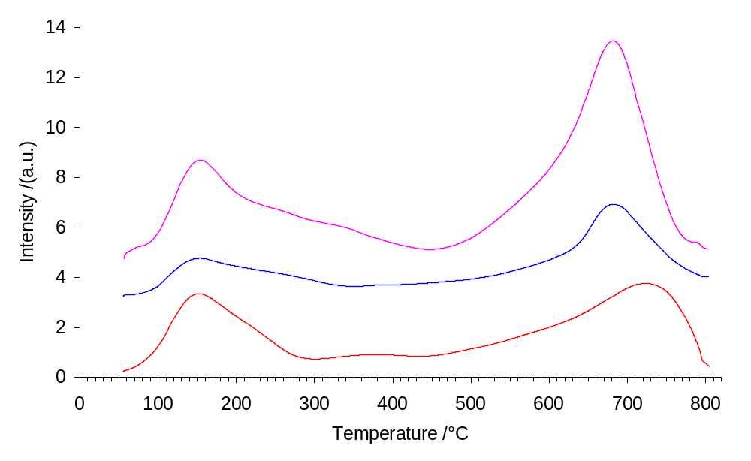
Supporting Information Fig.S6. Enlarged profiles for CO₂ temperature-programmed desorption (CO₂-TPD) of freshly reduced catalysts N1, REF0 and REF∞.

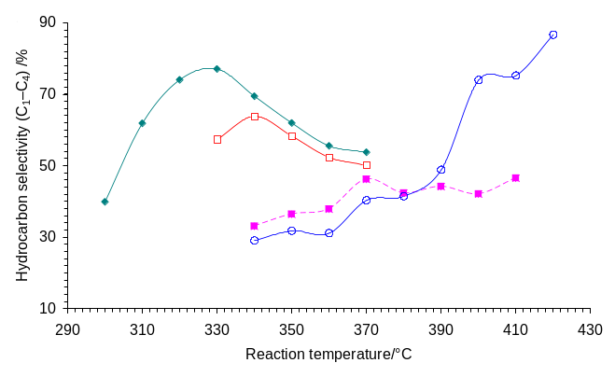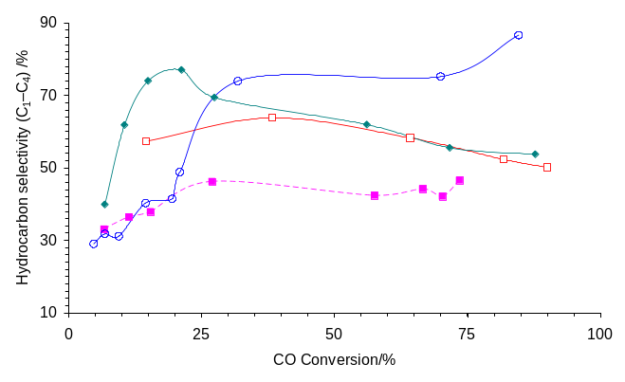
Supporting Information Fig.S7. C₁-C₄ hydrocarbon distributions (i.e., C₁-C₄ HC selectivity) of reduced catalysts at different reaction temperatures (a) and different CO conversions (b).

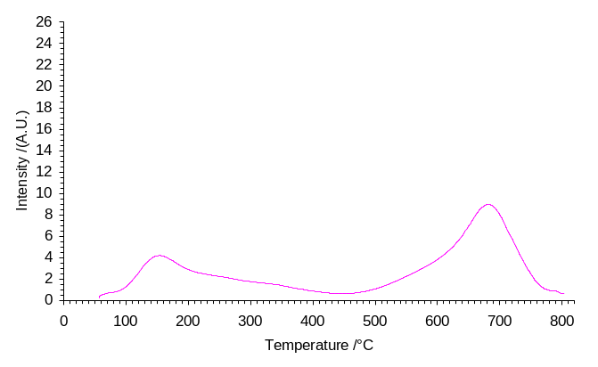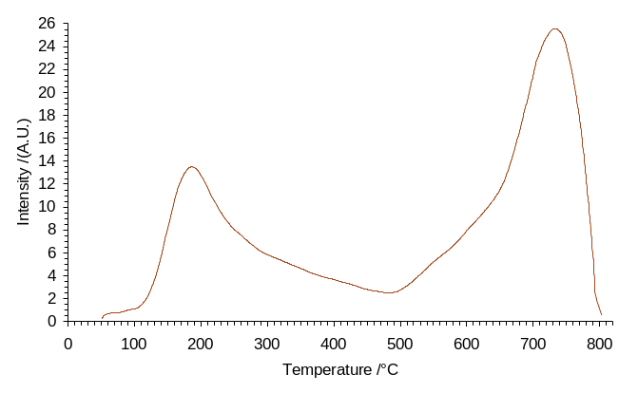
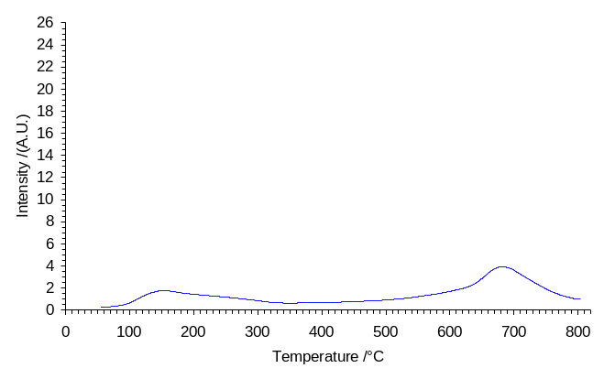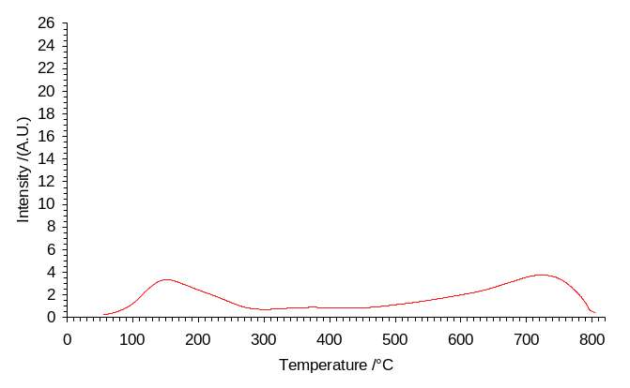
Supporting Information Fig.S8. Separate profiles for CO₂ temperature-programmed desorption (CO₂-TPD) of freshly reduced catalysts N1, N5, REF0 and REF∞. The weight of each CO₂-TPD sample is 0.1000 g.

Supporting Information Table S1. Contents of residue sodium (Na) in supports measured by ICP-OES
support sample  (nominal composition) | SP0  100%(ZnAl₂O₄) | SP1  100%(ZnAl₂O₄•1Al₂O₃) | SP5  100%(ZnAl₂O₄•5Al₂O₃) | SP∞  100%(Al₂O₃)
ICP content of sodium (Na) by weight | 1.25% | 1.19% | 1.21% | 2.49%

Supporting Information Table S2. Integral data of CO₂-TPD results *
sample  code | nominal composition  (metal/promoter/support)  (wt) | low temp. peak |  |  | high temp. peak |  |  | A_{total} | relative  A_{total} | A_{high} /A_{low} | I_{high} /I_{low}
sample  code | nominal composition  (metal/promoter/support)  (wt) | temp.  /°C | area% | I_{low}# | temp.  /°C | area% | I_{high}
N5 | 15%Fe/2%K₂O/83%(ZnAl₂O₄•5Al₂O₃) | 186.0 | 35.6% | 13.5 | 732.4 | 64.4% | 25.6 | 36394 | 213 | 1.8 | 1.9
N1 | 15%Fe/2%K₂O/83%(ZnAl₂O₄•1Al₂O₃) | 154.1 | 37.3% | 4.2 | 681.9 | 62.7% | 9.0 | 17104 | 100 | 1.7 | 2.1
REF0 | 15%Fe/2%K₂O/83%(ZnAl₂O₄) | 152.8 | 30.1% | 1.8 | 680.5 | 69.9% | 3.9 | 8936 | 52 | 2.3 | 2.2
REF∞ | 15%Fe/2%K₂O/83%(Al₂O₃) | 152.0 | 33.1% | 3.3 | 722.4 | 66.9% | 3.8 | 11330 | 66 | 2.0 | 1.1
* A_{high} denotes the integral area of high temperature peak for CO₂ desorption, while A_{low} denotes the integral area of low temperature peak for CO₂ desorption. A_{total} = A_{high} + A_{low}. The relative A_{total} of N1 is specified to be 100. # Peak intensity after background deduction.

Supporting Information Table S3. Catalytic performance of catalyst N1*
T  /°C | X_{CO}  /% | S_{CO2}  /% | hydrocarbon selectivity/%  (C mole%) |  |  |  |  |  |  |  | olefin/paraffin ratio  (O/P) |  |  |  | FTY  (10⁻⁵ mol_{CO}/  g_{Fe} s)
T  /°C | X_{CO}  /% | S_{CO2}  /% | C₁ | C₂ | C₃ | C₄ | C₂-C₄ | C₅₊ | C₁-C₄ | C₂⁼-C₄⁼ | C₂ | C₃ | C₄ | C₂-C₄ | FTY  (10⁻⁵ mol_{CO}/  g_{Fe} s)
330 | 14.5 | 48.5 | 6.7 | 17.2 | 20.2 | 13.2 | 50.6 | 42.7 | 57.3 | 46.9 | 10.9 | 15.1 | 11.9 | 12.6 | 1.2
340 | 38.3 | 48.0 | 7.7 | 19.2 | 22.3 | 14.6 | 56.1 | 36.2 | 63.8 | 52.1 | 9.8 | 17.7 | 13.0 | 13.0 | 3.3
350 | 64.2 | 51.7 | 8.0 | 18.1 | 20.3 | 11.9 | 50.3 | 41.7 | 58.3 | 46.4 | 8.0 | 17.7 | 13.8 | 11.9 | 5.5
360 | 81.8 | 47.7 | 7.9 | 16.3 | 18.0 | 10.1 | 44.4 | 47.7 | 52.3 | 40.6 | 6.6 | 17.2 | 12.7 | 10.5 | 7.0
370 | 90.0 | 46.3 | 8.8 | 16.3 | 16.7 | 8.4 | 41.4 | 49.8 | 50.2 | 37.3 | 5.6 | 16.2 | 12.5 | 9.2 | 7.7
* Catalyst N1: 15%Fe/2%K₂O/83%(ZnAl₂O₄•1Al₂O₃). P = 2.0 MPa. SV = 1500 mL•g cat⁻¹•h⁻¹. H₂/CO/Ar = 45/45/10. Iron time yield (FTY) represents moles of CO converted to hydrocarbons per unit of Fe per second.

Supporting Information Table S4. Catalytic performance of catalyst N5 *
T  /°C | X_{CO}  /% | S_{CO2}  /% | hydrocarbon selectivity/%  (C mole%) |  |  |  |  |  |  |  | olefin/paraffin ratio  (O/P) |  |  |  | FTY  (10⁻⁵ mol_{CO}/  g_{Fe} s)
T  /°C | X_{CO}  /% | S_{CO2}  /% | C₁ | C₂ | C₃ | C₄ | C₂-C₄ | C₅₊ | C₁-C₄ | C₂⁼-C₄⁼ | C₂ | C₃ | C₄ | C₂-C₄ | FTY  (10⁻⁵ mol_{CO}/  g_{Fe} s)
300 | 6.8 | 22.9 | 16.0 | 10.5 | 9.0 | 4.4 | 23.9 | 60.1 | 39.9 | 17.8 | 1.4 | 6.8 | 6.1 | 2.9 | 0.6
310 | 10.5 | 41.1 | 22.1 | 16.6 | 15.1 | 8.1 | 39.7 | 38.2 | 61.8 | 30.8 | 1.7 | 7.6 | 7.5 | 3.5 | 0.9
320 | 14.9 | 44.2 | 25.3 | 20.4 | 18.4 | 9.9 | 48.7 | 26.0 | 74.0 | 38.9 | 2.0 | 8.5 | 8.9 | 4.0 | 1.3
330 | 21.2 | 48.2 | 24.9 | 21.5 | 19.7 | 11.0 | 52.2 | 23.0 | 77.0 | 42.6 | 2.2 | 9.3 | 9.9 | 4.5 | 1.8
340 | 27.4 | 47.8 | 18.9 | 19.8 | 19.4 | 11.3 | 50.5 | 30.6 | 69.4 | 43.0 | 3.0 | 11.2 | 10.9 | 5.7 | 2.3
350 | 56.1 | 46.9 | 16.1 | 17.6 | 17.6 | 10.8 | 45.9 | 38.1 | 62.0 | 39.4 | 3.1 | 12.0 | 12.1 | 6.1 | 4.8
360 | 71.7 | 45.3 | 14.4 | 16.1 | 16.0 | 9.0 | 41.1 | 44.5 | 55.5 | 35.3 | 3.1 | 12.2 | 12.3 | 6.1 | 6.1
370 | 87.8 | 44.7 | 13.6 | 15.5 | 15.8 | 8.9 | 40.2 | 46.2 | 53.8 | 34.4 | 3.0 | 12.1 | 12.0 | 5.9 | 7.5
* Catalyst N5: 15%Fe/2%K₂O/83%(ZnAl₂O₄•5Al₂O₃). P = 2.0 MPa. SV = 1500 mL•g cat⁻¹•h⁻¹. H₂/CO/Ar = 45/45/10. Iron time yield (FTY) represents moles of CO converted to hydrocarbons per unit of Fe per second.

Supporting Information Table S5. Catalytic performance of catalyst REF∞ *
T  /°C | X_{CO}  /% | S_{CO2}  /% | hydrocarbon selectivity/%  (C mole%) |  |  |  |  |  |  |  | olefin/paraffin ratio  (O/P) |  |  |  | FTY  (10⁻⁵ mol_{CO}/  g_{Fe} s)
T  /°C | X_{CO}  /% | S_{CO2}  /% | C₁ | C₂ | C₃ | C₄ | C₂-C₄ | C₅₊ | C₁-C₄ | C₂⁼-C₄⁼ | C₂ | C₃ | C₄ | C₂-C₄ | FTY  (10⁻⁵ mol_{CO}/  g_{Fe} s)
340 | 4.7 | 21.2 | 12.6 | 8.5 | 5.5 | 2.5 | 16.5 | 70.9 | 29.1 | 14.0 | 4.4 | 8.7 | 5.8 | 5.6 | 0.4
350 | 6.8 | 32.6 | 11.9 | 9.0 | 7.2 | 3.7 | 19.9 | 68.2 | 31.8 | 16.5 | 3.7 | 7.2 | 5.6 | 4.9 | 0.6
360 | 9.4 | 34.3 | 10.5 | 8.9 | 7.4 | 4.3 | 20.6 | 68.9 | 31.1 | 17.2 | 3.6 | 6.8 | 6.6 | 5.0 | 0.8
370 | 14.5 | 41.4 | 10.7 | 11.8 | 11.3 | 6.5 | 29.6 | 59.7 | 40.3 | 25.1 | 4.0 | 7.1 | 7.3 | 5.5 | 1.2
380 | 19.4 | 36.3 | 11.1 | 12.8 | 11.4 | 6.2 | 30.4 | 58.5 | 41.5 | 26.2 | 4.7 | 8.9 | 7.3 | 6.3 | 1.7
390 | 20.9 | 39.2 | 12.9 | 15.7 | 13.4 | 6.8 | 35.9 | 51.2 | 48.8 | 31.3 | 5.0 | 9.6 | 8.1 | 6.8 | 1.8
400 | 31.8 | 47.1 | 19.6 | 24.4 | 20.2 | 9.8 | 54.4 | 26.0 | 74.0 | 47.9 | 5.3 | 11.2 | 8.9 | 7.3 | 2.7
410 | 69.9 | 44.8 | 25.8 | 21.4 | 20.3 | 7.7 | 49.4 | 24.8 | 75.2 | 36.3 | 1.4 | 6.0 | 5.8 | 2.8 | 6.0
420 | 84.6 | 44.5 | 27.6 | 22.8 | 25.9 | 10.3 | 59.0 | 13.4 | 86.7 | 36.9 | 0.7 | 3.3 | 3.6 | 1.7 | 7.3
* Catalyst REF∞: 15%Fe/2%K₂O/83%(Al₂O₃). P = 2.0 MPa. SV = 1500 mL•g cat⁻¹•h⁻¹. H₂/CO/Ar = 45/45/10. Iron time yield (FTY) represents moles of CO converted to hydrocarbons per unit of Fe per second.

Supporting Information Table S6. Catalytic performance of catalyst REF0 *
T  /°C | X_{CO}  /% | S_{CO2}  /% | hydrocarbon selectivity/%  (C mole%) |  |  |  |  |  |  |  | olefin/paraffin ratio  (O/P) |  |  |  | FTY  (10⁻⁵ mol_{CO}/  g_{Fe} s)
T  /°C | X_{CO}  /% | S_{CO2}  /% | C₁ | C₂ | C₃ | C₄ | C₂-C₄ | C₅₊ | C₁-C₄ | C₂⁼-C₄⁼ | C₂ | C₃ | C₄ | C₂-C₄ | FTY  (10⁻⁵ mol_{CO}/  g_{Fe} s)
340 | 6.7 | 17.6 | 15.4 | 9.9 | 6.7 | 1.0 | 17.6 | 67.0 | 33.1 | 14.3 | 3.6 | 8.0 | 1.5 | 4.3 | 0.6
350 | 11.4 | 31.0 | 16.1 | 9.2 | 8.0 | 3.1 | 20.3 | 63.6 | 36.4 | 17.1 | 3.7 | 8.0 | 7.2 | 5.3 | 1.0
360 | 15.4 | 36.6 | 13.0 | 10.5 | 9.0 | 5.4 | 24.9 | 62.1 | 37.9 | 21.3 | 4.0 | 9.5 | 7.1 | 5.9 | 1.3
370 | 27.0 | 45.1 | 13.2 | 13.3 | 12.2 | 7.4 | 32.9 | 53.9 | 46.2 | 28.8 | 4.8 | 10.9 | 8.5 | 7.1 | 2.3
380 | 57.6 | 45.6 | 10.0 | 12.1 | 12.4 | 7.9 | 32.3 | 57.7 | 42.3 | 29.1 | 5.9 | 12.7 | 11.6 | 8.8 | 4.9
390 | 66.6 | 46.8 | 11.1 | 12.4 | 12.8 | 7.8 | 33.0 | 55.9 | 44.1 | 29.2 | 5.0 | 10.8 | 10.6 | 7.7 | 5.7
400 | 70.3 | 44.3 | 10.9 | 11.9 | 12.0 | 7.3 | 31.2 | 57.9 | 42.1 | 27.2 | 4.6 | 9.6 | 9.0 | 6.8 | 6.0
410 | 73.5 | 44.8 | 12.3 | 13.1 | 13.1 | 8.0 | 34.2 | 53.5 | 46.5 | 29.2 | 3.9 | 8.2 | 7.6 | 5.8 | 6.3
* Catalyst REF0: 15%Fe/2%K₂O/83%(ZnAl₂O₄). P = 2.0 MPa. SV = 1500 mL•g cat⁻¹•h⁻¹. H₂/CO/Ar = 45/45/10. Iron time yield (FTY) represents moles of CO converted to hydrocarbons per unit of Fe per second.

