- Algorithm
分析主要流程得出算法为RC4
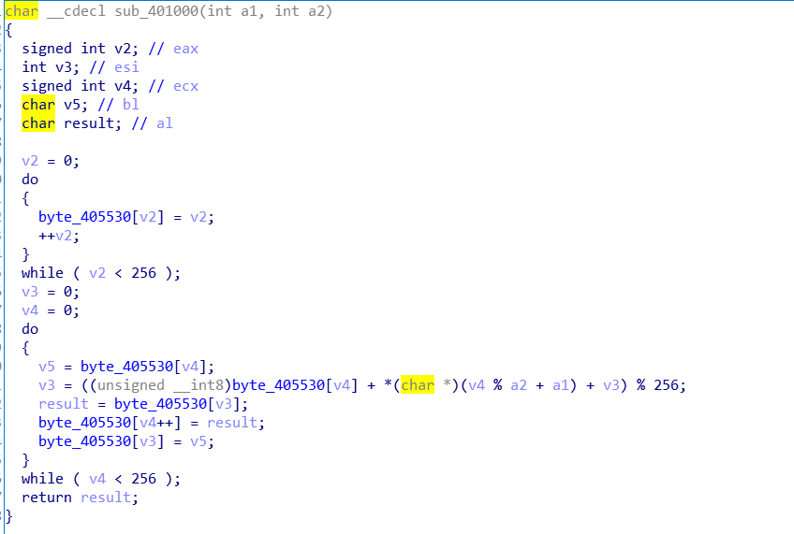
获得秘钥和密文即可
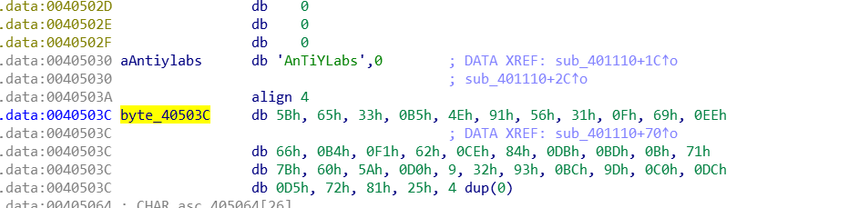
解题脚本如下
#include <stdio.h>
#include <string.h>
typedef unsigned long ULONG;
void rc4_init(unsigned char* s, unsigned char* key, unsigned long Len)
int i = 0, j = 0;
char k[256] = { 0 };
unsigned char tmp = 0;
for (i = 0; i < 256; i++) {
s[i] = i;
k[i] = key[i % Len];
}
for (i = 0; i < 256; i++) {
j = (j + s[i] + k[i]) % 256;
tmp = s[i];
s[i] = s[j]; //交换 s[i]和 s[j]
s[j] = tmp;
}
}
void rc4_crypt(unsigned char* s, unsigned char* Data, unsigned long Len)
{
int i = 0, j = 0, t = 0;
unsigned long k = 0;
unsigned char tmp;
for (k = 0; k < Len; k++) {
i = (i + 1) % 256;
j = (j + s[i]) % 256;
tmp = s[i];
s[i] = s[j]; //交换 s[x]和s[y]
s[j] = tmp;
t = (s[i] + s[j]) % 256;
Data[k] ^= s[t];
}
}
int main()
{
unsigned char s[256] = { 0 }; //S-box
char key[256] = { "AnTiYLabs" };
char pData[512] = "\x5b\x65\x33\xb5\x4e\x91\x56\x31\xf\x69\xee\x66\xb4\xf1\x62\xce\x84\xdb\xbd\xb\x71\x7b\x60\x5a\xd0\x9\x32\x93\xbc\x9d\xc0\xdc\xd5\x72\x81\x25";
ULONG len = strlen(pData);
printf("key : %s\n", key);
printf("raw : %s\n", pData);
rc4_init(s, (unsigned char*)key, strlen(key));
len = strlen(pData);
rc4_crypt(s, (unsigned char*)pData, len);
printf("decrypt: %s\n", pData);
getchar();
return 0;
}

- Antiquity_Fixed
动态调试至字符串比较函数处即可得出正确的flag
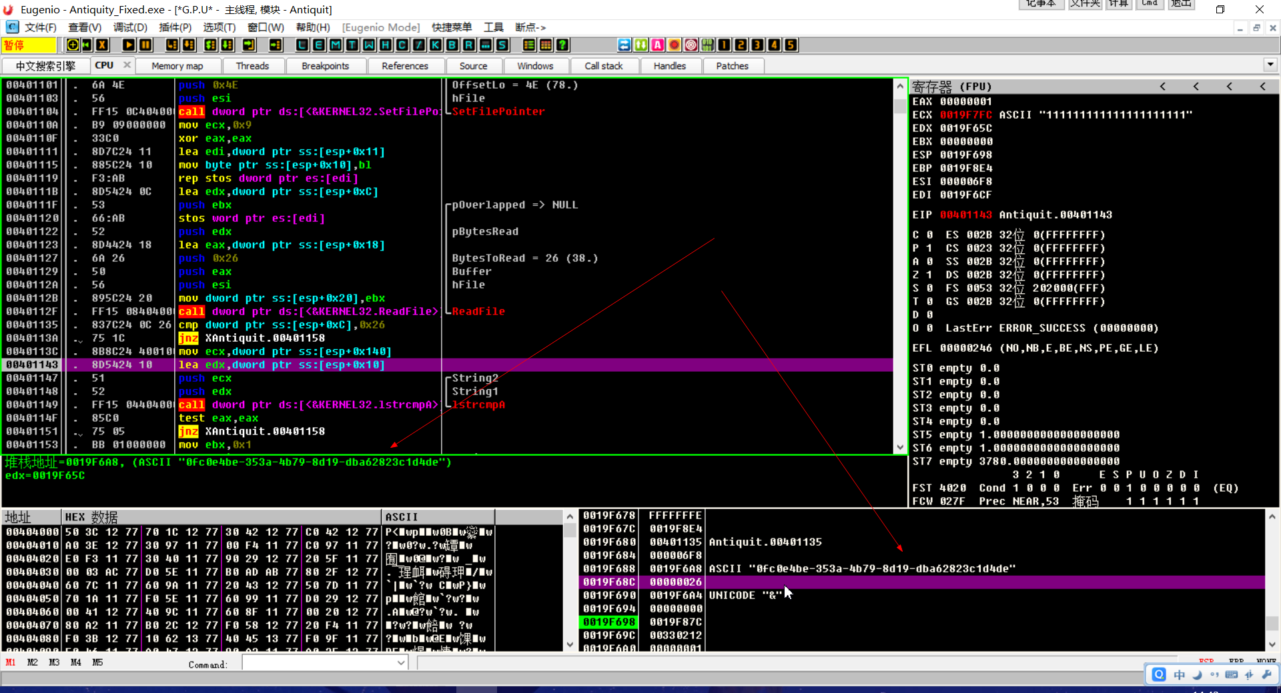

输入字符串后，程序会通过case将输入的每一位字符与正确的flag比较
通过此Jmp跳转到正确的flag的每一位
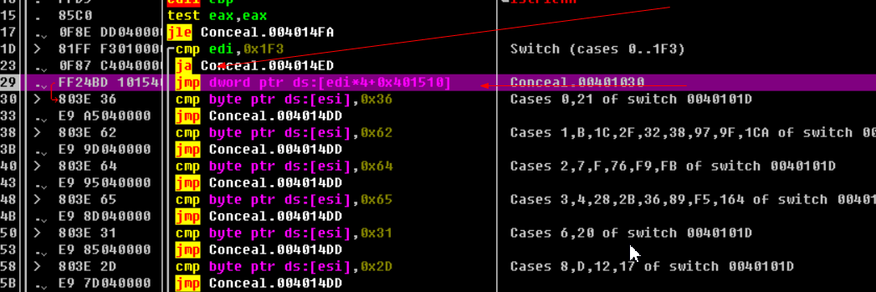
之后通过cmp和jmp跳转到jnz处
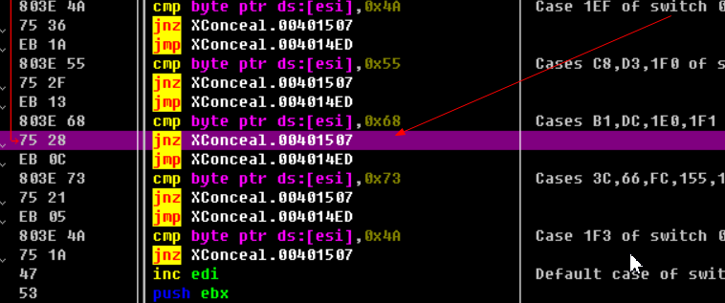
此时通过修改z标志位为1使得程序在输入flag错误的情况下也能继续运行，继续下一个case
因为是手工将每一个cmp byte ptr ds:[esi],0x??中的0x??一个一个提取，对照ASCII表得出flag
所以…没有用脚本

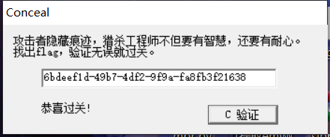

4、Scrape

使用 Xspy 发现确实存在隐藏按钮

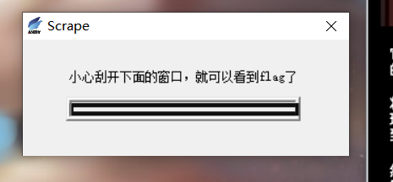

使用 Restorator 查看文件资源树

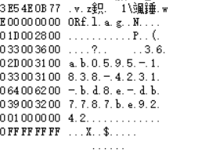

在资源中获取到，尝试进行提交，flag 正确

