Stampede
project plan
general
student's name: WU Yiyou
student number: 101731278
degree program: computational engineering (english bachelor)
year of studies: first year
date: 05 / 02 / 2024
General description
I plan to complete the project on the difficult level, that is, to create a program that simulate a rushing situation where all individuals in a room want to leave the room through its only small door at the same time and as quickly as possible.
And their behavior obeys the following rules:
1. Seek. all the members in the room are always adjusting there velocity to get through a fixed position( where the door is), they won’t slow down in front of the door(different from “arrive” which will stop right before the destination)
2. Brake. A member in the room can detect other individual in front of them and their speed, they will slow down if the other individual is slower than themselves.
3. Avoidance. Members in the room avoid walls. When a wall is present in the front of an individual within certain distance, a steering force will be applied to avoid collision
4. Separation. A member in the room can detect others in a nearby area, and depending on the distance between them, a combined force will be applied to steer it away from them.
Combination of those behavioral mode
1. linear combination: linearly combine the (weighted) steering force vector together.
2. assign priority: decide the most important action of the moment, and calculate the steering force of that action, then do some other calculations to decide to what extent the next force should be applied.(or omit them all at once)
which combination to implement is yet to be decided.

Functionality
1. to simulate in real time a reasonable number of members in the room that move within the room following the description above.
2. to present the motions of the members in 2d/3d graphics.
3. to read the beginning positions of all the members from a file when launching the program, and save the position data into a file( create a save) when the users exit the program or when they choose to save the program.
4. to allow user to change the size of the map, the door, and the parameters of the motion in the GUI intuitively.
For example, users can choose to save the positions and parameters into a file before exiting and to load that file the next time they start the program.
Users can also adjust some of the parameters in the simulation in real time. They can, for instance, adjust the maximum force that are allowed to be applied to the individual by entering a new number or dragging the marker on a slider.
Draft user interface

After launching the program, the user will enter the main menu.
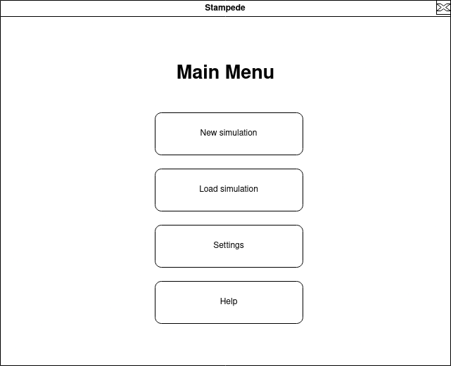
Help here contains a brief manual of the program.
Users can change the value of parameters in the Settings.

After the simulation starts, users can adjust the some parameters at the bottom left corner of the window with sliders. They should also be able to adjust them by clicking on the tab “setting” on the task bar on the top of the window.
There will be a save bottom in the task bar to enable saving during the simulation.
When trying to close the program, a pop up window will appear to ask if the user want to store the simulation in a save.

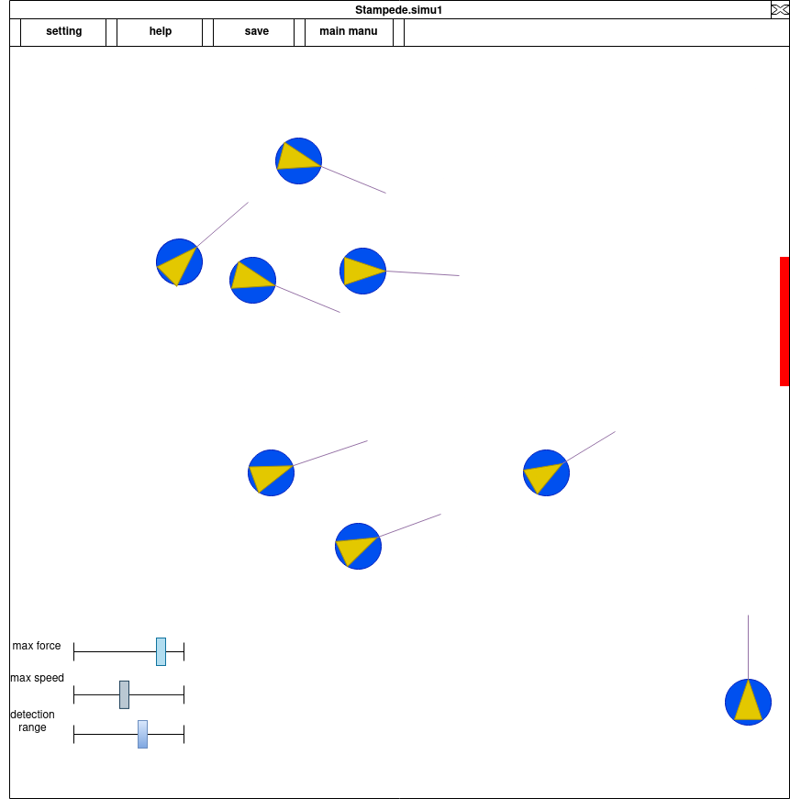
Note typo: manu to menu

File
to be elaborate
the position and parameter data will be stored in a file. And the program can read and create such files(load a save / create a save)
The format of file is .json

Errors:
Errors will mostly occur during the conflict between different behavioral mode.
To be continued.

