Detecting Coordinated Campaigns: Semantic Clustering and Temporal Analysis (Bursts)
Cotea Carla, Ginghină Mihai, Hriscu Cosmin, Picioroagă Alexandru, Smău Robert

Abstract: This project presents a robust pipeline for detecting coordinated information campaigns within continuous text streams by combining semantic similarity with temporal analysis. Utilizing the RoLargeSum dataset and timestamped social data, the initial phase focuses on preprocessing the corpus to clean the raw input and apply proper tokenization for downstream modeling. Rather than relying on exact deduplication, we leverage multilingual Sentence-BERT embeddings to capture deep semantic meaning, successfully grouping messages that share identical narratives despite varied phrasing.
To handle this data at scale, the dense vectors are indexed via FAISS for rapid nearest-neighbor retrieval. We then apply HDBSCAN clustering to automatically identify dense semantic communities without predefining the number of clusters. To establish coordination, we construct a discrete time series for each semantic cluster and apply the Kleinberg model to calculate temporal burst scores, formally identifying unnatural spikes in activity. By unifying semantic cohesion with temporal synchronization, this methodology reliably isolates highly suspicious clusters, providing a scalable unsupervised foundation that can directly inform the downstream classification of coordinated inauthentic behavior.

Keywords: tokenization; classification; coordinated campaigns; semantic embeddings; burst detection; HDBSCAN clustering; temporal analysis

- Opening remark
The resource we had on our hands (RoLargeSum) had a limited number of data entries (about 600k articles) spread across 16 years. Initially, we attempted to group the articles in smaller clusters to compensate for this issue but this resulted in really high noise rates within the clusters. Eventually we decided to increase the cluster size which seems to have given better results despite a small loss of cohesion.
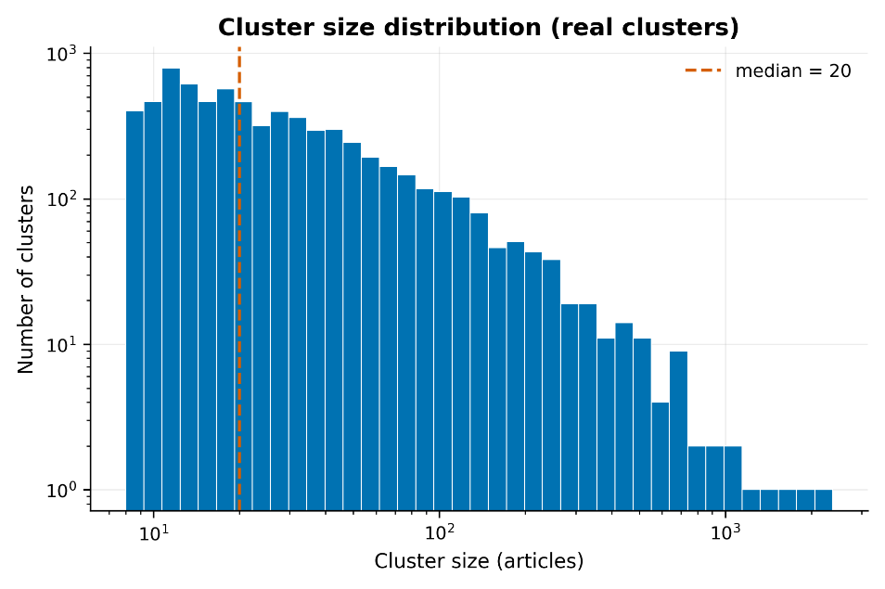
Fig. 1. the final cluster sizes
- Top campaigns
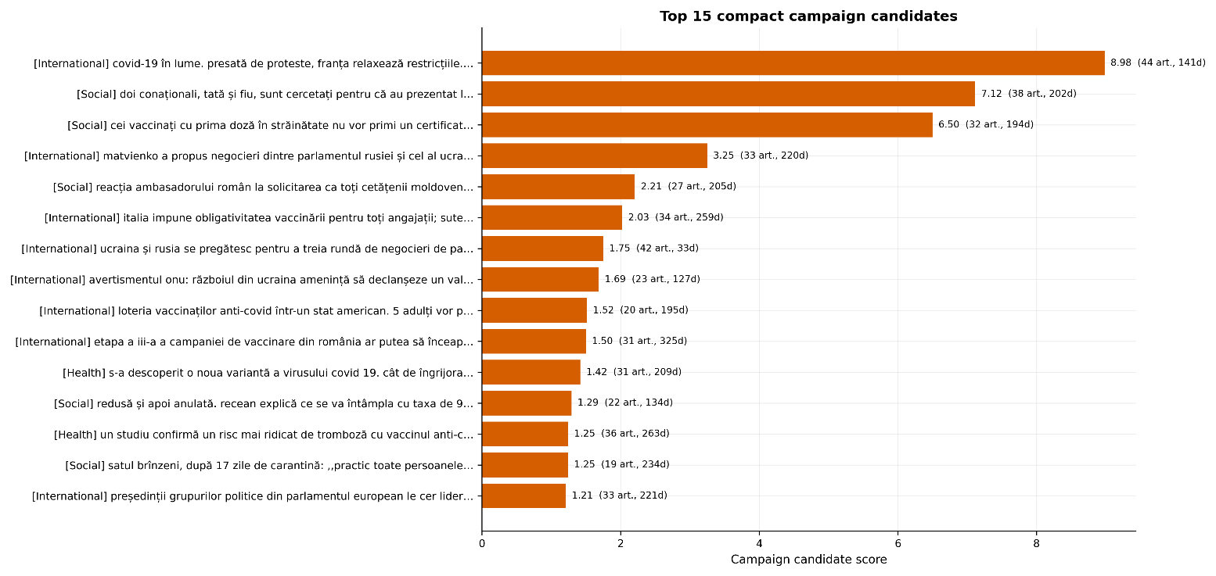
Fig. 2. top coordinated campaigns candidates scored by a multitude of criteria
- Global evolution of COVID-19 and the spread of Delta variants
Period: 27 active days
Articles regarding the pandemic situation worldwide, focusing on France relaxing restrictions amid protests, the alarming surge of cases in Turkey, and the dominance of the Delta and Delta Plus variants in the UK and Moscow.
- Investigation of forged COVID-19 vaccination certificates at the border
Period: 23 active days
News about Moldovan citizens, including a father and son, being investigated for presenting fake vaccination certificates or COVID tests at border crossings, alongside government warnings regarding the impact of these forgeries on international travel.
- International recognition and management of Moldovan vaccination certificates
Period: 17 active days
Articles regarding the mutual recognition of COVID-19 certificates between Moldova and other nations (such as Georgia), the potential for EU recognition, and regulations for citizens who received their first dose abroad.
- Peace negotiations between the Russian Federation and Ukraine
Period: 21 active days
A collection of articles covering various rounds of negotiations between Ukraine and Russia, including statements from presidential advisors and proposals for diplomatic dialogue between the two parliaments.
- Support from Romania for the vaccination of Moldovan citizens
Period: 17 active days
Articles describing the reactions and official statements regarding Romania's vaccine donations to the Republic of Moldova and the eligibility of Moldovan citizens to travel across the border to receive their vaccinations.
- Important graphs
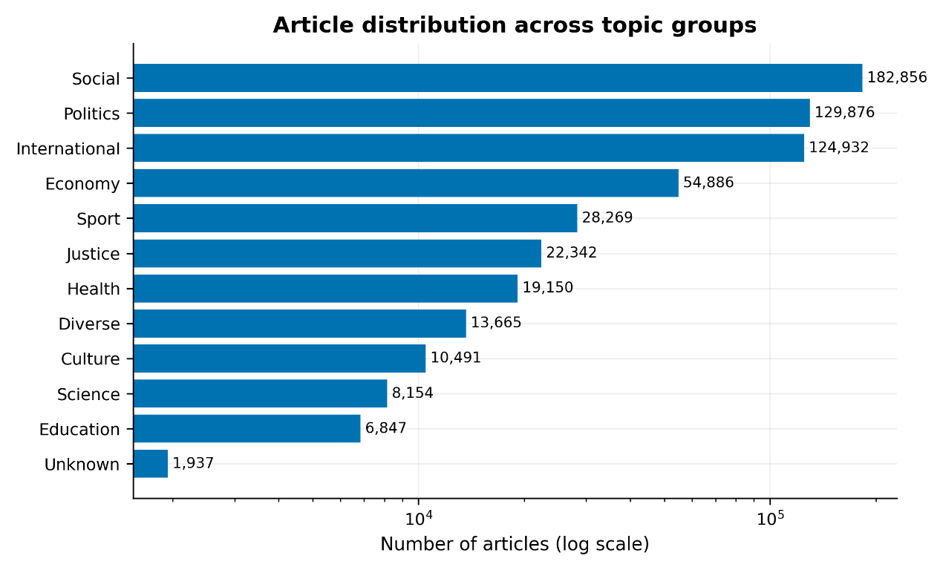
Fig. 3. The distribution of articles across topic groups
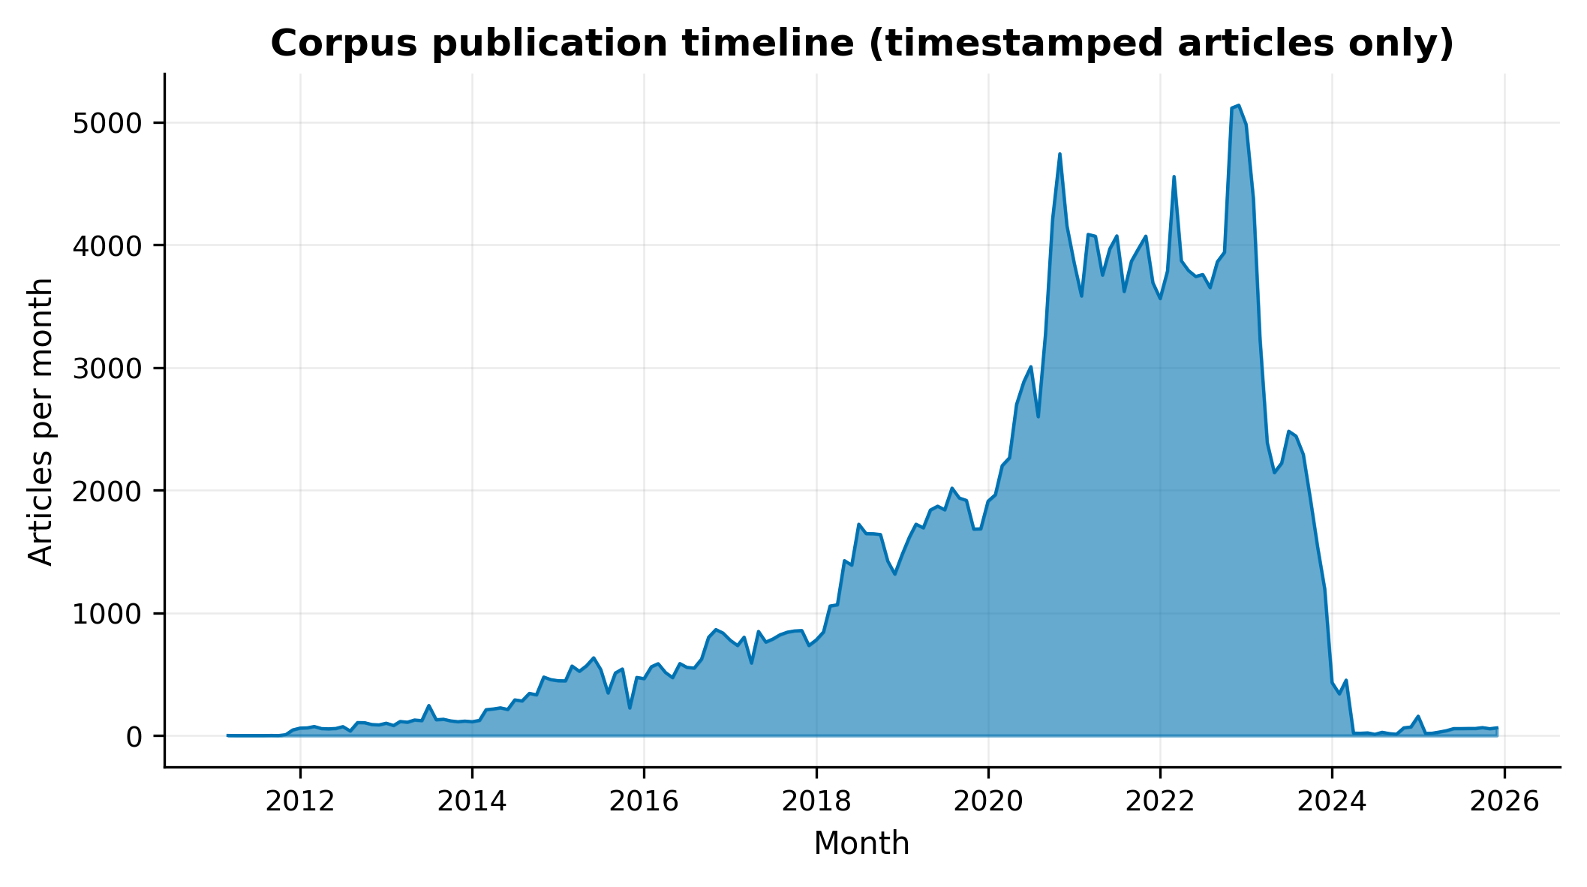
Fig. 4. The distribution of timestamped articles over the years
Shows the dataset spans many years with non-uniform density — useful to motivate the topic-first clustering and to caveat any temporal interpretation.
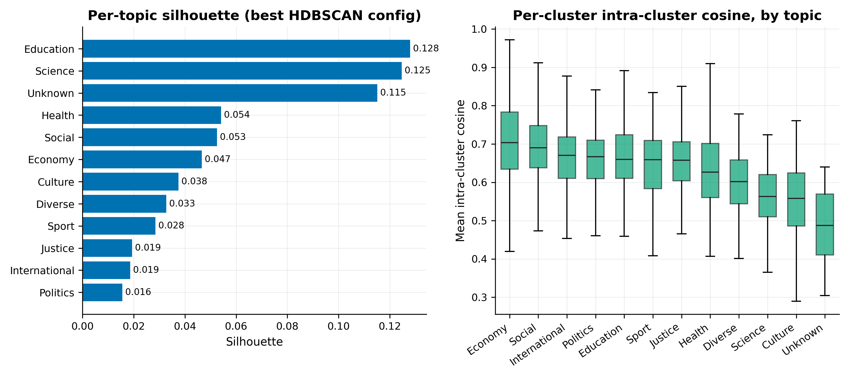
Fig. 5. (left) Silhouette score per topic (right) intra-cluster cosine by topic
The higher (closer to 1) silhouette score the clearer and more separated a topic is. The lower (closer to 0) the score is, it signifies that the topic overlaps with others. As can be seen most of these topics overlap hence the overall low scores.
The higher the intra-cluster cosine shows how similar the articles belonging to the same topic are amongst themselves.
From these two graphs we can obtain useful data, for example the articles belonging to the Economy topic are very similar amongst themselves (high intra-cluster cosine) but also pretty similar with articles regarding other topics (low silhouette score).
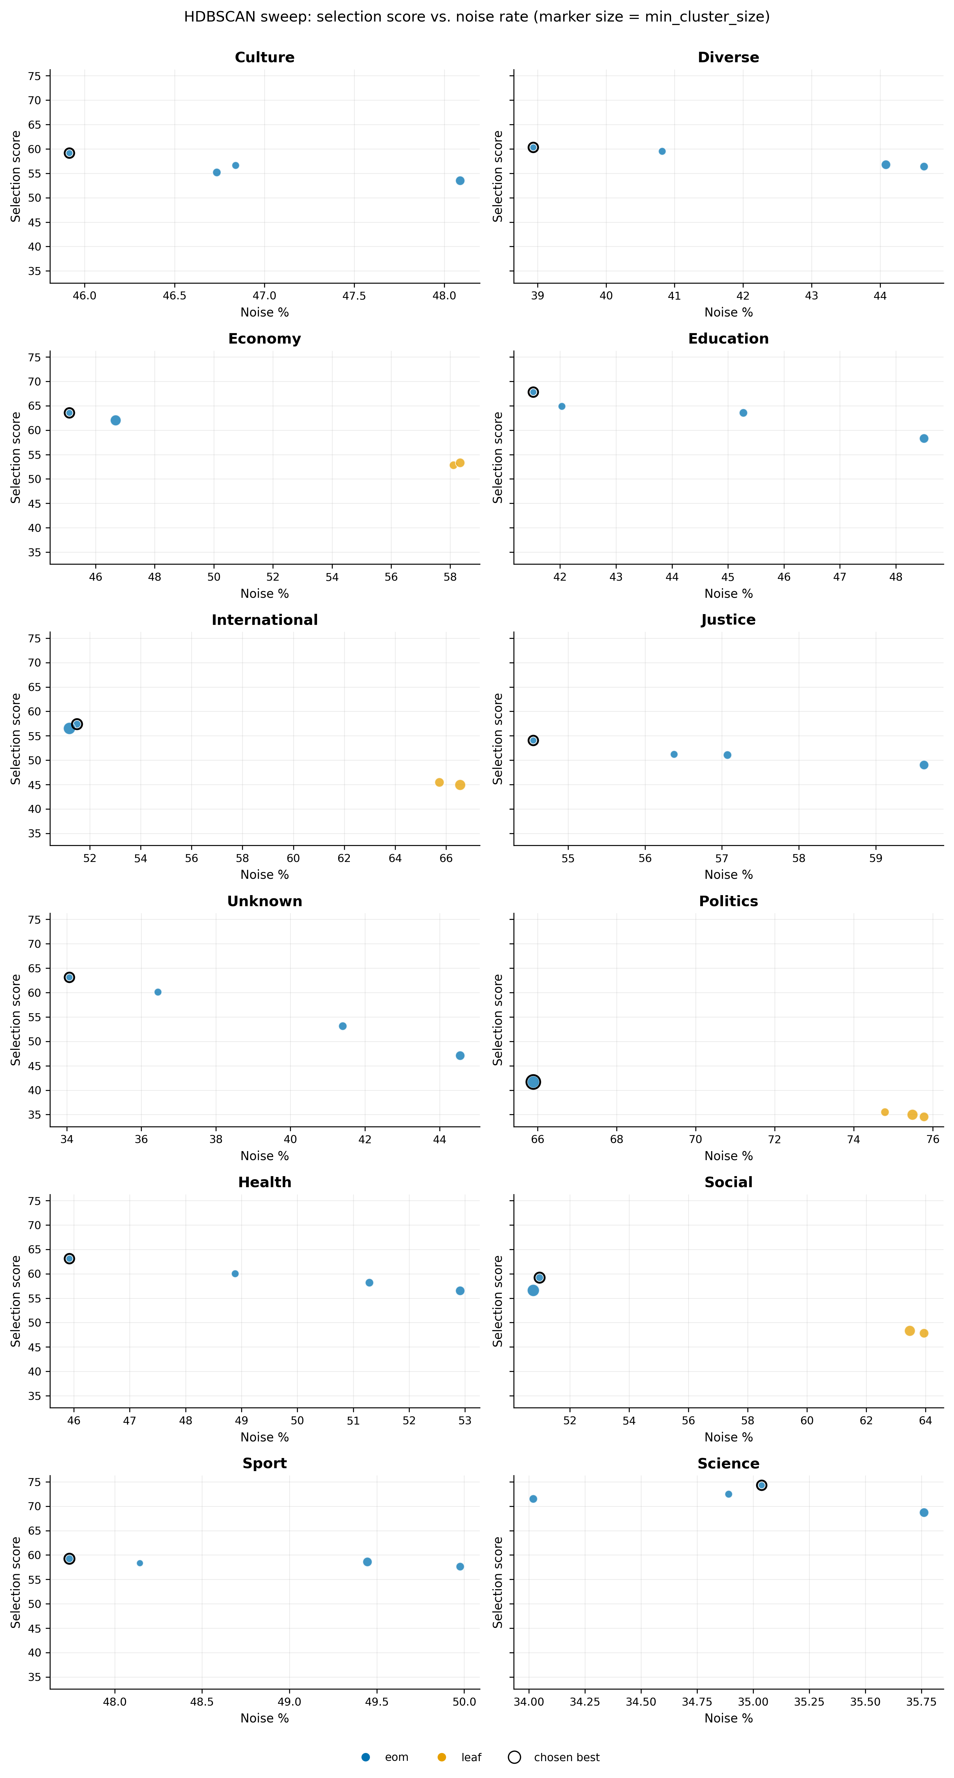
Fig. 6. Different configurations of parameters and how well the performed for each topic
We want a configuration with low noise (left) and a high score (top)
The configurations were obtained through the methods eom (excess of mass – HDBSCAN standard) and leaf (tries to find smaller clusters)
One panel per topic:
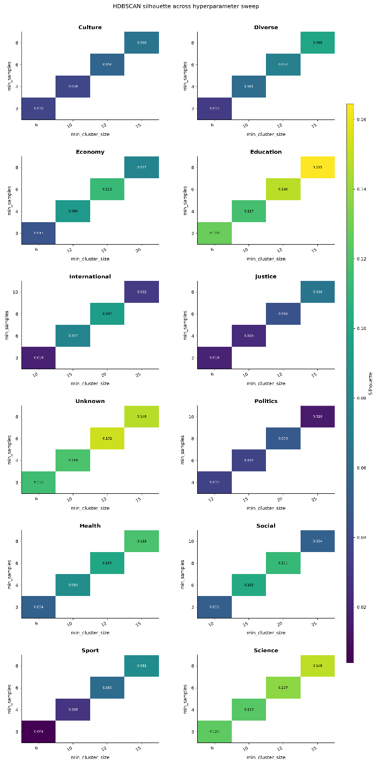
each dot is one (`min_cluster_size`, `min_samples`, `cluster_selection_method`) configuration. Marker size encodes `min_cluster_size`, color encodes selection method (eom/leaf), and the chosen best config is ringed in black. Shows there is a genuine tradeoff between noise rate and the composite selection score — the best config is never at a noise extreme.
Fig. 7. Some other configurations of parameters and how well the performed for each topic by other criteria
Per-topic heatmap of silhouette score across `min_cluster_size` × `min_samples`.
Smaller topics (Education, Science) have only a handful of cells; the sweep grid is denser for
the four big topics. The heatmap makes it visually obvious which corner of the grid HDBSCAN prefers and that the chosen config sits in or near the high-silhouette region.
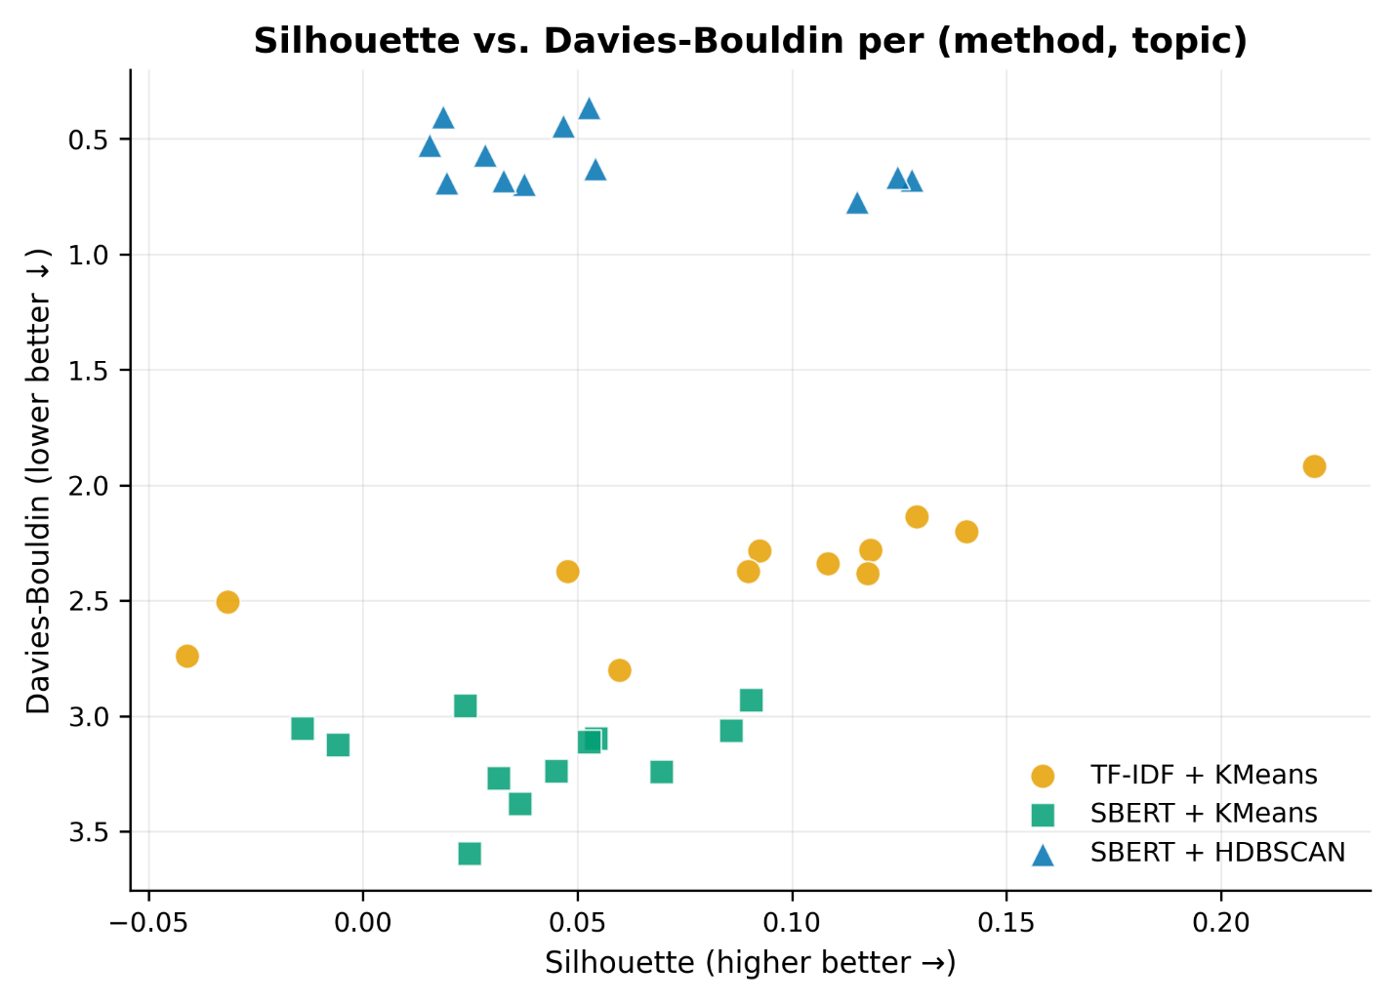
Fig. 8. Comparison of using different methods on the data we had and their performance
Here we have the results of using different methods to process the data using TF-IDF (a statistical method) and SBERT (deep learning model based on transformers) for all the topics.
As can be observed there are at least three topics where SBERT+HDBSCAN is clearly better and for the other topics we can choose which method to use depending on which criteria we value more: the DB or silhouette scores.
- Other remarks
The resource did not provide any timestamps to the articles, so we had to obtain them ourselves. At first, we tried to get them from the metadata of the articles but only around 13% of them had this kind of information. Using the htmldate library we managed to get a timestamp for 83% of the entries.
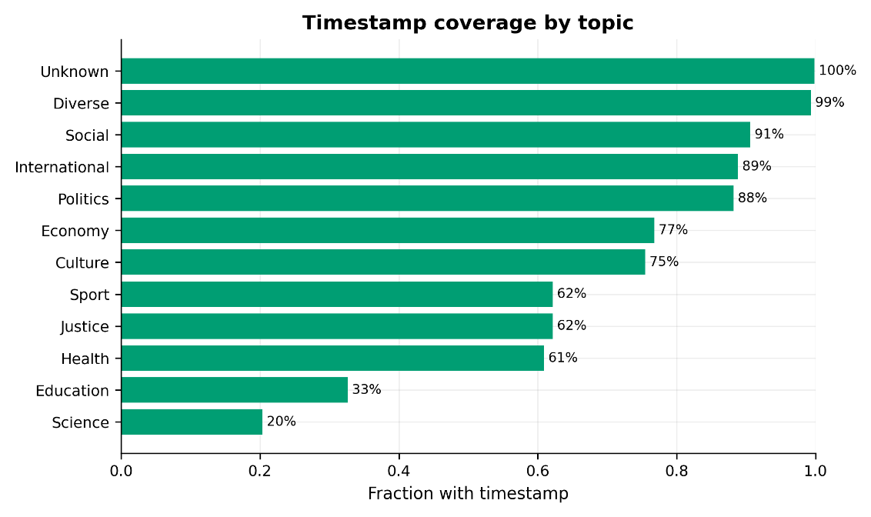
Fig. 9. Timestamp coverage by topic
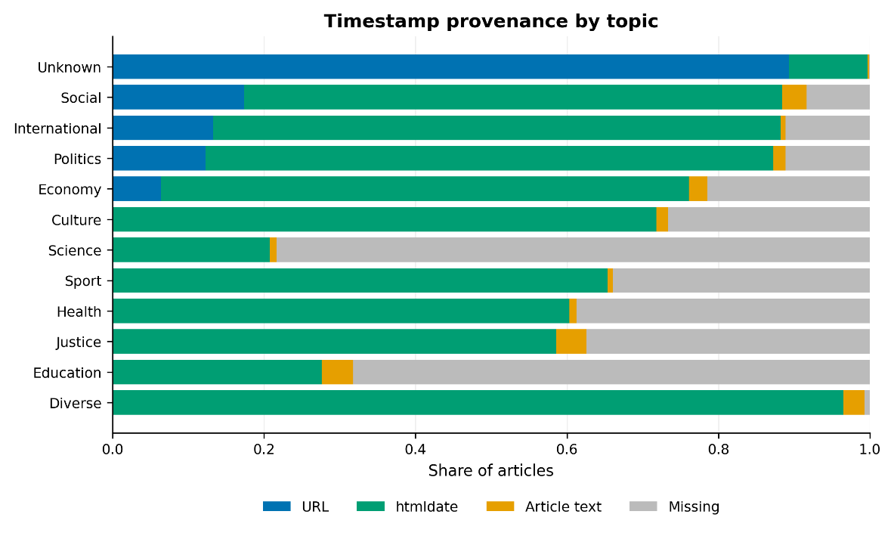
Fig. 10. Timestamp provenance by topic

