Specified requirement

1. C1, C2, C4, C5, C6, C7, C8, C9, C10

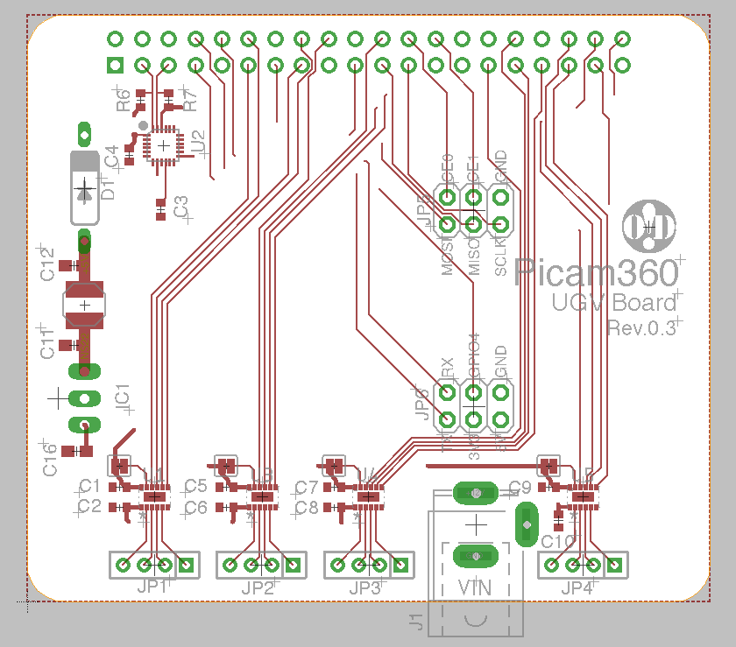

C10

C9

C8

C7

C6

C5

C4

C2

C1

2.R6, R7



R7

R6

3. C16



C16

4. C3



C3

5. C11, C12



C11

C12

6. U1, U3, U4, U5



U5

1

U4

1

1

U3

1

U1

7. L1



L1

5L1