KNUTSFORD UNIVERSITY
FACULTY OF COMPUTING & DATA SCIENCE
NFC-BASED STUDENT PERMIT VERIFICATION AND GOVERNANCE MANAGEMENT SYSTEM FOR KNUTSFORD UNIVERSITY
Rahim Daud
Kwuatsenu Divine
M'Bangot-Menard Naeem Latif
[INSERT MONTH AND YEAR]

KNUTSFORD UNIVERSITY
NFC-BASED STUDENT PERMIT VERIFICATION AND GOVERNANCE MANAGEMENT SYSTEM FOR KNUTSFORD UNIVERSITY
BY Rahim Daud (26102859); Kwuatsenu Divine (26102924); M'Bangot-Menard Naeem Latif (26102931)
department of computer science, faculty of computing & data science, knutsford university in partial fulfilment of the requirements for the award of the degree of bachelor of science in computer science
[INSERT MONTH AND YEAR]

DECLARATION
I hereby declare that this project is the result of my own original research and that no part of it has been presented for another degree in this university or elsewhere.
Candidate's signature: ______________________________
Date: ___________________________________
Name: Rahim Daud
Index Number: 26102859
I hereby declare that this project is the result of my own original research and that no part of it has been presented for another degree in this university or elsewhere.
Candidate's signature: ______________________________
Date: ___________________________________
Name: Kwuatsenu Divine
Index Number: 26102924
I hereby declare that this project is the result of my own original research and that no part of it has been presented for another degree in this university or elsewhere.
Candidate's signature: ______________________________
Date: ___________________________________
Name: M'Bangot-Menard Naeem Latif
Index Number: 26102931

SUPERVISOR'S DECLARATION
I hereby declare that the preparation and presentation of the project were supervised in accordance with the guidelines on supervision of project laid down by Knutsford University.
Supervisor's signature: ______________________________
Date: ___________________________________
Name: [INSERT SUPERVISOR NAME]

DEDICATION
To our families and supervisors.

ACKNOWLEDGEMENT
[INSERT ACKNOWLEDGEMENTS]

ABSTRACT
Manual student governance processes at Knutsford University create delays, weak auditability, and unreliable permit verification. This project designed and implemented an NFC-based student permit verification and governance management system that centralizes permit management, Paystack payment verification, NFC-assisted identity checks, election voting, public communication, audit logging, and mobile access. The solution uses a Laravel backend, a React and Inertia.js operations dashboard, a public portal, an Expo React Native mobile application, a Sanctum-protected mobile API, PostgreSQL, queues, and role-based access control. Self-service permit requests are linked to server-side payment confirmation. Verification supports NFC cards with student number and permit code fallbacks. Election voting applies eligibility checks and duplicate-vote prevention. Testing covered authentication, permits, payments, NFC lifecycle, elections, mobile API access, and authorization. The system provides a practical foundation for improving SRC operations subject to deployment readiness, user training, and policy alignment.

TABLE OF CONTENTS

LIST OF TABLES
[UPDATE LIST OF TABLES IN MICROSOFT WORD — USE TABLE AND PAGE COLUMNS]

LIST OF FIGURES
[UPDATE LIST OF FIGURES IN MICROSOFT WORD — USE FIGURE AND PAGE COLUMNS]

CHAPTER ONE — INTRODUCTION

1.1 Background to the Study
Student governance at universities depends on reliable identification, permit issuance, payment confirmation, elections, and public communication. When these activities are handled manually or through disconnected tools, verification becomes slow, records are difficult to audit, and students receive inconsistent information. The Students' Representative Council (SRC) at Knutsford University coordinates permits, events, elections, and student-facing services that require accurate records and accountable workflows.
Digital governance platforms address this problem by linking student records, user accounts, permits, payments, and verification events in one system. Mobile access allows students to request permits, view status, and participate in elections without visiting offices repeatedly. Near Field Communication (NFC) supports faster permit verification when a registered card is presented to an authorized device. Digital payment integration through Paystack allows self-service permit requests while server-side verification confirms successful transactions before issuance.
This study develops a centralized NFC-based student permit verification and governance management system for Knutsford University. The platform connects an operations dashboard, public portal, and mobile application to shared backend rules for authentication, permits, payments, NFC verification, elections, audit logging, and reporting.

1.2 Statement of the Problem
SRC operations currently face fragmentation across manual permit checks, informal payment confirmation, separate communication channels, and limited election controls. Permit fraud and impersonation are possible when verification depends on visual inspection alone. Payment disputes arise when receipts cannot be matched quickly to permit requests. Election integrity suffers when eligibility and vote records are not enforced systematically. Executives lack consolidated reports on permits, payments, verification attempts, and student account activation. The study addresses the need for a coordinated, secure, and auditable student governance platform.

1.3 Objectives of the Study
The purpose of the study is to design and implement a centralized student governance platform for Knutsford University.
The specific objectives are to:
1. design an operations dashboard for students, permits, payments, content, elections, roles, and reports;
2. implement permit issuance, revocation, verification, and duplicate prevention;
3. integrate NFC-based verification with student number and permit code fallbacks;
4. provide self-service permit requests with Paystack payment verification;
5. develop a mobile application and API for student and staff workflows;
6. implement controlled election voting with candidate approval and eligibility checks;
7. publish governance content through a public portal;
8. record audit logs and operational reports for accountability;
9. enforce role-based access control across modules;
10. test authentication, permits, payments, NFC, elections, and API security.

1.4 Research Questions
1. How can a centralized platform improve permit management and reduce fragmentation in SRC operations?
2. How can NFC technology support faster and more reliable permit verification?
3. How can server-side payment verification reduce permit issuance errors?
4. How can mobile access improve student participation in governance services?
5. How can role-based access control and audit logging improve accountability?

1.5 Significance of the Study
The system benefits students through self-service permits and mobile access. SRC executives gain consolidated reporting and communication channels. Security and verification staff receive structured verification results. The university benefits from improved auditability and a reusable governance platform.

1.6 Scope of the Study
The study covers permit management, Paystack payment verification, NFC card registration and verification, election voting, public content, audit logging, reporting, and mobile API access for Knutsford University SRC operations. It does not replace the university's official student information system. Offline NFC verification and full production deployment are noted as future work.

1.7 Limitations of the Study
The evaluation used test data and controlled environments. NFC availability depends on compatible mobile hardware. Payment testing used Paystack test mode. Some literature sources require final verification before submission.

1.8 Organisation of the Study
Chapter Two reviews literature and related systems. Chapter Three presents system analysis and design. Chapter Four describes implementation and testing. Chapter Five summarizes findings, conclusions, and recommendations.

1.9 Definition of Terms
Permit — An SRC-issued authorization linked to a student and academic period. NFC card — A contactless card registered to a student for verification lookup. Operations dashboard — The authenticated web interface for SRC administrators. Mobile API — Sanctum-protected endpoints used by the mobile application. Public portal — The student-facing website for content and permit requests.

CHAPTER TWO — LITERATURE AND REVIEW OF RELATED SYSTEMS

2.1 Introduction
This chapter reviews concepts and related systems that support the proposed NFC-based student governance platform. It covers the theoretical framework, technological base, review of two similar systems, comparative analysis, and the state of the art linked to this study.

2.2 Theoretical Framework
Client-server architecture places business rules, authentication, and data storage on a central server while clients such as web dashboards, public portals, and mobile applications present information to users (Tanenbaum & Wetherall, 2011). The proposed system applies this model so all clients share the same permit, payment, and election rules.
Role-based access control (RBAC) limits actions according to assigned roles and permissions (Sandhu et al., 1996). The dashboard separates student, executive, staff, and administrator capabilities so sensitive actions such as permit issuance and candidate approval are restricted.
Digital identity verification requires matching presented identifiers to authoritative records without exposing unnecessary personal data. NFC provides a contactless identifier, but permit validity must still be confirmed on the server.
Figure 2.1 illustrates the conceptual client-server relationship between clients, backend services, database, queue workers, and Paystack.
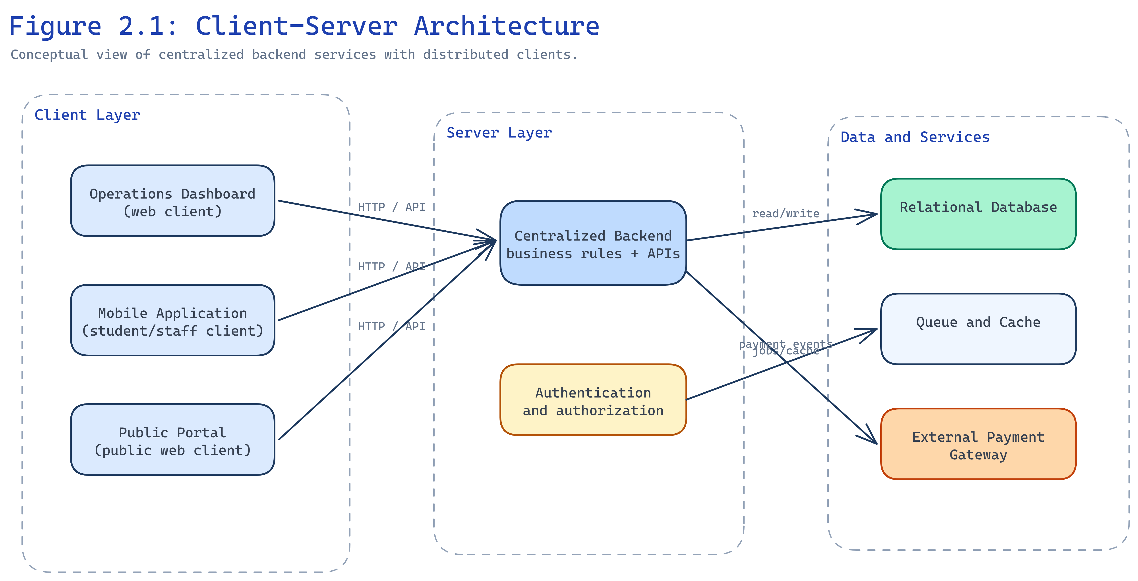
Figure 2.1: Client-Server Architecture

2.3 Technological Base
The backend uses Laravel for routing, validation, authorization, queues, and API resources. PostgreSQL stores relational governance data. React with Inertia.js delivers the operations dashboard. Expo React Native provides cross-platform mobile access. Laravel Sanctum issues bearer tokens for the mobile API. Paystack handles payment initialization and server-verified callbacks. Spatie Permission implements RBAC. Redis supports cache and queue drivers where configured.
Figure 2.4 presents the RBAC model used to separate administrative, staff, executive, and student responsibilities.
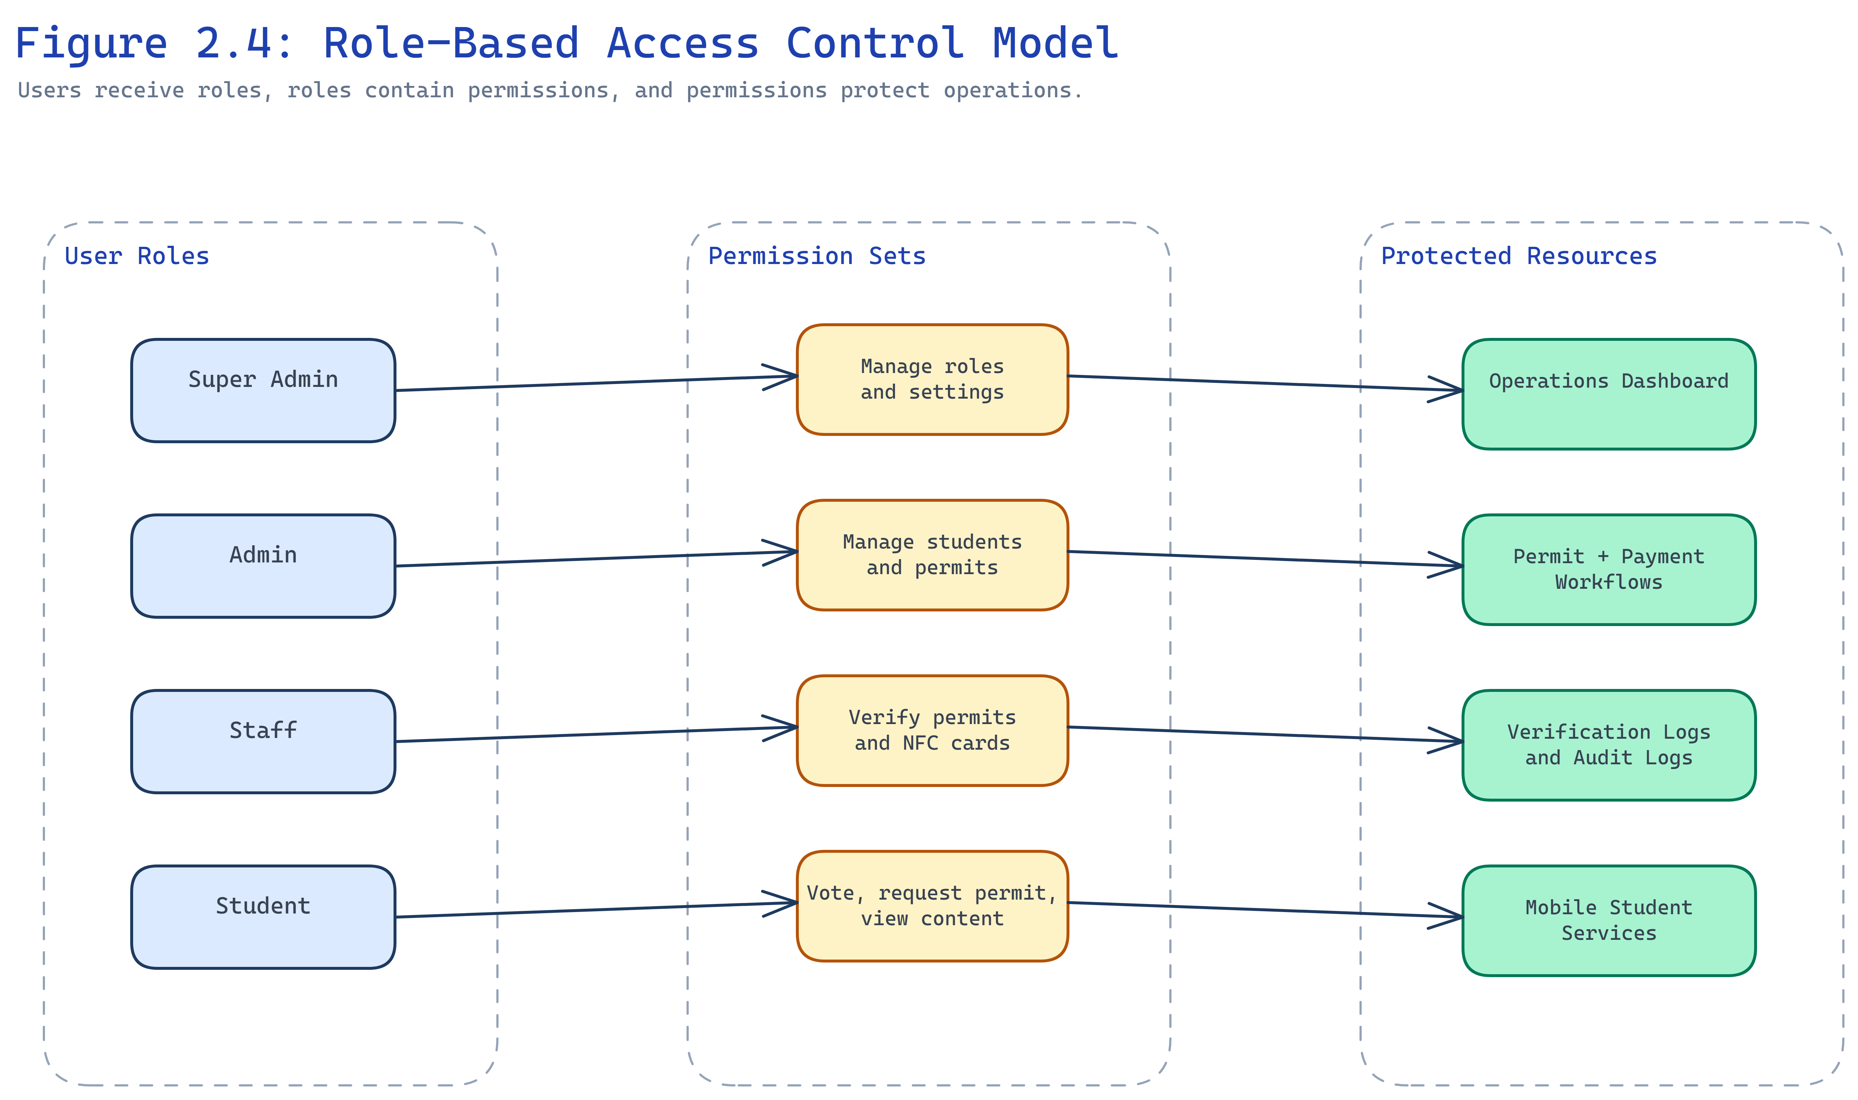
Figure 2.4: Role-Based Access Control Model

2.4 Review of Similar Systems

2.4.1 University of Ghana SRC e-Voting Platform
Several Ghanaian universities have adopted web-based SRC election platforms that allow students to authenticate and cast ballots online. Such systems typically provide candidate lists, position-based voting, and automated tallying. Strengths include convenience and faster result compilation than manual ballot counting. Limitations include weak integration with permit records, NFC verification, payment workflows, and broader governance reporting. Election data often exists separately from student service records.

2.4.2 KNUST Smart Attendance and NFC Campus Card Systems
Kwame Nkrumah University of Science and Technology and similar institutions have explored NFC and RFID attendance or access systems that read card identifiers and log presence events. These systems demonstrate fast contactless identification in campus settings. However, they usually focus on attendance or gate access rather than SRC permit lifecycle management, Paystack payment linkage, election voting, public communication, and audit logging for governance actions.

2.5 Comparative Analysis
Table 2.1 compares the reviewed systems with the proposed platform.
Feature | UG SRC e-Voting (typical) | KNUST NFC attendance (typical) | Proposed system
Permit management | Limited or absent | Limited or absent | Central module
Payment verification | Not integrated | Not integrated | Paystack server verification
NFC verification | Not supported | Supported for attendance | Supported for permit lookup
Election voting | Supported | Not supported | Supported with eligibility rules
Public portal | Election-focused | Not supported | Announcements, events, documents
Audit logging | Basic | Event logs | Governance action audit trail
Mobile access | Web voting | Reader devices / apps | Student and staff mobile API

Table 2.1: Comparative Analysis of Related Systems and the Proposed System

2.6 Electronic Voting and Payment Verification Concepts
Electronic voting systems improve convenience but require authentication, eligibility enforcement, immutable vote storage, and controlled result publication (ACE Electoral Knowledge Network, n.d.). The proposed election module applies these principles by binding votes to students, positions, and approved candidates rather than treating voting as an informal poll.
Payment gateways such as Paystack provide initialization, callback, and verification endpoints. Institutional systems should treat client redirects as insufficient proof of payment and should verify transactions server-side before completing permit requests (Paystack, n.d.). This reduces disputes when students present receipts that cannot be matched immediately to backend records.

2.7 Summary of Literature and State of the Art
Existing systems address parts of student governance—elections, attendance, or identity—but rarely combine permits, payments, NFC verification, elections, public communication, and reporting in one auditable platform. The proposed system fills this gap for Knutsford University SRC operations by integrating these workflows on a single Laravel backend with dashboard, portal, and mobile clients. Chapter Three translates these requirements into analysis and design for the implemented solution.

CHAPTER THREE — SYSTEM ANALYSIS AND DESIGN

3.1 Introduction
This chapter explains how the proposed system was analyzed and designed. It covers the existing manual processes, requirements of the proposed system, database and logic design, user interface design, and the test plan.

3.2 Analysis of the Existing System

3.2.1 Detailed Description of the Existing System
SRC permit and governance activities at Knutsford University have relied on manual forms, physical permit cards, paper payment receipts, notice boards, and informal messaging for announcements and elections. Verification officers check names against printed lists or inspect physical cards. Permit payments are confirmed manually before cards are issued. Elections may use paper lists or disconnected online tools without linkage to permit eligibility.

3.2.2 Challenges Associated with the Existing System
The manual approach causes slow verification during examinations and events, weak audit trails, payment mismatches, duplicate or altered permits, inconsistent public information, and election disputes when eligibility cannot be reconstructed afterward.

3.2.3 Detailed Definition of the Problem (System Request)
The institution requires a centralized platform where students, executives, and staff can manage permits, verify identity using NFC or fallback codes, confirm Paystack payments server-side, vote in controlled elections, publish official content, and review operational reports with role-based access and audit logs.

3.3 Analysis of the Proposed System

3.3.1 Requirements of the Proposed System

3.3.1.1 Functional and Non-Functional Requirements
Functional requirements include student and account management, permit issuance and revocation, permit request and payment workflows, NFC registration and verification, election setup and voting, public content management, audit logging, and reporting.
Non-functional requirements include secure authentication, authorization checks on every sensitive action, responsive web and mobile interfaces, queue-backed background jobs, data validation, and protection of sensitive identifiers such as hashed NFC UIDs.
Table 3.1 summarizes priority functional requirements.
ID | Requirement | Priority
FR-01 | Register and manage student records | High
FR-02 | Issue, revoke, and verify permits | High
FR-03 | Process permit requests with Paystack verification | High
FR-04 | Register NFC cards and verify by tap | High
FR-05 | Conduct elections with eligibility enforcement | High
FR-06 | Publish announcements, events, and documents | Medium
FR-07 | Record audit logs for sensitive actions | High
FR-08 | Generate operational reports | Medium

Table 3.1: Selected Functional Requirements

3.3.1.2 User Interface Requirements
The operations dashboard must support searchable tables, status badges, filters, and role-aware navigation. The public portal must present readable content and self-service permit request forms. The mobile application must provide clear permit status, payment progress, election screens, and staff verification views.

3.3.1.3 System Requirements (Hardware, Software, Platform)
Hardware: Web server, PostgreSQL database server, optional Redis, SSL termination, NFC-capable mobile devices for field verification.
Software: PHP 8.4, Laravel 13, Node.js build chain, Expo SDK, PostgreSQL 15+, Paystack account, queue worker processes.

3.4 Design and Architecture of the Proposed System

3.4.1 Database Design
The database stores students, users, roles, permissions, permits, permit requests, payments, NFC cards, elections, candidates, votes, content, and audit events. Figure 3.4 shows the entity relationship model.
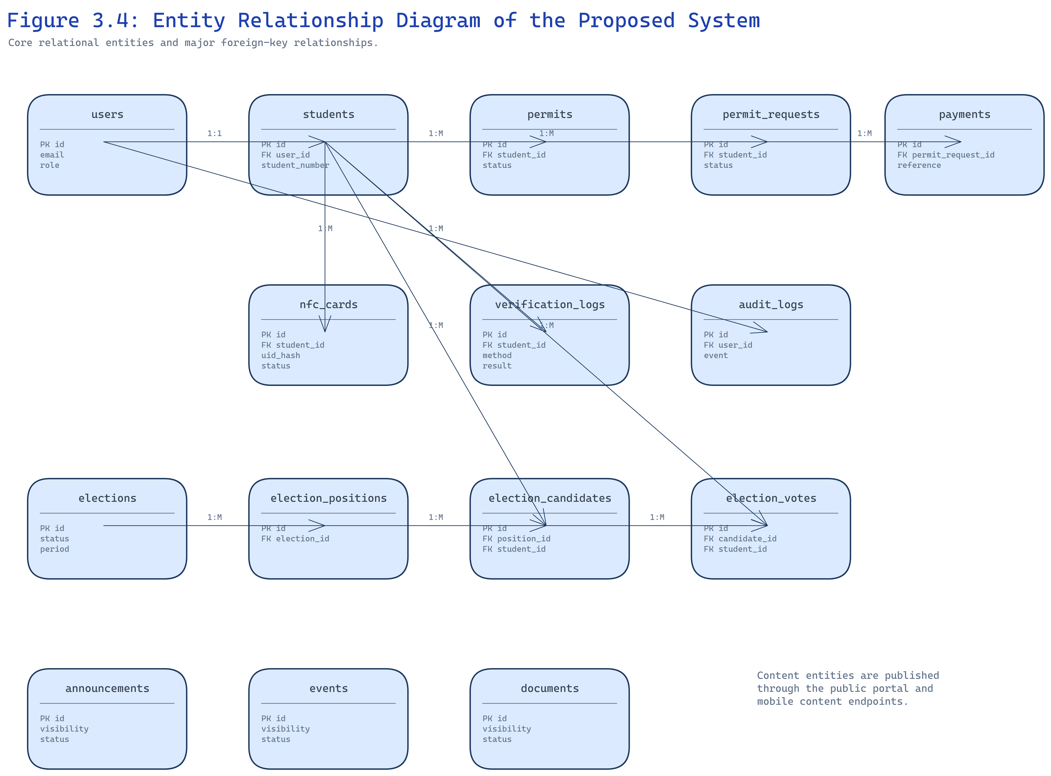
Figure 3.4: Entity Relationship Diagram of the Proposed System
Core relationships link students to permits and NFC cards, permit requests to payments, and elections to positions, candidates, and votes.

3.4.2 System Logic Design
Figure 3.2 presents the overall system architecture connecting the dashboard, public portal, mobile application, API layer, queues, cache, database, and Paystack.
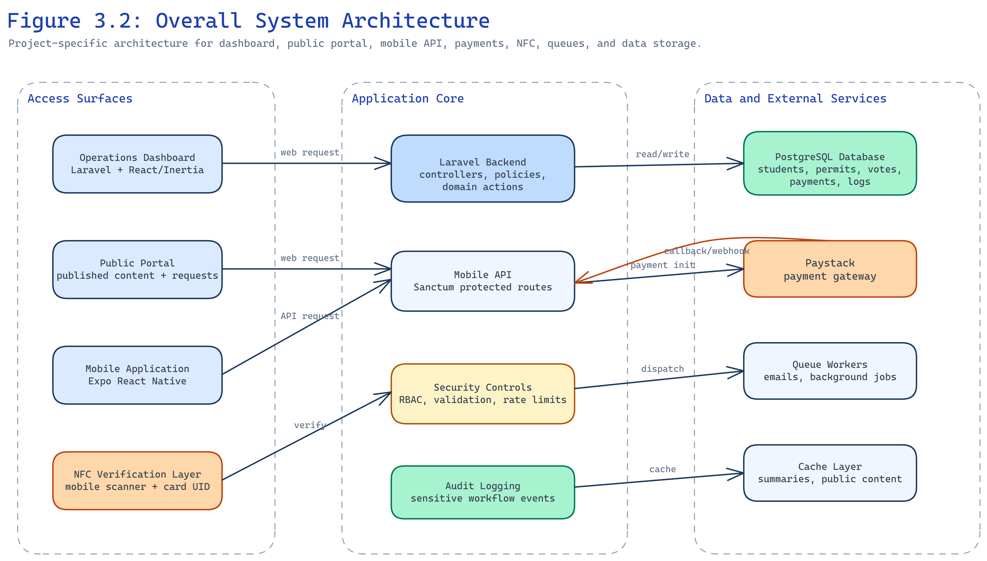
Figure 3.2: Overall System Architecture
Figure 3.5 shows the permit request and payment workflow from student submission through Paystack verification to permit issuance.
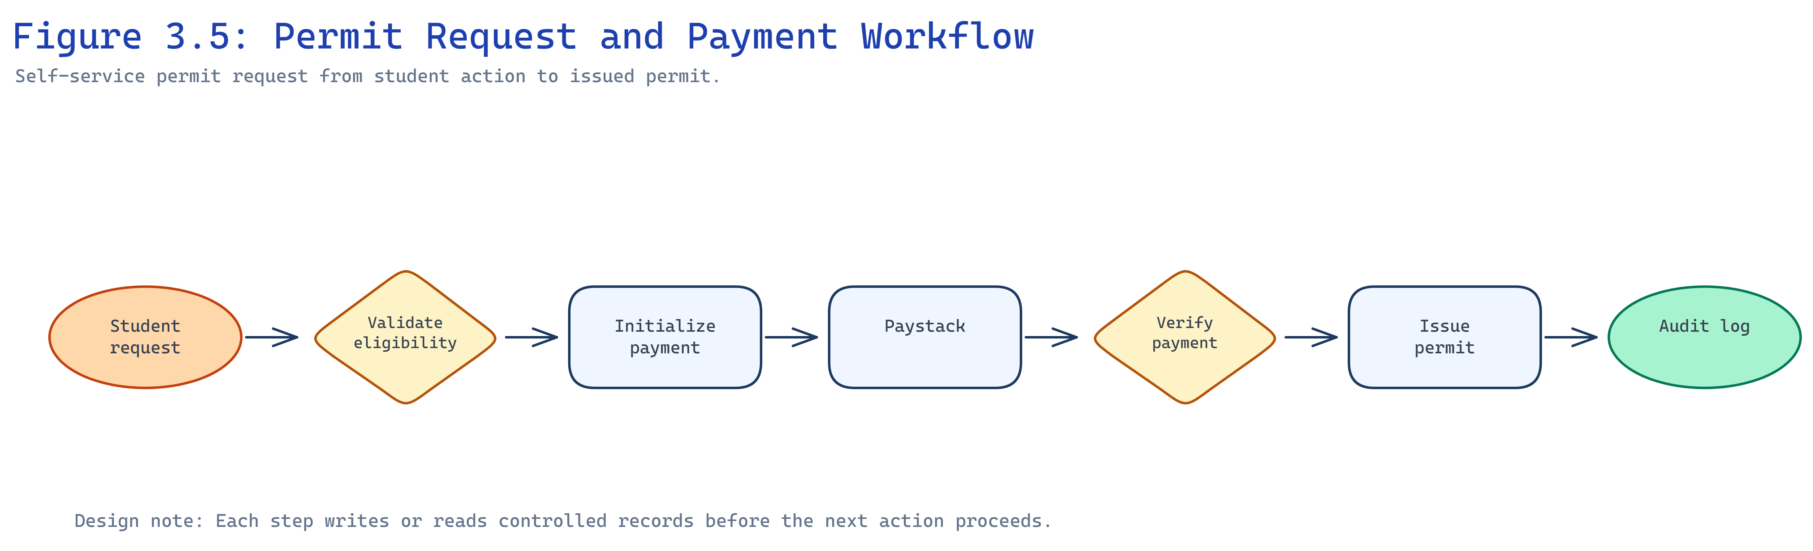
Figure 3.5: Permit Request and Payment Workflow
Figure 3.7 shows NFC verification from card tap through server lookup to permit status response and audit logging.
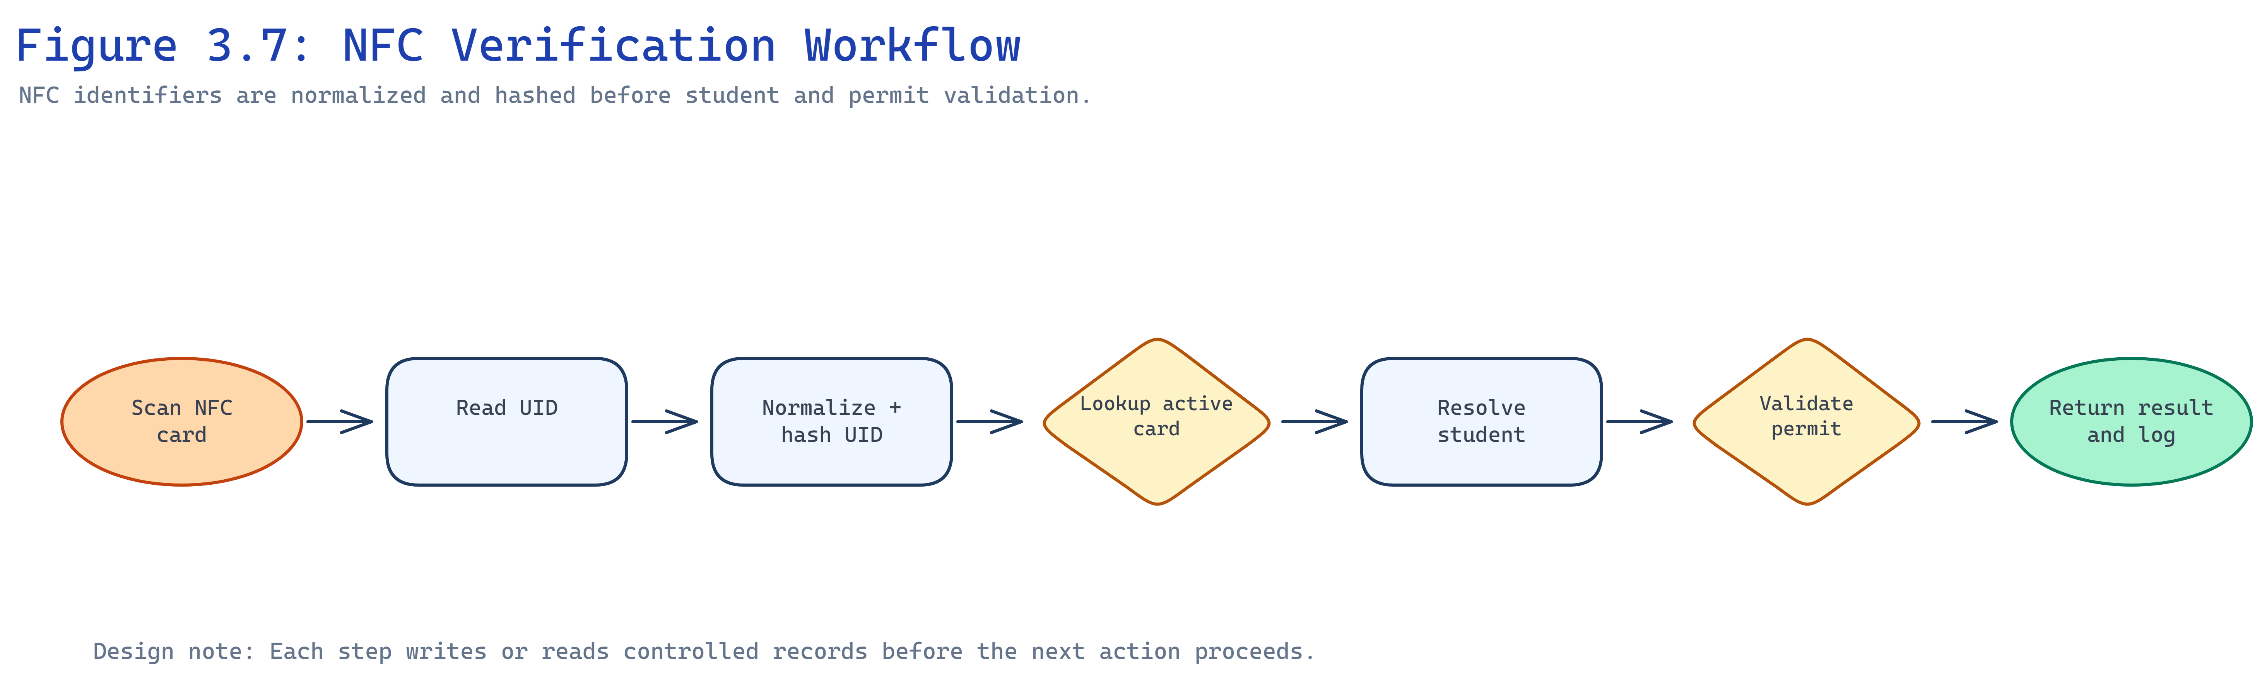
Figure 3.7: NFC Verification Workflow

3.4.3 User Interface Design
[INSERT FIGURE — Dashboard Wireframe or Student Management Screen]
Figure 3.15: Operations Dashboard Layout (placeholder)
The dashboard groups modules for students, permits, verification, elections, content, reports, and settings. The mobile application uses tab navigation for home, permits, elections, and profile. The public portal emphasizes announcements and permit request entry points.

3.4.4 System Test Plan
Testing will cover authentication, RBAC restrictions, permit lifecycle, Paystack callback handling, NFC registration and verification, election eligibility, mobile API tokens, and public content visibility. Feature tests use Pest; manual screenshots document user interface evidence in Chapter Four.

3.5 Security and Mobile API Design
Security design separates public routes, authenticated dashboard routes, and Sanctum-protected mobile routes. Sensitive actions such as permit issuance, payment recovery, NFC revocation, and candidate approval require both authentication and permission checks. The mobile API returns resource-oriented JSON responses and validation errors so the mobile client can display field-level messages.
Election voting applies stricter rules than informal polls: the backend confirms election window, approved candidate, linked student, active account, and permit eligibility before accepting a vote. Verification endpoints write audit records that include method (NFC, student number, or permit code), result, and acting user.

3.6 Queue, Cache, and Reporting Design
Queued jobs handle mail notifications, payment follow-up, and other asynchronous work so web requests remain responsive. Cache is applied selectively to reference data while permit validity and vote eligibility always query authoritative records. Reporting modules aggregate counts for permits nearing expiry, students without activated accounts, unpaid or stuck permit requests, and recent verification failures to support executive oversight.

CHAPTER FOUR — SYSTEM IMPLEMENTATION

4.1 Introduction
This chapter describes how the proposed system was implemented. It presents the programming languages and technologies used, development frameworks, coding evidence, testing results, and deployment documentation.

4.2 Programming Languages and Technologies Applied
PHP 8.4 implements server logic, validation, policies, and API resources. TypeScript and React build the Inertia dashboard and public-facing pages. TypeScript with Expo React Native implements the mobile client. SQL defines PostgreSQL schema through Laravel migrations. JavaScript supports Vite bundling and tooling.
PHP and Laravel were selected because the team required mature routing, ORM, queues, and API tooling in one framework. React and Inertia allow server-driven navigation with rich components without a separate SPA authentication layer. Expo reduces mobile build complexity for Android and iOS targets.

4.3 Frameworks and Development Platforms/Tools
Layer | Technology | Role
Backend | Laravel 13, Fortify, Sanctum | Web auth, mobile tokens, domain logic
Frontend | React 19, Inertia v3, Tailwind CSS v4 | Dashboard and portal UI
Mobile | Expo React Native | Student and staff mobile client
Database | PostgreSQL | Persistent storage
Payments | Paystack API | Initialization and verification
Authorization | Spatie Permission | RBAC
Testing | Pest 4 | Feature and unit tests
Build | Vite, Wayfinder | Asset bundling and typed routes

Development used Laravel Herd for local hosting, Git for version control, and PNPM for frontend dependencies.

4.4 Coding Evidence
The backend organizes domain logic into models, policies, form requests, and controllers. Mobile routes are grouped under routes/api.php with Sanctum middleware. Permit payment verification runs in dedicated action classes that validate Paystack references before completing requests.
// Illustrative pattern: server-side payment verification before permit completion
$payment = Paystack::verify($reference);
if ($payment->isSuccessful()) {
$permitRequest->markPaid($payment);
}
NFC UIDs are normalized and hashed before storage so raw identifiers are not kept in plain text. Election votes are stored with constraints preventing duplicate votes per student and position.
[INSERT FIGURE — Login Interface]
Figure 4.1: Login Interface
[INSERT FIGURE — Student Management Dashboard]
Figure 4.2: Student Management Dashboard
[INSERT FIGURE — Permit Management Screen]
Figure 4.3: Permit Management Screen
[INSERT FIGURE — NFC Verification Screen]
Figure 4.4: NFC Verification Screen
Figure 4.5 shows the permit verification workflow connecting NFC, student number, and permit code paths.
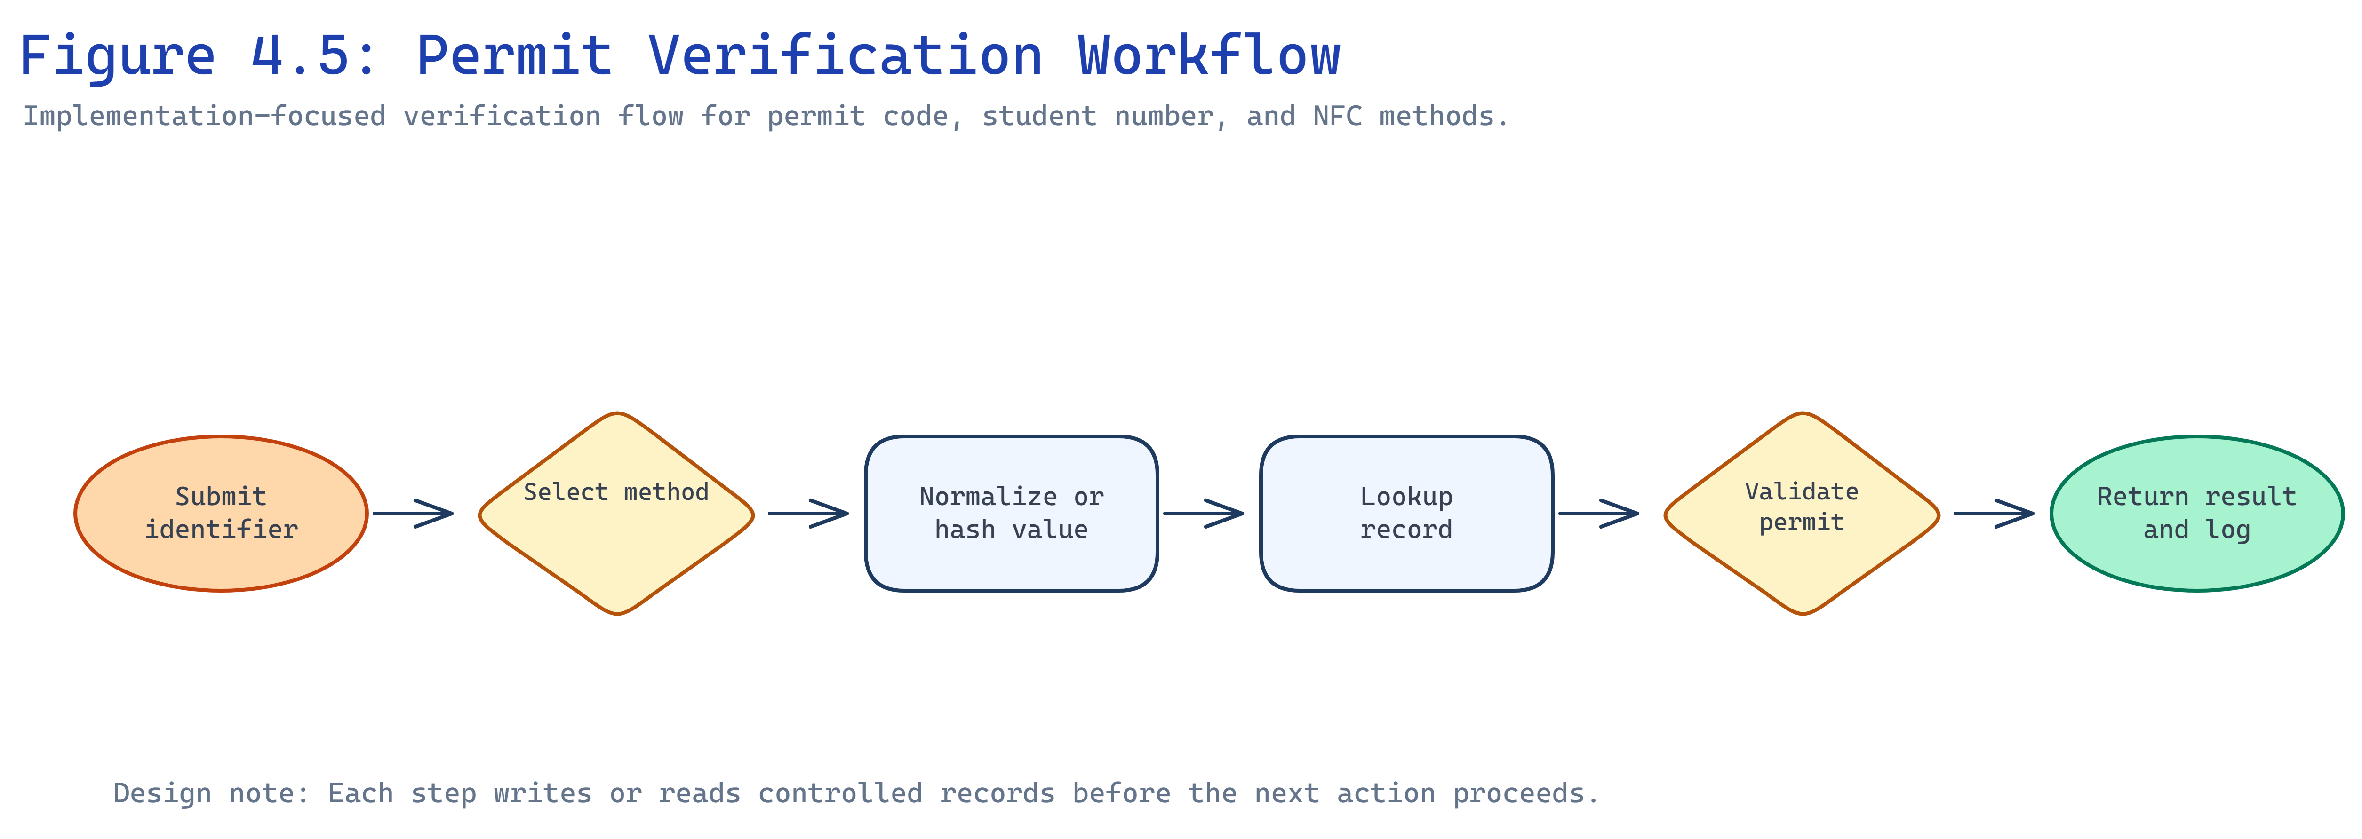
Figure 4.5: Permit Verification Workflow
[INSERT FIGURE — Election Dashboard]
Figure 4.6: Election Dashboard
[INSERT FIGURE — Mobile Voting Screen]
Figure 4.7: Mobile Voting Screen
[INSERT FIGURE — Student Home Screen]
Figure 4.8: Student Home Screen (Mobile)

4.5 Testing Results and Evidence
Automated tests cover authentication, permit issuance rules, payment recovery, NFC lifecycle, election constraints, and API authorization. Table 4.1 summarizes selected results.
Module | Tests executed | Outcome
Authentication | Login, 2FA, password setup | Passed
Permits | Issue, revoke, verify | Passed
Payments | Callback verification, recovery | Passed
NFC | Register, verify, revoke card | Passed
Elections | Eligibility, duplicate vote prevention | Passed
Mobile API | Token access, student scoping | Passed
Authorization | Role and permission restrictions | Passed

Table 4.1: System Testing Results Summary
[INSERT FIGURE — Audit Logs Dashboard]
Figure 4.9: Audit Logs Dashboard (optional evidence)

4.6 Deployment and User/System Documentation
Figure 4.10 outlines deployment architecture with web server, database, queue workers, scheduler, and SSL.
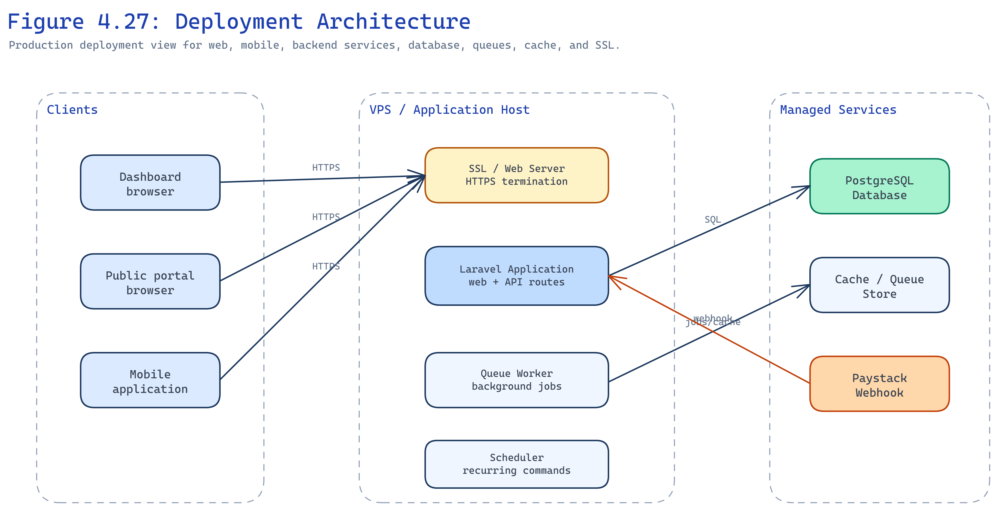
Figure 4.10: Deployment Architecture
User documentation: Students use the mobile app or public portal for permits and elections. Staff use dashboard verification and permit modules. Executives publish content and review reports.
System documentation: Environment variables configure database, Paystack keys, queue connection, and mail. Queue workers process notifications; the scheduler runs php artisan schedule:run via cron. Production requires HTTPS, backups, and masked test data in screenshots.
Administrator setup: Create roles and permissions, import or register students, configure permit types and fees, register NFC cards, and open election windows with approved candidates.

4.7 Backend Module Implementation Summary
The student module supports registration fields, account activation links, and linkage between user accounts and student records. The permit module manages permit types, issuance, revocation, duplicate checks, and verification responses. The permit request module exposes public and mobile creation endpoints, initializes Paystack transactions, and completes requests only after verified payment or authorized recovery.
The NFC module registers cards, stores hashed identifiers, supports replacement and revocation, and exposes verification to dashboard and mobile staff tools. The election module manages positions, candidates, approvals, voting windows, and result visibility. The content module publishes announcements, events, documents, and executive profiles to the public portal. The audit and reports modules record sensitive events and surface operational summaries for administrators.

4.8 Mobile Application Implementation
The Expo application provides authentication, student home, permit list and request flows, election browsing and voting, profile access, and staff verification screens where permitted. API calls attach Sanctum tokens and handle 401 responses by redirecting to login. NFC scanning is invoked only on supported devices; fallback entry uses student number or permit code through the same backend verification service.

4.9 Challenges Encountered
Integration between Paystack callbacks, queue workers, and permit state required careful ordering to avoid duplicate completion. NFC UID normalization across device vendors required consistent uppercase hex handling before hashing. Election testing needed realistic position and candidate seed data to validate eligibility paths. These issues were resolved through feature tests and manual verification using anonymized test records.

CHAPTER FIVE — SUMMARY, CONCLUSIONS AND RECOMMENDATIONS

5.1 Summary
This study addressed fragmented SRC governance at Knutsford University by designing and implementing an NFC-based student permit verification and governance management system. The methodology combined requirements analysis, object-oriented design, Laravel implementation, mobile API development, and Pest feature testing.
The system delivers an operations dashboard, public portal, and Expo mobile application connected to a shared Laravel backend. Key findings from implementation and testing include successful permit issuance and verification, Paystack payment confirmation before completion, NFC registration with hashed identifiers, election voting with eligibility enforcement, role-based access control, and audit logging for sensitive actions.

5.2 Conclusions
The project objectives were achieved. The platform centralizes permits, payments, verification, elections, and communication. NFC verification reduces manual lookup time when devices and cards are available. Server-side payment verification avoids relying on client redirects alone. Mobile access extends services beyond the desktop dashboard.
The findings confirm that integrated governance software is feasible for SRC operations, although institutional adoption still depends on training, policy alignment, and production deployment.

5.3 What Is New
The study contributes a single platform that combines SRC permit lifecycle management, Paystack verification, NFC-assisted verification with fallbacks, controlled elections, public communication, and operational reporting for Knutsford University. Existing comparators typically cover elections or attendance alone.

5.4 Contribution and Reflection
The work gives the SRC a structured digital record of permits, payments, verification events, and votes. Stakeholders can review audit logs and reports instead of reconstructing events from paper files. Testing results were generally positive, but offline NFC verification and full integration with the university student information system remain future improvements.

5.5 Recommendations
1. Deploy the system on secured infrastructure with queue workers and monitoring.
2. Train executives, staff, and students on permit requests, verification, and elections.
3. Align SRC policy with digital permit and voting rules.
4. Add offline verification caching for low-connectivity events.
5. Integrate with the official student information system when APIs become available.
6. Expand analytics for permit expiry and payment recovery trends.

REFERENCES
ACE Electoral Knowledge Network. (n.d.). *Electoral technologies*. https://aceproject.org/ace-en/topics/em/et
Expo. (n.d.). *Expo documentation*. https://docs.expo.dev/
Fielding, R. T. (2000). *Architectural styles and the design of network-based software architectures* (Doctoral dissertation). University of California, Irvine. https://www.ics.uci.edu/~fielding/pubs/dissertation/top.htm
Google. (n.d.). *Near Field Communication*. Android Developers. https://developer.android.com/develop/connectivity/nfc
Inertia.js. (n.d.). *Inertia.js documentation*. https://inertiajs.com/
Laravel. (n.d.-a). *Laravel documentation*. https://laravel.com/docs
Laravel. (n.d.-b). *Laravel Sanctum*. https://laravel.com/docs/sanctum
Laravel. (n.d.-c). *Queues*. https://laravel.com/docs/queues
Laravel. (n.d.-d). *Cache*. https://laravel.com/docs/cache
Meta. (n.d.-a). *React*. https://react.dev/
Meta. (n.d.-b). *React Native*. https://reactnative.dev/
National Institute of Standards and Technology. (2017). *Digital identity guidelines* (NIST Special Publication 800-63-3). U.S. Department of Commerce. https://doi.org/10.6028/NIST.SP.800-63-3
NFC Forum. (n.d.). *NFC technology*. https://nfc-forum.org/our-work/nfc-technology/
OWASP Foundation. (2021). *OWASP application security verification standard 4.0.3*. https://owasp.org/www-project-application-security-verification-standard/
Paystack. (n.d.-a). *Developer documentation*. https://paystack.com/docs/
Paystack. (n.d.-b). *Verify payments*. https://paystack.com/docs/payments/verify-payments/
PostgreSQL Global Development Group. (n.d.). *PostgreSQL 18 documentation*. https://www.postgresql.org/docs/
Sandhu, R. S., Coyne, E. J., Feinstein, H. L., & Youman, C. E. (1996). Role-based access control models. *IEEE Computer*, *29*(2), 38–47. https://doi.org/10.1109/2.485845
Tanenbaum, A. S., & Wetherall, D. J. (2011). *Computer networks* (5th ed.). Prentice Hall.
APPENDICES

Appendix 1: Testing Results

1.1 Overview
Feature tests were executed with Pest against authentication, permits, payments, NFC cards, elections, and mobile API endpoints using factory-generated test data.

1.2 Summary
Area | Result
Login and password setup | Passed
Permit issue and verify | Passed
Paystack callback handling | Passed
NFC register and verify | Passed
Election duplicate vote block | Passed
Unauthorized API access denied | Passed

1.3 Sample Evidence
[INSERT SCREENSHOT — Test runner output or CI summary]

Appendix 2: Database Schema Summary

2.1 Core Tables
Table | Purpose
students | Student biographical and academic identifiers
users | Authenticated accounts linked to students or staff
permits | Issued permit records and status
permit_requests | Self-service requests awaiting payment
payments | Paystack transaction references
nfc_cards | Registered cards with hashed UID
verification_logs | Verification attempts and outcomes
elections | Election metadata and windows
election_positions | Offices being contested
election_candidates | Approved candidates
election_votes | Cast votes
audit_logs | Sensitive action history

2.2 Relationships
Students link to users, permits, NFC cards, and votes. Permit requests link to payments. Elections link to positions, candidates, and votes. Roles and permissions are managed through Spatie tables.
[INSERT FIGURE — Full ERD export if required by examiner]

Appendix 3: System Screenshots
Additional interface evidence supporting Chapter Four.
[INSERT FIGURE — Public Portal Home]
Figure 3.1: Public Portal (Appendix)
[INSERT FIGURE — Permit Request Mobile Screen]
Figure 3.2: Mobile Permit Request (Appendix)
[INSERT FIGURE — Reports Dashboard]
Figure 3.3: Reports Dashboard (Appendix)
[INSERT FIGURE — Scan Screen Mobile]
Figure 3.4: Mobile Verification Scan Screen (Appendix)

Appendix 4: Code Snippets

4.1 Mobile API Authentication
Mobile clients authenticate with Sanctum personal access tokens. Protected routes require auth:sanctum middleware and policy checks on student-scoped data.

4.2 Permit Verification
Verification endpoints accept NFC UID, student number, or permit code, normalize input, query active permits, and write verification logs.

4.3 Election Vote Constraint
Vote creation validates open election window, approved candidate, active student account, active permit where required, and rejects duplicate votes per position.
// Illustrative guard: one vote per student per position
ElectionVote::create([
'election_id' => $election->id,
'election_position_id' => $position->id,
'election_candidate_id' => $candidate->id,
'student_id' => $student->id,
]);

