KNUTSFORD UNIVERSITY
DESIGN AND IMPLEMENTATION OF AN NFC-BASED STUDENT PERMIT VERIFICATION AND GOVERNANCE MANAGEMENT SYSTEM FOR KNUTSFORD UNIVERSITY



DAUD ABDUL-RAHIM, KWUATSENU DIVINE &
M'BANGOT-MENARD NAEEM LATIF DIEUDONNE

MAY 2026

KNUTSFORD UNIVERSITY

DESIGN AND IMPLEMENTATION OF AN NFC-BASED STUDENT PERMIT VERIFICATION AND GOVERNANCE MANAGEMENT SYSTEM FOR KNUTSFORD UNIVERSITY

BY
DAUD ABDUL-RAHIM - 26102859
KWUATSENU DIVINE - 26102924
M'BANGOT-MENARD NAEEM LATIF DIEUDONNE - 26102931

a final year project report submitted to the Department of Computer Science, Faculty of Computing and Data Science, Knutsford University, in partial fulfilment of the requirements for the award of a degree in Computer Science.

MAY 2026

DECLARATION
Candidates' Declaration

We hereby declare that this project is the result of our own original research and that no part of it has been presented for another degree in this university or elsewhere.
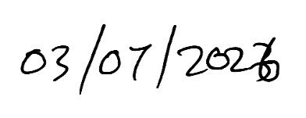
Candidate's signature: ……………………………………….. Date: …………………………
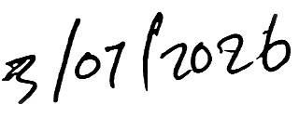
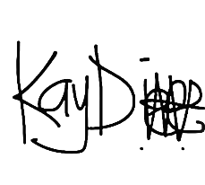
Name: DAUD ABDUL-RAHIM - 26102859

Candidate's signature: ……………………………………….. Date: …………………………

Name: KWUATSENU DIVINE - 26102924

Candidate's signature: ……………………………………….. Date: …………………………
Name: M'BANGOT-MENARD NAEEM LATIF DIEUDONNE - 26102931

Supervisor's Declaration
I hereby declare that the preparation and presentation of the project were supervised in accordance with the guidelines on supervision of project laid down by Knutsford University.


Supervisor's signature: ……………………………………….. Date: …………………………
Name: Mr. Bryan Laryea

DEDICATION
To our families.

ACKNOWLEDGEMENT
We express our sincere appreciation to our supervisor, Mr. Bryan Laryea, for the guidance, corrections and encouragement provided throughout this project. We also appreciate the lecturers of the Department of Computer Science and the Students' Representative Council personnel whose observations assisted the development and evaluation of the system. Finally, we are grateful to our colleagues and families for their support.

ABSTRACT
Student governance processes that depend on manual permit checks, fragmented payment records and informal communication can lead to delays, weak accountability and difficulty in verifying student eligibility. This project presents the design and implementation of an NFC-based student permit verification and governance management system for Knutsford University. The system integrates student records, permit issuance, Paystack-supported permit requests, NFC and alternative verification methods, election voting, public communication, reporting and audit logging. A Laravel backend provides shared business rules for a React/Inertia operations dashboard, a public portal and an Expo React Native mobile application accessed through Sanctum-protected endpoints. PostgreSQL stores linked operational records, while role-based access control, hashed permit/NFC identifiers, rate limits and audit trails support security and accountability. The implemented workflows allow authorized personnel to manage students and permits, verify permit status, administer elections and monitor operations, while students can access selected services through mobile channels. Testing focused on authentication, authorization, permits, payments, NFC cards, verification, elections, public content and mobile API restrictions. The project demonstrates that an integrated digital platform can improve the efficiency and traceability of SRC operations, although full institutional use requires deployment preparation, user training and policy alignment.

TABLE OF CONTENTS
DECLARATION 1
DEDICATION 2
ACKNOWLEDGEMENT 3
ABSTRACT 4
TABLE OF CONTENTS 6
LIST OF TABLES 11
LIST OF FIGURES 12
CHAPTER ONE INTRODUCTION 1
1.1 Background to the Study 1
1.2 Statement of the Problem 1
1.3 Objectives of the Study 2
1.4 Significance of the Study 2
1.5 Scope of the Study 3
1.6 Limitations of the Study 3
1.7 Organisation of the Study 3
1.8 Definition of Terms 4
CHAPTER TWO LITERATURE AND REVIEW OF RELATED SYSTEMS 5
2.1 Introduction 5
2.2 Theoretical Framework 5
2.2.1 Client-Server Architecture 5
2.2.2 Role-Based Access Control 6
2.2.3 Digital Identity and NFC Verification 6
2.2.4 Electronic Voting Systems 7
2.3 Technological Base 8
2.3.1 Backend and Web Technologies 8
2.3.2 Mobile, Authentication and Payment Technologies 8
2.4 Review of Related Systems 9
2.4.1 Student Permit Systems 9
2.4.2 University Election Systems 10
2.4.3 NFC and Student Verification Systems 10
2.5 Comparative Analysis of Related Systems 10
2.6 Major Findings of the Review 11
CHAPTER THREE SYSTEM ANALYSIS AND DESIGN 12
3.1 Introduction 12
3.2 Analysis of the Existing System 12
3.2.1 Detailed Description of the Existing System 12
3.2.2 Challenges Associated with the Existing System 13
3.2.3 Detailed Definition of the Problem (System Request) 13
3.3 Analysis of the Proposed System 13
3.3.1 Requirements of the Proposed System 13
3.3.1.1 Functional/Non-Functional Requirements 13
3.3.1.2 User Interface Requirements 14
3.3.1.3 System Requirements 14
3.4 Design and Architecture of the Proposed System 15
3.4.1 Database Design 16
3.4.2 System Logic Design 16
3.4.3 User Interface Design 19
3.4.4 System Test Plan 19
3.5 Chapter Summary 19
CHAPTER FOUR SYSTEM IMPLEMENTATION 20
4.1 Introduction 20
4.2 Programming Languages and Technologies Applied 20
4.3 Frameworks, Development Platforms and Tools 20
4.3.1 Implemented Dashboard Modules 21
4.3.2 Permit Payment, NFC and Election Workflows 22
4.3.3 Mobile Application Implementation 24
4.4 Coding and Implementation Evidence 25
4.5 Testing Results and Evidence 26
4.6 Deployment and User/System Documentation 26
4.6.1 Basic User Procedure 27
4.6.2 Basic System Administration Procedure 27
4.7 Pilot Implementation Results 28
4.8 Chapter Summary 28
CHAPTER FIVE SUMMARY, CONCLUSION AND RECOMMENDATION 29
5.1 Summary of the Study 29
5.2 Key Findings 29
5.3 Conclusions 29
5.4 Recommendations 30
5.5 Proposed Live Implementation Plan and Budget 30
REFERENCES 32
APPENDICES 34
APPENDIX 1: SELECTED IMPLEMENTATION AND TEST EVIDENCE 34
A.1 Core Implemented Modules 34
A.2 Summary of Validation 34

LIST OF TABLES
Table | Title | Page
Table 2.1 | Comparative Analysis of Related Systems | 10
Table 3.1 | Functional Requirements Summary | 13
Table 3.2 | Non-Functional Requirements Summary | 14
Table 3.3 | Hardware and Software Requirements | 14
Table 4.1 | Technologies Applied and Justification | 20
Table 4.2 | Testing Results Summary | 26
Table 4.3 | Pilot Implementation Results | 28
Table 5.1 | Objectives Achieved | 30
Table 5.2 | Proposed Live Implementation Plan | 31
Table 5.3 | Estimated Live Implementation Budget | 31

LIST OF FIGURES
Figure | Title | Page
Figure 2.1 | Client-Server Architecture | 6
Figure 2.2 | NFC Verification Workflow | 7
Figure 3.1 | Overall System Architecture | 15
Figure 3.2 | Entity Relationship Diagram of the Proposed System | 16
Figure 3.3 | Permit Request and Payment Workflow | 17
Figure 3.4 | Detailed NFC Verification Flowchart | 18
Figure 3.5 | Election Voting Workflow | 18
Figure 3.6 | Security and Verification Architecture | 18
Figure 4.1 | Login Interface | 22
Figure 4.2 | Operations Dashboard Interface | 22
Figure 4.5 | Self-Service Permit Request and Paystack Verification Screen | 23
Figure 4.6 | Student Election Voting Screen | 24
Figure 4.7 | Student Mobile Login and Permit Listing Interfaces | 25
Figure 4.9 | Final Test Execution Output | 26
Figure 4.10 | Deployment Architecture | 27

CHAPTER ONE
INTRODUCTION

1.1 Background to the Study
Educational institutions depend on many administrative processes that appear routine but have direct effects on student welfare, accountability, and institutional trust. Student identification, permit issuance, payment confirmation, elections, announcements, document circulation, and operational reporting all contribute to how students interact with their university and with student governance structures. When these processes are handled manually or through disconnected tools, simple activities can become slow, difficult to audit, and vulnerable to error. For a student governance body such as the Students' Representative Council (SRC), the problem has both technical and governance dimensions. It affects the credibility of decisions, the reliability of student records, and the quality of service delivered to students.
Universities have gradually moved many administrative functions from paper-based records to digital systems. This movement has been influenced by the need to improve access to information, reduce duplication of records, support remote interaction, and make institutional processes easier to monitor. In a typical university environment, students expect to receive information quickly, complete requests without unnecessary physical movement, and verify their status using channels that fit their everyday use of mobile devices. Staff and executives also need reliable records that can support decisions, reduce disputes, and provide evidence of actions taken. These expectations have made digital governance systems more relevant to student administration and institutional operations.

1.2 Statement of the Problem
Student governance operations can become inefficient when permit management, student verification, payment confirmation, election voting, public communication, and reporting are handled through manual or disconnected processes. In such an environment, students may be required to move between offices, present physical documents repeatedly, wait for manual confirmation, or depend on informal communication for updates. Administrators and SRC executives may also spend unnecessary time reconciling records from different sources before they can make decisions.
Permit fraud is one of the main concerns in a weak verification process. A permit may be altered, reused, duplicated, expired, or presented by a person other than the rightful holder. If verification depends mainly on visual inspection, the person performing the check may not have enough information to determine validity. Even where a printed permit contains a code or student details, the absence of a central verification process can make it difficult to confirm whether the permit is active, revoked, or linked to the correct academic period. This creates room for impersonation and weakens trust in the permit system.
Manual verification is also slow. During periods of high activity, such as examinations or SRC-organized events, several students may need to be checked within a short time. A manual process may require searching paper records, comparing names, inspecting receipts, or contacting another officer for confirmation. These steps consume time and can delay both students and staff. A slow verification process may also encourage shortcuts, especially when the number of students is high and the available personnel are limited.

1.3 Objectives of the Study
To design a centralized dashboard and mobile-supported platform for managing student permits and SRC governance activities.
To implement secure permit issuance and verification using NFC, permit-code and student-number verification methods.
To integrate verified digital payment processing, election voting and public communication services into the platform.
To evaluate the system's functionality, security and accountability through testing, role-based access control and audit records.

1.4 Significance of the Study
This study is significant because it addresses practical problems in student governance using a technically grounded information system. Student permit verification, payment confirmation, elections, and public communication are not isolated administrative tasks. They affect how students experience governance and how executives account for their decisions. A system that improves these workflows can support both service delivery and institutional accountability.
For students, the proposed system can reduce the inconvenience associated with manual permit requests and verification. A student should not have to depend entirely on physical movement, informal updates, or repeated manual checks to know the status of a permit request. Self-service permit issuance and mobile access can make the process more accessible. Students can also benefit from more organized public communication through announcements, events, documents, and election information published through a public portal.

1.5 Scope of the Study
The scope of this study covers the design and implementation of a student governance platform for Knutsford University with emphasis on permit verification, student services, governance communication, mobile access, elections, auditability, and reporting.
The system includes an operations dashboard for authorized users such as administrators, SRC executives, and staff. The dashboard supports student management, executive management, role and permission management, academic periods, permit settings, permit issuance, payment oversight, NFC card management, verification logs, audit logs, reports, announcements, events, documents, polls, and elections. This dashboard is intended for controlled internal operations rather than general public use.

1.6 Limitations of the Study
The study has some practical limitations that are common in software projects implemented within an academic period. These limitations do not remove the value of the system, but they define the conditions under which it is expected to operate.
The first limitation is dependence on internet connectivity. The dashboard, public portal, mobile API, payment verification, and most reporting functions require network access. If internet connectivity is poor, users may experience delays when submitting requests, verifying permits, or retrieving records. This limitation is important because student verification may sometimes occur in locations where connectivity is unstable.

1.7 Organisation of the Study
The report is organised into five chapters. Chapter One introduces the project problem, aim and scope. Chapter Two reviews relevant literature and related systems. Chapter Three analyses the existing process and presents the proposed design. Chapter Four describes the technologies, implementation evidence, testing and deployment considerations. Chapter Five provides the summary, conclusion and recommendations.

1.8 Definition of Terms
Term | Meaning in this Study
NFC | Short-range contactless technology used to identify a registered student card during verification.
Permit verification | Checking whether a student has a valid permit linked to the relevant academic period.
Mobile API | Protected JSON endpoints used by the Expo mobile application.
RBAC | Role-based restriction of actions available to students, staff, executives and administrators.
Audit log | Record of sensitive actions performed within the system for accountability.
Self-service permit request | Student-initiated permit workflow connected to verified payment processing.

CHAPTER TWO
LITERATURE AND REVIEW OF RELATED SYSTEMS

2.1 Introduction
Chapter One established the need for an NFC-based student permit verification and governance management system for Knutsford University. The chapter described the operational problems created by manual permit checks, fragmented student governance workflows, weak auditability, limited mobile access, and disconnected election and payment processes. This chapter builds on that foundation by reviewing the concepts, technologies, and related systems that inform the design of the proposed system.

2.2 Theoretical Framework
The theoretical framework provides the concepts that guide the structure and behavior of the proposed system. Since the project combines administrative workflows, identity verification, payment confirmation, mobile access, and election voting, no single theory is sufficient on its own. The system draws from several areas of computing: distributed systems, access control, mobile architecture, API design, identity verification, contactless authentication, and electronic voting.

2.2.1 Client-Server Architecture
Client-server architecture is a computing model in which client applications request services from a centralized server or backend system. The client may be a web browser, mobile application, desktop application, or another software component. The server processes requests, applies business rules, manages authentication, communicates with the database, and returns responses to the client. This model is common in institutional information systems because it allows shared data and rules to be managed centrally while still providing different access interfaces to users. (Tanenbaum & Wetherall, 2011)
In a student governance system, centralization has practical value. Permit records, payment statuses, student accounts, verification logs, election records, and published content must remain consistent. If each access channel keeps its own separate record, the system can produce conflicting results. For example, a student might appear to have an active permit in one spreadsheet but not in another. A payment could be marked successful in a receipt folder while the permit record remains pending. Client-server architecture reduces this problem by placing the authoritative data and business rules on the backend.
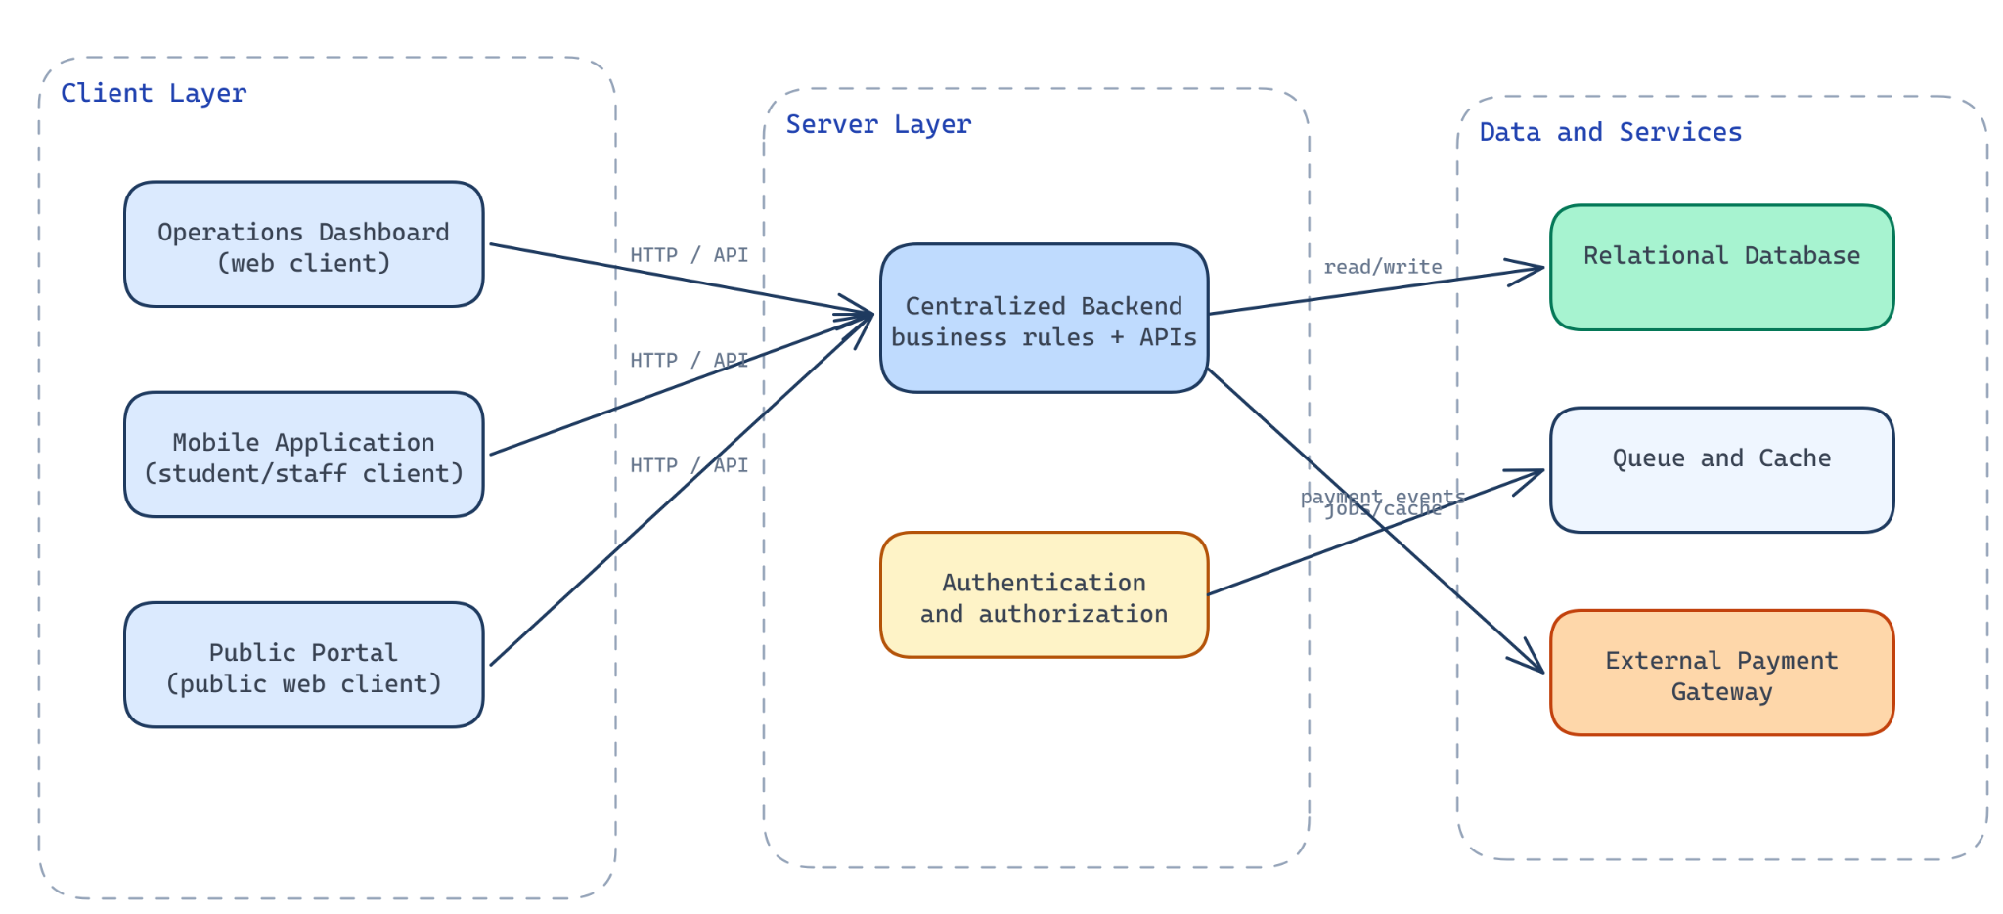
Figure 2.1: Client-Server Architecture

2.2.2 Role-Based Access Control
Role-Based Access Control (RBAC) is an authorization approach in which permissions are assigned to roles, and users receive permissions through their assigned roles. Instead of granting every permission directly to each user, the system groups permissions according to responsibilities. For example, an administrator may manage users and system settings, a staff member may verify permits, an executive may publish governance content, and a student may view personal records or participate in eligible elections. (Sandhu et al., 1996)
RBAC is useful in institutional systems because different users should not have equal access to all functions. Student governance workflows include sensitive actions such as issuing permits, verifying payments, approving candidates, registering NFC cards, publishing documents, and viewing reports. If the system allows all authenticated users to perform these actions, it creates security and accountability problems. Role separation helps limit access according to actual responsibility.

2.2.3 Digital Identity and NFC Verification
Digital identity verification systems are used to confirm that a person, account, card, or presented identifier corresponds to an authorized record. In educational institutions, identity verification may be required for examinations, library access, permit checks, student service requests, elections, and administrative approvals. A digital identity system usually depends on stored identity records, authentication credentials, verification identifiers, and rules for determining whether a person is eligible for a service. (National Institute of Standards and Technology, 2017)
Authentication and verification are related but different concepts. Authentication confirms that a user can prove control of an account or credential, such as a password or token. Verification checks whether a presented identity or permit is valid for a specific purpose. A student may authenticate into a mobile application, but permit verification may still require checking whether the student has an active permit for the current academic period. Similarly, an NFC card may identify a linked student record, but the system must still verify whether the associated permit is valid.
Digital identity verification also raises privacy concerns. Verification staff may need enough information to confirm a student, but they do not always need full personal details. A system should avoid exposing unnecessary information during verification. For example, a verification result may need to show student name, student number, permit status, and permit validity, but not unrelated account or payment history. This approach reduces privacy risk while still supporting the operational task.
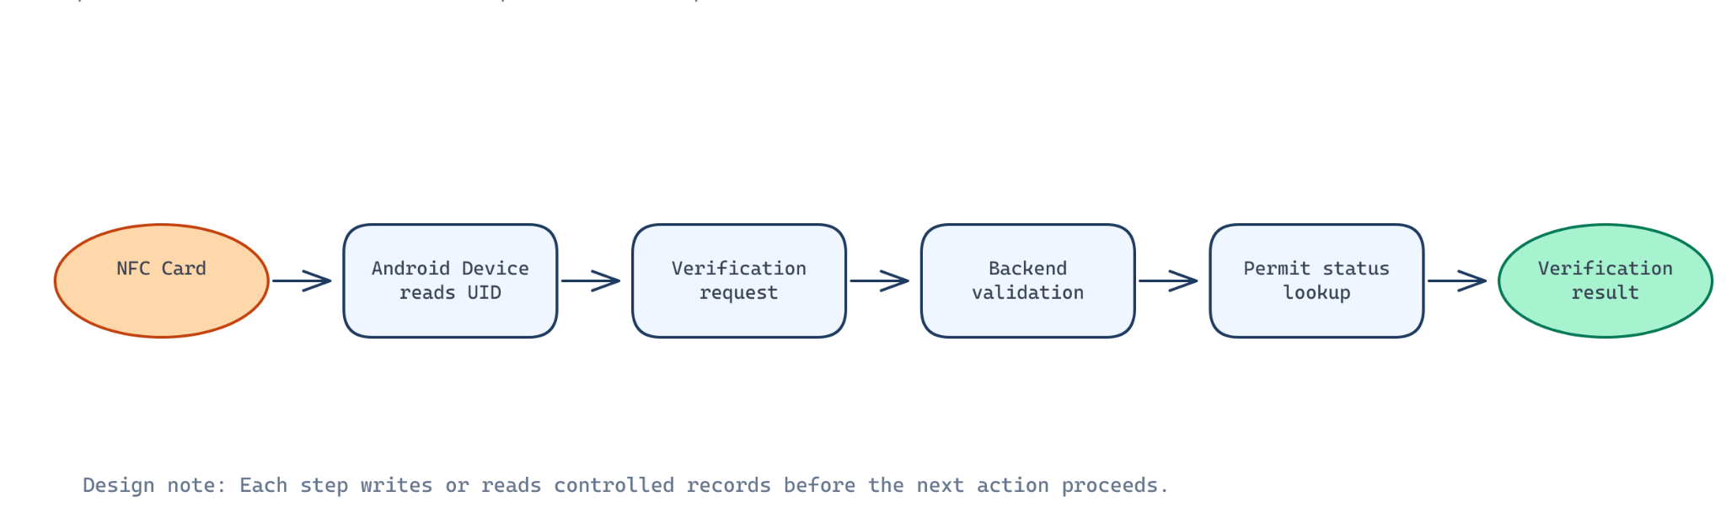
Figure 2.2: NFC Verification Workflow

2.2.4 Electronic Voting Systems
Electronic voting systems allow voters to cast votes using digital devices or software platforms. In institutional settings, they may be used for student elections, association elections, board elections, surveys, or referenda. A proper electronic voting system must address authentication, eligibility, ballot presentation, vote recording, duplicate prevention, result calculation, and auditability. (ACE Electoral Knowledge Network, n.d.)
Student elections require more control than ordinary polls. A poll may allow flexible participation or opinion gathering, but an election determines representation. Therefore, the voting process must be designed to prevent duplicate voting, restrict ineligible participation, manage candidate approval, and preserve result integrity. The system should also distinguish between active, scheduled, closed, and archived elections.

2.3 Technological Base

2.3.1 Backend and Web Technologies
Laravel is a PHP web application framework that supports routing, controllers, middleware, validation, authentication, database access, queues, events, notifications, and API development. It follows patterns commonly associated with Model-View-Controller (MVC) architecture, although modern Laravel applications may also use actions, services, policies, form requests, and frontend integration tools. (Laravel, n.d.-a)
Laravel is relevant to the proposed system because the project requires a backend capable of handling several modules. These include students, permits, payments, NFC cards, verification logs, elections, announcements, documents, audit logs, reports, and mobile API endpoints. A framework with established support for routing, validation, authorization, database models, and background jobs reduces the amount of low-level infrastructure that must be built manually.
Security support is another reason Laravel fits this type of project. Institutional systems require authentication, password handling, session protection, authorization checks, request validation, and protection against common web vulnerabilities. A framework does not automatically make an application secure, but it provides tested mechanisms that developers can apply consistently. For example, middleware can protect routes, policies can authorize actions, and validation classes can reject malformed input before it reaches domain logic.

2.3.2 Mobile, Authentication and Payment Technologies
Expo React Native is a development platform for building cross-platform mobile applications using React Native. React Native allows developers to write mobile interfaces using JavaScript or TypeScript while rendering native mobile components. Expo provides tooling, libraries, build services, and development workflows that simplify mobile application creation and testing. (Expo, n.d.; Meta, n.d.-b)
The relevance of Expo React Native to this project is tied to mobile access. The proposed system includes a mobile application for student and staff workflows. Students may use the mobile application to access permit information, view relevant governance content, submit permit requests, and participate in eligible elections. Staff may use mobile workflows for verification activities. A cross-platform approach is suitable because the project should not be limited to a single operating system where avoidable.
The mobile application should also avoid becoming the authority for sensitive rules. It may collect user input and display results, but permit eligibility, vote eligibility, payment verification, and authorization decisions should remain on the backend. Expo React Native supports the client side of the architecture, while the Laravel backend remains responsible for trusted decisions.

2.4 Review of Related Systems
Existing systems related to this project can be grouped into four categories: student permit systems, university election systems, student identity verification systems, and NFC attendance or verification systems. This review focuses on categories rather than unsupported claims about specific products. The aim is to understand common strengths and limitations and to identify where the proposed system adds value.

2.4.1 Student Permit Systems
Student permit systems are used to manage permissions, clearances, examination access, event access, or other institutional approvals. In some institutions, these systems are manual. Students may complete a form, pay a fee, receive a paper permit, and present it during verification. In other institutions, permits may be recorded in spreadsheets or basic administrative software.
Manual permit systems have a few practical strengths. They are easy to understand, require limited technical infrastructure, and can be used even when internet access is poor. Staff who are already familiar with paper records may find them simple to operate. For small groups, a manual permit register may be adequate.

2.4.2 University Election Systems
University election systems may range from manual ballot papers to online voting platforms. Manual voting has the advantage of being familiar and visible. Students can observe ballot boxes, candidate lists, and counting processes if the election is organized transparently. However, manual voting can be slow, labor-intensive, and difficult to audit after the process is complete.
Digital election systems improve convenience by allowing voters to cast ballots through web or mobile interfaces. They can enforce eligibility rules, prevent duplicate voting, and calculate results more quickly than manual counting. They can also support candidate information, election schedules, and controlled result visibility.

2.4.3 NFC and Student Verification Systems
NFC-based attendance systems are commonly applied in educational environments to record student presence through close-range contactless identification. In such systems, a student taps an NFC-enabled card or device against a reader, allowing attendance information to be captured electronically. Existing studies indicate that NFC can improve the efficiency of attendance recording by reducing dependence on manual registers and roll calls (Mohd Nasir et al., 2015).

The strength of NFC attendance systems is their operational speed and convenience. They reduce the need to call names or manually sign registers, while producing electronic records that are easier to retrieve and summarize. In educational settings, NFC may support class attendance, event participation, library access, or controlled entry.

2.5 Comparative Analysis of Related Systems
Table 2.1: Comparative Analysis of Related Systems
Criteria | Typical Existing Systems | Proposed System
Permit management | Paper or spreadsheet records; limited lifecycle control. | Central permit lifecycle, duplicate prevention and verification.
NFC verification | Often attendance-focused or absent. | Card lifecycle and permit validation integrated.
Payments | Manual receipt confirmation or separate processes. | Paystack verification linked to permit requests.
Election voting | Standalone or manual process. | Eligibility checks and controlled mobile voting.
Auditability | Limited action history. | Audit and verification logs for sensitive workflows.
Mobile/public access | Often incomplete or disconnected. | Mobile app and public portal backed by shared rules.

2.6 Major Findings of the Review
The first major gap is fragmentation. Existing approaches often solve one administrative problem while leaving related workflows disconnected. A permit system may not know whether payment was verified. An election system may not use current student eligibility data. A public communication channel may not connect to official executive or document records. This fragmentation creates repeated data entry, inconsistent records, and weak operational visibility.
The second gap is weak auditability. Manual and spreadsheet-based systems may show final records but often fail to preserve a reliable history of sensitive actions. In student governance, auditability matters because permits, payments, elections, account activation, and verification events can lead to disputes. A system that cannot show who performed an action and when it occurred provides limited accountability.
The third gap is poor mobile support. Many institutional workflows still assume that users will access services through offices, desktop computers, or paper forms. This does not match the way many students interact with information. Mobile support is especially relevant for student permit requests, election voting, announcement access, and field verification by staff.

CHAPTER THREE
SYSTEM ANALYSIS AND DESIGN

3.1 Introduction
Chapter Two reviewed the concepts and technologies that support the development of an NFC-based student permit verification and governance management system. It examined client-server architecture, role-based access control, mobile application architecture, REST API design, digital identity verification, contactless authentication, electronic voting, payment integration, and related systems. The review showed that the proposed system should not be treated as a single-purpose permit database or an isolated NFC scanner. It requires a coordinated design that connects student records, permit workflows, payment verification, mobile access, election voting, public communication, audit logging, and reporting.

3.2 Analysis of the Existing System
The existing system, as analyzed for this project, is a manual and fragmented student governance process. It depends on physical documents, informal communication channels, manual verification, separate payment evidence, and limited operational reporting. These processes may work in small or low-volume situations, but they become weak when student numbers, permit requests, payment records, elections, and verification activities increase.

3.2.1 Detailed Description of the Existing System
In the manual permit issuance workflow, a student typically initiates a permit request by contacting an SRC officer, visiting an office, filling a paper form, or submitting details through an informal channel. The student may then be required to provide proof of payment or wait for an officer to confirm payment. Once the officer is satisfied, the permit may be written, printed, stamped, signed, or recorded in a register.
Manual student verification depends on visual inspection, physical permits, printed lists, handwritten registers, or direct confirmation from an officer. During an examination, SRC activity, or security check, a verifier may ask a student to present a permit or student identity card. The verifier may then compare the details with a paper list or decide based on the visible permit.

3.2.2 Challenges Associated with the Existing System
Challenge | Effect on Operations
Manual verification | Slower checks and inconsistent decisions during busy activities.
Duplicate or fraudulent permits | Weak confidence in permit validity.
Separated payment evidence | Delays and disputes in permit issuance.
Fragmented communication | Students may miss official information.
Weak audit trail | Difficult to identify actions and resolve disputes.
Limited mobile access | Services remain dependent on physical or desktop access.

3.2.3 Detailed Definition of the Problem (System Request)
The system request defines what Knutsford University and the SRC require from the proposed system. The request is for a centralized student governance platform that can manage permit issuance, student verification, payment verification, NFC card lifecycle, public communication, election voting, audit logging, reporting, and mobile access.
The institution needs a system that can provide a reliable source of truth for permit and verification workflows. A student record should be connected to permits, permit requests, payments, NFC cards, user accounts, verification logs, and election participation where applicable. This does not mean all records are identical. It means that related records must be traceable through clear relationships.

3.3 Analysis of the Proposed System
The proposed system is a centralized student governance platform with three main access surfaces: an operations dashboard, a public portal, and a mobile application supported by a mobile API. The backend coordinates these surfaces and enforces the business rules. The design is based on the principle that sensitive workflow decisions should be made on the server, not inside the user interface.

3.3.1 Requirements of the Proposed System

3.3.1.1 Functional/Non-Functional Requirements
Table 3.1: Functional Requirements Summary
Req. ID | Functional Requirement
FR-01 | Authenticate users and restrict functions according to role and permission.
FR-02 | Manage student profiles and controlled account activation.
FR-03 | Issue, revoke and verify permits for academic periods.
FR-04 | Process self-service permit requests and verified Paystack payment.
FR-05 | Register and manage NFC cards and verification attempts.
FR-06 | Conduct student elections with eligibility and duplicate-vote controls.
FR-07 | Publish approved announcements, events and documents.
FR-08 | Provide mobile access, audit logs and operational reports.
Table 3.2: Non-Functional Requirements Summary
Requirement Area | Non-Functional Requirement
Security | Use authentication, authorization, hashing, rate limits and audit logging.
Reliability | Protect payment, permit and vote workflows from inconsistent states.
Usability | Provide clear dashboard, mobile and verification interfaces.
Performance | Use pagination, caching and queues for repeated or background work.
Maintainability | Keep shared business rules in backend actions and policies.

3.3.1.2 User Interface Requirements
The operations dashboard is used by administrators, staff, and SRC executives. It must support repeated operational work rather than casual browsing. Dashboard screens should include search, filters, status indicators, action dialogs, confirmation prompts, and detail views. Users should be able to manage students, permits, payments, permit requests, NFC cards, elections, content, reports, roles, and audit logs from structured pages.
The mobile application must support student-centered and staff-centered workflows. Students need quick access to permit status, permit request options, payment progress, announcements, events, documents, executive information, elections, and NFC card status. Staff users may need verification and selected operational functions.

3.3.1.3 System Requirements
Table 3.3: Hardware and Software Requirements
Category | Requirement
Hardware | VPS/server, modern browser workstation, NFC-capable Android device, student smartphones and NFC cards/tags.
Software | Laravel/PHP, PostgreSQL, React/Inertia, Expo React Native, Sanctum, Paystack, queue/cache services and HTTPS web server.

3.4 Design and Architecture of the Proposed System
The proposed architecture is designed around one central idea: all sensitive decisions should pass through the backend. The dashboard, public portal, and mobile application are access surfaces, but they do not independently decide whether a permit is valid, whether a payment succeeded, whether a student may vote, or whether a user may perform an administrative action.
System Architecture Overview
The overall system architecture connects the operations dashboard, public portal, mobile application, Paystack payment gateway, PostgreSQL database, queue workers, cache, media storage, and audit logs through a centralized Laravel backend. This design is shown in Figure 3.2.
The Laravel backend is the main coordination layer. It receives requests from the dashboard, public portal, mobile API, and Paystack webhook endpoint. It validates input, checks authorization, applies domain rules, reads and writes database records, dispatches queued tasks, updates cache where appropriate, and records audit events. This design keeps workflow decisions in one place.
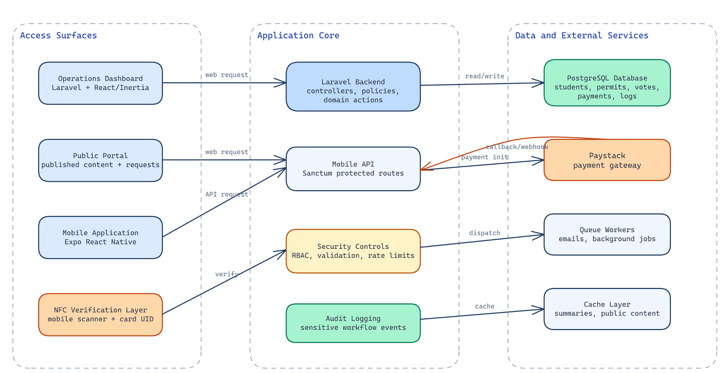
Figure 3.1: Overall System Architecture

3.4.1 Database Design
The proposed system uses a relational database design because its records have structured relationships and integrity requirements. Students, users, permits, payments, NFC cards, elections, votes, documents, and audit logs are not independent pieces of text. They form a connected operational model.
The database design uses relationships to connect records that depend on one another. A student may be linked to a user account. A permit belongs to a student and academic period. A payment may belong to a student and permit request. An NFC card belongs to a student. A verification log may resolve to a student and permit. An election belongs to an academic period, and its positions, candidates, and votes are related to that election.
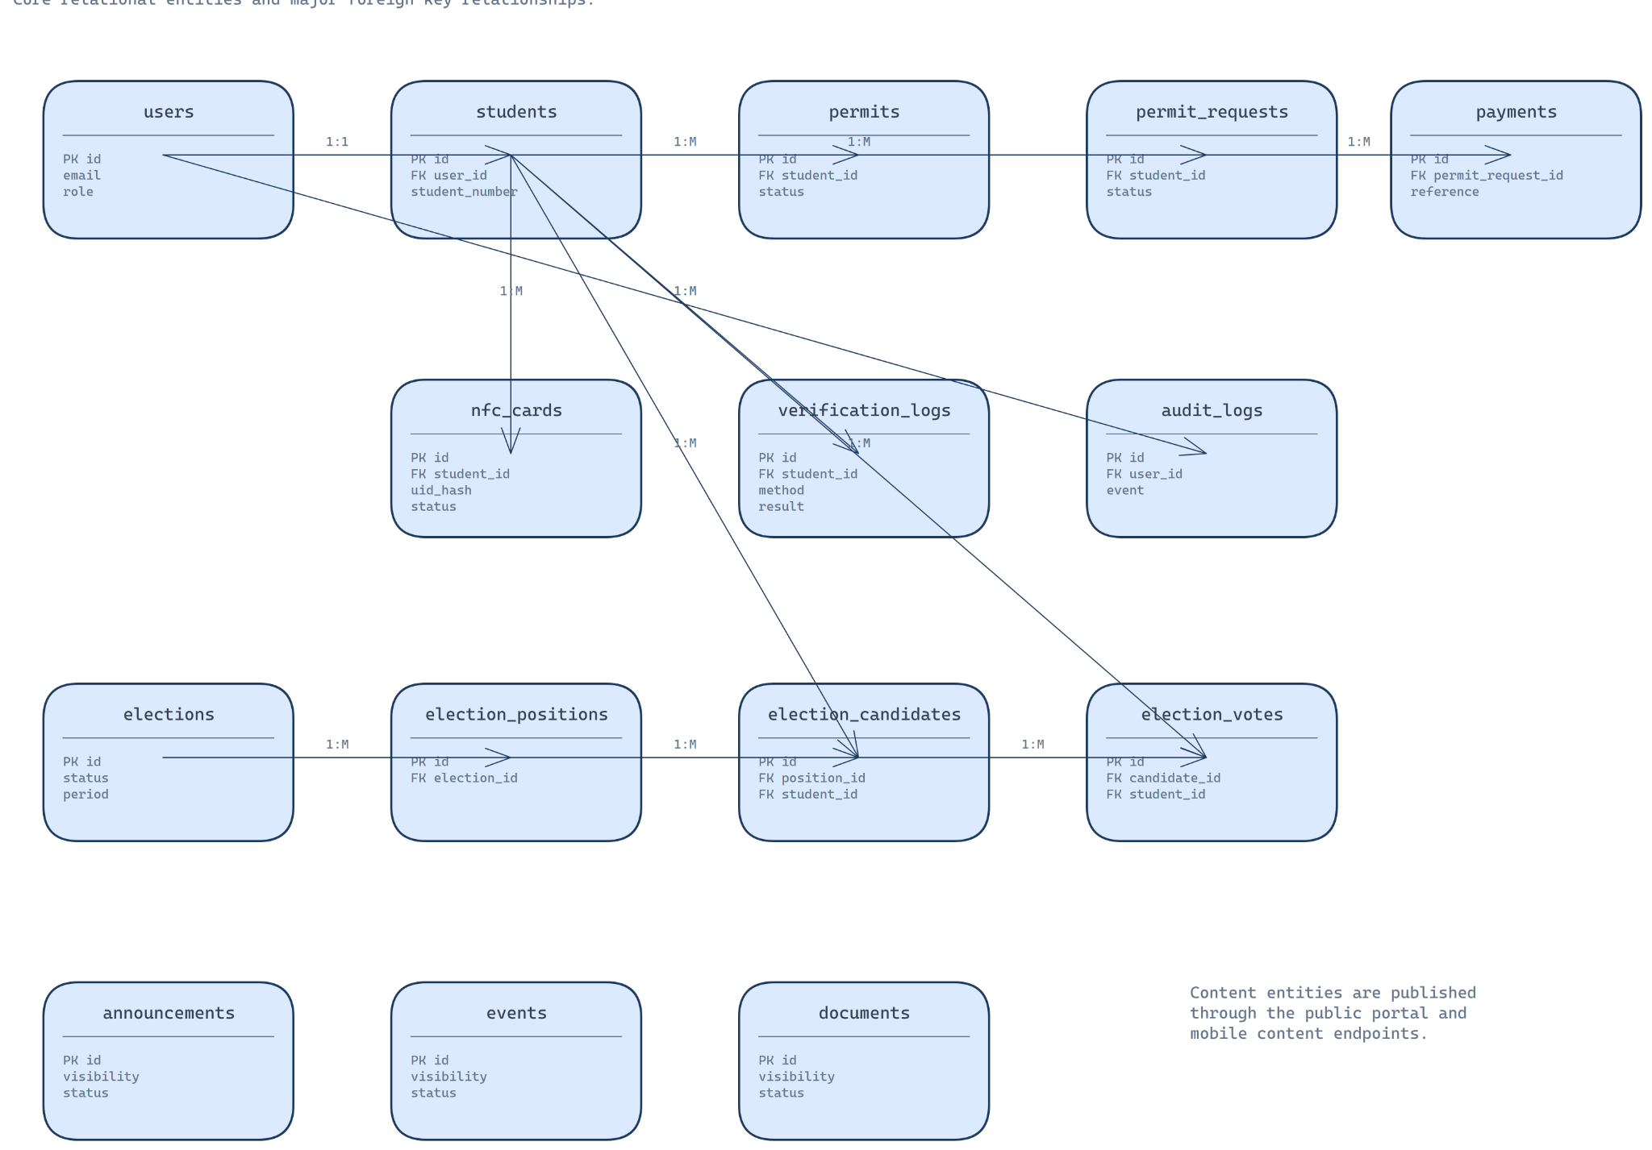
Figure 3.2: Entity Relationship Diagram of the Proposed System

3.4.2 System Logic Design
The permit request and payment workflow is one of the most important parts of the proposed system. It connects student access, permit eligibility, payment verification, administrative review, duplicate prevention, and audit logging. The design avoids issuing permits based only on user-submitted payment evidence or browser redirects.
The workflow begins when a student initiates a permit request. In the public portal, the student may be found through student number lookup. If the student exists, the system displays a masked preview and allows missing contact information to be completed. If the student does not exist, the system creates a provisional student record marked for review. This design allows self-service access while preventing unknown student records from being automatically trusted.
Before checkout, the system checks blocking conditions. If the student already has an active permit for the current academic period, checkout should be blocked. If the student already has a pending request, another request should not be created without resolving the existing one. These checks reduce duplicate records and prevent confusion.
The design deliberately avoids trusting browser redirects. A redirect shows that the user returned from Paystack, but it does not prove payment success. The backend uses the payment reference to verify the transaction directly with Paystack. Only after successful verification should the local payment be marked successful.
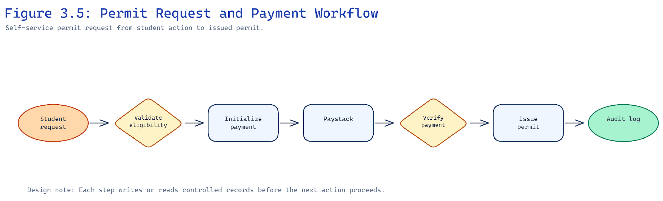
Figure 3.3: Permit Request and Payment Workflow
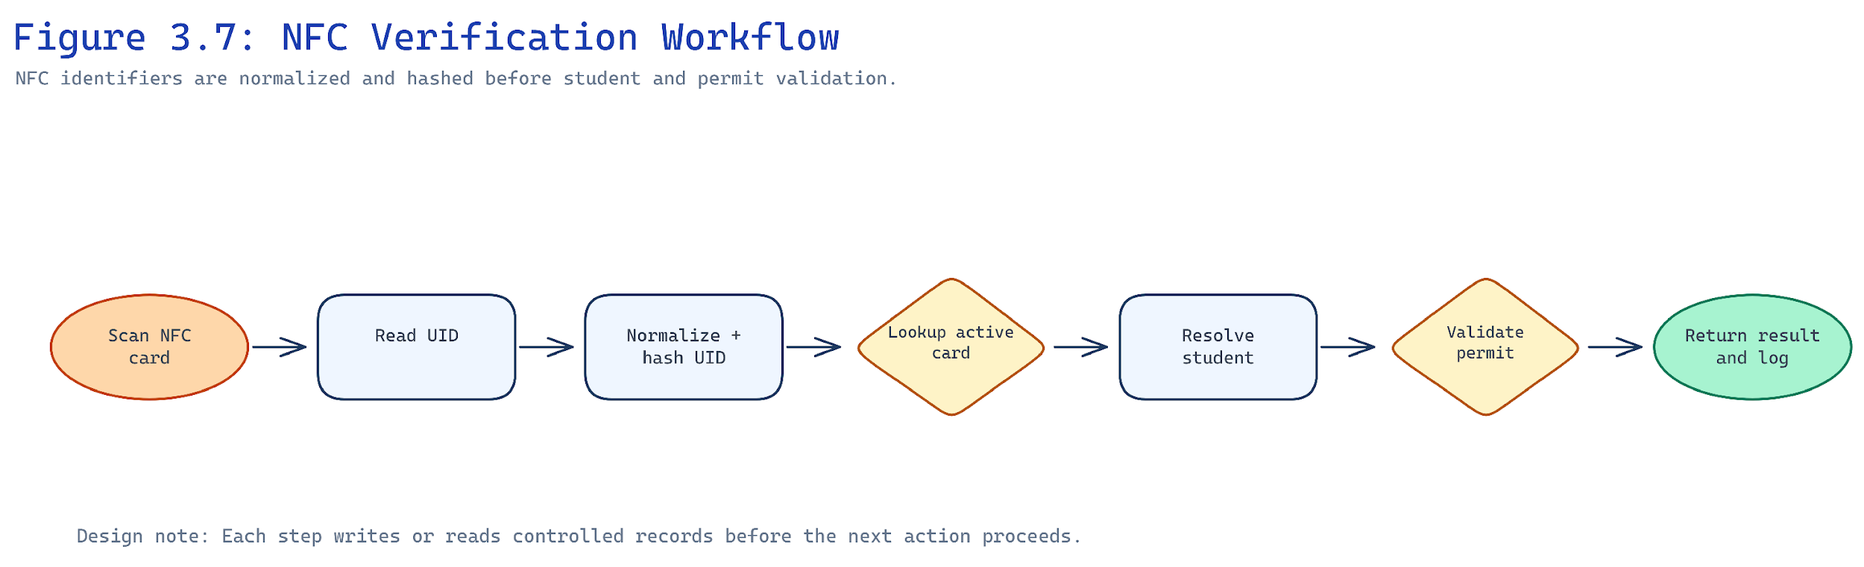
Figure 3.4: Detailed NFC Verification Flowchart
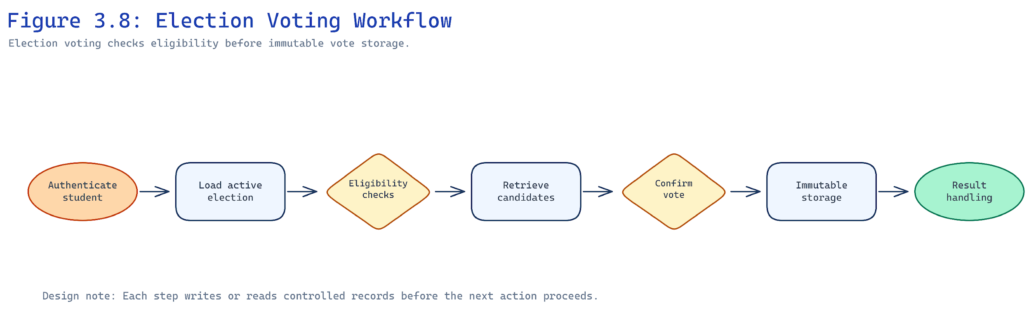
Figure 3.5: Election Voting Workflow
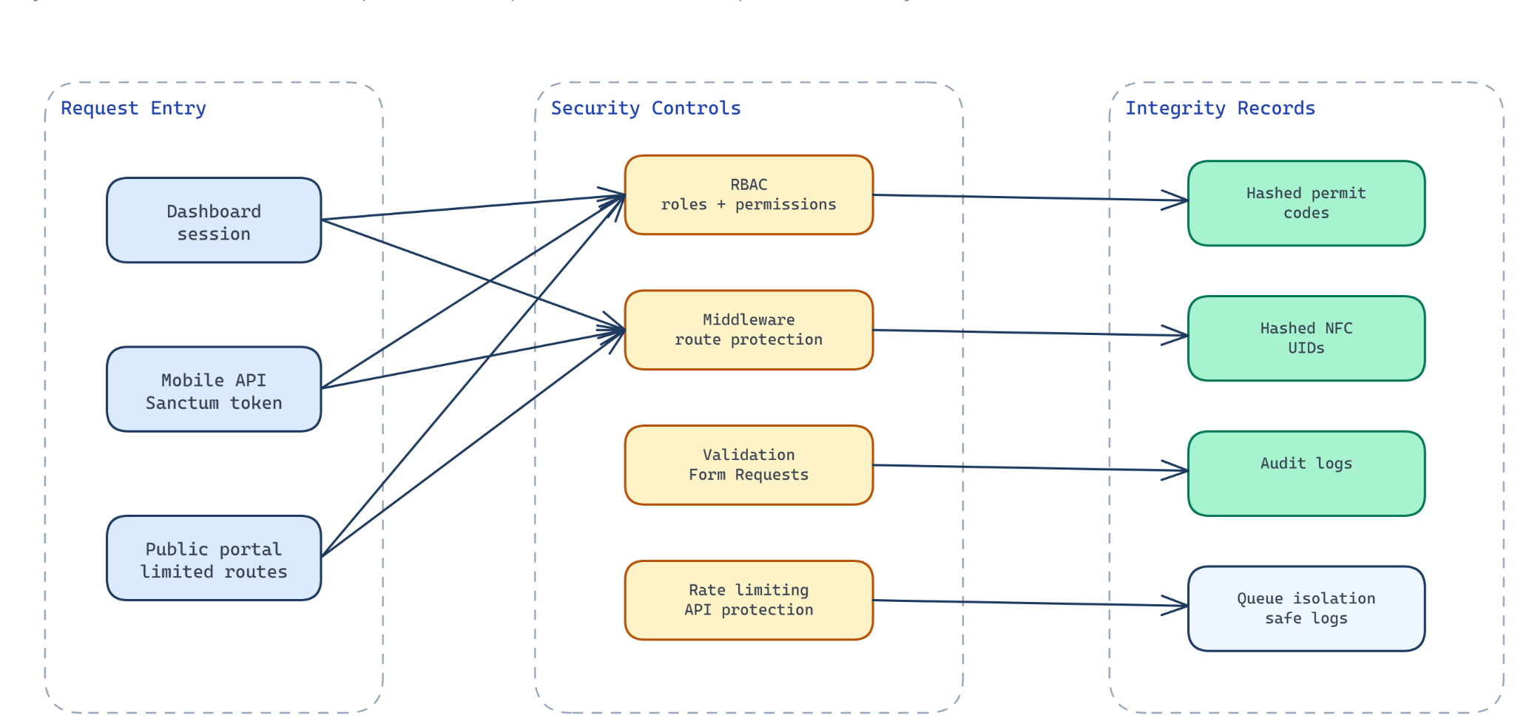
Figure 3.6: Security and Verification Architecture

3.4.3 User Interface Design
The dashboard is an operational interface. It should provide organized navigation, module pages, searchable tables, filters, detail screens, status badges, action dialogs, and confirmation prompts. The dashboard should support repeated administrative work such as managing students, reviewing permit requests, issuing permits, replacing NFC cards, approving candidates, publishing documents, and viewing reports.

3.4.4 System Test Plan
Testing is planned around the system's risk areas. The system handles authentication, permits, payments, NFC cards, verification, elections, public content, mobile API access, audit logging, and security boundaries. Each of these areas requires targeted validation.
Test Area | Validation Focus
Authentication and permissions | Protected access and role-specific actions.
Permit/payment workflows | Issuance, verification, duplicate prevention and recovery.
NFC verification | Card lifecycle, valid/invalid result and protected UID handling.
Elections | Eligibility, approved candidates and one vote per position.
Mobile/public access | Safe data exposure and visibility restrictions.

3.5 Chapter Summary
This chapter analyzed the existing manual and fragmented student governance processes and presented the design of the proposed NFC-based student permit verification and governance management system for Knutsford University. The analysis showed that the existing approach suffers from manual permit delays, weak verification, duplicate permit risk, fragmented communication, disconnected election workflows, poor reporting visibility, limited mobile access, and weak auditability.

CHAPTER FOUR
SYSTEM IMPLEMENTATION

4.1 Introduction
Chapter Three presented the analysis and design of the NFC-based student permit verification and governance management system for Knutsford University. It explained the existing manual processes, defined the system requirements, and described the proposed architecture, database structure, workflows, security model, user interfaces, and validation strategy. This chapter moves from design to implementation. It explains how the proposed system was developed, how the modules interact, how security rules were enforced, how payment and NFC workflows were implemented, how mobile integration was structured, and how the system was tested and prepared for deployment.

4.2 Programming Languages and Technologies Applied
The system was implemented with a backend-centered architecture that supports dashboard, public and mobile access. Table 4.1 summarises the key technologies applied and the reason each was selected for the implementation.
Table 4.1: Technologies Applied and Justification
Technology | Application in the System | Justification
Laravel/PHP | Backend, dashboard routing, public portal and mobile API. | Provides validation, policies, queues and reusable domain workflows.
PostgreSQL | Stores related governance records. | Supports relational integrity and transaction-sensitive workflows.
React/Inertia/TypeScript | Operations dashboard and public interfaces. | Provides interactive pages while keeping Laravel-controlled access.
Expo React Native | Student and operations mobile app. | Supports mobile workflows using a shared application codebase.
Sanctum | Mobile API authentication. | Provides token-based protection for mobile requests.
Spatie packages | Permissions and media handling. | Supports RBAC and structured document/image uploads.
Paystack | Permit payment checkout and verification. | Links digital payment confirmation to permit request completion.

4.3 Frameworks, Development Platforms and Tools
Laravel 13 was used as the main backend framework. Laravel was suitable because the system needed routing, controllers, middleware, validation, policies, database models, queues, notifications, API resources, and test support. The project uses Laravel as the central coordination layer for the operations dashboard, public portal, mobile API, Paystack webhook endpoint, and background jobs.
PHP was used as the server-side programming language through the Laravel framework. The decision to use PHP with Laravel was practical because Laravel provides a mature structure for web applications and API-driven systems. It also supports a clean separation of routes, form requests, policies, actions, models, and resources, which helped keep the platform maintainable as the number of modules increased.

4.3.1 Implemented Dashboard Modules
The backend implementation is the core of the platform. It contains the business rules that protect permit issuance, payment verification, NFC verification, election voting, audit logging, public/private separation, and mobile API access. The backend was implemented so that dashboard, public, and mobile workflows reuse the same domain logic where possible.
The student management module was implemented as the foundation for permit, NFC, mobile, and election workflows. Student records contain institutional identity details such as student number, name, email, phone, course, level, account link, and metadata. The module supports listing, searching, creating, updating, showing, soft deleting, and account activation.
Create, edit, delete, and account activation workflows use dialog-based interfaces. This design keeps the user on the student index or detail page while completing common administrative actions. It also reduces unnecessary navigation for repeated student management tasks.
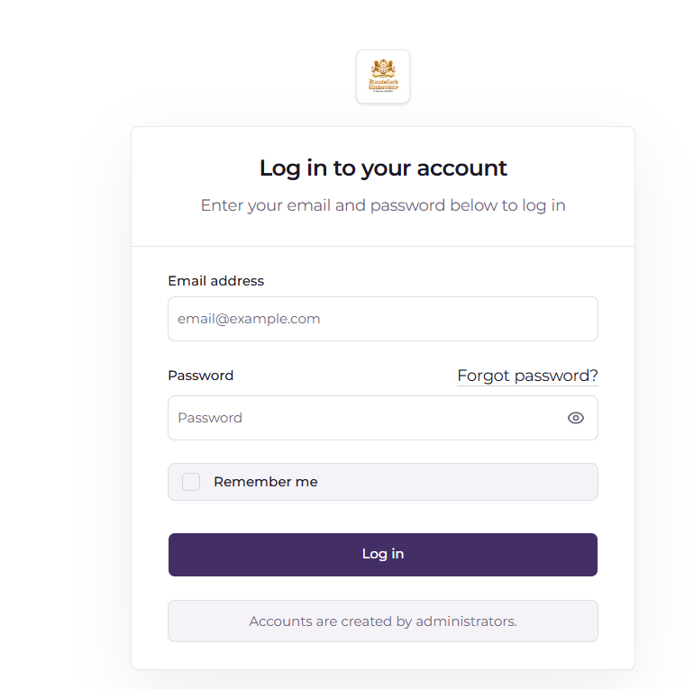
Figure 4.1: Login Interface
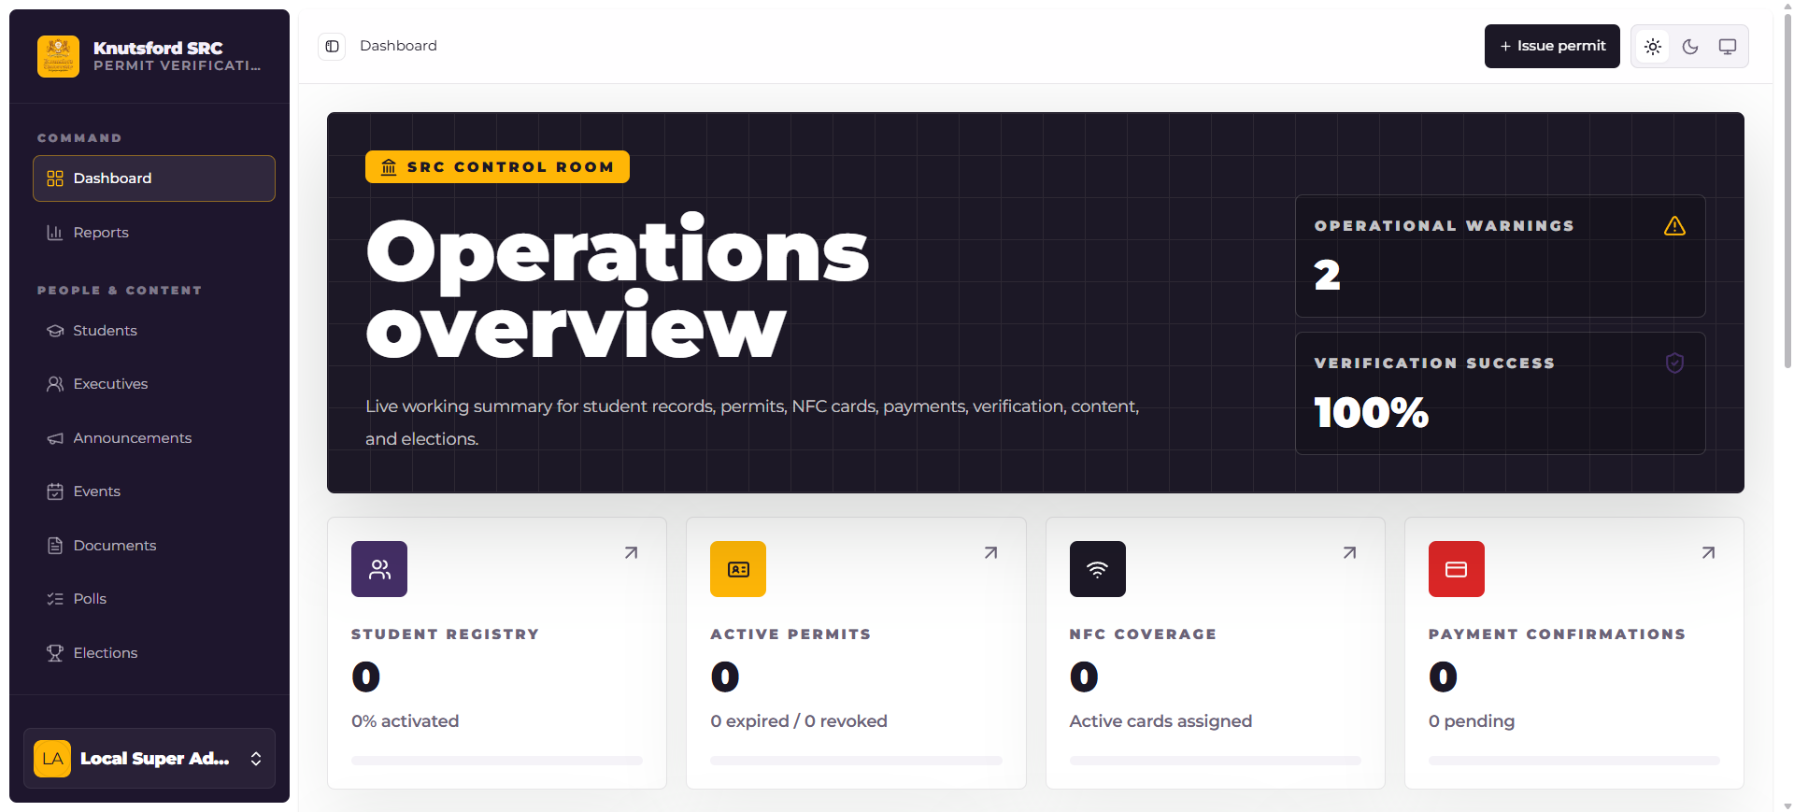
Figure 4.2: Operations Dashboard Interface

4.3.2 Permit Payment, NFC and Election Workflows
The self-service permit request and payment system is one of the strongest parts of the implementation because it connects public access, mobile access, payment verification, permit issuance, review workflows, and recovery handling. The implementation was designed to avoid the common weakness of issuing permits based on screenshots or browser redirects.
In the public portal, the workflow begins with student lookup. Existing students are found by student number. The public page displays a masked preview rather than full internal details. If the student exists and missing contact fields need completion, the student may supply those details within allowed rules. If the student number is not found, the system creates a provisional student record with source = self_service and a pending review status.
The mobile flow is stricter. A student can use the mobile permit request workflow only when authenticated and linked to a student profile. Unknown students are not created through the mobile API. This decision was made because provisional student creation needs administrative review and is safer in the public self-service flow.
The Paystack integration uses server-side verification. When the student returns from Paystack, the callback uses the reference to verify the transaction directly with Paystack. The webhook endpoint also verifies the Paystack signature and processes supported events. Mobile payment verification uses the same backend verification approach after the student returns to the mobile application.
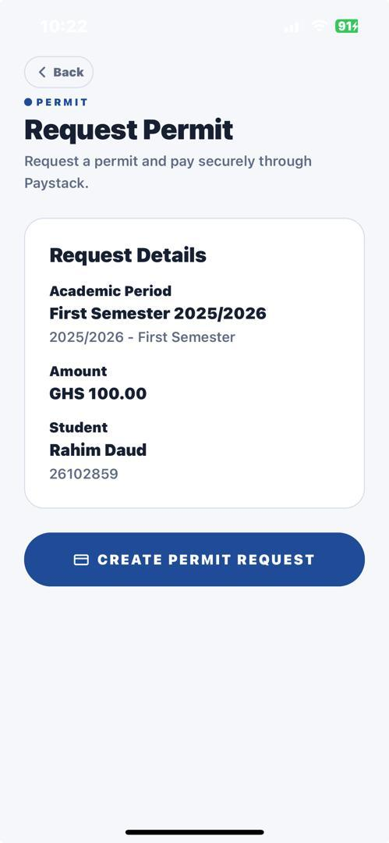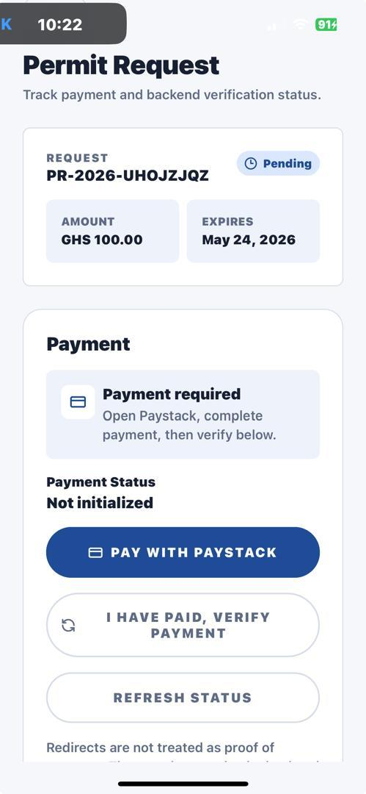
Figure 4.5: Self-Service Permit Request and Paystack Verification Screen
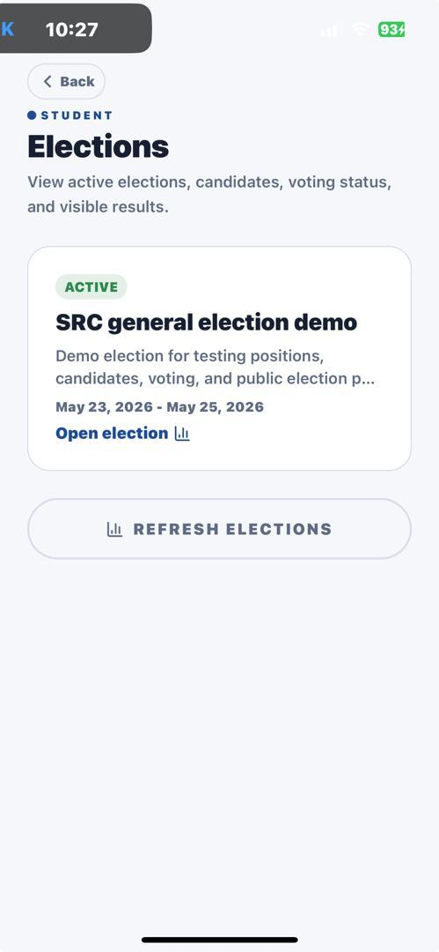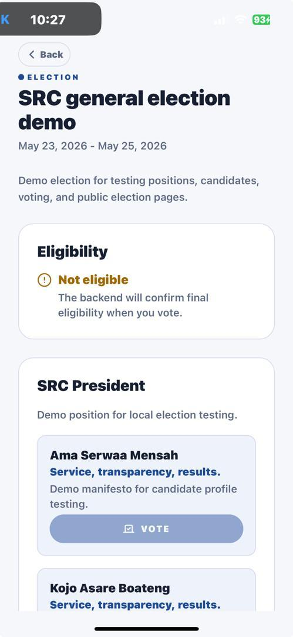
Figure 4.6: Student Election Voting Screen

4.3.3 Mobile Application Implementation
The mobile application extends the student governance platform beyond the dashboard and public portal. It provides students with access to personal permit workflows, governance content, election voting, and NFC card status. It also supports selected staff operations such as verification and card assignment through controlled mobile endpoints.
The mobile implementation was developed around the principle that mobile screens should be thin clients. They display data, collect input, and call endpoints. They do not decide payment success, vote eligibility, permit validity, or staff permissions. Those decisions remain in the backend.
Mobile authentication uses Sanctum token authentication. The mobile application sends email, password, and device name to the login endpoint. The backend validates credentials, rejects inactive users or users without passwords, and returns a bearer token. The token is stored securely by the mobile application and sent with authenticated requests.
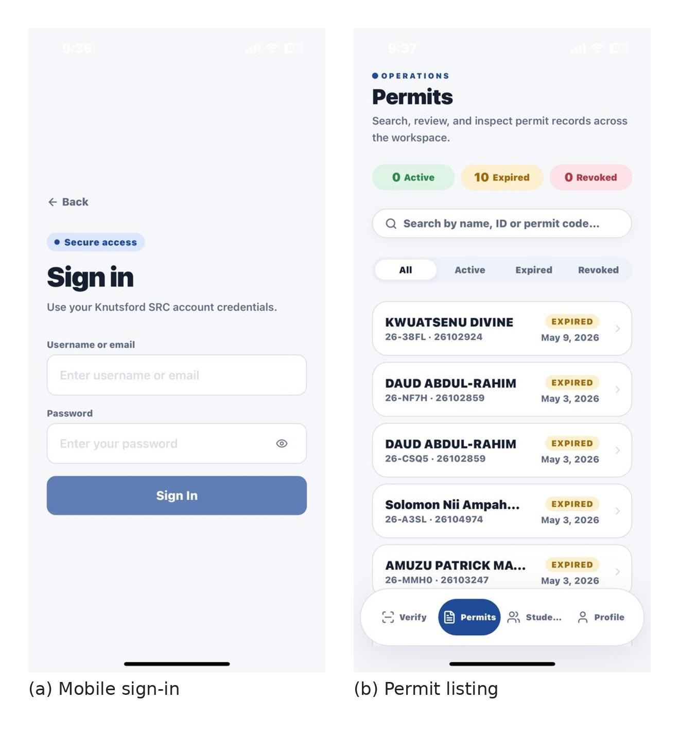
Figure 4.7: Student Mobile Login and Permit Listing Interfaces

4.4 Coding and Implementation Evidence
Only representative implementation evidence is presented in the main report. Full source code remains in the project repository, while selected supporting evidence is presented in the appendices.
Listing 4.1: Permit issuance control logic
resolve academic period -> reject duplicate active permit -> generate protected permit code -> create permit record -> write audit event

4.5 Testing Results and Evidence
Testing was planned around the system's highest-risk workflows: authentication, authorization, student management, permit issuance, payment verification, NFC card management, verification, elections, public content visibility, mobile API access, audit logging, and security boundaries.
The project documentation records a latest full-suite status of php artisan test --compact passing with 266 tests. During this chapter generation session, a fresh attempt to run the same command exceeded the 120-second tool limit, so the current live run could not be completed within the available execution window. The documented 266-test status remains the available project test evidence to reference until a fresh full run is captured for the final submission.
Table 4.2: Testing Results Summary
Test Area | Expected Result | Recorded Outcome
Authentication/permissions | Unauthorized users are rejected. | Passed in feature/security tests.
Permit issuance | Duplicate active permits are prevented. | Passed in permit tests.
Payment verification | Permit issue follows verified payment only. | Passed in payment/self-service tests.
NFC card/verification | Inactive cards fail and raw UID is not exposed. | Passed in NFC/verification tests.
Election voting | Eligibility and one-vote rules are enforced. | Passed in election/mobile tests.
Public/mobile API | Only permitted content and scoped records are returned. | Passed in portal/API tests.
Figure 4.9: Final Test Execution Output

4.6 Deployment and User/System Documentation
Deployment readiness was considered during implementation because the system depends on more than the Laravel request cycle. A production environment requires PHP, web server, PostgreSQL, queue worker, scheduler, writable storage, HTTPS, environment secrets, and build assets.
Environment configuration includes production settings such as APP_ENV=production, APP_DEBUG=false, HTTPS application URL, database credentials, queue connection, cache store, session driver, filesystem disk, Paystack keys, permit code hash key, NFC UID hash key, and webhook secret. Strong secrets are required for APP_KEY, PERMIT_CODE_HASH_KEY, NFC_UID_HASH_KEY, PAYSTACK_SECRET_KEY, and PAYSTACK_WEBHOOK_SECRET.
The deployment workflow includes installing Composer dependencies, installing JavaScript dependencies, building frontend assets, running migrations, clearing and caching configuration, caching routes and views, and restarting queue workers. These steps prepare both backend and frontend assets for production.
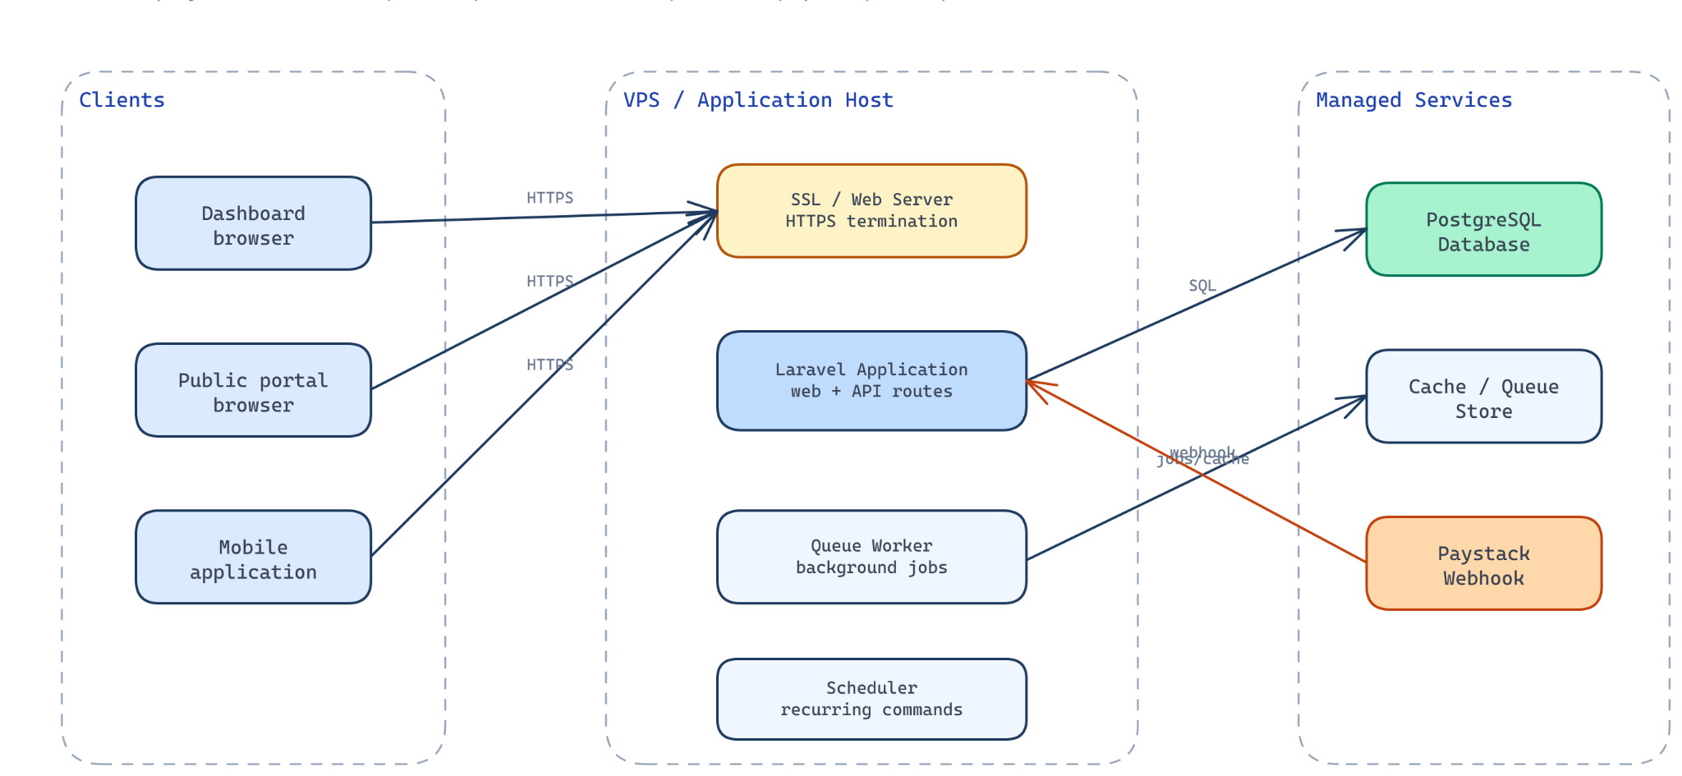
Figure 4.10: Deployment Architecture

4.6.1 Basic User Procedure
- An authorized administrator signs in to the dashboard and configures users, academic periods and permit settings.
- Student records are created or imported, and account activation links are issued where mobile access is required.

4.6.2 Basic System Administration Procedure
- Configure environment secrets, database connection, Paystack keys, hash keys and application URL before deployment.
- Run database migrations and required seeders, then build frontend assets.

4.7 Pilot Implementation Results
A pilot version of the system was implemented within the school environment before full NFC-based verification was introduced. The pilot focused on student registration, permit processing, payment tracking and administrative monitoring. Its purpose was to validate the practical usefulness of the platform before moving to a full NFC rollout.
Table 4.3: Pilot Implementation Results
Metric | Result | Interpretation
Registered students | 2,021 | Student records captured in the system during the pilot.
Permits issued / processed | 2,769 | Permits successfully processed through the pilot workflow.
Successful payments | 2,769 | Completed payment records linked to permit processing.
Revenue generated | GHS 276,900 | Permit-related revenue recorded during the pilot period.
NFC status during pilot | Not fully deployed | The pilot validated the core permit and payment workflow before NFC rollout.
The pilot results show that the system was able to support real administrative activity at scale. Since the pilot version did not include full NFC-based verification, NFC is treated as part of the proposed live implementation phase. The matching number of successful payments and permits processed also shows that the permit-payment workflow can be reconciled clearly during institutional use.

4.8 Chapter Summary
This chapter explained the implementation of the NFC-based student permit verification and governance management system for Knutsford University. It described the development environment, backend technologies, frontend tools, mobile technologies, infrastructure requirements, and module implementation.

CHAPTER FIVE
SUMMARY, CONCLUSION AND RECOMMENDATION

5.1 Summary of the Study
This chapter presents the summary, conclusion, limitations, recommendations, and suggested future work for the study. The previous chapter described how the NFC-based student permit verification and governance management system was implemented, tested, and prepared for deployment. It explained the backend, dashboard, public portal, mobile application, mobile API, payment integration, NFC verification, elections, audit logging, reporting, and security mechanisms that form the completed system.

5.2 Key Findings
The study was motivated by practical challenges in student governance operations, especially where permit issuance, student verification, payment confirmation, elections, public communication, and reporting are handled through manual or fragmented processes. In such an environment, records may exist in paper files, spreadsheets, messaging platforms, payment receipts, or isolated administrative tools. Each of these methods may solve a temporary problem, but they do not provide a unified governance record. This creates delays, weak auditability, inconsistent communication, and difficulty in verifying student identity and permit status when required.
The project focused on Knutsford University and proposed an NFC-based student permit verification and governance management system. The system was designed to support the Students' Representative Council (SRC), students, administrators, security personnel, and other authorized users who participate in student governance workflows. Its main concern was not only to digitize one activity, such as permit issuance, but to connect related governance operations within a controlled platform.

5.3 Conclusions
The completed project addressed the main objectives stated in Chapter One. The achievement summary is provided in Table 5.1.
Table 5.1: Objectives Achieved
Objective | Outcome Achieved
Centralized platform | Dashboard, public portal and mobile-supported services were implemented.
Secure verification | Permit, NFC and alternative verification workflows were implemented with protected identifiers.
Integrated services | Payment verification, elections and public communication modules were connected to shared backend rules.
Evaluation and accountability | Testing, access control, verification logs and audit records validated core workflows.

5.4 Recommendations
The project set out to design and implement an NFC-based student permit verification and governance management system for Knutsford University. Based on the completed analysis, design, implementation, and testing, the study concludes that the proposed system provides a practical and technically grounded response to the institutional problems identified in Chapter One. It addresses fragmentation by bringing student records, permits, payments, NFC cards, verification, elections, public communication, audit logging, and reporting into one coordinated platform.
One of the main conclusions is that student permit verification becomes more reliable when it is supported by structured digital records rather than by physical inspection alone. Manual verification can still have a place in institutional operations, but it is limited when records must be confirmed quickly or reviewed later. The implemented system improves this process by allowing authorized users to verify a student through NFC, permit code, or student number. The inclusion of multiple verification methods is important because it gives the institution flexibility. NFC supports faster contactless verification where supported, while permit code and student number checks provide alternatives when NFC is not available.

5.5 Proposed Live Implementation Plan and Budget
For full institutional adoption, the system should be implemented in controlled phases rather than deployed to all users at once. This reduces operational risk, gives users time to adjust, and allows the school to confirm hardware, payment, training and support requirements before full rollout.
Table 5.2: Proposed Live Implementation Plan
Phase | Activity | Expected Output
Phase 1 | Deploy the current non-NFC version for controlled permit and payment operations. | Stable live dashboard, public portal and payment workflow.
Phase 2 | Clean and import student records, confirm roles and activate user accounts. | Verified student and staff access structure.
Phase 3 | Procure NFC cards/tags and register them against student records. | NFC identifiers linked to valid student records.
Phase 4 | Train SRC executives, staff and verification officers on dashboard, mobile and NFC workflows. | Prepared users and reduced operational errors.
Phase 5 | Run a monitored live rollout with backups, audit review, reports and support procedures. | Full operational use with maintenance and monitoring.
The estimated budget below is indicative and should be reviewed through the university procurement process before live deployment. The figures are based on the expected needs of a first-year implementation covering hosting, NFC materials, verification devices, onboarding and support.
Table 5.3: Estimated Live Implementation Budget
Budget Item | Purpose | Estimated Cost (GHS)
Hosting and backend deployment | Production server, database setup, application configuration and deployment support. | 3,000
Domain, HTTPS and environment configuration | Secure public access, SSL/HTTPS setup and production environment configuration. | 500
NFC cards/tags | Approx. 2,800 NFC tags/cards for student permit verification. | 14,000
NFC-enabled verification devices | Three Android/NFC-capable devices for verification points. | 4,500
Internet/data support | Connectivity support for verification and administrative activities. | 1,500
Training and onboarding | Training for SRC executives, staff, administrators and verification officers. | 2,000
Maintenance and technical support | System updates, backups, issue resolution and first-year support. | 4,000
Contingency | Allowance for price changes, replacement tags and minor deployment adjustments. | 2,950
Estimated Total |  | 32,450
The budget shows that the proposed system can be implemented using a phased and controlled approach. The pilot revenue of GHS 276,900 also indicates that the platform is capable of supporting financially significant permit operations, but financial figures should continue to be reconciled through approved university accounting procedures.

REFERENCES
ACE Electoral Knowledge Network. (n.d.). Electoral technologies. https://aceproject.org/ace-en/topics/em/et
Mohd Nasir, M. A. H., Asmuni, M. H., Salleh, N., & Misra, S. (2015). A review of student attendance system using Near-Field Communication (NFC) technology. In Computational Science and Its Applications—ICCSA 2015 (pp. 738–749). Springer. https://doi.org/10.1007/978-3-319-21410-8_56
Expo. (n.d.). Expo documentation. https://docs.expo.dev/
Fielding, R. T. (2000). Architectural styles and the design of network-based software architectures (Doctoral dissertation). University of California, Irvine. https://www.ics.uci.edu/~fielding/pubs/dissertation/top.htm
Google. (n.d.). Near Field Communication. Android Developers. https://developer.android.com/develop/connectivity/nfc
Inertia.js. (n.d.). Inertia.js documentation. https://inertiajs.com/
Laravel. (n.d.-a). Laravel documentation. https://laravel.com/docs
Laravel. (n.d.-b). Laravel Sanctum. https://laravel.com/docs/sanctum
Laravel. (n.d.-c). Queues. https://laravel.com/docs/queues
Laravel. (n.d.-d). Cache. https://laravel.com/docs/cache
Meta. (n.d.-a). React. https://react.dev/
Meta. (n.d.-b). React Native. https://reactnative.dev/
National Institute of Standards and Technology. (2017). Digital identity guidelines (NIST Special Publication 800-63-3). U.S. Department of Commerce. https://doi.org/10.6028/NIST.SP.800-63-3
NFC Forum. (n.d.). NFC technology. https://nfc-forum.org/our-work/nfc-technology/
OWASP Foundation. (2021). OWASP application security verification standard 4.0.3. https://owasp.org/www-project-application-security-verification-standard/
Paystack. (n.d.-a). Developer documentation. https://paystack.com/docs/
Paystack. (n.d.-b). Verify payments. https://paystack.com/docs/payments/verify-payments/
PostgreSQL Global Development Group. (n.d.). PostgreSQL 18 documentation. https://www.postgresql.org/docs/
Sandhu, R. S., Coyne, E. J., Feinstein, H. L., & Youman, C. E. (1996). Role-based access control models. IEEE Computer, 29(2), 38–47. https://doi.org/10.1109/2.485845
Tanenbaum, A. S., & Wetherall, D. J. (2011). Computer networks (5th ed.). Prentice Hall.

APPENDICES

APPENDIX 1: SELECTED IMPLEMENTATION AND TEST EVIDENCE
This appendix presents a concise record of implemented modules and validated workflows. Detailed source code, route listings and full test logs are retained in the project repository and can be submitted separately when requested.

A.1 Core Implemented Modules
Module | Implemented Evidence
Permit and verification | Permit lifecycle, NFC registration, permit-code and student-number verification.
Payment | Paystack initialization and server-side verification linked to permit requests.
Elections | Eligibility validation, candidate approval and duplicate-vote prevention.
Governance and reporting | Published content, role-based access, audit logs and reports.

A.2 Summary of Validation
Test Area | Validated Result
Authentication and authorization | Protected workflows reject unauthorised access.
Permit/NFC verification | Valid states return authorised results; invalid or revoked identifiers are rejected.
Payment verification | Verified payment completes eligible processing without duplicate issuance.
Election voting | Eligible students can vote once per applicable position.
Security note: raw NFC identifiers, permit codes and payment secrets are not reproduced in this report.

