Lesson 1

Preliminary remarks about studying Pahlavi
Since Pahlavi is an Indo-European language, its grammar and grammatical terminology are those typical of such languages (English, German, French, Latin, etc.). The grammatical terminology of Semitic languages, for instance, Hebrew, can not be applied, so, if one has had little exposure to Indo-European grammatical terminology, one should study a book on grammar.
The grammar of Pahlavi is, at first glance, quite similar to that of Farsi, but there are some crucial differences, to which the Iranian students should pay special attention.
Pahlavi is difficult to get into because of its script, so one should try to memorize as much vocabulary as possible as one goes along. The spelling is particularly difficult, so one should get used to relying on one’s memory rather than on dictionaries and glossaries. Trying to find a word written in Pahlavi script in a dictionary usually takes a long time. For this reason, one should start compiling one’s own mini-dictionary right away. It is the best way to learn the words. Categorize the words into nouns, adjectives, arameograms, etc.
One should be able to figure out the meanings of the individual words in the sentences quoted with translations from the explanations in the grammar sections.
One should read through the entire lesson before studying it in detail, since, occasionally, a feature in a sentence is explained in what follows.
Numerous words included as examples in the sections on spelling and arameograms are not necessarily high-frequency and need not be learned. High-frequency words and important terminology will be repeatedly used in the examples and exercises to ensure familiarity.

Sound system
The phonology (sound system) of Pahlavi is similar to that of modern Persian.
Vowels are short or long (marked by a macron):

a e i o u
ā ē ī ō ū

Vowels should be pronounced cleanly, that is, as in Spanish and Italian, for instance. English diphthongization should be avoided (ei for ē, etc.).
It is not clear whether the vowels e and o were “phonemes,” that is, whether there were words that were only distinguished by one having i and the other e. On the whole it is doubtful. Here, e and o will be used consistently in cases where they may have occurred (e.g., kerbag [not kirbag] “good deeds,” and abdom [not abdum] “last”). To find such words in dictionaries and glossaries, you may have to look for the forms with i and u.

The consonants are as in modern Persian. Note the use of a haček in č, ǰ, š, and ž.
- č and ǰ are the sounds in English church and judge.
- š is English sh, German sch, French ch, etc.
- ž is the voiced sound of English pleasure. It is only found as a variant of ǰ before d and g as in duždēn “having an evil dēn,” for which we shall write duǰdēn; yōždahr “ritually clean,” for which we shall write yōǰdahr; aždahāg “dragon” from Avestan aži dahāka, for which we shall write aǰdahāg; and ažgahān “indolent,” for which we shall write aǰgahān. There may have been other sporadic cases, such as miǰag (mižag), Pers. može “eyelash.”
- x is the ch-sound in German Bach and the Spanish Spanish j-sound in juego (not as in American Spanish, where the j is pronounced as English h).
- γ (Greek gamma) is the sound of the Spanish g between vowels, as in haga. It is a variant of g used probably by influence from Avestan, e.g., moγ “Magian" instead of regular mow from Avestan moγu (< magu).
- xw was probably a sound like Eng. wh, when pronounced with aspiration (rather than simply as w), but with x (xw) instead of h (hw).
There were probably double consonants (geminates) kk, rr, tt, zz, e.g., waččag “child” = Pers. bač(č)e.

The Pahlavi script
The Pahlavi alphabet contains only twelve different letters to express all these sounds. Several of the letters therefore have many values, which makes reading difficult. This difficulty is compounded by the various shapes the different letters can take.
As students progress, they will become used to recognizing whole words rather than identifying each letter and finding a possible combination that produces a word and makes sense in the context.
The thirteen letters in the alphabetical order — right to left — used in MacKenzie’s Dictionary and their equivalents in the Semitic alphabets are as follows (the values of the letters are discussed below):

T Í C P M L ˚ K Z W Y, D, ï B A
t š č p m l γ k z w y b ’ (a)

Note the various forms of <y>. The use of <’> (alef or hamza) is a practice taken over from Semitic alphabets.

The following are (relatively) unambiguous letters:

B b K k ˚ γ L r, l C c
Z z M m Í š P p T t

When L spells l (rather than the more common r), it is often written R .
The very ambiguous letters are:

As vowels As consonants
A a, ā ’ - h - x
Y D ï i, ī, e, ē, ay d - g - ǰ – y ï + D = S and D + D = J also = s
W u, ū, o, ō, aw n - w - r

When these three letters express vowels, they are often called matres lectionis “mothers of reading.” Long vowels and diphthongs, as well as short u, are always spelled with matres lectionis, while short i may or may not be spelled with <y>. The assumed e and o are sometimes spelled with, sometimes without <y> and <w>.
Note that short a is rarely written and that long ā is written with <’>.

Adding the ambiguous letters and combinations to the alphabeth, we get the transliteration values:

T Í W C, c c , P S, J W M L ˚ K Z Y A W Y Y B A
t š r č p̄, p s, yy n m l γ k z y h w d g b ’

The script is a cursive script, that is, the letters are combined with one another.
The letter ˚ is found in a few words only.
Typical of the Pahlavi cursive is the way some letters are combined by a deep curve, dropping below the “base line” of the script, while others are not, for instance:

A + A > aÅ B + A > bA
W + A > wA K + A > kA
W + M > N M + A > µA

A + Y > E K + Y > I or kY
W + Y > wY M + Y > µY
Y + Y > S T + Y > tD

The only “tall” letter is L , which may be combined on the base line or below:

L + T + W > LTW <wtl> wattar “worse” L + W + P > LWP <pwl> purr “full (of)”
L + A + K > lAK <k’l> kār “work” L + A + M > la˜ <m’l> mār “snake”
T + A + L > tåÒ <l’t> rād “generous” K + M + L > kmL <lmk> ramag “herd”

The combination form of the letter P <p> is often identical with the combination form of the letter C <c>.
When that is the case, we usually transliterate <p> as <p̄>:

P + A > pA <’p> or cÅ <’p̄> C + A > cÅ <’c>
P + Y > pY <yp> or cD <yp̄> C + Y > cD <yc>
P + M > pM <mp> or c˜ <mp̄> C + M > c˜ <mc>
P + Z > pZ <zp> or c¸ <zp̄> C + Z > c¸ <zc>
P + L > pL <lp> or cÒ <lp̄> C + L > cÒ <lc>

Note the alternative forms of combinations with the letters L <l> and Z <z> on or below the “base line”:

W + L > wL or {<lw> W + Z > wZ or U <zw>
P + L > pL or fÒ <lp> P + Z > pZ or f¸ <zp>

In the manuscripts, there are still other variations, e.g., P + A > fÅ , Í + A > ˙Å , etc.
The word for the Evil One, Ahrimen, is often written up-side-down as ‹ for WwmlaÅ <’hlmn'>, also when followed by suffixes or enclitics: 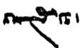 for <’hlmnyk’> “Ahrimenian,”  <’hlmn'-c> “Ahrimen, too.”

Note that the following letters are never combined to the left:

B b C c K k ˚ γ P p T t W w

Evolution of the script from Aramaic to Pahlavi

Semitic  alphabet | Hebrew  Farsi | Transliteration values | Parthian  inscriptions | MPersian  inscriptions | Psalter | Pahlavi | Identities
’ | א - ا | a A | a | a | A | A | = h
b | ב - ب | b B | b | B | B | B | = 1
g | ג - گ | g G | g | g | G | Y Á | = y, d
d | ד - د | d D | d | d | D | Y d | = g, y
ẖ | ה - ه | - E | e | e | E | N | = m + n
w | ו - و | w W | w | w [= O, r] | W | W | = n, r, O
z | ז - ز | z Z | z | z | Z | z
ḥ | ח - ح | h H | h | h | H | A | = O
ṭ | ט - ط | - ṭ | ƒ | † | - | -
y | י - ی | y Y | y | (final) ¥... y | (final) Á... Y | Y D | = g, d
k | ך - ک | k K | k | k | K | (˚ ) K
l | ל - ل | l L | l | l | L | (O Ø R ) L
m | מ - م | m M | m | m | M | M | = Q
n | נ - ن | n N | n | n | N | W | = w, r, O
s | ס - س | s S | s | s | S | S J | = y + y, etc.
‘ | ע - ع | O | r [= r] | w | W | W | = n, r, w
p | פ ף - پ | p P | p | p | P | P
ṣ | ץ צ - چ | c C | c | c | C | C c | c = p̄
q | ק - ق | Q | q | m | M | M | = m
r | ר - ر | n N | r [= O] | w | W | W | = n, w, O
š | ש - ش | š Š | π | π | π | ò (aD) | (= y + ÷)
t | ת - ت | t T | t | t | T | T

Notes: The capital letters are used to transliterate arameograms. This will be explained presently.
N = <E>; M = <Q>; and W = <O> only in arameograms.
The letter <ṭ> (ط) is no longer used in Pahlavi, where it was replaced by T <t>.

Spelling 1
For various reasons, Pahlavi was not written the way it was pronounced, but rather as it had been pronounced centuries earlier. This is similar to the case of French and English.
In order to determine the actual pronunciation, we may compare the spellings used in the Manichean texts of the 3rd-4th centuries, which were written in a Syriac alphabet, which showed the actual pronunciation. We may also compare the modern Persian (Farsi) pronunciation. Finally, we may consider the etymology (history) of the word to reconstruct the presumed pronunciation.
The general rule is that all the letters at the beginnings of words are pronounced as they are written, but when not at the beginning all kinds of changes occur. Compare the spelling and pronunciation of the following:

µÍCwA <hwcšm> hučašm “benevolent” CWB <bwc> buz “goat”
YWfJwY <gwspnd> gōspand “domestic animal” tD <dt> dad “wild animal”
gLwY <gwlg> gurg “wolf” íYtJ <gytyḏ> gētīy “the world-of-the-living, this world”
ÍwïdlY <dlygwš> driyōš “poor” lAk <k’l> kār “work”
tjYL <lyst> rist “departed, dead” kmL <lmk> ramag “herd, flock”
la˜ <m’l> mār “snake” ÓdM <myš> mēš “sheep”
MWt¬M <mltwm> mardōm “people, humans” LWP <pwl> purr “full (of)”
lïH <šyl> šēr “lion” LTW <wtl> wattar “bad, evil”
kahAWT <twhš’k> tuxšāg “diligent” thAWt¬Z <zltwhšt> Zarduxšt “Zarduxšt”

Notes:
Double consonants are not written double, except in some compounds, e.g., LKKCB <bckkl> bazzak-kar “evil-doer” (more commonly lYKCB <bckgl>)
When a letter is not what it seems to be, we often put a line under it, e.g., íYtJ <gytyḏ> gētīy “this world.”

Transliteration and transcription
Above, what is inside < > is a one-to-one correspondence between the Pahlavi and Latin alphabets. We call this trans-LITER-ation, meaning “transferring letter to letter.”
The pronunciation of the word is in cursive. This is called tran-SCRIP-tion, meaning that we “write” out the word so it can be pronounced.
Later, we shall talk more about various ways of transliterating and transcribing Pahlavi.

Grammar 1

The sentence
Pahlavi sentences can be short and clear or long and ponderous. The most common constituents are subject, direct object, and verb, in that order.
There are no definite or indefinite articles.
Personal pronouns as subjects of verbs may be left out.

Word order
The inflected verb is usually at the end of the clause or sentence.
The basic word order is therefore:
Subject - Verb, e.g.: Pērōz framāyēd “Pērōz commands,” Pērōz ōzad “Pērōz was-killed”
Subject - Indirect object - Direct object - Verb, e.g.:
hērbed hāwištān mizd dahēd
“the Hērbed + the students + reward + gives” = “the Hērbed gives the students a reward”

This is the word order that should preferably be used in the translations from English in the exercises.
The word order is relatively flexible, however, and a predicate or direct object is often “lowered” behind the verb, or the verb may be “raised/fronted” to in front of the subject.
Adverbs and complements of time, place, manner, etc., may precede the subject and are often placed at the beginning of the sentence, but they can also occur elsewhere in the sentence in various logical places.

Note on terminology:
In Western (Indo-European) languages, what one calls the “subject” of a clause is usually defined as the person or object that performs an action (or utters a statement, thinks a thought) or is (or gets into) a state, for instance:
action: “God created the world”; “Zarduxšt spoke a word”; “have you reflected on this?”
state: “man sleeps”; “we all die.”
In these cases, the subject is what is most closely connected with the verb, and the verb “agrees” with the subject.
There are examples of clauses that have no subject, for instance, “it rains,” “it is impossible,” in which “it” is an “empty” marker of the subject in English, but has not equivalent in Pahlavi. Such clauses are called “impersonal.”
There are also examples of clauses in which the one who performs the action is not what the verb agrees with, as in “the Zoroastrians were persecuted by the Arabs.” Here the agents are “the Arabs” and the verb agrees with “the Zoroastrians.” We call these clauses passive. In this Introduction, the term “subject” shall only refer to the part of the sentence with which the verb “agrees.”
The so-called ergative construction is like the English passive (Lessons 13-14).
A “predicate” is a noun or adjective connected with a noun (pronoun) by the verb “to be,” e.g., “the man is big,” “we are hungry,” “he is a teacher.”

Nouns
Important: Nouns as subjects and predicates have the same form in the singular and the plural.
If a noun as subject is singular, the verb is 3rd person singular. If a noun as subject is plural, the verb is 3rd person plural:

andar mān dēw būd “a demon was in the house” = “there was a demon in the house”
andar mān dēw būd hēnd “demons were in the house” = “there were demons in the house”

On the plural ending -ān, see Lessons 2, 3, 11. On the plural ending -īhā, see Lesson 8.
On the verbs, see below.

Personal pronouns
The personal pronouns used as subject are the following:

Singular Plural
1st an “I” 1st amāh “we”
2nd tō “you, thou” 2nd ašmāh “you, ye”
3rd ōy “he, she, it” 3rd awēšān “they”

Notes:
MacKenzie, in his Dictionary has “*az,” for an “I,” but that is the Parthian form. He also has amā and ašmā (Manichean amāh, ašmāh).
On the 1st singular man, see Lesson 4.
Do not confuse the 2nd singular and plural, which are not distinguished in English.
Note that pronouns as subject can be omitted when there is no risk of ambiguity, as in Italian and Spanish.

Appositions
These work as in English, e.g.:

amāh driyōš mazdēsn andar mān hēm “we, the poor Mazdayasnians, are in the house”

“To be”
The present (indicative), imperative, and past tense of “to be” are as follows:

Present tense: Imperative:
Singular Plural Singular Plural
1st ham “I am” hēm “we are”
2nd hē “you are (thou art)” hēd “you (ye) are” bāš “be!” bawēd “be!”
3rd (nothing) “he/she/it is” hēnd “they are”

Notes: MacKenzie, in his text editions, uses the Manichean 1st singular ending -ēm, but the Pahlavi manuscripts normally have -am.
On 3rd singular ast/nēst, see Lesson 7.

Past tense:
Singular Plural
1st būd ham “I was, I have been” būd hēm “we were , we have been”
2nd būd hē “you were, you have been” būd hēd “you were, you have been”
3rd būd “he, she, it was, has been” būd hēnd “they were, they have been”

Enclitic and phonetically written forms without h- occur, but are rare. The most common is probably the 2nd plur. -ēd “you (two/all) are” (see Sentences 1).

Negations
The common negation is nē “not,” occasionally find nē nē “not at all.”
The negation ma “(do) not” is used with imperatives.

Questions
Questions are distinguished from statements only when introduced by question particles, for instance interrogative pronouns (kē “who?” etc.).

Sentences 1
Analyze the following sentences:

ay mard tō kē hē “O man, who are you?”
an Kay Husrōy ham = an ham Kay Husrōy “I am Kay Husrōy”
ašmāh kē hēd “Who are you (all)?”
amāh mazdēsn hēm “We are Mazdayasnians”
ašmāh driyōš mardōm hēd “you (all) are poor people”
awēšān mard hēnd zan nē hēnd “they are men, not women”
dēw hēnd nē mardōm “they are demons, not humans.”
andar mardōm ērtan ud čarb ud hučašm bāš “among people, be humble and amenable and benevolent!”
ašmāh pad kār ud kerbag tuxšāg bawēd “(you all), be diligent in (your) work and good deeds!”
pad Ahrimen wistāx ma bawēd “do not be confident in (= rely on) Ahrimen (the Evil One)!”
pad gētīy nē būd ham “I have not (always) been in this world”
andar mān mār būd “(there) was a snake in the house”
fradom mardōm andar abēgumānīh būd hēnd “the first humans were in a state of non-doubt”
andar šahr was mazdēsn būd hēnd “In the land, there were many Mazdayasnians”
dušdānāg dēw-ēd “you are stupid demons”

Exercises 1

1. Practice writing the Pahlavi words in this lesson, using lined paper.
Note that Pahlavi is written on a straight line, never slanting, like Persian (Farsi).
Note in particular the height and depth of the letters relative to the base line, e.g.:
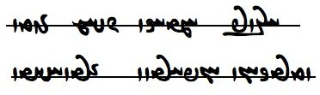

2. Match the Pahlavi words with their transliterations and identify them with words in this lesson:

ÍwïdlY <bckkl> µÍCwA <hwp>
Ewa˜wïDcÅ <bwc> MWt¬M <k’l>
CWB <bwt> MWtÒP <krpkkl>
kahAWT <clp> MwYcÅ <ky>
kmL <dlygwš> nlaÅ <lmk>
la˜ <dt> pLC <lt>
lAk <gwlg> PwA <m’l>
lïH <pltwm> thAWt¬Z <mltwm>
LKKCB <gwspnd> td <m’n>
LKKPWK <gytyd> tÒ <myš>
LTW <’hlmn> TWB <’pdwm>
LWP <hwcšm> wa˜ <pwl>
Wt¬ïÅ <’pygwm’nyh> íYtJ <wtl>
YK <šyl> YWfJwY <’yltn>
gLwY <twhš’k> ÓdM <zltwhšt>

3. Translate into English (do not attempt to write in Pahlavi):

- an Pērōz ham tō Wahrām hē
- ašmāh mardōm hēd
- gurg ud šēr dad hēnd
- pad gētīy wistāx ma bāš
- pad mardōm wistāx ma bawēd
- mān purr wattar mār būd
- andar ramag gurg būd hēnd
- ašmāh andar mazdēsn šahr ērtan bawēd
- amāh mazdēsn driyōš mardōm nē hēm
- Zarduxšt pad gētīy kār tuxšāg būd pad driyōš hučašm būd

4. Translate into Pahlavi (use transcription and write in Pahlavi):
Be sure to study the sentences with translations above to get used to the correct word order.

- You are Kay Wištāsp, I am Zarduxšt.
- Kay Wištāsp was a Mazdayasnian.
- You are Mašīy and Mašyānīy; you were the first humans (people).
- O Zardušt, be amenable and humble to a Mazdayasnian!
- O Mazdayasnians, in the land of the Iranians be benevolent and diligent!
- Ahrimen has not (always) been in this world.
- There were many demons in this world.
- The sheep and the goat are domestic animals.
- O man, be amenable and benevolent to (your) wife (= woman)!
- O woman, be humble toward (your) man!

Glossary of words in the Sentences and the Exercises 1

Note: Grammatical words in the lesson are not included. The students are not expected to learn the spelling of words spelled with arameograms (tranliterated in upper case), but they are included here for future reference.
On the extra W <'> at the end of some words, see Lesson 2.
On the words in CAPS (the arameograms), see Lesson 3.

Idioms:
kār ud kerbag (kār kerbag) work and good deeds; all activities
pad ... wistāx baw- have confidence in

Nouns, adjectives, adverbs, pronouns, etc.:
abēgumānīh Ewa˜wïDcÅ <’p̄ygwm’nyh> state of non-doubting; freedom from doubt
andar x <BYN> in, inside; during
abdom MwYcÅ <’p̄dwm> last; in the end
ay Ä <’y> O! particle of address
buz WCWB <bwc'> goat
bazzakkar LKKCB <bckkl> evil-doer, someone who does evil deeds
būd TWB <bwt> was
čarb WpLC <clp'> amenable
dad Wtd <dt'> wild animal
dēw aåH <ŠDYA> demon, demons
driyōš ÍwïdlY <dlygwš> poor
ērtan WWt¬ïÅ <’yltn'> humble
fradom MWtÒP <pltwm> first
gētīy íYtJ <gytyḏ> this world (of the living); adj.: being in/of the gētīy
gōspand YWfJwY <gwspnd> domestic animal
gurg gLwY <gwlg> wolf
hučašm µÍCwA <hwcšm> benevolent; “toward”: pad
kār lAk <k’l> work, activities
kay YK <kd> a title (Av. kauui)
kē WN <MNW> who, whom, whose; who, whom, whose?
kerbag WKPWK <krpk'> good deeds
kerbakkar lYKPWK , LKKPWK <krpkkl, krpkgl> someone who does good deeds
mān Wwa˜ <m’n'> house, mansion
mār la˜ <m’l> snake
mard AWbY <GBRA> man, men
mardōm MWt¬M <mltwm> people, humans
mazdēsn Wt∆da˜ , Wtja˜ <mzdysn' (= mh[y]yyt')> Mazdayasnian (noun and adjective; see Lesson 3 on the spelling)
mēš ÓdM <myš> sheep, ewe
pad WWP <PWN> in, to, toward, by (etc.)
purr LWP <pwl> full; “of”: + noun or + az + noun
ramag WkmL <lmk'> flock
šahr WWtH <štr'> land; town
šēr lïH , :dÍ <šyl> lion
tuxšāg WkahAWT <twhš’k'> diligent; “in”: pad
was SW , YBK <KBD (KBYR), ws> much, many, very
wattar LTW <wtl> bad, worse, worst
wistāx WwaÅtJW <wst’hw'> confident; pad ... wistāx baw- “be confident/have confidence in”
xūb WPwA <hwp'> good
zan nßYW <NYŠE> woman, women

Names:
Ahrimen WnlaÅ <’hlmn'> Ahrimen, the Evil One
Ērān šahr WWtH Wwa¬Ä <’yl’n štr'> land of the Iranians, Iran
Husrōy Y]JwA <hwslwd> Husrōy (later Husraw, Xosrow)
Mašīy îHM <mšyḏ > Mašīy
Mašyānīy íYwaåHM <mšyd’nyḏ> Mašyānīy
Pērōz WCwlYP <pylwc'> a name
Wahrām µa¬aÅW <w’hl’m> a name
Zardušt, Zarduxšt WtHWt¬Z , WthAWt¬Z <zltw(h)št'> Zardušt, Zarduxšt, Zarathustra

Verbs:
baw- būd WTWB -WWwaD <YHWWN- bwt'> be, become

Lesson 2

Spelling 2

The “otiose” stroke
The letter W < ' > is often added at the end of a word to signify the end. For some reason, this is often referred to as the “otiose” stroke, but could also be called a “final” or “superfluous” stroke.
The stroke is only added after the six consonants that do not connect to the left, so the stroke is always written separately and is never combined with a preceding letter (to the right), e.g.:

With “otiose” stroke:

WBwlY <dlwb'> drōw “deception, lie” WCwA <’wc'> ōz “strength”
WtÒ <lt'> rad “ratu” WPT <tp'> tab “fever”
WkmL <lmk'> ramag “herd, flock”

No otiose stroke is possible after letters that combine to the left:

aåD <g’h> gāh “throne, place” YN <mng> mang “hashish”
LKKCB <bckkl> bazzakkar “evil-doer” MWtÒP <pltwm> fradom “first”
ÍwY <gwš> gōš “ear”

Not all scribes used the final stroke or used it consistently, so, depending on the scribe, the words būd “was” and būdan “to be(come)” may be differentiated as follows:

with final < ' > without final < ' >
būd: WTWB <bwt'> TWB <bwt>
būdan: WWTWB <bwtn'> [WTWB <bwtn> not used]

In this Introduction, the final stroke will be used regularly from now on.
The otiose stroke is also frequently used inside words, either before suffixes (e.g., EWwZ <zn'yh> zan-īh “wife-hood”) or for no particular reason (e.g., Y>WwZWP <przn'd> “offspring”).

Consonants
The unvoiced consonants P T k C <p, t, k, c> are used to spell these sounds (p, t, k, č) when at the beginning of a word; after f [spelled <p>], x, s, š; or when double. This section should be read through (at least) twice, as some rules are given after the first example is cited.

Examples:

Initial:
lAk <k’l> kār “work” lAT <t’l> tār “darkness”
LWP <pwl> purr “full” lAC <c’l> čār “able, capable”

After f, x
WTcÅ <hp̄t'> haft “seven” WTPwY <gwpt'> guft “said”
WtåJ <sht'> saxt ”hard, firm(ly)” LtåÅ <’htl> axtar “constellation”

After s, š:
W˝JW <nsk'> nask, book of the Avesta WtjaÒ <l’st'> rāst “straight, true, truthful”
WfJW <wsp'> wisp “all” WtHWK <kwšt'> kušt “killed”
WkßlA <’lšk'> arešk “envy” WfjAtHW <wšt’sp'> Wištāšp, a king

Double:
LKKPWK <krpkkl> kerbakkar “doer of good deeds” (from kerbag + kar)
LTW <wtl> wattar “bad, evil” (from wad + tar)
WtÒWcÅ <’p̄wlt'> appurd “stole” (from older *apa-p-)
WKCW <wck'> waččag “child”

When the same consonants P T k C <p, t, k, c> come after a vowel or a voiced consonant, they are (usually) pronounced voiced b, d, g, z. After n, <c> is pronounced ǰ. We know this from the way the words are spelled in Manichean Middle Persian already in the 3rd century CE.
Examples:

WPT <tp'> tab “fever” WkmL <lmk'> ramag “herd, flock”
WPwA <hwp'> xūb (xūb) “good” WKPWK <krpk'> kerbag “good deed”
WKCB <bck'> baz(z)ag “evil deed”

WCwA <’wc'> ōz “strength” EKcDcÅ <’p̄yckyh> abēzagīh “purity”
WtD <gt'> gad “club” WtåÒ <l’t'> rād “generous”
WKtÒN <mwltk'> murdag “corpse” WcÒW <wlc'> warz “miraculous power”
MWt¬M <mltwm> mardōm “people” CWP <pnc> panǰ “five”

Exceptions include the following common words which have final -k and -č according to Manichean Middle Persian and modern Persian (Farsi):

WilAT <t’lyk'> tārīk “dark” W˝∆¸W, Wiï>¸W <nzdyk'> nazdīk “near”
EilAT <t’lykyh> tārīkīh “darkness” E˝∆¸W, Eiï>¸W <nzdykyh> nazdīkīh “nearness, vicinity”
WcdA <’yc'> ēč “any(thing)”

some Avestan words:

ßAtÅ <’thš> ātaxš “fire” ÍkLW <wlkš> Warkaš, the Warkaš sea
íYtJ <gytyḏ> gētīy “world-of-the-living”

and in compounds:

WklAWkA <’kn’lk'> a-kanārag “limitless” < WklAWK <kn’lk'> kanārag “border, side”

The letter P is also used to spell f, usually before consonants, but also between vowels and in final position, e.g.:

MWtÒP <pltwm> fradom “first” WPWK <kwp> kōf “mountain”
LPW <wpl> wafr “snow” WKcÅ <hp̄k'> xafag “strangled”

The letter <z> spells z also before and after a consonant; in final and between vowels it is relatively rare (except in arameograms) and almost only in compounds, e.g.:

zA <’z> az “goat” (rare word from Avestan aza)
ï<ΩA , g<zA <’zg> azg “branch”
ï>ΩM , g>zM <mzd> mizd “fee, reward”
tda¸cÅ <’p̄z’yt> abzāyēd “it increases”
WwaÂlzA <’zlm’n'> a-zarmān “unaging” < WwaÂlZ <zlm’n'> zarmān “old age”

Grammar 2

The use of -ēw “one” to specify
There is no indefinite article in Pahlavi, but the numeral !- <-1> -ēw “one” can be added to a noun to signify “one particular, a certain” and similar. Sometimes it comes close in function to the English indefinite article, but one should not make it a habit to translate every English indefinite article by Pahlavi -ēw! E.g.:

rōd-ēw !WTwL “a (certain) river” gyāg-ēw būd WTWB !WkAwïD “there was a (special) place (where)”
kanīzag-ēw !WKcDWK “a (certain) girl” čiyōn mard-ēw ī Y 1AWvY WwSC “like a man who”

Singular and plural
Normally, the verb agrees with the subject in number.
When plurality is not emphasized, but rather species, the singular is normally used, e.g.:

pad āsmān stārag ud axtar ud abāxtar ast
“there are [ast: see below] stars, constellations, and planets in the sky” (not hēnd)

When two or more 3rd plural past tense forms follow, the plural may be indicated on the last only, e.g.:

pad kerbag kerdan tuxšāg būd
ud az wināh pahrēxtār būd hēnd
“they were (būd) diligent (tuxšāg) in performing (kerdan [infinitive]) good deeds
and kept away (pahrēxtār būd hēnd) from sin (az wināh)”

The noun mardōm “people, humans” is always plural:

ēn mardōm kadām hēnd
“which (= who) are these people?”

The plural ending -ān with plural nouns governed by prepositions.
The plural ending -ān is used when nouns are governed by prepositions (postpositions), e.g.:

ēn kanīg ō abārīgān kanīgān nē homānāg
“this young woman is not like (other) young women”

Zarduxšt pad mardōmān rād ud rāst būd
“Zarduxšt was generous and straight/truthful toward people”

More examples of the ending -ān are given below. See also Lesson 11.

The adjective/adverb was “much, many, very”
This adjective is very commonly used to qualify nouns and adjectives, e.g.,

andar ērān šahr was mazdēsn būd hēnd
“in the land of the Iranians (= Iran), there were many Mazdayasnians”

ēn kanīzag was hučihr ān rēdag was huwīr
“this girl is very pretty, that boy is very manly”

Note the alternative word order, in which was is the predicate of the noun it qualifies:

andar ērān šahr was mowmard hēnd
“in the land of the Iranians, there are many Zoroastrian priests”
beside
andar ērān šahr mowmard was hēnd
“in the land of the Iranians, Zoroastrian priests are many”

Possession 1
Possession can be expressed by simply putting the possessor in front of what is possessed, similar to English In God’s name (as opposed to In the name of God).
If the possessor is a plural noun, it usually takes the ending -ān, e.g.:

pad Ohrmazd nām “in Ohrmazd’s name”
pad yazdān nām “in the gods’ name”
dēwān dām “the creation of the evil gods.”
andar mardān ruwānān “in men’s souls”

“To be” and “not to be”
To express existence, the verbs ast “exists” and nēst “does not exist” are used, past tense būd, future bawēd “there will be.
These forms are also used to express “there is, there are.”
The plural forms hēnd, nē hēnd, būd hēnd are used when plurality is emphasized.
Examples:

wahišt ast ud dōšox ast
“Paradise exists, and Hell exists; there is a Paradise and there is a Hell”

Ahrimen andar gētīy nēst
“Ahrimen does not exist in this world”

andar wahišt bazzakkar nēst
“there is no evil-doer in Paradise, there are no evil-doers in Paradise”

andar dōšox kerbakkar nē hēnd
“there are no doers of good deeds in Hell”

andar dōšox yazd nē būd hēnd
“there have been no gods (ever) in hell, there have never been any ...”

“To have”
The verbs “to be” and “not to be” are also used to express possession. Grammatically, we could say that the possessor is indirect object. Plural nouns take the ending -ān, e.g.:

amāh ēč nēst
“we have nothing” (“there is nothing for us”)

murwān parr ast
“birds have wing(s)” (“for the birds there are wings”)

Sentences 2

andar Ohrmazd mān wazurg šādīh ast “in Ohrmazd’s house, there is great joy”
wad dēw hēnd wad yazd nē hēnd “there are bad demons, there are no bad gods”
pad Ohrmazd warz yazdān dušmen nē hēnd “By Ohrmazd’s miraculous power, the gods have no enemies”
Wištāsp šāhān šāh ud Ērān šāh būd “Wištāsp was king of kings and (the) king of the Iranians”
ēn Wištāsp būd wazurg šāh “this was Wištāsp, a great king”
pad gētīy mardōm was hēnd “there are many people in this world”
andar am xwadāyīh haft-kišwar mardōm pad “during am’s kingdom (rule), the people of the seven
abēgumānīh bud hēnd continents were in absence of doubt” (“had no doubts”)
mardōmān tan ud gyān ud ruwān ast “humans have bodies, vital spirits (souls), and (immortal) souls”
gōspandān ud dadān ruwān nēst “domestic and wild animals have no souls”
andar wahišt rōšnīh widerdagān ruwān was hēnd “in the light of Paradise, there are many souls of the departed”
pad gētīy kōf ud rōd ud zrēy was ast bē stārag nēst “in this world, there are many mountains, rivers, and oceans, but there are no stars”
andar ēn zrēy ud rōd māhīg ast “in this ocean and river there are fish”
xwaršēd ud māh ud stārag pad āsmān hēnd “the sun, moon, and stars are in the sky”
bazzakkarīh mardōmān wattar kunišn “evil-doing (is) humans’ worst deed (act, action)”
andar mazdēsnān bazzakkar was nēst “there are not many evil-doers among the Mazdayasnians”

Exercises 2

1. Practice writing the Pahlavi words in this lesson, using lined paper.

2. Translate into English (do not attempt to write in Pahlavi):

- Ohrmazd dām ham nē Ahrimen dām
- Ohrmazd fradom dām kadām būd
- ēn Gayōmard būd fradom mardōm
- Hōšang ud Tahmōraf ud am haft kišwar šāh būd hēnd
- andar wahišt widerdagān ruwān andar šādīh būd hēnd
- Ohrmazd ud was yazd andar wahišt pad rōšnīh ud abēzagīh būd hēnd
- Ahrimen ud was dēw andar dōšox pad tārīkīh ud bazzakkarīh būd hēnd
- ēn gētīy rōšnīh az xwaršēd ud māh ud stārag ast
- yazdān kunišn andar gētīy nēst
- āsmān kanārag nēst

3. Match the Pahlavi words with their transliterations and identify them with words in this lesson:

aå˜ W˝JW <d’m> <’sm’n'>
aåD WfjAtHW <g’h> <st’lk'>
EilAT WfJW <hwcyhl> <š’tyh>
EKcDcÅ WilAT <lwšnyh> <’thš>
EtåH WKcDWK <hwwyl> <t’lyk'>
lECwA WKCW <hp̄t'> <t’lykyh>
LPW WklAtJ <’kn’lk'> <wck'>
LwßGK WklAWkA <knyck'> <whšt'>
lYWwA WKtdL <kt’m> <wlkš>
mATK WKtÒTW <kyšwl> <wpl>
ßAtÅ WthAW <l’t'> <wsp'>
ÍkLW WtåÒ <lytk'> <wšt’sp'>
WTcÅ EwÍwL <m’h> <wtltk'>
WwaÂsA µE <nsk'> <’p̄yckyh>

4. Translate into Pahlavi (do not attempt to write in Pahlavi):

- Jam was very generous to the poor.
- All demons do evil, all gods do good. [say: are evil-doers, etc.]
- The evil-doing demons are in darkness.
- The souls of the generous (ones) are in purity and joy.
- On the big mountain there is much snow.
- In the house, there were a pretty girl and a big boy.
- By Wištāsp’s miraculous power, the land of the Iranians had no enemies.
- In Hell, the souls of the evil-doers are in darkness.
- There was a girl in the house; she was very pretty.
- Who are these truthful men? They are Mazdayasnians.

Glossary of words in the Sentences and the Exercises 2

Note: Grammatical words in the lesson are not included.

Nouns, adjectives, adverbs, pronouns, etc.:
abēzagīh EKcDcÅ <’p̄yckyh> purity
akanārag WklAWkA <’kn’lk'> limitless
az N <MN> from
asmān WwaÂsA <’sm’n' sky, heaven
āsmān (āsemān) WwaÂïjA ’sym’n>
ātaxš aÒWW , ßAtÅ <’thš, NWLA> fire
bazzakkarīh elYKCB, eLKKCB <bckklyh, bckglyh> the practice of doing evil deeds
bē AWB <BRA> but
dām µE <d’m> creation
dōšox (MacK.: dušox) WwaHwY <dwšhw'> Hell
dušmen WnÍwY <dwšmn'> enemy
ēn NwY <ZNE> this
gāh aåD <g’h> (a special) place, position (e.g., in paradise, hell); throne
gyān ad>A , adA , WwE <y’n', HYA> soul, vital spirit (leaves the body at death)
haft-kišwar WTcÅ <hp̄t' kyšwl> of (living in) the seven continents
hučihr lECwA <hwcyhl> pretty, beautiful
huwīr lYWwA <hwwyl> manly
kadām mATK <kt’m> which (of many)
kanārag WklAWK <kn’lk'> border, edge, side
kanīzag WKcDWK <knyck'> girl
kišwar LwßGK <kyšwl> continent, land, country
kōf PWK <kwp'> mountain
kunišn WwÍWWK <kwnšn'> activity, doing of deeds
māh aå˜ <m’h> moon
māhīg Wiaå˜ <m’hyk'> fish
ō OW <OL> to, toward
nask W˝JW <nsk'> the Avesta was divided into 21 nasks
rād WtåÒ <l’t'> generous; “to(ward)”: ō
rāst WtjaÒ <l’st'> straight, true, truthful, fair, just
rēdag WKtdL <lytk'> boy
rōd WTwL <lwt'> river
rōšnīh EwÍwL <lwšnyh> light (noun)
ruwān WWABwL <lwb’n'> soul (goes to Paradise or Hell)
šādīh EtåH <š’tyh> happiness
šāh aåH <š’h> king
šāhān šāh AklM WwAklM <MLKA’n' MLKA> king of kings
stārag WklAtJ <st’lk'> star
tan WWT <tn'> body
tārīk WilAT <t’lyk'> dark
tārīkīh EilAT <t’lykyh> darkness
waččag WKCW <wck'> child
wad adlS <SLYA> bad
wafr LPW <wpl> snow
wahišt WthAW <whšt'> Paradise
wazurg yLWCW , AbL <LBA, wcwlg> big, great, large
warz WcÒW <wlc'> 1. miracle, miraculous power; 2. cultivation
widerdag WKtÒTW <wtltk'> departed, dead
wisp WfJW <wsp'> every, all
xwadāyīh eATwA , eÄTwA <hwt’dyh, hwt’yh> rule, royalty; + kun- “to rule”
xwaršēd WtdßLwA <hwlšyt'> sun
yazd WtåD <yzdt'> god
yazdān WwaåD <yzd’n'> (of, to, for) the gods
zrēy î¬Z <zlyd> sea, ocean

Names:
Gayōmard Wt¬MwïåD <g’ywmlt'> (note <-’y->) Gayōmard, the name of the first human-like living being
Hōšang YwÍwA <hwšng> a mythical king
am µY <ym> Jam (mythical king, deposed by Dahāg)
Ohrmazd a˜wAwA <’whrmzd> Ohrmazd (the supreme god)
Tahmōraf WcÒnAT <thmwlp'> a mythical king
Wištāsp WfjAtHW <wšt’sp'> Wištāsp (a king)

Warkaš ÍkLW <wlkš> Warkaš; the world ocean; Av. Vourukaṣ̌a

Lesson 3

Spelling 3

The letter <d/g/y>
This is the most problematic letter in the Pahlavi script.

Initial y
In initial position, <y-> rarely has the value y- and most often in words borrowed from Avestan.
The word lY <yl> yal “hero” may be a loanword.

Initial d and g
Words with initial d and g are common, e.g.:

WtåD <d’t'> dād “law” aåD <g’h> gāh “throne, place”
µE <d’m> dām “creation” µE <g’m> gām “step”
WwïD <dyn'> dēn, technical term (Lesson 4) kAwïD <gyw’k> gyāg “place”
aÅwY <dn’h> dannāh “tooth ache” kAWwY <gnn’k> gannāg “foul(-smelling)”
lY <dl> dar “door, chapter” lY <gl> gar “mountain”

Note: We see that lY has three different readings: yal, dar, gar. Such “homography” is quite common in Pahlavi.

<d/g> after n:
YWB <bnd> band “bond, tie, rope” YWW <nng> nang “modesty, shame”
YWC <cnd> čand “as much as, how much/many?” YWC <cng> čang “lyre” (musical instrument)
YWwlY <dlwnd> druwand “evil, wicked” YWT <tng> tang “narrow”
YwLWB <bwlnd> buland “tall, high” YwL <lng> rang “color”
YNwAtjA <’st’wmnd> astōmand “with bones” YN <mng> mang “hashish”

<d/g> after z:
gzA <’zd> azd “known” gzA <’zg> azg “branch”
gzM <mzd> mizd “fee, reward” gzM <mzg> mazg “marrow, brain”

<g> after r:
gLwY <gwlg> gurg “wolf” glmA , glM <mlg, ’mlg> marg “death,” amarg “immortal”
gLtJW <wstlg> wastarg “garment, clothes” gLtJW <wstlg> wistarg “carpet, bedspread, etc.”
Note: In MacKenzie’s Dictionary and commonly, <wstlg> is wrongly transcribed as “wastarag, wistarag,” and, similarly, widarg “passage,” dušfarg “unfortunate,” and Abarg, a commentator.

<y> for <z>
Sometimes the letter Y (Y>) is used for <z> and is then usually transliterated as <ẕ>. It can combine with a following <y> into the letter A <’>, transliterated as <-ẕḏ ->, e.g.:

WwaåD <yẕḏ’n'> yazdān “(of, to) the gods” a˜wAwA <’whrmẕḏ> ohrmazd
imZ , imY <ẕmyk> zamīg “earth” (also WwaÂZ, WwaÂY <ẕm’n'> zamān “time”
YwzLP , YwyLP < plẕnd> frazend “child, offspring” WwAtjmZ , WwAtjmY <ẕmst’n'> zamestān “winter”
WTWkaD <yẕḏkrt'> Yazdgerd, name of several kings of Iran, including the last.

Note the very irregular WtåD <yẕḏt'> yazd “god, gods,” spelled with <-ẕḏ-> as in WwaåD <yẕḏ’n'> yazdān and a˜wAwA <’whrmẕḏ> ohrmazd, but with an added -t- as in the older spelling <yzt> in the inscriptions. The word is much rarer than WtåD <d’t'> dād “law,” which is spelled the same way.

In Wtja˜ <mẕḏys̱ṉ'> mazdēsn “Mazdayasnian,” the wS <sn> has been distorted into tD <yt>. Some scribes write the word like <mhst'> mahist “biggest, greatest,” others distinguish the two words by spelling one Wtja˜ <mhst'>, the other mahist WtŸja˜ <mhyst'>. The word is occasionally found spelled out as WwïjgzM , WwïjzM <mzd(y)sn'>. Occasionally, the Avestanized form WwAwïŸjza˜ <m’zdysn’n'> is found (e.g., in AWN).
The adjective māzdēsn borrowed from Avestan is sometimes found in dēn māzdēsn spelled WwïŸjza˜, WwÀ∆>¿å˜, Wwïjza˜<m’zd(y)sn'>, but dēn mazdēsn is more common by far.

In addition to the multivalence of <y>, double <yy> also spells <s>: S , J, pronounced as s or h after vowel e.g.:

sM <ms> meh “bigger, greater” sAkA <’k’s> āgāh “aware, knowledgeable”
µaJ <s’m> sām “Sām” WtjaÒ <l’st'> rāst “straight, true, truthful”
WwaÂsA <’sm’n'> āsmān “sky, heaven” WwAtJtådmA <hmd’tst’n'> ham-dādestān “agreed”
SwaHwïD <swš’ns> Sōšāns, a commentator SwïHwïD <swšyns> Sōšyans = Sōšāns

Learn the following similar words:

WwaåD <yẕḏ’n'> yazdān “(of, to) the gods”
WwajaD , WwaååD <g’h’n', g’s’n'> gāhān “the Gathas”
WwaåJ <gyh’n'> gēhān “living beings, world (of living beings)”
WwaåH , WwaååH <ŠḎY̱A’n', ŠḎY̱’n'> dēwān “bad gods, demons”
aåH WwaåH , aåH WwaååH <ŠḎY̱A’n' ŠḎY̱A> dēwān dēw “the (worst) demon among demons”
Note: <ŠḎY̱A’n'> is sometimes written with extra loops as WwaåååH, WwaååååH. The abbreviated spelling WwaåH <ŠḎY̱’n'> is quite common.

Diacritics
The ambiguous <y> can be dis-ambiguated by adding diacritics for d, g, y, and ǰ, but the diacritics reflect the manuscript writers’ thoughts on the identity of the word more often than traditional practices. The marks are:

circumflex (“roof”): Y> for d (often added wrongly for <y>)
two dots above: Y< for g
one dot below: Y. for ǰ (as in Arabo-Persian ج).
two dots below: Y, for y (as in Arabo-Persian ي)

Examples:
Y>Wwï>˜ <mdnwd> mēnōy = YWwï˜ Wwa˜wY< <gwm’n> gumān = Wwa˜wY
Y>NwA <HWEd> hēnd = YNwA WwE. <ǰ’n'> gyān (ǰān) = WwE
E>W <wdh> weh = EW
Note: The mark for <d> is probably not originally a diacritic, but the top of the old form of <d>, in the inscriptions d and the Psalter D , cf. the occasional spelling of <’p̄d> abd “wondrous” as ºcÅ and º>cÅ and <mzd> mizd “reward” as º>zM.

Arameograms 1
We just saw that the word dēwān, possessive plural of dēw “bad god, (male) demon” is spelled with a completely different-looking word, aåH <ŠDYA>. The word ŠDYA is in fact from Aramaic and, when it is used to spell a Pahlavi word, is called an arameogram (also heterogram, ideogram, Persian hozvāreš).
A large part of the Pahlavi vocabulary is spelled by means of arameograms. This may sound very difficult, but with time the student will learn that it is often easier to recognize an arameogram than an Iranian word. This is in part due to some very common patterns, mainly in the verbs, but also because of certain letter combinations.
Arameograms are traditionally transliterated with capital letters.

Note final N- = <-E> (Aramaic hē). and the value <O> for W in arameograms.
Some letters have special shapes in arameograms. Note especially:
<-Ḵ> in ˚Ä (à) <AYḴ> kū, “where, when, that, etc.,” and W˚ <ḴN> ōh “thus”;
<-Ḻ> in OW <OḺ> ō “to,” oA <AḺ> ma “do not!,” and oaÅ <AHḺ> pas “after” (also: ØW , øA , øaÅ);
and the unusual x <ḆY̱N> andar “among.”
Here these will be transliterated as <K, L, BYN>.
Note: Aramaic ḥēt is transcribed as <H>.

Here are some common arameograms for words we have already learned and some other common words:

Conjunctions and particles
W <W> ud “and”
Y <Y> ī 1. particle; 2. relative pronoun
âL <LA> nē “not”
oA <AL> ma “do not”
AWB <BRA> bē 1. “but; 2. “out, away”; 3. verbal particle expressing beginning or completion
à <AYK> kū 1. “that,” introduces direct speech (= “ :”); 2. “so that”; 3. “where?”; 4. “when.”
Y>W , YW <OD> tā 1. “until, for (as long as); 2. “so that, in order that”

Adjectives
Y>BK , YBK <KBD> was “much, many” (inscr. wybk <KBYR>)
AbL <LBA> wazurg “big, great”

Adverbs
W˚ <KN> ōh “thus, in that manner; in the usual manner”
WwGwL <LOYN'> pēš “before”
oaÅ <AHL> pas “after, afterward”

Note the expressions:
pēš ī “before” (place) pēš az “before” (time)
az pas ī “after, behind” (time, place) pas az “after” (time)

Pronouns
Read from left to right:

NwA <ANE> an “I”
L <L> man “I, me, my” kL <LK> tō “you, your” (singular)
NwL <LNE> amāh “we” MWkL <LKWM> ašmāh “you, your” (plural)
ã <ZK> ān “that” NwY <ẔNE> ēn “this”
nÍPW <NPŠE> xwēš “own” nÍPWV <BNPŠE> xwad “self”
WN <MNW> kē “who, whom, whose” (relative and interrogative)
Note: In some mss., we find <ZK'> especially before ī: <ZK' y>.

Prepositions
OW <OL> ō “to” WWP <PWN> pad “in, with, by means of,” etc.
N <MN> az “from” (x>) x <BYN> andar “in(side), among”
Y>W , YW <OD> tā “until, etc.” NTwL <LWTE> abāg “(together) with”
(TcÒ) wYcÒ <LCDr> tar “through”

“To be”
The verb “to be” has two principal functions: 1. to add a predicate, in which case it is called a “copula”; 2. in the 3rd person to indicate existence, in which case it is called an “existential verb.” The copula has no 3rd singular. To say “is not” the negation nē usually suffices.
The existential verb (which we already encountered) corresponds to English “there is, there are.”

Present indicative:
A pronoun as subject can be omitted:

MNwA <HWEm> ham “I am” µYNwA <HWEym> hēm “we are”
ìNwA <HWEyd> hē “you are” WtDNwA <HWEyt'> hēd “you are” (plural)
(nothing) “is” YNwA <HWEd> hēnd “(they) are”
WtdA <AYT'> ast “is, exists; there is” WtDwL <LOYT'> nēst “there is not”

Imperative:
In the imperative, the stem baw- “be, become,” is used:

ßAWWwE , ÍWWwE <YHWWNš, -WN’š> bāš “be!” (sing.) WtDWWwE <YHWWNyt'> bawēd “be!” (plural)

Note:
The 2nd plur. is sometimes written as enclitic tD– <-yt> “you are.”
The stem baw- “be, become,” is also used to express future: bawēd “he/she/it will be,” bawēnd “they will be.”

Past tense:
In the past tense, the two kinds of “to be” are not distinguished. Moreover, there is no difference between 1. “was” and “became” and 2. “was” and “has been,” “became” and “has become” (English imperfect and perfect):

WTWB <bwt'> būd “(he/she/it) was/has been; there was/has been”
“(he/she/it) became/has become”
YNwA WTWB <bwt' HWEd> būd hēnd “(they) were/have been; there were/have been”
“(they) became/have become”

Notes:
Arameograms of verbs take phonetically written endings, usually called “phonetic complements”:
On the spelling of hē “you are,” see lesson 5.
Instead of MNwA, etc., we often see MWNwA, etc., with the otiose stroke between the arameogram and the ending.

Grammar 3

Adjectives
Adjectives can qualify a noun directly or as predicate of “to be” (many examples in lessons 1-2).
Adjectives can be placed before the noun they qualify, as in English, e.g.:

pad zarrēn gāh pad wazurg šādīh
“on a golden throne, on a throne of gold” “in great joy”

More commonly adjectives follow the noun, being attached to it by the particle ī ( Y <Y>), often referred to as the izafe, e.g.:

wistarg ī xūb Rašn ī rāst
“a good carpet” “the straight Rašn” (a god of judgment)

kanīzag ī was hučihr ud rēdag ī was huwīr
“a very pretty girl, a very manly boy”

The particle can also be used after the “specifying” -ēw, e.g.:

rōd-ēw ī wazurg
“a (certain) big river”

It can also be placed after an intervening verb, e.g.:

andar mān ātaxš-ēw būd ī wazurg
“in the house, there was a great fire”

The particle is also used with appositions and similar expressions such as:

Ohrmazd ī xwadāy kōf ī Harburz
“Ohrmazd, the Lord” “the mountain Harburz, Mount Harburz”
kerbag ī gētīy
“the good deeds (performed) in this world”

Several adjectives with one noun:

kanīg ī nēk ī was amāwand ī hu-rust ī āzād
“a beautiful woman, very powerful and well-grown (of tall stature), noble”

With appositions:

šahr ī wazurg ī Bābēl Ohrmazd ī xwadāy
“the great land (of) Babylon” “Ohrmazd the lord”

The particle is also used before prepositional phrases:

nēkīh ī pad wahišt ud anāgīh ī pad dōšox
“the goodness in Paradise and the evil in Hell” (AWN.5.7)

kanīg-ēw ī ō kanīgān nē homānāg
“a young woman not like (other) young women” (MX.1.167)

ān ī ( Y ã <ZK Y>):
The Pahlavi expression for “the X one,” is ān ī X literally, “that X one.” This expression can also be used to attach adjectives to nouns, e.g.:

ān ī pahlom axwān “the best existence” = pahlom axwān = axwān ī pahlom
ān ī wattar axwān “the worst existence” = wattar axwān = axwān ī wattar
ān ī meh kerbag ud ān ī keh “the greater good deed and the smaller one”

The construction with ān ī is very common and important, so learn it well!

Possession 2

The possessive particle ī ( Y <Y>)
We have already seen expressions such as man pid “my father” and ērān šāh “(the) king of the Iran(ians).” More commonly, genitives are connected to their nouns by means of the particle ī, which we also saw used with adjectives. In this case, too, plural nouns (and sometimes their adjectives) take the ending -ān.
Note that, in this construction, the ī is in the same position as English of.

gyāg ī Ohrmazd ud abārīgān yazdān
“the place of Ohrmazd and the other gods > Ohrmazd’s and the other gods’ place”
(beside: Ohrmazd ud abārīgān yazdān gyāg).

X xwēš “belonging to X”
Note the common possessive expressionx X xwēš “belonging to X,” literally “X’s own.” See more in Lesson 5.
Plural nouns take the ending -ān before xwēš, e.g.:

kē xwēš ham Ahrimen ud dēwān xwēš nē ham
“whose am I?” (“who do I belong to?”) “I do not belong to Ahrimen and the demons”

Sentences 3

Ohrmazd man xwēš ud an Ohrmazd xwēš ham
“Ohrmazd belongs to me, and I belong to Ohrmazd”

andar zrēy ī Warkaš xar-ēw ast ī 3-pāy (sē-pāy)
“in the Warkaš sea (ocean), there is a three-legged donkey (xar)”

Ērān šahr andar kišwar ī Xwanīrah
“the land of the Iranians is in the continent (kišwar) of Xwanīrah”

xarbuz ī spēd buzān rad
“the white oryx [oryx leucoryx] is the rad ‘chief’ of ‘goats’ (= of the ‘goat’ species)”

anōšag-ruwān Ādurbād ī Mahrspandān mazdēsnān sālār būd
“Ādurbād son of Mahrspand of-immortal-soul (anōšag-ruwān) was a leader of the Mazdayasnians”
Note the ending -ān in Mahrspand-ān meaning “son of.”

ahlawān widerdagān ruwān hamāg abāg Ohrmazd ud amahrspandān andar Garōdmān pad wazurg šādīh hēnd
“the souls of the Righteous departed are all (hamāg) in Garōdmān together with Ohrmazd and the amahrspands in great joy”

Appositions:
Appositions are not marked in Pahlavi and can at times be not so easy to identify (at first glance):

asar rōšnīh gāh ī amahrspandān ud Garōdmān ud āsmān awināh
“the Endless Lights, the place of the amahrspands, Garōdmān, and the sky are sinless (free from sin, awināh)”

ēk ast rāh ī ahlāyīh rāh ī pōryōtkēšīh ud ān ī abārīg rāh hamāg nē-rāh
“one (ēk) is the road (path, rāh) of Righteousness, (namely) the road of the teachings of old (pōryōtkēšīh); the other (abārīg) roads are all ‘non-roads’”

Exercises 3

1. Practice writing the Pahlavi words in this lesson, using lined paper.
2. Add the transliterations to these sentences and translate them:

1 an Pērōz ham. mazdēsn ham. tō kē xwēš hē. / ìNwA nÍPW WN kL ? MNwA tja˜ ? MNwA WCwlYP NwA
2 Ohrmazd xwēš ham, Ahrimen xwēš nē ham / MNwA aÒ nÍPW ‹ MNwA nÍPW a˜wAwA
3 yazdān xwēš ham nē dēwān / WwaååH aÒ MNwA nÍPW WwaåD
4 amāh Ohrmazd dām hēm, ān ī druwand dām nē hēm / µYWNwA âL µE YWwlY Y ˝¸ ? µYWNwA µE a˜wAwA NwL
5 ašmāh mardōm ī mazdēsn hēd, bē amāh driyōš hēm / µYWNwA ÍwïdlY NwL AWB WtDNwA Wtja˜ Y MWt¬M MWkL
6 dēw ī bazzakkar hēnd nē mardōm ī awināh / sAWwA Y MWt¬M aÒ YNwA LKKCB Y aåH
7 pad kōf ī buland wafr was ast / WtdA YBK LPW YwLWB Y PWK WWP
8 andar Ohrmazd mān wazurg šādīh ast / WtdA EtåH AvL Wwa˜ a˜wAwA x
9 pad gētīy kōf ud rōd was ast bē stārag nēst / WtDwL WklAtJ AWB WtdA YBK WTwL W WPWK íYtJ WWP
10 Ohrmazd andar asar rōšnīh būd zamān ī akanārag / WklAWkA Y WwaÂY WTWB EwÍwL :jA x a˜wAwA

3. Match the Pahlavi words with their transcriptions and add the transliterations:

a˜wAwA LwßGK WTwL <ANE> <HWEm> <mzdysn'>
aåD MNwA Wwa˜ <AYT'> <HWEy, HWEd> <NPŠE>
AbL mYNwA WwaåD <BRA> <HWE'ym> <pltwm>
EilAT MWtÒP WwaåJ <bckgl> <hwnyls> <ŠDYA’n'>
EKcDcÅ nÍPW WwaååH <bwlnd> <KBD> <’sm’n'>
EtåH NwA WwAtJtådmA <BYN> <krpkyl> <st’lk'>
EwÍwL PWK WwaÂsA <cnd> <kwp> <štr'>
YwLWB slYWwA YWC <cygwn'> <kyšwl> <š’tyh>
ega¬aÅ WcÒWvlA WwaÂZ <dyn'> <LBA> <’st’wmnd>
N WkAwïD WwïD <g’h> <LK> <t’lykyh>
WN WklAtJ WwïDC <gyh’n'> <LOYT'> <’whrmzd>
AWB WthAW WWtH <gyw’k'> <lwšnyh> <whšt'>
kL Wt¬MwïåD x <g’ywmlt'> <lwt'> <wpl>
lYKPWK WtdA YBK <’hl’dyh> <MN> <yzd’n'>
LPW WtDwL YNwA <hlbwlc> <MNW> <zm’n>
lYKCV Wtja˜ YNwAtjA <hmd’tst’n'> <m’n'> <’p̄yckyh>

4. Transliterate, transcribe, and translate the following sentences:
/ YwLWB Y WPWK WcÒWblA . !
/ WtdA YWC WklAtJ WwaÂsA WWP . 2
/ WthAW x WkAwïD< W aåD< a˜wAWA . 3
/ YNwA YBK Íwï<dlY> Y MWt¬M WWtH x . 4
/ YNwA WTWB WwAtJtådmA MWt¬M WkA≤A . 23
/ WTWB WtjaÒ W WtåÒ slYWwA ^ LwßGK x WthAWt¬Z . 33
/ WTWB WwaåJ< x Y Wwa˜Wt¬M N MWtÒP Wt¬MwïåD< ?34
/ YNwA WTWB Ewa˜wï<DcÅ x MWt¬M W EKcDcÅ x WwïD ? 44
/ WTWB WwaÂsA x WwaåD WwAIwAcÅ W WtjâL Y WwßL NTwL a˜wAwA . 333
/ ‹ N EilAT W a˜wAwA N EwÍwL / EwÍwL WN N W EilAT WN N . º

5. Translate into Pahlavi (try to write in Pahlavi):

- Jam was king of living beings with bones.
- Gayōmard was Ohrmazd’s first creation in the world of living beings.
- Ohrmazd and the other gods are in Paradise in high heaven in great joy.
- The evil Ahrimen is in the endless darkness, but the amahrspand are in the endless light.
- The demons are not like the gods: the gods are good, the demons are bad.
- The world of living beings is full of people, domestic animals, and wild animals.
- We Mazdayasnians are in the land of the Iranians (= Iran) together with the others who do good deeds.
- The one road to Paradise and the house of the gods, that of Righteousness, is narrow.
- Good deeds and work free from sin is the path of the dēn. Be not diligent in bad deeds.
- People who do good deeds belong to Ohrmazd and the gods. Those who do bad deeds belong to Ahrimen and the demons.

Glossary of words in the Sentences and the Exercises 3

Idioms:
ēdōn ... ī so ... that
(ō) ... homānāg, homānāg ō ... similar to, like
zamān ī akanārag for an unlimited time (duration of time, without preposition)

Nouns, adjectives, adverbs, pronouns, etc.:
3-pāy (sē-pāy) ÄP3 <3-p’ḏ> with three feet
abāg NTwL <LWTE> with
abārīg WIwAcÅ <’p̄’ryk'> the other, the remaining
ahlaw WBwlaÅ <’hlwb'> Righteous (opposite: druwand)
ahlāyīh ea¬aÅ , ega¬aÅ <’hl’dyh, ’hl’yh > Righteousness
amahrspand YWfJwaÂA <’mhrspnd> the six Life-giving Immortals
ān ã <ZK> that
anōšag-ruwān WwABwLkÍWwA <’nwšk'-lwb’n'> ‘of immortal soul’, dead
asar :jA <’sl> endless, eternal; lit. “head-less”
astōmand YNwAtjA <’st’wmnd> with bones
awināh aÅWwA <’wn’h> free from sins
buland YwLWB <bwlnd> tall, high
buz WCWB <bwc'> goat
čand YWC <cnd> how much? how many?
čiyōn WwSC <cygwn> like; how?
dēn WwïD <dyn'> the dēn (see Lesson 4)
druwand YWwlY <dlwnd> evil, wicked (opposite: ahlaw)
ēk WKwïÅ <’dwk' > one
gēhān WwaåJ <gyh’n'> living beings, world (of living beings)
gyāg WkAwïD <gyw’k> place
hamāg WkaÂA <hm’k'> all
ham-dādestān WwAtJtådmA <hmd’tst’n'> agreed
homānāg WkAwa˜WA <hwm’n’k'> similar, like: + ō “to”
nē-rāh saÒ aÒ <LA l’s> “non-road”
pōryōtkēšīh eßYKTwïÒWP <pwlywtkyšyh> the teachings of old, ‘orthodoxy’
rad tÒ <lt> Av. ratu; (divine/ritual) model, chief
representative
rāh aåÒ , saÒ <l’h, l’s> road, path
sālār lEwïD <srd’l> leader, chief, governor
spēd WtDfJ <spyt'> white
tang YWT <tng> narrow
xar AnA <HMRA> donkey
xarbuz CWblA <hlbwc> white oryx, oryx leucoryx
zamān WwaÂY , WwaÂZ <zm’n', ẕm’n'> time

Names:
Ādurbād WtÅPWWtÅ <’twrp’t'> a famous high priest in the 4th century
Garōdmān Wwa˜TwlY <glwtm’n'> the house of Ohrmazd, Paradise
Harburz WcÒWvlA <hlbwlc> the mountain surrounding the world
Mahrspandān WwaDWfJwa˜ <mhrspnd’n'> son Mahrspand
Rašn WwßL <lšn'> Rašn, one of the judges in the beyond
Xwanīrah slYWwA <hwnyls> the central one of the seven continents

Lesson 4

Spelling 4

The letter <n/w/r>
The letter W <w> is not quite as ambiguous as Y <y>. Its common values are n and w and as otiose stroke, of which we have already seen many examples.
In a few common words, however, it has the value r, for example:

WWWtÅ <’twr'> ādur “fire” WwYWcÅ <’p̄ryn'> āfrīn “blessing, applause”
WWt˜ <mtr'> mihr “Mithra; love” WWtH <štr'> šahr “land”
WTWK <krt'> kerd “did” laDWWtH <štr'd’l> šahryār “sovereign, ruler”
WWwYcD <dpywr'> dibīr “scribe” WKPWK <krpk'> kerbag “good deed(s)”
WcÅWP <pr’c'> frāz “forth, forward” YwYWP , YUWP <prznd, prẕnd> “child(ren), offspring”
WtŸJWWP <pwrsyt'> pursīd “asked” WIwAcÅ <’p̄’ryk'> abārīg “the other, the remaining”
WtJWwY , Wt∆DWwY <drwyst', drwst'> drīst, drust “whole, healthy, sound”

Note especially the irregular lEwïD <srd’l> sālār “leader, chief, governor.”

The value <r> is also found in many Zoroastrian technical terms, notably in the names of the 7 amahrspands (Ohrmazd and his six offspring;, also names of months):
YWfJwaÂA <’mhrspnd> amahrspand
a˜wAwA <’whrmzd> Ohrmazd
WNwAW <whwmn'> Wahman (Wahuman)
WthAWTwA <’rtwhšt'> Ardwahišt
LWWthA , LwLthA, WWwYWWtH , WWwYWtH < štrywr', štr'ywr', hštlwl, hštrwl> Šahrīwar, Xšahrewar
Wt˜wYWfJ <spndrmt'> Spandarmad (the Earth)
WtDWwA <hwrdt'> Hordad
WtDWnA <’mwrdt'> Amurdad

Letter values in Arameograms
Arameograms are always transliterated with capital letters, including <A> instead of <’>, for instance: AWbY <GBRA> mard “man.”
Three letter values are found only in Arameograms:

N- <-E> (only final), e.g.: NwY <ẔNE> ēn “this” nLW <OLE> ōy “he, she, it.”
W <O>, e.g.: OW <OL> ō “to” WWK <KON> nūn “now”
M <Q>: only in q <QDM> abar “on”

The letter N <-mn, -E> when final is almost always the sign of an Arameogram, for instance, nßYW <NYŠE> zan “woman”; only rarely are we dealing with an Iranian word, for instance WnÍwY <dwšmn'> dušmen “enemy.”

Note that final <-E> does not usually take a final <-'>, whereas final <-mn'> usually does.
Note letter combinations with <-ME, -mm->:

nM <ME> čē “what, which” nMWP <PWME> dahan, dahān “mouth”
Q, q <QDM> abar “on” (WtJWœ) WtJWnmï>˜, WtJWnmï˜ <MDMEN-st'> sahist “seemed”

The preposition WWP <PWN> pad (inscr. nwp, Psalter NwP) “in, with, by means of, etc.” is a pseudo-Arameogram, as it is not a known Aramaic word. Note also the strange spelling x <BYN> andar “in(side)” (inscr. nyB, Psalter NYV).

Arameograms 2
Here are some more arameograms:

Conjunctions
–∂¸ , –gZ <ZY-> ī- = ī, when used with enclitic pronouns (see below)
–pY <AP̄-> u- = u, when used with enclitic pronouns (here, spelled <AP-> for convenience)
tÂA <AMT> ka “when, if”
tÅ <HT> agar “if”
WwïdA <ADYN'> ēg “then”

Pronouns
nLW <OLE> ōy “he, she, it”
WwaHnLW <OLEš’n'> awēšān “they, them, their”
AwA <HNA> ēd “this” (X in question)
˝¸ <ZK> ān “that” (not this)

nM <ME> čē “what, which” (also conjunction “for, because”)

AWK <KRA> harw (har) “every, each” ˙dA, ßgA <AYŠ> kas “person, -body”
YWT <TWḆ> did “other” MwYN <MNDOM> tis “thing, -thing, matter”

Adverbs
nMtÒ <LTME> ēdar “here” (cf. ēd “this”)
nMT <TME> ānōh “there” (cf. ān “that”)

Adjectives
AbL <LBA> wazurg “big, great” WiâL <LHYK> dūr “far, distant”
LtdlS , LtådlS <SLY(A)tl> wattar “bad (people), worse” lYpÍ <ŠPYL> weh “good, better”
EI <DKYA> pāk “clean, pure” WwïÅva¸ <ZHBAyn'> zarrēn “of gold, golden”

Nouns
WbA <AB'> pid “father” ÂA <AM> mād “mother”
aÅ <AH> brād “brother” NtåÅ <AHTE> xwah “sister”
NWB <BRE> pus “son” NTWB <BRTE> duxt “daughter”
AWbY <GBRA> mard “man” nßYW <NYŠE> zan “woman”
AWwM <MROH> xwadāy “lord, ruler” ATWwM <MROTA> bānūg “lady” (rare)
AklM <MLKA> šāh “king” NTklM <MLKTE> bāmbišn “queen” (rare)
ATwÍwA <ANŠWTA> mardōm “people”

Grammar 4

Possession 3

ān ī X “that of X”
As in the case of adjectives, one can also use the formula ān ī X “that of X” to express possession, e.g.:

ān ī šāh pus
“the king’s son”

ān ī murwān parr
“the birds’ feathers/wings”

tan ī pasēn ān ī Ohrmazd abdom dām
“the Final Body (is) Ohrmazd’s last (abdom) creation”

gāh ī rāstān ud ān ī drōzanān
“the place of the truthful ones and that of the liars”

ān ī ahlawān kerbag ud ān ī druwandān wināh
“the good deeds of the Righteous ones and the sins of the wicked ones”

pad ān ī Ohrmazd āmurzīdārīh ud pad ān ī Ohrmazd rādīh
“by Ohrmazd’s mercy and by Ohrmazd’s generosity” (after Bd.26.9)

menišn ud gōwišn ud kunišn ān ī harw dō kē weh ud kē-iz wattar
“thinking, speaking, and acting (are) ‘both’s’ = belongs to both (harw dō): (the one) who is good and also (-iz) (the one) who is bad”

ōy ān ī kē ruwān
“whose soul (is) he (ōy)?” (Ardā Wirāz’s question on his trip to hell)

The construction sometimes has more pronounced deictic (‘pointing’) function, “that of,” which can then be contrasted with ēn (ēd) ī X “this one of X’s,” which usually has pronounced deictic function (on ōy ī, see below), e.g.:

mizd ī gētīy ān-iz ī mēnōy
“the reward of (= in) this world (and) that of the other world, too (-iz)”

ēn ī man dēn ud ān ī tō kerb
“this dēn of mine and that body/shape of yours”

ēd ī mardōmān zīndagīh
“this people’s life (this life that people lead)”

xwēš (nÍPW <NPŠE>) “own, belonging to”
As we saw in Lesson 3, the pronoun xwēš “own” can be used in the sense of “belonging too.” Plural nouns as possessor take the ending -ān. It can be combined with ān ī (ēn ī, ēd ī), e.g.:

harw gul-ēw amahrspand-ēw xwēš
“each flower (gul) belongs to one amahrspand”

drōš hamēmālān xwēš
“branding (drōš) belongs to (his) fellow men” (MHD.5.1) (i.e., they decide whether he should be branded)

ān ī Ohrmazd xwēš
“Ohrmazd’s, that of Ohrmazd’s, that which is that of = belongs to Ohrmazd”

ēd ī amahrspandān xwēš
“this that belongs to the amahrspands”

In the construction ī ... xwēš, ī is actually a relative pronoun, but is often used for emphasis:

pas az 10 (dah) sāl xwāstag ī man xwēš tō xwēš
“after 10 years, the property that (is) my own (belongs to me) (is) your own (belongs to you) (MHD.24.3)

Prepositions from adverbs + ī
Many adverbs of location and time can be turned into prepositions by adding ī, e.g.: pēš ī “before,” pērāmōn ī “around,” mayān ī “inside, in the middle of,” etc.

Personal pronouns
Personal pronouns have full forms and “enclitic” forms. Enclitic forms are short forms that can not stand alone, but are attached to a preceding word, often the first word in a clause.
They are often used as: genitives (“my, your, his,” etc.), direct object (“me, you, him,” etc.), indirect objects (“to/for me, you, him,” etc.); and they can be governed by prepositions and postpositions. Since the enclitic pronoun is usually attached to the first word of a clause, the preposition will often follow it and become a postposition.
An enclitic pronoun can never be the subject of a verb (i.e., the verb never agrees with an enclitic pronoun).
The pronouns as subjects of verbs are often left out.
There is no grammatical difference between “he, she, it.”
Note that the 1st pers. an is only used as subject (with which the verb agrees), but is fairly rare, while man and the other pronouns are used as direct and indirect object, possessive, with pre/postpositions, etc., often also as subject.

Full forms Enclitic forms
Singular
1st NwA <ANE> an “I” M- -(i)m “me, my”
L <L> man “I, me, my”
2nd kL <LK> tō “you, your” WT- , T- -(i)t “you, your”
3rd nLW <OLE> ōy “he/she, him/her, his/her” Í- -(i)š “him/her/it, his, etc.”
Plural
1st NwL <LNE> amāh “we, us, our” Wwa˜- -(i)mān “us, our”
2nd MWkL <LKWM> ašmāh “you, your” WwAT- -(i)tān “you, your”
3rd WwaHnLW <OLEš’n'> awēšān “they, them, their” WwaH- -(i)šān “them, their”

Note: when the arameogram L <L> man is followed by the enclitic particle -iz “too” it is most often written cdL <LYc> man-iz “me too.”

The 3rd plural awēšān is commonly used as subject, and ōy is also used with plural nouns as subjects, e.g.:

ōy yazd andar wahišt hēnd awēšān ān ī kē ruwān
“those gods are in Paradise” “those (are) whose souls?” = “whose souls are those?”

ōy ī
Note also ōy ī used like ān ī. This construction can sometimes be rendered by the English definite article e.g.:

ōy ī mazdēsn
“the Mazdayasnian (one/ones)”

ōy ī druwand Ganāg Mēnōy
“the/that wicked Foul Spirit”

ōy ī abārōn-dād ī wēš-wināh
“the one with evil law and greater sin”

mihr ī šōy drōzēd ī abāg ōy ī bazakkar mard xufsēd
“she belies (drōzēd) the love (mihr) of the husband (šōy) who sleeps (xufsēd) with a man who-does-evil-deeds”

ōy ī abardom rōšnān xwadāy Ohrmazd ī dādār
“the lord (xwadāy) of the highest (abardom) lights (rōšnān) (is) Ohrmazd the Creator” (DD.36.10)

Note the use of both ān ī and ōy ī in the following sentence:

ruwān ka ō ham rasēnd ān ī ōy ī nēk dastwar ī ruwān-dōst ruwān burzēnd
“the souls, when they come together (in paradise), praise the soul of the good dastwar who loves (his) soul” (Dk.9.20.1)

Here ān ī expresses possession: ān ī dastwar ruwān “the soul of the dastwar”; ōy ī is used to connect the adjective nēk to the noun dastwar: ōy ī nēk dastwar “the god dastwar”; and ī ruwān-dōst is a regular adjective construction.”

The enclitic pronouns must be attached to another word, most commonly the first word of a clause (in which case they are often separated from the words they qualify); examples with ā- “then,” agar “if”; particle ī; bē “but” and verbal particle; ī relative pronoun, etc., kū “that” etc.; u- “and”; ēg “then”:

ÂAWV <BRAm> bē-m MtÅ <HTm> agar-im
mï¸ <ZYm> ī-m WwaHWN <MNWš’n'> kē-šān
Wt∂¸ , t∂¸ <ZYt(')> ī-t Wwa˜à <AYKm’n'> kū-mān
˙∂¸ <ZYš> ī-š Wwa˜cÅ <APm’n'> u-mān
ßMA <’-mš> ā-m-iš WwATWwsA <ADYNt’n'> ēg-itān

Note the following common spellings, in which the enclitic pronouns are added without ligature; with ā- “then”: MA, TA <’-m, ’-t> ā-m, ā-t, etc.; with tā “up to,” etc. MY>W, T Y>W <OD-m, OD-t> tā-m, tā-t, etc. (beside ÂY>W, tD>W)
Some scribes write ßï¸ <ZYš> and wahï¸ <ZYš’n> instead of ˙∂¸ and waÔ∂¸, in which case they are mostly indistinguishable from aå¸ <z’’> and waåå¸ <z’’’n>.
The particle ā- and the negation nē <LA> can be attached to a following word, e.g., ā-šāyēd “is then appropriate,” nē-tuwān “is not possible.”
The enclitic pronouns can alternate with the full pronouns.
Enclitic pronouns are sometimes attached (in the manuscripts) to other words, notably prepositions, and rarely to nouns, e.g.:

abāg-išān ham-wināh pad ān anāgīh-iš
“together with their fellow sinner” “by that evil of his”

Examples with u-:
Zarduxšt mād nām būd Dugdōw u-š pid nām Pōrušasp
“Zarduxšt’s mother’s name was Dugdōw and his father’s name (was) Pōrušasp”

frahang tōhm ī dānišn u-š bar xrad
“learning is the seed of knowledge, and its fruit is wisdom” (PN.41)

u-m dēn kadām u-m kē dōst u-m kē dušmen u-m čē xwēškārīh ī gētīy ud čē mizd ī mēnōy
“Which is my dēn? Who is my friend? Who is my enemy? And what is my duty (of =) in this world, and what is (my) reward in the other world?” (PN.1)

pad gōwišnīh ī Ohrmazd paydāg kū ēd tō Mašīy gāw u-t ēd ǰōrdā
“by the statement of Ohrmazd (= from what Ohrmazd has said) it is manifest (well-known) that: This (is) your cow, Mašīy, and this (is) your barley” (Dk.7.1.11)

Other examples:

ān ī-š andar dānišn
“that which (is) within his knowledge”

ēn ruwān ī awēšān mardōmān hēnd kē-šān kerbag ud wināh rāst būd
“these are the souls of those people whose good deeds and sins are equal (in weight)” (after AWN.6.3)

ēg-im mang ma dahēd
“then do not give me hashish!” (after AWN.1.20)

būšāsp ma warz kū-t kār ud kerbag akerd nē mānēd
“do not practice sloth, so that your work and good deeds do not remain undone” (MX.1.29-30)

The conjunction u- “and” is also often used simply as a particle to attach the pronoun to, alternating with the particle ā- “then,” e.g.:

gētīy ham u-m mēnōy kunēd
“I am (a creature) of this world. Make me (one) of that world!”

ān haft amahrspand u-šān nām ēn = ān haft amahrspand ā-šān nām ēn
“those seven amahrspands—their names are these”

kē kerbakkar ā-š mizd wahišt
“he who does good, his reward is Paradise”

Note that enclitic pronouns can be governed by a postposition, which can follow it directly or come later in the clause:

u-šān mayān tuhīgīh būd
“and between them was emptiness” (Bd.1.5)

ōy ī mazdēsn agar-iš āb abar hilēnd ...
“the Mazdayasnians – if they release water upon it ...” (PV.6.3)

u-š 7 rōd andar
“and (the castle Kang) has seven rivers inside it” (after PR.49.7)

čē-t abdom margīh abar rasēd
“for, in the end, mortality will come upon you” (MX.1.111)

Enclitic pronouns are often found in impersonal constructions:

u-š haft murw andar kē-š pānagīh pad xwadāyīh šāyēd kerdan andar
“and (the castle Kang) has seven birds inside it, which it can protect by its reign” (-š ... šāyēd “it is possible for it = it can”) (after PR.49.7)

“To be” and “to have” 2
As already mentioned, the verb “to be, become” is also used to express possession “there is an X for Y” = “Y has an X.” Nouns as possessor often take the postposition rāy:

agar-it hambun-iz mihr ī amāh ast
“if you have any love for us at all (hambun-iz)” (KN.10.3/9.8)

Pābag rāy ēč frazend nē būd
“Pābag had no (ēč ... nē) child(ren)” (after KN.1.5)

ast “is”:
We find ast in certain contexts (not yet entirely defined), referring to some preceding discussion or explanation, meaning something like “that is (id est)” or “and that is X,” sometimes simply “is, are” e.g.:

ān ast Ohrmazd
“(Wahman said:) That (one)/he is Ohrmazd” (AWN.11.3b)

az asrō-kerb Ahunwar frāz būd ast dēn
“From the fire form the Ahunwar originated, that is, the dēn” (Bd.1.49)

stārag ī kōdag was hēnd kē-šān nām ēn ast
“there are many small stars, whose (kē-šān ‘who their’) names are these (= as follows)”

The verb

The present indicative and the imperative
Pahlavi verbs are conjugated in three persons and two numbers (1st, 2nd, 3rd person singular and plural), as in German, French, Persian (Farsi), etc.
The present and imperative are formed from the present stem, which differs from the past stem in various ways (see Lesson 5). In the Glossary, the present stem is followed by a hyphen and then the past stem, e.g., purs- pursīd “ask, asked.”

Present indicative
The endings of the present indicative are those of the verb “to be”: ham, hē, etc., except the 3rd person.
In this and subsequent lessons, we shall mainly use the 3rd person singular and plural forms. Other forms will be used from Lesson 7 on. Note that the present is also used to express future.
Subjects normally take no ending (mard, not mardān).

Endings:
Singular Plural
1st M– <-m> -am µY– <-ym> -ēm
2nd ì– <-yḏ > -ē WtD– <-yt'> -ēd
3rd WtD– <-yt'> -ēd YwY– <-ynd> -ēnd

Paradigm of yaz- “sacrifice”:
Singular Plural
1st McD <ycm> yazam µYcD <ycym> yazēm
2nd ìcD <ycyd> yazē WtDcD <ycyt'> yazēd
3rd WtDcD <ycyt'> yazēd YwYcD <ycynd> yazēnd

Examples of 3rd person forms (read from left to right):

WtdßAWT <twhšyt'> tuxš-ēd “makes an effort” YwïhAWT <twhšynd> tuxš-ēnd
WtŸJWWP <pwrsyt'> purs-ēd “asks” YwïJWWP <pwrsynd> purs-ēnd
WtjaÂLP <plm’dyt'> framāy-ēd “commands” YwsaÂLP <plm’dynd> framāy-ēnd
Wtja:J <sl’dyt'> srāy-ēd “recites, sings” Ywsa:J <sl’dynd> srāy-ēnd
WtDwï¸ <zywyt'> zīy-ēd “lives” YwYwï¸ <zywynd> zīy-ēnd
WtJWW <wndyt'> wind-ēd “finds” YwSWW <wndynd> wind-ēnd
Note: the hyphen here is used only to show what is stem and what is ending. In the texts, it will not be used.

Examples:
Zarduxšt az Ohrmazd ēdōn pursēd kū tō kē hē
“Zarduxšt asks Ohrmazd thus: who are you?”
Note purs- + az, literally “ask (something) ‘from’ somebody.”

mard az mard pursēnd kū-t pad ruwān dādestān čē būd
“men ask men: what was the judgment (dādestān) upon your soul?” (after Bd.34.20)
Note the use of the form mard + plural verb pursēnd (not mardān! )

amahrspand andar Garōdmān pēš ī Ohrmazd estēnd
“the amahrspands stand before Ohrmazd in Garōdmān”

ahlawān kerbag ō yazdān rasēd ayāb ō dēwān
“does the good activity (the good deeds) of the Righteous ones come to the gods or to the demons?” (after AWN.1.15)

win wāng ān ast kē ahlaw srāyēnd ī Abestāg abar gōwēnd
“the sound (wāng) of the lute (win) is that which the Righteous ones sing who recite (abar gōwēnd) the Avesta” (Bd.20)

Imperative 2nd person singular and plural
The imperative has no ending in the singular and in the plural is identical with the indicative ending -ēd.
The negation is ma ‘do not ...!”

Examples:
ßAWT <twhš> tuxš “make an effort!” WtdßAWT <twhšyt'> tuxšēd
SWWP <pwrs> purs “ask!” WtŸJWWP <pwrsyt'> pursēd
lABwY <dwb’l> dwār “run!” WtdlABwY <dwb’lyt'> dwārēd
áÂLP <plm’d> framāy “command!” WtjaÂLP <plm’dyt'> framāyēd
á:J <sl’d> srāy “recite!, sing!” Wtja:J <sl’dyt'> srāyēd

Examples:
pas Srōš-ahlaw ō man gōwēd kū ma tars
“then Srōš-ahlaw says to me: do not fear!” (after AWN.53.4)

ō ān wināhkār zahr dahēd tā andar zamān mīrēd
“give that sinner poison, so that (tā) he dies in time = on the spot!” (KN.10.3/9.8)

rāst gōwēd ān ī drōw ma gōwēd
“Speak the truth! Do not speak untruth/lies!”

ay bazzakkar Ohrmazd dām ma zanēd čē ō dōšox rasēd
“O evil-doers, do not smite Ohrmazd’s creation, because you will come to Hell!”

Double negations
Note the use of double negations: nē nē “not at all”; nē ... (ud) nē, ma ... ma, “neither ... nor,” e.g.:

ka-š bīm ī pad margīh ēwar ud kasān-iz bīm ī pad margīh ēwar ā pādixšāy ka nē nē kunēd
“when fear (bīm; i.e. danger) of death (margīh) for him (-iš) (is) certain and fear for the death of other people (if he does not help them) (is) certain, then he is authorized (pādixšāy) not to do it at all” (PR.17d.12)

ma-iz pas-iz mazdēsn ān zamīg kārēnd ma āb abar hilēnd kū pad ān abar sag ayāb mard widerd
“also, afterward, let the Mazdayasnians not till that earth, let them not release water on (it), on which (kū pad ān abar) a dog or a man has passed away!” (PV.6.2)

Also note the use of negation in negated + positive clauses with identical verb:

ān mard dušmen nē bē dōst bawēd
“that man does not become an enemy, but a friend”

Reported (direct and indirect) speech
Pahlavi does not have indirect speech, like English. That is, we cannot say “he said that they should go and tell him that he must come.” This sentence would have to be put as “he said: you go and tell him: you must come.” This is how it is said in Persian, as well.

an nē dānam kū pad handarz-nāmag čē nibišt estēd
“I do not know: what stands (= is) written in the will?” = “I do not know what is written in the will” (after REA.7.3)

an dādār Ohrmazd framāyam ō amahrspandān kū
gōwēd ō hamāg yazdān ud mēnōyān kū
rawēd ud rasēd ō hayārīh ī Pišišōtan ī bāmīg
“I, Ohrmazd the creator, command the amahrspands:
tell all the gods and (all others) in the other world:
go and come to the aid of Pišišōtan the bright!” (ZWY.7.27)
= “I, Ohrmazd the creator, command the amahrspands to tell all the gods and (all others) in the other world to go and come to the aid of Pišišōtan the bright”

In “disjunctive” questions kū should be translated as “whether”:

nē dānēnd kū rāst gōwēd ayāb nē
“they do not know: ‘is he speaking the truth or not?”
= “they do not know whether he is speaking the truth or not”

Three technical terms: dēn, paydāg, ahlaw

dēn:
The term dēn is often rendered as “religion,” which can be adequate in late texts. It can be misleading, however, if applied to early times, when the concept of ‘religion’ in the modern sense did not really exist. In ancient times, “religion” was more a way of life including the divine, rather than a personal attitude to the divine. Western scholars, however, have projected the characteristics of Christianity and Islam onto Zoroastrianism, rather than seeing it as a religion like those of the Ancient Near East. Pahlavi dēn has two distinct meanings:
The ‘Dēn’ and the ‘Good Dēn’ (weh dēn) refer to the entire tradition, knowledge, and customs of the Zoroastrians, which were revealed to Zarduxšt by Ohrmazd. It is sometimes synonymous with “Zoroastrianism.”
In the Zoroastrian eschatological myth, the dēn is the totality of a person’s good thoughts, speech, and deeds. After death, she appears to the soul in the shape of a woman, whose appearance is according to the balance of good versus evil thoughts, etc., and who leads the soul to heaven or hell accordingly.

paydāg:
The term paydāg and the phrase paydāg būd are often rendered as “it is/was revealed,” but paydāg only means “manifest, apparent, (for all) to be seen” and paydāg būd means “appeared.” The term is commonly connected with the dēn or ‘good dēn’, and what appears is often something that Ohrmazd shows Zardušt; in those cases it comes close to our use of “revealed.” The similar term az Abestāg paydāg means “it is manifest/known from the (oral) Avesta” and is sometimes followed by an Avestan quotation.
The corresponding noun is paydāgīh, often in the phrase (bē) ō paydāgīh āmad “came into full view (appeared, became clear for all to see).” Examples:

pad weh dēn paydāg kū Ohrmazd dādār ī hamāg gēhān ī astōmandān. ēn-iz paydāg kū harw kas ōšōmand
“(it is) manifest in the Good Dēn that Ohrmazd is the creator (dādār) of all living beings ‘with bones’ (gēhān ī astōmandān); this too is manifest: that every person (= everybody) (is) mortal (ōšōmand).”
Note the particle -iz “too, also.”

ast kē ēdōn gōwēd ēn az Abestāg paydāg
“there is (one authority) who says: this is manifest from the Avesta”

ahlaw, ahlāyīh:
These terms are commonly translated as “Righteous, Righteousness,” as they are in this introduction as well, but with capitals as “Righteous, Righteousness.” The Avestan original of ahlaw (aṣ̌auuan), referred to being and acting in accordance with the cosmic order (aṣ̌a) established by Ahura Mazdā in the beginning, and this meaning or something close to it is often evident in the Pahlavi texts, as well.

Sentences 4

u-m dēn kadām u-m kē dōst u-m kē dušmen u-m čē xwēškārīh ī gētīy ud čē mizd ī mēnōy
“Which is my dēn? Who is my friend? Who is my enemy? And what is my duty (of =) in this world, and what is my reward in the other world?”

Spandarmad zamīg rādīh ēd kū hamāg dāmān az ōy zīyēnd
“Spandarmad the earth’s generosity is this: all creatures (dāmān) live from her” (after Bd.26.83)

pad ān ī Ohrmazd āmurzīdārīh dāmān zīyēnd ud pad ān ī Ohrmazd rādīh ō ān ī pahlom axwān rasēnd
“by Ohrmazd’s mercy (āmurzīdārīh) the creatures live, and by Ohrmazd’s generosity they (will) come to the best existence” (Bd.26.9)

gyān ō sag ud way pahikārēd kū ma ēn ī man kerb frāz xwarēd
“the soul argues with (ō) the birds and dogs: Do not eat up this body of mine!” (after WZ.30.32)

ēn az Abestāg paydāg ān bawēd ka nē nān ud nē gōšt nēst
“This is manifest from the Avesta. That is/will be (the case) when (he has) neither bread nor meat.”

mardōm abēr tuxšāg bawēd kū tā Ohrmazd framān-burdār bawēd kū-tān mizd az Ohrmazd ī xwadāy bawēd
“people! be very diligent so that (kū tā) you will be obedient to Ohrmazd, so that you will have a reward from Ohrmazd the lord!’ ” (after Dk.6.249)

Text 4

Adapted from the Ardā Wirāz-nāmag “Book of the Righteous Wirāz” (the ‘Zoroastrian Divina Commedia’):

Ardā Wirāz az Mihr ud pērōzgar Srōš-ahlīy ud Ādur yazd pursēd kū
awēšān kē hēnd ud čē rāy ēdar estēnd
gōwēd Srōš-ahlīy ud Ādur yazd kū ēn gyāg hamēstagān xwānēnd
ud ēn ruwān tā tan ī pasēn ēn gyāg estēnd
ud ruwān ī awēšān mardōmān hēnd kē-šān kerbag ud wināh rāst būd
u-šān pādifrāh az wardišn ī andarwāy sardīh ayāb garmīh
u-šān anīy petyārag nēst
Ardā Wirāz asks Mihr, the victorious Srōš-ahlīy and the divine Fire:
Who are those (souls) and why are they standing here?
Srōš-ahlīy and the divine Fire say: This place they call Hamēstagān.
These souls stand (in) this place until the Final Body.
They are the souls of those people whose (kē-šān) good deeds and sins are equal (in weight).
And their punishment is from (results from) the turning of the atmosphere: coldness and heat.
And they do not have (any) other adversary.

Exercises 4

1. Add the transcriptions/transliterations to these sentences and translate them:

1 / WtdA WPwA ^ gLtJW WthAW x à WkAtDP WWWtdA WwïD WWP ? !
<PWN dyn' ’ytwn' pyt’k' AYK BYN whšt' wstlg Y hwp' AYT'>

2 / Y>wYwï¸ WwßmâL WWP nMtÒ WN WwaÂE a˜wAwA N LWP íYtJ NwY ? 2
<ZNE gytyd pwl MN ’whrmzd d’m’n' MNW LTME PWN l’mšn' zywynd>

3 / WnÍwY lAksAWW McÅ WtJwY lYKPWK L ? WnÍwY µATK TcÅ WtJwY µATK kL ? 3
<LK kt’m dwst' APt kt’m dwšmn'. L krpkgl dwst' APm wn’sk’l dwšmn'>

4 / Ywïda:J WkAtJcÅ W YwYwï¸ EKwYW WWP tÂA lYpÍ íYtJ Y MwYN AwA ? 4
<HNA MNDOM Y gytyd ŠPYL AMT PWN nywkyh zywynd W ’pst’k' sl’dynd>

5 / WtDBwY< saÒPtÅP nMT nLW WwaHcÅ Ywï¬ABwY ‹ Y ßYP OW Wwa¬AksAWW ^ WwABwL WwaHwY x ? 23
<BYN dwšhw' lwb’n' Y wn’sk’l’n' OL pyš Y ’hlmn' dwb’lynd APš’n' OLE TME p’tpl’s gwbyt'>

6 / WthAW gzM ßA Wtja:J LWWwaÅ W WtdßAWT ega¬aÅ WWP WN à WtDBwY< eßYKTwïÒWP x ? 33
andar pōryōtkēšīh gōwēd kū kē pad ahlāyīh tuxšēd ud Ahunwar srāyēd ā-š mizd wahišt

7 / WKPWK elAkßYwA WwaHà YNwA WwAtJtådmA Wtja˜ ^ nLW ? 34
ōy ī mazdēsn hamdādestān hēnd kū-šān xwēškārīh kerbag

8 / WwïDwA Y WKtdL ëNwA WwM kL à WtŸJWWP WKtÒTW Y AWbY Y WwABwL N î¬aÅ ÍwlS ? 44
Srōš-ahlīy az ruwān ī mard ī widerdag pursēd kū tō kē hē rēdag ī hudēn

9 / WBwY< q WkAtJcÅ kL à WtjaÂLP WWWtdA thAWt¬Z OW AklM WfjAtHW ? 333
Wištāsp šāh ō Zarduxšt ēdōn framāyēd kū tō Abestāg abar gōw

10 / WtdßAWT EKwYW WWP WwïdA ? LtdlS EkAwA W lYpÍ EKwYW à WtDBwY SwaHwïD ? º
Sōšāns gōwēd kū nēkīh weh ud anāgīh wattar. ēg pad nēkīh tuxšēd

2. Transliterate, transcribe, and translate at least three of sentences 1-5 and at least three of sentences 6-10:

/ ‹ N eLTW W a˜wAwA N EKwYW / eLTW WN N W EKwYW WN N ? !
/ µYwï¸ EtåH W WwßmâL WWP W WtDwL WnÍwY> WcdA NwL lYcÅB Y WWtH x nMtÒ ? 2
/ YwMwA WTWB Ewa˜wï<DcÅ x MWt¬M W EKcDcÅ x WwïD> WTwÍ 333 ? 3
/ WwAtJtåDtDwY PwïÅ WtDwMwA WwAtJtådmA MwY>N NwY WWP MWkL ? 4
/ WwaåD WwAIwAcÅ W WtjaÒ ^ WwßL W WWt˜ NTwL Y>WNwA WthAW x WwïJP Y WWT Y>W YWfJwaÂA W a˜wAWA . 23
/ WtDWnA W WtDWwA W Wt˜wYWfJ W WWwYWWtH W WthAWTwA W WNwAW W a˜wAwA YWNwA WTcÅ NwY YWfJwaÂA . 33
/ YWNwA EtåH AvL WWP WwAwABwL WwAKtÒTW NTwL Wwa˜TwlY< x WkaÂA ?34
WWtH Wwa¬Ä OW glM W WPwßA WWP WnÍwY WwaåD Y lAksAWW ˝¸ WWK à WtDBwY< WWWtdA AklM WwAwï¬A ? 44
/ WtdlABwY> x
/ WtDBwY< MWkL WwïDC WWWtdA âL à WkAtDP WtDBwY<< MWkL Y AwA Wwa˜à WtDBwY< AwA WthAWt¬Z .333
/ YWNwA WwßmaÒ W EtåH WWP WthAW x WwABwL EtåÒ ˙dZ ˝¸ WWP W elAtDcÒnA a˜wAwA Y ˝¸ WWP ? º

3. Match the Pahlavi words with their transcriptions, and transliterate, and translate them:

‹ Wtja˜ WwßL abāg dwārēd tā
à NwL WwßmâL abārīgān hamāg šāh
a˜wAwA OW Wwa˜TwlY ādur hēd ēč
a¬AtDcÒwmA YWfJwaÂA WwaåD Ahrimen ǰud-dādestān ēd
EilAT WPwïÅ WwAIwAcÅ akanārag kē ēdar
EwÍwL WcdA WwAKtÒTW amāh kū ēdōn
AklM WiâL WwAtJtåDtDwY amahrspand mardōm ēn
ATwÍwA WkaåD WwAwABwL āmurzīdārīh marg Ērān-šahr
AwA WkAtDP WwAwï¬A ān mazdēsn Garōdmān
nMT WkaÂA WWK ānōh Mihr gōwēd
˝¸ WklAWkA WWt˜ Ardawān nēst tārīkīh
lAksAWW wMwY WWtHWwa¬Ä āšōb nūn tis
lYcÅB WN WWwïDC ayāb ō wahišt
NTwL WnÍwY WWWtÅ az Ohrmazd widerdagān
MwYN WPwßA WWWtdA Bābēl paydāg wināhkār
WtDwï¸ WthAW YW čiyōn rāmišn wistarg
N WtDBwY glM Dahāg Rašn yazdān
nMtÒ WtdlABwY gLtJW dūr rōšnīh zīyēd
WtDwMwA WtDwL dušmen ruwānān

4. Translate into Pahlavi at least three of sentences 1-5 and at least two of 6-10 (do not attempt to write in Pahlavi):

- That man who sings the Ahunwar is our teacher.
- Pērōz asks Wahrām thus: Is battle a good thing or a bad one?
- In this world there are many men, domestic animals, and fires.
- In Iran, the people are all Mazdayasnians doing good deeds.
- The evil-doing Dahāg’s house was far from the land of the Iranians in the land of Babylon.
- People are Ohrmazd’s creatures and the demons are those of Ahrimen.
- Here, there are no demons and their evil, for they are together with Ahrimen in Hell, there where there is no goodness.
- Who is your father, mother, brother, and sister? Our father is Ohrmazd, our mother is Spandarmad, our brother is Srōš, and our sister is the Dēn of the Mazdayasnians.
- This woman who is together with Ohrmazd on the good carpet is his daughter Spandarmad (Spandarmad who (is) his (ī-š) daughter).
- It is clear in the dēn that goodness is the seed of knowledge, but Hell the fruit of sin.

Additional reading 4
After the Zand ī Fragard ī J̌ud-dēw-dād (p. 524). – On the question of nasāy, dead matter from living beings, and hixr, other dead matter shed by the body (hair, nails, etc.). About a sheep that eats a worm or insect while grazing.

gōspand ka nasāy bē xwarēd čiyōn
tā sāl-drahnāy ā-š gōšt ud šīr ud sargēn ud mōy harw tis-ēw hixr ī grāy
ud pas az sāl pāk
az abestāg paydāg nē pašm ud nē panīr ay kū pad zōhr nē šāyēd

When a sheep eats nasāy, how (is it)?
For one year, its meat, milk, droppings, and hair, everything is ‘heavier’ hixr [i.e., hixr that causes a ‘heavier’ sin]
And after a year it is clean.
From the Avesta it is manifest: “neither wool nor cheese,” i.e., that it is inappropriate for (being used as) oblation.

Glossary of words in the Texts and Exercises 4

Idioms:
abar gōw- utter, recite
ān bawēd ka that is the case when
frāz xwar- eat (up)
kū tā so that
purs- + az ask (something) of (somebody)

Nouns, adjectives, adverbs, pronouns, etc.:
9 (nō) 333 <3 3 3> nine, 9
Abestāg WkAtJcÅ <’p̄st’k'> Avesta
ādur WWWtÅ <’twr'> fire
āmurzīdārīh elAtDcÒwmA <’mwlcyt’lyh> mercy, forgiveness
anāgīh EkAwA <’n’kyh> evil
andarwāy äwlYwA <’ndlw’d> the intermediate space (between heaven and earth), atmosphere
anīy Ä˝¸ , WwaÅ <AHRN, ZK’y> another, any other
ānōh nMT <TME> there
āšōb WPwßA <’šwp̄> turmoil
axwān WwAwaÅ <’hw’n'> existence; ān ī pahlom/wattar ~ “the best/worst existence”
ay 1A <’ḏ> that is, that means; particle of explanation
ayāb, ayāb ... ayāb WPwïÅ <’dwp'> or; either ... or
bar LB <bl> fruit, profit
čē rāy äL nM <ME l’d> why?; lit. “for what, on account of what?”
čiyōn WWwïDC <cygwn'> as, like, in the way that; how?
dāmān WwaÂaD <d’m’n'> creatures
dānišn WwÍwE <d’nšn'> knowledge
dastwar LBWtjY <dstwbl> guide in religious mattes, teacher
drahnāy Äwa¬Y> <dlhn’d> length, extent
dūr WiâL <LHYK> far, distant
dōst WtJwY <dwst'> friend
ēč WcdA <’yc'> any, anything; + negation: “no, nothing”
ēdar nMtÒ <LTME> here
ēdōn WWWtdA <’ytwn'> thus, in this way
ēg WwsA <ADYN> then (frequently with enclitics)
framān-burdār lAtÒWBwaÂLP <plm’n-bwlt’l> obedient
garmīh EmlG <glmyh> heat
gōšt a∂:JV <BSLYA> meat
grāy ¡AlY , älY <gl’d, gr’ḏ> heavier (sin)
gumān Wwa˜wY <gwm’n'> doubtful (be ~ = have doubt); + pad “about”
hamdādestān WwAtJtådmA <hmd’dst’n'> agreed; + “to be”: “to agree’
hamēstagān WwAKtjˆÂA <hmystk’n'> the intermediate resting place of the souls
harw tis, harw tis-ēw ( !)MwYN AWK <KRA MNDOM(-1)> everything
hixr lsaÅ , lsA , laåÅ , leA <hyhl, h’hl, hsl, h’sl> bodily secretions (incl. nails and hair)
hudēn WwïDwA <hw-dyn'> having the good dēn, Zoroastrian
ǰud-dādestān WwAtJtåDWtDwY <ywbt'-d’dst’n'> disagreeing; + baw-: “to disagree’
ǰud-dādestānīh EwAtJtåDWtDwY <ywbt'-d’dst’nyh> disagreement
kārēzār lAcdlAK <k’lyc’l> battle
kerbakkar LKKPWK = lYKPWK <krpkgl = klpkkl> someone who does good deeds
kū à <AYḴ> that is, i.e.
marg glM <mlg> death
mizd gZM <mzd> fee, reward
mōy G>N <mwd> hair
nasāy (nasā) (aJW) áJW <ns’d (ns’)> dead matter, corpse
nēk WKwYW <nywk'> good
nēkīh EKwYW <nywkyh> goodness
nūn WWK <KON> now
ō OW <OL> to
pādifrāh saÒPtÅP <p’tpl’s> punishment; + kun- “to punish”
pāk EI , WkAP <p’k', DKYA> clean, pure
panīr lYWP <pnyl> cheese
pašm ÂÍP <pšm> wool
paydāg WkAtDP <pyt’k'> apparent, clear for all to see, evident
pērōzgar lYCwlYP <pylwcgl> victorious
pēš WwYwL , ßYP <pyš, LOYN'> before; ō pēš “before” (with “come, go,” etc.)
rādīh EtåÒ <l’tyh> generosity
rāmišn WwßmâL <l’mšn'> joy, happiness
rāy äL <l’d> because of, on account of, for
sāl WTwÍ <ŠNT'> year
sāl-drahnāy Äwa¬Y> WTwÍ <ŠNT' dlhn’d> for a year
sardīh Et:J <sltyh> cold(ness)
sargēn WwslS <slgyn'> dung, droppings
šīr lïH <šyl> milk
tā YW <OD> until, for (as long as); so that
tan ī pasēn WwïJP Y WWT <tn' Y psyn'> the Final Body (the world in the end)
tis MwYN <MNDOM> thing
tōhm mAWT <twhm> seed
wardišn WwÍtÒW <wltšn'> turning, rotating
wastarg gLtJW <wstlg> clothes
wattarīh eLtdlS , eLTW <wtlyh, SLYtlyh> wickedness
weh EW , lYpÍ <ŠPYL, wyh> good;, better (best)
wināh sAWW <wn’s> sin
wināhkār (wināhgār) lAksAWW <wn’sk’l> sinner
wistarg gLtJW <wstlg> (bed-)spread, carpet
xwēškārīh elAkßYwA <hwyšk’lyh> duty (all one’s duties as a good Zoroastrian)
zōhr lAU <zwhl> oblation, libation

Names:
Ahunwar LWwaÅ , LWWwaÅ <’hw(n)wl> a sacred text
Ādur WWWtÅ <’twr'> the divine fire, son of Ohrmazd
Ardā Wirāz Wcå¬YW At¬A <’lt’ wyl’c'> proper name
Ardawān WwAwˆ¬A <’ldw’n'> Ardawān
Bābēl lYcÅB <b’p̄yl> Babylon
Dahāg WkaåD <dh’k'> a mythical evil ruler of Iran
Kar LK <kl> name of a mythical fish
Srōš-ahlīy î¬aÅ ÍwlS <slwš ’hlyd> Srōš-ahlīy; Av. Sraoša aṣ̌iia, Sraošā “of the Rewards”
Wahman (Wahuman) WNwAW <whwmn'> one of the amahrspands

Verbs:
Note: verbs will be given with present and past stems (see Lesson 5).

dwār- dwārist -lABwY <dwb’l-> run (esp. about evil beings)
framāy- framūd WTnLP , –áÂLP <plm’d-, plmwt'> order, command; speak (said of superiors)
franaft- = franām- TP{P , -ÂA{P <plnpt-> go forth; + fṛaz
gōw- guft WTPwY, -BwY , -WwllmY -WWWnY <YMLLWN-, YMRRWN-;
gwb- gwpt'> say, speak; with abar: recite
pahikār- pahikārd Wt¬AKTP , –lAKTP <ptk’l> argue; + ō “with”
purs- pursīd –SWWP <pwrs-> ask; ask somebody: + az “from, of”
srāy- srūd WT]J , –á:J <sl’d-, slwt'> sing, recite
šāy- šāyist WtdaH , WtdaH <š’yt'> be appropriate, be permitted (impersonal verb; Lesson 9)
tuxš- tuxšīd -ßAWT <twhš-yt'> strive, work diligently, make an effort
xwar- xward –WNtHW <OŠTEN-> eat, consume; frāz ~: “eat (up)”
xwān- xwānd –WtDWK , -WtdLK <KL/RYTN-> call
zīy- zīst (zīyist) WtJwï¸ , -wï¸ <zyw-, zywst'> live
zīyēm ÂYwï¸ <zywym> we live

Lesson 5

Spelling 5
There are numerous irregular (i.e., unpredictable) spellings of Pahlavi words, as there are in English, most of them caused by the history of the words.
NOTE: The long survey in the lesson is crucial for understanding Pahlavi orthography and contains a large basic vocabulary. The student should re-read and consult frequently.

Combinations with <’, h>
<-’h-> = -āh-
The regular reading of the sequence <’h> is āh, e.g.:

aå˜ <m’h> māh “moon” aÅcJ <sp’h> spāh “army”
aåD <g’h> gāh “throne, place” aåÒ <l’h> rāh “road, path”
aÅkA <’k’h> āgāh “aware, knowledgeable” aÅWW <wn’h> wināh “sin, evil act”
aÅKW <nk’h> nigāh “a look” aåÒPtÅP <p’tpl’s> pādifrāh “punishment”

Some of these words are also spelled with <-’s->, e.g.:

sE <g’s> gāh “throne, place” saÒ <l’s> rāh “road, path”
sAkA <’k’s> āgāh “aware, knowledgeable” sAWW <wn’s> wināh “sin, evil act”
sAKW <nk’s> nigāh “a look” saÒPtÅP <p’tpl’s> pādifrāh “punishment”
Note: aåÒPtÅP and saÒPtÅP are also spelled aåÒPWtÅP or saÒPWtÅP <p’twpl’s/h> pādufrāh.

Less commonly, aÅ is to be read as <h’> and spells hā, e.g.:

MwlaÅC <ch’lwm> čahārom “fourth” WkaåD <dh’k'> Dahāg , mythical evil ruler of Iran

<-’h-> = -ah-/-ax-
In a number of common words, however, the sequence <-’h-> spells -ah-/-ax- (with short -a-), e.g.:

aÅP <p’h> pah, small domestic animal (sheep and goats, Av. pasu)
laÅB <b’hl> bahr “part, share” WtåÅB <b’ht'> baxt “divided, shared, allotted; destiny”
laÅcJ <sp’hl> spahr “firmament” ÂaåD <d’hm> dahm “qualified (priest)”
MwlaÅP <p’hlwm> pahlom “best” WwaåÅcJ <sp’h’n'> spahān “Isfahan”

With regular spellings:

WtåJ <sht'> saxt “hard, firm; firmly” vs. WtååJ <s’ht'> sāxt “made, built”
laÅB , lAB <bhl, b’hl> bahr “share” (cf. lAB <b’l> bār “burden; fruit; shore”)

Note: Wkaå¸ <zh’k' or z’hk'> zahāg “genitor” or zahag “child, offspring” (also Wka¸ <zhk'>)

Occasionally, <-’h-> is used to spell -h- or -x- after other vowels, e.g.:

WwaÂaå˜ <m’hm’n'> mehmān “guest; intimate” laÅwS <sn’hl> snexr “snow, sleet (?)”
laÅwZ , lAwZ <zwhl, zw’hl> zōhr “libation” laÅwS <sw’hl> suxr “(glowing) red”
laÅwY <gw’hl> gōhr “essence; jewel”

The sequence <-hm-> may be reduced to <-m-> in

ÂaJ <shm> sahm or ÂS <sm> sahm “terror”
ÂaÒcJ <splhm> sprahm or ÂLcJ <splm> spram “flower.”

The sequence <hw> and <-hw> = xw, -x
At the beginning of words, the sequence <hw>, in addition to hu-, also spells xw-, e.g.:

eÄTwA <hwt’dyh> xwadāyīh “rule” WwßLwA <hwlšn'> xwarišn “food”
LcÅwA <hw’p̄l> xwābar “clement” elâwA <hw’lyh> xwārīh “ease, bliss, joy”
WtdßLwA <hwlšyt'> xwaršēd “sun” elAkßYwA <hwyšk’lyh> xwēškārīh “duty” (as a Zoroastrian)

The sequence <hw> is found between vowels in:

WWwaJ <shwn'> saxwan “word, speech, talk” (also commonly <MRYA>, Lesson 9).

It is also found at the end of some very common words. Here, the original sequence -axw (with short a) was probably pronounced -ox, while original -āxw may have been pronounced -āxw or -āx.
Originally, the pronunciation may have differed when endings were added, e.g.:

WwaJP <pshw'> passox “answer” WwaÅtJW <wst’hw'> wistāx(w) “confident”
WwaÅ <’hw'> ox “existence” WwAwaÅ <’hw’n'> oxān or axwān “(the two) existences”
WwaHwY <dwšhw'> dōšox “Hell” EwaÅwA <hw’hwyh> hu-oxīh or hu-axwīh “good existence”
WwaåÒP <pl’hw'> frāx “broad, wide” EwaåÒP <pl’hwyh> frāxīh or frāxwīh “width; comfort”

Compare the Manichean spellings:

WwaÅtJW <wst’hw'> wistāx(w) “confident” Man. <wst’xw, wyst’h>
WwaÒP <plhw'> farrox “fortunate” Man. <prwx, prwx’n>
EwaÒP <plhwyh> farroxīh “fortune” Man. <prwxyh>
WwaJP <pshw'> passox “answer” Man. <pswx>

<-’w-> for ō
We find internal <’w> for <w> ō in a couple of words, perhaps to avoid confusion with similar words, e.g.:

Lwa¸ <z’wl> zōr “strength” for LwZ <zwl> zōr
cf. LwZ <zwl> zũr “deception, deceitful”

Postvocalic <y, d, g>
Intervocalic <-d-> and <-g-> spell -d- and -g- after prefixes and in compounds, e.g.:

WwïDwA <hw-dyn'> hu-dēn “having good dēn, Zoroastrian”
WwÍBwYwA <hw-gwbšn'> hu-gōwišn “speaking good speech”
Ewa˜wïDcÅ <’p̄y-gwm’nyh> abē-gumānīh “lack of doubt (gumān)”

-y spelled <d/g>
From the inscriptions and the Pahlavi Psalms, we see that final -y was always spelled <-d> and that intervocalic -y- was often spelled <-d-> but also <-g->:

YwL <rwd> rōy “face” YWB <bwd> bōy “smell, fragrance”
Note that YwL and YWB also spell rang “color” and band “bond, tie.”
ÄW <w’d> Wāy, a deity áJW <ns’d> nasāy “dead matter”
YWwï˜ <mynwd> mēnōy “the other world” ÄTwA <hwt’d> xwadāy “lord, ruler”
WiYWwï˜ <mynwdyk'> mēnōyīg “of the mēnōy” eÄTwA <hwt’dyh> xwadāyīh “rule”
YB <bg> bay “god(s), Majesty”
WwEB <bg’n'> bayān “gods, Majesty” YBwLP <plnbg, plwbg > Farnbay/Farrōbay

Note especially WPwïÅ <’dwp'> ayāb “or.”

-yā- spelled <-’’-> = <-dy’-, -yd’->
Since <-’-> can be for <-yy-> (etc.), the sequence <-’’-> can also be for <-yd’-> or <-dy’>, e.g.:

Wwaå˜ <m’’n'> = <mdy’n'> mayān “middle”
Wwaå¸ <z’’n'> = <zyd’n'> zyān (ziyān) “harm” (Inscr. Ynadyz <zyd’nȳ>)

WklaÅtDP = WklEtDP <pyty’lk'> or <pyt’’lk' = pytyy’lk'> (or -TP <pt->) petyārag, the Adversary, Av. paitiiāra

-yā- spelled <-’’- = -gd’->

WwaÅtå˜ <m’t’’n' >= <m’tgd’n'> mādayān “book” (Inscr. nadgtam <m’tgd’n>)

-yē- spelled <-d->
<y> does not have to be written double <yy> after vowel when it stands for -yē- (found frequently in verbs) or -yī-, e.g.:

WtdaÂLP <plm’dt'> framāyēd “he commands” = WtjaÂLP <plm’dyt'>
eATwA <hwt’yh> xwadāyīh “rule” = eÄTwA <hwt’dyh>
Cf. inscriptions Ytdamn <nm’dt ȳ> nimāyēd “he shows.”
The 3d plural regularly has <-yynd> after vowel: YwsaÂLP <plm’dynd> framāyēnd “they command.”

y spelled <-yw->, <-dw->
In some common words, <-yw->, <-dw-> is used instead of simple <-y->:

WkAwïD <gyw’k'> gyāg “place” WwS <ddw'> Day, name of a day
WKwï>Å , WKwïÅ <’ywk', ’dwk'> ēk “one” WKwYW <nywk'> nēk “good”
WTPwïåD <dhywpt'> dahībed “lord of the land” WwYcD <dp̄ywr> dibīr “scribe”
WtJwï¸ -wï¸ <zyw-, zywst'> zīy- zīst “to live” WIWwï¸ <zywndk'> zīyendag > zīndag “living, alive”
LwaD <y’wl> ǰār “time” (three times, etc.)
AWbYwï˜ , Wt¬Mwï˜ <mgwmlt', mgw-GBRA> and AWbSwï˜ , Wt¬mYwï˜ <mgwymlt', mgwy-GBRA>

Spelling of -ay, -ay- as <-’y(-)>
In a few words <’y, ’d> spells ay with short a, among them:

ÄW <w’ḏ> way “bird” -ïå¸ <z’y-, z’ḏ-> zay- “ask for”
Wt¬MwïåD <g’ywmlt'> Gayōmard
Note:
The graph Ä alone has several readings:
<HD> ēw “one”
<’y>
1. ē, a particle used with the present tense to give it imperative meaning, e.g., ē kunēd “let him do!”;
2. ay, a particle “i.e., that is”;
3. vocative particle ay “O.”
In some manuscripts, this particle is written <HNA> ē(d) in meanings 1 and 3, rarely (?) in meaning 2.

Spelling of final -ē, -ī (-ēy, -īy), -ay
These endings are spelled in several ways. There are no preferred spellings for individual words, only variants according to individual scribes.
The forms 1Y-, ì- <-yḏ> are archaic forms of <-yd>, cf. Psalter dY- <-yd>.
Forms such as E-, Ä-, aÅ- <-ydy> are from Psalter ÁdY- <-ydy> -īy, -ēy/-ē.
In some manuscripts, we find ì- shortened to A-.

The plural in -ān of nouns in <-yḏ> is commonly spelled WwaÅ- <-’’n'> or WwadA- <-’y’n'>.
Examples:

AwA , ìwA <hwyd, hwyd> xwēy “sleep”
aå¬Z , Y1a¬Z , ía¬Z , î¬Z <zlyd, zlydy> zrēy “sea, ocean (also “armor” Lesson 15)
plur. Wwaå¬Z , WwajlZ , Wwada¬Z < zlyy’n', zlyy’n', zl’’n'>.

The exact pronunciation of the word for “chariot” is uncertain:

1ïÒ , íaÒ , sL <ls, lhy, lyḏ/lẖ> rahīy, reh, rah “chariot” (Avestan raθa and *raθiya; Man. <rhy, ryh, rh>).

Note: It is possible that 1Y in some of these words reflects an older <h>, Psalter H, inscriptions h, so that 1ïÒ was actually <lh>. Cf. the spelling of sneh “blow” as aÅwS <sn’h> and 1YwS <snyḏ>.

The ending -īy (-ī) is found in the Pahlavi forms of Avestan words ending in -iia (= -iya), notably in Av. gaēθiia-:

-AtJ , aÅtJ , íYtJ <gytyḏ, gytydy > gētīy “(belonging to) this world (of the living)”
WwaÅtJ <gytyd’n'> gētīyān “those in this world”
iAtJ , iïÅtJ , iaÅtJ <gytydyk'> gētīyīg “of the gētīy”

Note: The terms gētīy and mēnōy are often transcribed as gētīg and mēnōg, based on the Manichean term <mynwgyh>, but they are never spelled with <-k>.

Av. maṣ̌iia- *maṣ̌iiānī- (the first two humans in the Pahlavi texts):

aåHM , îHM <mšyḏ, mšydy> Mašīy (etc.) íYwaåHM <mšyd’nyḏ> Mašyānīy
(etc.) î¬aå˜ <m’hlyḏ> Mahlīy (etc.) íYwaå¬aå˜ <m’hlyd’nyḏ> Mahlyānīy
(etc.) íYWt˜ <mtryḏ> Mahrīy (etc.) íYwaÅWt˜ <mtryd’nyḏ> Mahriyānīy

Srōš-ahlīy, Av. Sraoša aṣ̌iya “Srōš ‘with the rewards’”:

î¬aHwlS , î¬aåHwlS , î¬aÅ ÍwlS < slwš ’hlyḏ, slwš’hlyḏ, slwšhlyḏ> Srōš-ahlīy
á¬aÅ ÍwlS <slwš ’hlydy> Srōš-ahlīy

This is not infrequently rationalized into WBwlaÅ ÍwlS , WBwlaåHwlS <slwš ’hlwb', slwš’hlwb'> Srōš ahlaw.

The two Spirits
The two opposing “spirits,” Avestan spəṇta maniiu “the life-giving spirit” and aŋra maniiu “the Dark Spirit” have various representations in Pahlavi. Note that YWwï˜ <mynwd> is often spelled Y>Wwï>˜ <mdnwd>:

YWwï˜ / Y>Wwï>˜ WkAWcJ / WkAwYcJ <spyn’k', spn’k' mynwd> Spenāg Mēnōy
YWwï˜ / Y>Wwï>ÂïÅWcJ <spn’y-mynwd> Spenāy-mēnōy
WIWwZpY YWwï˜ / Y>Wwï>˜ <mynwd ’p̄zwnyk'> Mēnōy abzōnīg
“the mēnōy that makes increase (abzōn)”

nlaÅ , ‹ <’hlmn'> Ahrimen
YWwï˜ / Y>Wwï>˜ WkAwY / WkAWwY <gnn’k', gn’k' mynwd> Gan(n)āg Mēnōy
Y>Wwï>ÂAWwY / Y>Wwï>ÂaÅWwY / Y>Wwï>ÂïÅWwY <gnn’y-mynwd, gnn’(’)-mynwd> Gan(n)āy-mēnōy “the Foul Spirit”

Grammar 5

The relative pronouns
The relative pronouns ī (Y <Y>) and kē (WN <MNW>) are both of them common in the functions of “who, whom, which.”
Note that relative clauses introduced by ī usually contain a verb, which helps distinguish them from izafe constructions.
Examples:

ast kē ēdōn gōwēd ān ī dānēd ud ān ī nē
“there is one who says thus (as follows) ...” “the one who knows and the one who does not”

mardōm ī andar ēn šahr hēnd mazdēsn hēnd
“the people who are in this town are Mazdayasnian”

ātaxš ī Burzisawang ātaxš ī pēš ī Ohrmazd ī xwadāy estēd
“the Burzisawang fire is the fire which stands before Ohrmazd the Lord” (after Bd.18.1)
Note: The four particles in this last sentence have three different functions. What are they?

Relative pronouns with enclitics, e.g.:

ān ī-š andar dānišn
“that which (is) within his knowledge”

“Whose”
The relative pronoun kē can be direct or indirect object, as well as possessive “whose,” e.g.:

Ardaxšīr az awēšān pursīd kū ēn rēdag kē ast
“Ardaxšīr asked them: whose (son) is this boy?” (KN.14.9)

ān kē kār abāg wehān wehīh kunēd ud kē abāg wattarān wattarīh kunēd
“he whose business (is) with good (people) does good things (goodness); and (he) whose (business is) with bad ones does bad things (badness)” (after MX.59.12-14)

The possessive “whose” can also be expressed by attaching an enclitic pronoun to the relative pronoun, e.g.:

Ardawān kanīzag būd ī-š kerb was nēk
“Ardawān had a (servant) girl, whose (lit. who her) shape (was) very good (beautiful)”

u-šān čē wināh būd kē-šān ruwān ōwōn garān pādifrāh bawēd
“and what (čē) sin was theirs whose soul gets (lit. who for their soul = for whose soul there will be) such a heavy punishment?” (after AWN.99.3)

The relative pronoun čē (nM <ME>) is most often used indefinitely: “that which,” harw čē “everything that,” etc., e.g.:

ud čē andar ān dar
“and (that) which (is) in that chapter”

harw čē andar dānišn ī Ohrmazd kanāragōmand
“everything that (is) in Ohrmazd’s knowledge is limited” (after Bd.1.9)

Note: be careful to distinguish the various functions of kē, cē, and kū:

Relative: Interrogative: Conjunction:
kē “who, which” “who?”
čē “which” “what?” “for”
kū “where” “where?” “that, so that, where, when” etc.

The verb. The present and past stems 1
The Pahlavi verbal system is based upon two forms of the verb: the present stem and the past stem. The past stem ends in -d after vowels and voiced consonants and in -t after voiceless consonants.
The past stem mad (Wt˜ <mt'>) “came” has no corresponding present stem.
From the present stem are formed the present indicative, subjunctive, optative, and imperative by adding the appropriate endings.
The past stem does not take endings, only auxiliary verbs, e.g., šud hēnd “they went,” bōxt estēnd “they have been saved,” although enclitic forms of the auxiliary are also found, e.g., šud-ēnd.

Verbs can be divided into two groups: regular (weak) and irregular (strong) verbs. The present stem of regular verbs can be deduced from the past stem, though not vice versa, while the stems of irregular verbs cannot be determined (with certainty) from one stem or the other. Here, a hyphen is inserted before the endings, which will not be used in the texts.
“Regular” (“weak”) verbs take endings (-ād, -īd, -ist), while “irregular” verbs have unpredictable past stems, e.g.:

Present stem Past stem
-ād:
est- (ēst-) est-ād “stand”
nih- nih-ād “place, lay down”

-īd:
ras- ras-īd “arrive”
tuxš- tuxš-īd “strive, work diligently, make an effort”
frēst- frēst-īd “send”

-ist:
dān- dān-ist “know”
dwār- dwār-ist “rush” (how evil beings move)
drāy- drāy-ist “howl” (how evil beings speak)
zīy- zīst (< zīy-ist) “live”
Note: In the same way that -yē- can be spelled with single <-y-> (<-d->) instead of double <-yy->, in the same way -yist- can be spelled with double <yy> = <s> as <-yyt> instead of with triple <yyy> as <-yyyt>, e.g.:

WtjAcÅ <’p̄’st'> abāyist “it was necessary” beside WtŸjAcÅ <’p̄’yst'>
WtjaH <š’st'> šāyist “it was possible” beside WtŸjaH <š’yst'>

Among the irregular verbs, a few form the past stem by adding -d or -t directly to the present stem, e.g.:

Present stem Past stem
abgan- abgan-d “throw”
xwar- xwar-d “eat”
mān- mān-d “remain, dwell”
xwān- xwān-d “call”

More often, the two stems differ in various ways, e.g., the past stem can be made from the present stem by replacing a final consonant with -d, e.g.:

zan- zad “strike, smite, smash”
ōzan- ōzad “kill”
framāy- framād “order, command”
zāy- zād “be born”

Arameograms 3. Verbs 1
The large majority of common Pahlavi verbs are spelled with arameograms. Thus, most of the verbs above are spelled with arameograms. Here are some common ones:
Present stem Past stem
-WWtÅwA <HNHTWN-> nih- nihād “place”
-WtDWK = -WtdLK <KLYTN-, KRYTN-> xwān- xwānd “call”
-WwLTK <KTLWN-> mān- mānd “remain”
-WtdmL <LMYTN-> abgan- abgand “throw”
-Wtda˜ <MHYTN-> zan- zad “strike”
-WnmÍW <OŠMEN-> ašnaw- (āšn-) ašnūd “hear”
-WNtHW <OŠTEN-> xwar- xward “eat, consume”
-WWwïH <ŠDRWN-> frēst- frēstīd “send”
-WtDwA <YDOYTN-> dān- dānist “know” (something)
-WWtÂE <YHMTWN-> ras- rasīd “arrive”
-WwsE <YHSNN-> (= Inscr.) dār- dāšt “hold”
-WWwE <YHWWN-> baw- būd “be, become”
(rarely -WnYWkY) -WnYWI <YKOYMWN-> est- (ēst-) estād “stand (up)”
-WwLT˝¸ = -WwLTI <YKTLWN-, YKTLWN-> ōzan- ōzad “kill”
-WwaÒZ <YLYDWN-> zāy- zād “be born”
Note <YD-> written <-’>; <-Z-> written <-Y->; <-Y-> written <-Z->.
If we arrange these arameograms by forms, we recognize certain patterns:

Present stem Past stem
Ending in <-WN>:
-WwLTK <KTLWN- > mān- mānd “remain”
-WWwïH <ŠDRWN-> frēst- frēstīd “send”

Ending in <-YTN>:
-Wtda˜ <MHYTN-> zan- zad “strike”
Note: This is how this type of arameograms is spelled in the inscriptions and often also in old manuscripts. In many manuscripts, they end in <-YTWN->, with an extra <w/n> after the <-WN>-types.

Beginning with <Y->, ending in <-WN>:
-WWtÂE <YHMTWN-> ras- rasīd “arrive”
-WnYWI <YKOYMWN-> est- estād “stand (up)”
-WwaÒZ <YLYDWN-> zāy- zād “be born”

Beginning with <H->, ending in <-WN>:
-WWtÅwA <HNHTWN-> nih- nihād “place”

Beginning with <Y->, ending in <-N>, <-WN>, or <-YTN>:
-WwsE <YHSNN-> dār- dāšt “hold”
-WWwE <YHWWN-> baw- būd “be, become”
-WtDwA <YDOYTN-> dān- dānist “know”

Ending in <-EN> (or <-E>)
-WnmÍW <OŠMEN-> ašnaw- ašnūd “hear”
-WNtHW <OŠTEN-> xwar- xward “eat, consume”

The verb “to be” belongs here:

(-WNwA) -WNwA <HWE- (HWE'-)> h- “be”

Arameograms and “Phonetic Complements”
Arameograms of verbs take regular (Iranian) endings. Such “phonetically” spelled endings are commonly referred to as “phonetic complements.”

Present and imperative endings of arameograms
The present indicative and imperative endings = phonetic complements are the same as phonetically spelled forms, with the exception of the 3rd plural, which takes only Y- <-d>, but must still be read as -ēnd (Lesson 7).
The present indicative and imperative of gīr- “take” and šaw- “go, walk”:

Present:
Singular
1st MWwˆÅW <OHDWNm> gīram MWwlZW <OZLWNm> šawam
2nd ìWwˆÅW <OHDWNyḏ> gīrē ìWwlZW <OZLWNyḏ> šawē
3rd WtDWwˆÅW <OHDWNyt'> gīrēd WtDWwlZW <OZLWNyt'> šawēd
Plural
1st ÂYWwˆÅW <OHDWNym> gīrēm ÂYWwlZW <OZLWNm> šawēm
2nd WtDWwˆÅW <OHDWNyt'> gīrēd WtDWwlZW <OZLWNyt'> šawēd
3rd YWwˆÅW <OHDWNd> gīrēnd YWwlZW <OZLWNd> šawēnd

Imperative:

Singular: WwˆÅW <OHDWN> gīr “take!” WwlZW <OZLWN> šaw “go!”
Plural: WtDWwˆÅW <OHDWNyt'> gīrēd “take!” WtDWwlZW <OZLWNyt'> šawēd “go!”

The past stems of arameograms

The common ending of (irregular) past stems is WT- <-t'>, e.g.:

WTWNtHW <OŠTEN-t'> xwar- xward “eat”
WTWtda˜ <MHYTN-t'> zan- zad “strike (down), smite”

Past stems ending in -ād, -īd, -st take the endings WtÅ-, WtD-, WtJ-, e.g.:

WtÅWnYWI <YKOYMWN-’t'> est- estād “stand”
WtDWWtÂE <YHMTWN-yt'> ras- rasīd “arrive”
WtDWWwïH <ŠDRWN-yt'> frēst- frēstīd “send”
WtJWtDwA <YDOYTN-st'> dān- dānist “know”
Notes:
Forms such as WtDWWtÂE (etc.) can be read as <YHMTWNyt'> rasīd (past stem) or rasēd (3rd sing. present)!
The arameogram <HNHTWN-> nih- “place” takes <-t'> or <-’t'> WTWWtÅwA / WtÅWWtÅwA <HNHTWN(’)t'> nihād.

The past tense
The past tense of intransitive verbs is formed like the past tense of “to be” (Lesson 1). “Intransitive” verbs are verbs that cannot take a direct object, for instance verbs of motion or state.
Note that Pahlavi does not distinguish “I went” from “I have gone.” Most of the time the forms correspond to English imperfects, but to perfects in sentences such as “when I have gone,” “he has never killed.”

The past tense often takes the particle AWB <BRA> bē, usually to indicate beginning or end of an action or a state, as opposed to an action or state in progress. It is often separated from the verb, sometimes at a considerable distance. See the examples below.

Paradigm of the past tense:

Singular
1st MNwA WtDWWtÂE <YHMTWNyt' HWEm> rasīd ham “I arrived, I have arrived”
2nd ìNwA WtDWWtÂE <YHMTWNyt' HWEyḏ> rasīd hē “you arrived, you have arrived”
3rd WtDWWtÂE <YHMTWNyt'> rasīd “he, she, it arrived, has arrived”

Plural
1st ÂYNwA WtDWWtÂE <YHMTWNyt' HWEym> rasīd hēm “we went, we have arrived”
2nd WtDNwA WtDWWtÂE <YHMTWNyt' HWEyt'> rasīd hēd “you went, you have arrived”
3rd YNwA WtDWWtÂE <YHMTWNyt' HWEd> rasīd hēnd “they went, they have arrived”

“To be, become”:

Singular
1st MNwA WTWWwE <YHWWNt' HWEm> būd ham “I was/became, I have been/become”
2nd ìNwA WTWWwE <YHWWNt' HWEyḏ> būd hē “you were/became, you have been/become”
3rd WTWWwE <YHWWNt'> būd “he, she, it was/became, has been/become”
Plural
1st ÂYNwA WTWWwE <YHWWNt' HWEym> būd hēm “we were/became, we have been/become”
2nd WtDNwA WTWWwE <YHWWNt' HWEyt'> būd hēd “you were/became, you have been/become”
3rd YNwA WTWWwE <YHWWNt' HWEd> būd hēnd “they were/became, they have been/become”

Examples:

ka Ardašīr ō dād ī 15-sālag rasīd āgāhīh ō Ardawān mad
“when Ardašīr came to (= reached) the age of 15, information came to Ardawān” (KN.2.5/1.24)

dēw gōwēnd kū amāh hagriz andar Ērānwēz nē būd hēm
“the dēws say: we have never (hagriz ... nē) been in Ērānwēz”

Sentences 5

Analyze the following sentences. Note: there is no future tense in Pahlavi, instead the present is often used. See also Lessons 7 and 16 (on the subjunctive).
/ WcÅ W ‹ YWwLTK WcÅWP WCwlY 2 oaÅ ? !
pas 2 (dō) druz frāz mānēnd Ahrimen ud Āz
“afterward, two Lie-demons remain: Ahrimen and Āz”
/ µYNwA Wt˜ lAWP WTPWwYC OW WcÅWP ? 2
frāz ō Činwad puhl mad hēm
“we came to the Činwad bridge”

/ WtDWwmYWI WwYwL WKWcåÒT ÍcÅ WtjaÒ ^ WwßL nMT ? 3
ānōh Rašn ī rāst u-š tarāzūg pēš estēd
“there stands Rašn the Straight and his balance”

/ YNwA Wt˜ WklYTP OW WwABwL WwAKtÒTW WwaHnLW WkAwïD ˝¸ WWP Wwa˜cÅ ? 4
u-mān pad ān gyāg awēšān widerdagān ruwān ō padīrag mad hēnd
“and, in that place, the souls of the departed came toward (ō padīrag) us”

/ WtJwï¸ TwÍ # EtDbïÅ x Wt¬MwïåD WtjlABwY x WklEtDP tÂA ˝¸ N oaÅ ? 23
pas az ān ka petyārag andar dwārist Gayōmard andar ēbgadīh 30 (sī) sāl zīst (zīyist)
“after the Adversary (= Ahrimen) (had) rushed in, Gayōmard lived in the State after the Invasion (ēbgadīh) for 30 years”

/ YNwA WTWwa¬Z Wt¬MwïåD ^ WkmAWT N WkaÂA ATwÍwA WIwAcÅ W íYwaåHM W îHM ? 33
Mašīy ud Mašyānīy ud abārīg mardōm hamāg az tōhmag ī Gayōmard zād hēnd
“Mašīy and Mašyānīy and the other humans were all born from Gayōmard’s seed/stock”

/ WtDWWtÂE q WimY WWP EI>wY W ÍW WwaHcÅ WTWwLTK x WimY WWP WKtÒN ^ LtJplA ˝¸ ? 34
ān xrafstar ī murdag pad zamīg andar mānd u-šān wiš ud gandagīh pad zamīg abar rasīd
“those dead evil animals remained inside (pad ... andar) the earth, and their poison and foulness came up on the earth”

Texts 5

Adapted from the Ardā Wirāz-nāmag:

ēdōn gōwēnd kū pas az marg ī ahlaw Zarduxšt tā bowandagīh ī 300 (sē sad or tīrēst) sāl dēn andar abēzagīh ud mardōm andar abēgumānīh būd hēnd
ēg ān gizistag Aliksandar ī hrōmāyīg pad garān zyān ud anāštīh ō Ērān šahr āmad
pas az marg ī Aliksandar mardōmān ī Ērān šahr ēk abāg did was āšōb ud pahikār būd
čiyōn-išān xwadāy ud sālār ud dastwar ī dēn-āgāh nē būd
ud mowmard-iz pad tis ī yazdān gumān būd hēnd
ud was ǰud-dādestānīh andar gēhān bē ō paydāgīh āmad
So they say: After the death of Righteous Zarduxšt until the completion of 300 years, the dēn (was) in purity, and people were in a state of non-doubt.
Then that accursed Alexander, the Roman, came to Iran with (= bringing) severe harm and lack of peace (= war).
After the death of Alexander, there was much turmoil and strife among the people of Iran (lit. “the people of Iran had much turmoil and strife one with the other”)
since they had no lord (king), governor, and teacher knowledgeable in the dēn.
And the high priests, too, were doubtful about the matters of the gods.
And much disagreement appeared [Lesson 4] in the world.

Exercises 5

1. Transcribe/transliterate these sentences and translate them. Underscore letters with irregular shapes. Identify the past and present tense arameograms:

/ LtJplA LtdlS ^ ˝¸ W YNwA NTwL aåH ÍcÅ WtdA ‹ à WtJWtDwA esAkAfJwlA WWP CNwY a˜wAwA ? !
Ohrmazd ēn-iz pad harwisp-āgāhīh dānist kū Ahrimen ast u-š dēw abāg hēnd ud ān ī wattar xrafstar

/ WtDWtda˜ egZfJ WWP MWt¬M ^ WtdA 1aåH à WkAtDP WWWtdA WwïD WWP ? 2
<PWN dyn' ’ytwn' pyt’k' AYK ŠDYA-1 AYT' Y mltwm PWN spzgyh MHYTNyt'>

/ WwAwaÅ LtdlS ^ ˝¸ OW lYKCB AWB YNwA WtDWWtÂE WwAwaÅ MwlaÅP ^ ˝¸ OW lYKPWK ? 3
kerbakkar ō ān ī pahlom axwān rasīd hēnd bē bazzakkar ō ān ī wattar axwān

/ WfjAc¬A WKwïÅ ˝¸ AWB WTWwLTK âL AWB lAwaÒ WI>Wwï¸ ßgA lAcdlAK ˝¸ N oaÅ ? 4
<AHL MN ZK k’lyc’l AYŠ zywndk' LAWHL BRA LA KTLWNt' BRA ZK ’dwk' ’lc’sp'>

/ YwYwïÒK áJW ÄW W AbLK W WtDWWtÂE q glM MwY>cÅ TnM ßAB oA WwaÅtJW EI>Wwï¸ WWP ? 23
pad zīndagīh wistāx ma bāš čē-t abdom marg abar rasēd ud sag ud way nasāy kirrēnēnd

/ WtDWWtÅwA ßAtÅ q µïdA AwA à WtDBwY< WwAIfjaÒ OW WTwZ ? 33
<zwt' OL l’spyk’n' gwbyt' AYK HNA ’sm QDM ’thš HNHTWNyt'>

/ WtDWtDwA aÒ WtDWtDwA aÒ Y ã à WtDWtDwA WN EW ã lYW ? 34
wīr ān weh kē dānēd kū ān ī nē dānēd nē dānēd

2. Transliterate, transcribe, and translate at least four of the following sentences:

WTWB WCwlmYW lAnA W YNwA WtÅWwmYWI WwaÂsA WWP WklAtJ W aå˜ W WtdßLwA Wt˜ WtDbïÅ Y>W ? !
/ YNwA WtÅWwmYWkY WwÍtÒW OW WklAtJ W aå˜ W WtdßLwA Wt˜ WtDbïÅ tÂA ˝¸ N oaÅ W

nLW N nM WtDWtda˜ oA WIWK ˝¸ à WtDWWWnY WWWtdA WwaååH OW WcjaHwLWP ? 2
/ µÍ WthAWt¬Z WBwlaÅ WN WtDWwa¬Z AbL Y1AWvY

YNwA WtDWWtÂE lAWP WTPWwYC OW WcÅWP tÂA ? 3
YNwA WTWB WkAtDP nMT î¬aÅ ÍwlS lYCwlYP W WtåD WWt˜ WwsA
/ WtÅWwmYWI ßYP WwYva¸ ^!WKWcåÒT ÍWN WtjaÒ ^ WwßL WTWB NTwL WwaHcÅ

WwAIWwï¸ ^ WWtH NwY N WwaÂZ N ßYP Mà WtDBwY< WWWtdA WwaÅWvYwï˜ OW Wcå¬YW At¬A ? 4
/ WtDWWwïH oA WwAKtÒN ^ ˝¸ oW AWB
WtÅWwmYWkY WiLW OW µY eÄTwaHwY x ÍWN WTWB !WTPwïåD WktJcD Y WkaåD ? 23
/ WtÒTW TwÍ + N oaÅ W

WtdA WkAwïD µATK NwY à WtŸJWWP WtåD WWWtÅ N Wcå¬YW At¬A ? 33
/ Y>WtDWK WwAKt∆ŸÂA WkAwïD NwY à WtDWWWnY WwaJP WWP Wcå¬YW At¬A OW WtåD WWWtÅ W

3. Match the Pahlavi words with their transcriptions:

ādur frāz pēš At¬A Wcå¬YW WtDWtda˜
ānōh kanīg srōš ATwÍwA WcÅWP WwaåD
ardā mad wardišn AWbY WCwlY WwaJP
ašmāh mard wattar AWbYwï˜ WfjAtHW WwaååH
āsmān mardōm wirāz LtdlS WIWK ÍWWwaD
bāš mazdēsnān wištāsp WWWtdA Wt˜ ßAtÅ
dēwān mihr xwaršēd WwYba¸ WtåD WwAtja˜
druz mowmard yazd lYCwlYP WtÅWwmYWI WwaÂsA
dwārēd nūn yazdān MWkL WtdaÂLP WWK
ēdōn pas zanēd nMT WtdlABwY WwÍtÒW
estād passox zarrēn oaÅ ßYP WWt˜
framāyēd pērōzgar ātaxš ÍwlS WtdßLwA WWWtÅ

4. Translate into Pahlavi and write in Pahlavi at least four of the sentences. Do not translate present into past.

- The demon howls to the Righteous man: “Do not speak truth, for (čē) those who speak the truth will come [use present] to hell.
- But speak lies, for those who speak lies, their place and position will be in Paradise.”
- Then Zarduxšt stood before the demons. Thus, he says:
- But Zarduxšt, says to you, the demons: For (rāy) that lie, there, there will be punishment for you from Ahrimen in Hell.
- Have no doubt about this thing: from the accursed Ahrimen there will be no mercy.
- Do not speak slander, for in Hell every sin will run after you, but the sin of slander will run in front of you!
- Destiny is from the turning of the stars in the atmosphere, goodness is from the duties you perform, and rewards are from the generosity and truthfulness which are intrinsic to you (= in you).

Additional readings 5
From the Zand ī Wahman Yasn: ZWY.7.36. Note that the text probably goes back to Pahlavi versions of Avestan texts, which accounts for some of the unusual syntax and word order.

ud wāng kunēd Mihr ī frāy-gōyōd ō Pišišōtan ī bāmīg kū
bē kan bē zan ān uzdēstčār ī dēwān nišēmag
raw ō ēn ērān dehān ī man ohrmazd-dād
abāz wirāy gāh ī dēn ud xwadāyīh
abar druwandān ka tō wēnē bē škennē
ud abar rasēd Pišišōtan ī bāmīg
ud ādur Farrbay ud ādur Gušnasp ud ādur Burzēnmihr ī pērōzgar bē zanēd ān druz ī was-ōz
bē kanēd ān uzdēstčār kū nišēmag ī dēwān
ud yazišn frāz sāzēnd barsom frāz wistarēnd ud yazēnd dwāzdah-hōmāst
33-ēw (sī ud sē-ēw) stāyēnd man Ohrmazd abāg amahrspandān
And Mihr Frāy-gōyōd calls to the radiant Pišišōtan:
“Pull down, strike that place of idols, the dwelling of dēws!
Go to these towns of the Iranians—mine—established by Ohrmazd!
Redress the throne of dēn and royalty!
Smash (abar ... škennē, 2nd sg.) the wicked when you see (them)!”
And the radiant Pišišōtan arrives;
and the Farrbay fire, the Gušnasp fire, and the victorious Burzēnmihr fire, and he strikes that mighty Lie.
And he pulls down (destroys) that place of idols, where the dwelling of dēws (was).
And they prepare a sacrifice, spread out the barsom,
and they sacrifice (= perform the sacrifice of) the Twelve Hōmāst.
They praise (= offer in praise) one Thirty-three to/for me Ohrmazd, together with the amahrspands.

Glossary of words in the Texts and Exercises 5

Idioms:
abar ras- = ras- arrive, come upon
abar ... škenn- = škenn- break; perhaps: strike sth. from “above” and break it
abāz mān- remain behind
abāz wirāy- redress, rebuild
az ... wider- pass over/through; cross over
frāz ō ... āy- come forth to, arrive at
frāz mān- = mān- remain
frāz sāz- = sāz- prepare
frāz wistar- spread out
gyāg ud gāh place and position
ō paydāgīh āy- appear
ō padīrag āy- come toward, come to meet
ō pas behind, e.g. “run behind”
ō pēš in front, e.g. “run in front”
ō ... rasīdan come to, reach
ō wirēg est- be in exile
ō wardišn estād had begun turning
pad ... andar = andar in
pas az after (place, time); preposition
pas az ān ka after (time); conjunction
pēš ī in front of, before

Nouns, adjectives, adverbs, pronouns, prepositions:
33 (sī ud sē, sēz-sī) 3 # <30 3> a “Thirty-three” ritual
1000 (hazār) lAcÅ , + <1000, hc’l> a thousand
abāz WcÅcÅ , lAwaÒ <LAWHL, ’p̄’c'> back, backward
ādur WWWtÅ <’twr'> fire
anāštīh EthAwA <’n’štyh> lack of peace, war
bāmīg WimAB <b’myk'> radiant (like dawn)
barsom MwsLV <blswm> ritual grass, twigs
baxt WtÅB , WtåÅB <b’ht', bht'> destiny
bē AWB <BRA> 1. particle; 2. “but”; 3. “except”;
4. “out, away”
bē ō OW AWB <BRA OL> to
bē-šawišnīh aDwÍWwlZW AWB <BRA OZLWNšnyh> going out, leaving
čē nM <ME> rel. pron. “(that) which”; conj. “for”; what?
čiyōn WwSC <cygwn> as, because; like
deh At˜ <MTA> town, village
dēn-āgāh sAkAWwïD <dyn'-’k’s> knowledgeable in the dēn
drōw WBwlY <dlwb'> lie(s)
druz WCwlY <dlwc'> the Lie, lie-demons (often female)
dušxwadāyīh eÄTwaHwY <dwšhwt’dyh> evil rule, misrule
dwāzdah-hōmāst Wtja˜wA <hwm’st'> “the sacrifice of the twelve hōms”; name of a lengthy atonement ritual
ēbgad WtDbïÅ <’ybgt'> the Invasion (the attack by the Evil Spirit)
ēk ... did YWT ... WKwïÅ <’dwk' .. TWB> one another
ēr :dA , lÄ <’yl> Iranian
esm AbYC , mïdA <’sm, CYBA > firewood
frāy-gōyōd WTwYwïåÒP <pl’(y)gwywt'> epithet of Mihr; Av. vouru.gaoyaoiti “who has wide grazing grounds”
frāz cÅWP <pr’c> forth, forward; opposite abāz.
garān Wwa¬G <gl’n'> heavy, severe
gizistag WKtJcD <gcstk'> accursed (about Ahrimen and Alexander)
hamwār lAnA <hmw’l> always
harwisp-āgāhīh esAkAWfJwlA <hlwsp'’k’syh> omniscience
hrōmāyīg Wia˜wlA <hlwm’yk'> Roman
ǰud-dādestānīh EwAtJtåDtDwY <ywḇt-d’tst’nyh> disagreement
kanīg WIWK <knyk'> young woman
mehmān WwaÂaå˜ <m’hm’n'> intimate, intrinsic; + no pre/postposition
mowmard AWbYwï˜ , Wt¬Mwï˜ <mgwmlt', mgw-GBRA> high priest
nām µÍ <ŠM> name, fame
nēmrōz WCwlmYW <nymlwc'> noon
nišēmag WkmïHW <nšdmk'> seat, dwelling
ohrmazd-dād Wwtåda˜wAwA <’whrmzd-d’t'> set in place/‘created’ by Ohrmazd
padīrag WklYTP <ptylk'> toward, (come) to meet, against
pahikār lAKTP <ptk’l> strife
paydāgīh EkAtDP <pyt’kyh> appearance
puhl lAWP <pwhl> bridge
rāspīg WIfjâL <l’spyk'> assistant priest
rāstīh etjaÒ <l’styh> truth, truthfulness
sag AbLK <KLBA> dog
spazgīh Eï¸fJ <spzgyh> slander; + kun- “to slander”
tarāzūg WKWcåÒT <tl’cwk'> balance, scales
tōhmag WkmAWT <twhmk’> seed, stock; family
uzdēstčār lACt∆jZwA <’wzdystc’l> place of idol(-worship)
wāng a¬AK , Y<wAW <w’ng, KALA> sound; + kun- “shout, bray,” etc.
wardišn WwÍtÒW <wltšn'> turning, rotating; ō wardišn est- “be/start turning”
was-ōz WCwaD>BK <KBD-’wc'> having much strength/many strengths, mighty
wīr lYW <wyl> man
wirēg WiLW <wlyk'> flight, exile; ō wirēg est- “be in exile”
wiš ÍW <wš> poison
xrafstar LtJplA <hlpstl> evil animals (made by the Evil Spirit)
yazišn WwÍWwAvzY , WwÍcD <ycšn', YZBHWNšn'> ritual, yasna sacrifice
zarrēn Wwï¬Z , WwYva¸ , WwïÅva¸ <ZHB(A)yn', zlyn'> of gold, golden
zīndag (zīyendag) WIwï¸ , WIWwï¸ <zy(w)ndk'> living, alive
zīndagīh EIwï¸ , EIWwï¸ <zy(w)ndkyh> life
zōd WTwZ <zwt'> chief priest

Names:
Arzāsp WfjAc¬A <’lc’sp'> Arzāsp, king of the Khionians
Burzēnmihr WWt˜wYcÒWB <bwlcynmtr'> name of one of three main Sasanian fires
Činwad puhl lAWP WTPWwYC <cynwpt' pwhl> the Činwad bridge
Farr(ō)bay YBwLP <plnbg/plwbg> name of one of three main Sasanian fires
Gušnasp WfJwÍwY <gwšnsp'> name of one of the three main Sasanian fires
am µY <ym> Jam, Jamshid (mythical king, Avestan Yima)
Mihr (yazd) (WtåD) WWt˜ <mtr' (yzdt')> Mihr (the god, the divine Mihr); Av. Miθra
Pišišōtan WWTwßßYP <pyššwtn'> Pišišōtan, son of Wištāsp
Pōrušasp, Pōršasp WfjßLWP,WfjÍwLWP <pwl(w)šsp'> Zarduxšt’s father

Verbs:
drāy- drāyist, drāyīd -älY <dl’d-> howl (demonic way of speaking)
est- (ēst-) estād WtÅWnYWI , –WnYWI <YKOYMWN-’t'> “stand
kan- kand -WwLcÅ <HPLWN-> dig (out: bē), pull down, destroy
kirrēn- kirrēnīd WtDwïÒK <klyn-> cut up
mad Wt˜ <mt'> came (see Grammar)
mān- mānd -WwLTK <KTLWN-> dwell; remain (often with abāz, frāz)
ras- rasīd –WWtÂE <YHMTWN-> to arrive, come to
raw- raft –pL , –WtåJ <SGYTN-, lp-> go, go about
sāz- sāxt WtååJ , -cåJ <s’c- s’ht'> prepare, make, perform
škenn- škast WtJWwLVT , -WwLBT <TBLWN-> break; abar ~ “(strike so as) to break”
stāy- stāyīd –ÄtJ <st’d-> praise
wēn- dīd WtÎD> , WtJ> -WtjA <HZYTN-> see, experience (suffer, e.g., pain)
wider- widerd/widurd WtÒWTW/WtÒTW , -lYTW <wtyl-, wtlt'> pass (over, through: az), pass away, cross over
wirāy- wirāst Wtja¬YW , -á¬YW <wyl’d-, wyl’st'> arrange
wistar- wistard -LtJW <wstl-> spread out (with frāz)
zan- zad Wt¸ , -WZ , -Wtda˜ < MHYTN-, zn-, zt'> strike (down), smite

Lesson 6

Spelling 6

Initial <pt-> = pay-, <p’t-> = pāy-
These spellings are found in a few words:

YWWTP <ptwnd> paywand “connection, lineage”
WtJWTP , -YWWTP <ptwnd-, ptwst' > paywand- paywast “connect, link”
SWKtÅP <p’tkws> pāygōs “district”

Note the irregular:
mAtDP <pgt’m> paygām “message” LbmAtDP <pgt’mbl> paygāmbar “messenger”
(Inscr. <ptg’m> magtp)

Initial <pt-> = pahi-
This spelling is found before k and p (over time, pahi- became pay-):

LKTP <ptkl> pahikar “image, picture”
lAKTP <ptk’l> pahikār “strife”
WTPKTP , –PKTP <ptkp-> pahikaf-, pahikaft “to fall (onto: pad)”
WTcÅKTP , –cÅKTP <ptk’p̄-> pahikāf-, pahikāft “to pierce, split”
WTPWKTP , –PWKTP <ptkwp-> pahikōb-, pahikōft “to bump into”
Wt∆DWWPTP , –SWWPTP <ptpwrs-> pahipurs- (pahiburs-) pahipursīd “to read”

-h- spelled <-t->
This spelling is found in the sequence <-tr-> -hr- and occasionally between vowels in some words from Avestan corresponding to Avestan -θ-, e.g.:

WWt˜ <mtr'> mihr “Mithra (a god); love”
WWtH <štr'> šahr “land”
STK <kts> kahas “channel, sewer” (Man. <khs>)
MWt¸ , Mt¸ <ztm, ztwm> zaxm “wound”
WwYPtDpL <lpytpyn'> rabihwin “noon” (Av. rapiθβina)
WtÅWtdM <mytwht'> mihōxt “false speech” (Av. miθaoxta)

Initial <y> = ǰ
This represents the regular development of Old Persian y- to Middle Persian ǰ-, e.g.:

WtåD <y’t'> ǰād “share” µY <ym> ǰam “Jam”
µE <y’m> ǰām “cup” WtdßmY <ymšyt'> ǰamšēd “Jamshid” = Jam
WTwY <ywt'> ǰūd “chewed” WwAtDwE <y’wyt’n'> ǰāwēdān “eternal”
WkAtÒwY , AtÒwY <ywlt’(k')> ǰōrdā(g) “barley, grain” LwE <y’wl> ǰār “time” ( ‘three times’, etc.)
Notes:WwE <y’n'> gyān, later ǰān, but still spelled <gy’n> in Man. Mid. Pers. — On ǰud see below.

Initial and internal <b>
The letter <b> = b is rarely found between vowels and usually in Avestan words or in compounds and after prefixes. Initially and after n, m it spells b (on <-wb->, see just below), e.g.:

lAB <b’l'> bār “burden; time (three times, etc.)” WWwlYB <bylwn'> bērōn “out, outside”
WKWB <bwk'> būg “owl” MWB <bwm> būm “earth”
YWBwA <hw-bwd> hubōy “having good smell, fragrant” LWBWT <tnbwl> tanbūr, tambūr “drum”
mYvYcÅ <’p̄y-bym> abēbīm “without fear” WtDvïÅ <’ybgt'> ēbgad (ēbgat), the Invasion
(attack of the Evil Spirit; Av. *aibigaiti)

Final <-mb>
Final -b after -m- was probably still pronounced in early Pahlavi, but spellings without -b show that it was eventually lost. After -hm- it was probably no longer pronounced, though it may have persisted before suffixes, e.g.:

∫MwY <dwmb> dumb “tail”
MwS , ∫MwS <swmb, swm> sumb “hoof”
∫MkßA , ∫MWkßA <’škwmb, ’škmb> aškomb, aškamb “belly”
MwYcD , ∫MwYcD , ∫MwYCK <kcdwmb, gcdwm(b)> kazdumb, gazdum(b) “scorpion”
∫maÅtJ <st’hmb> stahm(b) “violence”
WKvmaÅtJ <st’hmbk'> stahm(b)ag “violent”
YWwaÂY , YWwAvMwY <dwmb’wnd, dm’wnd> Dumbāwend, Damāwand” (mountain)

-w- spelled <-wb->
This combination is found in a few common words, some of which we have already encountered:

WBwlaÅ <’hlwb'> ahlaw “Righteous” WWABwL <lwb’n'> ruwān “soul”
LBWtjY <dstwbl> dastwar “teacher” lABwsA <’swb’l> aswār “on horse, rider”
WWBwAK <khwbn'> kahwan “old”

-w- spelled <-wy-> instead of <-wb->, <-wd->
WwEwY <ywḇ’n'> ǰuwān “young, a youth” µEwA <’wḏ’m> āwām “toil” (Inscr. madwa)

Note that µEwA <’wḏ’m> āwām is indistinguishable from µEwA <hng’m> hangām “time (point of time, time for some activity),” which is therefore often spelled µE<wA <hng’m>.

Note the similar spelling of ǰud, presumably from *wiyuta-:
WtDwY <ywḇt> ǰud “separately” WkAtDwY <ywḇt’k'> ǰudāg “separate”

-w- spelled <-wp->
WTPWwYC <cynwpt'> Činwad “Činwad puhl,” the bridge of judgement (also WTWwYC <cynwt'>)
WwAPWtjA , WwAPtjA <’st(w)p’n> āstawān “having faith” (in the dēn)
saDTPWtHwA <’wštwptg’s> Uštwad-gāh, the Uštauuaitī gāθā, 4th of the five Gāθās

-w- spelled <p>
WKcDW <wdp̄k'> wēwag “widow”

-y- spelled <-yyb->
The sequence AbsA spells ayā in the following words:

lAbsA <hdyb’l> hayār (ayār) “helper” elAvsA <hdyb’lyh> hayārīh “help” (Ps. ¥hylAbYdH)
WtÅvsA <’ḇyḏ’t'> ayād “memory” a¬AKtÅvsA <’ḇyḏ’tk’lyh> ayādgārīh “remembrance”

Note: Do not confuse lAbsA <hdyb’l> hayār and lABwsA <’swb’l> = aswār “horseman”

Grammar 6

The verb. The present and past stems 2
The past stem can be made from the present stem by changing the final consonant and adding -t, e.g.:

Present stem Past stem
ōbad- ōbast “fall”
xwāh- xwāst “seek, ask for”
hil- hišt “let, leave, allow”
dār- dāšt “have, hold”

The past stem can be made from a present stem in -r by changing the vowel and adding -d, e.g.:

bar- burd “carry, bring”
mīr- murd “die”

The past stem can be made from the present stem by changing the vowel and final consonant(s) and adding -d or -t. This gives us past stems ending in one or two consonants, e.g.:

Past stem ending in one consonant:

dah- dād “give”
šaw- šud “go”
baw- būd “be, become”
srāy- srūd “recite, sing”
āšnaw- āšnūd “hear, listen”

Past stem ending in two consonants:

band- bast “tie, bind, close”
nišīn- nišast “sit”
šōy- šust “wash”
kun- kerd “do, make”
raw- raft “go (about)”
gōw- guft “say, speak”

Sometimes the change is more substantial, e.g.:

Present stem Past stem
gīr- grift “take, seize”
padīr- padīrift “receive, accept”

Some past stems are not etymologically related to the present stem, e.g.:

h- būd “be, become”
āy- āmad (mad) “come”
wēn- dīd “see”
Note: Cf. English be - am - was and go - went.

Arameograms 4. Verbs 2
Here are the arameograms of the verbs above arranged by patterns:

Ending in <-WN>:

-WwïÅW <OḆYDWN-> kun- kerd “do”
-WwïÅW <OHDWN-> gīr- grift “take, seize”
–W]JW <OSLWN-> band- bast “tie, bind, close”
-WwlZW <OZLWN-> šaw- šud “go”
WtJwEW| -WwEW| <BOYHWN-, -st'> xwāh- xwāst “seek, ask for, request”
-WWiÍ , -WWkïH <ŠḆKWN-> hil- hišt “let, leave, allow”
WtJWwLPW -WwLPW <NPLWN-, NPLWN-st'> ōbad- ōbast “fall”

Note: This verb is related to ōft- ōftād “to fall,” the present stem of which, <’wpt->, can be read as ōbad- or ōft-.

Beginning with <M->, ending in <-WN>:

–WWwlY>kM <MKḆLWN-> padīr- padīrift “receive, accept”

Ending in <-YTN (-YTWN)>:

-WtjA <HẔYTN-> wēn- dīd “see”
-WTWtåJ <SGYTN-> raw- raft “go (about)”

Beginning with <Y->, ending in <-WN>:

-WWtåD <YATWN-> āy- āmad “come”
-WWvE <YHBWN-> dah- dād “give”
-WwsE <YHSNN-> dār- dāšt “hold”
-WwllmY , -WWWnY <YMLLWN-, YMRRWN- > gōw- guft “say, speak”
WtJWW}YtD , -WWvYtD <YTYBWN-> nišīn- nišast “to sit”

Some verbs tend to have the past stem written phonetically, spellings with arameograms being less common.

WTWK , -WwïÅW <OḆYDWN-, krt'> kun- kerd “do”
WTWB or WTWWwE , -WWwE <YHWWN-, YHWWNt' or bwt'> baw- būd “be, become”
WthE or WTWwsE , -WwsE <YHSNN-, YHSNNt' or d’št’> dār- dāšt “hold”
Wtå¸ or WTWwaÒZ, -WwaÒZ <YLYDWN-; YLYDWNt' or z’t'> zāy- zād “be born”
WTPwY or WTWWWnY , -WWWnY <YMLLWN-, YMRRWN- or gwpt'> gōw- guft “say, speak”
WTWNtHW , –WNtHW <OŠTEN-> xwar- xward “eat, consume”

The common verb kun- kerd “do” rarely spells the past stem with the arameogram WTWwïÅW < OḆYDWNt'>, which is usually reserved for grift WTWwïÅW < OHDWNt'>.

Some verbs also tend to have the present stem written phonetically (in some mss.), e.g.:

–lYTP or –WWwlY>kM <MKḆLWN- or ptyl-> padīr- “receive, accept”
–PwwßA , –WwßA or -WnmÍW <OŠMEN- or ’šnw(p)-> āšnaw-/ašnaw- “hear, listen”
–lE or -WwsE <YHSNN- or d’l-> dār- “hold”
–tjG or -WnYWI <YKOYMWN- or yst-> est- “stand (up)”
–U or -WWtda˜ <MHYTN- or zn-> zan- zad “strike”
–UcÅ or -WwLTI <YKTLWN or ’p̄zn-> ōzan- ōzad “kill”

Arameograms 5. Adverbs
Here are some common adverbs and other useful words, arameograms and others (read left-to-right):

tÂA <AMT> ka “when, if” tÂïÅ <AYMT> kay “when?”
nMtÒ <LTME> ēdar “here” nMT <TME> ānōh “there”
WcÅWP <pr’c'> frāz “forth, forward” lAwaÒ <LAWHL> abāz “back, backward”
WTwLP <plwt'> frōd “down” a¬aÒ <LALA> ul “up”
WWwlYwA <’ndlwn'> andarrōn “in(side)” WWwlYB <bylwn'> bērōn “out(side)”
lYcÅ <’cdl> azēr “below” LPcÅ <’cpl> azabar “above”
WwYwL <LOYN'> pēš “before, in front” oaÅ <AHL> pas “after, behind”
MWtÒP <pltwm> fradom “first” MwYcÅ <’p̄dwm> abdom “last, in the end”
ˆ¸W <nzd> nazd “near” WiâL <LHYK> dūr “far, distant”
Wtjï¸W <nzdst'> nazdist “first (of all)”
Note: nazdist is often spelled WtjZW <nzst'>, which may reflect a local pronunciation.

The following adverb is also used as an imperative:
nMWcÒ <LPNE> awar “hither, come here!”
WtDnMWcÒ <LPNEyt'> awarēd “hither, come here!”
Note: The word is spelled as if < L-PWME> with <PWME> “mouth.”

Nouns and adverbs as prepositions and postpositions
Several of these adverbs can be used as prepositions, in which case some take the connecting particle ī, others combine with the preposition az, e.g., pēš ī “in front of,” ō pēš ī “(go) before,” pēš az “before,” pas az “after,” az pas ī “after, following, in pursuit of,” dūr az “far from,” etc. Note pas az ān (ī) ka “after ...” (conjunction).
Many nouns indicating position also behave in this manner, e.g., mayān ī “in the middle of,” pērāmōn ī “around,” kanārag ī “by the side of, beside.”
Note that, in many cases, it can be difficult to decide whether or not these expressions take the particle. Examples:

pēš and pas:
dānāg ud xwamn-wizār ō pēš xwāst hēnd
“the wise men and the dream-interpreters were called before (him)” (KN1.12)

Ohrmazd pēš az dām-dahišnīh nē būd xwadāy ud pas az dām-dahišnīh xwadāy būd
“before the creation was established, Ohrmazd was not lord, and, after the creation was established, he became/was lord” (after Bd.1.33)

ud pas ōy Wirāz pēš ī mazdēsnān šud
“and, afterward, that Wirāz went before the Mazdayasnians” (AWN.2.9)

pas az ān (ī) ka druz ō dām dwārist
“after the Druz rushed upon the world”

az pas ī awēšān rōdān 18 (haštdah) rōd az ham bunxān frāz tazīd hēnd
“after those rivers, 18 (other) rivers flowed forth from the same source” (Bd.6b.21)

spāh ī Kirm az pas ī Ardaxšīr aweštāft
“Kirm’s army hurried after Ardashir” (KN.8.6/6.24)

Other adverbs/prepositions of place:
Wād mēnōy wād kē ēn zamīg azēr ud azabar dārēd
“the Wind is the wind in the other world, which holds (up) this earth below and above” (Bd.26.112)

azēr ī ēn zamīg hamāg gyāg āb bē estēd
“under this earth, in every place, there stands water” (Bd.1a.12)

Harburz ān kōf ī pērāmōn ī ēn zamīg
“Harburz is that mountain which (is) around this earth”

kōf ī Harburz pērāmōn ī gēhān kōf ī Tērag mayān ī gēhān
“Mount Harburz is around the world, Mount Tērag is in the middle of the world” (Bd.5b.1)

Činwad puhl pad Čagād ī Dāitīy estēd ī kōf ī buland ī mayān ī gēhān
“the Činwad Bridge is on the Ridge of Dāitīy, which is the high mountain in the middle of the world”
zrēy ī Frāxkerd kanārag ī Harburz
“the Frāxkerd sea is beside (Mount) Harburz” (Bd.10.1)

The Xwarrah
The meaning of Av. x^{v}arənah-, Pahl. xwarrah has been much discussed, and we will leave it untranslated here.
According to the Avesta, it is a luminous substance distributed over the earth by the gods when the sun and moon shine (see Yašt 6.1 in Exercises 9.2).
It is also an element in the mix of substances together with semen and frawahr, required to make a fetus, as when it mingled with Z.’s mother’s body to make her pregnant (Bd.33.45, see Exercise 10.1 sentence 10), so it may also have a ‘fertilizing’ quality and, together with the frawahr, probably helps things grow. This may explain its connection with the mountains, which grew out of the xwarrah deposited in the earth (see Text 9.3), as well as the fact that a description of the mountains introduces the Avestan Yašt 19, Zamyād-yašt, dedicated to the Earth, but dealing with myths involving various kinds of x^{v}arənah-. Note also ŠnŠSupp.19.12, where one is enjoined to recite eleven Ahunwars when one goes into the mountans as blessing to the xwarrahs of the mountains and hills (xwarrah ī gar ud kōf), so that they will be one’s friends.
A still more precise clue is given in the Bundahišn (Bd.14.10), where it says that the xwarrah that entered Mašīy ud Mašyānīy was nothing but the ruwān “soul” (Sentences 9.5).
In the Pahlavi tradition, xwarrah is also identified with a person’s xwēškārīh, one’s special duties according to one’s station in life (see Text 9.4).
The xwarrah is also associated with other things, e.g., somebody’s house (PR.19.1, ZFJ.529).
In Western scholarship it has often been translated as “glory.”
Old Iranian also had a dialect form farnah, known mostly from personal names, such as Old Persian Vindafarnāh “who finds/obtains farnah (Greek Gondopharēs) and Greek Tissaphernēs < *čiça-farnāh “with luminous or resplendent farnah.”
This form became Pahlavi farr, found only in compounds: farrox “fortunate,” noun farroxīh, and the name Farrbay, the exact reading of which is uncertain, as it is spelled variously <plwbg = plnbg> and <plbg>; Farnbay is also possible. In the indigenous Zoroastrian tradition, we also find Frōbag and similar.
In the Bactrian tradition, farro was identified with the Greek Tukhē, goddess of fortune.

Sentences 6

Analyze the following sentences, and identify the arameograms. – Note again that there is no future tense in Pahlavi, instead the present is often used (see also Lesson 12 on the subjunctive).

/ WtDWWiÍ oA AWB lsaÅ x sAWW ? !
wināh andar hāsr bē ma hilēd
“do not let a sin within a mile (of you)!”

/ Y>WwLT˝¸ WwahA Y>WtjA LtJplA tÂA MWt¬M ? 2
mardōm ka xrafstar wēnēnd ā-šān ōzanēnd
“when/if people see evil animals, they kill them”

/ LbmAtDP WwAtja˜ NwL ^ Wcå¬YW kL nMWcÒ Wt∆DWwY ? 3
drīst awar tō Wirāz ī amāh mazdēsnān paygāmbar
“welcome, Wirāz, our, the Mazdayasnians’, messenger!”

/ WtDWtjA EkAwA AWK nMT W WtDWwLPW WwaHwY OW YWWwlY Y WwABwL ? 4
ruwān ī druwand ō dōšox ōbadēd ud ānōh harw anāgīh wēnēd
“the soul of the wicked (person) falls (will fall) down to Hell, and there it will see (=suffer) every evilness”

/ WcÒWvlA Y WPWK Y WklAWK WCwlmYW Y WtJWK WWP ÍkLW Y íglZ à WwïD WWP WtDWWWnY ? 23
gōwēd pad dēn kū zrēy ī Warkaš pad kust ī nēmrōz kanārag ī kōf ī Harburz
“It says in the dēn that the Warkaš Sea (is) in the southern direction next to Mount Harburz”

/ WtDWWwïH WwAKtÒN ^ ˝¸ oW AWB WwAI>Wwï¸ ^ WWtH NwY N WwaÂY N WwYwL MWWK ? 33
nūn-im pēš az zamān az ēn šahr ī zīndagān bē ō ān ī murdagān frēstēd
“now, send me before (my) time from this realm of the living to that of the dead!”

/ YWWbE WwaHwY oW WPwïÅ WthAW oW WwABwL WTWtdmY tÂA íYtJ x nMtÒ ^ MWt¬M ? 34
mardōm ī ēdar andar gētīy ka murd ruwān ō wahišt ayāb ō dōšox dahēnd
“people in this world, when they have died (are dead), do they give (their) soul(s) to paradise or to hell?”

/ WtDWwïÅW Wwaå¸ à YWWiÍ âL WklaÅtDP NwY W YWwEWB MwYN NwY ^ WklAC YWfJwaÂA W a˜wAwA ? 44
Ohrmazd ud amahrspand čārag ī ēn tis xwāhēnd ud ēn petyārag nē hilēnd kū zyān kunēd
“Ohrmazd and the amahrspands will seek a means (to deal with) this matter, and they will not permit this adversary to do harm”

Texts 6

Text 6.1
From Pand-nāmag ī Zarduxšt “Zarduxšt’s Book of Advice”:

paydāg kū xwaršēd harw rōz 3 bār ō mardōm ī gētīy framān dahēd. bāmdād ēn gōwēd kū
Ohrmazd ō ašmāh kē mardōm hēd hamē gōwēd kū pad kār ud kerbag tuxšāg bawēd tā-tān man zīyišn ī gētīy pad mayān kunam
It is well known that, every day three times, the sun commands the people of this world. At dawn it says:
“Ohrmazd keeps saying to you, who are people: ‘Be diligent in all (your) activities so that I (can) place (kunam) among you life in this world!’”
Note: kē mardōm hēd “(you) who are people” is an Avestan-type phrase and means only “(you) people.”

Text 6.2
Adapted from the Ardā Wirāz-nāmag:

fradom gām pad humad ud didīgar gām pad hūxt ud sidīgar gām pad huwaršt
frāz ō Činwad puhl mad ham ī was-pahnāy ī amāwand ī Ohrmazd-dād
čahārom gām frāz niham ō ān ī rōšn Garōdmān ī hamāg-xwārīh
u-mān ō padīrag āmad awēšān widerdagān ruwān
ud drōd pursēnd ud āfrīn kunēnd ud ēn gōwēnd kū
čiyōn tō ahlaw bē mad hē az ān ī was-anāgīh axwān ud abar ō ēn axwān ī apetyārag āmad hē
ud anōš xwar čē dagr zamān ēdar rāmišn wēnē
The first step with good thought, the second step with good speech, and the third step with good action—
I came forth to the very wide and powerful Činwad bridge established by Ohrmazd.
The fourth step I place forth to the luminous Garōdmān, full of bliss.
And those souls of the departed came to meet us.
And they ask (us about our) health; they applaud (us); and they say this:
How did you, O Righteous one, come from that existence with much evil and came to this existence, free from adversity?
And drink nectar! For you shall see (= experience) joy for a long time.

Exercises 6

1. Add the transcriptions/transliterations to these sentences and translate them (note the use of the particle bē to express incipient or completed action/state):

Ohrmazd ī xwadāy pad ān ī asar rōšnīh nišīnēd / WtDWWbYtD EwÍwL :jA Y ˝¸ WWP AWwM Y a˜wAwA ? !

/ WkAwa˜wA la˜ WtÅWnYI AWB WwaÂsA ^ WWwlYwA lECwY ? 2
<gwcyhl ’ndlwn' Y ’sm’n BRA YKOYMWN’t' m’l hwm’n’k'>

/ WTWwlZW WwAwï>¬A Y WwYwL OW lAwaÒ oaÅ W WTWWwE lgße>lA NTwL µAB ^ ï>¸W Y>W WKcDWK ˝¸ ? 3
ān kanīzag tā nazd ī bām abāg Ardaxšīr būd ud pas abāz ō pēš ī Ardawān šud

/ WtDWwE WwaÂaå˜ WkßlA Wwa˜A WtDWWtÂE WtÅWtdM à . 4
<AYK mytwht' YHMTWNyt' ’-m’n' ’lšk' m’hm’n' YHWWNyt'>

/ WtDWtjA EkAwA AWK nMT W WtDWwLPW WwaHwY OW WWWK{J lAWP WTPWwYC N Y>WwlY> Y WwABwL . 23
ruwān ī druwand az Činwad puhl sar-nigūn ō dōšox ōbadēd ud ānōh harw anāgīh wēnēd

/ WtDWWvE WwAtDwE ^ EIWwï¸ Mà WtDWwEWB NwY WwaåD N Y>Wwï>˜ ^ ˆ>ΩM WthAWt¬Z . 33
<zltwhšt mzd Y mynwd MN yzd’n' ZNE BOYHWNyt' AYKm zywndkyh Y y’wyt’n' YHBWNyt'>

/ a˜wAwA WvA McÅ Wt˜wYWfJ µA McÅ ? Wt¬MwïåD N W˝ÂAWT W YWWTP McÅ . 34
÷ YNwA WTWB Wt¬MwïåD N µAWT W Y>WWTP MWtÒP WN íYwaå¬aå˜ W î¬aå˜ N eMWt¬M McÅ
u-m paywand ud tōhmag az Gayōmard. u-m mād Spandarmad u-m pid Ohrmazd.
u-m mardōmīh az Mahlīy ud Mahliyānīy kē fradom paywand ud tōhm az Gayōmard būd hēnd.

2. Transliterate, transcribe, and translate at least five of the following sentences:

/ WtDWWvE a˜wAwA ^ WwaÂE OW eY>wïDWwaÅ à NwY lAk aåH WKwïÅ ? !
/ Y>WWiÍ âL WwßmâL W EtåH ÍcÅ WthAW x WwABwL WwE>WwlY> ^ ˝¸ WtåD WIwAcÅ W a˜wAwA ? 2
/ YNwA nï>d<LWP W WwÍwL lYcÅ aåD< WwaHcÅ MWtjA WwABwL WwABwlaÅ Y ˝¸ WthAW x ? 3
/ YWwsE lAwaÒ WWtH Wwa¬Ä N WnÍwY> W YWWwE NTwL lABwsA Y>BK ÍWwïDA WtDWWtåD tÂA WWTwaHP ? 4
YWwlZW µGvGcÅ ^ YWBwA ^ WthAW ^ WwAwaÅ MwlaÅP OW WwïD>wA ^ LKKPWK lYpÍ ? 23
/ YWtdmL WTwLP WwaHwY OW LKKCB ^ WKvmaÅtJ ^ lAkaÅWW LtdlS AWB
à WtDWWWwmY WwaHcÅ WtDWwsE q EthA Wwa¬AbsA ÍcÅ YWwï˜ WkAwY OW a˜wAwA WwïDA ? 33
/ WtDWWbE Ww˙dAtJ W WtDW]J elAvsA L ^ µE> OW q kL ^ µE> W kL YWwï˜ WkAwY
WtDWWwE kAwa˜wA G<wïdLP Ä ÄwaÅP lAWP ã WtdlYTW lAWP ã WWP tÂA WwABwlaÅ ^ WwABwL ? 34
/ WtdlYTW AWB lAWP ã N WwABwL WwABwlaÅ ^ ã W
EI>Wwï¸ a˜wAwA N W WtDWWtåD a¬aÒ WwEWfJwaÂA W a˜wAwA ^ WwYwL WthAWt¬Z µE<wA ˝¸ WWP ? 44
÷ WtDWwlZW WTwLP aÅtJ OW lAwaÒ W YWWbE âL ßAWB WtDWwEWB WwAtDwE ^

3. Match the Pahlavi words with their transcriptions:

abārīg ēg-iš sarnigūn eYwïDWwaÅ lgßelA MwY>cÅ
abdom ēk stahmbag WKwïÅ ÍWwïDA WwYva¸
ahunsandīh ērān šahr tis aåH WWtH Wwa¬Ä WwAwï¬A
amahrspandān farrox tōhm WwaÂE WwïDwA WkAwE
Ardaxšīr gētīy u-šān WtåD lAkaÅWW WKvmaÅtJ
Ardawān haftān wēnēnd WIwAcÅ lAWP WkßlA
arešk hangām wināhkār WwEWwlY mEwA MwYN
aswār hilēnd wistāx YWWiÍ WwEWfJwaÂA WwATcÅ
dāmān hudēn xwaršēd mAWT aÅtJ WwaÅtJW
dānāg pasēn yazd YWtjA WwïJP WwaÒP
dēw puhl zarrēn WwaHcÅ WtdßLwA WWWK{J
druwandān lABwsA

4. Translate into Pahlavi and write in Pahlavi at least 2 of sentences 1-5 and 3 of sentences 6-10:
Note the tenses. Do not translate present into past.

- When Sōšāns comes, the Final Body will come about (= become).
- Every day, the sun goes in(side) through one window and goes out(side) by one window.
- Who knows how much good and evil there is in this world and what will be at last?
- Do not do work that you do not know, and do well (= good) the one you do know!
- Seek from the gods the reward of this world, and they will give you that of the other world, too.
- And then those seven men sat down on a golden throne. Thus, they say: Mazdyasnians, do not do this thing!
- One day, Ardawān requests the wise ones (to come) before (him) and asks (them): What do you (plur.) see in the matter of the seven (planets)?
- If you (plur.) have confidence in the law of Ohrmazd, you will be very fortunate in this world and very Righteous in the other world.
- In Paradise, the generous and truthful man seeks from Ohrmazd the reward of the Righteous (ones).
- In that fierce battle of the Iranians and the Xyōns, many Mazdayasnian heroes die and go to Ohrmazd in Garōdmān, where they will now be together with the other Righteous ones.

Additional readings 6

Additional readings 6.1
From the Bundahišn: Bd.26.34. – About the duties of the various divine beings.

mēnōy-ēw ī abāg Mihr hamkār Sōg xwānēnd.
hamāg nēkīh ka az abargarān ō gētīy brēhēnīd nazdist ō Sōg āyēd
Sōg ō Māh abespārēd Māh ō Ardwīsūr abespārēd
ud Ardwīsūr ō Spahr abespārēd ud Spahr pad gēhān baxšēd
kē wēš dahēd nēkīh Spahr ud kē kem dahēd wad Spahr xwānēnd
ud ān-iz baxšišn pad Zamān rasēd kē Wāy ī dagrand-xwadāy ī ast ī Zurwān
One being in the mēnōy who collaborates with Mihr they call Sōg.
All goodness, when it is fashioned (to be sent) from those who work above to this world, first comes to Sōg.
Sōg transfers it to the Moon. The Moon transfers it to Ardwīsūr.
And Ardwīsūr transfers it to the Firmament. And the Firmament distributes it among living beings.
The one who gives the more goodness is the Firmament, and the one who gives less they call the bad Firmament.
And that distribution (of goodness), too, comes through Time, who is Wāy “of long-lasting lordship,” whom some (call) Zurwān.

Additional readings 6.2
From the Bundahišn: Bd.26.35-36.
Ardwahišt xwēškārīh ēd kū ruwān ī druwandān andar dōšox dēwān wēš az wināh ī-šān ast pādifrāh nē hilēd kerdan u-šān was abāz dārēd.
čiyōn gōwēd kū Ašwahišt ašāyīh ī pahlom ī amarg ī abzōnīg.
Ardwahišt’s special duty is this: He does not permit the demons to exact more punishment on the soul of the wicked in Hell than their sins (warrant), and he holds many of them back.
As it says: Ardwahišt: the best Righteousness, undying and making increase.

Glossary of words in the Texts and Exercises 6

Idioms:
abāg baw- be with, accompany
abar bar- bring (to); + ō: give
abar dār- extend, offer
abāz dār- hold back
āfrīn kun- congratulate, “bless”
andar/bē šaw- go in/out
bē est- stand, come to a standstill, take up a position
drīst (drust) awar welcome!
frāz brēhēn- fashion forth, “create”
framān dah- give an order, order, command; opposite: framān bar- “obey”
mehmān baw- (be)come intrinsic (to), lodge (in)
ō padīrag āy-, āmad come toward, come to meet
pad mayān kun- place in the middle
pādifrāh kun- exact punishment, punish
xwarrah Xwarrah

Nouns, adjectives, adverbs, pronouns, etc.:
abargar :dLcÅ <’p̄lgl> who works above
abēr lYcÅ <’p̄yl> very
abzōnīg WIWwZcÅ <’p̄zwnyk'> making increase (for Av. spəṇta ‘life-giving’)
āfrīn WwYWcÅ <’p̄ryn'> blessing; + kun-: bless
ahunsandīh eYwïDWwaÅ <’hwnsndyh> discontent
amarg g<lmA <’mlg> undying
amāwand ^WwaÂA <’m’wnd> powerful
anāg-kerdārīh elATWK kAwA <’n’k-krt’lyh> evil-doing
andarrōn WWwlYwA <’ndlwn'> inside; as preposition: + ī
anōš ÍWwA <’nwš> nectar
apetyārag WklEtDpA <’pyty’lk'> lacking adversity
ašāyīh eˆåhA <’š’dyh> Righteousness (another form of ahlāyīh)
āštīh EthA <’štyh> peace
āwām µABwA <’wb’m> (time and) age
bām, bāmdād WtådmA| , µAV <b’m, b’md’t'> dawn
bār lAB <b’l> time (three times, etc.)
baxšišn WwÍWWklA <HLKWNšn'> distribution
brāh aåÒB <bl’h> splendor, radiance
čārag WklAC <c’lk'> means, remedy, help
dādār lAtåD <d’t’l> creator
dagr :J <dgl > long, long-lasting
dagrand-xwadāy ÄTwaD>]J> <dglndhwt’d> having long-lasting lordship
didīgar LItD <dtykl> second
drīst, drust WtJWwY , Wt∆DWwY <drwyst', drwst'> healthy
drōd WTwlY , MwÍ < ŠRM, dlwt'> health, well-being
duškām-kerdārīh elATW˝ÂAkÍwY <dwšk’m-krt’lyh> performing of evil wishes
framān WwaÂLP <plm’n'> order, command
frasang GwïDLP <plsng> parasang, ‘mile’
hamāg-xwārīh elâwAWkaÂA <hm’k'-hw’lyh> all bliss, all joy
hamēstārīh elAtŸjmA <hmyst’lyh> opposition
hamkār lâkmA <hmk’l> collaborator
hāsr :jaÅ <h’sl> a ‘league’ (measure of distance)
homānāg WkAwa˜wA , WkAwaÂA <hwm’n’k', hm’n’k'> similar to, like
ǰāwēdān WwAtDwE <y’wyt’n'> eternal
kem µYK <kym> less
kerdan WWTWK <krtn'> to do; infinitive of kun- kerd
kust WtJWK <kwst'> side, direction
mardōmīh eMWt¬M <mltwmyh> humanity (human-ness), being human
mayān Wwaå˜ <mdy’n'> middle; waist; + ī: “in the middle of”
mēnōy YWwï˜ <mynwd> the other world; someone in the other world; a being in the other world, “spirit”
nazdist (WtjZW) WtŸ∆¸W, Wtjï>¸W <nzdst' (nzst')> first, at first
pahlom MwlaÅP <p’hlwm> best, foremost
pahnāy ÄwaÅP <p’hn’d> width
paywand YWWTP <ptwnd> connection, lineage
purr-xwarrah nïdLWP <pwl-GDE> full of Xwarrah
rōšn WwÍwL <lwšn'> bright, light, clear (adj.); brightly, clearly
rōz MwY <YWM> day
rōzan WWCwL <lwcn'> window
sahmgen WwˆÂaJ <shmgn'> fearsome, frightful, terrible
sar-nigūn WWWK{J <sl-nkwn'> headlong
sidīgar LItJ <stykl> third
spahr (spihr) (laDfJ) laÅfJ <sp̄’hl (sp̄yhl)> firmamant
stāyišn Ww˙dAtJ <st’dšn'> praise
škeft, škoft WTPWkÍ , WTPkÍ <škpt', škwpt'> awesome; fearsome, fierce; adv. hard, harshly, very
ul a¬aÒ <LALA> up
was-anāgīh EkAwA YBK <KBD-’n’kyh> of much evil > very evil
was-pahnāy ÄwAP YBK <KBD-phn’d> of much width > very wide
wēš ßYW <wyš> more
xwah NtåÅ <AHTE> sister
xwarišn WwßLwA <hwlšn'> = food
yal lY <yl> hero
zīyišn WwÍwï¸ <zywšn'> life, living

Names:
Ardaxšīr lgßelA <’ldhšyl> Ardaxšīr
Ardawān WwAwˆ¬A <’ldw’n'> Ardawān
Ardwahišt WthAWTwA <’rtwhšt'> Ardwahišt, one of the amahrspands
Ardwīsūr LwïDwYkLA <’ldywswl> Ardwīsūr, goddess of the heavenly river
Ašwahišt = Ardwahišt WthAwßA <’šwhšt'> Ašwahišt
Gannāg Mēnōy YWwï˜ WkAWwY <gnn’k mynwd > the Foul(-smelling) Spirit
Gōčihr laDCwG <gwcyhl> a celestial dragon; lunar node
Pišyōtan WWTwaHYP <pyšydwtn'> Pišyōtan = Pišišōtan, (future) son of Wištāsp
Sōg WKwS <swk'> Sōg; Av. Saokā, a deity
Spahr laÅfJ <sp’hl> the Firmamant
Wāy ÄW <w’y > Wāy; Av. Vaiiu, a deity
Xyōn WWwïÅ <hywn'> Xyōn (enemies of the Iranians)

Verbs:
abespār- abespurd WtÒWfJcÅ , –lAfJcÅ <’p̄sp’l-, ’p̄spwlt'> deliver, render, hand over, transfer
baxš- baxt -WWklA <HLKWN-> share, divide (equally), distribute
brēhēn- brēhēnīd -wïådL| <blyhyn-> fashion; allot; frāz + “fashion forth, ‘create’”
dah- dād WtåD , WTWWbE , -WWbE <YHBWN-, d’t'> give; establish, “create”
dār- dāšt WthaD , -laD -WwsE <YHSNN-, d’l-, d’št'> hold, have (as one’s own)
gōw- guft -WwllmY , (-WWnY) -WWWnY <YMLLWN-, YMRRWN-;
WTPwY, -BwY <gwb- gwpt'> say, speak
hil- hišt -WWkˆH <ŠBKWN-> let out, allow
kun- kerd WTWK , -WWK , -WwïÅW <OBYDWN-, kwn-, krt'>;
<kwn- krt'> do
xwān- xwānd -WtDWK , -WtdLK <KL/RYTN-> call

Lesson 7

Spellling 7

Spelling of enclitics after ā-
Enclitics following the particle ā- are usually not joined with ā- in ligature, but simply placed next to it, touching it or not, e.g.: MA <’-m> ā-m, çA <’-c> ā-iz “then, too.” Spellings such as µA <’m> and cÅ <’c> are also found.

Spelling of the enclitic -iz
The enclitic -iz “too” is usually written C-, also in ligature, e.g., çoaÅ <AHLc> pas-iz “also afterward” but in ligature we usually find c-, e.g.: c˜wYN <MNDOMc> tis-iz “anything” (with nē: “nothing”); cdaåH <ŠDYAyc> dēw-iz “the dēw(s), too”; cdL <LYc> man-iz “I too.” çA <’-c> and cÅ <’c> ā-iz (in some mss. we find ñÅ) are both common. Some scribes use cD- <-yc> for C-, e.g., cD˝¸ <ZKyc> ān-iz “that too.”

Arameograms 6. Nouns
Here are (again) some common and less common nouns from the human sphere:

WbA <AB'> pid “father” µA <AM> mād “mother”
LtDbA <ABYtl> pidar “father” LtdmA <AMYtl> mādar “mother”
aÅ <AH> brād “brother” (L)NtåÅ <AHTE(l)> xwah(ar) “sister”
( L)NWB <BRE(l)> pus(ar) “son” (L)NTWB <BRTE(l)> duxt(ar) “daughter”

Note: The forms pidar, mādar, etc., are used in the same way as the plurals in -ān: with pre/postpositions and as possessive and indirect objects. Beside the arameograms, phonetic spellings are also found, e.g., <bl’t'>, <dwht'>, <hw’hl’n'> xwaharān (AWN.2.7).

ATwÍwA <ANŠWTA> mardōm “people”
AWbY <GBRA> mard “man” nßYW <NYŠE> zan “woman”
o˝¸ , O˝¸ <ZKL, ZḴL> nar “male” Y>KW , YKW <NKḆ> mādag “female”
AklM <MLKA> šāh “king” NTklM <MLKTE> bāmbišn “queen”
AWN <MROH> xwadāy “lord, ruler” ATWwM <MROTA> bānūg “lady”
AtDbLV <BLBYTA> wispuhr “prince” ABwZ , ABwY <GNBA, G̱-> duzz (duzd) “thief”
eßLP <PLŠYA> aswār “horseman”

e>A , eA <HYA, HŶA> gyān (ǰān) “soul” MwÍ <ŠRM> drōd “health”
nßYwL <LOYŠE> sar “head” NwïÅ <AYNE> čašm “eye”
nMWP <PWME> dahan (dahān) “mouth” nLWC <CWLE> grīw “neck, self”
nïD <YDE> dast “hand” nlïÒ <LGLE> pāy “foot”
nïΩLK , nsLK <KLSE> aškomb “belly” ÚB}L <LBBE̱> dil “heart”
AKK <KKA> dandān “teeth” AwÍ <ŠNA> (!) uzwān “tongue”
NtH <ŠTE> kūn “buttocks”
Note: The use of Ú <-E̱>for N in ÚB√L <LBBE> dil is also seen in ÚWcÒ <LPNE̱> awar “hither, come here!” (Lesson 6).

Word formation 1.
In Pahlavi, word derivation is very common. Nouns and adjectives are made from other nouns and adjectives and verbs, by prefixes and suffixes and by combining words; verbs can be made from nouns and adjectives and other verbs; and the meaning of verbs can be modified by preverbs. We have already seen many examples of such derived words.
Often Pahlavi derivatives express what in English would be expressed by syntax. Understanding derived words is therefore an important part of understanding the language.

Prefixes and suffixes 1
New nouns and adjectives can be formed by means of prefixes or suffixes from other nouns and adjectives, single or in combination (compounds) or from the stems of verbs, most commonly the present stem, occasionally the past stem. Some of the most common prefixes and suffixes are the following:

-īh
The suffix -īh (E- <-yh>) is used to form abstract nouns from other nouns and from adjectives, especially of compounds, e.g.:

Noun > noun
xwadāy “lord” xwadāyīh “(over)lordship, rule”
ǰādūg “sorcerer” ǰādūgīh “sorcery”

Adjective > noun
šād “happy” šādīh “happiness”
nēk “good” nēkīh “goodness”
wattar “bad” wattarīh “badness”
frārōn “(morally) good” frārōnīh “(moral) goodness”
abārōn “(morally) bad” abārōnīh “(moral) badness”
druwand “wicked” druwandīh “wickedness”
abēzag “pure” abēzagīh “purity”
dānāg “knowing, wise” dānāgīh “wisdom”
tuxšāg “diligent, hard-working” tuxšāgīh “diligence, hard work”
hubōy “smelling good, perfumed, fragrant” hubōyīh “good smell, perfume, fragrance”
dusraw “of evil fame” dusrawīh “infamy”
abēgumān “free from doubt” abēgumānīh “freedom from doubt”
ham-dādestān “agreeing” ham-dādestānīh “agreement”
harwisp-āgāh “omniscient, all-knowing” harwisp-āgāhīh “omniscience”

Note the phonetic change in

ahlaw “Righteous” ahlāyīh “Righteousness”

-išn
This suffix, spelled WwÍ- <-šn>, less commonly WwßY- <-yšn>, is used to form “action nouns” from present stems of verbs, occasionally from the past stem e.g.:

men- “think” menišn “thinking, thought”
gōw- “say, speak” gōwišn “speaking, speech”
kun- “do” kunišn “doing, deed”
warz- “make, perform, produce” warzišn “making”
dān- “know” dānišn “knowledge”
dwār- “run” (about evil beings) dwārišn “running”
rām- “be in peace” rāmišn “joy”
āmad “came” āmadišn “coming” (in the past)

The original implication of “action” is often faded, and the noun is no longer an “action” noun and may express the result of the action rather than the action itself, as in several of the above examples (“thinking” > “ thought”).
Occasionally, there is no “action,” as in xwarišn “food” from xwar- “eat.”

-išnīh
The combination -išnīh (EwÍ- <-šnyh>) is also common, e.g.:

bē wider- “pass away” bē-widerišnīh “passing away”
tar men- “scorn” tar-menišnīh “scorning, scorn”
drōw gōw- “speak lies” drōw-gōwišnīh “speaking lies, the lies one speaks”
dām dah- “establish the creation” dām-dahišnīh “the establishment of the creation”
hamē raw- “go forever” hamē-rawišnīh “ ‘going forever’, eternity”
hu-kunišn “doing good deeds” hu-kunišnīh “the doing of good deeds, the good deeds one does”

These nouns are frequently spelled with the arameogram of the verb, e.g., WwÍWwllmY <YMLLWNšn'> gōwišn “speaking, speech,” EwÍWWiÍWwÍwY <gwšn'-ŠḆKWN-šn-yh> gušn-hil-išn-īh “the releasing of the male animals” (i.e., in to the females for mating).

Grammar 7

Comparisons with čiyōn
The conjunction of comparison čiyōn “as, like, that is; how?” is usually combined with an adverb meaning “such, in this/that manner.” The constructions can rarely be translated literally into English.
The commonest combinations are:

WWwYwA <’wgwn'> ōwōn “in that way, so” WWwïDC <cygwn'> čiyōn “as”
WWWtdA <’ytwn'> ēdōn “in this way, so”
Note: Both WWwYwA and WWwïDC tend to be written without final stroke and even without the final -n as WwYwA, wYwA, WwïDC, wïDC.

Only čiyōn:
čiyōn gōwēd kū
“as it says (in the dēn): ...”

dōšox zofr čiyōn ān ī sahmgentom čāh
“hell is deep, like the most terrifying well” (AWN.18.3)

xwaršēd gardišn čiyōn abesar pērāmōn ī gēhān
“the turning of the sun is like a crown around the world” (Bd.5b.1)

ōy Wirāz rāy haft xwah būd ud awēšān harw haft xwahān Wirāz čiyōn zan būd hēnd
“that Wirāz had seven sisters, and all of those seven sisters were like a wife to Wirāz” (AWN.2.1)

ciyōn “that is”:

ēn dēn čiyōn hamāg Abestāg ud zand abar gāw pōstīhā nibišt estād
“this dēn, that is, the Avesta and (its) zand (commentary) was written on bull-hides” (after AWN.1.5)

čiyōn ka “as when/if”:
mār ān-iz ast kē zahr pad čašm dārēd pad nigerišn mardōm bē ōzanēd čiyōn ka gazīd estēd
“there is that snake, which has venom in the eyes; it kills a person with (its) look, just as when he is bitten” (Bd.22.19)

The adverbs may precede čiyōn directly or at a distance, and homānag “like, similar,” may be added e.g.:

ōwōn čiyōn, ōwōn ... čiyōn “as, like, in that way that”:

ōwōn čiyōn pad dēn gōwēd kū
“as/in the way that it says in the dēn”

ōwōn saxt čiyōn sang-ēw
“as heavy as a stone”

Ardā Wirāz ōwōn būd čiyōn mard-ēw ī huram
“Ardā Wirāz was like a happy man”

tō ōwōn kerbag kun čiyōn-it Ohrmazd framāyēd
“perform good deeds in the way that Ohrmazd commands you!”

ēdōn čiyōn, ēdōn ... čiyōn “like, in this way that”
ēdōn čiyōn tō “like you”

mēnōy āsmān ēdōn estād čiyōn gurd ī artēštār
“the divine sky stood like a warrior hero” (after Bd.1a.7b)

an ēdōn dušxwār būd ham čiyōn mard-ēw ka-š mān kanēnd
“I was as unhappy as a man when they destroy his house”

pad ēč nēkīh ī gētīy wistāx ma bāš čē nēkīh ī gētīy ēdōn homānāg čiyōn abr ī pad ābsālān rōz āyēd kē pad ēč kōf abāz nē pāyēd
“have confidence in no goodness of this world, for the goodness of this world is just like a cloud that comes on a spring day (and) which does not linger on any mountain” (MX.1.98–99)

In similes, homānāg “resembling” can be used as a postposition:

dām ī Ohrmazd pad mēnōyīh ēdōn parward ... čiyōn šusr homānāg
“the creation of Ohrmazd was nurtured in mēnōy state, like semen” (Bd.1.57)

Note that ōwōn and ēdōn are commonly used with adjectives and adverbs to mean “as, so,” e.g.:

arz ī kerbag ōwōn wazurg ud akanārag (kū ...)
“the value good deeds is so great and immeasurable (that ...)” (PN.53)

Arameograms 7. Verbs 3
Here are some more arameograms, arranged by patterns:

Ending in <-WN>: Pres. stem Past stem
-W]∂ÇD , -W]ÇD <DḆLWN-, YDḆLWN-> nay- nīd “lead”
-WwLTW <NTLWN-> pāy- pād “protect, wait, linger”

Beginning with <Y->, ending in <-WN> or <-TN>:

WtÒWV , -WwLvY , -W]Ÿ>D>> , -W]J <YḆLWN-, YBLWN-; bwlt'> bar- burd “carry, bring”
WthY , -WwAvzY <YḎBHWN-; yšt'> yaz- yašt “sacrifice (to)”
-WwYtdE , -wYtdE <YHYTYW(N)-> āwar- āwurd “bring, fetch” (things)
-WWvYTI <YKTYBWN-> nibēs- nibišt “write”
-WwïJwY <YNSḆWN-> stān- stad “take”
-WtdmY <YMYTN-> mīr- murd “die”

Beginning with <H->, ending in <-WN>:

-WwAkßA <HŠKHWN-> wind- windād (-īd) “find”
-WwYtdA , -WwYtdA <HYTYW(N)-> ānay- ānīd “bring, fetch” (people)
Note: <HYTYW> is the form in the inscriptions and often in the Pahlavi manuscripts.

Note the pairs:
-W]∂>D> , -W]J <YḆLWN-> bar- burd “carry, bring” (away things)
-WwYtdE <YHYTYWN-> āwar- āwurd “bring, fetch” (hither things)
-W]∂ÇD , -W]ÇD <DḆLWN-, YDḆLWN-> nay- nīd “lead” (away people)
-WwYtdA <HYTYWN-> ānay- ānīd “bring, fetch” (hither people)

Similarly:
Wt˜ <mt'> - mad “came” (only past)
-WWtåD <YATWN-> āy- āmad “come”

The verb
The present indicative and the imperative are formed from the present stem. As in English, the present indicative is commonly used to express present and future action or state.
There is also a 1st plural imperative (=1st plural indicative), which is used to express “let us ...!” (“cohortative”).

The present indicative

Endings:
Singular Plural
1st µY–, M– <-m>, <-ym> -am, -ēm µY– <-ym> -ēm
2nd E-, aÅ-, ∫Y-, ì– <-yḏ, -ydy> -ē WtD– <-yt'> -ēd
3rd WtD– <-yt'> -ēd Y–, YwY– <-ynd> -ēnd
Note: On the spellings of the 2nd singular ending -ē and <-dt'> for <-yyt'>, see Lesson 5.

The 1st singular:
1st-singular discourse is relatively rare and phonetically written forms even rarer.
The most common ending is -am, e.g. Mwï˜ <mynm> menam “I think,” McD<ycm> yazam “I sacrifice,” but the ending -ēm appears to be found with certain kinds of present stems, e.g.:

present stems in -s-:µïJWWP <pwrsym> pursēm “I ask,” µïjAwÍ <šn’sym> šnāsēm “I know”;
present stems in -š-: µïhAW <whšym> waxšēm “I grow,” µïhAWT <twhšym> tuxšēm “I strive”;
present stems in -y-: µïå¸ <z’ym> zayam or µsa¸ zayēm “I ask for” and µïÅtJ <st’ym> and µsAtJ <st’dym> stāyam or stāyēm “I praise”
Note: some of these may be caused by uncertainty about how to connect with the <-m>.

There are also examples of an ending -om, e.g., MwlYKW <nkylwm> “I look at.”
In arameograms, the 1st singular and 1st plural endings are always distinguished: sing. <-m>, plur. <-ym>.

The 2nd singular:
For îJWWP <pwrsyḏ> “you ask,” we also find îŸJWWP <pwrsyyḏ, etc.
The 2nd singular of zay- is ísa¸ <z’dyḏ>, aŸŸ©a¸ < z’dyydy>, etc., “you ask (for).”

The 1st plural:
The 1st plural occasionally has the endings -am or -om, e.g., McD <ycm> yazam and MWcD <ycwm> yazom “we sacrifice,” abespāram “we shall hand over” (AWN 2.7), MwLwmEwA <’wšmwlwm> ōšmurom “we enumerate” (PY.31.1).

The 3d plural:
The 3rd plural is not infrequently written with <-nd>, e.g., <wcynnd> wizīnand, <lwnd> rawand (MK 4r).
Some scribes often simplify the endings of present stems in -ēn-, e.g., <’k’synynd> āgāhēnēnd “they inform” to <’k’synd>, paydāgēnd for paydāgēnēd “he makes manifest.”
In arameograms, the ending is always <-d>.

Paradigms:
Paradigms of men- (-wï˜ <myn->) “to think,” purs- (-JWWP <pwrs->) “to ask,” framāy- (-áÂLP <plm’d->) “to order, command,” gīr- (-WwˆÅW <OHDWN->) “to take, seize,” and šaw- (-WwlZW <OZLWN->) “to go”:

Singular
1st Mwï˜ <mynm> menam µïJWWP <pwrsym> pursēm µïdaÂLP <plm’dym> framāyēm
2nd ìwï˜ <mynyd> menē îJWWP <pwrsyd> pursē ísaÂLP <plm’dyd> framāyē
3rd WtDwï˜ <mynyt'> menēd WtŸJWWP <pwrsyt'> pursēd WtdaÂLP <plm’dt'> framāyēd
Plural
1st µYwï˜ <mynym> menēm µïJWWP <pwrsym> pursēm µïdaÂLP <plm’dym> framāyēm
2nd WtDwï˜ <mynyt'> menēd WtŸJWWP <pwrsyt'> pursēd WtdaÂLP <plm’dt'> framāyēd
3rd YwYwï˜ <mynynd> menēnd YwïJWWP <pwrsynd> pursēnd YwïDaÂLP <plm’dynd> framāyēnd

Singular
1st MWwˆÅW <OHDWNm> gīram MWwlZW <OZLWNm> šawam
2nd ìWwˆÅW <OHDWNyḏ> gīrē ìWwlZW <OZLWNyḏ> šawē
3rd WtDWwˆÅW <OHDWNyt'> gīrēd WtDWwlZW <OZLWNyt'> šawēd
Plural
1st ÂYWwˆÅW <OHDWNym> gīrēm ÂYWwlZW <OZLWNm> šawēm
2nd WtDWwˆÅW <OHDWNyt'> gīrēd WtDWwlZW <OZLWNyt'> šawēd
3rd YWwˆÅW <OHDWNd> gīrēnd YWwlZW <OZLWNd> šawēnd

The imperative
The imperative has no ending in the 2nd singular and is identical with the present indicative in the 1st and 2nd plural.
The 2nd singular present indicative is also sometimes used as imperative.
Paradigms of ōbār- (-lAPwA <’wp’l->) “swallow,” purs-, framāy-, gīr-, and šaw-:

Paradigms:
Singular
2nd lAPwA <’wp’l> ōbār “swallow!” SWWP <pwrs> purs “ask!”
Plural
1st µï¬APwA <’wp’lym> ōbārēm “let us swallow!” µïJWWP <pwrsym> pursēm “let us ask!”
2nd WtdlAPwA <’wp’lyt'> ōbārēd “swallow!” (you all) WtŸJWWP <pwrsyt'> pursēd “ask!” (you all)

Singular
2nd áÂLP <plm’d> framāy “order!”
Plural
1st µïdaÂLP <plm’dym> framāyēm “let us order!”
2nd WtdaÂLP <plm’dt'> framāyēd “order!” (you all)

Arameograms:

Singular
2nd WwˆÅW <OHDWN> gīr “take!” WwlZW <OZLWN> šaw “go!”
Plural
1st ÂYWwˆÅW <OHDWNym> gīrēm “let us take!” ÂYWwlZW <OZLWNm> šawēm “let us go!”
2nd WtDWwˆÅW <OHDWNyt'> gīrēd “take!” WtDWwlZW <OZLWNyt'> šawēd “go!” (you all)

Notes:
The imperatives of “to come” are the regular āy, āyēd, but awar <LPNE̲>, awarēd <LPNE̲yt'> are also common.
The verb baw- “become, be” has the irregular 2nd singular imperative: ßAWWwE , ÍWWwE <YHWWN(’)š> bāš “be!”
For 2nd sing. <-’ḏ> -āy, e.g., áÂLP <plm’ḏ> “command!” we also find <-’’>, e.g., aåÂLP <plm’’> (perhaps for framāyē) “command, order!”

Uses of the present and the imperative

Present indicative
The present indicative is used for actions taking place in the present or future and for general statements, e.g.:

ēdōn gōwēnd kū
“thus they say (are saying): ...”

agar ašmāh stāyēd weh dēn ī abēzag ī Spitāmān ahlaw Zarduxšt amāh ō tō dahēm dagr-xwadāyīh
“if you (and your followers) praise the good, pure dēn of the Righteous Spitamān Zarduxšt, (then) we shall give to you long-lasting kingship” (Dk.7.4.81)

az dēwān ud druzān garān zyān ud wizend pad Ohrmazd dāmān bawēd
“there will be heavy damage and harm to Ohrmazd’s creatures from the demons and lie-demons” (after AWN.33.3)

Gannāg Mēnōy hagriz az petyāragīh nē wardēd
“the Foul Spirit will never (hagriz ... nē) turn away from being the Adversary (of Ohrmazd’s creation)” (Bd.1.35)

ātaxš gōwēd kū nē waxšēm ud āb gōwēd kū nē tazam
“the fire says: ‘I will not blaze!’ the water says: ‘I will not run/flow!’ ” (ZWY.9.19)

Imperative
The imperative expresses commands, e.g.:

andar hamēmālān ērtan ud čarb ud hučašm bāš
“be humble and amenable and benevolent with respect to (= toward) your fellow men!” (MX.1.7)

Sōšāns gōwēd kū Kay raw ud dēn stāy Kay Husrōy dēn bē stāyēd
“Sōšāns says: ‘Go, Kay, and praise the dēn (dēn)!’ — Kay Husrōy praises the dēn” (PR.48.48)

The 1st plural expresses an exhortation to oneself (“cohortative”), e.g.:

tā šab kārēzār kunēm
“let us do battle until night(-fall)!” (Bd.1.26)

Zarduxšt bē ō gētīy bē dahēm
“let us give Zarduxšt to the world!”

The imperative is negated with ma “do not,” which usually precedes the verb but can also be separated from it, e.g.:

Sāsān ō Pābag guft kū-m wizend ud zyān ma kun
“Sāsān said to Pābag: do not do harm and damage to me!” (KN.1.15)

pad ēč nēkīh ī gētīy wistāx ma bāš
“do not be confident in (do not rely upon) any goodness of this world!” (MX.1.98)

ēč zamān ma pāy u-š ōzan
“do not linger (hesitate) any (amount of) time, and (= but) kill him!” (KN.10.15)

ašmāh mard ma dēwān yazēd
“you, men, do not sacrifice to the dēws!” (Dk.7.1.9)

With 2nd singular indicative:
Mihr ma abar-druxtār bawē
“do not belie Mihr = the contract!” (abar-druxtār baw- “belie”)

Subject and verb agreement
When the subject is the plural of an animate noun (humans or animals) the predicate is usually in the plural, but in the past tense the auxiliary (hēnd) is sometimes omitted. When there are several inanimate subjects, the verb normally agrees with the closest one. When the subject is not expressed, the auxiliary can not usually be omitted:

čand āyēnd xyōn az bunag čand aswār āyēnd čand mīrēnd ud čand abāz šawēnd
“how many Xyōns will be coming from the camp? How many will come on horseback? How many will die? And how many will go back?” (AZ.65)

ud pas awēšān haft mard bē nišast hēnd
“and then those seven men sat down” (AWN.1.19)

u-mān ō padīrag āmad awēšān widerdagān ruwān
“and the souls of those departed came to meet us” (after AWN.10.2)

Collective nouns
Collective nouns in the singular can take a plural verb:

grōh-ēw āyēnd ... ud rōdestāg ī Ērān šahr tā Bābēl gīrēnd
“one group will come, and they will take the provinces of Iran (all the way) to Babylon” (after Bd.33.29)

az dašn wēnīg ī ōy snexr padīd hēnd
“from his right nostril, snow fell” (Dk.9.21.22)

When the subject is an inanimate noun, the predicate is usually in the plural only when individuality is emphasized, otherwise in the singular:

gōwēd pad dēn kū nazdist kōf frāz rust Hariburz ... az ān pas hamāg kōf frāz rust hēnd pad 18 sāl
“it says in the dēn: the first mountain (that) grew up (is) Hariburz; from that, afterward, all the mountains grew up in 18 years” (Bd.9.1)

Verbal particles
There are two particles of negation, nē and ma, and three verbal particles with modal functions: hamē, bē, and ē.

Negations
To recapitulate: The normal negations are nē (aÒ , âL <LA>) “not” and ma (oA , øA <AL>) “(do/let) not!,” both of which we have seen many times, e.g.:

ēg-im akāmagōmand mang ma dahēd
“then do not give me hashish unwillingly!” (i.e., if I do not want it) (AWN.1.20)

ma Xyōn rasēnd
“let not the Xyonians come!” (AZ.81)

Note repeated nē and ma, often with -iz “either,” e.g.:

ān tarāzūg ēč kustag ōgrāy nē kunēd nē ahlawān rāy ud nē-iz druwandān nē xwadāyān rāy ud nē-iz ān ī dahībedān
“that balance does not dip to any side (i.e., the wrong way): neither for the Righteous nor the wicked, neither for lords nor governors” after MX.1.120)

ān ēk rāh gīrēd ī ahlāyīh ud ma pad frāxīh ud ma pad tangīh ud ma pad ēč rāh az-iš wardēd
“take that one path, that of Righteousness, and do not turn from it in any way, (n)either in well-being (n)or (when) in a tight spot (distress)!” (AWN.101.8)

Note hambun-iz <hmbwnc, hmbwnyc> “altogether,” hambun-iz (hāmbun-iz) ... nē “not at all”:

agar-it hambun-iz mihr ī amāh ast Ardawān hambun-iz nē pād
“if you have any love for Us at all” (KN.10.3) “Ardawān did not linger at all” (KN.4.13)

The particle hamē
The particle hamē (áÂA <hmydy>) literally meant “ever, forever” and is used to express continuing action. With verbs, it can be rendered by “keep doing” or similar. With nouns and adjectives, it may mean “still,” e.g.:

kāmag ī Ganāg Mēnōy hamē warzēnd
“they keep performing the will/wish of the Foul Spirit” (Bd.1.24)

Ohrmazd ō ašmāh kē mardōm hēd hamē gōwēd kū pad kār ud kerbag kerdan tuxšāg bawēd
“Ohrmazd keeps saying to you (who are) people: Be diligent in performing (kerdan infinitive) (your) work and good deeds!” (PN.49)

anšahrīg ī ag-dēn ka abāg xwadāy ayāb pas az xwadāy ō hudēnīh ā329
ēd hamē anšahrīg
“if a slave belonging to one of an evil dēn comes to (joins) the community of those of the good dēn (= Zoroastrians) together with (his/her) master or after the master, he/she will still be a slave” (MHD.1.8)

hamē ka “(for) as long as”
hamē ka wārišn wārēd xrafstar ēdōn wārēd čiyōn wārišn
“(for) as long as it rains, it rains evil animals like rain” (MX.61.36)

Note tā hamē ud hamē-rawišnīh “forever and ever.”

The particle bē
As an adverb, bē (AWB <BRA>) means “out (from), away (from),” and is often used with prepositions, as in bē ō “to, all the way to.”
As a verbal particle, one of its most common functions seems to be to express beginning or end of an action or state, especially with past tenses, but also with the present, and imperative. It is often unclear whether we are dealing with the adverb or the particle, e.g.:

With the present:
ka 9000 (nō hazār) sāl bowandag bawēd Srōš-ahlīy Xešm bē zanēd
“when the nine thousand years are complete, Srōš-ahlīy will smite Wrath” (after MX.7.13)

pad abdom Gannāg Mēnōy nē bawēd andar dām ī Ohmrazd ud pad frazām bē abesihēd
“in the end, the Foul Spirit will not be (exist) in Ohrmazd’s creation, and, for (all) future, he will be destroyed”

With the imperative:
bē nigerēd “look!”

wināh andar hāsr bē ma hilēd
“do not let a sin within a ‘mile’ (of you)!” (PN.36)

With the past tense:
Hōšang dēw bē ōzad
“Hōšang killed the dēw” (after Bd.33.1)

Ganāg Mēnōy abesinnēnišnīh ī dēwān agārīh ī xwēš rōšn bē dīd
“the Foul Spirit saw the destruction of the dēws (and) his own undoing clearly” (Bd.6a.4)

Repetition of bē without verb:
bē abar ō ān deh ān ī guxrūn anāštīh padēd bē ān ī abārōn snōhišn bē ān ī abārōn spazgīh
“upon that town bloody discord will fall (bē ... padēd), (as well as) immoral lamentation and immoral slander” (Dk.7.7.36)

The particle ē
The particle ē (Ä , íA <’y, ’d>; inscr. ēw wya, Man. hēb) is used with the present to express exhortation to other than 2nd person. It can usually be translated with “let ... !”
It is negated with ma (ma ē) e.g.:
Note: In the manuscripts, ē is frequently spelled <HNA> ēd, which indicates that at the time the manuscripts were written, the pronoun ēd had lost its final -d and become ē.

paydāg kū mard menišn az zan ē bandēd
“it is manifest: let a man close his mind to women!” (after PR.10j.1)

ka meh ruwān-dōstar meh ē šawēd
“when the older loves (his) soul more, let the older go!” (Herb.1.3.1)

aškamb rāy ēdōn ma ē tuxšēd
“let him not labor so for the sake of his belly!” (PR.10j.1)

awēšān ē ōšmurēnd kē sūdōmand hēnd
“let them enumerate (recite, i.e., the dēn), they who are the Profit-makers!” (Dk.9.46.2)

Spitāmān Zarduxšt tēz ō man bē ē rasēd ... ud ō man ē nigēzēd dēn ī Ohrmazd ud Zarduxšt
“let Spitāmān Zarduxšt come quickly to me, and let him teach me the dēn of Ohrmazd and Zarduxšt!” (Dk.7.4.86)

Sentences 7

Analyze the following sentences, and identify the arameograms:
/ YWtDWK WTCW nßYwL ABwY< ^ WtdA !W˝JW WIPW WTWKwïD x ? !
andar Dēnkard-nibēg nask-ēw ast ī Duzd-sar-nizad xwānēnd
“In the written Dēnkard, there is a book that they call ‘struck down on the head of the thief’”
Note: Cf. Yt.10.40 “Even their well-wielded axes/well-brandished cudgels, when struck down upon the heads of men ...”

WklAWkA ^ WwaÂZ elYpÍ W esAkA WfJwlA WWP WItjlA| a˜wAwA à WkAtDP WWwY<wA WwïD> EW WWP ? 2
/ WTWWwE áÂA EwÍwL q
pad weh-dēn ōwōn paydāg kū ohrmazd bālistīg pad harwisp-āgāhīh ud wehīh zamān ī akanārag
abar rōšnīh hamē būd.
“In the good dēn it is thus evident that Ohrmazd was on high in the light in omniscience and goodness for a limitless time”

Wwa˜Wt¬M ^ nßYwL WN WWwSC WkAwa˜wA WWWtdA nLW WtDWNtHW nÍPW ^ EkaHAWT WWwlaÒP N âL WN ? 3
/ WtDWNtHW WwaÅTwÍwA ^ ï<ΩM W WtDWwsE nïD WWP
kē nē az frārōn-tuxšāgīh ī xwēš xwarēd ōy ēdōn homānāg čiyōn kē sar ī mardōmān pad dast dārēd ud mazg ī mardōmān xwarēd
“He who does not eat from his own good diligence, he is like someone who holds people’s heads in his hands and eats people’s brains.”

/ WtDWwLTW oA WtDWtjA NwïÅ WWP aå¬Z tÂA W î¬Z OW Y>W WtDpAtHwA WWK ? 4
÷ WtDWWwE µYvYcÅ WwAnÍwY N WtDWwLPW î¬Z OW NwïÅ WwATtÂA nM
nūn aweštābēd tā ō zrēy ud ka zrēy pad čašm wēnēd ma pāyēd
čē ka-tān čašm ō zrēy ōbadēd az dušmenān abēbīm bawēd
“Now, hurry to the sea! And, when you see the sea with (your own) eye(s), do not linger!
For, when your eyes fall on the sea, you will be without fear of the enemies”

WtÅwY. 33 WwaHnLW N W AWbY W nßYW WTWwaÒZ !WtÅwY. aå˜ 333 WWP íYwaåHM W îHM N ? 23
/ YWNwA WTWWwE nßYW ^ NtåÅ W aÅ WkaÂA W ? Y>KW W O˝¸ ^ YWNwA WTWWwE
az Mašīy ud Mašyānīy pad 9 (nō) māh ǰuxt-ēw zād zan ud mard ud az awēšān 6 (šaš) ǰuxt būd hēnd ī nar ud mādag. ud hamāg brād ud xwah ī zan būd hēnd
“From Mašīy and Mašyānīy, within nine months, one couple was born, woman and man, and, from those (two), there came six couples, male and female. And they were all brother and sister-wife.”

ÍwlgLwA ^ µßA WWwSC YWnYWI lAt∆ÎÂA YBK WwïÂaJ ^ YwLWB ^ lAWP WTPWwYC WWP ? 33
/ WtDWtDwA âL aŸ:∂<J W WtdlAPwA µE> WwïD>naÅ WN WtåÅWtjA W
pad činwad puhl ī buland ī sahmgen was hamēstār estēnd čiyōn Xešm ī xurdruš
ud Astwihād kē hāmōyēn dām ōbārēd ud sagrīh nē dānēd
“At the high and frightening Činwad bridge, many opponents are standing: Wrath with-the-bloody-club
and Astwihād, who swallows the entire creation and knows no satiety.”
¡Y>WV aåH WtåÅWtjA ÍWwïdA WtDWwlZW LtdmA ^ nsLK OW LtDvA ^ WtHWP N tÂA ATwÍWA ? 34
/ WtDWtdmL nLWC OW x
mardōm ka az pušt ī pidar ō aškomb ī mādar šawēd ēg-iš Astwihād dēw band-ēw andar ō grīw abganēd
“When a human goes from the father’s loins to the mothers belly, then (= at that time) the demon Astwihād throws a rope about his neck.”

/ WtDWwLPW nLWC N Y>WB WVwlaÅ ^ ˝¸ EwÍWWKwA nÍPW ^ ˝¸ WWP EwßlYTW AWB N oaÅ . 44
pas az bē-widerišnīh pad ān ī xwēš hukunišnīh ān ī ahlaw band az grīw bē ōbadēd
“After his passing (away), on account of his good deeds, the rope of the Righteous falls away from the neck.”

Texts 7

Text 7.1
From the Bundahišn: Bd.34.9. – Account of the last days.

pas mardōm mardōm bē šnāsēnd kū ruwān ruwān tan tan bē šnāsēd kū ēn man ast pid ēn man ast brād ud ēn man ast zan.
pas bawēd hanǰaman ī Isadwāstarān kū mardōm pad ēn zamīg bē estēnd.
andar ān hanǰaman harw kas nēk-kunišnīh ud wad-kunišnīh ī xwēš wēnēnd.
ahlaw andar druwand ōwōn paydāg čiyōn gōspand ī spēd andar ān ī syā bawēd.
pas ahlaw az druwand ǰudāg kunēnd ud ahlaw ō Garōdmān nayēnd ud druwand abāz ō dōšox abganēnd.
ud 3 (sē) rōz šab dōšoxīg tanōmand gyānōmand andar dōšox pādifrāh widārēnd ud ahlaw andar Garōdmān tanōmand ān 3 rōz šab urwāhmenīh wēnēd.
Then people will know (recognize) people, i.e., souls will know souls (and) bodies bodies (knowing that) this is my father, this is my brother, and this is my wife.
Then comes the assembly of Isadwāstar, where (= in which) people will stand on this earth.
In that assembly, all will see what good they did and what bad they did.
The Righteous will be as manifest among the wicked as a white sheep among the black.
Then they will separate the Righteous from the wicked. And they lead the Righteous to Garōdmān and throw the wicked back into Hell.
And, for three days (and) nights, those hell-bound will suffer punishment in hell in body and soul, and the Righteous (one) in Garōdmān will see (= experience) bliss in body for three days (and) nights.

Text 7.2
From the Māh nyāyišn “Hymn to the Moon”: Ny.3.4. – Pahlavi rendering of the Avestan in bold.

čiyōn ka māh waxšēd čiyōn ka māh nirfsēd
15 (panzdah) ka māh waxšēd 15 ka māh nirfsēd
15 rōz az gētīyān kār ud kerbag padīrēd ud az mēnōyān mizd ud pādāšn
ud 15 rōz ō mēnōyān kār ud kerbag bē abespārēd ō gētīyān mizd ud pādāšn
nēkīh ī māh ī pērōzgar az ēk tā 15 rōz az mēnōyān nēkīh ud farroxīh padīrēd
ud az 15 tā bowandagīh ī 30 (sī) rōz pad gētīyān baxšēd
ud az ān ēk rōz ka nōg bē abzōn pad māh bawēd tā bowandagīh ī 30 rōz rōšnīh ud nēkīh az mēnōyān padīrēd ō gētīyān abespārēd mizd ud pāddāšn
‘How (is it) when the moon waxes? How (is it) when the moon wanes?
Fifteen when the moon waxes. Fifteen when the moon wanes.’
For fifteen days, it receives all the activities of those in this world and rewards and countergifts from those in the other world.
And for fifteen days, it transfers all the activities to those in the other world, (and) to those in this world the rewards and countergifts.
The goodness of the victorious moon: from day one to (day) fifteen, it receives from those in the other world goodness and good fortune.
And from day fifteen to the completion of thirty days, it distributes it among those in this world.
And from that day one, when (it is) new, there is (bē ... bawēd) increase in the moon, to the completion of thirty days, it receives light and goodness from those in the other world (and) transfers rewards and countergifts to those in this world.

Exercises 7

1. Identify the verbs in Texts 7.1-2 that are spelled with arameograms. Remember that ī can be either the connecting particle or a relative pronoun. Also remember the many functions of tā.

2. Add the transcriptions/transliterations to these sentences and translate them:

/ WtÒTW AWB tÂïÅ YWNwA Wt˜ WWwL WKtJWK NwY OW ^ nßYW W AWvY ^ eßLP 2 ˝¸ ? !
ān 2 aswār ī mard ud zan ī ō ēn kustag rōn mad hēnd kay bē widerd

/ YwYwï¸ elâwA x nMT WWK W YNwA WTWwlZW WcDWwa¬Ä OW AWB WwaåJ WkaÂA ˝¸ N oaÅ W ? 2
<W AHL MN ZK, hm’k' gyh’n' BRA OL ’yl’nwyc' OZLWNt' HWEd W KON TME BYN hw’lyh zywynd>

WtDWWtÂE WwaåD OW WKPWK NwY à Y>WtDwA Y>WNwA WWK ^ ATwÍwA à WtŸJWWP a˜wAwA N WthAWt¬Z ? 3
/ WwaååH OW WPwï>Å
<zltwhšt' MN ’whrmzd pwrsyt' AYK ANŠWTA Y KON HWEd YDOYTNd AYK ZNE krpk' OL yzd’n' YHMTWNyt' ’dwp' OL ŠDYA’n'>
[note that the second part is a disjunctive question, Lesson 4]
EwaÒP µÍ NwY W µï¬AfJcÅ MWkL OW AWB WtjYWwY> WWT MwY 34 Y>W Wcå¬YW At¬A NwL . 4
/ WtDWwLTK AWB AWvY NwY q
amāh Ardā Wirāz tā haft rōz tan-drīst bē ō ašmāh abespārēm ud ēn nām farroxīh abar ēn mard bē mānēd

WtDWWtÂE aå¬Z OW Y>W WtdlABwY à WtDWwrrmY WWWtdA WwAwï¬A ? 23
/ WtDWwLT˝¸ WkAwïD WWP ßAWB WtDWwLTW oA WwaÂY> WcdA nMT
<’ldw’n' ’ytwn' YMLLWNyt' AYK dwb’lyt' OD OL zlydy YHMTWNyt'.
TME ’yc' zm’n' AL NTLWNyt’ BRAš PWN gyw’k' YKTLWNyt'>

EtåH W WwßmaÒ W EwajA W elAwA W EwÍwL W WwaHwY W WthAW µïda˜W kL OW Y>W WWWtåD AWB . 33
/ YWwlY>kM WwE>WfJWwaÂA W a˜wAwA N nMT ^ WwABwlaÅ Y WwßE>tÅP W WthAW x Y eY>WBwA W
bē āy tā ō tō nimāyēm wahišt ud dōšox ud rōšnīh ud xwārīh ud āsānīh ud rāmišn ud šādīh
ud hubōyīh ī andar wahišt ud pāddāšn ī ahlawān ī ānōh az Ohrmazd ud amahrspandān padīrēnd.

3. Match the Pahlavi words with their transcriptions:

Ä lABwsA Wt¬A ānōh ǰāwēdān šāh
aÅ LbmAtDP WtDWtda˜ Ardā Wirāz kay spāh
WTcÅ lY WtDWwLTK aswār mānēd šud
aÅfJ nMT WtDWwsE aswār mazdēsnān u-tān
AklM NtåÅ WtDWWwïH brād mizd Wahman
áÂA ßÄ AWK WtJWWvYtD dārēd nām Waran
eßLP ßYP WTWwlZW ēč nēkīh Wištāsp
cå¬YW At¬A tÂïÅ WwAtDwE ēw nišast xrad
CWWP saÒPtÅP WwLW farroxīh ōbadēnd xwah
EKwYW WwAtja˜ WWwïÅ frēstēd ōzanēnd Xyōn
EkY>Wwï¸ WwATcÅ YWwLPW haft pādifrāh yal
EwaÒP WcdA YWwLT˝¸ hamē pad-iz yazdān
ï>ΩM WfjAtHW µÍ harw kas paygāmbar zanēd
lAbsA WNwAW WwaåD hayār pēš zīndagīh

4. Transliterate, transcribe, and translate the following sentences:

/ YNwA WtJWWvYtD nMT W YNwA WTWwlZW ßYP WwAtja˜ ^ WNCwA x Wcå¬YW At¬A ^ LNtåÅ WTcÅ ˝¸ ? !
WtDWWwïH WwAwaÅ WwEWwï˜ OW AWB NwL ^ aÅ Ä ˝¸ Wtja˜ MWkL oA à YWWWnY WWWtdA oaÅ
/ EtåH W EKwYW WfJwlA AWbY nLW N Wwa˜nM
à WtdaÂLP WWWtdA AklM WfjAtHW ? 2
WtDWtda˜ WnÍwY WwaåD ^ sAWW LWP ^ LKKCB Y WWwïÅ ˝¸ W WtDWwlZW WcÅWP MWkL WWK ? lY<CwlYP ^ lY Ä
WtDWWwE AWB WwAtDwE ^ EwaÒP W µÍ WwATcÅ WtDWwLTK Ä oA WWwïÅ WcdA WwAnÍwY ^ aÅfJ N Y>W
/ EwÍBwláÂA W áÂA Y>W
/ WTWWtÅwA Wwa˜Wt¬M ^ WWT x ^ aåÒ 3 CNwY . 3
/ YWwsE aåÒ WCwlY 3 W aåD< YWwï˜ 3 aåÒ 3 NwY WWP
/ WtDWwsE aåÒ µßA W aåD WNwAW WwÍwï˜ WWP
/ WtDWwsE aåÒ WwLW W aåD Wt¬A WwÍBwY WWP
÷ WtDWwsE aåÒ YWwï˜ WkAwY W aåD YWwï˜ WkAwYfJ WwÍWWK WWP
Note: nihãd is the past tense: “(are) placed.”

5. Translate into Pahlavi and write in Pahlavi at least four sentences, including at least two of the longer ones:

- Gayōmard’s life was 30 years. After that he died.
- Zarduxšt, the Mazdayasnians’ messenger, will bring Ohrmazd’s dēn to King Wištāsp.
- Now, Ohrmazd, show me heaven and hell and the reward of the Righteous and the punishment of the wicked!
- Always be truthful and generous (so) that (tā) you will be happy after death! [singular and plural]
- Praise Righteousness and scorn the demons like Zarduxšt praises them and scorns them!
- At the Činwad bridge (there) stand three helpers and three opponents.
- From that bridge the wicked fall into Hell, but the Righteous go to Heaven.
- Let Pišyōtan and his horsemen go forth, and let them kill the enemies!
- Do not let the Xionians strike the heros of Iran!
- Everybody in this world has (lit., there is for ...!) sins in (his) hand and foot (= commits sins with his hands and feet).

Additional readings 7

Additional readings 7.1
From the Mēnōy xrad: MX.2.110-115

pad zīndagīh wistāx ma bāš čē-t abdom margīh abar rasēd
ud nasāy sag ud way kirrēnēd ud astag ō zamīg ōftēd.
ud tā 3 (sē) rōz-šabān ruwān pad bālēn ī tan nišīnēd.
ud rōz ī čahārōm andar ōšbām pad abāgīh ī Srōš-ahlīy ud Wāy ī weh ud Wahrām ī amāwand
ud hamēstārīh ī Astwihād ud Wāy ī wad ud Frazišt dēw ud Wizišt dēw
ud duškām-kerdārīh ī Xešm ī anāg-kerdār ī xurdruš
tā ō Činwad puhl šawēd ī buland ī sahmgen
kē harw ahlaw ud druwand awiš madār.
Do not rely on life, because, in the end, death will come upon you (-t ... abar).
And dogs and birds will cut up the corpse, and the bones will fall on the ground.
And for three days and nights, the soul sits at the headboard of (the bed where) the body (lies).
And, on the fourth day, at dawn, (it goes) accompanied by Sroš-ahlīy the good Wāy, and the powerful Wahrām
and with the opposition of Astwihād, the evil Wāy, the demons Drag-forth and Drag-down,
and Wrath whose actions are according to his evil will and who does evil things, he with the bloody club,
it goes to the Činwad bridge, tall and fearsome,
to which (kē... awiš) every Righteous and wicked are destined to come.

Additional readings 7.2
From the Dēnkard 7.1.21 (from PV.2.4). – Note the imperatives in -ē.

ud andar weh dēn pad gōwišn ī dādār Ohrmazd ō J̌am paydāg kū
ēg ān ī man gēhān frāyēn kū marag wēš bē kunē ud ēg ān ī man gēhān wālēn kū frabihtar bē kunē
ud ēg az man padīrē gēhān srāyišn ud parwarišn
ud sālārīh ud abar-nigāhdārīh ēdōn bē kunē kū kas abar ōy ī did rēš ud zyān nē kunēd
And in the Good Dēn it is evident from the creator Ohrmazd’s words to J̌am:
‘So further this world of mine!’ i.e., make (its) number more! ‘And then increase this world of mine!’ i.e., make it fatter!
‘And then accept from me to protect and foster this world!’
‘And guard it and look after it!’ (i.e.) so that nobody can cause hurt and harm to one another!

Additional readings 7.3
After the Pand-nāmag: PN.29-44.

/ WtDWwLTK aÒ WTWkA WkPWK W lAK Tà WcÒW oA WfjaHWB
/ LTBwlSwA MwYcÅ WWP ^ lYcH ˝¸ nM WwYCW laÅwY WWP ^ nßYW
/ WtdE aÒ Wwa¬Y ^ lAtjA YWfJwaÂA WtDWnA W WtDWwA x Tà WwïÅW oA EwßYwYWwea¬Y
/ WtDWWtÂE âL YUW WwEwYWP WWP W Wwaå¸ WweAP4 W WweAP2 WWP Tà WwïÅW OA EwßlABwYWtåHW
/ WtDWWtÂE aÒ WwABwL OW Wwa¬Y ^ lAtjA Tà WtåJ OA WKN!
/ YwˆHK aÒ WwaHwY> OW aåH áÒ sAWW ã Tà WwˆÅ oA lAwlahYP nlˆÒ N
 WwˆÅW laÅV Wwa¬YcH W WwaåD W WNtHW nÍPW ^ EkahAWT WwlaÒP N W ÍWWwaD WkahAWT
būšāsp ma warz kū-t kār ud kerbag akerd nē mānēd.
zan ī pad-gōhr wizīn čē ān weh ī pad abdom husrawtar.
drāyān-ǰōyišnīh ma kun kū-t andar hordad ud amurdad amahrspand āstār ī garān nē ǰahēd.
wišād-dwārišnīh ma kun kū-t pad 2-pāyān ud 4-pāyān zyān ud pad frazendān wizend nē rasēd.
ēw-mōg ma raw kū-t āstār ī garān ō ruwān nē rasēd.
az pāy pēšārwār ma kun kū-t ān wināh rāy dēw ō dōšox nē kešēnd.
tuxšāg bāš ud az frārōn-tuxšāgīh ī xwēš xwar ud yazdān ud wehān bahr kun
Do not practice sloth, so that your work and good deeds do not remain undone!
Choose a woman of good family, for that one is the better one who in the end is the one of better reputation!
Do not speak while eating, so that no heavy transgression against Hordad and Amurdad befalls you!
Do not walk about without tying the kusti, so that no harm comes to your bipeds and quadrupeds (those in your household on two and on four) and no damage to your children!
Do not walk with one shoe, so that no heavy sin comes to your soul!
Do not urinate standing up, so that, on account of that sin, the demons do not drag you to Hell!
Work hard, and eat from your good hard work, and give the gods and good (people) (their) share!

Glossary of words in the Texts and Exercises 7

Idioms
abar ras-/madan come upon
andar ō ... abgan- throw onto
ēč + nē/ma not any, no
ō ... rōn to(ward), in the direction of
pad gyāg on the spot, at once
rāh dār- watch the road, lie in wait; cf. rāhdār “higway robber”
nām ud farroxīh fame and fortune
tā haft rōz in/within/after seven days
tā hamē ud hamē-rawišnīh forever and ever

Nouns, adjectives, adverbs, pronouns:
1-mōg (ēw-mōg) WKN! <1-mwk'> walking with one shoe
2-pāy (dō-pāy) ÄP2 <2-p’d> biped, living being on two feet
4-pāy (čahār-pāy) ÄP4 <4-p’d> quadruped, living being on four feet
abāgīh EkAcÅ <’p̄’kyh> accompaniment; < abāg “together with”
abar-nigāhdārīh eladaÅKwLcÅ <’p̄l-nk’h-d’lyh> watch, guard; from nigāh dār- “to watch, guard”
abē-bīm ÂYvYcÅ <’p̄y-bym> fearless, without fear (of: az)
akerd WTWkA <’krt'> undone, not done
amāwand ^WwaÂA <’m’wnd> powerful
anāg-kerdār lATWK kAwA <’n’k-krt’l> evil-doing
āsānīh EwajA <’s’nyh> ease (of mind), freedom from worry
astag WKtjA <’stk'> bone
āstār lAtjA <’st’l> transgression, sin
bahr laÅB <b’hl> part, share; + kun- “give a share”
bālēn Wwï¬AB <b’lyn'> the head end of the bed, headboard, pillow
bālistīg WItjlAB <b’lstyk'> located on high
band Y>WB <bnd> bond, rope
bē-widerišnīh EwßlYTW AWB <BRA wtylšnyh> passing away
būšāsp WfjaHWB <bwš’sp'> sloth, the demon of sloth (procrastination)
dōšoxīg WIwaåHWY <dwš’hwyk'> Hell-bound, inhabitant of Hell
drāyān-ǰōyišnīh EwßYwYWwea¬Y <dl’d’n-ywdšnyh> speaking while eating
duškām-kerdārīh elATWK ÂAkÍwY <dwšk’m krt’lyh> action according to (one’s) evil will/wish
frabih, frabihtar LtåDpLP , EpLP <plpyh, -tl> fat, fatter
frārōn WwlaÒP <pl’lwn'> good (morally)
frārōn-tuxšāgīh EkaHAWT WWwlaÒ <pl’lwn' twhš’kyh> good diligence, diligence in doing good
frazend (frazand) YwZWP , YwYWP <prẕ/znd> offspring, child
gētīy, plur. gētīyān WwaÅtJ , íYtJ <gytyḏ, gytyd’n'> this world; of this world (adj.); cf. lesson 5
gyānōmand YNwAwE <y’n'-’wmnd> with soul, in soul
hamē-rawišnīh EwÍBwláÂA <hmydy-lwbšnyh> eternity
hamēstār (lAtjaÂA) lAtjˆÂA , lAt∆ÎÂA <hmyst’l (hm’yyt’l)> opponent
hanǰaman WNCwA <hncmn'> assembly
harwisp WcJwAWK , WcJwlA < hlwsp̄', KRAwsp̄'> every, all
hāmōyēn WwïDnaÅ <h’mwdyn'> all, entire; altogether
husraw, -tar LTBwlSwA , WBwlSwA <hwslwb', -tl> of good fame, famous; more famous
Isadwāstarān WwaÒtjAWtjY <ystw’stl-’n'> adjective of Isadwāstar (below)
ǰudāg WkAtDwY <ywḇt’k'> separate; + kun-: to separate;
+ baw-: be separated (from: az)
ǰuxt WtÅwY <ywht'> pair, couple
kustag WKtJWK <kwstk'> side, direction
madār lAt˜ <mt’l> coming, destined to come
marag WklM <mlk'> count, number
margīh eglM <mlgyh> death, mortality
menišn WwÍwï˜ <mynšn'> thought
mēnōy, mēnōyān WwEWwï˜ , YWwï˜ <mynwd, mynwd’n'> the other world; of the other world (adj)
nibēg WIPW <npyk'> written text, book
nōg WKWW <nwk' > new
ōšbām µAvÍwA <’wš-b’m> dawn; from ōš ”dawn” + bām “brightness”
pad-gōhr laÅwYWWP , lAwYWWP <PWN-gwhl, -gw’hl> of good family
parwarišn WwßLwLP <plwlšn'> fostering, raising
pāddāšn WwßEtÅP <p’td’šn'> countergift, reward
pāy nlïÒ <LGLE> foot
pēšārwār lAwlahYP <pyš’lw’l> urination; + kun-: “to urinate”
purr-wināh sAWwLWP , sAWW LWP <pwl(-)wn’s full of sins
rēš ˙dL , ßˆÒ <lyš> wound, harm, injury
rōn WWwL <lwn'> direction; ō ... rōn: in the direction of ...
rōz-šabān WwAcHCwL <lwcšp̄’n'> day-and-night
šād WtåH <š ’t'> happy
sagrīh aŸ:∂<J <sglyh> satisfaction, fullness (from eating food)
sahmgen WWkmaJ <shmkn'> terrible, terrifying
sālārīh elEwïD <srd’lyh> leadership, guardianship; + kun- “guard”
šnāyišn WwßÄwÍ <šn’dšn'> satisfaction (to), (by: pad) satisfying
spāh aÅfJ <sp’h> army
srāyišn Ww˙da:J <sl’dšn'> protection
syā aåJ <syd’> black
tā Y>W , YW <OD> until; in order that
tan-drīst, tan-drust WtJWwYWWT , WtjYWwYWWT <tn'-drw(d)st'> healthy (in body), in good health
tanōmand YNwAWWT <tn'-’wmnd> with body, in body
urwāhmenīh EnaÅwLwA <’wlw’hmnyh> blissfulness
wišād-dwārišnīh EwßlABwY WtåHW <wš’t'-dwb’lšnyh> going about without tying the kusti
xešm (hešm) Â˙dA , µßA <hšm, hyšm> anger, Wrath; + gīr- “become angry”
xrad Wt¬A <hlt'> wisdom
xurdruš ÍwlgLwA <hwldlwš> with-the-bloody-club, epithet of Xešm
xwah, xwahar LNtåÅ , NtåÅ <AHTE, AHTEl> sister
xwārtar Lt¬AwA <hw’ltl> less heavy (sin), less severe
zamān WwaÂY> , WwaÂZ <zm’n', dm’n'> time

Names:
Amurdad WtDWnA <’mwrdt'> 6th of the Amahrspands
Astwihād WtåÅWtjA <’stwh’t'> Astwihād, the Bone-untier
Činwad WTPWwYC <cynwpt'> name of the bridge in the beyond (Av.
Cinuuatō)
Dēnkard WTWKwïD <dynkrt'> name of a large Pahlavi book
Duzd-sar-nizad WTCW nßYwL ABwY< <GNBA LOYŠE nct'> ‘struck down on the head of the thief’; a subdivision of the Videvdad according to Dēnkard book VIII.
Ērānwēz WcDWwa¬Ä <’yl’nwyc'> Ērānwēz, mythical homeland of the Iranians
Frazišt WtÔŸΩLP <plzyšt'> (the demon) Drag-forth
Hordad WtDWwA <hwrdt'> 5th of the Amahrspands
Isadwāstar ltjAWtjY <ystw’stl> Isadwāstar, a son of Zarduxšt
Spenāg Mēnōy YWwï˜ WkAwYfJ <spyn’k' mynwd> the Life-giving Spirit
Waran WwLW <wln'> the demon Greed
Wizišt WtÔŸ¸W <wzyšt'> (the demon) Drag-off
Xešm (Hešm) Â˙dA , µßA <hšm, hyšm> Wrath (demon of darkness)

Verbs:
aweštāb- aweštāft WTcÅtHwA , -WcÅtHwA <’wšt’p̄- ’wšt’p̄t'> hurry
frāyēn- frāyēnīd –wˆdaÒP <pl’dyn-> further
ǰah- ǰast WtjY , -aD <yh- yst'> jump, occur (to), befall
keš- kešīd -ÍK <kš-> drag, pull
nay- nīd -W]∂ÇD , -W]ÇD <DḆLWN-, YD-> lead (away)
nih- nihād –WWtÅwA <HNHTWN-, -WNt'> place
nikōh- nikōhīd –AWKW <nkwh-> blame, scorn, mock
nimāy- nimūd WTNW , -á˜W <nm’d-, nmwt'> show
nirfs- –ScÒW <nlps-> wane
ōbad- ōbast WtJWwLPW , -WwLPW <NPLWN-, -WNst'> fall
ōft- ōftād WtÅTPwA , –TPwA <’wpt-, ’wpt’t'> fall
pāy- pād -WwLTW <NTLWN-> protect, wait, linger
šnās- šnāxt WtåÅwÍ , -sAwÍ <šn’s- šn’ht'> know (a person), recognize
stāy- stūd WTWtJ , -ätJ <st’d- stwt'> to praise
wālēn- wālēnīd -wˆ®AW <w’lyn-> make (something) grow
warz- warzīd -cÒW <wlc-> perform; cultivate
waxš- waxšīd -ßAW <whš-> 1. grow, wax; 2. shine, blaze
widār- widārd Wt¬ATW , –lATW <wt’l-t'> go through, suffer; make pass, convey across, pass in review
wizīn- wizīd WtDCW –wYCW <wcyn- wcyt'> choose
xwar- xward –WNtHW <OŠTEN-> eat, consume
(–WtÒWwA) , –WtÒwA <hwlt- (hwwlt-)>

Lesson 8

Spelling 8

The phoneme / ǰ / (ž)
The sound ž may have existed in some words, especially words with Avestan -ž-, but the evidence is not clear. MacKenzie, in his Dictionary, assumes this ž belongs to the phoneme /ǰ/ (Aǰdahāg, etc.), presumably by comparison with Manichean Middle Persian (<’jdh’g>, etc.). Among the possible examples are the following:

WkaåDcÅ <’cdh’k'> Aǰdahāg (Aždahāg) Av. Aži Dahāka (dragon slain by Θraētaona, Pahl. Frēdōn)
:jadÍwY <ywšd’sl> yōǰdahr (yōždahr) “ritually clean” (Av. yaoždāθra, ManMP. <ywjdhr>)
y>ÍwlA , º>ÍwlA <hlwšd> xruǰd (xružd) “hard, harsh”
MWtDCwlA <hlwcdtwm> xruǰdtom (xruždtom) “hardest” (Av. xruždišta)
Wwaåd<ßA <’šgh’n'> aǰgahān (ažgahān) “lazy, indolent”

The sound may also have been used in duž-, a byform of duš- “evil, bad,” e.g.:

WwsÍwY <dwšdyn'> duǰdēn (duždēn) “of evil dēn” (Av. duždaēna, ManMP. <dwjdynyy>).

Examples of Avestan -ǰ- in Pahlavi include the two following common terms referring to something bad:

WcŸJ <syc'> seǰ “*danger, *damage” (Av. iθiiajah; sexual impotence?)
WcŸjA <’syc'> aseǰ “free from *danger, *damage” (Av. aiθiiajah)

Arameograms 8. Nouns
Here are some common and less common arameograms (read left to right):

aŸJwS <SWSYA> asp “horse” AWWT <TWRA> gāw “bull, cow”
AnA <HMRA> xar “donkey” AnY <GMRA> uštur “camel”
AbLK <KLBA> sag “dog” AwYK <KYNA> gōspand “sheep”

aÂaÒ <LHMA> nān “bread’ a∂:JV <BSLYA> gōšt “meat”
(á˜) SA <HS, m’y> may “wine”

AwYW <ODNA> zamān “time”
MwY <YWM> rōz “day” elyL <LYLYA> šab “night”
AwYB <BYRH> māh “month” TwÍ <ŠNT> sāl “year”
la˜ <MHL> fradāg “tomorrow” (MwG) LtÂY <YMTL (YWM)> dīg(-rōz) “yesterday”

eM <MYA> āb “water” aÒt˜ <MTLA> wārān “rain”

nïD <GDE> xwarrah “Xwarrah” nïŸJW <OSGDE> namāz “homage”
Note: nïD can be read as nïD, <YDE> dast, nïD< <GDE> xwarrah, or <smn> saman “trefoil” (a flower)

Y<WP <PRG> nēm “half” aÒtH , AWtH <ŠTRA, ŠTLA> ālag “side”

WBC <CBW> xīr “matter, possessions”
MwYN <MNDOM> tis “thing, something”

Word formation 2. Prefixes and suffixes 2

a- (an-)
Adjectives denoting lack of something are formed from nouns or present stems of verbs by means of the prefixes a- (-A <’->) and, before vowels, an- (-wA <’n->) = “un-, -less, without,” etc.
In the manuscripts, this a- is sometimes written separate or attached without adapting its form to the following letter (e.g., ylMA <’-mlg>) or in the form ë <A-> (e.g., mYB ë <A-bym>.
The opposites of these adjectives are formed by means of the suffixes -ōmand and -gen, on which see Lesson 9. Nouns in -īh can in turn be formed from such adjectives, e.g.:

dān- “to know” adān “without knowledge, ignorant” adānīh “ignorance”
petyārag “adversary” apetyārag “without adversary” apetyāragīh “adversary-less-ness”
kanārag “border, limit” akanārag “limitless” akanāragīh “limitless-ness”
zarmān “old age” azarmān “unaging” azarmānīh “absence of aging”
marg “death” amarg “undying” amargīh “immortality”
ōš (hōš) “death” ahōš “immortal” ahōšīh “immortality”
bīm “fear” abīm “free from fear” abīmīh “freedom from fear”
bēš “harm” abēš “free from harm” abēšīh “freedom from harm”
tazišn “running, flow (of rivers)” atazišn “not flowing” atazišnīh “fact/state of not flowing”
ēr “Aryan, Iranian” anēr (an-ēr) “non-Iranian” anērīh “not being Iranian”
(spelled <’n-’yl>, less commonly <’nyl>)

From compounds:

abar-dāštār “supporting” an-abar-dāštār “without anything supporting (it)

Words beginning with h- may take an- instead of a-, e.g.:

hambasān “opponent” an-(h)ambasān “having no opponents”
haspīn “rest, repose” an-(h)aspīn “incessent(ly)”
hammōxt “(sth.) learned” an-hammōxt “(sth.) not learned”

Words beginning with sibilant + consonant may take a prosthetic e- (a-, i-?) and the prefix an-, e.g.:

spās “gratitude” an-espās “ungrateful”
šnōhr “gratitude” an-ešnōhr “ungrateful”
šnās- “to know (sth.)” an-ešnās “unknowing”
spurr “complete” an-espurr “incomplete”

abē-
Adjectives denoting lack of something can also be formed from nouns or present stems of verbs by means of the prefix abē- (-YcÅ, -1YcÅ, -AcÅ <’p̄y-, ’p̄yḏ-, ’p̄’->) “without” (occasionally bē <BRA>, Persianism?).
The opposites of these adjectives are formed by means of the suffixes -ōmand and -gen “full of,” on which see Lesson 9. Examples:

mizag “taste” abē-mizag “tasteless”
bīm “fear” abē-bīm “without fear” abē-bīmīh “fearlessness”
wināh “sin” abē-wināh “sin-less, having no sin” abē-wināhīh “sinlessness”
gumān “doubt” abē-gumān “having no doubt” abē-gumānīh “state of non-doubt”
āstār “sin” bē-āstār “without sin” (DD.16.14b)

pad- “with”
A few adjectives are formed with pad- ( WWP <PWN>).
They are not easy to recognize, as they look like prepositional phrases, e.g.:

bun “beginning” pad-bunīh “being at the beginning”
dād “law” pad-dād “legitimate, according to the law”
drōw “lie” pad-drōw “lying, untruthful”
dumb “tail” pad-dumb “with tail” (cf. a-dumb “tail-less”)
gōhr “substance, descent” pad-gōhr “of substance, of (good) descent”
mizag “taste” pad-mizag “tasty”

hu- ~ duš-
Nouns can be formed from other nouns by means of the prefixes hu- (-wA <hw->) and duš- (-ÍwY <dwš->) and mean “a good X, a bad X,” e.g.:

pādixšāy “king” hupādixšāy “a good king” hupādixšāyīh “a good rule”
dušpādixšāy “a bad king” dušpādixšāyīh “a bad rule”

More commonly, adjectives are formed from nouns by means of the prefixes hu- and duš- and mean “having good/bad X.” Note that duš- becomes du(s)- before s and, sometimes, duǰ- before voiced stops, e.g.:

menišn “thinking, thought” hu-menišn “having good thoughts” duš-menišn “having bad thoughts"
gōwišn “speaking, speech” hu-gōwišn “having good speech” duš-gōwišn “having bad speech”
kunišn “action, deeds” hu-kunišn “having good deeds” duš-kunišn “having bad deeds”
dēn, technical term hu-dēn “having a good dēn” duǰ-dēn “having a bad dēn”
sraw “reputation” husraw “of good fame, famous” dusraw “of bad fame, infamous”

Note the following common forms from Avestan:

humad (humat) dušmad (dušmat) = hu-menišn duš-menišn
hūxt dušhūxt = hu-gōwišn duš-gōwišn
huwaršt dušhuwaršt = hu-kunišn duš-kunišn

Sometimes the meaning is modified and cannot be predicted from the individual components:

čihr “appearance” hu-čihr “beautiful” duš-čihr “ugly”
čašm “eye” hu-čašm “benevolent” duš-čašm “envious”
āgāh “aware” duš-āgāh “ignorant”

When added to an adjective with negative connotation, it means “very”:

zišt “ugly” duš-zišt “very ugly”

nā- ‘not”
The rare prefix nā- (-AW <n’->) negates adjectives like a-, but can sometimes be difficult to distinguish from a-:

arzānīg “valuable, worthy” nā-arzānīg “valueless”
waxr “crooked” nā-waxr “not crooked”
kām-tazišn “who runs according to his will” nā-kām-tazišnīh “not running acc. to one’s will” (souls in hell)

-īg, -īk
The most common suffix forming adjectives from nouns is -īg, with the rare variant -īk (both WkY-/WI- <-yk'>):

āb “water” ābīg “living in water”
zamīg “earth” zamīgīg “living on earth”
hrōmāy “a Roman” hrōmāyīg “Roman” (adjective)
dōšox “hell” dōšoxīg “denizen of hell, hell-bound”
abzōn “increase” abzōnīg “making increase” abzōnīgīh “increase”
waran “greed” waranīg “greedy” waranīgīh “greediness”
tuwān “ability, capability” tuwānīg “able, capable” tuwānīgīh “(having) ability, capability”
tār “darkness” tārīk “dark” tārīkīh “darkness”
nazd “nearness, vicinity” nazdīk “near” nazdīkīh “vicintiy”

-āg
The suffix -āg (WkA- <-’k'>) makes agent nouns from verbs:

dān- “know” dānāg “knowledgeable; a wise man” dānāgīh “being knowledgeable”
saz- “fit” sazāg “fitting, appropriate” sazāgīh “being fitting, appropriate”
tuwān- “be able” tuwānāg “mighty” tuwānāgīh “might”
tuxš- “be diligent, strive” tuxšāg “diligent” tuxšāgīh “diligence”

-an
The unproductive suffix -an (WW- <-n'>) is found in a few inherited nouns. It makes nouns from verbs:

hanǰaman “assembly” (Av. haṇjamana- from ham-jam- “come together”)
paymōzan “garment” (cf. paymōz- “don, put on”)
xwaran “meal, banquet” (cf. xwar- “to eat”)
stawan in Hōm stawan “praise of the Hōm” (name of Yasna 9-11)
yazan “sacrifice” (Ny.3.8a, cf. OPers. ā-yadana “place of sacrifice”)

Compounds 1
We have already seen many examples of compounds, that is, words formed by combining other words, with or without suffixes. Some common types of compounds are represented by the following:

harwisp “all” + āgāh “aware”
> harwisp-āgāh “omniscient, all-knowing” > harwisp-āgāhīh “omniscience”

rāst “truthful” + gōwišn “speech”
> rāst-gōwišn “of truthful speech, truthful” > rāst-gōwišnīh “speaking the truth”

dām “creation” + dahišn “establishing”
> dām- dahišn > dām-dahišnīh “establishment of the creation”

kār “work” + nāmag “written document”
> kār-nāmag “book of deeds”
uzdēs “idol” + parist- “to worship”
> uzdēs-parist “idol-worshipper” > uzdēs-paristišnīh “idol-worship”
+ kerd “made with/from”: zarrēn-kerd “made from gold, with gold (thread, etc.)”
+ pēsīd “adorned with”: harwisp-pēsīd “adorned with every (adornment)”
zarrēn-pēsīd “adorned with (adornments) of gold”
asēmēn-pēsīd “adorned with (adornments) of silver”
gōhr-pēsīd “adorned with jewels”

Pronouns + words meaning “manner, kind,” etc.:

čē + ēwēnag ‘way, manner” čē-ēwēnag “what kind of”
ēdōn + čihr “form, nature” ēdōn-čihrag “this form/type of (thing)”

Grammar 8

Nouns. The plural ending -īhā
The plural ending -īhā (aåD- <-yh’>) expresses “individual plurality,” e.g., kōfīhā “(all) the (individual) mountains.” This plural form takes the plural of the verb, e.g.:

Spahān ud Pārs ud kustagīhā ī abārīg
“Spahān (Isfahan), Pārs, and the other areas” (KN.1.2)

xrafstar ī parrwar andar sūrāgīhā ī zamīg šud hēnd
“the winged evil animals went into the holes of the earth” (after Bd.6b.7)

Tištar wārān ō kišwarīhā wārēd
“Tištar rains the rain onto the continents” (after Bd.16.4b)

zrēyīhā az wārān ī Tištar būd hēnd
“the oceans became (= came into existence) from Tištar’s rain” (after Bd.8.2)

abārīg kōfīhā az Harburz frāz rust hēnd
“the other (= remaining) mountains grew forth from Harburz” (after Bd.9.3a)

ēdōn-čihragīhā nē garm nē sard
“things of this nature are neither warm nor cold” (WZ.30.21)

The postposition rāy
The postposition rāy (äL , áÒ <l’d>) plays a very important role in Pahlavi syntax and has several functions. We have already seen it used with “to be” to express possession. Other examples:

Pābag rāy pus-ēw būd ī abāyišnīg Pābag rāy ēč frazend nē būd
“Pābag had a nice son” (after KN.2.5/1.24) “Pābag had no child” (after KN.1.5)
Note: pus-ēw ... ī abāyišnīg.
ud ōy Wirāz rāy haft xwah būd amāh haft xwah rāy brād ēn ēk ast
“and that Wirāz had seven sisters” (AWN.2.1) “we seven sisters have (only) this one brother” (AWN.2.4)

Its other principal functions are:

rāy “for the sake of” and indirect object (instead of ō):
tan ruwān rāy bē abespārēd
“he gives over (gives up) his body for the sake of (his) soul” (MX.14.25)

pid ud mād frazend ī xwēš rāy ēn kār ud kerbag pēš az panzdah (pānzdah) sāl bē ē hammōzēnd
“let the parents teach their child these works and good deeds before the age of fifteen (before fifteen years)” (after PN.34)

rāy “about, regarding, as for”:
may rāy paydāg kū kū gōhr ī nēk ud wad pad may pad paydāgīh šāyēd madan
“regarding wine, it is manifest (well known) that (it has bot) a good and bad essence, (and) by (drinking) wine it can become manifest” (MX.15.20)

bāz ī spēd rāy gōwēd kū mār ī pad-parr ōzanēd
“about the white falcon it says that it kills the winged snake” (Bd.24j.34)

rāy “on account of, because of”:
harwisp-āgāhīh ī Ohrmazd rāy
“because of Ohrmazd’s omniscience, because Ohrmazd knows/knew all” (Bd.1.9)

Note the following common combinations:

čē rāy “for what reason, why?”
čē čim rāy “for what reason, why?”
ēd rāy (+ kū) “for this reason that, so that”
ēd rāy (+ čē) “for this reason that, because”
ān čim rāy “for that”
ham čim rāy “for the same reason, for that very reason”

Examples:
čē rāy mardōmān māh Frawardīn rōz ī Hordad az abārīg rōzīhā pad meh ud weh ud grāmīgtar dārēnd
“why do people hold the day of Hordad (6th day of the month) in the month of Frawardīh (1st month of the year) to be greater and better and more dear that the other days?” (MF.1)

mard ī ašō ēn mehīh čē čim rāy ast
“why does the Righteous Man have this greatness?” (DD.3.1)
gōspand pad ēd hamāg sardag ēd rāy dād kū ka Ganāg Mēnōy ēk bē abesīhēnēd ēk bē mānēd
“animals were established in all these species, so that, when the Foul Spirit destroys one, one remains” (after Bd.13.30)

ēd rāy sag xwānīhēd čē-š 3 ēk-ēw az mardōmān
“for this reason he it called ‘dog’, because one-third of it is from men” (Bd.13.28a)

ēd rāy čē duš-āgāh mard duš-āgāhīh ī xwēš pad menišn ēdōn weh dārēd čiyōn dānāg dānāgīh ī xwēš pad menišn
“... because an ignorant man in his mind regards his ignorance as so much better, just as the knowledgeable (man regards) his knowledge in his mind” (MX.53.3–4)

ān čim rāy ā-m wahišt ud Garōdmān bē dah
“for that reason give me paradise and Garōdmān!” (PR.18f.25)

ham čim rāy gōwēnd kū Ohrmazd stārag ī zīndagīh ud Kēwān stārag ī margīh
“for the same reason, they say that Ohrmazd is the star (= planet) of life an Kēwān the star of death” (Bd.5b.13)

Adjectives. Comparative and superlative
The comparative of adjectives ends in -tar (-LT <-tl>) and the superlative in -tom (-MWT <-twm>).
In Manichean texts, the suffixes became -dar and -dom after voiced consonants, but Persian has the forms with -t-, which are used here, e.g.:

Comparative Superlative
abēzag abēzagtar abēzagtom “pure, purer, purest.”
rēman rēmantar rēmantom “polluted, more polluted, most polluted”
xwār xwārtar xwārtom “light, lighter, lightest” (also describing sins)
garān garāntar garāntom “heavy (serious), heavier, heaviest” (also describing sins)

When the adjective ends in -t, sometimes only one <-t-> is written, e.g., saxt-tar “harder” spelled <s’htl> LtååJ beside <s’httl> LTtååJ, škefttar “more violent, more terrible” spelled <škyptl> LTcDkÍ beside <škypttl> LTTcDkÍ.

Irregular forms.
The following irregular (“suppletive’”) comparatives and superlatives should be noted carefully:

Comparative Superlative
xūb WPwA e>W , lYpÍ weh (MwßAP) MwlaÅP pahlom (pāšom) “good, better, best”

wad LTW , LtådL% , LtdL% wattar MWTW , MWtÒtådL% wattartom, wattom “bad, worse, worst”

xwālēn WwylAwA WtjlAwA , MwlAwA xwālom, xwālist “sweet, sweetest”
buland YwLWB (cf. bālāy älAB “height”) Wt∆dlAV , WtjlAV bālist “high/tall, highest (point)”

wazurg g<LWCW , AbL adM , sM meh WtŸja˜ , Wtja˜ , WtjsM mahist “great, greater, greatest”
LtjM mehtar, MWtjM mehtom “greater, greatest,
Ltja˜ , Ltda˜ mahītar, mahistar most adult, oldest”
LtåjM mahādar, mehādar “more adult, older”

kōdag WKTWK LtjSK , LtJK , SK keh, kehtar, kehisttar WtjSK kahist “small, smaller, smallest”

was YBK ßYW wēš, wēštar WtjßYW wēšist “much, more, most”
1âLP , äLP frāy WtŸjâLP , WtjâLP frayist, frāyist “more, most”
eLP , îÒP (freh) (frahist)

garān Wwa¬Y ¡AlY , älY grāy WtŸjâlY grāyist “heavier, heaviest” (sin)
Ltå¬Y, LT1a¬Y, Ltda¬Y grāytar, grātar “more ‘heavier’ (sin)”
dūr iaÒ LTiaÒ dūrtar WtŸjAwY> dwayist “distant, mre/most distant”

Notes:
There is also an adjective weh “good” different from weh “better,” which is mainly used in the expression weh dēn “the good dēn,” which corresponds to Avestan vaŋvhī daēnā (the comparative weh corresponds to Avestan vahiiah).
We also find comparatives and superlatives such as pahlomtar “better,” pahlomtom “best.”

xwālom is found only (?) in the expression rāmišn xwālom, which renders Av. rāman x^{v}āstrəm “peace with good pastures.”

mehādar is also in ŠGW.14.40 as an epithet of Abraham. ManParth. has masādar.

The various spellings of frāy and frayist indicate analogical leveling. If the forms <plyh, plhst'> are, indeed, for freh, frahist [thus MacKenzie, Dictionary], they were probably changed in analogy with keh, meh - kahist, mahist.

Note the expressions pad wēšistīh, pad kamistīh “at (the) most, at (the) least.”

Note that garān “heavy” is used in the literal sense, as well as of sins, referring to the weight of the sin when the soul comes to the Činwad bridge, where they are weighed. The comparative grāy is used to denote an especially “heavy” sin and has its own comparative “more grāy.”

dwayist is found in the expression pad dwayist “at the most distance” once (cf. OPers. duvaištam, Av. dbōištəm):

čand pad dwayist ān ī kē āsrō pad āsrō’īh az gēhān bē rawād
“how far at the most distant shall he who is a priest go away from the animals to perform priestly duties?” (Her.4.1)

The following expressions characterize the soul going to Paradise. Here frāy- is also sometimes spelled <pl’->:

frāy-humad frāy-hūxt frāy-huwaršt
“having (thought) more good thoughts, having (spoken) more good words, having (performed) more good acts (than bad ones).”

Comparatives and superlatives from derived adjectives and compounds

awināh awināhtar awināhtom “(more/most) free from sin”
hutōhmag hutōhmagtar hutōhmagtom “of good (better/best) lineage”
hufrahaxt hufrahaxttar hufrahaxttom “well (better/best)-trained”
abēgumān abēgumāntar abēgumāntom “(more/most) free from doubt”
xwarrahōmand xwarrahōmandtar xwarrahōmandtom “(more/most) endowed with Xwarrah”
tom-arzānīg tom-arzānīgtar tom-arzānīgtom “(more/most) worthy of darkness”
dūr-nigerišn dūr-nigerišntom “whose sight (reaches) far/farthest”
pad-wisp-āgāhīh pad-wisp-āgāhīhtar “having (more) all-awareness/omniscience”

Comparatives and superlatives from adverbs

frāz “forward” frāztar “more forward, future” frāztom “most forward”
abar “above” abartar (-dar) “higher” abartom (-dom) “highest”
azabar “above” azabartar “farther above” azabartom “farthest above”
azēr “below” azērtar “farther below” azērtom “farthest below”
Note: In the inscriptions, we find the form <pl’stly> frāstar, which shows that the suffix was -tar, not -dar.

Note also

ēw “one” ēwtom MWtdA , MWTwˆÅ <’ywtwm, HDtwm> “one and the same, equally” bē “out(side) bēdom MWtDV <bytwm> “outermost”

fradom MWtÒP “first” abdom MwYcÅ “final”
nidar LtDW “lower” nidom MWtDW “lowermost”

Uses of the comparative: “than”
To express comparisons, “than,” the preposition az or the conjunction kū, occasionally čiyōn, is used, and very rarely ī. Note that az is avoided before other prepositions, i.e., we do not find †“az ō” “than to ...,” only kū ō, čiyōn ō. Examples:

ān mard az man meh
“that man (is) bigger than I”

mard-ēw ī pad ān ēwēnag ī čiyōn nibišt abarmānd ... yazišn ī yazdān xūbtar rāyēnēd az awēšān kē-šān abzār ud hunar ī ōy nēst
“a man who is excellent in the way that (it is) written (above) ... conducts the sacrifice(s) to the gods better than those who do not have his skill and talent” (DD.43.7-8)

spazgīh garāntar kū ǰādūgīh
“slander is a heavier (sin) than sorcery” (MX.1.11)

tan ka murd čē rāy rēmantar kū ka zīndag
“when the body is dead why is it more polluted (and polluting) than when alive” (Dk.5.23.19)

andar gētīy mardōm kē 100 sāl bē zīyēd kem kū ān kē 100 sāl nē zīyēd
“in this world, people/a person who lives a hundred years, (are) less (= fewer) than one who does not live a hundred years” (Dk.9.10)

u-š xwaštar sahist ān bōy čiyōn harwisp bōy xwaš ī-š pad zīndagān pad wēnīg abar šud
“and that smell seemed to him more pleasant than every pleasant smell that had come to his nose in life” (AWN.4.8)

ān kē yašt nē kerd estēd u-š Itā ud Ašemwohū nē wurrōyēd guftan-iš garāntar-iz ast čiyōn ān kē yašt kerd estēd u-š drōn nē wurrōyēd yaštan
“he who has not performed the ritual, but does not believe in saying the iθā and aṣ̌əm vohū, for him it is an even more ‘heavy’ (sin) than for him who has performed the ritual, but does not believe in performing the drōn ritual” (ŠnŠ.5.5)
The iθā āat̰ yazamaidē “and thus we sacrifice” (Yasna 5.1 = 37.1) is said as grace before meals; the aṣ̌əm vohū is a frequently recited Avestan “prayer.”

ud ōy ī abārōn-dād ī wēš-wināh ī-š kerdag kerbag pad ān kerbag zamānīg rāmišn rasēd
“and upon the one who followed a depraved law and whose sins are more than the good deeds he has done, for those good deeds there comes instant happiness” (DD.12.5)

With relative pronouns:
Ardā Wirāz ōwōn būd čiyōn mard-ēw kē tā pad gētīy būd az ōy āsāntar ud xwaštar ud huramtar nē būd
“Ardā Wirāz was like a man than whom, while he was in this world, there was no one more at ease, more pleased, and more cheerful” (AWN.4.6)

With ān ī az “the one ...-er than”:
ān ī az tō keh “that one who (is) smaller than you(rself), the one smaller than you”

“The ...-er the better”
harw čē zūdtar “as quickly as possible, the faster the better” $$

Uses of the superlative
The superlative is used to express 1. a high degree of something; 2. the most oustanding of a group (+ possessive) or among (+ az) others, e.g.:

az nēmag ī dēwān bē āmad gandagtom wād
“from the direction of the demons came the foulest wind” (after AWN.17.8)

kē yazdān mahist ud kē mardān pahlom
“who is the greatest of gods, and who is the best of/among men?”

Ohrmazd az mēnōyān abzōnīgtom
“Ohrmazd, the most life-giving (Av. spəṇta) of/among beings in the world of thought” (AWN.101.7)

man ēg andar ān ī amāh deh az mardōmān pad ǰādūgīh dūr-nigerišntom
“then, on account of my sorcery, of/among the people in our village I am the one who sees the farthest” (Dk.7.3.21)

With ān ī and ān ī az “the most X (of)”:
čiyōn ān ī bazzag-ēwēntom xrafstar ī rēmantom ī gandagtom
“like the evil animal having the worst habits, the filthiest, and the foulest” (AWN.17.9)

kadār ast weh kadār wehtar ud kadār az harwispīn pahlom ān ī az harwispīn pahlom
“what is good, what is bettter, and what is the best of all” (WZ.22.3)
dēn 7 parisp ast u-šān ān ī bēdom Mānsr ud zand guft
“the dēn has 7 enclosing walls, and the outermost of them is the sacred word and the zand (Pahlavi Avesta)” (Dk.6.215)

The adverb pēš ‘before” is construed as a comparative, usually pēš az or pēš ... az, but occasionally with čiyōn:

pad kadār pēš azmāyišn pad mazdēsnān dēwēsnān
pad dēwēsnān pēš ē azmāyānd čiyōn pad mazdēsnān
“on which (of the two)—Mazdayasnians or worshippers of dēws should they experiment first?
Let them experiment on worshippers of dēws before on Mazdayasnians!” (PV.7.37; about how to become a doctor)

Arameograms 9. Verbs 4
Here are some common and less common arameograms:

-WWiLW <OLYKWN-> wirēz- wirēxt “flee”
-WwAB <BK̲YWN-> grīy- grīst (grīyist) “weep”
-WWklA <HLKWN-> baxš- baxt “share, divide (equally)”
-WwllA <HLLWN-> šōy- šust “wash”
Note: WwllA <HLLWN> šōy (imperative) is also used for the noun šōy “wash, manner of washing.”

-WnlA <HLMWN-> xufs- (xuft-) xuft “sleep”
-WwLcÅ <HPLWN-> kan- kand “dig (out), destroy”
-WwABkÍ <ŠKBHWN-> nibay- nibast “lie (down)”
-WtjÍ <ŠDYTN-> wih- wist “shoot (arrow)”
-WŒ <MDMEN-> sah- sahist “seem”
(-mAk) -WNBcD <YCBEN-; k’m-> kām- kāmist “wish” (impersonal)
-Wnï>Å , -WnïÅ <HYMNN-> wurrōy- wurrōyist “believe” (impersonal)

The verb: The Perfect
The present and past perfect are formed with the present and past of the auxiliary estādan est-, e.g., -WnYWI WTWwlZW šud est- <OZLWNt' YKOYMWN-> “have gone”:

The present perfect:
Singular Plural
1st šud estam MWnYWI WTWwlZW 1st šud estēm µYWnYWI WTWwlZW
2nd šud estē ìWnYWI WTWwlZW 2nd šud estēd WtDWnYWI WTWwlZW
3rd šud estēd WtDWnYWI WTWwlZW 3rd šud estēnd Y>WnYWI WTWwlZW

The past perfect:
Singular Plural
1st šud estād ham MNwA WtÅWnYWI WTWwlZW 1st šud estād hēm µYNwA WtÅWnYWI WTWlZW
2nd šud estād hē ìNwA WtÅWnYWI WTWwlZW 2nd šud estād hēd WtDNwA WtÅWnYWI WTWwlZW
3rd šud estād WtÅWnYWI WTWwlZW 3rd šud estād hēnd Y>NwA WtÅWnYWI WTWwlZW

Note: A “doubly” characterized past perfect is occasionally found, e.g., mad estād būd “had come” (AWN.89.4).

The original meaning of this tense was state resulting from previous action or other event, e.g., ēdōn nibišt estēd “it is written thus,” with empasis on the actual presence of writing, not on the fact that it was written at some specific moment in the past. Thus, šud estēd also means “he has gone,” but with the implication that “he is now away,” as in English “he is gone.”

When the main verb is transitive, the perfect is passive. Examples:

čiyōn gurd ī artēštār kē zrēy paymōxt estēd
“like a warrior (artēštār) hero (gurd) who is dressed in armor” (Bd.1a.7b)

spāh homānāg kē ō kārēzār baxt estēd
“like an army that (has been and now) is partitioned (distributed) for battle” (after Bd.2.3)

pad kār-nāmag ī Ardaxšīr ī Pābagān ēdōn nibišt estēd
“in the book of deeds of Ardaxšīr son of Pābag it is written as follows” (KN.1.1)

Ardawān andar kōšk xuft estād
“Ardawan (had gone to sleep and) was lying asleep in a pavilion” (after KN.3.14/2.13)

Sāsān pad pīl-ēw ī ārāstag ī spēd nišast estād
“Sasan was seated on a white, adorned, elephant” (KN.1.9/1.10)

ān hōm pad ān wan abar rust estād
“that hōm (had grown and) was (now fully) grown on (pad ... abar) that tree” Dk.7.2.30)

Sentences 8

Analyze the following sentences, and identify the arameograms:

murwān tan az parr paymōxt estēd / WtDWnYWI WtÅNTP LP N WWT WwAwLN ? !
“The body of birds is dressed in feathers.”

/ WtÅWnYWI WTWK glmA EWwlaÒP WWP WWT WtHAWt¬Z ^ ˝¸ ? 2
ān ī Zarduxšt tan pad frārōnīh amarg kerd estād
“Zarduxšt’s body had been made (and was now) immortal by (his) goodness”

/ WtDWnYWI WtJWTP Y<wLWTcÅ OW 1Y>WV 1LwßGK AWK N LwßGK 34 N ? 3
az 7 (haft) kišwar az harw kišwar-ēw band-ēw ō Haftōring paywast estēd
“From each single continent from the seven continents, a bond is connected to the Big Dipper.”

/ WtDWnYWI WTWK x WtåJ WWT WWP WtJWK WkaÂA WkmE WkmE ÍtÂA ¡AWvY Y WkAwa˜wA WWP WimY> ? 4
zamīg pad homānāg ī mard-ēw ka-š ǰāmag ǰāmag hamāg kust pad tan saxt andar kerd estēd
“The earth (is) like a man, when various pieces of clothing have been placed firmly on his body on all sides.”
µAWT WtHAWt¬Z ^ EKwAP WWP WwABwlaÅ ^ laÅwLP LwYB 333 W ª W ≠Ä33 W =Ä33 ? 23
/ YWnYWI Wt¬a˜wY
nō hazār ud nō sad ud nawad ud nō bēwar frawahr ī ahlawān pad pānagīh ī zarduxšt tōhm gumārd estēnd
“99,999 fravashis of the Righteous are appointed for the protection of Zarduxšt’s seed/semen”

laDwS WWP sM kL N ^ ˝¸ W sM kL N WWP WkAtÂA W WwsE WkAtÂA WWP SK kL N ^ ˝¸ ? 33
/ WwsE ÄTwA WWP laDwS W
ān ī az tō keh pad hamtāg dār ud hamtāg pad az tō meh ud ān ī az tō meh pad sālār ud sālār pad xwadāy dār “regard the one smaller than you as (your) equal and (your) equal as greater than you; and regard the one greater than you as (your) chief and (your) chief as (your) lord”

WwEWcJwaÂA W WwaåD WcJwlA NTwL AWwM ^ a˜wAwA nM WtjaÒ WWWtdA äL AwA YWwï˜ ^ WBC W ? 34
/ YWNwA WklEtDcÅ
ud xīr ī mēnōy ēd rāy ēdōn rāst čē Ohrmazd ī xwadāy abāg harwisp yazdān ud amahrspandān apetyārag hēnd “And for this reason the affairs of the other world are so straight, because Ohrmazd the Lord together with all the gods and the amahrspands are without the Adversary.”

YwïHAWK nÍPW ^ laÂˆÂA WklYTP WiYWwï˜ W WiAtJ ^ WwßEWWB WcJwAWK WtDWWtÂE WtDbïÅ tÂA ? 44
/ WtDWnYWI WtåÅ| lAcdlAK OW WN YWwG W aÅfJ ^ WKcåDwA YwGCWB WklaÅtDP WwaHnLW N WwaÂE W
ka ēbgad rasēd harwisp bun-dahišn ī gētīyīg ud mēnōyīg padīrag hamēmāl ī xwēš kōxšēnd
ud dāmān az awēšān petyārag bōzēnd handāzag ī spāh ud gund kē ō kārēzār baxt estēd
“When the Invasion comes, all the first creations, both those in this world and those in the other, will fight against their own (assigned) opponents
and will deliver the creatures from their Adversary, in the manner of an army and fighting force that has been partitioned for battle.”

Texts 8

Text 8.1
After Bundahišn 2.18
WwÍWtåJ aå˜ / WtDWtjÍ Wwa˜K SK ^ ˝¸ N AWvY SK tÂA SK ^ lY<T WkLP3 WwSC WwÍBwL WwaÒtJ
/ WtDWtjÍ Wwa˜K WKwaå˜ ^ ˝¸ N AWvY WKwaå˜ ^ ˝¸ tÂA WKwaå˜ ^ EtÅ WkLP3 WwSC WWwYwA
÷ WtDWtjÍ Wwa˜K Ltda˜ ^ ˝¸ N AWvY Ltda˜ ^ ˝¸ tÂA WkLP3 ^ lY<T Ltda˜ WwSC WtdßLwA ^ WwÍBwL
starān rawišn čiyōn 3-parrag tigr ī keh ka keh mard az ān ī keh kamān wihēd.
māh rawišn ōwōn čiyōn 3-parrag tigr ī mayānag ka ān ī mayānag mard az ān ī mayānag kamān wihēd.
rawišn ī xwaršēd čiyōn mahītar tigr ī 3-parrrag ka ān ī mahītar mard az ān ī mahītar kamān wihēd.

Text 8.2
From the Bundahišn 34.14-15
YWWwE WkAtDwY YWwlY N WBwlaÅ W WBwlaÅ N YWwlY tÂA MwY ˝¸ WWP à WtDWWWnY WwSC
YWWwE WkAtDwY WtJwY N WtJwY aÅ N aÅ WvA N NWB tÂA ? WtDWWtåD WTwLP Y<wZ WWP YW slA ˙dA AWK
? WtdlATW WwÍWWK nÍPW ^ ˝¸ ˙dA AWK W
÷ WWT nÍPW Q WtDWwAB YWwlY ? YWwlY q WVwlaÅ WtDWwAB
čiyōn gōwēd kū pad ān rōz ka druwand az ahlaw ud ahlaw az druwand ǰudāg bawēnd
harw kas ars tā pad zang frōd āyēd, ka pus az pid ud brād az brād ud dōst az dōst ǰudāg bawēnd
ud harw kas ān ī xwēš kunišn widārēd.
grīyēd ahlaw abar druwand. druwand grīyēd abar xwēš tan.

Exercises 8

1. Add the transcriptions/transliterations to these sentences and translate them:

/ WCwlmYW WtjlABwY x WklaÅtDP a˜wAwA MwY WwYtÒwLP AwYB ? !
māh Frawardīn rōz Ohrmazd petyārag andar dwārist nēmrōz

/ Y>WwïÅW lYpAV Y>W WWtH Wwa¬Ä ^ WIwAcÅ ^ aåDkAtJwL W slAP W Y>WWtåD 1AwlY< ? 2
<glwh-1 YATWNd W p’ls W lwst’kyh’ Y ’p̄’ryk' Y ’yl’n štr' OD b’p̄yl OHDWNd>

/ YNwA WtDCT WcÅWP WTwL 2 ˝¸ N aådeM WIwAcÅ oaÅ YNwA WtDCT AWB WTwL EW W WTwL YWwlA MWtÒP ? 3
fradom Arwand rōd ud Weh rōd bē tazīd hēnd pas abārīg ābīhā az ān 2 rōd frāz tazīd hēnd

LtJplA tÂA à WtDWwllmY äL aåH NwY AWB Y>WwLT˝¸ WwaHA Y>WtjA LtJpLA tÂA MWt¬M ?. 4
/ WtDWwLT˝¸ âL ÍcÅ WtDWtjA
<mltwm AMT hlpstl HZYTNd ’-š’n' YKTLWNd BRA ZNE ŠDYA l’d YMLLWNyt' AYK AMT
hlpstl HZYTNyt' APš LA YKTLWNyt'>

/ á¬Y ^ WtdA W Lt¬AwA ^ WtdA W WTPwY WwAc¬glM ^ WtdA sAWW ? 23
wināh ast ī margarzān guft ud ast ī xwārtar ud ast ī grāy

EWwlaÒP à Y>wYcÒW ßYW EWwlAcÅ WN YWNwA Y>BK WwÍcdMwY x Y MWt¬M CWWK ? 33
/ YwYcÒW áÂA YWwˆ˜ WkAwY ^ W˝ÂAK à
<KONc mltwm ī BYN gwmycšn' KBD HWE'd MNW ’p̄’lwnyh wyš wlcynd AYK pl’lwnyh
AYK k’mk' Y gn’k' mynwd hmydy wlcynd>

/ YWNwA WtÅWnYWI Wt˜ EwÍtjLP sïD>CwA OW MWt¬M äL lYpAV x WkaåD ^ EKWtåD ? 34
ǰādūgīh ī Dahāg andar Bābēl rāy mardōm ō uzdēs-paristišnīh mad estād hēnd

/ WtDWwïJwY ßYW ÍkLW Y î¬Z N AWB ? WtDWwïJwY î¬Z WkaÂA N eM LthYT WtdlAW Wwa¬AW tÂA ? 44
<AMT w’l’n' w’lyt' tyštl MYA MN hm’k' zlyḏ YNSBWNyt'; BRA MN zlyḏ Y wlkš wyš YNSBWNyt'>
WthLWweaÒP ^ WtÅweaÒP ^ Wt˜weaÒP ^ µYWtjA WwAilAW WwaHnLW ^ WwABwL ? 333
WtŸjYP WwˆÂïjA ^ WtŸjYP WwYva¸ ^ WWCNTP WWP à YWwsE lEwS WWP YwÍ WwaHWN
/ YWnYWI WtÅNTP WtŸjYplaÅwY W
ruwān ī awēšān nārīgān wēnēm ī frāy-humad ī frāy-hūxt ī frāy-huwaršt
kē-šān šōy pad sālār dārēnd kū pad paymōzan ī zarrēn-pēsīd ī asēmēn-pēsīd
ud gōhr-pēsīd paymōxt estēnd

? Y>W]ÇD WwaHwY OW ßYW aÅWW ÍWN ? WtDWwlZW WtHAW OW aÅWW à ßYW WKPWK ÍWN AWK ? º
/ YWnYWI WwAKtjˆÂA WWP WwïJP ^ WWT Y>W WtjaÒ 2 AWK WN
<KRA MNWš krpk' wyš AYK wn’h OL whšt' OZLWNyt' . MNWš wn’h wyš OL dwšhw' DBLWNd .
MNW KRA 2 l’st' OD tn' Y psyn' PWN hmystk’n' YKOWMWNd>

2. Match the Pahlavi words with their transcriptions:

g<lmA ßA WTWtdmY abāz hubōy stanēd
AbLK ßYvA WTWWvE abēš hupādixšāy tištar
AwYK WkAtDP WTWWtÅwA abīm J̌am tōhm
áHAtÅPwA WklaÅtDP Wwa¬AW amahrspand kerb tuwānāgīh
eATwA WpLK WwaåD amarg murd wārān
EkAwAVWT WtåD WwaÂlZA ā-š nihād wārēd
î¬Z WtdlAW YWfJwaÂA azarmān nūn wattar
ÍwˆdlY WtDWnYWI WWK dād ōzanēd wēnēd
lAwaÒ WtDWtjA YWBwA dāšt paydāg xrafstar
lGCwlYP WtDWwïJwY YWwlY driyōš pērōzgar xwadāyīh
LtdlS WtDWwLTI YwYBwY druwand petyārag yazd
LtHYT WtHE µAWT estēd pus yazdān
LtJplA WtJwL µY gōspand rõz zan
MwY WTPwY µYvA gōwēnd rust zrēy
nßYW NWV guft sag

3. Transliterate, transcribe, and translate at least sentences 4-7 (numerals see Lesson 9):

/ ? ? ? NwY µÍ ßA WtDWnYWI WTWWtÅwA WwAiaå˜ WWP WWK ^ MwG # ˝¸ ? !
/ WtDWwLTI âL ÍcÅ WtDWtjA LtJplA tÂA à YwYBwY< äL aåH ÍTkA ? 2
/ WtÅWnYWI WTWK WkAtDP Lt¬GCwlYP a˜wAwA nïD W äL WtåD Wwa¬aÒW ^ ˝¸ WWP ? 3
/ YWNwA WtÅWnYWI WthE lAwaÒ aÅWW N AwYK W MWt¬M WkaÂA eATwA µY ^ ˝¸ WWP ? 4
/ WtDWnYWI WTPwY< WwEWfJwaÂA W WwaåD ^ WkAtÂA áHAtÅPwA ? 23
÷ WtDWnYWI WTWWvE eaHAtÅPwA a˜wAwA ^ WklaÅtDP WWP eaHAtÅpÍwY Y>WwlY> ^ ‹ W
? WtDWnYWI WtJwL WTWKwaåÒP ^ î¬Z x Y WwaÒwLwA ^ WkmAWT N WkmAWtD>BK ^ WWW ? 33
/ WtdlAW aådLwßGK OW W WtDWwïJwY LtHYT ÍcÅ YNwA WTWWwE WWW ˝¸ N ^ aådmAWT ˝¸ W
^ WKWwÍ cÅWP ^ WpLK nßYW WWP WtDWtjA WwÍWWK W WwS nÍPW ^ ˝¸ WwABwL LtdL% ^ ˝¸ oaÅ W ? 34
MWTI>wY< ^ MWTnïÒ ^ LtJplA MWTwYwïÅKCB ^ ˝¸ WWwSC WtDWWtåD WklYTP OW ? NtH cÅcÅ

4. Translate into Pahlavi and write in Pahlavi at least sentences 1, 3, 5, 7, 9:

- In heaven the souls of the Righteous are unaging, undying, free from fear, and free from the Adversary.
- By his ability, diligence, knowledge, and wisdom, a good ruler keeps his land in peace and happiness.
- When the Roman army came against the land of Iran, it was greatly smitten, and many Romans died.
- When Tištar rains the rain on the (various) continents, the (various) oceans all become (= come into existence).
- About the dog they say that it came from the star-level from the direction of the star Ursa Major.
- The most happy among men is he whose wife is the best among women.
- (He) who gives less to the poor than to the rich, his sin is more than that of him who kills his own son.
- Because of your wish and action, I, who am your Dēn, am so (much) better and more sweet-smelling and more victorious and more free from harm as you see me.
- Ardawān had four sons: two were with their father and two had fled to Babylon (and were now there).
- That evil which we see in Babylon, has all been done by the sin(s) of the Babylonians.

Additional readings 8

Additional reading 8.1
From the Pahlavi Videvdad: PV.3.15-17.
The [...] indicates glosses added to the Pahlavi translations of the Avestan text.

pursišn. dādār ī gēhān ī astōmand ahlaw kū ōy mard gāh ī rist-keš.
passox. kē hēnd pad ēn zamīg ǰud-ābtom ǰud-urwartom yōǰdahr-zamīgtom az hixr hušk-zamīgtom kū nam pad ān nēst
kamist-iz pad awēšān rāh franāmēnd pah ud stōr ātaxš-iz ī ohrmazd ud barsom-iz ī pad ahlāyīh frāz wistard mard-iz ī ahlaw
Q. O Righteous creator of the bony world of the living! Where is there a (final resting) place for the man who is a carrier of the dead?
A. (The places) that are, on this earth, the most devoid of water, the most devoid of plants, where the earth is the most (ritually) clean (i.e.) from bodily secretions, where the earth is the driest (i.e.,) there is no humidity on it,
and (where) they go forth the least on their paths, small and large domestic animals and the fire of Ohrmazd and the barsom spread out in proper fashion and Righteous men.

dādār ī gēhān astōmandān ahlaw čand drahnāy az ātaxš čand drahnāy az āb čand drahnāy az barsom pad ahlāyīh frāz wistard čand drahnāy az mard ī ahlaw
30 gām az ātaxš ud 30 gām az āb ud 30 gām az barsom pad ahlāyīh frāz wistard ud 3 gām az mardān ī ahlawān
Q. O Righteous creator of the bony world of the living! How much distance from the fire, how much from the water, how much from the barsom spread out in proper fashion, and how much from the Righteous man.
A. Thirty steps from the fire, thirty steps from the water, thirty steps from the barsom spread out in proper fashion, and three steps from Righteous men.

Additional reading 8.2
From the Ardā Wirāz-nāmag: AWN.4.7-9. – The conjunction kū “i.e.” introduces exegetical explanations (“i.e.”).

pad ōšībām ī sidīgar ōy ruwān ī ahlawān andar urwar ud bōy ī xwaš bē wašt
u-š xwaštar sahist ān bōy čiyōn harwisp bōy ī xwaš ī-š pad zīndagān pad wēnīg abar šud; ud ān bōy wād az rabihwintar rōn az nēmag ī yazdān bē āyēd
u-š ān ī xwēš dēn ud ān ī xwēš kunišn ō padīrag āmad pad kanīg kerb ī nēk pad dīdan ī hurust kū pad frārōnīh rust estād frāz-pestān kū-š pestān abāz nišast ī dil ud gyān dōst kē-š kerb ēdōn rōšn čiyōn pad dīdan hudōšagtar pad nigerišn abāyišnīgtar
At the third dawn, the soul of the Righteous wandered among nice fragrent herbs.
And it seemed nicer to him that all the nice fragrance that had come to his nose in life.
And the breeze of that fragrence is coming from the southern direction, from the direction of the gods.
And his own dēn and his own deeds came toward him in a maiden’s form, beautiful to see, well-grown, i.e., she had grown up in goodness, with forward bosom, i.e., her bosom sat well[?], and a friend to heart and soul,
(a maiden) whose (kē-š) form was as bright as to be most pleasant to see, most attractive to look at.

Additional reading 8.3
From the Ardā Wirāz-nāmag 9.1-4

ka sidīgar gām frāz niham pad huwaršt ānōh kū huwaršt pad mehmānīh ō ānōh rasēm
rōšnīh ī bālistān bālist xwānēnd
ud wēnam ān ī ahlaw pad gāh ud wistarg ī zarrēn-kerd
ud mardōm būd hēnd kē-šān rōšnīh ō rōšnīh ī xwaršēd homānāg būd
pursēm az Srōš-ahlīy ud Ādur yazd kū ēn gyāg kadām ud ōy ruwān kē hēnd
gōwēd Srōš-ahlīy ud Ādur yazd kū ēn gyāg xwaršēd-pāyag
ud ōy ruwān hēnd kē pad gētīy hupādixšāy būd hēnd.
When I take the third step in Good Deeds, we come to where Good Deeds abide.
They call it the light of the highest of heights.
And I see the Righteous on couches and carpets made from gold.
And they were people whose (kē-šān) light was similar to the sun’s light.
I ask Srōš-ahlīy and the divine Fire: Which is this place, and who are those souls?
Srōš-ahlīy and the divine Fire say: This place is the sun-level.
And those souls are (those) who were good rulers in this world.

Glossary of words in the Texts and Exercises 8

Idioms
abāz dār- (dāšt) hold back, keep back
andar kun- place, apply; + andar “into, onto”
ast ī ... ast ī one ... another, some ... others (Lesson 14)
bē est- stand (still)
handāzag ī like, similar to
ō ... estād turned to
pad ... dār- regard as ...
pad ... nih- establish as ...
rāy ud xwarrah expression taken from Avestan ahe raiia xvarənaŋhaca “by his wealth and Xwarrah”; reinterpreted to mean something like “luminosity and Xwarrah”; the Persian translations of the Avesta have nur o xorah “Light and Xwarrah”; in the Pahlavi tradition this rāy is understood as tuxšāgīh “diligence”

Nouns, adjectives, adverbs, pronouns:
3-parrag WkLP3 <3-plk'> having three feathers, with three feathers
30 = sī # <30> thirty
abārōnīh EWwlAcÅ <’p̄’lwnyh> bad behavior
abāyišnīg WIwßYAcÅ <’p̄’dšnyk'> pleasing, attractive; needed
abāz nišast WtjÍW cÅcÅ <’p̄’c-nšst'> “sitting back”; not too prominent?
abāz-kūn NtH cÅcÅ <’p̄’c ŠTE> “back-assed” = flat-assed (?)
abēš ßYBA <’byš> free from harm
ars slA <’ls> tear
asēmēn-pēsīd WtÎjGP WwïÂïjA <’symyn'-pysyt'> adorned with (adornments) of silver
bābēlāyīg Wia¬YcÅV <b’p̄yl’yk'> Babylonian
bālist Wt∆dlAV , WtjlAV <b’l(y)st'> height, highest point
bazzag-ēwēn WwYwïÅ KCB <bck-’dwyn'> of evil habits
bun-dahišn Ww˙dEWWB , WwßEWWB <bwn-dh(y)šn'> the first creation
did Y>WT <TWB> again; the other
frārōnīh EWwlaÒP <pl’lwnyh> good behavior
frawahr laÅwLP <plw’hl> frawahr, fravashi (the pre-existing soul)
frāy-humad Wt˜weaÒP <pl’yhwmt'> having (thought)more good thoughts
frāy-hūxt WtÅweaÒP <pl’yhwht'> having (spoken)more good speech
frāy-huwaršt WthLWweaÒP <pl’yhwwlšt'> having (performed) more good acts
frāz-pestān WwAtJP cÅWP <pr’c-pst’n'> with prominent bosom
frāz-šnūg WKWwÍ cÅWP <pr’c-šnwk'> with prominent knees, knobly-kneed
gandag WkY>wY< <gndk'> foul-smelling
gētīyīg WiAtJ <gytydyk'> of/in this world
gōhr laÅwY <gw’hl> (some kind of) substance; jewel
gōhr-pēsīd WtÎjGplaÅwY , WtÎjGP laÅwY <gw’hl-pysyt'> jewel-adorned
grōh AwlY <glwh> group
gumēzišn WwÍcdMwY <gwmycšn'> mixture, the Mixture (of Good and Evil)
gund YWwY <gwnd> fighting force, troop; testicle
hamēmāl laÂˆÂA <hmym’l> opponent (war and law); fellow man
hamtāg WkAtÂA <hmt’k'> (social, socially) equal
handāzag WKcåDwA <hnd’ck'> similarity, example, measure; + ī “similar to”
harw dō 2 AWK <KRA 2> both
harw kas ˙dA AWK <KRA AYŠ> everybody
hixr ( :jA , laåÅ ) :jaÅ , leA <hyhl, h’sl (h’hl, hsl) > bodily excretions
hudōšag WkÍwYwA <hwdwšk'> very pleasing
hupādixšāy áHAtÅPwA <hwp’thš’d> good ruler
hurust WtJwLwA <hwlwst'> well-grown
hušk-zamīg WimY WkÍwA <hwšk'-zmyk'> (place) where the earth is dry
ǰādūgīh EKWtåD <y’twkyh> sorcery
ǰāmag WkmE <y’mk'> garment, coat
ǰud-āb adMWtDwY <ywḇt'-MYA> devoid of water
ǰudāg WkAtDwY <ywḇt’k'> separated; + baw-: be separated
ǰud-urwar LwLwAWtDwY <ywḇt'-’wlwl> devoid of plants
kāmag WkmAK <k’mk'> will, wish
kamān Wwa˜K <km’n'> bow
kerb WpLK <klp̄'> form; Av. kəhrp-
kūn NtH < ŠTE> buttocks
māhīgān WwAiaå˜ <m’hyk’n'> month(s)
margarzān WwAc¬aDlM , WwAc¬glM <mlg(’)lc’n'> deserving-of-death, guilty of capital
(sin, offense)
mayānag WKwaå˜ <mdy’nk'> middle(-sized), intermediate
mehmānīh EwaÂaå˜ <m’hm’nyh> being guest, intimacy
mēnōyīg WiYWwï˜ <mynwdyk'> of/in the other world
murw WwLN <mwlw'> bird
nam MW <nm> humidity, moisture
nārīg, nāyrīg WilyAW , WilÄW , WilAW <n’lyk', n’ylyk'> adult woman (Av. nāirikā)
nēmag WkmYW <nymk'> side, direction (one of two); < nēm “half”
nigerišn < niger- WwßlYKW <nkylšn'> look, looking at
ōšībām = ōšbām µAvˆHwA <’šyb’m> dawn
pah aÅP <p’h> small domestic animal (sheep and goats)
pānagīh EKwAP <p’nkyh> protection
parr LP <pl> feather, wing
paydāg kun- -WwˆÅW WkAtDP <pyt’k' OB̲Y̲DWN-> make manifest (clear), “reveal”
paymōzan WWCNTP <ptmwcn'> clothes, garment
pestān WwAtjGP , WwAt∆DP , WwAtJP <pst’n', pyst’n'> bosom
rabihwintar LTwYPtDpL <lpytpyntl> southern; < rabihwin “noon”
rawišn WwÍB{ , WwÍWtåJ <SGYTNšn', lwbšn'> movement
rāy ud xwarrah nïD W äL <l’d W GDE> Light and Xwarrah; see above under idioms.
rēman WnïÒ <lymn'> polluted, filthy
rist-keš ÍKWtjyL <lyst'-kš> carrier of the dead, ‘mortician’
rōstāg, rōdestāg WkAtJTwL , WkAtJwL <lw(t)st’k'> district, ‘county, province’
saxt WtååJ , WtåJ <sht', s’ht'> hard, firm, firmly
šōy YwÍ <šwd> husband
star LtJ <stl> star
star-pāyag WkïÅP LtJ , WkïÅpLtJ <stl-p’dk'> the star level, sphere of the stars
stōr LWtJ <stwl> large domestic animal (cows and horses)
tigr EtÅ , lYT <tgl, HTYA> arrow
tuwāngar lYwABWT <twb’ngl> rich
urwar LwLwA <’wlwl> plant
uzdēs-paristišnīh EwÍtjLP sïD>CwA <’wzdys-p̄lstšnyh> idol-worship
wan WWW <wn'> tree
wārān Wwa¬AW <w’l’n'> rain
was-tōhmag WkmAWtDBK <KBD-twhmk'> with many seeds
wēnīg WIwYW <wynyk'> nose
wistarg gLtJW <wstlg> carpet, bedspread, etc.
xwarrah nïD <GDE> Xwarrah
xwaršēd-pāyag WkˆÅPWtdßLWA <hwlšyt'-p’dk'> the sun-level
xwēš tan WWTnÍPW <NPŠE-tn'> “one’s body,” oneself (myself, yourself, himself, herself, etc.)
yōǰdahr-zamīg WimY :jadÍwY <ywšd’sl-ẕmyk'> (place) where the earth is (ritually) clean
zang YwZ <zng> shank, leg

Names:
Akataš ÍTkA <’ktš> Akataš, a demon, lit. “evil-fashioner”
Arwand YWwlA <’lwnd> name of a river
Frawardīn WwYtÒwLP <plwltyn'> name of a month; (festival) of the fravashis
Frāxkerd WTWKwaåÒP <pl’hwkrt'> name of the world ocean = Warkaš
Haftōring (Haptōring) YwïÒWTcÅ , YwLWTcÅ <hp̄twl(y)ng> the Big Dipper, Ursa Major; Av. Haptōiriṇga
Ohrmazd a˜wAwA <’whrmẕḏ > first day of the month
Tištar LthYT <tyštl> a stellar deity, Sirius
Warahrān Wwa¬aÒW <wlhl’n'> Warahrān, a martial deity
Warkaš ÍkLW <wlkš> name of the world ocean = Frāxkerd
Weh (rōd) WT[EW , WT{ EW <wyh(-)rōd> name of a river

Verbs:
baxš- baxt WtÅB ; -WWklA <HLKWN-; bht'> share, divide
bōz- bōxt WtÅWB -CWB <bwc- bwht'> save, deliver
dār- dāšt WthaD , -WwsE <YHSNN-> hold; pad ... dār- “regard as ...”
est- estād -WnYWI <YKOYMWN-> stand; bē + stand (still)
franām- franaft WTPwLP -mAwLP <pln’m-, plnpt'> go forth
gīr- grift WTpLY , -WwïÅW <OHDWN-; glpt> take, seize
grīy- grīst (grīyist) -WwAB <BK̲YWN-> weep
gumār- gumārd Wt¬a˜wY -la˜wY <gwm’l-t'>. appoint; + pad: “to, for”
kōxš- kōxšīd (kōš- kōšīd) -ÍWK , -ßAWK <kwh(š)-> struggle, fight
niger- nigerīd -LKW , -lYKW <nk(y)l-> look (at)
paymōz- paymōxt WtÅNTP -CNTP <ptmwc- ptmwht'> put on, dress in
paywand- paywast WtJWTP , -YWWTP <ptwnd-, ptwst' > to connect, link
rōy- rust WtJwL -YwL <lwd-, lwst'> grow
stān- stad -WwïJwY <YNSB̲WN-> take
taz- tazīd -CT <tc-> flow, run (water and with the feet)
wār- wārīd -lAW <w’l-> rain
ward- wašt WtHW -WtÒW <wlt-, wšt'> turn (around), change; go about, wander
wih- wist -WtjÍ <ŠDYTN-st'> shoot (arrows)

Lesson 9

Numerals

Cardinals

1 ēw ( W¡) ! , ¡ <1 (1')> -WwïÅ , Ä <HD, ’yw'->
1 ēk <’ywk'>
2 dō 2 <2> wïÒT <TLYN>
3 sē 3 <3> AtÒT <TLTA>
4 čahār 4 <4> laÅC <ch’l> AblA <ALBA>
5 panǰ 23 <2-3 > WCWP <pnc> adßMwA , ahMwA <HWMŠA, HWMŠYA>
6 šaš šašw) 33 <3-3 > ßÍ <šš, ššw-> AtH <ŠTA>
7 haft 34 <3-4> WTcÅ <hp̄t'> AbÍ <ŠBA>
8 hašt 44 <4-4> WthA <hšt'> ENWT <TWMNYA>
9 nō 333 <3-3-3> WwAW <n’w'> adÍT , aHT <TŠA, TŠYA>
10 dah º> , º <10> adlsA , a¬sA <ASLA, ASLYA>

Alternative spellings: Ë¥ <2>, Ë˝¥ <3>, ∂∆ÿ , ›<4>, ËK Ë˝K <5>, etc.

11 yāzdah aåDcåD 5> , 5 <10-1>
12 dwāzdah aåDcÅwY 6 <10-2>
13 sēzdah aDcŸJ 7 <10-3>
14 čahārdah adlaÅC 8 <10-4>
15 panzdah, pānzdah aDCwAP , aDCWP 36 <10-2-3>
16 šazdah, šāzdah aDcåH 37 <10-3-3>
17 hafdah, haftdah aDTcÅ , aDcÅ 38 <10-3-4>
18 hašdah, haštdah aDthA , adßA 48 <10-4-4>
19 nōzdah aåDCWW 337 <10-3-3-3>

Alternative spellings: 4º “14,” etc.

70-90 take various forms in the manuscript, and their readings are sometimes uncertain. Note the extra initial Y in the MHD (Macuch 1993: 407).

MHD
20 wīst R , lY ™ , L <20>
30 sī kR ËL , # <30>
40 čihl ïdG ïD <20-20)
50 panǰāh aÅCWP ksG ∞>, ∞ <20-20-10>
60 šašt ËJ £ ïjG § <20-20-20>
70 haftād WtÅTcÅ Ë∆D k£ dßG , kïjG ¶ <20-20-20-10>
80 aštād $ •G °, • <20-20-20-20>
90 nawad Ë∆dG ,Ë∆J ksA, ·, ª <20-20-20-20-10>

Plural endings:
The numerals can take the ending -ān or -nān in the usual syntactic positions, e.g. WwA2 <2-’n'> dō’ān and WwAW2 dōnān (Man. <dwn’n>).
More commonly, they take the ending -īn, preceded by the ambiguous <-w->: -wīn or -nīn, e.g.:
WwYW2 *dōwīn/dōnīn <2'-yn'> “of the two,” WwYW# *sīwīn/sīnīn “30” (Bd.5.4).
Note also waswīn <KBDwyn> (PV.5.32d).

100 sad ≠Y , ±
200 duwēst ±2 , ≠A
300 tīrēst (sē-sad) ±3 , ≠Ä Wt∆dL„T <tylyst'>
800 hašt sad ±Y43 , ±43 , ≠$4 t∆DthA <hšt syt> (PV.8.26c)
900 nō sad ±343 , ≠Ä33

1000 hazār =Y , + lAcÅ <hc’l>
2000 dō hazār +2 , =A
10,000 bēwar LwYB <bywl>
50,000 panǰāh hazār + • , =•
100,000 + ≠Y
1.000,000 + +

Compound numerals are written with or without ud, e.g.:

21 wīst ēk WKwïåÒ , 1L <20-1, 20-’ywk'>
22 wīst dō 1ˆÒ <20-2>

23 £ ≠£ <3-00 60 3 2> “365” (Bd.1.49)
4 W ¢ W ≠A W =A <2-1000 W 2-100 W 40 W 4> dō hazār ud duwēst ud čihl ud čahār “2244”
=• ±4 + + 33 <6-1000 1000 4-100 80-1000> šaš hazār hazār čahār sad hāstād hazār
= “6,000,000 + 480 thousand” = “6,480,000”

Numerals in <-1> sometimes take the “final stroke,” e.g., W1L “21.”

Compound numerals with 10, 20, 30, 40 found on Sasanian coins:

20 wīst, wīs Wt∆DW <wys(t')>
11 yāz-dah, ēk-dah <y’cdh, ’ywkdh> 21 yāz-wīst Wt∆DWcåD <y’cwyst'>
12 dōz-dah <dwcdh> 22 dō-wīst Wt∆DWWY <dwwyst'>
13 sēz-dah <syzdh> 23 sēz-wīst Wt∆DWc∆D <sycwyst'>
14 *čahr-dah <chldh> 24 *čahr-wīst Wt∆DWwlAC <chlwwyst'>
15 panz-dah <pncdh> 25 panz-wīst Wt∆DWCWP <pncwyst'>
16 šaz-dah <šcdh> 26 šaš-wīst Wt∆DwßÍ <ššwyst'>
17 haf-dah, haft-dah <hp(t)dh> 27 haft-wīst Wt∆DWTcÅ <hptwyst'>
18 haž-dah, hašt-dah <hš(t)dh> 28 hašt-wīst Wt∆DWthA <hštwyst'>
19 nōz-dah <nwcdh> 29 nōz-wīst Wt∆DWCWW <nwcwyst'>
30 sī, sīh a∆D < syh> 40 čihl lAC <chl>
31 yāz-sīh a∆DcåD <y’csyh> 41 yāz-čihl lACcåD <y’cchl>
32 dō-sīh a∆DwY <dwsyh> 42
33 sēz-sīh a∆Dc∆D <sycsyh> 43 sēz-čihl lACc∆D <sycchl>
34 *čahr-sīh a∆dlAC <chlsyh>
35 panz-sīh a∆DCWP <pncsyh>
36 šaš-sīh a∆dßÍ <ššsyh>
37 haft-sīh a∆DTcÅ <hptsyh>
38 hašt-sīh a∆DthA <hštsyh>
39 nōz-sīh a∆DCwY <nwcsyh>

Ordinals
The regular ordinals are formed by adding -om to the cardinal, e.g., MW33 <3-3-wm> “6th.”
11-20 are often spelled phonetically.
“1st,” “2nd,” “3rd,” and “4th” also have special words.

ēkom MWKwˆÅ <’dwkwm> fradom MWtÒP <pltwm>
dōwom MW2 <2-wm> didīgar LItD <dtykl>
sēyom MW3 <3-wm> sidīgar LItJ <stykl>
čahārom MW4 MwlaÅC <ch’lwm> tasom MwST <tswm>
panǰom MW23 MWCWP <pncwm>
šašom (šašwom) MW33 (MWwßÍ) Mw˙H , MwßÍ <šš(w)wm>
haftom MW34 MWTcÅ <hp̄twm>
haštom MW44 MWthA <hštwm>
nohom MW333 MwAW <nhwm>
dahom MWº> MwaåD , MwaD <dhwm, d’hwm>

Note also dīdīgarīg and sidīgarīg “happening for the second/third time” (Dk.3.227.15).

yāzdahom MW5> MwaDcåD <y’cdhwm>
dwāzdahom MW6> MwaDcÅwY <dw’cdhwm>
sēzdahom MW7> MwaDcJ , MwaDcŸJ <sycdhwm, scdhwm>
čahārdahom MW8> MwadlaÅC <ch’ldhwm>
panzdahom (pānz-) MW27> MwaDCwAP , MwaDCWP <p(’)ncdhwm>
šāzdahom MW37> MwaDcåH <š’cdhwm>
hafdahom MW38> MwaDcÅ , MwaDTcÅ <hptdhwm, hpdhwm>
hašdahom MW48> MwaDthA <hštdhwm>
nōzdahom MW337> MwaDCwAW , MwaDCWW <n(’)wcdhwm>
wīstom MWtJ™ , MW L ( MWtJW) MWt∆…W , MWtjGW <wystwm (wstwm)>
sīyom MWkL
čihlom MW ïD
etc.
sadom MW≠Y, MW± <100, 1-100> hazārom MW+ <1000, 1-1000>
duwēstom MW≠A <2-100>
*tīrēstom MW≠Ä <3-100>
*čahār-sadom MW≠$ <400>, etc.

“Enclitic” numerals
The numeral “one” is regularly enclitic to its noun: 1- <-1> or Ä <-HD> = ēw.
The numeral “two” is occasionally enclitic, e.g., 1ï¬AK <k’l-2> = kār dō (Dk.5.24.16b, ms. DH 264v21), 1ïÅWK <KRA-2> harw dō (PN.41, ms. MK f. 44v).

Derivatives in -(g)ānag “-fold”
These are often spelled as numerals with the ending <-’nk', -k’nk'> -gānag, e.g.:

ēkānag (ēgānag) “single, identical”; also “submissive”
dōgānag <dwk’nk'> “double, twins”
segānag <3’nk', sk’nk'> “triple, triplets”
sadgānag ud hazārgānag “a hundred-fold and a thousand-fold, by hundreds and thousands”

Note also hazāragīhā “by thousands.”

Fractions and percentages, multiplication
One “half” is nēm <PRG, nym->.
Fractions are of the type sē-ēk, e.g.: sē-ēk-ēw ÄWwˆÅ3 <3 ’ywk'-HD> “one-third,” sē-ēk ī rōz “one-third of the day.”

ka-š dēg abar nihēnd āb ud gōšt ēdōn abāyēd kerdan ī-š pad 3-2 andar bawēd
“when one places a pot on it (the fire), one must put in water and meat in such a manner that it is in it at two-thirds” (PR.37a.6)

pad 100 pad 1000 pad bēwar ēk-ēw bawēd kē pad ēn dēn wurrōyēd
“there will be (only) one in a hundred, in a thousand, in ten thousand, who believes in this dēn” (ZWY.4.31)

Percentage and multiplication are expressed by expressions with bahr “part, share,” e.g.:

(az) ān-iz ī didīgar drōw-gōwišnīh dēwān ōz abar mad. u-šān mizag ī xwarišn bē duzzīd ōwōn kū az 100 bahr ēw bahr mānd
“and (by) the second lie, strength came to the dēws, and they stole [ergativve, Lesson 14] the taste of the food so that only 1% remained” (Bd.14.20)

ēk bahr ēk ēk 2 bahr 2 4 “1*1 = 1, 2*2 = 4”
būd bawēd zamān-ēw ayāb gyāg-ēw kū 2 bahr 2 5 ayāb 3 gōwīhēd
“there may have been or is a time or place where 2*2 is said to = 5 or 3” (ŠGW.5.12, 14)

“Twice as,” etc.
This is expressed with and “so much”:

ohrmazd ēn zamīg 2 and drahnāy pahnāy čand ān ī nūn ast bē kunēd
“Ohrmazd makes this earth twice as much (in) length and width (twice as long and wide) as it is now” ((PR.48.61)

Arameograms 10, Nouns
Here are (again) some of the more and less common nouns:

mÍ <ŠM> nām “name, fame” á¬AK , a¬AK <KALA> wāng “voice, sound, cry”
EN <MRYA> saxwan “word, speech, talk” AbGK <KDBA> drōw “lie”
AwS> , AwS <DYNA> dādestān “law, judgement”

eM <MYA> āb “water(s)” aÂY <YMA> drayāb “sea”
aÒWW <NWLA> ātaxš “fire” AbYC <CYBA> esm “firewood”

AıB <BBA> dar “door; chapter” At˜ <MTA> deh “village”
AtÒK <KLYTA> diz “fortress” AwsM <MDYNA> šahrestān “town”
a∆DKW <NKSYA> xwāstag “property” WkAtDB , AtDB <BYTAk(')> xānag “house”

EtÅ <HTYA> tigr “arrow” AwG˝J <SKYNA> kārd “knife”
Nwa˜ <MANE> ǰām “cup, goblet”

Aba¸ <ZHBA> zarr “gold” aÒcÅ <APLA> xāk “earth, dirt”
AfJK <KSPA> asēm “silver” AfDK <KYPA> sang “stone”
ACC <CCA> sang “stone”

Word formation 3. Prefixes and suffixes 3

ham- ~ ǰud-
Adjectives formed from nouns by means of the prefixes ham- (-ÂA <hm->) and ǰud- (-WtDwY <ywyt'->) mean “being of the same ...,” “being of different/opposite ...” Nouns in -īh are common, e.g.:

ham-dādestān “agreed” ǰud-dādestān “disagreeing”
ham-dādestānīh “agreement” ǰud-dādestānīh “disagreement”
ham-dēn “having the same religion” ǰud-dēn “having a different (the opposite) religion”
ham-paywand “relative”
ham-kār “collaborator”
ǰud-kēš “having different teachings”
ǰud-wurrōyišn “having a different belief”
ǰud-ristag “having different ways,” ǰud-ristagīh “heresy”

In some words, ǰud has the meaning “keeping away” (for Avestan vī-), e.g.:

bēš “harm” ǰud-bēš “keeping harm away” (Av. vībaēša)
dēw “demon” ǰud-dēw “keeping the demons away” (Av. vīdaēuua)

hām-
This prefix indicates totality, e.g.:

kišwar “land, continent” hām-kišwar “(in) the whole land
Xwanīrah “(the continent of) Xwanīrah hām- Xwanīrah “(in) the whole continent of Xwanīrah
šab “night” hām-šab “the whole night”
gēhān “world” hām-gēhān “(in) the whole world”

-ān, -agān
These two suffixes (WwAk- <-k’n'), WwaD- <-g’n'>) are used to form adjectives meaning “son of”:

Ardašīr Ardašīrān “son of Ardašīr”
Pābag Pābagān “son of Pābag”
Šābuhr Šābuhragān “son of Šābuhr”

The suffix -ān can also form “possessive” adjectives of names, e.g.:

Isadwāstar hanǰaman ī Isadwāstarān “the assembly of Isadwāstar”
Zarēr kēn ī Zarērān “revenge for Zarēr”; ayādgār ī Zarērān “the Memorial of Zarēr”
Wištāsp razm ī Wištāspān “the battle fought by Wištāsp”
Frāsyāb ǰādūgīh ī Frāsyābān “the sorcery of Frāsyāb”

The suffix -agān is found also elsewhere, e.g.:

Ādurbādagān Azerbaijan
āfrīnagān name of a ceremony
wāspuhragān “in particular”

-ēn
Adjectives designating material and similar are formed from nouns by means of the suffix -ēn ( WwY- <-yn'>):

zarr “gold” zarrēn “of gold, golden”
āhen “iron” āhenēn “of iron”
dār “tree, wood” dārēn “of wood”

-ōmand
Adjectives meaning (things) “full of ...” are formed from nouns by means of various suffixes, most commonly -ōmand (YwMwA- <-’wmnd>). Note that this suffix is spelled with initial <’-> as if a separate word:

ast “bone” astōmand “having bones, bony” astōmandīh “fact of having bones”
ōz “strength” ōzōmand “strong” ōzōmandīh “strength”
xwarrah “xwarrah” xwarrahōmand “full of Xwarrah” xwarrahōmandīh “being full of Xwarrah”
rāmišn “joy” rāmišnōmand “full of joy” rāmišnōmandīh “joyfulness”

sar “head, beginning” sarōmand “having a beginning” contrast asar “having no beginning”
bīm “fear” bīmōmand “fearful” contrast abīm, abēbīm “without fear”
kāmag “will, wish” kāmagōmand “willing” contrast akāmag “unwilling”
dādestān “law” dādestānōmand “law-abiding” contrast adādestān “not law-abiding””

-āwand (-āwend) ( YwA- <-’wnd>)
This is an older version of -ōmand that survives in a few words, e.g.:

(Av. ama- “power”) amāwand “powerful” amāwandīh “power”
hunar “skill, artistry” hunarāwand “skillful, artful” hunarāwandīh “skill, artfulness”
pādyāwand “strong” pādyāwandīh “strength”
xwēš “(one’s) own” xwēšāwand “a relative”
zēnāwand “vigilant” zēnāwandīh “vigilance”
(dumb “tail”) Dambāwand, Dumbāwand, name of a mountain

-gen
This rare suffix (WWK-, WwYK- <-kn', -kyn'>; WwY<-, WwS<- <-gn', -gyn'>) has a function similar to that of -ōmand. In New Persian, it is -gīn < *-gēn, but the Pahlavi spellings indicate a short vowel, e.g.:

andōh “sorrow” andōhgen “sorrowful”
bīm “fear” bīmgen “scary” cf. bīmōmand “fearful”
rēš “wound, harm” rēšken “harmful”
sahm “terror” sahmgen “terrible, fierce”
xešm “anger” xešmgen “angry, quick to anger” (NP. xašmgīn)
nam “moisture, dew” namgen “moist” (NP. namgīn)

Grammar 9

“Other,” “the others,” “one ... another”
We have seen numerous examples of the use of abārīg (WIwAcÅ <’p̄’ryk'>) “the other(s),” that is, those that remain of a group or class of objects after one part has been removed.
For “other(s),” i.e., something or someone different from something or someone already mentioned, the word anīy WwaÅ <AHRN is used. The word is also frequently spelled Ä˝¸ <ZKydy>, which is abbreviated to G˝¸ <ZKḏ>, ˝¸ <ZK> in less careful manuscripts:

WwAWwaÅ , WwaÅ <AHRN, AHRN’n'> anīy, anyān “other, another, others”
WwAcDWwaÅ , cDWwaÅ <AHRNyc, AHRNyc’n'> anīz, anīzān “another, too; others, too”
(Y˝¸) Ä˝¸ <ZKydy> anīy “other, another, others”
WwA˝¸ , WwaD˝¸ <ZKy’n', ZK’n'> anyān “the other(s)”
MWTÄ˝¸ < ZKydy-twm> anītwm “most others” (?)
Nir.65.1 has the plural form WwAIWwaÅ < AHRNyk’n'>, perhaps for anīyān.

Examples:
abāg anīy mard xuft
“she slept with another man” (AWN.69.5)

az frazendān (ī) Ēriǰ bē kanīg-ēw anīy kas bē nē mānd
“of the children of Ēriǰ nobody but (bē) a young woman remained” (PT.3.6)

az 7 frazend ī Mihrōg bē man tā anīy kas nē mānd estēd
“of Mihrōg’s seven children nobody else but me (bē man tā) is left” (KN.13.21/12.21)

Wāy ī abarkār tarwēnīdārtom az anyān dāmān
“Wāy of lofty work is the one among the other creations who overcomes (evil) the most” (PY.0.9 etc.)

anīz was šahr ud šahrestānīhā ud mānīhā kerd hēnd
“many other lands, cities, and houses were made, too” (after Bd.32.9)

ān ī pad xwēš nē nēk pad anīzān nē kerdan
“not to do to others that which is not good for one’s own” (Dk.5.19.12)

anītom “most others” (?)
Noticed only once:

anītom ka ōh gumānīg awēšān abēgumān hēnd ka bāzāy
“most others, when (they are) doubtful in the usual way, have no doubt when (a ritual fault is a sin worth) ‘an arm’” (Nir.19.11e) – “most others” = “most other priests” or “in most other cases”

anīy ... anīy “one ... another, (the) one ... the other”:
ēg ān rahīy 2 rahīy būd mēnōy anīy ud gētīy anīy
“then that chariot became two chariots, one in the other world, the other in this world” (Dk.7.6.11)

ēdōn tō ātaxš ... ān wazr bar pad mēnōy hād abzār-it-ēw ī čiyōn ān daham kē pad ān harwisp ox ī astōmand bē wardē ō ān ī asar rōšnīh ān anīy ud ō ān ī asar tārīkīh anīy
“thus, Fire, carry that cudgel in the other world, that is (hād), I shall give you a tool like that, by which (kē ... pad ān “which by that”) you shall turn the entire bony existence: the ones to the eternal lights, the others to the eternal darkness” (Dk.9.11.12)

ēw ... anīy “one ... another, this and that”:
xwarišn kē zan ī daštān hu-frayād bawēd ēg-iš dādestān čē ... pad adwadād ēw saxwan ud anīy saxwan pad-iš
“what is the legal position regarding the food that is beneficial to a menstruant women? ... regarding ‘unlawful abandonment’ (adwadād) — there is this and that word about it” (ZFJ.579)

ēk-ēw ... ēk-ēw “one ... one (= another)”:
amahrspandān ... hamē-zīndagān ud hamē-sūdān ēk-ēw kū bē nē mīrēnd ēk-ēw kū ōzad nē šāyēnd
“‘to the amahrspands ... ever-living, ever-benefiting’, one (reason) is this: they do not die; another is this: they can not be killed” (PY.4.4)

Arameograms 11. Verbs 5
Here are some less common arameograms:

-WWplA <ALPWN-> hammōz- hammōxt “teach”
-WWPpA <APPWN-> paz- puxt (poxt) “cook”
-WWTtÅ <ATTWN-> dōz- dōxt “sew, mend”
-WwAvaD <GHBHWN-> xand- xandīd “laugh”
-WwlYcÅ <HCDLWN-> drūn- drūd “reap”
-WnYtÅ <HTYMWN-> āwāš- āwišt “seal”
-WnY>K , -WnYK <KYMWN-, KDMWN-> āxēz- āxist “rise, go up”
-WWtåÒ <LHTWN-> daw- dawīd “run”
-WtDN <MNYTN-> ōšmar- ōšmurd “count, reckon”
-WwLBT <TBLWN-> škenn- škast “break (something/somebody)
(-WWkSP) -WW˝JP <PSKWN-> brīn- brīd “cut”
-WW˝∆D , -WWkïJ <SDKWN-> darr- darrīd “tear, rend”
-WwaJW <NSHWN-> wez- wēxt “sift, winnow”
(-WwaÒP)-WwaÒpY <YP̄LHWN- (PLHWN-)> xwah- xwast “thresh, trample, ‘tenderize’ (a text)”
-WtdlS <SLYTN-> gāy- gād “have sex with”
-WwLCwE <YHNCLWN-> appurd appar- “take away, steal, rob”
-WWKPwY <YNPKWN-> uzīd uzīh- “go out, pass (time)”
-WtdlZ <ZLYTN-> kār- kišt “sow”
-Wwï¸ <ZḆNN-> xrīn- xrīd “buy”
-WwïΩM <MZḆNN-> frōš- frōxt “sell”

The verb

The Symbols <x1> and <x2>.
In arameograms, instead of the usual 3rd person singular and plural endings <-yt'> and <-d>, two symbols are often used, now commonly transcribed as <x₁> and <x₂>.

While <x₁> has only the form x (or x>), <-x₂> has several forms, the simplest being 9 or ¼, ~., and extended by <y> or <d>: þ , Þ ; ž ,Ž. Instead of 9 (= Avestan ą̇) many manuscripts also use (, ) (= Avestan ą).

<x₁> is used in the 3rd sing., while <x₂> is used for the 3rd plur., the past stem, or the infinitive.
In some manuscripts, <-x₂> is also, very occasionally, used for the 2nd singular present indicative and imperative. A very few scribes hardly use the symbols at all.

These symbols are used with arameograms that originally contained a <B>, which was then spelled as <Y> (or <-Z->.
In some verbs, especially <OBYDWN->, the original <-B-> has left a trace of its presence in a ‘subscript hook’ used by some scribes under certain endings, e.g., æ- <-m̨>, tˇD- <-yt̨>, or elsewhere.
Some common verbs of this type are:

-W]ÇD <DBLWN-> nay- nīd “lead” (inscr. nwwBd, nwlBd <DBRWN-, DBLWN->)
-WwlYKM, -WwlY>KM <MKBLWN-> padīr- padīrift “receive” (inscr. nwlBkm)
-WwïΩM <MZBNN-> frōš- frōxt “sell”
-WwïÅW, -Wwï>ÅW <OBYDWN-> kun- kerd “do” (inscr. nwdyBw)
(but not -WwïÅW, -Wwï>ÅW <OHDWN-> gīr- grift “take”(!), inscr. nwdhw)
-WWkˆH <ŠBKWN-> hil- hišt “let, leave” (inscr. nwkBπ)
-W]∂>D> , -W]J <YBLWN-> bar- burd “carry” (but not when with <-B->: -WwLvY <YBLWN->; inscr. nwlBy, Ps. NwlbY)
-WwïJwY <YNSBWN-> stān- stad “take” (inscr. nwBsny)
-Wwï¸ <ZBNN-> xrīn- xrīd “buy”

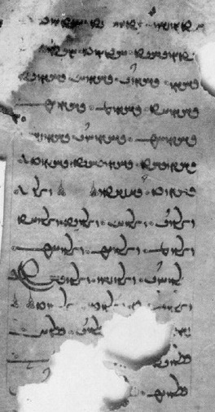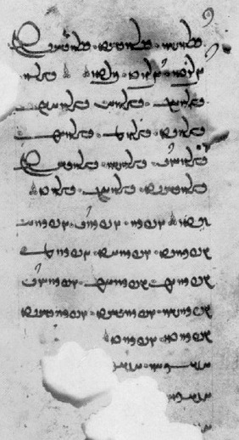

1 HYTYWNšn'. HYTWN[yh]yt. HYTYWNt[n ?] 1 YḆLWNšn'. YḆLWNyhyt. YḆLWNyhsT.
2 [H]YTYWNyhst. HYTYWNt. ’nytn 2 YḆLWNtn. YḆLWNt. bwltn. ∴ ∴ DḆLWN.
3 YHSNN. YHSNNd. YHSNNyḏ. YHSNNyt[- 3 DḆLWNx₂. DḆLWNyḏ. DḆLWN’x₁.
4 YHSNN’t. YHSNNm. YHSNNym. 4 DḆLWNyt. DḆLWNm. DḆLWNym.
5 YHSNN’m. YHSNN’nd. YHSNNšn[- 5 DḆLWN’nd. DḆLWNšn'. DḆLWNyhyT.
6 YHSNNyhyt. YHSNNyhst. YHSNNtn. 6 DḆLWNyhst. DḆLWNx₃. DḆLWNt ∴
7 YHSNNt. d’št'. ∴ ∴ OZLWN. 7 nytn ∴ YNPKWN. YNPKWNd. YNPKWNyḏ.
8 OZLWNd. OZLWNyḏ. OZLWNyt. OZLWN’t. 8 YNPKWNyt. YNPKWN’t. YNPKWNm.
9 OZLWNm, OZLWNym. OZLWN’m. 9 YNPKWNym. YNPKWN’m. YNPKWN’nd.
10 OZLWN’nd. OZLWNšn’. OZLWNyhyTY 10 YNPKWNšn'. YNPKWNyhyt. YNPKWNyhst.
11 OZLWNyhst'. OZLWNtn. OZLWNt ∴ ∴ 11 YNPKWNtn. YNPKWNt ∴
12 šw[tn. ∴ ∴ YḆLWN. Y]ḆLWNd. YḆLWyḏ. 12 HŠKHWN. HŠK[HWNd. HŠKHWNyḏ
13 YḆLWNyt. [YḆLWN’t. YḆLWNm. 13 HŠKHW[Nyt. HŠKHWN’t. HŠKHWNm]
14 YḆLWNym. YḆ[LWN’m. YḆLWN’n]d. 14 HŠ[KHWNym ...

The symbols can be combined with other endings or suffixes:

1. symbol + ending:
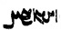 <OBYDWN-x₂-yd> kunē “you do.”

2. stem + symbol + suffix:

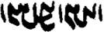 <OBYDWN-x₂-šn'> kunišn “should be done”
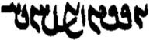 <YNSBWN-x₂-šnyh> stānišnīh “taking” (REA.5.10 = TD2, p. 249)
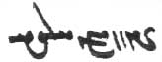 <ZBNWN-x₂-’lyh> xrīdārīh “buying” (MHD.20.7)

The Turfan fragment
Note: the students are not expected to learn what is in the section on the Turfan fragment.

A single leaf from a manuscript containing a list of verbal arameograms was found at Turfan. This is the oldest Pahlavi manuscript in existence. The verbs are (on the left) <HYTYWN-> “fetch,” <YHSNN-> “have, hold,” <OZLWN-> “go,” <YBLWN-, YBLWN-> “carry,” (on the right) <DBLWN-> “lead,” <YNPKWN-> “exit,” <HŠKHWN-> “find.”
The leaf was published by Kaj Barr in the Bulletin of the School of Oriental Studies (BSOS) 8, 1936, pp. 391-40.

Origins of the symbols:
Since these symbols are used almost exclusively with arameograms that contain an original <-B->, it is not impossible that they originated from the intersection of the “foot” of the <B> B with the endings at some stage of the script (cf. inscr., nyB <BYN> = x = x₁>), and the two forms, when used for the 3rd singular (2nd plural) and the 3rd plural, can conceivably be derived from <-yt> and <-ynd>, respectively, cf.:

Psalms: tYNWdYVW <OBYDWNyt> ⇾ xWwïdAW
Psalms: DNWdYVW <OBYDWNd> ⇾ žWwïdAW ,ŽWwïdAW

The Turfan ms., however, suggests the story may be more complicated, as it features three different forms, two of which are also common in economic documents on papyrus and leather.
Here, the three symbols are seen on the right: <x₁> at the end of line 3 (3rd sing.), <x₂> at the beginning of line 3 (3rd plur.), and x₃ in the middle of line 6 (infinitive).

Turfan ms. Papyri
x₁ = 3d sg. <YZLWNx₁> nayēd  
x₂ = 3rd pl. <YZLWNx₂> nayēnd 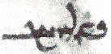
x₃ = inf. <YZLWNx₃> nīdan 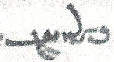 

In the Turfan fragment, the oversized <-t> used at the end of lines recalls <x₁>, but, as it is used only at the end of a line, it is probably just a flourish, found also in the manuscripts, for instance, final Æ is not uncommon in J2 and K5 and is very common in K20.

Examples of the use of the symbols

gyān ka az tan ī mardōmān frāz stānēnd (mss.: 9WwïJwY, (WwïJwY, )WwïJwY) čiyōn bē šawēd
“when they take the soul from the body of people, how does it go?” (DD.22.1)

pad gyān-bōzišnīgīh xrīdan ((Wwï¸) ud garān frōxtan ((WwïΩM) pādixšāy
“in order to save one’s soul, one is authorized to buy (cheap) and sell dear” (DD.48.10)

bē niwēyēnam kū bun kunam (MWwïÅW) ud hangerdēnam kū-š sar bē (æWwïÅW) kunam
“I invite, i.e., I begin (the ritual), I complete, i.e., I finish (it)” (PY.1.1)

ōy kē kūn-marz kunēd (mss.: xWwïÅW , WtˇDWwïÅW) ēzišn abāyēd framūdan ud kerdan
ud kē kunēd (xWwïÅW, (WwïÅW) ayāb-iš padiš kunēnd (xWwïÅW, (WwïÅW, 9WwïÅW) ēg-iš ham-nišastagīh ud ham-xwarišnīh abāg abāyēd kerdan ayāb nē
“He who performs anal intercourse: should he order a ritual of perform (one)? And one who performs (it) or upon whom they perform (it), then should one sit down with him and eat with him, or not?” (DD.71.1).

ud pas ōy Wirāz pēš ī māzdēsnān dast pad kaš grift ud ō awēšān guft kū dastwarīh ast tā ruwānīgān yazam ud xwarišn xwaram ud handarz kunam (æWwïÅW) pas may ud mang bē dahēd
dastwarān framūd kū hamgōnag kun (WwïˇÅW)
“And then that Wirāz (stood) before the Mazdayasnians (and) put his had in his armpit and said to them: it is according to the religious rules that I should perform the ritual for (my) soul, eat, and make (my) will. Then (yo can) give me wine and hashish! — The dastwars ordered: Do (just as) you say!” (AWN.2.9-10)

xwāham ō ēn yazišn Ayāsrim ī pad frōd-waštag-zamānīh gōwēd ī gušn-hilišnīh (Ew†ÍWWkïH) andar āyēd ī ahlaw ī ahlāyīh rad
“I request Orderly Ayāsrim (genius of season), ‘when time turns down’ (autumn), in which comes the releasing of the males, a Model of Order” (PY.3.11, ms. K5)

The Passive
Originally, in Iranian languages, the passive was only used in sentences in which the person or thing performing an action was not mentioned specifically. That is, there were only constructions of the type “he is being eaten,” but not “he is being eaten by a lion.” In this way, active constructions were reserved for sentences in which the “performer” (“agent”) was explicitly mentioned, e.g., “Ahura Mazdā establishes the world,” “the soul sees its dēn,” “they think good thoughts.”
By the time of Pahlavi, this rule had been relaxed, and we find constructions such as “he is led away by the demons.” We will return to these constructions later. Here, examples are given only of those without “performer.”
On the passive formation in -īh-, see Lesson 15.

Passive without “performer” with “to be/become.”
A so-called “analytic” passive is formed with būdan “to be/become,” e.g.:

guft bawēd kū “it is said that ...”

abar amāh stahm-ēw abēčim kerd bawēd
“for no reason violence will be done to us” (AWN.2.6)

ka xrafstar ōzanēnd ahrimen bēšīd bawēd čē xrafstar hamāg az tan ī ahrimen
“when one kills evil animals, Ahrimen is (will be) hurt, because evil animals are all from Ahrimen’s body” (after PT.28. Handarz ī Dastwarān ō Weh-Dēnān 29)

mard-ēw kē duxt-ēw ī purnāy pad zanīh bē ō mard-ēw dahēd duxt nē ham-dādestān sālārīh bē ōy dād bawēd ayāb nē
“a man who gives a daughter (who has come) of age as wife to a man (but) the daughter does not agree, (then) is guardianship given (has it thereby been given) to him or not?” (RAF.10.1)
az bīmīhā ān ēk bīm rāy dād šāyēd būd (ī) az bīm ī dōšox rāy ō arzānīgān tis dahēd
“among the various fears, it can be given for that one fear: he who, for fear of hell, gives something to those worthy” (RAF.74.3)

drōw az tan bērōn kun u-t tan wirāst ud ruwān bōxt bawēd
“expel lies from (your) body, and your body will be restored and your soul will be saved” (Dk.3.56.2)

Past transitive verbs without “performer” as passive.
When a past transitive verb is used without a “performer,” it is passive, e.g.:

ēn ān mard ī-š pus andar kārēzār ōzad
“this (is) that man whose (ī-š “who his”) son was killed in the battle”

šusr ī gāw abar ō māh-pāyag burd ānōh bē pālūd hēnd. ud az ān šusr gōspand ī purr-sardag frāz brēhēnīd
“the bull’s semen was brought to the moon-level (and) there it was purified [note plural]; and from that semen the animal of many-species was fashioned forth” (Bd.13.4)

an pādixšāy kerd ham
“I was made authoritative (was placed in charge)” (Kerdīr)

hamāg mardōm ō dar ī ādur Farrbay xwānd hēnd
“all people were called to the house of the Farrbay fire” (AWN.1.16)

The 3rd plural expressing indefinite subject (“one”)
When the “performer” is unknown, one can also use an indefinite 3rd plural: “they say” = “it is said,” “they killed him” = he was killed,” e.g.:

gōwēnd kū “they say, it is said”

ud az tan ī Gayōmard rōšnīh ōwōn bē šud čiyōn āhen ī garm ī suxr ka-š pōlābd abar zanēnd ud syā bē bawēd
“and from Gayōmard’s body light went out as (when) they strike steel on a redhot iron and it becomes black” (Bd.7.11)

kas pad wēmārīh nē mīrēd bē pad zarmānīh ayāb ōzanēnd
“no one will die from illness, other than from old age or (if) they kill them (= they are killed)” (Bd.33.37)

ka-š ǰud az hunsandīh ī sālārān frēbēnd ud nayēnd
“when they deceive her and lead her (away) without the pleasure (of the husband) (= when she = the wife is deceived and led away)” (MHD.30.2)

Note the combination of intransitive + indefinite verb:

harw čē abēzag ō Garōdmān šawēd ud harw čē druwand ō dōšox abganēnd
“everything that is pure goes to Garōdmān, and everything that is wicked they throw (= is thrown) into hell” (Bd.28.10)

Impersonal expressions
Impersonal expressions are sentences without grammatical subjects (English “it is necessary, it is possible, etc.). Most impersonal expressions involve a 3rd singular verb or a noun or an adjective (tuwān, etc.).
The person it is necessary, etc., for can be expressed by a noun, an independent pronoun, or an enclitic pronoun.
Plural nouns take the ending -ān.
When the person is expressed by a relative pronoun (kē), an enclitic pronoun can be added to clarify the person.
Impersonal expressions include:

abāyēd, abāyist “it behoves/behoved X (to), X should, must”
kāmed, kāmist “wants, wishes”
sahēd, sahist “seem (to ...), seem (OK to ...)”
šāyēd, šāyist “be appropriate; be possible (for X to do)”
wurrōyēd, wurrōyist “believe”
wizīrēd “it is avoidable”
awizīrišnīg “unavoidable, doing without (az).”
tuwān “it (is/was) possible (for)”

Impersonal expressions are often combined with an infinitive (see Lesson 10).
In the English translation, the impersonal expression must often be turned into a personal one.
Note that pādixšāy “authorized” (often used in the same kind of contexts as šāyēd) is a normal adjective.

Note also that the past stems abāyist and šāyist are frequently written as if “abāyīd” and “šāyīd,” but this is probably a special way of spelling -āyist (see Lesson 5).
Examples:

čand-itān tuwān pad kerbag kerdan tuxšāg bawēd
“as much as it is possible for you (= you can), be diligent in performing good deeds!”

ān mard u-m and sahist čand 3 mard nēzag-bālāy
“that man seemed to me as large as three men the height of a spear” (after Dk.7.3.52)

ka-š zan ud xwāstag ī-š abāyišnīg sahist dāštan āgāhīh mad
“when information came of a woman or property that seemed to him good to have” (Dk.9.21.13)

harw čē-t kāmag ast xwāh tā-t daham
“ask everything you wish, so that I shall give it to you!” (after Bd.4.6)

ēk ka-š tis kāmēd guftan
“one, when he wants to say something” (Dk.9.2.4)

u-šān ārzōgīhēd kū kāč nē zād būd-ēnd
“and they desire: if only they had not been born!” (after Dk.3.178.8)

nohom kē pad harw kēš wurrōyēd ud paristīdan kāmēd
“ninth, he who (kē) believes in every teaching and wishes to worship (in it)” (MX.35.12)

kē-š wurrōyēd xwarēd ud kē-š nē wurrōyēd nē xwarēd
“he who (kē-š) believes shall eat, and he who does not believe shall not eat”

kē tis wēš gōwēd kū ān ī dānēd ān-iz ī dānēd mardōmān nē wurrōyēd
“he who says more than what he knows, (then), also what he knows people will not believe” (Dk.6C.2)

ka-m frāz mad hēnd pad ān paymōzan ī zarrēn-pēsīd ī asēmēn-pēsīd ī brāzišnīgtom az harwisp paymōzanān u-m burzišnīgtar sahist
“when they come forward to me in that (those) gold-embroidered, silver-embroidered garment(s), most radiant of all garments, it seemed to me most praiseworthy” (AWN.12.6)

ka wizīrēd abāg wattarān ham-kunišn ... nē bawišn
“when one can avoid it, one should not be collaborators with bad ones” (Dk.6C.22)

nōg-widurdān ... az yazišn paristišn awizīrišnīg
“the newly departed cannot do without sacrifices and worship” (DD.80.3)

Impersonal andar abāyēd expressing need and necessity
In this impersonal expression, the person who needs to do something is often an enclitic pronoun; “needed for” is expressed by pad, e.g.:

Ohrmazd ēdōn gōwēd kū ka ēbgad āmad ān ī xwēš hamēmāl pad kōxšišn frāz gīrēd kū nōg framān andar nē abāyēd
“Ohrmazd says as follows: When the Invasion has come, (each) seizes his own opponent to fight with, that is, a new command is not needed” (Bd.3.12)

gōwēd pad dēn kū hōm ī spēd pad fraškerd-kerdārīh andar abāyēd
“it says in the dēn that the white hōm is needed for making Fraškerd” (after Bd.24a.1)

Ohrmazd rāy gōwēd kū Wāy-iz abzār-ēw būd ī-š pad dām-dahišnīh andar abāyist
“it says about Ohrmazd that Wāy, too, was a tool that he needed for establishing the creation” (Bd.1.45)

u-š pānagīh ī awēšān ... awizīrišnīg andar abāyēd bē dād
“and he cannot avoid (a-wizīrišnīg) having to (andar abāyēd) provide (dād) protection for them” (DD.53.6)

Ohrmazd abzār-ēw pad akārēnīdan zadan ī Gannāg Mēnōy andar abāyist
“Ohrmazd needed a tool for incapacitating and striking down the Foul Spirit” (WD.10.3)

Note abd sahist “seemed wondrous (to),” škoft sahist “seemed amazing (to).”

Sentences 9

Analyze the following sentences, and identify the arameograms:

/ WTWV Wwˆ<ÂßA äL EKwßYT W EksLwY< W EI>wa˜ lAWcåH ? !
Šābuhr māndagīh ud gursagīh ud tišnagīh rāy xešmgen būd
“Šābuhr was angry because he was tired, hungry, and thirsty.”

ßYVtDwY W WKwAcÒP W AWN Ewßad>maD> N oaÅ W AWN WTWV âL Ewßad>maD> N WwYwL a˜wAwA ? 2
/ WTWV WIwZcÅ W
Ohrmazd pēš az dām-dahišnīh nē būd xwadāy ud pas az dām-dahišnīh xwadāy ud frazānag ud ǰud-bēš
ud abzōnīg būd
“Before the establishment of the creation, Ohrmazd was not ‘ruler’, and, after the establishment of the creation, he was ‘ruler’, ‘possessed of foreknowledge’, ‘keeping harm away’, and ‘making increase’”
(on Ohrmazd’s epithets)

/ LW ^ Y<wlYW ã WwaDWwlY WtDWnmˆÅ WwahA Ywˆ¬YKW tÂA à WtDWwrrmY CNwY AıB µA q WwˆdaDW WWP ? 3
pad weh-dēn abar ham dar ēn-iz gōwēd kū ka nigerēnd ā-šān wurrōyēd druwandān ān nīrang ī war
“In the Good Dēn, about the same matter, this, too, it says: when they look (closely at it), then they, the wicked, will believe that ritual of the ordeal”

WwYwˆjA W WwYCwˆÒV W WwYTcåÒWP W WwˆÂˆjA W WwˆÅva¸ tdA ^ WfjLP 34 Íà WtDWWWwmY äL cdY<WK ? 4
/ WwY˝JAK W WwYKwYKcÅ W
Kangdiz rāy gōwēd kū-š haft parisp ī ast zarrēn ud asēmēn ud pōlābdēn ud brinǰēn ud āhenēn ud ābgēnagēn ud kāskēn
“It says about the Kangdiz that it has seven enclosing walls, which are of gold, silver, steel, bronze, iron, crystal, and lapis lazuli.”

? YWNwA WtHW EcÒK ATwÍWA OW AWB EcÒK LwLwA N 2 AWK íYwaåHM W îHM oaÅ ? 23
/ WwAVwL tdA ^ WTWwlZW WwaHnLW OW x aådY>Wwˆ˜ nS< ã W
pas Mašīy ud Mašyānīy harw 2 az urwar-kerbīh bē ō mardōm-kerbīh wašt hēnd.
ud ān xwarrah mēnōyīhā andar ō awēšān šud ī ast ruwān
“Then Mašīy and Mašyānīy both turned/changed from plant-form to the form of humans.
And that Xwarrah went into them through the other world (‘invisibly’), that is (as) the soul.”

? YWtDWK WtÅW WWwlaÒP ^ ã WtDCW aådYNwATwS tÂA WtÅW ? 33
aådYWwaDtÅP W WtdlYKW AWB WtDwY WtDwY MwYN AWK äL WwaååH N ^ mYV WtÅW WWwlaÒP ^ ã
/ WtDCW WcÅWP eYNwAKwlYW WWP
wād ka sūdōmandīhā wazēd ān ī frārōn wād xwānēnd.
ān ī frārōn wād bīm ī az dēwān rāy harw tis ǰud ǰud bē nigerēd ud pādyāwandīhā pad nērōgōmandīh frāz wazēd
“When the wind blows so that it provides benefit, they call it the ‘good wind’.
For fear of the demons, the ‘good wind’ looks at everything individually and blows forth mightily and with strength.”

OW lAwaÒ WwaHwY ^ WimY ã W YWWwaD Wt¸ WCwlY W aåH CIwAcÅ ‹ AwYW WTWkßLP WWP ? 34
/ WtDWWwaD WTWwYtdaD WwaåJ ^ EwaåÒP
pad Fraškerd zamān Ahrimen abārīg-iz dēw ud druz zad bawēnd ud ān zamīg ī dōšox abāz ō frāxīh ī gēhān āwurd bawēd
“At the time of Fraškerd, Ahrimen and the other demons and lie-demons will be smashed, and that earth of hell (= where hell is located) will be brought back to the expanse of the world of the living.”

WKwˆÅ W ? žWwˆÅW LWP WwˆÅva¸ ^ Nwa˜ 3 WwAfjAtHW ^ Y<N W sA LBWtjY> WwˆD> WwaHnLW øaÅ W . 44
/ YWWvaD Wcå¬YW ØW WcÅWP WthLWwA WWP Nwa˜ LItJ W WtÅwA WWP ÂaD LItD W Wt˜wA WWP Nwa˜
ud pas awēšān dēn dastwar may ud mang ī Wištāspān 3 ǰām ī zarrēn purr kunēnd; ud ēk
ǰām pad humad ud didīgar ǰām pad hūxt ud sidīgar ǰām pad huwaršt frāz ō Wirāz dahēnd
“And then those teachers of the dēn fill three golden cups with wine and the bhang of Wištāsp, and they offer one cup with Good Thought, a second cup with Good Speech, and a third cup with Good Deeds to Wirāz.”

Texts 9

Text 9.1
From the Bundahišn: Bd.6b.17 (after ms. TD2)

? WtDwaHW :ÅwaÒ WimY ^ WtJWK WtJWK WWP MwY3 EI>WWV Y>W WKwYwˆÅ ÂA WWP adM ã WtÅW øaÅ
? Wt˜ EkAtDP ØW ÍcÅ ía¬Z ^ WkmÍC 2 WTWWwaD ÍcÅ SK ^ á¬Z L W adM ^ ía¬Z 3
/ WtDWnYWI WtJWTP á¬Z ^ WkmÍC ØW WwaÅ WWB waHWN LBwS WKwˆÅ WtJcDC WKwˆÅ
pas wād ān āb pad ham ēwēnag tā bowandagīh (ī) 3 rōz pad kust kust ī zamīg abāz nišānēd
3 zrēy ī meh ud 20 zrēy ī keh az-iš būd 2 čašmag ī zrēy az-iš ō paydāgīh mad.
ēk Čēčast ēk *Sawar kē-šān bun-xān ō čašmag ī zrēy paywast estēd
Then the wind settles that water in the same manner to the completion of (= altogether for) 3 days in the various areas of the earth.
3 larger seas and 20 smaller seas (be)came from it. 2 sources of (= in) the sea appeared from it:
one Čēčast and one *Sawar, whose (kē-šān) sources are connected to the wellspring of the sea.

Text 9.2
From the Pahlavi Rivayat: PR.46.5. – About the origin of the mountains. Mss. TD4a, p. 108, BL, f. 53r, D7, p. 82
/ YWNwA WtJwL AWB nïD ^ laÅwY ˝¸ N aåDPWK W YWKW AWB x nï>D, laÅwY a˜wAwA W
/ WtJwL áÂA 2 AWK LPcÅ W lY>cÅ TwÍ ±$4 =Y
/ WwaÂsA OW AWB Y>W WtJwL áÂA Y>WT TwÍ ±$4 LPcÅ WtÅnYWI AWB lYcÅ oaÅ W
ud Ohrmazd gōhr xwarrah andar bē nigand ud kōfīhā az ān gōhr ī xwarrah bē rust hēnd.
180 sāl azēr ud azabar harw 2 hamē rust.
ud pas azēr bē estād azabar 800 sāl did hamē rust tā bē ō āsmān
And Ohrmazd buried the Xwarrah into (the earth) as ‘substance’.
And the mountains grew from that ‘substance’ of the Xwarrah. For 1800 years they grew both below and above.
Then they stopped below; above they grew again for 800 years all the way to (tā bē ō) the sky”

Text 9.23
From the Bundahišn: Bd.9.1-3 (after ms. TD2) — Further details about the origin of the mountains.
øaÅ ã N W WtåÅBWKV ^ WcÒWvlA WtJwL WcÅWP WPWK Wtjï>¸W à WwˆD> WWP WtDWwllmY / WwAPWK ^ EWwˆDC q
/ TwÍ 48 WWP Y>WNwA WtJwL WPWK WkaÂA
WkˆÅP aå˜ ØW YW ≠A W WkˆÅP LtJ ØW YW TwÍ ≠A? WtJwL áÂA TwÍ ≠$4 ^ EIWWB Y>W WcÒWvlA
/ WwaÂˆdA ^ WtjlAV ØW YW ≠A W WkˆÅP WtdßLWA ØW YW ≠A W
/ WPWK 4 W ¢ W ≠A W =A WklM WWP ? Y>WnYWI WtJwL WcÅWP WcÒWvlA N aåDPWK WIwAcÅ WwˆDC
abar čiyōnīh ī kōfān. gōwēd pad dēn kū nazdist kōf frāz rust Harburz ī baγbaxt ud az ān pas hamāg kōf rust hēnd pad 18 sāl.
Harburz tā bowandagīh ī 800 sāl hamē rust: 200 sāl tā ō star-pāyag ud 200 tā ō māh-pāyag ud 200 tā ō xwaršēd-pāyag ud 200 tā ō bālist asmān.
čiyōn abārīg kōfīhā az Harburz frāz rust estēnd. pad marag 2244 kōf.
It says in the dēn:
(As) the first mountain, Harburz “allotted-by-the-allotter” grew forth, and, afterward, all the mountains grew forth from it in (the space) of 18 years.
Harburz kept growing to the completion of (= altogether for) 800 years—
200 years (up) to the star-level, 200 to the moon-level, 200 to the sun-level, and 200 to the highest of heaven.
That is (čiyōn), the other mountains are grown forth from Harburz, 2244 mountains in number (= in total).

Text 9.4
After the Bundahišn: Bd.14.8. – As M&M grew up from the earth in the form of a rhubarb plant, two xwarrahs grew up between them. Ohrmazd is asked which grew up first, the body or the xwarrah. Mss. TD1, ff. 40r-41v, TD2, p. 101, DH, ff. 186v-187r.

čiyōn gōwēd kū kadār pēš dād xwarrah ayāb tan
Ohrmazd gōwēd kū xwarrah pēš dād ud tan pas ō ān dād estēd
andar tan dād kū xwēškārīh bē brēhēnīd tan bē ō xwēškārīh dād
As it says: Which was established before (= first): the xwarrah or the body?
And Ohrmazd says: The xwarrah was established before, and the body was afterward established for it.
It was established in the body, i.e., one’s duties were fashioned, (then) the body was established for one’s duties (in order that one might do one’s duties).

Exercises 9

9.1. Add the transcriptions/transliterations to these sentences and translate them:

ātaxš ī Ohrmazd madārtom az anyān amahrspandān / WwaDWcJwaÂA WwaDã N MWt¬At˜ a˜wAwA ^ ßAtÅ ? !

/ WtdaH WtDWWWnY g<LcÅ WwˆDC WWWtdA AWB WtdaH aÒ WtDWWWnY SwaHwS WwˆDC WwYwA ã ? 2
<ZK ’wgwn cygwn swš’ns YMRRWNyt' LA š’dyt' BRA ’ytwn' cygwn ’p̄lg YMRRWNyt' š’dyt'>

/ YWtDWK aåÂLWP Wtda¸cÅ tÂA 27 Y>W º N YWtDWK aåÂlY>wA Wtda¸cÅ aå˜ tÂA º Y>W WKwˆÅ N ? 3
az ēk tā 10 ka māh abzāyēd andar-māh xwānēnd az 10 tā 15 ka abzāyēd purr-māh xwānēnd

WtDcÅW WcÅWP ìtJ ^ ã WWP W ? WWwaÅ ìtJ W WWwaÅ YWwˆ˜ WTWWwaD îÒ 2 îÒ ã WwsA ? 4
/ EwÍwˆ˜wA W EwmaÅwLwA WWP WwaÒTWW ^ SW ØW q WfjAtHwYK Y>WwAcÒWB
/ WwAwaÅ MwlaÅP Y ã OW q WwAf:JW ^ Wt:J ^ WwABwL WtDcÅW WcÅWP YWwˆ˜ ^ ã WWP W
ēg ān rahīy 2 rahīy būd mēnōy anīy ud gētīy anīy
ud pad ān ī gētīy frāz wāzīd burzāwand Kay Wištāsp abar ō wis ī Nōdarān pad urwāhmenīh ud humenišnīh
ud pad ān ī mēnōy frāz wāzīd ruwān ī Srid ī Wisrabān abar ō ān ī pahlom axwān.
(about Srid’s magic chariot; note that mēnōy and gētīy are also adjectives)

WTWtåJ Et¬mYN ^ aåÒB WWP WN WwaHnLW Wt˜ WWtH Wwa:dA OW á˜wlA ^ lY>wSklA WKtJcD< tÂA ? 23
/ YNwA WTWWtåD WwAtJ˝J OW YWcdA WKtdL W AWvY ? WTWwLTI WTc¬Y<
<AMT gcstk' ’lksndl Y hlwm’d OL ’yl’n' štr' mt' OLEš’n MNW PWN bl’h Y mwgmltyh SGYTNt'
glpt' YKTLWNt'. GBRA W lytk' HD-cnd OL skst’n' YATWNt HWEd>
(moving the vanquished population to the land of the victorious was common practice, cf. the Jews in Babylon)

/ MWwYtdaD aåDtjaÒ µAtDP NwY W WwaD>WwlY> W WwAvlaÅ ^ WkAwˆD< ã OW MWwlZW aådY>NwAkmAK ? 33
<k’mk’wmndyh’ OZLWNm OL ZK gyw’k' Y ’hlwb’n' W dlwnd’n' W ZNE pgt’m l’styh’ YHYTYWNm>

/ WtDWnYWI WTWWtÅwA WWwlYwA WtjAcÅ x WwßßAWK WWP ^ la¸cÅ AWK ÍWN WkAwa˜wA WtHWPwlY OW WwaÂsA ? 34
asmān ō drubušt homānāg kē-š harw abzār ī pad kōxšišn andar abāyist andarrōn nihād estēd

YWtDWK Wtå¬Y> WwLKwY< WN WtDfJ ^ MwA à WwˆD> WWP WtDWwrrmY ? 33
/ WtdAcÅ x elATWK WTWkßLP WWP W WtDWnYWI WtJwL LW LPwZ ^ ã WWP WTWKwaåÒP ^ î¬Z x
< YMLLWNyt' PWN dyn' AYK hwm Y sp̄yt' MNW gwkln' dlht' KRYTNd,
BYN zlyd Y pl’hwkrt' PWN ZK Y zwpl wl lwst' YKOYMWNyt' W PWN plškrt-krt’lyh BYN ’p̄’dyt'>

9.2. Transliterate, transcribe, and translate at least nos. 4-7.

/ WtDWWvaD øA G<N Y>NwAkmAkA MWwsA WtDWŒ WwATtÅ ? !
/ YWwˆ˜ WkAwY ^ Cã a˜wAwA ^ µaD> WwaÂaD> WwA2 AWK N LtD>NwACwA WwaÂZ à WwS> WWP WtDWwllmY ? 2
/ lAtDwYCwlM WKwïÅ W lAtåD WKwïÅ WwïÒT WtHWWB à WtDWWwaD Wwa˜wïDcÅ wMwY CWWP W ? 3
/ Y>WNwA WtDwˆådLV WcÅWP elAvsA WWP WklAtJ WKtÒwA =• ±4 + + 33 WwaHnLW N ¡LtåÅ AWK ? 4
WwaåJ Y>W nMtÒ N W µYWWiLW AWB MwY 3 NwY x WtdA WKwAKwˆÅ W WtjaÒ L NTwL WwÍwˆ˜ TtÅ ? 23
/ µYWwlZW AWB µYWwˆÅW

WkAwAVWT ^ WkAwaD> ^ sAkAfJwlA ^ LtD>NwAnS< ^ LtD>NwadaÒ ^ a˜wAwA lAtåD> WwßÄwßA ? 33
/ WwÍWWK WwÍVwY< WwÍwˆ˜ WWP WthLWwA WtÅwA Wt˜wA WtŸja˜ ^
÷ WwaÅtJ ^ CWwEWwï˜ ^ WwABwlaÅ ^ WwaåD WwßÄwßA
(Note “X-iz Y” = “X and Y”)

From Yašt 6.1 to the Sun
÷ MWwAvzY WcjaD>WwlA ^ YNwadaÒ ^ g<lmA ^ WtdßLwA ? 34
? WKwYwˆÅ NwY WWP WtDcÅT WwÍwL WtdßLwA tÂA WwsA ? WtDWWtåD a¬aÒ à WtDcÅT WwÍwL WtdßLwA tÂA WwsA
? WkAwˆD Ä OW žW]J µA nS< ã WWWtdA ? WKwAklAcÅ W WKwAKtJ WtåD YWwˆ˜ YWnYWI
Wtåda˜wAwA ^ q WimY WWP YWWklA nS ã W ? EKTWKwˆÅ WWP YwYwYwaÒ AWB nS ã W

In this text, the direct translation from the Avestan (next page), preserving the Avestan word order, is followed by short explanations (glosses), some introduced by kū “that is.”

The Avestan Text:
huuarəxšaētəm aməṣ̌əm raēm We sacrifice to the immortal sun, wealthy
auruua.aspəm yazamaide with fleet horses.
āa ya huuarə raoxšne tāpaiieiti Then, when the sun warms (the world) in the light,
āa ya huuarə raocō tāpaiieiti Then, when the sun warms the light,
hištəṇti mainiiauuåŋhō yazatåŋhō (then) those worthy of sacrifice in the world of thought stand
satəmca hazaŋrəmca a hundred and a thousand.
ta xvarənō haṇbāraiieiṇti They gather that Xwarrah.
ta xvarənō nipāraiieiṇti They convey down that Xwarrah.
ta xvarənō baxšəṇti They apportion that Xwarrah
ząm paiti ahuraδātąm over the earth set in place by (Ahura) Mazdā.

9.3. Match the Pahlavi words with their transcriptions:

Ä Wt˜wA WCwlY andarwāy gēhān ohrmazd-dād
aådY>NwAwßmâL WtåD WimY arwand-asp gīram ōzōmandtar
AwlY WtÅwA WNCwA ast gōwizārīhātar rah(īy)
äwlYwA WtdA WwaÂZ axwān grōh rāmišnōmandīhā
LtåådlACWwY WwÍwL WWtdAtJ baxšēnd hanǰaman rōšn
elAvsA WtdAWKW YWWklA dō’ān hayārīh stāyīdan
EwÍBwY|wlY WthLWwA µaD dām humad u-tān
LtDNwACwA WwA2 MWwsA drōw-gōwišnīh huwaršt xwurdag
MWwˆÅW WwaåJ îÒ druz hūxt yazd
Wtåda˜wAwA WwATcÅ WcjaDWwlA ēg-im kešēd zamān
WtdÍK WwAwaÅ WKtÒwA ēw nikōhīd zamīg

9.4. Translate into Pahlavi and write in Pahlavi at least sentences 2, 4, 6, 8, 9:

- When I praise Righteousness, then the demons are scorned.
- Before the Renovation, Ohrmazd needs Frēdōn for the striking of Dahāg.
- Ahrimen and the other demons and lie-demons will be stricken and killed.
- Everything that was said there in that assembly was written (down) clearly.
- If it seems (good) to you (all), tell me in more detail what is written here in this book.
- Another day, Ardaxšīr was standing on a chariot, and all the other people were sitting on horses (all) around him.
- The one who does good deeds, he goes forth to Paradise, and he who does evil deeds, him they throw into Hell.
- Do not speak lying speech, because, if you speak lying speech, Astwihād will drag you to the worst existence, and there you will experience (see) much unhappiness.
- When I came to Paradise, a group of departed ones came toward me, and, from the souls of the Righteous, a light went out like that of the sun, the moon, and the stars; and they went about joyfully in the light of the intermediate space (the atmosphere).

Additional readings 9

Additional readings 9.1
From the Pahlavi Videvdad: PV.6.1-3 9. — Note: the particle of exhortation ē “let ...!” is spelled AwA <HNA> and 1A <’ḏ>.

/ Wt¬gLP Mw˙H
/ t©lYTW AWB AWvY PwˆÅ AvLK q ã WWP à tdaH aÒ lAK CwAC WWP à wAtDcÅwA imY NwY waÂY Awa¬Y> Y>WC
/ t©lYTW AWB AWvY PwˆÅ AvLK q ã WWP Íà tdaH aÒ lAK CwAC WWP à WwAtDcÅwA imY NwY WtHWt:¸ WBwlaÅ ÄwâlY> TwÍ
šašom pargard
čand-drahnāy zamān ēn zamīg anabēdān kū pad če’ān-iz kār nē šāyēd kū pad ān abar sag ayāb mard bē widerēd
sāl-drahnāy ahlaw zardušt ēn zamīg anabēdān kū pad če’ān-iz kār nē šāyēd kū-š pad ān abar sag ayāb mard bē widerēd
“For how much length of time (= for how long) (is) this earth not to be ‘approached’”, i.e., it is no good for any work at all, on which a dog or a man passes away?”
A year long, O Righteous Zardušt, this earth (is) not to be ‘approached’, i.e., it is no good for any work at all, on which a dog or a man passes away.”
/ Äwa¬Y> TwÍ kmYWWwlY>wA N tÒTW AWB AWvY PwˆÅ AvLK ã WWP à ŽWWkˆH q adM øA Y>WtdlZ imY ã WtŸjâM CøaÅ CøA
/ žWWkˆH 3 q adM kmAK WWP ÍcÅ Wna:ÿP Y>WWtdlZ AwA imY Äã ã WtŸjâM øaÅ kmAK WWP
ma-iz pas-iz mazdēsn ān zamīg kārēnd ma āb abar hilēnd kū pad ān (abar) sag ayāb mard widerd az andarrōn-nēmag sāl-drahnāy
pad kāmag pas mazdēsn ān anīy zamīg ē kārēnd pērāmōn az-iš pad kāmag āb abar ē hilēnd
“also, afterward, let the Mazdayasnians also not till that earth, let them not release water on it, on which a dog or a man has passed away, within the length of a year! — afterward, at will, let the Mazdayasnians till that other earth!” i.e., around it, “at will, let them release water on it!”

/ ÄwâlY> ! TwÍ WkmYWWwlY>wA N / tÒTW AWB AWvY PwˆÅ AvLK q ã WWP à žWWkˆH q adM ÍtÅ Y>WWtdlZ imY ã WtŸjâM tÅ
Y>WwLcÅ AWB tÂA imY Y>wYcdL AWB WtÂA adM Y>NwA WtŸjâM WN waHnLW Y>wˆÒtjA øaÅ EwAKW áJW WWP WN WwˆDC
/ Y>WtdlZ AWB tÂA LwLwA W
agar mazdēsn ān zamīg kārēnd agar-iš āb abar hilēnd kū pad ān abar sag ayāb mard be widerd az andarrōn-nēmag sāl ēw drahnāy
čīyōn kē pad nasāy-nigānīh pas āsterēnd awēšān kē mazdēsn hēnd āb ka bē rēzēnd zamīg ka bē kanēnd ud urwar ka bē kārēnd
“if the Mazdayasnians till that earth, if they release water on it (-iš ... abar), on which a dog or a man has passed away, within the length of one year, — afterward they become guilty like him who (is guilty) for burying corpses, they who are Mazdayasnians, (with respect to) the water, (ie.) when they pour it, the earth, (ie.) when they dig it, and the plants, (ie.) when they till (them).”

Additional readings 9.2
After Bundahišn: Bd.4.10
? WwAwÍwL ^ klYTP OW WwaååH nˆÅK NTwL YWwˆ˜ WkAwY WtJcdaÅ oaÅ
/ WTWK q KT aåDkmAKkßglA? WtÅWnYWI aÒ WTWWvaD> Y>WNwAtjA CWwaÅ WtÂA WTWWwaD WkAtDP aådYWwˆ˜ WwaÂsA ã WwaHcÅ
^ WKthYWWV glY>wA à WtHPW WWB WWP ^ WtååÅ EkˆÅWT OW WTwLP WtÅWnYWI iˆÅP LtJ WWP WwaÂsA
? WtÅWnYWI AWB Ä WkwˆÅ3 Y>W WwaÂsA Y WWwlY>wA N kˆÅP LtJ ^ LPcÅ à WwY<wA WTWWwaD wAkˆ˜WT W WwAwÍwL
/ WtJWwLVT AWB WtJWwaÒP WcÅWP WtjY AWB imY> NwY ^ lYcÅ WwaÂsA WkAwa˜wA la˜ W
pas āxēzist Ganāg Mēnōy abāg hamist dēwān ō padīrag ī rōšnān
u-šān ān asmān mēnōyīhā paydāg būd ka ahanūz astōmand dād nē estād. arešk-kāmagīhā tag abar kerd.
asmān pad star-pāyag estād frōd ō tuhīgīh āhaxt ī pad bun nibišt kū andarg buništag ī rōšnān ud tomīgān būd
ōwōn kū azabar ī star-pāyag az andarrōn ī asmān tā 3 ēk ēw bē estād.
ud mār homānāg asmān azēr ī ēn zamīg bē ǰast frāz xwast bē škast.
Then the Foul Spirit rose up together with all the demons against the light ones.
And that sky appeared to them in the other world when it had not yet been established as ‘bony’.
Out of envious desire, he made an assault on it.
The sky stood on the star-level, (but) was dragged down into the void, which, it was written in the beginning, was between the “principles” of the light ones and the dark ones, so that it stood as much as one-third from inside the sky above the star-level.
And like a snake, the sky jumped beneath this earth and was shattered and broken.

Additional readings 9.3
From the Mēnōy xrad: MX.61.4, 20-21
/ WtDWwABkÍ WkAwïD à µaJ ^ WWT / Ww˙JWWP
/ Y>WwaÂY> ^ WPWK OW W˝jZW îJwaHYP ^ WtHY> WWP µaJ ^ WWT / WwaJP
Wtå¬Y W ÄWwlY WwaÅ YW YwYwï¸ ˝¸ WWP W YWwlY>cÅ W YWtdlZ ^ MwYN WIwßLwA W WkAtÒwY AWB WtHY ˝¸ WWP W
÷ WtDwL LwLwA W
pursišn. tan ī Sām kū gyāg nibayēd.
passox. tan ī Sām pad dašt ī Pēšānsīy nazdīk ō kōf ī Damāwand.
ud pad ān dašt bē ǰōrdāg ud xwarišnīg tis ī kārēnd ud drūnēnd ud pad ān zīyēnd tā
anīy drūnāy ud draxt ud urwar nēst
Q. Where does Sām’s body lie?
A. Sām’s body (is) in the Pēšānsīy plain, near Mount Damāwand.
In that plain, except (bē ... tā) grain and eatables that they sow and reap and live thereby,
there is no other harvestable things, and there are no trees and plants.

Additional readings 9.4
From the Mēnōy xrad: MX.61.7, 28-30. After ms. K43 ff. 174v–175r-v

ŽWwïÅW ˝¸ WWP WwSP ^ WWT W Y>wsa:D,W ˝¸ WWP WtjïÒ WN lAtja¬A WtjïÒ ^ MwA / Ww˙JWWP
WtDWnYWI WtJwL à
/ WtDWnYWI Wt¬a˜wY lAK nM WWP Wiaå˜ LK W
/ WtDWnYWkG WtJwL WkAwïD MWtdAPwZ ^ ˝¸ x ÍkLW Y á¬Z WWP lAtja:DW WtjïÒ ^ MwA / WwaJP
WwABwlaÅ ^ laÅwLP LwYB 333 W =Ä33 ΩlÄ33 kïÅ333 ÍcÅ
/ YWnYWkG Wt¬a˜wY EKwAP WWP
tDWwsE WcÅcÅ ÍcÅ LtJplA WIwAcÅ W WKW W WtDt:D< áÂA Wna:DP Wkïåå˜ LK ÍcÅ
pursišn. hōm ī rist-ārāstār kē rist pad ān wirāyēnd ud tan ī pasēn pad ān kunēnd kū rust estēd.
ud Kar māhīg pad čē kār gumārd estēd.
passox. hōm ī rist-wirāstār pad zrēy ī Warkaš andar ān ī zofāytom gyāg rust estēd.
u-š 99,999 frawahr ī ahlawān pad pānagīh gumārd estēnd.
u-š Kar māhīg pērāmōn hamē gardēd u-š wag ud abārīg xrafstar aziš abāz dārēd.
Q. The ‘hōm that restores the dead’, with which they restore the dead and with which they make the Final Body, where does it grow?
And for what action (purpose) is the Kar fish appointed?
A. The ‘hōm that restores the dead’ grows in the Warkaš Sea in the deepest place.
and 99,999 fravashis of the Righteous have been appointed for its (-š) protection.
And the Kar fish turns around it (-š ... pērāmōn) and keeps frogs and other evil animals away from it (-š ... aziš).

The number: 9 ud 70 [for 90] ud 900 ud 9000 ud 9 bēwar
= 9 + 90 + 900 + 9,000 + 90,000 = 99,999 (= 100,000-1).

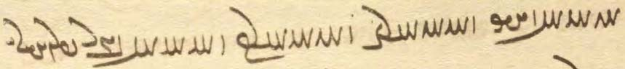

Glossary of words in the Texts and Exercises 9

abāz dār- hold back, keep away from (trans.)
ān-ōwōn čiyōn in that way that
bē ... tā anīy except ... (there is/are) no other
ēdōn čiyōn in this way that
gēhān gīr- take (i.e., conquer) the world; cf. royal name Jahangir
... homānāg = ō ... homānāg like, similar to
ō hayārīh xwāh- request as help, as to come to help
ō paydāgīh mad became manifest, appeared
pad čē kār for what ‘work’, for what purpose
pad marag in total
purr kun- to fill
tā ō all the way to

Nouns, adjectives, adverbs, pronouns:
abēgumān Wwa˜wïDcÅ <’p̄y-gwm’n> having no doubts
ābgēnagēn WwYKwYKcÅ <’p̄kynkyn'> of glass
abzār lACcÅ , la¸cÅ <’p̄z’l, ’p̄c’l> tool
agar tÅ <HT> if
ahanūz; ahanūz ... nē CWwaÅ <’hnwc> still; not yet
āhenēn WwYwˆjA <’synyn'> of iron
akāmagōmand Y>NWAkmAkA <’k’mk’wmnd> unwilling
anabēdān WwAtDcÅwA <’n’p̄yt’n'> ‘un-approached’ (sexually; Av. term)
andarg glY>wA <’ndlg> between
andar-māh aåÂlY>wA <’ndl-m’h> the moon between new moon and full moon
andarrōn (< andar-rōn) WWwLx , WWwlYwA <’ndlwn', BYN-lwn'> inner, interior, inside; + az or ī: “inside, within”
andarrōn-nēmag kmYWwlY>wA <’ ndlw(n)-nymk'> the inside
arešk-kāmag WkmAKkßglA <’lyšk-k’mk'> having envy as one’s wish
arešk-kāmagīhā aåDkmAKkßglA <’lyšk-k’mkīhā> adverb from arešk-kāmag: “since his/its wish was envy” (Lesson 13)
arwand-asp WcjaDwlA <’lwnd-’sp'> with fleet (speedy) horses
ašādīh EtåhA <’š’tyh> unhappiness
asēmēn WwˆÂˆjA <’symyn'> of silver, silvery
axtar LtåÅ <’htl> star, constellations, sign of the zodiac
azabar LPcÅ <’cpl> above
azēr lYcÅ <’cdl> below; azēr ī “below, underneath”
baγōbaxt, baγbaxt WtåÅBKV , WtåÅBWKV <bk(w)b’ht'> ‘allotted by the allotter’ (Av. epithet)
bē ... tā YW ... AWV <BRA ... OD> except
bowandagīh EIWWV <bwndkyh> fullness, completeness
brinǰēn WwYCwˆÒV <blncyn'> of bronze, brazen
bun WWB <bwn'> beginning
buništ WthYWWV <bwnyšt'> principle
buništag WKthYWWV <bwnyštk'> (first) principle
bun-xān WwaÅ WWB <bwn'-h’n'> source
burzāwand YWwAcÒWB <bwlc’wnd> lofty, tall
čahār-ēwēnag WKwYwïÅ AblA <ALBA’ywynk'> in four ways
če’ān-iz ... nē aÒ ... CwAC <c’nc> not ... any at all
čašmag WkmÍC <cšmk'> well-spring, source
čiyōnīh EwˆDC <cygwnyh> ‘howness’, how things are
dar lY , AıB <BBA, dl> door; gate, court; section; topic, subject
darbušt, drubušt WtHWP[Y , WtHWplY <dlpwšt', dlwpwšt'> fortress
dašt WtHY <dšt'> (a) plain
dām-dahišnīh Ewßad>maD> <d’m-dhšnyh> (the establishment of) the creation
dānāg WkAwaD <d’n’k'> knowledgeable, wise
draxt Wtå¬Y <dlht'> tree
drūnāy ÄWwlY <dlwn’d> harvestable things
ēw-čand, ē-čand YWcdA <’y-cnd , HD-cnd > some, a few
ēg WwïDA <ADYN'> then, next
ēkānag WKwAKwˆÅ <’ywk’nk'> single, identical
ēwēnag WKwYwˆÅ <’dwynk'> manner, way
ēwkardagīh EKTWKwˆÅ <’yw-krtkyh> unison; pad +: “in unison, jointly”
fragard, see pargard (below) Wt¬gLP <plklt'>
Fraškerd-kerdārīh elATWK WTWkßLP <plškrt' krt’lyh> the making of the Renovation
frāxīh (frāxwīh) EwaåÒP <pl’hwyh> expanse; comfort; oppos. tangīh
frazānag WKwAcÒP <plc’nk'> possessing foreknowledge; learned man
gōkarn WwLKwY <gwkln> Cow’s ear (Avestan); name of a mythical plant
gōwizār lACWwY <gwwc’l> in detail, detailed
gursagīh EksLwY <gwlskyh> hunger
ham ÂA <hm> same
hammis, hamist nˆÅK <KHDE> 1. (together) with (postpos.); 2. all
hayārīh (ayārīh) elAvsA <hdyb’lyh> help
hazārgānag WKwAklAcÅ <hc’l-k’nk'> a thousand-fold, by thousands
hōm MwA <hwm> hōm, ritual drink (Av. haoma, OInd. soma)
ǰōrdāg WkAtÒwY <ywlt’k'> barley, grain
ǰud-bēš ßYVtDwY <ywbt-byš> keeping harm away
kāmagōmandīhā aådY>NwAkmAK <k’mk’wmndyh’> willingly
kāskēn WwY˝JAK <k’skyn'> of lapis lazuli
kerdārīh elATWK <krt’lyh> making, action
kōxšišn WwßAWK <kwhššn'> struggle, fight
madārtom MWt¬At˜ <mt’ltwm> coming most often
māh-pāyag WkˆÅP aå˜ <m’h-p’dk'> the moon-level
mādayān WwaÅtå˜ <m’tgd’n'> book
māndagīh EI>wa˜ <m’ndkyh> tiredness
mang GN <mng> hashish, bhang
mardōm-kerbīh EcÒK ATwÍWA <ANŠWTA klp̄yh> being in the form of a human
marnǰēnīdār lAtDwYCwlM <mlncynyt’l> the Destroyer
mowmardīh Et¬mYN < mwgmltyh> Magian-hood, community of Zor. priests
nasāy-nigānīh EwAKW áJW <ns’d-nk’nyh> burial of corpses
nīrang (nērang) Y<wlYW <nylng> a ceremony, ritual, spell
nērōgōmand YNwAKwlYW <nylwk’wmnd> possessing strength
ōzōmand YNwACwA <’wc’wmnd> strong, powerful
pādyāwand YWwaDtÅP <p’ty’wnd> strong, mighty
pānagīh EKwAP <p’nkyh> protection
pargard (commonly fragard) Wt¬gLP <plklt'> a chapter/book division in the Avesta
parisp WfjLP, WcjLP <pl(y)sp'> enclosing wall
paygām µAtDP <pgt’m> message
pērāmōn WWna¬YP <pyl’ mwn'> around; ± ī or + az
pōlābdēn WwYTcåÒWP <pwl’ptyn'> of steel
purr-māh aåÂLWP <pwl-m’h> full moon
rah, rahīy îÒ <lyd, l’d> chariot (see Lesson 5)
rāmišnōmand YNwAwßmâL <l’mšn’wmnd> joyful, happy
rāstīhā aåDtjaÒ <l’styh’> truthfully, honestly, fairly
rāyōmand YNweaÒ <l’d’wmnd> + xwarrahōmand: “luminous and full of Xwarrah” (Lesson 8, Idioms)
rist-ārāstār lAtja¬A WtjïÒ <lyst'-’l’st’l> who/which restores the dead
rist-wirāstār lAtja:DW WtjïÒ <lyst'-’l’st’l> who/which restores the dead
sadgānag WKwAKtJ <st-k’nk'> a hundred-fold, by hundreds
šnāyišn = xšnāyišn WwßäwÍ <šn’dšn'> hail (to ...)! (Av. xšnaoθra)
sūdōmand YNwATwS <swt’wmnd> bringing benefit
tag WKT <tk'> attack, assault
tišnagīh EKwßYT <tyšnkyh> thirst
tomīg (tamīg) Wkˆ˜WT <t(w)myk'> belonging to darkness
tuhīgīh EkˆÅWT <twhykyh> emptiness, void
tuwānāg WkAwABWT <twb’n’k'> mighty
urwar-kerbīh EcÒK LwLWA <’wlwl-klp̄yh> being in the form of a plant
wag (waγ) WKW <wk'> frog
wād WtÅW <w’t'> wind
war LW <wl> lake; bay, inlet
war LW <wl> chest, ordeal (of pouring molten metal on the chest)
wis sYW <wys> town
xešmgen Wwˆ<ÂßA <hšmgn'> angry
xšnāyišn = šnāyišn WwßäwßA <hšn’dšn'> hail (to you)!
xwarišnīg WIwßLwA <hwlšnyk'> something eatable
xwurdag WKtÒwA , WKtÒWwA <hw(w)ltk'> little, small
zanišn WwÍWtda˜ , WwÍU <znšn', MHYTNšn'> striking, smashing
zarrēn WwYva¸ , WwˆÅva¸ <ZHBAyn', ZHByn'> of gold, golden
zofāy ÄPU <zwp’d> deep
zufr LPwZ <zwpl> deep

Names:
Abarg yLcÅ <’p̄lg> Abarg, name of a scholar-priest
Alaksandar lYwSklA <’lksndl> Alexander
Čēčast WtJcDC <cycst'> name of a lake
Damāwand Y>WwaÂY> <dm’wnd> name of a mountain
Fraškerd WTWkßLP <plškrt'> the Renovation
Frēdōn WWWtdLP <plytwn'> hero who captured Dahāg
Kangdiz cdY<WK <kngdc'> name of a castle
Nōdarān WwaÒTWW <nwtl’n'> belonging to the family of Nōdar
Ohrmazd-dād Wtåda˜wAwA <’whrmzd-d’t'> established by Ohrmazd
Pāzag [mss. WWcÅP] WKcÅP <p’ck'> one of the Avestan nasks
Pēšānsīy îJwaHYP <pyš’nsyḏ> name of a plain
Šābuhr (Šāpūr) lAWcåH <š’pwhl> a 3rd-cent. Sasanian king
Sagestān WwAt∆∂J , WwAtJ˝J <skst’n', skst’n'> Sistan
Sawar (?) LBwS < swbl = yywbl> name of a lake
Srid WtdlS <slyt'> mythological person
Wisrabān WwAf:JW <wslp’n'> son of Wisrab, a mythical character

Verbs:
abzāy- abzūd WTUcÅ -á¸cÅ <’p̄z’d- ’p̄zwt'> increase (intransitive)
āhanǰ- āhaxt WtååÅ -CwaÅ <’hnc- ’hht'> pull
āster- -LtjA <’stl-> become guilty (Av. āstriia-)
āwar- āwurd -WwYtdaD <YHYTYWN-> bring (hither)
āxēz-ist TtjaÅ -cdaÅ <’hyc- ’hst'> rise, get up
drūn- drūd -WwlYcÅ <HCDLWN-> reap
gard- gardīd -t¬Y <glt-> turn around, turn about
kār- kišt -WtdlZ <ZLYTN-> sow, plough, till
nibēs- nibišt -WWvYTI , WtHPW -jYPW <npys- npšt', YKTYBWN-> write
nigan- nigand YWKW -WKW <nkn- nknd> bury
niger- nigerīd -lYKW <nkyl-> look (at)
nih- nihād -WWtÅwA <HNHTWN-> place, lay
nišān- nišāst WtjaHW -waHW <nš’n- nš’st'> settle, set down, seat,
WtJWW}YtD -WWvYtD <YTYBWN-st'> establish, endow, “enthrone” (a fire)
rānēn- rānēnīd WtDwYwaÒ -wYwaÒ <l’nyn-> drive (trans.), push (away)
rēz- rēxt WtådL -cdL <lyc- lyht'> pour
šāyēd WtdaH <š’dyt'> it is appropriate, it is allowed, it is possible
tāb- tāft WTcÅT , –cÅT <t’p̄-> shine, heat
waz- wazīd -CW <wc-> blow
wāz- wāzīd - cÅW <w’c-> fly, drive (in chariot)
wirēz- wirēxt -WWiLW <OLYKWN-> flee
wirāy- wirāst Wtja¬YW -á¬YW <wyl’d- wyl’st'> restore
xwah- xwast WtJWwaÒP -WwaÒP <PLHWN-> thresh, thrash; frāz + “thrash”
yaz- yašt -WwAvzY <YDBHWN-> (offer) sacrifice (to)

Lesson 10

Spelling 7

sr for Avestan θr
In loanwords from Avestan, θr becomes sr, e.g.:

:Jwa˜ <m’nsl > mānsr “sacred word,” Av. mąθra
YWc∆:Jwa˜ <m’nsl-sp̄nd> mānsr-spand a deity, name of a day, Av. mąθra spəṇta
:jaÅ <h’sl> hāsr “league,” Av. hāθra
:jadÍwY <ywšd’sl> yōǰdahr (yōždahr) “ritually clean,” Av. yaoždāθra

Arameograms 12. adjectives and adverbs
Here are (again) some of the more common adjectives:

AbL <LBA> wazurg “big, great” nla˜ <MALE> purr “full”
WkïÅL , WiâL <LHYK> dūr “far, distant” Wkï¬A, WilA <ALYK> dagr “long” (time)
lYpÍ <ŠPYL> weh “good, better” elS <SLYA> wad “bad”
µïJ| <BSYM> xwaš “pleasant” Y>T <TB̲> nēw “good, well”
EI <DKYA> pāk “clean, pure” AtdlÍ <ŠLYTA> pādixšāy “authorized”

YBK <KBD> was “much, very” gZK <KZY> ahīy “earlier, formerly, at first”

WwYwL <LOYN'> pēš “before, in front” oaÅ <AHL> pas “after(ward), behind”
LtÅV <BATL> pasīy “after(ward), behind”

Note the following arameogram:

(WwYbA , wYBwA) WwYBwA <HWBDW(N) (HBDWN)> wanīy “destroyed”

used in the expressions
wanīy kun- “destroy” wanī-gar “destroyer” wanī-garīh “destruction” (active)
wanīy baw- (šaw-) wanī-būdīh (wanyūdīh) “destruction” (passive)

Word formation 4. Prefixes and suffixes 4

¹-āy, -āyīg
The suffixes ¹-āy (-ā) -āyīg (Ä- <-’d>, <-’d, [W∂ÎdA-] WiÄ-, WiA- <-’d(y)k'>) make adjectives from geographical names::

hrōm “Rome” hrōmāy (hrōmā) “a Roman” hrōmāyīg “Roman”
*muzr, misr muzrāyīg “Egyptian”
bābēl “Babylonia” bābēlāyīg “Babylonian”
asūrestān “Assyria” asūrāyīg “Assyrian”

²-āy
The rare suffix ²-āy (Ä- <-’d>) mostly makes nouns corresponding to adjectives denoting size:

drahnāy “length”
drāzāy “length” (rare) cf. drāz “long” (distance, cf. darg “long” time)
pahnāy “width, thickness” cf. pahn “broad, thick”
bālāy “height” cf. buland “high”
zofāy “depth” cf. zafr, zofr “deep”
drūnāy “harvesting” cf. drūdan “to reap, harvest”

Note also zan-rēbāy “*seduction” (Dk.5.9.9 < rēb- ‘to defraud”?), as well as the Aramaic loan word nakkīrāy “denying” and the adverb agāmāy <’k’m’y> “unwillingly” (see Lesson 18).

-gar, -gār
The suffixes -gar ( LK-, lY- <-gl, -kl>) and -gār ( lAk-, laD- <-g’l, -k’l>) mostly make adjectives and nouns meaning “doer of X, making X.” Examples:

pērōz “victorious” pērōzgar “victorious”
yōǰdahr “ritually pure” yōǰdahrgar “who makes ritually pure”
warz “cultivation, farming” warzīgar “cultivator, farmer”

kerbag “good deeds” kerbakkar <krpkkl, krpkgl> “doer of good deeds” (Man. <kyrbkr>)
bazzag “bad deeds bazzakkar <bckkl, bckgl> “doer of bad deeds, evil-doer” (Man. <bzkr>)

kām “wish, desire” kāmgār “who does what he wishes”
wināh “sin, crime” wināhgār “sinful, guilty” (oppos. awināh “who has no sins”)
ayād “memory” ayādgār “memorial”
rōz “day” rōzgār “time” (as it passes day by day)

-tār/-dār, -tārīh/-dārīh
Nouns of agent (performer of action) in -tār/-dār ( lAT- <-t’l>) are formed from past stems of verbs by replacing the final -t or -d with -tār or -dār, respectively.
Negative nouns in a- and abstract nouns in -īh (elAT- <-t’lyh>) are frequently formed from such agent nouns:

bōxtan “deliver” bōxtār “deliverer” bōxtārīh “deliverance”
warzīdan “work, labor, perform” warzīdār “laborer, sb. who performs/does sth.” warzīdārīh “performance”
xwardan “eat” axwardār “not eating, without eating”
pahrēxtan “guard (against)” pahrēxtār “staying away from”
dīdan “see” dīdār “seeing, a view (of)”
madan “come” madār “bound/destined to come, sb. who comes frequently”

In compounds:

āyaft-xwāstār “sb. who seeks rewards” āyaft-xwāstārīh “the seeking of rewards”
kerbag-warzīdār “sb. who performs deeds” kerbag-warzīdārīh “the performing of good deeds”

These nouns can take direct objects, e.g., druzān wānīdārtom “one who most often overcomes the lie-demons” (StS.17.9)
Some nouns in -tār/-dār have passive meaning, e.g.:

griftan “seize” griftār “prisoner”
frēftan “deceive” frēftār “(easily) deceived”
dīdan “see” dīdār “visible,” cf. dūr-dīdār “visible from afar”
bastan “bind, close (road)” bastār “closed (road)”

-estān
This common suffix, spelled WwAtJ- <-st’n'> or WwAtjG- <-yst’n'> (occasionally WwAtjA- <-’st’n'>) makes nouns of place:

Asūrestān “Assyria, Syria” Hūzestān “Khuzistan” Tabarestān “Tabaristan”
Čīnestān “China” Sagestān “Sistan” Turkestān “Turkistan”
Hindūstān “India” Sō(g)westān “Sogdiana”(?)

šahr “realm” šahrestān “town”
hērbed, a priestly teacher hērbedestān, lit., place for priestly studies

aspestān “(horse) stable” gōstān “cow pen”
uštar-estān “camel-stable” [but: pahast “sheep stall” < pah]

In a few words, the function of the suffix is indeterminate, e.g.:

dādestān “law, judgement” cf. dād “law”
zamestān “winter” cf. zamčīg “of winter, winterly”
bārestān “patient” bār “burden”

Note also names of Avestan texts, all listed with short descriptions in Dēnkard book VIII:

Hērbedestān, rules connected with priestly studies
Nīrangestān, rules connected with the performance of rituals
Zaxmestān, Rēšestān, rules dealing with bodily assault and harm (text not extant)
Hamēmālestān, rules dealing with bodily assault and harm (not extant)
Pasuš-horwestān, rules for dealing with sheep and shepherd dogs (partly extant)
Stōrestān, rules for dealing with domestic animals (partly extant)
Arzestān, rules for determining value (partly extant)
Waxšestān, rules for gift exchange, compensation (waxš “interest”), etc. (not extant)

-bān (WwAP- <-p’n'>) “guardian of”
darbān “door guard” marzbān “border guard”
pāsbān “watch guard, watcher” zēndānbān “prison guard”

-bed (WTP- <-pt'>) “lord of, master of”
mānbed “house-master” spāhbed “master of the army, general”
wisbed “town-master” hērbed “priest” (Av. aēθrapaiti “master of learning”)
dahībed (dehbed) “lord of the land” mowbed “high priest” (Av. *moγupaiti “master of the Magi”)

-war ( LW- <-wl>)
This fairly rare suffix (from -bar “carrying”) mostly makes nouns and adjectives from nouns. Examples:

waxš “word” (Av. vāxš) waxšwar “prophet”
nēzag “spear, lance” nēzagwar “spear/lance-carrying”
kēn “vengeance” kēnwar “vengeful”
āz “greed” (demon: Āz) āzwar “greedy”

Note:
mādag “substance” mādagwar “especially”

-wār (lAW- <-w’l>)
This suffix makes adverbs of manner. Examples:

sazāg “fitting, appropriate” sazāgwār “fittingly, appropriately”
xwadāy “lord, ruler” xwadāywār “lordly, in a manner befitting a lord”
ham “same” hamwār “always”

-čār, -zār ( lAC- <-c’l>) “place of”
uzdēsčār “place of idols, idol temple” ǰašnzār “place of celebrations”

Grammar 10

Demonstrative pronouns (recapitulation)

Near-deictic “proximal” (“this, these”):
ēn NwY , NwY> <Z̲NE> “this”
ēd [Ä] AwA <HNA (’y)> “this”
im Nwï>Ò , NwïÒ <LZ̲NE> “this” imēšān WwaHNwïÒ <LZNEš’n'> “these”

Far-deictic “distal” (“that, those”):
ōy nLW <OLE> “that” awēšān WwaHnLW <OLEš’n'> “those”
ān ˝¸ <ZK> “that (there)”

The pronouns ēn and ān can be preceded by ham to add emphasis: “this/that very.”
Only ōy and im have plural forms: awēšān and imēšān (Manichean also imīn).
ōy is rarely plural; instead awēšān tends to be used as general plural, both as personal pronoun (alone) and demonstrative pronoun (with a noun).
ōy, awēšān is also used as a personal pronoun “he, she, it; they.”
ēn, ēd, and ān can be used with singular and plural nouns, including nouns in -ān.
ēd is commonly used to refer to the text or the situation in which a sentence is spoken: “this one in question, this that we have been talking about, the following,” etc.
im “this” is the least frequent of the near-deictic pronouns; it is mainly used in expressions such as im rōz “this day, today.” The plural imēšān is very rare and only used with nouns in -ān.
Examples:
ān sāl wārān bawēd
“that year there will be rain” (in predictions) (PR.48.13)

ēn dašt nēk ud gōr ēdar was
“this plain is fine and wild asses are plentiful here” (KN.2.18)

pad gōwišnīh ī ohrmazd paydāg kū ēd tō mašīy gāw u-t ēd ǰōrdā
“in/by the statement of Ohrmazd it is manifest: This is your cow, Mašīy, and this (is) your barley” (Dk.7.1.11)

Gayōmard daxšagōmandīh ēd kū mardōm az ōy tōhmag pad ān hangōšīdag zād hēnd
“Gayōmard’s ‘having a mark’ is this (the following): people were born from his seed in that similar manner” (Bd.1a.16)

Ādur-mihr guft kū druz-ēw Āz stahmagtar ud xwarišn-ēw ham ēn xwārtom ī amāh nūn xward ham ān
“Ādur-mihr said: ‘One lie-demon, (namely) Greed is the most violent, and one food is the lightest (namely) this very one that we have eaten now, (yes) that very one’ ” (Dk.6d.2)

Note expressions such as ēn nām “this fame,” that is, “the fame for this deed” (AWN.2.7), pēš az ān nibištan “before that writing,” that is, “before writing (all) that” (Dk.8.1.4)

ōy, ān “that, the other,” ēn ... ān as “this ... that,” and ēk ... ān “one ... the other”:
gōy ōy kanār ī Ardaxšīr ōbast
“the (polo) ball fell on the other side of Ardaxšīr” (KN.14.6)

hutuxšīh ān 3 pēšag hayār
“the artisanate (is) the helper of those (= the other) three estates (priests, warriors, farmers)” (Dk.3.27)

ka pad ān kust ī Tērag andar šawēd kišwar ī Sawah ud Wōrūbaršn ud Wōrūǰaršn nēm-ēw az Xwanīrah tābēd
“when (the sun) sets on that (= the other) side of (Mount) Tērag, it shines on the continents of Sawah, Wōrūbaršn ud Wōrūǰaršn, and half of Xwanīrah” (Bd.5b.11)

ka zarmān mard pad ēn darag andar šawēd aburnāy ī 15-sālag pad ān dar bērōn āyēd
“when an old man goes in through this (one) door, he comes out through that (other) door as a 15 year-old youth” (Bd.32.11)

2 mard ēk abāg did pahikār ud harw 2 brād hēnd ēk gōwēd kū pidar ī man wāhmān 2 xwāstag *ō man dād ... ud nūn-iz ān pusar ōwōn gōwēd ...
“two men had a legal fight one with the other, and the two (of them) were brothers; the one says ‘my father such and such gave two pieces of property to me ... and now that (= the other) son says thus ...” (Purs.53.1)

kerbag ī az ēn gāhānbār tā ān gāhānbār kunēd ēw-kardag bē bawēd harw ēk ēk ōh bawēd
“the kerbags he makes from this Gāhānbār to that (= another, the next?) Gāhānbār will be connected, (and) each one will be in the usual way” (Nir.42.5b; about the merit accruing from celebrating the Gāhānbārs)

ēd rāy (ē rāy) “for this reason,” pad ēd dār- “to think, estimate (that)”:
ēd rāy star ī agumēzagīh xwānēnd
“for this reason they call (them) ‘the stars un(touched by) the Mixture’” (after Bd.2.11)
pad ēd dārēnd kū ēk-tāg hēnd
“they think that they are alone” (Bd.27.57)

ka ... ēd (ī) kā, ēd (ī) ka ... ēd (ī) kā “whether ... or” (rare):
ān anāgīh ī ka kerbakkar ēd ka bazakkar ud ka tuxšēd ēd ī ka nē tuxšēd ēd ka hunsand ud ēd ka nē hunsand ud pas a-kām ... rasēd
“whether one does good or one does evil, whether one is diligent or not diligent, whether one is content or discontented, that evil (= death) will then come (even) against one’s wish” (DD.14.3)

Abarg guft ēd ka bē (= pad) kēr dārišn bē gīrēd ēd ka pad dast dārišn bē ō an-Ērān kunēd pad gyāg tanābuhl ud pad sāl-drahnāy margarzān
“Abarg said: whether he takes (the child) by virtue of ‘possession by penis’ (as the father), or he hands it over to non-Iranians by virtue of ‘possession by hand’ (as the one who actually has the child), (in either case) he is tanābuhl and after a year margarzān” (ZFJ.593)
(about a man who has sex with a non-Iranian woman and she becomes pregnant)

ēd ka pus ēd ka mard ī šahr pad 3-gōwišnīh gōwēd kū xwāstag-dār ham hamē xwāstag-dār bawēd
“whether a son or a man of the (same) town/land says with three utterances: ‘I am in possession of the (inherited) property’, (he is to be believed and) will be (regarded as) the one in (legal) possession of the property” (MHD.41.6)

adār-ēw !lAtÅ <’t’l-1> “whichever (of two)”:
This rare word, which rhymes with kadār-ēw “which of two,” looks like a demonstrative adverb, but renders the Avestan relative adverb yatāra “the one of the two who = whichever of two” (?):

ēg gōwēd dōst ō ōy dōst ān ī pad bālišn nibāyān kū ul tō ēst čē wigrād man
adār-ēw kē pēš ul estād ā-š bē rawišnīh ō ān ī pahlom axwān
“then the friend says to (his) friend, the one lying on his pillow: ‘get up! for I am awake’
the one who (= whichever of the two) has gotten up first, he will be going to the Best Existence” (PV.18.26)

The verb. The infinitives
Infinitives are formed in two ways:

1. “short” infinitives are identical with the past participle
2. “long” infinitives are formed from the past stem by adding -an:
WWT- <-tn'>, WWtÅ- <-’tn'>, WWtD- <-ytn>, WWtJ-, WWt∆D- <-(y)stn'>.

Since the only orthographic difference between the short and the long infinitives is the final stroke, they cannot always be distinguished, but we know from Manichean Middle and modern Persian that they both existed, e.g.:

griftan WWTWwïÅW , WWTplY <glptn'; OHDWNtn'> “to take, seize”
nišastan WWtJWW}YtD <YTYBWNstn'> “to sit”
madan WWt˜ <mtn'> “to come”
āmadan WWTWWtåD <YATWNtn'> “to come”
kerdan WWTWK <krtn'> “to do”
framūdan WWTnLP <plmwtn'> “to command, order”
estādan WWtÅWnYWI <YKOYMWN’tn'> “to stand”
pursīdan WWtŸJWWP <pwrsytn'> “to ask”
frēstīdan WWtDWWwïH <ŠDRWNytn'> “to send”
dwārīdan WWtdlA|wY <dwb’lytn'> “to run” (esp. evil beings)
dwāristan WWtjlA|wY <dwb’lstn'> “to run”

Notes:
Remember that the verb madan “come” (= āmadan) has no present stem.
Recall also that the infinitive may take the ending <-x₂>.
The infinitive pargandan “scatter, sow” is spelled WwY>WkLP <plkndn'>.

Uses of the infinitive
European speakers on non-English languages (and Pahlavi) will all have to learn that there correspond in English two forms to their infinitives: the infinitive (to sing) and the ing-form of the verb (sing-ing). Conversely, English-speakers should realize that, to translate a Pahlavi infinitive, either an English infinitive or an ing-form can/must be used. Keeping this in mind will make it easier to understand the following examples.
Note also that the Pahlavi infinitive sometimes needs to be translated into English as a passive infinite.

Infinitive as subject, direct object, possessive
Since the inifinitive is a nominal form of the verb, it can be used in all the functions of a regular noun. In English, ing-forms are often preferred in some of these functions, e.g.:

subject: to sing/singing can be hard work
direct object: I like to sing/singing, he commanded the army to attack
possessive: the art of singing, a time of rejoicing
with prepositions: in order to sing
with adjectives: able to sing, authorized to leave

On the whole, Pahlavi infinitives, too, work in this way!

Infinitive as subject and predicate:
An infinitive is often found as subject in impersonal expresssions [on these, see below], but rarely otherwise.

Infinitive as predicate:
fradom sūd ī az Gayōmard ōzadan ī Arzūr ud abespārag kerdan ī tan ī xwēš meh-dādestānīhā ō Ahrimen būd
“the first benefit from Gayōmard was to kill Arzūr and surrender his own body to Ahrimen obeying a higher law (requirement or similar) (meh-dādestānīhā)” (after MX.26.14-15)

Infinitive as direct object:
nūn-it nimāyam būdan ī ristāxēz ud tan ī pasēn
“now I (will) show you the becoming (= coming into existence) of the Resurrection and the Final Body (= how the R. comes about)” (after AWN.5.7)

Infinitives governed by prepositions
These constructions are very common:

abar agārēnīdan ī abārōn-dādīh ud wad-kunišnīh ī Banīg Srāyēl
“about how to undo the evil laws and evil deeds of Banī Isrāyīl” (Dk.5.1.5)

xwarrah pad ān hangām mad ō Waēgird ī Hōšang ī pēšdād abar winnārdan andar gēhān dād ī dehgānīh ud gēhān warzīdārīh ud dahībedīh ī gēhān pānagīh
“at that time, the Xwarrah came to Waēgird son of Hōšang Pēšdād about (= for the sake of) establishing in the world the law of landownership, the cultivation and overlordship of the world, which (is = that is) the protection of the world” (Dk.7.1.16)

ōh-iš az guftan kerdan paydāg
“thus it is manifest to him from what is said and done” (Purs.26.2)

pad marnǰēnīdan tag abar kerd
“he attacked in order to destroy (it)” (Bd.1.15)

Ardawān spāh ud gund ī ārāstag abāg pus ī xwēš ō pārs pad griftan ī Ardaxšīr frēstīd
“Ardawān sent an equipped army and force with his own son to Pārs in order to seize Ardaxšīr” (KN.3.22)

ān ī weh ōstigāntar winnerdan pad wattarīh škastan wišuftan
“how to establish more firmly what is good by breaking and scattering (what is) bad” (Dk.3.229.18)

mardōm pad kerbag kerdan tuxšāgēnēd kē dāšn ō kerbakkarān kunēd
“he who makes gifts to those who do good makes people be diligent in doing good things” (after Dk.9.67.5)

pēš az madan ī ō gāw ohrmazd mang ī bēšāz ō gāw pad xwardan dād
“before coming = before he (the Adversary) came to the bull, Ohrmazd gave the bull medicinal hashish to eat” (after Bd.4.20)

ud nasāy sag nimūdan nīrangīg čim ēk ēn kū a-wiškinn awēšān druzān ī tan agārēnīdārān kē nasuš-iz xwad hēnd pad ōy tan gāh dāštan ud tā waštan ī az nasāyīh abāz madan ī did ō kār ud sūd ī gēhān šāyēnd
“and one ritual reason for showing (a corpse) to a dog is this: uninterruptedly (a-wiškinn), those lie-demons who are what makes the body useless (agārēnīdārān), who are (nothing but) the Nasuš itself, are able to (šāyēnd) keep (their) place in that body until the changing from being nasāy (and) returning (= until it changes and returns) again to service and profit for the world of the living” (Dk.5.24.28)

Infinitives with rāy, pad ... rāy “in order to, for ... -ing”

gumān kerdan ī mardōmān pad ēn dēn rāy
“in order to make people doubtful about this dēn” (AWN.1.3)

ohrmazd guft kū nē šāyēd kerd čē tūr ī brādarōxš ī karb ī ahrimen ōzad ī tō rāy dād ān a-marg bē bawēd
“Ohrmazd said: it is not possible (to give Z. immortality), because (then) Tūr ī Brādarōxš, the evil priest (karb) whom Ahrimen established in order to kill you—he will become immortal (too)” (PR.36.6)

harw kas ... wistāx bawišn kū hagriz tis aw-iš nē rasēd ī aw-iš madan rāy zyān
“everybody should be confident that nothing will ever come to (= happen to) him (aw-iš), which, because it comes to him, (there) is harm” (Dk.6.28)

ān āb pad fraškerd rist wirāstan rāy andar abāyēd
“that water is needed at the Fraškerd in order to restore the dead” (Bd.12.12)

ān ī ka kār frārōn hudānāg pad hu’īh burd ī dānišn ō kār rāy pad ēk-brahmīh estēd ī-š paymān
“when it is that the activity is good (and the performer) is ‘well’-knowledgeable, by bringing knowledge to an activity with/by ‘well’-ness, he finds himself (estēd) in ‘being of one manner (brahm),’ which is his ‘mean’” (Dk.3.144.4)

Infinitives with subject and direct object
Since the infinitive is a verbal form, it can also have a ‘subject’ (who/which performs the action of the infinitive), a direct or indirect object and sometimes all three, as in these English examples:

“(about) Ohrmazd’s creating mankind”
= “(about) the fact that Ohrmazd [Subj.] created mankind [Dir. Obj.],” “(about) how Ohrmazd created mankind”

“(at the time of) Z.’s giving the dēn to the world”
= “at the time when Z. [Subj.] gave the dēn [Dir. Obj.] to the world [Indir. Obj.]”

These infinitives may be translated by ing-forms, but quite often as subordinate clauses. There are several examples in the preceding sentences (find them!), and here are some more:

Infinitive with ‘subject’:
The ‘subject ‘ of an infinitive usually follows the infinitive and is connected to it by ī. Other words may intervene:

abar madan ī pad harw zamān Astwihād ō ōšōmandān kē ōš mad estēd kē-iz nē
“about Astwihād’s coming at every time both those to whom death has come and those not”
= about how Astwihād ... comes or “about the fact that A. comes) to mortals” (Dk.9.12.17)

pas az madan ī gizistag Aliksandar ī Hrōmāyīg
“after the coming of the accursed Alexander, the Roman” = “after A. came ...”

xešmgen mard hāmōyēn wināh ud bazag ō menišn ōbadēd tā bē nišast ī xešm
“all (kinds of) sins and evil deeds fall into the thoughts of a wrathful man until the subsiding of (his) wrath = “until (his) wrath subsides)” (MX.1.18)

Infinitive with ‘subject’ and direct object:
Note that the direct object can be separated from the infinitive at quite a distance:

muštan ī wād āb ō zrēy
“the wind’s [Su] sweeping (of) the water [DO] into the ocean (= how the wind sweeps ...)” (WZ.3.33)

ka hangām ī xwarišn xwardan ī ān kirm bawēd ēdōn kunē
“when the time comes of Kirm’s eating food, then you (shall) do thus (= as follows)
= “when the time for that Kirm [Su] to eat food [DO] ...” (KN.8.14)

abar kerd ī Kāy-Us xwadāyīh pad čērīh abar būm ī haft pad dēwān ud mardōmān
“about Kāy-Us’s exercising kingship by valor over demons and men on the seven(fold) earth”
= how Kāy-Us [Su] by valor exercised kingship [DO] ...” (Dk.9.22.4)

abar xwardan ī artēštārān rōz ī kārēzār gōšt
“about soldiers’ [Su] eating meat [DO] on the day of battle” (Dk.8.26.12)

handarz ī abar nē guftan ī andar xwarišn ud xwārišn saxwan
“the advice about not speaking a word while eating and drinking” (Dk.9.9.2)

abar garān-wināhīh ī mard nibāg az an-ērān abāz duzzīdan ka-š xwēš pus
“about the gravity of the sin of (= incurred by) a man [Su] stealing back a hostage (nibāg) [DO] from non-Iranians when it is his own son” (Dk.8.20.120)

Infinitive with ‘subject’, direct object, and indirect object (with ō):
abar nimūdan ī Ohrmazd ō Zarduxšt dāmān pad tan ī pasēn
“about how Ohrmazd [Su] showed Zarduxšt [IO] the creations [DO] at the final body” (Dk.9.35.14)

Infinitive in impersonal constructions
On the constructions of impersonal verbs, see Lesson 9 [see also Lesson 12 on personal forms of ‘impersonal’ verbs]. These often take the short infinitive. Examples:

With abāyēd “one should, one must it behoves”:

pidar ud mādar frazend ī xwēš rāy ēn and kār ud kerbag pēš az 15 sāl bē hammōxtan abāyēd
“a father and mother should teach these many (= all the following) actions and good deeds to their own child before it reaches fifteen years (of age)” (PN.34)

u-šān ... guftan abāyēd “it behoves them to say”

With šayēd “it is appropriate, it is possible, one can”:

pad tārīkīh ēdōn tārīk ī pad dast frāz šāyēd grift(an)
“(hell) is so dark with respect to darkness that grasping it with the hands is possible
= it is possible to grasp it with the hands” (AWN.18.4; mss. short and long inf.)

wināh wizārišn rāy čand weh šāyēd kerbag warzīdan
“to perform good deeds the best (čand weh) one can in order to atone for (one’s) sins” (MX.52.9)

Ardašīr widerdan nē šāyist
“Ardaxšīr was unable to cross (over)” (KN.8.6/6.24)

Note that šāyēd need not take an infinitive:

nasāy ka andar āb wišuft estēd ān ī šāyēd bērōn bē āwarēnd ān ī nē šāyēd dādestān čē
“when a dead thing is broken up in (a body of) water, what is the legal position of that which they can bring out = can be brought out and that which cannot?” (RAF.38.1)

With tuwān “it is possible”:

u-tān griftan nē tuwān
“and (it will) not (be) possible for you = you will not be able to seize (him, them, etc.)” (KN.4.12/3.10)

ān-and dušmen az šahr abāz dāšt kē tuwān
“who can hold so many enemies back from the land?” (AZ.63)

pad ēn hamkārīh dēwān andar ēbgadīh ayōxšust wanīy kerdan nē tuwān bawēd
“by this collaborations (between Šahrīwar and other deities), during the Invasion, the demons will be unable to destroy the metal” (Bd.3.19)

nē harwisp-kerdār hē Ganāg Mēnōy kū-t man nē tuwān marnǰēnīdan
“(Ohrmazd said) you are not omnipotent, Foul Spirit, i,e., destroying me is not possible for you = you are unable to destroy me” (Bd.1.23)

Other:
ēk ka-š tis kāmēd guftan ēk ka-š tis kāmēd xwāstan
“one, when he wants to say something (and) one when he wants to seek something” (Dk.9.2.4)

čē sazēd būdan “what can it be?” (KN.4.16/3.14)

Infinitives with other adjectives and nouns
The adjectives and nouns that take infinitives are mostly the same as in English.

Srid guft kū nē ādūg ham bē ōzadan čē-m az-iš garzišn bē abaxšīh pad dil
“Srid said: I am not able to kill (the bull); for, because of (az ... bē) its complaint, I have (-m) pity in (my) heart” (WZ.4.17)

ka mēwag xormāy ayāb angūr yašt harw mēwag pādixšāy xwardan
“when one has sacrificed fruit—dates or grapes—(one is) authorized to eat every fruit” (MX.15.18)

With nouns:
drust āmad hē tō ardā wirāz ka-t ahanūz āmad zamān nē būd
“welcome, Righteous Wirāz, (who have come) when it was not yet the time for you to come” (AWN.4.1)

ōy kē-š pad ēn frahang ud rāz hammōxtan kāmag būd
“he who whose wish it was to be taught in this learning and secret
= who wished to be taught in this learning and secret” (Bd.0.5)

čiyōn dūdag kadag-bānūg ast bē ō stūr gumārdan nē niyāz
“since there is (an authorized wife), (namely) the house-mistress of the family, there is no need to appoint her as guardian (of her non compos mentis husband)” (DD.53.9)

pad ēmēd ī kār wēš ayāftan
“in the hope to get (= of getting) more work” (DD.87.9)

Wāy ān ī andar harw 2 dām petyārag bē burd xwēškārīh
“Wāy’s duty is to remove/removing the adversities in both creations” (Bd.3.6)

u-m ... xwēškārīh ud frēzwānīh ēn
kū ohrmazd pad astīh ... ud akanāragīh ud abēzagīh ahrimen pad nēstīh ud wanī-būdīh menīdan
“and my duties and obligations (are) these: to think/thinking about Ohrmazd as being, as limitless and pure, (but) about Ahrimen as not being and as someone that will be destroyed” (PN.3)

Infinitive with verbs
The most common verb taking an infinitive is “to order, command (somebody to do),” “to give,” “say,” “to know, be able,” “begin,” and others:

ēdōn framāyēd nibištan
“he orders (him) to write as follows”

āwarēnd wiš ud zahr ī mār ud gazdum ud abārīg-iz xrafstar ī pad dōšox u-š xward dahēnd
“they bring venom and poison from snakes, scorpions, and the other evil animals in hell and give him to eat” (MX.1.191)
ka gād ēw-bār dahēd bīm pad tan ēwar
“when she offers him to have sex once, fear (= danger) to the body is certain” (because she may conceal her menstruation) (after PR.34d.2)

kē yazd šnāxtan gōwēd u-š čiyōnīh nē dānēd ... az yazd-šnāsīh dūr
“he who says he knows god, but does not know how he is, is far from knowing god” (Dk.3.109.9)

kē pad āsn-xrad ud gōšōsrūd-xrad abar nigerīdan dānēd
“he who knows (how) to look at (something) by (both his) ‘inborn wisdom’ and the ‘wisdom acquired through the ear’” (Dk.6B.11)

hudānāg būdan ud kār ud kerbag čāštan nē dānēd
“he does not know (how) to be well-knowing and to teach works and good deeds (Purs.45.2)

xwaršēd Mūš parīg ō rahīy ī xwēš bast ... kū tā wināh kerdan kam tuwānist
“the Sun bound the witch Mūš to his own chariot ... in order that she should be able to do less sin” (Bd.5.5)

ud az ēdar niwennīhēd guftan abar rēmanīh ī bahrān ī andar-iz zīndagīh ī tan az tan murd ud ǰudāg bawēnd
“and from here we start (niwennīhēd “it is started”) to speak about the pollution of the parts that, also during the life of the body, become dead and separated from the body” (after Dk.5.24.19b)

In one (famous) example, kāmēd appears to be used with the infinitive as future (a construction found in some Persian dialects):

pad dēn gōwēd kū dušpādixšāyīh ī awēšān sar kāmēd būdan
“it says in the Religion that their evil rule will come to an end” (Bd.33.23)

Infinitives in enumerations
This usage is often indistinguishible from the use identical with the participle of necessity, e.g.:

pad gētīy fradom pad dēn āstawān būdan didīgar zan kerdan ud paywand ī gētīy rāyēnīdan ... ud pad ēn abēgumān būdan
“in this world, firstly, to have (= having or one should have) faith (āstawān būdan) in the dēn; secondly, to marry and to arrange (= marrying and arranging or one should marry) continuation of one’s line in this world ... and to be (= being) without doubt (= have no doubt or one should have no doubt) about this (= the following)” (PN.4)

harw šab 3 bār pad hamāg ram madan ... harw rōz bāmdād bē raftan ... andar gōspandān nigerīdan ān ī wēmār ud rišt ... gōspand dādīhā darmānēnīdan sālārēnīdan
“to get to (or one should go to, etc.) the entire flock three times every night ...; to go among the cattle every day at dawn ...; to check out the cattle that are sick and hurt; to give them medication according to the rules; and to be their guardian” (Dk.8.23.5; the duties of the cattle owner)

Infinitive ≈ participle of necessity in -išn
In legal texts, the infinitive is often used similar to the participle of necessity in -išn “which needs to be done” (Lesson 13) and can often be translated in English by a passive infinitive “is to be done,” e.g.:

ēn dādestān abāg wizīr ī ... azabar-nibišt estēd nigerīdan
“(as for) this judgement together with the opinion ...., what is written above is to be looked at (= see what is written above)” (MHDA.8.84)

ōy ī margarzān wināh andar radān garzišn ud tan bē abespārdan
ǰud az radān tan bē abespārd nē bawēd
“he who has a margarzān sin, should complain to the judges and (his) body is to be surrendered;
the body is not surrendered other than (to = only to) the judges” (ŠnŠ.8.2)

The use of derived nouns instead of subordinate clauses
The nouns in -īh, especially those made from compounds, are often used much in the same way as infinitives. They can, and should, often be translated as full clauses. Note especially the use of rāy in such constructions:

u-m mardōmīh az Mahrīy ud Mahriyānīy
“and my being a human being (comes) from (being descended from) Mahlīy ud Mahliyānīy = I am a human being because I am (descended) from Mahlīy ud Mahliyānīy” (PN.2)

did Ahrimen gōwēd kū bē hāzam harwisp ox ī astōmand ō adōstīh ī tō dōstīh ī man
“then Ahrimen says: ‘I will lead the entire bony existence to being unfriendly to you, (but) to being friendly to me (not being your friend ...)’” (WZ.1.7)

sag pad hamēstārīh ī gurg-sardagān ud pānagīh ī gōspandān kerdan rāy dād estēd
“the dog has been established (‘created’) in order to oppose the wolf-species and to protect the domestic animals” (after Bd.24.38)

Note how phrases are changed into adjectives and adjectives are changed into nouns:

harwisp-āgāh “all-knowing”
> Ohrmazd harwisp-āgāhīh rāy “because of Ohrmazd’s all-knowing-ness = because Ohrmazd knows/knew all”
garān wināh (wināh ī garān) “a heavy sin”
> mard ī garān-wināh “a heavy-sin man = a man who commits (and is guilty of) heavy sins”
> garān-wināhīh ī ān mard rāy “on account of the heavy-sin-ness of that man = because that man had committed (and was guilty of) (such) heavy sins”

mard-ēw kē-š gōwišn rāst “a man whose speech is truthful”
> mard ī rāst-gōwišn “a truthfully-speaking man”
> pad rāst-gōwišnīh ī ēn mard “through the truthfully-speaking of this man = because this man speaks the truth”

wišād dwār- “run about untied (i.e., without tying the kusti)
> wišād-dwārišnīh wināh ī garān “going about (with the kusti) untied is a heavy sin”

Sentences 10

Analyze the following sentences, and identify the arameograms:

/ WtDWtjA Wwa¬G ^ saÒPWtÅP WwaHwY x áÒ WwaDWwlY MWkL ^ eLKKC| ? !
bazzakkarīh ī ašmāh druwandān rāy andar dōšox pādufrāh ī garān wēnēd
“on account of your evil-doing, (you) wicked ones, you will see (experience, suffer) heavy/severe punishment in hell = for the evil deeds you have done, O evil ones ...”

/ WwABwL ^ Wwaå¸ N WtDwY WWT ^ EwaDTP W WwßlaD WWtJWwaDW| WtdaH WWwˆDC ? 2
čiyōn šāyēd xwāstan dārišn ud padēxwīh ī tan ǰud az zyān ī ruwān
“how is it possible to seek the upkeep and prosperity of the body without harm of (to) the soul?”
/ WtDWwsaD ßYP EthA áÒ AwA W WklAcÅ nLW x a˜wAwA à WtDWwsaD AwA WWP ? 3
pad ēd dārēd kū Ohrmazd andar ōy ačārag ud ēd rāy āštīh pēš dārēd
“he (Ahrimen) thinks that Ohrmazd is helpless against him and for this reason is offering peace”

/ WWt¸ Wt¬Y> W WWtååJ WwßLwA WWTWK MWt¬M ^ WKtjLP EtD<vˆÅ x ßAtÅ OW WtdaÂLP ? 4
framāyēd ō ātaxš andar ēbgadīh paristag ī mardōm kerdan xwarišn sāxtan ud dard zadan
“(Ohrmazd) orders the fire to serve mankind during the time after the Invasion, to make food, and to strike pain”

/ áÒ WwÍcdMwY x WwaÒwßYK ^ lAt¬AWW WtDWnYWI WtJWTP Ä YWB 1LwßGK AWK N LwßGK 34 N ? 23
az 7 kišwar az harw kišwar-ēw band-ēw paywast estēd winnārdār ī kišwarān andar gumēzišn rāy
“from each individual continent among the seven continents a bond is tied (connected) for (rāy; = to serve as) upholder of the continents in the Mixture (to keep the continents in their places)”

/ WwaåD WwaDWwˆ˜ N MWtDNwAnˆD< à WTPwˆåD WwaÅt˜ WkaÂA WWP à WtDWWWwmY CNwY áÒ WWt˜ ? 33
Mihr rāy ēn-iz gōwēd kū pad hamāg dehān dahībed kū xwarrahōmandtom az mēnōyān yazdān
“about Mihr he says the following, too: he is the town-master of all towns, i.e., he is the most endowed with xwarrah of all the gods in the other world”
nMT à LTwÍwL WtDcÅT AWB WWT NwˆÒ N ^ EwÍwL N WtDWWvYtD WKTK LTWwLx ^ ã x WIWK NwY tÂA ? 34
/ YwYwˆhAW WcÒWB ßAtÅ à
ka ēn kanīg andar ān ī andarrōntar kadag nišīnēd az rōšnīh ī az im tan bē tābēd rōšntar kū ānōh
kū ātaxš burz waxšēnēnd
“when this young woman (Z.’s mother) sits in the innermost room, (then,) from the light that shines out from this body (of hers, it becomes) brighter than there where they light a tall fire”

/ WtdAcÅ WWtJWwaDW| WklAC Wwa˜à WTWWwaD NwY q aDwM WKwYwˆÅ YBK W ? 44
ud was-ēwēnag saxwan abar ēn būd kū-mān čārag xwāstan abāyēd
“there was various talk (discussion) about this, (namely) that: we must seek a means”

WtåD WWP WWTWK ßAtÅ ^ WcdlaÅP WwaHWN Wwa˜ ã N ßAtÅ ^ Wwa¬AtÒW| N WwÍc¬Y LItD ? 333
/ WtDwL WtåD WWP WWTWK ßAtÅ ^ WcdlaÅP WwaHWWM Wwa˜ ã ØW
didīgar garzišn az burdārān ī ātaxš az ān mān kē-šān pahrēz ī ātaxš kerdan pad-dād
ō ān mān kē-šān pahrēz ī ātaxš kerdan pad-dād nēst
“second, the (Fire’s) complaint about those who carry a fire from a dwelling of those for whom (kē-šān) caring for the fire is according to the law to a dwelling where it is not according to the law”

WimY N ÍW ã ? WtådMwY q WimY WWP EIwY W ÍW ÍcÅ WTWwLTK x WimY WWP WKtÒN ^ LtJpLA ã ? º
/ WTWwlZW WTwLP ía¬Z x WvMwYWcå¬Y ^ WtDfJ ^ EpLK aŸJwS WWP LthYT áÒ žW]J AWB
ān xrafstar ī murdag pad zamīg andar mānd u-š wiš ud gandagīh pad zamīg abar gumēxt.
ān wiš az zamīg bē burdan rāy Tištar pad asp-kerbīh ī spēd ī drāz-dumb andar zrēy frōd šud.
“that dead xrafstar remained inside the earth, and its poison and foulness was mixed into the earth;
to remove that poison from the earth, Tištar went down into the ocean in the form of a white horse with a long tail”

Texts 10

Texts 10.1
From the Mēnōy xrad 21
/ à WtŸJWWP Wt¬A YWwˆ˜ N WkAwaD
/ aÒ WPwˆÅ WWTWK WtdaH nÍPW ØW ìtJ ^ WKtjAwA W WBC EkahAWT WWP
/ à xWwˆÅW WwaJP Wt¬A YWwˆ˜
/ WtdaH aÒ WWTWK nÍPW ØW Y WtDWnYWI WtDwˆådL| aÒ ^ EKwYW ã EkahAWT WWP
/ WtDWWtÂaD AWB ˆ¸K áÒ EkahAWT WtDWnYWI WtDwˆådL| ^ ã AWB
/ LbYcÅ ìtJ WWP NTwL aÒ WtåD ÍtÂA EkahAWT AWB
÷ Wtda¸cÅ WKWcåÒT WWP W WtDWWtÂaD WtååÒP ØW YWwˆ˜ WWP çøaÅ AWB
dānāg az mēnōy xrad pursēd kū
pad tuxšāgīh xīr ud xwāstag ī gētīy ō xwēš šāyēd kerdan ayāb nē.
mēnōy xrad passox kunēd kū
pad tuxšāgīh ān nēkīh ī nē brēhēnīd estēd ī ō xwēš kerdan nē šāyēd.
bē ān ī brēhēnīd estēd tuxšāgīh rāy ahīy bē rasēd.
bē tuxšāgīh ka-š yazd (or dād) nē abāg pad gētīy abēbar
bē pas-iz pad mēnōy ō frayād rasēd ud pad tarāzūg abzāyēd.
The knowledgeable man asks the divine Wisdom:
Is it possible to make the property of this world one’s own through diligence?
The divine Wisdon answers:
Through diligence, it is not possible to make one’s own that goodness that has not been (already) assigned (as such by the divine).
But that which has been (so) assigned comes earlier by diligence.
But diligence in this world, when/if it does not have the gods (or the law?) with it, bears no fruits.
But, afterward, in the other world, it comes to (one’s) aid and increases (the good deeds) on the scale.

Texts 10.2
After Mēnōy xrad 3

/ Lt¬YwA|WT WN WwaHwslY N W LtHwslY WN Wwa¬YwA|WT N / à WtŸJWWP Wt¬A YWwˆ˜ N WkAwaD
/ à xWwˆÅW WwaJP Wt¬A YWwˆ˜
/ xW]J laÂYT áÒ MwYN ^ WWTWB ßY,W W YwSWwA aÒ WtdA ˙dZ ã WWP WN LtHwslY nLW Wwa¬YwA|WT N
/ Wtd˙*J>wA aÒ áÒ MwYN ^ WWTWB ßYW W YwSWwA WtDWnYWI Wt˜ ^ ã WWP WN Lt¬YwA|WT nLW WwaHwslY N W
dānāg az mēnōy xrad pursēd kū az tuwāngarān kē driyōštar ud az driyōšān kē tuwāngartar.
mēnōy xrad passox kunēd kū
az tuwāngarān ōy driyōštar kē pad ān ī-š ast nē hunsand, ud wēš būdan ī tis rāy tēmār barēd.
ud az driyōšān ōy tuwāngartar kē pad ān ī mad estēd hunsand, ud wēš būdan ī tis rāy nē handēšēd.
The knowledgeable man asks the divine Wisdom: Who is the poorer among the rich, and who is the richer among the poor?
The divine Wisdon answers: Of the rich, he is the poorer who is not content with what he has and worries about how (his) things (belongings) can become more.
And, of the poor, he is the richer who is content with what has come (to him and he now has) and does not think about how (his) things (= belongings) can become more.

Exercises 10

1. Add the transcriptions/transliterations to these sentences and translate them:

WtDWWwaD aÒ sAkaHwY AWvY lAtdßAwYW W WtDWWwaD aÒ aå¬YcÅ AWvY lAtŸJWWP ? !
/ WtDWWwaD aÒ lATcjLP AWvY W˝JWWpmA W
pursīdār mard abērāh nē bawēd ud niyōxšīdar mard dušāgāh nē bawēd
ud hampursag mard frēftār nē bawēd

/ WtDWwLTK aÒ WTWkA WtdAcÅ WWTWK ^ WkPWK W lAK Tà WcÒW oA WfjaHWB ? 2
<bwš’sp' AL wlc' AYKt k’l W krpk' Y krtn' ’p̄’dt' ’krt' LA KTLWNyt'>

/ WtDWWwaD lAtådlaÅP sAWW N W WtDWWwaD WkahAWT WWTWK WKPWK WWP ? 3
pad kerbag kerdan tuxšāg bawēd ud az wināh pahrēxtār bawēd

WkaÅwÍwY ^ WwaHwY W YWwlY> ^ ‹ N W WWt˜ WwaåD ^ WwÍwYW W WthAW OW WKwYwˆÅ nM WWP ? 4
/ WtdaH WWtÅWB
pad čē ēwēnag ō wahišt ud wēnišn ī yazdān madan ud az Ahrimen ī druwand ud dōšox ī dušwahāg
bōxtan šāyēd.

ìWWwaD aÒ lATc¬Y< WwaåH ^ WtåD> WWP à WwˆÅW øA lAwlahGP nlˆÒ N . 23
/ YwˆHK aÒ WwaHwY> ØW aåH áÒ sAWW ã TcÅ
<MN LGLE pyš’lw’l AL OBYDWN AYK PWN d’t' Y ŠDY’n' glpt’l LA YHWWNyd
APt ZK wn’s l’d ŠDYA OL dwšhw' LA kšynd>

kL W L q WwAwˆ¬A à ìWtDwA nÍPWV kL à WtÅWnYWI WtHPW WWWtdA lyßadlA OW WkpAP ^ WkmÍ WWP ? 33
/ WtdA AtdlÍ W lATWkmAK WKtjAwA W WBC W adA W WWT WWP WwaåJ x ^ ATwÍwA WwaD>BK W
WcÒW WWT nÍPW WwˆÅW elAtÒWB WwaÂLP W EKwAkwˆÅ à LtååJ NwY kL OW L ^ Wc¬YwA CWWK W
/ / lAcJcÅ oA ETWB WwY◊wA OW
pad nāmag ī Pābag ō Ardaxšīr ēdōn nibišt estād kū tō xwad dānē kū Ardawān abar man ud tō
ud wasān mardōm ī andar gēhān pad tan ud gyān ud xīr ud xwāstag kām-kerdār ud pādixšāy ast.
ud nūn-iz handarz ī man ō tō ēn sax(t)tar kū ēkānagīh ud framān-burdārīh kun xwēš tan warz
ō wanī-būdīh ma abespār.

WWTWW˝JP WtdaH Wt¬AK WWP Y EI>wY< W WWTWwˆÅW WtdaH nS WWP Y lAT à WtDWWWwmY áÒ WwaHwY ? 34
YWNwA WkAT WKwˆÅ à YWwsaD AwA WWP ŽWwˆÅW saÒPtÅP !WtjGTW x AWvY + tÅ W
/ LtdlS EkAT WKwˆÅ ^ saÒPtÅP ÍcÅ
<dwšhw' l’d YMRRWNyt' AYK t’l Y PWN YDE š’dyt' OHDWNtn' W gndkyh Y PWN k’lt' š’dyt' PSKWNtn'
W HT 1000 GBRA BYN wtyst'-1 p’tpl’s OBYDWNx₂ PWN HNA YHSNNd AYK ’dwk' t’k' HWENd
APš p’tpl’s Y ’dwk'-t’kyh SLYTl>

/ WtDWWtÂE aÒ WwaHwY OW WwABwL à WWTWK WwABWT à NwY ele>sAfJ WWP nM ? WWTWWwE lesAfJ wïDA ? 44
WtDWwlZW LtdmA ^ nsLK OW LtDbA ^ WtHWP N tÂA MWtÒM nM
/ WtDWtdmL nLWC OW x 1YWB aådYWwï˜ WtåÅWtjA ÍwïDA
ēg spāsdār būdan. čē pad spāsdārīh ēn kū tuwān kerdan kū ruwān ō dōšox nē rasēd.
čē mardōm ka az pušt ī pidar ō aškomb ī mādar šawēd
ēg-iš Astwihād mēnōyīhā band-ēw andar ō grīw abganēd.

adlïÒ AtÒT WTWWwaD WWtJWcÅ WthAWt¬Z WWP tÂA ÂA WthAWt¬Z Y WwaD>KwY> à WkAtDP YWcJ WWP ? 333
YNwA WtjlABwY WthAWt¬Z Y WWtjAWW ØW aåH ∞ ± NTwL 1aåH 1adlïÒ AWK
/ YNwA WtJWtDwA aÒ WWTWK WklAC áÒ WWTWB Wwa˜ x ßAtÅ W
<PWN spnd pyt’k' AYK dwkd’w' Y zltwhšt' AM AMT PWN zltwhšt' ’pwstn' YHWWNt' TLTA LYLYA
KRA LYLYA-1 ŠDYA-1 LWTE 150 ŠDYA OL wn’stn' Y zltwhšt' dwb’lst' HWEd
W ’thš BYN m’n' bwtn' l’d c’lk' krtn' LA YDOYTNst' HWEd>

WwaHtÂA WKwˆÅ WKwˆÅ ? WtDWwllmY ÂÍ SwaHwS W aåÂLtdÍwA W LtdÍwA ^ WthAWt¬Z ^ NWB 3 ã ? º
WtDWwlZW îJwaDK ^ adM ã ØW áÒ WWTWwllA nßYwL !WIWK à WtDWWwaD WWWtdA WtDWWtÂaD nÍPW ^ WKwaÂZ
/ YWwa¬Z WWWtdA nÍPW ^ WKwaÂZ WWP WKwˆÅ WKwˆÅ WwaHnLW WtDWWwaD WWtJcÅ WtDcdMwY< WWT ØW x nS< ÍcÅ
ān 3 pus ī Zarduxšt ī Ušīdar ud Ušīdarmāh ud Sōšāns nām gōwēd
ēk ēk ka-šān zamānag ī xwēš rasēd ēdōn bawēd kū kanīg-ēw sar šustan rāy ō ān āb ī Kayānsīy šawēd
u-š xwarrah andar ō tan gumēzēd ābestan bawēd awēšān ēk ēk pad zamānag ī xwēš ēdōn zāyēnd

2. Transliterate, transcribe, and translate:

/ Y<wsLP YBK WWP WKtJWK ã OW WTWKwaåÒP ^ î¬Z ^ LPcÅ WwajaÒwA ^ WtJWK WWP WcdY<WK ? !
/ WwAKtÅPWWtÅ ^ WKtJWK WWP WcDWwa¬Ä
/ LtåÅcÅ ^ WtJWK WWP WwAtJwYC OW WwAtJkLWT ^ aåÒ WWP WwAtJWKwS ^ WimY
/ WwAtJwY>wA x lˆÂÍK / WwAkmY> ^ WPWK ^ lYcÅ WTWkmY ^ LW à YWwllmY WWWtdA ? slAP ^ Wwaå˜ WTWkmY ^ LW
? WtdA nMT WWK W slAP ^ WKtJWK OW WTWwlZW WTWWiLW lyßadlA à WkAtDP WWWtdA ? 2
/ WwABWT aÒ WWTWwˆÅW ã N oaÅ WtdaH aÒ WWTWwˆÅW MwY 3 Y>W tÅ W

/ WwYKwYKcÅ 2 W WwYTcåÒWP wïÒT W WwïÂïJ 2 W WwYva¸ WKwïÅ cÒWvlA Y Wkwaå˜ WWP Wwa˜ 34 ã SwïÅK Y WWTWK W ? 3

/ YWwˆ˜ ^ ã WwSC WtDWnYWI WTWWklA WtjaÒ WWWtdA EwßaD>WW| WWP ìtJ ^ WBC ? 4
/ žWwlYkM a˜wAwA N áÒ WWTWWklA aåDkAcJ W aåDtjaÒ WWB ØW WwßaD> W ÂaD> NwY WWP ^ EKwYW WwSnaÅ W
/ WtjlABwY x EklaÅtDP WWP a˜wAwA ^ WwaÂaD> N EKwYW ã ^ ŽWwïJwY AWB W WWTPwÍW WWP ‹ øaÅ W

WtDWwlZW 1ßÄ Wwa˜`>W WtdAcÅ WWtJWwaDW| WklAC Wwa˜à WTWB NwY q lAkSwA W aDwM WKwYwˆÅ YBK W ? 23
YWtDwA AWB YWNwA ÂaD<wA NwY x ^ MWt¬M à WtDWwYtdaD esAkA WwaDWwˆ˜ N W
µYWwYtdaD WKTWK WWP NwL ^ elsadÍwY W EcåDtÅP W Y<wlYW W WwAKwYWcÅ W WWwlY> W WwÍcD NwY à
/ aÒ WPwˆÅ WtDWWtÂaD NwL ^ WwABwL ^ WtååÒP ØW W WwaåååH ØW WPwˆÅ WtDWWtÂaD WwaåD ØW

3. Match the Pahlavi words with their transcriptions:

aDwM LwßGK Wwaå˜ anāgīh frāxkerd saxwan
mE<wA WBC aåDtåD āwām frayād sē
ÄTwA WcDWwa¬Ä WwAtjmY āwarēd gētīy stadan
EkAwA WklAC WwÍcD ayāb gizistag tuxšāg
EklaÅtDP WklYTP WWtDcÒW azabar gōspand warzīdan
WtååÒP WKtJcD WWtÒTW baxt hangām widerdan
EKwYW WPwˆÅ žWWiÍ čārag hištan xīr
elAkßYwA Wt¬A 9WwïJwY dādīhā kišwar xrad
GwïDLP WtDWwYtdaD WWwYcD dānēnd mān xwadāy
î¬Z WtjlABwY YWfJwY dibīr mayān xwēškārīh
ìtJ WTWKwaåÒP YWtDwA dwārist nēkīh yazišn
kahAWT WTWWklA µABwA ērānwēz padīrag zamestān
LPcÅ Wwa˜ AtÒT frasang petyāragīh zrēy

4. Translate into Pahlavi and write in Pahlavi:

- When we arrived in (= to) Babylon, we came to a river which we were not able to cross.
- It says in the Avesta that, in Ērānwēz, the winter is ten months and the summer two months.
- Until the resurrection and the Final Body, one must be in Hell in much evil and many kinds of punishment.
- Gōbedšāh’s house is in Ērānšahr in the continent of Xwanīrah, but there is (one) who says he was ruler of Sogdiana, which is on the road from Xwarāsān to China.
- In the Hērbedestān there is much talk about (abar) how to become a priestly teacher, and the Nīrangestān is about how to perform the yasna to the gods properly.
- The accursed king of the Xionians orders the scribe to write as follows in a letter: You must relinquish that Mazdayasnian religion! If not, we will come against you with 10,000 Turanian warriors and we will kill all the Iranians.
- In this world, one should, first, believe in the dēn; second, marry; third, cultivate the earth; fourth, tend (cultivate) cattle according to the law; fifth, one-third of the day and one-third of the night go to school and inquire about (ask) the wisdom of the Righteous; one-third of the day and one-third of the night be diligent in one’s duties, and one-third of the day and one-third of the night be happy and relax.

Additional readings

Additional readings 10.1
From Bundahišn 9.12, 20, 11a.2-3
? WWB ÍcÅ slAP WkaÂA ^ WPWK WtDWWWwmY WwˆjLWpA à WtdA sM WPWK WwˆjLWpA WcÒWvlA N WtDwY à WtDWWWnY CNwY
/ WtdA 1aDT WwajaÒwA CWWP WwAtJCwA WWP nßYwL ÍcÅ WwAtJ˝J WWP WWB ßA
/ WKtJWK ã W Wwa:J< W WwAtjLPT WWP ^ ã WPWK :d<lAwaHTP
ēn-iz gōwēd kū ǰud az Harburz Abursēn kōf meh ast kū Abursēn gōwēd kōf ī hamāg Pārs az-iš bun
ā-š bun pad Sagestān u-š sar pad Hūzestān pad-iz Xwarāsān tēx-ēw ast. ...
Padišxwārgar kōf ān ī pad Tabarestān ud Gēlān ud ān kustag.
This, too, it says: Aside from Harburz, Mount Abursēn is the largest, i.e., (as for) Abursēn it says the mountains of all of Pārs have their origin from it, so its beginning is in Sagestān and its end in Hūzestān, and it has one branch in Xwarāsān.
Mount Padišxwārgar (is) the one in Tabarestān and Gēlān and those parts.

WtDcdL á¬Z ØW WwAtJwY>wA WWP W WtDWwlZW MWB Y>wS WWP W WtdlYTW AWB WwajaÒwA WWP WTwL aD>W
/ YWtdLK CWTwL WwAKwY>wA W YWtdLK WTwL WwaÒt˜ nMT ÍcÅ
WtDcdL WtdL%> ØW W WtdlYTW WwAtjLwsA WWP MwlA ^ Y>nYW N WwaÅWWV WTwL WtåÒP
/ Y>WWK WwßlAwA WimY q à AwA EtåÒP ÍcÅ
Weh-rōd pad Xwarāsān bē widerēd ud pad Sind būm šawēd ud pad Hindūstān ō zrēy rēzēd
u-š ānōh Mihrān rōd xwānēnd ud Hindūgān rōd-iz xwānēnd.
Frād rōd bunxān az wimand ī Hrōm pad Asūrestān widerēd ud ō Daǰlit rēzēd
u-š frādīh ēd kū abar zamīg xwārišn kund (= kunēd, Lesson 11)
The river Weh passes through Xwarāsān and goes to the land of Sind, and it pours into the sea in India.
There they call it the Mihrān river, and they also call it the river of the Indians.
The source of the river Euphrates (is) from the border with ‘Rome’, and it passes through Asūrestān and flows into the Tigris. And it is called ‘Frād’ because it produces something to drink (all) over the earth.
Cf. Avestan frāda- “to further, make prosper.”

Additional reading 10.2
From the Hērbedestān, about the vicissitudes of accompanying a woman (wife of his teacher) away from her home to pursue religious studies.
/ ABwY< WwaÅW tÂA WkLcÅ WklAkßA tÂA WtDwYkAcÅ áÒ µlaHwY> WWTWtŸ:J tÂA
WtDWtŸ:J aÒ :jaÅ x ÍcÅ WtDWwsaD aÒ q WkmaD ÍcÅ xW]ÇD EwÍwˆ˜ WWTWtŸ:J WWP ÍtÂA WtDWWwaD ã
/ ABwY< WwaÅW tÂA WkLcÅ WklAkßA tÂA :jaÅ WWP tÂA
ka gādan dōšāram rāy abāgēnēd ka āškārag apparag ka nihān duzz.
ān bawēd ka-š pad gādan-menišnīh nayēd u-š ǰāmag abar nē dārēd u-š andar hāsr nē gāyēd
ka pad hāsr ka āškārag apparag ud ka nihān duzz
When he accompanies (her) because of desire to have sex with (her), if it is in the open (he is) a ‘robber’, if in secret a ‘thief’.
The above obtains when he leads her with the intention of having sex with (her), but he does not lift her garment and does not have sex with her within a league (from her house).
If he has sex with her at one league (or farther), (then) if it is in the open, he is a ‘robber’ and if in secret a ‘thief’.

Notes:
The terms ‘robber’ and ‘thief’ are technical legal terms and clearly refers to offences committed openly (‘robber’) or in secret (‘thief’).
ān bawēd is a technical term meaning “that obtains, that is the case (when).”
gādan-menišnīh “thinking about having sex,” i.e., he thinks: “I shall have sex,” is a common way of expressing “intention” in Pahlavi.
Note the contrast andar hāsr “within a league” and pad hāsr “at a league(’s distance).”

Additional reading 10.3
From the Rivayat of Ādur-farrbay: RAF.20. Questions and answers. Note that ka “when” is often close to “if.”

WtdAcÅ x EnßYW WWP nÍPW ^ NtåÅ WPwˆÅ nÍPW ^ NTWV WN AWvY / Ww˙JWWP
/ WWTWK EnßYW WWP vmaÅtJ WWP WwaHnLW áhAtÅP AWvY ã
/ aÒ WPwˆÅ WtDWWwaD esY>WtDwA ^ WKPWK xWwˆÅW tÂA
pursišn. mard kē duxt ī xwēš ayāb xwah ī xwēš pad zanīh andar abāyēd
ān mard pādixšāy awēšān pad stahmb pad zanīh kerdan.
ka kunēd kerbag ī xwēdōdahīh bawēd ayāb nē.
Q: A man who needs his daughter or sister as wife, is that man authorized to make her his wife by force?
When he does it, will there be (for him) merit of “xwēdōdah” (= for performing xwēdōdah)?

Notes:
He presumably “needs” them for legal purposes: most probably to produce an heir, perhaps for reasons of property and/or inheritance.
xwēdōdah, or next-of-kin marriage, was (apparently) widely practiced in Sasanian Iran, although often, it seems, for purely practical (legal) purposes.

/ MWtDwA NwA WwSC / WwaJP
/ AtdlÍ WWTWK nßYW vmaÅtJ WWP WKwYwˆÅ ã WWP NTWV WPwˆÅ NtåÅ
/ WtDWWwaD W˚ esYWtDwA ^ WKPWK WPwA EnßYW xWwˆÅW tÂA
/ sAWW W AtdlÍ aÒ WWTWK AwsmA aÒ YwÍ tÂA
passox. čiyōn an dānam. xwah ayāb duxt pad ān ēwēnag pad stahmb zan kerdan pādixšāy.
ka kunēd zanīh xūb, kerbag ī xwēdōdahīh ōh bawēd.
ka šōy nē hamdādestān kerdan nē pādixšāy ud wināh.
A: As I know (it): He is authorized to make a sister or daughter his wife in that manner by force.
When he does, then the wife-hood is “good,” and he gets (the merit of) the good deed in the usual way (ōh) for performing xwēdōdah.
When (her) husband does not agree, he is not authorized, and it is a “sin.”

Notes:
pādixšāy means “authorized (by law).”
Note that the suffix -īh in xwēdōdahīh serves to quote the word (legal term) xwēdōdah.
Note the use of ōh to mean “in the usual, standard, way.”
Note the use of xūb “good” to mean “valid, in order.”

Additional readings 10.4
From the Mēnōy xrad 61.8, 31-36. – About the mythical Gōbedšāh.

/ WkAwïD µATk WWP aåH WTPwY / Ww˙JWWP
/ slYWwA ^ LwßYK x WcDWwa¬Ä WWP aåHTPwY / WwaJP
/ MWt¬M LPcÅ Y>W WWT ÂYW N W AWWT WWT ÂYW Y>W nlˆÒ N W
WtDcdL áÂA î¬Z OW lAwZ W xWwïÅW áÂA WwaåD ^ WwÍcD W WtDWWvYtD lAB aÂY WWP lAnA W
/ YWtdmY AWB î¬Z x LtJplA lmA EwÍcdL lAwZ ˝¸ WWP äL WN
LtJplA lmA ˝¸ à WtDcdL aÒ î¬Z ˝¸ OW lAwZ ˝¸ W xWwïÅW aÒ elYwÍcD ˝¸ nLW Wtjg<LP tÅ nM
WwßlAW WWwsC WtdlAW WWWtdA LtJplA WtdlAW WwßlAW tÂA áÂA WwsA ? WtdaŸJcÅ AWB
pursišn. Gōbedšāh pad kadām gyāg.
passox. Gōbedšāh pad Ērānwēz andar kišwar ī Xwanirah
ud az pāy tā nēm-tan gāw ud az nēm-tan tā azabar mardōm
ud hamwār pad drayā(b) bār nišīnēd ud yazišn ī yazdān hamē kunēd ud zōhr ō zrēy hamē rēzēd
kē rāy pad ān zōhr-rēzišnīh amar xrafstar andar zrēy bē mīrēnd.
čē agar pargast ōy ān yazišngarīh nē kunēd ud ān zōhr ō ān zrēy nē rēzēd kū ān amar xrafstar bē abesihēd
ēg hamē ka wārišn wārēd xrafstar ēdōn wārēd čiyōn wārišn.
Q. Where is Gōbedšāh?
A. Gōbedšāh is in Ērānwēz in the continent of Xwanirah.
And from the feet to the waist he is a bull, and from the waist up human.
And he always sits on the sea shore and sacrifices to the gods and pours libations into the sea,
on account of which (= and therefore), by that libation pouring, countless evil animals die in the sea.
For if, God forbid, he should not perform that sacrificing and should not pour the libations into the ocean so that those countless evil animals are destroyed, then whenever it rains, it rains evil animals like rain.

Additional readings 10.5-7: On the three-legged donkey

Several central terms for pollution and purification are found in the texts below:
nasāy: dead matter, originates from bodies of humans and animals; it is polluted by the female demon Nasuš, who needs to be exorcised by washing (šōy- šust) or by a dog looking at the dead being/thing.
daštān: menstrual discharge.
hixr: excreted or vomited matter, hair and nails.
pāk: clean, about polluted objects that have been washed or have become clean naturally, e.g., having lain outdoors for a specific time period.
yōǰdahr: ritually clean and usable for ritual purposes, e.g., wood for firewood.
gōmēz: cow’s or bull’s urine, used in addition to water to wash polluted objects: first gōmēz, then water.

Additional readings 10.5
From the Mēnōy xrad: MX.61.6, 26-27. – About the three-legged donkey as the world’s first “sewage plant.”

/ WtDWnYWI WkAwïD à nlˆÒ 3 ^ AnA / Ww˙JWWP
/ WtDWWbYtD ÍkLW ^ î¬Z ^ Wwaå˜ nlˆÒ 3 ^ AnA / WwaJP
WtdlAW leA WIwAcÅ W WwAtHY> W áJW OW Y eM WwSnaÅ
÷ xWwïÅW lsadÍwY W EI WwÍWtjA WWP WwSnaÅ WtDWWtÂE nlˆÒ 3 ^ AnA OW tÂA
pursišn. xar ī 3-pāy kū gyāg estēd.
passox. xar ī 3-pāy mayān ī zrēy ī warkaš nišīnēd.
hāmōyēn āb ī ō nasāy ud daštān ud abārīg hixr wārēd
ka ō xar ī 3-pāy rasēd hāmōyēn pad wēnišn pāk ud yōǰdahr kunēd.
Q. Where does the three-legged donkey stand?
A. The three-legged donkey sits in the middle of the Warkaš Sea.
All the water that rains on dead bodies, menstrual discharge, and other excretions,
when it comes to the three-legged donkey, it makes it all clean and pure by looking at it.

Additional readings 10.6
From the Bundahišn: Bd.24d.17-18.

YWWwaD AWB SWcÅ a˜wAwA ^ Y>KW ^ WIcÅ ^ µaD WkaÂA xWwïÅW a¬AK tÂA à WtDWwllmY áÒ nlˆÒ 3 ^ AnA
/ YWtdmL AWB WKtdL YWnmÍW Y<wAW ã tÂA SWcÅ ^ WIcÅ ^ LtJplA WkaÂA W
/ WimY LwßYK WTcÅ WWP WWN WtDWWwaD AWB lsadÍwY î¬Z ^ adM WkaÂA WtDcdM î¬Z x tÂA W
/ / YwYcdM x YWtjA adM tÂA AnA WkaÂA MC ã CWWP W
xar ī 3-pāy rāy gōwēd kū ka wāng kunēd hamāg dām ī ābīg ī mādag ī Ohrmazd ābus bē bawēnd
ud hamāg xrafstar ī ābīg ī ābus ka ān wāng āšnawēnd rēdag bē abganēnd.
ud ka andar zrēy mēzēd hamāg āb ī zrēy yōǰdahr bē bawēd kē pad haft-kišwar zamīg.
ud pad-iz ān čim hamāg xar ka āb wēnēnd andar mēzēnd.
It says about the three-legged donkey, that, when it brays, all of Ohramzd’s female creatures in the water become pregnant, and all the evil animals in the water that are pregnant, when they hear that sound, throw (= abort) the children.
And when it urinates in the sea, all the water of the sea that is in the earth with its seven continents becomes pure. And for that reason, too, all donkeys, when they see the sea, urinate in it.

Additional readings 10.7
From the Bundahišn: Bd.24d.20-21

/ xWwïjwY Lt¬YcÅ áÒ nlˆÒ 3 ^ AnA ^ elA}sA WWP WTWKWwaåÒP ^ î¬Z N adM LthYT W
? WtdA nlˆÒ 3 ^ AnA ^ WwsL% à WkAtDP CLvmA W
WtDWwlZW WWT ØW aåDkaÒwS WWP ^ adM ^ lAwLP W MW ã CoaÅ WtdA WwßLwA YWwˆ˜ CY>BK tÅ nM
/ / / WtDWtdmL lAwaÒ WwsL% W WcdMwY WWP
ud Tištar āb az zrēy ī Frāxkerd pad hayārīh ī xar ī sē-pāy rāy abērtar stānēd.
ud ambar-iz paydāg kū sargen ī xar ī sē-pāy ast
čē agar was-iz mēnōy xwarišn ast pas-iz ān nam ud *parwāl ī āb ī pad sūrāgīhā ō tan šawēd
pad gōmēz ud sargen abāz abganēd.
Tištar takes the water from the Frāxkerd Sea mostly with the help of the three-legged donkey.
And it is also manifest that amber is the feces of the three-legged donkey.
For, even if there is (too) much other-worldly food, afterward that moisture and *nourishment of (= from) the water that enters the body through (its various) openings, too, it throws back through urine and feces.
Note: An asterisc <*> indicates uncertain reading of a word or uncertain translation.

Additional readings 10.8
From Sūdgar nask in Dēnkard book IX.
/ WwAtJtåD> a˜wAwA Y aåH WtDwY Y Wt∆da˜ WwS ^ Ww˙d>AtJ
/ Wt¬g<LP 2@ WtdA LKTwS
/ WwS ^ EWWB WWP WKwˆ¬YWwaåÅtD WwSC WKwˆ¬YWwaåÅtD Wt¬g<LP MWtÒP
/ WWB Wwa¬AK q .OyliaV,Uha,AfaY.^ WWTPwY N ^ elY<CwlYP W eY>WwaÂA q WtDWwllmY nMtÒ W
? WWtJWwaDW| WtDWN|cD MwYN ÍtÂA WKwˆÅ ? WWTPwY WtDWN|cD MwYN ÍtÂA WKwˆÅ
/ WWTWK WtDWN|cD WwYWcÅ ÍtÂA 2 / WtDWwlZW lAK ØW tÂA WKwˆÅ
/ EwßLV AWB WCwlY> ØW tÂA 4 / lABwaååD< ^ WwÍWwAvzY W EwßmAwLP WtÒ ØW tÂA 3
/ lAcdlAK ^ elY<CwlYP ØW tÂA 33 / eY>WwaÂA ØW tÂA 23
/ WWTWK WtdmAK WwaDWfJwaÂA ^ WwÍWwAvzY tÂA W WwÍWwAvzY WwaDWfJwaÂA ^ ã ØW tÂA 34
/ WTWtdmL WtDWN|cD WimY ØW MWT ÍtÂA 333 / WwÍWwAvzY laÅwLP WwABwlaÅ ^ ã ØW tÂA 44
/ WtDWwlZW WWtJWwaDWV nßYW ØW tÂA 5 / žWWiÍ WtDWN|cD WwÍwY< ÍtÂA º
/ WTWwlZW WtdmAK Ä WkAtJwL ØW ÍtÂA 7 / WtDWnYK aÒaÒ !PWK WWP tÂA 6
/ WTWwlZW WtDWN|cD AWB g<LTW WwAcÅ ^ ã WWP ÍtÂA WKwˆÅ / WtDWwlZW AWB sâlAcÅ tÂA 6
WTPwY< WKwï¬YWKwaådAtD ,OyliaV,Uha,AfaY, MWtÒP WwaåååH ^ WwÍwZ WWP à q W
stāyišn ī dēn māzdēsn ī ǰud-dēw ī ohrmazd-dādestān.
Sūdgar ast 22 pargard.
fradom pargard Yatā-ahū-wēryō čiyōn Yatā-ahū-wēryō pad-bunīh ī dēn.
ud ēdar gōwēd abar amāwandīh ud pērōzgarīh ī az guftan ī . yaθā . ahū . vairiiō . abar kārān bun.
ēk ka-š tis kāmēd guftan. ēk ka-š tis kāmēd xwāstan. ēk ka ō kār šawēd. 2 ka-š āfrīn kāmēd kerdan.
3 ka ō rad-franāmišnīh ud yazišn ī gāhānbār. 4 ka ō druz bē-barišnīh.
5 ka ō amāwandīh. 6 ka ō perōzgarīh ī kārēzār.
7 ka ō ān ī amahraspandān yazišn ud ka yazišn ī amahraspandān kāmēd kerdan.
8 ka ō ān ī ahlawān frawahr yazišn. 9 ka-š tōm ō zamīg kāmēd abgand.
10 ka-š gušn kāmēd hištan. 11 ka ō zan xwāstan šawēd.
12 ka pad kōf-ēw ul āxēzēd. 13 ka-š ō rōstāg-ēw kāmēd šud.
12 ka abērāh bē šawēd. ēk ka-š pad ān ī ābān widarg bē kāmēd šud.
ud abar kū pad zanišn ī dēwān fradom Yatāy-ahū-wēryō guft.

Additional readings 10.9
A text from the 13-cent. manuscript MK.
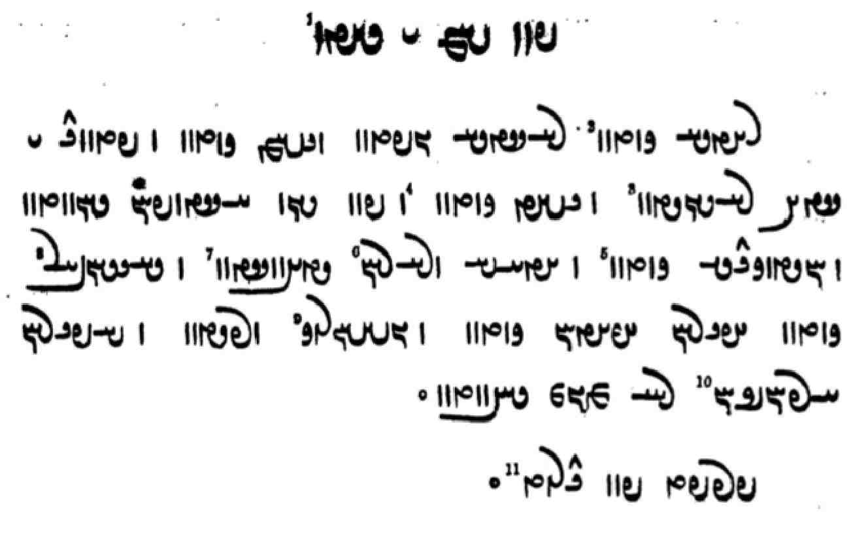

Glossary of words in the Texts and Exercises 10

Idioms:
abar dāštan raise, lift up
andar abāyēd need (impersonal; Lesson 9)
andar ēn āwām in this day and age
āsāyišn kun- relax
ātaxš ī warahrān the Victorious Fire; the fire in the fire temple
bē bar- carry away, get rid of
bē stān- take out, take away
čārag kun- find a means (to)
dām ud dahišn the entire creation; cf. dām-dahišnīh “the establishment of the creation”
dēn mazdēsn the Mazdayasnian dēn, the Zor. tradition
dēn ī mazdēsnān the dēn of the Mazdayasnians
ēdōn bawēd kū it happens (comes about) that
ēk ēk one by one
ēn kū as for this (statement, issue) that
hērbedestān kun- ‘go to school’
kē rāy wherefore, and therefore
(ō) ham bar- carry together, gather, accumulate
ō bun baw-, ras- (become) one’s/their own, (accrues) to one’s stock (of good/bad deeds)
ō xwēš kun- make one’s own, appropriate
pad ān čim for that reason
pad čē ēwēnag in what manner? how?
pad dēn āstawān baw- to profess (have faith in) the dēn
pad ēd dār- (kū) think, consider (that)
pad kardag āwar- do according to sanctioned practice
pad mayānag ī in the middle of
pēš dār- hold forth, offer
rāmišn kun- be happy, have fun
xūb good, valid (legal)

xwēš tan warz- cultivate one’s body, take care of oneself (?), do exercise (?)
zan kun- marry

Nouns, adjectives, adverbs, pronouns:
3 = sē AtÒT , 3 <3, TLTA> three
abāxtar LtåÅcÅ <’p̄’htl> north; planet
abēbar LbYcÅ <’by-bl> fruitless, not bearing fruits
abērāh sâlAcÅ <’p̄yd-l’s> having lost one’s way
ābīg WIcÅ <’p̄yk'> water-, living in the water
ābestan = ābustan
ābus SWcÅ <’p̄ws> pregnant
ābustan WWtJcÅ, WWtJWcÅ <’p̄(w)stn'> pregnant
ačārag WklAcÅ <’c’lk'> helpless; + andar “against”
āfrīnagān WwAKwYWcÅ <’p̄rynk’n'> Āfrīnagān, name of a a ceremony
āgāhīh esAkA <’k’syh> awareness, knowledge, information
ahīy ˆ¸K <KZY> earlier (adverb); + rāy “before” (postposition)
akerd WTWkA <’-krt'> undone
amar lmA <’ml> countless, innumerable
amāwandīh eY>WwaÂA <’m’wndyh> powerfulness, strength
ambar LbmA <’mbl> amber
appar, apparag WkLcÅ , LcÅ <’p̄l, ’p̄lk'> robber
artēštār lAthYt¬A <’ltyšt’l> soldier, warrior
arzānīg WIwAc¬A <’lc’nyk'> worthy; + pad “of”
āsāyišn Ww˙dajA <’s’dšn'> relaxation
asp-kerbīh EpLK aŸJwS, EpLK WfjA <’sp̄'/SWSYA-klpyh> the form of a horse
āstawān WwAPWtjA <’stwp’n'> see pad dēn ~ above
āškārag WklAkßA ’šk’lk'> openly, evident
aškamb, aškomb nsLK , vMkßA, vMWkßA <’šk(w)mb, KLSE> belly, womb
awērān WwaÒYcÅ <’p̄yl’n'> desolate (land)
bār lAB <b’l> shore, riverside
bē-barišnīh EwßLV AWB <BRA-blšnyh> getting rid of
būm MWB <bwm> land
bun WWWB <bwn'> bottom, foundation, beginning; capital
bundahišnīh EwßEWWB <bwndhšnyh> the first establishing of the cosmos, Creation
bunīh EWWB <bwnyh> beginning, foundation (of)
bunxān WwaÅWWV <bwn'-h’n'> source (water)
burdār LAtÒW| <bwlt’l> someone who carries; womb
burz WcÒWB <bwlc'> tall, lofty
dādīhā aåDtåD <d’tyh’> according to the law (dād)
dahībed WTPwˆåD <dhywpt'> lord of the land
dard Wt¬Y> <dlt'> pain
dārišn WwßlaD <d’lšn'> upkeep (lit. “holding”)
daštān WwAtHY <dšt’n'> menstruant; menstrual discharge
dibīr WWwYcD <dpywr'> scribe
dōšāram µlaHwY <dwš’lm> desire, love
drayā, drayāb aÂY , Wcåå¬D> <YMA, dlyd’p'> sea, ocean
drāz-dumb WvMwYWcå¬Y <dl’c-dwmb'> having a long tail
drōn WWwlY <dlwn'> (ceremony of the) ritual cake
dušwahāg WkaÅwÍwY <dwš-wh’k'> worthless; < wahāg “exchange value, price”
duxt NTWV <BRTE> daughter
duzz, duzd WTCwY , WCwY , ABwY <GNBA, dwc', dwct'> thief
ēbgadīh EtDvˆÅ <’ybgt'> the time after the Invasion
ēkānagīh EKwAkwˆÅ <’yk’nkyh> obedience, submission
ēk-tāg WkAT WKwˆÅ <’ywk'-t’k'> single, alone
ēk-tāgīh EkAT WKwˆÅ <’ywk'-t’kyh> being single, loneliness
framān-burdārīh elAtÒWBwaÂLP <plm’n-bwlt’lyh> obedience
frayād WtåådLP, WtååÒP <pl(y)yd’t'> help
frēftār lATcjLP <plydpt’l> (easily) deceived
frōd WTwLP <plwt'> down; oppos. ul
gādan-menišnīh EwÍwˆ˜ WWTWtŸ:J <SLYTNtn'-mynšnyh> thought of having sex (with)
gāhānbār lABwaååD <g’h’nb’l> a ritual associated with the five times of the day
gandagīh EIwY <gndkyh> foulness
garzišn WwÍc¬Y <glcšn'> complaint; + az ”about”
gōmēz WcdMwY <gwmyc'> urine (of cattle used for cleansing)
griftār lATc¬Y <glp̄t’l> captive, prisoner
grīw nLWC <CWLE> neck, self
gušn WwÍwY <gwšn'> male animal; + hištan, let the males in (to the females to breed)
haft-kišwar LwßGK WTcÅ <hpt' kyšwl> having seven continents
hāmīn [WwˆÂA] WwˆÂaÅ <h’myn' [hmyn']> summer
ham-pursag W˝JWWpmA <hmpwrsk'> someone who consults (with learned men)
hangām ÂE<wA <hng’m> time
handarz Wc¬YwA <hndlc'> advice
hērbed WTplÄ <hylpt'> (religious) teacher
hērbedestān WwAtJTplÄ <hylptst’n'> place for priestly studies; + kun- “go to ‘school’”
hunsand YwïDWwA <hwnsnd> content; + pad “with”
ǰam-kerd WTWkmY <ym-krt'> (the war ‘bunker’) made by J̌am (Yima)
ǰud-dēw aåHWtDwY <ywdt-ŠDYA> keeping the dēw(s) away
kadag WKTK <ktk'> house, room
kām-kerdār lATWkmAK <k’m-krt’l> acting at will/according to wish
kārd AwG˝J , Wt¬AK <k’lt', SKYNA> knife
kardag WKTWK <krtk'> sanctioned practice: pad k. āwar- “do according to sanctioned practice”
nāmag W˝ÂÍ , W˝ÂAW <n’mk', ŠMk'> letter, book
nēm-tan WWT ÂYW <nym tn'> waist
nihān WwaÅW <nh’n'> hidden, in secret
ōh W˚ <KN> thus; in the usual manner
ohrmazd-dādestān WwAtJtåda˜wAwA <’whrmzd-d’tst’n'> which is (contains) Ohrmazd’s law
pad-dād WtåD WWP <PWN-d’t'> according to the law
padēx(w)īh EwaDTP <ptyhwyh> prosperity
pādixšāy AtdlÍ , áhAtÅP <p’thš’d, ŠLYTA> authorized; + infinitive or kū
pādyābīh EcåDtÅP p’ty’p̄yh> ritual purity (of people, implements)
pahrēxtār lAtådlaÅP <p’hlyht’l> staying away; + az “from”: + baw- “stay away from”
pahrēz WcdlaÅP <p’hlyc'> care, protection; + kerdan “care for, protect”; + būdan + az “stay away from”
pargast Wt∆dLP , WtjïÒP <plgst'> God forbid!
paristag WKtjLP <plstk'> servant; + kerdan “to serve”
*parwāl lAwLP <plw’l> *nourishment
passox, pāsox WwajAP , WwaJP <pshw', p’shw’> answer; + kerdan “to answer”
pērōzgarīh elY<CwlYP <pylwcglyh> victoriousness
rad-franāmišnīh EwßmAwLPWtÒ <lt'-pln’mšnyh> behavior according to the ‘models’
ristāxēz WcdaÅtjgL <lst’hyc'> resurrection of the dead
sar :J , L% , nßYwL <LOYŠE, sl> head
sargēn WwsL% <slgyn'> feces
saxwan aDwM , WWwaJ <shwn', MRYA> talk, word
sazāg WkAcJ <sc’k'> fitting, suitble, appropriate
sazāgīhā aåDkAcJ <sc’kyh’> fittingly, suitably, appropriately
sēmēn (= asēmēn) WwˆÂˆJ <symyn'> of silver, silvery
spāsdār lesAfJ <sp’sd’l> grateful
spāsdārīh elesAfJ <sp’sd’lyh> gratitude
stahm(b) ÂaÅtJ , vmaÅtJ <st’hm(b)> violence, force
sūrāg WkaÒwS <swl’k'> hole
tār lAT <t’l> darkness
tēmār laÂYT <tym’l> sorrow, concern; + burdan “be concerned”; + rāy “about”
tēx aDT <tyh> edge, ridge
tōm = tōhm MWT <twm> seed, grain
tuwān WwABWT <twb’n'> able, it is possible (impersonal)
uskār lA˝JwA , lAkSwA <’wsk’l> discussion, consideration
wanī-būdīh EWTWB WwYBwA <HWBDWN bwtyh> annihilation, destruction (passive)
war LW <wl> Yima’s vara, bunker; bay (of a sea, ocean)
wārišn WwßlAW <w’lšn'> rain
was-ēwēnag WKwYwˆåD>BK , WKwYwˆÅ YBK <KBD(-)’dwynk'> many kinds of, miscellaneous
wēnišn WwÍWtjA , WwÍwYW <wynšn', HZYTNšn'> sight, seeing (ability)
widarg gLTW <wtlg> crossing, ford
widest WtjGTW , WtJTW <wt(y)st'> a span (9 inches)
wimand YnYW <wymnd> border, limit
winnārdār lAt¬AWW <wn’lt’l> (someone) who holds up
xīr :dA , lyA , WBC <CBW, hyl> matter, things; + xwāstag “all one’s possessions”
xūb PwA <hwp> good, valid
xwah NtåÅ <AHTE> sister
xwarrahōmand YNwAnˆD <GDE’wmnd> endowed with Xwarrah
xwāstag a∆DKW , WKtjAwA <hw’stk', NKSYA> property
xwēdōdah WtåD>WtDwA , sY>WtDwA <hwytwds, hwytwd’t'> next-of-kin marriage
xwēdōdahīh esYWtDwA <hwytwdsyh> performance of next-of-kin marriage
yašt WthG <yšt'> ritual, sacrifice
yazišngarīh elYwÍcD <ycšnglyh> sacrificing
yōǰdahr lseÍwY <ywšd’sl> ritually pure
yōǰdahrīh elseÍwY <ywšd’slyh> purification ritual
zamānag WKwaÂY> , WKwaÂZ <zm’nk', zm’nk'> time (appointed)
zanīh EnßYW <NYŠEyh> wifehood, marriage; pad zanīh “as one’s wife”
zōhr lAwZ <zwhl> libation
zyān Wwaå¸ <zyd’n'> harm

Names:
Abursēn WwˆjLWpA <’p̄wlsyn'> name of a mountain
Ādurbādagān WwAKtÅPWWWtÅ <’twr'p’tk’n'> name corresponding to modern Azerbaijan
Asūrestān WwAtjLwsA <’swlst’n'> Syria
Čīnestān WwAtJwYC <cynst’n'> China
Daǰlit WtdL% <dglyt'> Tigris
Damagān WwAkmY <dmk’n'> a mountain in Pārs
Dugdōw WwaDKwY <dwkd’w'> Zarduxšt’s mother
Frād WtåÒP <pl’t'> Euphrates
Gēlān Wwa:J <gyl’n'> Gilan (southwest of the Caspian Sea)
Gōbedšāh aåHTPwY <gwptš’h> name of a mythical king
Gōšurūn (KwLwaHwY) WWwLwaHwY <gwš’wlwn'> the Soul of the Cow/Bull
Hērbedestān WwAtJTplÄ <hylptst’n'> name of a book: “Manual for teachers”
Hindūg WKwYwA <hndwk'> Indian
Hindūgān rōd WTwL WwAKwYwA <hndwk’n' lwt'> the river of the Indians, the Indus
Hindūstān WwAtJwYwA <hndwst’n'> India
Hrōm MwlA <hlwm> ‘Rome’; area west of (the Sasanian empire in) Asia Minor
Hūzestān WwAtJCwA <hwcst’n'> Khuzistan (southwestern Iran)
Kang-diz WcdY<WK <kng-dc'> the fortress Kang
Kašmīr lˆÂÍK <kšmyl> Kashmir
Kayānsīy îJwaDK <ky’nsyd> sea in which Z.’s semen is preserved (in a box)
Kāy-Us (Kay Us) SwïÅK <k’yws> Kāy-Us; Pers. Kābus, Qābus
Mahrīy = Mahlīy ìWt˜ <mtryd>
Mahryānīy = Mahlyānīy ìwaÅWt˜ <mtryd’nyd>
Mihrān-rōd WTwL WwaÒt˜ <mtl’n'-lwt'> name of a river; the Indus
Nīrangestān (Nēr-) WwAtJjYwlYW <nylngst’n'> name of a book: “Manual of rituals”
Padišxwārgar :d<lAwaHTP <ptšhw’l-gl> name of a mountain
Pārs slAP <p’ls> Pars, modern Fars
Sagestān WwAtJ˝J <skst’n'> Sistan (eastern Iran)
Sind YwS <snd> Sindh
Sōšāns SwaHwS <swš’ns> son of Z., born 3000 years after Z.
Sōwestān WwAtJWKwS <swkwst’n'> *Sogdiana
Spand YWfJ <spnd> name of one of the 22 books of the Avesta
Sūdgar (nask) LKTwS <swtkl> a text found in the Dēnkard
Tabarestān WwAtjLWPT , WwAtjLPT <tp(w)lst’n'> Tabaristan (southeast of the Caspian Sea)
Turkestān WwAtJkLWT <twlkst’n'> Turkestan
Ušīdar LtdÍwA <’wšytl> son of Z., born 1000 years after Z.
Ušīdarmāh aåÂLtdÍwA <’wšytlm’h> son of Z., born 2000 years after Z.
Weh-rōd WTwlaD>W , WTwL aD>W <wŷh(-)lwt'> the Oxus
Xwarāsān WwajaÒwA <hwl’s’n'> land in the east (sunrise), Khorasan
Yatāy-ahū-wēryō WKwï¬YWKwaådAtD <yt’y-’hwk-wylywk'> sacred Old Avestan text

Verbs:
abāgēn- abāgēnīd -wYkAcÅ <’p̄’kyn-> accompany
abesih- abesihist –aŸJcÅ , –ajYcÅ <’p̄ysh-, ’p̄sh-> be destroyed
(MacK.: abesīh-) –aJcÅ
abgan- abgand -WtdmL <LMYTN-> throw (away), abort
āšnaw- āšnūd -WwßA , -WnmÍW <OŠMEN-, ’šnw-> hear
frazām- frazaft WTpcÒP -ÂAcÒP <plc’m-, plcpt'> complete, finish (something)
gāy- gād -WtŸ:J <SLYTN-> have sex with
gumēz- gumēxt WtådMwY -cdMwY < gwmyc- gwmyht'> mix, mingle, blend
handēš- handēšīd -˙*J>wA <hndyš-> think; + rāy “about”
kām- kāmist WtJNBcD -WNBcD <YCBEN-st'> wish (impersonal)
kuš- kušt -WwSKW , WtHWK -ÍWK <kwš- kwšt', NKSWN-> kill
mēz- mišt WthM -cdM < myc- mšt'> urinate
niyōxš- niyōxšīd - ßAKwYW <nywkhš-> listen
niyōš- niyōšīd - ßAwYW <nywkš->
padīr- padīrift -WwlYKM <MKBLWN-> receive
rāyēn- rāyēnīdan -wsaÒ <l’dyn-> organize, arrange
šōy- šust WtJW]¬A, WTW]¬A -W]¬A <HLLWN-; -t'/-st' > wash
WtJwÍ -YwÍ <šwd- šwst'>
tāb- tāft WTcÅT -cÅT <t’p- t’pt'> shine
waxšēn- waxšēnīd -wˆhAW <whšyn-> make (the fire) blaze/grow
wināh- wināst WtjAWW -sAWW , -aÅWW <wn’h-/wn’s- wn’st'> soil, pollute
wināhīd Wt∆dAWW , WtdaÅWW <wn’hyt'/wn’syt'>
wišōb- wišuft WTPwÍW -PwÍW <wšwp- wšwpt'> disturb, destroy, rout, cause chaos; pass.: fall apart, fall into disarray; tousle (hair)

Lesson 11

Note:
At this stage the students should start familiarizing themselves with the use of MacKenzie’s Dictionary if they have not already done so.
A pdf is currently available at http://www.rabbinics.org/pahlavi/MacKenzie-PahlDict.pdf.

Spelling 9

The allophones /e/ and /o/
As already mentioned in lesson 1, MacKenzie introduced the use of the vowels e and o in his Dictionary. MacKenzie assigned them, in particular, to words in which the spelling of the vowel varies in the manuscripts, although he did not do so consistently, e.g.:

men- “think” and menišn- “thought”: usually spelled <myn->, occasionally <mn->
zofr “deep”: usually spelled LPU <zwpl>, occasionally LpZ <zpl>, cf. zofāy ÄPU <zwp’d> “depth”
homānāg “similar (to)”: spelled WkAwa˜WA <hwm’n’k'> and WkAwaÂA <hm’n’k'>
abaxšāyīdan, aboxšāyīdan “forgive; withhold”: spelled -áhAcÅ <’p̄hš’d-> and -áhAWcÅ <’p̄whš’d->
škeft or škoft “amazing(ly), very; harsh”: spelled WTPkÍ <škpt'>, <škypt'> TpYkÍ, and TPWkÍ <škwpt'>
padifrāh or pādofrāh “punishment”: spelled saÒPtÅP / aåÒPtÅP <p’tpl’s/h>
or saÒPWtÅP / aåÒWPtÅP <p’twpl’s/h>
pādixšāy or pādoxšāy “authoritative”: spelled áHAtÅ <p’thš’d> or áHAWtÅ <p’twhš’d>
pornāy, abornāy “adult, minor (child): spelled ÄwLP , ÄwLcÅ <pln’d, ’p̄ln’d>,
more commonly ÄwLWP , ÄwLWcÅ <pwln’d, ’p̄wln’d>

Here, we will use the spellings abaxšāyišnīh/abuxšāyišnīh pādifrāh/pādufrāh, pādixšāy/pāduxšāy, and purnāy, abarnāy/aburnāy.

Short -u- spelled without <-w->
This spelling is found in a few words in MacKenzie’s Dictionary, but it is doubtful. The most common is dudīgar “second,” after Manichean <dwdygr>, with analogical <dw-> after dō “two,” but the Pahl. form is clearly didī-gar (from OPers. duvitīya-). Other words are drubušt “fortress,” most often spelled <dlpwšt’> darbušt (rarely <dlwpwšt'>), kandāg <knd’k> “magician,” Man. <qnd’-> (MacK. kundāg after NPers. kondā), rubūd <lpwt'> for rabūd “rob,” and sidāb <st’p'> “rue” (NPers. sodāb).
The words gund “troop” and gung “deaf” are often spelled without <w> (Mack.: <gwnd>, but <g(w)ng>), notably in the Kār-nāmag, but these may be examples of influence from Persian.

Grammar 11

Plural of nouns and adjectives
Pahlavi originally had two cases, one reserved for the (grammatical) subject, i.e., the word with which the verb agrees, as well as words qualifying the subject, and one for the other syntactic functions.
The cases are distinguished in the 1st person pronoun an ∼ man; in the plural of nouns and adjectives, where the oblique takes the ending -ān; and in the family terms (see below).

The cases are commonly referred to as “direct” and “oblique,” a terminology that says little about either form or function. Thus, it may be simpler just to remember that an “I” is only used as subject of verbs and that the plural forms in -ān are used when the noun is not the (grammatical) subject of a verb.

The older paradigm is thus as follows:

Singular Plural 1st person “I, me”
Subject yazd yazd an
Non-subject yazd yazdān man

The subject case is also used for the predicate of the verb “be, become,” as well as with verbs such as “be called,” and for appositions to the (grammatical) subject and the predicate, as well as the vocative.
The direct object is sometimes in the subject case, sometimes in the non-subject case. In this Introduction, we will simply follow the manuscripts on this point.
The main uses of the non-subject case is as indirect object, as possessor (including in ān ī constructions), after/before pre/postpositions, and in impersonal expressions.
In the manuscripts, the forms in -ān are often used as subject as in modern Persian, see below.

Examples:
pōryōtkēš hamāg pad ēn ham-dādestān bē būd hēnd
“the teachers of old have all been agreed about this” (DD.40.6)

awēšān ātaxš ī sōzēnd ī xwarg nē kunēnd ā čē
“those fires which burn which make no embers what (are they)?” (PR.35c.7)

amahrspand dārēnd dāmān, baxšēnd rāy ud xwarrah ō gēhān, ēdōn-iz abārīg mēnōy yazd
“the amahrspands maintain the creations, bestow Light and Xwarrah on living beings, thus also the other gods in the other world” (Dk.3.51.3)

ān paydāg kū Zardušt ān zamān abāg yazdān wēš būd estād u-š yazd āšnāgtar būd hēnd
“that is manifest: at that time, Zardušt had been more with the gods, and the gods were more familiar to him” (after PY.9.1)

az pāy pēšārwār ma kun kū pad dād ī dēwān griftār nē bawē u-t ān wināh rāy dēw ō dōšox nē kešēnd
“do not urinate standing, so that you do not become ‘seized’ by the law of the demons and the demons do not drag you to hell for that sin!” (MX.1.39-41)

Plural of adjectives
Adjectives used with nouns ending in -ān can take no ending or the ending -ān (-īn, see below).

2 srišwādag Ēr deh ahlaw hēnd ud ēk druwand
“the Iranian towns are (i.e., will be) two-thirds Rightous and one(-third) wicked” (Dk.7.9.13)

pad abāz-estišnīh ī ān ī dēwān bēš ud ān-iz ī mardōmān ī wadag
“to withstand the hostility of the demons, as well as that of bad people” (PY.68.8)

ō abēzagān mardōmān “to pure people”

ahlawān mardān zanān yazam. driyōšān mardān zanān yazam druwandān mardān zanān nē yazam
“I sacrifice for the Righteous men and women. I sacrifice for the poor men and women; I do not sacrifice for wicked men and women” (after Dk.7.3.38, cf. WZ.12.6, below)

When adjectives are used as nouns, they regularly take the ending, e.g.:

ēn mard wehān ud arzānīgān ud driyōšān padīrēd u-šān tis dahēd
“this man receives the good, worthy, and poor and gives them something (after AWN.68.3)

kē hučašmīh ī wehān xwāhēd ud xwad-iz pad wehīh ī andar wehān wēnēd hučašm bawēd
“he who seeks the benevolence of the good, he will himself, too, be benevolent because of the goodness he sees in the good” (MX.36.17)

u-š ham-ōwōn pad rōšnīh kāmag čiyōn pad-iz tārān
“and he desired (-š kāmag ... pad) the light, as (he desired) dark (places)” (WZ.1.3)

The plural ending -īn with pronouns and nouns
In early Pahlavi, there were two alternative endings for oblique plural -ān: -īn, and -ūn, e.g., zanīn “of/to the women,” ǰehīn (ǰahīn) “of/to wicked women,” frazendīn “of/to the children,” and dušmenūn “of/to the enemies.”
In Book Pahlavi, the ending -īn survives in the numerals (Lesson 9), the pronominal forms harwīn and harwispīn from harw and harwisp “every, all” and čandīn from čand “how many?” (the forms harwist, harwistīn are also common), as well as sporadically in nouns:

abar ō harwispīn kišwar kē haft
“onto all the seven continents” (PY.65.5) – Note that kišwar does not have the ending.

čandīn mardān pad āfrāh ō zōd radīhā kū pad yašt-ēw rāspīg čand dastwarīhā
“(with) how many men to inform the main priest (zōd) is according to the rads (ritual models), i.e., for one ritual, how many auxiliary priests (rāspīg) (are) according to sanctioned practice?” — Here čandīn mardān renders Av. cuuaiti narąm “how many men?”

ātaxš ī zanīn nišāst sālārīh pad zan
“guardianship of a fire endowed (lit. enthroned) of (by) women (rests) with the woman (who endowed it)” (MHDA.50.4.15)

ahlāyīh yazam ahlawān driyōšān mardān zanīn yazam
“I sacrifice for the Righteousness of Righteous, poor men and women” (WZ.12.6, cf. Dk.7.3.38, above)

ud ōy-iz druz ī hu-zahagīh marnǰēnīdār ī zāyišn wizūdār pādīrāngar ī mādagān petyāragtom ǰahīn srādag
“and that lie-demon too which destroys easy birth, ruins and impedes birth, the greatest adversary of females, the species of evil women” (Dk.5.24.19b)

Note duzz duzzīn appar apparīn “thief of thieves, robber of robbers” (PV.4.1).

The “family terms”
In Iranian languges in general and Pahlavi in particular, the family terms father, etc. (cf. Lesson 7), have some irregular forms (cf. Eng. brother, brethren).
In early Pahlavi, they took the ending -ar in the plural, but also in the singular in the same positions that plural nouns take -ān, hence they are also called r-stems. This distribution is still often found in the Pahlavi texts:

Singular Plural
Subject pid pidar
Non-subject pidar pidarān

The word pus “son” was originally not an r-stem, and so had pus in the singular and non-subject plural. In the texts, it is often declined as an r-stem, however, and in PR.26.2, all the mss. have pusarīn instead of pusarān.
The Psalter also has pidarūn <ptlwn>.

Examples:
az pidar nāmburdār bāš bē harw-ēwēnag mād ma āzār
“carry the name of (your) father, but do not bother (your) mother in every way!” (PKX.2c)

pidar ī gēhān hēd
“you are the fathers (= parents) of living beings” (Bd.14.11)

pus ī Frēdōn rāy xānag az abarmānd ī pidarān was būd
“Frēdōn’s son had many houses from (his) parents’/fathers’ inheritance”

awēšān rasēnd kē pus ī Zarduxšt hēnd
“those will come who are the sons of Zarduxšt (Dk.7.8.50)

pas gōwēd kay-Wištāsp-šāh kū agar hamāg pus ud brād ud wispuhrag ī man kay-Wištāsp-šāh murd bawēnd ēg-im ēn abēzag dēn ī mazdēsn bē nē hilam
“then King Kay Wištāsp says: if all my sons, brothers, and princes are to die, I shall not relinquish this pure Mazdayasnian dēn” (AZ.68)

awēšān pusarān ud brādarān ud wispuhragān ī tō rām-šahr kay-Wištāsp-šāh andar ān diz bē framāy nišastan
“O King Kay Wištāsp, of peaceful land, order those your sons, brothers, and princes to sit in that fortress!” (AZ.62)

ka pad kāmag abāg zanān pusarān duxtarān <BREl’n BRTEl’n> xwaš bē šāyēd nišastan pad rāh ī tō
“when one can sit pleasantly at will with one’s wives, sons, and daughters, it is by way of (≈ through) you (Mihr)” (after StS.16.16)

Feminine nouns and adjectives.
A few nouns and adjectives have special feminine endings. These are found mainly in the oldest manuscripts of the Pahlavi Avesta:

ahurānīy “lady” (Av. ahurānī-, fem. of ahura- “lord”).
ahlaw, fem. ahlawēnīy (J2, K5), ahlawīy <’hlwbwy> (Mf4, Pt4), plur. ahlawīyān <’hlwbwy’n> (Mf4, Pt4; also in StS.19)
ašō <’šwk'>, fem. ašōnīy <’šwknyḏ> (NM.1.7.10).
mānbed, fem. mānbedīn (PVr.3.3), mānbedīy (PVyt.3.5c [17] <m’nptyh>), Av. nmānō.paθnīm/paθniiå.
Frawāg, fem. Frawāgīy (Bd.14.33, IndBd. Fravākayn in Avestan script).

Examples:
mādagān rad gōwam dēn ī mazdēsnān ... kē-iz dō-padištān ahlawēnīy/ahlawīy kū zan-ēw ī nēk u-š rad ī mādagān gōwam ēn zamīg kē ān ī amāh dahišn ud burdār u-š rad ī mādagān gōwam
“‘(as) model of the females I say the Mazdayasnian dēn ... and who(ever) is a Righteous (woman) among bipeds,’ i.e., a good woman, her I say (is) the model of the females, (namely) ‘this earth who is our carrier/womb,’ her I say (is) the model of the females” (PY.13.1)

ma ... rasād ō ātaxš ma ō āb ma ō zamīg ma ō gōspand ma ō urwar ma ō mard ī ahlaw ma ō nāyrīg ī ahlawēnīy/ahlawīy
“let her (the corpse demon) not come [subj.] upon the fire nor the water nor the earth nor the animals nor the plants nor the Righteous man nor the Righteous woman!” (PV.9.33)

ēn-iz xwāham az xwābar Ohrmazd dādār ī harw nēkīh kū-mān ān hayārīh ī az ahlawīyān ī wehān ī abzārān ī abzōnīgān frawahr bowandagīhā awiš rasād
“this too I ask of merciful Ohrmazd, the Creator of every goodness, that that assistance from the Righteous, good, strong, beneficent frawahrs [female!] may come to us in full measure (bowandagīhā) (StS.19.11)

The use of endings in the manuscripts.
All our Pahlavi manuscripts were written in or after the 13th century, that is, well into the modern Persian period, when the case distinctions had been lost. In early modern Persian, therefore, the forms in -ān simply indicated plural, and the family terms could take the shorter or longer forms, for instance, according to metrical requirements or at the whim of the writer.
The pronoun an “I” had simply disappeared by then and been replaced by man.
This practice shows up in the Pahlavi manuscripts, as well, but, in good manuscripts based on strong traditions, the older distribution of the forms is still very common, e.g.:

amahrspandān ud yazd bē rasēnd ud nē niyōšēnd ud bē padīrēnd
“the amahrspands and the gods arrive and do not listen, but accept” (ŠnŠ.9.10)

In the exercises in this Introduction, the students are expected to use the original distribution. Examples of actual usage in the texts will be found in the manuscript samples given from this lesson on.

Interrogative pronouns and adverbs
Interrogative pronouns and adverbs are made from the same stems as relative pronouns (k-, č-), as in English, e.g. who, which, etc.:

kē WN <MNW> “who?”
kē’ān/ke’ān WwAWN <MNW’n'> “whose?”
ān ī kē WN Y ã <ZK Y MNW> “whose?”
kadām µATK <kt’m> “which?”
kadār lATK <kt’l> “which (usually of two)?”

kē ham ud kē xwēš ham
“who am I, and whose am I (= who do I belong to)?” (PN.1)

awēšān ān ī kē ruwān
“whose souls are those?” (after AWN)

kē hē ud az ke’ān hē
“who are you, and from whom are you?” (PY.43.7; Dk.7.3.55 spelled <MNW ZK>!)

az kadām paywand ud tōhmag ham
“of which lineage and descent am I?” (PN.1)

zamīg kadār gyāg mustōmandtar
“which place (of/in) the earth is more oppressed?” (or “as for the earth, which place ...”) (Bd.9.11)

kadār-itān sūdōmandtar sahēd
“which (alternative) seems more profitable to you?” (Bd.3.26)

kadār ast weh kadār wehtar ud kadār az harwispīn pahlom
“which is there (that is) good, which is better, and which is best of all?” (WZ.22.3)

Note kadām gyāg “in which place?”:

kadām gyāg brēhēnīd Ohrmazd pad bun-dahišn ǰōrdāy
“in which place did Ohrmazd fashion barley at the first creation?” (after Dk.8.31.30)

kay tÂïÅ <AYMT> “when?”
kū à <AYK> “where?”
az kū “from where, whence?”
ō kū “to where, whither?”

abar čē ud pad čē ud ō čē ud az kū ud ō kū abāz ō kū
“about what and with what and to what and from where and to where (and) back to where?” (Dk.3.222.1)
az bunīh kū būd ham ud kay mad ham ud ēdar čē kunam
ud kay bē šawam ud čim bē šawam ud ka bē šawam ō kū šawam
“from the beginning, where was I? and when did I come? and what am I doing here?
and when do I go (from here)? and why do I go? and, when I go, to where do I go?” (Dk.6E.3)

Note also kū gyāg “where?”:

ka ān ī ahlaw bē widerēd ruwān šab ī fradom ud didīgar ud sidīgar kū gyāg nišīnēd
“when the soul of the Righteous passes away, where does it sit the first, second, and third nights?” (DD.23.1)

ēn mardōm az kū gyāg abāz āxēzēnd
“these people (who died), from where will they rise again?” (ŠnŠSup.17.11)

ahlawān ud druwandān ō kū gyāg šawēnd
“to where do the Righteous and the wicked go?” (DD.19.1)

čē nM <ME> “what?”
čē rāy áÒ nM <ME l’d> “for what reason, why?”
čē ēwēnag WKwYwïÅ nM <ME ’dwynk'> “what kind of?”
pad čē ēwēnag WKwYwïÅ nM WWP <PWN ME ’dwynk'> “in what way? how?”

Note: On če’ān-iz “anything,” see Lesson 12.

čē dānē kū
“what do you know (about the fact) that?” (= “how do you know that?”) (Dk.6.214)

ān 2 aswār ī ō ēn kustag rōn āmad čē zamān bē widerd
“when did those two horsemen who came in this direction pass through?” (KN.4.9)

awēšān kē hēnd ud čē rāy ēdar estēnd
“who are those and why do they stand here?” (AWN.6.2)

kū pad gyān ī xwadāyān kōxšēnd pad čē dārē
“when they make an attempt upon the life of lords, how do you regard it?” (cf. pad ēd dāram “I consider, I think (that)”) (after KN.10.9)

čand YWC <cnd> “how much, how many?”
čim (rāy) MC <cm> “why?”
čiyōn WwSC <cygwn> “how?”

čand āyēnd xyōn az bunag čand aswār āyēnd čand mīrēnd ud čand abāz šawēnd
“how many Xyōns will be coming from the camp? How many will come on horseback? How many will die? And how many will go back?” (AZ.65)
Ahrimen drāyēd kū druwand bē ō gilistag ī man čim āmad hē
“Ahrimen howls: O wicked one, why have you come to my den?” (PR.23.33)

mard ī ašō ēn mehīh čē čim rāy ast
“why does the Righteous Man have this greatness? (DD.3.1)

The question words can be placed at the end of the question (as in modern Persian), e.g.:

ān mard ī-š abāg pad asp kē
“who is that man who is with him on the horse?” (KN.3.19)

Kang-diz kū gyāg estēd war ī ǰamkerd kū kerd estēd tan ī Sām kū gyāg nibayēd ud mānišn ī Srōš kū
“the wise man asked the Spirit of Wisdom: where is the Kang fortress? where is the bunker made which J̌am made? where does Sām’s body lie? and where is Srōš’s dwelling?” (MX.61.1-5)

dōšox čiyōn ud čand. ud ahlawān andar wahišt dādēstān čē ud nēkīh az čē
“Hell is how and how many? And what is the judgement for/of the Righteous in Paradise, and from what is the goodness (there)?” (MX.6.4)

Substantivized forms:
See also Lesson 17 for these forms, e.g.:

(Srid) abāz ō Kāy-Us šud u-š az čē-ēwēnagīh āgāhēnīd
“Srid went back to Kay Us and informed him of how it was” (WZ.4.15)

ān zand āgāhīh ... pas abar xīr kē gēhān dārēd pad wizārišn ī čē’īh ud čiyōnīh
“that awareness of the Zand ... is next about the stuff that the world of the living contains, with an explanation of what and how it is” (Bd.0.0)

Alternative questions
These are formed with ayāb “or,” e.g.:

ēn yazišn ō yazdān rasēd ayāb ō dēwān
“does this sacrifice come to the gods or to the demons?”

Regular questions can also be formulated as alternative questions by adding ayāb nē “or not,” where ayāb nē does not necessarily have to be translated, e.g.:

tō ēd dānē ayāb nē “do you know this or not?”

pad tuxšāgīh xīr ud xwāstag ī gētīy ō xwēš šāyēd kerdan ayāb nē
“is it possible to appropriate the things and possessions of this world by diligence or not?” (MX.21.2)

Negative questions
nē wād tō dād āb tō dād gil tō dād ātaxš tō dād harw tis tō dād
“did you not establish the wind, the water, the clay, the fire, and everything?” (PR.36.7)

Indirect questions
Indirect questions are regular questions preceded by kū (cf. Lesson 4), e.g.:

gōw kū ān 3 tis čē
“say: those three things (are) what? = say what those three things are!” (Bd.36A.1)

abar bē šnāxtan ī-š waččag kū kadām gōspand
“about knowing its child: which animal? = about how he is to know to which animal the child belongs” (Dk.8.23.7)
abar xwānam zamīg ud az-iš xwāham ast ud gōšt ud pay ī Gayōmard ud abārīgān.
gōwēd zamīg kū čiyōn rasēnam, ka nē ēn bē dānam kū kadār ān ī ōy ast ud kadār ān ī ōy
“(Ohrmazd said:) I shall call up the earth and request from her the bones, flesh, and tendons of Gayōmard and the others. The earth says: How shall I make that happen, when I do not know (this:) which are this one’s bones and which are that one’s?” (WZ.34.8)

Alternative indirect questions
These are of various types, e.g.:

čiyōn gōwēd kū kadār/kadām pēš dād xwarrah ayāb tan
“as it says (in the dēn): which was established first: the Xwarrah or the body? (Bd.14.8)

ašmāh dānēd kū ēn yazišn ō yazdān rasēd ayāb ō dēwān
“do you know: does this sacrifice come the gods or the demons?” (= whether this sacrifice comes to the gods or the demons?” (after AWN1.15)

āfrāh ī dēn zēnāwandīhā abar tuxšēd tā dānēd kadār ayāb ahlaw ayāb druwand wurrōyēd meh
kū kasān ayāb ān ī ahlaw tuxšāgīhātar wurrōyēd ayāb ān ī druwand
“apply yourselves vigilently to the instructions of the dēn so that/until you know which (of the two): either a Righteous or a wicked believes greater = whether a Righteous or a wicked person believes more (diligently) than (other) people, (i.e.) whether the Righteous one or the wicked one believes the most diligently” (PN.53 + PY.31.17) (note the word order, cf. Lesson 4)
dōšox azēr ī zamīg az azabar abar asmān u-š dar ul ō zamīg
ēn kū abar bērōn asmān ast ayāb nē ā-m nē rōšnag
“Hell is under the earth, (but) up above the sky (beneath the earh), and it has a door up to the earth;
whether ‘above’ (means) outside the sky or not is not clear to me” (PV.3.7)

Relative pronouns and relative clauses
Of the three relative pronouns kē, ī, and čē, the relative pronoun čē is relatively rare; it is used mainly when the referent is not specific (that which, everything that, whatever).
Relative pronouns are most often used as subject, direct object, and possessive (genitive).
Relative pronouns usually have an “antecedent,” that is, a noun, adjective, or pronoun that they refer to. The antecedent may be separate and quite a distance from the relative pronoun, e.g.:

Ardawān rāy kanīzag-ēw abāyišnīg būd kē az abārīg kanīzagān āzarmīgtar ud grāmīgtar dāšt
“Ardawān had a (certain) attractive (servant) girl, whom he held (= who was to him) more beloved and more dear than the other girls” (KN.3.1)

amāh haft xwah rāy brād ēn ēk ast kē-mān zīyišn ud dārišn
“we seven sisters have (only) this one brother, who is our life (= livelihood) and upkeep” (AWN.2.4)

ān menišn agriftār ud kunišn griftārōmand čē mardōmān pad kunišn kunēnd
“that thought (is) intangible and (that) action tangible which people perform in their action (= when they act)” (PN.25)

kē and ī often alternate in the same sentence, e.g.:

Ādur yazd ō Ardā Wirāz war-ēw nimūd ud guft ēn ān āb ast kē az ān esm bē tazīd ī tō abar ō man nihād
“the divine Fire showed Ardā Wirāz a lake and said: this is that water which flowed from the firewood that you laid on me” (after AWN.10.8)

ī ast “that is”:
4 pēšag ī ast āsrōnīh ud artēštārīh ud wāstaryōšīh hutuxšīh
“the four estates, that is: priesthood, military, husbandry, artisanate” (Dj.7.1.20)

Indefinite relative pronouns
Sometimes the antecedent is missing, in which case we must translate the relative pronoun as “he who, someone who, whoever” and “that which, something which, whatever,” e.g.:

pad ēd dāram kū wahišt ast ud dōšox ast ud kē ruwān weh ān ō wahišt šawēd ud kē ruwān wattar ān ō dōšox ōftēd
“I think that Paradise and Hell exist and (he) whose soul is good goes to Paradise and (he) whose soul is bad falls into Hell”

ōy ēdōn homānāg čiyōn kē sar ī mardōmān pad dast dārēd ud mazg ī mardōmān xwarēd
“he is like (someone) who holds people’s heads in his hands and eats people’s brains” (MX.1.49)

ud čē andar ān dar
“and (that) which is in that chapter”

kē kamēd kū čē-š az yazdān xwāhēd abērtar windēd, yazišn ī yazdān gōwizār ē kunēd
“(he) who (= whoever) wishes that he more often gets (that) which (= whatever) he asks of the gods, let him perform a detailed sacrifice to the gods” (Dk.6.125)

Indefiniteness can be emphasized by adding ēč before the relative pronoun, e.g.:

ēč kē būd hēnd ud ēč kē bawēnd ud ēč kē hēnd
“whoever have been, whoever will be, and whoever are” (PN.21)

Indefinite alternatives are expressed by repetition of kē, čē, and kū, e.g.:

kē ... kē:
hāmōyēn dām ud dahišn ī dādār Ohrmazd ... kē zāyišnīg ud kē-iz ārōyišnīg
“the entire creation of the Creator Ohrmazd ... (be it that) which is still to be born and (that) which is still to grow (or whether still to be born and still to grow)” (MX.48.23)

ud 57 sāl Sōšāns rist hangēzēnēd ud harwisp mardōm hangēzēnēnd kē ahlaw kē druwand mardōm harw kas az ānōh ul hangēzēnd
“and for 57 years Sōšāns will raise the dead, and they will raise all people, (be it those) who (are) Righteous (be it those) who are wicked (people), everybody will be raised from there” (Bd.34.7)

čē ... čē:
tar-menišnīh ī dēn abāz-stāyišnīh az-iš nē dāštan ī dastwar xwad-dōšagīhā raft
abārīg andar ham dar čiyōn pad hangerdīg čē ag-dēnīh tā čē a-dēnīh nām
“scorning the dēn, ‘back-praising’ (oneself) from it, not having a dastwar, behaving bstinately,
(and all) the other things of the same sort, as called succinctly whether/be it ‘having an evil dēn’ or/be it even (tā čē) ‘having no dēn’” (Dk.5.9.5)

ud pas az Gayōmard andar zamān zamānag ... hamē bahr az-iš
čand dānišn āgāhīh ud kunišn bōzišn ī mardōm ī ān āwām kē padiš ō paydāgīh mad abāyišnīg būd
čē pad ham-pursagīh ī ō dādār ud čē waxš-abar-burdārīh ī abartarīg pad dādār framān
“after Gayōmard, at various times ... a few parts (were revealed) from it (= the dēn):
as much knowledge and science and action that was needed for the salvation of the people who appeared in that age,
be it through conversation with the Creator, be it through the prophecy from on high, at the order of the Creator” (Dk.7.1.8)

kū ... kū:
ēn dēn ... andar hamāg gēhān kū abēzagīhā ud kū gumēzagīhā rawāg kerd estēd
“this dēn was propagated in the whole world, in some places in its pure state, in other places in a mixed state” (Dk.5.24.14)

“Case forms” of relative pronouns
The relative pronouns do not have case forms, and possession and other syntactic functions can be expressed in the clause, either by a pronoun or by a possessive or prepositional phrase (cf. Lesson 4 on “whose”), e.g.:

harw kē-š ān wād pad wēnīg abar šawēd bē larzēd ud bē ōftēd
“everybody (who up his nose ⇾) up whose nose that wind goes, trembles and falls” (AWN.18.4)

ān widarg kū abar āmad xwad ast rāh ī ō dōšox kē pad ān dwārēnd dēw ī druwand
“that passage where (Ahrimen) came up is itself (= is nothing but) the road to Hell, (which on that ⇾) on which the wicked demons run” (WZ.2.5)

nēk ōy kē az ān ī ōy nēkīh kadār-iz-ēw nēkīh
“good for him (who from his ⇾) from whose goodness (comes) whichever goodness (= any goodness there is)” (Pahl. Aṣ̌əm vohū)

ēn ruwān ī awēšān mardōmān hēnd kē-šān kerbag ud wināh rāst būd
“these are the souls of those people (who their ⇾) whose good and bad deeds were equal” (AWN.6.3)

ēn mardōm būd hēnd kē-šān rōšnīh ō rōšnīh ī xwaršēd homānāg būd
“these were people whose light was similar to the light of the sun” (AWN.9.2)

Cf. adverbial clauses of place:

stāyēm gar ī buland kū ānōh hōm rust estē
“I/we praise the lofty mountain (where there ⇾) where you, Hōm, have grown” (PY.10.3)

Note that prepositions do not usually precede the relative pronoun, but come later in the clause, e.g.:

zan ān wattar kē abāg pad rāmišn zīyistan nē šāyēd
“the worst wife is she with whom it is not possible to live in peace” (MX.32.14)

gāw zōd rafēd kē andar dārišn
“the bull attacks the priest, in whose keeping (it is)” (PY.11.1)

mān homānāg kē harw tis andar pāyēd
“like a house in which he guards everything” (Bd.1A.6)

ramag ī gōspand ēw andar kē nasāy ǰūd estēd nē dānēd kū kadām
“a herd in which (is) a sheep that has chewed nasāy, (and) one does not know which” (ZFJ.437)
Not: “a herd of sheep ‘in which’ nasāy has been chewed ...”

The use of Pre- and postpositions with enclitic pronouns 1
This and subsequent sections on this topic contain some of the trickiest syntax of Pahlavi and needs to be studied carefully.
Most prepositions, simple and combined, can govern an enclitic pronoun, e.g.:

u-m kāmist pad pēš-iš namāz burdan
“and I wished to bear homage before him” (AWN.11.4)

mard-ēw was wazurg abāg-iš pad asp nišast estād
“a very large man was sitting with him on the horse” (KN.4.22)
As we have seen before, prepositions often turn up as postpositions, as when they govern relative pronouns and enclitic pronouns. This also happens in other cases, where it is sometimes difficult to decide whether we are dealing with a postposition or a preverb, e.g.:

Following the pronoun directly:
u-šān mayān tuhīgīh būd
“and between them was emptiness” (Bd.1.5)

u-šān pērāmōn dēwār bē estēnīd
“and around them a wall had been set up” (Dk.7.2.23)
cf.
pērāmōn ī Sāsān estēnd
“they stand around Sāsān” (KN.1.9)

Separated from the pronoun:
u-š kōšk asēmēn ud dandānag zarrēn u-š 14 kōf andar
u-š 7 rōd nāydāg andar u-š haft murw kē-š pānagīh pad xwadāyīh šāyēd kerdan andar
“and (castle Kang) has a silver turret and golden crenelations, and there are 14 mountains inside it
and seven deep rivers inside it, and (there are) seven birds inside it, which it can (-š ...šāyēd) protect (pānagīh ... kerdan) by its reign” (PR.49.7)

With relative pronoun:
tis-iz ēč ast ī hamāg āhōgēnīd estēd kē-iz-iš gōhr andar gumēxt estēd
“there is something that is all polluted and also (something) (which into it ⇾) into which jewels are mixed, as well (-iz)” (after Bd.18.13)

az, ō, and pad governing enclitics
The prepositions az “from,” ō “to,” and pad “on, with” regularly govern the 3rd singular enclitic pronoun. More rarely they govern other enclitic pronouns.
In these functions, these three prepositions are usually written phonetically, not with arameograms, although spellings with arameograms are found in a very few manuscripts, e.g.:

az-iš ÍcÅ <hcš> “from him, her, it”
pad-iš ÍTP <ptš> “on him, her, it”
aw-iš ÍBwA <’wbš> “to him, her, him”

Examples:

aw-:
andar ēw rōz mard ēn hamāg tis (ī) bē aw-iš rasēd ...
“in one day, this man, all these things (that) come to him ...” (PR.28c.1)
darbuštīh āsmān kerd kū petyārag aw-iš gumēxtan nē tuwān
“the heaven was made (to be) a fortress, so that the Adversary was not able to mingle himself into it” (Bd.4.27)

rasēd aw-išān sūd ī az frārōnīh
“the benefit of honesty comes to them” (Dk.9.39.6)

abar wizīn ī artēštārān rōzīg artēštārān stōr ud ǰāmag abzār ... ī aw-išān dahišn
“about the selection of the soldiers’ daily (needs): the soldiers’ beasts, clothes, tools ... which should be given (dahišn) to them” (Dk.8.26.2)

az-:
ud ēn-iz nihang-ēw az-iš
“and this too is a chapter from (i.e., in) it” (Dk.7.8.11)

ēn frašn az-iš pursīd kū
“this question was asked of him”

3 zrēy ī meh ud 30 zrēy ī keh az-iš būd
“three great seas and 30 small seas arose from it” (Bd.6B.17)

az aspān astar ī az asp ud xar ī ō ēč az-išān nē homānāg
“among horses, the mule, which (is) from a horse and a donkey, (is) not like any (ēč ... nē) of them” (after Dk.3.80.16)

ud Ohrmazd ō Zardušt guft kū yazdān stāy u-šān hamīh xwāh
ud dēwān harw az-išān ǰudāgīh dōš
“and Ohrmazd said to Zardušt: Praise the gods and seek their company!
And, (as for) all the dēws, choose separation from them!” (Dk.9.24.13)

Note the use of az-išān to indicate some of an indefinite group:

pōryōtkēš ī az-išān
“a teacher of old from (among) them” = “one of the teachers of old” (Dk.3.294.4)

pad-:
zamīg ka suft Gannāg Mēnōy pad-iš dwārist
“when the earth was pierced, the Evil Spirit rushed through/into it” (after Bd.4.28)

az, ō, and pad with enclitics not governed by the preposition
Other enclitic pronouns when not governed by the preposition, can also be attached to it. In these cases, the prepositions are usually spelled with arameograms, e.g.:

az awēšān gyāg > az-išān gyāg <MN-š’n' ... > “from their place”
ō man xānag > ō-m xānag <OL-m ... > “to my house”

ān ī abyōxt ō-m <OLm> dānišn ud mānd pad-im <PWNm> ayādīh
“that which was attached to my knowledge and remained in my memory” (DD.36.48)

ka mānd estād ō-š <OLš> zāyišn 3 rōz
“when there remained 3 days to his birth” (Dk.7.2.56)

ud paydāgīhist wazurg abdīh ō-šān <OLš’n'> harw dō
“and a great wonder was manifested to the two of them” (Dk.7.2.48)

ō-mān <OLm’n'> harw dō’ān sūd abgārīhēd az-iš
“to both of us profit will accrue from it” (after Bd.1.20)

nām ī Zarduxšt xwānīhist abar zamīg pēš az-iš <MNš> hampursagīh pad 30 sāl
“the name of Z. was sounded over the earth before his conversation (with Ohrmazd) at thirty” (WZ.49)

dād estēd ō-šān <OLš’n'> hayārīh az andarrōn tan bōy ud pad-iš <PWN-š> wīr nērōg xwāstār ud ayāftār
“the conscience (bōy) was given for their aid inside (az andarrōn) the body and by the power of its memory it is the seeker and the obtainer” (Dk.3.60.2)

āsmān pad ēwēnag ī warr-ēw nihuft dāšt ud 6 amahrspand pad-iš <PWN-š> ham-bašnīh paydāg būd hēnd
“(he) wore the sky like a piece of clothing, and the six Amahrspands appeared in his same height (= as being of the same height as he)” (WZ.22.9)

The verb: Shortened Forms of the 3rd person
In addition to the usual forms and endings of the 3rd person singular, some unusual forms and endings also exist.
Shortened forms of the 3rd singular are relatively common in some texts, notably in the Pahlavi Videvdad, e.g.:

º>LV , ºLV , y>LB bard = barēd “carries” [also tÒWB M51b in IndBd.34]
GwaD> , G>waD> dānd = dānēd “knows”
–>WWK , GWWK , G>WWK kund = kunēd (Man. kwnd) [occasionally WTWWK <kwnt'>]
º>pL , G>pL rawd = rawēd “goes”
ï>ÇD> , Y>zY> dazd = dazēd “burns” (PV.5.9)
ï>¸P pazd = pazēd ‘cooks” (Nir.49.17)
ï>ÇJ sazd = sazēd “passes” (time; PV.5.10, 18.16)
ï>¸T tazd = tazēd “runs, flows” (PV.13.48i)
º>LwA , ï>ÒwA xward = xwarēd “eats” (PV.13.45a)
ï>ÇD yazd = yazēd “sacrifices” (PV.18.43)
WtDB bēd = bawēd (common, especially at the end of lines)
WtD> , WtD dat = dahēd (common in PV; Man. dat and tad!)
WthAC čāšt = čāšēd “teaches” (PY.19.12, AWN.12.5, Dk.3.16.2, etc.)
WtHwA hōšt = hōšēd “dries out” (PV.16.2N; Psalter <hwšty>)
WtÒwLP parward = parwarēd “nurtures, raises (PV.14.16, IndBd.14.30)
WthAWT tuxšt ? = tuxšēd “strives” (PR.28c.3 beside tuxšēd)

In the manuscripts, dānd is sometimes written with the arameogram as `>WWtDwA <YDOYTWNd> or with extra <w>'s as `>WWwaD> <d’n"d> (making it look like <YHWWNd>!). See Exercise 11.1 sentence 10!
The form bēd is also used in the 2nd plural imperative.
It is likely that the form <YHWWNyt'> was also commonly read as bēd, as the two forms alternate in the manuscripts.
Similarly, we occasionally find 1st sing. <bym> for <YHWWNm> (PV.18.32; K1 end of line), 1st plural bēm <bym> for <YHWWNym> and 3rd plural band for <YHWWNd> (PV.7.24). The Pahlavi Psalter has 1st plural bam <bmy>.
For šāyēd the mss., not infrequently, have <šyt'>, but it is not clear whether this is a genuine form or a typo.

Sentences 11

11.1. Add the transcriptions/transliterations to these sentences and translate them:

WtDWWwaD Ä LTkmAKwA W LtÅtjLPwA WwaåD ã WtDWWwaD äTwA NwL oaÅ WN ? !
? YNwA WTWB NwL WWwSC YWWwaD lAvsA WwYwA NwY WtåD CnLW à WwYwA
kē pas amāh xwadāy bawēd ān yazdān huparistātar ud hukāmagtar ē bawēd ōwōn kū ōy-iz yazd ēn-ōwōn hayār bawēnd čiyōn amāh būd hēnd

Note: kē ... ān: “(he) who ... he ...” — oy-iz can be taken with yazd, but is more probably “to him, too.” – The text is from Šāpūr’s inscription at Naqš-e Rostam.

÷ WwaHtÅ WwYfJwlA NTwL ìNwA WwÍcD NwY WWP WN kL NWB a˜wAwA ^ ßAtÅ kL WwÍcD NwY OW MWwaDWV ? 2
<BOYHWNm OL ZNE ycšn' LK ’thš Y ’whrmzd BRE
LK MNW PWN ZNE ycšn' HWEyd LWTE hlwspyn' ’thš’n'>

YNwA WTWWwaD NtåÅ W aÅ WwYWkA WN íYwaåHM W îHM ^ WTWB ã eaåDWtDwA ^ WwÍcÒW MWtÒP ? 3
fradom warzišn ī xwēdōdahīh ān būd ī Mašīy ud Mašyānīy, kē āgenēn brād ud xwah būd hēnd.
Note : ān būd ī M&M for ān ī M&M būd.

WtÒ WwYwlA à NwY N WwACwL W Wwaåå˜ W WwATwÍ ^ WtÒ WtDWwA ? 4
<hwrdt' lt' Y ŠNT’n' W m’h’n' W lwc’n' MN ZNE AYK hlwyn' lt'>

? WKwÍwL aÒ MA aÒ WPwïÅ WtDWWwaD WwAc¬adlM W WnïÒ à NwY ? 23
÷ WtDWWwaD aÒ WwAc¬adlM WtDWWwaD W˚ WnïÒ Ä WTPwY WwÍwL
ēn kū rēman ud marg-arzān bawēd ayāb nē ā-m nē rōšnag
Rōšn guft ay rēman ōh bawēd marg-arzān nē bawēd

WTWB WtDWWtÂaD aÒ ÍBwA CWwaÅ eäTwA ^ nS ã WtÒTW ÚtÒ N tÂA lyßadlA ? 33
<’ldhšyl AMT MN LTME wtlt' ZK GDE Y hwt’yyh ’hnwc ’wbš LA YHMTWNyt' bwt'>

Note: <YHMTWNyt' bwt'> is pluperfect, see Lesson 12.

÷ Ú√L WWP eßAcÅ AWB WwÍc¬Y< ÍN MÚ WWTW{TI AWB AWWT MNwA WKWtÅ aÒ à WTPwY WtdlS ? 34
Srid guft kū nē ādūg ham gāw bē ōzadan čē-m az-iš garzišn bē abaxšīh pad dil
Note: az ... bē = az.

`>WWK x lABwA Íà Y>NwaÒtjAW Y ? `>WWK x WKPWK lAK Íà Y>Nwaåja¬aÅ Y C˙j>A ? 44
/ `>WwYwYcÒnA W˚ x ATwÍwA Íà Y>NwAwÍcÒnA Y ? ÍcÅ elAwA Íà Y>NwaådlAwA Y
<hdyš Y ’hl’yyh’wmnd AYKš k’l krpk' BYN kwnd, Y w’stl’wmnd AYKš hnb’l BYN kwnd
Y hw’lyh’wmnd AYKš hw’lyh hcš, ’mwlcšn’wmnd AYKš ANŠWTA BYN KN ’mwlcynyn'd>
Note: kū = “i.e.” — andar presumably “during” Hadiš = the harvest season.

xW[zY WtJB nLW LtdlS Y 1AW xW]jA nLW WtåÅWtjA ? WtDWtda˜ AL AWbY ßAtÅ ? 333
/ WTWplAK W WwaD W WWT y>zY> ÂA OW ßAtÅ
ātaxš mard nē zanēd; Astwihād ōy bandēd Way ī wattar ōy bast nayēd,
ātaxš ō ham dazd tan ud gyān ud kālbod
MNwA a˜wAwA WN L cÒkA nLW AL WtD> a∂:JV ájM WWT ßlY>{P Y W{N L Y ã WWM ? º
/ WwaÅ M[aÅP Y ã ØW WtDTP{P cÅWP nM MWWwaD lAt∆DWWP cÅcÅ WwÍBwY LItD Y ã ÍA
kē ān ī man murw ī Parōdarš tan-masāy gōšt dat
nē ōy hagriz man kē Ohrmazd ham ā-š ān ī didīgar gōwišn abāz-pursīdār bawam
čē frāz franaftēd ō ān ī pahlom ox
Ohrmazd is speaking: the Righteous one who feeds this bird will go directly to paradise and will not need to be interrogated again. – ā-š resumes ōy.

Texts 11

Text 11.1
From the Bundahišn: Bd.18.19. — See: https://en.wikipedia.org/wiki/Ateshgah_of_Baku.

WkAtDP ßAtÅ elyL WWP WTwY> MwY WWP WtdßAW ämA WwßLwaÅ à WkAtDP áÒ LkmLP Y ßAtÅ
WtDWtjÍ lAwaÒ WwmïÒ Y ã tÂA xW[YkM YWtdmL ÍBwA adI MwYN tÂA
/ Ywï¬AvsA aÒ WWTW[ZW ÍBwA lAksAWW Y WKWtåD cdA W WtdaH aÒ WWTW[ZW W˝∆¸W oW aåÂlY N
ātaxš ī Framgar rāy paydāg kū axwarišn hamē waxšēd pad rōz dūd pad šab ātaxš paydāg
ka tis pāk aw-iš abganēnd padīrēd ka ān ī rēman abāz wihēd
az garmāh ō nazdīk šudan nē šāyēd ēč ǰādūg wināhgār aw-iš šudan nē hayārēnd ∵

Text 11.2
From the Mēnōy ī xrad: MX.1.1-15. – Ms. K43 fols. 132v-133r. – Note that the text in { } is not in this manuscript, but has been supplied from the Pazand (Pahlavi in Avestan script) and Sanskrit versions.

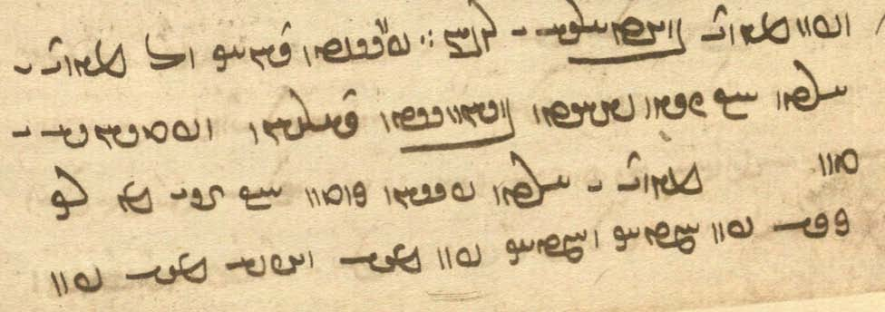
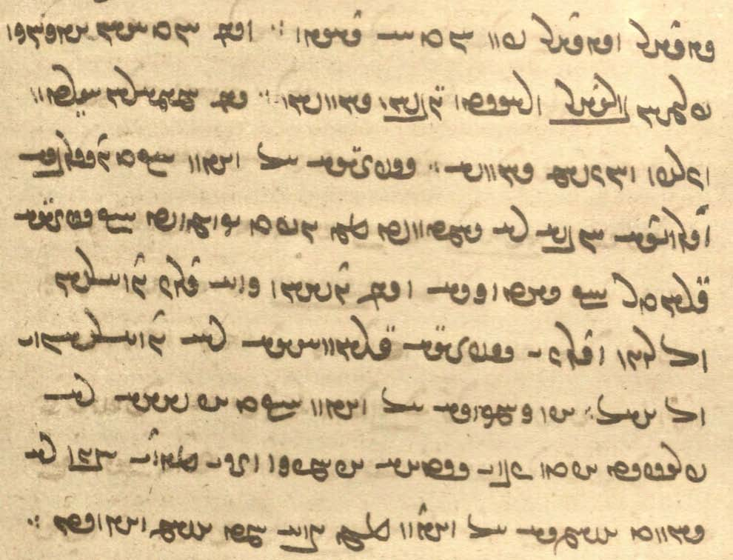

Notes:
bāš first spelled <YHWWNšn'> then <YHWWNš> exemplifies a tendency for scribes to change a word they do not immediately recogninze, but then they get it right the 2nd (or 3rd) time.
dusrawīh, ms. <-lwbs>: some scribes tend to “abbreviate” final E <-yh> at line ends as óD or S .

For -t ... awiš “upon you,” see Lesson 12.

pursīd dānāg ō mēnōy ī xrad kū
čiyōn šāyēd xwāst dārišn ud padēxwīh ī tan {ǰud az zyān ī ruwān ud bōxtārīh ī ruwān ǰud az zyān ī tan}
mēnōy ī xrad passox kerd [ms. <krt">] kū
ān ī az tō keh pad ham-tāg {dār} ud ham-tāg pad {az-iš} meh.
ud az-iš meh pad [133r] sālār ud sālār pad xwadāy dār ∵
ud andar xwadāyān ēkānag framān-burdār ud rāst-gōwišn bāš [ms. <YHWWNšn'>] ∵
andar hamēmālān ērtan ud čarb ud hu-čašm bāš ∵
spazgīh ma kun kū-t dusrawīh [ms. <-lwbs>] ud druwandīh awiš nē rasēd
čē guft estēd kū spazgīh garāntar kū ǰādūgīh ud andar dōšox harw druz dwārišn [ms. <dww’l-> for <dwb’l-> twice] ō pēš ud druz ī spazgīh garān-wināhīh rāy dwārišn ī ō pas ∵
āz-kāmagīh ma kun kū-t āz dēw nē frēbēd u-t xīr ī gētīy abē-mizag ud ān ī mēnōy wanīy nē bawēd [ms. <YHWWNt'>]

Text 11.3
From the Pahlavi Videvdad: PV.4.1 L4 48v-49r
Go to http://ada.usal.es – click on Manuscripts view – pull down the Work tab to V – pull down the Book tab to 4 – pull down the Paragraph tab to 1 – Go to + V_P (on the left) – Click on L4. This will take you to the first picture. You will find the text one line down from where it says 4.1 in the right margin. – When you have read the first page, click on the < sign to advance to the next page. – Click on the images to enlarge. – Skip the Avestan text! Do the same for M3.
The Avestan text: “He who to a man who gives him greetings does not bear the greeting in return/back, he becomes a thief of the greeting, a violator of the greetings-bearer.”
niyāyišn here renders Avestan nəmō “homage, reverence, greetings,” cf. Av. nəmas^{ə} tē “homage/greetings to you!”
The first part contains the rendering of the Avestan plus glosses; the second part contains the commentary.
kē ō mard ī niyāyišnōmand tis abāyēd dādan ā-š nē niyāyišn abāz bard kū-š ne dahēd
duzz ī [L4, M3 duzzīh] niyāyišn bawēd ān ī-š pad ēd menišn bē stānēd kū abāz ne daham {M3 + ēn}
u-š apparīh (ī) [L4 <’p̄l>, M3 <QDM>!] niyāyišn az barišn ka xwāhēd gōwēd ay ast-im u-t nē daham

ēn az Abestāg paydāg ān bawēd ka gōwēd ay [not in M3] tis-iz dah, ud tō-iz ka abāyēd ā-t daham
ud pad ēd [in L4 correction] menišn bē stānēd kū abāz ne daham,
{M3 repeats: ud <LKWM> for <LKc> kē ast ā-t daham ud pad ēd menišn bē stānēd kū abāz ne daham}
ka kas nē dānd, pad hāsr duzz [M3 CwL for CwY>]; ud ka kas dānēd, pad hāsr apparag
ka xwāhēd, gōwēd ay nēst-im, pad gyāg duzz
ka gōwēd ay ast-im u-t nē daham, pad gyāg duzz ī duzzīn ud appar {ud} apparīn [M3: apparag duzz ī appar ī apparīn]

Ms. readings in [...]. Text in {...}: ignore!
The text is about a man who is greeted by another and the various reactions to the greeting by the man who receives the greeting. It is somewhat elliptic, e.g., ka xwāhēd “when he wishes [to receive the greeting].”

Exercises 11

11.1. Transliterate/transcribe and translate:
Note: ka “when, if”; kū “that, where, when.”

? WwÍcD NwY OW MWwaDWV WTPwïåD WwaÅt˜ WwYfJwlA ^ WWt˜ MwsLV W WklAwZ NwY WWP ? !

WbA tdA L NwY à WtŸjAwÍ AWB WWT WWT WwABwL WwABwL à YwïjAwÍ AWB MWt¬M ATwÍwA øaÅ ? 2
? LtDWWTP W˝∆¸W !c¬ATK tdA L NwY W WiläW tdA L NwY W aÅ tdA L NwY W
(after the resurrection)

WW˙dAtJ W žW]Ÿ>D ÍBwA nÀ<JW nLW Y>WnYWkY WwajaJ ^ WWna¬YP LwßGK x WN AWK W ? 3
? žWwïÅW áÂA WwYWcÅ W

? aj,âlaÅ Y saÒ tdA KwïÅ à AtJ Y wAwÀ∆>¿å˜ ØW cå:DW Ät¬A kL WWWwmY AWB ? 4
/ tDtÒW ÍcÅ saÒ cdA WWP øA W eY<WT WWP øA W EwaåÒP WWP øA W

? WtDWtdmY WwaÂZ x Y>W WtDWWvaD laå¸ WCwlYWWt˜ W lAksAWW ã OW WwßLwA N WwYwL WwABWT WwATtÂA ? 23
? îdaHW WKtJV ^ LtåÒB 2 AWK ã kL W

WtDWtDwA aÒ WtDWwABkÍ ÚT 1áJW W WtDWWtåD lAwaÒ ÚT WkAtÒP WtDWwlZW áÂA !WkAwïD a∂:dL tÂA AWvY ? 33
/ WTWWwaD ÚT aÒ à WtdAcÅ WthaD AwA WWP ßA aÒ WPwïÅ WTWWwaD ÚT MNwA Wt˜ AWB NwA à ÍwY à

à WtŸJWWP laDwS Wwa¬aÂLtåÅ N WwAwï¬A WTWWiLW WwAwï>¬A ^ LNTWB NTwL lïhad>lA tÂA ? 34
? YNwA WTWwlZW WkAwïD ÂATK

WtDWWtÂaD aÒ ÍBwA CWwaÅ eATwA ^ nS< ã à WtDWWWnY WwAwï¬A OW LaDwS Wwa¬aÂLtåÅ ? 44
÷ WWTWWï>ÅW ÂsaH WtDWWtÂaD ÍBwA nS ã à WwYwL à WtdaH ? Âï¬ABwSW AWB à WtdAcÅ AWB

? WtDWWtÂaD ÍBwA EKwYW WwATtÂA WtDWWwaD WtåH lYcÅ OA ? 333
÷ WtDWWtÂaD q ÍBwA EkAwA WwATtÂA WtDWWwaD WtdßYB lYcÅ OA

t∂,D> AL AbLK à `>WWwaD> W TWWtdmY à `>WWtDwA tÂA ` tDWWwaD ã ? kAtDP kAtJcÅ N NwY ? º
/ WTWWtjA AL AbLK à `>WWtDwA à tjAcÅ AL x AwA ÍcÅ WwAc¬ylM sAWW à `>waD

11.2. Match the Pahlavi words with their transcriptions:

CWwaÅ laÅwY ÓdM abgand gōhr rāst
YWBwA gLwY WwaÅt˜ āfrīn gurg Sāsān
äwlYwA EksLwY lAcdlAK ahanūz hamēmāl stāyišn
WfjAc¬A WwajaJ WpLK andarwāy hubōy škast
laÂˆÂA AwS WWna¬YP Arzāsp kand gursagīh
WTWwLcÅ WW˙dAtJ WTwLP āsānīh kārēzār tār
Wwˆ<ÂßA nÀ<JW WWCNTP buland kerb tārīkīh
WwYWcÅ WwaÅtJW lAT bun-xān namāz tišnagīh
WwaÅ WWB WIWwï¸ EilAT dādestān mēš wistāx
YwLWB WtjaÒ WtJWwLVT dahībed paymōzan xešmgen
EwajA WTWtdmL EKwßYT dehān pērāmōn zīndag
WTPwïåD frōd

11.3. Translate into Pahlavi and write in Pahlavi at least sentences 2, 4, 6, 8, 9:

- A wise man is like a good field (earth) on which one sows (throws) seed and many fragrant plants and tall trees come up from it.
- Then Ahrimen rose up from the depth in order to smash Ohrmazd’s creation, but he was thrown back down into the darkness of Hell.
- When the adversary had run in, the sky feared him like a sheep the wolf; he came upon the fire in the form of a fly.
- If I become the gods’ helper, the gods will make me their own, and I will not fear (my) enemies, but be confident in the goodness of this world and the just judgement in the other world.
- The Righteous in paradise are clothed in gold-adorned, silver-adorned, jewel-adorned garments, shinier than all (other) garments.
- He who digs a well for (his) opponents falls into it himself, and he will not be able to come out of it, but will die in it from (because of) hunger and thirst.
- Do you know why the sky is above and the earth is below and the atmosphere is in between and whether it is possible go from this world to the other?

Additional Readings 11

Additional Reading 11.1
From the Mēnōy ī xrad: MX.8,1-8. – Ms. K43 fol. 143v.

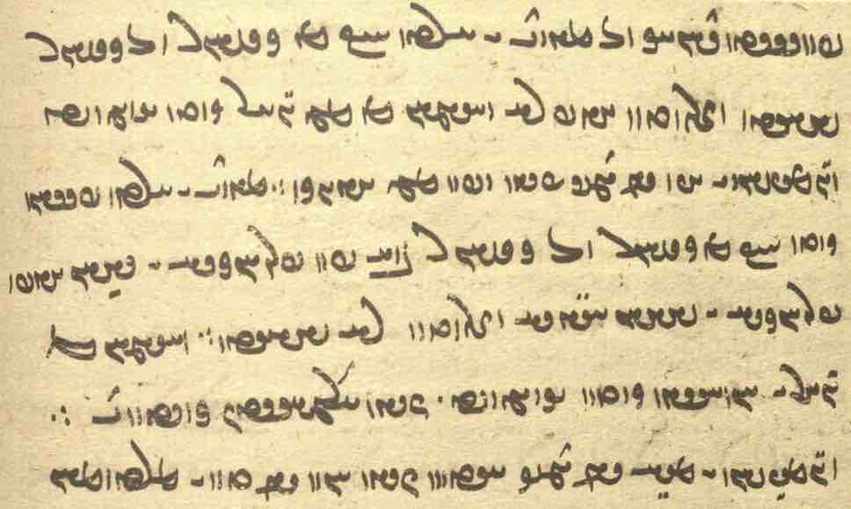

pursīd dānāg ō mēnōy ī xrad kū
az kišwar ō kišwar šāyēd šudan ayāb nē ∵
ud āsmān az čē gōhr kerd estēd ∵
ud gumēzišn ī āb andar zamīg čiyōn ud pad čē ēwēnāg ∵

mēnōy ī xrad passox kerd kū
az kišwar ō kišwar bē pad parwānagīh ī yazdān ayāb parwānagīh ī dēwān ēnyā šudan nē šāyēd ∵
ud āsmān az gōhr ī xwēn-āhen kerd estēd čiyōn almāst-iz xwānēnd ∵
ud gumēzišn ī āb andar zamīg ēdōn čiyōn xōn andar tan ī mardōmān ∵

Additional Reading 11.2
From the Mēnōy ī xrad: MX.1.49. – Ms. K43 fol. 134r.

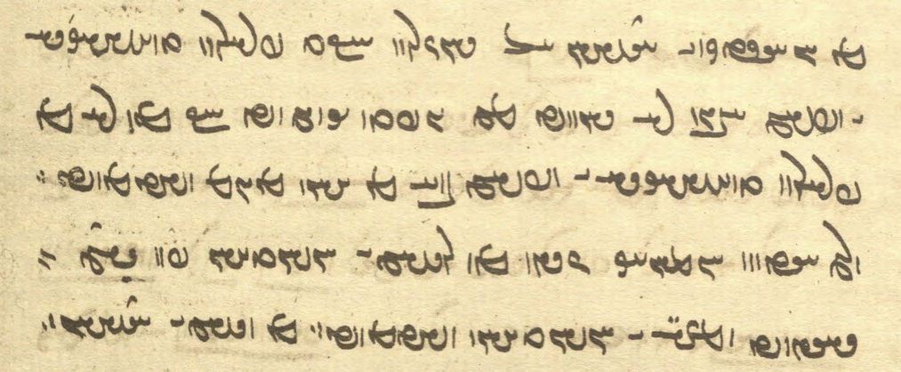

az xwāstag ī kasān ma appar kū-t frārōn-tuxšāgīh ī xwēš wanīy nē bawēd
čē guft estēd kū kē nē az frārōn-tuxšāgīh ī xwēš bē az anīy tis xwarēd ∵
ōy ēdōn homānāg čiyōn kē sar ī mardōmān pad dast dārēd ud mazg ī mardōmān xwarēd

Additional Reading 11.3
From the Šāyist nē šāyist “What is appropriate and what is not”: ŠnŠ.9.9-10. – Mss. K20 fols. 69r-69v, M51a pict. 203 (http://daten.digitale-sammlungen.de/~db/0002/bsb00028015/images/).

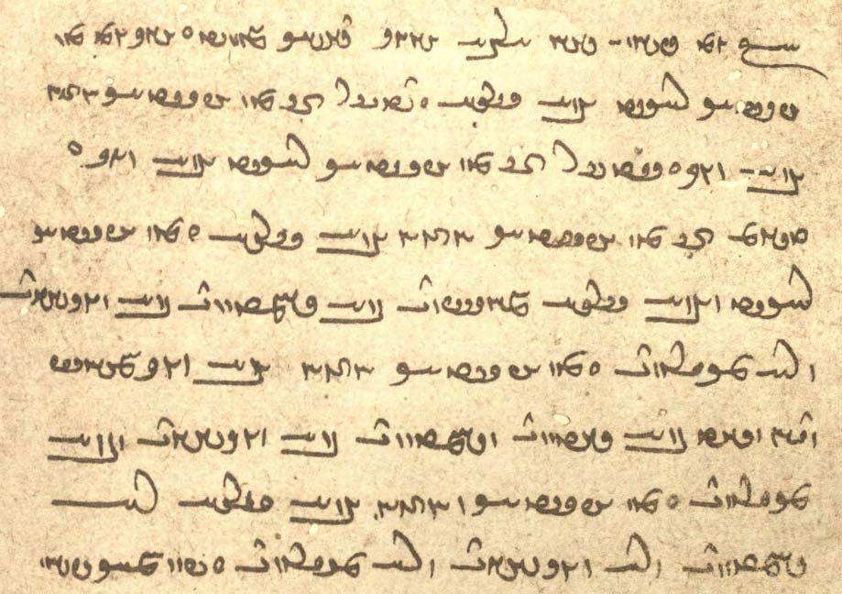

Text in { } not in K20.
Pāzag spelled <p’cn'>.
zēfān <zyp̄’n> is spelled <’wzw’n> in K20, a misunderstanding
of <zyp̄’n> as NPers. zebān “tongue,” Pahl. uzwān.
amahrspand is spelled <’myhrspnd> in M51a and once in K20.
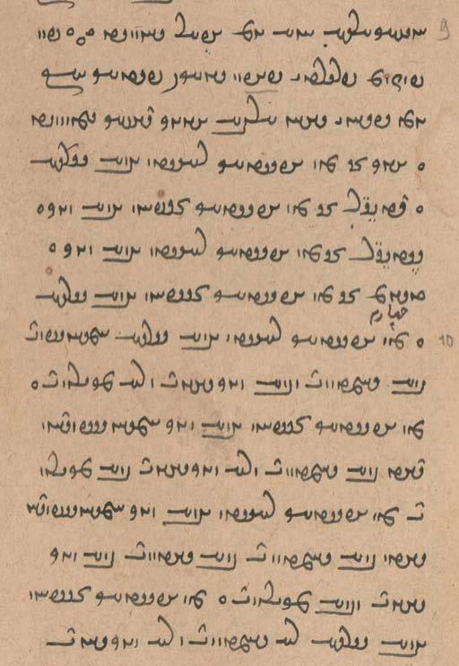
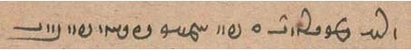

pad panǰom pargard ī *Pāzag gyāg-ēw paydāg [K20 69v] kū ēn yazišn ī yazdān čahār-ēwēnag daxšag gōwēd o
ēk ān [K20 ēn] kē Abestāg rāst mard wad o didīgar ān kē Abestāg zēfān mard nēk o
sidīgar ān kē Abestāg rāst mard nēk o tasom ān kē Abestāg zēfān mard wad o
kē Abestāg rāst ud mard wad amahrspand bē rasēnd ud bē niyōšēnd ud nē padīrēnd o
kē Abestāg zēfān mard nēk amahrspa / {ndān ud yazd bē rasēnd ud nē niyōšēnd bē padīrēnd
kē Abestāg rāst} mard nēk amahrspa} / ndān ud yazd bē āyēnd ud rasēnd bē niyōšēnd ud bē padīrēnd o
kē Abestāg zēfān mard wad nē rasēnd ud nē niyōšēnd [M51 204] ud nē padīrēnd o

Additional Reading 11.4
Questions from Pand-nāmag, Book of Advice (of Zarathustra): PN.1. – Basic questions.

? WwaååH WPwïÅ MNwA nÍPW WwaåD ? ‹ WPwïÅ MNwA nÍPW a˜wAwA
? aåH WPwïÅ MNwA MWt¬M ? WwaÒtdlS WPwïÅ MNwA nÍPW Wwa¬YcH
? WwmÍwY WN McÅ WtJwY WN McÅ ? Wwaå¸ Ú W WTwS Ú McÅ ? ÂATK WwïD McÅ YWC saÒ
? eadlS WN N W EKwYW WN N W ? EilAT WN N W EwÍwL WN N W ? 2 WPwïÅ WKwïÅ WKtHWWV
? EwAtJtådA WN N W ? EwAtJtåD WN N W ? EI>wY WN N W ? eYWBwA WN N W
/ EwÍcÒnAwA WN N W ? EwßáhAcÅ WN N W

Glossary of words in the Texts and Exercises 11

Idioms:
abar āxēz- rise up
abar mad came upon
abāz bar- carry back, return (sth.)
abāz dah- give back
ān bawēd ī ka that is the case when
andar āmadan come in(side)
andar kerdan put into; also = kerdan (?)
andar taz- set upon, attack
andar xwēšīh (ī) in the possession (of)
andar (ham) zamān at once
az ēn kū for this reason that, because
az .... bē from
az ... wider- pass through, cross over (bridge)
bād may it be (subj. of baw-)
gyāg-ēw in some place, somewhere
ī ast that is
ma abēr not (too) much
ō ham dazdan burn up
ō yazišn xwāh- ask (a divine being to come) to the sacrifice
ōh bawēd it is in the usual manner
pad ēč rāh in any way
pahlom ox = pahlom axwān the Best Existence, paradise
pēš kū before (conjuntion, time)
šāyēm we can (see Lesson 12)
tag abar kerdan set upon, attack

Nouns, adjectives, adverbs, pronouns:
abaxšāyišnīh EW˙dahAcÅ <’p̄hš’yšnyh> forgiveness
abuxšāyišnīh EW˙dahAWcÅ <’p̄whš’yšnyh> =
abaxšīh eßAcÅ <’p̄hšyh> pity
abāz-pursīdār lAt∆DWWP cÅcÅ <’p̄’c pwrsyt’l> asking again
abd ºcÅ , º>cÅ , Y>cÅ <’p̄d> marvelous, wonderful
abē-mizag WKcÂAcÅ <’p̄yymck'> tasteless
adādestānīh eAwsA , EwAtJtådA <’d’tst’nyh, ’DYNAyh> lawlessness, lack of justice
ahlāyīhōmand Y>Nwaåja¬aÅ <’hl’yyh’wmnd> possessed of Righteousness
axwarišn WwßLwaÅ <’hwlšn'> without food (i.e., firewood)
ādūg WKWtÅ <’twk'> able (to); + infinitive
āgenēn WwYWkA <’knyn'> together
ahanūz CWwaÅ <’hnwc> yet; ahanūz ... nē “not yet”
almāst WtjaÂlA <’lm’st'> steel
āmurzišnōmand Y>NwAwÍcÒnA <’mwlcšn’wmnd> full of forgiveness
anāmurzīšnīh EwÍcÒnAwA <’n’mwlcšnyh> mercilessness
apparīh eLcÅ <’p̄lyh> robbery
āsān WwajA <’s’n'> at ease, free from worry
āwahan WwaÅBwA <’w’hn'> (some kind of) dwelling
ay 1A <’d> particle: “that is, the meaning is”
ayār = hayār lAvsA <hdyb’l> helper
āz WcÅ <’c'> greed, the demon of Greed
āz-kāmagīh Ek≤AKWcÅ <’c' k’mkyh> desire, lust
bastag WKtJV <bstk'> bound, tied up, imprisoned
buništag WKtHWWV <bwnštk'> ‘principles’: Light and Darkness
čāh aÅC <c’h> well (for drawing water)
čihrīg WilaDC <cyhlyk'> natural
daxšag WkßE <dhšk'> mark, characteristic feature, manifestation, symbol; memory
dādestānīh eAwS , EwAtJtåD <d’tst’nyh, DYNAyh> compliance with the law
dāšn WwßE> <d’šn'> gift; from dādan dah- “to give”
dast nïD <YDE> hand
dōš ÍwY <dwš> yesterday, last night; back (of body)
duz(z)īh ECwY <dwcyh> theft
dūd WTwY <dwt'> smoke
dusrawīh EBwlSwY <dwslwbyh> infamy
dwārišn WwßlABwY <dwb’lšn'> running (esp. about evil beings)
dwārišnīh EwßlABwY <dwb’lšnyh> running (esp. about evil beings)
ēkānag WKwAKwïÅ <’ywk’nk'> submissive, obedient
fradāg oa˜ , WkAtÒP <plt’k', MHL> tomorrow, the next morning/day
framān-burdār lAtÒWBwaÂLP <plm’n bwlt’l> obedient
garān-wināhīh EsAWW Wwa¬G <gl’n' wn’syh> (the fact of something) being a heavy sin
garmāh aåÂlY <glm’h> heat
gōhr-pēsīd WtÎjGplAwY <gwhlpysyt'> adorned with jewels
hamahl laåÂA <hm’hl> (someone of) equal (social standing)
hambār lAbmA lABwA <hnb’l, hmb’l> store (what is stored up); + kun- “store up”
hamtāg WkAtÂA <hmt’k'> equal, peer
hayār = ayār lAvsA <hdyb’l> helper
hukāmag WkmAKwA <hwk’mk'> of good will (toward)
huparistāy ÄtjLPwA <hwplst’y> of good service (to)
huram µLwA <hwlm> happy, elated
kadār-iz-ēw !c¬ATK <kt’l-c-1> whichever (of two)
kālbod WTWplAK <k’lpwt'> body, form
magas SkM <mks> a fly
magas-kerb WcÒkSkM , WcÒ˝JkM <mksklp'> in/with the shape of a fly
mazg gzM <mzg> brain, marrow
mihrdrōz WCwlYWWt˜ <mtr'dlwc'> contract-breaker, cheater
nam bMW , MW <nm(b)> dew
namāz Wcå˜W , nïŸJW <OSGDE, nm’c'> homage; + bar- “pay homage (to)”
nāyrīg, nārīg WilAW , WilÄW <n’(y)lyk'> female; Av. nāirikā
nazdīk W˝∆¸W <nzdyk> near, close
nazdīk-paywand YWWTP W˝∆¸W <nzdyk-ptwnd> belonging to the close family
niyāyišn Ww˙ÌaÅW <n’’yšn'> reverence, respect; greeting; name of an Avestan/Pahlavi text
niyāyišnōmand YNwAWw˙ÌaÅW <n’’yšn'’wmnd> reverent, respectful
ox (axw) WwaÅ <’hw'> existence
rad WtÒ <lt'> 1. divine model for things in this world, “chief”; 2. a (religious) judge
rasišn Ww˙jL , WwÍWWtÂaD <YHMTWNšn', lsšn'> coming
rōšnag WKwÍwL <lwšnk'> clear
sūd WTwS <swt'> use, usefulness
tan-masāy ájM WWT <tn' ms’d> the size of a body
tangīh eYWT <tngyh> narowness, constriction, dire straights; discomfort
wadīh eadlS , ETW <wtyh, SLYAyh> badness
wanīy WwYBwA <HWBDWN> + baw-: perish; + kun-: destroy
warzišn WwÍcÒW <wlcšn'> doing, making, performing
xwārīh elAwA <hw’lyh> comfort, ease
xwārīhōmand Y>NwaådlAwA <hw’lyh’wmnd> having comfort, ease
xwaš µïJ| <BSYM> pleasant, comfortable
xwēnāhen WwïåÅ WwYwA <hwyn' ’hyn'> some kind of shining metal
wāstarōmand Y>NwaÒtjAW <w’stl’wmnd> having/full of fodder (grass)
zahr la¸ , laå¸ <z’hl, zhl> poison, venom
zarrēn-kerd WTWK Wwˆ:¸ WTWKWwïÅba¸ <ZHBAyn'-krt'> made of gold, inlaid (?) with gold
zēfān WwAfdZ <zyp’n'> wrong
zōhrag = zōhr WklAwZ <zwhlk'> libation

Proper names:
Ardwīsūr (Ardīwsūr) LwïDwYkLA <’lḏywswl> Ardwīsūr, the heavenly river
Framgar LkmLP <plmkl> name of a fire
Hadiš ˙j>A <hdyš> genius of the dwelling place, deity of the harvest season
Rōšn WwÍwL <lwšn'> name of a commentator
Sāsān WwajaJ <s’s’n'> Sāsān, Ardaxšīr’s protector
Srid WtdlS <slyt'> mythological person
Zarēr lYlZ <zlyl> Wištāsp’s brother

Verbs:
āmurzēn- āmurzēnīd -wYcÒnA <’mwlcyn-> provide forgiveness
appar- appurd -WwLCwE <YHNCLWN-> take away, steal, rob
āxēz- āxist WtjaÅ -cdaÅ , -WnYK <KYMWN-; ’hyc- ’hst'> rise; ~ up: abar āxēz-
ayār- ayārīd = hayār- WtdlAvsA , -lAvsA <hdyb’l-> be able to
āzār- āzurd, āzārd Wt¬AcÅ, WtÒWcÅ, -lAcÅ <’c’l-, ’cwlt'> harm, injure, offend
bēš- bēšīd -ßGB <byš-> harm, hurt
daz- dazīd -cD <dc-> burn (sth.); + ō ham “burn up”
frēb- frēftan -fjLP , -cjLP <pldyp/p̄-> deceive
hayār- = ayār- WtdlAvsA , -lAvsA <hdyb’l-> be able to
nibay- nibast WtJWwABkÍ , -WwABkÍ <ŠKBHWN-st'> lie (down)
nihumb- nihuft WTPwAW , -bMwAW <nhwmb-, nhwpt'> cover, hide
nixwār- nixwārīd - lABwSW <nswb’l-> hurry
wih- wist -WtjÍ <ŠDYTN-> to shoot (arrow); abāz +: shoot back
wišāy- wišād -áHW , -WtdlÍ <ŠLYTN-, wš’d-> open (the bonds), free

Lesson 12

Grammar 12

Indefinite pronouns/relatives/adverbs

kadām-iz-ēw ÄcÂATK <kt’mc-HD> “whichever, any ... at all/soever”
kadāmagān-iz CWwAkmATK <kt’mk’n'c> “whosoever, any ... at all/soever”
kadāmīyān-iz(-ēw) !CwadmATK < kt’my’nc(-1)> “whosoever, any ... at all/soever”
kadār-iz(-ēw) !c¬ATK <kt’l-c[-1]> “whichever (of two or more)”
kuwām-iz-ēw !CµAWK <kw’m-c-1> “wherever, anywhere ... at all/soever l”

Examples:
kadām-iz-ēw šōyišn ī ǰud az baršnūm
“whichever washing other than the baršnūm” (NM.3.12)

kadāmagān-iz mardōm andar harw gāh ud zamān tis ī mēnōy pad ayād dārišn nēkīh ī wahišt ud anāgīh ī dōšox “any people soever, in every place and time, should keep in mind the matters of the other world: the goodness of paradise and the evil of hell” (DD.93.9)

Note: kadāmag “whichever” is found in compounds: kadāmag-ōzīhā kōxšišn “fighting with whichever powers” (DD.36.64)

arzānīgān wazurg-dāšnīhā ruwān rāy ō dēnīgān wēš ud ō kadāmīyān-iz hudēn
“(alms shold be given) to those worthy by giving great gifts for (one’s) soul, mostly to those of the dēn and to whosoever (is) a hudēn” (Dk.5.17.3)

kadāmīyān-iz margōmandān ī pad nēkīh ī wispān dāmān anarešk ud ham-rāmišn
“any mortals soever who (are) unenvious of and joyful at the goodness of all creatures ...” (DD.36.106)

kadār-iz-ēw ān ī bē-tāzišnōmand urwar
“whichever (is) a plant that causes abortion” (PV.15.14)

pas mardōm mardōm bē šnāsēnd kū ... ēn man ast kadār-iz-ēw nazdīk-paywandtar
“then people will recognize one another (and know): ‘this is whichever is my closest relative’” (Bd.34.9)

kē dēwān kuwām-iz-ēw čiyōn nāyrīg ī šōy tarsagāy ā ān dēwān tarsagāh ...
gušn ī wīftag ud gušn wīftēnīdag ān dēwān kuwām-iz-ēw čiyōn nāyrīg ī šōy tarsagāh ān dēwān tarsagāh
“who is ‘wherever’ for the demons? (i.e.) in the way a woman is obedient to her husband, he is obedient to the demons ... a male who is buggered and the male who is caused to be buggered, he is ‘wherever’ for the demons, (i.e.) in the way a woman is obedient to her husband, he is obedient to the demons” (PV.8.31-32)
Here kuwām-iz-ēw čiyōn nāyrīg renders Av. kū.nāiriš “*pseudo-woman”?
Another verson of this text (ZFJ.589) has čiyōn kadām-iz-ēw nāyrīg ud šōy ī tarsagāh ān dēwān ast tarsagāh
“just as whichever obedient wife and husband, he is obedient to the demons.” – Nir.52.1 has kuwām-iz ēw translating Av. kuuacit̰ “wherever.”

če’ān ã nM <ME ZK> anything
če’ān-iz ... nē aÒ ... CwAC <c’nc ... LA> “not any/nothing at all”
čēgām-iz(-ēw) !cÂAIC , ÄcÂAIC , cÂAIC <cyk’mc(-HD/-1)> “whatever”
čēgāmag WKcÂAIC <cyk’mk' “(any ..) whatever”

Examples:
šā-dānag ī Siyārzūrīg ... xwaš pad xwardan hu-bōy pad dahān hu-gugārd pad aškambag ud pad če’ān kār frāztar
“hemp seed from Siyārzūr is nice to eat, smells good in the mouth, is easy to digest for the stomac, and is superior for any use” (Husraw ud rēdag 53)

ka ēwar dānd kū ābustan ham bē ka ēwar dānd kū nisēy tā, pad če’ān-iz nē dārišn
“when she knows for certain that: “I am pregnant”—except (= unless: bē ... tā) she knows for certain that it a dead fetus, it should be regarded as nothing (i.e., of no consequence)” (PV.5.49)

sāl-drahnāy ... ēn zamīg anabēdān kū pad če’ān-iz kār nē šāyēd
“‘for a year this earth is un-approached, i.e., it can not be used for any purpose” (PV.6.1)

Pōrušasp ō Dugdōw guft kū Dugdōw ... bē awēšān gāw dōš kē ān ī ōy gāw čēgāmiz-ēw ox ī astōmand rāy xwarrah aziš
“and Pōrušasp said to Dugdōw: Dugdōw, (go) milk those (two) cows, from whichever (of them there is) Xwarrah for the existence with bones!” (Dk.7.2.41)

abar ābusīh ī dēw az ǰeh kē pas az hūfrāšmōdād čē-gāmag ǰōyēd
“about the pregnancy of the demon (= about how the demon becomes pregnant) from the wicked woman who, after sunset, gobbles up anything whatsoever” (Dk.9.19.1-2)

kas, kas-iz C˙dA , ˙dA <AYŠ, AYŠ-c> “person, somebody”
kasān WwaÔdA <AYŠ’n'> “(other) people”
kas(-iz) ... nē aÒ ... (C˙dA) ˙dA <AYŠ, AYŠ-c ... LA> “nobody, no one”
kas-iz kas ... nē aÒ ... ˙dA C˙dA <AYŠ-c AYŠ ... LA> “nobody/no one at all”
tis (čiš) (ÍnM) MwYN <MNDOM (MEš)> “thing, something”
tis, tis-iz cdMwYN , MwYN <MNDOM(yc)> “any(thing) at all”
tis(-iz) ... nē aÒ ... (cdMwYN) MwYN <MNDOM(yc) ... LA> “nothing”
tis(-iz) tis ... nē aÒ ... MwYN (cdMwYN) MwYN <MNDOM(yc) MNDOM ... LA> “nothing at all”
Note: The occasional spelling <MEš> čē-š is for čiš, a dialect form of tis, found in Manichean Middle Persian.

kas, tis non-negated:
kas(-iz) az gētīyān
“anybody (at all) among those in this world” (Dk.3.318)

čē tā andar ēn gēhān pad kas-iz mardōmān kōdag druz-ēw mehmānīh ēg Ahrimen andar gēhān
“for as long as, in the world of the living, a small Druz resides in anybody of mankind, then Ahrimen is in the world of the living” (Dk.6.264)

pad tis-iz šāyēd
“can (be used) for anything at all”

Ahrimen ī druwand u-š dēwān ud wišūdagān abāg Ohrmazd ud amahrspandān tis-iz āštīh ud dōšāram ēk abāg did būd šāyēd ayāb nē
“can there be any peace and love at all between the wicked Ahrimen and his dēws and abortions with Ohrmazd and the Amahrspands at all?” (MX.9.4)

kasān:
ēk kū harw ān ī pad xwad nē nēk pad kasān nē kerdan
“one (another thing): do not do to (other) people that which is not good for yourself!” (ŠnŠSup.13.39)

az xwāstag ī kasān ma appar kū-t frārōn tuxšāgīh ī xwēš wanīy nē bawēd
“do not steal from (other) people’s stuff, so that your own good diligence may not be ruined” (MX.1.46-47)

ēn ruwān ī ōy druwand mard kē-š pad gētīy xwāstag nē az frārōnīh bē az tis ī kasān duzdīd
“this is the soul of that wicked man who (kē-š; ergative, Lesson 14), in this world, did not (acquire) wealth from good behavior, but stole from (other) people’s stuff” (AWN.46.3)

kas, tis negated:
nē bōxtēnd az-iš kas-iz bē kē ruwān bōzēd
“nobody will be saved from him (Astwihād) except (bē) he who saves his soul” (Dk.9.16.2)

pas az ān ī ka druz ō dām dwārist bē Zardušt tā az gētīyān kas-iz nē dīd haft kišwar
“since the Druz rushed onto the creation, other than (bē ... tā) Zardušt, nobody of those in this world has seen the seven continents” (PR.46.9)

pad kas-iz kas afsōs ma kunēd
“do not deride anybody at all” (PN.43)

u-šān ēk-iz passox nē kerd
“and not a single one of them answered” (Bd.26.38)

Akōman handēšīd kū-m nē tis warzišn kē-š ō man guft Wahuman
“Akōman reflected: I must make/do nothing that Wahuman told (-š ... guft “he said”, ergative, Lesson 13) me (to do)” (WZ.8.14)
yazd ō mardōmān bē nēkīh ēnyā tis-iz ǰuttarīh nē dahēnd
“the gods give nothing at all (producing) contrariety to people, only (bē ... enyā) goodness” (MX.51.15)

ruwān ī ahlawān pas az ān ī ka gyān az tan bē šawēd ... tis-iz duš-xwārīh nē bawēd
“for the soul of the Righteous, after (pas az ān ī ka) the breath-soul leaves the body, there will be no discomfort at all” (PR.24.1)

tis pad tis-iz tis nē dārēd
“he does not consider anything as anything at all,” approx. “he does not consider anything at all worth worrying about” (Ōšnar 20)

Double negatives occur occasionally, perhaps as a scribal error, e.g.:

nē kas az mardōmān ahlaw ud garōdmānīg nē bawēd kē-š gāhān nē warm kerd “no one at all among men becomes Righteous and Garōdmān-bound who has not performed (-š ... kerd “he has done”) the Gathas” (PR.17b.1)

Note also ēk-iz ... nē aÒ ... CKwïÅ <’ywkc ... LA> and ēw (...) nē aÒ (...) Ä <HD (...) LA> “not (a single) one”:
ēg pursīd az awēšān kū amāh kē brēhēnīd hēm, u-šān ēk-iz passox nē kerd
“then (one) among them (the amahrspands) asked: ‘who fashioned us?’—and not one of them answered” (MX.26.38-39)

ka-š nasāy ēk-iz čarbišn gumēxtagīh andar nēst ud ka šud ēw nē paydāg, tanūr hixrōmand
“when there is no nasāy and not a single fattiness mixture in it (-š ... andar) and not one (piece of skin) has manifestly come loose, the (legal position of) the oven (is) ‘contains hixr’” (RAF.109.2; when one burns a hand on the oven)

ēč (hēč) cdA <’yc> “any (at all)”
ēč kas ˙dA cdA <’yc AYŠ> “anybody”
ēč tis(-ēw) MwYN cdA <’yc MNDOM> “anything”
ēč kē WN cdA <’yc MNW> “whoever”

ēč non-negated:
ēč kē būd hēnd ud ēč kē bawēnd ud ēč kē hēnd
“whoever have been, whoever will be, and whoever are”

ēč negated:
ān ēk rāh gīrēd ī ahlāyīh ud ma pad frāxīh ud ma pad tangīh ud ma pad ēč rāh az-iš wardēd
“take that one path, that of Righteousness, and do not turn from it in any way, (n)either in well-being (n)or (when) in a tight spot (distress)!” (AWN.101.8)

abar wināh ī hamēmālān bē andar xwad-iz hamēmāl pad anīy ēč kerbag nē tōzīhistan
“about sins against one’s fellow men: it is not to be redeemed by any other good deed except (one done) to that fellow man himself” (Dk.8.17.9)

yazd ēč kas pad hammōg ī dēwān nē hišt
“God has not left anybody to the teaching of the demons” (Dk.5.24.14a)

pad ēč rāh ud pad ēč tis sūdagīh nē kerdan
“one is not to practice neglect in any way and in any matter = in no way and in no matter is one to practice neglect” (WD.89.5)

Ardaxšīr ēč tis-ēw nē paydāgēnīd
“Ardashir revealed nothing” (KN.14.7)

andar zamānag ī spurr-wehīh ēč dard bēš pad ēč čār ō ēč dām handāxtan nē šāyēd
“in the time of complete goodness, no pain (and) harm can by any means be plotted against any creature” (DD.36.102; at the end of the world)

hamāg, plur. hamāgān WkaÂA <hm’k'> “all”
harw, plur. harwīn AWK <KRA> “every, all”
harw ēk WKwïÅ AWK <KRA ’ywk'> “each one”
harw dō 2 AWK <KRA 2> “both”
harw kas ˙dA AWK <KRA AYŠ> “everybody”
harw tis MwYN AWK <KRA MNDOM> “everything”
harw kadār lATK AWK <KRA kt’l> “whichever” (of two)
harw kē WN AWK <KRA MNW> “whoever”
harw čē nM AWK <KRA ME> “whatever”
harw čiyōn WwSC AWK <KRA cygwn> “in whatever way, how(so)ever”
harwisp, plur. harwispīn, -ān WcJwAWK <KRAwsp'> “every, all”
harukīn, harkīn (rare) WwYklA , wYKwlA <hlwkyn'> “all” (ManMP hrwkyn, hrwqyn)

Note the frequent use of plural verbs with harw.

ud ham-kāmagīh ī 7-ān amahrspandān rāy ān čē ēk handēšēd ēg hamāgān dānēnd “because the seven amahrspands have the same wish, that which one thinks, they all will then know” (WZ.35.17)

ruwān ī druwand ō dōšox ōbadēd ud wēnēd harw anāgīh
“the soul of the wicked (person) falls (will fall) down to Hell, and (there) it will see (= undergo, suffer) every evilness” (after Bd.30.25)

Hordad rad ī sālān ud māhān ud rōzān az ēn kū harwīn rad
“Hordad is the rad of the years, months, and days, because (az ēn kū) he is the rad of all things” (Bd.26.103)

harw ēk 100 sāl bē zīst hēnd
“each (of them they) lived 100 years” (Bdh.35.9)

Pašang ud Wēsag harw 2 brād būd hēnd
“Pašang and Wēsag were both brothers” (Bd.35.18)

harw kas dōst bāš
“be a friend to everybody!” (DD.93.6)

harw kas az-iš hammōxtār hēnd
“everybody—they are learners (= learn) from him” (Bd.3.3)

Ahrimen harw tis pad zyān ī Ohrmazd kunēd
“Ahrimen does everything for the harm of Ohrmazd” (DD.93.8)

petītīgīh hamē ka kunēnd harw čiyōn kunēnd ud pēš ī harw kē kunēnd
“as long as they perform repentance, however they do it and before whomever they do it ...” (ŠnŠ.8.13)

harw čē-t kāmag ast xwāh tā-t daham
“ask whatever you wish, so that I shall give it to you!” (after Bd.4.6)

bēšēm āb bēšēm zamīg bēšēm ātaxš bēšēm urwar bēšēm harwisp dahišn ī Ohrmazd-dād
“I shall soil the water, the fire, the plant, and the entire creation Ohrmazd set in place” (Bd.4.4b)

harw čē with comparative “the -er ... the -er”:
This construction, which is quite common in modern Persian, is rare in Pahlavi, e.g.:

asp ud gāw ud mēš ud buz ud abārīg sardag ī gōspandān harw čē gušn meh mādag bar weh dahēd
zarrēn ud sēmēn ud abārīg ayōxšustīg ǰāmag harw čē pāktar ud an-āhōgtar ēg-iš wāng xwaštar
“horses, cattle, sheep, goats, and the other kinds of domestic animals, the bigger the male, the better offspring the female will give;
a bowl of gold, silver, and the other metals, the purer and more unsullied, the more beautiful the sound” (after Dk.6.90)

har(w)kēn “all”
kerbag ī az ēn gāhānbār tā ān gāhānbār kunēd ēw-kardag bē bawēd harw ēk ēk ōh bawēd
ast kē ēdōn gōwēd ay ka-iz ēk xwēdōdah ēw bē kunēd ā-iz harkīn ōh bawēd
“the kerbags he makes from this Gāhānbār to that Gāhānbār will be connected, (and) each one will be in the usual way; there is one who says: (even) when he performs (only) one xwēdōdah, then too they will all be in the usual way” (Nir.42.5b; about the merit accruing from celebrating the Gāhānbārs)

ēn stūnag ī pad āsmān paydāg bawēd kē mardōmān sanwar xwānēnd harw čē dabr zard sabz ud suxr ud xšēn ud harukēn waxšōmand
“this column that appears in the sky, which people call the Bow, (is) everything that (is) violet (?), yellow, green, red, and dark blue (?), they are all blazing (?)” (Bd.21e.5) (rainbow colors: red, orange, yellow, green, blue, indigo, and violet)

The use of Pre- and postpositions with enclitic pronouns 2
This section deals with what may seem like a counter-intuitive use of the aziš, etc., so study it well!

aziš, padiš, and awiš as postpositions
When az, pad, and ō become postpositions, an element -iš is added that has no meaning of its own (aziš, padiš, and awiš). [Compare Old Persian patiš mām “against me,” where we have patiš instead of patiy.]
Unfortunately, these are spelled just like the prepositions + governed enclitic pronoun, which makes this one of the trickier aspects of Pahlavi grammar. The student should examine the examples below very carefully.

... aziš ÍcÅ <hcš> “from ...”
... padiš ÍTP <ptš> “on ..., with ..., etc.”
... awiš ÍBwA <’wbš> “to ...”

An additional complication occurs in relative clauses, since kē-š(ān) can be a relative by itself ‘who his/their’ (see Lesson 5 on “Whose”). Here, it needs to be determined from the context whether the postposition goes with the relative, with the enclitic pronoun, or with both.
Examples:

awiš postposition

With personal pronouns:
u-m rēmanīh awiš abganēnd
“they throw impurities at me” [not, e.g., “they throw my (-m) impurities at him (aw-iš)”] (after PR.18d.12)

spazgīh ma kun kū-t dusrawīh ud druwandīh awiš nē rasēd
“do not slander, so that bad fame and wickedness may not come upon you” (MX.1.8-9)

ō tō bē daham zarduxšt kē-t hōm ud zōhr awiš rēzēd
“I give to you (= a river!) Zarduxšt, who will pour hōm and libations into you” (after Bd.11C.1)

ast grōh kē-mān awiš hamē āyēnd
“there is one group (of people) who keep coming to us” (DD.65.17)

ud anāgīh ī-šān nūn az mardōmān bē awiš hamē rasēd
“and the evil that (here and) now comes upon them from people” (PR.14.2)
Note both bē and hamē!

With relative pronouns:
pursišn. mard-ēw kē duxt-ēw pad duxtarīh pad ō mard dahēd ēg-iš sālārīh pad kē.
passox. pad ōy kē-š awiš dahēd
“Q.: a man who gives a daughter to some man to be his daughter, then, with whom does her guardianship rest?
A.: With him to whom he gives (her)” (RAF.6.1)
Note: kē-š awiš could also be analyzed as “to whom (kē) he gives her (-š), but similar examples show that the above interpretation is more likely. – pad ō may be for bē ō.
ud abar kē-šān wināh tōzišn awiš nē bawēd
“and about ‘(those) for whom there will be no redemption for (their) sins’” (Dk.8.31.41)

Note awiš-išān:

ud az ōz ud zōr ud nērōg ud rāy ud xwarrah ī wisp-tuwān dādār Ohrmazd awiš-išān dād estēd was burdār hēnd nēkīh
“and, from (= because of) the strength, power, and might and Light and Xwarrah which the almighty Creator Ohrmazd has given to them (the fravashis), they are carriers of much goodness” (StS.19.6)
for:
... ī-šān wisp-tuwān dādār Ohrmazd awiš dād estēd ...

With kū “where’:
ud grift ī ān ī abartom mizd kū rāh ī awiš abē-āhangīh az wināh frāz-āhangīh ō kerbag
“... and seizing the supreme reward, whereto (to which) the road is being without inclination from (= toward) sin (and) having forward inclination toward good deeds” (Dk.5.9.2)

harw 2 (rōd) pad zrēy ī Frāxkerd ō ham rasēnd ud abāz ō bun-xān rasēnd kū aziš bē tazīd hēnd
“both (rivers) come together in the Frāxkerd ocean and come back to their sources, wherefrom (whence) they flowed” (Bd.11.5)

aziš postposition

With personal pronouns:
ēn-iz guft estēd kū harw kas bē abāyēd dānistan kū az kū bē mad ham ud čim ēdar ham u-m abāz ō kū abāyēd šudan u-m čē aziš xwāhēnd
“this too it is said: everybody should know: from where did I come, and why am I here, where must I return to, and what will they ask of me (ask me)?” (PT.11.11)

u-š āsmān aziš bē tarsīd čiyōn gōspand az gurg
“and the sky was afraid of him (the Evil Spirit), like a sheep of the wolf” (Bd.4.10b)

pas Sām abar āxēzēd ud padīrag ī Ažidahāg šawēd u-š saxwan aziš <MNš!> nē āšnawēd u-š gad ī pērōzgar ō sar pahikōbēd ud zanēd ud ōzanēd
“then Sām (Karsāsp) rises and goes against Ažidahāg (a dragon); and he hears no word from him (the Evil Spirit); and he strikes the victorious cudgel at its head and strikes and kills it” (after ZWY.9.22)

kū-mān anāgīh ī Ganāg Mēnōy aziš abāz dār
“i.e., keep the Foul Spirit’s evil away from us!” (PV.8.21a)

Note aziš-išān:

ud handarz ī ō mardōmān abar pahrēz ī az pasīy ī ōy ahlomōγ ud nē niyōšīdan ud nē xwastan ī aziš-išān Abestāg ud Zand
“and the advice to mankind about watching carefully the heretic from behind and not listening to and not learning (lit., “threshing”) from them the Avesta and the zand” (Dk.9.31.22)
for:
u-šān nē niyōšīdan ud nē xwastan ī aziš

With relative pronouns:
kas-ēw nē dānam kē-m nēkīh ēdōn aziš ciyōn az ašmāh
“I know no one from whom there is goodness for me like (there is) from you” (PY.29.1c)

duš-rawišnīh ī ān mēnōy ī-š gannāgīh ī dāmān ī Ohrmazd aziš būd
“the evilness of that spirit, from whom the stench of Ohrmazd’s creatures came” (Bd.1.48)

abar āxēz pid ī amāh čē ān kārēzār kunam ān ī-š Ohrmazd ud amahrspandān tangīh anāgīh aziš
“get up, our father, for I shall do that battle, the one from which (there will be) ‘dire straights’ (and) evil to Ohrmazd and the amahrspands” (Bd.4.2)

tis ān ast ī ān kē andar estēd aziš bē nē ayāsēd ud ān kē andar nē estēd awiš ayāsēd
“there is that (one) thing which that one who stands in (it) does not long (to be away) from and someone who does not stand in it longs for” (Dk.6.57) [lit.: from it, to it])

Note:
5-ēwēnag gōspand kē-š padiš 282 sardag kē aziš-išān [for kē-šān aziš] for was gōnag padēxwīh ud nēkīh hu-zīyišnīh ō dāmān ī Ohrmazd rasišnīg
“five species of animals, in which (there are) 282 kinds, from whom many kinds of prosperity, goodness, and good living will come (rasišnīg) to Ohrmazd’s creations” (StS.14.5)

padiš postposition

With personal pronouns:
bē gētīy nē šawam čē-m anāgīh was padiš kunēnd
“(the Fire says to Ohrmazd:) I am not going to the world of the living, because they will do much evil to me” (PR.46.30)

bē hilēd kū-š padiš andar tazēnd
“permit that they set upon him (attack him)!” (after Bd.6c.4)

ka-tān aǰdahāg padiš ōftēd
“when the dragon falls upon you (all)”

With relative pronouns:
tērag ī Harburz ān kē-š star māh ud xwaršēd padiš andar wardēnd padiš abāz āyēnd
“the top of Hariburz (is) the one upon which the stars, moon, and sun turn around (and) to (which) they come back” (Bd.9.6)

kār ī didīgar nē dānēd kerdan kē-š sazāgīh padiš ast
“he knows (how) to do no other work for which he has (-š ... ast) suitability (= for which he is suited)” (after DD.43.3)

ānōh was zarrēn gāh ud wistarg ī xūb ud bālišn abāg bōb passazag wēnam kē-šān padiš nišast hēnd kadag-xwadāyān ud dahīgānān ruwān
“there I see good seats and carpets and pillows with fitting *pillow-cases on which the souls of the petty kings and land-owners were seated” (AWN.15.4)

With nouns (rare):
Damū Asūrestān kadag-xwadāyīh awiš dād
“to Damūg the rule over Assyria was given” or “(as for) Damūg ... was given to him (aw-iš)” (Bd.35.46)

Wispān-frīy Kay-Husrōy aziš zād
“from Wispānfrīy Kay-Husrōy was born” (Bd.35.21)

ēd ast ān xwarrah kē-š mardōm awiš dahīhist
“this is the Xwarrah which was given by him [agential] to mankind” (WZ.3.74) [rather than: “to which mankind was given”] (WZ.3.74)

ašmāh ō awēšān Ohrmazd hayārīh dahēd Ašwahišt ud Šahrewar kū Zardušt ud hāwištān ī Zardušt nēkīh padiš kunēd
“‘you, Ohrmazd (and) Ašwahišt and Šahrewar, give help to them! i.e., do (some) goodness for Zardušt and Zardušt’s pupils!” (PY.29.10) [recall that bold type indicates Pahlavi rendering of Avestan text]

Ērān šahr was wišōbišn ud awērānīh padiš kerd
“much destruction and laying waste was done to Iran” (Bd.33.6)

With implicit reference:
harw čē kāmēnd awiš nimāyēnd
“(the gods) will show to (them) everything they wish for” (Dk.6.44)

pad nēkīh awiš madārīh spāsdārīh weh
“in order that goodness may come to (one), gratitude is the better (thing for one to do)” (MX.1.72)

The verb

The pluperfect
The past tense “he (has) asked, went (has gone)” and pluperfect “he had asked, gone” are formed with the past stem of the main verb + present and past tenses of “to be.” The past indicative forms of šaw- šud are therefore as follows:

Paradigm of the pluperfect:
Simple past Pluperfect
Singular
1st šud ham “I went” šud būd ham “I had gone”
2nd šud hē “you went” šud būd hē “you had gone”
3rd šud “he, she, it went” šud būd “he, she, it had gone”
Plural
1st šud hēm “we went” šud būd hēm “we had gone”
2nd šud hēd “you went” šud būd hēd “you had gone”
3rd šud hēnd “they went” šud būd hēnd “they had gone”

Uses of the pluperfect
The pluperfect is used to indicate that an action or incipient state was completed before something else happened in the past, e.g.:

Intransitive verbs:
ka ān dō rōd ī Ārang rōd ud Weh rōd bē tazīd būd pas abārīg ābīhā az ān nāydāgān frāz tazīd hēnd
“when those two rivers, the river Ārang and the river Weh, had flowed out, then the other waters flowed forth from those deep ones” (after Bd.6b.21)

kū šud būd hēnd abar ō ān ī murw pus ēg franaft ān ī Zarduxšt frawaš
“when (the snakes) had set upon the child of that bird, then Zarduxšt’s fravashi went forth” (after Dk.7.2.27)

ka Mānuščihr uzīd būd did Afrāsyāb āmad
“when Mānuščihr had passed away, (then) Afrāsyāb came again” (Bd.33.6)

Transitive verbs without “performer” (passive):
ka dēw ī māzandar ud abārīg druz wisp zad būd hēnd Hōšang ō Čīnestān pad ōzadan ī aždahāgān ī amar šud
“when the giant dēw and all the other lie-demons had been stricken down, Hōšang went to China to kill countless dragons”

The Subjunctive
In addition to the indicative and imperative, the Pahlavi verb also has a subjunctive and optative.
The subjunctive stem is formed by changing the vowel of the ending to -ā-. Endings:

Paradigm of the subjunctive:
Singular Plural
1st -ān(ī) Y>wA- , YwA- , WwA- <-’n', -’ny, -’nd> 1st -ām µA- <-’m>
2nd -āy îÅ- , !A- , Ä- <-’y, -’d, -’yd> 2nd -ād WtÅ- <-’t'>
3rd -ād WtÅ- <-’t'> 3rd -ānd YwA- <-’nd>

The first singular ending is often written Y>wA- as if it were the 3rd plural, but probably has <-d> for final -y: -ānī.

Subjunctive of “to be”:
Singular
1st hān(ī) WwAWNwA , YwAWNwA <HWE’n(y)>
3rd hād WTWNwA , WtÅWNwA <HWE'’t', HWE't'>
Plural
3rd hānd YwAWNwA <HWE'’nd>

Note: The 3rd sg. form WTWNwA (HWE't') is not uncommon, especially in compound tenses, but it is more common as the particle hād, see below.
On the use of hād <HWEt'> for hē as irrealis, see Lesson 16.
Note also the short form bād <b’t'> beside bawād.

Paradigm of the subjunctive:
Present Past Pluperfect
Singular
1st šawān(ī) WwAWwlZW , YwAWwlZW šud hān(ī) šud būd hān(ī)
2st šawāy !AWwlZW
3rd šawād WtÅwAWwlZW šud hād šud būd hād
Plural
1st šawām µAWwlZW
2st šawād WtÅWwlZW
3rd šawānd YwAWwlZW šud hānd šud būd hānd

Uses of the subjunctive
The subjunctive is used in both main and subordinate clauses.

In main clauses

Expressing an exhortation:
dagr zīyād “long live!”

ka nēkīh-ēw bē handēšišn zūd bē kunāy ud ka wattarīh-ēw bē handēšišn az xwēš bē spōzāy
“when something good is to be considered, you shall do it quickly; when something bad is to be considered, push it away from you!” (Ōšnar 48)

dahāy-im Ašwahišt ān tarsagāyīh ī pad Wahuman ābādīh kū-m tarsagāhīh ēdōn dahād ī pad tan ī pasēn abāz nē abāyānd (abāyānī?) ōzad
“‘you shall give me, Ašwahišt, that respect which is lucky through Wahuman’, i.e., he shall give me respect in such a way that they shall not need to kill (me) or: I shall not need to be killed again at the Final Body!” (PY.28.7)

ēn az tō šašom yān hōm zayam ī dūr-ōš kū pēš az duzz ud pēš az gayg ud pēš az gurg wēnām mānišn čārag
“this is the sixth boon I ask of you, death-averting Hōm: let us see a means to dwell (here?) before the thief, before the highwayman, and before the wolf (sees us?)” (PY.9.21)

pad rāstīh ud pad frārōnīh bowandag-āgāh bē būd hānī
“let me have become completely aware in truthfulness and good behavior!” (PY.28.10a)

Subjunctive with negation ma:
ohrmazd guft kū-t garān ma sahād zardušt
“Ohrmazd said: do not let it seem heavy to you, Zardušt!” (PR. 18f.36)

passox ō ōy dōyīd duš-dānāg Gannāy-Mēnōy kū ma ēn ī man dām marnǰēnāy ahlaw Zardušt
“the evil-knowing Foul Spirit answered him: you shall not destroy this creation of mine, Righteous Zardušt!” (PV.19.6)

ma kū hād ōy kas duš-xwadāy ud zūr-dādwar
“may not that person be a bad ruler and a crooked judge” (Dk.3.387.2)

Subjunctive with ē instead of with indicative::
This is found notably in the ZFJ, e.g.:

bē ē kunānd astōdān-ēw
“let them make an ossuary!” (ZFJ, ms. p. 502)
ēdōn awēšān kē mazdēsn hēnd ān wastarg frāz-iz ē kirrēnānd kū bē ē brīnānd ud bē-iz ē nigānānd
“in this way, let those who are Mazdayasnian cut it off, too, i.e., let them cut (it) away, and let them bury (it), too!” (ZFJ, pp. 512–13)

ōy abar pad ēn zamīg bē ē dahānd
“let them place him on this earth!” (ZFJ, ms. p. 503)

Subjunctive expressing future (intent):
pad ahlāyīh ō amāh bē rasād pad frārōnīh ... abar rasānī ud hunsand hānī ud padīrānī kū-š bē padīrānī ud hunsandīhā ōh kunānī
“‘in Righteousness it shall come upon us’, (i.e.) in goodness ... ‘I shall come upon and I shall be content and shall accept,’ that is, I shall accept it and shall contendedly do so” (PY.7.24)

tō Ohrmazd andar axwān xwadāy hē kū pad wināh ud kerbag āmār kunāy
“you Ohrmazd ‘are lord in the (two) worlds’, i.e., you shall do the accounting with respect to sins and good deeds’” (after PY.31.8)

čiyōn gōwēd kū az Srōš hamāg dēw akāmagīhā pad stōw ō tom dwārānd
“as it says: from Srōš all the demons shall run unwillingly (and) in defeat into the darkness” (after Bd.26.49)

In subordinate clauses

In temporal clauses expressing future:
kū-t mizd ēdōn stabr dahēm kū ka pad mayān estāy ō kanārag nē wēnē zamīg-pahnāy ud rōd-dranāy [= -drahnāy] ud xwaršēd-bālāy
“i.e., we shall give you a reward so big that, when you shall stand in the middle, you will not see (all the way) to the borders the thickness of the earth, the length of a river, and the height of the sun” (Dk.9.35.17)

In subordinate clauses expressing purpose, etc.:
ān čē-t pad bun bē padīrift kū bē hāzāy harwisp ox ī astōmand ō a-dōstīh ī Ohrmazd dōstīh ī xwēš
“that which you (Ahrimen) have received to be yours so that you shall induce the entire existence with bones not to be Ohrmazd’s friends, (but) your own friends” (WZ.34.35)

čiyōn-imān ēdar pad gōšt ān ī meh bahr kunēnd kū-mān pāduxšāyīh dahānd
“in the way that here they give us the greatest share in the meat (offering), so that they may give us sovereignty” (Dk.7.8.26)

yazdān pad-iz uzwān ī gōspandān srūd andar gēhān wistard kū tā ān-iz gugāh bawād abar-iš waxšwarīh
“the gods also proclaimed (it) with the tongue of animals (and so) spread (it) throughout the world so that that too should be a testimony to his (Zardušt’s) prophethood” (Dk.7.2.61)
šud pēš ī Zarduxšt nišast u-š sar ī Zarduxšt saxt pēčīd kū tā bē ōzanīhād
“he went before (baby) Zarduxšt, sat down, and twisted Zarduxšt’s head strongly in order that he should be killed” (WZ.10.2)

xīr ī gētīy ān ī frāy az paymān frāz hištan kū tā gētīy rēbagīh rāy ān (ī) weh kū gētīy az-iš appār ma bawād
“(and also:) to let go of stuff in this world that is more than the mean in order that, because of the cheating in this world, that which is better than this world should not be taken from him” (Dk.6E.16)

tā gōhr ī Zarduxšt bē ō pidarān rasād ēg az ān ī amahrspandān nixwārišn ō awēšān urwar abar rawēnīd Pōrušasp 6 gāw ī spēd ī zard-gōš
“in order that the substance of Zarduxšt should come to his parents, at the instigation of the amahrspands, Pōrušasp was induced to drive six white, yellow-eared cows to those plants” (Dk.7.2.39)

In indefinite relative clauses:
dōyīd Gannāg Mēnōy ō ǰahī kū-t čē kāmag hād xwāh tā-t daham
“the Evil Spirit lied to (= told) eh: whatever your wish shall be, ask (for it) so I may give it to you” (Bd.4.6)

harw kār ud kerbag ī-t tuwān hād kerdan, harw ham rōzgār ī mad estēd bē kun
“every work and good deed that you shall be able to perform, do that on that very day every (day) it occurs!” (PR.28b.1)

With impersonal expressions of necessity, etc.:
bē abāyēd abesihād wis ī Pōrušasp “it is necessary (that) the house of Pōrušasp should be annihilated” (Dk.7.2.57)

In conditional clauses expressing potential future (rare):
agar-it kāmag hād Zardušt awēšān bēš tarwēnīdan ... ēg ēn ī man nām dranǰēn kū warm bē kun
“if you have the wish, Z., to overcome their harm ... then hold on to these names of mine, i.e., learn (them) by heart (warm kun)!”

Past subjunctive in temporal clauses expressing (potential) completed future:
ka ōy dast frāz šust hād tā 3 bār
“when he has washed (his) hands up to three times (then let him ...)” (PV.9.15)

‘Explanatory’ hād:
The form hād, usually spelled <HWEt>, occasionally <HWE’t'>, is used to introduce exegetical explanations, “that is, that will be,” sometimes it appears to mean something like “yes, and” or “yes, but” or “so be it!,” e.g.:

ō man ōy passox guft Hōm ī ahlaw ī dūrōš
hād dūrōšīh-iš ēd kū ōš az ruwān ī mardōmān dūr dārēd
Rōšn guft hād ahōšīh pad Hōm bawēd
“he answered me, the Righteous Hōm, the ‘death-averting one’ (dūrōš);
that is, (Hōm) is said to be ‘dūrōš’ for this reason: (he) keeps death (ōš) far away (dūr) from people’s souls;
Rōšn said: ‘yes, and being ‘deathless’ comes about through Hōm” (PY.9.2) — Explanation of Hōm’s epithet dūrōš, Av. duraoša (whose meaning is unknown).

zamīg kadār gyāg mustōmandtar guft:
hād Arzūr grīwag pad dar ī dōšox kē-š hamdwārišnīh ī dēwān padiš bawēd
“which place of the earth is said (to be) the most oppressive?
That will be the ridge of (Mount) Arzūr, at the gate of Hell, upon which the demons run together” (Bd.9.11)

Personal forms of impersonal verbs
Personal forms of some of the impersonal verbs (see Impersonal expressions in Lesson 9) are also found, e.g.:

abāyistan
čiyōn hēnd kū gōwēnd kū pad dastwar abāyēnd dāštan
“as there are those who say that they need to be (= should be) regarded as (spiritual) guides” (Dk.7.4.47)

kāmistan
harw čē kāmēnd awiš nimāyēnd
“(the gods) will show them everything they wish for” (Dk.6.44)

sahistan
ka-š tis andar nēst ī ān rāy juttar ōwōn saham kū ...
“when (= if) there is nothing in it that differs from it, it seems to me that ...” (DD.48.2)

šāyistan
ud pas āb ud ātaxš ud urwar pēš ī Ohrmazd ī xwadāy pad garzišn estēd ud garzišn ēn kunēd kū Frēdōn zīndag abāz kun tā Ažidahāg bē ōzanēd čē agar tō Ohrmazd ēn nē kunē amāh pad gētīy nē šāyēm būdan
“then the water, fire, and plant stand before the lord Ohrmazd with complaints; they complain (saying): make Frēdōn alive again so that he may strike down Ažidahāg; for if you, Ohrmazd, do not do this, then we will not be able to be in this world!” (ZWY.9.18)

ka awēšān ēdōn was-marag hēnd pad čē abzār bē šāyēnd abesistan
“when (= if) these are so numerous, by what tool are they able to annihilate = can they be annihilated?” (ZWY.7.1)

wurrōyistan (wirrōyistan)
hamāg mardōm pad weh dēn ī mazdēsnān bē wurrōyēnd
“all people will believe in the Good dēn of the Mazdayasnians” (ZWY.9.7).

Note that passandīdan “be pleased with” is always personal, e.g.:

ka gōwēd kū ān ī tō sahēd ayāb ān ī tō kāmēd ayāb ān ī tō passandē ayāb ān ī tō abāyēd harw 4 ēw-ēwēnag
“when one says: ‘That which seems (good) to you or that which you wish or that which you are pleased with or that which you need’, all four are one kind” (MHD.43.2)

ud agar ka-š wēmārīh-ēw padiš wasān biziškān nigerīd ud dānāgān passandēnd čand abērtar pad yōǰdahrēnīdan ī az ōwōn wizendīg nasuš dīd nē āhōg
“and, if many doctors have looked at an illness in her (afflicting her, the woman who has had an abortion) and the wise are pleased (with it), (then), all the more so, in order to purify her of such a harmful nasuš (the carrion demon), there is no fault in seeing (the genitals)” (Dk.5.24.22)

Exclamations (Interjections)

Pahlavi has a few exclamatory words, some more common than the others, e.g.:

āfrīn/āfrīnišn (ō) WwYWcÅ <’p̄ryn'> (rarely WwïÒWcÅ <’p̄lyn'>) “blessing on!, blessed be!”
āfrīn ō Srīd awestād dagr zīyād
“blessed be Srid, the teacher! May he live long!” (ŠnŠSup. 22.32)

āfrīnišnīh abēzag weh dēn ī mazdēsnān
“blessed be the pure Mazdayasnian dēn!”

anāg WkAwA <’n’k'> “evil to ...!”
See below under nēk.

drōd WTwlY , MwÍ <dlwt', ŠRM> “health, greetings!”
ašmāh rāy drōd az Ohrmazd xwadāy ud amahrspandān ud drōd az ahlaw Zarduxšt ī Spitāmān
“greetings to you from the lord Ohrmazd and the amahrspands, and greetings from Spitamān Zarduxšt!” (AWN.3.6)

az Wištāsp-šā ī Ērān dahībed ō Arzāsp ī Xyōnān-šā drōd
“greetings from King Wištāsp, Land-lord of the Iranians to Arzāsp of the Xyōns!” (AZ.17)

Cf.: drōd pursēnd ud āfrīn kunēnd “they ask about his health and bless/congratulate him” (AWN.10.3)

drīst (drust) awar nMWcÒ (WtJWwY) Wt∆DWwY <drw(y)st' LPNE̲>, drīst (drust), pad-drōd awarēd “welcome!”
On the use of awar(ēd) as imperative of “to come,” see Lesson 7.

drīst ud weh ud pad-drōd awarēd
“come healthy and good and in health! = Welcome, you (all)!” (KN.13/12.4)

ma drust awar sēmspār ī ǰādūg čē tō mād ǰādūg u-t pid drōzan būd
“you are not welcome, you sorcerer stargazer, for your mother was a sorcerer and your father a liar!” (AZ.51)

farrox WwaÒP <plhw'> “fortunate ...!”
farrox ōy mard kē pad rāh ī šāh rawēd
“fortunate the man who walks on the path of the king!” (Dk.6.173)

nēk WKwYW <nywk'> “good for ...! hail!”
nēk tō kē rādān ruwān hē
“good for you, who (are) the soul(s) of the generous!” (AWN.12.3)

ruwān ō tan ēdōn gōwēd kū ay tan ī sazōmand ahlāyīh stāy pad ul-ēstīšnīh
ud ka tan hamgōnag kunēd ruwān šādīhēd ud ō tan āfrīn kunēd kū nēk tō bawād ay tan ī sazōmand
ud ka tan ān ī ruwān āfrāh nē padīrēd ud anāg-rawišnīh gōwēd pad ul-ēstīšnīh kū anāg tō tan ī seǰōmand
“the soul says to the body: O transient body, praise Righteousness when you get up!
And, when the body does like that (i.e., as told), the soul is made happy and blesses the body: may it be good for you, O transient body!
And, when the body does not accept to the instruction of the soul and speaks ‘evil to you’ when getting up: evil to you, O transient body!” (after Dk.9.19.3-5)

pahrēzōmandīh aJNwAcdlaÅP <p’hlyc’wmndyh> “beware!”
pahrēzōmandīh saxwan ī dēwān ma āšnaw ud dēn bē padīr
“beware! do not listen to what the dēws say, and accept the dēn!” (PR.31c.3)

pargast Wt∆dLP , WtjïÒP <plgst'> “god forbid!”
ud tā ristāxēz ud tan ī pasēn pad was anāgīh ud pādifrāh ī ēwēnag ēwēnag pad dōšox abāyēd būdan.
ud pargast kū ānōh xwarišn šāyēd xwardan bē pūdag hangōšīdag xōn homānāg
“and until the resurrection and the final body, (they) have to be in hell, in much evil and (suffering) various kinds of punishments; and god forbid (they) be allowed (other) food there except rotten (things) just like (hangōšīdag ... homānāg) blood!” (after MX.1.194)

ud tō rāy gōwam pus ī man kē ǰahišn-hayār pad mardōmān tis ī xrad weh
čē agar pargast xwāstag bē šawēd ayāb čahārbāy bē mīrēd xrad bē mānēd
“and I say to you, my son: (among the things) that help destiny among men, the things of wisdom is best,
for if, god forbid, property should go away or the quadrupeds (= cattle) die, (then still) wisdom remains” (Andarz ī Ādurbād Mahrspandān 104)

šnāyišn, xšnāyišn WwßÄwßA , WwßÄwÍ <šn’dšn', hšn’dšn'> “hail to ...!”
xšnāyišn dādār Ohrmazd ī rāyōmand ī xwarrahōmand ī harwisp-āgāh ī dānāg ī tuwānāg ī mahist humad hūxt huwaršt pad menišn gōwišn kunišn
“hail to Ohrmazd the creator, luminous and full of Xwarrah, all-knowing, wise, who is greatest (with respect) to having thought (good thoughts) in his thought, having spoken (good speech) in his speech, and having performed (good acts) with his action!” (Bd.0.0)

wāy “woe!”
wāy ō mardōm bawād [subj.]
“woe to mankind!”

xunak WKWwA <hwnk'> “happy (he who ...)!”
xunak ōy tan ī wispān-dānāgīh-pēsīd dēn mazdēsn āgāh ud rāh-nimāy bawēd
“happy that body (= person) who is aware of (= familiar with) the Mazdayasnian dēn, (which is) adorned with the knowledge of all (beings), and (is) a guide (to/in it)!” (Dk.5.24.30a)

ābād WtÅcÅ <’p̄’t'> “prosperous, lucky”
This is often used with gōw- (also hangār-, kun-, pad ... dār-; MacKenzie s.v. āzādīh).

az wehān ābādīh ud spās gōwišn
“one should say ‘be properous!’ and gratitude (coming) from good people” (Dk.6.286)

ābād-gōwišn hēnd kū saxwan čarbīhā gōwēnd ud druwand hēnd
“they say ‘be prosperous!’, i.e., they are mild-spoken, but wicked” (Dk.7.8.13)

ābādīhā ī ka-m anāgīh ēn čē az ēn wattar šāyēd būdan
“what good luck that my evil (the evil that befell me) is this, for it could be worse than this!” (WAM.27)

Sentences 12

/ YNwAklAWK a˜wAwA ^ WwÍwaD x nM AWK à YWwllmY áÒ a˜wAwA ^ esAkAWfJwlA Y>WT ? !
<TWB hlwsp'’k’syh Y ’whrmzd l’y YMLLWNd AYK KRA ME BYN d’nšn' Y ’whrmzd kn’lk’wmnd>

/ žWWkˆH ÍBwA WKtåÅTW ^ WtJwßAKwïÅ ìtJ WWP WwaHtÂA WWwSC WtDWWwaD WWWtdA elAwaHwY WwaHcÅ ? 2
u-šān dušxwārīh ēdōn bawēd čiyōn ka-šān pad gētīy ayōxšust ī widāxtag awiš hilēnd

/ WTWWwaD aÒ LtÂLwA W LtÂïJV W LTwajA ÍcÅ WTWWwaD ìtJ WWP Y>W WN 1AWvY WwsC WTWWwaD WwYwA Wcå¬YW At¬A ? 3
<’lt’ wyl’c ’wgwn YHWWNt' cygwn GBRA-1 MNW OD PWN gytyd YHWWNt' hcš ’s’ntl W BSYMtl W hwlmtl LA YHWWNt'>

/ lAt˜ ÍBwA YWwlY W WBwlaÅ AWK WN WwïÂaJ ^ YwLWV ^ WtDWwlZW lAWP WTPWwYC OW Y>W saÒ ã ? 4
ān rāh tā ō Činwad puhl šawēd ī buland ī sahmgen kē harw ahlaw ud druwand awiš madār

WtDWWtåD x ÍTP Ew†ÍWWkïH WwÍwY< WN AwYW ã µï¬sadA ? 23
<’y’slym ZK ODNA MNW gwšn' ŠBKWNš̨nyh ptš BYN YATWNyt'>

? YWWbaD aÒ eLtDwY çMwYN aDwïÅ EKwYW AWB WwaÅTwÍwA OW WwaåD à WTWB Wwa˜wï<ÅcÅ NwY WWP oaÅ ? 33
/ YWWbaD aÒ EKwYW cDA aDwïÅ EkAwA AWB WwaååH W ‹ W
pas pad ēn abē-gumān būd kū yazdān ō mardōmān bē nēkīh ēnyā tis-iz ǰuttarīh nē dahēnd
ud Ahrimen ud dēwān bē anāgīh ēnyā ēč nēkīh nē dahēnd
WWK Y>W WTWwïÅW WwAB{ aÒ WN WTWwïÅW MwYN ÓdA aÒ ? 34
/ WcÅWP WWK N WtDWwïÅW WwAB{ aÒ WN WtDWwïÅW MwYN ÓdA aÒ W
<LA AYŠ MNDOM OHDWNt' MNW LA lwb’n' OHDWNt' OD KON
W LA AYŠ MNDOM OHDWNyt' MNW LA lwb’n' OHDWNyt' MN KON pr’c'>
Note: we would expect ruwān rāy.
/ WtÅWWwaD MwÍ Tƒ LbmAtDP WwAt∆da˜ N{ Y Wcå¬YW kL nMWcÒ WtJWwY> à YwYBwY ? ? ? LBWtjY WwS ? 44
dēn dastwar ... gowēnd kū drust awar tō Wirāz ī amāh mazdēsnān paygāmbar u-t drōd bawād

/ WtÅWWwaD AWB YWWTP LwßYK OW LwßYK N YW à WtJ{ AWB YwRWB Y WPWK WwßLC{wAW W WwßLB{wAW Y Wwaå˜ ? 333
<mdy’n' Y w’wlwblšn' W w’wlwclšn' kwp' Y bwlnd BRA lwst' AYK OD MN kyšwl OL kyšwl
ptwnd BRA YHWWN’t'>

Wt˜ ÍBwA WwaååH WIwAcÅ W WtåÅWtjA N ˙dZ lAWP Y yLTW WKcH 3 ã N WwAB{ WtjajA ÍWwsA ? º
/ WtDwaHW q WtDtÎjYP WcJwlA Y saD< WWP Íƒ
ēg-iš āsāyēd ruwān az ān 3-šabag widarg ī puhl ī-š az Astwihād ud abārīg dēwān awiš mad
u-š pad gāh ī harwisp-pēsīd abar nišānēd [subjext probably “one”]

/ WtDWwïÅW W˝ÂAK Y>WC wATƒ WtDWwïÅW áÒ nÍPW WtDWwïÅW nM AWK à WtDWwaDWB NwY WwaÅTwßwA N a˜wAwA ? 5>
<’whrmzd MN ANŠWTA’n' ZNE BOYHWNyt' AYK KRA ME OBYDWNyt' NPŠE l’y OBYDWNyt'
AP̄t’n čnd k’mk' OBYDWNyt'>

Texts 12

Text 12.1
From the Mēnōy xrad: MX.4.3. – Orthography as in ms. K43 fols. 140r-141v. — (...) means missing in ms.

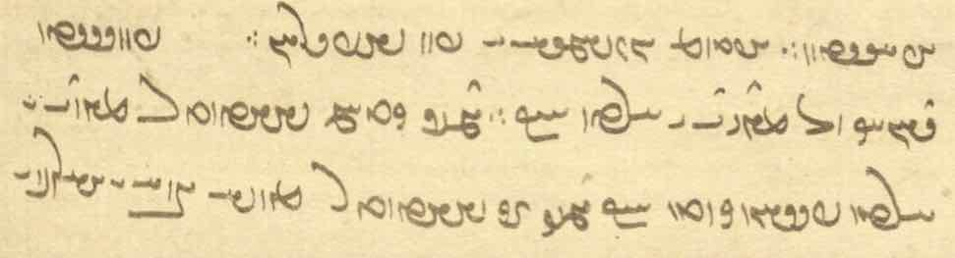
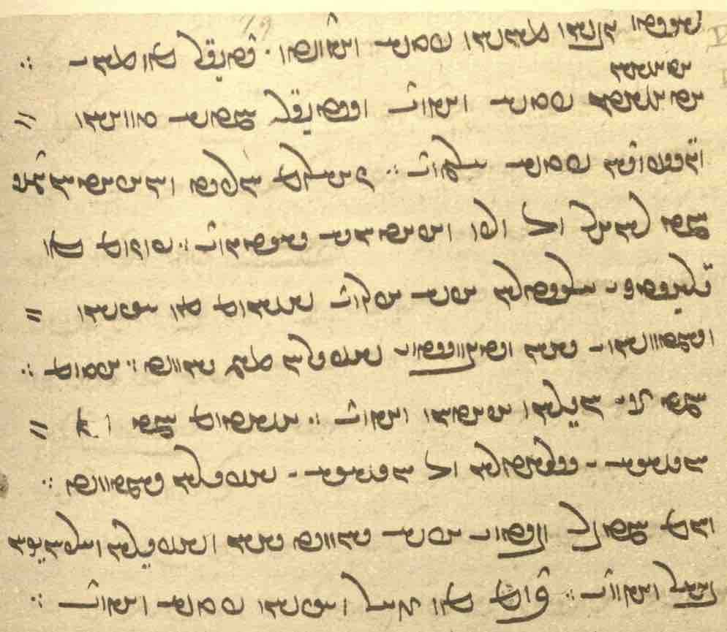

pursīd dānāg ō mēnōy ī xrad kū zamīg kadām šādtar
mēnōy ī xrad passox kerd kū
zamīg ān šādtar kē-š mard ī ahlaw ī rāst-gōwišn mānišn padiš kunēd.
didīgar kē mān ī ātaxšān padiš kunēnd.
ud sidīgar ka-š gāwān ud gōspandān padiš xufsēnd.
čahārom a-warzīd ud an-ābādān zamīg ka abāz ō warz ud ābādānīh āwarēnd.
ud panǰom kē gilistag ī xra(f)starān aziš kanēnd.
šašom kē ēzišn ud rasišn ī yazdān ud nišast ī wehān abar bawēd.
haftom ka ān ī awērān ābādān kunēnd.
haštom ka az xwēšīh ī wattarān ō xwēšīh ī wehān rasēd.
nohom ka bar ud bēd ī az-iš bawēd yazdān ud wehān ī arzānīgān bahr kunēnd.
dahom kē zōhr ud ēzišn padiš kunēnd.

Text 12.2
From the Dēnkard book VI: Dk.6.16. – From Madan’s edition.

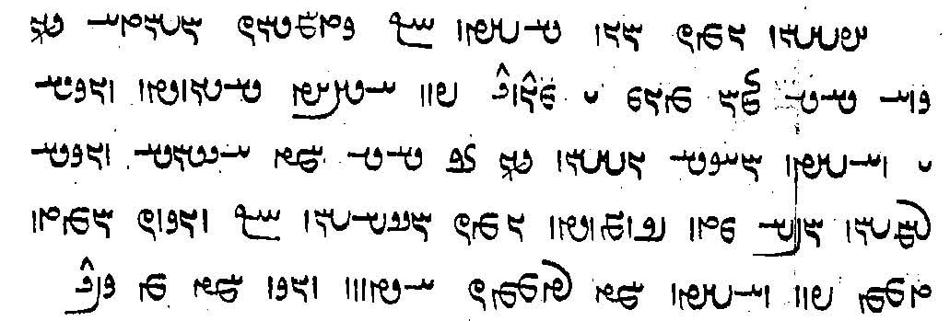

u-šān ēn-iz ōwōn dāšt kadāmīyān-iz mardōm andar harw gāh ud zamān tis ī mēnōy pad ayād dārišn [ed. dārēd] ud nēkīh ī wahišt ud anāgīh ī dōšox andar ān gāh ka āsānīh ud nēkīh ud rāmišn aw-iš mad estēd
ēn-iz handēšišn kū nēk-iz hād ānōh pad wahišt ka ēdar-iz ēdōn nēk

Any person at all, in every place and time, should remember the matters of the other world and the goodness in paradise and the evil in hell at that time when comfort and goodness and joy has come to him,
and he should also think (as follows): ‘it will be [it is bound to be? or let it be good!] in Paradise, since it is so good also here!’

Notes:
dārišn “one should keep” and handēšišn “one should think” (Lesson 14).
Note the different meanings of gāh “place, time.”

Text 12.3
From Dēnkard book VI: Dk.6.23. – From Madan’s edition, p. 477.

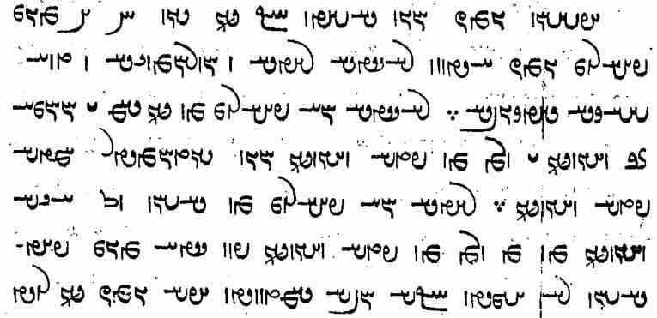
u-šān ēn-iz ōwōn dāšt kū andar dēn 5 tis ī pahlom ēn-iz ēdōn
rāstīh ud rādīh ud hunarāwandīh ud tuxšāgīh ud ǰādag-gōwīh
rāstīh ēd pahlom kē andar dām ī ohrmazd ān kunēd ī ōy kē padiš kunēd ōwōn sūdōmandtar ka-š padiš kunēd.
rādīh ēd pahlom kē dāšn ō kas kunēd kē az ōy kē padiš kunēd pad gētīy tis-iz pādāšn nē ēmēd kū-š awiš rasēd.
[3rd-4th lines:]
(As for) truthfulness, this is the best: (he) who, among the creatures of Ohrmazd, does that which (ān ... ī) is thus more profitable to him to whom (ōy kē padiš) he does (it) when he does (it) to him (-š ... padiš).
(As for) generosity—this is the best: (he) who gives a gift to somebody (and) who has no hope in this world that any counter-gift will come to him (-š awiš) from (him) to whom (az ōy kē padiš) he gives (it).

Text 12.4
From the Mēnōy xrad: MX.1.187–194. — Ms. K43 fol. 139v.

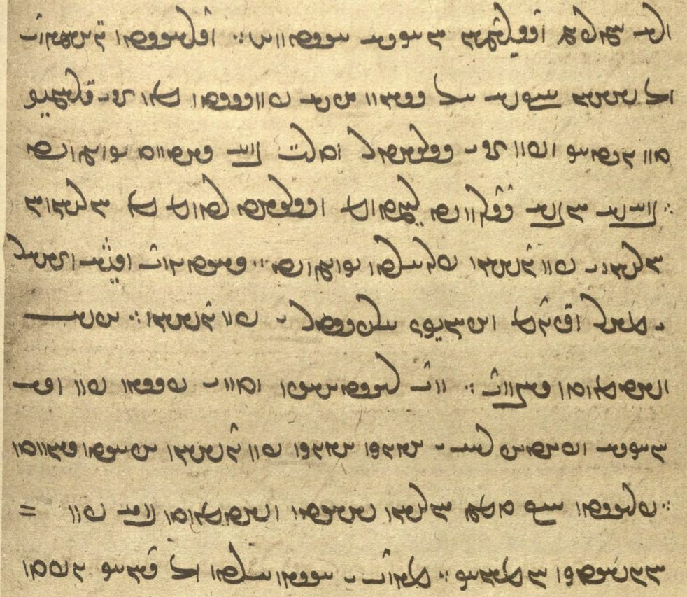

ud drāyēd Ganāy-Mēnōy ō dēwān kū-š ma saxwan aziš pursēd
kē az ān ī grāmīg tan ǰudāg ud pad ān ī wattar widarg bē āmad estēd.
bē-š awiš barēd rēmantom ud wattartom az xwarišnān, xwarišn ī pad dōšox parwārd estēd.
āwarēnd wiš ud zahr ī mār ud gazdum ud abārīg-iz xrafstar ī pad dōšox u-š xward dahēnd
ud tā ristāxēz ud tan ī pasēn pad was anāgīh ud pādifrāh ī ēwēnag ēwēnag pad dōšox abāyēd būd.
ud pargast kū ānōh xwarišn šāyēd xward bē *pūdag hangōšīdag, (xōn) homānāg.

Note: in the last line pūdag has been restored for <PWN> and xōn supplied according to the Pazand pū and xun and Sanskrit durgaṃdhi-rakta-pratirūpāṇi “similar to foul smell and blood.

Exercises 12

12.1. Transliterate, transcribe, and translate:

WtÅWWwïD LTWWtdA WtÅWWwïD WWWtdA WwAt∆da˜ Y Wws>lYcH Y nS< WtÅWWwïD WCwlYP ? !
/ WwßmaÒ W EtåH W MwÍ WWP WTPcÒP
From a ms. colophon.

/ WtJWtDwA lïhadlAwYW ã Y ÂYC WN WwAKwY>wA Y WwAkAwaD> N WTWB aÒ ÓdA WcdA ? 2

/ WtDWwYtdaD aÒ q EthAwA W WwYK aåH ÂßA wAT`>W WtDWwsaD oA EthAwA W WwYK çÓdA NT{ ? 3

WtdßAW áÂA ÍcÅ EwÍwL WkACwL ^ LtJ WwSC WwaHWN WwABwL WwAVwlaÅ ^ ã MWtjA ? 4
/ WTWWwaD nS< LWP W WkaDcåÒB W WwÍwL lYƒ WtjÍW W saD< WwaHƒ

/ xWwïJwY a¬aÒ ÍcÅ LthYT WwaÔdZ WtDWwlZW WwAcÅ ^ WwaÅWWV µA OW lAwaÒ WtdlAW Y adM ã ? 23
WtJ> ìtJ WWP ^ EKwYW WkaÂA Y>WC WtDWnYWI Wt˜ ÍBwA EwajA W EKwYW Y>wA ã a∂:dL 3 ã x ÍcÅ ? 33
/ WTWWwaD aÒ LtÂLwA W LtÂïJB W LTwajA ÍcÅ WTWWwaD ìtJ WWP Y>W WN 1AWvY WwSC

/ WWTWwïÅW ÂsaH lïhadlA WtDWWtÂaD ÍBwA nS< ã à WwYwL à WtdaH ? Âï¬ABwSW AWB à WtdAcÅ ? 34
About Ardaxšīr and the girl running away. Ardawān speaking.

à WkAtDP ÂY OW a˜wAwA lAtåD Y WwÍBwY WWP Wws>aDW x ? 44
/ WtÅWWwïD WwABWT aÒ WWTWK Wwaå¸ W ßyL Y>WT Y nLW q ˙dA à WwïÅW AWB WWWtdA

? Y>NwA WN Y>wsAcÅ x elATWK WTWkßLP x WN WwaHnLW à Wt∆DWWP Y ã Ww˙JWWP MW23# ? 333
/ Y>NwA WwSC ? YWWwaD WN
/ Wcå¬Y> WtÒnÍwA WIwAKwY< lAK MwßAP Y ã WWP Y WwAIwÓdAcÅ à AwA WwajAP .? º

Y>NwAnS< Y Y>NwadaÒ Y a˜wAwA lAtåD> Ww˙dAwÍ ? 5
? WtÅB ÂAcÒP WPwA Y WkAwLwM WpwA W WwßaD.wA Y>wZ W WthY WkAtJƒ

11.2. Match the Pahlavi words with their transcriptions:

EthAwA WcÒWB WtjÍW ābān frōd pursišn
WwAKwYwA LtÂïJV Wwaå¸ abāyišnīg hindūgān rahīy
lECwA EBwlSwY íaÒ āfrīn hučihr ranǰ
WtÒnÍwA elAwaHwY WCwlYWWt˜ anāštīh kun! tā-tān
MWtjA WwïÅW WCwL Ardaxšīr mihrdrōz tār
lïhadlA WwsaDW WwaÅt˜ bunxān Nēw-ardaxšīr weh-dēn
WwAcÅ wAtDW WWwma¬YP burz nišast wēnam
WIw˙dAcÅ lïhadlAWwYW Ww˙JWWP dehān nixwārēm wirēxt
WwYWcÅ WTWWiLW WTwLP dušxwārīh ōšmurd xwaštar
WwaÅWWV Âï¬ABwSW lAT dusrawīh pērāmōn zyān

11.3. Translate into Pahlavi and write in Pahlavi at least one of the longs sentences:

- At the Renovation, God will leave nobody to the torment of Ahrimen and the demons.
- Ahrimen and the demons in hell do everything to harm and destroy Ohrmazd creation.
- When the soul (ruwān) goes out of the body, there will be no discomfort for the body at all.
- Do not slander, so that infamy and evil do (does) not come to (ras-) you.
- In paradise, Ardā Wirāz sees those souls of the Righteous from whom a light like a shining star kept blazing.
- When it became clear to Ardawān that Ardaxšīr had fled with his daughter, he became very angry and went after him with a large army. Thus he says to his general: That contract-breaker is the enemy of gods and men. God forbid the Xwarrah of kingship has reached him!
- To whom does this wonderful chariot belong on which you are standing, and where are you going in it? — It belongs to Spandyād, brother of Zarēr and son of King Wištāsp, ruler of the Iranians, and I am going to the land of the Xyōns, because my beautiful sister and wife has been taken from me and now dwells there.
- How many horses and how many men were in that army with which King Wištāsp had gone to Turkestān to do battle with the enemies of the land of the Iranians, and when will they come back to their wives and children?

Additional Readings

Additional Readings 12.1
From the Bundahišn: Bd.34.24. — In the aftermath of the Resurrection. Mss. TD1, f. 97r, TD2, p. 226.

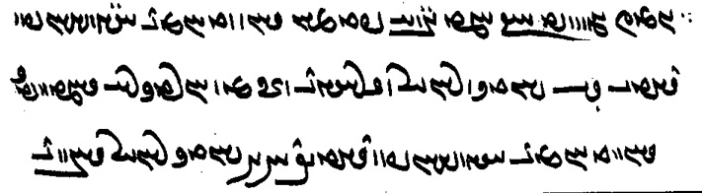
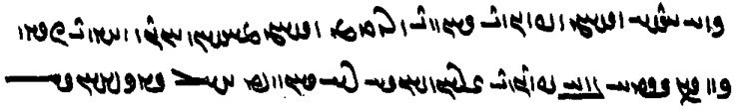

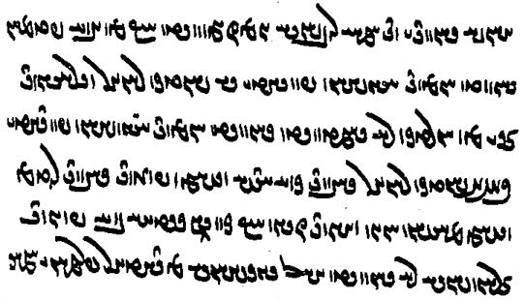
ēn-iz gōwēd kū
kē mard-paymān būd hēnd ēg-išān pad dād ī 40-sālag abāz wirāyēnd
ud ān kē xwurdag nē rasīdag būd hēnd ēg-išān pad dād ī 15-sālag abāz dahēnd
harw kas zan frazend dahēnd
ud abāg zan māyišn ōwōn kunēnd čiyōn nūn andar gētīy bē frazend-zāyišnīh nē bawēd

Additional Readings 12.2
From Dēnkard III: Dk.3.261.1-2. – Mss. B, p. [210].

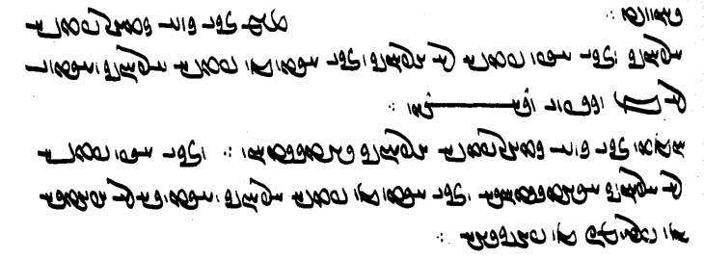
abar ān ī harw kadār padiš arzānīg ud ān ī ēč padiš nē arzānīg ud ān ī ast kē padiš arzānīg ud ast ī nē
az nigēz ī weh-dēn ∵
hād ān ī harw kadār padiš arzānīg dādestān ∵ ud ān ī ēč padiš nē arzānīg adādestānīh
ud ān ī ast kē padiš arzānīg ud ast ī nē āzādīh kē fradom-iz az pāyagīhā

Note ms. <AYT'yh> for ast ī and <MNW> for <MN>.

Additional Readings 12.3
From the Letters of Mānuščihr: NM.2.8.2.

WtDWWtåJ aÒ lAwaÒ elAtDwYcåhYB EklYTP WWP WtDtÒW aÒ AWB Íƒ Wt¬AwYW KWW Y WTWWtåJ NwY tjYLP MWkL tÅ nM
? ? ? WtjÍwY> Y WwAima¬Y< W nÍPW WwaD>wZWP oaÅ xWWiÍ aÒ AWB WKt∆dL WKwAKWW TWwSC CIwAcÅ NwY
/ (WWiÍ emAtJcÅ WwaåD WWP laDwS W aÅWP WWP elaDwsA W eaÅWPA WWP L ã

čē agar ašmāh pargast ēn raft ī nōg-winnārd aziš bē nē wardēd pad padīragīh bēšāzēnīdārīh abāz nē rawēd
ēn abārīg-iz ī čiyōn-it nōgānag rasīdag bē nē hilēd, pas frazendān (ī) xwēš ud grāmīgān ī dōšist ...
ān man pad apanāhīh ud asālārīh pad panāh ud sālār pad yazdān abestāmīh hišt
For if you, god forfend, do not turn away from this new-fangled behavior, do not go backward against healing,
and do not abandon also these other (things) that have newly occurred to you,
then your own children and (your) most beloved dear ones ... they (have been) left without my (?) protection and guardianship to protect and guard (them), with their trust (only) in the gods”

Additional Readings 12.4
From the Zand ī Wahuman Yasn: ZWY.8.5-6. — Mss. K20 fol. 141r, DH fol. 239v.
Note that the two manuscripts both omit some passages. Transcribe each text separately and compare the two.

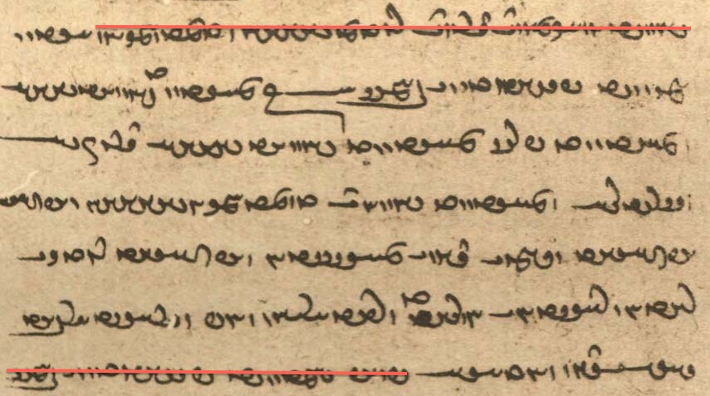

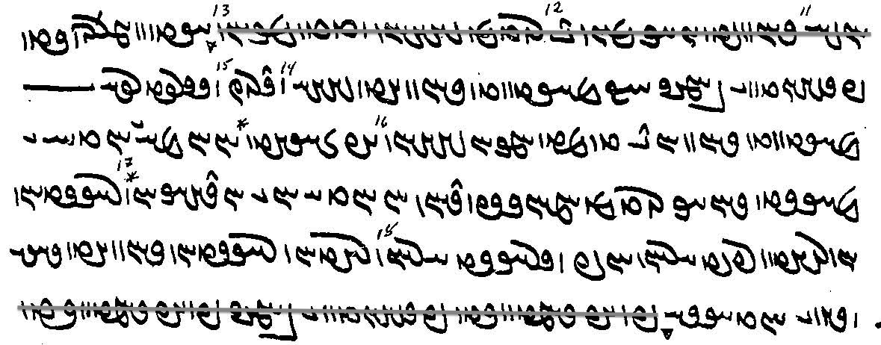

Glossary of words in the Texts and Exercises 12

Idioms:
abāg-iz also with, even with
ast ī ... ast ī, ast kē ... ast ī there is one who ... and another who, sometimes ... sometimes”
az nūn frāz from now on
abāz wirāstan reconstitute
ān and ... čand as/so much ... as
bahr kerdan give a share (to)
bē ... ēnyā other than, except; but rather
bē waštan + az turn away from
drāz + infinitive it would take too long to ...
drust (drīst) awar welcome!
ēwēnag ēwēnag of various kinds
harw kadār each and everyone
kū tā so that, in order that
ō kū whither, to where (cf. az kū “whence, from where”)
ō xwēšīh ī ... ras- come into the possession of
pad padīragīh against

Nouns, adjectives, adverbs, pronouns:
3-šabag WKpÍ3 <3 špk'> three nights’
40-sālag WKTwÍ ¢ <40 ŠNTk'> forty-year-old
ābādānīh EwAtÅcÅ <’p̄’t’nyh> inhabited area
abāyišnīg WIwßYAcÅ <’p̄’dšnyk'> needed; pleasing, attractive
abestāmīh emAtJcÅ <’p̄st’myh> having as refuge, support
anābādān WwAtÅcÅWA <’n’p̄’t’n'> uninhabited
apanāhīh eaÅWPA <’pn’hyh> having no protection
asālārīh elaDwsA <’srd’lyh> having no guardian
awarzīd WtDcÒwA <’wlcyt'> uncultivated
awērān Wwa¬YwA , Wwa¬YcÅ <’p̄yl’n', ’wyl’n'> lying waste, wasteland
ayād WtÅvsA <’ḇyḏ’t'> memory
ayōxšust WtJwßAwïÅ <’ywhšwst'> metal
āzādīh EtÅcÅ <’pc’tyh> freedom; of the state of the āzād ‘freemen’
āzār lAcÅ <’c’l> torment
bar ud bēd WtDB W LB <bl W byt'> profit
brāziyāg WkaÅcåÒB , WkaDcåÒB <bl’cy’k', bl’c’’k'> shining, resplendent [reading uncertain]
čim ÂYC <cym> meaning, reason (why)
dād WtåD <d’t'> age
dādestān AwS>, WwAtJtåD <DYNA, d’tst’n'> law, judgement, justice
did Y>WT <TWB> again
druzīh ECwlY <dlwcyh> the Lie demons
dušxwārīh elAwaHwY <dwšhw’lyh> discomfort
drāz Wcå¬Y <dl’c > long
dūdag WKTwY <dwtk'> family
ēmēd Wtdmï>Å <’ymyt'> hope
ēzišn = yazišn WwÍcdA <’ycšn'> sacrifice
frazām ÂAcÒP <plc’m > end
frazend-zāyišnīh EwÍWwaÒZ YwYWP <prẕn(n)d birth of children
EwÍWwaÒZ YWwYWP YLYDWNšnyh>
gazdumb, gazdum ∫MwYcD , MwYcD <gcdwm(b)> scorpion; lit. “tail-biter”
gilistag WKtjlY <glstk'> den, burrow
gōkānīg WIwAKwY <gwk’nyk'> detailed
grāmīg WIma¬G <gl’myk'> dear, precious
gušn-hilišnīh EwÍWWiÍ WwÍwY <gwšn' ŠḆKWN-šn-yh> releasing of the male animals (in to the females)
harwisp-pēsīd WtDtÎjYP WcJwlA <KRAwsp̄' pysyt'> adorned with every (adornment)
hangōšīdag WKtdÍwYwA <hngwšytk'> like; also: hangōšīdag ... homānāg
har(w)kīn WwYklA , WwYKwlA <hl(w)kyn'> all
hudahāg hudāg WkaDwA , WkaåDwA <hwdh’k', hwd’k'> giver of good (gifts); epithet of the amahrspands
hunarāwandīh eYWwa¬WwA <hwnl’wndyh> skill
huwaršt-warzīdār lAtDcÒW WthLWwA <hwwlšt' wlcyt’l> doer of good deeds
huxwadāy ÄTwAwA <hwhwt’y> having a good lord; epithet of the amahrspands
ǰādag-gōw WBwYWKtåD <y’tk' gwb'> advocate, intercessor (e.g., for the poor)
ǰahišn WwßE <yhšn'> chance, destiny; distinguish from dahišn “creation,” dāšn “gift”
ǰuttarīh eLtDwY <ywyttlyh> opposition, something different
huǰahišn WwßEwA <hwyhšn'> having a good destiny (adj.)
kadāmīyān-iz CwadmATK < kt’my’nc> any at all
kanāragōmand YWNwAklAWK <kn’lk’wmnd> limited
kēn WwYK <kyn'> hate, vengeance
mānišn WwÍwa˜ <m’nšn'> dwelling
mard-paymān Wwa˜TP AWvY <GBRA ptm’n'> having the measure of a man, adult (15 yrs. +)
māyišn Ww˙da˜ <m’dšn'> pleasure
murwāg WkAwLN <mwlw’k'> omen
nēk WKwYW <nywk'> good; good for ...! (see Grammar)
nigēz WcDKW <nkyc'> teaching, instruction
nišast WtjÍW , WtJWWvYtD <YTYBWNst', nšst'> seat
nōg-winnārd Wt¬AwYW KWW <nwk wyn’lt'> newly established, new-fangled
nōgānag WKwAKWW <nwk’nk'> newly
panāh aÅWP <pn’h> refuge
pargast WtŸjLP <plgst'> god forbid!
parīg WiLP <plyk'> witch
pāšom = pahlom (MwßAP) MwlaÅP <p’šwm> best
pāyag WiaÅP , WiAP , W˝ÎÅP <p’yk'> level (spacial, social)
paygāmbar LbmAtDP <pgt’mbl> messenger
pērōz WCwlYP <pylwc'> victorious
pūdag WKTWP <pwtk'> rotten
raft WTWWtåJ , WTWtåJ <SGYT(W)Nt'> behavior
rasīdag WKt∆dL <lsytk'> having come/occurred/matured (pf. ptc.)
rōzāg WkACwL <lwc’k'> shiny, shining
spāhbed WTpaÅfJ <sp’hpt'> general
tam/tom-tōhmag WkmAWt˜WT , WkmAWt˜T <tm/twm-twhmk'> brood of darkness
widāxtag WKtåÅTW <wt’htk'> molten, melted
wirāstār lAtja¬YW <wyl’st’l> arranger, organizer
xōn admY , WWwA <hwn', DMYA> blood
xūb-frazām ÂAcÒP WPwA <hwp' plc’m > having a good end (adj.)
xūb-murwāg WkAwLN WPwA <hwp' mwlw’k'> of good omen (adj.)
zand Y>wZ <znd> zand (Pahlavi version of Avestan text)
zāyišn WwÍWwaÒZ , WwßäZ <z’dšn', YLYDWNšn'> birth, being born

Proper names:
Ayāsrim µï¬sadA <’y’slym> name of the fall season
Ganāy-mēnōy Y>WwïÂaÅwY< <gn’’mynwd> = Gannāg Mēnōy
Nēw-ardaxšīr lïhadlAwYW <nyw'’lthšyl> backgammon
Spandyād WtådYWfJ <spndd’t'> Wištāsp’s son
Wourubaršn WwßLB{wAW <w’wlwblšn'> name of the NW continent (kišwar)
Wouruǰaršn WwßLC{wAW <w’wlwclšn'> name of the NE continent (kišwar)

Verbs:
āsāy- āsūd WTWwsA , - ájA <’s’y- ’swt'> rest, relax
parwār- parwārd Wt¬AwLP , - lAwLP <plw’l-> *gather (food); Skt. MX saṃcita “gathered”
xufs- xuft WTPwA , -WnlA <HLMWN-; hwpt'> sleep

Lesson 13

Grammar 13

Simple adverbs
Many adjectives are also used as adverbs, e.g., ēwar “for certain,” nōg “anew,” rāst “true, truly,” rōšn “brightly,” saxt “firmly, intensely” škeft “hard, strongly,” xwaš “pleasant, pleasantly”:

u-m ēn dēn grift ud saxt dāšt
“and I took (-m ... grift) and held this dēn firmly” (Kerdīr) (ergative, see below and Lesson 14)

ka ēwar dānēd kū nē Ādur māh ud ēwar dānēd kū nē Frawardīn rōz mīrēd
ā-š māh Day ud rōz Warahrān abāyēd dāštan
“(when one does not know the actual date someone dies, then,) when he knows for certain that he does not die in the month of Ādur, and he knows for certain (it is) not on the day of Frawardīn,
then he has to hold (= celebrate) the day of Warahrān in the month of Day” (PR.1.3)

Adverbs in -īhā
Other adverbs are formed from nouns, pronouns, adjectives, and simple adverbs with the ending aåD- <-yh’> -īhā. This is identical with the plural ending of nouns, but the use of the adverb is very different from that of the plural nouns in -īhā, so there is hardly ever any danger of confusion.
All the simple adverbs above can also take this ending (ēwarīhā, etc.).
See also expressions of manner, time, and measure Lessons 17-21.

Examples:
Pāzag mādayān abar gōspand dādīhā pad ēzišn ī ātaxšān ud ābān zōhr ... kuštan
“the Pāzag (nask) is mainly about killing cattle according to the law for the sacrifice to the fires and the libation to the waters” (Dk.8.7.1)

ka pad gētīy šēwan mōyag ud grīstan adādīhā ma kunēd
“when you (are) in this world, do not wail, sob, and weep (lit.: do wailing, sobbing, and weeping), (thus) breaking the law!” (AWN.16.7)

ašmāh xwēšīhā bē nišīnēd
“go and sit by yourselves!” (AWN.1.18)

ka J̌am āmad ud mast būd anāgāhīhā abāg J̌amag ī-š xwah būd bē xuft
“when Jam came and was drunk, he unwittingly slept with Jamag, who was his sister” (PR.8e.10)

3 rōz-šabān tanōmandīhā andar dōšox pādifrāh kunēnd
“for three days and nights, they punish (them while) in bodily form in hell” (Bd.34.13)

tis ī mēnōy ōwōn hamēšag menišnīhā ud tuxšāgīhā kunišn čiyōn ka dānē kū ēk rōz zīyam
“matters of the other world should always be performed (kunišn) in thought and diligently, as when you know: “I shall live (only) one (more) day” (Dk.6.151)

pad rāstīhā ud ō hamāg kustag niyābagīhā hāwand-āyišnīh ī Abestāg
ud mayānag gēhān uzwānīg āšnāgīhā frēstišnīh ī zand purr-bōzišn paydāg andar kadamīyān-iz-ēw
“because the Avesta comes equally (by its equal-coming), fairly and to all the regions as is proper,
and, (because) the Zand is sent (by its sending) by tongue (orally) into the world of the living in known manner (= so as to make it known), it is evident (that it leads to) full salvation among whomsoever” (Dk.5.24.12)

stāyišn ud paristišn ast ī wāspuhragānīhā dādār xwēš pad dahišnān nē sazēd
“some praise and worship specifically belongs to the Creator (and) is not suitable for (His) creations” (Dk.3.241.2)

Note that these adverbs (like prepositional phrases) can be connected to nouns with ī and must then be translated according to the sense required, e.g.:

dām-dahišnīh ī mēnōyīhā gōwam ud pas gētīyīhā
“I shall talk about the creation of the creatures (as it took place) in yonder world and then in this world” (Bd.1.32)

These adverbs sometimes indicate distribution, e.g.:

zamānag ī-š rāyēnišn abrāz amaragānīhā pad frāz-āhangīg ud hangāmīhā ud kasīhā pad abāz-āhangīg
“time whose organization (is in) ‘ascendance’ is among the countless ones (= generally) forward-striving (≈ makes progress), and (= but) at various times (= occasionally) and from person to person (= individually) backward-striving” (Dk.3.68.2)

The adverbs in -īhā are often formed from compounds and can take the place of prepositional phrases and subordinate clauses, e.g.:

mēnōy-wāzišnīhā bē ō wahišt ayāb ō Garōdmān ānōh kū-š gāh ast franāmēd
“flying through the other world, (the soul) proceeds to paradise or to Garōdmān, there where its place is” (DD.30.2)

gāw mardōm-saxwanīhā aw-iš pahikārd kū-m bē ma ōzan
“the bull argued with (ō) him using the speech of humans: do not kill me!” (WZ.4.14)

spāh ī Kirm kē pad diz būd hāmōyēn ō bērōn mad ud abāg aswārān ī Ardaxšīr kōxšišn ud kārēzār ī gyān-abespārīhā saxt kerd ud az harw 2 kustag was ōzad
“Kirm’s army, which was in the fortress, came out and struggled and battled (so) fiercely with Ardaxšīr’s cavalry as to surrender their souls, and many were killed from both sides (KN.6.16)

ud hamāg rāst ud meh-dādestānīhā ud yazdān-šnāyēnīdārīhā guft estēd
“and it has all been spoken truly and according to a greater (= higher) law and so as to make the gods favorable” (Dk.5.24.12)

az 3 stēr ī pad bun xwāstag ī stūrīh uzēnīdan ud kāstan nē pādixšāy ud tuwān-sāmānīhā barōmand dārišn
“one is not authorized to spend (any) from the three staters that constitute the initial amount of money of the stūrīh or to diminish (it), but should keep (it) so that it produces income to the extent of one’s ability” (REA.18.8)

From prepositional phrases:
wād pad-wād-ēwēnag-čihrīhā frāz wāyēd (< pad wād ēwēnag)
“the wind blows forth according to the čihr (~ nature) that is in the manner of the wind” (WZ.30.59)

pad ān ī tēz asp bowandag-dārōg-paywāsīg-abāgīhā
“having with (him) on the fast horse a bag (containing) the complete medications” (Dk.3.157.40)

Adverbs in -īhā in the comparative and superlative:
gōwizārīhātar “more in detail” < gōwizār “in detail, detailed”
kam-wināhīhātar “in such a manner that there is little/less sin”

āfrāh ī dēn zēnāwandīhā abar tuxšēd tā dānēd kadār ayāb ahlaw ayāb druwand wurrōyēd meh kū kasān ayāb ān ī ahlaw tuxšāgīhātar wurrōyēd ayāb ān ī druwand
“apply yourselves vigilantly to the instructions of the dēn until/so that you know which (it is): does either a Righteous believe more diligently than (kū) (other) people or a wicked person = whether the Righteous one or the wicked one believes the more diligently” (PN.53 + PY.31.17)

mardōmān 3 tis ēn xwēš-kārīhātom
“for humans, these three things (the ones that should be performed) the most according to their ‘proper duty’” (Dk.6.13)

ēk pad kerdan harw kār mādagwarīhātom tis tuxšāgīh
“one thing is the most especially (needed) for performing every work: diligence” (Ōšnar 4)

čand ... -īhātar šāyēd “as ... as possible”:
čand abēzagīhātar šāyēd
“as purely as possible” (DD.47.37)

mardōm ud gōspand ud abārīg dahišn ī weh čand frārōnīhā šāyēd abzāyēnīdan
“increasing people, domestic animals, and the other creatures in as (morally) good a way as possible” (Dk.5.13.9)

mēnōy ī tan xōg ī dagr andar tan būdan rāy a-wišōbišn ōwōn kāmag ī pad-iš mānist ka-iz-iš hilēnd az māništ
pad ham rāh ān ī widerdān tan čand a-wināhīhātar šāyēd drīstīhā pāyišn
“the spirit of the body, because (it is in) its nature to be in the body for a long time, so much (ōwōn) desires not to be shattered that (ī), even when they release it from its abode, (it remains) in its abode,
in the same way, the bodies of the departed should be guarded firmly so as to cause as little sin (contagion) as possible” (DD.16.4)

Some expressions of length and duration

pad was frasang “at (a distance of) many frasangs”
andar zamān “immediately”
pad ān zamān “at that time”
pad ham zamān “at the same time, immediately”
pad gyāg “on the spot, immediately”
tā hamē ud hamē-rawišnīh “for ever and ever”
tā 3 rōz “within three days”

Nouns denoting time or space can be used without prepositions to denote length, duration, or point of time:

māh frawardīn rōz ohrmazd andar dwārist nēmrōz
“in the month of Frawardīn, on the day of Ohrmazd (the Foul Spirit) rushed in (at) midday” (= the first day of the first month = spring equinox) (Bd.4.10b)

ka dagr zamān Ohrmazd rāy yazišn ... ī frārōn kunēnd āsānīh az-iš “when/if they perform good sacrifices for Ohrmazd for a long time, there is comfort from it” (AWN.4.14)

abēr dagr zamān andar ān kār estēd
“she is at work at that (washing) for a very long time” (ŠnŠ.3.5)

ēč zamān ma pāyēd
“do not wait (for) any time (= not even a moment)!”
Ohrmazd bālistīg ... zamān ī akanārag abar rōšnīh hamē būd
“Ohrmazd was up above in the light (for) an unlimited time” (Bd.1.1)

Hariburz tā bowandagīh 800 sāl hamē rust 200 sāl ō star-pāyag ud 200 tā ō māh-pāyag 200 tā ō xwaršēd-pāyag ud 200 tā ō bālist ī āsmān
“Hariburz kept growing until the completion of 800 years; 200 years to the star-level, 200 (years) to the moon-level; 200 (years) to the sun-level; and 200 (years) to the highest point of the sky” (Bd.9.2)

ud hamāg gēhān nasāy-nigānīh ud nasāy-wistarišn bē bawēd
“and in the whole world there will be burying of corpses and laying out (= ?) of corpses” (ZWY.4.23)

čē ka hamāg gēhān ābādānīh būd hē agar-išān was-iz zad ud stō kerd hēnd hē az dāmān wizendīh bērōn nē šud hēnd hē čē-šān nē tuwānist hē šudan
“for, when (= if) there were prosperity in the whole world, (then,) even if they struck and subdued many (evils), (still) they still would not go out (= disappear), for they would not be able to go” (Bd.28.19)

ka Ēbgad ō dām mad ... pad zamīg homānāgīh ī čašmagīhā ī āb wasān gyāgān čašmag ātaxš ul uzēnd
“when the Adversary came upon the creation ... on earth in many places springs of fire come up like springs of water” (WZ.34.48-49)

abar wihēz ī ō kišwar kišwar ud kustag kustag ī gēhān ān dranāy kē dādār ō ān kišwar ud kustag wizīd
“about traveling to the various continents and the various districts of the world that length which (as far as) the creator chose for that district and continent” (Dk.7.1.15)

kē sag nē dārēd nē šāyēd nāmčišt ān kē-š mān gōspand
“he who does not have a dog–it is not appropriate, especially he who has sheep in his house” (ZFJ, p. 665)

ān pad abdom āškārag paydāgīhā wēnīhēd šabān andar andarwāy
“in the end that (battle of the gods and demons,) will be seen at night visibly and clearly in the atmosphere (sky)” (WZ.34.54)

Distance in steps
The nouns gām and pay “step, stride” take the particle ī (often not written!) with the object “from” which, as well as az:

ka bē ō 24 pay ī amahrspandān mad
“when he came to (within) 24 steps of the amahrspands” (WZ.21.9)

30 gām ī čāh yazišn kerdan ud drōn yaštan nē pādixšāy
“one is not authorized to perform a yazišn and drōn ritual (within) 30 steps of a well” (RAF.43.2)

agar-iz ātaxš ēdōn bē tuwān burdan kū pad 3 gām ī nasāy bē barēd pas-iz bē barišn ...
ātaxš andar 3 gām ī nasāy burdan tanābuhl-ēw wināh
“and if it is possible to carry the fire in such a way that one carries it (at least) 3 steps from the fire, then one should carry it too ...
(for) carrying the fire within 3 steps of dead matter (there is) a sin of one tanābuhl” (ŠnŠ.2.38)

With az:

30 gām az ātaxš ud 30 gām az āb ud 30 gām az barsom pad ahlāyīh frāz wistard ud 3 gām az mardān ahlawān
“30 steps from the fire, 30 steps from the water, 30 steps from the barsom spread out in orderly fashion, and 3 steps from Righteous men” (PV.3.17)

Compounds expressing length, height, and duration
Distance and length of time are often expressed by compounds with nouns ending in -āy (Lesson 10), exceptionally with drang “duration,” e.g.:

zan ka zanīh ī šōy nē kunēd pad gyāg tanābuhl ud pad sāl-drahnāy margarzān
“when/if a women does not perform her wifely duty to her husband, she is immediately (guilty of) a tanābuhl sin and is margarzān at the length of (= after) a year” (after RAF.16.2)

mard-ēw ī abar sang-ēw bē mīrēd ud sang abāg zamīg ēw-kardag sang pad andar sāl-drahnāy abāg zamīg pāk bē bawēd
“a man who dies on a stone, and the stone is connected with the earth, (then) the stone, together with the earth, becomes clean within one year” (ŠnŠ.2.15)

u-š xwāstag ī stūrīh zīndag-drahnāy ōh dārišn
“and he should keep possession of the property in stūrīh in the usual way for as long as he lives” (REA.18.13)

u-m dīd ān ī xwēdōdahān ruwān andar rōšnīh kē-š gar-bālāy rōšnīh aziš hamē waxšīd
“and I saw in the light the souls of those who had performed xwēdōdah, from whom a light shone the height of a mountain” (AWN.12.8)

Hugar ī Buland ān kē-š āb Ardwīsūr aziš frōd ǰahēd 1000 mard-bālāy
“the tall Hugar is (the mountain) from which Ardwīsūr cascades down the height/depth of 1000 men” (Bd.9.7)

mayān ōy ī xwēdōdah nē kerd ud pahlom axwān, dēwār-ēw čand zamīg-pahnāy ud zōfāy bē estēd u-š ō ān ī pahlom axwān nē hilēnd
“between him who has not performed xwēdōdah and the Best Existence, there stands a wall as wide and deep as the earth, and they do not let him into the Best Existence” (after REA.24.3)

ka an mard 30-sālag bawēd ān xwaršēd bē estēd pad bālist ī ān asmān 30 rōz šab-drang
“when that man (Sōšāns) is thirty years old, yonder sun will stand in the heighest heaven for 30 days and nights” (Dk.7.10.19)

The Verb. The ergative/agential construction
We now come to yet another tricky aspect of Pahlavi syntax, the so-called “ergative” construction. It is recommended that the students study all the examples very carefully and be able to analyze every example in detail.
Note that the grammar of the construction is not difficult per se, it is in fact quite simple, but the students sometimes have a hard time getting used to thinking in such an unfamiliar way. Everything they have learned about nouns, pronouns, verbs, and pre/postpositions must be mastered in order to understand the syntax and workings of the construction. These sections of the grammar in preceding lessons should therefore be carefully reviewed, especially the section on passive in Lesson 9 and about the pre/postpositions in Lessons 11 and 12.

Active and passive
It is important that the students have a good understanding of how active and passive work in English and other languages they know.

In English, there are two kinds of passive sentences:
- sentences with transitive verbs, but without “performer”
- sentences with transitive verbs and “performer”

In the first kind of sentence, the passive is necessary and can only be avoided by turning the sentence into an impersonal one (see Lesson 9), e.g.:

This book is rarely read (people rarely read this book)
A man was seen running in the street (they saw a man running in the street)
This has never been done before (nobody has done this before)

The other kind of sentence is a stylistic alternative to a corresponding active sentence:

My students rarely read this book = This book is rarely read by my students
Have you ever done this before = Has this ever been done by you before?

In modern Persian, and, for instance, the Semitic languages, only the first kind is used, that is, passive forms of the verb are only used when the “performer” is not mentioned (except in a few idioms).
This was the situation in early Pahlavi, as well, but it was later complicated by various analogical syntactic developments. Here, we shall describe the early Pahlavi syntax; later, we shall see how this was modified.

Intransitive and transitive and the past tense
To understand the construction, we need to understand the difference between intransitive and transitive verbs.
An ‘intransitive’ verb is a verb that can not take a direct object, for instance, verbs that usually express state or motion, like būdan “to become” and šudan “to go,” while a ‘transitive’ verb is a verb that can take a direct object, for instance, verbs that express actions, like kerdan “to do,” ōzadan “to kill,” xwardan “to eat,” etc.
In Pahlavi, as in many other languages, there is a fundamental difference between intransitive verbs and transitive verbs in the formation of the past tense. Familiar examples are German and French (Italian), where intransitive verbs in the perfect take the auxiliary “to be,” Germ. sein, Fr. être, while transitive verbs take the auxiliary “to have,” Germ. haben, Fr. avoir, e.g.:

German French
Intransitive ich bin gegangen je suis allé “I went, have gone”
Transitive ich habe ein Kind gesehen j’ai vu un enfant “I saw/have seen a child”

In English, this distinction has been abandonded, reserving the construction with “to be” for a very few expressions with specialized meaning, such as “he is gone.”

Intransitive and transitive, active and passive
In Pahlavi, the difference between the intransitive and transitive past looks quite different from the examples above, at least on the surface, although, in principle, it is of the same kind.
The construction described in the following is what is commonly referred to as “ergative” (from Greek ergon “work”). Since the construction is only used in the past tenses, and not in the present, it is also called “split ergative.”
The construction has also been called an “agential” construction (from Latin agens “actor, performer”), as the “performer” is usually called the “agent.”

Ergative
This is the construction that transitive verbs take in past tenses.

We saw in Lesson 9 that the following sentence is passive:

grammatical subject + verb:

dušmen ōzad hēnd “the enemies were killed”

Recall that the ‘grammatical subject is what the verb agrees with, that is, in this case, dušmen “the enemies.”

In order to say “who” did the deed, the “who,” or “performer” = agent, is simply added in front of this sentence, and the sentence can be translated in English as active OR passive.

Consider the following sentences in the PRESENT tense:

agent = grammatical subject + direct object + verb:

aswār dušmen ōzanēnd “the horsemen kill the enemies”
amāh dušmen ōzanēm “we kill the enemies”

These correspond to the following sentences in the PAST tense:

agent + grammatical subject + verb:

Ergative (Pahlavi) Passive (English) Active (English)
aswār dušmen ōzad hēnd “the enemies were killed by the horseman” = “the horseman killed the enemies”
amāh dušmen ōzad hēnd “the enemies were killed by us” = “we killed the enemies”

As in the English passive, the verb in the ergative constructions agrees with the direct object in the English active sentence, although it is the subject in the passive sentence.

The word order is usually AGENT - SUBJect - VERB.

Prepositional phrases and indirect objects remain unchanged and are not affected by the ergative construction.

Thus we have the following Pahlavi structures:

Present:
agent = grammatical subject + direct object + verb (agrees with grammatical subject = agent)

Past:
agent + direct object = grammatical subject + verb (agrees with grammatical subject = direct object)

Present:
aswār dušmen ōzanēd “the horseman kills the enemies” [or “the enemies are killed by the horseman”]
amāh dušmen ōzanēm “we kill the enemies” [or “the enemies are killed by us”]

Past:
aswār dušmen ōzad hēnd “the horseman killed the enemies” = “the enemies were killed by the horseman”
amāh dušmen ōzad hēnd “we killed the enemies” = “the enemies were killed by us”

Note that there is no other way of saying, for instance, “Frēdōn is/was killed by the dragons.”
When we translate such constructions we may therefore use either active or passive as best suits English style, but most often they should be translated as active.

To understand and get used to the construction it may be useful to think of it in terms of the English passive, e.g., “you were killed by me” = “I killed you,” but one should not make it a habit to translate it with an English passive, but with an English active in most instances.
In fact, since the active is much more common in English than the passive, the students are expected to use primarily English active constructions in the translations. If they keep using the passive, it is to be assumed that they have not grasped the nature of the construction.

It may also be useful for some to keep in mind that the ergative construction corresponds formally to the “have” constructions in the European languages.
Similarly, Pahlavi uses its regular “possessive” construction with “to be,” compare:

man waččag ast “I have a child” man waččag dīd “I have seen/saw a child”
man waččag hēnd “I have children” man waččag dīd hēnd “I have seen/saw the children”

Here waččag is the grammatical subject of the verb, and the verb agrees with it, while man is the one who “possesses” the action.
Those familiar with Syriac will recognize the similarity with the construction with lī: lī kṯīḇ “I wrote.”
Thus, the English subject has become the “possessor of the action,” and pronouns and nouns (and adjectives) take the same forms as they do in possessive constructions.

Examples of agential constructions

Present active: Past ergative:
mard man wēnēnd “the men see me” mardān an dīd ham “the men saw me”
mard zan wēnēnd “the men see a woman” mardān zan dīd “the men saw a woman”
mard zan(ān) wēnēnd “the men see the/some women” mardān zan dīd hēnd “the men saw the/some women”

Past ergative, agent = noun in the singular:
frēdōn aǰdahāg ōzad “Frēdōn killed a/the dragon.”
frēdōn aǰdahāg ōzad hēnd “Frēdōn killed some/the dragons.”
ēn hēnd aǰdahāg ī Frēdōn ōzad hēnd “these are the dragons which Frēdōn killed”
dušmen was mard ōzad hēnd “(one) enemy killed many men”
ohrmazd mardōm ud gōspand dād hēnd “Ohrmazd established/created people and animals”
amāh mardōm hēm ohrmazd dād hēm “we are people; Ohrmazd established/created us”

ohrmazd andar yazišn kunišn dām hamāg bē dād
“during his performance of the sacrifice, Ohrmazd established the entire creation” (after Bd.3.26)

pas Srōš ahlaw ud Ādur yazd dast ī man frāz grift ud guft kū bē āy tā ō tō nimāyēm wahišt ud dōšox ud rōšnīh
“then the Righteous Srōš and the divine Fire took my hands and said: Come so we may show you Heaven and Hell and the light!” (AWN.5.4)

Ardā Wirāz ka ān saxwan āšnūd zofr namāz burd ō dādār Ohrmazd
“when Ardā Wirāz heard what He said, he bowed deeply to Ohrmazd the Creator” (AWN.101.14)

Form of the agent
Since the “agent” is not the grammatical subject, plural nouns as “agents” take the ending -ān; the r-stems take the -ar forms as “agents”; and the 1st sing. pronoun man must be used, since an is only used as “grammatical subject”:

dānāgān ōwōn guft “the wise men said as follows”
aǰdahāgān Frēdōn ōzad “the dragons killed Frēdōn.”
dušmenān was mard ōzad hēnd “the enemies killed many men”
andar hazārag sar dēwān am kirrēnīd “at the end of the millennium, the dēws cut am in half” (Bd.33.1)

ēn fradom ardīg axtarān kerd abāg Gannāg Mēnōy
“this first battle the constellations made (fought) with the Foul Spirit = this first battle with the Foul Spirit was fought by the constellations” (Bd.6.2)

Agent = personal pronoun
Examples with dīdan, wēn- “to see” all three persons (non-enclitic):

Present: Past:
an tō wēnam “I see you” man tō dīd hē “I saw you”
amāh tō wēnēm “we see you” amāh tō dīd hē “we saw you”
tō man wēnē “you see me” tō an dīd ham “you saw me”
tō amāh wēnē “you see us” tō amāh dīd hēm “you saw us”
ašmāh man wēnēd “you (all) see me” ašmāh an dīd ham “you (all) saw me”
an ašmāh wenam “I see you (all)” man ašmāh dīd hēd “I saw you (all)”
ōy ašmāh wēnēd “he sees you (all)” ōy ašmāh dīd hēd “he saw you (all)”
awēšān amāh wēnēnd “they see us” awēšān amāh dīd hēm “they saw us”

kē tō dād hē kē an dād ham
“who established you, who established me?” (Dk.7.3.60)

kē amāh dād hēm kē amāh tāšīd hēm u kē parward hēm
“who established us, who fashioned us, and who nourished us?” (PY.1.1)

Compare the non-agential (passive) version:

ō ašmāh amahrspandān gōšurūn garzīd kū
ō kē an brehēnīd ham ō kē an tāšīd ham kū ō kē dād ham
“to you, the amahrspands, Gōšurūn complained:
for whom was I ‘created’, for whom was I fashioned, i.e., for whom was I established?” (PY.29.1)

On enclitic pronouns as agents see Lesson 14.

‘Zero’ direct object
Some transitive verbs do not take normal direct objects, in which case the direct object can be regarded as “it” and the verb is in the singular. This happens, for instance, with verbs meaning “say, ask,” where the “direct object” is what is said or asked about, e.g.:

man az āmāsp pursīd kū kē hē “I asked āmāsp: Who are you?”
mardān guft kū bē āy “the men said: Come!”

In questions and negations, the grammatical subject may be a pronoun, e.g.:

tō čē guft “what did you say?”
man ēč nē guft “I said nothing”

‘Raising’ (“topicalization”) in ergativic clauses:
The word order often differs from the ‘normal’ one in various ways by one term being moved toward the beginning of the clause, a phenomenon referred to as ‘raising’ or ‘fronting’ (depending on how the clause is visualized) or toward the back (‘lowering’):

verb + agent:
ud pursīd ān ī ahlawān ruwān az ān kanīg kū tō kē hē ud kē xwēš hē
“and the soul of the Righteous asked that young woman: who are you, and whom do you belong to?” (AWN.4.10)

gr-subject + agent + verb:
u-t wars ud rēš wādān wišuft
“and the winds have tousled your (-t) hair and beard” (AZ.86)

tō dānāg baγ tāšīd hē pad mēnōyīh tō dānāg baγ bē dād hē ō gētīy
“the wise god fashioned you (while) in the world of thought; the wise god established you into the world of the living = you were fashioned by the wise god (etc.)” (PY.10.10)

az šīrēnīh ī frazend ēk mādar ǰūd ud ēk pidar
“because of the children’s sweetness (because they were so sweet), the mother ate one and the father one (one was eaten by the mother, one by the father)” (Bd.14.31)

gr-subject + verb + agent:
sidīgar hazārag bun būd ka Frēdōn kišwar baxt Salm ud Tūz
“it was the beginning of the third millennium when Salm and Tūz divided Frēdōn’s land” (Bd.33.3)

Note the avoidance of ambiguity in sentences such as abāz pādixšāy hē grift “you are authorized to take [short infinitive] (it) back” (MHD.43.12) instead of *abāz pādixšāy grift hē*, where grift hē would have meant “the ruler took you again/back.”

Sequences of verbs
An agent can have a series of verbs with it, without being repeated each time, e.g,:

Sequences of transitive verbs:
andar ān hazārag Zarduxšt dēn az Ohrmazd padīrift āwurd Wištāsp-šāh padīrift rawāg kerd
“in that millennium, Zarduxšt received the dēn from Ohrmazd (and) brought (it to W.); King Wištāsp received (it and) propagated (it)” (Bd.33.12)

Sequences of transitive and intransitive verbs:
Note that, in a series of clauses, when the gr-subject of an intransitive verb becomes the agent of a transitive verb it can be expressed or be omitted (implied), e.g.:

pas Afrāsyāb āmad Mānuščihr abāg ērānagān ō Padišxwārgar spōxt
“then Afrāsyāb (subject) came; (he = agent) pushed Mānuščihr together with the Iranians back to Padišxwārgar” (Bd.33.5) [could also mean: “(and) M. pushed (him)”]

On the use of enclitic pronouns in such cases, see Lesson 14.

The participle of necessity in -išn
A ‘participle of necessity’ is made from the present stem with the ending -išn. The construction is impersonal and the agent (the person who must/should/ought to do something) is in the oblique case, e.g.: man kunišn “I must/ought to do.” The construction is therefore reminiscent of the ergative. Note that, differently from the action nouns in -išn (kunisn, etc., lesson 7), this form has verbal syntax with agent and grammatical subject, e.g.:

bē man čē kunišn
“but what do I have to do = but what should I do?”

(ka) xufsēd pad frārōnīh ud abēwināhīh xuftišn ud Ašemwohū-ēw bē gōwišn
“(when; not in ms.) one goes to sleep, (one) should sleep in goodness and sinlessness (= without sinning) and say one Ašemwohū” (ŠnŠ.10.24)

ān kē tuwāngarīh az frārōn-tuxšāgīh kerd estēd pad farrox ud ān kē az abārōnīh kerd estēd pad dušfarg dārišn
“he who has made his wealth through hard work should be regarded as (pad) ‘fortunate’, and he who has made it through wrong-doing as ‘unfortunate’” (MX.49.4)

The participle of necessity in -išn can be used in the comparative (-išntar) and superlative (-išntom), but there are few certain examples; most commonly we are dealing with compounds containing a verbal noun in -išn:

kadār awēšān gurgān zanišntar hēnd ahlaw Ohrmazd
“which of those wolves should be killed more (are more worthy of being killed), o Righteous Ohrmazd” (PV.13.41a)

sidīgar brīnag Artēštārestān. mādayān abar zanišn-arzānīgīh ī gurg ud andar gurgān zanišntarīh ī ān ī 2-zang az ān ī 4-zang
“the third section, Artēštārestān (book about soldiers), (is) mainly about the wolf’s being worthy of being struck down (verbal noun zanišn) and the fact that (-īh), among wolves, those with two feet should be struck down more than those with four feet” (Dk.8.26.1)

The verbal adjective in -išnīg
This form, which is derived from the participle of necessity, usually refers to the future and can refer to active or passive actions (“intent on ...-ing,” “(sth. that is) to be ...-ed”).

ōwōn čiyōn Ohrmazd bālistīg ud Ahrimen zōfāyīg u-š āgenēn nērōg andar gētīy ēk ō did kōxšišnīg mardōm-iz 2 wād andar tan
“just as Ohrmazd is on high and Ahrimen in the depth and his (their) strengths (= armies) together are intent on battling each other in this world, there are also two winds in the body of men” (Bd.28.12)

ānōh kū tārīkīh zahīy rōšnīh nē windišnīg tis
“there where darkness is deep, light is not something going to be found” (Dk.3.142.6)

Note abāyišnīg “which will be needed; comely, attractive,” wēnišnīg “which can be seen, visible.”

Substantivized -išnīgīh:
The nouns in -išnīgīh denote future state (“deserving to be ..., going to be ..., be bound to ..., be intent on), while the nouns in -išnīh are most common in compounds with nouns in -išn, e.g.:

a-wardišnīgīh ī čihrēnīdagān az ān ī padiš čihrēnīd estēd
“the fact that those who have been given a (specific) nature, are not going to be turned from that for which they have been given (this) nature” (Dk.3.83.2)

harw rōz 3 bār ... astīh ud hamēyīgīh ī yazdān ud an-astīh ud abesihišnīgīh ī Ahrimen ud dēwān bē gōwišn
“three times every day one should utter the facts that (-īh) the gods are and are eternal, but that Ahrimen and the demons are not and are going to be destroyed” (Dk.6E.31c)

nikōhišnīgīh ī dēwān a-paristišnīh ī uzdēs ... āgāh būd
“to be aware that the demons deserve to be scorned and idols (are) something one must not offer worship (to)” (Dk.5.13.11)

andar mardōm Wahuman Akōman mehmānīg ud kē mehmānīg gāh-gīrišnīh ud kē widārīg abar-rasišnīgīh
“in people, Wahuman and Akōman are lodgers; and the one who lodges (permanently) (is characterized by the term) ‘taking the place’ and the one who is transient (by) ‘going to come upon’” (Dk.3.63.3)

čē-m a-pardazišnīgīh ī abar was darīhā rāy bē ō nišān-šnāsīh dil nē frahaxt
“for, because of my inability to (?) undertake several issues (at the same time), (my) heart is not trained in recognizing allusions” (NM.2.1.3)

Adverbial -išnīgīhā:
yazdān ō amāh frayādišnīgīhā rasānd
“the gods will come to us intent on helping” (NM.1.2.14)

Sentences 13

1. Transliterate, transcribe, and translate these sentences:

/ MNwA aåDWWT à WtDwï˜ WWWtdA ˙dA AWK W WtdaH aÒ WTWB WwÍtjY ˙dA AWK áÒ eY<WT Y Y<WT WWWtdA WwaHwY> ? !
dōšox ēdōn tang ī tangīh rāy harw kas estišn būd nē šāyēd ud harw kas ēdōn menēd kū tanīhā ham

/ YNwA WtDCT AWB Y<wsLP ¶ ¡MwY WWP WN WTWB 2 a∆DwS WwAwï¬A ? 2
<’ldw’n' SWSYA 2 bwt' MNW PWN YWM-1 70 plsng BRA tcyt' HWEd>

/ WTWK WwÍcdMwï<Å ^ WwaÒtJ MwaåD W WTWK WwaåD WwaD>Wwï˜ WIt¬A MwAW ? 3
nohom ardīg mēnōyān yazdān kerd ud dahom starān ī agumēzišn kerd.
/ aåDtådA Äwa¬Y WtJCW 4 à YWnlA ßGW MWt¬M tÂA ? 4
<AMT mltwm wyš HLMWNd AYK 4 wcst' dlhn’y ’d’tyh’>
(about the nature of sleep)

/ LwßGK 34 WTWtjA aÒ çßgA WwaÅtJ N Y>W WthAWt¬Z AWB WtjlABwY ÂaD ØW CwlY tÂA ã N øaÅ ? 23
pas az ān ka druz ō dām dwārist bē Zarduxšt tā az gētīyān kas-iz nē dīd 7 kišwar.

/ EtÅcÅ WfJwlA W WtdßLwA W aå˜ W LtJ W AwYK W LwLwA W WimZ W adM WTWWvaD a˜wAwA ? 33
<’whrmzd YHBWNt' MYA W zmyk' W ’wlwl W KYNA W stl ud m’h W hwlšyt' W hlwsp̄' ’p̄’tyh>

ÄPwZ aÂY W á¬AV WtdßLwA W Äwa¬Y WTwL W ÄwaÅP WimZ xWwïÅW EKwYW tÂA ¡˙dA W ? 34
/ WtDWWtÂaD EKwYW ã
ud kas-ēw ka nēkīh kunēd zamīg-pahnāy ud rōd-drahnāy ud xwaršēd-bālāy ud drayāb-zofāy ān nēkīh rasēd.

WwÍWWwaD WkaÔÅWT WWTWK WKPWK WWP W LWtDW W lAPwA Wkr-Y< wATà WtDWnYWI WTPwY ? 44
÷ WwaÅtJ N aÒ WwÍWwaDWV WwaD>Wwï˜ N sAcJ W
<gwpt' YKOYMWNyt' AYKt’n głk'-’wp’l W wytwl PWN krpk' krtn' twhš’k’ YHWWNšn'
W sp’s MN mynwd’n' BOYHWNšn' LA MN gytyd’n'>
WwYWcÅ WwaÂaåD> WKwAP WTWK EkahAWT WWP WwaÅTwÍwA ^ WKtjAwA ? º
WwaÒwLwA WkaÂA ^ Wk˙dL W WwaD>NwAwAtHwA WkaÂA ^ WWT OW ÂaD<wA 4 WfH W WCwL AWK
WtDWWtÂaD AWB WwAPWK ^ WtjlAV OW W
<hw’stk' Y ANŠWTA’n' PWN twhš’kyh krt' p’nk' d’hm’n' ’p̄ryn'
KRA lwc' W šp' 4 hng’m OL tn' Y hm’k' ’wšt’n’wmnd’n' W lyšk' Y hm’k' ’wlwl’n'
W OL b’lst' Y kwp’n' BRA lsyt'>

/ WtdAƒŽWW˝ÎH AWB W WtdA WIwÍtÒW nM WwßlaD aÒ áÒ AwA CMwYN WWP ? 333
pad tis-iz ēd rāy nē dārišn čē wardišnīg ast ud bē hištan abāyēd
(on the mutability of everything)

Texts 13

Text 13.1
From Dēnkard book VI: Dk.6A.6a. — About this world. Mss. K43 223r-v, B, p. 432.

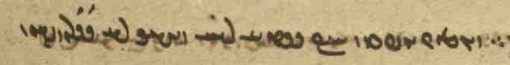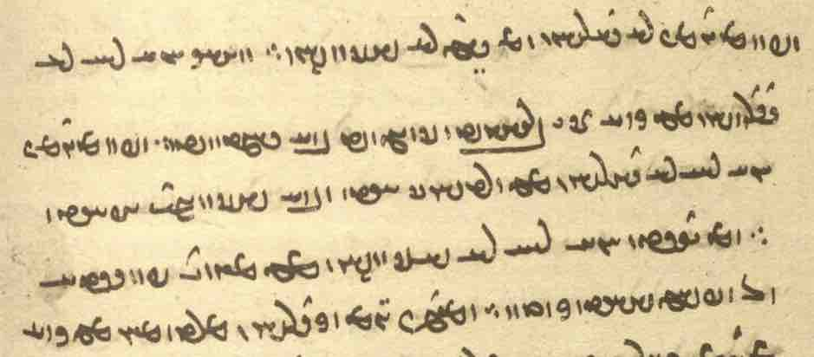

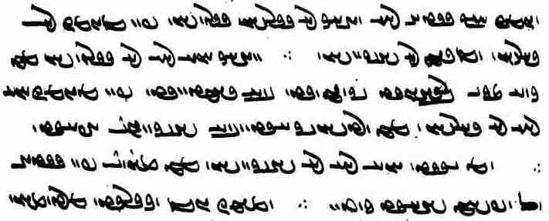

Text 13.2
From Ardā Wirāz-nāmag: AWN.5.4, 6.

Âïda˜W kL OW Y>W WWtåD AWB à WTPwY W WTWwïÅW cÅWP L ^ nS WtåD WWWtÅ W WBwlaÅ Í]J oaÅ W
EtåH W WwßmaÒ W emLwA W emïJV W EwaåÒP W EwajA W elAwA W EwÍwL W WwaHwY W WthAW
? ? ? WwAVwlaÅ ^ WwßaDtÅP ^ WthAW ^ eY>WBwA W
? WwAWCwlY> ^ ã W WwAtjaÒ ^ saD< Âïda˜W TcÅ
WwaDWcJwaÂA W a˜wAwA WWP WwAwßYwlYW WPwA ^ WwßaDtÅP Âïda˜W TcÅ
WwaååH W ‹ ^ EtDwL W WwaDWcJwaÂA W WwaåD ^ EtjA W WwaHwY WWP ^ EkAwA W WthAW WWP ^ EKwYW W
÷ WwïJP ^ WWT W cdaÅtjgL ^ WWTWWwaD W

Text 13.3
From the Bundahišn: Bd.33. 24.
? WTWWtÅwA E˝∂>ΩM ^ WtåD ? Wt˜ EkAtDP OW WwAtådmAV ^ W˝∂>ΩM WtÅWK ^ a∂dATwA x
? WTWK WwAcåÅW W WTcjLP WtÅWK
? WTnLP WWthaD WtdAcÅ eÄvmA W emA WWP WKtjAwA W Y>wYWP W nßYW
? Wt˜ a∂dAwLP OW WwAtÅWK ^ Y]JwA WwABwLWkÍWwA Y>W WthaD lAK N WwAtja˜ ^ WwS
? YNwA WtÅWfJ ? ? ? WWwïÅ WwaHnLW W Wt¬AWW WwAtja˜ ^ WwS WTWwLTI W˝∂>ΩM
/ WTWK ÂYvYcÅ WWtH Wwa:dA W WtJB yLTW W
andar xwadāyīh ī Kawād Mazdak ī Bāmdādān ō paydāgīh mad, dād ī mazdakīh nihād.
Kawād frēft ud wiyābān kerd.
zan ud frazend ud xwāstag pad hamīh ud hambāyīh abāyēd dāštan framūd.
dēn ī mazdēsnān az kār dāšt tā anōšag-ruwān Husrōy ī Kawādān ō pornāyīh mad
Mazdak ōzad dēn ī mazdēsnān winnārd ud awēšān Xyōn ... spōxt hēnd.
ud widarg bast ud Ērān šahr abēbīm kerd.

Exercises 13

13.1. Transliterate, transcribe, and translate:
/ WTcÅtHwA WtåJ WwaådßLP NTwL WwAwï>¬A ? !

/ WwÍWWvaD AWB WwaÂZ x ÍwsA MWWvaD kL ØW EwZ WWP Íà WtDWwllmY áÒ nßYW tÂA ?2

/WTWnlA AWB WwßmaÒ WWP W WTWNtHW Y<N ã aådY>NwAkmAK cå¬YW ät¬A oaÅ ? 3

÷ WtjlABwY> ÍTP W WTPwS WimZ YWwï˜ WkAWwY< à nMT WimZ ^ WKwaå˜ x WwaHwY ? 4

WtdAtJ ea¬aÅ 9WwlY>kM WwS WcjAtHW tÂA à WkAtDP ^ AwA WKwïÅ ? 23
÷ YNwA WtDt¬ad,A WwÍBwY ã x aåH
nÍPW ^ WwÍWWK N AWvY Wwad>A N ^ WWTWK WwABWT aÒ ã WnÍwY> WWP WnÍwY à WTPwY WwAkAwaD> ? 33
÷ WtDWWtÂaD ÍBwA

? WTWwYtdaD Y>WwY< W aÅfJ WTWwlZW WwAKwY>wA OW WTWkaD Y NWB ? 34
WwAIcÅT WWP WWtH Wwa:dA W WTPwÍW Y>WwY< W aÅcJ ã WtDCwA WwajaÒwA OW Y WWTWWtåD N ˙DP
/ Wt˜ aÒ LTwa¬Y< NwY N EkAwA MwY NwïÒ Y>W Ww˙daD> WWB N W ? WTWwLTK

WtÅWwmYWI AWB AWWT WwYwL WTWWtåD WWwlYV AWWT ^ WWT N WtåDKwïÅ ^ AWWT ^ WwABwL WwSC WWwLwÍwY< ? 44
? WtDc¬Y< a˜wAwA OW YWwsaD `<wAW lAB WKwïÅ WWP tÂA AWvY + YWC
? WtDWWWwmY AWB WcdlaÅP WN ëtJ OW MWWbaD AWB à WTNW AWB ÍBwA WtHWt¬Z Y laÅwLP a˜wAwA oaÅ
/ žWwlYkM W WWwLwÍwY WTWB Y>wSWwA

WTWWvaD cÅWP WcDWwa:dA x WtDwïådLV AWB WwßY> Y nï>D, N AWWT á˜wAwA ? 333
WTWWtdmY AWB kAwS WWP Wt˜ q ‹ ÍtÂA ? WTWB ÄwaÅP á¬AB AWbY< 23 ÍcÅ
/ WTWK AWB :JwÍ ã N á˜wAwA waD>WcJwY Y WKt:J kaÂA W Wt˜ ImY OW AWB kAwS WWP :JwÍ ÍcÅ
(About how things in the world were fashioned from a primordial giant.)

13.3. Match the Pahlavi words with their transcriptions:

aDT nïD žWwlYKM arešk drōzan marg
eßLP LtdmA WtåJ aswār dušmen mayān
AWWT nßYW WwˆÂaJ āsmān framān-burdār padīrift
glM ßYK Wwaå˜ āy! gāw sahmgen
WTcÅtHwA WfjAtHW WwaÂsA aweštāft gōwišn saxt
lAB WilAT WwaHwY azabar hamēstār tarāzūg
lAtÒWB WwaÂLP WkahAWT WWCwlY azēr hučihr tārīk
lAtjgmA WkAwaD WwEwY bār hunsand tēx
YwSWwA WkßlA WwÍBwY bērōn ǰuwān tuxšāg
lECwA WKWcåÒT WWtåD dānāg kēš Wištāsp
LPcÅ WnÍwY WWwlYB dast mādar zan
lYcÅ dōšox

13.2. Translate into Pahlavi:
Note: Do not use enclitic pronouns as agents, but the regular ones.

- When the Evil Spirit had rushed against (pad) every creation of Ohrmazd’s, he made the world at noon like a dark night, and he made the sky underneath and above the earth dark.
- Salm and Tūz killed all the children and descendants of Ēriǰ, but Frēdōn kept Ēriǰ’s daughter hidden for 10 years.
- From that daughter a daughter was born. Salm and Tūz killed the mother of the daughter, but Frēdōn kept hiding the girl for (tā) 10 generations.
- When Ahrimen saw Ohrmazd’s light, he rose from the depth and because of envy he attacked (it) in order to destroy (it).
- Ohrmazd recited the Ahunwar, and the Foul Spirit was stunned and fell back into the darkness.
- The hērbeds and mowbeds said to Ardā Wirāz: Welcome, you messenger of the Mazdayasnians! who have come back from that dark hell. Now tell us what you saw there.
- Then the Righteous Srōš and the divine fire brought me to a place and showed (to) me heaven and hell.
- When Ardā Wirāz came to that place (he) saw a beautiful woman who said to him: O young (man), I am your dēn! In the world of the living, you made me more beautiful than I was.
- Ardā Wirāz said to her: O beautiful woman! When did I make you beautiful? I have never seen you before.
- After the death of Zarduxšt, there were many people who left the dēn of Ohrmazd and the (other) gods and took (accepted) the teaching of Ahrimen and the demons.

Additional Readings 13

Additional reading 13.1
From Bundahišn: Bd.30.1.
YWtDWK ìtdE> ^ WtÅKC WN WwaåJ ^ Wwaå˜ á¬AB AWvY ± ^ tdA Ä WtÅKC à WwS WWP WtDWWWwmY
? WtåDWwßL ^ WKWcåÒT ^ WKwY. W
^ WtJWK WWP WcÒWvlA ^ WPWK ^ nßYwL WWP 1aDT W LtåÅcÅ YWtJWK WcÒWvlA ^ WPWK ^ WWB WWP 1aDT W
WtDWnYWI ìtdE ^ WtÅKC ã Q Wwaå˜ WCwlmYW
÷ ÄwaÅP W Äwa¬Y WKcDW 333 ÍWN WtDWwmYWI WkAwa˜wA :dÍpÍ ^ WcDT ^ !WkAwïD Wwaå˜ ã WWP

Additional reading 13.2
From the Bundahišn: Bd.14.2-6 (death of Gayōmard). Orthography as in mss.

/ WtJWwLPW nS YwA WWP Wt˜ Q elaÂYW Wt¬MwïåD< tÂA
WKwYKcÅ AbLT N YwL WKtjA N W WwïjA nlïÒ N W µïjA ï<ΩM N W WcDc¬A WWwA N W WP]J nßYwL N
WTWWtåD EkAtDP OW Aba¸ EwÍWwlZW AWB WwaD< N W WTcåÒWP ÄcÅB N W
/ YWWbaD AWB adA NTwL WwaÅTwÍwA áÒ eY>NwAwAc¬A WWK WN
/ Wt˜ Q eylM WTWkßLP Y>W WwaÂaD WfJwlA ? WTWwlZW x Wt¬MwïåD< ^ WWT WWP eylM WI,wA ^ ã N
/ YNwA WTwlAP AWB WtdßLwA ^ EwÍwL WWP µAWT ã WTWWvaD AWB µAWT Wt¬MwïåD< tÂA
/ WTWWvaD WimZ x TwÍ ¢ ? WTWwlYkM Wt˜wYWcJ 1laÅV Wthad>sAKW Y<wSwï¬YW 1laÅV 2 ÍcÅ
WimZ N íYwaå¬aå˜ W î¬aå˜ yLW 27 ^ WWWtJ WKwïÅ ^ WcÒK sAcdL TwÍ ¢ ^ EI>WWV WWP
WKtJWTP YWT OW WKwïÅ WtÅWwmYWI lAwaÒ ÍwY> WWP nS WwaHà WkAwa˜wA WwYwA YNwA WtJwL q
÷ YNwA WTWWwaD W˝Î©s>mA W WwÍvmA
Body parts: sar, xōn, mazg, pāy, astag, pih, bāzāy, gyān, tōhm, dast, dōš; — “right and left”: dašn, hōy(ag)
Metals: srub, arziz, asēm, āhen, rōy, ābgēnag, pōlābd, zarr.

Additional readings 13.3
From the Pand-nāmag: PN.26-29.
? WtDWnYWI WTWWtÅwA WwaÅTwÍwA Y WWT x saÒ 3 CNwY
? WtDWwsaD saÒ WCwlY 3 W saD< YWwï˜ 3 saÒ 3 NwY WWP
? WtDWwsaD saÒ Â˙dA saD WNwAW WwÍwï˜ WWP
? WtDWwsaD saÒ WwLW saD Wt¬A WwÍBwY WWP
? WtDWwsaD saÒ Y>Wwï˜ WkAWwY< saD Y>Wwï˜ WkAwYcJ WwÍWWK WWP
WwÍt∆dA WtåJ saÒ 3 NwY WWP Wwa˜Wt¬M
? WwÍWWiÍ aÒ AWB YWwï˜ Y y>zM áÒ aÅtJ Y WKWc¬A W W˝jAwA W WBC
WtDWwLTW AWB nÍPW Y WWT q WTPwY L Y sAP 3 NwY ÍWN ATwÍwA nM
? WtDWwLTW WthLWwaHwY N WwÍWWK W WtÅwaHwY N WwÍBwY W WtÂÍwY N WwÍwï˜

Additional readings 13.4
From the Stāyišn ī Sī-rōzag: StS.21.5. — Ms. K24, f. 30v.
http://www.kb.dk/manus/ortsam/2009/okt/orientalia/object65189/en/

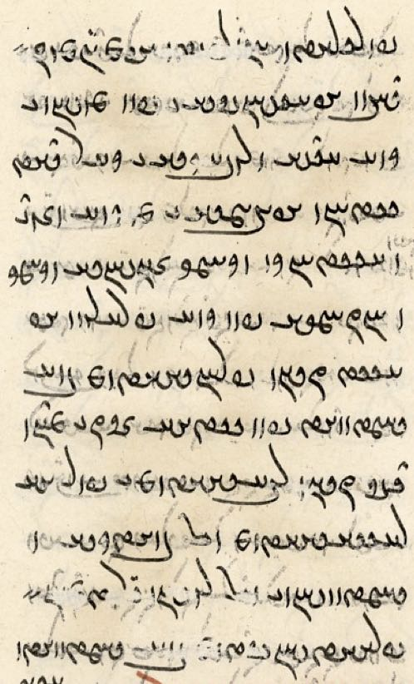
u-m ēn-iz
dah abāyišnīgīh [ud] pad menišn ī
harw kas ud rawāgīh ī kār (ud) dād-
estān abē-bīmīh ī az harw wizend
ud astānag ud kāmag-zīyišnīh ud kāmag-
hanǰāmīh pad harw frārōn ab-
āyist čiyōn farroxīhātom bē
rasād pad gētīy ud ān-iz ī mēnō-
yīg čiyōn wazurgīhātom ī purr-
ahlāyīhīhātom ō bōxtagīh ud
rasišn ī ō rōšn Garōdmān
frayādišnīgtom bē rasād

And give me this attractiveness in everybody’s thought; and currency of work and law; and freedom from fear of every harm and misfortune; and living at will and succeeding at will in every good necessity.
Let it come as in the most fortunate way in this world as well as in the other; let it come as in the greatest way, in a way that it is most full of Righteousness, in a way that is most helpful for being saved and coming to the Light Garōdmān!

Additional readings 13.5
From Mānuščihr’s Dādestān ī Dēnīg: DD.0.12.

ān ī-tān wistāxīhā ud wistāxgarīhā abar drāz nibištan ī pursišn ēn-iz nimūd kū
passox pad hangām nibēsam ī-m andar pardazišn bawēd
ud ān ī ašmāh pad hučihr-pursišnīh wistāxīh čimīg
ud man abar gōkānīg-passoxīh ud spōz-az-gāhīh kām ī taftīg
čē spōz ayāb abowandagīhā passoxīh aniyābag ast
az ān ī škeft-kōxšišnīh ī druz rāy aweštāb
ud wizōyišnīg-menišnīh az ān ī awizīrišnīg ud frēzwānīg kār kam pardazišnīh ast
That question of yours (asked) confidently and in a manner to inspire confidence, regarding (my) writing (to you) at length, showed this, too,
that I should write a response at a time that (it is) within my leisure.
And your confidence in your question being a “pretty” (question) is reasonable.
And I have an ardent desire for answering in detail and without *procrastination,
for putting off or answering incompletely is something inappropriate.
Because of (az ... rāy) the severe battling of the Lie there is haste.
And (for) scrutinizing thinking there is little respite from unavoidable and obligatory work.

Additional readings 13.3
From the Pahlavi Rivayat:

PR.10c (ms. in the British Library)

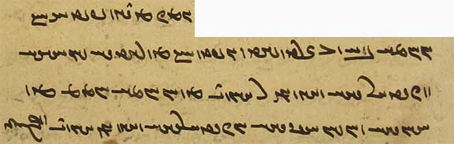
ēn-iz az dēn paydāg kū Ohrmazd bē ō Zardušt guft kū
kē rādīh šnāsīhā ud wizīdārīhā kunēnd man hāwand kē Ohrmazd ham
kē adānīhā ud anešnāsagīhā ud awizīdārīhā kunēnd hāwand Ahrimen

Additional readings 13.7
PR.10k.1 (ms. TD4a)
Note that the particle of exhortation ē is written <’y> and <HNA> and that arameograms in <-YTN-> are spelled <-YTWN->.

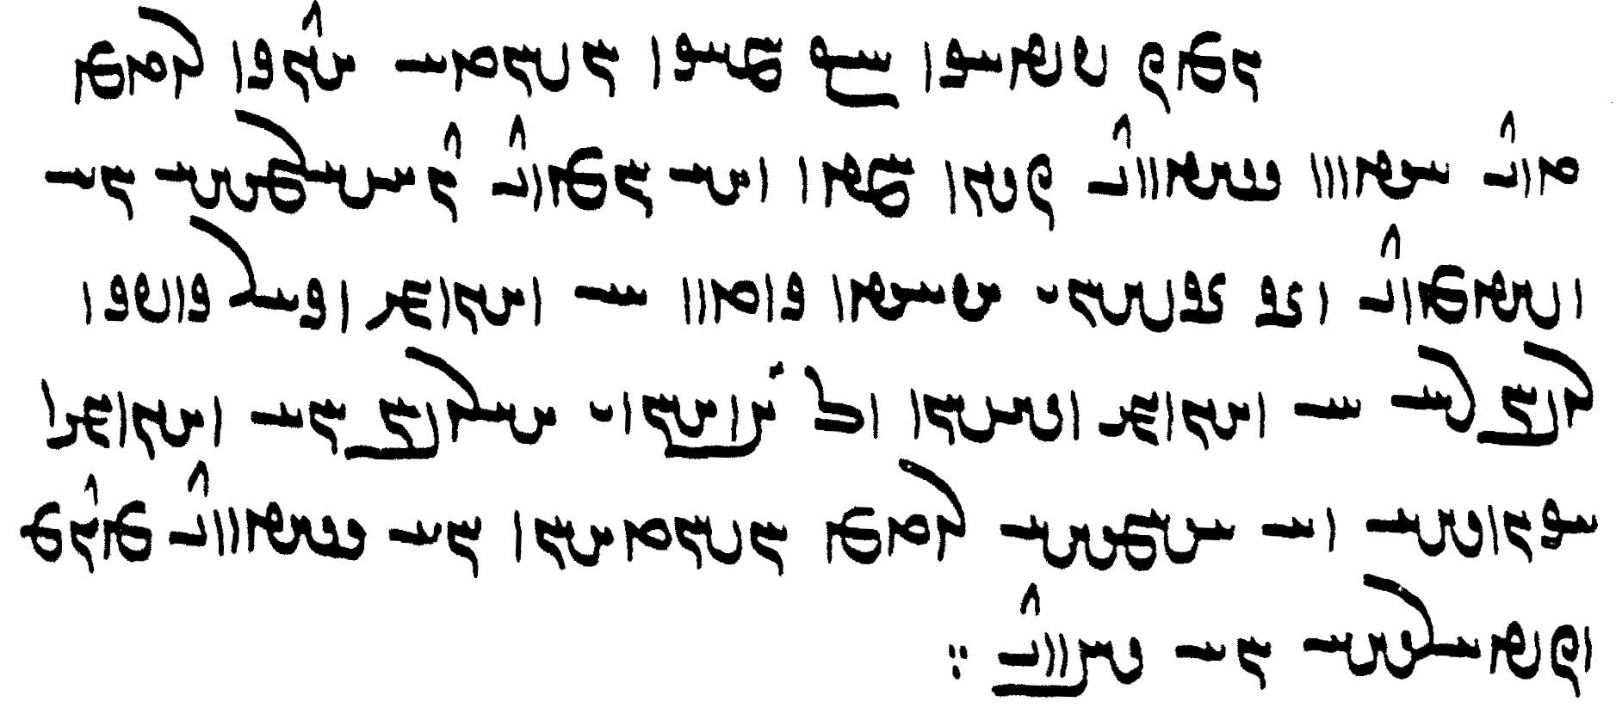
ēn-iz paydāg kū hamāg mardōm ēk abāg did ēdōn (ē) rawēnd čiyōn ka [w] brād hēnd
dōšāramīhā ē xwarēnd ud ān ī-šān abāyēd kerdan ē kunēnd
ud kār kerbag ruwān rāy ē kunēnd ud dāšn ō mardān ī ahlawān ē kunēnd
ud a-kēnīhā ud a-xešmīhā abāg mardōmān ē rawēnd tis wizīdārīhā ē dahēnd

Glossary of words in the Texts and Exercises 13

Idioms:
abar grift took up
abar mad came upon
andar šaw- go in
andar zamān at once
az kār dār- discard, ignore, put to ‘dis-use’ (?)
bē ... tā except
bē šaw- go out
čand 30 mard as much as thirty men
čiyōn also: “that is”
ēd rāy ... čē for this reason that, because
ēdōn ... ī so ... that
frāz srāy- sing, recite
im rōz today
ō paydāgīh mad appeared
ō ... šaw- go to, approach
pad ... dār- hold on to
pad ān mayān ‘in that middle’ = in the middle of that
pad gyāg on the spot, right away
pad kār nē abāyēd have no need for
pad nihānīh dār- keep hidden
pad xwār dār- look down upon, despise
pahrēz gōw- ‘utter pahrēz’, care (for)
tag abar kun- attack
wāng dār- ‘have a voice’, shout
widarg band- close a passage

Nouns, adjectives, adverbs, pronouns:
ābādīh EtÅcÅ <’p̄’tyh> wealth, prosperity, well-being
abāyist Wt∆dAcÅ <’p̄’dst'> wish, liking, necessity (?)
abāyišnīgīh EIwßYAcÅ <’p̄’dšnykyh> pleasingness, attractiveness
abē-bīmīh EmYvYcÅ <’p̄y-bymyh> freedom from fear, fearlessness (of: az)
ābgēnag WKwYKcÅ <’p̄kynk'> glass
abowandag WIWWvA <’bwndk'> incomplete
adādīhā aåDtådA <’d’tyh’> not according to/against the law
adān WwadA <’d’n'> without knowledge, ignorant
āgāh aÅkA , sAkA <’k’s, ’k’h> aware; + az “of”
agumēzišn WwÍcdMwïÅ <’gwmycšn'> unmixed, not part of the Mixture
āhen WwˆjA <’syn'> iron
akēn WwYkA <’kyn'> without malice
anešnāsag EksAwÍwA <’nšn’sk'> unknowing (an-, see Lesson 8)
aniyābagīh EKcåÅwA <’nyd’p̄kyh> inappropriateness
ardīg WIt¬A <’ltyk'> battle
arzānōmandīh eY>NwAwAc¬A <’lc’n’wmndyh> (great) value
arziz WcDc¬A <’lcyc'> tin
ārzōg WKWc¬A <’lcwk'> desire: + ī “for”
asēm ÂïjA <’sym> silver
astag WKtjA <’stk'> bone
astānag WKwAtjA <’st’nk'> misfortune
aswār eßLP <PLŠYA> horseman, rider
āwādag WKtÅBwA <’wb’tk'> generation, descendant
aweštāb WcÅtHwA <’wšt’p̄'> haste
awizīdār lAtDCwA <’wcyt’l> undiscriminating
awizīrišnīg WIwßlYCwA <’wcylšnyk'> unavoidable
axešm mßA A , mßaÅ <’hšm> without anger
bālāy á¬AB <b’l’d> height
bāzāy ÄcÅB <b’z’d> arm
bē-šawišnīh EwÍWwlZW AWB <BRA OZLWNšnyh> going out, departure
bēšēnīdār, see tēz-bēšēnīdār
bōxtagīh EKtÅWB <bwhtkyh> fact of having been saved, salvation
čagād WtÅKC <ck’t'> ridge, summit
čimīg WIMC <cmyk'> reasonable, sensible; it makes sense + inf.
dahan, dahān nMWP <PWME> mouth
dašn WwßY <dšn'> right (versus left)
dōš ÍwY <dōš> the back (of body)
ēk-dād WtåDKwïÅ <’ywkd’t'> established alone; about the First Bull
ēk-stūn WWWtJKwïÅ <’ywk-stwn'> having one stalk
estišn WwÍtjY <ystšn'> standing (room)
farrox WwaÒP <plhw'> fortunate
frayādišnīg WIÍtååÒP <plyd’tšnyk'> which is going to be of help, helpful
frēzwānīg WIwAWcdLP <plycw’nyk'> obligatory (e.g., duties)
gāhān WwajaD< <g’s’n'> the Gathas
gilag-ōbār lAPwA WklY <glk'-’wp’l> swallowing one’s complaints, patient, long-suffering
gōš ÍwY <gwš> ear
hambašn WwÍvmA <hmbšn'> of the same height
hambāyīh a∂dAvmA <hmb’gyh> sharing, partnership
hamdēsag W˝Î©s>mA <hmdysk'> of the same shape
hamīh emA <hmyh> togetherness
handām µEwA <hnd’m> limb, body part
hāwand YWwaÅ <h’wnd> equal, counterpart
hōy, hōyag WkYwA, YwA <hwy, hwyk'> left (side)
hubōyīh eG>WBwA <hwbwdyh> fragrance, perfume
hučihr-pursišnīh Ew˙JWWP laDCwA <hwcyhl-pwrsšnyh> it being a “pretty” question, a question’s being appropriate (?)
ǰuγ WKwY <ywk'> yoke
kāmag-hanǰāmīh EmACwA WkmAK <k’mk' hnc’myh> achieving/succeeding at will = as one wishes
kāmag-zīyišnīh WwÍwï¸ WkmAK <k’mk' zywšn'> living at will = as one wishes
mard-bālāy á¬AB AWbY <GBRA b’l’d> the height of a man
mazdakīh E˝∂>ΩM <mzdkyh> Mazdakism
mazg gzM <mzg> brain, marrow
nēzag WKcDW <nyck'> spear
nigāh dār- -lad>sAKW <nk’s-d’l-> watch, guard
nihānīh EwaÅW <nyh’nyh> hiding
niyōxšīdār lAtdßAwYW <nywhšyt’l > who listens
nōg WKWW <nwk'> new; anew
pānag WKwAP <p’nk'> protector, protection
pardazišn WwÍcdLP <pldcšn'> leisure
pardazišnīh EwÍcdLP <pldcšnyh> respite, getting away; + az “from”
pās sAP <p’s> watch, guard + dār- “keep watch”
paywand YWWTP <ptwnd> connection, lineage
paywastag WKtJWTP <ptwstk'> combined, connected
pih AbLT , WwaDP <pyhw', TLBA> fat
pōlābd WTcåÒWP <pwl’pt'> steel
pornāyīh a∂dAwLWP , a∂dAwLP <p(w)ln’dyh> adulthood
purr-ahlāyīh ega¬aÅ LWP <pwl ’hl’dyh > full of Righteousness
Rašn-dād WtåDWwßL <lšn-d’t'> placed by Rašn
rawāgīh EkABwL <lwb’kyh> currency; setting in motion
rēbāh sAcdL <lyp’s> rhubarb
rēbāh-kerb WcÒK sAcdL <lyp’s-klp'> in the form of a rhubarb
rēšag Wk˙dL <lyšk'> root
rōy `wL <lwd> 1. brass; 2. face
sardag WKt:J <sltk'> species
spās sAfJ <sp’s> gratitude
spōz WCWcJ <spwc'> delay, putting off
spōz-az-gāhīh esaD N WCWcJ <spwc'-MN-g’syh> delay, procrastination (?)
srub WPwlS <slwp'> lead
stard, sturd WtÒWtJ , WtÒtJ <st(w)lt'> stunned
stūn, see ēk-stūn
šafšēr, šufšēr :dÍPwÍ , :dÍpÍ <š(w)pšyl> sword
škeft-kōxšišnīh EwßßAWK WTpYkÍ <škypt' kwhššnyh> severe battling
šnāsag WksAwÍ <šn’sk'> knowing
šufšēr = šafšēr
šusr :JwÍ <šwsl> semen
taftīg WITPT <tptyk'> ardent
tan-gōhr laÅwY WWT , lAwY WWT <tn' -gwhl, -gw’hl > body substance
tanīhā aåDWWT <tn'yh’> alone
tērag WklYT <tylk'> dark (night)
tōhm mAWT <twhm> seed, semen
uštānōmand YNwAwAtHwA <’wšt’n’wmnd> living and breathing being
wardišnīg WIwÍtÒW <wltšnyk'> bound to change
warg yLW <wlg> leaf
*wāhak WkaÅW <w’’k'> fear, worry (NPers. bāk); + bar- “to fear, worry”
wēmārīh elaÂYW <wym’lyh> sickness
wirrōyišn, see xūb-wirrōyišn
wistāxgar lYwaÅtJW <wst’hwgl> confidence-inspiring
wiyābān WwAcåÅW <wyd’p̄’n’> astray; + kun- “lead astray”
wizend Y>wzYW <wznd> harm
wizist (wačast) WtJCW <wcst'> a strophe of the Gathas (Avestan vacastašti)
wizist-drahnāy äwa¬Y WtJCW <wcst'-dlhn’d> for as long as it takes to recite a wizist
wizīdār lAtDCW <wcyt’l> discriminating
wizōyišnīg-menišnīh EwÍwï˜ EIwßYWCW <wcwdšnyk' mynšnyh> scrutinizing thinking, thinking that scrutinizes/examines
wīdwar LWtDW <wytwl> patient
xūb-wirrōyišn WwßYwlYW WPwA <hwp-wylwdšn'> (someone) having good faith; + pad “in”
zarr Aba¸ <ZHBA> gold

Proper names:
Ahunwar LWwaÅ , LWWwaÅ <’hw(n)wl> name of the first strophe of the first Gatha
Bāmdādān WwAtådmAV <b’md’t’n'> son of Bāmdād
Čagād ī Dāytīy ìtdE ^ WtÅKC <ck’t' Y d’ytyd> the Lawful Ridge/Summit (a mountain)
Dahmān Āfrīn WwYWƒ WwaÂaåD <d’hm’n' ‘pryn'> the Blessing of the Qualified (ones), a deity
Ēriǰ WcdlgA <’ylyc'> Ēriǰ (son of Frēdōn); Pers. Iraj
Husrōy Y]JwA <hwslwd> Husrōy (Khosrow) I Anōšīrwān (531-79)
Kawād WtÅWK <kw’t'> Kawād I (488-96, 499-531)
Kawādān WwAtÅWK <kw’t’n '> son of Kawād
Mahlīy aå¬a˜ <mhlydy) = Mašīy
Mahlyānīy aÅwaå¬a˜ <mhlyd’nydy) = Mašyānīy
Mazdak (W˝∆>ΩM) W˝∂>ΩM <mzd(y)k'> a reformist under Husrōy
Nēryōsang YwSKwï¬YW <nylywksng> deity, messenger of the gods; Av. Nairiiō.saŋha-
Salm µrS <slm> son of Frēdōn
Tāzīg WIcÅT <t’cyk'> Arab
Tūz WCWT <twc> son of Frēdōn
Yazdgerd WTWkaD <yzdkrt'> Yazdegerd

Verbs:
abesihēn- abesihēnīd -WwïåJcÅ <’p̄shyn-> cause to perish, destroy
ayārd- ayārdīd -t¬adA <’y’lt-> seethe, boil, be disturbed
frēb- frēft -cjLP , -fdLP <pld(y)p-> deceive
garz- garzīd -c¬Y <glc-> wail, complain
kōš- = kōxš-
marnǰēn- marnǰēnīd -wYCwlM <mlncyn-> destroy
murnǰēn- murnǰēnīd -wYCwLN <mwlncyn->
ōbār- ōbārd –lAPwA <’wp’l-> swallow
pahrēz- pahrēxt WtådlaÅP –cdlaÅP <p’hlyc-, p’hlyht'> take care, stay away: + az “from”
pālāy- pālūd WTwlAP , -á¬AP <p’l’d-, p’lwt'> purify
spōz- spōxt WtÅWfJ , -CWfJ <spwc- spwht'> push back
WtÅWcJ , -CWcJ <sp̄wc- sp̄wht'>
srāy- srūd WT]J , -á:J <sl’d-, slwt'> sing, recite
sumb- suft WTPwS , -vMwS <swmb- swpt'> pierce
tars- tarsīd -∆ÒT -sLT <tls-> fear (+ az)
uzīh- uzīd WtDCwA , -aDCwA <’wcyh-, ’wcyt'> go out, leave; pass (of time), die
winnār- winnārd Wt¬AwYW , -lAwYW <wyn’l-> arrange, fasten

Lesson 14

Grammar 14

ham “same, ‘said’”
ham “same” is also used to refer to someone or something just mentioned, as English “said” in legalese. Some text editors tend to read this <hm>, wrongly, as <’m> for im “this.”

tarsāgīg, kē Yišōy kē Mašīhā-iz xwānēnd, pad pus ī yazd ... hangārēnd ...
grōh-ēw ham Mašīhā rāy gōwēnd kū murd grōh-ēw gōwēnd kū nē murd
“the Christians who count Jesus, whom they also call Mašīhā, as the son of god ...
one group say about said Mašīhā that he died, another group that he did not die” (after DD.36.76-77)

ka pad čāštag ī ēw šāyēd hērbedān kam wardēnīdan ān ī abāyēd kerdan ...
ham-iz čāštag ō ān kē Abestāg gugāhīh hayārtar ud abērtar hangāštan
“when something is appropriate according to the teaching of one of the hērbeds, little is to be changed in how it should be done ...
also, said teaching should be counted to that which is more helpful for (= supports?) the testimony from the Avesta and more frequent (better attested?)” (RAF.73.4)

Indefinite expressions with ast
Beside its use as “there is” (and derived from it) are several important constructions, among them the following:

ast (būd) ī, ast kē “there is/was one who ...; some”; ast kū “it happens that; some”:
ast kē ēdōn gōwēd “there is one who says ....”
ast kē ēdōn gōwēnd “there are some who say ....”

ast kē Wāy ī dērang-xwadāy gōwēd
“there is one who says ‘Wāy of long dominion’” (Bd.1.44)

mang ī bēšāz kē ast ī banǰ xwānēd
“medicinal/healing hemp, which some call hashish” (Bd.4.20)

pad ē-mar ... ān ī pad Salm deh ast ī Hrōm ān ī pad Sēn deh ast ī Čīnestān
“in this number (are) those in the land of Salm, some (say) Rome, (and) those in the land of Sēn, some (say) China” (Bd.14.3)
About the 15 kinds of couples born from Siyāmak, son of M. and M., and Wašāg.

ka ō ōy dahēnd padīrišn ast kū awēšān deh ka xwāhēnd bēšāzišnīh windēnd
“when they give him reception (receive him well), it happens that those towns (or: some of those towns?), when they ask (for it), obtain healing” (Dk.7.7.37)

ast čē “there is something which; some”
ka az awēšān kē ān paymān kerd mard-ēw ān paymān ast čē ǰuttar kerd ān tāywān ō tōzišn ī harw 2 mard rasēd
“when, of those (two) who made that agreement, there is something (of) that agreement that one man has done differently [if one of the two ... does something differently], then the penalty comes to the paying for both men [both men are responsible for paying the penalty for it]” (MHD.20.11)

ast ī ... ast ī, ast kē ... ast ī, ast kū ... ast kū “there is one who ... and another who, one ... another, some ... others”; “sometimes ... sometimes.” In these constructions, the ī is often omitted:
xwarrah ast ī xwēškārīh ud ast ī pad tan ī mard
“(the word) xwarrah: sometimes (it refers to) one’s duties, sometimes to (what is) in man’s body” (PY.9.4d)

abar ān ī harw kadār padiš arzānīg ud ān ī ēč padiš nē arzānīg ud ān ī ast kē padiš arzānīg ud ast ī nē
“about that which each and every one is worthy of, and that which nobody is worthy of, and that which some are worthy of and others not”(Dk.3.261.1)

was ruwān ud frawahr andar ān rōd būd hēnd ud ast ī-šān pad garān ranǰ hamē widerd ud ast ī xwārīhā widerd hēnd
“there were many souls and frawahrs in that river; some of them passed (across) by heavy toil, others of them passed lightly” (AWN.16.2)

was-sardag dad ud dām ast kū Spēnāg Mēnōy ud ast kū Gannāg Mēnōy dām hēnd u-šān abar tō frāz rawišn
“wild animals and (other) creatures of many kinds, some are the creations of the Benificent Spirit, others (of) the Foul Spirit, (they all) have their going forth = go forth upon you (Spandarmad, the Earth)” (StS.5.3)

ast ī ka “sometimes, it happens that”:
Note: the ī is often not written in the manuscripts.

čē rāy ka aǰgahān ud duš-āgāh ud wad mard ast ī ka ō burzišn ud nēkīh ī wazurg rasēd
“why (is it) that (lit. when) a lazy and ignorant and bad man sometimes comes to honor and great goodness?” (MX.50.2)

kē ān kār ī nē dānēd pad kerdan frāz gīrēd ast ī ka ān kār tabāh ud agār bawēd
“he who undertakes to do something he does not know, it happens that the work is destroyed and useless” (MX.31.8)

ast (ī) ka tēz ast ī dērang ast (ī) ka abāz-rawišn ast (ī) ka estādag hēnd
“sometimes (the planets are) fast, sometimes (they are) slow, sometimes they go backward, sometimes they stand still” (Bd.5A.9)

Distinguish (ī) ast “which is, that is,” e.g.:

u-š az 4 pēšag ī dēn ast āsrōnīh ud artēštārīh ud wāstaryōšīh ud hutuxšīh padīrift 4 pēšag ī ast āsrōnīh ud artēštārīh ud wāstaryōšīh hutuxšīh ud pad-iš frāxēnīd wālēnīd waxšēnīd gēhān
“and from the four ‘trades’ of the dēn, that is, priesthood, soldiery, husbandry, and artisanry, (J̌amšēd) the four ‘trades’, that is, priesthood, soldiery, husbandry, and artisanry received/accepted, and thereby/with them he broadened and made the world prosper and grow” (Dk.7.1.20)

On xwad ast “is itself, is nothing but” and ī xwad ast “that is, nothing but ... (itself), who/which is nothing but,” see Lesson 15.

The verb. Ergative constructions with enclitic pronoun as agent
Recall that enclitic pronouns can never be grammatical subject: one cannot say “u-m kunam”! In the ergative construction, however, they are very common as agents: u-m kerd “I did.”

In main clauses
u-m pursīd az pērōzgar Srōš ahlaw
“and I asked the victorious, Righteous Srōš” (AWN.6.2)
Note: pursīdan takes the preposition az (az kas pursīdan “ask somebody”).

u-m az ēn and sāl abāz az ašmāh pad nihān dāšt
“and since (for; az ... abāz) these many years I have kept (him) hidden from you” (KN.14.16)

bē-m xwāst andar āb ud zamīg ud urwar ud gōspand ud bālist ī garān ud ān-iz ī zofr rōstāg nē ayāft ǰāmag kē mard ī ahlaw aziš bawēd ǰud zan kē ǰeh petyārag
“(Ohrmazd says: If it had been possible to find one, I would have), but I sought in water, earth, plants, beasts and on the highest of mountains and the deep river (and) did not find a vessel from which a Righteous man might become (be born) other than (ǰud) the woman, whose adversary is the ǰeh” (Bd.14a.1)

ka mard abāg 2 ī pādixšāyīhā ī xwēš paymān kerd kū-m tō ud tō hamwindišn kerd hēd
zan ǰud ǰud abāg šōy hamwindišn ud zanān ēk az did ǰud-windišn hēnd
“when a man has made an agreement with his two ‘authoritative’ (wives saying): ‘I have made you and you my partners-in-income,’
(then) the wives, each individually, (are) partners-in-income with husband, and (each) of the wives has separate income from one another” (MHDA.1.3)

u-t az 7-sālag abāz frazend ī ēdōn nēkōg az man pad nihān dāšt
“and since (he was) seven-years-old you have kept such a good child hidden from me” (KN.14.17)

u-t hāmōyēn az daxšag bē hišt u-t menišn abāg ōy mihrdruz rāst bē kerd
“and you have forgotten everything, and you have made your thought equal with (made common cause with) that criminal” (KN.10.1/9.6)

u-š pas mayānag ī zamīg suft andar āmad
“next he pierced the middle of the earth (and) came inside” (Bd.4.10b)

u-š wizārišn ēn kū-š pad ēd dāšt kū Ohrmazd andar ōy ačārag
“and the explanation of it is that he figured (pad ēd dāšt) that Ohrmazd (was) helpless with respect to (andar; = against) him” (Bd.1.22)

u-š mēnōyīhā ān dām ī pad ān abzār andar abāyist frāz brēhēnīd
“and he fashioned forth in the world of thought that creation which (he) needed as that tool” (Bd.1.12)

ēg-imān zan dīd ī was hučihrtar az awēšān ī-mān pad gēhān dīd
“then we saw a woman who (was) much more beautiful than those whom we have seen in the world of the living” (after Kerdīr)
čē-mān andar-iz pārs dīd kē-š kār pad nēmag mizd ī ān ī pēš pad uzēn andar abāyist padīrift ud mizd stad
“for I have seen, even in Pārs, (someone) who accepted a work at half the salary of what he previously needed for the expense (of the same service?) and took the (reduced) salary” (DD.65.28)
About payments for religious services.

wad-itān ō man guft andar mardōmān rawāg-dahišnīh kū-tān ēd guft kū dēn rawāg kerd dušwār
“‘bad,—you told me—is the giving (of the dēn) currency among men’, that is, you said this: it is difficult to make the dēn current” (PY.43.11d).
Note that rawāg means literally “going (forth)”; here, rawāg-dahišnīh renders Av. zraz-dāiti, which may have meant something like “confidence.”

čiyōn gōwēd kū drāyist Ganāg Mēnōy ō dēwān kū ēd wād murnǰēnēd ī čēr ī tagīg ī Ohrmazd-dād
čē ka-tān wād murnǰēnīd ā-tān harwisp dām murnǰēnīd bawēd
“as it says (in the dēn): the Foul Spirit howled to the demons: “destroy this Wind, victorious, fleet, set in place by Ohrmazd; for when you have destroyed the Wind, then you will have destroyed the entire creation’!” (Bd.21.4)
For murnǰēnīd bawēd, see Lesson 15: Constructions of result.

u-š brāh ud payrōg dūr gyāg payrōgīhist rāy ēg-išān nē ayāft hēnd čār
“and, because its (the xwarrah) brilliance and shine shone far away, they (the demons) did not obtain any means (to harm Z.)” (WZ.8.9)
Here, ayāft hend either agrees with čār “means, ways” or it is a New Persian construction yāftand “they obtained.”

Wāy-hayār guft kū būd kē pahikārišn ēn būd kū tis ī sālārīh ǰuttar bē būd čē ān zamān ādurōg būd bē-šān ǰuttar bē nē kerd
“Wāy-hayār said: there was one (lawyer) who had the following argument: (in that case) the matter of guardianship was different, for at that time it was (about) a small fire, but they (the lawyers involved) did not do (≈ decide) differently” (MHD.26.24, Macuch, chap. 12, ms. p. 27)
About the ownership of a fire someone has founded and a specific case that is cited.

With direct and indirect objects:
abar xwānēnd druwandān ō ahlawān kū ān ī man pid ud brād ud šōy ud zan ud dōst čiyōn kū-t pad zamīg nē hammōxt ō man ān ī abēzag rāh ī rāst u-t bē (nē) wardēnīd ham az wināh u-t nē hāxt ham ō kerbag “The wicked call out to the Righteous: O my father, brother, husband, wife, and friend! How come (čiyōn kū) you did not on earth teach me (ind. obj.) the pure straight road and you did (not) turn me away from sin and you did not lead me to good deeds?” (WZ.35.42; after the resurrection)

Without grammatical subject:
Some verbs that we regard as intransitive are transitive in Pahlavi and so (sometimes) use the ergative in the past, e.g., kō(x)š- “make an effort, struggle,” xand- “laugh”:

andar ān wārān-kerdārīh Aspanǰarūš ud Apaoš kōxšīd hēnd
“during that rain-making Aspanǰarūš and Apaoš struggled” (Bd.6B.15) [intrans.]

u-š abāg druz ī mēnōy kōxšīd
“and he (the Buland-sūd fire) struggled with the lie-demon in the other world” (WZ.3.83) [ergative]

ēk ēw paydāg kū-š pad zāyišn bē xandīd
“one thing is manifest: he (Z.) laughed at birth” (Dk.7.3.2)

amahrspandān pērāmōn ī ātaxš nišast hēnd u-šān griyist
“the amahrspands sat around the Fire and they wept” (PR.18d.6) (when Ohrmazd had decided to send the Fire down to earth)

Verb raised
When the verb is raised/fronted (Lesson 1), the agent may be expressed by an enclitic pronoun attached to the verb. The auxiliary may then be separated from its verb:

guft-iš Ohrmazd ka-š zan brēhēnīd kū dād-iz-im hē tō kē-t ǰehīn sardag petyārag
“when Ohrmazd had fashioned the woman, he said: I established you, too, whose opponent is the whore (ǰeh) species” (Bd.14a.1)

Verb raised and agent a noun with anticipating pronoun
When the agent is a noun, it may be anticipated by a pronoun in the following way:

u-š guft mēnōy āsmān ō Gannāg Mēnōy
“and he, the divine sky, said to the Foul Spirit” (Bd.4.12).

u-š guft Ohrmazd kū nē harwisp-kerdār hē Gannāg Mēnōy kū-t man nē tuwān marnǰēnīdan
“Ohrmazd said: you are not omnipotent, O Foul Spirit, i.e., you are not able to destroy me” (Bd.1.23)

u-š drāyīd Gannāg Mēnōy ka-š karzag dād kū dād-im hē tō kē karzag hē
“and, when he had established (set in its place) the snake, the Foul Spirit howled: I established you, you who are the snake ...” (Bd.23.3)

u-š nē ayāft Gannāg Mēnōy widarg ī abāz-dwārišnīh
“and the Foul Spirit did not obtain (find) a passage to rush back (through)” (Bd.6a.4)

u-šān dīd frawahr ī mardōmān pad ān xrad ī harwisp-āgāh anāgīh (ī) az druz ud Ahrimen andar gētīy padiš rasēd
“and the fravashis of men saw by the all-aware wisdom the evil which would come upon (them) in the world of the living from the Lie and Ahrimen” (Bd.3.26; they are in heaven discussing with Ohrmazd, who wants to send them down)

The ergative construction in subordinate clauses

Agent of a subordinate clause is a noun, a relative pronoun, or an enclitic pronoun

When the agent of a subordinate clause is a noun, for instance a proper name, the agent is often “raised” before the conjunction and often repeated by an enclitic pronoun attached to the conjunction. Other parts of the subordinate clause may also be so “raised.”

In temporal, conditional, and other subordinate clauses:

ka-šān am bē kirrēnīd xwarrah ī am az dast ī Dahāg Ādur ī Farrōbay bōzēnīd
“when they cut Jam in half, (it was) the Farrōbay Fire (that) delivered am’s xwarrah from the hand(s) of Dahāg” (Bd.18.6)

mowbedān mowbed ka-š dīd kū ...
“(as for) the supreme mowbed, when he saw that = when the supreme mowbed saw that ...” (KN.11.8/10.9)

Gannāg Mēnōy ka-š agārīh ī xwēš abesihišn ī dēwān hamist dīd stard būd
“when the Foul Spirit saw his own undoing together with the annihilation of the demons, he became stunned” (Bd.1.29) [trans. + intrans.]

ān ī andar ōšyārīh (gōwēd) ud ān-iz ī ham mard bē ō duxt dād agar-iš ōšyārīhā dād ka wēmār būd ēg-iz rawāg dahišn ud agar-iš nē andar ōšyārīh dād ēdōn bawēd čiyōn ka an-handarz murd
“(as for) that which he, while of sound mind, says (in his will) and that which said man gave to the daughter, if he gave it while of sound mind, (even) when he was sick, then too (it was) OK to give it, and if he did not give it while of sound mind, it becomes just as if he had died intestate” (DD.53.8)
A man has given his property to one of his daughters, and the other daughters plead that he did it while in great pain and not while of sound mind)

kanīzag ān saxwan čiyōn-iš ō Ardawān guft .. abāz guft
“the girl repeated that story as she had told it to Ardawān” (KN.3.8/2.7)
ēn pursišnīhā čiyōn-imān pursīd ēg-imān rōšnīhā awiš framāyēd nimūdan
“please (framāyēd) explain to us clearly these questions as we have asked (them)” (DD.65.18)

čiyōn-itān amāh dād hēm amahrspandān ēdōn amāh srāyišn dahēd
“as you created us, O amahrspands, so give us protection!” (PY.58.5)

In relative clauses:
ān ī-tān dīd ān gōwēd
“that which you saw (have seen), that do tell!” (Kerdīr)

harw kē-š pad duščašmīh padiš nigerīd bē ōzad
“whomever he [agent] looked at (kē ... padiš) with his evil eye was killed” (Bd.33.9)
Here, harw is gr.-subject of nigerīd, the enclitic pronoun -š is the agent of nigerīd, and padiš governs kē.

was dēw būd hēnd kē-šān ǰud ǰud duškunišnīh ī xwēš gōkānīg ōšmurd
“there were many demons, who enumerated separately in detail their evil-doings” (after Bd.4.3)

weh dēn ī mazdēsnān kē Ohrmazd ō Zarduxšt čāšt
“the Good dēn of the Mazdeans, which [gramm. subject] Ohrmazd [agent] taught to Zarduxšt” (AWN.12.5)

nēk tō bawād ay tan ī sazōmand kē-t man buland kerd ham kē-t man nazdīk rasēnīd ham ō ān ī pahlom axwān
“good for you, o ephemeral body, who made me (the soul) tall, who made me come close to the best existence” (Dk.9.19.4)

A relative pronoun can be the agent by itself, or the nature of the agent may be specified by an enclitic pronoun:

ka tō kas dīd kē ... paristišn ī yazdān kerd
“when you saw somebody who worshipped the gods ...” (AWN.17.13)

u-m dīd ān ī awēšān ruwān kē-šān pad gētīy gāhān srūd ud yašt kerd ud āstawān būd (hēnd) pad weh dēn ī mazdēsnān
“and I saw the souls of those (who they >) who in this world recited the Gathas and performed sacrifices and believed in the good dēn of the Mazdayasnian” (AWN.12.5)

Relative clauses with embedded statements
Relative pronouns, with or without enclitic pronouns attached, are often qualified by other subordinate clauses:

pas ō āb mad ī-m guft kū azēr ī ēn zamīg winnārd estēd
“next he fell upon the water, which I said that it was set up below this earth” = “which I said was set up” (Bd.4.10b)

kū ast ān mard kē-t guft kū ō gētīy daham
“where is that man of yours whom you said: ‘I shall give (= you would give) to the world of the living’?” (after Bd.4a.2)

man ān dād fraškerd-kerdār ahlāyēnīdār Sōšāns kē gōwēnd mardōm kū nē rasēd
“I created that maker of the Renovation, Sōšāns, who will make Order, who people say will not come” (Dk.9.33.1)

ān frazend ī-š ašmāh framūd kū bē ōzan u-mān nē ōzad
“that child which you ordered (us): ‘kill him (-š ... ōzan)!’ (= ordered us to kill), we did not kill” (KN.11.10/10.11)
Note the distance between the direct object -š and the imperative ōzan.

Unusual word order:
Unusual word order is found, especially in imitation of Avestan originals:

kū-š kār kerbag ān and kerd estēd čand spīg ī urwarān ka pad wahār frāz waxšēd kē-š dād was Ohrmazd ān spīg
“... that he has performed as many good deeds as the sprouts of plants when it (they) grow up in spring, which he established many (of), Ohrmazd, those sprouts” (ŠnŠ.12.2)

Indefinite agent
An idefinite agent can be expressed by the 3rd plur. enclitic -šān, cf. gōwēnd “they say, it is said,” etc.:

Yazdgerd ō Turkestān šud u-šān ānōh ōzad
“Yazdegerd went to Turkistan, and they killed him (= he was killed) there” (Bd.33.25)

Uzaw ī Tōhmāspān wārān kerd ī-šān nōg-wārānīh xwānd
“Uzaw son of Tōhmāsp made rain (after the drought), which they called (= was called) New Rain” (Bd.33.6)

Ergative with a sequence of enclitic pronouns
When we have two enclitic pronouns in an ergative construction, then, as in non-ergative constructions, the context will determine which is agent and which is some other part of the sentence, e.g.:

kū-m-it gāh meh bē kerd ham
“i.e., you (-it agent) made my (-m poss. pronoun) position greater (higher)” (HN.2.14)

ka kē ō ānōh kāmag ā-t-iš kāmag dād
“when (it was someone) whose wish (was) toward yonder (the other world), then you (-t = agent) gave him (-iš = ind. obj.) (his) wish” (PY.31.11)

Sequences of transitive and intransitive verbs with agent = noun

Wehdād ī Ādur-Ohrmazdān ī mowbedān mowbed ... frāz ō gyāg-ēw mad u-š hērbed mard 2 dīd kē esm az kōf pad pušt ī xwēš hamē kašīd
“Wehdād son of Ādur-Ohrmazd, the chief mowbed, came to a place and he saw to hērbeds, who were carrying (lit. “dragging”) firewood from the mountain on their backs” (Dk.6D.5)

mardōm kē-šān dōšīd ān ī wattar ī pad menišn ēdōn abāg xešm ō ham dwārīd hēnd u-šān wēmārēnīd axwān ī mardōmān
“people who chose the worse (things) in thought, thus ran together with Wrath, and they sickened the worlds of men” (Purs.4.2)

Sequences of intransitive and transitive verbs with agent = noun and/or enclitic pronoun
When a noun is the agent of a sequence of coordinated or subordinated clauses with transitive verbs, it can be resumed by an enclitic pronoun, but not necessarily:

In main clauses with agent:
pas Ohrmazd Ādur Gušnasp pad Ādurbādagān pad warahrānīh bē nišāst u-š guft kū
“then Ohrmazd established the Gušnasp fire as a Warahrān (“victorious” fire) in Azerbaijan, and he said: ...” (PR.46.31-2)

In main clauses without agent:
ud pas awēšān haft mard bē nišast hēnd ud az haft 3 ud az 3 ēk-ēw Wirāz nām bē wizīd
“and then those seven men sat down and chose three out of the seven and (then) one out of the three, whose name was Wirāz” (AWN.1.19) [intrans. + trans.]

In complex sentences: agent repeated
Pābag ka-š nāmag dīd andōhgen būd u-š pad passox ī ō Ardaxšīr kerd nibišt kū
“when Pābag saw the letter he became sad, and he (-š) wrote in the answer which (he) made to Ardaxšīr that ...” (KN.2.24-25/1.41-42)

Pābag ka-š pad ān ēwēnag dīd abd sahist u-š dānāgān ud xwamn-wizārān ō pēš xwāst
“when Pābag saw in that way he marveled, and he called the wise men and the dream interpreters (to come) before (him)” (KN.1.11/1.12)

mowbedān mowbed ka-š dīd kū Ardaxšīr az ān kār ō pašēmānīh mad pad rōy ōbast u-š guft ...
“when the supreme mowbed saw that Ardaxšīr regretted that matter, he fell upon his face, and he (-š) said” (KN.11.8/10.9) [trans. + intrans. + trans.]

ēg ān čarātīg estād u-š bē-iz nigerīd
“then that woman stood and she looked around” (Dk.7.2.12) [intrans. + trans.]

In complex sentences: agent not repeated
ud pas ōy Wirāz čiyōn-išān ān saxwan āšnūd abar ō pāy estād ud dast pad kaš kerd ud guft
“and then that Wirāz, when he heard that speech of theirs, got up, placed his hands under the armpits, and said” (AWN.1.20) [trans. + intrans. + trans. + trans.]

In the following example, the subject of the intransitive verb šud “went” becomes grammatical subject of the transitive past verb ōzad “killed,” resulting in an agentless = passive construction u-šān ānōh ōzad “and they killed (him) there” = “and he was killed by them there”:

Yazdgerd ... ō Xwarāsān ud Turkestān šud asp ud mard ō hayārīh xwāst u-šān ānōh ōzad
“Yazdegerd went to Xwarāsān and Turkestān, called for horses and men (to come) to (his) aid, and they killed him there” (Bd.33.20) [intrans. + trans./pass.]

The “indirect affectee”
Occasionally we find constructions (especially in relative clauses) in which the verb agrees, not with the grammatical subject, but with whoever is more logically affected by an action, even if this person or thing is grammatically a possessive pronoun or governed by a pre/postposition, with which compare English “I was given a book = a book was given to me”:

u-š guft Ohrmazd kū wēmār hē Gōšurūn az ān ī Gannāg Mēnōy wēmārīh ud kēn ī dēwān abar burd hē
“and Ohrmazd said: you are sick, Gōšurūn, with the Foul Spirit’s sickness and the malice which you were brought upon by the demons = which the demons have brought upon you (implicit in hē)” (Bd.4.31)

u-šān pas petyārag pad menišn abar dwārist u-š menišn bē āhōgēnīd hēnd u-šān drāyīd kū Gannāg Mēnōy dād āb ud zamīg ud urwar ud abārīg tis
“then the Adversary rushed into their thoughts, and he fouled their (implicit in hēnd) thought, and they howled: the Foul Spirit established the water, the earth, the plants, and the other things” (Bd.14.15)

ēd ast ān xwarrah kē-š mardōm awiš dahīhist (awiš + implicit “them” in [hēnd])
“this is the Xwarrah that men were given by him” (WZ.3.74)

az ēn 350 drahm awiš dād ham (awiš + implicit “me” in ham)
“from these 350 drahms were given to me (implicit in ham)” (DD. 65.15)
Also English: “I was given 350 drahm”

ēg-it zaxm ud pādifrāh čē rāy padiš nē kerd ham (padiš + implicit “me” in ham)
“so why did you not hurt and punish me?” (AWN.68.9)

ā-šān Ohrmazd pušt-ēw abāg bē kerd hēnd
“then Ohrmazd sent with them (implicit in hēnd) something to help them (accept)” (PR.14.3)
Animals agree to be used as sacrificial victims.

mēnōy āsn-xrad ō dānāg guft kū
ēd ī-t pad dārišn ī tan ud bōzišn ī ruwān rāy pursīd u-m xūbīhā awiš guft ud handarzēnīd hē awiš nēk pardaz
ud pad kār dār čē-t ēd ast mahist rāh pad dārišn ī tan ud bōzišn ī ruwān
“the divine Inborn Wisdom said to the knowledgeable (man):
this which you asked about the upkeep of the body and the salvation of the soul and (which) I told you (-m ... awiš guft [hē]) well and advised you (about) (handarzēnīd hē), set about it well!
and keep working at it! for this is your greatest way to the upkeep of the body and the salvation of the soul” (MX.1.195-198)

Ergative in the pluperfect of transitive verbs
The agential pluperfect is construed just like the past tense, e.g.:

pas az ān ī Ardaxšīr ān Kirm ōzad būd abāz āmad
“after Ardaxšīr had killed that Kirm he returned” (KN.10.1/9.1)

ka-š bē kerd būd ā-š andar ō tan burd
“when he had made it, he brought it into the body” (PR.46.3)

ka-š dād būd hēnd 3 rad ...
“when he had established the three rads ...” (Bd.1.52)

pas Ohrmazd Ahunwar frāz srūd ... ka-š 2 bahr guft būd Gannāg Mēnōy pad šnūg andar ōbast
“then Ohrmazd recited the Ahunwar ... when he had spoken two parts ... the Evil Spirit fell on his knees” (Bd.1.30)
pad gōwišn ī Ohrmazd paydāg kū guft ō awēšān ka-š dād būd hēnd kū mard-ēd [for hēd] dād-im hēd pid ī harwisp ox ī astōmand “it is manifest by the word of Ohrmazd that he said to them when he had made them: ‘you are men; I made you father of the entire existence with bones’” (Dk.7.1.9)

Mixed ergative/active constructions
In a few texts we encounter the influence of modern Persian, in which transitive verbs are construed just as intransitive verbs in the past tenses:

andar ān stardīh kamālīgān dēwān ǰud ǰud dōyīd hēnd
“during that unconsciousness (of the Evil Spirit) the demons with (demon) heads individually shouted” [instead of dōyīd] (Bd.4.2)

Salm ud Tūz andar pidar a-burd-framān šud hēnd ud Ēriǰ ī brād ī xwēš rāy bē ōzad hēnd
“Salm and Tūz became (šud hēnd = Persian šodand) diobedient toward (their) father and killed their own brother Ēriǰ (rāy dir. obj.)” (Māh Frawardīn 15) — Persian: barādar-e xod rā be-koštand.
Ardawān aswār frāz rasīd hēnd ud ka-šān zanišn pad ān ēwēnag dīd abd sahist ud pursīd kū ēn zanišn kē kerd
Ardaxšīr guft kū man kerd ham pus ī Ardawān guft kū nē čē man kerd ham
“Ardawān and the horsemen arrived, and when they saw that kind of striking [Ardaxšīr had shot a wild ass straight through the stomach], they wondered and asked: ‘who made this strike?’
Ardaxšīr said: ‘I did!’; Ardawān’s son also said: ‘no! for I did!’” (KN.2.15-17/1.34-36)

Sentence Connectors

The conjunction ud, u-
Main clauses following subordinate clauses are often introduced by ud or u- with enclitic pronoun, for instance in ergative constructions, where a particle is often needed to attach an enclitic agent. It can often be translated as a weak “and yet, but,” e.g.:

Kay-Wištāsp ka az wistar frāz būd u-š ō Hudōs guft kū ...
“when Kay-Wištāsp got up from bed he said to Hudōs (his wife): ...” (Dk.7.4.86)

J̌am ī šēd ī Wiwanghān ... ka az druz frēbīhist u-š az Ohrmazd bandagīh bē ō abardom xwadāyīh ārzōgēnīd
“radiant Jam son of Wīwangh, when he was deceived by the Lie, (then) from being Ohrmazd’s bondsman, desired (-uš ... ārzōgēnīd) the highest kingship” (DD.38.19)

Occasionally, u- <AP̄-> may just be a connecting vowel for enclitics:

gyāg-ēw paydāg kū Zarduxšt az Ohrmazd pursīd kū haguriz u-t [haguriz-ut] miyazd kerd
“it is manifest in one place (in the dēn) that Zarduxšt asked Ohrmazd: ‘Did you ever perform a myazd (ritual)?” (PR.16b.1)

The enclitic particle -iz (C-) “and, too, also”
This particle is used alone or combined with ud (ud ... -iz). Enclitic pronouns follow -iz, e.g.:

kē-m būd hēnd abarmānd az pidarān ud kē-iz-im hēnd handōxt ī xwēš
“‘those that were for me’, the inheritence from my parents and also those (things) that are mine (as) what I myself have accumulated” (PY.33.10)

guft-iš Ohrmazd ka-š zan brēhēnīd kū dād-iz-im hē tō kē-t ǰehīn sardag petyārag
“Ohrmazd said when he had fashioned the woman: ‘I gave you too (to the world), who (will have) the ǰeh species as your adversary’” (Bd.14a.1)

ud ka-iz-išān ham-gumēzišnīh kerd ēg-išān frazend-zāyišnīh nē būd
“and also when they had mingled together (had intercourse), then they had no birth of children” (Bd.14.29)

Double -iz ... -iz “both ... and” is often found in imitation of Avestan:

[Av.:]
āa ahe paitiiārəm frākərəṇta aŋrō mainiiuš pouru.mahrkō
ažimca yim raoiδitəm ziiąmca daēuuō.dātəm
Then the Evil Spirit full of destruction whittled forth as its antagonist
a dragon, the red, and the winter made by the evil gods.

u-š pad ān ī ōy petyāragīh frāz kirrēnīd Gannāg Mēnōy ī purr-marg
az-iz ī rōdīg was bawēd zamestān-iz ī dēwān-dād stahmagtar bawēd
And for its opposition, he, the Foul Spirit, full of death, whittled forth
both the dragon in the river —there are many—and the winter set in place by the demons—it is harsher
(PV.1.2)

With both subordinate clause and main clause introduced by -iz:

ka-iz az amāh dūr hē ēg-iz az tis ī amāh abāz ma est, ud ka-iz-it tis ī gētīy nē xūb estād
ēg-iz amāh ēzēš u-mān franāmēš
“both when you are far from us, then, too, do not avoid (az ... abāz est-) our matters, and when matters of this world shall not go (nē ... estād subj.) well for you,
then, too, you shall sacrfice to us and promote us” (Dk.9.39.2; -ēš, optative, Lesson 15)

The particle ā- (–A) “then”
This particle is rarely used alone; usually, it takes an enclitic pronoun. In most manuscripts, it usually does not take the connected, but free form, e.g., MA, TA <’-m, ’-t> ā-m, ā-t. Sometimes it is written together with the following word, e.g.: WtdahA ā-šāyēd “then it is allowed,” a¬A <’LA> ā-nē “then ... not.” The sense of “then” is more or less accentuated, but sometimes it is just a particle to attach an enclitic to. Whether independent or with enclitic, often it need not be translated:

Without enclitic:
ka nasāy-ēw az bērōn pad xumb-ēw abāz estēd kē-š may andar ā xumb rēman may pāk
“when a dead thing reaches to the outside of a jar in which there is wine, then the jar is unclean, the wine clean” (ŠnŠ.2.30)

3 sāl urwar harw čē nē abāyēd ā nē hōšēd
“for three years, every plant that does not have to, does not dry out” (PR.48.3)

čē paydāg kū Ahrimen ī gizistag ka-š abāg xwēš-tan kūn-marz kerd ā garāntar būd čiyōn ka-š abāg dēwān kerd
“for it is manifest that, when the accursed Ahrimen performed anal intercourse with himself, it was a heavier (sin) than (čiyōn) when he did (it) with the (male) demons” (PR.8d.2)

With enclitic:
Gannāg Mēnōy dād wattarīh u-š kāmag ēn kū ā-m ma pursēd u-m ma šnāsēd čē agar-im pursēd ud šnāsēd az pas ī man nē āyēd
“the Foul Spirit created badness, and he wished the following: Do not ask me and do not recognize me! For if you ask me and recognize me, you will not follow me” (Bd.27.50)

ēd kū-š andar ān āsmān dādestān čiyōn bawēd ā-m nē dīd
“this that: ‘what justice there will be in that heaven’—I did not see” (Dk.7.3.29)

ka man nēk būd ham ā-t nēktar kerd ham
“when I was good, then you made me better (still)” (AWN.4.14)

ka xwaršēd-nigerišn būd ud paydāg kū mard abāz šawēd hixr ī ā-š az tan āyēd čiyōn – pad nasāy dārišn
“when (the dead fetus) has “seen the sun” and (it is) clear that it is a person(?), (but) goes back (in), how (is) the hixr that then comes from her body?” (ZFJ.472)

ōy kē-š zan nē būd ā-š zan dahēnd zan kē-š šōy nē būd ā-š šōy dahēnd
“he ‘who for him there was’ = who had no wife, (then) to him they will give a wife, and the woman who had no husband, (then) to her they will give a husband” (PR.48.63-64)

mardōm ka az gētīy bē šawēnd ka-š ruwān āmār bē kunēnd ēd ka-š kerbag wēš kū wināh ā-š bē ō wahišt nayēnd
“when people go from this world, when they do the counting of his soul, (in) this (case?), when his good deeds (are) more than his sins, then they lead him to paradise” (PR.15b.1)

ēn kū ān ī ō dām rasēd tā fraškerd ā-š dānist
“(the reason was) this that: what would come upon the world until the Renovation—he (Ohrmazd) knew” (Bd.1.52d)

u-š Frēdōn hāxt ōy-iz Ohrmazd tar menīd u-š pad ān tar-menišnīh ā-š zarmān abar ōbast
“and he (Ahrimen) made Frēdōn (his) follower; and he (ōy, Frēdōn) scorned Ohrmazd, and, for that scorn of his (-š), old age fell upon him (-š ... abar)” (PR.47.9)

ka-šān anāgīh abar rasēd ā-mān abāz dāštan nē tuwān
“when evil comes upon them, (then) we will not be able to hold it back” (ŠnŠ.9.13)

J̌am ō dēwān guft kū ul ēdar zāyēd abēzag ahlaw Zarduxšt kē ašmāh kē dēw hēd ā-tān ān ī kerd axwāyišnīh dahēd kū bē ačārēnēd
“Jam said to the demons: here the pure Righteous Zarduxšt will be born, who will ‘give non-seeking’ to that which you, who are demons, have done, that is, he will incapacitate you” (Dk.7.2.60)
After a non-extant Avestan passage, in which the ainišti “lack of wish” of the demons was mentioned, as in Yašt 13.130: ainištōiš daēuuō.frakarštaiiå “the ainišti dragged forth by the daēuuas,” with frakaršta “dragged forth” understood as containing kərəta “made.”

abar ham dar ēn-iz gōwēd kū ān was ka nigerēnd ā-šān wurrōyēd druwandān ān nīrang ī war
“it says in the same chapter that, when those many watch it, then they believe the rite of the ordeal (even if they are) wicked” (Dk.9.40.12)

ud mad andar ham (zamānag) ō Waēz ī Ēriǰ ā-iz raft abāg Nēryōsang yazd ō Mānušēr
“and (the xwarrah) came in the same (period) to Waēz son of Ēriǰ, and then it went with the god Nēryōsang to Manūšēr” (Dk.7.1.29)

ka-š gugāh abāyēd nīd kū-m ēn tis bē ō tō nē dād ā-iz-iš ōh nayēnd
“when he needs to lead (adduce) a witness (to testify) that: ‘I did not give you this!’ then too they (shall) lead him in the usual way” (PR.10e.1)

The particle ā- is especially common in the Pahlavi translations of the Avesta, e.g.:

āgāh ham ān kē ham Ohrmazd axwāstār ēn kū-m ēn atuwānīgīh čē rāy dānam
man ka kam-ramag kū-m xwāstag kam ud ka-iz kam-mard ham kū-m gund ud abzār kam ā-iz nē dānam kū čē rāy
“’I am aware of the one who I am, O Ohrmazd: a non-seeker’, (i.e.) this: that I know why I have this lack of capacity, — ‘I, when I have few herds,’ i.e., my possessions are little, ‘and also when (or: even if) I have few men,’ i.e., that my flock and tools (resources?) are few, then, too, I do not know: why?” (PY.46.2)

Wahman pid hē tō pid ī Wahman hē
ka-m tō pad hamčašmīh ō ham grift hē kū-m pad harw 2 čašm dīd hē ā-m ēdōn menīd kū pid ī Wahman hē
“ ‘you are Wahman’s father’ [i.e.] you are the father of Wahman; — ‘when I seized you together by eye-togetherness,’ i.e., I saw you with (my) two eyes, then I thought: You are Wahman’s father” (PY.31.8)

amāwand awēšān yazdān kū awēšān amāwandtar bē kund
kē amahrspandān huxwadāyān hudahāgān ā-iz-išān amāwandtar bē kund
“ ‘Powerful those gods’, i.e., one makes them more powerful. — ‘the amahrspands, having a good lord, giving good gifts’, then too one makes them more powerful” (PVr.9.4de)

ka-iz padīrēnd ō druwandān hayārīh ā-iz pad xrad ī awēšān bawēd
“ ‘also when they accept help for (= to help) wicked people’, then, too, it is according to their wisdom” (PY.32.14)

The adverb ēg (WwïdA <ADYN'>)
This adverb is used freely or to introduce the main clause after a subordinate (temporal, conditional, etc.) clause and has the fuller temporal meaning “then.” It can begin a sentence or answer a preceding clause, e.g.:

Introduces main clause not preceded by subordinate clause:
ēg spāsdār būdan
“then (= next): to be grateful” (PN.30)

ēg abar pad ān zamān dēwān hanǰamanēnīd
“then, at that time, the demons gathered” (Dk.7.2.43)

ēg Gannāg Mēnōy awēnāg-frazāmīh rāy pad ān paymānag hamdādestān būd
“then the Evil Spirit, because he did not see the end, agreed to that pact” (Bd.1.26)

Introduces main clause after subordinate clause:
mard ka xešm gīrēd ēg-iš kār ud kerbag frāmōš bawēd
“when wrath seizes a man, then (all) good and other actions are forgotten for him (= he forgets)” (MX.1.17)

kē-š wināh ud kerbag harw 2 rāst ēg-iš ō hammistagān dahēnd
“he whose sins and good deeds are even (balanced = same amount)—then they give him (over) to Hammistagān” (Bd.30.32)

kē ān kār ī nē dānēd pad kerdan frāz gīrēd ast ī ka ān kār tabāh ud agār bawēd ud ka was-iz ōy mard kē kār ī xwēš hušnūdag kunēd ēg-iz-iš ān wināh ō bun bawēd
“he wo undertakes to do something he does not know, it happens (ast ī ka) that the work is destroyed and useless; and however much that man who performs his work is satisfied (who is satisfied with his own work), then too that sin accrues to his stock (of sins)” (MX.31.8)

ka az pušt ī pidar ō aškomb ī mādar šawēd ēg-iš Astwihād mēnōyīhā band-ēw andar ō grīw abganēd
“when he goes from the loins of his father to the womb of his mother, then Astwihād in the other world throws a string about his neck” (PN.31)

kū šud hēnd abar ō ān ī murw pus ēg franaft ān ī Zarduxšt frawaš
“when they (the snakes) set upon the child of that bird, then Zarduxšt’s fravashi went forth” (Dk.7.2.27)

In second position in a clause, also in the sense of “then, at that time”:
ud yazd ōy hambedīg abāz dāštan šāyist ayāb nē
ud agar abāz dāštan šāyist čē rāy ēg abāz nē dāšt
“and was god able to keep the opponent back or not?
and if he was able to keep him bac, why did he not keep him back then?” (DD.5.23.6)

ud agar ēg abāz dāštan nē šāyist pad abdom abāz dāštan čiyōn šāyēd
“and if he was not able to keep him back then, how will he be able to keep him back in the end?” (DD.5.23.9)

Preceded by ud, which can take an enclitic pronoun:
ud andar weh-dēn pad gōwišn ī dādār Ohrmazd ō am paydāg kū
ēg ān ī man gēhān frāyēn kū marag wēš bē kunē
ud ēg ān ī man gēhān wālēn kū frabihtar bē kunē
ud ēg az man padīrē gēhān srāyišn ud parwarišn ud sālārīh ud abar-nigāhdārīh
“and in the Good dēn it is manifest by what Ohrmazd said to am:
‘Then further my flocks!’ i.e., make (their) numbers more!
‘And then make my flocks grow!’ i.e, make them fatter!
‘And then accept from me to protect and nourish my flocks, and to be (their) guardian and protector!’” (Dk.7.1.21; cited from PV.2.4)

Ādurbād ī Zarduštān ēw-bār hāwišt-ēw framūd kū az nūn frāz hagriz paydāg ma bāš
u-š pas az ān abar ān hāwišt abaxšīh ud pašēmānīh was dīd u-š ēg-iz abar dastwarīh nē būd.
“Once Ādurbād son of Zardušt ordered a student: ‘From now on, don’t ever show yourself (here again)!
And after that, he saw (= experienced) much repentance and regret toward that student, and (but) not even then was he (again) his advisor” (ŠnŠ.8.10)

Sentences 14

1. Transliterate/transcribe and translate these sentences:

/ MWcÅkTP lYT NwY TwsA aÅWWtdmL aÒ AWB WtD W 1sAtJ aÒ WwS> WtÅ ? !
agar dēn nē stāyē ud gad bē nē abganē ēg-it ēn tigr pahikāfom
(Tūs threatens Garišāsp)

WtˇDWwïÅW WiaÅ WKwïÅ MwY WKwïÅ WWP ??? YWtDWK ßlYwLP Y WwLN WN SwlA ? 2
/ WklAkßA tÂA Y WtdA W WIwaÅW tÂA Y WtdA W
<hlws MNW mwlw' Y plwdlš KRYTNd ... PWN ’ywk' YWM ’ywk' h’dk' OBYDWNx₁
W AYT' Y AMT nh’nyk' W AYT' Y AMT ’šk’lk'>

áå¸ WcjA Y WtdA áå¸ AnY Y WtdA W ? YWnYWI WtJwL WKwïÅ WV]J N Y WV]J + WtdA ÄP 3 Y AnA ? 3
/ WtDWwLBT AWB W WtDwZ AWB WwaÒtJc¬A WcJwlA WV]J ã WWP W áå¸ AnA Y WtdA W áå¸ AWWT Y WtdA W
xar ī 3-pāy ast 1000 srūw ī az srūw ēk rust estēnd, ast ī uštar-zahāy ast ī asp-zahāy ud ast ī gāw-zahāy ud ast ī xar-zahāy ud pad ān srūw harwisp xrafstarān bē zanēd ud bē škennēd.

/ WtDWWtÂaD ÍTP ìtJ x ‹ W WCwlY> N ^ EkAwA Wwa˜Wt¬M ^ laÅwLP WTWtjA WwaHcÅ ? 4
<APš’n' HZYTNt' plw’hl Y mltwm’n' ’n’kyh Y MN dlwc' W ’hlmn' BYN gytyd ptš YHMTWNyt'>
When Ohrmazd first asked the fravashis to go down to the world of men. – Note ī[-šān] ... padiš.
? yLwY N YWcJwY WwSC WtÎjLT AWB ÍcÅ WwaÂsA ÍcÅ ? WwaååH nïÅK NTwL YWwï˜ kAwY WtJcdaÅ oaÅ ? 23
WimY ^ WKwaå˜ oaÅ ÍcÅ WtDWwmYWI Wt¬AwYW WimY NwY ^ lYcÅ à WTPwY Âï¸ Wt˜ adM ã OW oaÅ
/ WTWWtåD x WTPwS
pas āxēzist Ganāg Mēnōy abāg hamist dēwān. u-š āsmān aziš bē tarsīd čiyōn gōspand az gurg.
pas ō ān āb mad ī-m guft kū azēr ī ēn zamīg winnārd estēd u-š pas mayānag ī zamīg suft andar āmad.
GM has seen the lights of Ohrmazd above and makes his first move against him.

∞ ≠Y NTwL WKwïÅ AWK aåH WtÅW W aåH Wt¬Y> W aåH WPT ‹ WwÍWwa¬Z OW WTWWwaD ï>¸W ÍtÂA ? 33
/ YNwA WTWWwïH WthAWt¬Z ^ WwÍWwLTI OW AWB aåH
<AMTš nzd YHWWNt' OL YLYDWNšn' ’hlmn' tp' ŠDYA W dlt' ŠDYA W w’t' ŠDYA KRA ’ywk'
LWTE 150 ŠDYA BRA OL YKTLWNšn' Y zltwhšt' ŠDRWNt' HWEd>
(Happenings before Z.’s birth.)

WKwYwïÅ lAWP ÍcÅ YNwA WTWB Wt˜ WWT 34 lYP ^ ATwÍwA W nßYW N Wt˜ AWB adM Y lAB WWP WthAWt¬Z ? 34
/ YNwA Wt¬ATW AWB
Zarduxšt pad bār ī āb bē mad az zan ud mardōm ī pīr 7 tan mad būd hēnd u-š puhl-ēwēnag bē widārd hēnd
(Z. helps some old people cross a river.)

WTWWvaD WcÅWP elA˝ÂA WWP WTcåÅcJ 4 ÍcÅ ? WcÅ WtdA nÍPWV ^ laDwS WTcåÅcJ WtDCW øaÅ ÍcÅ ? 44
WCwlmYW W WwaÒPwaÒwA W WwajaÒwA ^ EkAwaÂA WWP WcŸJ W WwaÂlZ W WwAtjmZ W ÂßA WtdA ^ YNwA
/ WTcåÅcJ LtåÅcÅ W
<APš AHL wcyt sp՚hpt' srd՚l Y BNPŠE AYT ՚c'. APš 4 sp՚hpt' PWN hmk՚lyh pr’c' YHBWNt' HWEd
Y AYT' hšm W zmst՚n W zlm՚n W syc' PWN hm’n’kyh Y hwl՚s՚n’ ud hwl՚wpl՚n' ud nymlwc' W ’p’htl sp՚hpt'>
(The agent is Ahrimen. – Sasanian Iran had four generals assigned to the four quarters (their seals are known).
Here, the four generals also have a commander-in-chief above them.)

? WTWK ÍTP Ewa¬YwA W WwÍPwÍW YBK WWtH Wwa¬Ä WTWWtåD WcååjaÒcÅ YWT WTWV WtDCwA laDcHWwa˜ tÂA ? 333
WTWK Wwa¬AW W WtÅWcJ WcååjaÒcÅ Wt˜ WwAcjaÂAWT ^ WBwZwA Y>W WthaD> lAwaÒ WWtH Wwa¬Ä N Wwa¬AW
/ WTWtDWK Ewa¬AW WKWW Wwahï¸
ka Mānuščihr uzīd būd did Afrāsyāb āmad, Ērān šahr was wišōbišn ud awērānīh padiš kerd.
wārān az Ērān šahr abāz dāšt tā Uzaw ī Tōhmāspān mad, Afrāsyāb spōxt ud wārān kerd
ī-šān nōg-wārānīh xwānd.

WWtH Wwa¬Ä OW EklM YBK WWP WwAIcÅT WwsA ? WTWK eÄTwA TwÍ L Wt˜ WTWkaD OW eÄTwA tÂA W ? º
aŸJwS W AWvY W WTWwlZW WwAtJkLWT W WwajaÒwA OW WwaHnLW NTwL lAcdlAK WWP WTWkaD ? YNwA WtjlAVwY
/ WTWwLTI nMT WwaHcÅ WtJWwaDWV elAvsA OW
<W AMT hwt’dyh OL yzdkrt' mt' 20 ŠNT hwt’dyh krt'. ADYN' t’cyk’n' PWN KBD-mlkyh OL ’yl’n' štr'
dwb’lst' HWEd. yzdkrt' PWN k’lyc’l LWTE OLEš’n' OL hwl’s’n' W twlkst’n' OZLWNt' W GBRA
W SWSYA OL hdyb’lyh BOYHWNst' APš’n' TME YKTLWNt'>
The final battle of the last Sasanian king.

WIwAcÅ ^ LPcÅ W WTWtåJ WIwÍcåÒV WN WwABwL WwAtåÒ ^ ã WTWtjA McÅ MNwA Wt˜ cÅWP !WkAwïD W ? 5
? YWwaÂA W YwLWB W WwÍwL ^ WwABwL WwAtåÒ ^ ã WtDcÒWV áÂA a˜wAwA W ? EwÍwL WkaÂA WWP WwAwABwL
? WwAwABwL WIwAcÅ ^ LPcÅ WWWtdA Y ìNwA WwABwL WwAtåÒ WN kL WKwYW à WTPwY McÅ
/ WTWŒ WIwÍcÒWV McÅ
ud gyāg-ēw frāz mad ham u-m dīd ān ī rādān ruwān kē brāzišnīg raft ud azabar ī abārīg ruwānān
pad hamāg rōšnīh. ud Ohrmazd hamē burzīd ān ī rādān ruwān ī rōšn ud buland ud amāwand
u-m guft kū nēk tō kē rādān ruwān hē ī ēdōn azabar ī abārīg ruwānān. u-m burzišnīg sahist

Texts 14

Text 14.1
From the Bundahišn: Bd.1.14-16. – About the two ‘principles’, Good and Evil, while still separate.

/ WTWWwE sAkAwA a˜wAwA ^ EtjA N äL EwÍwE oaÅ YWwï˜ WkAwY
/ Wt˜ WwAwÍwL ^ lAtJ ^ YwmYW OW WtJcdaÅ WiAPU ã N oaÅ
/ WTWK q KT WWtDwYCwlM WWP äL elAwY<kÓÌlA W EkmAklAt¸ WKwLTP cÅWP W lATf:dA EwÍwL a˜wAwA ^ ã WTWtjA ÍtÂA
WtjlABwY MT oW lAwaÒ nÍPW ^ ã N áÒP ^ EcDwLcÅ W elYC WTWtjA oaÅ ÍcÅ
/ elY<It¬A OW WcåÅW ^ lAtDwYCwlM ^ µE ã aåH Y>BK WtDwïÒK
Ganāg Mēnōy pas-dānišnīh rāy az astīh ī Ohrmazd anāgāh būd.
pas, az ān zοfāyag āxēzist, ō wimand ī dīdār ī rōšnān mad.
ka-š dīd ān ī Ohrmazd rōšnīh, agriftār ud frāz-payrōg, zadār-kāmagīh ud arešk-gōhrīh rāy pad marnǰēnīdan tag abar kerd.
u-š pas dīd čērīh ud abarwēzīh ī frāy az ān ī xwēš, abāz ō tam dwārist
kirrēnīd was dēw, ān dām ī marnǰēnīdār ī niyāz ō ardīkkarīh.

Text 14.2
From the Bundahišn: Bd.1a.6. – Creation of the sky.

? :∂¸ Y WtjaÂlA laÅwY< WtdA Y WwïåÅWwYwA sï,D>iaÅ W LwY> :Dƒ Y WkAtDP WwÍwL WTWWbaD WwaÂsA Wt∆¸W
WtJWTP WwÍwL :jA OW AWB n˙D{ Íƒ
wtHWplY> W WkAwaÂA WwaÅBwA WTWWbaD AWB WwaÂsA Y WWwlY>wA WkaÂA µaD> Íƒ
WtDWnYWI TWWtÅwA WWwlY>wA Wt∆dAƒ x Ww˙hAWK WWP Y la¸ƒ AWK ÍWN
/ WtDWwLTK x MwY>N AWK WN WkAwa˜ Wwa˜ WPwïÅ

naz(d)ist asmān dād rōšn paydāg ī abēr dūr ud xāyag-dēs xwēnāhen ī ast gōhr almāst ī nar
u-š sar bē ō a-sar rōšn paywast
u-š dām hamāg andarrōn ī asmān bē dād āwahan homānāg ud darbušt
kē-š harw abzār ī pad kōxšišn andar abāyist andarrōn nihād estēd,
ayāb mān mānāg kē harw tis andar mānēd

Text 14.3
From the Bundahišn: Bd.1.17. – The two have both produced their creations.

eÍwY WKTW ^ WKTWP ^ Wwï<ÂaJ ^ µE ? WtJWŒ âL WTWtjA YWwï˜ WkAwY ^ µE ÍtÂA a˜wAwA
/ YWNwA WtdcÒWB âL ÍcÅ
Ew˙JWWPkaÂA WWW ^ LPU ^ µE Y>BK ? WtJWnmï˜ WTWtjA a˜wAwA ^ µE YWwï˜ WkAwY oaÅ W
/ EwßemE a˜wAwA ^ ã WtdcÒWB ÍcÅ
Ohrmazd ka-š dām ī Ganāg Mēnōy dīd nē sahist, dām ī sahmgen ī pūdag ī wadag-dōšīh u-š nē burzīd hēnd.
ud pas Ganāg Mēnōy dām ī Ohrmazd dīd sahist, was dām ī zofr ī wan (ī) hamāg-pursišnīh
u-š burzīd ān ī Ohrmazd dām-dahišnīh.

Text 14.4
From the Bundahišn: Bd.1.29-30. – Ohrmazd shows the Foul Spirit what will happen in the end. He recites the Ahunwar.
/ WtJPwA MT OW lAwaÒ WTWWwE YWvA W WtÒtJ WTWtjA nïÅK WwaååH ^ WwßaJcÅ nÍPW ^ EklAkA ÍtÂA YWwï˜ WkAwY
/ WtDCwA x WWT µYB N YWwï˜ WkAwY WTWWwE WTPwY !KwïÅ 3 ÍtÂA à WtDWwllmY WwïD WWP WwïDC WWwYwA
/ WtJWwLPW x WKWwÍ WWP YWwï˜ WkAwY WTWWwE WTPwY laÅB 2 ÍtÂA
/ YWwï˜ WkAwY WTWWwE lAkA WTWWwE WTPwY WI>WWB ÍtÂA
/ WtJWwABkÍ EtÒtJ WWP TwÍ =Ä WWTWK EkAwA a˜wAwA ^ WwaÂE WWP ^ elAkA N
Ganāg Mēnōy, ka-š agāragīh ī xwēš abesihišn ī dēwān hamist dīd, stard, ud abōy būd abāz ō tam ōbast
ōwōn čiyōn pad dēn gōwēd kū ka-š 3 ēk-ēw guft būd Ganāg Mēnōy az bīm tan andar uzīd
ka-š 2 bahr guft būd Ganāg Mēnōy pad šnūg andar ōbast
ka-š bowandag guft būd agār būd Ganāg Mēnōy.
az agārīh ī pad dāmān ī Ohrmazd anāgīh kerdan 3000 sāl pad stardīh nibast.

Text 14.5
From the Pahlavi Rivāyat: PR.16b.1-2. – Ohrmazd performs a myazd, an offering of drōn (sacred bread), fruit, flowers, wine, milk, etc. The fravashis in particular enjoyed these offerings.

gyāg ēw paydāg kū Zarduxšt az Ohrmazd pursīd kū haguriz u-t miyazd kerd
Ohrmazd guft kū-m kerd
čē ka-m gēhān dād ā-m miyazd-ēw bē kerd
ka-m gyān ō Gayōmard dād ā-m miyazd-ēw bē kerd
ka tō Zarduxšt az mād zād hē ā-m miyazd-ēw bē kerd
ka-t dēn az man bē padīrift ā-m miyazd-ēw bē kerd
miyazd ēdōn sahīg ī mardōmān harw kār ud dādestān ī frārōn ī frāz gīrēnd ā-šān pad bun miyazd-ēw bē kunišn ::
“It is known from one place that Zarduxšt asked Ohrmazd: ‘Did you ever perform a myazd (ritual)?
Ohrmazd said: I did!
For, when I established the creatures, I performed a myazd. When I placed the soul in Gayōmard, I performed a myazd. When you, Zarduxšt, were born from (your) mother, I performed a myazd. When you received the dēn from me, I performed a myazd.”
The myazd is so worthy that (ēdōn ... ī) that every work and good law that people undertake, at the beginning (to start), they have to perform a myazd.

Exercises 14

14.1. Translate and rewrite these sentences substituting the past tense for the present tense:
Advice: First, translate the sentences into English; then turn the Enlish sentences into the past and into passive (if possible); notice what needs to be changed; then put it into Pahlavi. Change “now” to “then,” etc. You do not have to use enclitic pronouns; you can also use the normal ones. Do not forget the past of “to be.” Example: “now I (shall) kill him/the enemies” ⇾ “then I killed him/the enemies” = “then he was/the enemies were killed by me.”

- ka 9000 sāl bowandag bawēd, Srōš-ahlīy Xešm bē zanēd, ud hamāg gēhān rāmišn ud šādīh bawēd
- pad ān zamān mazdēsn zamīg kārēnd ud āb abar hilēnd, ud pas urwar ul rōyēnd
- bē kē nē az frārōn-tuxšāgīh ī xwēš xwarēd, ōy ēdōn homānāg čiyōn kē sar ī mardōmān pad dast dārēd ud mazg ī mardōmān xwarēd
- bazzakkar ī druwand ī wināhgār kāmag ī Gannāg Mēnōy hamē warzēnd, u-šān pad ān wināh dēw ō dōšox nayēnd
- pad Čīnwad puhl ī buland ī sahmgen was hamēstār estēnd, čiyōn Xešm ī xurdruš ud Astwihād kē hāmōyēn dām ōbārēd ud sagrīh nē dānēd
- ud pas awēšān dēn dastwar may ud mang ī Wištāspān 3 ǰām ī zarrēn purr kunēnd, ud ēk ǰām pad humad ud didīgar ǰām pad hūxt ud sidīgar ǰām pad huwaršt frāz ō Wirāz dahēnd
- ka ēn kanīg andar ān ī andarrōntar kadag nišīnēd, az rōšnīh ī az im tan bē tābēd rōšntar kū ānōh kū ātaxš burz waxšēnēnd

In the following sentences there is already one or more enclitics, but none of them agents. Remember that you can use independent pronouns and that the postpositions aziš etc. can be reinterpreted as az-iš; etc.:

- ō gētīy nē šawam, čē-m anāgīh was padiš kunēnd
- ud harw kē andar kišwar pērāmōn ī Sāsān estēnd, namāz aw-iš barēnd, ud stāyišn ud āfrīn hamē kunēnd
(from a dream)
- ēd ī pad dārišn ī tan ud bōzišn ī ruwān rāy pursē, aw-iš nēk pardaz, ud pad kār dār čē-t ēd ast mahist rāh pad dārišn ī tan ud bōzišn ī ruwān
- nūn-it nimāyam kārēzār ī abdom, ī Ohrmazd ud yazdān abāg Ahrimen ud dēwān kerd, ud būdan ī ristāxēz ud tan ī pasēn, ud šādīh ī andar wahišt tā ō hamē ud hamē-rawišnih
- Ahrimen ō dēwān drāyēd kū-š nūn ašmāh kē dēw hēd rēmantom ud wattom xwarišn awiš barēd; āwarēnd wiš ud zahr ī mār ud gazdum ud abārīg-iz xrafstar ī pad dōšox u-š xward dahēnd
(the soul of the wicked is received in hell)

14.3. Translate into Pahlavi:
Make sure you analyze the English sentences before you attempt the translation. Remember the various ways described above of starting a sentence in ergative.

- The Righteous who come/came to paradise constantly praise/praised Ohrmazd and the amahrspands. [two sentences: present and past]
- After the boy had washed his hands, he took his books and went to school.
- In Xwanirah, many people dwelt. There they were immortal, and Astwihād never brought them away to Hell.
- When Spitūr had cut am in half, the world became full of evil beings, and Dahāg ruled for 1000 years, before Frēdōn killed him and his collaboraters.
- When the Foul Spirit attacked the dwelling of Ohrmazd, he was stunned by the Ahunwar, which Ohrmazd recited to undo him.
- Ohrmazd said to Mašīy and Mašyānīy: I have made you (as) humans. You are my creatures. When you have praised me, I shall show you what I have made for your enjoyment.
- When the souls of the wicked came to Hell, they saw there many departed ones, who endured much punishment at the hand of the demons.
- The Mazdayasnians sent Ardā Wirāz to the other world, where he saw heaven and hell and the souls of the Righteous. When Ardā Wirāz came back to this world, he said to the Mazdayasnians: Greetings to you from Ohrmazd and the amahrspands! who sent me to the other world, where I saw heaven and hell and the souls of the Righteous.
- After he had fled, Ardaxšīr sent his men to Pārs. Then he asked them (to come) to his court and gave them an order: go and kill Ardawān! They went and killed all the king’s men, but they placed Ardawān on a donkey and led him to the court, where all the people saw him. Afterward, Ardaxšīr seized all the land of Iran and ruled for many years, until his son Šābuhr received the kingdom from his father.
- Zarduxšt said: This Mazdayasnian dēn which I have received from Ohrmazd, I have never let go! I have never taken the teaching of the dēws. And I brought the dēn to King Wištāsp, who fought a battle over it with the wicked Xyōns. In that battle, many heroes were killed. There were some whose souls went to Paradise where they experienced joy and happiness, others to Hell, where they experienced many kinds of punishments for the heavy sins which they had committed.

14.2. Match the Pahlavi words with their transcriptions:

^W]ÇD lAB WtåÒ abdom frāy raft
^wLWB lAcdlAK WtDCW amāwand kārēnd sahist
^WtdlZ lEwïD WtDwïÒK anāgīh kārēzār sahmgen
^WwaÂA MwYcÅ WtJwABkÍ astīh kirrēnīd sālār
áÒP slYWwA WtJWŒ hayārīh marag spāhbed
EkAwA WcÒWB WtJWwLPW bahr nayēnd tag
elAvsA WklM WTpaÅfJ bār nibast wimand
EtjA WKT WTWtåJ buland ōbast wizīd
Íwlï¬wA WKTWP WwˆÂaJ burz pūdag xurdruš
laÅB Wt¬Y YnYW dard rād Xwanirah

Additional readings

Additional readings 14.1
From the Ardā Wirāz-nāmag: AWN.2.15-19. — Mss. K20 fols. 3v-4r;
M51b pics. 13-14 (http://daten.digitale-sammlungen.de/~db/0008/bsb00083791/images/ pics. 13-14).

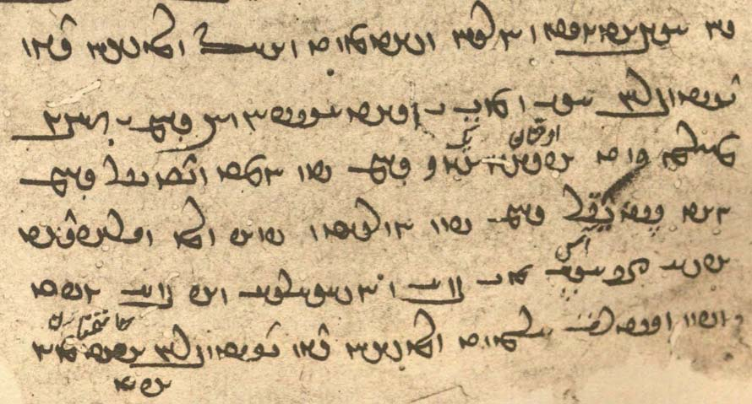
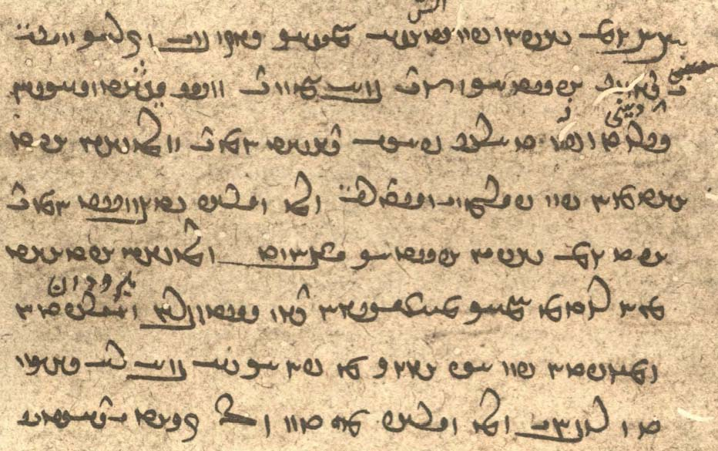

Make a list of the differences between the mss.
Also note the way diacritics are used.
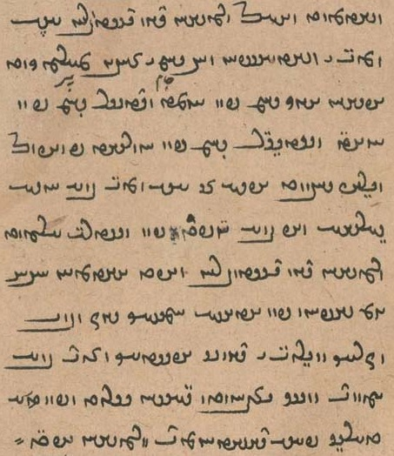
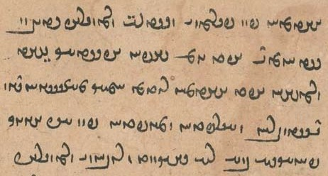

ud pas awēšān dēn dastwarān may ud mang ī Wištāspān ud 3 ǰām ī zarrēn purr kerd
u-šān ēk ǰām pad humad ud didīgar ǰām pad hūxt ud sidīgar ǰām pad huwaršt frāz ō Wirāz dād
u-š ān may ud mang bē (xward) ud ōšyārīhā wāz bē guft ud pad wistarg xuft
awēšān dēn dastwarān ud haft xwahān [K20 4r] 7 rōz šabān pad ātaxš (ī) hamēšag-sōz ud bōy-wizarāg nīrang ī dēnīg Abestāg zand bē *guft [mss. gōwēnd] ud nask yašt gāhān srūd (ud) pad tārīk pās dāšt hēnd
ud awēšān haft [M51b 156v] xwahān pad pērāmōn ī wistarg (ī) ōy Wirāz nišast hēnd haft rōz-šabān Abestāg yašt
awēšān haft xwahān abāg hamāg māzdēsnān dēn dastwarān ud hērbedān ud mowbedān pad ēč ēwēnag az pānāgīh bē nē hišt
Notes: We do not know whether <AHTE’n> is for xwah-ān or xwāhar-ān. — pērāmōn is spelled <pylmwn> as quite commonly. — Note the “bookish” spelling of māzdēsnān after Avestan māzdaiiasni, epithet of daēnā.

Additional readings 14.2
From the Ardā Wirāz-nāmag: AWN.19.1-20.3. — K26 fols. 23v-24v. – Punishments for anal intercourse and for not observing the menstrual precautions.

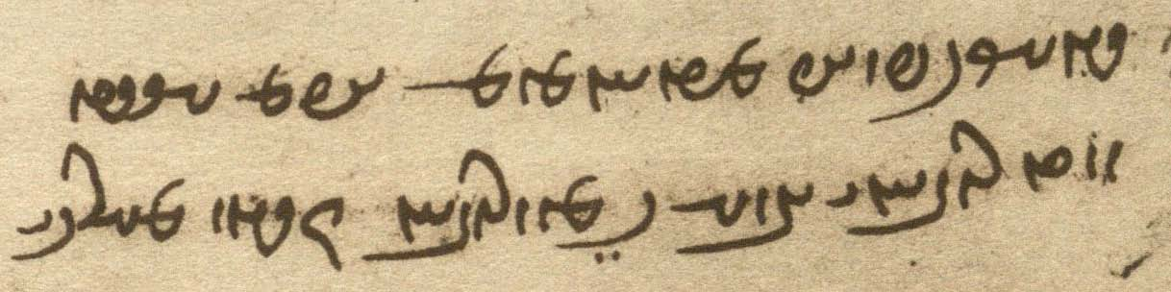
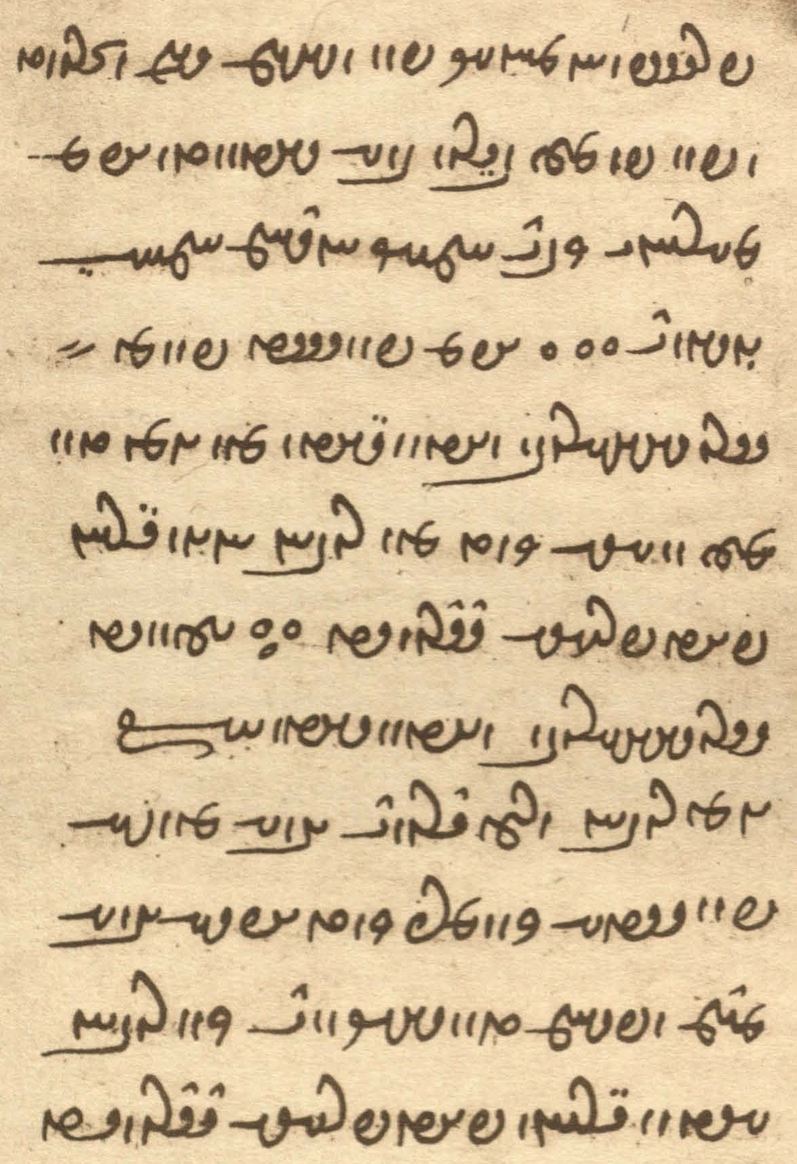

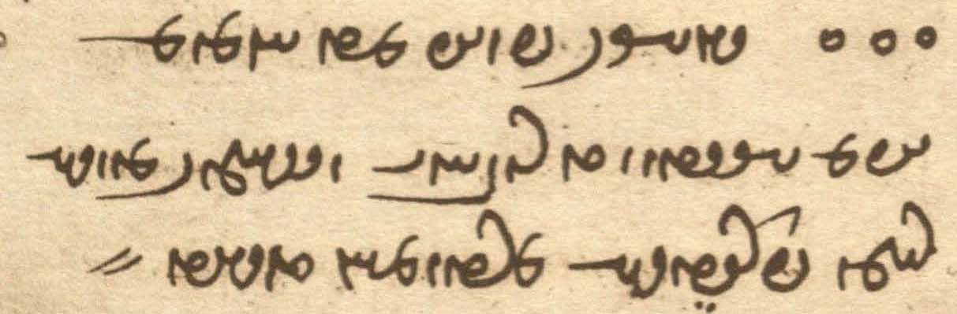
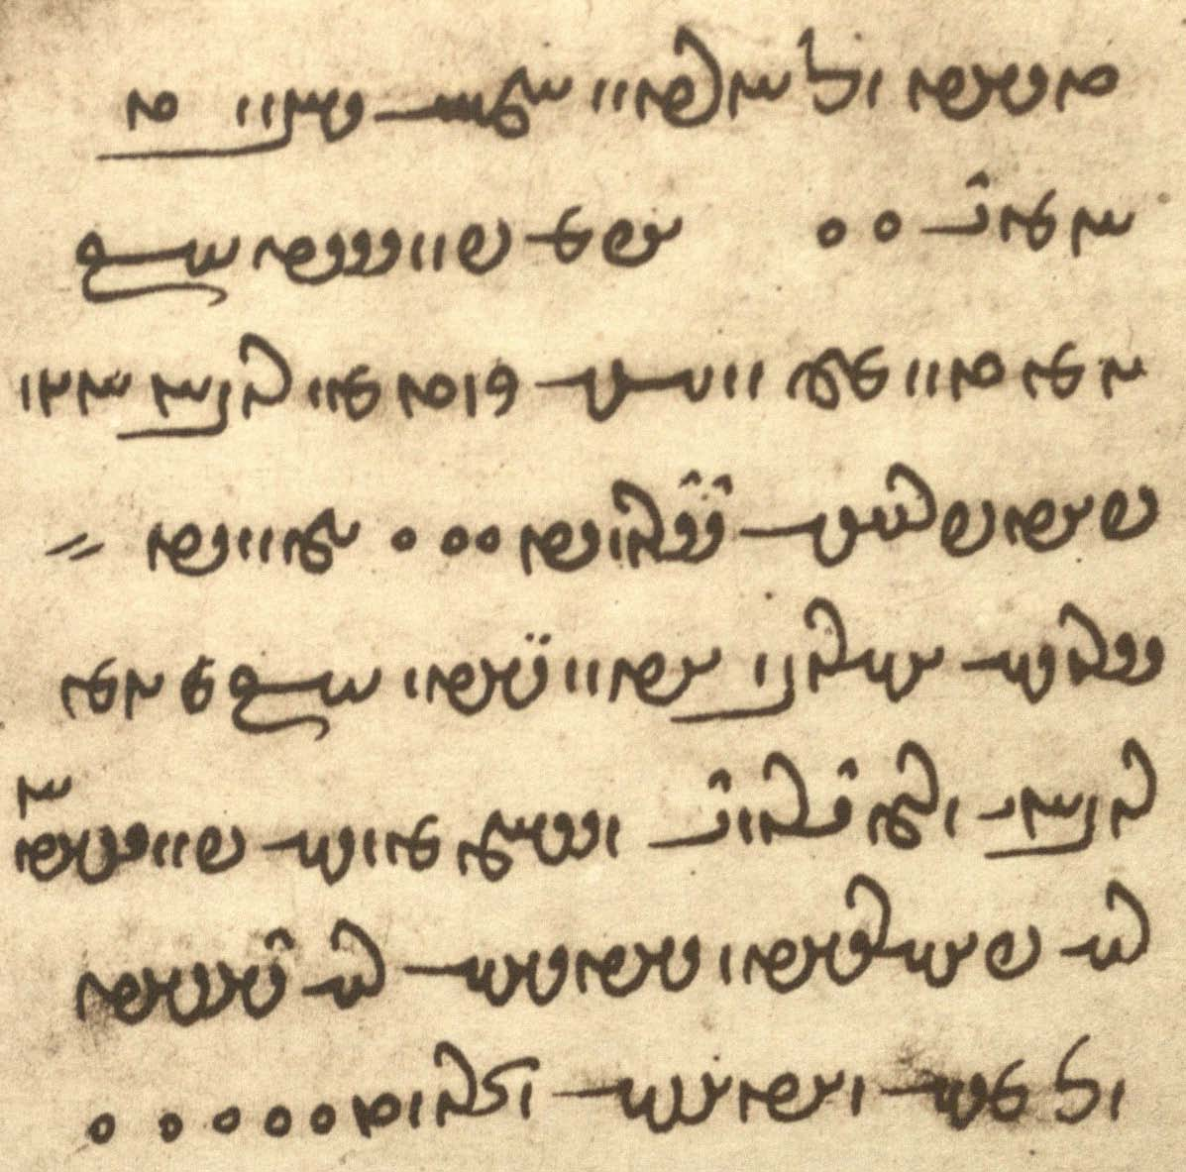

gyāg-ēw frāz mad ham u-m dīd ruwān ī mard-ēw kē ruwān čiyōn mār-ēw ī [K26_24r] frasp homānāg pad nišēm andar šud ud pad dahān bērōn bē āmad ud [ms. u-m] mārān ī was hamāg handām hamē ǰōyēnd
u-m pursīd az Srōš-ahlaw ud Ādur-yazd kū [ms. kē] ēn tan čē wināh kerd kē ruwān ōwōn garān pādifrāh barēd
gōwēd Srōš-ahlaw ud Ādur-yazd kū
ēn ruwān ī ōy druwand mard kē-š pad gētīy kūn-marz kerd u-š mard abar xwēš tan hišt
nūn ruwān ēdōn garān pādifrāh barēd ::
gyāg-ēw frāz mad ham u-m dīd ruwān ī zan-ēw kē-š rēm ud palīdīh (ī) mardōmān tašt [K26_24v] tašt ō xwardan hamē dād hēnd
u-m pursīd kū ēn tan čē wināh kerd kē ruwān ōwōn pādifrāh barēd ::
gōwēd Srōš-ahlaw ud Ādur-yazd kū
ēn [M51b_169v] ruwān ī ōy druwand zan kē-š pad daštān nē pahrēxt ud dādīhā nē dāšt ō āb ud ātaxš šud ::

K20 fol. 13r

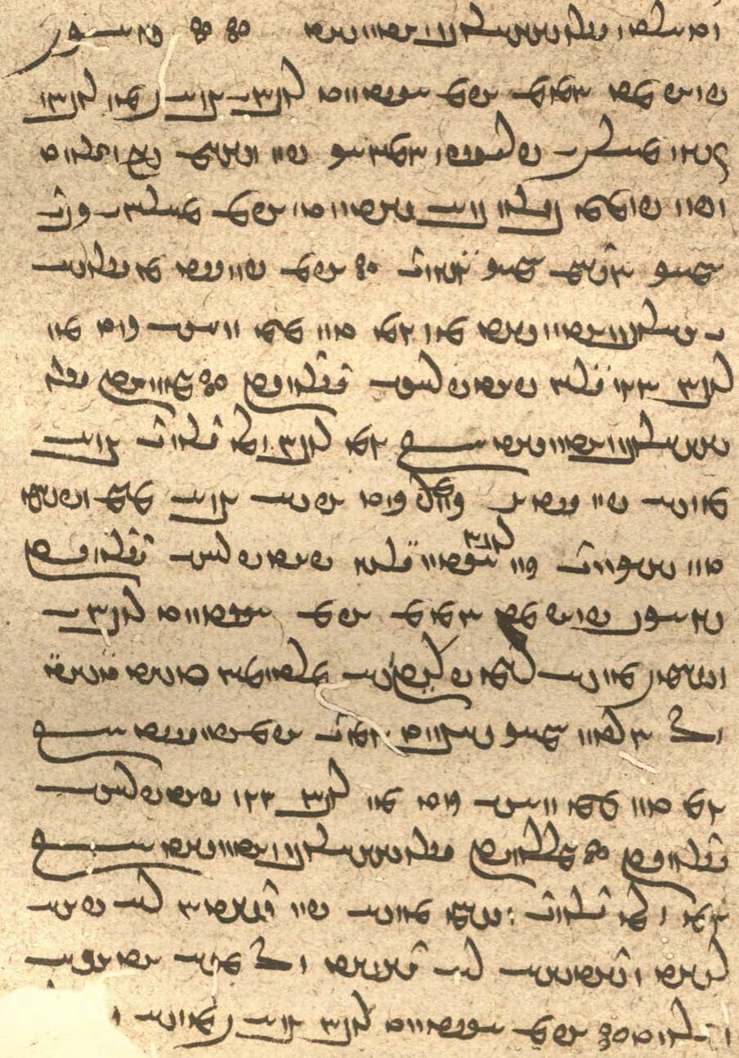

M51b fols. 169r-169v, pics. 39-40

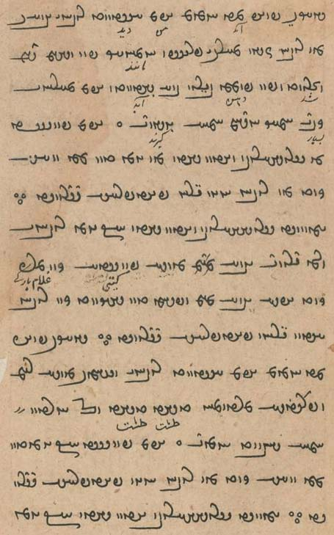
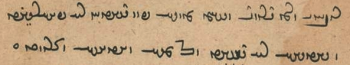

Notes:
bar-, like wēn-, about experiencing bad things.
dād hēnd can be plural because of tašt tašt “bowl after bowl” or a Persianism: NPers. dādand “they gave.”
pad daštān: during menstruation.
dādīhā nē dāšt “(and who) did not observe them according to the law.”

Additional readings 14.3
From the Pahlavi Videvdad: PV.1.13d, Avestan and Pahlavi (zand). — Mss. Meherji Rana Library G151 (beginning of L4), F10 (copy of K1). – About the evil sorcerers.

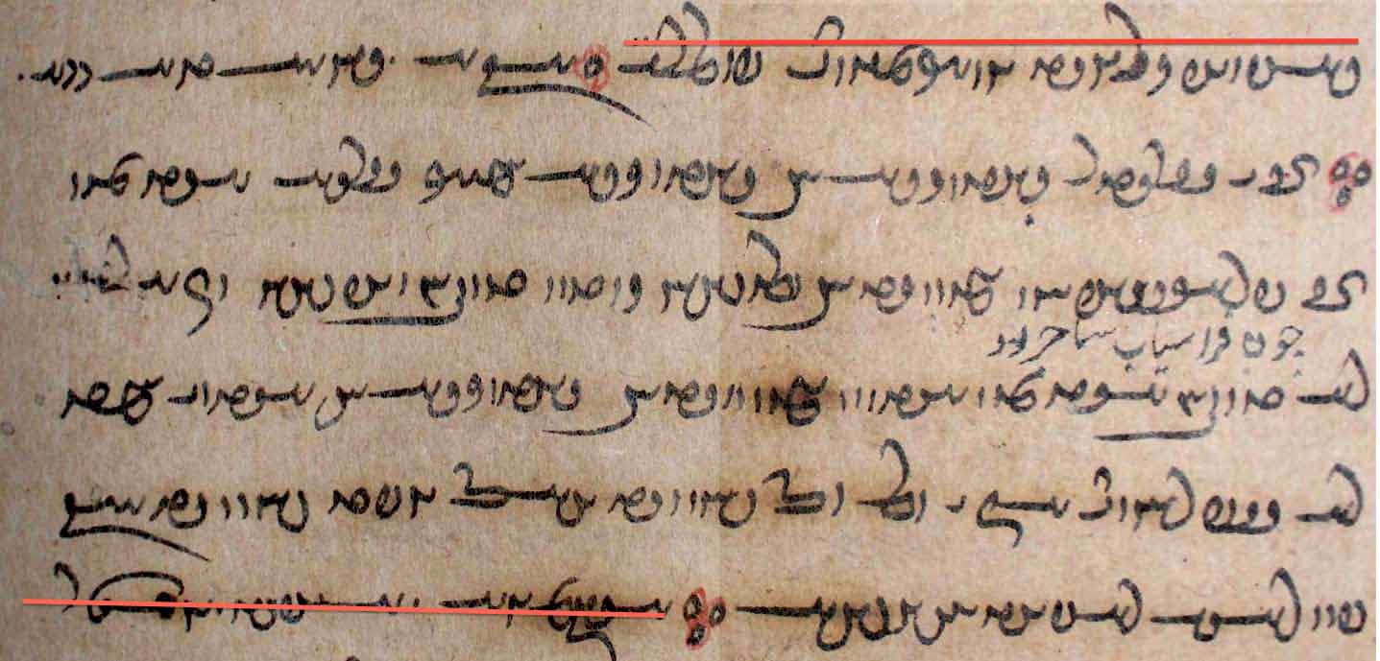

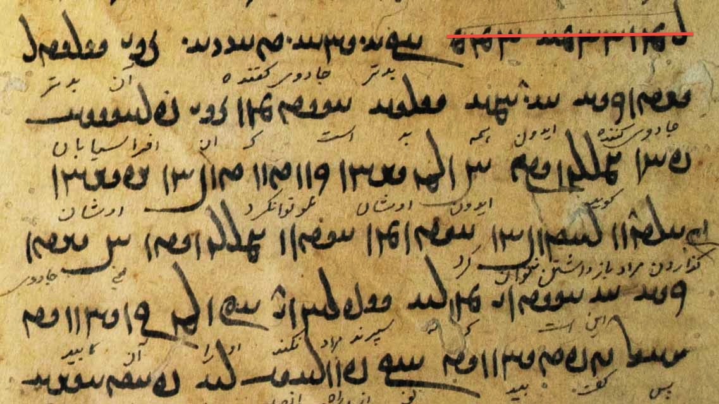

Av. aγa yātauua “evil” sorcerers.”
The zand:
ān ī wattar ǰādūgīh ay ǰādūgīh hamāg wad
ast kē ān ī Frāsyābān gōwēd ay awēšān kerdan tuwān u-šān wizārdan nē tuwān
ast kē ēdōn gōwēd ay ǰādūgīh ēd <’y> ast ī ka nē xwahēnd ā-iz warm ōh [ms. <OL>] bawēd
pas guft bawēd kū pad rāh (ī) nē pādixšāy (L4: <p’thšš’>) ∵
Note: Both xwah- xwast and warm are terms referring to the oral learning process. See Skjærvø “The Zoroastrian Oral Tradition” (2012).

Additional readings 14.3
From the Bundahišn: Bd.14.11-15. – Note the “indirect affectee” constructions.

? WtDWNwA WwaåJ ^ LtDbA ? WtDWNwA MWt¬M à íYwaåHM W îHM OW a˜wAwA ÍWTPwY
? xWwïÅW aåDwÍwï˜ WIWWB WwAtJtåD W lAK ? WtDWNwA WTWWvaD MwlaÅP Y EwÍwï˜ WI>WWB McÅ
? WtDWwAvzY oA WwaååH WtDcÒW WthLWwA W WtDWWWwmY WtÅwA WtDwï˜ Wt˜wA
? WtdA MWt¬M à WtDWwï˜ áÒ ^WT nLW WKwïÅ WwaHtÂA WtDWwï˜ NwY WtŸ∆>¸W 2 AWK WwaHnLW
? WtjM AWB WwaHcÅ ^NwA WTpL AWB tÂA WTWK NwY WwÍWWK WtŸ∆¸W WwaHcÅ
WtdßLwA W aå˜ W LtJ W ^>WcJwY W LwLwA W WimY W adM WTWWvaD a˜wAwA à WTPwY NwY WwÍBwY WtŸ∆¸W WwaHcÅ
÷ LB W WWV WtDWWWwmY ? EkAtDP eá¬aÅ N WN EtÅcÅ WcJwlA W
Wtja¬Y> waHcÅ YNwA WtDwYKwaÅ AWV WwÍwM ÍcÅ WtdlABwY> q WwÍwM WWP WklaÅTP ØaÅ WwaHcÅ
MwYN WIwAcÅ W Y>WcJwY< W LwLwA W WimZ adM WTWWvaD Y>Wwï>˜ WkAWwY< à

Glossary of words in the Texts and Exercises 14

Idioms
(abāg ...) hamist together with
az ahlāyīh paydāgīh for Avestan aṣ̌ō.ciθra- “having the seed of Order”
az pānāgīh hil- leave unprotected
bun ud bar beginning and fruits, capital and interest; first and last (indicates totality)
daštān dār- observe the menstruation rules
ēdōn homānāg čiyōn just like
ēk ōy (ī) did one another
frāz gīr- undertake
... hamist together with (postposition)
ī xwad ast who/which is nothing but (Lesson 15)
kār ud dādestān “work and justice”; expresses all human activities
miyazd kun- make ritual offerings (bread, fruit, wine, etc.)
nēk tō good for you! (Lesson 12)
pad ... abar = pad
pad ēč ēwēnag ... nē in no way
pad homānāgīh ī in the resemblance of, in analogy with (appr.: corresponding to)
pad kār ... dār- practice
pad ... rāy = ... rāy
pad tārīk in the dark
pad was-maragīh in great numbers
pādifrāh bar- suffer punishment
rawāg kun- give currency; set in motion, propagate
sahist seemed (good) to
tā hamē (ud) hamē-rawišnīh for ever and ever
tan andar uzīd appr. “he went out of his skin”?
tašt tašt bowl after bowl
xwadāyīh kun- rule

Nouns, adjectives, adverbs:
ahanūn-iz CWWwaÅ <’hnwnc> still; + nē “not yet”
abarwēzīh EcDwLcÅ <’p̄lwycyh> superiority (in battle, etc.)
abēbēš ßYvYcÅ <’p̄ybyš> unharmed
abesihišn Ww˙åJcÅ <’p̄shšn'> destruction
abōy YWbA <’bwd> unconscious
abzār la¸pA <’p̄z’l> tool, resource
agār (a-kār) lAkA <’k’l> undone, helpless
agāragīh (a-kāragīh) EklAkA <’k’lkyh> impotence
agriftār lATf:dA <’glpt’l> untouchable, intangible
anāgāh sAkAwA <’n’k’s> unaware
ardīkkarīh (ardīg-garīh) elYIt¬A <’ltykglyh> fighting, battle
arešk-gōhrīh elAwYkßlA <’lšk-gwhlyh> having an envious/jealous nature
asp-zahāy áå¸ WcjA <’sp̄' zh’y> the “depth” (height) of a horse
awērānīh Ewa¬YcÅ , Ewa¬YwA <’wyl’nyh, ’p̄yl’nyh> desolation, laying waste
bīm ÂGV <bym> fear
bowandag WIWWB <bwndk'> complete, balanced
bowandag-menišnīh EwÍwï˜ WkYWWB <bwndk' mynšnyh> complete/balanced thought, equanimity; renders Av. Ārmaiti
bowandag-menišnīhā aåDwÍwï˜ WI>WWB <bwndk'-mynšnyh’> with balanced thought, equanimously
bōy-wizarāg WkaÒCW YWB <bwd wcl’k'> fragrant
brāzišnīg WIwÍcåÒV <bl’cšnyk'> radiant
brēhēnišn WwÍwïådLV <blyhynšn'> assignment, allotment
burzišnīg WIwÍcÒWV <bwlcšnyk'> praiseworthy
čašmgāh aådmÍC <cšm-g’h> conspicuous
čērīh elYC <cylyh> valor
dar AıB <BBA> door; (royal) court
dīdār lAtJ <dyt’l> (act of) seeing
frārōn-tuxšāgīh EkahAWT WWwlaÒP <pl’lwn' twhš’kyh> diligence in doing good
frazām-pērōzīh ECwlYfÂAcÒP <plc’m-pylwcyh> final victory
*frāz-payrōg WTwLTP/WPwLTP cÅWP <pr’c' ptlwc/t'> shining far ahead (uncertain reading)
gad WtD <gt'> mace (Av. gaδa)
gāhān WwajaD , WwaååD <g’h’n', g’s’n'> the Gathas
gāw-zahāy áå¸ AWWT <TWRA zh’y> the “depth” (height) of a bull
hagriz ... nē âL ... cÒkA <hklc ... LA> never (see Lesson 19)
hamāg-pursišnīh EwÓJWWP WkaÂA <hm’k'-pwrsšnyh> being informed about all things; rendering of Av. *hāmō.fraša- “all perfect” or similar
hamē-rawišnīh ÍwÍBwláÂA <hmydy-lwbšnyh> eternity
hamēšag-sōz WCwS Wk˙dmA <hmyšk' swc'> ever-burning
hamkārīh elA˝ÂA < hmk՚lyh. collaboration
hērbed WTplÄ <hylpt'> teacher of the dēn
homānāg WkAwa˜wA , WkAwaÂA <h(w)m’n’k'> resembling, similar; + ō “to”
kēš ßYK <kyš> teaching; esp. of non-Zoroastrians and demons
homānāgīh EkAwa˜wA , EkAwaÂA <h(w)m’n’kyh> resemblance, similarity; + ō “to”
kūn-marz Wc¬MWWK <kwnmlc> anal intercourse
mānāg WkAwa˜ <m’n’k'> similar (to), like; cf. homānāg
mārīg Wila˜ <m’lyk'> word
marnǰēnīdār lAtDwYCwlM <mlncynyt’l> destructive
mowbed WTPwï˜ <mgwpt'> mowbed, high priest
nēmrōz WCwlmYW <nymlwc'> south
nihānīg WIwaÅW <nh’nyk'> in hiding, hidden
nišēm ÂïHW <nšdm> seat, bottom
niyāz WcåÅW <nyd’c'> need; needed; + ō “for”
nōg-wārānīh Ewa¬AW WKWW <nwk'-w’l’nyh> New Rain
ōšyār ladÍwA <’wšd’l> conscious
palīdīh EtdRP <płytyh> *offal, refuse
pas-dānišnīh EwÍwE oaÅ <AHL-d’nšnyh> backward-knowledge, knowledge after the fact
pānāgīh EkAwAP <p’n’kyh> protection; from pānāg “protector”
pīr lYP <pyl> old
puhl-ēwēnag WKwYwïÅ lAWP <pwhl ’dwynk'> like a bridge
rawāg WkABwL <lwb’k'> current; + kerd = rawāgēnīdan “give currency; set in motion, propagate”
rēm ÂïÒ <lym> filth, (bodily) dirt
sahīg WiaJ <shyk'> worthy
seǰ WcŸJ <syc'> something bad, “danger”
srūw WV]J <slwb'> horn, nail
šnūg WKWwÍ < šnwk'> knee
stard WtÒtJ <stlt'> (was) stunned/paralyzed
stardīh EtÒtJ <stltyh> stunned state, paralysis
tab WPT <tp'> fever
tam MT <tm> darkness
tašt WtHT <tšt'> bowl
uštar-zahāy áå¸ AnY <GMRA zh’y> the “depth” (height) of a camel
wadag-dōšīh eÍwYWKTW <wtk'-dwšyh> devotion to bad things
wan WWW <wn'> 1. victorious; 2. tree; 3. win “lute”
warm (probably narm) ÂLW <wlm> by heart (literally “tender” like meat)
wāz WcÅW <w’c'> + gōw-: say “grace”
wišōbišn WwÍPwÍW <wšwpšn'> turmoil, destruction
xar-zahāy áå¸ AnA <HMRA zh’y> the “depth” (height) of a donkey
xāyag WiaÅ <h’dk' > egg; + kun- “lay eggs”
xāyag-dēs sïD>iaÅ <h’dk'-dys> egg-shaped
xrōs SwlA <hlws> rooster
xwarāsān WwajaÒwA <hwl’s’n'> east, “sunrise”
xwarōfrān WwaÒPwaÒwA <hwl’wpl’n'> west, “sunset”
zadār-kāmagīh EkmAklAt¸ <zt’l-k’mkyh> killing-wish, wish to kill
zarmān WwaÂlZ <zlm՚n> old age
zofr LPU <zwpl> deep
zοfāyag W˝ÎÅPU <zwp’dk'> deep place

Proper names and ethnic nouns and adjectives:
Afrāsyāb WcååjaÒcÅ <’p̄l’syd’p̄'> Afrāsyāb (Frāsiyāb); a Turanian, Iranians’ epic enemy
Āz WcÅ <c'> the (female) demon Greed (Manich. Hule)
Frāsyābān WwAcå∆daÒP <pl’sy’p̄’n'> adj. from Frāsyāb/Afrāsyāb
Mānuščihr laDcHWwa˜ <m’nwšcyhl> epic character
Parōdarš ßlYwLP <plwdlš> name of the rooster, Av. parō-darš “the foreseer”
Tohmāspān WwAcjaÂAWT <twhm’sp’n'> son of Tohmāsp (Tūmāsp, epic character)
Uzaw WBwZwA <’wzwbw> epic character
Yazdgerd WTWkaD <yzdkrt'> name of several kings of Iran

Verbs:
abesih- abesist Wt∆jYcÅ, –aJcÅ <’p̄syh-, ’p̄sst'> be destroyed (< cut off); cf. abesihist
āhōgēn- āhōgēnīd –wYKwaÅ <’hwkyn-yt'> to soil, sully, pollute
āxēz- āxist (āxēzist) WtjaÅ , –cdaÅ <’hyc-, ’hst'> rise, get up
burz-īd –cÒWB <bwlc-> praise
frēst-, frēstīd (frēstād) [–WWtH] –WWwïH <ŠDRWN-> to send
ǰōy- ǰūd WTwY , -YwY <ywd-, ywt'> chew
mēz- mist (mēzīd) WtjM , -cdM <myc-, mšt'> urinate
pahikāf- pahikāft –cÅKTP <ptk’p̄-> split, pierce, drive through
pardaz- pardaxt WtådLP , –cdLP <pldc- pldht'> set about sth.; + ō
uzīh- uzīd WtdZwA , -adZwA <’wzyh-, ’wzyt'> go out, get out; pass (time)
winnār- winnārd Wt¬AwYW , -lAwYW <wyn’l-> hold up and out, set up, arrange
wizār- wizārd Wt¬ACW , -lACW <wc’l-> explain; ‘resolve’ (a sin) (make up for a sin)
xwah- xwast -WwaÒcJ , -WwaÒfD <YPLHWN-, YYP̄L-> thresh, pound

Lesson 15

Grammar 15

Possessive personal pronouns

Both Pahlavi and Manichean Middle Persian have possessive pronouns derived from the personal pronouns. In Pahlavi, the plur. oblique of the 1st sing. and 1st plur.—manīgān <mnyk’n'> and amāgān <LNEk’n'>—are found in only a couple of places in the Pahlavi Avesta:

kē mizd ī ō manīgān frāz dahē ān ī ō dēnīgān Ohrmazd ān ī ō manīgān hāwištān ī man abāyēd dād
“‘(you) who give the fee to mine (my people), the one for those of the dēn, O Ohrmazd’ the one to mine, (to) my students, (you) should give” (PY.28.6)

(ān J̌am) kē-š ō mardōmān čāšīd kū amāgān gōšt pad bazišn xwarēd
“(that Jam) who taught people: eat the meat of ours (= our people) by sharing it out!” (PY.32.8)

Reflexive pronouns
In ergative constructions, the reflexive pronouns normally refer to the agent, but sometimes to the grammatical subject or other parts of the sentence.

xwad WTwA , nÍPWB <BNPŠE, hwt'> “(my, your-, him-, etc.) self.”
xwēš ßYwA , nÍPW <NPŠE, hwyš> “(my, etc.) own.”

From these two, the nouns xwadīh “selfness, ‘essence’” and xwēšīh “ownership” are formed.
The mss. not infrequently have xwēš for xwad.

Examples with xwad:
xwad siyā būd u-š kunišn-iz siyā būd
“he was black himself, and his action too was black” (Dk.7.6.7)

az dām ī gētīy pad mēnōy dād nazdist 6 ān ī 7om xwad būd
“of the creation of the world of the living in the world of thought he first established six; the seventh was he himself” (Bd.1.52)

yazd ... mardōm nē ōwōn dārēnd andar ēn gēhān čiyōn xwad kāmag u-š pad tan-iz nēktar bē ... čiyōn ān ī pad ruwān sūdōmandtar
“the gods do not keep/regard a person in the world of the living (according) as it is his own wish (for himself) and it is better for his body, but as is more profitable for his soul” (Dk.6.221)

In ergative constructions:
čim andar gētīy az kunišn ī nēk ī-t xwad warzīd an āgāh nē kerd ham
“why did you not inform me about the good deeds which you yourself performed (while) in the world of the living?” (Bd.34.12; after the resurrection)
On xwad ... xwad, see below on reciprocal pronouns.

Note the expressions xwad ast “is itself, is nothing but” and ī xwad ast (short also ī xwad) which probably means “that is, nothing but ... (itself), who/which is nothing but”:

ān widarg kū abar āmad xwad ast rāh ī ō dōšox kē pad ān dwārēnd dēw ī druwand
“that passage where (Ahrimen) came up is itself (nothing but) the road to Hell, on which the wicked demons run” (WD.2.5)

sidīgar ham-hayārīh būdan ī dāmān ēk abāg did ud az ham-hayārīh ham-spāhīh az ham-spāhīh pērōzīh ī abar dušmen bawēd ī xwad fraškerd
“thirdly: that the creatures together should help one another; for from helping together comes going in army together, and from going in army together comes victory over the enemies, which is itself (nothing but) the Fraškerd” (WZ.1.23)

Examples with xwēš:
pad bahr ī xwēš hunsand bēd ud bahr ī anīy kas ma apparēd
“be content with your own share and do not take the share of another person!” (Handarz ī Husraw ī Kawādān 5)

abāz ō xwēš buništ tābēnd
“they (the heavenly lights) shine back toward their own place of origin” (Bd.7.9)

pid ud mād frazend ī xwēš rāy ēn and kār ud kerbag pēš az 15 sāl bē hammōxtan abāyēd
“parents should teach their own child these many works and good deeds before (it turns) fifteen” (PN.34)

In ergative constructions:
Mihr ī tamīg ō xwaršēd māh ī tamīg ō māh ī gōspand-tōhmag mad hēnd u-šān ō rahīy ī xwēš bast hēnd
“the dark Mihr came upon the sun, the dark moon upon the moon with the seed of cattle, and they tied them to their own chariots” (Bd.5.4a)

Ohrmazd az ān ī xwēš xwadīh az gētīy rōšnīh kerb ī dāmān ī xwēš frāz brēhēnīd
“Ohrmazd fashioned forth from his own selfdom (essence), from the light of the world of the living, the shape of his own creatures” (Bd.1.43)

Occasionally, the pronoun refers to other parts of the clause, e.g.:

u-šān kerdārīh pad dar ī xwēš gōwam
“and I shall talk about their activities in (their) own chapters” (Bd.13.37)

ēdōn-iš pad gyāg ī xwēš nimūd
“thus he showed it (= each nask) in (its) own (proper) place” (Dk.6D.8)
harw kerbag ī frāz mad, ī bē rāyēnīdan šāyist, pad xwēš hangām bē rāyēnīd ud ō zamān ī wēš nē spōxt
“(it is a good thing) to see to every good deed that has come (before one) that one should be seeing to in its own time and not to delay to more time (until more time has passed)” (rāyēnīd, spōxt: short infinitives)

The following expressions involving xwēš should by now be quite familiar:

X xwēš “belonging to X, that of X”;
ān ī xwēš X “my (your, his, our, their) own X”;
ō xwēš kun- (padīr-) “to make (receive as) one’s own, to appropriate”

Examples:

Ohrmazd xwēš ham
“I belong to Ohrmazd” (Dk.6.169, etc.)

pad ān ī xwēš hukunišnīh
“by his/one’s good actions” (PN.32) (= pad hukunišnīh ī xwēš)

man fradāg šawam abāg ān ī xwēš zōr Xyōn 15 bēwar ōzanam
“tomorrow I shall go and, with my own strength, kill 150,000 Xyōns” (AZ.55)

Ohrmazd ... az gētīyān bun mardōm ō xwēš kerd
“(as) the first of the (creations) in the world of the living, Ohrmazd appropriated (made his own) man” (Bd.3.14)

panǰom az mēnōyān Spandarmad. u-š az dahišn ī gētīy zamīg ō xwēš padīrift
“fifth of the beings in the other world (was) Spandarmad; and, of the creations in this world, she received the earth as her own (to be her own)” (Bd.3.20)

ān brādar u-š pad anīy rāh sazāgīhā ēw ast ēnyā ān guftan rāy stūrīh xwēštar bawēd
“unless (... ēnyā) there is one (brother) who, in some other way, is (more) suitably (appointed) than him, because of what was said, the stūrīh belongs more to that brother” (RAF.70.2)

az xwēš and az ān ī xwēš “of/from (one’s) own”:
ka dastwar gōwēd kū-m xwāstag frōxt bē az xwēš nē būd
“when a dastwar says: I sold the property, but it was not one of my own” (MHD.20.18)

u-š dastwarēnīd dād ud dēn pad sazāg xwāyišn ī az ān ī xwēš nē az ān ī a-xwēš
“and (the Creator) established as authoritative (dastwarēnīd) law and dēn (‘tradition’ about) seeking appropriate (mates) from one’s own (family), not from (a family) not one’s own” (DD.76.6)
About the establishment of procreation and xwēdōdah.

Expressions for possession and ownership:
In legal language these expressions implies “belonging absolutely,” as opposed to something that is “held” (dār-), i.e., temporarily:

ō xwēšīh (ā)madan/rasīdan “to come into one’s ownership, become somebody’s property”
ō xwēšīh padīriftan “to receive as one’s own”
ō xwēšīh dādan “to give to someone to be one’s own”
ō xwēšīh āwurdan “to bring back to someone’s ownership”
pad xwēšīh būdan “to be one’s property”
pad xwēšīh māndan “to remain one’s property”
pad xwēšīh dādan “to give to be one’s property”
pad xwēšīh dāštan “to hold as the property (of somebody else)”

asēm ī ō xwēšīh ī man mad ud zarr ī ō xwēšīh ī man rasīd čand arz
“how much is the value of the silver that became my property and the gold that became my property?” (MHD.24.6)

ka gōwēd kū-m ēn xānag pad mānišn dāštan ō tō dād ǰāwēdānīg pad xwēšīh dād bawēd
“when he says: I have given you this house to be your dwelling, (then) it is given to be his own forever” (MHD.24.13)

abarmānd ī pad stūrīh abarmānd ī pad xwēšīh būd nē šāyēd
“an inheritance in stūrīh can not be an inheritance that is one’s property (belong to him absolutely)” (MHD.25.5)

ān xwāstag abar awēšān pad xwēšīh mānēd ayāb pad stūrīh
“does that possession remain to them as (their) property or in stūrīh” (RAF.22.1)

xwēš tan pad xwēšīh ī Ohrmazd ud amahrspandān dāštan
“to hold one’s body as the property of Ohrmazd and the amahrspands” (PN.3)

xwēš tan, tan ī xwēš
The meaning “one’s own body” is common, but the later use as reflexive pronoun (as in Persian) is also found. Often it is difficult to distinguish between the two:

ēn ruwān ī ōy druwand mard kē-š pad gētīy kūn-marz kerd u-š mard abar xwēš tan hišt
“this is the soul of the wicked man who, in this world, practiced anal intercourse and let a man upon his (own) body” (AWN.19.4)

Ganāg Mēnōy az stī-tārīkīh ān ī xwēš tan dām frāz kirrēnīd
“the Foul Spirit whittled forth his own creation from the *existential darkness, (i.e.) his own body” (Bd.1.46)

pad tan ī xwēš abē-gumān kū ... tis-iz ǰuttar nē abāyēd kerdan kū ān ī-š kerd estēd
“(who) has no doubt in himself (in his own mind) that one should do nothing different from that which he has done” (Dk.6.23)
harw kas ōy ī did ēdōn dōst bawēd čiyōn tan ī xwēš
“everybody will be as friendly to another as to himself” (PR.48.102)

mardōm-dōstīh ān bawēd kē sūd ud nēkīh ī harw wehān ēdōn abāyēd čiyōn ān ī xwēš ān ī-š pad xwēš tan nē nēk sahēd pad kas nē kunēd
“being a friend of men is the following: he to whom the benefit and goodness of all good persons are as important (abāyēd) as his own (and who) does not do to anybody (= others) that which does not seem good to himself” (DD.62.25a)

xwēšīhā “by oneself, alone” and xwadīhā “by oneself, of one’s own accord”

ašmāh xwēšīhā bē nišīnēd
“sit down by yourselves!” (AWN.1.18)

ēn ān ī xwadīhā rasēd ō Ohrmazd yazišn ud stāyišn
“this is the one who comes of his own accord to the sacrificing to Ohrmazd and to praising him” (Dk.9.49.6)

Note also xwēšīhā-gāh <hwyšyh’ g’s> “latrine”:

dar ī xwēšīhā-gāh pad ān ī daštānestān šāyēd
“the door of the latrine can (be used) as that of a menstruation (hut)” (ŠnŠ.2.75)

reciprocal pronouns
The reciprocal pronoun is a double expression, as in English:

ēk (...) did Y>WT (...) WKwïÅ <’dwk' (...) TWB> “one ... another”
ēk ... didān WwaD>WT ... WKwïÅ <’dwk' ... TWB’n'>) “one ... another”
Note: the plural didān is rare.

Examples:
u-šān dūrīh ēk az did dūrīh-iz ī az āb ī Dāytīy čand bālāy ī xwēš būd
“and their distance one from the other, as well as the distance from the water of the (river) Dāytīy, was as much as his (Gayōmard’s) own height” (Bd.1a.13; about the Bull and Gayōmard)

u-šān rēšag ēk andar did ōwōn bē widārd
“and (he) passed their (-šān) roots one in/through the other in that way” (Bd.6c.1b)

ēk tā did šud nē šāyēd
“it is not possible to go (from) one to the other” (Bd.8.5; about the seven continents)

With singular verb:
mard ēw kē ēk abāg did ǰang kunēd
“a man who fights— one with another—, ...” (RAF.58.1)

ka ēk did rāy ul yazēd ā šāyēd
“when one sacrifices for another (when they sacrifice for one another) then it is appropriate” (ŠnŠ.11.6)

With plural verb:
ēk ōy ī did rāmēnēnd
“they cheer up one another” (WZ.35.29)

ud ēk ō did nē paywast hēnd
“and they are not connected to one another” (Bd.1.8)

ēk ōy (ī) did rāy wad xwāhēnd
“they seek bad (things) for one another” (ZWY.4.13)
Note: on ōy ī (like ān ī), see Lesson 4.

ēk ōy ī didān xwānēnd
“they call (out to) one another” (Dk.9.21.19)

ēg-išān dumb ēk ān ī did hamē xward
“then they ate one another’s tails” (WZ.15.1)

With 1st plural verb in direct speech:
u-š ēn-iz guft kū ka ōwōn gōwēd kū ēk ōy ī did pāyēnān hēm
“and he said this too: when he says as follows: ‘we are one another’s guarantor ...” (MHD.40.20)

Other reciprocal expressions

āgenēn “together, each other”

fradom warzišn ī xwēdōdahīh ān būd ī Mašīy ud Mašyānīy kē āgenēn brād ud xwah būd hēnd
“the first performance of the brother-sister marriage was that of Mašīy and Mašyānīy, who were each other’s brother and sister” (after DD.64.2)

harw 2 mēnōy pad-iz ǰud-wimandīh ǰuttar hēnd az āgenēn
“the two mēnōys (the good gods and the evil demons) differ from one another also by their different scope” (after Dk.3.123.41)

2 hamēstār ī dūr az āgenēn
“two opponents far from each other” (after Dk.3.150.2)

ka gōwēd kū mard 2 pad āgenēn 200 ō man dahišn āgenēn kār ēdōn framūd estēd kū rāst
“when (the creditor) says: two men together have to give (= pay) me 200 (drahm), (then) ‘together’ has been ordained (by the mowbedān mowbed to mean) ‘equally’” (MHD.40.2)

Note also the use of xwad ... xwad, mard ... mard, and similar:

xwad ō xwad kōxšēnd ud zanēnd ud darrēnd ud kirrēnēnd ud wišōbēnd
“they struggle with, strike, tear at, cut up, and destroy one another” (DD.36.94)

druwandān xwad ō xwad druwandēnēnd ud dōšaxwīgēnēnd
“the wicked themselves make themselves wicked and destined for hell” (Dk.9.42.6)

u-šān xwad pad xwad ān ī abārōn arešk abar burd
“and they brought the evil envy upon one another” (Bd.27.39)

mard az mard pursēnd kū-t pad ruwān dādestān čē būd
“(after the resurrection) men ask one another: what was the judgment upon your soul?” (Bd.34.20)

The verb. Passive
We are already familiar with the passive formations using the past stem + baw- “to be, become” (see Lesson 9). There are two other forms of the passive, both of which are formed with suffixes, one commonly to the present stem (-īh-) and one restricted to the past stem (-t-).

Passive in -īh-
The present passive stem is formed from the present stem with the suffix -īh-.
The past stem ends in -īh-ist, less commonly in -īh-īd.

Examples:
tan drustīh ud dagr-zīyišnīh ud ābād-xīrīh ōy rāy kē nibēsīhēm
“health, long life, and prosperity for him for whom I am being written!” (only in introductions to manuscripts)

pad ān čim Haftōring xwānīhēd
“for that reason/therefore it is called Haftōring (Ursa Major)” (Bd.2.9)

wināh (ī) pad nihān kunīhēd nē kerbag
“a sin that is performed in secret is (still) not a good deed” (Dk.6.119)

čē-š dānist kū ka ēbgad rasēd rōz pad ēn 5 hangām baxšīhēd
“for he knew that when the Invasion comes, the day will be divided into these five parts” (Bd.3.25)

pad ān abar bē zanīhist hēnd wispān xrafstarān
“in that (bucket with rain water) all the evil animals were struck down” (WZ.3.9)
In subjectless sentences a passive form can be translated using “one, somebody” (Germ. man, Fr. on). It can then be replaced by the 3rd plural active, e.g.:

kū pad gyān ī xwadāyān kōxšīhēd pad čē dārē u-š čē kunišn
“when somebody exerts himself (makes an attempt) upon the soul (life) of lords, how do you regard it, and what should he do?” (KN.10.9)

az ēk tā dah abzāyēd andarmāh xwānēnd
az dah tā pānzdah abzāyēd purrmāh xwānīhēd
“from the 1st to the 10th it waxes (and) they call it andarmāh ‘moon inside’;
from the 10th to the 15th it waxes (and) it is called purrmāh ‘full moon’” (Bd.26.22)

ōy kē pad kerbag kerdan dar wišādag nē dārēd ēg-iš dar ī wahišt ud garōdmān aziš bē bandīhēd.
“he who, when doing good deeds, does not keep (his) door wide open, then the door to Heaven and Paradise will be closed for him” (Some sayings of Ādurbād son of Mahrspand)

čiyōn-itān āfrīnēnīd purr-paymānīhā ud bowandag-abzōn-padēxwīhā ōy-iz ašmāh ... spurr rasād
ud dagr pattāyād ud ō nēk-frazāmīh paywandīhād
“in the same way you have blessed (me), let it too (the blessing) reach you complete in full measure and with complete growth and prosperity,
and let it last long and be connected to (your) having a good future!” (DD.0.3)

Derived nouns from passives in -īh- from basic verbs are very rare, while those from denominatives/causatives are common (see Lesson 16).

Note that the passive suffix can be combined with the symbols <x₁, x₂>, which can precede or follow the ending:
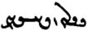 <YḆLWNyh-x₁> barīhēd “is carried”
 <YḆLWN-x₂-yhst'> barīhist “was carried”

Origin of the passive stem in -īh-
The passive marker -īh- was probably generalized from a few verbs in which the Old Persian passives in -ya- had produced forms in -ih-/-īh-. Compare:

škenn- <škyn-> škast “break” ških- (škīh-) <škyh-> “be(come) broken”
wisinn- <wsyn-> wisist “split” (trans.) wisih- (wisīh-) wisist “split” (intrans.)
(abesih-ēn- <’pysh-yn-> “cut off, destroy”) abesih- <’p̄ysyh-> abesist “be cut off, be annihilated”
Here škī̆h- is from *škidya-, -sī̆h- from *-sidya-.

abāg bun druz škihēd ud abesihēd
“the druz with its origin is broken and cut off” (Dk.3.105.9)

abāz-wisinnišnīh rāy kū tā pad 2 bē wisihād
“for cutting back, so that it is split in two” (PY.68.8e; explanation of Av. paitiscaptaiiaēca)

Passive in -xt and -ft
Some verbs with past stem in -xt or -ft have a passive, sometimes intransitive, even active, present stem in -xt- and -ft, as well. These passive verbs do not have a special past stem.
Note: See Dhabhar, 1955, pp. 109-112. These forms correspond to older forms in -s- with intransitive-passive meaning; e.g., Parthian buxs-, āmixs-, wiδifs-, Pahl. bōxt-, āmēxt-, wiyēft-.

From transitive verbs:
kas az ōy nē bōxtēd
“nobody is saved from it (= Time)” (Bd.1.42)

tan-išān abar zamīg ī ast ī ō āb ud ast ī ō urwar ast ī ō sag ēw gumēxtēd
“(when people die) their body (lying) on the ground is either mixed into water or plants or stones” (Dk.7.8.40)

nimūdār būd kū fradom Mēdōmāh pas harwisp ox ī astōmand hāxtēnd
“and (this) showed that first Mēdōmāh, then the whole existence with bones, will be led (to the dēn)” (WZ.20.4)
Zardušt dreamed that Mēdōmāh was the first guide of men of those before Z.

pad ātaxš ī andar dil kē-š sardīh ud xwēdīh ī az suš abāg āmēxtag
ham-ēwēnag paymānīgīhā bē tābēd ud hamāg tan garm dārēd
“by the fire in the heart, which is mixed with cold and humidity from the lungs (suš)—
in the same manner, it radiates warmth (bē tābēd) and keeps the whole body warm to its proper level (paymānīgīhā)” (WZ.30.21)

keš abāz ō keš nē kārišn tā andar ō kār kunišn hamē
ka be āšuftēd ā-š pad Abestāg abāz kārišn
“what has been ploughed should not be ploughed back into what has been ploughed until it is to be put to use;
if it is muddled up, then he should plough it again by (or: while reciting) the Avesta” (PV.9.32)

From intransitive verbs:
frāz franaftēd ō ān ī pahlom ox
“he goes forth (< franam-) to the best existence” (PV.18.29)

ēdōn ō tō gōwam Spitāmān kū ma ǰeh hāzē ō kunišn
kū-š zan ma kun ... u-š abāg ma xuft
“thus I say to you, Spitāmān, [quotation from Av.:] ‘do not induce a wicked woman to “do it”!’,
that is, do not make her (your) wife and do not sleep with her! (Dk.9.20.6)

Derived nouns from passives in -t-:
bōxtišn ī ruwān az harw ēwēnag anāgīh ud rasišn pad-iz tan ī pasēn
“the salvation of the soul from all kinds of evil and also (its) coming to the Final Body” (Dk.5.5)

tā ham-taftišnīh (ī) ābān kū purr bē tābād kerdārīh ī mardān
kū kār šāyēd kerdan zardušt
“‘until the waters having been warmed up’, i.e., (until) it is fully warm, ‘(there is) the work of men’,
i.e., it is appropriate to work, ‘O Zardušt!’” (PV.4.46)

Derived forms from past stems in -st (āmadišn is found in Man. MPers. and the Psalter):

pēš az abrāstišnīh ī pad xwadāyīh ud gumārdan ī pad dādwarīh ī ōy kas
“before that person’s being elevated to kingship and before he is appointed as judge” (Dk.3.387)

ag-dēnīg wināstišnīh ī pad āb ud ātaxš
“(another is this:) the water and fire being polluted (coming) from an evil dēn” (Dk.3.390.3)

bē dānēd kū az amar petyārag (ī) Ganāg Mēnōy ī druwand kirrēnīd 3 ēn garāntar
bastišn (ī) wēnišn ī čašm ud nē āšnawišn ī gōš ud sidīgar druz ī anāštīh
“know that, of the innumerable adversities that the Foul Spirit whittled forth, these three are the most serious:
the eye sight being bound (= closed), the ear’s not hearing, and the third the demon of discord” (PN.46)

Verbs. Ergative with passive.
In the inscriptions and the Psalter, there are no examples of the ergative with passive forms in -yh- and baw-, but in Pahlavi this usage is not uncommon, e.g.:

tarsāgīg kē Yišōy ī-šān Mašīhā-iz xwānīhēd pad pus ī yazd ... hangārēnd ...
grōh-ēw ham Mašīhā rāy gōwēnd kū murd grōh-ēw gōwēnd kū nē murd
“the Christians who count Jesus, who is also called Mašīhā by them, as the son of god ...
one group say about said Mašīhā that he died, another group that he did not die” (DD.36.76-77)

ud was ān ī xwēškār mardōm ...
u-t xwēšīhēd ān ī awēšān kerbag ud spās
“and many (are) people who perform their duties ...
their good deeds and service will be appropriated by you (Z.)” (Dk.9.24.17)

ēd ast ān xwarrah kē-š mardōm awiš dahīhist [hēnd] (awiš + implicit “them” in [hēnd])
“this is the Xwarrah that men were given by him” (WZ.3.74)

Passive with az “by” and pad “by (means of), through”

Passive with az “by” is rare:

mēš bērōn truft ud burd bawēnd az duz ud rabūd ud darrīd az gurg
“sheep (kept) outside are stolen and taken away by the thief and robbed and torn apart by the wolf” (Dk.3.385.6)

Passive with inanimate agents is quite common:

ān ī nē sōhīhēd pad sōhišnān wēnīhēd pad gyān wēnišn
“that which is not sensed (perceived) by means of the senses is seen by the seeing capacity of the soul” (Dk.3.123.26)

rāh ī ō ān ī rāst bowandagīh pad xrad dānīhēd
“the road to true completeness is known through knowledge” (DD.6.6)

gētīy pad ēn 6 tis rāyēnīhēd • pad zamān ud ǰahišn ud dānišn ud hayār ud abzār ud tuxšāgīh
“this world is governed by the following six things: by time, chance, knowledge, a helper, tools, and diligence” (Dk.6C.83b)

ēdōn gōwēd kū-š pad dandān grift ham ud (ān?) ēk gōwēd kū-m nē grift
“he says as follows: he seized me with the teeth! and (that) one says: I did not seize him!” (after RAF.58.5)

Constructions of result with baw-
Quite common in didactic style is what looks like a present passive with baw- in the ergative, but which is most often used to express a result: “if this happens, then (right away) this will have happened.” It differs from the passive in that it can also be formed from intransitive verbs, e.g.:

Intransitive
hamē ka ēdōn bawēd miyazd bē ō dēwān mad bawēd
“as long as it is like this, the myazd will have come to the dēws” (PR.16b.10)

ud tā-iz bar hamē barēd wizend ī pad awināhīh ī rād ō bun rasēd ō harw 2 nēm mad bawēd
“and as long as he carries (away = gains) the yield, (any) damage that comes to the principal in which the donor is not guilty will have come to (becomes the responsibility of) both of them, half (each)” (MHD.39.3)

Ergative
ka-š wināh-ēw tanābuhl kerd estēd drōn-ēw bē yazēd
ayāb kerbag ī tanābuhl bē kunēd ā-š wizārd bawēd
“when he has committed a sin worth on tanābuhl, (and) he performs one drōn sacrifice
or he performs a good deed worth one tanābuhl, then (the sin) will be atoned for by him (he shall have atoned for)” (ŠnŠ.8.20)

ka-šān rist wirāst bawēd čiyōn bawēnd.
ka-šān kerd bawēd waxšišn rōšnīh ī star ud māh ud xwaršēd andar abāyēd būd ayāb nē
“when they shall have restored the dead, how will they be?
when they have done it, will there need to be waxing of the light of the stars, and moon, and sun or not?” (DD.36.1)

čiyōn gōwēd kū drāyīd Gannāg Mēnōy ō dēwān kū ēd wād murnǰēnēd ī čēr ī tagīg ī Ohrmazd-dād
čē ka-tān wād murnǰēnīd ā-tān harwisp dām murnǰēnīd bawēd
“as it says: the Foul Spirit howled to the demons, (saying): Destroy this valorous, fleet wind set in place by Ohrmazd!
for, if you destroy the wind, then (at the same time) you will have destroyed the entire creation” (Bd.21.4)

frazānagīh-iš ī ohrmazd hammōxt bawēd kē ō ohrmazd ān nigēzišn ī fraškerd-kerdārīh
“he who (has given) to Ohrmazd that exposition of how to perform the Renovation, he will have taught the foreknowledge of Ohrmazd” (Dk.9.59.12)

wināh ī hamēmalān ka-š hamēmāl hušnūd ā-š wizārd bawēd
“(as for) a sin/crime against one’s fellow men, when (= as soon as) one’s fellow man is satisfied, then he will have resolved (the sin/crime)” (PR.18g.2)

Perfect (with est-) and ergative
In the inscriptions and the Psalter, there are no examples of the ergative used in the perfect, but in Pahlavi this usage is not uncommon, e.g.:

ēn-iz paydāg kū Ohrmazd ēn dām ud dahišn ī andar gētīy pad āsn xrad dād estēd
“this too is manifest: Ohrmazd has ‘created’ this whole creation in the world of the living by means of the Inborn Wisdom” (MX.0.49)

ēn-iz gōwēd kū kē yašt nē kerd estēd gētīxrīd nē framūd estēd ǰāmag ahlawdād ō arzānīgān nē dād estēd ānōh brahnag
“this too it says (in the dēn) that: he who has performed no sacrifices, has ordered no gētīxrīd (alms), (and) has given no clothes as alms to those worthy, (he is) naked there (in Paradise)” (Bd.34.26)

ruwān ī Karišasp anāgīh ī-š andar dōšox dīd estād rāy bē ō Zarduxšt guft
“on account of the evil which he had seen in hell, Karišasp’s soul said to Zarduxšt” (PR.18f.3)

ud am andar xwadāyīh hamāg kār pad hayārīh ī awēšān harw 3 ātaxš abērtar kerd
u-š Ādur Farnbay ō dād-gāh pad Xwarrahōmand kōf ī pad Xwārazm nišāst estād
“and in the reign of am, all work was done mostly with the help of those three fires;
and he had seated (enthroned) the Farnbay fire on a seat of justice on Mount Xwarrahōmand in Xwārazm” (Bd.18.6)

homānāg ī mard-ēw ka-š ǰāmag ǰāmag hamāg kust pad tan saxt andar kerd estēd
“like a man, when his various garments are firmly wrapped around the body” (Bd.1a.10)

ēg Ganāg Mēnōy a-wēnāg-frazāmīh rāy pad ān paymānag ham-dādestān būd
“then the Foul Spirit, because he did not see the outcome, agreed to that deal” (Bd.1.26)

Present participles
Three verbal nouns are made from the present stem (present participles) by means of the endings -āg (see suffixes, Lesson 4), -ān, and -endag (rare in early Pahlavi).

The agent noun /present participle in -āg
This participle is an agent noun used as an adjective. It can be negated and be turned into an action noun in -āgīh, e.g.:

ēn-iz gōwēd kū ān māhīg ōwōn mārāg kū andar ān ī zufr āb
sōzan tēx mālišn āb padiš bē abzāyēd ayāb bē kāhēd dānēd
“and it also says: that fish (the Wāsī Panǰāsadwarām) is so sensitive that, (even) in deep water,
it knows (recognizes if) the touch of water on it (as much as) the tip of a needle increases or decreases” (Bd.24a.5)

Kang-diz rāy gōwēd kū dastōmand ī pāyōmand
ud estāg rawāg ī hamēšag-wahār pad kamāl ī dēwān būd
“about the castle Kang (built by Siyāwuš, son of Kāyus) it says that it had hands and feet,
and was standing and moving, with eternal spring, on the head of demons” (Bd.32.12)

3000 sāl dām pad mēnōyīgīh estād kū būd hēnd a-mēnīdār ud a-rawāg ud a-griftār
“for 3000 years, the creation was in the state of mēnōy, which have been, non-thinking, non-moving, and non-seizing” (Bd.1.13)

kē az dēn āgāh ēg pad kār ud kerbag kerdan tuxšāg aziš a-wardāgtar bawēd
“whoever is aware of the dēn, then he becomes diligent in performing works and good deeds and (becomes) more non-turning-away from it” (PN.53)

ud pas frēzwān ast hamāg mardōmān *gōwizārīhā abar nigerīdan kū pad kerdan ī ristāxēz ud tan ī pasēn tis-ēw čē bōzāgīhātar
“and then it is compulsory for all men to examine closely what single thing (works) in the more salutary fashion in making the resurrection and the Final Body” (Ōšnar.55)

The present participle in -ān
This participle expresses accompanying action and can be used as an adjective, including as predicative noun, and as adverb:

Zarduxšt griyān passox guft
“Zarduxšt answered weeping” (PR.36.7)

ēg-im dīd ruwān ī mard-ēw kē kešān ō dōšox nayēnd ud hamē zanēnd
“then I saw the soul of a man whom they lead dragging (him) to hell and keep striking” (AWN.58.1)

niyāyišn (ī) xwaršēd pad pušt ī stōr šāyēd kerdan ayāb nē ...
az Abestāg paydāg
ka estān xēzān ayāb nišīnān ayāb nibayān ayāb barān ayāb wāzān ka aibyāst kū šabīg kustīg dārēd ēdōn radīhā
“is it appropriate to perform the reverence to the sun on the back of a horse or not? ...
it is manifest from the Avesta:
when standing, getting up or sitting or riding or driving, when (as long as) one is girded, i.e., one has (wears) the shirt and the belt, in this way it is according to the (ritual) model” (Purs.10)

ēk ēn kū hēnd az-iz hāwištān ī ka ō yazišn ī yazdān kerdan hamē šawēnd mēwag hamē āwāsēnd
ud agar ān āwāsišn namb-ēw az-iš bē burdan rāy kunēd nišīnān kunišn
“one thing is this: there are even some of the students who, when they go to perform a sacrifice for the gods, keep drying off the fruits;
and if one does the drying in order to remove (bē bar-) (even?) a single (drop) of moisture from it, one should do it sitting down” (ŠnŠ.10.5)

pad nišēbīgīh nirfsān nirfsān
(Dk.3.329.10)

Note widerān būdan = widerdan “to pass on, die”

The present participle in -endag (-andag)
This form is found frequently in the Pahlavi translation of the Xorda Avesta (almost exclusively kunendag), where it is probably influenced by modern Persian, but less frequently elsewhere.
In Pahlavi it is found in some idioms, e.g: šāyendag “worthy,” šāyendagīh “worthiness,” zan (ziyānag) ī šōyendag “a washing woman (wife),” i.e. a woman who is performing her ablutions after menstruation; ātaxš ī waxšendag “blazing fire” (also in Man. MPers.), wāyendag “flying thing, bird; zīndag “living” and zīndagīh “life” from zīyendag(īh), e.g.:

buland-ēwāz bē gōwam az anīy amahrspandān abārīg nēk hayārīh kunendag
“with loud voice I speak of the other Amahrspands, the remaining good assistance-giving ones” (PYt.3.3)

dūr-kunendag ast man Ardwahišt amahrspand kē bahr-ēw dahendag ast man ...
“removing, that is (ast) I, the Life-giving Immortal Ardwahišt; he who is share-giving, that is I ...” (PYt. 3.13)

Sentences 15

1. Transliterate/transcribe and analyze/translate these sentences and identify the grammatical points discussed in this lesson:
/ MWwAbzY Íƒ WwÍwï¸ WwaD W WWT WwAkaÂA WN nLW ? !
<OLE MNW ’m’k’n' tn' W y’n' zywšn' hcš YDBHWNm>

/ YwïhAWK nÍPW Y laÂïÂA WklYTP 1YtJ Y WwAwßaDWWV WcJwAWK WtDWWtÂaD WtDbïÅ tÂA ? 2
ka Ēbgad rasēd harwisp bun-dahišnān ī gētīy padīrag hamēmāl ī xwēš kōxšēnd

? nÍPW 1Y>Wwï>˜ WwaÅTwÍwA Y 1WkßYP AWK à WkAtDP CNwY ? 3
/ nÍPW WtDWnA Y,N W WtDWwA emY> Wt˜wYWcJ ï<ΩM WwYWWtH WtjA WthAWTwA 1YP W WkaÒ nÍPW NwAW e]JV
<ZNEc pyt’k' AYK KRA pyšk'-1 Y ANŠWTA’n' mynwy-1 NPŠE.
BSLYA whwmn NPŠE, lhk' W pyḏ ’rtwhšt', ’st' štr'ywr, mzg sp̄ndrmt', DMYA hwrdt', W mwy ’mwrdt' NPŠE>
(correspondences between body parts and the amahrspands)

/ Wwa¬aÅwlP WwAWB[aÅ WIKT Y lYC EKNTP `tJ WtdA nÍPWV Y ECNTPwAtDP OW AWB WtDwïådLV ÍcÅ ? 4
u-š brēhēnīd – bē ō pidān-paymōzīh ī xwad ast stī-paymōgīh – čēr ī tagīg ahlawān frawahrān
(How the fravashis were created to ‘clothe’ the unfinished beings)
/ WTNW Y>Wwï>˜ WkAwY< OW AWB ... Y>Wwï>˜ WkAwY< Y elAkA nÍPW Y ECwlYfÂAcÒP a˜wAwA ?23
<’whrmzd plc’m-pylwcyh Y NPŠE ’k’lyh Y gn’k' mynwy ... BRA OL gn’k' mynwy nmwt'>

/ mïåDWWvYTI WN áÒ nLW elïÅ WtÅcÅ W EwÍwï¸ :J> W EtJWwY> WWT WwAtja˜ Y WwsaD>W WKcDcÅ EwÍwYWcÅ ? 33
āfrīnišnīh abēzag weh dēn ī mazdēsnān tan-drustīh ud dagr-zīyišnīh ud ābād-xīrīh ōy rāy kē nibēsīhēm (in introduction to ZWY; the book/mauscript is speaking; ōy rāy kē “for him for whom”)

/ YwYtådMwY WkAwS Ä x W YWwlZW WkAwS Ä OW AWB WkaÂA WKt:J Y<LwY< ? 34
<gwlg sltk' hm’k BRA OL HD gyw’k' OZLWNd W BYN HD gyw’k' gwmyhtynd>

/žWWIÍ q WwaÒtJc¬A Y WwÍwZ WWP WwaÒAW elyL kL LthYT W ? 44
/ WtdaDCwaÅ q adM WN WtHT AVL WtDwY WtDwY YNwA WTWB WwAkßylS W
/ YNwA WTW[ZW x WimZ Y WkaÒwS x WN WwaDwïdAW N Y<wSW AWB WwaÒtJc¬A WwAcJW YNwA WtjaDWwLT˝¸ q ã WWP
ud Tištar 30 šab wārān pad zanišn ī xrafstarān abar hišt . ud sreškān būd hēnd ǰud ǰud wazurg tašt kē āb abar āhenjīhēd.
pad ān abar bē zanīhist hēnd wispān xrafstarān bē nihang az wāyendagān kē andar sūrāg ī zamīg andar šud hēnd
(how the rain contributes to ridding the world of evil animals)

... Ywï¬ATW WKtåÅTW Y WwïåÅ x MwY 3 WwaD>WwlY> Y WwAwAB{ ã WCwlY> WtdaDwAW tÂA WKwaÂZ WTWkßLP WWP ? 333
eLcÅwA WWP W WKcjL WtjG< N Y>wïådlsaD>ÍwY AWB WwïåÅ WKtåÅTW Y ã WWP EwßYwÍ MWtÒƒ Y ã WWP W
/ Y>wïåDcÒnA MWtÒcÅwA WwaÒcÅwA Y elAtdßAWcÅ W
<PWN plškrt' zm’nk' AMT w’nyhyt' dlwc' ZK lwb’n’n' Y dlwnd’n' 3 YWM BYN ’hyn' Y wt’htk' wt’lynd ...
W PWN ZK Y ’p̄ltwm šwdšnyh PWN ZK Y wt’htk' ’hyn', BRA ywšd’slyhynd MN gst' lypk' W PWN hw’p̄lyh
W ’p̄whšyt’lyh Y hw’p̄l’n' hw’p̄ltwm ’mwlcyhynd> (how the sinners are cleansed of their sins at the end)

Texts 15

Text 15.1
From the Bundahišn: Bd.26.9-14. – On Ohrmazd’s mercy and Wahuman’s duty.
Note the use of the suffix -īh to “quote”: u-š wehīh “and his ‘good’-ness, his being weh ‘good’.”

Y>WWtÂaD WwAwaÅ MwlaÅP Y ã ØW EtåÒ a˜wAwA Y ã WWP W Y>wYwï¸ WwaÂaD> elAtDcÒnA a˜wAwA Y ã WWP
? Y>WWtÂaD a˜wAwA Y e˙DwA ØW W Y>wYtÅWB WtDvïÅ N esAkAcJwlA W eY>NwAnï>D< a˜wAwA Y ã WWP W
WBwlaÅ Y AWbY< Wk˙åD> aÅtJ Íƒ
/ WtDWWwaD WtdßYV WPwïÅ WtDwïÂaÒ a˜wAwA ÍwsA WtdßYV WPwïÅ WtDwïÂaÒ WBwlaÅ Y YAWbY< WWM
/ lAtåD EthA Y Y>WwaÂA Y :DcH NwAW à WtDWWWwmY WwSC elG<waÂS>wA elAkÓDwA NwAW
WtD]J NwAW WwAwaÅ M[aÅP Y ã OW WwAB[aÅ à elG<waÂS>wA a∂¬YfH Íƒ
÷ WtDWwïÅW NwAW a˜wAwA Y WwaÂS>wA W

pad ān ī Ohrmazd āmurzīdārīh dāmān zīyēnd ud pad ān ī Ohrmazd rādīh ō ān ī pahlom axwān rasēnd
ud pad ān ī Ohrmazd xwarrahōmandīh ud harwisp-āgāhīh az Ēbgad bōxtēnd ud ō xwēšīh ī Ohrmazd rasēnd;
u-š gētīy daxšag mard ī ahlaw
kē mard ī ahlaw rāmēnēd ayāb bēšēd ēg-iš Ohrmazd rāmēnīd ayāb bēšīd bawēd
Wahuman xwēškārīh handēmāngarīh
čiyōn gōwēd kū Wahuman weh ī amāwand ī āštīh-dādār
u-š wehīh handēmāngarīh kū ahlawān ō ān ī pahlom axwān Wahuman barēd
ud handēmān ī Ohrmazd Wahuman kunēd

Text 15.2
From the Bundhišn: Bd.36A.1. – About the two things Wrath can ruin and the one he cannot.
à Wtja¬Y ÍcÅ WwYwL ‹ OW WtjlABwY ÂßA à WtDWnYWI WTPwY WwS x
/ WwABWT aÒ WWTWK cdMwY< L WN WtDWnYWI WTWWvaD MwYN 3 ìtJ x ÄTwA Y a˜wAwA nM MWwlZW aÒ ìtJ x L
/ nM MwYN 3 ã à WWWwmY à Wtja¬Y ‹
/ sY>WtDwA W Y>zadM W lABwaååD< à Wtja¬Y ÂßA
à Wtja¬Y ‹
/ kL Y WkmAK WWP lAK W WtJWwLBT AWB lABwaååD WtDCwY AWB 1MwYN WkwïÅ WwaHnLW N tÅ ? WWtÂaD AWB lAVwaååD x
/ kL Y WkmAK WWP lAK W WtJWwLBT AWB YzadM Wtja¬Y AWB !WkwïÅ WwaHnLW N tÅ ? WWtÂaD AWB YzadM WWP
a˜wAwA Y eßYwA N WTWwlZW W˝∆¸W OW lAB 3 WN nM MWtDwA aÒ WklAC L ÍnM WWiÍ AWB sYWtDwA
/ WtDWWwaD aÒ WkAtDwY WwaDWcJwaÂA W
andar dēn guft estēd kū Xešm dwārist ō Ahrimen pēš, u-š drāyīd kū
man andar gētīy nē šawam čē Ohrmazd ī xwadāy andar gētīy 3 tis dād estēd kē man gumēz kerdan nē tuwān.
Ahrimen drāyīd kū gōw kū ān 3 tis čē.
Xešm drāyīd kū gāhānbār ud miyazd ud xwēdōdah
Ahrimen drāyīd kū
andar gāhānbār bē ras. agar az awēšān ēk tis-ēw bē duzēd gāhānbār bē škast ud kār pad kāmag ī tō.
pad miyazd bē ras. agar az awēšān ēk-ēw bē drāyēd miyazd bē škast ud kār pad kāmag ī tō.
xwēdōdah bē hil. čē-š man čārag nē dānam čē kē 3 bār ō nazdīk šud az xwēšīh ī Ohrmazd ud amahrspandān ǰudāg nē bawēd

Text 15.3
From the Bundhišn: Bd.26.78-83. – Mss. TD1, fol. 72v, TD2, fol. 88r.
About the specific duties (xwēškārīh) of Spandarmad, the Earth. Her specific epithets are explained. Her epithet bowandag-menišn is the scholastic literal translation of Av. Ārmaiti from arəm.maiti “balanced thinking,” but should probably be understood as “complete/balanced thinking” or “equanimity.” In Dk.5.9.11, bowndag menīdan is is contrasted with tar menīdan “despise,” so, perhaps, also “admire” or similar, cf. Av. tarō.maiti- contrasting with arəm.maiti. [In the Xorde Avesta (PKX.3), we find once purr-menišnīg Spandarmad “Sp. (is) ‘full thinking’.”]

TD1, fol. 72v TD2, fol. 88r.
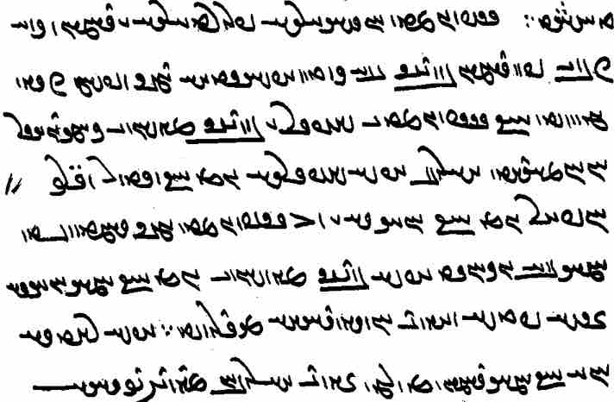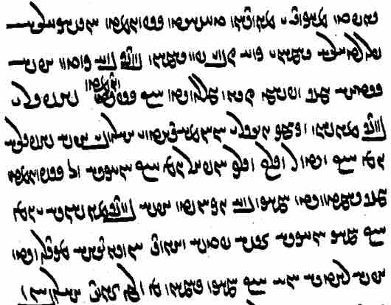

Spandarmad xwēškārīh parwardārīh ī dāmān ud harw xīr ī pad dāmān bowandag bē kerdan.
u-š gētīy zamīg xwēš.
čiyōn gōwēd kū Spandarmad ī weh ī rād ī bowandag-menišn ī kāmag-dōysr ī Ohrmazd-dād ī ahlawīy.
u-š wehīh ēn kū wīdwar ud gilag-ōbār
(u-š gilag-ōbārīh) ēn kū anāgīh ī ō Spandarmad zamīg rasēd hamāg bē gugānēd.
u-š bowandag-menišnīh ēn kū hamāg anāgīh ī-š padiš kunēnd hunsandīhā padīrēd.
u-š rādīh ēd kū hamāg dāmān az ōy zīyēnd.
Note: kāmag-dōysr, lit. “having eyes at wish,” is the rendering of Avestan vouru.dōiθra “with broad eyes.” The redactors of the Pahlavi text, regularly rendered all words beginning with v-r- as kām(ag).

Text 15.4
From the Dēnkard: Dk.9.60.4-5. – Ms. B, pp. [622-623] — Exegesis on the Pahlavi gloss in Y.45.10e: ahmāi stōi “for him to be”: ud ōy estēd “and for him stands” Spandarmad pad duxtarīh “and for him stands” (i.e.) “Spandarmad in ‘daughter’-hood (= as daughter).” The commentator compares the xwēdōdah relationship between Ohrmazd and Spandarmad to that assumed between the xrad “wisdom” and bowandag-menišnīh “equanimity.”

ēn-iz kū-š Spandarmad pad duxtarīh ō Ohrmazd čāšt kē xrad pad bowandag-menišnīh.
ēd-iz rāy xrad bowandag-menišnīh andar kanārag hēnd ī Ohrmazd ud Spandarmad.
ud xrad ān ī Ohrmazd bowandag-menišnīh ān ī Spandarmad.
ud bowandag-menišnīh xrad zahag čiyōn Spandarmad Ohrmazd.
ud az ēd bē guftan čimīg kū kē bowandag-menišnīh ō xrad paywast ā-š Spandarmad pad duxtarīh ō Ohrmazd čāšt bawēd.
ud ēn-iz kū-š ēdōn ān duxtarīh kunišn čāšt bawēd kē ahlāyīh pad bowandag-menišnīh.
This too:
He has ‘assigned’ (čāšt) Spandarmad to Ohrmazd as his daughter who (has?) wisdom with equanimity.
For this reason, wisdom and equanimity are next to Ohrmazd and Spandarmad.
And wisdom belongs to Ohrmazd, equanimity to Spandarmad.
And equanimity is the child of wisdom, like Spandarmad (that of) Ohrmazd.
And from this it makes sense to say that, he who has connected equanimity with wisdom, he will (at the same time) have ‘assigned’ Spandarmad to Ohrmazd as his daughter.
And this too:
In this way, he has ‘assigned’ that daughter-hood as worthy of being performed whose Righteousness is through/with equanimity.

Exercises 15

15.1. Transliterate, transcribe, and translate:
/ YwYTcjLP âL WcÒkA Y>WcJwaÂA W a˜wAwA ? !
/ WtjaDWWvaD Ewßad>maD> NTwL WwS à WtDWWWwmY WwS WWP ? 2
/ WthaD> EW]jA Y WkmaÒV W WtÅNTP WtDcJ Y WWCNTP nÍPWV a˜wAwA ? 3
/ WtjadlAwYW AWB ey>WbmA WWP WtjadlATW AWB Y>WT OW WKwïÅ WwAPWK Y WkßyL ? 4
/ YWWtÂaD aÒ nLW Y eßYwA OW lAwaÒ à WWTWK WwABWT aÒ WWWtdA a˜wAwA Y ÂaD> ‹ ? 23
áÒ Y>WT Y nLW WKwïÅ à YWWwaD AWB lATcjLP ATwÍwA WkaÂA ? WthAWt:¸ WwaÂAtDcJ ? ÂaD<wA ã x ? 33
/ YWwaDWV adlS
Ewaåd<ßA Y WCwlY ÍcÅ ? WtDWwïÅW Ww˙ÌaÅW ßAtÅ W WtDWwlZW WwahAtÅ Y Wwa˜ OW tÂA ? 34
/ WtDWWwaD WTWtda˜
WtåD MwA ã nM YwA Y NwïÅ W WklAwlÄ W WwAwZwA AWB WtdaHA WtDWWvzY a¬aÒ áÒ Y>WT WKwïÅ tÂA ? 44
/ ToanrlRlP,m1vzih / WkAtDP WwS N WwSC nÍPW
WtDWwsaD WwYtJwßAwïÅ Y î¬Z WN lAthYt¬A Y>WwlA Y ã WwSC WwaÂsA YWwï˜ á˜wAwA ? 333
/ Wt¬AwYW AWB YWwï˜ WkAWwY< Y WklYTP WwaÂsA tdA nÍPWV Y
Wtåd>a˜wAwA Y WIKT Y lYC Y WtDwYCwLwM WtÅW AwA à WwaååH OW YWwï˜ WkAWwY< Wtja¬Y> ? º
/ WtDWWwaD WtDwYCwLwM µaD> WfJwlA wATA WtDwYCwLwM WtÅW wATtÂA nM

15.2. Translate into Pahlavi and write in Pahlavi script with transliteration and transcription:

1. He who is not in charge of himself should be considered poor.
2. Zardušt himself said: do good deeds to one another so that your own place (gāh) will be in paradise!
3. He who makes metal happy or harms (it), he will then have made Šahrīwar happy or have harmed (him).
4. He who commits a sin toward (andar) water, and (then) kills frogs and the other evil animals living in water, he will have ‘resolved’ (it = the sin).
5. The white falcon was created in order to kill snakes, but it happens that they are equally strong and they both are intertwined with one another and fall dead to the earth.
6. It may happen that a man is healthy and active and before six o’clock he is sick and inactive and the next day he is mingled with the earth and becomes dust.
7. He who commits a sin and becomes repentant within a year, then, because of that repentance, (his) soul is saved from hell.
8. When a margarzān has repented for his sin, then he is (only) killed at the order of the lords and suffers no other punishment.

15.3. Match the Pahlavi words with their transcriptions.

Wwtåda˜wAwA Ewaåd<ßA laÂYW aǰgahānīh drīst paymōzan
NwïÅ wATA Ww˙daÅW amahrspand ērwārag wad
eßYwA WklAwlÄ Wt¬AWW artēštār frēftār wēmār
ÂaDwA YWwaDWV î¬Z arwand hagriz winnārd
WcÒkA WtåD WtDwYCwLwM āsrōnīh hangām xwāhēnd
Y>WwlA adlS WKtÒN ā-tān murdag xwēšīh
lAthYt¬A Wt∆DWwY lATcjLP ā-šāyēd murnǰēnēd/-īd yazēd
WcJwaÂA WtDWwAvzY WWCNTP čašm niyāyišn yazd
EWwlsA Wtja¬Y> YWT did ohrmazd-dād zrēy
WtdaHA drāyīd

Additional readings 15

Additional readings 15.1
From the Kār-nāmag: KN.13.1-8. – About Šābuhr ( lAWcåH ), Ardaxšīr’s unknown son, and his meeting with a young woman, who pretends she is the daughter of a farmer, but is actually the daughter of Ardaxšīr’s enemy Mihrōg. Note late grammatical features: nouns in -ān and man as grammatical subject. Note also abgand spelled <LMYTWNd> for <LMYTNt'>

? WTWwlZW lYcåÅW OW WTWWtåD WWtH ã OW Wwa¬ïhad>lA ^ lAWcåH 1MwY áÒ WwÍwïådLV WwaÂZ W WwßaD.
/ WTWWwaD ÍTP WKcDWK WN Wt˜ At˜ ã OW lABwsA 333 NTwL nÍPWV lYcåÅW ^ oaÅ W
? WTWWvaD áÂA adM áÒ WwadAplaÅC W WtåÅ áÂA adM W WTWWwaD aÅC ^ nßYwL WWP WKcDWK áÒ WwßaD.
/ WtÅWnYWI WTWwlZW 1lAK WWP LIcÒW
/ WtDÚWcÒ WT[Y> WWP W lYfH W WtJwlY à WTPwY WTW]J nïŸJW W WtjaÅ WtdY> Wwa¬ABwsA W lAWcåH ÍtÂA WKcDWK
? MCwA adM L Y>W µlY< µaD<wA W WKWwA WwAtå¬Y> ^ W∂d,aJ µïJB WkAwïD nM WtJWWvYtD WtdaÂLP AWB
/ WtDWNtHW adM WwaÒWtJ W nÍPWV
à WTPwY WKcDWK OW ÍcÅ WTWWwaD Wwï<Â˙dA áÒ EKwßT W E˝jLwY< W EI>wa˜ lAWcåH
/ WtdAcÅ aÒ lAK WWP kL ^ adM NwL WwmïÒ Y 1S AWB
/ WtJWWvYtD AWB !WtJWK WWP WTWwlZW laÂYT WWP WKcDWK
? WtDWWbaD adM WwaÒWtJ W µYWwïÅW WcÅW NwL Y>W WtDCwaÅ adM W WtDWtdmL aÅC OW WKcdA à WTPwY Wwa¬AVwsA OW lAWcåH
/ WtjaH aÒ WWtdÍK âlâL WTWB adM nla˜ áÒ WKcdA ^ EAbL W Y>WWtdmL aÅC OW WKcdA WTWK WKWwï<ÂA Wwa¬AVwsA
/ TWK sAKW áÂA kAwS lWY N KcDWk W
TWwlZW aÅC l⁄ ØW TWwïÅW µßA tjaH aÒ WtåÅ aÅC N KcdA wa¬ABwsA à TWWtjA ÍtÂA lAWcåH
/ tDNwA LtÒWwATWW LtD>WwaÅtÅcÅ !nßYW N WN tÅWWwaD Y<WWW ÂlÍ wATà tåD> wa¬ABwsA ØW waÂÍwY>W
/ tåÅ AlAL aÅC N KcdA Íƒ TWK sYwlA WWP lAwZW ¼WwïJwY wa¬ABwsA nS N sYwlA Íƒ
/ tJWŒ º>cÅ KcDWK lAWcåH Y KwlYWW LWwAW lAwZ WWP
TPwY TWK WwYWcÅ tJPwA Y,wL WWP t˜ lAWcååH WwYwL ØW wABwY> tååÅ ALAL aÅC N kcdA nÍPW
÷ MwlaÅP WAt:˜ wa:dßAt¬A lAWcååH tDWWwaD kÍWwA à
ǰahišn ud zamān brēhēnišn rāy rōz-ēw Šābuhr ī Ardaxšīrān ō ān šahr āmad ō naxčīr šud
ud pas ī naxčīr xwad abāg 9 aswār ō ān deh mad kē kanīzag padiš būd.
ǰahišn rāy kanīzag pad sar ī čāh būd ud āb hamē haxt ud čahār-pāyān rāy āb hamē dād.
warzīgar pad kār-ēw šud estād.
kanīzag ka-š Šābuhr ud aswārān dīd āxist ud namāz burd guft kū drust ud weh ud pad-drōd awarēd.
bē framāyēd nišast čē gyāg xwaš sāyag ī draxtān xunak ud hangām garm tā man āb henǰam.
xwad ud stōrān āb xwarēd.
Šābuhr māndagīh ud gursagīh ud tišnagīh rāy xešmgen būd u-š ō kanīzag guft kū
bē ǰeh ī rēman amāh āb ī tō pad kār nē abāyēd.
kanīzag pad tēmār šud pad kust-ēw bē nišast.
Šābuhr ō aswārān guft kū hēzag ō čāh abganēd ud āb āhenǰēd tā amāh wāǰ gīrēm ud stōrān āb dahēd.
aswārān hamgōnag kerd hēzag ō čāh abgand ud wazurgīh ī hēzag rāy purr āb būd ul kešīdan nē šāyist.
ud kanīzag az dūr gyāg hamē nigāh kerd
Šābuhr ka-š dīd kū aswārān hēzag az čāh haxt nē šāyist xešm grift ud ō sar čāh šud ud dušmān ō aswārān dād
kū-tān šarm nang bawād kē az zan-ēw a-pādyāwandtar ud wad-hunartar hēd
u-š arwēs az dast aswārān stad ud zōr pad arwēs (kerd) u-š hēzag az čāh ul haxt
pad zōr ud hunar ud nērōg ī Šābuhr kanīzag abd sahist ... xwēš hēzag az čāh ul haxt
dawān ō pēš Šābuhr mad pad rōy ōbast āfrīn kerd guft kū anōšag bawēd Šābuhr Ardaxšīrān mardān pahlom

Additional readings 15.2
From the Dādestān ī dēnīg: DD.63. — Mss. K35 fol. 177r-v, T60 fols. 100b-101a.
The answers are written in response to questions raised by the hu-dēns, so pursēd is 2nd plural.

63om pursišn :: ān ī pursēd kū fradom dahišn ī mardōmīh az čē kerd
bun-tōhmag ī mardōmān čiyōn-iz būd
az Gayōmard kē bē āmad ud čē bē būd
Mašīy [K177v] ud Mašyānīy az kē bē būd hēnd
pāsox ēd kū
Ohrmazd ī wisp-xwadāy az ān ī asar rōšnīh brēhēnīd āsrō-kerb kē-š dām ān ī Ohrmazd ud rōšnīh ān ī ātaxš
ud asōzišnīh būd čiyōn *xwarg ī rōšn, abzōnīgīh čiyōn zamīg ī hubar
u-š andar ān [T60_101a] āsrō-kerb dād mardōm ī xwānīhēd gētīy
ud 3000 sāl ka nē raft u-š nē xward nē xuft u-š nē guft
bē-š ahlāyīh menīd ī pahlom ud dēn ī rāst ī abēzag-stāyišn kām ī dādār
ud pas mad *ōy druz ī kōxšišngar u-š wināhīd
zīndagīh kerd garān margōmandīh ī xwānīhēd Gayōmard ī wizārīhēd zīndag ī mīrāg
az Gayōmard pad bē-widerišnīh frāz tazīd šusr ī zīndagīh gōhr ud mad bē ō zamīg ī Spenāg-dād
pāyīhīd andar zamīg pad ān ī yazdān pādārīh
az-iš hambūsīhīd pus ud duxt mardōm ud rust hēnd abar būm
ud wašt ō ǰumbišn ud rawišn
mad hēnd bē ō-iz hamgumēzišn ud zāyēnīdārīh
ud az ān zamīg kū Gayōmard gyān bē šud zarr
ud az [T60_101b] abārīg būm kū handām handām ōš mad čand ēwēnag āyōšustān ī brāziyāg frāz tazīd guft estēd
Note āsrō-kerb spelled <’slwk(') klp>, where <-wk-> is a regular way of spelling long ō in words from Avestan (āθrō).

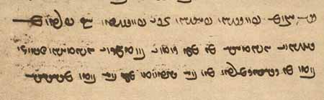
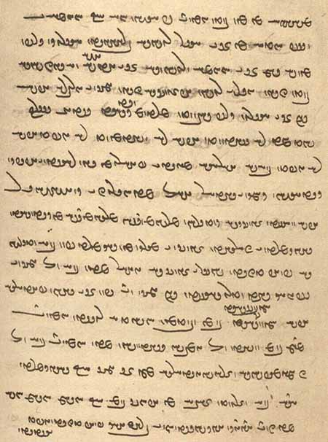
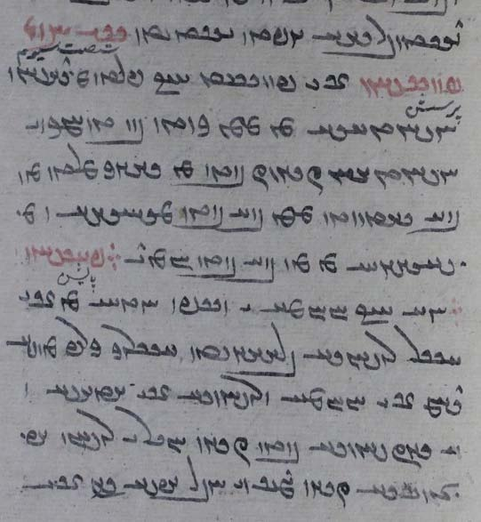
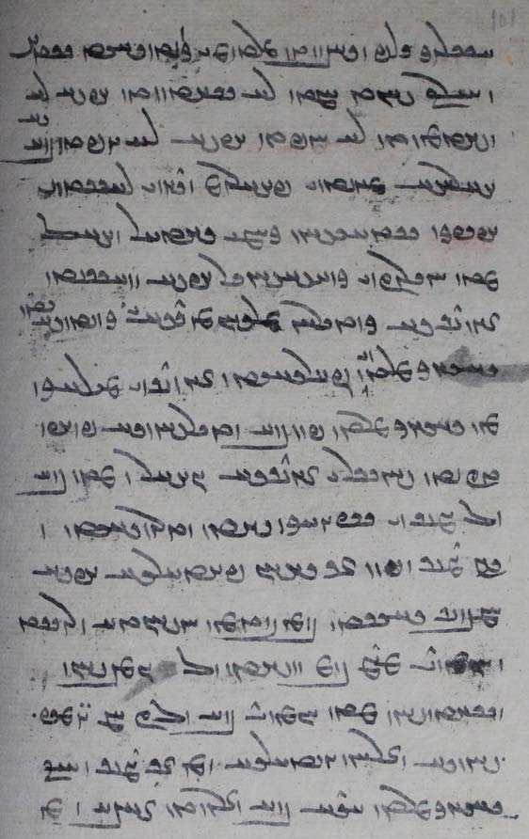
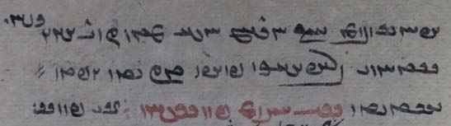

Additional readings 15.3
From the Dēnkard: Dk.9.58.17. Ms. B, pp. [617-618], DH fol. 318r.
Exegesis on PY.43.6d-e:

awēšān kē rad hammōzēd pad bowandag-menišnīh Sōšāns
kē ēd ī tō xrad padiš nē pad tis bē frēbīhēd
He who teaches them the rad by Equanimity, (i.e.) Sōšāns;
by which (whom?) this wisdom of yours is in no matter deceived.

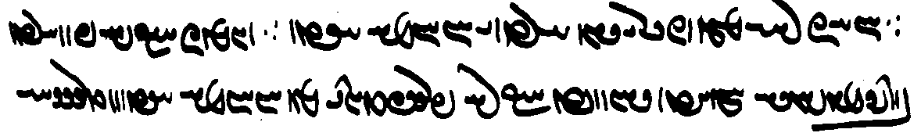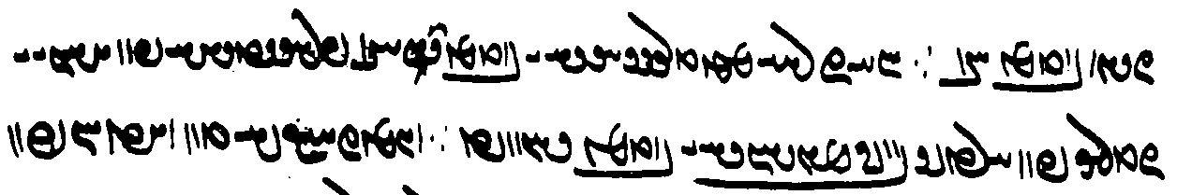

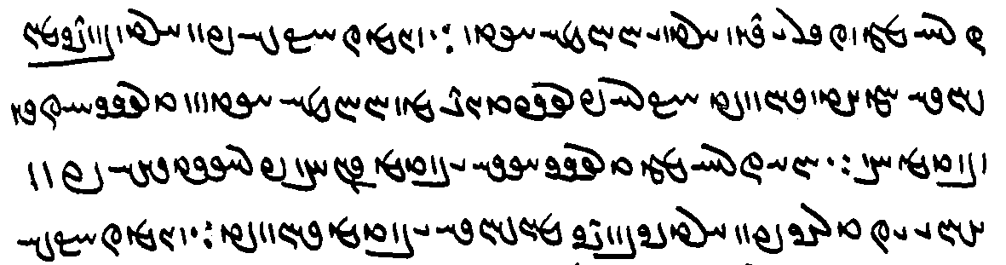

ud ēn-iz kū-š pad xrad bowandag-menišnīh hammōxt bawēd kū nē frēftēnd kē Ohrmazd ēdōn tarsagāy [B618] čiyōn duxt pid ::
ēd-iz rāy čē tarsagāyīh ī duxt andar pid frayistīhā pad āhang ī čihrīg pad xradīg bowandag-menišnīh ī duxt bawēd.
And this, too, that by his wisdom (xrad) Equanimity is taught so that they are not deceived who are respectful toward Ohrmazd in this way, in the same way as a daughter toward her father.
And for this reason too, because the respect of a daughter toward her father is mostly by natural inclination, by the equanimity of the daughter inspired by her wisdom.

Glossary of words in the Texts and Exercises 15

Idioms:
andar zamān right away
āgāh kerdan make aware, inform
ān-and ... čand as much ... as, so ... that
bawēd ī ka it happens that, sometimes
bē begone!
ēdōn ... kū in such a way that
ēn kū (is) this, (namely) that
framāyēd nišast please be seated!
ǰud ǰud each one separately
kār pad kāmag ī X the matter (will be) as X wishes
mard ī ahlaw a/the Righteous man; epithet often applied to Gayōmard
ō nazdīk šaw- ‘approach’ (for sex)
ō ... pēš (come, go, etc.) before (someone)
pad ān abar thereby
pad andar in(side)
pad ... pādixšāy in charge of
pas az ān ka after (conjunction)
pas ī after (location)
pēš kū before (conjunction)
rāh dār- “hold” the road; cf. rāh-dār “highway robber”
šāyēd būd ka it is possible that, it may happen that
ul yaz- = yaz-
widārīh- be passed through (one another)
6 zaman 6 o’clock

Note expressions for penitence:
pad-petīt = petītīg penitent
petītīg = pad-petīt penitent
petītīgīh penitence
petīt-wināh having repented for one’s sin(s)

Nouns, adjectives, adverbs, pronouns:
ābād-xīrīh elïÅ WtÅcÅ <’p̄’t' hylyh> prosperity
abar-kār lAKq <QDM-k’l> superior, more effective than all others
aboxšīdārīh elAtdßAWcÅ <’p̄whšyt’lyh> forgiveness, mercy
ābustan, ābestan WWtJcÅ , WWtJWcÅ <’pwstn', ’pstn'> pregnant
abzōnīgīh EIWwZcÅ <’p̄zwnykyh> being full of increase/growth
āfrīnišnīh = āfrīn EwÍwYWcÅ <’p̄rynšnyh> blessed be! (lesson 12)
agārag WklAkA <’k’lk'> inactive
āhang YwaÅ <’hng> inclination
aǰgahānīh (ažgahānīh) Ewaåd<ßA <’šgh’nyh> laziness
anōšag WkÍWwA <’nwšk'> immortal
arwand YW>wlA <’lwnd > fleet, fast; Av. auruuaṇt
ārzōg WKWc¬A <’lcwk'> desire, longing
asōzišnīh EwÍCwsA <’swcšnyh> non-burning
āsrō-kerb WcÒK K]jA <’slwk klp'> in the form of fire
āsrōn WWwlsA <’slwn'> āsrōn, head priest
āsrōnīh EWwlsA <’slwnyh> office of āsrōn, head priest
ast = astag WtjA <’st'> bone
ayōxšustēn WwYtJwßAwïÅ <’ywhšwstyn'> of metal
baršnūm MWwßLV <blšnwm> a purification ritual
bāz WcÅB <b’z'> falcon
brahmag W˝ÂaÒV , WkmaÒV <blhmk'> form, manner, costume
bun-tōhmag W˝ÂAWT WWWB, WKmAWT WWWB <bwn' twhmk'> the first seed/family
čahār-pāy ÄpLaÅC <ch’l-p’d> quadruped
čār lAC <c’l> possibility
čēr lYC <cyl> valorous
dagr-zīyišnīh EwÍwï¸ :J> <dgl zywšnyh> long life
dušhūxt WtÅwaHwY <dwšhwht'> evil speech; Av. duš.hūxta-
duškerb WpLkÍwY <dwšklp'> of bad shape
dušhuwaršt, dušxwaršt WthLWwaHwY <dwšhwlšt'> evil deed; Av. duš.huuaršta-
duxtarīh eLNTWB , eLtÅwY <dwhtlyh, BRTElyh> daughterhood
ēk-zōr lAwZ WKwïÅ <’ywk' zw’l> equally strong
ērwārag WklAwlÄ <’ylw’lk'> chin
ēw-kardag WKtÒKwïÅ <’ywkltk'> of one piece; opp. ǰud-kardag
frayistīhā aåDtjaÒP <pl’styh’> mostly, for the most part
gast WtjG< <gyyt'> foulness
gumēz WcdMwY <gwmyc'> mixed; + kerdan: mingle (evil into)
hambandīh ey>WbmA <hmbndyh> being bound together
hamgumēzišn WwÍcdMwY µA <hm gwmycšn'> mingling together, having intercourse
handēmān WwaÂSwA <hndym’n'> lit.: being before one’s eyes; ~ ī ... kerdan “bring into the presence of, introduce to”
handēmāngarīh elGwaÂSwA <hndym’nglyh> the task of introducing someone
hazzān, hazdān WwadzA , WwaΩA <hz’n', hzd’n'> ossuary (place to put the bones)
hēzag WKcdA <hyck'> bucket
hubar LBwA <hwbl> fruitful, fertile
ǰeh 1S <yh> disparaging term for woman; hussy
ǰud-kardag WKtÒKtDwY <ywyt'kltk'> not of one piece; opp. ēw-kardag
ǰumbišn WwÍbMwY <ywmbšn'> movement, motion
kāmag-dōysr :JwY WkmAK <k’mk' dwysl> “having eyes at wish” (Avestan term)
kārīg WilAK <k’lyk'> active
kanārag WklAWK <kn’lk'> side; andar ~ ‘next to’
kōxšišngar lYw˙hAWK <kwhššngl> fighter
mardōmīh eMWt¬M <mltwmyh> mankind, humanity
margōmandīh eYNwad<lM <mlg’wmndyh> mortality
miyazd Y>zï˜ , Y>zadM <my’zd, myzd> a ritual meal; Av. miiazda-
murdag WKtÒN <mwltk'> dead; corpse
myazd = miyazd
naxčīr lYcåÅW <nhcyl> game, hunt; ō ~ šaw- “go hunting”
nazdīk W˝∆¸W , WiyZW <nzdyk'> near, close
nihang YwSW <nsng> a few
nizār weak, feable
ōš ÍwA <’wš> death
pad-petīt WtDTP WWP <PWN ptyt'> repentant
*paywēšag WkaDWTP , WkßYWTP <ptwyšk', ptwyhk'> contaminated
pādārīh elAtÅP <p’t’lyh> protection
parwardārīh elAtÒwLP <plwlt’lyh> nurturing
pay 1YP <pyḏ> tendon, sinew
pēšag WkßYP <pyšk'> limb
petītīg WItDTP <ptytyk'> repentance
petītīgīh EItDTP <ptytykyh> repentant
petīt-wināh sAWW WtDTP <ptyt' wn’s> having repented for one’s sin(s)
pidān-paymōzīh ECNTPwAtDP <pyt’nptmwcyh> dressing (providing a garment for) the meats (the flesh of living beings)
rahag WkaÒ <lhk'> vein
rēbag WKcjL <lypk'> cheating (?)
rōy `wL <lwd> 1. brass; 2. face
sang AfDK , GwïD <sng, KYPA> stone
sāyag WiaJ , WkïåJ <s’yk'> shade, shadow
sōhišn WwßAwS <swhšn'> sense
spand GWcJ <spnd> Spand; name of a nask (section of the Avesta)
Spenāg-dād WtåD WkAwYfJ <spyn’k' d’t'> Av. spəṇtō.dāta “established by the Lifegiving (Spirit)”
srešk WkßylS <slyšk'> drop
stahmbag WKvmaÅtJ <st’hmbk'> violence
stī `tJ <sty> ‘existence’
stī-paymōgīh EKNTP `tJ <sty ptmwkyh> the garment of ‘existence’
šōyišnīh EwßYwÍ <šwdšnyh> washing
tagīg WIKT <tkyk'> swift, impetuous
tan-drustīh EtJWwY> WWT <tn' drwstyh> health (of body)
tarsagāy, tarsagāh sA˝jLT , Ä˝jLT <tlsk’d, tlsk’s> respectful
tarsagāyīh, eÄ˝jLT <tlsk’dyh, tlsk’syh> respect
tarsagāhīh esA˝jLT
tašt WtHT <tšt'> bowl
uzwān wAwZwA <’wzw’n'> tongue
warzīgar LIcÒW <wlcykl> farmer
wazaγ W˝¸W <wzk'> frog
wazurgīh eAbL <LBAyh> big size, greatness
wāǰ WcÅW <w’c'> + griftan “say ‘grace’”
wārom MwlAW <w’lwm> “heart”; innermost mental organ
wāyendag, -ān Wwa∂<DwïdAW , WIwïdAW <w’yyndk', -ndg’n'> bird
wēmār laÂYW <wym’l> sick
wimand YnYW <wymnd> here: definition
xāk aÒcÅ <APLA> earth, dirt, ‘dust’
xunak WKWwA <hwnk'> cool; happy (he who ..)! (Lesson 12)
xūb-pahrēzīhā aåDcdlaÅPPwA <hwp-phlycyh’> while taking good care
xwābar LcÅwA <hw’pl> clement, benevolent
xwābarīh eLcÅwA <hw’plyh> clemency, benevolence
xwarg yLwA <hwlg> ember
zahag Wka¸ <zhk'> child
zaman WnZ <zmn'> hour
zāyēnīdārīh elAtDwsa¸ <z’yynyt’lyh> causing birth(s)
zīyišn WwÍwï¸ <zywšn'> living, livelihood
zrēy aå¬Z , î¬Z <zlyḏ, zlydy> 1. sea, ocean; 2. armor

Proper names and ethnic nouns and adjectives:
Ardaxšīrān Wwa¬ïhad>lA <’ldhšyl’n'> son of Ardaxšīr
Wanand-Ohrmazd a˜wAwaDWWW <wnnd-’whrmzd> name of a commentator
Wištāsp-šā aHWfjAtHW <wšt’sp'š’> King Wištāsp
Xyōn WweA <hywn'> Khiyonian; Av. Xiiaona

The six amahrspands:
Wahuman (Wahman) WNwAW <whwmn'> protector of cattle
Ardwahišt WthAWTwA <’rtwhšt'> protector of fire
= Ašwahišt WthAwßA <’šwhšt'>
Šahrīwar WWwYWWtH , WWwYWtH <štrywr', štr'ywr'> protector of metals
= Xšahrewar LWWthA , LwLthA <hštlwl, hštrwl>
Spandarmad Wt˜wYWfJ <spndrmt'> protector of the earth
Hordad WtDWwA <hwrdt'> protector of plants
Amurdad WtDWnA <’mwrdt'> protector of water

Verbs:
āhenǰ- (āhanǰ-) āhaxt WtååÅ , -CwaÅ <’hnc-, ’hht'> pull, draw (water) = henǰ- haxt
āmurz- āmurzīd –cÒnA <’mwlc-> forgive, show mercy to
brāz- brāzīd -cåÒB <bl’c-> shine
čāš- čāšt WthAC , -ßAC <c’š-, c’št'> teach; assign (a word to)
darr- darrīd -WW˝∆D , -lY <dl-, dlyt'; SDKWN-> tear
duz- duzīd (duzz-) -CwY <dwc-> steal
gugān- -wAKwY <gwk’n-> bury; destroy
hambūsīh- -eSWbmA <hmbwsyh-> passive of Man. MPers. hambūsēn- “to produce, spawn”
henǰ- (hanǰ-) haxt WtåÅ , -CwA <hnc-, hht'> pull, draw (water) = āhenǰ- āhaxt
parwar- parward –LwLP <plwl-> nurture, raise
pēč- pēčīd –cDP <pyc-> twist, intertwine
rāmēn- –wˆÂaÒ <l’myn-> make happy
sōh- sōhist WtjAwS , -AwS <swh-> feel, sense, perceive
škenn- škast -WwLBT , WtJkÍ , -wYkÍ <škyn- škst'; TBLWN-> break
wān- wānīd –wAW <w’n-> overcome, conquer
ward- wašt WtHW ,-tÒW <wlt-, wlšt'> turn, change; + ō “(in)to”
wēnēn- -wYwYW <wynyn-> make see, cause to see
wināh- wināst WtjAWW , -sAWW <wn’s-, wn’st'> soil, pollute
wizār- wizārd Wt¬ACW , -lACW <wc’l-> here: explain
yōǰdahrīh- –a:jaD>ÍwY <ywšd’slyh-> be purified

Avestan:
hizuuąm frə̄rənao “(he) offered the tongue”

Lesson 16

Grammar 16

Nominal Compounds
These comprise adjectives (often substantivized) and nouns made from nouns, adjectives, adverbs, and verbal stems, present and past.
Adjectival compounds can of course also be substantivized with -īh and used as adverbs with -īhā.

Noun + noun > adjective > noun:
drōw “lie” + dādwar “judge” drōw-dādwarīh “being a false judge / (sb.) whose judgements are lies/false”
wināh “sin” + kār “work” wināh-gār “one who commits sins, a sinner, criminal”
wināh-gārīh “committing sins/crimes”

With plural noun as first member:
ud ēč drōw ud halagīh ud dēwān-kāmagīh pad-iš nē
ud hamāg rāst ud meh-dādestānīhā ud yazdān-šnāyēnīdārīhā guft estēd
“and there is no falsehood, stupidity, and anything going according to what is the wish of the demons in it;
and it is all spoken true and according to (Ohrmazd’s) ‘greater law’ and so as to please the gods” (Dk.5.24.12b)
< dēwān kāmag “the wish of the demons” and yazdān šnāyēnīdārīh “pleasing of the gods”
Cf. yazdān-parist “someone who serves the gods” (below).

Noun + verbal noun > adjective > noun:
The second term may be a present stem (these sometimes take -ag), an action noun in -dār/-tār, or a verbal noun in -išn:

kerbag “good deed” + -kar “doer” kerbakkar “doer of good deeds”
kerbakkarīh “doing good deeds”
uzdēs “idol” + parist- “to worship” uzdēs-parist “idol-worshipper”
gyān “life” + abespār- “consign, give over” gyān-abespār “one who gives his life”
gyān-abespārīhā “ (fighting) so as to give up one’s life
framān “order” + burdār “carrier” framān-burdār “carrier of the command > obedient”
anāg “evil” + kerdār “doer” anāg-kerdār “evil-doing, evil-doer”
duškām “evil wish” + kerdār “doing” duškām-kerdār “ one whose doings are from evil wishes
> sb. whose behavior is according to his evil wishes”
pārag “bribe” + stanišn “taking” pārag-stanišn “one who takes bribes”
pārag-stanišnīh “taking bribes”
dēw “demon” + ēzag “sacrificer” dēw-ēzag “sb. whose sacrifice is to the demons”

Note:
ārzōg “desire” + tēz “quick” ārzōg-tēzīhā “as soon as the desire takes one” (Dk.5.24.23)

All the following adjectival compounds can also take -īh and -īhā.

Noun + past participle > adjective:
yazd “god” + āfrīd “created” yazd-āfrīd “god-created”
Ohrmazd + dād “given, created” Ohrmazd-dād “given, created by Ohrmazd”
harwisp “every” + pēsīd “adorned” harwisp-pēsīd “adorned with every (adornment)”

Agent noun in -dār/-tār + noun:
In these compounds the agent noun governs the second noun:

wistan “shoot (arrow) + tigr “arrow” wistār-tigr “sb. who shoots an arrow”
wināhēnīdan “turn into a sin” wināhēnīdār-kerbag “sb. who turns a good deed into a sin”
+ kerbag “good deed” wināhēnīdār-kerbagīh “act of turning a good deed into a sin”

Adjective + noun > adjective:
garān “heavy” + wināh “sin” garān-wināh “whose sins are heavy; very sinful”
rāst “truthful” + gōwišn “speech” rāst-gōwišn “of truthful speech”
ēr “low” + tan “body” ēr-tan “respectful, humble”

Adverb + noun > adjective:
was “much” + anāg “evil” was-anāg “who commits much evil”
dūr “far” + ul-barišn “up-carrying” dūr-ul-barišntar “carrying further upward”

Pronoun + noun > adjective
čē “what” + ēwēnag “kind” čē-ēwēnag “of what kind”
čē “what” + kāmag “desire, wish” čē-kāmag “having what desire”
kadām “which(ever)” + ōz kadām-ōz “having which force”

With -īh:
abāz ō Kāy-Us šud u-š az čē-ēwēnagīh āgāhēnīd
“he returned to Kāy-Us and informed (him) of how matters stood” (WZ.4.15)

čē-kāmagīh-iš rāy frāz guft
“on account of his having what desire (= desiring what) did he say (it)?” (PY.20.4)

With -īhā:
kadāmag-ōzīhā kōxšišn
“with which(ever) force one is to fight” (DD.36.64)

Numeral + noun > adjectives of measure:
These usually have the ending -ag:

sē “three” + šab “night” sē-šabag “lasting three nights, three-night”
pānzdah “15” + sāl “year” pānzdah-sālag “fifteen year-old”

Past participle + noun (see also Lesson 19) > adjective:
These compounds express “(after) having done” sth.

agar mard tis az kāmag ēn kū was-abestāg ud was-zand ud kerd-hērbedestān bawam
“if any of a man’s wish is this: I shall be someone with much Avesta and much zand (= having learned A&Z) and someone who has ‘done’ hērbedestān (has ‘gone to school’)” (Dk.6.310c)
< u-š hērbedestān kerd būd “he had ‘done’ H.”

yazdān-paristān pad ... sam ī az wēš-škōhīh ud hišt-pihwīh pad ǰāwēdān abē-niyāzīh ēmēd
“for those who serve the gods through fear (sam = sahm) of greater poverty and having given up food, for eternity, (there will be) hope of having no need(s)” (Dk.5.24.29b)
< u-šān pihw hišt būd “they had given up food”

az būm kand-rēšagīh
“once the roots have been dug out of the earth” (Dk.3.227.19)

Preposition + noun > adjective:
was-dušmenīh rāy mard andar-bīmtar ud a-rāmišntar zīyēd
“because of having many enemies, a man lives more in fear and more having no peace” (Dk.6C.62)

Two or more compounds abbreviated:
mard-marag ud xwāstag-marag > mard- ud xwāstag-marag
“number/amount of men and property” (PV.4.10)

ǰeh-marzīh ud daštān-marzīh
> ǰeh- ud daštān-marzīh
“intercourse with an evil woman and a menstruant woman” (Dk.5.9.11)

a-warzīd-hilišnīh ud a-bār-hilišnīh ud a-mānišn-hilišnīh
> a-warzīd- ud a-bār- ud a-mānišn-hilišnīh
“leaving (the earth) un-cultivated, infertile, and uninhabited” (Dk.5.19.22)

bowandag-mēnīdārīhā ud bowandag-guftārīhā ud bowandag-warzīdārīhā
> bowandag-mēnīdārīhā ud -guftārīhā ud -warzīdārīhā
“by thinking ‘complete’ (thoughts) and speaking (‘complete’ speech) and doing (‘complete’ acts)” (Dk.5.19.2)

First member an adverb in -īhā > adjective:
Note pādixšāyīhā-zan “(a woman who is) a wife with authority” (the principal wife, whose son will inherit).

Examples:
abartomīhā-nērōg “having power in the highest degree” (Dk.3.253)
< kē nērōg abartomīhā ast “one who has power in the highest degree”

adādīhā-dārišnīh rāy “because of keeping (= maintaining, i. e., the fires) not according to the law” (DD.48.5)
< adādīhā dārēd “he keeps (the fires) in a manner not according to the law”

2-dastwarīhā-dārišnīh rāy wizīr kunišn
“the judgement should be made according to (= keeping in mind) the fact that (the property) is held according to two authorizations” (MHD.20.15, ms. p. 7)
< 2-dastwarīhā dārēd “he holds (the property) according to two authorizations”

bē-š bowandag-menišnīhātar ud uspurrīgīhā-uzwārīhātar sazēd nigerīdan
“but it behooves him to look (at it) with more balanced mind and in such a way that it explains (it) more fully” (NM.1.8.2)
< uspurrīgīhā uzwārēd “he explains it fully” ⇾ adverb: uspurrīgīhā-uzwārīhā nigerēd “he looks (at it) in (such) a manner (as to) explaining (it) fully” ⇾ comparative: uspurrīgīhā-uzwārīhātar nigerēd “he looks (at it) in (such) a manner (as to) more explaining (it) fully (= explaining it more fully)”

u-š payrāst ān ī srišwadag ō a-petyāragīhā-xwānišn ī abēzagān amahrspandān ud kerd-espāsān ahlawān
“and he arranged that third (of the sky) for summoning — without any Adversity — the pure amahrspands and the Righteous ones who have performed service (to the gods)” (DD.36.17)
< u-š amahrspand a-petyāragīhā xwānd hēnd “he summoned the amahrspands (to come) in (such) a manner (as) to be without adversary” (i.e., without being harassed by the Adversary)
< ahlawān spās kerd būd “the Righteous ones had performed service”

“Sentential” compounds (univerbated phrases, MacKenzie 1990: “open phrasal compounds”):
frēftār ahlomōγīg purr-zafar-hixr Āz-andarrōn-pōst
“the heretical deceiver with (his) foul mouth full of of hixr (and) Āz inside (his) skin” (Dk.3.202.2)

abar gētīy čē’īh ud ō-čē-dahišnīh
“about what this world is (its quiddity) and for what it was established” (Dk.3.123.1)
< gētīy ō čē dād “for what was this world established”

hambedīgīh paydāgīh ēk čim-abāyišnīgīh ī dahišn
“that the Opponent exists is manifest (from) one (fact): the reason why the creation was needed” (Dk.5.24.1)
< dahišn čim abāyišnīg “why (was) the creation needed?”

hunsand būd Gōšurūn ud padīrift kū dām bē parwārām kū pad gōspand-abāz-ō-gētīy-dahišnīh ham-dādestān būd
“Gōšurūn was content and accepted: “I shall nurture the creation.” i.e., it (= G.) agreed to the establishing/giving of cattle back (in) to this world = to establish/give cattle ...” (Bd.4a.6)
< gōspand abāz ō gētīy dādan “to establish/give cattle back to this world”

abgand ōbastan ī-š abāz ō tuhīgīh spurr-uzmāyišnīhā ud bowandag-stōwīhā ud a-kārīha ud purr-waxrīhā ud zad-abzārīhā ud wašt-rangīhā ud widārd-garāntom-aweštābīhā ud škefttom-bīm-paymōgīhā
“his (the Foul Spirit) lying thrown back to the Emptiness (having undergone) complete trials and complete subduing, unable to act, all distorted, his tools struck down, his color turned, having suffered the heaviest oppression, and clothed in the most terrifying fears” (Dk.5.24.9)
< garān aweštāb widārd “he suffered heavy oppression” (cf. Past participle + noun, above)
and u-š škefttom bīm paymōg “he has fear as his garment”

az āzādīh ī yazd pēš-gēhānīhā-dahišnīhā ō mardōm dād (ān) ī-šān xwadīh dānišn nērōg kē mardōm niyāyišn paristišn ī yazd padiš kunēnd paydāg
“from the freedom which god gave mankind before (their) creation as living beings, their (= god, the gods, mankind?) selfness, knowledge, (and) power is manifest, by which people perform homage and service to god” (Dk.3.241.9)
cf.
pēš kū yazd āzādīh gēhānīhā ō mardōm dād “before god gave freedom to mankind while in this world”
yazd āzādīh ō mardōm ī andar gēhān dād “god gave freedom to mankind in this world”

“Split-term” compounds
adānišnīg (ī) pad abārōn-menišnīh harw dō-gar kerbag wināh
“the one without knowledge, (who,) by thinking (about doing) wicked things, commits both: good deeds and sins” (Dk.3.158.12)
< harw dō: kerbak-kar ud wināh-gar

nē ēdōn-tis-ēw-warzišnīh abar estēm
“we shall not undertake doing such a thing (again)” (Dk.7.2.51)
< nē ēdōn tis-ēw warzēm “we shall not do such a thing”

druzīh hamāg an-abāz-bawišnīg wišuftan bun druz an-abāz-did-ārāyišnīg
“lie-demonhood is all to be routed so as not to come into existence again (and) the original lie-demon so as not to be set up again a second time” (Dk.3.162.12)
< abāz nē bawēd “he will not again exist” + “future participle” -išnīg (Lesson 13)
< did abāz ārāst nē bawēd “he will not again be set up a second time (did)” + “future participle” -išnīg

With -iz:
tō hē frāy-iz-arztar ud tō ahlawtar ud tō āgāhtom
“you are also more valuable, more Righteous, and the most aware” (Dk.9.24.4)
< frāy-arz + -iz

abesihīd-frēbīhā wišuft-iz-čārīhā ud stardīhā ud a-kārīhā bērōn abgand
“(the Lie-demon) having had her deceits cut off, and also her means perturbed, stunned, and with no recourse, was thrown out” (DD.36.13e)

With negation:
dānišn ēč-nē-gar nē kerbag ud nē wināh
“(committing with) knowledge: performing nothing, neither good deeds nor evil deeds” (Dk.3.158.6) < ēč + nē kerbakkar ud nē wināhgar
xwadāy- ud dastwar-nē-dārīh xēm ud dād ī dēwān būd
“having neither lord nor dastwar was the character and law of the demons” (Dk.9.25.3)

wizīr padiš ēn kū
pad wināh-nē-garīh a-bun-dāšt
ud pad kerbag-nē-garīh ān ī frēzwānīg bun-dāštīg ān ī afrēzwān a-bun-dāšt
“the opinion on it is this:
for not doing evil deeds nothing accrues to him;
and for not doing good deeds, (if) a compulsory deed: it accrues to him; if not compulsory: it does not accrue to him” (Dk.3.158.6)

The verb. The optative
Few forms of the optative other than the 2nd and 3rd singular have been noticed.
The endings are:

Singular
1st -ē (-ēnīy?) Ä-, ì <-yḏ>; ëwY- <-ynyḏ>, Y>wY- <-ynd>
2nd -ēš ß`- , ßG- , ˙D>- , ˙D- <-yš, -dš>
3rd -ē Ä-, aD-, aÅ-, ì- <-yḏ, -ydy>
Notes:
The 1st sg. ending may be -ēnīy in the Pahlavi Avesta (cf. subj. -ānīy). For -ē, see examples under kāč below and in Text 16.1.
The 1st sg. pluperfect ending is būd ham, etc. in the examples below.
The 2nd sg. ending is well attested. The common reading of this ending as -ē is erroneous. The final <-š> is sometimes written <-yh>.
The 3rd sg. ending ì- <-yḏ> is the oldest and most common. Next in frequency is aÅ-.

Of “to be” only the 3rd sg. hē is known. For the 1st sing., ham is used in the examples below.
The 3rd s. of baw- is bē <byḏ> (e.g., PV.8.8A) and bawē <YHWWNyd>.

In some manuscripts, we find <HWEt'>, apparently hād, for expected <HWEyD> (see examples below), which may go back to older <HWE> = hē, with the more common 3rd singular ending (indicative, subjunctive) added.

Paradigms:
Present Preterite Pluperfect Perfect
Singular
1st šawē
2nd šawēš
3rd šawē šud hē šud būd hē šud estē
Plural
3rd šawēnd, šawēnd hē šud hēnd, šud hēnd hē

For the 3rd pl., see the examples below.
Instead of hē, the manuscripts sometimes have -ē spelled <-yḏ, -’ḏ> and even <HNA>, e.g., būd-ē “if ... had been,” wēnīhist-ē “(then) it would be seen”; tuwān-ē “it would be possible,” dād-ē “if ... had given”; instead of hēnd we sometimes find -ēnd, e.g., būd-ēnd.

Uses of the optative
The optative was mainly used in two functions: to express a wish or exhortation and in “irrealis” constructions, that is, statements against reality.
The optative of exhortation is found mainly in translations of (extant and non-extant) Avestan texts, notably 2nd singular forms in -ēš corresponding to Avestan forms in -ōiš, -aēša, sometimes alternating in the manuscripts with the imperative and the indicative -ē or forms in -išn or -išnīh.

Exhortations:
Negation is ma:

keš frāz kārēš
“you shall draw ‘forth’ a furrow!” (FO.5.283 karšaci frakāraiiōiš)

ma ōy mard zanēš
“you shall not strike that man!” (Dk.7.4.9)

u-š ma ham-hāgīh dahē ud ma ham-pursagīh ma (ham-)kerdārīh
framāyēš ōy ō pasīy frōd waštan
ān ī pērōzgar gōwišn frāz gōwēš Yatā-ahū-wairyō
“and you shall not accord her (the demon) company, conversation, and cooperation (sex?);
you shall bid (her) turn backward (= around);
you shall utter that victorious utterance, the Yatā-ahū-wairyō!” (Dk.7.4.56)
Although she looks like a beautiful woman, her back is full of evil critters.

Ardaxšīr ka-š ān saxwan āšnūd guft kū
ān rōz ma bawē kū az tōhm ī Mihrōg... kas pad Ērān šahr kāmgār bawēd
“When Ardašīr heard that speech, he said: Let that day not be when somebody from the seed of Mihrōg becomes acting according to wish over the land of the Iranians!” (KN.12.6/11.9)

Wishes:
Negation appears to be nē in simple wishes for the future and ma in past wishes against reality.

ān ī weh xwadāyīh ī tō Ohrmazd bē ayābēnīy hamē tā ō wisp
“may I obtain your good rule, Ohrmazd, forever!” (PY.41.2)
Avestan apaēmā “may we obtain!” (opt.). – Mss.: J2, K5 <-ynyḏ>, Mf4, Pt4 <-ynd>.

awēšān-iz kē ahlaw hēnd andar Garōdmān ā-šān xwašīh ud rāmišn rāy ī-šān ast
ā-šān ān abāyēd kū haguriz ān zamān nē rasē
“and those in Garōdmān who are Righteous, because of the pleasure and joy which they have,
then (the only thing) they need is: may that time never come!” (PR.25.6)

In a relative clause:
čiyōn hagriz ān dāšn ast kū ān zamānag hagriz rasēd ka ō ōy dahīhēd
(ī) pad tuwān-xwāyišnīh ayārē ō ōy ī Zardušt
“how will there ever be that gift (or: dahišn “creature”), that is, will that time ever come when (somone) will be given (or: set in place, ‘created’) to/for her,
(who) as much as he is able to seek (pad tuwān-xwāyišnīh), may assist him, Zardušt?” (PY.29.9c)
The soul of the cow is complaining about the deities’ choice of Z. as the one to look after her.

Unreal wishes past:
ēn-iz kū-š ēdōn kāmag būd Ganāg Mēnōy kū ma hagriz dām frāz brēhēnīd hē ohrmazd ud ma ēdar ahū’īh hē ud ma radīh
“this too: the Foul Spirit wished: would that Ohrmazd never created the creation and that there was no ahū’hood or radhood here!” (Dk.9.29.7)

Note also the following (not optative) expression:

ēdōn abar menīd kū-mān-iz 50 sāl kār ēn abāyēd būd
“it occurred (to them) thus: And this is what we should have been doing for 50 years (already)!” (Bd.14.29; M&M discover sex)

With the particle kāč “if only!”

The particle kāč (WcÅK k’c') is sometimes found in the manuscripts with the optative to express wish, but more often with the indicative, e.g.:

... ī-šān ārzōgīhēd kū kāč nē zād būd-ēnd
“... (such) that they desire: if only they had not been born” (Dk.3.178)
Note: -šān ārzōgīhēd is an impersonal construction with a denominative passive verb (Lesson 17).

kū-m kāč xwad <NPŠE> ud mānīgān rāy diz-ēw pad uzēnag ī az xwēš kerd estē
u-š an tanīhā andar *mānē ayāb-im andar ēn diz uzēnag az harw kas wēš kerd estē
“.. that: if only I had made a fortress for myself and my household from my own expense
and I were to dwell in it alone or I had expended more than everybody in this fortress!” (Dk.6.304c)
For mānē, the mss. have: B <-WNyt>, K43a <-WNm>.

The particle kāč with hypothetical wish and hypothetical consequence:
kāč driyōštar būd hē <HWEyḏ> u-m anāgīh ī az driyōšīh wēš dīd ud burd hē
ud nūn āmār andak ud xwārtar abar būd hē
“if only I had been poorer and I had experienced and suffered more evil from being poor,
then, now, my reckoning would have been just a little (andak) and lighter” (Dk.6.304d)

kāc man hērbed-ēw būd ham kē-m hanbān-ēw pad pušt hē
zīyišn xwāstan rāy pad gēhān hamē raft ham ud gēhān man zišt pad cašm būd hē
ud gēhān az warz ī man tarsīd hē
“if only I had been a hērbed who would have a pocket in the back;
to seek a life, I would go out in the world, and the world would appear (pad cašm būd hē) ugly to me,
and the world would fear my miracles!” (PR.18f4)

In unreal conditional clauses
The optative is used in conditional sentences introduced by agar or ka, in both the if-clause (protasis) and the main clause (apodosis).

With present + present:

gōwēd J̌āmāsp bidaxš kū
agar diz-ēw ī rōyēn bē framāyēš kerdan ān-iz ī dar-band āhenēn bē framāyēš kerdan
awēšan pusarān ud brādarān wispuhragān ī tō rām-šahr Kay-Wištāsp-šā andar ān diz bē framāyēš nišastan
pas ān-and dušmen az šahr abāz dāšt kē tuwān
“Jāmāsp the bidaxš says:
If you were to order a castle of brass to be made and were to order a bar/locks (?) of iron to be made
and were to order your, King Kay Wištāsp of peaceful reign, sons, brothers, and princes, to sit in that castle,
(even) then who (would be) able to hold that many enemies from the land!”

ka nē sag rāy hē a-paydāg bē <byḏ>
“if it were not for the stone, it would be invisible” (PV.8.8A)

sūd ī yazdān az yazišn ka-iz ēwāz kam-pādixšāyīh ī dēwān abar xwad ōy ī yaštār hē ēg-iz az wēš-pādixšāyīh abē-niyāz sazē hangārd
“the benefit for the gods of the sacrifice, even if it were only less dominion of the demons over the sacrificer himself, still (ēg-iz) it would be proper to consider it as (their) having no need for greater dominion” (Dk.5.24.18)

abēr tuxšišn ō ham-rasišnīh ud ham-xwarišnīh ī abāg wehān;
čē agar dānē kas kū čiyōn nēk ham-rasišnīh ud ham-xwarišnīh ī abāg wehān ka tis ī ōwōn nē mad estēd ī ō wehān šāyēd dād
ēg-iz nān ī xwēš stānē ud andar ō wehān šawē ud abāg wehān bē xwarē
“one should make an effort to get together with and eat with good people;
for, if someone knew how good it is to get together with and eat with good people (and) nothing was at hand that he could give to good people,
then he would also take his own bread and visit good people and eat with good people” (Dk.6.188)

Present 3rd plural:
ka hamāg xrafstar ī andar gēhān kōf-bālāy bē mīrēnd hamāg wiš ud gandīh ud rēmanīh bē ō ēw gyāg āyē
gand bē ō Ohrmazd ud wahišt nē rasē
“if all the evil critters in the world were to die (and make a heap) high as a mountain (and) all the poison, foulness, and pollution were to come to one place,
the foul smell would not reach Ohrmazd and paradise” (PR.8c.4)

With past + past:
ud Sōšāns gōwēd kū-t weh ēdōn kunišn warzīd
čē agar-it nē kerd hē duzd hamāg ān wardēnišn būd hē kē fraškerd-kerdārīh ī weh gōwēd
“and Sōšāns says (to Kay Husrōy): you did this well,
because if you had not done it (smitten Frangrasyāb the Turanian), he would have been the thief of all that change, namely the good making of the Renovation” (after PR.48.43-44)
čiyōn gōwēd kū agar xar ī sē-pāy yōǰdahrīh bē ō āb nē dād hē
harwisp ābān ī pad zrēy bē abesihīd hē az āhōgēnišnīh ī Gannāg Mēnōy abar ō āb burd estēd pad margīh ī dām ī Ohrmazd
“as it says: if the three-legged donkey had not given purification to the waters,
all the waters in the sea would have been destroyed from the defiling that the Foul Spirit has brought upon the water to bring death upon Ohrmazd’s creatures” (Bd.24.19)

Subjectless:
ābādīhā čē wattar šāyist hē būd
“Luckily! For it could have been worse” (Dk.6D.7b)

nēk-iz hē (<HWE’’>) ānōh pad wahišt ī rōšn ka ēdar-iz ēdōn nēk ud wad-iz hē ānōh pad dōšox ka ēdar ōwōn anāg
“it would have to be good there in the light paradise since it is this good here (already), too; it would have to be bad there in hell since it is so evil here (already)!” (DD.93.10, Dk.6.16)

kē zāyišnīg ud kē-iz ārōyišnīg hē
“be it that which will be born or that which will grow” (MX.48.23)

Past 3rd plural:
See below on Subjunctive hād <HWEt'> for hē as irrealis.

The auxiliary may be omitted in sequences of several verbs:
agar ēd-ōwōn nē būd Wištāsp awēšān āwāmīgān Abestāg kē ēd ēdōnīh aziš paydāg pad drōw dāšt ud nē padīruft ō amāh nē paywast hē
“If it were not in this way, Wištāsp and those of that time, would have regarded the Avesta, from which it was manifest that this was like this, as a lie and would not have accepted (it, and) it would not have been linked to (= come down to) us” (Dk.7.4.63b)

With past + present:
ka nē ka hambun-iz wināh kerd hē margarzān bawē
“if not, (even) if no sin at all had been committed, he would (now) be margarzān” (PY.65.11c)

With hypothetical bē ka “were it not,” bē ka ... ēnyā “unless”
Most often this type of sentences shows up with indicative verbs in the manuscripts.

bē ka-m pad xwarrah ī Ohrmazd-bay ud dēn ī mazdēsnān ud gyān ī Zarēr ī brād sōgand xward hē ēg-im pad ēn 2 tēx ī šamšēr kārd sar brīd bē zamīg abgand hē
“were it not for the fact that I had sworn an oath by the divine Ohrmazd’s Xwarrah, the Mazdayasnian Dēn, and my brother Zarēr’s soul, I would have cut off your head with this two-edged sword and thrown you to the ground” (AZ.52)

ag-dēn bē ka pad ēd dārē kū bē mīrēd ēnyā-š tis-iz nē abāyēd dād
“an ag-dēn, unless he were to think he was dying, he need not give anything” (PR.14.7)

As irrealis in clauses of comparison with čiyōn ka “as if”

Present optative:
ēdōn čiyōn ka-š harw 2 pad abāyist hē
“as if he had need of both” (Dk.9.11.10)

Pusānweh ī Burz-ādur-farnbayān *guft kū ka pad ān ēwēnag pad ān tis dādestān ǰuttar nē bawēd
čiyōn ka sālār (ī) būdag hē
“Pusānweh, son of Burz-ādur-farnbay, said: when such judgement about that matter is not different,
as if (= than if) he were a natural guardian” (MHD.24.29)

Wahrām guft kū ka-š andar ān-ēw šōy kerd ēdōn abāyēd dāštan čiyōn ka nē zīndag hē
“Wahrām said: when/if she at that time married, it must be regarded as if she were not alive” (MHD.25.4)
On whether a married but divorced daughter who returns to her father’s family can inherit; W. says that, as soon as she had married out of the family, she should not be considered a member of her father’s family, but simply as if she was already dead (did not exist to them).

ud abar pādufrāh ī zan kē tan pad zanīh ō mard ī ahlaw dahēd az-iš abāz āyēd
čiyōn ka-š zūzag bāstān pad haxt andar šawē ud bē āyē
ud brīd-rāhīh ī-š az ān ī pahlom oxān
“about the punishment of a woman who gives her body in ‘wifehood’ to a Righteous man, (then) comes back from it (= reneges on it?):
(it was) just if a hedgehog were entering her loins and coming out;
and (about) how her road had been cut off from the Best existence” (Dk.9.17.5)

Past optative:
ud ka frazend ī zāyēd purnāy bawēd harw kār ud kerbag ī ān frazand kunēd pid ud mād harw dō ēdōn bawēd čiyōn ka-šān pad dast ī xwēš kerd hē
“and when the child that is born comes of age, every work and good deed that that child performs becomes for both the mother and father as if they had performed it with their own hands” (PR.43.5)

Perfect optative:
ēn-iz kū ka weh-ēw bēš abar mad estēd pad ān bēš bē burd
harw kas ēdōn tuxšišn čiyōn ka-š ō xwad mad estē
“and this too: when some harm has come upon a good person (and) he has been carried away (died) by that harm,
(then) everybody should make an effort in such a way as if it had come upon himself” (Dk.8.19.52)

In hypothetical relative clauses

Present optative:
dādār mardōm rāy ... abar ān ī nē wēnēnd dādestān wizīd ī-šān āgāh būd tuwān-ē
“the Creator chose for mankind a judgement about that which they do not see (something of) which they would be able to be aware” (Dk.3.332.3)

mānāg ī ōy čiyōn kē pus ī dōst ī 2-sālag 3-sālag pad tōšn-dārišnīh barē
“just like he who would carry a dear two- or three-year-old son while feeding him (?)” (Dk.7.2.34; tōšn only here?)

awēšān wēnišn ōwōn tēz kū ān ī arγandtom dōšox ōwōn wēnēnd čiyōn mard-ēw kē čašm abēr wēnāg andar ēwēnag nigerē <nkylnd> tan ī xwēš wēnē <HZYTWNd> awēšān-iz weh abērtar wēnēnd
“their vision is so sharp that they see the terrible hell just like a man whose eye were very seeing (could see very well) would look in a mirror and would see himself—those see even much better” (Handarz ī Dastwarān 22)

ud abar pādufrāh ī druwandān ēn-iz čiyōn gōspand-ēw kē zīndag pad pāy ud sar nigōn āgust estē
u-š angust-zahyā-ēw māyišn pad wēnīg tazē
“and about the punishment of the wicked: this also is like an animal which, while alive, were to be suspended by the feet and upside down and the *mucus were to flow into its nose to a depth of one finger” (Dk.9.17.7)
nēk bawād ōy mard ōy mard nēk bawād kē tō bāstān frāz yazē
“‘Let it be good for that man!’: let it be good for that man who were repeatedly to sacrifice to you” (Ny.5.7c)

Subjunctive hād <HWEt'> for hē as irrealis:
Some scribes used the (apparent) subjunctive form hād <HWEt'> for hē as irrealis:

pad dēn gōwēd kū agar man nē dād hād mēnōy ī būm ud deh harwisp mardōm bē ō Ērānwēz šud hēnd hād xwašīh ī ānōh rāy
“it says in the dēn: if I had not established the spirit of earth and town, all men would have gone to Ērānwēz because of the pleasantness there” (Bd. 31.1)

agar nē ēdōn kerd hād ān rōšnīh ō gētīy nē tābēnīd hād
“if it had not been done in this way, that light would not have shone upon the world” (Bd.7.9)

rōzan nē guft estēd čē agar bē guft hād dēwān rāz bē dānist hē ud wizend handāxtan tuwānist (hē)
“the heavenly window (of Aries during the 5 gāhānīg days) is not stated (mentioned by name), for if it had been stated, the demons would have known the secret and (would have) been able to plot harm” (Indian Bd.5b.6).
Here the Iranian Bundahišn has the optatives guft hē, dānist hē, handāxt hē.

agar Kay-Husrōy uzdēszār ī pad war ī Čēčast nē kand hād ... ēg petyārag ēdōn stahmagtar būd hād kū ristāxēz ud tan ī pasēn kerdan nē šāyist hād
“if Kay-Husrōy had not demolished the idol temple by the Čēčast Sea, then the adversary would have become so much more violent that it would not have been possible to make the resurrection and the Final Body” (MX.1.95)

Sentences 16

Wwa˜T[Y< WtdaDWtDWK WKTw˙∂:J MWtÒcÅ Y ã ? !
EwÍcådA aÒ ÍBwA WC[Y> W Ew˙ÂaÒ WcJW W EwÍ{ WkaÂA W EKcDcÅ WWP WTWK WtHWc¬Y>
ān ī abardom srišwadag xwānīhēd Garōdmān
darbušt kerd pad abēzagīh ud hamāg-rōšnīh ud wisp-rāmišnīh ud druz-awiš-nē-ayābišnīh
About the arrangement of heaven.

/ WwÍW[ZW WtDWWwaD LTwaÂaå˜ WWT WWP WwS W LTkAwaD Y>W à NwY WWP WwAkAwaD Y AB◊ OW ? 2
<OL BBA Y d’n’k’n' PWN ẔNE AYḴ OD d’n’ktl W dyn' PWN tn' m’hm’ntl YHWWNyt' OZLWNšn'>

/ WtåDwaå¸ WtåD ã ˙DK WWTWK ATwÍwA x WtåD wcåÅW adL„KCB adsAwÍ aÒ WtåD WN Wwa¬adßYK ? 3
/ WtDWWwaD WTPwY WkmAK ATwÍwA elYKCVW esAwÍ aÒ WtåD ? aÒ ATwÍwA Y elAtDcÒW WKPWKW esAwÍ WtåD
kēšdārān kē yazd-nē-šnāsīh bazakkarīh niyāz, yazd andar mardōm kerdan kēš, ān yazd ziyān-yazd
yazd-šnāsīh ud kerbag-warzīdārīh ī mardōm nē, yazd-nē-šnāsīh ud bazakkarīh mardōm kāmag guft bawēd
From a polemic agains other believers. Note that <y’t'> can be read as yazd or as dād.
The form of these texts is: those kēš-dārs whose kēš (kē[-šān] ... kēš) is that god has done such and such, their god is such and such; that god is not such and such; rather ...

ßAtÅ WWSC WWWtdA lAwY< Wt¬A à WthaD WwYwA CNwY waHcÅ ? 4
/ xaDWwïÅW Wt¬A WWP Y MwYN ã WwïDC ëWWwaD AWB WWWtdA Y WtDwL MwYN WwaåJ NwY x
<APš’n ẔNEc ’wgwn d’št' AYK hlt' gwhl ’ytwn' cygwn ’thš;
BYN ẔNE gyh’n' MNDOM LOYT' Y ’ytwn' BRA YHWWNyḏ cygwn' ZK MNDOM Y PWN hlt'
OBYDWNyh-x₁>
About the superiority of the āsn-xrad “inborn wisdom.”

WwßAWK aåDCwA WkmATK äL WCwlY> Y elAtdßAWK aådsAkaHwY> à NwY WKwïÅ ? 23
WilAtJ> ÍcÅ emAcÒPTW W EwaÂïHP W WKtååJP Ewaå¸ ECwlY> nÍPWV OW
ēk ēn kū dušāgāhīhā-kōxšīdārīh ī druz rāy kadāmag-ōzīhā kōxšišn ō xwad druzīh ziyānīh passāxtag;
ud pašēmānīh ud wad-frazāmīh az-iš dīdārīg
Z. is told about the ignorance of the Druz and fighting against it.

ìwï˜ WwÍwï˜ WWP WwSC ˙DWwllmY WwAUwA WWP WWWtdA à WwaÂAtDcJ MWwllmY kL OW W ? 33
˙DcÒW WwÍWWK nS 2 AWK WWP EwÍwï˜ WI>WWB WWP W
<W OL LK YMLLWNm sp̄yt’m’n' AYK ’ytwn' PWN ’wzw’n' YMLLWNyš čyywn PWN mynšn' mynyḏ
W PWN bwndk'-mynšnyh PWN KRA 2 YDE kwnšn' wlcyš>
About how to speak and how to act.

aDwÍcåÔDB aDkÍCV WKWtåD. WWP Wc∆D WwaHnLW MwYN AL ? ëWWtåJ nMT ØW øA ëW]¸W WN ItåÒC ? 34
AWWT Y adßa˜ ˙dLV á:JV áÒ iÄ{cÅ nLW qW ŽWwïJwY ÂsA ã nS WW]:Å nS cÅWP
/ ˙dLV ßAtÅ áÒ nLW cÅWPW
čarātīg kē šawē ma ō ānōh rawē . nē tis awēšān seǰ pad ǰādūg-biziškīh bēšāzišnīh
frāz dast šōy ān dast esm stān ud abar ōy, abornāyīg rāy, gōšt barēš rōγn ī gāw
ud frāz ōy rāy ātaxš barēš
The sorcerers have told Zardušt’s pregnant mother how to heal the pains she is having; a heavenly voice tells her to do otherwise.

1sa˜W C`>BK IwÍWWKW ìWtDWK C`>BK IwÍBwY< tÂA IwÍwï˜ aÒ WwS q EwABWtjA WN ? 44
/ ìWWtÂaD aÒ WwS ØW CWsA
<MNW ’stwb’nyh QDM dyn' LA mynšnyk, AMT gwbšnyk KBDc KRYTNyḏ W kwnšnyk KBDc nm’yyḏ
ADYNc OL dyn' LA YHMTWNyḏ> (how to prove one’s adherence to the dēn)

WwßlaD> WwßLwA WWP WwÍWWwaD lABwA W laD>wA W ea¬aÅ WWP WwÍWWwaD WkahAWT à WthaD WwYwA CNwY waHcÅ ? 333
WtDWWtÂaD WwaDWwï˜ Y laÂA ØW tÂA MWt¬M LTKCwAI>wA W MWt¬aD>wA MWTKPWK MWTkahAWT Y Cã nM
/ ìWNwA WTWK ˙DW W WthaD> MK W ìWNwA WTNtHW MK Mà WtDWWwaD WwYwA WkmAK ÍwïdA
u-šān ēn-iz ōwōn dāšt kū
tuxšāg bawišn pad ahlāyīh ud hudār ud hubār bawišn pad xwarišn dārišn
čē ān-iz ī tuxšāgtom kerbagtom hudārtom ud andak-ōzagtar mardōm ka ō āmār ī mēnōyān rasēd
ēg-iš kāmag ōwōn bawēd kū-m kam xward hē ud kam dāšt ud wēš kerd hē (Dk.6.211)
One should have been more diligent in doing good when one comes to the accounting. —Note the chiastic position of hudār ... dārišn and hubār ... xwarišn, which excludes the readings hugār “of good deeds” and hubahr “giving good shares.”

Texts 16

Text 16.1
From the Dādestān ī dēnīg: DD.93.11. — Ms. T60, f. 138a. – About who is the happiest.

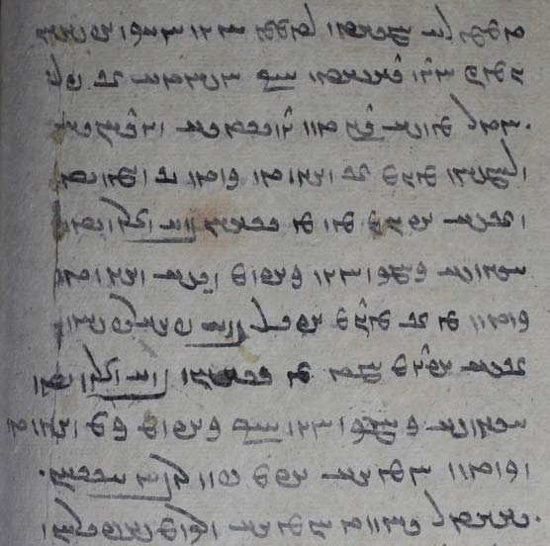

u-šān ēn-iz ōwōn dāšt kū
mardōm ān farroxtar kē-š andar tan-drustīh ud ǰuwānīh ud rāmišn tis ān grift (ud) kerd estēd ī-š abdom kē (for ka) az gēhān bē šawēd ēg-iš kāmag ōwōn (kū) kāč-im wēš grift kerd (hē)
ud az ān tis abēr bē pahrēzišn ī-š abdom ka az gēhān bē šawēd ēg-iš kāmag ōwōn kū kāč-im kem grift ud kerd hē u-m pad ruwān āsānīhātar būd hē

text 16.2
From Dēnkard book VII: Dk.7.6.14. – Ms. B, p. [501]. – About what could have happened to the revelation if it had not been revealed.
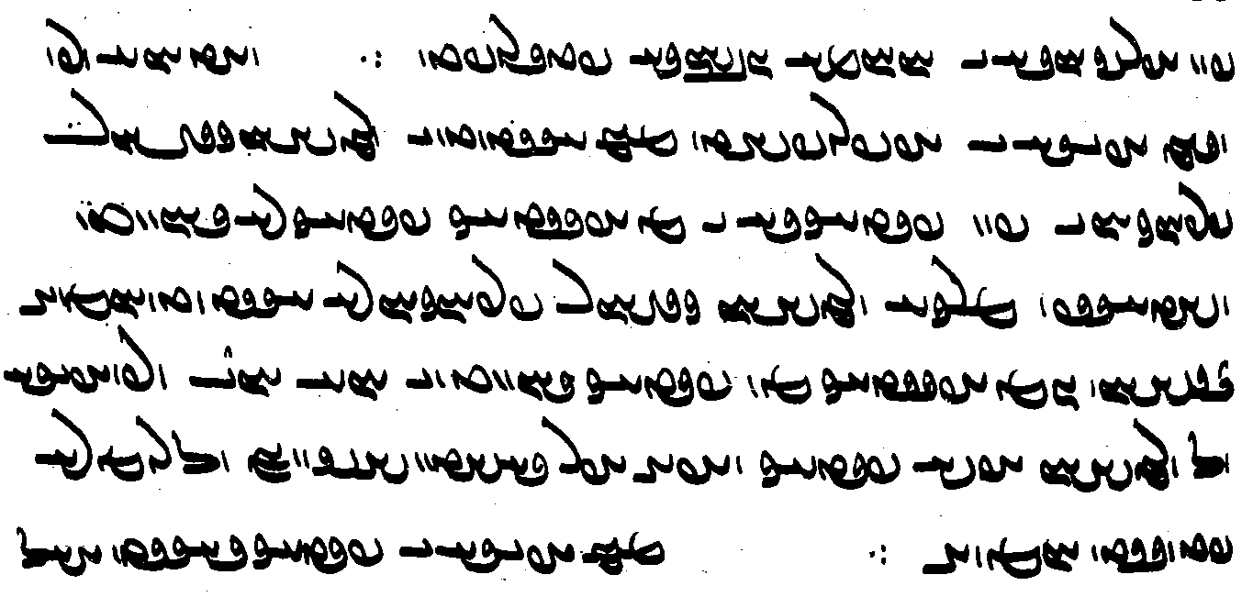
ud agar ēd warz xwarrah abdīh ī azabar-nibišt, abar dīd [= dīdan] ī awēšān kišwar-frazānagān [ī] pad paydāgīh ī az Abestāg, paydāg nē būd
(ud) Wištāsp šāh (ud) awēšān kišwar-frazānagān nē dīd hē, ī-šān ēn Abestāg – kē paydāg būd [= būdan] ī ēd and warz abdīh ō awēšān aziš paydāg – *abē-wābar dāšt ud hišt, ō amāh nē paywast hē (Dk.7.6.14)

Note the omission of the auxiliary (hē) everywhere except at the end and in one other place.

Text 16.3
From Dēnkard book VII: Dk.7.2.54. – Ms. B, pp. 484-485. – About Z.’ mother and the sorcerer doctors.

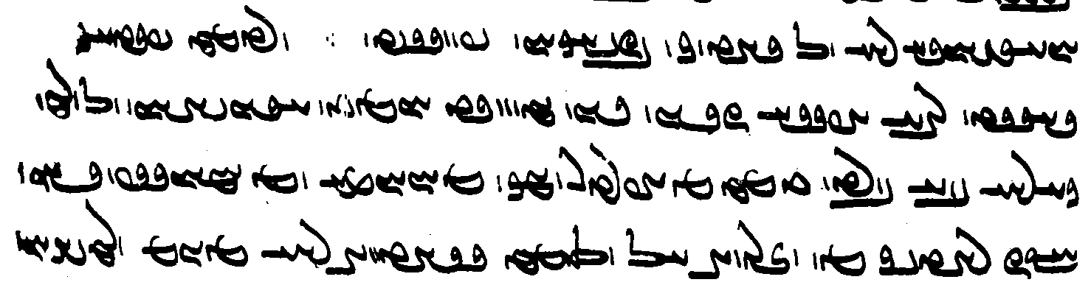
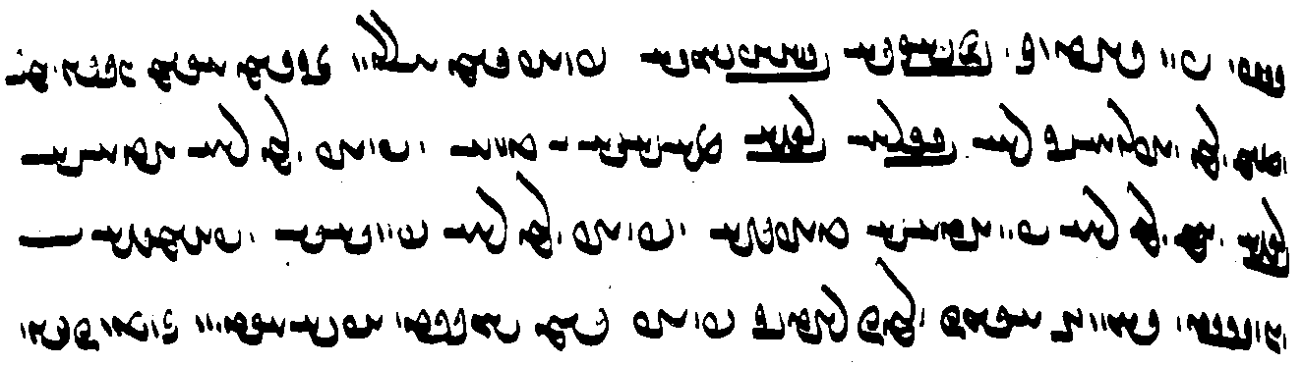

ud ēdar paydāgīhist wazurg abdīh čiyōn dēn gōwēd hād
ēg-išān ō ōy wāng bē burd ānōh az abartar nēmag az Ohrmazd ud Amahrspandān kū
čarātīg kē šawē ma ō ānōh rawē *nē tis awēšān seǰ pad ǰādūg-biziškīh bēšāzišnīh
frāz dast šōy ān dast esm stān(ē) ud abar ōy w aburnāyīg rāy gōšt barēš rōγn ī gāw
ud frāz ōy rāy ātaxš barēš ud ham ōy rāy pad ātaxš tābēš
ud frāz ōy rāy pad gāh nibaēmēš ud drīst bawē

Text 16.4
From the Ayādgār ī Zarērān, the “Memorial of Zarēr”: AZ.40 – Wištāsp aske his wise minister J̌āmāsp to foretell the result of the great battle with the Xyōnian king Arzāsp: how many of his sons and brothers will die.

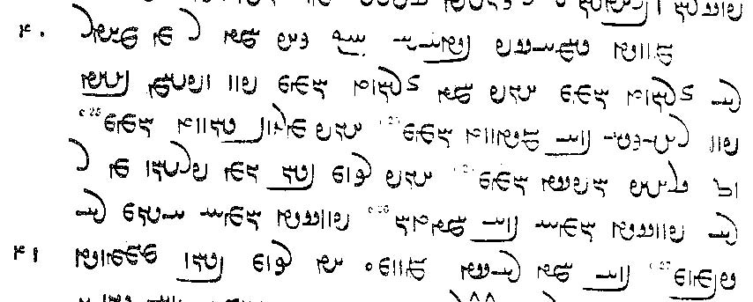

gōwēd J̌āmāsp bidaxš kū kāč ka man az mādar nē zād ham
ayāb ka zād ham pad xwēš baxt pad rahīgīh bē murd hē
ayāb murw-ēw būd hē ō drayāb ōbast hē
ayāb ašmāh bayān ēn frašn az man nē pursīd hē
bē ka-tān pursīd hē ēg-im nē kāmē bē ka rāst gōwam
Note: Jamasp-Asana (the ed.) has corrected hē <HWE’y> to ham and kāmē <YCBEN’y> to kāmam.

Exercises 16

WwßßAWK lïhAt¬A Y Wwa¬ABwsA NT{ Wt˜ WW[YV oW WwSnaÅ WTWWwaD WcD> WWP WN ÂLK Y aÅcJ ? !
/ WTW{TkZ Y>BK WKtJWK 2 AWK NW WTWK WtåJ aådlAcJcÅWwaD< lAcdlAKW

/ WWTWK ëWNwA WwABWT ˙DW WcÅK Mà WwYwA WkmAK ATwÍwA AWK à WthaD> WwYwA CNwY WwaHƒ ? 2

/ EtåÒ kL OW Y AwA NwL N ÂYWNwA Y>WcJwaÂA WN NwL N thAWt:¸ a∆Ìa¸ ? 3

ìWNwA TWNtHW MK Mà WtDWWwaD WwYwA WkmAK ÍwïdA WtDWWtÂaD WwaDWwï˜ Y laÂA OW tÂA
ìWNwA WTWK ßYW W WthaD MK W ? 4

ECwlY> WcåÅW WcÅ tÂA à WkAtDP nM ? Y>WNwA WTWWtdmY ATwÍwA WTWWvaD ey<lM ‹ tÂA Y ã WKwïÅ ? 23
/ aÅWNwA Wt∆dAcÅ WTWwLTI AWB ? äL EwaÂlZ Y>WNwA WtÒN ATwÍwA WTWWwaD WtåD> WwßßAWK W

aÅNwA WTWWvaD AL WwAK[G< aÅNwA WTWwïJwY ÂAcÅ ÍtÂA Y WtDB WWWtdA nM ? 33
/ WwABWTW lAC WWP WwÍCWT W˚ ßAWW ÂAcÅ çøaÅ ÍcÅ
(about what can happen when a man takes up a loan and provides a collateral; conclusion)

WcDWwa¬Ä OW AWB ATwÍwA WcJwlA At˜ W MWB Y YWwï˜ ëWNwA WTWWvaD aÒ L tÅ à WtDWWWwmY WwS WWP ? 34
/ áÒ wmMT Y emïJV WTNwA Y>WNwA WTWwlZW

/ AwA Y>wYCnlM AWB WwaDWwLY> Y WwABwL WwS>naÅ WwAKTwÍW W nlaÅ ÄNwA áÒ WwaHnLW Y EKwAP aÒ tÂA WwaHwY> x ? 44
Note <mlncynd> for <mlncynynd> and <HNA> for -ē.

$$

$$

16.2. Match the Pahlavi words with their transcriptions.

WwSnaÅ Wwa¬ABwsA WwˆjA abāyist āhen aswārān
WcDWwa¬Ä aÅWwA WcÅ awināh āz bēd
Wt∆dAcÅ WtDB WTWNtHW čim dard Ērānwēz
WcåÅW WNt¬ACW Wt¬Y hāmōyēn kārēzār kōxšišn
WTWwïJwY aÅfJ WwaÂAtDcJ mār niyāz ōh
lAcdlAK WwßßAWK W˚ rōšn spāh spitāmān
WwÍwL la˜ MC stad škeft wizārdan
WTPkÍ xward

16.3. Translate into Pahlavi and write in Pahlavi script with transliteration and transcription:

- By showing you clearly its meaning, I shall now explain the sacred word to you.
- The soul of the departed, having performed the accounting and having expiated (its) sins, arrives in paradise in such a way that its place will be there until the Fraškerd and it will have no need of a new accounting.
- Afterward you shall sprinkle the dead body with an iron (implement).
- If those bird-borne or wolf-borne nasāys made a man a sinner, the entire existence with bones would never be free of sin.
- And the soul of the sinner’s father would cry out: If only he had not been born and he had never experienced such harsh pain!
- One (thing) is this: when he cooled the fire; for, if the fire had burnt (on) in the usual way (and) had not been cooled down, fire would have stood over (pad) all this world of the living in such a way that everybody would have fear of burning.
- One should walk purposefully, as if one were a man without shoes and this whole world were full of snakes, scorpions, evil animals, and thorns and he were afraid (had fear) that the evil animals might bite him or a thorn might go into his foot. [note indirect speech > direct speech, lesson 4]

Additional Readings 16

Additional Reading 16.1
From Dēnkard book III: Dk.3.412a.1-2. – Ms. B, p. [308]. – About that which is good and the bad.

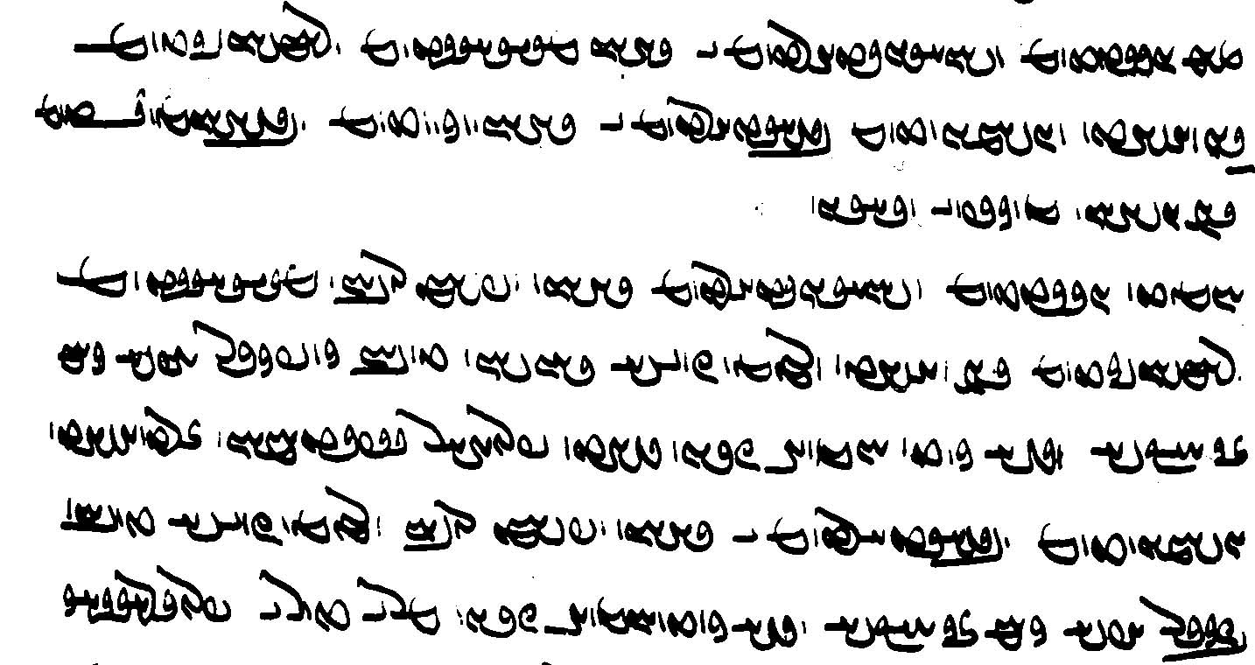
abar dōsttom ud šnāyēnīdārtom ī yazdān, meh-gāhtom ud rāmišnīgtom andar wahišt
ud dušmentom bēšīdārtom ī yazdān, nigūntom ud bēšōmandtom andar dōšox
az nigēz ī weh-dēn ∵
hād
dōsttom ud šnāyēnīdārtom (ī) yazdān: xwēš ruwān
meh-gāhtom ud rāmišnīgtom andar wahišt ōy kē čand-iš dānišn tuwān kerbakkar u-š kām ān kū-š wēš kerd hē čiyōn yašt-frawahr spitāmān Zarduxšt
dušmentom bēšīdārtom ī yazdān: xwēš ruwān
< nigūntom ud bēšōmandtom andar dōšox >
ōy kē čand-iš dānišn tuwān bazakkar u-š kām ān kū-š wēš kerd hē čiyōn mar ī Tūr ī Frangrāsiyāg

Additional Reading 16.2
From Dēnkard book IX: Dk.9.38.7. – Ms. DH f. 294v. – About reciting Zardušt’s dēn and Ohrmazd urging Z. to recite it to everybody and pointing out what would have happened if he himself had not held the dēn dear (dōš-).

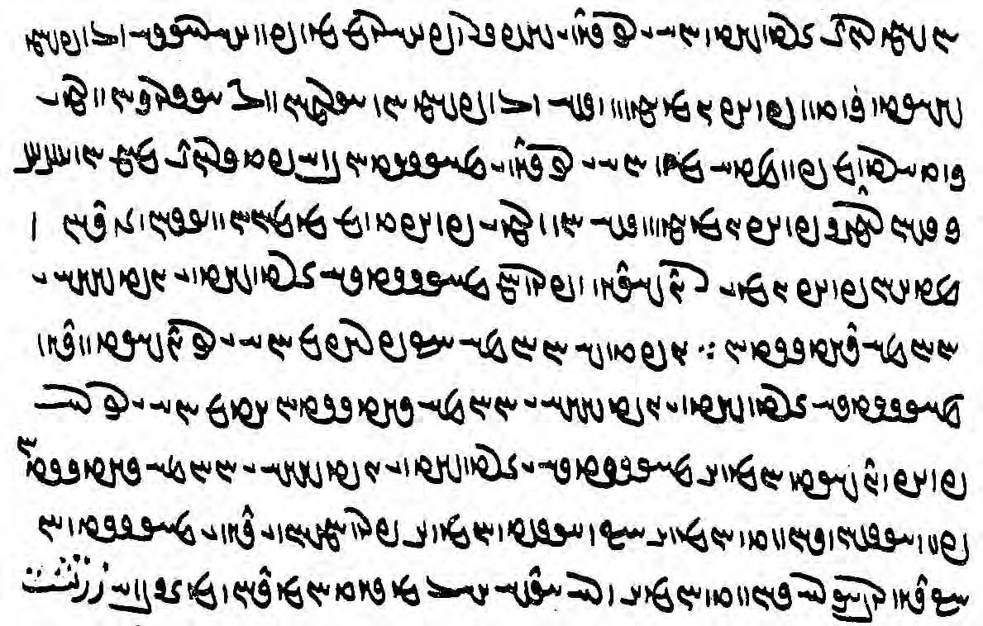

ōšmurēnd Zardušt ēd ī tō dēn ī weh ud pahlom kē pad ahlāyīh ō xwēš / šāyēd kerdan
frāz ēn gōwēš ō xwēšān ērmānān (DH ērmān ) ud ō āsrō’ān
ud ōy ī / kerdārtom pad deh kē ēd ī tō dēn ī mazdēsnān bē padīrēnd abar ō 7- / -kišwar zamīg
frāz ēn gōwēš ō ōy ī frāztom az mānān ud wisān ud zandān ud / dehān:
frāz ēn ī man dōš dēn (mss. <dwšdyn'>)
ud franām (DH <plwn’m>) mazdēsnīh Zardušt ī ǰud-dēw ī / Ohrmazd-dādestān ∵
guft-iš Ohrmazd kū
frāz-im ēd ī tō dōšīd w dēn / *mazdēsn ī Zardušt ī ǰud-dēw ī Ohrmazd-dādestān
agar-im ēd ī tō nē frāz dōšīd hē (dēn) *mazdēsn ī Zardušt ī ǰud-dēw ī Ohrmazd-dādestān / pad *wināhišn būd hē
kū *wināhīd hē franāmišn ī dēn ī mazdēsnān kū dēn rawāg nē būd hē

Note the spelling of ō as <’w'> and of frāz (usually <pr’c>) as <pl’c> in frāz-im.
The last sentence contains two explanatory clauses introduced by kū.

Additional Reading 16.3
From the Ardā Wirāz-nāmag: AWN.69.1-5. - Ms. K20 fol. 22v, M51b, pict. 65. – About punishments in hell.

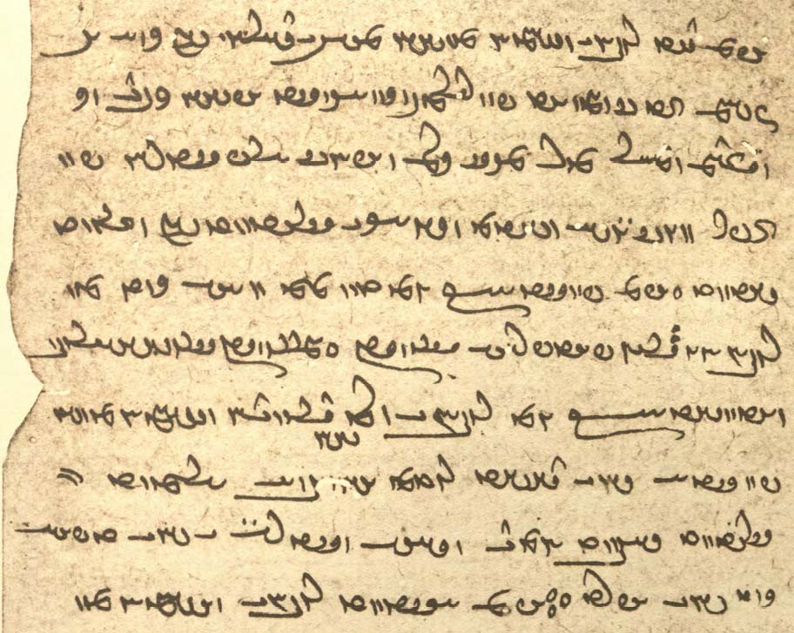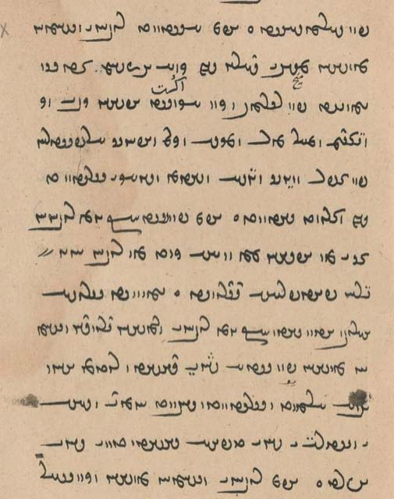

u-m dīd ruwān ī zanān kē-šān mēx-ēw ī dārēn andar harw 2 čašm zad estād
pad pāy-ēw nigūn āgust
u-šān was waγ ud gazdom ud mār mōr ud magas ud kirm ud abārīg xrafstarān pad zafar ud wēnīg ud gōš ud kūn ud gyāg ī gād andar šud āmad o
u-m pursīd kū ēn [ruwānān ān ī kē u-šān] čē wināh kerd kē ruwān ōwōn garān pādifrāh barēd o
gōwēd Srōš-ahlaw ud Ādur-yazd kū ēn ruwān ī awēšān druwandān zanān kē-šān pad gētīy šōy dāšt ud abāg anīy mard xuft ud gād dād hēnd ud gāh (ud) wistarg ī šōy tabāh kerd/dāšt ud tan ī šōy āzard ∵

For the text in [...], K20 has only tan. — Note the active form dād hēnd “they gave” for u-šān dād.

Additional Reading 16.4-5
Two texts from the Mādayān ī hazār dādestān, “the book of a thousand judgments, on legal issues connected with a man’s primary wife, the pādixšāyīhā-zan, “wife-in-authority” (whose children are his heirs).
The first text deals with the question of guardianship (sālārīh), which can be of three kinds:
būdag ‘(always) been, natural’: the guardian is a relative;
kerdag ‘made, designated’: the man has designated a guardian (sālār) while alive (not in this text) [note: this kerdag “made” is different from pad kardag “according to what has been done = custom”].
gumārdag, ‘appointed’ by a local authority, often the rad, highest religious judicial auhority, when the man dies and there is neither a būdag nor a kerdag.
A stūr is somebody contracted to produce an heir for a man who can not or has died.
MHD.37.48 [MM ch. 19]

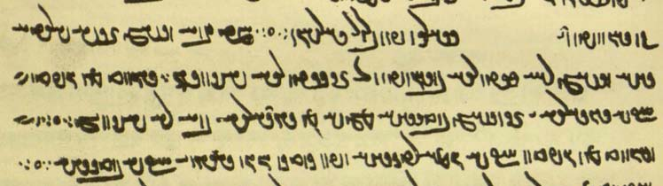

ka mard zan ī-š pādixšāyīhā-zan rāy stūrīh xwāhēd ō ān stūrīh hilēd ∵
būd kē guft kū-š sālārīh ī ān zan būdagīhā čē-š az sālārīh bē nē hišt ∵ o∵
ud būd kē guft w kū-š gumārdagīhā
ud pad kardag ōwōn dārēnd kū-š būdagīhā ∵ o∵

MHD.2.17 [MM ch. 48] – About questions of property (xwāstag) rights when the wife becomes a-tarsagāy “disobedient.” Note the use of xwēš “belonging to.” – Note the active (Persian) form dād hēnd “they gave.”

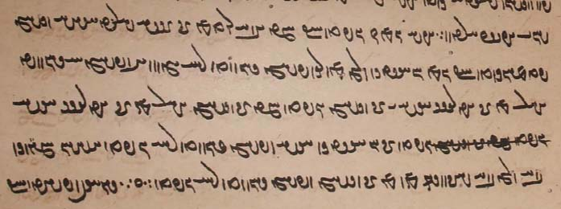

u-š en-iz guft kū ka mard abāg ān ī-š pādixšāyīhā-zan paymān kerd kū
ēn xwāstag ōy kē tō xwēš būd rāy gōwē xwēš ē bawēd
pas az ān atarsagāyīh ī ān zan guft
ka ān zan pas az ān atarsagāyīh guft ka ān xwēš guft ān xwāstag kas xwēš būd rāy guft
ā-šān hamgōnag bē ōy bē *hilišn kē az ān zan xwēš būd rāy guft ∵ o∵
In view of the presence of an agent -šān, <ŠBKWNx₁> cannot be 3rd sing. hilēd, but is probably for hilišn (rather than for hišt).

Glossary of words in the Texts and Exercises 16

Idioms:
abar xwān- cry out
abd sah- seem marvelous (to)
bē ... ēnyā except
ēdōn ... ī so/such ... that
frāz bar- bring forth
gād dah- offer sex
gyāg ī gād place of sexual activity, female genitals
hād ‘so be it!’; that is; yes (and)
kēšdārān kē ... kēš the ‘holders of teachings’ whose teaching (is) ...
mān ud wis ud zand ud deh appr.: house, village, (extended) family/tribe, town/land
ō amāh paywast has come down to us
ō xwēš kun- make one’s own, appropriate
pad čār ud tuwān according to means and ability
pad ēn kū tā with this (thought) that, in order that
pad homānāgīh ī in the same way as, just like
pad kardag according to custom
pad nigerišn on purpose, purposefully
paymān kun- enter into a contract
rawāg baw- be set in motion, be propagated
šud āmad going and coming, going back and forth

Nouns, adjectives, adverbs, pronouns:
7-kišwar LwÓDK 34 <7 kyšwl> containing 7 continents
abām ÂAcÅ <’p̄’m> loan, debt
abartar LtÒcÅ <’p̄ltl> higher
abartom MWtÒcÅ <’p̄ltwm> uppermost, supreme
abdīh a∂DcÅ , eYcÅ <p̄dyh> marvel, wonder
abē-kafš ÍPK ëcÅ <’p̄yd kpš> shoe-less
abē-wābar LcÅW ëcÅ <’p̄yd w’p̄l> unbelievable, untrue
aburnāyīg/ WiAwLWcÅ , WiÄwLWcÅ <’p̄wln’(y)yk'> child (under 15)
abornāyīg WiAwLcÅ , WiÄwLcÅ <’p̄ln’(y)yk'>
āmār (ahmār) laÂA <’m’l, ’hm’l> counting, accounting
andak-ōzag WKCwAI>wA <’ndk' ’wck'> having little strength
angust WtJwYwA <’ngwst'> finger
aniyāz WcåÅwA <’n’’c'> needless, having no need; + az, ō, or pad “for”
apādyāwand YWwaDtÅcÅ <’p̄’ty’wnd> lacking strength
arwēs sYwlA <’lwys> rope
āsrō = āsrōn WKwlsA <’slwk'> āsrōn, head priest
atarsagāyīh a∂dA˝jLtÅ <’tlsk’dyh > lack of respect
ayābišn WwÍcådA <’y’p̄šn'> reaching
azabar-nibišt WtHPwLPcÅ <’cpl-npšt'> written above
bēšāzišnīh EwÍcåhYB <byš’cšnyh> medicating
bēšīdār lAtdßGB <byš-> harmful
bēšōmand YNwahGV <byš’wmnd> suffering harm
biziškīh EkÍCV <bcškyh> healing, doctoring
būdag WKTWV <bwtk'> (always) been, natural (guardian, etc.)
čarātīg, čarāytīg WItdaÒC , WItåÒC <cl’(y)tyk’> woman; Av. carāitī.
dārēn Wwï¬aD <d’lyn> (made) of wood
dīdārīg WilAtJ <dyt’lyk'> visible
diz AtdLK , WcD <dc', KLYTA> fortress, castle
dušmān WwaÂÍwY> <dwšm’n> insult; + dah- “to insult”
ērmān WwaÂlÄ <’ylm’n'> friend(?); Av. airiiaman “community”?
franāmišn WwßmAwLP <pln’mšn'> going forth
frayist WtjaÒP <pl’st'> most; Lesson 8
frazānag WKwAcÒP <plc’nk'> foreknowing, wise
gazdom gazdum, Âï>ÇD< , MwYcD <gzdm, gcdwm, scorpion
gazdumb ∫MwYcD gcdwmb>
grawagān WwAK[G <glwk’n'> security, collateral
gumārdag WKt¬a˜wY <gwm’ltk'> appointed (guardian, etc.)
gurg-borne WtÒWV gLwY <gwlg> wolf-borne
gyān-abespār lAcJcÅ WwaD <y’n' ’p̄sp̄’l> (someone) who gives his life
homānāgīh EkAwaÂA , EkAwa˜WA <h(w)m’n’kyh> similitude, likeness
hād TWNwA , TNwA <HWE(')t'> particle introducing a comment
hubār lABwA <hwb’l> who carries well (?)
hudār laDwA <hwd’l> who uholds well
hušk WkÍwA <hwšk' > dry
kāč WcÅK <k’c'> particle with optative expressing wish (see grammar)
kardag WKTWK <krtk'> custom
kerdag WKTWK <krtk'> made, designated (guardian, etc.)
kēšdār ladßYK <kyšd’l> someone with a (different) belief (Jews, Muslims, Christians)
kirm µLK <klm> worm
kūn NtH <ŠTE> buttocks, anus
mānsr :Jwa˜ <m’nsl> sacred word
mar lM <ml> 1. villain, Av. mairiia-; 2. number
meh-gāh sadsM <msy’s> whose position is greater (higher)
mēx eM , sM <ms, myh> nail
mōr LN <mwl> ant
nang G<WW <nng> shame, modesty
nigāh sAKW <nk’s> look; + kun- “look”
nigūn WWWKW <nkwn'> head-first, upside-down; lowly
nimūdārīh adlATNW <nmwt’lyh> (a) showing
ox (axw) WwaÅ <’hw'> some mental faculty, “mind”
passāxtag WKtåJP <ps’htk'> fitted (to)
paymān WwaÂYP <pym’n'> pact, contract; moderation
rāmišnīg WIwÍmâL <l’mšnyk'> at ease, enjoying
rist WtjyL <lyst'> dead body
rōγn (rōwn) (WWwL) WWKwL , eßa˜ <MHŠYA, lwkn', lwn'> butter, oil
sālārīh elEwïD <srd’lyh> leadership, guardianship; + kun- “guard”
srišwadag WKTw˙∂:J <slyšwtk'> a third (part)
stūrīh eLWtJ <stwlyh> “proxy” marriage
šnāyēnīdār lAtDwsAwÍ <šn’yynyt’l> favorable
tabāh aÅPT <tp’h> ruined; + kun-/dār- “to ruin”
tōzišn WwßCWT <twcšn'> payment, redemption
wad-hunar LWwA TW <wt hwnl> unskillful
waxš ßAW <whš> growth, interest
way-burd WtÒWV ÄW <w’y bwlt'> bird-borne
wināhišn WwÓjAWW < wn’sšn'> pollution, sullying
wišūdag WKTwÍW <wšwtk'> aborted; derogatory term for demons
xār laÅ <h’l> thorn
xwašīh emïJV <BSYMyh> pleasantness
yašt-frawahr laÅwLP WtÔD <yšt' plw’hl> whose frawahr (is) sacrificed (to), common epithet of Zarathustra
zafar Lf¸ <zpl> mouth (of evil beings)
zand Y>wZ <znd> zand (extended) family, tribe (?); Av. zaṇtu
zarmānīh EwaÂlZ <zlm’nyh> old age

Proper names and ethnic nouns and adjectives:
Āz WcÅ <’c'> (demon of) Lust
Frangrāsiyāg Wkaja:DwLP <plngl’yy’k> Frangrāsiyāg = Afrāsiyāb
Kay-ādur-bōzēd WtDCWVWWtåDWK, WtDCWVWWtåDK <k(w)y’twrbwcyt'> a commentator
Kirm ÂLK <klm> Kirm, Ardaxšīr’s opponent
Sōšyans = Sōšāns SwïHwS <swšyns> a commentator
Spitāmān WwaÂAtDfJ <spyt’m’n'> of the Spitāmas; Z.’s family
Tūr LWT <twl> Turanian

Verbs:
ayāb- ayāft WTcådA , –cådA <’y’p̄- ’y’p̄t'> reach, obtain, get
āfsār- afsārd Wt¬aJcÅ , –laJcÅ <’p̄s’l- ’p̄s’lt'> cool
āgōz- āgust WtJWkA , –CWkA <’kwc- ’kwst'> hang up, suspend
āmurzēn- –wYcÒnA <’mwlcyn-> show mercy
āšinǰ- āšixt WtådßA , –CwßA <’šnc- ’šyht'> sprinkle
āzar- āzard WtÒcÅ , –LcÅ <’cl- ’clt'> torment
brīn- brīd (-WWkSP) -WW˝JP <PSKWN-> cut
dōš-īd –ÍwY <dwš-> like: frāz dōš- “choose”
franām- franaft WTPwLP -mAwLP <pln’m-, plnpt'> go forth; profess, tr. Av. frauuar- “choose”
gaz- gazīd –cD< <gc-> bite
nibaēm- –µYPW , –µïÅPW <np(’)ym-> lay down
ōšmar-/ōšmur- ōšmurd -WtDN <MNYTN-, count, reckon, recite (a text)
’wšm(w)l->
passāz- passāxt WtååJP , –cåJP <ps’c-, ps’ht'> fit (together) (trans.)
paydāgēn- –wYkAtDP <pyt’kyn-> make manifest, reveal
sōz- sōxt WtÅwS , –CwS <swc- swht> burn (trans., intrans.)
šnāyēn- –wsAwÍ <šn’yyn-> please
tāb- tāft –cÅT <t’p̄- t’p̄t'> heat
tāš- tāšīd –ßAT <t’š-> fashion, “create”; carpentry term
tōz- tōxt WtÅWT , –CWT <twc- twht'> repay, expiate
xrōs- xrōst WtJ]Å , –S]Å <hlws- hlwst'> howl
yōǰdahrēn- –wï:jaD>ÍwY <ywšd’slyn-> purify
zay- zast WtjZ , –ja¸ <z’y- zst'> beg, implore

Lesson 17

Grammar 17

Causative and denominative verbs
From verbs and nouns, adjectives, or adverbs secondary verbs can be formed by adding the suffix -ēn- to the present (occasionally past) stem of the verb. When formed from a verb, the new verb is causative, when from a noun or adverb, the verb is ‘denominative’. We have already encountered several such verbs.
Occasionally (e.g., AWN), one finds the NPers. suffix -ān- instead of -ēn-.
The passive of such verbs is formed by replacing -ēn- by -īh-.

Causatives
These are formed from either intransitive or transitive verbs:

Intransitive verb:

abzāy- “to increase” (intrans.) abzāyēn- “to increase, cause to grow” (trans.)
abzāyīh- “to be increased, made to grow”
est- “to stand” estēn- “to make stand, establish, place”
estīh- “to be established, placed”
ras- “to arrive” rasēn- “to cause to arrive, send”
rasīh- “to be caused to arrive, be sent”
šaw- “to go” šawēn- “to cause to go, send off”
šawīh- “to be caused to go”
āy- “to come” āyēn- “to make come”
abesih- (abesīh-) “to be cut off, perish” abesihēn- “to cause to perish, destroy”

Note that abesih- is not a passive in -īh-. It is spelled with short -ih- here to distinguish it from the passives.

Transitive verbs:
ōzan- “to kill” ōzanēn- “to cause (sb.) to kill”
dān- “to know” dānēn- “to cause (sb.) to know”

Causatives from transitive verbs do not have a passive, which would coincide with the passive of the simple verb!

From past stems in -d/-t:
raft “went” raftēn- “to cause (sb.) to go”
zād “born” zādēn- “to cause (sb.) to be born”
burd “carry” burdēn- “to cause (sth.) to be carried, brought”
kerd “done” kerdīh- “to be caused to be done”

Denominatives

From a noun:
tarāzūg “scales” tarāzūgēn- “to weigh”
appar- “robber” apparēn- “become a robber of” (PV.4.1, 7.78-9)

From an adjective:
paydāg “apparent” paydāgēn- “to make appear, reveal, to produce”
paydāgīh- “to be made to appear, be revealed”
āgāh “aware, known” āgāhēn- “to make (sb.) aware, inform”
āgāhīh- “to be made aware, to learn”
nērōgōmand “powerful” nērōgōmandēn- “to make powerful, strengthen”
pērōzgar “victorious, victor” pērōzgarīh- “to be made victorious”
frāy “more” frāyēn- “further”

From an adverb:
frāz “forward” frāzēn- “bring/move forward, promote”
abāz “backward” abāzēn- “bring/move backward”
wanīy- <HWBDW(N)> wanīyēn- <HWBDW(N)yn-> “to destroy”
(+ kerdan/būdan “destroy/be destroyed”) wanīyīh- <HWBDW(N)yh-> “to be destroyed”
nēst nēstēn- “annihilate”
(+ kerdan/būdan “annihilate/be annihilated”)

Notes:
Derived nouns and adjectives from causative and passive verbs are the same as from simple verbs, see examples below.
paydāgēn- is not infrequently spelled -WwsAtDP for -WwYkAtDP.
In the 3rd plural, verbs in -ēnēnd not infrequently have only -ēnd by scribal error, e.g., paydāgēnd for paydāgēnēnd “they make manifest, reveal,” frōdēnd for frōdēnēnd “they lower”; – arameogram: <SGYTWNynd> rawēnēnd “they make go (forth)” (PV.3.21d), <SGYTWNynnd> (PV.3.11c).
brēhēn- “fashion,” kirrēn- “cut up, cut to pieces; whittle (about the evil creation),” and rāyēn- “arrange” are not derived forms and have passives brēhēnīh-, *kirrēnīh- (not found?), and rāyēnīh-.
frāyēn- was connected with frāy by folk etymology, but is a construct based on Av. frāδaiia- “further.”
wāyēn- “lead (as bride)” is from and old verb (Parth. wāδ- “to lead”) no longer used in Pahlavi and is related to wayūg “bride.”

From verbs:
ud pad-iz wirrōyišn nām rāh mānāg abērāh pēš kam-wizōstārān ī awizīdār-xīrān dārēnd; ud pad-iš āyēnēnd ō ān ī ǰāwēdānīg anāgīh
“and even in the name of ‘belief/faith’ (the enemies of the dēn) present (pēš ... dār-) to those who investigate little and do not make decisions about things a non-road like (= as if) a road; and thereby they make them come to eternal evil” (Dk.5.24.30a)

abar hōm ud mang amāh rāy bar ō Wištāšp u-š pad ān abar frāz xwārēn dahībed Wištāsp
“bring (abar ... bar) Wištāsp hōm and hashish on Our (Ohrmazd’s) behalf, and with that (cup) make him (-š) drink, (he,) the landlord Wištāsp” (Dk.7.4.85)
nūn-iz pad gētīy pad ān hangōšīdag andar aškomb ī mādar hambawīhēnd ud zāyēnd
“now, too (= still), in the world they are formed in the womb of the mother like that and are (then) born” (Bd.1.57)

pad hambawēnīdārīh ī bawišnīgān ō gētīyīh wašt ī wēnišnīg gīrišnīg
“by the action of forming those who are to be, (the mēnōy state) was changed to gētīy state, which is visible and tangible” (Dk.3.105.2)

abar wāyēnīdan ī kanīg az pidarān sālārān kadag ō šōy wis
“about leading a young woman (as bride) from the house of (her) parents (and/or) guardians to the husband’s town” (Dk.8.31.6)

From nouns, adjectives, and adverbs:
ān petyāragīh ǰud pad dām-dahišnīh nē agārīhēd
“that adversary is only (= can only) be undone by establishing the creation” (Bd.1.35)

dōstīhēnd ō yazd ud nazdīkīhēnd awiš
“(people) will be made friends of the gods and be brought close to them” (Dk.3.107)

ān-it mard bundahišnīh az madan ī Tāzīgān ō Ērān šahr rawāgēnīdan ī ān-išān dušdēnīh
“there you have it, man, the original establishment from the coming of the Arabs to Iran, the propagation of their evil dēn” (Bd.0.2)

Zarduxšt andar ān ī abēzag rōšnīh hāwand amahrspandān az bundahišn ōrrōn ... padīruftārīh rawāgēnīdārīh ī dēn andar gēhān rāy mēnōyīg tāšīd ud payrāst estād
“Zarduxšt had been fashioned in that pure light like the amahrspands already from the original establishment and been equipped for the reception and propagation of (= receiving and propagating) the dēn in the world of living beings” (Dk.5.2.1)

awēšān ī abar pad Wahman mānēnd Zarduxšt awēšān rāmēnīdārīh pad gōwišn
“Zarduxšt, those who dwell with Wahman, is their pleasure-giving (= are they given pleasure) by speech?”
Pōrušasp ō karb-ēw Dūrāsraw nām kē andar ān deh pad ǰādūgīh nāmīgtar būd raft u-š az zāyišn ī Zarduxšt abdīh ī padiš paydāg būd āgāhēnīd
“Pōrušasp went to a priest called Dūrāsraw who was best known in that village, and he informed him about (az) the birth of Zarduxšt (and) the marvels that had been made known about him” (Dk.7.3.4)

čiyōn-iš ī pad menišn āgāhīhišnīh
“according to his being made aware (= according as he has been made aware) by his thought” (Dk.7.7.29)

ōh-iz ān ī dādīgīh andar mardōm kē rāy-šān kār kerbagīhēd padiš ahlawīhēnd
ān ī adādīh kē rāy-šān kār bazagīhēd pad-iš druwandīhēnd
“and thus (is) also the adherence to the law (dādīgīh) among men, whereby (kē rāy) their work is turned into good deeds (and) they thereby are made Righteous (and) the non-adherence to the law (adādīh), whereby their work is turned into evil deeds (and) they thereby (pad-iš) are made wicked” (Dk.3.119.9)

kerbagēnīdan kār padiš bōxtan ī ruwān
“(how) to make a work a good deed (and) thereby save the soul” (Dk.3.122.6)

ēk niwāxtan ud nazdīkēnīdan frāzēnīdan ī wehān
“one thing is: to extol, bring close, (and) bring forward good people” (Dk.3.133.21)

ud wēš-hunar stāyīdan frāzēnīdan wēš-āhōg nikōhīdan abāzēnīdan
“and to praise and bring forward those who have more good features, (but) scorn those who have more blemishes and bring them backward” (Dk.3.243.9)

pad-iš anōdagīhēnd mardōm az šnāxtan ī dādār ... ud abāzīhēnd az kerbag ud āyōzēnd [for āyōzīhēnd?] ō bazag
“thereby (by the evil wrought by Waran) people are alienated from knowing the Creator ... and they are brought backward from good deeds and they yoke them to evil deeds” (Dk.3.77.5; cf. Yasna 46.11)

ēdōn purr ast az kēn ud frēb ud wiyābāngarīh wanīyēnīdārīh ud wišōbišngarīh ... kū nē ēwāz bē ō hambedīgān ud padīragīgān bē ō-iz xwēšīgān ud ham-gundān ... wiyābānēnāg ud wišōbāg ud wanīyēnāg ud kēnēnāg
“she (the Druz) is so full of hate and deception and leading astray, destruction, and ruin ... that she not only causes the opponents and adversaries, but also her own kind and her commilitants to go astray, and ruins and detroys (them) and incites (them) to hate/vengeance” (DD.36.5)

ud wanīyīhēd zēn ī druxtārīh ud abesihēd čār ī frēbāgīh
“(but in the end her) tools of lying will be destroyed and her means of being a deceiver (= her deception) be cut off” (DD.36.11c)

pad bowandag-menišnīh frāyēnēnd gēhān ī astōmand ī ahlāyīh ud tangīh ō druz dahēnd
“with equanimity they further the bony world of living beings of Order and give the Druz a hard time (gives her ‘narrowness’)” (Dk.7.7.19) — On bowandag-menišnīh, see Text 15.3.

frāyēnīdārīh ī gētīy pad harw-ēwēnag ēwēn
“the furthering of the world of the living by every kind of ritual” (Dk.5.5.5)

ēn kū šnūman ī drōn kū gyāg paydāgēnišn kū gyāg nē paydāgēnišn ud čiyōn paydāgēnišn
“this: where (in the ritual) should one announce the drōn [šnūman “propitiation”]? where should one not announce it? and how should it be announced?” (Q&A.6.1)

andar yazišn was nīrang daxšag ud nišān ī mēnōy-zōrīh paydāgīhēd ō dēwān tarsēnāg ud bēšēnāg ō yazdān azbāyāg ud urwāhmēnāg
“during the sacrifice, many ritual actions are manifested as marks and signs of the heavenly strength, which frightens and hurts the demons, (but) invoke the gods and give them joy” (DD.47.29)

From adverbial phrases:

šahrestān Weh-ardašīr pad 3 xwadāy kerd ud Ardašīr Pābagān pad-frazāmēnīd
“the city of Weh-ardašīr was made under three kings, and Ardašīr son of Pābag ‘finalized’ (completed) it” (ŠahrĒr.40) — From pad frazām “in the end, finally.”

With -ān-:
nē wardānīdan ud nē hammōzānīdan ī ān zan kē andar dārišn awiš mad būd
“(and because of) not making that wife who had come to him to keep turn (from evil) and make (her) learn” (AWN.68.12)

Double causative:
A double causative can be made from derived forms of causative verbs:

abzāyēnāgēnīdan ān ī ahlaw pad dānāgīh ud kāhēnīdan ī ān ī druwand pad dušāgāhīh gēhān
“to make a Righteous person into somebody who makes the world increase (abzāyēnāg) with knowledge and making the wicked decrease (it) with ignorane” (Dk.8.24.10)

From present and past stems and in -d/-t:
kē az man ān sūr zinēnēd (< zin-) ayāb triftēnēd (< trift “stolen”)
“he who makes them take that meal from me or cause (it) to be stolen” (PY.11.5)

ud ēn-iz kū kē menišn ō dēn ī Zardušt dahēd xrad hammōxtēd ēd-iz rāy čē weh dēn hamāg xrad pad menišn-awiš-dahišnīh hammōxtīhēd
“and this too: he who give his thought to Zarathustra’s dēn, learns wisdom; and (that is) for this reason that the Good Dēn is all wisdom (and) one is caused to learn it by ‘giving one’s thought to it’” (Dk.9.54.7)

abar ǰud-āhangīh ī-š abāg zādēnīdārān
“about his (Z.) having different leanings from (his) birth parents” (WZ.11.0)

dehīgān kanīg pad ǰādūgīh hambasānēnīdan ud abar bērōn kerdan ī az ān deh ō zādēnīdārān škeft pahikārīd
“the villagers argued (pahikārīd) strongly with those who caused her to be born (= her birth parents) (to make them) regard (her) as an adversary (hambasānēn-) because of (her) sorcery and about expelling her from that village” (Dk.7.2.6)

abāg zan ī ag-dēn gādīhēd az ān gādan frazend andar aškamb frāz bawēd ēg-iš wināh čē
“someone who is made to have sex with a woman of an evil dēn (and) a child is conceived in her belly because of that sex, then what is his sin?” (RAF.42.1)

čiyōn ān druz pahikārēd kū-š stahmagīh čiyōn bē bawād
ast kē ēdōn gōwēd ay čiyōn pad ān druz pahikārīhād
kū-š stōw bē kerdīhād kē az ōy ī rist ō ōy ī zīndag abar dwārēd pad hamrēd
“‘How does one fight that lie-demon?’ that is, how can there be oppression for/of her?
There is one who says, the meaning is: how is battle to be engaged against that lie-demon
so that oppression may be caused to be perpetrated on her, who runs from the dead onto the living with (= causing) direct contamination?” (PV.9.57) [only ms. L4 <krtyh’t>; K1 has <-WNyh’t'> and IM, TU1 <-WN’t'>]

nasāy ō āb ud ātaxš burdēnišn pad ēč meh-dādestānīh nē pādixšāy
“causing nasāy to be carried (or: “causing someone to carry nasāy?) onto water and fire is not authorized, (not even) by any ‘higher law’” (RAF.104.2)
Mss.: TD 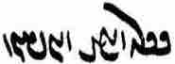 <-x₂y wynšn'> (or: barēnišn?).

Phraseology

Adverbs of manner
This is a review of common expressions of manner, most of which are well known by now.

ōh W˚ <KN> “thus; in the usual way”
ēdōn WWWtdA <’ytwn'> “in this way”
ōwōn (WwYwA) WWwYwA <’wgwn'> “in that way”
čiyōn (wïDC , WwïDC) WWwïDC <cygwn'> “as, such as; how?”
Note: in many manuscripts, the spellings OW ō, nLW ōy, and W˚ ōh are used interchangably.

ōh “thus; in the usual way”
This is used 1. in its literal meaning of “thus, in this/that way, as follows” commonly before verbs, but also in other positions; and 2. to indicate the “unmarked” situation, which does not need to be specified: “in the usual way.”

ud druz ōh dōyīd hēnd kū ...
“and the lie-demons spoke thus/as follows: ...” (Dk.7.4.39)

ōh-iz nazdīkīh ī yazd pad yazd-šnāsīh ud šnāxtan ī yazd pad dānišn bawēd
“and in this way, the closeness of god is by way of recognizing the god, and recognizing the god is by way of knowledge” (Dk.3.107.3)

agar ōh-iz ašmāh dōstīh rāy nibišt pas-iz man dušxwār sahist az ēd-ōwōn stāyišn
“if you wrote in (just) this way because of friendship, then also it seemed difficult for me from this kind of praise” (DD.0.10)

harwisp ān ī weh-dahāg yazd ī mēnōy ud kē-iz gētīy ... pad frārōnīh ōh abāyēnd yaštan
“all the deities in the other as well as in this world who give good (gifts) should be sacrificed to with goodness in the usual way” (PY.1.19)

u-š az ōy pursīd Zardušt kū kē mard hē; hād nē pad yašt ī fradom būd az pēš paydāg
u-š dānist kū hōm ōh rasēd ud ka mad būd ā-š pursīd abāyist
“and Z. asked him: ‘who are you, man?’
that is, it was not at the first sacrifice, (as) manifest from before (i.e., earlier),
and he knew: the Hōm will come in the usual way (i.e., as before)” (PY.9.1)

ēdōn, ōwōn, čiyōn
These three are used in a variety of ways, which need to be carefully distinguished.
ōwōn and čiyōn can be combined with the demonstrative pronouns (ēd/ēn/ān-, ān-čiyōn) and all three with ham- for emphasis (ham-ēdōn, ham-čiyōn), from which they can be separated by -iz (ham-iz ōwōn).
Note especially the use of ēdōn, ōwōn in the sense of “such” and “so, to such a degree” with adjectives/adverbs.
ēdōn and ōwōn are frequently followed by čiyōn, either directly or with intervening words: ēdōn (...) čiyōn, etc.
See also on Adverbial clauses of comparison-result (Lesson 22).

ēdōn “thus, in this way; so”:
nē ān ī ēdōn xwarrahōmand ǰādūg bawēd
“someone so glorious cannot be a sorcerer” (Dk.7.2.8)

ka frōd nihēd pad ēd dārēd kū āb az nasāy abāz ō āb rasēd ā-š čē kunišn
ul stānišn u-š ēdōn dūr bē barišn kū āb ī az nasāy abāz ō āb nē rasēd – nē rēman
“when one lays (the nasāy back into the water), thinking: the water from the nasāy will reach back to the water, then what should one do? — One should take it up (= lift it) and carry it so far away that the water from the nasāy does not reach back to the water, (then) one is not polluted” (ZFJ, p. 494) [about removing a carcass from a body of water]

bē andar ēn-ēdōn gumēzagīh hamāg abēzagīhā rawāg būdan nē bē kōšišnīg(īhā) šāyēd
“but, in this kind of Mixture (that we see now), is not possible for the entire (dēn) to become propagated in its pure state, but (= other than) by fighting” (Dk.5.24.14a)

dānāg (ī) uzmūdag-xrad ān-ēdōn guft
“a knowledgeable man whose wisdom had been tested, said as follows” (Ōšnar 54)

ka gištag-ēw kē kālbod ī mardōmīh nē paydāg ka sag nimāyēnd čiyōn nimāyišn; bē nē škāfišn ham-ēdōn sag nimāyišn
“when it is a fetus (in) which a human body is not manifest, when they show a dog, how is it to be shown? It is not to be split open (to check), (but) should be shown a dog in the same manner (as in the preceding cases)” (ZFJ, p. 468)

Note the use of ēdōn ... kū to explain something:

Zrēy Frāxkerd pad kust ī nēmrōz kanārag ī Harburz 3 ēk ī ēn zamīg dārēd
ud ēdōn Frāx-kerd kū-š 1000 war andar dāšt estēd
“the Frāxkerd Sea (is) in the southern direction, alongside (Mount) Harburz (and) has (= occupies) one-third of this earth;
and (it is) thus (called) Frāx-kerd (= ‘made-wide’) because 1000 lakes are contained in it” (Bd.10.2)

ōwōn “so, in that way, such”:
u-šān čē wināh kerd kē-šān ruwān ōwōn garān pādifrāh barēd
“what sin did they commit whose soul carries (= suffers) such a heavy punishment” (AWN.99.3)

agar ēd-ōwōn nē būd ...
“if it were not in this way ...” (Dk.7.4.63)

ēd-iz ōwōn nibišt kū ...
“and it is written in the following way: ...”

ān-ōwōn wehīh ud xwarrah
“in that manner (as I just explained) (are) goodness and Xwarrah” (Dk.5.4.2)

ud ōwōn xwadāy andar Dēn Mazdēsn weh-xwādāy nām ud pad gēhān pahlom
“and such a king’s name in the Mazdayasnian Dēn is “good king” and in the world (at large) “the best” (Dk.3.273.3)

andar ān-ōwōn pādufrāh
“in that kind of punishment” (Dk.7.4.69)

4-ān zōrān ī tan ham-iz ōwōn pad-iš frāz rawēnd čiyōn tazāgān āb pad wād
“the four ‘powers’ of the body go forth (moved) by it (= the heart) in the same way, too, as flowing waters (moved) by the wind” (WZ.30.21)

ōwōn ... ī, ēdōn ... ī “in such a way that”:
Here, the ī is often missing in the mss. and must be added from the context; its presence is alsways explicit when it has an enclitic pronoun, ī-š, etc.:

tis-ēw pad dahān ud wēnīg frāz kunišn ēdōn ī-š wād ī az dahān ud wēnīg bē āyēd bē ō ātaxš nē rasēd
“(when speaking near the fire) one should place something over the mouth and nose, in such a manner that the wind from one’s mouth and nose does not reach the fire” (PR.37a.3)

ka ēdōn ī pad gōmēz ud āb abāyēd šustan ā-š 3 stēr wināh
“when it is in such a manner that it needs to be washed with gōmēz and water, then he has a sin of three stēr” (ZFJ, p. 478)

ud ēn mānsr ud dēn abestāg harwisp-āgāhīh čiyōn weh mēnōyān nazd-brahmīhātar pad hamāg āwāz ī gēhānīgān ōwōn widēmāsīg ī widerd az harw ayābagīh ī mardōmān
“and this sacred word and tradition of the all-awareness of the Avesta, since (it is spoken) more closely to the manner (brahm) of the good entities in the other world, is so miraculous in all the languages of people in this world that it has gone beyond all reach of men” (Dk.5.24.12)

ka-šān az frazend-xwāyišnīh-iz nērōg ... an-ēmēdīh rasēd
ēmēd ī az zīndagīh bīm (ī) az margīh harw 2 ō nizārīh ōwōn rasēd (ī) az zīndagīh bē-ayās ō margīh frāz-ayās bawēnd
... ōwōn wašt bawēd ī-šān ārzōgīhēd kū kāč nē zād būd-ēnd
“when they (people) lose hope even of the power of procreation ...
(then) the hope of life and fear of death both come to tenuousness in such a way that (= become so tenuous that) their longing (-ayās) for life (goes) away (bē-) and their longing for death (comes) to the fore (frāz-).
... (and their situation) becomes so changed that they are filled with the desire: If only they had not been born!” (Dk.3.178.7)

čiyōn “how?”:
čiyōn az ān ī seǰōmand ī bīmōmand ī was-anāgīh axwān ō ēn ī aseǰ axwān ī apetyārag mad hē
“how have you come from that dangerous and frightening existence with much evil to this dangerless existence without the Adversary?” (MX.1.149)
ka-š pārag ēw xward ud kē nigerēd xōn wēnēd dādestān ī pārag čē ud čiyōn
“when he has eaten the piece (of skin he bit off his cheek) and he who looks sees blood, what and how is the legal situation of the piece (of skin)?” (RAF.86.1)

čiyōn ... ēdōn(-iz) “as ... thus/so (also)”:
čiyōn-itān amāh dād hēm amahrspandān ēdōn amāh srāyišn dahēd
“as (in the same way that, because) you created us, O amahrspands, so give us protection!” (PY.58.5)

čiyōn wināh marag was ēdōn-iz wizārišnīhā
“in the same way that sins are many, thus also (are) the resolutions (of sins many)” (Dk.5.10.2)

čiyōn Wāy ī wattar appurdār ud zadār ēdōn-iz Wāy ī weh kōxšīdār ud ham-padīrag ī Wāy ī wattar
“as (in the same way that) the bad Wāy robs and strikes down, thus also does the good Wāy fight and (in the ) same (way) against the bad Wāy” (DD.29.4)

andar harw 3 gyāg pāyagīhā; ud čiyōn gyāg ēdōn-iz xwārīh ud nēkīh ud a-xwārīh ud anāgīh
“in all three places (paradise, etc.), there are (various) levels, and as (is; = according to) the place (in each of them: high or low) thus also (will there be) comfort and goodness and discomfort and evil” (Dk.5.8.7)

čiyōn bawēd kū, čiyōn kū/ka, čim ka “how come?”:
čiyōn bawēd kū nasāy ō āb ud ātaxš rasēd padiš wināhgār nē bawēd
“how come that nasāy comes to water and fire, and he (the perpetrator) does not become a ‘sinner’?” (ZFJ.517)

čiyōn kū-t pad zamīg nē hammōxt ō man ān ī abēzag rāh ī rāst
“ how come you did not on earth teach me (ind. obj.) the pure straight road?” (WZ.35.42)
See Lesson 14 on constructions with hammōz- hammōxt.

čiyōn ka-mān pad zīndagān harw nēkīh pad āgenēn būd nūn tō ō wahišt ud man ō dōšox hamē nayēnd
“how come we had every goodness together in life (but) now they lead you to paradise and me to hell?” (AWN.68.2)

u-t wehīh ud frārōnīh čim ka nē hammōxt ham kē-m pas wehīh ud frārōnīh kerd hē
“and how come you did not teach me, me, who (kē-m) afterward would have performed goodness and virtuousness?” (AWN.68.10)

čiyōn conjunction “as, in the way that”:
čiyōn az dēn ī Mazdēsnān paydāg
“as is manifest from the dēn of the Mazdayasnians”

ān mard ka-š ēd-ōwōn abdīh az gāw dīd nē ōzad bē abāz ō Kāy-Us šud čiyōn-iš dīd guft
“when that man saw such a miracle from the bull, he did not kill it, but went back to Kāy-Us (and) said (= told) it the way he had seen it” (Dk.7.2.65) (a bull who was able to tell the border line between Iran and Turan)

nē amāh pas mazdēsn kēnēnēnd [ms. kynynd] wēš az ān čiyōn ān ī xwēš zahag ud pus
“the Mazdayasnians will not hereafter hate us more than the way our own children and sons (do)” (Dk.7.9.7)

ēn yašt ī gētōxrīd kerbag ham-čiyōn yašt ī nāybar bawēd ayāb nē
“is the good deed of this ritual for the dead (yašt ī gētōxrīd) just like the initiation ritual (nāybar) or not?” (DD.78.4)

ātaxš ī Warahrān ... harw čiyōn bē ōzanēd ... margarzān bawēd
“in whatever way one kills a Warahrān fire one is ‘death-deserving’ (guilty of a capital sin)” (PR.18e5)

ēdōn/ōwōn čiyōn “(just) as, like”
ēdōn čiyōn tō “like you”

ēdōn čiyōn Ohrmazd pad bun-dahišn dād abāz bawēd
“just as Ohrmazd had established (it) at the first establishment, it will become again” (PR.48.58)

ōwōn čiyōn pad dēn gōwēd kū
“as it says in the dēn”

ēdōn/ōwōn ... čiyōn “as/so ... as, like”
dām ī Ohrmazd pad mēnōyīh ēdōn parward ... čiyōn šusr homānāg
“the creation of Ohrmazd was nurtured in the world of thought like semen” (Bd.1.58)

u-š harwisp dahišn ōwōn āhōgēnīd čiyōn ka az ātaxš hamāg gyāg dūd abar āxēzēd
“and he so soiled every creation as when from a fire smoke rises everywhere” (Bd.4.27)

ān (ī) az ān zan pas az bē-widerišnīh ī ān mard zād ham-ēdōn bawēd čiyōn ka az ān mard zād hē
“the (child) that was born after the passing of that man becomes (legally) just as if he were born from that man” (RAF.23.2)

u-š ham-ōwōn pad rōšnīh kāmag čiyōn pad-iz tārān
“and he desired (-š ... kāmag) the light, just as (he desired) dark (places)” (WZ.1.3)

Nouns expressing manner

ēwēnag WKwYwˆÅ <’dwynk'> “manner, way, kind”
(ēwēn WwYwˆÅ <’dwyn'> “manner, way”
gōnag WKWwY <gwnk'> “kind, sort”
šōn, šōnag WKWwÍ , WWwÍ <šwn(k)'> “manner”
sān WwaJ <s’n'> “manner”
rāh aåÒ <l’h> “way”
dar ABV <BBA> “kind, issue, way, respect

Expressions with ēwēnag “manner”
This noun occurs combined with demonstrative and indefinite pronouns and various adverbs in adjectival function and in prepositional phrases in adverbial function and can be repeated to indicate indefiniteness.

Noun
abar ēwēnag ī Ohrmazd dahišnān hamēstār
“about the manner of the opponent(s) of Ohrmazd’s creations” (Dk.3.48.1)

pad harw ēwēnag paristišn ī Ardawān būd ān kanīzag kerd estād
“in every way the service of Ardawān was, that girl had done it” (KN.2.1)

Adjectival
ud ēn-iz guft estēd kū ēd-ēwēnag wazurg xwarrah ud wehīh az ham-tōhmag awisānišnīg
“and this too is said that such a great xwarrah and goodness is not to be separated from those of the same seed” (Dk.5.4.7) — About the line of mythical heroes.

was-ēwēnag kēš ud wurrōyišn
“many kinds of teachings and faiths” (AWN.1.9)

Ādur Gušnasp tā xwadāyīh ī Kay Husrōy pad ān-ēwēnag pānagīh ī gēhān hamē kerd
“until the rule of Kay Husrōy, the Gušnasp fire was protecting (pānagīh ... kerd) the world of the living in that way” (Bd.18.8)

Azdahāg andar xwadāyīh ǰuwān zan dēw abar hišt ud ǰuwān mard abar parīg hišt; u-šān pad dīdarīh ī ōy marzišn kerd; az ān-ēwēnag kunišn zangīg būd
“during his rule, Azdahāg let a demon onto a young woman and a witch onto a young man, and they had intercourse while he watched; from that kind of activity the negroes came about” (Bd.14B.2)

ud anīy-ēwēnag xwadāy ān kē amaragānīg kam ō xwēš kām ud xwēš kām ō xwēš xrad handāzēd
“and another kind of king (is) the one who measures the general will against his own will and his own will against his own wisdom” (Dk.3.273.4)

ud ēdar gōwēd mādayān 3 saxwan andar hamāg-ēwēnag yazišn ī Ohrmazd
“and here he says in particular three sayings about (andar) sacrificing to Ohrmazd in all ways” (Dk.9.49.5)

anīz was tis ī abd ud saxwan ī ēd 7 frašn hangerdīg-ēw ī az harw-ēwēnag dānišn āgāhīh
“many other wondrous things and sayings (about) which these (= the following) seven questions (are) a summary from every way of knowledge and awareness” (Dk.8.14.9)
bē was ǰud-ēwēnag ī nē hambedīg ī ēk gētīy būd šāyēd
“but many (things are) of different kinds, which can have no single counterpart in this world (gētīy adj.)” (Dk.3.142.3)

andar gētīy ... marg ud seǰ ud niyāz dard ī ēwēnag ēwēnag ō mardōmān
“in this world, death, danger, need, and pain of various kinds (came) upon men” (Bd.5.3)

Adverbial

ēk ēd ī paydāg bawēd kū did ka az stardīh frāz būd ōy ǰādūg ēg-iš ō Zarduxšt ham-ēwēnag drāyīd
“one (i.e. another thing) is this that is manifest: when that sorcerer came out of his stupor, then again (did) he howled in the same way at Zarduxšt” (Dk.7.3.43)

pas-iz abar gōwišn ī ān dastwar kē anīy-ēwēnag ast ǰud-dādestānīh nēst
“and next, there is no disagreement about the sayings of that dastwar for whom there is (something done?) differently” (DD.0.21)

pad bōxtagīh rāstīh harw ēwēnag abē-gumān būd ēč ēwēnag aziš bē nē estād
“about salvation (and) truth (one should) in every way be without doubt and should in no way stand away from it” (Dk.4.91)

ud ēn-iz kū mad ō ōy kadār-iz ēwēnag-ēw ī-š zast
“and this too: (the hōm) came to him in whichever way that he requested (it)” (Dk.9.36.5)
(kadār-iz ēwēnag-ēw < kadār-iz-ēw ēwēnag)

čē ēwēnag mad hēnd mēnōyīhā pad hamēstārīh kamālagān dēwān ō mēnōyān yazdān
“in what way they come through the other world for opposition (i.e., to fight one another): the (demon-)headed demons against the gods in the other world” (Bd.5.0)

With prepositions:
pad ān-ēwēnag sarmāg ... ud gandagīh dīd kē-m hagriz andar gētīy pad ān ēwēnag nē dīd ud nē āšnūd
“and (I) saw such heat and stench as I have never seen or heard (about) in that way in this world” (AWN.18.2)

ud ka Ohrmazd pad ēn ēwēnag guft man škoft bē mānd ham
“and when Ohrmazd spoke in this way, I remained awed” (AWN.101.6)
awēšān haft xwahān ... mowbedān pad ēč ēwēnag pānagīh bē nē hišt
“the mowbeds in no way relinquished the protection of those seven sisters (of Ardā Wirāz)” (AWN.2.19)

pad tis-iz ēwēnag ō Mihrēn ī man pus ma ē rasēd pēš az ān ī ka pid pad baxt šawēd
“let her not in any way come to (= be given to) my son Mihrēn before the father goes to his destiny” (MHD.G.8)

Ohrmazd abāg-iz čē-ēwēnag dānistan ī dām frazām ī kār ō padīrag ī Ganāg Mēnōy āštīh abar dāšt
“even though (abāg-iz) he knew how the end (frazām ī kār) of the creation (would be), Ohrmazd offered (ō padīrag ī ... abar dāšt) the Foul Spirit peace” (Bd.1.19)

ēwēnag ... ī “such a manner that”:
Cf. ōwōn ... ī (above).

Zand pad ēwēnag-ēw guft estēd ī pad mayānag ī gēhān rawāgtar ud andar gēhān āšnāgtar
“the Zand has been spoken in such a manner that it is more current in the world and better known in the world” (Dk.5.24.12a)

pad ēč ēwēnag (ī) šāyēd
“in any way it is possible” (RAF.37.2)

With particle ī + prep.:
ud abārīg ī az ēn ēwēnag
“and the others of this kind” (Dk.3.48.1)

u-š az awēšān pursīd kū ka ašmāh kerdgār ud abzārōmand paydāg hēd čē cim rāy kār ī pad ēn ēwēnag hamē kunēd
“and he asked them: when/if (= since) you are clearly mighty and resourceful, why do you keep doing work of this kind?” (Dk.6D.5)

With numerals:
rāmišn 2-ēwēnag
“joy is (of) two kinds” (Dk.3.63.2)

saxwan ī 2-ēwēnag ma gōw
“do not speak words of two kinds (ambiguous, both good and bad?)!” (AAM.96)

hunar rāyenīdan pad xūb-burdārīh ī 2-ēwēnag hunar andar 2-gōnag zamānag
“directing one’s talents by (or for) supporting well the two kinds of talent in the two kinds of times (looking toward the future or the past?)” (Dk.3.66) (see on gōnag below)

ka gōwēd kū ān ī tō sahēd ayāb ān ī tō kāmēd ayāb ān ī tō passandē ayāb ān ī tō abāyēd harw 4 ēw-ēwēnag
“when one says: that which seems (good) you or that which you wish or that which you like or that which seems fitting to you, (then) all four are in one and the same way (= identical)” (MHD.43.2)

With nouns:
āsn-xrad-ēwēnag ... gōšōsrūd-xrad-ēwēnag
“in the manner of the in-born wisdom ... in the manner of the wisdom acquired-through-the ears” (Dk.3.63.2)

karb-ēwēnag druz mānēd
“the karb-kind of lie-demon remains” (Dk.7.10.5)

Substantivized with -īh:
abar ēwēn ī wastarg šustan wināh ī az ǰud-ēwēnagīh
“about the customary way of washing a garment (and) the sin from doing it in a different way” (Dk.8.38.41)

abāz ō Kāy-Us šud u-š az čē-ēwēnagīh āgāhēnīd
“(Srid) returned to Kāy-Us and apprised him of how it was” (Dk.4.15)

Adverbial with -īhā:
zanišn ī gōspandān abar čē-ēwēnagīhā dādestān ī ǰud ǰud zanišn ī pad nigerišnīg-zanišnīh dārišn
“the striking of cattle: about in what way the law about striking (them) separately while striking (them) carefully (or intentionally?) should be kept” (Dk.8.24.8)

čiyōn ō wizārišn ī wināh ī pidar frayādišnīgtar-ēwēnagīhā uzēnag kunišn
“because he should expend it in such a manner as to be of the greatest help for the resolution (atonement) of the father’s sin” (RAF.141.2)

Expressions with gōnag “kind, sort”
These function much like the expressions with ēwēnag, but are not so common.

u-šān pad pēm ud panīr ud tis-ēw az ēn gōnag drōn bē sāzišn
“and they should prepare the drōn with milk and cheese and this sort of things” (ZFJ, pp. 532-3)

agar pad bēl-ēw ayāb taber-ēw tis-ēw ī az ēn gōnag ǰumbēnēd ud 3-paywand nē rēman
“if one moves something of this sort (of dead matter) with a spade or an axe and one (moves it) by three (men) connected, one is not polluted” (ZFJ, p. 667)

ōwōn čiyōn gētīy pahnāy abāg drahnāy rāst mardōm-iz ham-gōnag
“just as the width of this world is equal to its length, men are of the same sort” (Bd.28.3)

andar ān āwām ... hamāg mardōm frēftār bē bawēnd ēk ōy did rāy wad xwāhēnd ud mihr wazurg ǰud-gōnag bē bawēd
“in that age all men will be deceived; they will seek bad things for one another and great love will be of a different sort” (ZWY.4.13)

stāyišn yazišn ud azbāyišn ī yazdān hamāg ēk-gōnag abestāg-gōwišnīh
“the praise of, sacrifice to, and invoking of the gods is all one sort: saying the Avesta” (Purs.31.1)

ud az-iš ... wēnīšn ī was-gōnag anāgīh čiyōn paydāg
“and how is the seeing (= suffering) of many sorts of evil manifest from it?” (Dk.3.151.5; about the evils of the time)

an az tō abardar ham pad was-gōnag xīr
“I (the goat) am superior to you (the Assyrian tree) in many sorts of things” (DA.6)

urwar xwābargar ī was-gōnag (spelled <ws-gwnk'>) ī tarr ī zargōn ī harw gētīyān aziš dārišn ī zīyišn
“the beneficial moist, green plants of many sorts from which all things in this world (get what) supports life” (StS.8.5)

mard (ī) pad ēn ēwēnag ēg-iš pad ēč gōnag nām-iz ī hērbedīh yōjdahrgarīh padiš nē sazāg
“a man (who behaves) in this manner, then in no way is even the name of hērbed and purifier suitable for him” (RAF.9.7)

u-t nimāyēm ... pādifrāh ī gōnag gōnag kē dēwān ud ǰādūgān ō bazakkarān kunēnd
“and we shall show you the various kinds of punishment that the demons and sorcerers perpetrate on the evil-doers” (AWN.5.5)

Expressions with šōn (šōnag) “way, manner, kind”
These function much like the expressions with ēwēnag and gōnag, but are rare.

ud wattar-dād zandīg ud tarsāg ud yahūd ud abārīg ī az ēn šōn hēnd
“and those with the worst law are the Manicheans, the Christians, and the Jews and the others of this sort” (ŠnŠ.6.7)

gandum ud ǰaw ud brinǰ ... ud naxōd ud abārīg ī az ēn šōn ī ǰōrdāg xwānēnd
“wheat, barley, rice ... and peas and the others of this sort, which they call ‘cereal’” (Bd.16.11)

abārīg-iz ān ī az ān šōn xwāstag kē dārišn bē grift abāz nē āwarišn
“and the remaining property of that sort which was taken to ‘hold’, is not to be brought back” (MHD.13.9)

rōz ī čahārom Wizarš dēw āyēd ud ruwān ī druwandān pad ān šōn bandēd
“on the fourth day, the demon Wizarš comes and binds the soul of the wicked in that manner” (MX.1.161)

abar tis tis kū pad čē šōn dād estēd u-šān hamēstārīh čē mad
“about each individual thing: in what way (as what sort of thing?) it was created and what opposition came upon them” (Bd.24.0, chapter heading)

Warestān kē-š war ud passāxt aziš paydāg ud abārīg ī ham-šōn
“the Book on Oaths, from which are manifest oaths and ordeals and the other things of the same sort” (WZ.28.4)

ud ast ī az anīy āmēg pad ham-šōn
“and there are things that are mixed from other (things) in the same way” (Dk.4.43)

abar šōn ud čār ī-š pad abāz dāštan ī duzz ud gurg az gōspandān
“about the manner (in which) and means (by which) he is to keep (-š dāštan) thieves and wolves away from the sheep” (Dk.8.23.8)

abar zamānag rāyēnīdārīh šōnag
“about the ways of managing time” (Dk.3.68.1)

Expressions with sān “way, manner, kind”
These function much like the expressions with ēwēnag, but are quite rare:

abar sān ī gēhān razm
“about the manner of the battle of (= fought by) the world of the living” (Dk.3.124.1)

sān ī madan ī ō a-wināhīh ēn-iz dō
“the ways to come to being without sin are these two” (Dk.3.117.2)

ud kēšdārān kē yazd kāmag harw rōz ō sān-ēw waštan kēš ... yazdīh aziš bē
pad hudōstīh ī-š kāmēd fradāg kām pašēmān im rōz kām hudōst guft estēd
“and those having (other) beliefs, whose belief is that god’s wish changes every day into some (different) manner ... (they take) away from him ‘divinity’;
for (= instead of) the friendliness he wishes: tomorrow (his) wish (will be) sorry, (although) today (his) wish has been said to be friendly” (Dk.3.396.7)

Expressions with rāh “way”
This usage recalls English “way.”

čiyōn ān pid mardōmān xward rāh nēst
“for there is no way for people to eat that flesh (of a corpse)” (DD.80.11)

pad ān rāh paydāgīhēd wazurg sūd ī frayādišnīgīh ī-š az zīndag-ruwān yaštan
“in that way is made manifest the great benefit there is from performing the ‘ritual for the soul-while-alive’ to help him (in the beyond)” (DD.16.13a)

hayār-barišnīh pad hamāg rāh hayārīh ud ǰādagōwīh kerdan
“‘bringing help’ (is) helping and interceding in all ways” (PY.62.1a)
pad ēč rāh nasāy pad nigerišn jōyīdan nē dastwarīhā
“in no way is it according to the dastwars to ‘chew nasāy’ deliberately” (RAF.57.2)

ān ēk rāh gīrēd ī ahlāyīh ud ma pad frāxīh ud ma pad tangīh ud ma pad ēč rāh az-iš wardēd
“take that one path, that of Righteousness, and do not turn from it in any way, (n)either in well-being (n)or (when) in a tight spot (distress)!” (AWN.101.8)

ud čē ān ī pad ēč rāh an-āzarm nē kunišn ...
pad burdārīh ōy passandišnīgtar kē anāgīh ud petyārag ī-š az Ahrimen ud dēwān ud wattarān abar rasēd hunsandīhā ud pad kāmag ō grīw padīrēd ud pad ēč rāh ruwān ī xwēš nē āzārēd
‘And what is this that one should not dishonor in any way?
He is the more likable in patience who happily and willingly takes upon himself the evil and adversity that comes upon him from Ahrimen and the demons and evil (people), and in no way harms his soul” (MX.38.18, 31-32)

ān brādar u-š pad anīy rāh sazāgīhā ēw ast ēnyā ān guftan rāy stūrīh xwēštar bawēd
“unless (... ēnyā) there is that (one) brother who, in some other way, is (more) suitably (appointed) than him, because of what was said, the stūrīh belongs more to that brother” (RAF.70.2)

pad rāh ī “by way of, through”:
gōwēd kū Wahuman weh ī amāwand ī āštīh-dādār ... u-š amāwandīh ēd kū gund ī yazdān ud ān-iz ī ērān ka āštīh kunēnd bē abzāyēnd pad rāh ī Wahuman ka-šān andar mayān šawēd
“one says: Wahuman the good, powerful, peace-giver; ... and his being ‘powerful’ is this: when the gods’ army and that of the Iranians make peace (and) increase it, (it is) by way of Wahuman, when he goes among them” (Bd.26.13-15)

az Abestāg paydāg kū rist-āxēz tan ī pasēn kerdan ud a-margīh winnārdan pad rāh ī āštīh šāyēd būd
“from the Avesta it is manifest that the resurrection, the making of the Final Body, and the establishing of deathlessness can come about by way of peace” (PR.62.14)

ka rad dastwar pad rad dastwar nē dārēd šāyēd ēg-iš kerbag ī kunēd pad rāh ī a-srōš-dārīh pad mēnōyān ō frayād nē rasēd
“when (someone thinks it is) OK when one does not regard a rad and dastwar as rad and dastwar, then (any) good deed that he performs, by way of (= because of his) disobedience, does not come to his (-iš) aid in the other world” (REA.17.32)

EXPRESSIONS with dar “issue; kind, category; respect, way”
These usages may have developed from the use of dar “door” to indicate section of a text, as used in Dk.8: u čē andar ham dar “and anything (else) in the same section”:

Zarduxšt abar ān dar az Ohrmazd pursīd
“Zarathustra asked Ohrmazd about that issue” (ŠnŠ.12.29)

hagriz ēč anāgīh ō man nē mad kē-m pad 6 dar rāmišn az-iš nē padīrift
“no misfortune has ever befallen me, from which I have not received happiness in six respects/ways” (Dk.6A.5)
dastwar guft kū anōšag bēd Ardaxšīr xwarrah ī kayān awiš rasīd pad ēč čārag griftan nē tuwān ...
čārag ī Ardaxšīr az ān dar xwāhēd
“the dastwar said (to Ardawān): May you (plur. maj.) be immortal! The Xwarrah of the kays has reached Ardaxšīr; in no way can he be caught! ... Seek another way of (catching him)!” (KN.4.24/3.20)

awēšān kē-šān Abestāg wēš warm ayāb ōy kē zand šāyist nē šāyist weh dānēd ud kehīh ud mehīh ī pad ēn dar ...
“those who have the Avesta more (learned) by heart (warm) or he who knows the zand (and) ‘what is appropriate (and) not appropriate’ better and what is less and greater in this respect ...” (DD.46.4)

az-iz ēd dar pōryōtkēšān pēšīy xēm wirāstan pasīy xrad pursīdan čāšīdan
“and that, for this reason, the teachers of old taught that one should first cultivate one’s character, afterward consult one’s wisdom” (Dk.3.113.6)

ud tar-menišnīh ī dēn abāz-stāyišnīh az-iš ud nē dāštan ī dastwar xwad-dōšagīhā raft abārīg (ī) andar ham dar
“and scorning the dēn and ‘back-praising’ (oneself) from it, and not having a dastwar, and behaving obstinately, and the other (things) in that category” (Dk.5.9.5)

pad harw dar andar yazdān spāsdār ham
“I am thankful to the gods in every respect” (NM.2.1.1)

pad harw dar ēw ka sag ōh nimāyišn xūbtar
“in each and every respect (in any case?), it is better when the dog is shown in the usual way” (RAF.32.2)

u-š pad hamāg dar čē az tōzišn kerdan ī wināh ī pidar ud kerbag ī ruwān-iz pidar rāy ka wināh ud ērang ud abām ī pidar bē wizārēd weh kū pad ruwān ī pidar yazišn ud myazd ud anīy kerbag kunēd
“and, in all respects, what is regarding (rāy) atoning for one’s father’s sins and the good deeds also for the father’s soul, when one resolves (atones for) one’s father’s sins, guilt, and debts, it is better to perform services for the father’s soul, (offer up) myazd, and do other good deeds” (RAF.141.3)

(Srid) ō Kāy-Us pad was dar frayādišnīg
“(Srid) was helpful to Kāy-Us in many respects” (WZ.4.13)

Expressions with rang “color; kind, way”

ān-iz ī wahārān ārōyišn ī bāmīg wāstar ud urwar was-gōnag ī was-rang
“and the splendid growth in spring, grass and plants of many sorts and colors” (StS.5.4)

ud andar-iz pahikār pursišn ī ēk-wizārišn ān ī was-wizārišn was-rang bē šnāxtan
“and, also, (when) in a discussion, to recognize a question that has one explanation (and) that which has many variegated explanations” (Dk.4.10.22)

ōh-iz ān ī ōwōn zofrīhā saxwan ud ēwēn rāstīhā ud a-wašt-rangīhā abespārdan šāyistan
“and that thus (i.e., by learning the dēn by heart) it is possible to transmit words of such deep (meaning) as well as rituals correctly and in no way changed (lit. so that their ‘colors’ remain unchanged’)” (Dk.5.24.13)

EXPRESSIONS with mar “number, count; kind, way”

harw pēšag-ēw ī mardōmān mēnōy-ēw xwēš, gyān harw rōšnīh abāg gyān ōš bōy abārīg ī az ēn mar Ohrmazd xwēš
“every single bodypart of humans belongs to one entity in the other world: the soul (is) all light (and) together with the soul (!), memory, conscience, (and) the others of (in) this number belong to Ohrmazd” (Bd.28.22)

Ahrimen ī druwand u-š dēwān ud wišūdagān abāg Ohrmazd ud amahrspandān tis-iz āštīh ud dōšāram ēk abāg did būd šāyēd ayāb nē ... pad ēč mar-iz būd nē šāyēd
“(it possible) that there will be any peace and love one for the other: the wicked Ahrimen and his demons and abortions for Ohrmazd and the amahrspands? — it is in no way possible that there will be” (MX.9.1-4)

Sentences 17

WTW]¸W SwïÅK ØW :ÅwaÒ AWB WTW{TI aÒ WTWtjA AWWT N e`>cÅ WwYwA AwA ÍtÂA AWbY ã à kAtDP ? !
/ WTPwY WTWWtjA ÍWwSC
paydāg kū ān mard ka-š ēd-ōwōn abdīh az gāw dīd nē ōzad bē abāz ō Kāy-Us šud čiyōn-iš dīd guft
(the story of Srid = “that man” and Kāy-Us’s bull, who knew the speech of humans)

/ WTWWtåD EkAtDP OW AWB WwaåJ< x EwAtJtåD WtDwY W Ewa˜wY W EKt∆dL WtDwY W WwÍWnïÅ W ˙DK WKwYwïÅ Y>BK ? 2
<KBD ’ywynk' kyš W HYMNNšn' W ywḇt' lystkyh W gwm’nyh W ywḇt' d’tst’nyh BYN gyh’n' BRA OL pyt’kyh YATWNt'> (from the story of the decline of the dēn)

WtdßAWK WtååJ WWWtdA lAB 333 k˙D 9WwïÅW lAcdlAK waåH WwaHnLW NTwL Y>WwAvzY tÂA WW[Y> Y>Wwï>˜ ? 3
/ WtDTPwA WimY ØW AWB WtÂA y<ly<T WwSCW Y>WWtda˜ imY ØW AWB waåH WwaHnLW WWK CWkÍV AWWT WwSC
mēnōy drōn ka yazēnd abāg awēšān dēwān kārezār kunēnd 99 bār ēdōn saxt kōxšēd
čiyōn gāw baškuč nūn awēšān dēwān bē ō zamīg zanēnd ud čiyōn tagarg ka bē ō zamīg ōftēd
(about the cosmic power of the ritual of the drōn offering; – the mss. have 9WwïÅW / ÞWwïÅW, perhaps for xWwïÅW)

WtDWWwaD aÒ YWÍ Y lAtÒWV WwaÂLP WN WWthaD> WtdAcÅ nßYW WWP aÒ nßYW ã ? 4
WtDWwsaD aÒ WWT nÍPW Y ã WwSC ÂA YwÍ Y WwßmaÒ W AwY>wA W Wwaå¸ W WTwS W
/ LtdL% WwmÍwY AWK N nLW nM ? WtDWWwaD aÒ WwaåΩmA W WTwsmA YwÍ NTwL W
<ZK NYŠE LA PWN NYŠE ’p̄’yt' d’štn' MNW plm’nbwlt’l Y šwd LA YHWWNyt'
W swt' W zyd’n' W ’ndwh W l’mšn' Y šwd hm-cygwn ZK Y NPŠE tn' LA YHSNNyt'
W LWTE šwd hmswt' W hmzyd’n' LA YHWWNyt', ME OLE MN KRA dwšmn' SLYtl>
(about the disobedient wife)
ëNwA WtDwïåJcÅ AWB kL Y µaD> WkaÂA ßA ëNwA WTW{TI aÒ WcÅ ã MtÅ ? 23
/ ëNwA WtJWtDwA aÒ ‹ Y WklAC çLWkA kL W
<HTm ZK ’c' LA YKTLWNt' HWEyḏ ’š hm’k' d’m Y LK BRA ’p̄shynyt' HWEyḏ
W LK hkwl-c c’lk' Y ’hlmn' LA YDOYTNst' HWEyḏ> (Karisāsp justifies his actions to Ohrmazd)

MwyN YWWtjGWB aåDTwA WtdaH çaÒ WwSC ? WtdaH WWtÒWB WtDwL ØW lAwaÒ WWtDwYWwaD WtDwL N WkwYwïÅ WcdA aÒ ? 33
lAC WWP WKtDwYWWwaD ÂAW WKtDwYWWwaD nÍPW lAtåD kAwaD lAtDwYWWwaDmAW lAtDwYWWwaD CaÒW
/ WtDcJ WWTPwÍWW WWtJWW
nē ēč ēwēnag az nēst bawēnīdan abāz ō nēst burdan šāyēd,
čiyōn nē-iz šāyēd xwadīhā *būsīdan ī tis
ud nē-iz bawēnīdār ud hambawēnīdār dānāg dādār *xwēš bawēnīdag ud hambawēnīdag pad čār
winastan ud wišuftan sazēd
(about creatio ex nihilo and monotheism – *būsīdan is spelled WWtdGWB in the ms. – *xwēš for ms. xwēšīh)

aådAtJ nM AWK Y elAtDwYwaD> WKwï>Å ? 1ï¬AK aåDwaÅtå˜ waÅtJ x WwïD> WwSC ? 34
/ WtDcJ WtJWnï>Å Y ã OW WtDaH aÒ WWtjWtDwA aådAtJ Y ã WWP Y elATNW saÒ WKwï>ÅW ? WtdaH WtJWtDwA
čiyōn dēn andar gētīyān mādayānīhā kār-2 ēk dānēnīdārīh ī harw čē gētīyīhā dānist šāyēd
ud ēk rāh-nimūdārīh ī pad ān ī gētīyīhā dānistan nē šāyēd ō ān ī wurrōyist sazēd (Dk.5.24.16b)

ëNwA WTWWvaD aÒ adM OW AWB e;jadÍwY ÄP3 Y AwmA tÅ à WtDWWWwmY WwSC ? 44
WTW]J adM OW Q YWWï>˜ WkAWwY< Y EwÍwYKwaÅ N ëNwA WtjaJcÅ AWB 1ï¬Z WWP Y WwAcÅ WcJ]Å
/ a˜wAwA Y µaD Y eg<lM WWP WtDWnYWkY
<cygwn' YMRRWNyt' AYK HT HMRA Y 3-p’d ywšd’slyh BRA OL MYA LA YHBWNt' HWEyḏ
hlwsp̄' ’p̄’n Y PWN zlyḏ BRA ’p̄shst' HWEyḏ MN ’hwkynšnyh Y gnn’k' mynwd QDM OL MYA YḆLWNt' YKOYMWNyt' PWN mlgyh Y d’m Y ’whrmzd>

WWtDwsa¸cÅ WtdaH aåDWW[aÒP `>WC lYfH Y Ww˙åD> IwAcÅ W Y>WcJwY W ATwÍwA ? 333
/ WwtDwïåjGcÅ W WWtDwï¬AtjïÂA wAw˙åD> lYfH Y wa¬AT¨DWW WklaÅtDP IwAcÅ W waÒtJplA W waåH W
mardōm ud gōspand ud abārīg dahišn ī weh, čand frārōnīhā šāyēd abzāyēnīdan
ud dēwān ud xrafstarān ud abārīg petyārag ud wizūdārān ī weh dahišnān hamēstārēnīdan ud abesihēnīdan
(about one’s duties as a good Zoroastrian)

aÅNwA WtÅtjG AWB adM WimY> NwY WkaÂA aÅNwA aÒ WwÍwïjAwA AWB adM tÂA Y ã KwïÅ ? º
/ aÅNwA EkAwA Wwa:D< ÍcÅ ÍcÅ
aÅNwA Wt¬aJcÅ aÒ AWB aÅNwA WtÅwS W˚ ßAtÅ tÅ nM ? Wt¬aJcÅ AWB ßAtÅ ÍtÂA Y ã KwïÅ
WtÅNwA TWB ÂYV WwÍCwS ˙dA AWK Y aÅNwA WtÅtjG AWB WWWtdA ßAtÅ WwaåJ< NwY kaÂA
/ WtÅNwA TWB elAwaHwY>W EkAwA Wwa:D< ÍcÅ ÍcÅ
<’ywk' ZK Y AMT MYA BRA ’w’synšn' LA HWE’’ hm’k' ẔNE ẕmyk' MYA BRA yst’t' HWE’’
APš hcš gl’n' ’n’kyh HWE’’ ∵
’ywk' ZK Y AMTš ’thš BRA ’p̄s’lt' ME HT ’thš KN swht' HWE’’ BRA LA ’p̄s’lt' HWE’’
hm’k ẔNE gyh’n' ’thš ’ytwn' BRA yst’d HWE’’ Y KRA AYŠ swcšn' bym bwt HWE’t'
APš hcš gl’n' ’n’kyh Wdwšhw’lyh bwt HWE’t' ∵ >
(about the rationale for the drying up of water and extinguishing of the fire, both sacred)
WtdÍWK WTPkÍ WKWW WwaåH ÂA Y lAtÒWB x WthAWt:¸ Y EwÍWWwaD ÂA N øaÅ à WkAtDP Y AwA WKwïÅ ? 5
MkßA LtdmA x WthAWt:¸ Y WWtDwïd<lM WWP
lAtÒWB ˙∂¸ Wt¬Y> lAtDwïhYV WcDT MWTcDT Y ã WWP WtDwï¬aÂYW waHƒ
÷ WtÎJWWP WwAkÍCV WKWtåD OW áÒ Ew˙∂ÅwA EcåhYV WtJWNBcD ß`>W
ēk ēd ī paydāg kū pas az ham-bawišnīh ī Zardušt andar burdār ī mād, dēwān nōg škeft kōšīd
pad margēnīdan ī Zardušt andar mādar aškam
u-šān wēmārēnīd pad ān ī tēztom tēz bēšēnīdār dard ī-š burdār
tā-š kāmist bēšāzīh rāy ō ǰādūg biziškān pursīd.

Texts 17

Text 17.1
From Dēnkard book VII: Dk.7.2.11. – Ms. B, pp. [478-479]. – About Z.’s future mother.

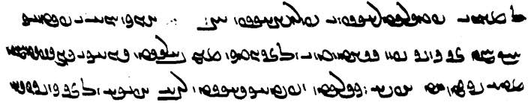
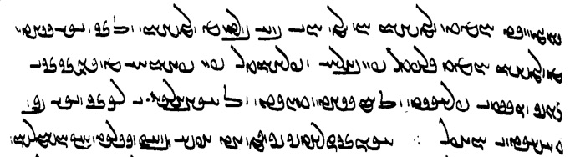

∵ ēk ēd ī paydāg / kū ka ān kanīg pad raft ī ō ān dūdag abar bālist gyāg ī andar Spitāmān / deh estād u-š nigerīd
ud paydāgīhist wazurg abdīh ō ān kanīg čiyōn // *dēn [ms. <d’n>] gōwēd
hād awēšān ō <’w'> ōy *wāng [ms. <’ng>] bē burd: az awēšān ō ān wis raw /
kē awēšān hād <ylptl> pad bālāy ud frāxtar pad pahnāy
kē, andar ān, ān ī / zīndag [ms. <zyndk'>] gōspand frayist ō ham raftēnīd
ō hayārīh ī tō ān wis bag / tāšīd ī xwābar

Text 17.2
From Dēnkard book III: Dk.3.123.24-26. – Ms. B p. [91]. – About which psychological elements are of this world and what is of the other world.

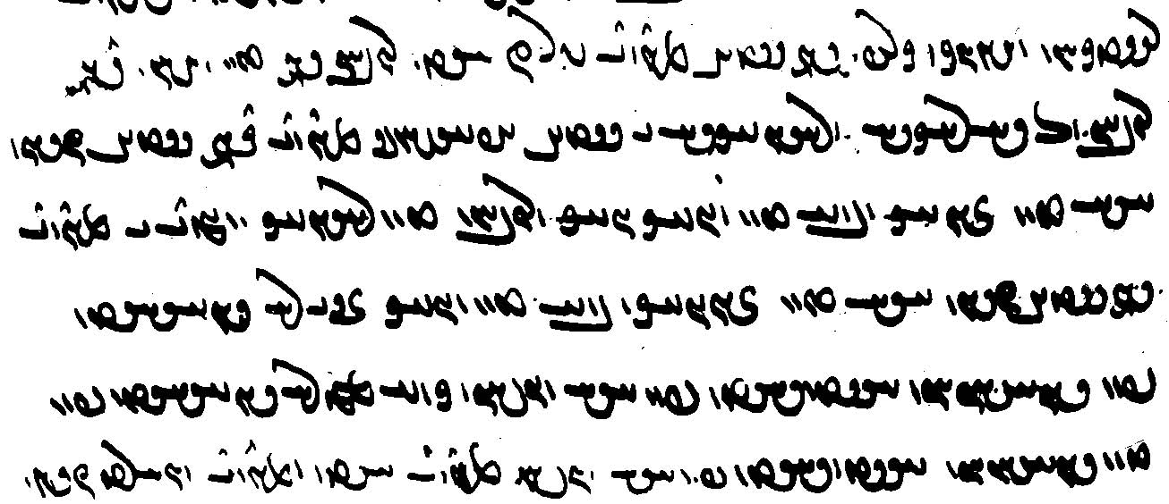

andar gētīy mēnōytar-iz ast ruwān andar tan
ud ox andar / ruwān ō dārāgīh ud rāyēnāgīh ī gētīy abāyišnīg
mēnōy andar gētīy čiyōn / gyān (ī) tan *zīyēnāg [ms. <zyw’k>] ud *bōy [ms. <BRA>] (ī) tan wēnāgēnāg ud ruwān (ī) tan rāyēnāg
ud wimand ī mēnōy / andar gētīy čiyōn gyān (ī) tan zīyēnāg *bōy (ī) tan wēn(ēn)āg
ān ī nē sōhīhēd / pad sōhišnān, wēnīhēd pad gyān wēnišn
harw čē nē sōhīhēd pad / tan sōhišnān, wēnīhēd pad gyān wēnišn

Text 17.3
From the Dādestān ī dēnīg: DD.36.46. – Ms. TD4, p. 253, variants in ( ) from T60 ff. 50v-51r. – About how the good deities fight against Ahrimen and his ilk.

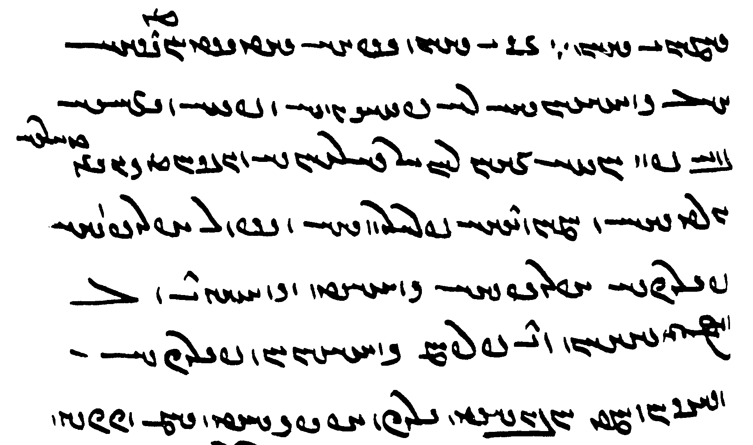

∵ ān ī yazdān spāh dādestān(ō)mandīhā / pas-kōxšišnīhā
(ud) nē pēš-kēnīh ud pēš-wizāyīh / bē pad xwēš ziyān abāz-dārišnīh ud *gundagān [ms. <gwdk’n>] az *kēn-wizūdārīh [ms. <kynyzwt’lyh->] /
gurdīhā ud amāwandīhā frārōnīhā ud spurr-abarwēzīhā / pērōzīh-abarwēzīhā kōxšēd
ud kōxšēnd ō / Ahrimen dēwān tā frazām-kōxšišnān pērōzīh ī / wehīgān
ka wanīyīhēd druz abēzagīhēd dām
Either pad pēš-kēnīh or pēš-kēnīhā. $$

Exercises 17

17.1. Transliterate/transcribe and translate:

WwÍCwL„> W eAWkÍ W eLtd;J WkwaÅ WIwAcÅ W esAkaHwY WWP ÂABwA Y EtÔ∂¸ W EKTPwÍW LB ÍcÅ ? !
/ ˙DB EkAwA WiY>Wwï>˜ W WiAtJ WKWwY AWK W
(about adherence to the Jewish faith in the “worst ages”)

? ? ? ëNwA 9WwïJwY WwYWkA waHtÂA WwSC WTPwY cÅWP WWwÍ NwY WWP 9WwïJwY ÂAcÅ L N 2 AWbY à WtDWwllmY tÂA ? 2

/ WtD{ çMwYN ? WtDWWwaD WwSC WtDPKTP ÍBwA áJW ÍtÂA WKtJwL Y LT ? 3

? WKwYwïåÂA WtDc¬Y< WiAP aå˜ Y>W WTWWtåJ cÅWP ? WKwYwïåÂA WtDc¬Y< WiAP LtJ WWP WWwLwÍwY< WTWWtåJ cÅWPW ? 4
WTNW WWwLwÍwY OW AWB WthAWt¬Z Y laÅwLP oaÅ waHcÅ ? WKwYwïåÂA WtDc¬Y< WiAP WtdßLwA Y>W WTpL cÅWP
/ WWwLwÍwY WTWWwaD Y>WwSWwA ? WtDWwllmY AWB WcdlaÅP WN ëtJ OW MWWvaD AWB à

WthaD> LTima¬G< W LTimLcÅ WwAKcDWK WIwAcÅ N WN WTWB WIw˙dAcÅ !WKcDWK áÒ WwAwï>¬A ? 23
/ WtÅWnYI WTWK WKFWK ã WTWB WwAwï>¬A Y WwÍtjLP WKwYwïÅ AWK WWPW

/ WtdaH aÒ WWtDwYtÒW elYcH OW WKwYwïÅ cdA WWP ad;J Y lAwY<W eLtd;J OW WklAC çMwYN WWP WKwYW Y lAwY< ? 33

/ WtdaDkAtDP Wwa˜wï<Å W lAcDWwY <W WwÍ{ WwAt∆da˜ Y E>W Y WwS N Y>Wwï˜ W ëtJ Y WBC WKwYwïÅ AWK ? 34

? WtDwYkABwL ÍcÅ WTWWtåD EkAtDP OW WwïD AklM WcjAtHW Y egATwA x ? 44
WtDWWtåD a˜wAwA N eLBÂAtDP WWP WthAWt¬Z Y aåÂLtdÍwA WklAcÅ ã WWP
/ WtDwYkABwL WwaåJ< x CnLW WTWwYtdaD WwS WthAWt¬Z WwSC

WtDWWwaD WWWtdA WtdßAC :Jwa˜ lABWtJwA âL WwaåD Y WBC WWP Y AWbY OW tÂA ? 333
/ ìWNwA WtDwSwL WwaD>wY> g<LwY< OW TtÂA wSC

/ TNwA WtDwYcÅT AL ëtJ oW EwÍ{ ã TNwA WTWK WWWtdA AL tÅ ? º

17.2. Match the Pahlavi words with their transcriptions.

LPtJ WWtDwïådL| WtHwaÅ agārēnīdan dām-dahišnīh hayārēnīdan
yZK EwßlYTW AWB ÂABwA āgenēn dušāgāhīh hunsand
WwaÅtå˜ Ewßad>maD Y>WwSWwA ahīy framūdan mādayān
çMwYN WWTWwïJwY WWtDwï¬AkA āšnāg frawahr stabr
laÅwLP esAkaHwY WwYWkA āwām garzīd stadan
WWTnLP WWtDwï¬sadÍwY WKwYwïåÂA āz-kāmagīh gētīyīg tis-iz
WtdßAC WtDc¬Y WWtDwï¬AbsA bē-widerišnīh Gōšurūn xīr
WBC WWwLwÍwY EkmAK WcÅ brēhēnīdan ham-ēwēnag yōǰdahrēnīdan
WiAtJ WkAwßA čāšēd hāwišt
17.3. Translate into Pahlavi and write in Pahlavi script with transliteration and transcription:

- Do not do battle with a greedy man, and do not harm him in any way!
- How is the mixing of water into the earth and in what manner? – The mixing of water into the earth is just like the blood in the body of men.
- Ohrmazd created Jam, Frēdōn, and Kāy-Us immortal, and thus he turned Ahrimen (back), as is well known, and in such a way turned it into a greater benefit as that which is manifest.
- Do not practice greedy desire so that the demon Greed deceives you and the matter of this world becomes tasteless and that of the other world is destroyed!
- Can one, by diligence, make one’s own the goodness that has not been allotted or not? – One cannot, by diligence, make one’s own the goodness that has not been allotted, but that which has been allotted comes sooner because of diligence.
- They also held that a small good deed is the cover [sth. which hides] of a bad deed, for a thick bad deed that is done is less manifest because of a small good deed.
- Four things are essential, but one in particular is very essential: to be a pupil, for those other (thing)s too are known by being a pupil.
- During the first creation, when Ohrmazd fashioned the Ahunwar from the endless light, then the dēn was ‘created’ together with the creation.
- That good deed that the departed ordered in life is propagated after his passing and becomes something that makes him happy in paradise.

Additional Readings 17

Additional Reading 17.1
From Wizīdagīhā ī Zādspram: WZ.35.41-42. – Ms. TD4a, p. 597. – On the final punishment of the wicked, before their final purification.

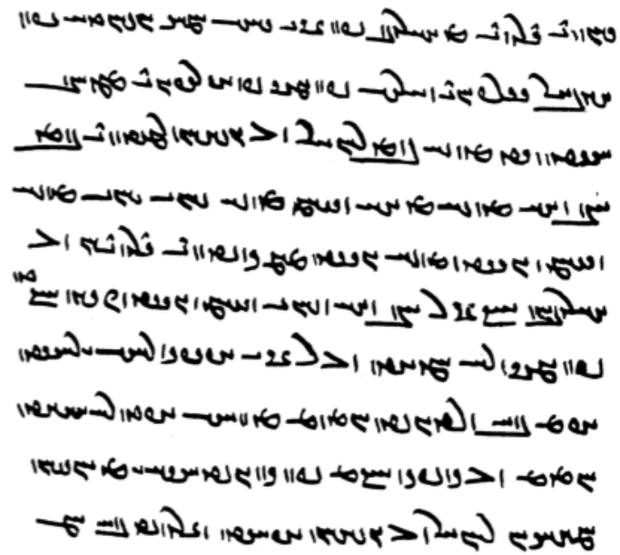
pad ān y gāh hamāg mardōm pad / ēw-bār garzānd ud ars pad zamīg frāz rēzēnd
čē pid / wēnēd kē-š pus abāz ō dōšox abganēnd
pus / (kē-š) pid, brād kē-š {az} brād, zan kē-š šōy, šōy kē-š / zan, ud dōst kē-š dōst [i.e., wēnēnd]
abar xwānēnd druwandān ō / ahlawān kū: ān man pid ud brād ud šōy zan ud dōst!
čiyōn kū-t / pad zamīg nē hammōxt ō man ān ī abēzag rāh ī rāst /
*u-t [ms. u-m] bē (nē) wardēnīd ham az wināh u-t nē hāxt / ham ō kerbag
kū-m pad nūn [for nūn pad] ǰudāgīh ī az xwēšān [ms. <hwyšn'>] / hamhāgān abāz ō dōšox abāyēd *šud [ms. <OZLWNyt>]

Note <gylc-> for <glc->.
Note the fronting of nē hammōxt for nē ān ī abēzag rāh ī rāst ō man hammōxt .

Additional Reading 17.2
From the Dēnkard: Dk.7.2.9-11. – Ms. B, p. [478]. – About how the machinations of the evil ones were used by the gods to make Z.’s mother meet his father. Note the infinitives taking both ‘subject’ and direct objects in this text (see Lesson 10).
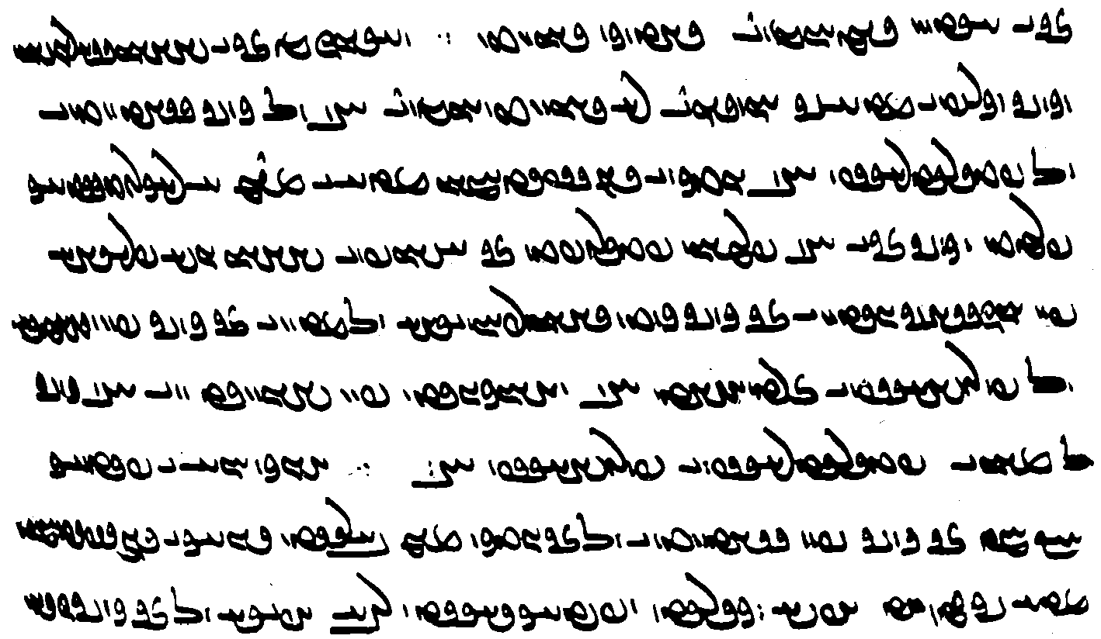

∵ ud ēg-iz az ān ī dēwān sārēnišn / {ud} kayg ud karb ī dehīg hunsand nē būd hēnd
pid ō kanīg raft ī / ō Padērēdarāsp pid (ī) dūdag ī andar Spitāmān deh ī abar Arāg rōdestāg / framūd
ud kanīg ān ī pid framān padīruft
ān āšōb ī dēwān dušfargīhā / pad uzdehīgēnīdan ī ān kanīg kerd
yazdān warzāwandīhā ō madan ī ān kanīg pad zanīh / ō Pōrušāsp ī Zarduxšt pid wihānagēnīd
pad frēstīdan ī pid kanīg / ō mān ī Padērēdarāsp ī Pōrušāsp pid ∵
ēk ēd ī paydāg / kū
ka ān kanīg, pad raft ī ō ān dūdag abar bālist gyāg ī andar Spitāmān / deh, estād u-š nigerīd
ud paydāgīhist wazurg abdīh ō ān kanīg

Notes:
<kwyk> (= <knyk>!) for kayg.
raft ... framūd “ordered (her) to go,” with short infinitive.
pad + (short/long) infinitive: “in order to; by(means of); while.”
āšōb ... yazdān ... ō (infinitive) wihānagēnīd pad (infinitive) “the gods made the confusion ... a means for ...”

Additional Reading 17.3
From the Dēnkard: Dk.3.253.7–11. – Ms. B, pp. [206–7] – About the three kinds of knowledgeable (wise) men and the positions of other religions on god’s omnipotence, etc. (the Mutazilites).

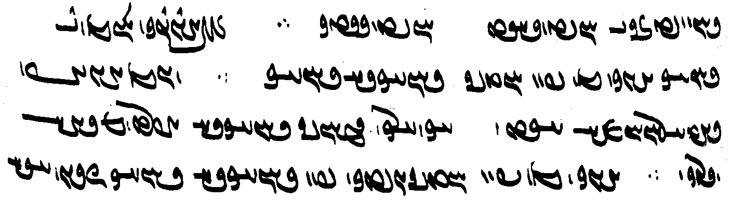
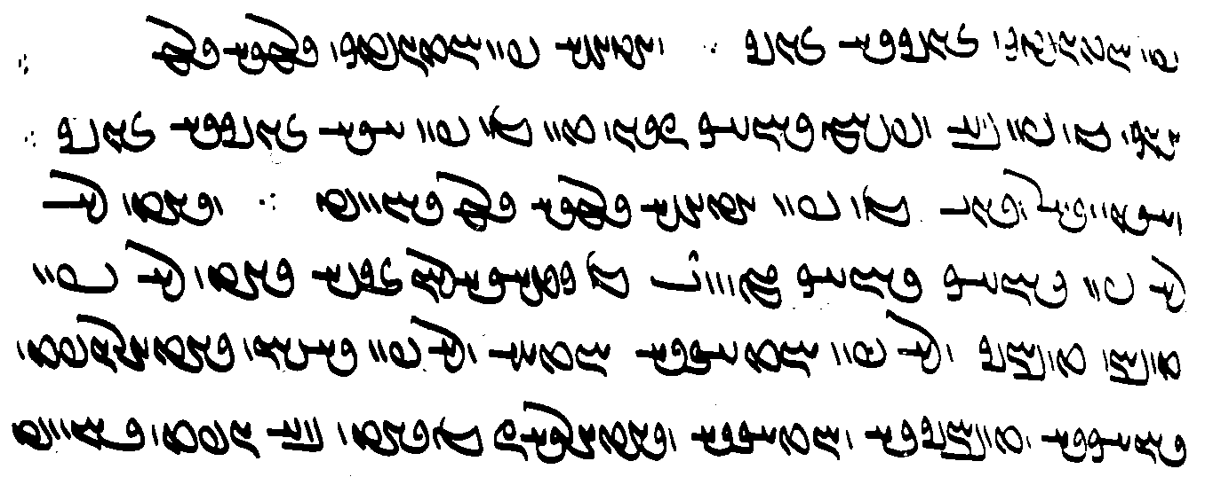
3 ēwēnag hēnd dānāg
ēk kē pad xwadīg dānāgīh dānāg ∵
ud ēn ēwāz dādār Ohrmazd ast ∵ akanārag-zamānīg dānāgīh abardomīhā-nērōg ∵
ēk kē pad xwadīgēnīdag {pad} dānāgīh dānāg
čiyōn gyān [B207] pad xwadēnīdag zīndagīh zīndag ∵
ud ātaxš pad xwadēnīdag garmīh garm ∵
ēk kē pad (dānāgīh ī) bē-xwēš dānāg
čiyōn tan kē pad gyān zīndagīh zīndag ∵
ud āhen ud dār ud sang kē pad ātaxš garmīh garm bawēd ∵
ud yazd nē / {nē} pad dānāgīh [ms. dānāg] dānāg gōwēnd
az kēšdārān ī-š(ān) yazd nē pad tuwān tuwānīg ud nē pad xwadāyīh xwadāy ud nē pad dahišn dādār guft (for kēš?)
dānāgīh ud tuwānīgīh ud xwadāyīh ud dādārīh-iz az yazd bē guft bawēd

Notes:
zīndag(īh) is often spelled <zyndk', -yh> beside <zywndk', -yh>.
xwadēn- is probably a scribal error for xwadīgēn-
kēšdārān ī-š(ān) ... guft (for kēš?) “the kēšdārs who said (whose kēš is?) ...

Additional Reading 17.4
From the Rivāyat of Ādurfarrbay son of Farroxzād: RAF.32. – Ms. Td2, p. 342. – On the validity of the sagdīd (showing a nasāy to a dog) among Iranians and non-Iranians.

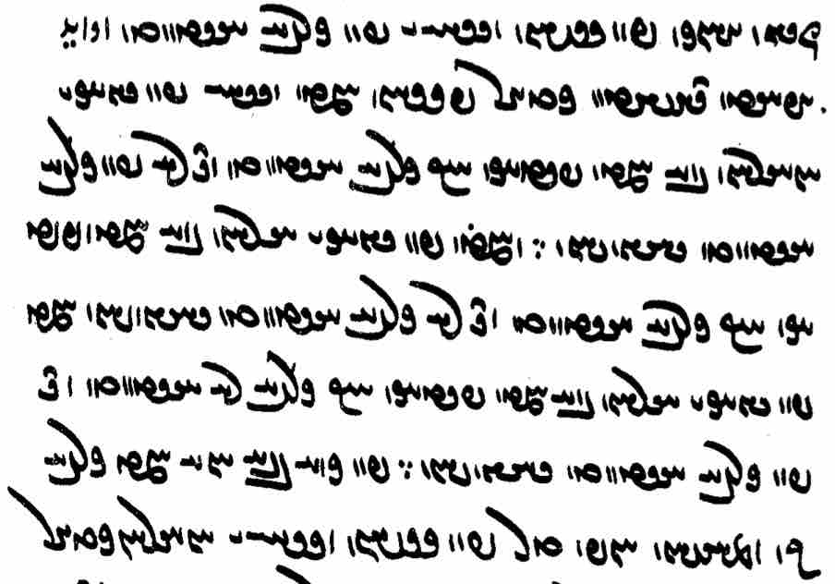
pursišn: nasāy ī pad sag dīd [Pers.] avāyēd / abāyēd dāštan kadār
passox: ka nasāy pad gyāg ī / an-ērān: bē ka paydāg kū sag / dīd tā nē pad sag / dīd dārišn ∵
ud ka pad gyāg ī ērān: bē ka payd/āg kū sag dīd tā nē (pad) sag dīd dārišn
ka / pad gyāg ī ērān: bē ka paydāg kū sag nē dīd tā / pad sag dīd dārišn ∵
pad harw dar ēw ka sag / ōh nimāyišn xūbtar

Remember: bē ... tā “except,” pad ... dār- “to regard as.”

Glossary of words in the Texts and Exercises 17

Idioms:
az yazd bē guft bawēd is denied god (lit. “is said away from”; opposite of “is ascribed to”)
čand frārōnīhā in as (morally) good way as possible (Lesson 13)
dādestānōmandīhā by being someone acting in compliance with the law
duš-fargīhā in order to make miserable/cause misery
ēdōn ... ī in such a way that
hamāg ēn zamīg on this whole earth; note no preposition in adverbial phrases of place
hunsand + az happy/satisfied with
ō xwēš kerdan make one’s own, appropriate
pad čār (even though) being able (to do so)
pad margīh for the death (of ...) = in order to cause the death ...
pad paygāmbarīh as messenger (paygāmbar)
pad tis-iz ēwēnag in any way at all
pahrēz gōw- ‘utter pahrēz’, care (for)
pas-kōxšišnīhā by (only) fighting after (having been provoked/attacked
wāng bar- call, shout
warzāwandīhā by using (one’s) miraculous powers
X bār ēdōn ... čiyōn X times as ... as ...

Nouns, adjectives, adverbs, pronouns:
99 333 kÓD <90 3 3 3>
abāz-dārišnīh EwßlaD lAwaÒ <LAWHL d’lšnyh> holding back, withstanding
agumān Wwa˜wïÅ <’gwm’n'> not doubtful
ahīy yZK <KZY> first, at first; sooner
āhōg WKwaÅ <’hwk'> blemish
āhōgēnišnīh EwÍwYKwaÅ <’hwkynšnyh> soiling, sullying
ahōš ÍwaÅ <’hwš> immortal
akanārag-zamānīg WIwaÂY WklAWkA <’kn’lk' ẕm’nyk'> which lasts for a limitless time
andōh AwYwA <’ndwh > sadness, sorrow
āšnāg WkAwßA <’šn’k'> (well-)known
āwāsēnišn WwÍwïjAwA <’w’syn šn'> (the act of) drying (up)
awestwār lABWtJwA <’wstwb’l> firm, confident, reliable
az WcÅ <’c'> 1. snake, dragon (Av. aži); 2. āz, Āz
āzarmīg WimLcÅ <’clmyk'> beloved
āz-kāmagīh EkmAK WcÅ <’c' k’mkyh> greeedy desire, desire caused by Āz
āzwar LWcÅ <’cwl> greedy
bag WKB <bk'> god
baškuč CWkÍV <bškwc> gāw ~: gryphon (MacK.)
bawēnīdār lAtdwYWWwaD <YHWWNynyt’l> one who brings into existence
bēš ßGB <byš> harm, hurt
bēšāzīh-xwāyišnīh Ew˙∂ÅwA EcåhYV <byš’cyh hw’yšnyh> seeking healing
bē-xwēš nÍPW AWB <BRA NPŠE> outside of one’s own, extrinsic
bizišk WkÍCV <bcšk'> healer
dādestānōmand YNwAwAtJtåD <d’tst’n’wmnd> someone (acting) in compliance with the law
dandān WwaD>wY , AKK <KKA, dnd’n'> tooth, teeth
dārāgīh Eka¬aD <d’l’kyh> being dārāg, the one who upholds/holds up
dehīg WiaD> , WiAt˜ <MTAyk', dhyk'> of the village, villager
drōzišn WwÍCwlY <dlwcšn'> lying
dušfargīhā aådLpÍwY <dwšplgyh’> (by) causing misfortune, making miserable
ēwāz WcÅwïÅ <’yw’c'> only
frāx WwaåÒP <pl’hw'> wide, broad
frazām-kōxšišn WwßßAWK ÂAcÒP <plc’m kwhššn'> one who will fight in the future/to the end
gōhr lAwY <gwhl> substance, disposition
gundag WIWwY <gwndk'> troop (of soldiers)
gurdīhā aåDtÒwY <gwltyh’> like a hero
hambawēnīdār lAtdwYWWwaDmA <hm-YHWWNynyt’l> one who makes sth. into something composed
hambawišnīh EwÍWWwaD ÂA <hm YHWWNšnyh> becoming composed, conception
ham-ēwēnag WKwYwïåÂA <hm’dwynk'> in the same way/manner
hamhāg WkaåÂA <hmh’k'> companion
hamsūd WTwsmA <hmswt'> sharing benefit
hamziyān WwaåΩmA <hmzyd’n'> sharing damage
haguriz = hagriz cÒWkA <hkwlc> ever; + nē: “never”
harw-gōnag WKWwY AWK <KRA gwnk'> every kind of
hāwišt WtHwaÅ <h’wšt'> student, pupil
hazārag WklAcÅ <hc’lk'> millennium
ǰud-ristag WKtjgL / WKt∆dL WtDwY <ywyt' lystk'> having different ‘ways’
ǰud-ristagīh EKtjgL / EKt∆dL WtDwY <ywyt' lystkyh> heresy
karb WpLK <klp'> karb, Av. karapan, kind of priest, enemy of Z.
kayg WIWK , WIK <k(w)yk'> kayg, Av. kauui, kind of priest, enemy of Z.
kēn-wizūdārīh elATuYW WwYK <kyn' wyzwt’lyh> destruction caused by animosity/revenge
mādayān WwaÅtå˜ <m’t’’ny'> 1. particular, special, essential; also adverb; 2. book
mādayānīhā aåDwaÅtå˜ <m’t’’nyh’> in particular, especially, essentially
meh-sūdīh EWwS sM <ms swtyh> greater benefit (in the greater scheme of things)
nibard WtÒPW <nplt'> battle; + bar-: “do battle”
nihumb WvMwAW <nhwmb'> cover; cf. nihumb- nihuft “cover, conceal”
paristišn WwÍtjLP <plstšn'> service
pas-kōxšišn WwßwßAK oaÅ <AHL kwhššn'> who fights (only) after (being attacked)
pērōzīh ECwlYP <pylwcyh> victory
pērōzīh-abarwēzīhā aåDcDwLcÅ ECwlYP <pylwcyh ’plwycyh’> with the superiority of (certain) victory
pēš-kēnīh EWwYk˙DP <pyškynyh> (harboring) prior animosity
pēš-wizāyīh eáΩYW ˙DP <pyš wyz’dyh> prior (desire) to destroy
spurr-abarwēz WcDwLcÅ LWcJ <spwl ’p̄lwyc> full of (martial) superiority
rāh-nimūdārīh elATNW saÒ <l’s nmwt’lyh> showing of the way, guidance; from rāh nimāy- “to guide”; cf. rāh-nimāy “guide”
rāyēnāg WkAwˆdaÒ <l’dyn’k'> one who governs, arranges/organizes
rāyēnāgīh EkAwˆdaÒ <l’dyn’kyh> being the one who governs, arranges/organizes
rustag < rōy- WKtJwL < lwstk'> grown
sōhišn WwßAwS <swhšn'> sense(s)
sōzišn WwÍCwS <swcšn'> burning
stabr LPtJ <stpl> thick
škōhīh eAWkÍ <škwhyh> poverty
tagarg (tiyarg?) y<ly<T <tglg> hail
tarr LT <tl> moist (plant)
tēz WcDT <tyc'> sharp, narrow
tēz-bēšēnīdār lAtDwïhYV WcDT <tyc' byšynyt’l> giving sharp pain, hurting badly
tuwān WwABWT <twb’n'> ability, (omni)potence
tuwānīg WIwABWT <twb’nyk'> able, (omni)potent
tuwānīgīh EIwABWT <twb’nykyh> being able, being (omni)potent
waranīg WIwLW <wlnyk'> greedy, ‘horny’
warzāwand YWwAcÒW <wlc’wnd> having miraculous power
wehīg WiaDW <wyhyk'> adherent of what is good, good people
wēnāgēnāg WkAwYkAwYW <wyn’kyn’k> one who makes sb. wēnāg “seing, able to see”
wimand YnYW <wymnd> border; definition
winast WtJWW <wnst'> soiled, sullied
wis s`W <wys> village
wišuftagīh < wišōb- EKTPwÍW < wšwptkyh> disturbance, destruction
wizūdār < wizāy- lAT¨DW < wyzwt’l> destroyer
wurrōyišn, wirrōyišn WwßYwlYW , WwÍWnïÅ <HYMNNšn', wylwyšn'> belief, faith
xwadīg WITwA <hwtyk'> coming from oneself oneself
? LTpL„ <ylptl> taller, higher?
zīyēnāg WkAwYwï¸ <zywyn’k'> (re)vivifier, one who brings (back) to life
zištīh EtÔ∂¸ <zyštyh> ugliness, nastiness

Names:
Arāg Wka¬A <’l’k'> name of a county/province
Ōšīdarmāh aåÂLtdÍwA <’wšytlm’h> 2nd of Z.’s three eschatological sons
Padērēdarāsp WcjaÒtdL„TP <ptylytl’sp̄'> name
Pōrušāsp = Pōrušasp WcjaHwLWP <pwlwš’sp̄'> Z.’s father

Verbs:
abēzagēn/īh- –EKcDcÅ , –wYKcDcÅ <’p̄yckyn/yh-> make/be made pure
abzāyēn- –wsa¸cÅ <’p̄z’yyn-> to increase, cause to grow
afsār- afsārd Wt¬aJcÅ , –laJcÅ <’p̄s’l- ’p̄s’lt'> cool, extinguish (fire)
agārēn- –wï¬AkA <’k’lyn-> incapacitate
awest- awestād = est- –tJwA <’wyst-> stand; + ul: “rise up”
awestēn- –wYtJwA <’wystyn-> make stand; + ul: “raise up”
(mistake? for hangēzēn- –wYcJwA <hngycyn-> + ul: “raise up”)
bawēn- –wYWWwaD <YHWWNyn-> bring into existence
būs-īd WtjGWB , –SWB <bws-> come into being
dānāgēn- –wYkAwaD <d’n’kyn-> turn into a wise man (trans.)
dānēn- –wYwaD <d’nyn-> cause to know
frēst- frēstīd = frēstād WtDWWwïH , –WWwïH <ŠDRWNyt'> send
–WWtH <ŠDRWN->
hayārēn- –wï¬AvsA <hdyb’lyn-> assist
hambawēn- –wYWWwaDmA <hm YHWWNyn-> make into something composed/coherent (?)
hamēstārēn- –wï¬AtjïÂA <hmyst’lyn-> be an opponent of, oppose
hāz- hāxt WtååÅ , –cåÅ <h’c- h’ht'> lead, guide (Av. hācaiia- lit. “make follow”)
margēn-īd -wïdlM <mlgyn-> kill
padīruft = padīrift WTPwL„TP <ptylwpt'> received, accepted
pahikaf- pahikaft WTPKTP , –PKTP <ptkp- ptkpt'> to fall; + pad: “onto”
paydāgēn/īh- –EkAtDP , –wYkAtDP <pyt’kyn/yh-> make/be made manifest
raftēn- –wYWtåJ <SGYTNyn-> make go; + ō ham: “round up”
rawāgēn/īh- –EkABwL , –wYkABwL <lwb’kyn-> set in motion, propagate
rāyēn-īd –wˆdaÒ <l’dyn-> arrange, organize
rōyēn- < rōy- –wSwL <lwdyn-> make grow
sārēn- –wï¬aJ <s’lyn-> provoke
saz- sazist –cJ <sc-> it behoves, one should; impersonal verb
sōh- sōhist –AwS <swh-> sense
tābēn- –wYcÅT <t’p̄yn-> make shine
uzdehīgēn- –wY˝ÎåJCwA <’wcdyhykyn-> chase out of the village, exile
wanīyēn-/īh- –EwYBwA , –wYwYBwA <HWBDW(N)yn/yh-> destroy/be destroyed
wardēn- –wYtÒW <wltyn-> turn, make turn (trans.); + ō: “turn into”
wēmārēn-īd -wï¬aÂYW <wym’lyn-> make sick
wihānagēn- –wYKwaÅW <wh’nkyn-> make the cause, make a pretext for; + ō “for” + infinitive
wizāy- wizūd WTuYW , –ïåΩYW <wyz’d- wyzwt'> destroy
wurrōy-ist –WnïÅ <HYMNN-> believe, have faith; impersonal verb (Lesson 9)
xwadēn- error for xwadīgēn-? –wYTwA <hwtyn->
xwadīgēn- –wYITwA <hwtykyn-> make sth. into sth. coming from oneself

Lesson 18

Grammar 18

The Verb. The past stem = past participle = short infinitive

Past participle/short infinitive as noun
The past participle/short infinitive can be used as a noun and often to refer to a preceding action expressed by the same word. It is often used like English “...-ing” e.g.:

ka Garišasp kār mardōm ōzad būd čē rāy nazdist rist ān ī ōy kunēnd
“when (= since) Garišasp’s work was killing people, why will they do (= raise) his dead body first?” (PR.18f.35)

ud abar pād ī-š gōspand ī az wāstar kasān ud wināh tōzišn (ī) az nē pād
“and about keeping one’s cattle from (other) people’s grass and the payment for the sin of not keeping (them)” (Dk.8.23.9)

mard ēw kē abāg mard ēw ēk abāg did ǰang kunēnd ān ī jang kunēd andar ān ǰang-kerd ōy ī did pad dandān gīrēd
“two men who fight with each other; the aggressor in that fight grabs the other with the teeth ...” (RAF.56.1)

[...] ... ān mard az ān zad <MHYTNt'> ... murd būd
“[if a man is struck] (and the pain does not subside within 3 or 7 days and) that man has died from that striking ...” (MHD.F.2)

pad guft ī dastwarān ōwōn nibišt kū
“according to the saying of the dastwars it is thus written: ...” (MHD.25.6)

ud pad-iz abārīg was čim zīndag-gōwišnīg saxwan az ān ī pad nibišt mādagwartar hangārdan čimīg
“and it is logical that also in other matters the word from the living speech should be regarded as more essential than that in writing” (Dk.5.24.13)

ka pid duxt ī abornāy pad zanīh bē dahēd duxt agar ... pad ān dād <YHBWNt'> a-hunsand ...
“if a father gives away a minor daughter in wifehood, if the daughter (once adult) is not happy (does not agree) with that giving ... (MHD.E.9)

ka mard zan kē sālār ī pad nāmčišt ud stūrīh ī kas nēst gād ud pad ān gād frazend zāyēd
“if a man has had intercourse with a woman who has no specific guardian and is not the stūr of anybody and (if) a child is born from that intercourse ...” (MHD.30.3)

ka Farrox abāg Mihrēn paymān kunēd kū agar ō Kuwār šawam ēnyā dram 50 bē daham pad šud Farrox paydāgēnišn
“if Farrox makes an agreement with Mihrēn that ‘unless I go to Kuwār, I shall give (you) 50 drahms,’ (then) Farrox has to inform (him) of (his) going” (MHDA.5.18)

The long infinitive used in the same function:
weh-dēn mard kē zan ī ag-dēn gād az ham gādan ābustan bawēd ēg-iš frazend ag-dēnān dādan rāy zamānīg tanābuhl ēw wināh
“a man of the Good Dēn who has had intercourse with a woman from an evil Dēn (and) she becomes pregnant from said intercourse, then (s)he incurs a sin of an immediate tanābuhl for giving a/the child to those of evil Dēn” (REA.42.2)

‘Absolute’ constructions
These can be characterized as verbless clauses meaning “while sth. happens, once sth. has happened” and are similar to the Latin absolute ablative and the Sanskrit absolute locative, cf. Eng. all things considered.

Adjective plus noun:
zīndag pidar “while the father is alive” (RAF.62.2)

Past participle plus prepositional phrase:
ud mad ō pornāyīh pēšagān wizīnēd
“and, (once) having come of age, (the child) chooses a trade” (WZ.31.1)

mad ō 9-sālag frāz raft abar ān ī ōy zanišn
“(once) having come to the age of nine, (Frēdōn) went forth (bent) upon his smiting (= smiting him = Dahāg) (Dk.7.1.26)

Past participle plus noun or pronoun:
This construction is quite common (cf. the compounds in Lesson 16).
It is identical with a ka-clause with fronted verb, but without ka, cf.:

ka kand xwēd pāk > kand xwēd pāk “when the wet (part) has been eliminated (it is) clean” (PV.16.2)

Examples:
uzīd ān zamān
“once that time has passed” (MHD.E.1)

ēdōn druwand ruwān frōd murd tan
“thus (also) the soul of the Wicked, once the body has died” (Dk.3.108.13)

ud pad-iz ān hamīh ī frawahr waxšōmand *bōy widerd tan abāg ahlaw ruwān
“and also by that togetherness (= by being together) with the frawahr, which contains the growth, the consciousness (bōy), once the body has passed on, (is) together with the soul of the Righteous one” (Dk.3.123.38)

hērbedān hāwištān būd hēnd pad hammōxtan ī az xwēš hērbed hāwišt-iz hammōxt dānišn hērbed bawēd abāg hammōxtār andar ēk tan bawēd
“the hērbeds have been students by learning from their own hērbed, and the student, as well, once (they) have been taught/learned the knowledge (Avesta and Zand), becomes a hērbed: he will be in one body together with the teacher” (DD.44.3)

pad ān ī škefttar dard bēš bē ōzad tan ruwān wišād ō ul ahrāmādan ... abāg ahlawān āsānīhād ud šnāyīhād pad ān abardom āsānīh šnāyišn
“once the body is slain by that very harsh pain (and) harm, the soul, (now) released for rising up ..., will be made relaxed and pleasured in that highest rest and pleasure” (Dk.3.358)

u-š pad abardomīh ī ham srišwadag estēnīd rōšn Xwar ud bāmīg Māh ud xwarrahōmandān starān u-š payrāst kū mad petyārag wāzēnd ud gardēnd pērāmōn ī dām
“and in the uppermost of said third, he set in place the bright Sun, the shiny Moon, and the Xwarrah-filled stars, and he aranged (it) so that, once the Adversary had come, they would fly (above) and turn around the creation” (DD.36.21-22)

u-šān kerd kām ī dādār fragānēnīd was kār ī gēhān-sūd
“and, having performed the Creator’s wish, they (= M&M) laid the foundation for many actions benefiting the world of the living” (Dk.7.1.10)

abar duxt kē a-kerd šōy kē nē pid ud nē mād ud nē-iz widurd pidarān ā-iz az brādarān pad šōy ud nē-iz xwēš tan pad sālārīh bē dād pādixšāy
“about a daughter who, having not yet married, who has neither father nor mother, and her grandparents (?) having not yet passed on, then it is authorized (that she be given) by (her) brothers to a husband, but it is in no way (authorized for her) to give herself in guardianship (to somebody) (Dk.8.43.11)

pad zōdīh ī Sōšāns ud hamīh ī 6’ān hamān fraškerd-kerdārān ul-uzišnīh ī wispān rōšn-tōhmagān rāy yašt ī fraškerd-kerdārīh frāz srāyēnd
kerd yašt ... abar xwānēd Sōšāns kū ul estēd tanōmand hēd
“with Sōšāns as zōd (chief priest) and together with (pad hamīh ī) the same six Renovation-makers recite the Renovation-making ritual for the rising up of all those of the seed of light;
having performed the ritual ... Sōšāns calls out: Arise! You have bodies!” (WZ.35.19-20)

widerd man xwāstag ī man xwēš tō xwēš
“once I have passed on, the property that is mine will be yours” (MHD.J.9)

With preverb:

abar nīd Spitāmān Zardušt sag zard 4-čašm ayāb spēd zard-gōš
ān druz ī Nasuš abāz dwārēd ō abāxtar nēmag
“Sp. Z., once a yellow dog with four eyes or white with yellow ears has been led to (the dead body),
(then) that druz, the Nasuš, runs back to the northern direction” (PV.8.16cd)

In adverbial phrases:
widārd-garāntom-aweštābīhā
“having suffered the heaviest oppression” (Dk.5.24.9)
⇽ widārd aweštāb “having suffered oppression”

With verb + -iz “even when ...”:
abornāyīg murd-iz pid dūdagīh ōwōn čiyōn nūn-iz čē-š tis-iz tis juttar bē nē bawēd
“the family (situation of) an under-age child, even (when) the father is dead, (remains) just as it is now, for none of it becomes at all different” (MHD.37.42)

Noun plus past participle:
These have sentence syntax, but are rare:

ēk-bar sag ō dast grift baršnūmgar ēn gōwišn frāz gōwišn
“once the man who carried a nasāy alone has taken the dog by his hand, the person administering the baršnūm should say forth the following utterance: ...” (ZFJ.627)

sidīgar garzišn ī az ǰeh kē-š pad, daštān abar rasīd, gand ud rēm ī az daštān aw-iš rasēnīdan ud xīndagīh ud stardīh ī az-iš
“the third complaint (by the fire) is about the evil woman who, once the menses have come upon her, for (pad) causing foul smell and filth from the menstruation to come upon it (the fire) and how it becomes sick and faint from it” (Dk.9.11.5)

pad ōy frazend bawēd (ī) pas az wināh kerd zāyēd
“(the penalty for breaking an oath) is with that child that is born after the sin was committed” (PV.4.10D)

The nouns in -īh
As we have seen, the derived abstract nouns in -īh are extremely versatile. Here are some more examples.

“Being something, the fact that something is”

ō laškarīgīh ud spāhīgīh šudan
“to go to be an army soldier (laškar, spāh)” (REA.11.1)

abar tuwān (ī) harw kas pad bōxtan ī az druwandīh ud xwēšēnīdan ahlawīh
“about every person’s ability to be saved from be(com)ing druwand and appropriate (make one’s own) be(com)ing ahlaw” (Dk.3.339.1) – Note that ahlawīh means being one of the ahlaws; here it probably refers to after death, when the druwands are separated from the ahlaws.

burzāwand Kay-Wištāsp čiyōn az dēn abar bawēdīh ī andar ān hangām ēd abdīh āgāh būd ...
“when the exalted Kay-Wištāsp became aware from the dēn of the fact that this miracle was to be (= happen) at that time ...” (Dk.7.6.4)
wēš-awiš-madārīh ī xrad rāy
“because of the fact that wisdom comes to (them) more (often)” (MX.56.20)
⇽ ēd rāy čē xrad wēš awiš mad “because wisdom came to (them) more (often)”

Kay-Wištāsp abar bawēdīh ī andar ān hangām ēd abdīh āgāh būd
“Kay Wištāsp was made aware of the fact that this miracle would be (happen) in that time” (after Dk.7.6.4)
⇽ ēd abdīh andar ān hangām bawēd “this miracle will be in that time”

‘Quotational’ -īh
One common usage, especially frequent in exegetical texts, is that of ‘quoting’ a word to explain it.

pad waxšwarīh wābarīhist hēnd
“they were recognized as ‘prophets’” (Dk.7.1.3)
⇽ wābarīhist kū waxšwar hend “it was recognized that: they are ‘prophets’”
u-m mardōmīh az Mahrīy ud Mahriyānīy
“and my humanity (the fact that I am mardōm) is from Mahrīy and Mahriyānīy’ (PN.2)
⇽ mardōm ham “I am a human”
ud ka pad nasāyīh warōmand
“when there is doubt with regard to its being ‘nasāy’” (ZFJ, p. 546)
⇽ warōmand kū nasāy ayāb nē “it is in doubt whether it is a nasāy or not”

kē-š handām ī tarr abar rasīd hixrōmandīh kē-š ān ī hušk abar rasīd ēdōn čiyōn wars nāxun ī hušk ka bē āb bē šōyēd pāk
“(a place) which a moist bodypart has come upon, (should be regarded as) being ‘containing hixr’; that which a dry (bodypart) has come upon, such as dry hair, nails, when one washes with water, (it becomes) clean” (ZFJ, p. 546)
⇽ pad ēd dārišn kū hixrōmand “it should be regarded as ‘containing hixr’”

u-m warzišn ud xwēškārīh ud frēzwānīh ēn kū Ohrmazd pad astīh hamē-būdīh hamē-bawēdīh ud anōšag-xwadāyīh ud akanāragīh ud abēzagīh. Ahrimen pad nēstīh ud wanī-būdīh menīdan
“what I have to do and my duty is this: to think about Ohrmazd as (pad) being, always having been, and always going to be, as having undying kingship, being unlimited, and being pure, (but) Ahrimen as not being and as being destroyed” (PN.3)
⇽ Ohrmazd ast hamē būd ud hamē bawēd u-š xwadāyīh anōšag ud akanārag ud abēzag “Ohrmzd is, always was, and always will be, and his kingship is immortal, limitless, and pure”

Groups of people
The suffix -īh is also used to denote religious or social groups:

āzādīh ud wazurgīh ud dahīgānīh
“the freeborn, the grandees, and the land-owners” (ZWY.4.7)

druzīh az druz ō ohrmazd dahišn kōšišnīg mad estēd
“the lie-demons came from the Lie for the purpose of battling Ohrmazd’s creatures” (Dk.3.167.2)

tōxt dušmad dušhūxt dušhuwaršt abāg frayādāg ud rāmēnāg mēnōy ī xwēš humad hūxt huwaršt bē ō garōdmān ayāb ō wahišt ayāb ō hamēstagān ī ahlawān ānōh kū-š andar ahlawīh gāh ast awiš franāmēd
“once one has expiated one’s evil thoughts, etc., one proceeds together with the helping and pleasing spirit of his good thoughts, etc., to Garōdmān, the Best (Existence), the Intermediary place of the Righteous, to where one’s place is in the community of the Righteous” (DD.23.6)

čihrōmēhan ī ahlaw abāg wazr ī pērōzgar abāg 53 mardān raft ī hāwištān ī amāwand ī buland ... ī sīžd-sneh kū-šān dēw ud wattarīh aziš tarsēnd
“Č. the Righteous, with the victorious cudgel, went with 53 men, (his) students, tall and mighty ... with fearful weapons, i.e., the demons and all the bad ones fear them” (Dk.7.8.45–66)

Phraseology 2

Expressions of similarity
In addition to phrases with čiyōn expressing similarity, there are a number of other words used in phrases signifying “like, similar to.” Most of these are combined with ī and prepositions and, like ēwēnag (Lesson 17), can be combined with ēn, ān, ham- and ōwōn and čiyōn and can be used as adverbs in -īhā.

handāzag WKcåDwA <hnd’ck'> “(same) measure, etc; like manner”
hangōšīdag WKtdÍwYwA <hngwšytk'> “like manner”
mānāg WkAwa˜ <m’n’k'> “like”
homānāg WkAwa˜wA , WkAwaÂA <h(w)m’n’k> “like”

handāzag “measure, amount”
As a noun, this means “measure, amount, same measure/amount, degree, extent; same/like manner, like manner,” but is also used in the sense of “analogue, example, similar, comparable (to).” The derived noun handāzagīh means “similarity, analogy.”

As noun:
harw ān kē ō dōšox ōbast ēg-iš andar dōšox pādifrāh pad ān handāzag bawēd kē-š wināh kerd estēd
“everyone who has fallen into hell, then, in hell, his punishment will be in that measure/amount (to) which he has committed sins” (REA.39.26)

ka sidōš bē mānēd ōy kē pad nē yaštan wināhgār ā-š tōzišn ērang handāzag čiyōn ān ī gāhānbār nē yaštan
“when the sidōš (ritual) remains (unperformed), (then) he who is guilty of not performing the ritual, his atonement and guilt (are) the same amount as for not performing the gāhānbār ritual” (RAF.144.2)

ēg awēšān druzān, ham-čiyōn sag ayab way frāz ō nasāy nigerēnd, ān gāh dāštan nē šāyēd ōšmārēnd bē ō wizandišn ud wihēzišn estēnd;
ud az mehmānīh ī-šān padiš bahrag bē kāhēd ud ham handāzag ān nasuš nizārīhēd
“then, they figure (ōšmārēnd) (that), as soon as the dogs or birds look at the corpse, those lie-demons cannot hold on to (their) place (inside the carcass and) begin to tremble and move about;
and their share diminishes from their lodging in it, and that carcass demon is weakened to the same degree” (Dk.5.24.28a)

u-š ham-handāzag ī zōr ud nērōg ī-šān az ān ī ōy wināh ǰād ān tā bē ō fraškerd zamān an-āsānīhā dardēnēnd ud bēšēnēnd ud pad ān ī Wizarš nīdārīh a-kāmagīhā āyēd bē ō dōšox
“and (the demons), giving him no respite (an-āsānīhā), cause him pain and harm to the same extent as (= in proportion to) the strength and power that is their share from that sin of his until the time of the Renovation,
and led by (pad ... nīdārīh < nay-) (the demon) Drag-off, against his will, he comes to hell” (DD.31.5)

kerbag-iz pad-ham-handāzagīhā kunīhēd
“and good deeds are performed to the same amount” (FO.25b.706)
[< pad ham handāzag “to the same amount]

ud ka abāyišn wārēnēd ud abāyišn-handāzagīhā sūd-abgārīhā abar gyāgān rōdestāgān baxšēd
“and when it is needed, (the wind) makes it rain, and it distributes (the rain) over the places and districts in the needed amount, (thereby) providing benefit (for them)” (DD.92.5)

In comparisons:
In comparisons, handāzag can take the particle ī (ī), an enclitic pronoun, and often the preposition pad.
It can be combined with demonstrative pronouns, čiyōn, and ham- “same.”

ud abārīg-iz ēk ēk kār ī gēhān pad uzmāyišn handāzag ān ī bizišk rāy nibišt
“and also the other individual actions of the world (are to be put) to the test, just as that which was written about the doctor” (Dk.3.229.6)

u-š xwarišn pad handāzag ī ān ī andar gētīy gandagtom pūdagtom rēmantom ud a-xwašīhtom
“and its (the soul of the wicked) food is just like that which is the most foul, rotten, filthy, and unpleasant in this world” (DD.31.6)

sahīg kamar nigerēnd ud sēnag stabr mānēnd kū-mān nēst kas handāzag
“the worthy look at (their) kamar [kind of belt or collar, sign of distinction] and remain with their chest thick (= puffed out?) (thinking:) no one is like us!” (PT.37.20: Abar Xēm ud Xrad ī Farrox Mard)

dānāgīh ān ī pad nērōg ī dānāg čiyōn wēnāgīh ān ī pad nērōg ī wēnāg čašm;
u-š handāzag ēd-iz ī xwāstagōmand, ud xwāstag ān ī xwāstagōmand padiš xwāstagōmand bawēd
“knowledge is what is in the power of the knowledgeable man, just as ability to see is what is in the power of the eye, which is seeing;
and its comparandum/analogy is this too: someone possessing property; and property is that whereby (ī ... padiš) someone possessing property comes to possess property” (Dk.3.253.3)

u-š ān pādifrāh az druz mēnōy ī xwēš wināh pad ān ēwēnag ud handāzag abar rasēd ī-š *āzārd ud bēšīd
“and that punishment comes upon him from the Lie in the other world, which is his own sin, in that (same) manner and measure/amount as he (himself) harmed and hurt (things)” (DD.31.9)

wašt-gōhrīh ī az wattarīh az ān handāzag ī zandīg (ī) abar gyān zēfān gōwēd kū
agar wināh kunē ēg-iš gōhr wašt bawē abar guft bawēd
“(the soul’s) substance being changed from (= because of) evilness is analogous to what is ascribed to (abar guft bawēd) the Zandīg (= Manichean) who maliciously (zēfān) says about the soul: if you commit a sin, then its substance would be (opt.) changed” (Dk.3.272.10)

ka ān spurrgar frēstag ī ast Sōšāns parwānag ud Ērman pad zamīg paydāg bawēd pad ham-handāzagīh pad 30-sālag bē ō mēnōyān ham-pursēd
“when that messenger who will make all complete, that is Sōšāns the guide, and Ērman appears (sing.) on earth, (S.) will, at the age of thirty, in the same manner (as his two brothers), converse with the divine beings” (WZ.34.48)

ēd-iz rāy čē mard dānāgīh pad ēn 2 rāh waxšēnēd ayāb xwad gōwēd ud hammōzēd ayāb bahr ud ābādīh ō dānāgān handāzagēnēd kē guftār ud hammōxtār bawēnd ī dānāgīh
‘because a man increases knowledge in the following two ways: either he speaks it himself and teaches (it) or he compares (its) share and prosperity (advantage, gain?) to the knowledgeable ones who speak and teach knowledge” (Dk.9.53.9)

hangōšīdag “like manner”
This alone or with pad and/or ī also functions as a pre/postposition meaning “like.”
It can be combined with demonstrative pronouns, (ōwōn) čiyōn, and ham- “same,” as well as with other words of similar meaning.

mardōm-iz pad hangōšīdag kustīg pad mayān dārēnd
“similarly, too, people have the kustīg around their waist” (Bd.28.15b)

nūn-iz mardōm andar gētīy pad ēn hangōšīdag mīrēnd
“people in the living world, now too (= still) die just like this” (Bd.7.12a)

nūn-iz pad ān hangōšīdag draxt ul rust estēd
“now, too, trees have grown up just like that” (Bd.14.10)

pad asmān ham-hangōšīdag az abāxtarān tīr xwarāsān spāhbed
“in the sky (in the heavens), likewise, of the planets, Tīr is the general of the East” (Bd.5A.4)

ud abar an-hangōšīdagīh ī Zardušt pad-iz wasīh ī kerbag
“and about there being no one similar to Zardušt also in terms of the large number of (his) good deeds” (Dk.9.43.10)

abar rāstīh ī-mān ud ērangīh ī hambedig-gōwišnān kū
ka-iz ān ī az warz-kerdīh ud xwarrah-kārīh ud amahrspandān gugāy-abāgīh
ud abārīg ān-ēwēnag abd ud bē az hangōšīdag paydāg rāyēnišnīh ī pad ahlaw Zarduxšt
“about our truth and the heresy of those who say against (us):
also when (~ the fact that) what was made manifest from wonders being performed and activities through Xwarrah and the accompanying testimony of the amahrspands
and the other wondrous and matchless/incomparable (things) of that kind which were arranged (rāyēnišnīh) by Righteous Zarduxšt” (Dk.5.22.2)

stāyišn ī paristišn ast ī *wāspuhragānīhā dādār xwēš pad dahišnān nē sazēd
čiyōn stāyišn ī dādār pad mēnōyān mēnōyīh ud wisp-āgāhīh ud wisp-tuwān(īh) ud wisp-xwadāyīh ud hammist ī-š hangōšīdagīhā xwēš
“some (ast ī) praise and service belong especially to the Creator (and) is not suited for (His) creatures,
since the praise of the Creator (is) for being a mēnōy among mēnōys and all-aware and omnipotent and the lord of all and everything (hammist), which similarly belongs to him” (Dk.3.241.2)

With a subordinate clause:

hangōšīdag ī ka hu-fraward pidar-imān az astōmand axwān ēwarzīd
“Like when our blessed father traveled from this bony world” (NM.2.1.5)

With čiyōn:
čiyōn ān-iz hangōšīdag ī andar dēn gōwēd
“just like that too which it says in the Dēn” (NM.1.2.3)

ōwōn čiyōn rēšag ī draxtān andar zamīg widerēd hangōšīdag, xōn ī andar rahagān kē zōr ō hamāg tan dahēd
“just like the roots of trees pass through the earth, (so also does) the blood in the veins, which gives strength to the entire body” (Bd.6C.4)

nē weh az ān kunišn warzēd pad hangōšīdag čiyōn ka-š mard ī ahlaw ... stūrīh abar škast hē
“he does no better act (than) like if he were to break the stūrīh (‘proxy’ marriage) of a Righteous man” (Purs.75.6; one of the worst sins ever, since it deprives a man who died without an heir of the possibility of acquiring one)

With handāzag:
frēzwānīg ud afrēzwānīg-iz kerbag-warzīdārīh kē dānāgān was hangōšīdag handāzag ī pad ahlāyīh-warzīdārīh abāyišnīg aziš āwurd
“the performance of good deeds (that are) obligatory and non-obligatory duties, from the knowledgeable ones have brought out many similar similes as needed (abāyišnīg) for performing Righteousness” (REA.17.25)

abārīg az ham-nimūnag ud handāzag hangōšīdag kerdan dāštan čimīgīhā
“doing and keeping (all) the other things of the same type and of similar sort in the same way (as those mentioned) makes sense (čimīgīhā)” (DD.47.41)

mānāg “resembling, similar to, like ”
This is the “present participle” in -āg of mān- “to resemble,” also used as a pre- or postposition. It very rarely takes the preposition ō or ham- and can be combined with a demonstrative pronoun and ham.

mān-:
spram-ēw kadām hu-bōytar ... spram-ēw yāsemīn hu-bōytar čē-š bōy ēdōn čiyōn bōy ī xwadāyān mānēd
“what flower smells the best? ... the jasmine flower smells the best, for its smell is just like (resembles just like) the smell of rulers” (XK.68-69)

As adjective:
u-tān nibišt ēn mānāg kū ast ī az čāštag-ēw ēwēnag ī nē šāyēd
“and what you wrote is like this that it sometimes is from a kind of teaching that is not permissible” (NM.2.2.4)

ud mānāgtar andar pēšēn zamānag būd az hāwištān kē-šān āgenēn duš-sāzagīh ud hamēmālīh kerd
“and there was (even) more similar (cases) in former times from students who fitted badly together and (constantly) quarreled” (DD.87.12)

Pre/postposition:
kēšdārān was ēn-mānāg kerd saxwan
“the holders of (other) faiths, have said much like this” (Dk.3.240.6)

guft estēd kū pāsdārīh ēd bawēd kē ēn tan diz mānāg bē kerd u-š pās abar frāz kūnēd
u-š yazd andar dārēd ud dēw andar awiš nē hilēnd
“it is said: ‘keeping watch’ is this: (someone) who has made this body like a fortress and appoints a guard over it; and he keeps the gods inside it, and they do not let the demons into it” (Dk.6E.34a)

ud ham dēn kustīg-bandišnīh mānāg xwarrah ī mayān ī xwarrahān yazdān
čē xwad ast pad abāgīh ī ox ud dil kē gyāg ī menišn ud xānag ī gyān
“and that same/aforementioned tying of the kusti, (i.e.) Dēn, is like the Xwarrah among the Xwarrahs of the gods: for it is itself in company with the mind and heart, which is the place of the mind and the house of the soul” (DD.38.29)

With čiyōn:
mānāg ī ōy čiyōn kē pus ī dōst ī 2-sālag 3-sālag pad tōšn-dārišnīh barē
“just like him who were to carry a dear two- or three-year-old son holding it in a tōšn (= ?)” (Dk.7.2.34) — cf. homānāg ī ōy .... čiyōn in PV.3.42 cited above

In compounds:
ēk ān nam ī ... bārīkīhā ud dūd-mānāgīhā ud māzanīg-kerbīhā ul hanǰīhēd
“one is the moisture that is drawn up (from rivers, etc.) finely (bārīkīhā), in a way resembling smoke, and taking the form of giants (?)” (DD.92.3)

gyān ka az tan ī mardōmān frāz stānēnd čiyōn bē šawēd
pad ān homānāg guft estēd ī čiyōn ka az ātaxš suxrīh ul uzīhīhēd ...
gyān-iz pad atōšagīh andar tan nē estēd ud ham-mānāg bē šawēd
“when they take the soul from peoples’ bodies, how does it go?
it is said (to be) just like when redness goes up from the fire (and when the fire is not fed, it goes out),
the soul too, when not fed, does not stay in the body, but goes away in a similar way” (DD.22.1-2).
andar warzišn (ī) daštān-marzīh-iz az mānāg-zahāg-sōzišnīh ast gast bīmgen
“while having intercourse with a menstruant there is a frightening foul smell from (something) like burning a child” (DD.77.4)

mānāgēnīdan/mānāgīhistan “to liken to, be likened to”:
ōy kē pad čand mardōm ō yazd mānāgīhistan šāyēd: yazd mānāg dānāg xwadāy mard ī ahlaw
“(as for) he who, to the degree a person can be likened to a god: a knowledgeable king (and) Righteous man is like a god” (Dk.3.126.5)

homānāg (ō) “similar (to), like”
This term, presumably from ham-mānāg, is somewhat more frequent than mānāg. It usually takes the preposition ō, but sometimes pad or ī, is often preceded by čiyōn, and is also used as a postposition. It is often combined with other terms of similarity.

xīr ī gētīy ō čē homānāg
“what are the matters of this world like (= similar to)?” (AWM.110)

abārīg mardōm ... homānāg hēnd ō abārīg stārag ī xwurdag ī pad asmān hēnd
“the other persons are just like the other small stars that are in heaven” (MYF.2.61)

With handāzag:
pad ān homānāg čiyōn gētīyān az xwarišn ī urwāzišnīgīh frazāmīhēnd, ān-iz ruwān mēnōyīg frazāmišn rāmišn ham-handāzagīhā awiš rasišnīg, u-š pad nimāyišn ī ō gētīyān nām Mēdyōzarm rōγn
“just like that (the gods’ food), when those in this world are perfected from eating (such) blessedness,
perfection and joy in the other world will also reach that soul (of theirs) in the same way;
and when it is shown to those in this world it’s name is Spring Butter” (DD.30.12)

pas 2 čašm ī zrēy bē ō zamīg wišāyīhist ... čē handāzag homānāg ī čašm ast kē harw gardīh ud harw rēmanīh bē ō kustān abganēd
“next, two sources of the ocean were opened up to the earth ... which are analogous to the eye, which throws every dusty thing and every pollution to the sides” (WZ.3.24)

With hangōšīdag:
ud ēn-iz hangōšīdag šīr homānāg
“and this is just like milk” (Bd.15.11a)

With čiyōn:
u-m dīd ruwān ī mard-ēw kē-š dēwān čiyōn sag homānāg hamē darrēnd
“and I saw the soul of a man whom the demons, just like dogs, were tearing apart” (AWN.48.1)

dām ī Ohrmazd pad mēnōyīh ēdōn parward kū tarrīhā estād a-mēnīdār a-griftār ud a-rawāg čiyōn šusr homānāg
“Ohrmazd’s creation was nurtured in the state of mēnōy in such a way that it was moist, unthinking, ungrasping, unmoving, (and) just like semen” (Bd.1.57)

mēnōy ud gētīy ēdōn homānāg čiyōn darbuštīh 2
“this world and the other world are just like two fortresses” (MX.0.31)

pas kālbod ī mardōmān ōwōn homānāg čiyōn draxt-ēw ka kārēnd ud rōyēd ud abzāyēd ud waxšēd
škennēnd ud brīnēnd ud *wēzēnd ud abar ō ātaxš nihēnd ud ātaxš sōzēd ud gugārēd ud Wād ī Ardāy andar gēhān parganēd
“next, people’s bodies are just like a tree when they plant it and it grows and increases and becomes bigger, (and then) they break it and cut it in pieces and clean it and place it on the fire, and the fire burns it and digests it, and the Righteous Wind scatters it throughout the world” (PT.10.4)

homānāg ī ōy Spitāmān Zardušt dēn ī mazdēsnān az mard ī ahlaw frāz mālēd harwisp dušmad ud dušhūxt ud dušhuwaršt čiyōn wād-ēw ī škuft-tag ka tēz āyēd ud dašt frāz mālēd ud kāhīzagīh ud tis-ēw bē bard
“in just such a way, Spitāmān Z., does the Mazdayasnian dēn wipe away all bad thoughts, bad words, and bad deeds from the Righteous man, as the wind in its fast run—(i.e.) when it comes quickly—and wipes the plain and carries away straw and (other) things” (PV.3.42)
Here homānāg ī ōy .... čiyōn renders the Avestan phrase mąnaiiən ahe ... yaθa “just like.”

Postposition:
u-š mard (ī) ǰuwān ī 15-sālag homānāg ō ǰahīy nimūd
“and he (Ohrmazd) showed the Jahīy a man like a 15 year-old youth” (Bd.4.7)

u-m dīd ān ī ǰādag-gōwān ud āštīh-xwāhān ruwān ... kē-šān rōšnīh ī star ud māh ud xwaršēd homānāg aziš hamē waxšīd
“and I saw the souls of intercessors and peace-seekers, from whom light like (that of) the stars, moon, and sun shone forth” (AWN.15.9)

homānāgīh:
brēhēnīd zamīg pad homānāgīh ī mard-ēw
“he fashioned the earth comparable to/in analogy with a man” (Bd.1a.11)

u-š frawahr ī artēštārān ī ahlawān gurd-asp nēzag dast pērāmōn ī ān darbuštīh ōwōn bē gumārd čiyōn homānāgīh (ī) mōy abar sar, hangōšīdag ī awēšān kē darbuštīh pās pāyēnd
“and he appointed the warrior faravashis of the Orderly, with valiant horses and spears in the hands, around that fortification (numerous) just like (= as many as) the hairs on a head, like those who mount the guard of the fortification” (Bd.6a.3)

hamgenīh “equality, one and the same”

dēwīh druzīh harw 2 hamgenīh ast kē nar ud mādagīh gōwēd
“being a dēw and being a druz are both one and the same: there is one who says: ‘male- and femaleness’” (PV.3.7B)

gyāg ud rōstāg harw 2 hamgenīh ast kē ēdōn gōwēd ay gyāg ān gyāg kū mardōm abar nē mānēnd ud rōstāg ān gyāg kū mardōm abar mānēnd
“gyāg ‘place’ and rōstāg ‘district’ are both one and the same; there is one who says: the meaning is (ay): gyāg is the place where people do not dwell; rōstāg is the place where people do dwell” (PV.1.1D)

Sentences 18

/ Y>WC Kwa˜TP W WKcåDwA Y>WwïÅW Ewa:DTW N WcÅWP WwaHWN WKPWK ? !
kerbag kē-šān frāz az widerānīh kunēnd handāzag ud paymānag čand

/ tdÓj>wA MWkL WwSC WWWtdA aÒ MwYN NwY KtdÍwYwA à TPwY TPwï˜ ? 2
<mgwpt gwpt AYK hngwšytk ZNE MNDOM LA ’ytwn' cygwn LKWM hndyšyt>

/ YwïÒwLP W YWwa:¸ W YWwïåDWVwA LtdmA Y WbMWkÓÅ x KtdÍwYwA ã WWP aÅtJ WWP CWWK ? 3
nūn-iz pad gētīy pad ān hangōšīdag andar aškomb ī mādar hambawīhēnd ud zāyēnd ud parwarēnd
(about babies)

Y>wYCWV klaÅtDP waHnLW N waÂaD> W Y>wïhAWK nÍPW Y laÂïÂA klYTP WtDWWtÂaD tDvïÅ tÂA ? 4
/ WtDWnYkY WtåÅV lAcdlAK OW WN Y>WwYW aÅcJ Y KcåD>wA
<AMT ’ybgt YHMTWNyt ptylk hmym’l Y NPŠE kwhšynd W d’m’n MN OLEš’n pytyd’lk bwcynd
hnd’ck Y sp̄’h Wgwnd MNW OL k’lyc’l b’ht YKOYMWNyt'>
(about the creation of the stars)

WtDTPwA imY ØW aå˜ Y bAT N laÅcJ x WwSC la˜ laDCwY<W ? 23
/ WtDWwL ÂÍP ï<ÒwY< ÍtÂA Ód,M WwSC WtDWWwaD Wt:D> kAwa˜wA WwYwA imY
ud Gōčihr mār čiyōn andar spahr az tēx ī māh ō zamīg ōftēd zamīg ōwōn homānāg dard bawēd
čiyōn mēš ka-š gurg pašm rūnēd
(events at the end of time)

kAwaD CkAwa˜ WwaåD WwaHcÅ ÄKwY ajAkwY ã LPcÅ WwïÒT AWK Y aDWtdA q ? 33
/ aådATwÍwA sAkaHwY kAwa˜ WCwL„W aåH
<QDM ’styh Y KRA TLYN ’cpl ZK gwk’yyh gwk’y : hcš’n' yzd’n' m’n’k-c d’n’k
ŠDYA Wdlwc m’n’k dwš’k’s ANŠWTAyh’>
(3rd proof of the existence of the gods and the demons, superior to the previous two: about the various kinds of people)

9Wwl„kM kL N WWT WWP TwÍ Ä `>W Mà tDWWWnY tÂA ? 34
/ ? / WwßlAcJcÅ :ÅwaÒ WWT AWB WtDwL EwAwïÅP TwÍ Ä TWWKPwY
ka gōwēd kū-m tā ēw sāl pad tan az tō padīrift
uzīd ēw sāl pāyēnānīh nēst bē tan abāz abespārišn
(a creditor is speaking to the guarantor about the debtor)

MWNwA 9WWiÍ WKtjAwA NTwL `wÍ à tdlAKTP W 9WWiÍ EU N n˙DW Y ã WKwïÅ ? 44
/ WKwaå¸ WWP WwßLÕD> WKtjAwA W á:DKW áÒ 9WWiÍ WKtjAwA `wÍ W
<’ywk' ZK Y NYŠE MN znyh ŠBKWNx₂ W ptk’lyt AYK šwy LWTE hw’stk' ŠBKWNx₂ HWE'm
W šwy hw’stk’ ŠBKWNx₂ r’d nkyl’y W hw’stk' d’lšn' PWN zyd’nk'>
(about an issue of property after divorce)

WthLWwA WtÅWwA Wt˜wA nÍPW Y YWwï˜ WkAwïÂaÒ W WkAtååÒP NTwL WthLWwaHwY WtÅWwaHwY WtÂÍwY WtÅWT ? 333
WtdA saD EBwlaÅ x Íà nMT WwABwlaÅ Y WwAKt∆dmA OW WPwïÅ WthAW OW WPwïÅ Wwa˜TwlY OW AWB
/ WtdmAwLP ÍBwA
tōxt dušmat dušhūxt dušxwaršt abāg frayādāg ud rāmēnāg mēnōy ī xwēš humad hūxt hu-waršt
bē ō Garōdmān ayāb ō wahišt ayāb ō hamēstagān ī ahlawān ānōh kū-š andar ahlawīh gāh ast awiš franāmēd

µÍcÒwYB Y ÍwY< + WTwYwïåÒP Y WWWt˜ ? º
ßAwYW ã W ßAwYW NwY à ÞWwïÅW eÍwY< Y lAK ÍcÅ YWWvYtD nßYwL OW Y>Wwï>˜ ≠A3 Íà AwA eÍwY< + ÍcÅ
WWtjA NwY à ÞWwïÅW emÍC Y lAK ÍcÅ Y>wïåÅ nßYwL OW Y>Wwï>˜ =A3 Íà AwA emÍcÒwYB ÍcÅ
/ WWtjA ã W
Mihr ī frāgōyōd hazār-gōš ī bēwar-čašm
u-š hazār-gōšīh ēd kū-š 500 mēnōy ō sar nišīnēnd u-š kār ī gōšīh kunēnd kū ēn niyōxš ud ān niyōxš
u-š bēwar-čašmīh ēd kū-š 5000 mēnōy ō sar āhēnd ud kār ī čašmīh kunēnd kū ēn wēn ud ān-iz wēn

WtjeWWvaD Wt¬MKwïåD Y ÂAWTW eA N áÒ Aba¸ Y adMwlaÅP ? 5
WTWB imY x WTwÍ ¢ W WTcdlYTP cÅWP Wt˜wYWcJ Aba¸ Wt¬MKwïåD WtÒWTW
/ YWNwA WTWwYtdaD Q 1YwaåhMW ahM WKwYwïÅ sAfdL WTwÍ ¢ Y :J WWP
<p’hlwmyh Y ZHBA l’d MN HYA Wtwhm Y g’ywkmlt' YHBWNyhst'
wtwlt g’ywkmlt' ZHBA sp̄ndrmt' pr’c ptylpt' W 40 ŠNT' BYN zmyk bwt'
PWN sl Y 40 ŠNT' lyp’s ’ywynk' mšyḏ Wmšyd’nyḏ QDM YHYTYWNt' HWE'd>

Texts 18

Text 18.1
From the Dēnkard book VI: Dk.6.314. – Mss.: K43, f. 220v, B, p. [428]. – About xēm and xrad. – Note the differences between the mss.

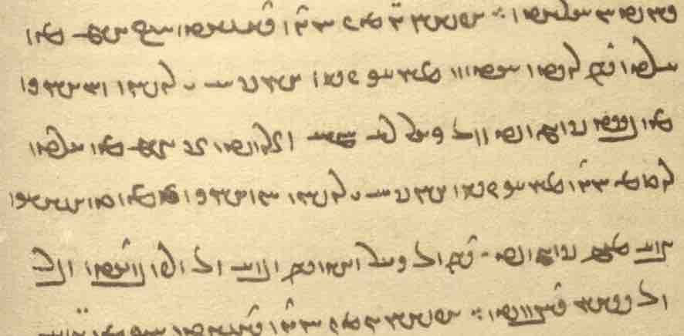
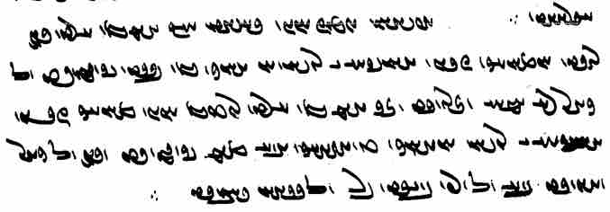

u-šān ēn-iz ōwōn dāšt kū
xēm kē xrad andar nēst ēdōn (ho)mānāg čiyōn xānīg ēw ī rōšn ud anāhōg kē bast estēd ud ō kār nē hamē šawēd
ān xēm kē xrad abāg ōwōn mānāg čiyōn xānīg ēw ī rōšn anāhōg (kē) tuxšāg mard abar estēd ud andar ō kār kunēd ud bē ō warz bandēd ud bar ō gēhān dahēd

Text 18.2
From Dēnkard book IX: Dk.9.53.2. – Mss. DH, fols. 309r-v.

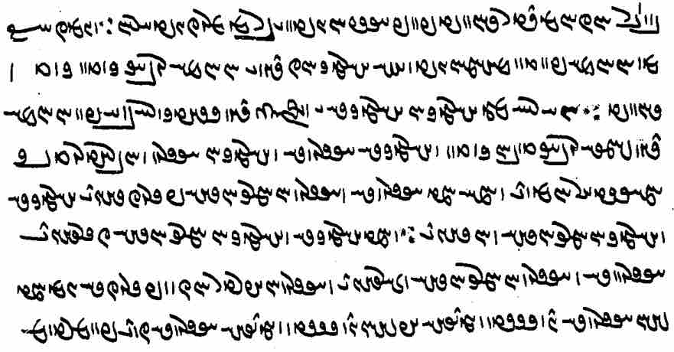
ēn-iz kū kē Ohrmazd pad tan mehmānēnīd ā-š ahlomōγān-iz dēn ī Ohrmazd rawāg kerdan kerd bawēd
ēd-iz rāy čē ahlomōγān ahlomōγīh ī Ahrimen dēn saxtag nē, bē pad Ohrmazd-dēn-nāmīh rawāg tuwān kerdan
ud ahlomōγīh āsrōnīh ud ahlomōγān āsrōnān brādarōdīg hamēstār hēnd
ud hamē ka āsrōnīh ud āsrōnān amaragānīhā pērōzīhēnd ahlomōγīh ud ahlomōγān amaragānīhā wānīhēnd ∵
ud ka ahlomōγīh ud ahlomōγān amaragānīhā čērīhēnd āsrōnīh ud āsrōnān amaragānīhā nizārīhēnd
ud āsrōnān abardar ōz ud perōzīh ēn: ka-šān āsrōnīh drīst-wimandīhā u-šān drīst-wimandīhā āsrōnīh čand pad mardōm šāyēd būd pad Ohrmazd mehmān-padišīh bawēd

Text 18.3
From the Dēnkard book IX: Dk.9.52.15. – Mss. DH, f. 309r, B, p. [600].
About god’s gifts to men, which are still owned (xwēš) by god, although they are in the possession (dārišn) of men, who can profit by their use.

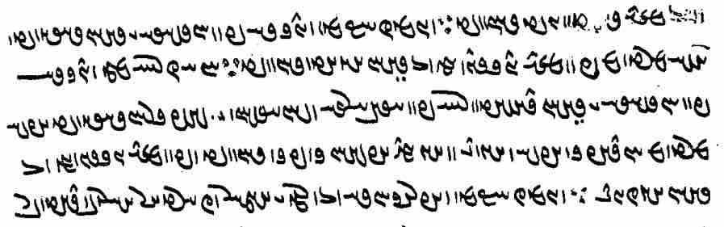

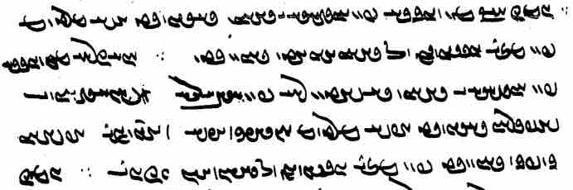

ēn-iz kū kē nēkīh pad xwēšīh ī yazdān dārēd ā-š mardōm, pad mizd stadan, ō yazdān āyōxt bawēd ∵
ēd-iz rāy čē, nēkīh pad xwēšīh ī yazdān dāštan rāy, pad hayārīh ud šnāyišn ī wehān dārēd u-š mardōm handāzag aziš gīrēnd ud kunēnd u-šān kerbag (ī) bawēd, pad mizd stadan, ō yazdān āyōzēnd
“This too: he who holds goodness (that is actually) in the possession of the gods, he will have ‘yoked’ men to the gods in order to get a reward/prize;
and this is because, in order to keep goodness (that is) in the possession of the gods, by the assistance and approval that good people hold and from which men take (their) example and act(?), they ‘yoke’ the good deed(s) they receive (-šān ... bawēd) to the gods in order to get a reward/prize”

Cf. PY.30.10 ēdōn tēz āyōzēnd ō mizd stad ...;
PY.49.9c kē pad dēn pahlom āyōzēd mizd kū-š mizd dahēnd.

Text 18.4
From the Mādayān ī hazār dādestān: MHD.40.2-3 (Macuch 1993, chap. 22, f. 55).

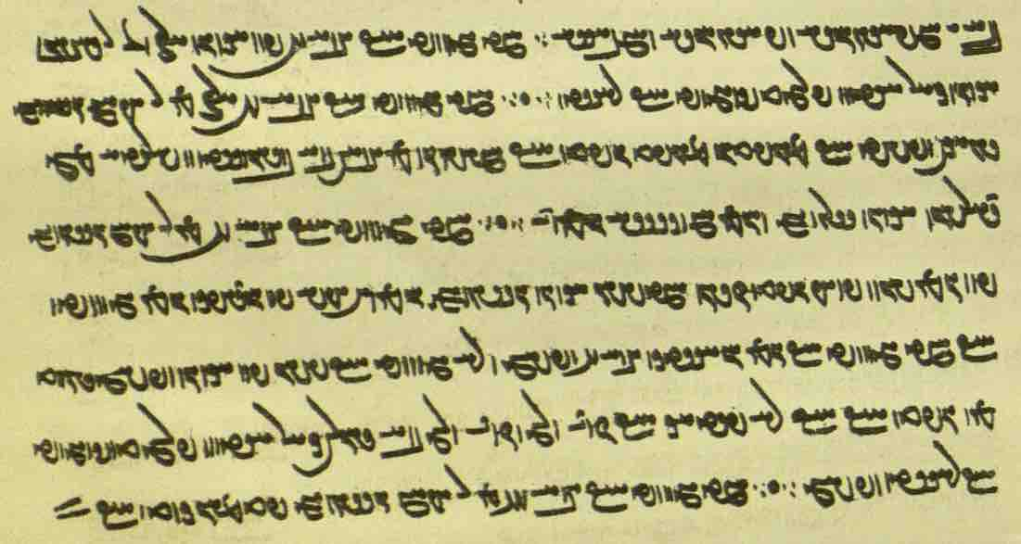

ka gōwēd kū mard 2 pad āgenēn 200 ō man dahišn [ms. <YHBšn'>] āgenēn kār ēdōn framūd estēd kū rāst ∵ o ∵
When (the creditor) says: two men together have to give = pay me 200 (drahm), (then) ‘together’ has been ordained (by the Mowbed of Mowbeds to mean) ‘equally’.

ka gōwēd kū mard 2 200 az man abām stad gyāg-ēw nibišt kū mowbedān mowbed guft kū ham-ēwēn az mard-ēw bē xwāstan pādixšāy čē dārišn āgenēn barēnd ud {hmn} ham-xwāstag hēnd ∵ o ∵
When he says: two men borrowed 200 from me, (then) it is written in one place that the Mowbed of Mowbeds said: (the creditor) is authorized to request (the debt) in total (?) from one man, for they carry ‘holding’ together and are co-owners of the property.

ka gōwēd kū mard 2 az man abām stad pad ēn šōn frāz guft čiyōn ka-šān āgenēn stad hē
u-š pad handāzag ēn gōwēd kū ka gōwēd kū ēn xwāstag mard 2 xwēš ud nē gōwēd kū-šān pad āgenēn xwēš
būd kē guft kū: kū nē paydāg kū čand ōy ud čand ōy, bē ǰār-ēw kār ēdōn framūd estēd kū rāst xwēš ∵ o ∵
When he says: two men took up a loan from me; he said (this) in such a way as if they took it up together;
and regarding the amount of it (-š) he says as follows: When he says: “This property belongs to the two men,” but he does not say that it belongs to them together,
(then) there was one who said: “When it is not evident how much for him and how much for him, but (?), once and for all, it was ordained that it belonged (to them) equally.”
Note: the function of bē is not clear here.

Text 18.5
From the Mādayān ī hazār dādestān: MHD.26.39-40 (Macuch, chap. 12, f. 29). – Two cases about the guardianship of a fire endowed by a man who then dies without having given instructions for the guardianship of the fire and of income from use of the fire.

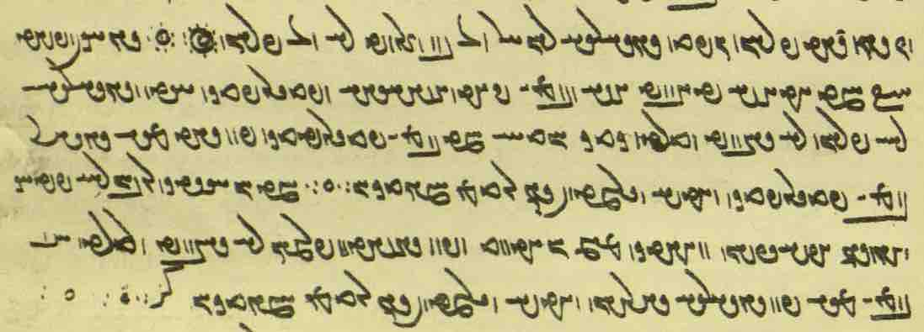

gyāg-ēw nibišt kū ka ātaxš nišānēd ā-š w pus ī pāduxšāyīhā ud padīruftag ast ud sālārīh rāy *framān [ms. <plhw'>] nē dahēd
widerd kadag-xwadāy, ka pus ī padīruftag pad dād meh, sālār pus ī padīruftag
ud agar-iš nīrmad-ēw andar abāg hamdūdagān ∵ o ∵

ka xwāstag ruwān rāy paydāg kunēd u-š yazišn w nihādag abar nihād ud pad dāštan framān nē dahēd
widerd pid pus ī meh pad sālārīh dārišn
ud agar-iš nīrmad-ēw andar abāg hamdūdagān KZ [= 27] ∵ o ∵ o ∵

Exercises 18

WtdaDWtDWK LW WN Wt˜ EkAtDP ØW WwAcÅ YWkmÍC adM `>wA NwY à WwS> WWP WtDWwllmY ? aådLW EWwSC q ? !
/ `>WNwA WwAcÅ Y kmÍC WwaHnLW Wwa˜Wt¬M Y ÂÍC Y KcåDwA

LTTPkÍ Y ã WWP WtÅwïÔDV W WtÅwYt:D WtÅwYwa¬YtÅP WTWkßLP `>WW WtåHK WwaHwY ØW WtåÅWtjA ÍwsA ? 2
? ˙DB Wt:D
WtååDwajA wABwlaÅ NTwL Y EnY ÂA WWPW WtåådmAlaÅ a:åÒ ØW WTWtdlÍ WwABwL WWT WTWwLTI AWB
/ Ww˙dAwÍ EwajA MWtÒcÅ Y ã WWP WtåådAwÍW

/ Wws>aDW Y WcDKW N WwaÅW ÍwA Y EKwL„W WTPkÍ q ? 3
sAkA WwaÅW ÍwA Y Cã à CNwY WwaÅW ÍwA Y EKwL„W WTPkÍ TNwA
/ tDWWtåÒ WwaÅW ÍwA ØW nÍPWV waÅtJ N C˙dA Y EwßÍWK kAtDpA WWP Y 1a¸ W ÍwA Wt˜
About the effect of knowing the cause of one’s death (ōš wihān).

ï<ÒwY Y EIwAcÒA WwÍU q WwaÅtå˜ WwAt∆:ÅtÔDt¬A KwïÒV LItJ ? 4
/ Y<U 4 Y ã N Y<U 2 Y ã Y eLTwÍU wadLwY< x W

/ Ww˙*JWWP ? 23
WtDWWwaD cÅWP bmAkßA x Y>wYWP WWTWWtdL% ã N WtdaDWWtdL% WwS>kA Y nßYW NTwL Y sAWW ÍWN
/ Y>WC sAWW WtDWWwaD aÒ WtÅ ? nM sAWW ÍwˆÅ
/ WwaJP
WtDWWwaD WWtJWcÅ WWTWWtdL% ÂA ã N WTWWtdL% WwS>kA Y nßYW WN AWbY Wws>aD>W
sAWW Ä :ÅWcÅWT IwaÂY áÒ WWTWWvaD WwAWwS>kA Y>WwY>WP ÍwsA
x>WwˆÅW áJW WtDWWtdmY nßYW ÂA Y WbmAk˙Å x WPwˆÅ WtDWwa:¸ Y>WwYWP WtÅW
/ WWB W˚ WtdaDWwˆÅW ÍTP EWwS>kA x Y sAWW
Note the spelling of aškamb as <’šk’mb'>.
? wÍWWK WWP PwïÅ tDWWwaD tÅB WWP tDWWtÂaD wa˜Wt¬M ØW Y MwYN ? 34
? waD W WWT WwïDC Y>NwA kAwa˜wA WwYwA WwYWkA wÍWWK W tÅB
? lATply<A Y tdA !tÅW WWT N tDwY waD W lAkA Y tdA !TWplAK ad>A N tDwY WWT nM
/ Y>NwATwS AbL W Y>NwACwA Y>WnYWI WwYWkA tÂA W

? 44
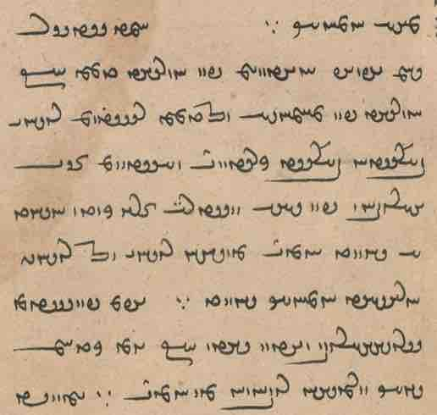
Notes: <’p̄r’c> for <pr’c>. – nihēm for niham. – rasīd-om for rasīd ham. – <lwšny> for <lwšnyh Y> twice. –
óDwaDwL for EwÍwL. – ruwān has been left out in ān ī ahlawān ruwān.

? 333
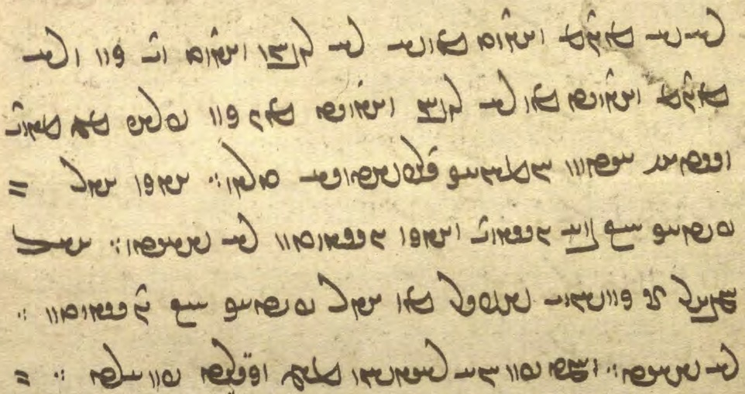
Notes: ruwān probably for ruwān rāy. – Ignore izafe in kunišn ī weh (kunišn is the partic. of necessity).

18.2. Match the Pahlavi words with their transcriptions.

ābustan gyān² srešk Ä WtDWWtdmY WIWwï¸
āgāh hamhāg stānēnd ad>A WtjY WTWK Wwˆ:¸
āhen ǰast syā WwˆjA aåJ WtdaDWtDWK
Astwihād kanīg tanābuhl WtåÅWtjA laÅfJ WIWK
bar kešād škeft sAkA WkßylS WtåHK
čāšmag mādayān warz WkaåÂA WtdaDWWtdL% WwaÅtå˜
ēw margīh wistarg WWtJWcÅ WwTWï>ÅW eglM
gāyīhēd mīrēd xwānīhēd LB WcÒW WkmÍC
grift nērōg zarrēn-kerd waD WKwL„W WTPkÍ
gyān¹ spahr zīndag Y>WwïJwY gLtJW :ÅWcÅWT

18.3. Translate into Pahlavi and write in Pahlavi script with transliteration and transcription:

- In the Dēn it says that men’s bodys are analogous to this world, for this world has been made from a drop of water, and men too are made from a drop of water.
- Ardā Wirāz asked: Whose soul is this? – The Righteous Srōš and the divine Fire answered: “This is the soul of that wicked man who, in this world, did not keep straight (his) bushels, cups, weights, and measures”
- The demon Drag-off seizes the soul of the wicked and drags it to hell. Then a young woman unlike other young women comes to meet him. The soul of the wicked says: “Who are you, than whom I have never seen any bad young woman ‘badder’ and uglier than you.” duš-kanīg duštar
- The soul of the Righteous, while the body is alive, is a good companion, once the body has passed on, it is immortal and ready for the Renovation
- When mortality came upon Gayōmard, the light went out of his body like red, hot iron when one strikes a hammer pōdag on it and it becomes black. Now, too, people in this world die in this manner.
- Just as in this world the Xwarrah of the Dēn of the Mazdayasnians has ‘jumped’ into the firmament like a star-studded kusti with three strands fashioned in the other world, in a similar way people too have a kusti at the waist with three strands.
- They also held this: That ‘character’ in which there is no ‘wisdom’ is like a clear and unsullied source that is dammed up and is not put to use. And that ‘character’ with which there is ‘wisdom’ is like a clear and unsullied source that a diligent man sets upon and puts to use and dams up for cultivation and (then) it gives profit (‘fruit’) to the world.

Additional Readings 18

Additional Reading 18.1
From the Pahlavi Rivāyat: PR.46.5. – Mss. TD4a (BL) 53r, TD4c, p. 108. – Creation of the world from the primeval giant. – Note the differences between the mss.

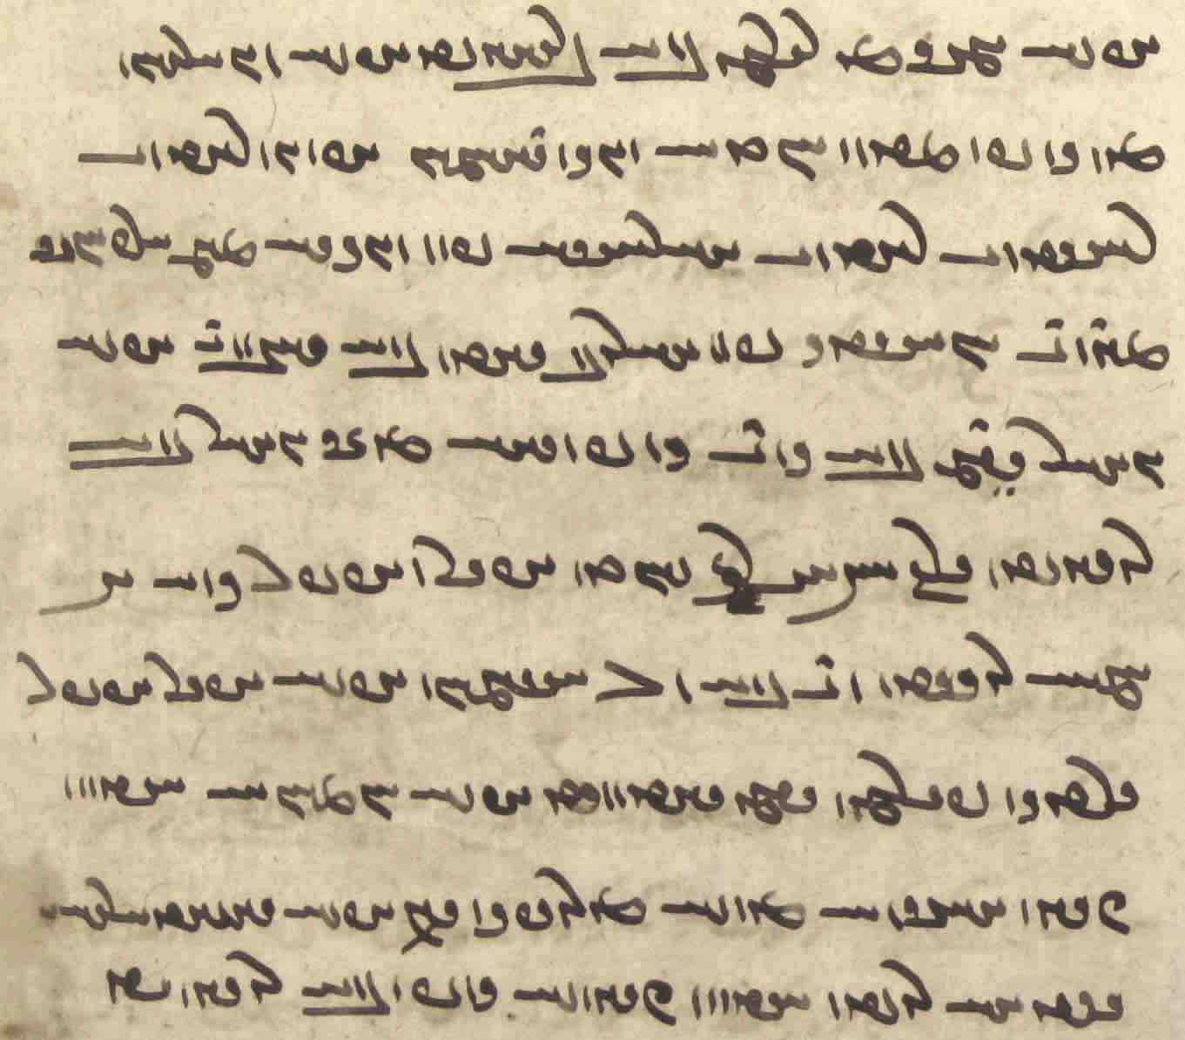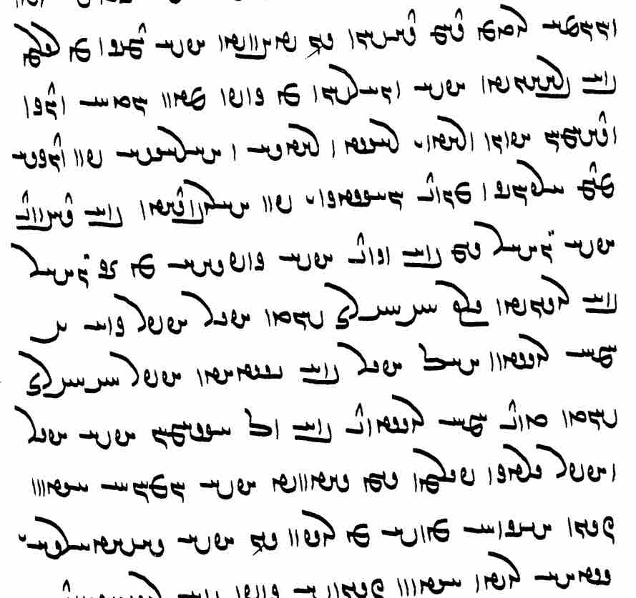

u-š zamīg az pāy bē brēhēnīd u-š winnārišn az kōf,
Mihr xwadāy nēk, ud Dahmān Āfrīn rād ī rāst
rāstīh rādīh ud ahlāyīh pad nēkīh abar-arzānīg mēnōy xwāstag ī pad ahlawdād bē dahēnd
u-š gōhr xwarrah (andar) bē nigand u-š kōfīhā az ān gōhr bē rōyēnīd
1700 sāl azēr ud azabar harw 2 { hamē rust ud pas azēr bē estād
azabar 800 sāl did } hamē rust tā bē ō āsmān u-š azēr ud azabar gerdag pērāmōn xwarrah āyēd
u-š homānāg ēdōn čiyōn xāyag ēw kē-š murwīzag andar u-š dāštārīh ī gētīy nēst

Additional Reading 18.2
From the Mēnōy ī xrad: MX.1.96-103. – Ms. K43 f. 135v.
Note: <twhšk'> for <twhš’k'>, <AYK> for <AYKt>; <YNE> for <YWM>.
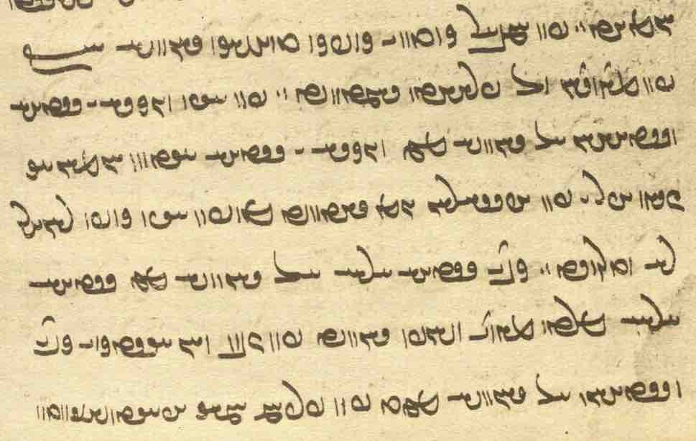

Additional Reading 18.3
From the Selections of Zādspram: WZ.3.28-32. – Mss. K35 f. 240v, TD4a, pp. 498–99. – Here you see that the ms. TD4a has been corrected. Compare the corrections with the readings of K35.

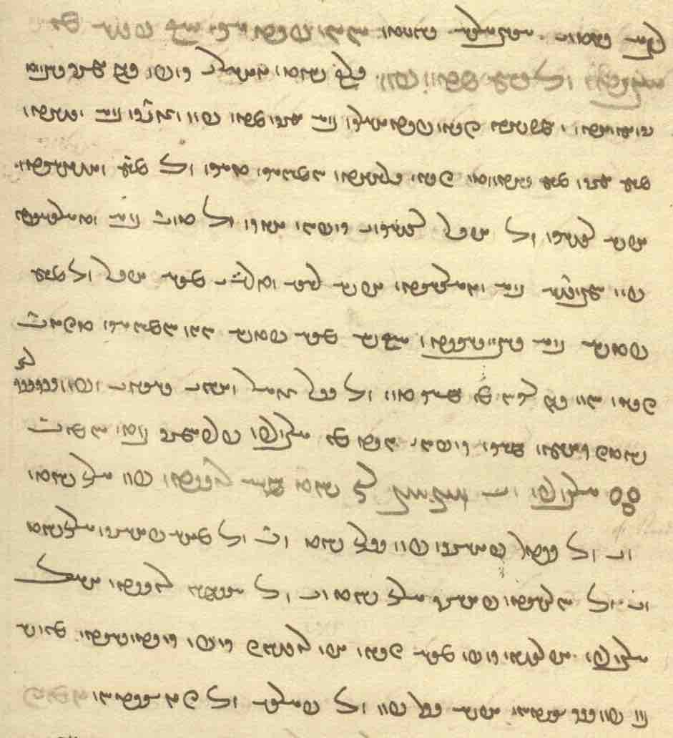

ōwōn paydāg kū pēš az Ēbgad ō dām madan pad 1000 sāl gōhr ī kōf andar zamīg dād estād
nāmčišt čiyōn petyārag bē zamīg mad pad wizendag bē wišīd
abar zamīg abar āmad čiyōn draxt homānāg kē tāg ō abar waxšēd u-š rēšag ō azēr
rēšag ī kōfān ēk ō did bē widārīhist pad hambandīh bē winnārīhist
u-š rāh widarg ī āb azēr ō abar padiš bē dahīhist kū-š āb padiš ōwōn homānāg tazēnd čiyōn xōn andar ragān
az hamāg tan ō dil zōr ud āhang dārēnd
ud pad 600 sāl-iz hammis hamāg kōfān ī ǰud az Harburz frazāmīg būd hēnd ∵
Harburz tā 800 sāl hamē rust
pad 200 sāl tā ō star-pāyag pad 200 sāl { tā ō māh-pāyag (pad) 200 sāl tā } ō xwaršēd-pāyag
pad 200 sāl tā ō āsmān rust
pas az Harburz Abarsēn kōf ī meh čiyōn Abursām-iz kōf xwānīhēd kē-š bun pad Sagestān u-š sar pad wimand Pārs ō Čīnestān
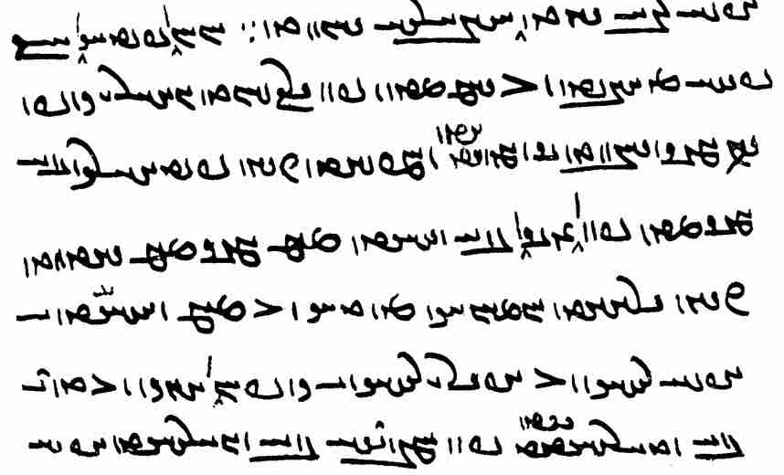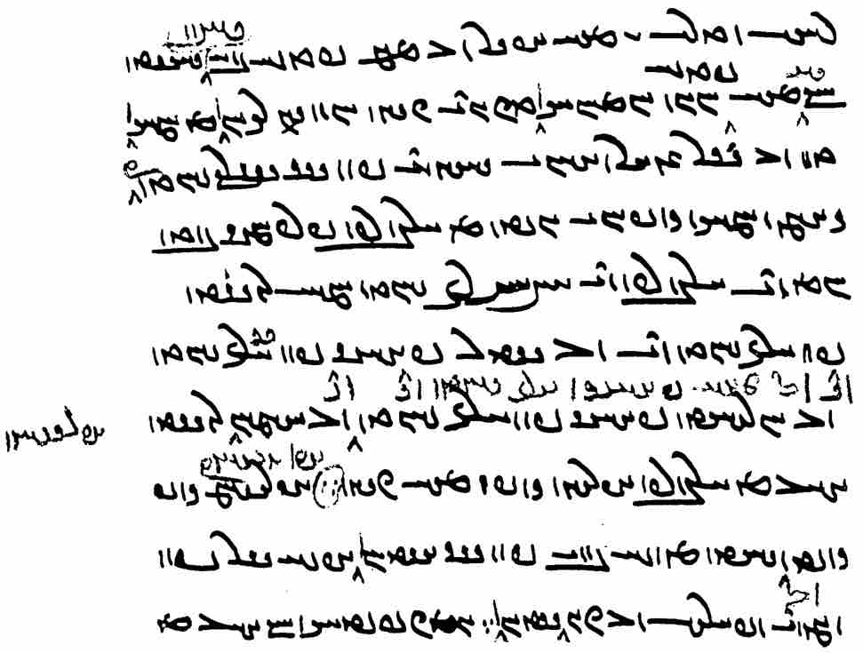

Additional Reading 18.4
From the Pahlavi Videvdad: PV.8.33-34. – Ms. K1, ff. 80v–81r, T44, ff. 77v–78r. – Note the examples of the referential use of the suffix -īh. – Creator: How will those men become pure, o Righteous Ohrmazd, who step onto a nasāy, dry, dead beyond a year? – K1 abbreviates a large chunk by tā ō “all the way to.” The missing passage is found in PV.5.4, added here from T44. – Remember that bold = translation of the Avestan.

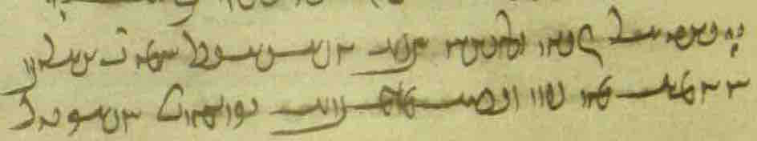
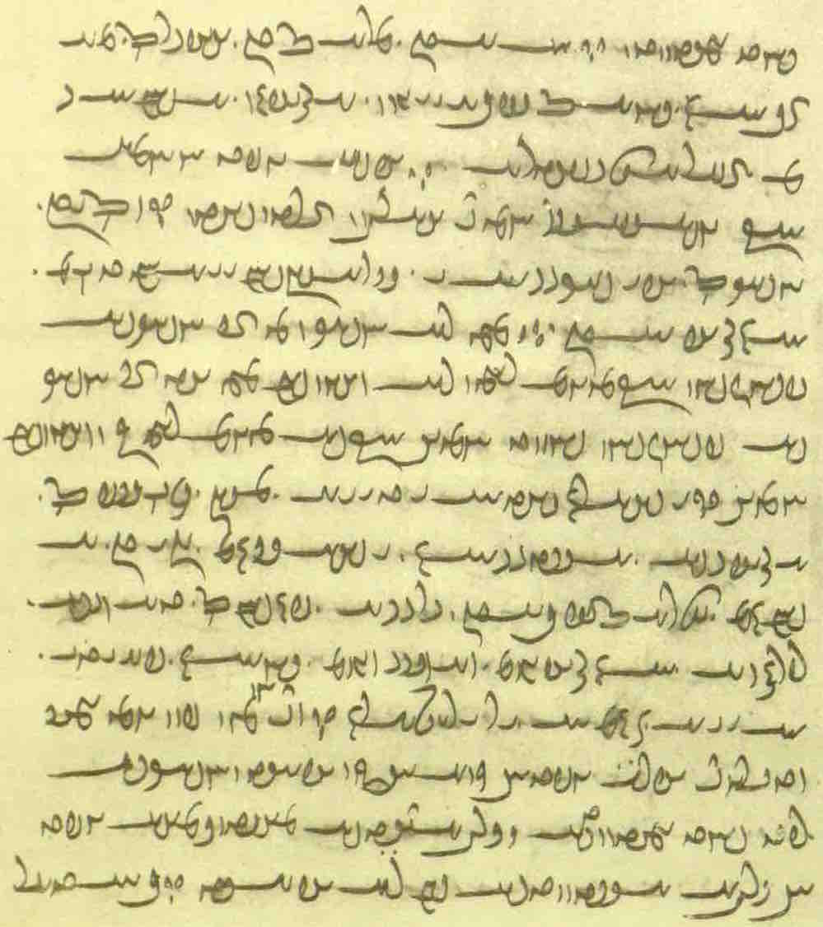

dādār. čiyōn awēšān mard yōǰdahr hēnd ahlaw Ohrmazd kē pad nasāy abar bē estēnd hušk tar sāl murd
u-š guft Ohrmazd kū yōǰdahr hēnd ahlaw Zardušt
čē nē hušk az ān huškīh paššinǰišn kū tis rēman nē kunēd
čē agar hušk az ān huškīh paššinǰišn būd hē kū-š tis rēman ōh kerd hē
{ pad tēz-rawišnīh kū ay zūd būd hē ān ī man harwisp ox ī astōmand
zad-xwāstār ī ahlayīh kū-šān rāh ī kār ud kerbag zad estād hē
xrōsišn dād ō ruwān kū-šān ruwān az Garōdmān xrōstag ud xwistag būd hē
tanābuhlīgān kū margarzān būd hēnd
pad frayistīh az wasīh awēšān nasāy } kē pad ēn zamīg widerēnd
Abarg guft ay harw 3 ōh abāyēd huškīh tar sāl-murdīh ud sag-dīdīh
Mēdōmāh <m’ytwkm’h> guft ay sag-dīdīh andar nē abāyēd

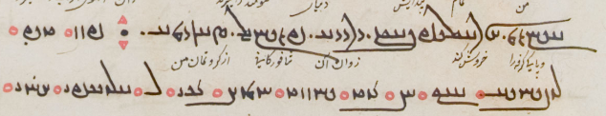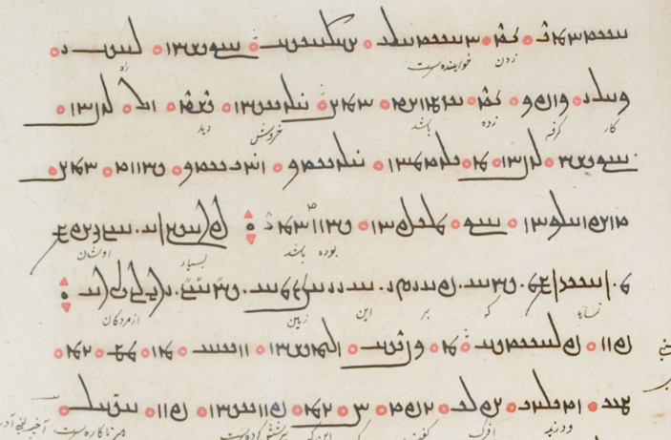

Additional Reading 18.5
From the Pahlavi Videvdad: PV.9.50. – Mss. L4, f. 174v–175r and TUL_171v (commentary in right margin). About sins, repentance, and atonement.

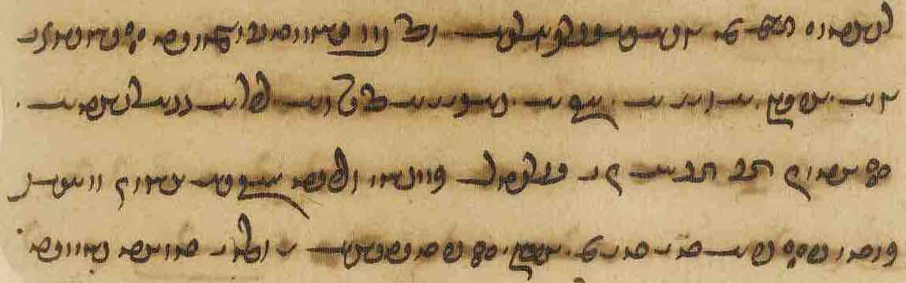
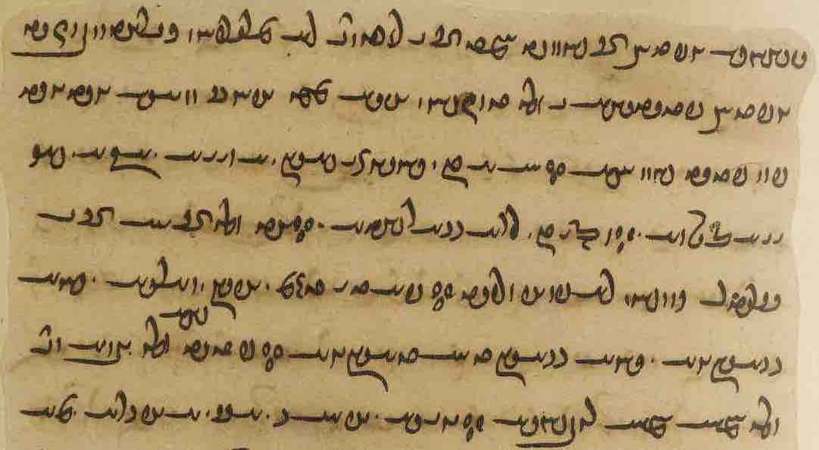

Av. yezica hē aniia aγa š́iiaoθna frauuaršta ∵
agar-iz ān anīz <ZK’y cy> wattar kunišn frāz warzīd kū-š anīz <AHRN'c> wināh-ēw kerd ∵

Av. paitita hē ciθa ∵
petītīhā y ōy y tōxt bawēd – [TUL <ptytykyh>]
Sōšāns guft ay ān bawēd ka ān ī did nē margarzān
Kay-ādur-bōzēd guft ay petītīgīhā y ōh <OLE> tōzišn u-š az-iz <ME> abārīg wināh ǰud ǰud pad petīt bawišn ∵
[K1: <kyl’twrbwcyt>, TUL <kwy’twr->; L4 <YHWWN’š>]

Av. āat̰ yezi šē aniia aγa š́iiaoθna nōit̰ frauuaršta ∵
agar ōy anīy ān ī wattar kunišn nē frāz warzīd [TUL:] kū-š ēg-iz wināh-ēw (nē) kerd ∵

Av. paititəm ahe narš yauuaēca yauuaētātāeca ∵
petītīhā ōy mard tā ō <OLE> hamē hamē-rawišnīh ∵

And if he has committed another bad deed, i.e., he has committed another sin, then the atonement is (to be regarded as) being in a state of having repented (petītīha)
Sōšāns said: That is the case when the other one is not margarzān.
Kay-ādur-bōzēd said: The meaning is: his atonement for that (particular) one is to be regarded as having been repented; his other sins have to be repented separately.
And if he has committed no other bad deed, then the atonement is to be regarded as having repented for ever and ever” (PV.3.21)

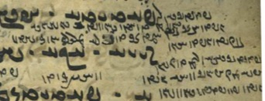

Additional Reading 18.6
From the Selections of Zādspram: WZ.35.13. – Ms. TD4a, pp. 589–90. – Parallelism between Ohrmazd and Zardušt.

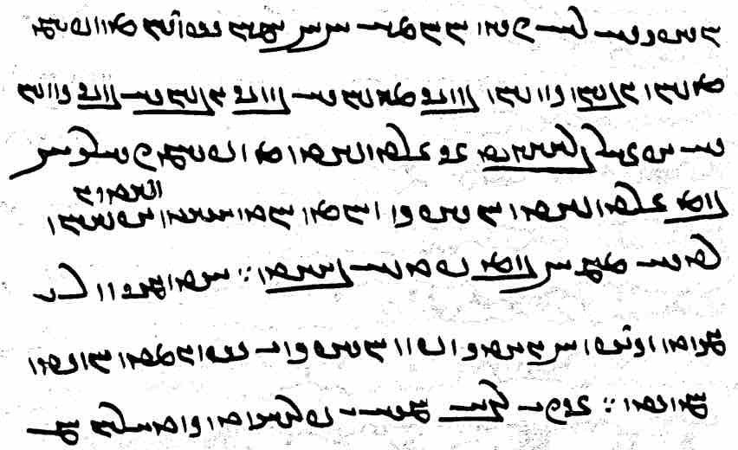

pad dēn Zardušt Ohrmazd handāzagīh rāy
čiyōn Ohrmazd 6 amahrspandān az [ms. kē] xwēš menišn gōwišn kunišn
bowandag-menišnīh bowandag-gōwišnīh bowandag-kunišnīh abzār brēhēnīd
ān Zardušt az xwēš čihrag 3 pus (ī) Zardušt (pad) handāzag Wahuman Ardwahišt ud Šahrīwar
u-šān radīh abar 3 būm <BRE = bwmn> padiš baxt ast zamīg ud War ī J̌am-kerd ud Kang-diz
ud 3 duxtag pad handāzag ī Spandarmad Hordad ud Amurdad
Note ān Zardušt: here ān may be used as “therefore.”

Additional Reading 18.7
From the Šāyist nē šāyist: ŠnŠ.2.118. – Mss. K20, f. 60v, M51a, f. 90r (online pict 177). – About firewood that has been in contact with nasāy. – Note the ms. differences and the spellings, e.g., K <cygwnd> for <cnd>, M <d’wst> for <šwst>.

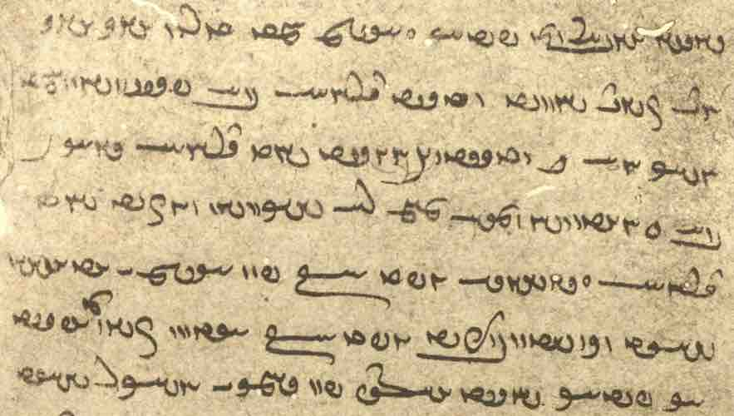

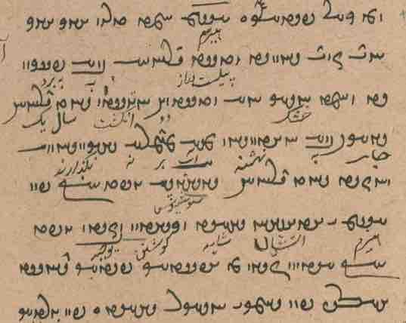
esm ka tarun ēk ēk and čand bawēd widest-drahnāy bē brinišn, ud ka hušk ēw <HNA> widest ud 2 angust
sāl-drahnāy gyāg-ēw bē nihišn ud āb abar nē hilišn
ud uzīd sāl-drahnāy o
Sōšyans guft kū pad esm ī ātaxšān šāyēd
ud Kay-ādur-bōzēd guft kū, ēdōn čiyōn az Abestāg paydāg šust, pas-iz pad ǰāmag ī huškar šayēd

Glossary of words in the Texts and Exercises 18

Idioms:
abām stan- take up a loan
abar est- step on; be in charge of, take care of (?)
abar nih- endow
andar ō kār kun- put to use
ānōh kū ... awiš to where
azabar ān gugāyīh gugāy above that witness (is) the witness (that)
abāz abespār- release (from servitude)
ātaxš nišān- establish, endow, “enthrone” a fire
bastan here: dam (up), channel
dādan dah- note the use as “estblish” in creation context
dārišn ‘holding’, but not necessarily ‘owning’ (xwēšīh)
dārišn bar- ‘carry possession’
ēd rāy čē for the reason that, because
ēk ān ī one case is that of ...
frāz az after
frāz padīr- receive
frāz warz- = warz-
hamē ka as long as
hamist (ud) hamāg all
ǰār-ēw in sum, all in all, all told; once and for all
kār framāy- apply (?), use
nihādag nih- make an endowment
mizd stadan obtain a reward
nisēy kerdan abort; note that nisēy is spelled like nasāy!
nūn-iz now too, still (Pers. hanuz “still”)
ō kār šaw- be used
ō warz band- $$
pad dāštan having in one’s care
pad handāzag regarding the size/amount
pad petīt baw- be repentant
pad tan “in/with body,” indentured (servant)
pad tēz-rawišnīh quickly
paydāg kun- here: make public, advertise
petītīgīhā while being repentant, when repentant
petītīhā while in a state of repentance
tar sāl for over a year

Nouns, adjectives, adverbs, pronouns:
2-zang YwZ 2 <2 zng> two-legged, biped
4-zang YwZ 4 <4 zng> four-legged, quadruped
abar-arzānīg WIwAc¬Aq <QDM ’lc’nyk'> supremely (?) deserving: + pad “of”
ābsālān (MacK. *afsālān) Wwa¬aJcÅ <’p̄s’l’n'> springtime
ag-dēn WwS>kA <’kdyn'> having an evil Dēn
ag-dēnīh EwS>kA <’kdynyh> community of ag-dēns
ahlawdād WtåD WBwlaÅ <’hlwb' d’t'> alms
ahlomōγ WKnlaÅ <’hlmwk'> heretic; inscr. <’lswmwkȳ>
ahlomōγīh EKnlaÅ <’hlmwkyh> being a heretic, heresy
amaragān WwAklmA <’mlk’n> the many, the common people
amaragānīhā EwAklmA <’mlk’nyh’> generally, commonly, universally
anāhōg WKwaÅwA <’n’hwk'> unblemish, unsullied
apaydāg WkAtDpA <’-pyt’k'> indiscernible, unnoticeable
bēwar-čašm µÍcÒwYB <bywlcšm> with ten thousand eyes
brādarōd WTwLtåÒV <bl’tlwt'> opponent, evil counterpart
brādarōdīg WITwLtåÒV <bl’tlwtyk'> opposed
brīnag WKwïÒV <blynk'> section (of text)
darbuštīh = darbušt EtHWplY <dlpwštyh> fortress
dāštārīh elAthaD <d’št’lyh> ‘holding’, support
dil :J> , ÚBvL <LBBE̱; dyl> heart
dōlag ElKwY <dwlk'> a measure; from dōl “bucket”
drīst-wimandīhā aådYnYW WtjYWwY <drwyst' wymndyh’> kept within proper borders
duškanīg WIWkÍwY <dwšknyk'> bad young woman
duštar LtHwY <dwštl> more duš, ‘badder’
ēwar LwïÅ <’ywl> for sure, certain(ly)
frāgōyōd WTwYwïåÒP <pl’gwywt'> epithet of Mihr, Av. vouru.gaoiiaoiti “having/with wide pastures”
fraškerdīg WITWkßLP <plškrtyk'> lasting until the Renovation
frayistīh EtjâLP <pl’(y)styh> large quantity
frazāmīg WImAcÒP <plc’myk'> completed
gerdag WKt¬Y <gltk'> circle
gētīy-ārāy á¬A ìtJ <gytyḏ ’l’d> ‘world-adorning’, adorning this world
gugāyīh, gugāhīh esAKwY , eÄKwY <gwk’y/syh> testimony
ham-dmanīh EwmY ÂA <hmdmnyh> living in the same house
ham-dūdag WKTwˆÂA <hmdwtk'> someone of the same family
ham-ēwēn WwYwˆåÂA <hm’ywyn'> in total (?); uncertain meaning (Macuch suggests ‘having equal shares’)
ham-xwāstag aÎJKWmA , WKtjAwaÂA <hmhw’stk' hmNKSYA> being co-owner of a property
hazār-gōš ÍwY< + <1000 gwš> with a thousand ears
huškar LkÍwA <hwškl > some kind of drying agent
kabīz WcDPK <kpyc'> bushel
kadag-xwadāy TwAKTK <ktk-hwt’d> master of a house; petty ruler
kālbod WTWplAK , WTplAK <k’lp(w)t'> body, bodily frame
kušišn WwßÍWK <kwššn'> killing
mehmān-padišīh EÍTP WwaÂaå˜ <m’hm’n' ptšyh> the fact of being lodged in it
mēnōyān-tāšīd WtdßAT WwaDWwï˜ <mynwy’n' t’šyt'> fashioned by those in the other world
mēnōy-wišōb WPwÍW Y>Wwˆ˜ <mynwy wšwp'> destroying the other world
murwīzag WKcDwLN <mwlwyck'> little bird, chick
nakkīrāy á:DKW <nkyl’y> denying; + “to be”: “to deny”; + rāy
nērōg WKwlYW <nylwk'> strength
nihādag WKtåÅW <nh’tk'> endowment
nīrmad WtÂlYW <nylmt'> income, financial advantage, profit
nisēy áJW <nsydy> dead fetus; + kun- “to abort”
padīruftag = padīriftag WKTPwlYTP <ptylwptk'> adopted
paššinǰišn WwÍCwÍP <pšncšn'> contamination
paymānag Kwa˜TP <pym’nk'> measure
pāyēnānīh EwAwsAP <p’yyn’nyh> guarantee
petīt WtDtDP , WtDTP <ptyt', pytyt'> while in a state of repentance
petītīg WItDtDP , WItDTP <ptytyk', pytytyk'> while being repentant
rag WkL <lk'> vein
rēbāh-ēwēnag WKwYwïÅ sAfdL <lyp’s ’ywynk'> like a rhubarb
sang GwïD <sng> weight (of)
saxtag WKtåJ <yyhtk'> (uncrtain)
suxr LaÅwïD <sw’hl > red
šōn WWwÍ <šwn'> manner (Lesson 17)
tanābuhlīg WiLWcÅWT <tn’p̄whlyk'> whose body is forfeit (degree of sin)
tar LT , TcÒ , wYcÒ <LCDr, LCDR; tl> through
tarun WwLT <tlwn> moist
tēz-rawišnīh EwÍVwLWcDT <tyc' lwbšnyh> pad ~: “quickly”
wasīh eYBK <KBDyh> large quantity
widerān WwaÒTW , Wwa:DTW <wt(y)l’n> passed on
widerānīh EwaÒTW , Ewa:DTW <wt(y)l’nyh> passing on (death)
wihān WwaÅW <wh’n'> cause
winnārišn WwßLAWW <wn’lšn'> ‘upholding’, support
wizendag WkYWCW <wcndk'> earthquake
xānīg WIwaÅ <h’nyk' > source, wellspring, watering duct
xēm µïÅ <hym> character
xrōsišn WwßSwlA <hlwsšn'> howling, booing
xrōstag WKtJwlA <hlwstk'> booed
xwistag WKtjYwA <hwystk'> pursued
zay 1a¸ <z’ḏ> weapon
ziyānag WKwaå¸ <zyd’nk'> woman, wife; oppos. mērag “man, husband”
zōr LU, Lwa¸ < zwl, z’wl> power, might
zūd WTU <zwt'> quickly

Names:
Artēštārestān WwAt∆:ÅtÔDt¬A <’ltyšt’lst’n'> Book about warriors
Wizarš ßylzYW ßlzYW <wyzlyš, wyzlš> the demon Drag-off

Verbs:
āh- –aÅ <’h-> sit
ahrām- ahrāft/ WTcå¬aÅ –Âa¬aÅ <’hl’m- ’hl’p̄t'> lift up, raise, make go up
ahrāmad
āsānīh- –EwajA <’s’nyh-> be given rest; from āsānēn- “give rest” from āsān
āyōz- āyōxt WtÅwˆÅ –CwˆÅ <’ywc- ’ywht'> yoke, attach
bēšēn- –wˆhYV <byšyn-> harm, make suffer harm
čērīh- –elYC <cylyh-> be made victorious; from čērēn- “make victorious” from čēr “victorious, brave”
dardēn- –wYt¬Y <dltyn-> make suffer pain
daw- dawīd –BwY , –WWtåÒ < LHTWN-; dwb-> run
hambawīh- –EWbmA <hmbwyh-> be composed, come together
mehmānēn- –wYwaÂaå˜ <m’hm’nyn-> make (sb.) lodge in
nizārīh- –ela¸W <nz’lyh-> be weakened; from nizārēn- “weaken” from nizār “weak, feeble”
pādīrānēn- –wYwa¬YtÅP <p’tyl’nyn-> restrain
pērōzīh- –ECwlYP <pylwcyh-> be made victorious; from pērōzēn- “make victorious”
rūn- rūd WT{ , –W{ <lwn- lwt'> pluck, tear out
wān- wānīd –WwAW <w’n-> win
widurd = widerd WtÒWTW <wtwlt'>
wišīh- (wišīy-) wišīd WtdÍW –eÍW <wšyh- wšyt'> be opened (up)

Lesson 19

Grammar 19

The Perfect participle of state in -ag.
A past participle of state (perfect participle) is made from the past stem with the ending -ag. Participles from transitive verbs have passive meaning. Examples:

āfrīdag ham nē būdag
“I am someone created, not someone (who has always) been” (PN.2)

mardōmān tan passāxtag ī az ast ī saxt pid ī sust
“men’s bodies are fitted together from hard bones and soft flesh” (DD.16.8)

xastagān ud wistagān darmān burdan
“to bring medication to the wounded and those shot by arrows” (Dk.8.26.26)

xwarišn ī sāxtag ēn čiyōn nān ud gōšt ī puxtag ud brištag ud xwardīg ī kerdag
“‘prepared’ food is such as bread, cooked and fried meat and (uncooked?) eatables that have been made(?)” (ŠnŠ.2.48)

menišn ī Wištāsp šāh ud wasān was ān ī nihuftag xīr āškārag guft
“(Z.) spoke many a hidden matter (so that it was) clear to the mind of King Wištāsp and the many” (Dk.5.2.8)

hušk ka rustag ayāb brīdag u-š nasāy andar gumēxtēd čiyōn bawēd
passox: ān ī and gyāg bē tāšišn; abārīg pad sāl-drahnāy; šōyišn kār
“when it is a dry (plant), grown or cut, and some nasāy is mixed into it, how will it be?
answer: so much area (as the nasāy has touched) is to chopped off; the rest (will be clean) after a year; (then) it needs (kār) to be washed” (ZFJ, p. 436)

hišt būd kē guft kū ān ī zanīh rāy andar barēd čiyōn pēšīgān ud wāspuhragān bē barēd ud windišn ī andar zanīh ēw bē mānēd u-š kardag ōwōn abāg kū saxtag bē šawēd
“(regarding) releasing (a women from a marriage), there was one who said: that which she ‘carries in’ for the marriage she ‘carries out,’ such as ‘priors’ and ‘special’ (things), and let the income from during the marriage remain; and the established custom (kardag) is for him (the husband): ‘what is passed goes away’” (MHD.19.8; ch. 4, p. 4, MM. p. 85)

ka hamāg nihuftag ayāb hamāg āhuftag barēnd šāyēd ayāb čiyōn •
hamāg nihuftag; nē hamāg āhuftag ǰud az ān nisēy ī az kadag bē āwarēnd ēnyā nē šāyēd
“is it OK when they carry it all covered or all uncovered, or how is it?
(when) all covered (it is OK, but) not (when) all uncovered, except that aborted fetus which they bring out of the hut” (ZFJ, p. 531)

kē parwardārīh ī dāmān pad frārōnīh kunēd ā-š wahuman-ohrmazd-zahagīh
ud kē ān ī-š andar dārišn xūb dārēd ā-š ohrmazd-wahuman-pidarīh gāh bawēd ::
ud harw frārōn parwardār ān ī-š parwardag-frazendīh andar-iš ēdōn bawēd čiyōn wahuman andar ohrmazd
ud harw frārōn dām pānag abar ān ī-š pādag-pidarīh ēdōn čiyōn ohrmazd abar wahuman
“whoever takes care of the creatures by good behavior, then it is (like) Wahuman being Ohrmazd’s child;
and, whoever keeps well whatever is in his keeping, then it is (like) Ohrmazd being Wahuman’s father;
and every well-behaved caretaker, whatever is in his (-š ... andar-iš) ‘having taken-care of his children,’ is just like Wahuman (being) in Ohrmazd’s (care);
and every well-behaved watcher of the creatures, whatever is his ‘having been watched over by the father,’ is like Ohrmazd (watching) over Wahuman” (Dk.9.53.24)

In the comparative:
kerbag hamē ān mādagwartar ī andar hangām madagtar
“that good deed is always more special which has come more often at the (right) time” (REA.17.6)

In compounds:
Ardaxšīr framūd kū ēn ǰeh ǰādūg druwand zadag-zādag ō aspānwar bar ud framāy ōzadan
“Ardaxšīr ordered: Take this evil woman, a wicked sorceress, whose children are smitten, to the cemetery and order her to be killed!” (KN.10.11)

With kerdan:
duxt ī Ardawān ka-š ān nāmag pad ān ēwēnag dīd abāg zahr ī-š awiš frēstīd handēšīd kū
ham-gōnag abāyēd kerdan ud ān 4 brād ī wad-baxt az band rastag kerdan
“when Ardawān’s daughter saw that letter (speaking) in that manner together with the poison that was sent to her she reflected: that is how (I) must act and make escaped (= free) those four ill-fated brothers from bondage (i.e., prison)” (KN.10.4)

With -īh denoting state resulting from past acts of events:
astīh ī yazd paydāgīh az was ēk kerdagīh ī gēhān
“the fact that god’s existence is manifest (is) from many (things), one (being) the fact that the world has been made” (Dk.5.24.1)

ud bē nigerēd kū az dušmen pad kēn zadan čē rēš ud ziyān ud wanī-būdagīh abar šāyēd madan ud gugārēd kēn andar wārom ī xwēš
ma zanēd dušmen pad kēn čē paydāg kū kē ān ī kamist kēn framōšēd ā-š az ān ī mahist bīm bōzēnd pad čēh-widarg
“Consider what damage, harm, and destruction can come upon (you) from striking an enemy in vengeance, and swallow vengeance in your ‘heart’!
Do not strike an enemy in vengeance! for it is manifest that he who forgets the smallest vengeance, then they will save him from the greatest fear at the Passage of the Wails”
(Wāzag ēw-čand ī Ādurbād ī Mahrspandān 4)

paywastag ō (pad) “connected with”:
tarsagāyīh ī andar pidarān u-šān paristišn paywastag ast ō tarsagāyīh ī andar dādār u-š paristīšn
“respect for parents and serving them is connected with respect for the ‘creator’ and surving him” (Dk.9.55.6)

paywastag ast kehān ī gēhān pad mehān ī gēhān
čiyōn wehīh winnārišn pad dānāgīh ud dānāgīh xwad ast dādīh
“the smaller of this world are conneced with the greater of this world;
like the upholding of goodness with being knowledgeable and being knowleadgeable is nothing but justice” (Dk.3.244.2)

būdag kerdag gumārdag “having been, made, appointed”:
Three legal terms applied, for instance, to the question of who should be a guardian if the former guardian passes away: someone who ‘has been’ in the family, that is, the ‘natural’ successor as guardian, such as the oldest son; someone ‘made, assigned as’ guardian by the former guardian; or, when the first two cases do not apply, someone ‘appointed’ by ‘guardians of the age,’ in practice, the town judge (rad) or the mowbed, by the criterion of being the ‘more suitable’ (sazāgtar), often the one who is the nazdist-paywandtar ‘the closer relative.’

ān ī kerdag ān bawēd (ī) kadag-xwadāy andar xwēš zīndagīh sālārīh ī dūdagān dādestān awiš kunēd u-š dūdag-sālārīh kerdagīhā
ud ayāb mard ēw ōšyār ī 15-sālag (ī) pad sālārīh šāyēd pad pusarīh padīrēd agar-iš pad pašn xwēš kunēd
ud ān ī būdag ān ī ka kadag-xwadāy az āwām bē šāwēd ēg-iš pus-ēw tanī-zād ī ōšyār ī 15-sālag ast ham pus dūdag-sālārīh būdagīhā
ān ī gumārdag ān ī frāz az widerānīh ī kadag-xwadāy pad dūdag-sālārīh sazāgtar u-š āwām-sālārān gumārēnd
u-š dādestān gumārdagīhā
“the kerdag is the one to whom the master of the house, during his lifetime, assigns the legal decision of ‘guardianship of the families’, and his guardianship of the family is ‘by dint of having been assigned’;
or else he receives (= adopts) a 15-year-old male of sound mind who is appropriate for being guardian, as his son, if he makes him his own by a contract;
the būdag is the one who when the master of the house goes away from (this) age, then he has one son born from his own body, of sound mind, and fifteen years of age, said son will be guardian of the family ‘by dint of being būdag’;
the ‘appointed’ is the one who after that passing of the master of the house is the ‘more suited’ for being guardian of the family and the ‘guardians of the age’ appoint him, and the legal decision is ‘by dint of having been appointed’” (REA.5.3-6)

The use of the participle in -ag as a “conjunctive participle”
The form is sometimes used to express “after having done such and such” (cf. the Latin and French gerunds):

ud az Kurdān mard 1000 ōzad abārīg xastag dast-gīr kerd ud az Kurdān-šā abāg pusarān brādarān frazendān was xīr ud xwāstag ō Pārs wisēy kerd
“and he (Ardaxšīr) killed one thousand of the Kurds, the rest, wounded, he captured; from the king of the Kurds with (his) sons, brothers, (and) children, he dispatched stuff and property to Pārs” (KN.5.11)

andar rāh Haftānbōxt ī Kerm(ān) xwadāy pad-iš pahikōftag ān hāmōyēn xīr ud xwāstag bunag az ān aswārān ī Ardaxšīr bē stadag ō Kulālān dastkerd-ēw ī Kulāl ānōh kū Kerm bunag dāšt āwurd
“on the way, Haftānbōxt, lord of Kermān, having fallen upon him (and) having taken all the stuff and property and equipment from those cavalerists belonging to Ardaxšīr, brought it to Kulālān, a landed property in Kulāl, where Kerm had (his) camp” (KN.6.1)

The form used in an ergative construction:
ān-iš ī ōy gōwišn padīruftag Ašwahišt pāduxšāy az-iš stad tašt ī nēk u-š pad ān frāz xwārēnīd
“he (-š) having received that speech of his (Ohrmazd) (ān ... ī ōy), Ašwahišt, the (heavenly) ruler, took from him (Ohrmazd) the good cup and made him (Wištāsp) drink from it (Dk.7.4.85-6)

With -īhā:
The adverbial form of the participle of state probably indicates reason, cause:

Walaxš ī Aškānān Abestāg zand čiyōn abēzagīhā andar āmad estād hammōg-iz ī aziš
—harw čē az wizend ud āšuftkārīh ī Alkasandar ud ēwār ud rōb ī Hrōmāyān andar Ērān-šahr pargandagīhā abar nibištag tā čē uzwān-abespārišnīg (ī) pad dastwar mānd estād andar šahr čiyōn frāz mad estād—
nigāh-dāštan ō šahrīhā ayādgār kerdan framūd
“Walaxš of the Arsacids ordered a memorandum to be sent to the towns that the Avesta and the Zand were to be preserved the way they had come down in pure form, as well as the teachings from it—everything that, having been written up, (survived) in scattered form from the damage and disarray caused by Alexander and the looting and pillaging by the Romans in the land of the Iranians, including (tā čē) the oral (tradition) that had remained authoritative (pad dastwar) in the land the way it had come down” (Dk.4.3.3/24)

mad ō ham-pursagīh ī Ohrmazdud az (ōy) padīrift dēn
Ahrimen ud was dēwān ud druzān pad bīm-nimāyišnīh ... ud pahikārišn ud xwāyišn ud hāzišn aw-iš āmad hēnd
ud hamāg a-padīrišnīhā ud zadagīhā stōwīhā az-iš wašt hēnd
“(Z.) came to the conversation with Ohrmazd (and) received the Dēn (from him).
Ahrimen and many demons and lie-demons came to show him fear, fighting, seeking, and persuading;
and all turned away from him without being received, having been struck down, and defeated” (Dk.5.2.6)

Phraseology 3

Adverbs and other expressions of time
Among the adverbs of time, place, and manner, some function only as adverbs, while others can also be prepositions (sometimes in combination with other prepositions), preverbs, or conjunctions (sometimes combined with prepositions and/or other conjunctions).
Many expressions are made from nouns meaning “time” and similar.
Some refer exclusively to time or place, others to both time and place (see Lesson 20).
On the times of the days, months, and years, see Lesson $$.

Exressions of time

“First” and “last”

fradom âLwA , MWtÒP <pltwm, AWLA> “first, in the first place”
fradomīg WiMWtÒP <pltwmyk'> “initial”
abdom MwY>cÅ <’p̄dwm> “last, at last, in the end”
abdomīg WiMwY>cÅ <’p̄dwmyk'> “final”

Note: Expressions meaning “first” are often followed by pas “then.”

fradom “first, at first, in the first place” pad fradomīh “at first, in the beginning”

ud ān kē nē mad estēd fradom awiš nē rasēd
“and (the misfortune) that has not come (befallen him), will not come to him in the first place” (Dk. 6.126)

u-š xrad ud kām ud kār ud zamān a-wardišnīg ast az fradomīg handāzišn
‘and His wisdom and will and act and time are something immutable from the initial planning” (Dk.3.208.5)

hamāg dām ud dahišn ī Ohrmazd apetyārag, ēdōn abāz bawēd čiyōn ān ī-š pad fradomīh brēhēnīd ud dād
“the entire creation of Ohrmazd (will be) free from adversity; it will again be the way he fashioned and established it in the beginning” (MX.7.16)

abdom, pad abdom, pad abdomīh “at last, in the end”:
hamāg mardōmān andar ayōxšust bē widerēnd ud druwandān az wināh abdom pad ān pāk bawēnd
“all people will pass into that (molten) metal (stream), and through it the evil-doers will finally become clean of (their) sin” (PR.48.70)

ma ēn ī man kerb frāz xwarēd kē-m Ohrmazd abdom-iz abāz kunēd pad tan ī pasēn
“do not devour this form of mine, which Ohrmazd will finally make for me again at the Final Body!” (WZ.30.32; the dead fearing dogs and vultures)

zan ī pad-gōhr wizīn čē ān weh ī pad abdom husrawtar
“choose a wife with pedigree, for he is best (off) who, in the end, has the better fame” (MX.1.31-32)

ristāxēz pad abdomīg bē-abesīhēnišnīh ī petyārag bawēd (ī) xwābar dādār ud hamāg mardōm zīndag abāz kunēd
“the Resurrection will happen/come about at the final ‘cutting off’ (annihilation) of the Adversary by the merciful Creator, and he will make all people alive again” (Dk.5.8.8)

ka druwand hēnd ā (ēk abāg did ōh) nē rasēnd pad abdomīh
“if they are evil, then they will not come together in the usual way in the end” (PR.36.4)

“First,” “next,” “again”

ahīy yZK <KZY> “first, at first”
nazdist Wt∆∂¸W , Wt∆Î¸W , WtjgZW <nz(d)st'> “first, at first”
etc. Wt∆¸W , WtjZW
did YWT <TWB> “next, again” (also pronoun “other, second”)

ahīy- <KZY> “at first, before, earlier, sooner”

nūn anīy šahriyār paydāg ... ud az awēšān aγrātar kē-mān ahīy dīd hēnd
“now another prince appears, and he is more excellent that those whom we saw at first” (KNRm/KSM §28)

ōwōn nibišt kū-m — ō xwēš kerdan kār ud kerbag ī az ahīy nišāst ī ān ātaxš rāy — ān ātaxš pad warahrānīh ō dādgāh nišāst
“thus it was written: I set down (established) that fire as Warahrān-fire in its lawful place in order (rāy) to appropriate the deeds and good deeds from that fire’s being established first” (MHD. J.34, p. 110, ch. 42)

ka brād stūrīh ahīy ō xwāyišn kerd kū xwah pad ān stūrīh xwah nē bē brād gumārišn
“when/if a brother submitted a request for the stūrīh sooner than the sister, (then) not the sister, but the brother should be appointed to that stūrīh (to be stūr)” (MHD.37.17, p. 43, ch. 19)

paydāg kū ahīy rōšnīh būd pas framān sazist dād
“it is obvious that the light was first, then it was appropriate to command!” (ŠGW.13.90-91) (criticism of Genesis 1)

čand ahīy “as soon as possible, the sooner (the better)” or “no sooner ... than ...”:
čand ahīy xwadāy ī dēnīg bē rasād dēn-burdārān az dēn nēkīh rasād
“the sooner a ruler according to (or: uupholding) the dēn shall come, (the sooner) the goodness from the dēn will come to the dēn-carriers” (ColDkB)

ēdōn weh ka ēn 3 wināh čand ahīy az gēhān bē barīhēd
“this is better: when these three sins are removed from the world as soon as possible (= the sooner these ... are the removed, the better)” (Dk.6.275)

hamāg zōhr Ādur Farnbay ud Ādur Gušnasp ud Ādur ī Burzēnmihr ud abārīg ādurān ātaxšān ī pad dād-gāh nišāst estēnd čand ahītar hamēšag-sōz hamēšag-yazišn ud hamēšag-zōhr bawānd
“Hamāzōr to the Farnbay Fire, the Gušnasp Fire, the Burzēnmihr Fire and the other fires that are seated in their proper place; let them, the sooner (the better), be ever-burning, ever receiving offerings, and ever receiving oblations!” (Sūr saxwan 6)

nazdist “first, at first”
Superlative of nazd “close.”

ān zand āgāhīh nazdist abar bunyādīh ī Ohrmazd ud petyāragīh ī Gannāg Mēnōy
pas abar čiyōnīh ī gēhān dām az bundahišnīh tā frazām čiyōn az dēn ī Mazdēsnān paydāg
pas abar xīr kē gēhān dārēd pad wizārišn ī čē’īh ud čiyōnīh
“that knowledge from the Zand (is) first about the foundation (made) by Ohrmazd and the adversity of the Evil Spirit;
then/next about the nature of the creation of living beings from the first creation to the end, (as) manifest from the Dēn of the Mazdayasnians;
then/next about the stuff the world has (i.e., consists of) with an explanation of what and how it is” (Bd.1.0)

did “next, again”

u-š dām ī gētīy mēnōyīhā dād u-š did bē ō gētīyīhā dād
“and he (first) established this world in that world; next he established it into this world” (Bd.1.52)

did harwisp-āgāhīh ī Ohrmazd rāy harw čē-š andar dānišn ī Ohrmazd kanāragōmand
“second/next, about the omniscience of Ohrmazd: everything which (is) in his knowledge, Ohrmazd’s, is limited” (Bd.1.9)

Expressions with bun “bottom, beginning,” sar “top, end,” padisār “beginning,” frazām “end”
For sar-nigūn, see Lesson 20.

bun WWWB <bwn'> “bottom, beginning”
sar :J , nÍwL <LOYŠE, sl> “head, top, end”
padisār laJTP <pts’l> “beginning”
frazām AcÒP <plc’m> “future, end”

“Top and bottom, beginning and end”:
āb mard nē zanēd ... āb-iš ul wazēnēd kū-š ul ō sar āwarēd u-š āb nigūn wazēnēd kū-š frōd ō bun bard
“the water does not strike down a man, the water makes makes him fly up, i.e., it brings him up to the top, and the water makes him fly downward, i.e., it carries him down to the bottom (PV.5.8ad)

čāh ēw ka az bun tā sar hamāg āgur kerd estēd u-š sag ēw andar bē mīrēd u-š handām-ēw abāz ō āgur estēd ān čāh dādestān čē
“a well, when it is all made with bricks from the bottom to the top and a dog dies in it and one of its limbs reaches (abāz ō ... estēd) a brick, (then) what is the legal situation of that well?” (RAF.44.1)

u-m dīd ruwān ī mard-ēw kē sar tā pāy škenǰag abar nihād estād ud 1000 dēw azabar frāz kōft ud pad garān anāgīh ud saxtīh hamē zad
“and I saw the soul of a man over whom, from head to foot (= from head to toe), a škanǰag (some torture instrument) had been placed and a thousand demons banged on it and kept striking (it/him) with heavy evil and firmness (maliciously and brutally)” (AWN.31.1)

pad bun “in the beginning, in the first place”
āsmān pad star-pāyag estād frōd ō tuhīgīh āhaxt ī-m pad bun nibišt kū andarg buništ ī rōšnān ud tamīgān būd
“the sky stood on the star-level; (the Foul Spirit) dragged it down to the emptiness, which I wrote in the beginning that it was between the (two) principles: light and darkness” (Bd.4.10a)

ān kē xrad āsn-xrad nē bowandag ēdōn homānāg čiyōn mādag kē gušn nē padīrēd čē mādag kē gušn nē padīrēd bar ōwōn nē dahēd čiyōn ka pad bun gušn nēst
“he who does not have inborn wisdom completely is just like a female who does not receive the male; for a female who does not receive the male will give (produce) no fruit, just as if there were no male in the first place” (Dk.6.262)

az bunīh “from the beginning,” pad sarīh “at/in the end”:
māh pad 100 ud 80 rōz abāz ō ān gyāg āyēd ī az bunīh bē raft
“in 180 days, the moon comes back to the place (from) which it went out in the beginning (to start with)” (Bd.25.27)

dastwarān zamān rāy guft kū zamān az bunīh a-kanārag būd pas bē ō kanāragōmandīh wašt ud pad sarīh abāz ō a-kanāragīh wardēd
“the dastwars said about time: from the beginning, time was limitless, then it turned (= changed) into limitedness, and, in the end, it will turn back to unlimitedness” (Dk.3.267.4)

zamān az bunīh a-kanārag būd pas bē ō kanāragōmandīh wašt ud pad sarīh abāz ō a-kanāragīh wardēd
“from the beginning, time was unlimited; then it changed to being limited; and, at the end, it will change back to being unlimited” (Dk.3.267.4)

pad sarīh ōy (ī) andar Pārs mardōm bē abesīhānd bē huzārag ī pad Kāzrūn drayā bārīhā tā bē nē mānēd az ān
“in the end, the people in Pārs will be annihilated; except (bē ... tā) a few along the shores of the sea by Kazerun, none of those will remain” (Bd.33.30)

In legal discourse az bunīh sometimes has the meaning of “starting all over again”:
ka az daštān šustan 3 rōz pad pākīh nišast ud did daštān bawēd
čiyōn az bunīh 4 rōz bē pāyišn ud rōz ī panǰom ōh šōyišn
“when she has sat clean for three days from washing (after) menstruation and then becomes menstruant again,
she has to wait for four days just as from the beginning and wash in the usual way on the fifth day” (ŠnŠ.3.17)

A similar idea is expressed by abāz ō bun šawēd “it goes back to the beginning, starts all over again,” usually the search for a replacement:

ka xwāstag ruwān rāy paydāg kunēd ud pad dāštan ō Farrox dahēd ud Farrox gīrēd ud dārēd
widerd Farrox ud pad paywand ī Farrox bē rawēd u-š ōy ī sālār wināh padiš kunēd ud appār bawēd
ud čiyōn Dād-farrox guft sālārīh abāz ō bun šawēd nē ō Farrox
“when somebody publicizes an endowment ‘for the soul’ and gives it to Farrox for keeping, and Farrox receives it and keeps it;
Farrox having died, and (the money) goes in the family (offspring) of Farrox, and the guardian commits a sin with it and it is lost;
then, as Dādfarrox has said, the guardianship ‘goes back to the begininng’, not to Farrox(’s heirs)” (MHD.26.38)

pad sar “finished, concluded” in legalese:
pad ēw-gōwišnīh ud 2-gōwišnīh būd kē guft kū dād pad sar bawēd
“when it has been said once and twice (that ‘I give it’), there was one (authority) who said that the giving is concluded” (MHDA.3.11)

māh Frawardīn rōz ī Hordad ... hazārag ī Xwaršēdarān bun bawēd ud ān ī Zarduxštān pad sar bawēd
“On the day of Hordad in the month of Frawardīn (1/6), the millennium of Xwaršēdar (= Ošīdar) will begin and that of Z. will be finished” (MāhFr.30)

Note sar pad sar, probably like Persian sar-be-sar “throughout, completely”; similarly sarōmandīhā (?)
u-š az abāxtar andar kunišn u-š sar pad sar abāz widārišn
“and he should be introduced into (the purification area) from the north, and he should be made to traverse (it) throughout” (PV.9.32L)

garmīh pad sardīh ud xwēdīh pad huškīh sarōmandīhā ānāftan
“to remove throughout warmth by means of cold, moisture by means of dryness”
(Dk.3.162.4)

padisār “beginning”

az padisār “from the beginning”:
az pas ī awēšān 18 rōd az ham bun-xān frāz tazīd hēnd
čiyōn gōwēd kū ēdōn zūd zūd ēk az pas ōy ī did bē tazīd hēnd čiyōn mard-ēw kē Ašemwohū-ēw az padisār bē gōwēd
“after those (two rivers: the Weh and the Ārang), eighteen rivers flowed forth from the same source;
as it says: they flowed as quickly one after the other as a man who recites one Ašemwohū from the beginning” (Bd.11.2-3)

pad padisār, padisārīg “from first to last, one after the other”:
kadām ōšmurd ī āsrō fradom az srawān pad padisār tā ān (ī) abdom
“which is the first of the sacred words recited by the priest, one after the other to the last one?” (Dk.8.28.5)

u-š nimūd xwēš čihrag āsmān handāzagīhā ...
ud 6 amahrspand pad-iš ham-bašnīh paydāg būd hēnd
ōwōn kū padisārīg harw ēk az ān ī did angust ēw homānāgīh paydāgīhist
“and he (Ohrmazd) showed (Z.) his own shape similar to the sky ...
and the six amahrspands appeared in the same height as he (as tall as he)
in such a way that they were made manifest one after the other, each from the next, just like fingers” (WZ.22.9)

frazām “end, completion”
pad frazām bē ō druzān wēmārīh ī garān-margīh ī spurr (rasēd) ud ō dām ī yazdān bēšazišnīh ud zīndagīh
“at the end, sickness and heavy mortality (will come) to the lie-demons, and to the gods’ creation healing and life” (DD.36.59) — Note also pad-frazāmēnīdan “to finalize, complete” (Lesson 17).

pad 3-uzmāyišnīh sar frazām rasišn hām-dahišn rawāgīh ud hamāg mardōm padiš āstawānīh ud abar-estišnīh
pad dādār kām ud framān fraškerd tan ī pasēn abar (?) kerdan paydāg
“through the three trials [to propagate the Dēn by Z. and his two son], in the end, will come (its) propagation throughout the whole world, and all people will profess it and abide by it; by the will and command of the Creator, the making of the Renovation and the Final Body will be manifest” (Dk.3.29.14)

az bun-dahišn ka dām dād tā ō frazām kū Ganāg Mēnōy agār bawēd paymānag-ēw 12,000 sāl kū kanāragōmand
“from the first creation, when the creation was established, until the end, when the Foul Spirit will be undone, there is a measure of 12,000 years, which is ‘limited’” (Bd.1.41)

ēg Ganāg Mēnōy awēnāg-frazāmīh rāy pad ān paymānag ham-dādestān būd
“then the Foul Spirit, because of not seeing the end, agreed to that deal” (Bd.1.26) (Ohrmazd has proposed that they would fight for 9000 years)

pad 600 sāl-iz hammis hamāg kōfān ī ǰud az Harburz frazāmīg būd hēnd
In 600 years all the mountains together except Harburz were completed” (WZ.3.30)

frazām ī kār “how it will be in the end”:
Ohrmazd abāg čē-ēwēnag dānist ī frazām ī kār ō padīrag ī Gannāg Mēnōy šud u-š āštīh abar dāšt
“Ohrmazd, although he knew how it would be in the end, went toward the Foul Spirit and offered him peace” (IndBd.1.19)

ō frazām āwurdan “to complete”:
ka kār ud dādestān was frāz gīrēd tis-iz bē ō frazām nē āwarēd
“when one takes on to much ‘work and law’ one does not complete anything” (PR.26.4)

“Still, (not ...) yet”

nūn-iz CWWK <KONc> “still”
ahanūn-iz cDWwaÅ, cDWWwaÅ <’hnw(n)yc> “still, (not ...) yet”
ahanūz (... nē) CWwïjA, CWwaÅ <’hnwc, ’synwc>

The spelling CwaÅ = <AHR(N)c> is also found (e.g., KN.4.17).

u-š ahanūz guft kū dēn padīr
“and still he said: receive/accept the dēn!” (PR.46.20)

ān xwarrah ī xwadāyīh ahanūz aw-iš nē rasīd
“that glory of kingship has not yet reached him” (KN.3.15)

ka-š nasāy xward ud ahanūz <’synwc> nē gugārd estēd bē mīrēd ēdōn bawēd čiyōn hambān-ēw kē nasāy andar
“when (the sheep) has eaten nasāy, but it is not yet digested, (and) it dies, it will be like a pocket in which there is nasāy” (ŠnŠ.2.111)

ēw and ēwīg
The common word hamē is from earlier hamēw, that is ham-ēw, with ēw presumably from earlier āywa-, Avestan āiiu- “time/life period,” instrumental yauua “ever.” The form ēw is found in the phrase andar ān ēw:

ēn dādestān abāg ān ī guft estēd kū ka hambāy-ēw tōzišn [...] waxš kerd estēd andar ān ēw ka hambāy mad estēnd ǰud az pahikārišn ī hambāyān bē wizārēd ān ī wizārēd pad wizārdan abārīg ham-bāyān niyābēd abāz xwāst pādixšāy
“this judgement (goes) with that which has been said: when a partner has paid (tōzišn ... kerd) [ms. broken out] interest, whenever (during that *time? when) the partners are present (and the one) resolves (the issue) without taking the partners to court, (then) that which he resolves is incumbent upon (niyābēd) the other partners (too) to resolve, (and) he is authorized to request back (what they owe him?)” (MHD.34.8)

ka sāl pad petītīgīh bawēd u-š yašt ī nōg-nāywar abāz kunišn u-š tanābuhl ī ruwānīg bē wizārišn
u-š kār kerbag (ī) pēš az ān kerd abāz rasēd ān ī andar ān ēw xwēš nē bawēd
“When he is penitent for a year, then he (u-š) must redo the ritual for novices (nōg-nāywar), and (thus) he must expiate for the tanābuhl sin on his soul.
And the deeds and good deeds he has performed before that (apostasy), come back. Those (= the new ones) he performs at that time (while he was apostate) will not be his (xwēš).” (Nir.23.7)

urwāhmen-ox pad gyān zīyē tā ān šab zīyē pad rāmišn zīyē ay ēwīg zīy ēn ān ī ātaxš āfrīn (ī) bāstān ōh kunēd
“you will live with yor soul filled with mind bliss (?) until the night (= for as long as) you live; you will live in joy, that is, live for a long time! — this is the fire’s blessing, which he repeatedly makes thus” (Ny.5.16)
(the corrresponding text in Y.62.10 has a-xīndag zīy “live without sickness!”)

“Ever, always” “never”:

hamē áÂA <hmydy> “always”
hamēšag WkßgmA <hmyšk'> “always”
hamwār lAnA <hmw’l> “always”
hagriz (haguriz) (cÒWkA) cÒkA <hk(w)lc > “ever”
hagriz (haguriz) ... nē âL ... (cÒWkA) cÒkA <hk(w)lc ... LA> “never”
ǰāwēdānīg WIwAtDwaD <y’wyt’nyk'> “eternal”
fraškerdīg WITWkßLP <plškrtyk'>. “lasting to the Renovation
tay-ā-tay 1YTA 1YT <tyḏ ’tyḏ> “uninterruptedly, continuously”

hamē “always, constantly”
This adverb is occasionally used freely in the above meaning, but most often it is used with verbs (sometimes seprated from the verb) to indicate progressive action “keeps/kept doing”:

Ohrmazd bālistīg pad harwisp-āgāhīh ud wehīh zamān ī akanārag andar rōšnīh hamē būd
“Ohrmazd was ever on high in omniscience and goodness (for) an unlimited time in the light” (Bd.1.1)

paywastag hamē pad šab ... ān kanīzag pad nihān ō nazdīkīh ī Ardaxšīr raft
“constantly, at night, that young woman would go secretly to Ardaxšīr” (KN.3.3)

With tā:
tā hamē hamē-rawišnīh “forever and ever”

tā hamē ān ī wēš-abzārtar gāh meh bahr wēš handāxtan sazāg
“(it is) forever appropriate to regard the position of the more resourceful as greater (and his) share as more” (DD.46.7)

tā hamē ... tā “for ever (= the entire period) until”
ka gōwēd kū ēn ō tō daham bē xwāhišn ud agar bē dahēd tā hamē pad azišmānd graw abespārišn tā bē abespārēd
“if he says: ‘I am giving this to you,’ it can be requested (immediately); and if he gives it away (to someone else), he must hand over a guarantee for what is owed (to be kept) for the entire period until he hands over (the thing he gave him)” (MHDA3.9)

hamēyīhā “lasting forever”:
agar zamān ī kārēzār ī-š nē kunam ēg tuwān kerdan pad dām ī man čiyōn padest abar burd ud kōxšišn ud gumēzišn ī hamēyīhā aziš būd
“if I do not set a time for the battle with him, then he will be able to do to my creation as he threatened and from it (there will be) fiighting and mixture that will last for ever” (Bd.1.24)

hamēyīg “eternal”:
and frayist nēkīh ī mēnōy az ān ī gētīy čand ān ī akanārag ud hamēyīg az ān ī kanāragōmand ud gēhānīg
“the goodness of that world is as much more [lit. most] than that of this world as what is unlimited and eternal (is more) than that which is limited and belonging to the world of the living” (DD.25.7)

frasast kanārag nē kerd čim ēn ast čē harw tis ud harw kas kanārag ast ud Ohrmazd hamēyīgīhā dād rāy akanāragōmand ast
“no limit is made to the frasast: the reason is because everything and everybody has a limit; and because Ohrmazd created (everything to last) eternally, it is unlimited” (PR.56.4) (drōn and frasast are small breads consumed during the yasna; the drōn has a raised edge, the frasast none)

hamēšag “always”
tā pēš ka Ēbgad mad hamēšag nēmrōz būd ast Rabihwin
“before the Assault came, it was always noon, that is, Rabihwin” (Bd.3.25)

guft estēd kū dārūg ēk ud wāzag ēk dārūg paymān-xwarišnīh ud wāzag hamēšag-menīdārīh ī ahlāyīh
“it is said: one remedy and one word: the remedy is eating in moderation, and the word is always to think about Righteousness” (Dk.6E.17)

sōzāg bawē andar ēn mān hamēšag-sōz bawē andar ēn mān
“you (the fire) shall be burning in this house, you shall be ever-burning in this house” (PY.62.3a)

hamwār, “always, constantly”

ud Sāsān šabān ī Pābag būd ud hamwār abāg gōspandān būd
“and Sāsān was Pābag’s shepherd and was constantly with the animals” (KN.1.6)

ud abāg-iz hamwārīhā kōšīdan ī-šān nūn-iz ēk ō did čand pattūgīh ud a-wardišnīg estād nē šāyistan
ī pad-iz ham-čim tanān andar gumēzagīh pas-iz pad ēd šōn hambedīgān āgenēn a-sāzišnīgīhā andar-iz ēw tan *hamēšag-kōšīdārīhā [ms. mēšag-] kardag ham-parwandīh
and (also about the fact that) in spite of their constantly struggling, even now, with one another, there cannot be as much patience and refusal to turn back
as, also for the same reason, (there is) for the bodies in the Mixture, yet, the opponents having acted together in this way (pad ēd šōn) in such a way that they cannot be fitted together (a-sāzišnīgīhā) and by constantly (?) fighting in one and the same body, (in spite of all that) a connectedness” (Dk.4.10.10; about warm and cold, dry and wet)

hagriz (haguriz) “ever,” hagriz ... nē “never”

ēd-iz az awēšān saxwanān saxwantom pad-kārtom kē hagriz frāz guft
“and this is of (all) those words the ‘most word’ (i.e.) the most effective (of those) which (have) ever been uttered” (PY.19.10)

Gannāg Mēnōy hagriz tis ī frārōn nē menēd nē gōwēd nē kunēd
“the Evil Spirit never thinks, says, or does anything good” (Bd.1.55)

u-š dīd pad rōšn-wēnāgīh Ohrmazd kū Gannāg Mēnōy hagriz az petyāragīh nē wardēd
“and (as for) Ohrmazd, he saw with his clear-sight that the Evil Spirit would never turn away from adversity” (Bd.1.35)

kē-š nē haguriz mih menīd u-š nē haguriz mih guft u-š nē haguriz mih kerd
“who has never thought anything crooked and has never spoken anything crooked and has never done anything crooked” (Pursišnīha 17.2; cf. Yt.19.95)

Expressions with nūn “now”

nūn, nūn-iz CWWK , WWK<KWN(c)>:
xwarišn ud mizag 1000 ān and čand ān ī nūn ast bawēd
“food and taste will be a thousand times as much as it is now” (PR.48.59)

nūn-iz pad gētīy pad ān hangōšīdag ... zāyēnd
“even now (still), in this world, they are born in that manner” (Bd.1.57)

ō-nūn WWKwA <’wKON> “now, currently”:
ēn rad (ī) ō-nūn rad mowbed nēst
“the rad who is currently rad is not a mowbed” (RFS.2.1)

u-šān astīh ēd kū ō-nūn hēnd u-šān nēstīh ēd kū pas nē bawēnd
“and their ‘be-ing’ is this: they are now; and their not-be-ing is this: they shall not be hereafter” (PY.12.4b)

guft az dahībed dēn paydāgīh kū
tō ēn xēm ēn dēn kē xrōsag ast xwistag ō-nūn ō ham kunē Kay-Wištāsp kū bē padīrē tō ēn xēm ēn dēn
“it was said from the manifestation of the dēn to (?) the ‘land-lord’ (Wištāsp):
Assemble now this xēm, this Dēn, for which there is ridicule and persecution (= which is ridiculed and persecuted), o Kay-Wištāsp, that is, receive, you, this xēm, this dēn!” (Dk.7.5.6)
Note: xēm is usually translated as “character, temperament,” which seems to fit poorly into this context.

tā nūn “until now, by now”:
mardōmān guft kū ... dānēm kū tā nūn was frasang zamīg šud u-tān griftan nē tuwān
“the people said: we know that, by now, he has gone a distance of many frasangs, and you will not be able to catch him” (KN.4.10-12)

az nūn frāz “from now on”:
nimūd dādār ō awēšān ǰōrdāy-kārišnīh čiyōn pad gōwišnīh Ohrmazd paydāg kū
ēd tō Mašīy gāw u-t ēd ǰōrdāy u-t awēšān abzār ī abārīg ud az nūn frāz tō weh dānē
“the Creator showed them (= M.&M.) how to plant barley (grain), as it is manifest by Ohrmazd’s utterance:
this, Mašīy, is your cow, and this is your barley, and those are (all) your other tools, and from now on you will know better” (Dk.7.1.11)

Combinations with nūn:
ēd-iz az awēšān saxwanān saxwantom pad-kārtom kē hagriz frāz guft tā nūn frāz gōwēd ō-nūn frāz gōwīhēd az-iz nūn frāz
“and this is of (all) those words the ‘most word’ (i.e.) the most effective (of those) which (have) ever been uttered (i.e.) until now, is uttered (i.e.) now, will be uttered (i.e.) from now on” (PY.19.10)

az Abestāg paydāg kū-š nē tis grift kē-š nē ruwān rāy grift tā nūn
ud nē tis gīrēd kē nē ruwān rāy gīrēd az-iz nūn frāz
“he has seized nothing who has not seized (it) for his soul, by now; and he will seize nothing who does not seize it for his soul, also from now on” (after MX.0.27–30 and other texts; note: “seize” coresponds to “win, gain” in the original Avestan)

Expressions with nōg “new” and derivatives

nōg WKWW <nwk'> “anew, newly, recently”
nōgīhā aåDKWW <nwkyh’> “anew, again”
nōgānag WKwAKWW <nwk’nk'> “newly, recently”
nōgwar LWKWW <nwkwl> “anew, again”

nōg “anew (again), newly, recently”

abar ān ī-š nōg pad ham-pursagīh ī Tarsāg mard-ēw Bōxt-Mārīy xwānēnd pursīd
“about that which he recently asked in a discussion with a Christian man they call Bōxt-Mārīy” (Dk.5.23.0)

ka az stardīh frāz būd ōy ǰādūg ēg-iš did ō Zarduxšt ham-ēwēnag drāyīd
Zarduxšt pāsox ān ham guft
nōg a-kār būd mar ud stard čand drang ī 20 asp ī purr-pēm dōsišn kē dōsīdār ēk bawēd
“when that sorcerer came out of his ‘coma’, then he again howled at Zarduxšt in the same way;
Z. gave the same answer;
again the villain was incapacitated and stunned for as long as it takes to milk twenty mares full of milk whose milker is one (person only)” (Dk.7.3.42

az nōg “anew, again, afresh”:
ud was kārēzār didīgar abāg (Frāsiyāb) kerd tā spōxt ō Turkestān abgand Ērān šahr az nōg ābādānēnīd
“and (Rōstahm) fought many other battles with (F.) until he was pushed back and thrown (back) to Turkestān; the land of the Iranians was again made prosperous” (Bd.33.10c)

hudēnān pēšōbāy widurd ēn rad (ī) ō-nūn rad mowbed nēst; harw kē ōy rāy mowbed xwānēd tā nōg gumārd ēw az nōg hu-dēnān pēšōbāy ēw nē bawēd u-š wināh ī garān bawēd
“the leader of the hudēns has passed away; the rad (who) is currently rad is not a mowbed; everyone who calls him mowbed until a new (rad) has again been appointed as leader of the hudēns—(that) is not (OK), and he incurs a heavy sin” (RFS.2.1)

pad nōg “anew, again, afresh”:
ān xūbtar ka rāspīg nōg ō yazišn rasīd zōd āgāh kunišn kū rāspīg pad nōg ō yazišn mad
“it is better, when the assistant priest has newly come to the ritual, that the main priest should be informed that the assistant priest has again come to the ritual” (Nir.2.7)

nōgīhā “anew, again”:

ud ka waxšēd ō purrīh rasišn ī hamwarīh ī xwaršēd ud ēbārag āyēd ud hām-šab wēnīhēd
nōgīhā nirfsēd ud abāz rasēd ō hamwarīh ī xwaršēd ud šawēd ō brāh ī xwaršēd
“and when (the moon) waxes (it means) it comes to be side-be-side with (hamwarīh) the sun, and it comes in the evening and is seen all night;
again it wanes and returns to being side-by-side with the sun and goes (in)to the brilliance of the sun” (DD.67.6)

nōgānag “newly, recently”:
čē agar ašmāh ... ēn abārīg-iz ī čiyōn-it nōgānag rasīdag bē nē hilēd ...
“for, if you do not abandon these other (practices) as (they) have recently come to you ...” (NM.2.8.2; see Additional Readings 12.3)

nōgwar “anew, again”:
ka šust bē rīyēd ayāb bē ka az-iš tan paydāg ā-š nōgwar gōmēz xwarišn u-š abāz šōyišn
“(someone who has eaten nasāy,) when he defecates/urinates after he has been washed, or except when (something) is visible (coming?) from his body, then he should drink gōmēz again and wash again” (ZFJ, p. 515)

“Time” (Fr. fois, Germ. Mal)

bār lAB <b’l> “time”; in compounds
ǰār LwaD <y’wl> “time
ēw ǰār, pad ēw ǰār “once, at once, at the same time”
harw ǰār “every time, whenever”
ǰārīhā “at times,”
ǰār ǰār “every time, again and again”
ǰār-ēw “all in all, all told; once and for all, right away(?)”

bār

ka-š gād ēw bār bē dād bīm pad tan ēwar
“when she has offered sex once, (then) fear for (his) body is certain” (PR.34d2)

Wehdād pad passox guft kū ma agar az ēn hād kū agar ēw bār ō ahlāyīh taft ham hagriz bē nē afsard ham
“Wehdād answered: perhaps it is because of this: if, once, I became hot for Righteousness, I never cooled (again)” (Dk.6D.10)

ka ō čand pus pad xwāstag-dārīh dahēd ēd ka pēš ud pas dahēd ud ēd ka pad ēw bār dahēd hamē hamāg-tōzišn hēnd
“when/if he gives several sons (a part of the heritage) ‘to hold as their property’, whether (ēd ka) he gives one before and (one) after, or whether he gives (it) at once, (then) they will always have to pay all (of any debts owed)” (MHD.41.5, p. 60, ch. 23)

az ān gyāg harw 2 pad ēw bār bē dwārēnd
“the two of them run away from that place at once” (PR.48.83)

Gōšurūn čiyōn ruwān ī gāw ī ēkdād az tan ī gāw bērōn āmad pēš gāw bē estād čand 1000 mard ka pad ēk bār wāng dārēnd ō Ohrmazd garzīd
“Gōšurūn, that is, the soul of the Bull Established-Alone, came out of the body of the bull, stood before the bull, and complained to Ohrmazd as (loudly) as 1000 men when they shout at the same time” (Bd.4A.2)

ǰār

zūzag pad hamēstārīh ī mōr ī dānag-keš dād estēd čiyōn gōwēd kū zūzag harw ǰār ka andar mōr āšyānag mēzēd 1000 mōr bē ōzanēd
“the porcupine was established to oppose the grain-pulling ant; as it says: every time a porcupine urinates in an anthill, it kills one thousand ants” (Bd.24.42)

ka-š brād 2 ud xwah-ēw ān gyāg ud ān xwah abāg brād-ēw ham-bāy u-š brād ī did abar sālārīh ud brād 2 harw pad ēw ǰār pad baxt bē šawēnd pad čāštag ī Abarg sālār pad ān ī Mēdōmāh ham-bāyīh gōwēnd kū ka-š ast ā-š abar ōh mānēd
“when he has two brothers and one sister, and that sister is the partner of one brother and the other brother has guardianship over her, and both brothers go to their destiny at the same time, (then) they say—acc. to the teaching of Abarg (because he is her) guardian, and acc. to that of Mēdōmāh (because of) the partnership—that, when she has it (already?), then (the property) remains with her in the usual way” (MHD.25.7, p. 22 ch. 25. – ‘partner’ implies sharing of inheritance)

ud ka xwāstag ō čand mard ī šahr pad ēw ǰār pad xwēšīh dahēd hamgōnag čiyōn ān-iz ī pus
“and when he gives the property to several landsmen to be theirs all at once, (then) it is just as the (case) of the son, too” (MHD.41.4, p. 60, ch. 23)

dēn widārīg awiš rasīd ān ī pad hāzišn ī menišn gōwišnīg ud nimāyišnīg dēn-dāštār andar kōšišn ī druz pad menišn ǰārīhā abāz ō dēn šawēd
“(he) to whom the dēn comes in passing, is the one who, when his thought is led to it, holds on to the dēn in words and actions (and), while fighting the druz with his thought, time and time again (?) comes back to the dēn” (Dk.3.225.12)

Mihrēn pad 3 ǰār ǰār ǰār pad 3 bahr ēw bahr Farrox xwēš būd guft ... xwāstag hamāg Farrox xwēš
“three times, every time, Mihrēn said one third belongs to Farrox ... (so now) the property all belongs to Farrox” (MHD.H.4, p. 95, ch. 40)

ka pēšēmāl pad hunsandīh ī ǰādaggōw ī pasēmāl dādestān ast ī ǰār-ēw az rāyēnišn hišt
ayāb dādwar pad hunsandīh ī ǰādaggōw ī pēšēmāl ud ǰādaggōw ī pasēmāl ǰādaggōw ǰādaggōw ī pasēmāl ǰār-ēw az gōw wisēy kunēd xūb
“when the accuser with the agreement of the advocate of the defendant has, once and for all, left some of (ast ī) the proceedings out, or the judge, with the agreement of the advocate of the accuser and the advocate of the defendant, once and for all, has excluded the (replacement) advocate of the advocate of the defendant from speaking, then it is OK” (MHD.6.6, p. 75, ch. 30)

čand awēšān mihr ī tō kē Ohrmazd hē čandtom ī ka bē drōzēnd wināhgār ōh bawēnd
u-š guft Ohrmazd kū 6 ahlaw Zardušt ay ǰār-ēw 6 gōwēd
“How many are those contracts of yours, you who are Ohrmazd, at most, which, when they belie them, they become ‘sinners’ in the usual way? — And Ohrmazd said: Six, Righteous Zarathustra, i.e., he says six once and for all/right away” (PV.4.1-2)

ka-š mihrōdruzīh ī Mihrōg ud abārīg mardōmān Pārs pad (ān) ēwēnag āšnūd ǰār-ēw ēn handēšīd kū az kōxšišn (ī) Kerm bē abāyēd pardaxtan
“when (Ardaxšīr) heard about Mihrōg and the other people of Pārs breaking their deals in that way, (then,) right away, he reflected as follows (ēn), ‘I have to get done with fighting Kerm’” (KN.8.1)

pas šāhān šāh ō Māh-husrōy Anōš-husrōy framūd kū ǰār-ēw pad tis ī ēn rēdag abar rasēd 12,000 drahm ī purr dahēd
“then the king of kings ordered M. A.: see to this young man right away/once and for all (?), (and) give him 12,000 full drahms!” (XR.105)

Expressions with words for “time”

zamān WwaÂY , WwaÂZ <zm’n', dm’n'> “time”
zamānag WKwaÂY , WKwaÂZ <-k'> “time”
hangām ÂEwA <hng’m> “time, specific time; season”
rōzgār lAKCwL <lwck’l> “(passing) time; daily salary”
tāyag WiAT <t’yk> “time, period” (e.g., menstrual)
gāh aåD , saD <g’s, g’h> “time” (of the day, etc.)
For WwaÂY, we commonly find WwaÂY>.

zamān
The word zamān (zamānag) is used on the whole as in English. Distinguish zamān used for zaman “hour” (below).

ēn/ān zamān:
ān zamān abāg yazdān wēš būd estād
“at that time he was more with the gods” (PY.9.1c)

čē zamān “when?”:
čē zamān bē widerd
“when did he pass?” (KN.4.9/3.9)

(andar/pad/tā) ... zamān “at/during/until ... time”:
tā-š sag bē nimāyišn ēdōn čiyōn andar ān zamān bawēd ka-š gyān šawēd
“until (the showing of =) one has shown it (the dead body), it is like during that time when his soul leaves” (ŠnŠ.2.56)

agar ān mard andar ēn zamān frāz šāyist dād Ganāg Mēnōy ēn stahmagīh nē būd hād [for hē]
“if it had been possible to set forth that man (who would protect Gōšurūn) during this time, the Foul Spirit would not have had this oppression (been able to oppress the world)” (Bd.4A.3)

čiyōn-iš guft pad dēn kū andar ān zamān spurr-pādixšāy bawam man kē Ohrmazd ham
“as he said in the dēn: during that time I shall become a full king, I who am Ohrmazd” (DD.6.3)

ud ka-š 9 sāl ast pad ān zamān bē pādixšāy dād
“and when she is nine years old, at that time one is authorized to give (her in marriage)” (PR.34b.2)

ēg abar pad ān zamān dēwān hanǰamanēnīd
“then at that time the demons gathered” (Dk.7.2.43)

pēš az ān zamān bērōn nē kerdan čim
“why (is it) not (possible) to evict him before that time?” (Dk.5.24.7)

andar zamān “immediately, right away”:
ud ǰahišn ī abāyēd būdan rāy andar zamān ān kanīzag ābustan būd ud Ardaxšīr aziš zād
“and because what is destined must come to pass, right away, that young woman became pregnant, and Ardaxšīr was born from her” (KN.2.1)

ham zamān (pad, andar +) “at the same time; immediately, instantaneous(ly)”:
u-š ham zamān kas frēstīd (ī) Šābuhr xwānd
“and at the same time he sent someone (who) called Šābuhr” (KN.14.13)

andar ham zamān kas mad kē Šābuhr ō ānōh nīd
“at the same time someone came who took Šābuhr there” (KN.11.14)

u-š urwar zahr ōwōn burd (ī) ham zamān bē hōšīd
“and he brought poison upon the plant in such a manner (that) it dried out immediately” (Bd.4.17)

pad ham zamān nizār ud wēmār būd ud pēm bē šud frāz widerd
“at the same time (= right away), (the Bull) became weak and sick, (its) milk came out, and it passed away” (Bd.4.20)

čē agar-iš bē bāš pad ham zamān guft ēg-iš ranǰ ud āsān ham zamān sazēd būdan
“for if he (= Adonay) said “Be!” instantaneously (= taking only a moment), then his trouble and rest would be right away” (ŠGW.13.105; why did God need the sabbath?)

šāhān šāh andar zamān rēdag ō pēš xwāst u-š guft kū
hunar-šāyendagīh ī tō abāyēd ka (for kū) ān šagrān rāy zīndag ō amāh āwarēd
ud rēdag pad ham zamān šud
“The king of kings summoned the boy at once and said:
‘It behoves you, who are so talented, that you (all) bring Us those lions alive!’
And the boy went right away” (Husrōy ud rēdag 112–113; – note rāy direct object as in Persian)

ēč zamān ... ma “not for any length of time, not at all”:
ēč zamān ma pāy
“do not linger for any length time!” (KN.10.15)

čand zamān, čand-drahnāy zamān “for how long?”:
abar wināh ī nasāy pad wināhgārīh niganēnīdan čand zamān agārīh (ī) zamīg (ī) andar nigān kunīhēd
“about burying a nasāy intentionally: (for) how long is the earth in which it it buried useless?” (Dk.8.44.11)

mardōmān-zad kū pad dādestānōmandīh zūr-zad pad a-dādestānīh tangīh-zad pad xafag ā-š pad čand zamān ā-š ān druz ī Nasuš abar dwārēd
“(someone) struck by men, i.e., according to the law/by justice; struck by deceit, (i.e.) by lawlessness/injustice; struck in a tight place, i.e., by the noose—in how much time = how long does it take (before) the lie-demon, the Nasuš, rushes upon him?” (PV.7.3)

dagr/dagrand zamān, dagr-zamānīhā “for a long time”:
dagr zamān Ohrmazd rāy yazišn ud hampursagīh ī frārōn kunēnd
“for a long time they sacrifice to and converse with Ohrmazd” (AWN.4.14)

anōš xwar čē dagr-zamānīhā ēdar rāmišn wēnē
“drink nectar! for you shall see (experience) happiness here for a long time” (AWN.10.3)

pad zamānag “at the proper time, when time is right”; pad-zamānīg =

3.215.8 (4) ōy kē pad wattarīh ōstīgān pad wehīh an-ōst
pad pahrēz-azišīh hamēšag-menišn
paywand-awišīh ǰārīhā ud pad-zamānag
wisānag kār dōšišn

hangām
This often has the nuance of proper time, season (for sth.).

ēn-iz pursīd Zarduxšt az Ohrmazd kū hangām kadār ī ka gōšt nē abāyēd xwardan
“Z. asked Ohrmazd this too: which is the (proper) time when one should not eat meat?” (ŠnŠSup.17.1)

ān kē hangām nē paydāg hamē ka frāz estēd ā šāyēd
“that (sacrifice) whose (proper) time is not manifest, as long as he ‘stands forth’ (continues? KK) it is appropriate” (Nir.28.7)

harw čē wiškuftag ud hu-bōy ud pad dast-warz mardōmān hangām hangām bawēd ayāb bun hamwār ast ud pad hangām wiškōfēd nōg-šāg škōfag hu-bōy ... abārīg az ēn šōn gul xwānēnd
“Everything that has blossoms, smells nice, and becomes (i.e., grows up) from season to season by the handiwork (i.e., cultivation) of men or always (= permanent) has a trunk and blossoms in (its own) season (with) with new branches, blossoms, fragrant ... and the other (growing thing) of this sort, they call ‘flowers’” (Bd.16.13)

pad hangām ī ‘at the time of”:
pad hangām ī zāyišn šīr abāz ō pestān āyēd kē padiš frazend parwālēd čiyōn hamāg šīr az tōhm ī narān bawēd
“at the time of birth, the milk comes back to the breasts, by which (the mother) suckles the child; for all milk comes from the males’ seed” (Bd.15.5b)

hangāmīhā “according/at to the (right) time(s)”:
ēwēn zīndag-ruwān framūdan hangōšīdag sidōš ēdōn niyābag kū ... ātaxš-ēw andar yazišn rōšnīhēd hangāmīhā bōy ī pāk bōyīhēd
“ordering the zende-ruvān ritual is like the sidōš; it is fitting that a fire is lit during the sacrifice and that clean fragrant (firewood) is made to exude fragrance at (all) the right times” (DD.80.12)

rōzgār
This often implies passing time or specific times within a passing time, e.g., seasonal festivals.
It also means “(daily) salary.”

windišn ī az sālārān nē andar zamān bē pad rōzgār ... ēmēdēnišn
“one should hope for gaining (something) from the chiefs not right away, but over time” (Dk.6E.43d)

Rašn rōz rōzgār sabuk ud harw kār ī kāmē kerdan andar frārōnīh kun
“On the day of Rašn, the time is easy (?), and every activity you wish to do, do it in ‘goodness’” (AAM.136)

Wazurg-mihr Bōxtagān abar awēšān sālār kerd ud rōzgār-ēw wizīdag pad nēk ǰahišn ud yazdān hayārīh ō Hindūgān frēstād
“he made Wazurg-mihr son of Bōxtag their headman and sent him to India at a chosen time with good omen and the help of the gods” (WČ.33)

Mardak anšahrīg rāy ōwōn nibišt kū pad nazdist azišmānd rōzgār and-čand dādestān rāyēnīdan rāy andar abāyēd abārīg bē abespārišn
“regarding a slave, Mardak wrote as follows: at the first ‘obstruction’ (of justice), as much of the daily salary as is needed for managing the procedure (is deducted from it?), the rest must be handed over” (MHD.22.6, ch. 7)

andar rōzgārān pad wēš-gīrišnīh ī gētīyīg zōr saxwan-šnās bawēd frāz-raftār
“with time/as time goes by, (the child), by acquiring more of the strength of this world, gets to know talking and walking) (WZ.31.1)

tāyag
This often has the nuance of “(prescribed) time period, waiting period.” It is often spelled tāyag WiAWT as if tuhīg.

ud ka pus 2 duxt-ēw ud pid ān gyāg; pus harw 2 ud pid pad ēw tāyag mīrēnd pusarān ǰud ǰud handōxt ī xwēš 1 drahm ast ud pid xwāstag 75 bawēd
“and when (there are) two sons and one daughter and a father in that place; both sons and the father die within one (short period of?) time; the amassed (wealth) belonging to the sons, individually, is one drahm and the property of the father is 85 (drahms) ...” (MHD.B.2, p. 81, ch. 33)

čē-m stāyišn ān kāmag ī pad xwēš pāyag ud tāyag
“for that is my wish: a praise according to my own position and time (in service?)” (DD.0.11)

u-š pad harg ud bār pad grawagān dāštan tā ān tāyag guft ka abām bē wizārēd
“and (the thing lent) is assigned (guft) to him (the lender, for him) to keep as security for duties and expenses until that time when (= until such time as) (the borrower) pays back the loan” (MHD.33.19, p. 40, ch. 18)
The lender has the right to any profit from the item (animal, piece of land, etc.) lent to the borrower.

ka-š ka tāyag padiš bē šud tis ān rasēd ī-š bē šustan nē tuwān ā-š dast ōh šōyišn u-š wāz ōh gīrišn
“when (= if) —when the (waiting) period has passed for her (-š ... padiš) — something (some menstrual matter) arrives that she cannot wash off (because of what she is doing), then (when she is free) she should wash the hands in the usual way and she should take the bāǰ in the usual way” (PV.16.11E)

wisānag “exceptionally”(?)

Dk.3.215.9

āwām “age” (of the world):

āwām pad hu-xwadāyīh ud hu-dēnīh dānāgīh ud dād wirāstag hambāstag mardōm kāmag-zīyišnīh bōxtagīh abērtar bawēd
“knowledge and law having been reetablished by good rule and adherence to the Good Dēn, (then) the age will be more (about) all people’s living (as long/well as) they wish and salvation” (Dk.3.66.3)

ka ōy mad kē abē-bandīh ud an-aybiyāghanīh pad dād framūd škefttar ud garāntar seǰ andar āwām ōwōn paydāgīhist
“when he came who ordered lack of bondedness and girdedness to be legal, a more fierce and heavier affliction was thus revealed in (that) age” (DD.38.24a)

andar āwām āwām ō harw kē rāy baxt estēd čiyōn ān ī abāyēd madan abar rasēd
“in age after age, whatever ought come to him to whom it has been allotted will come” (MX.26.11)

ǰāwēdān, ǰāwēdānīg; fraškerdīg “for ever and ever”
These two adjectives are used in legal and similar texts about situations that are supposed to last forever:

hamē-zīndag ī petyāragōmand ǰāwēdān-dard
“living forever with the Adversary is eternal pain” (DD.36.29a)

ka gōwēd kū-m ēn xānag pad mānišn dāštan ō tō dād ǰāwēdānīg pad xwēšīh dād bawēd
“if he says: I have given you this house to be yours to dwell in, (then) it is given to be his own forever” (MHD.24.13, Macuch, chap. 10)

ēwāz ahlāyīh nām fraškerdīg ud kunišn ī frārōn pad ēč kas appurdan nē tuwān
“only Righteousness (and a good) name last until the Renovation, and good deeds can be taken from nobody” (AWM.3) – Note pad instead of common az.

kē-š xwēš anšahrīg gād pad xwēš estēd fraškerdīg-iz bē pādixšāy dādan
“someone who has had sex with his own servant—she remains his property(?)—(and) he is authorized to give her (in marriage to someone else) to last until the Renovation” (ZFJ, p. 592)
ka gōwēd kū-m tā 10 sāl ayāb gōwēd kū-m pas az 10 sāl bahr ī pusīh rāy ēn xwāstag ō tō dād bahr ī pusīh fraškerdīg dād bawēd
“when (the testator) says: I have given this property for ten years or he says (I shall have given this property) after ten years to you as the share for being (my) son, then it shall (thereby) be given to last until the Renovation” (MHD.41.18, Macuch, chap. 23)

sazišnīg, frasāwand “transient”; asazišn(īg) intransient”
Literally, “sth. that is bound to pass.”

xīr ī gētīy hamāg sazišnīgīh ud wardišnīgīh
“things of this world are all something that will pass and change” (AWM.2)

ud gētīy ast kanāragōmand ud sazišnīg ud kāhišnīg ān ī asar-rōšnīh ast asazišnīg akāhišnīg
“and this world is something (ast) limited, bound to pass, and bound to diminish; the Endless Light is something that will not pass and not diminish” (DD.30.19)

šādīh ī ōstīgān a-sazišn gētīyīg šādīh ī ō mēnōyīg urwāhm paywastag
ān ī an-ōst ud sazišnīg gētīyīg šādīh ī az mēnōyīg rāmišn brīdag
ud bēš ī ōstīgān gētīyīg bēš ō mēnōyīg pīm paywastag
ud ān ī sazišnīg gētīyīg bēš ī az mēnōyīg pīm brīdag
“the stable joy that does not pass is the joy in this world that is connected to the bliss in the other world;
the instable (joy) that does pass is the joy in this world that is cut off from the happiness in the other world;
and the stable suffering is the suffering in this world that is connected to the pain in the other world;
and the suffering that does pass is the suffering in this world that is cut off from the pain in the other world” (Dk.3.323.2-3)

u-šān ēn-iz ōwōn dāšt kū mard ān farroxtar kē ēn xīr ī gētīy (ī) ēdōn frasāwand andar ō ān ī afrasāwand gumēzēd kū ka az gētīy sazēd pad mēnōy bawēd
“and they held this too: that man is the most fortunate who mingles these matters of this world that are so transient with that which is intransient that, when he passes from this world, he will be in that world” (Dk.6.180)

drang “period, duration, while”

ud mardōmān xwāstag xrad ud pānag xēm ud hambār kerbag weh čē ēdar drang andak ēwarz zūd
“and for humans (their) property is wisdom, their protection is ‘character’, what they have stored up is good good deeds, for the duration here is short, the journey (hence) soon” (Dk.6A.6c)

u-š drang ī andar gētīy pad dahišnān petyāragīh 6000 sāl paydāg
“and its (= the Mixture) duration in this world with opposition to the creations is manifest (from the dēn to be) 6000 years” (Dk.3.329.7)

andar drang-iz 9 hazangrōzim ān ī padiš wanīyīhēd xwad druz
“in the period of nine centuries (= during the 9-century period) is also the one in which the Lie herself will be destroyed” (DD.36.9)

ud abardom ēwēnag az dādār wisp-āgāhīh rāyēnīdārīh ud wisp-tuwānīhā ōz
andar drang ī ō fraškerd hangām druzīh hamāg anabāz-bawišnīg wišuftan
bun druz anabāz did ārāyišnīg abesistan weh-dēn āgāhīh
“and the supreme kind (of counterattack comes) from the Creator’s omniscience, his organizing, and his strength (wielded) with omnipotence:
during the period (leading) up to the Renovation, to rout the entire Lie-demonhood (so that it) will not again come into existence; to cut off the original Lie (so that it) will not again a second time (be able) to organize (her army?);
(thus is) the awareness from the Good dēn.”
(Dk.3.162.12) — About how Spenāg Mēnōy counters the attacks of the Lie.

drang kerdan “to linger, tarry”:
ud nā-kām-tazišnīhā rawēnd abāz estād ud drang kerdan nē hilēnd
and (the souls) go unwillingly; they do not permit them to stop (and remain) behind or linger” (DD.20.7)

-drang “duration, (for) the duration of”
This means the same as -drahnāy (-dranāy) [Lesson 13], but is quite rare:

andar drang-iz (ī) 9 hazangrōzim ān ī padiš wanīyīhēd xwad druz
“... and during the period of nine centuries—those in which the Lie herself will be destroyed” (Dk.36.9)

ka ān mard 30 sālag bawēd ān xwaršēd bē estēd pad bālist ī āsmān 10 rōz- 10 šab-drang
“when that man (= Z.) is thirty years old, yonder sun will stand (still) at the highest of the sky for (the duration of) ten days and ten nights” (Dk.7.8.58)

xwaršēd az ān ī ka axtar-ēw bē hilēd tā ān ī did bē ayābēd mayān-drang and-čand mard-ēw sag-ēw abar stānēd bē wihēd
“from the time the sun leaves a ‘house’ until it reaches (it) again, the time in between is as much as (when) a man picks up a stone and throws it” (Bd.2.22)
ēk ēwēnag huzārag-drangīg pattūdan
“... (that) one kind of (contrary forces) lasts (only) for a little while” (Dk.3.142.4)

tay-ā-tay “continuously”

9-šabag dāštan sāmān ēn kū pas šustan ī-š pad pišag 3 rōz-šabān tay-ā-tay bē pāyišn ud ēk bār bē šōyišn
“the scope of keeping the ‘9-night’ (period) is this: after washing with the knotted stick, one should wait 3 days and nights continuously and (then) wash once” (REA.34.2)

3 šabān-rōz nē pādixšāy nigerēd rōz ī čahārom ā-š bē nigerēd ka pāk ā-š tāyag gīrišn az ān frāz
ēw šabān-rōz tay-ā-tay bē pāyišn u-š pas bē šōyišn pāk
“for three nights and days he does not look (at her to see if there is still blood); on the fourth day he looks at her: if she is clean, she should take the tāyag from then on; she should wait for one night and day continuously, and then she should wash, (and she is) clean” (ZFJ, p. 583)

rōz-šabān, rōzān-šabān, šabān-rōz, šabān-rōzān “day and night, night and day = 24 hrs.”

awēšān dēn dastwarān ud haft xwahān 7 rōz-šabān pad ātaxš hamēšag-sōz ud bōy-wizarāg nīrang ī dēnīg Abestāg ud zand bē guft ud nask yašt ud gāhān srūd ud pad tārīk pās dāšt hēnd
“for seven days and nights, those dastwars of the Dēn and the seven sisters recited formulas from the Dēn, Avestan and Zand, chanted the Gathas, and kept vigil during darkness” (AWN.2.17) – Note the Persian-type past tenses without ergative.

čiyōn tan kāmag kū kāmagīhā pad rōz šab bē xufsēd ān ī ruwān kāmag ka (pad) tan rōzān-šabān xrad ī ahlawān xwāhēnd
Just as the body’s wish is that it may sleep at day and at night as it wishes, (thus) the soul’s wish, when (= as long as) it is in the body, is to seek, day and night, the wisdom of the Righteous” (WZ.30.45)

pursišn ∵ mardōm ēw kē dandān frōd šawēd tā čand āb nē abāyēd xwardan
passox ∵ čiyōn man dānam šabān-rōz ēw
“Q.: a person whose toth (comes loose) and goes down (he swallows it), for how long should ne not drink water”
A.: As far as I know, for one night-and-day” (RAF.49)

Compounds with numerals
Compounds indicating number of days, etc., have various meanings depending on the contexts:

-rōzag period of X days, enough for X days
-šabag period of X nights
-māhag period of X months
-sālag X years old, X-year-old

az pōryōtkēšān weh-dēn-nigēzīg gōwišn
ōy nēk kē hamē nēk u-š tan drīst abar xwēš tan pādixšāy u-š pihw ī ēw-rōzag nē zad estēd
“from the speech of the teachers of old containint the teachings of the Dēn: he is well who is always well and his body healthy, in charge of his own body, and food for one day has not been ‘struck’ (diminished) for him” (Dk.3.245.3)

pursēd kū pad xānag (ī) mardōm ka widerān bawēd
andar 3-šabag gōšt tāzag čē rāy ka nē xwarēnd ud ka xwarēnd čē ǰuttarīh bawēd
“you ask why it is it, when someone dies in people’s houses, when, for a three-night period, they do not eat fresh meat, and when they do eat, what is different?” (Handarz ī dastwarān ō weh-dēnān 34)

zan ī ābustan az ēw-māhag tā 10-māhag ka-š zāyišn zamān gumānīg kū-š andar aškamb murd estēd āb xwardan
“a pregnant woman, from the first to the tenth month, when her delivery is in doubt whether there is a dead fetus in her womb, is (allowed) to drink water (even though the sacred water might then come in contact with nasāy)” (ZFJ, p. 467)
u-š pas wād brēhēnīd pad mard kerb ī ǰuwān ī 15-sālag
“and then he fashioned the wind in the form of a 15-year-old young man” (Bd.1a.5)

zaman “hour”
This word is occasionally confused with zamān.

ān 3 panǰag ī mādagwar az xwēškārīh nē muštan
tuwān-tuxšāgīhā kerbag andar warzīdan
ud xwurdag-iz ī zaman ī aziš az kerbag nē tuhīgēnīdan
ud pad-iz abārōn bazag mēnōy ān zaman nē bēšīdan
“those three principal pentads are not to be ‘wiped clean’ of doing one’s duties,
(rather) good deeds are to be performed during (them) as diligently as possible;
and, one is not to empty even a small (part) of the hour of them;
and one is also not to harm the divine (model) of that hour with evil bad deeds” (Dk.3.259.5)

ōš ī mardōmān andar harw zaman zaman frāz rasēd
bīm ēwāz pad ān gāh ī ka ōš frāz rasēd ēg mard tis ī abārōn hamē menēd
ōh-iz pēš az ān (ī) mard frārōn-kunišn bawēd ēg ruwān dušmen bē bawēd
“death of men arrives at every and any hour; fear arrives only at the time when, when death arrives, then a man keeps thinking something bad; and thus, (even) before he becomes a man doing good deeds, he becomes an enemy of (his) soul” (Dk.6.236)

spāsdār ham az dādār ī weh ī abzōnīg ī menōyān ud gētīyān mahist ī ka(-š) frāz brēhēnīd tō Hordad ...
kē ēč gyānōmandān aziš ǰud ēw zamān pattūdan nē tuwān
“I am grateful to the good Creator, who makes increase, greatest among those in this and that worlds, that (ī ka) he fashioned forth Hordad ...
without whom (kē ... aziš ǰud) none of beings with souls can last for an hour” (StS.6.2)

Sentences 19

WTPwY tÒWB cå˜W L ØW waHcÅ WtåD WWtÅ WBwlaåHwl⁄ t˜ AWB klYTP ØW L a¬yL aÒwA ã WWP
/ TWWwaD aÒ waÂY TWWtåD cDWwaÅ TtÂA At¬A kL ANwA TWWtåD tJWwY à ? !
pad ān ī fradom šab man ō padīrag bē mad Srōš-ahlaw ud Ādur-yazd
u-šān ō man namāz burd ud guft
kū drust āmad hē tō Ardā Wirāz ka-t ahanūn-iz āmad zamān nē būd

WtdaH aÒ WWTWK nÍPW ØW WtDWnYWI WtDwaådLV aÒ Y WKwYW ã EkaHAWT WWP ? 2
/WtDWWtÂaD AWB ï¸K áÒ EkaHAWT WtDWnYWI WtDwaådLV Y ã AWB
<PWN twhš’kyh ZK nywk' Y LA blyhynyt' YKOYMWNyt OL NPŠĒ krtn' LA š’yt'
BRA ZK Y blyhynyt' YKOYMWNyt twhš’kyh l’y KZY YHMTWNyt'>.

tDWWwaD aÒ :DpÍ 1MwYN WwABwL WWP CA WWwlYkM AWB WwS tÂA WtdA WWWtdA elAksAWW L à WTPwY WfjAtHW ? 3
WTWWTI =lA3 :ItJ ã WWP =A3 :ItD ã WWP =Ä3 MWtÒP lAcdlAK WWP MnM
/WTWwLTI =Y LItJ =Y> LItDW =Y MWtÒP WTWK LAcdlAK MtÂA Y>WT
Y>NwA wad<LwY< kÍWWwA waHnLW WwSC WtDwL sAWW çMwYN waHnLW Y WTCwA à WTPwY WtHWt¬Z
/WWwlYkM WwS à WTPwY CWwaÅ ÍcÅ ? Y>NwA WTWWTI waHnLW TWN KL KwYW W
Wištāsp guft kū
man wināhgārīh-ēw ī ēdōn ast ī ka dēn bē padīram ā-iz u-m pad ruwān tis-ēw weh nē bawēd
čē-m pad kārezār ī fradom 6000 pad ān ī didīgar 5000 ud pad ān ī sidīgar 5000 ōzad
did ka-m kārēzār kerd fradom 1000 ud didīgar 1000 ud sidīgar 1000 ōzad
Zardušt guft kū
pad ōzad ī awēšān tis-iz wināh nēst čiyōn awēšān hunušk gurgān būd hēnd
ud nēk tō kē-t awēšān ōzad hēnd u-š ahanūz guft kū dēn padīr
Note: ā-iz u-m is to be read as ā-iz-um = ā-iz-im.

? WWthaD WtdAcÅ WwSC WKwaÅ WWP ßAtÅ à AwA ? 4
/WwÍWWtÅwA ÍBwA oaÅ ÍcÅ WwÍWWK AWB aDI>W WwßlYKW AWB PwA lAB 3 Y>WWtÅwA q ÍtÂA 1lAB AWK ÂïjA
<HNA AYK ’thš PWN h’nk' cygwn ’p̄’yt' d’štn'
’ysm KRA b’l-1 AMTš QDM HNHTWNd 3 b’l hwp BRA nkylšn' WDKYA BRA kunšn' AP̄š AHL ’wbš HNHTWNšn' ∵ .

tÎ,D> wÍWWKW WwS> nÍPW Y ã I>wY< Y Wt:J Y tÅW ã x wABwL `>WwlY Y ã ? 23
tÅWnYWI TJWTP Âï¬Y ØW à Âï¬Y> klAWkA Y WWK cÅcÅ Y KWwÍ cÅWP Y KtåHP Y KTWP Y KTwL 1ïJ nßYW
tDWWnY `>WwlY> Y wABwL nLW øaÅ ? MWTI>WwY<W MWTnïÒ Y LtJplA MWTwsAKCB ã WwsC
/WTWWtjA aÒ LTI>wY<W LTnïÒW Lthï¸ kL N nï¬yaÅW a˜wAwA Y ÂaD> N cÒkA MWN ANwA WN kL à
ān ī druwand ruwān andar ān wād ī sard ī gandag ān ī xwēš dēn ud kunišn dīd
zan ǰeh rūdag ī pūdag ī paššixtag ī frāz-šnūg ī abāz-kūn ī a-kanārag-drēm kū drēm ō drēm paywast estād
čiyōn ān ī bazzag-ēwēntom xrafstar ī rēmantom ud gandagtom
ud pas ōy ruwān ī druwand gōwēd kū
tō kē hē kē-m hagriz (az) dām ī Ohrmazd ud Ahrimen az tō zišttar ud rēmantar ud gandagtar nē dīd

? tDWWtÂaD a˜wAwA Y e˙D,wA WwA lAwaÒ :Jwa˜ Y saÒ WWP ÂaD> kaÂA à ? WwÍBwL kaÂA Y :Jwa˜ ? 33
/ WTwÍ 34W ∞ Y ã x tDWWwaD ÍcÅ EwÍBwL y<lmA ßA WWKwA y>WwsaD ajâlaÅ WWP tÂA Y
<m’nsl Y hm’k rwbšn' kū hm’k PWN r’s Y m’nsl LAWHL ’w' hwyšyh Y ’hrmzd YHMTWNyt
Y AMT PWN ’hl’yyh YHSNNd ’wKON ’š ’mlg lwbšnyh hcš YHWWNyt BYN ZK Y 50 W 7 ŠNT' ∵ >

tDWWtÂaD a˜wAwA Y E∂JWWfÂA OW AWB kraJ # WWP aåÂLtdÍwA :J WklAcÅ WWP ? 34
/ tDtjG AWB wtjlAV wAfH MwY @ Y>W MwY ã N tdßLwA
YwYtådMwY kAwS Ä x Y>WWwlZW WkAwS Ä OW cÅWP kaÂA Kt:J la˜
/ tDWWwaD AWB Äwa¬Y> ÂaD< 33ËJ ±33 + ÄwaÅP ÂaD< 3 # ≠44 1lAM
pad hazārag sar Ōšīdarmāh pad 30-sālag bē ō ham-pursagīh ī Ohrmazd rasēd
xwaršēd az ān rōz tā 20 rōz-šabān pad bālist bē estēd
ud mār sardag hamāg frāz šawēnd ud andar ēw gyāg gumēxtēnd
mār-ēw ī 800 30 3 gām-pahnāy 1000 600 60 6 gām-drahnāy bē bawēd

`>NwA TWWtåJ aÒ WtÅWnYWI wAklAtJ waHnLW W tdßLwA W aå˜ tDbïÅ Y WWt˜ `>W ? 44
WTWWwaD CwlmYW :ÅnAW Wt¬ATW áÂA waÂZ aåDKcDcÅ W
/ `>WnYWI aÒ WwÍBwL ã N ÂAcÒP `>WW `>NwA tÅWnYWI WwÍBwL OW tDbïÅ Y WWt˜ N oaÅ
<OD mtn' Y ’yybgt m’h W hwlšyt W OLEš’n st’lk’n YKOYMWNt' LA SGYTWNt HWENd
W ’p̄yckyh’ zm’n hm’y wt’lt' Whmw’l nymlwc YHWWNt'
AHL MN mtn' Y ’yybgt OL lwbšn' YKOYMWNt' HWEd WOD plc’m MN ZK lwbšn' LA YKOYMWNd ∵>

WtDWWtÂaD WwÍcÅW 4 WWP WtDwïådLV WwßaDWWV WWP lAtåD à WwaÂïjA WtjlAV ØW lAwaÒ WtdßLwA ? 333
WTWWvaD cÅWP WKtÅWWnYI WwaÂïjA WtjlAV WWP WwßaDWWV WWP WtdßLwA lAtåD WcDKW WwS N CW˚
WtDWWtÂaD LcÅ ØW l∑A N ` WwtJwYwA WKwïÅ ØW lAwaÒ WtdßLwA µAcÒP µZKwL∑wzA WwAthAWt¬Z ` WwYwA
WwÍtjA WtjlAV WwaÂïjA ØW lAwaÒ ` WwÍcÅW MWtÒP WtdßLwA WWtdaDWtDWK ` saDFkl„wA MWtÒP `
/ `<wl„> el∑LW NwY º> saDkl„wA µA WWP Y
xwaršēd abāz ō bālist āsmān kū dādār pad bun-dahišn brēhēnīd pad čahār wāzišn rasēd
ōh-iz az dēn nigēz dādār xwaršēd bun-dahišn pad bālist āsmān estādag frāz dād ...
ōwōn ī Zarduxštān hazangrōzim frazām xwaršēd abāz ō ēk angust ī az ēr ō abar
(ī) fradom andarak-gāh xwānīhēd xwaršēd fradom *wāzišn ī abāz ō āsmān bālist-estišn
ī pad ham andarak-gāh 10 rōz ud šab drang

elAtDwïhAWK nÍPW ` ã W WwÍwaÒ nÍPW ` ã WWP Wwï¸ nÍPW ` ã WWP WCwlY> W ? º>
??? Y>WwïåDCwlYP WwaåD ` ã W nS lAtåD ` ã W
Wwa¬a¸cÅ ` EtDwY ã WWP aådÍbWA cÅcÅ `>wï¬AVsA ( aÒ ) aåDTnZwaÒWcJ W aåDt:D> LWP nM AwA
/ aådLU WTpAwA aådla¸cÅ WtDwY aåDKTPwÍW WtdaDkAtDwY WWT N adA WwaD>Nwad<lM iAtJ WwSC `
<W dlwc' PWN ZK Y NPŠE zyn' PWN ZK Y NPŠE l’nšn' W ZK Y NPŠE kwhšynyt’lyh
W ZK Y d’t’l GDE W ZK Y yzd’n pylwcyhyn'd ...
HNA ME pwldltyh’ W spwl’wzmwtyh’ (LA) ’dyb’lynd ’p̄’c ’wbšyh PWN ZK ywytyh Y ’p̄z’l’n'
Y cygwn gyt’yk mlgwmnd’n' HYA MN tn' ywyt’kyhyt' wšwptkyh’ ywyt ’p̄z’lyh’ ’n’p̄t' zwlyh’ ∵ >

Texts 19

Text 19.1
From the Ardā Wirāz-nāmag: AWN.38.1-3. – Mss. K20 f. 16r, M51b f. 173r, pict. 47. – About polluting the fire, water, and people with hixr and nasāy.

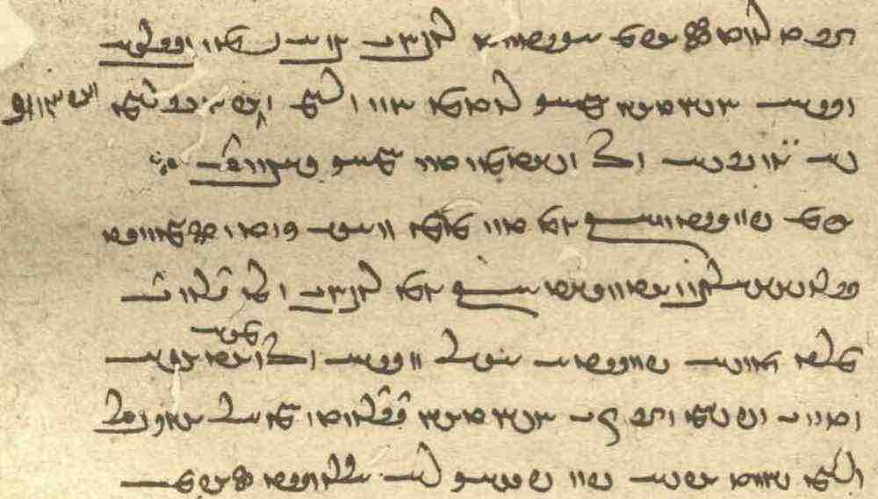
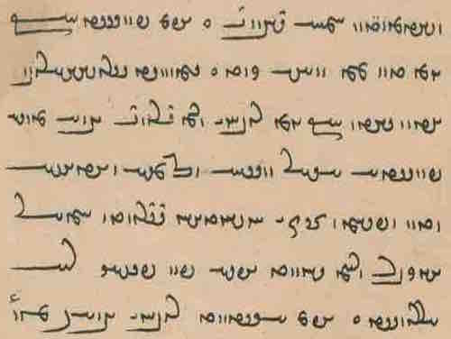

Text 19.2
From the Zand ī pargard ī J̌ud-dēw-dād: ZFJ.515–6. — Ms. TD2, pp. 516–6. – About a pregnnant woman eating nasāy.

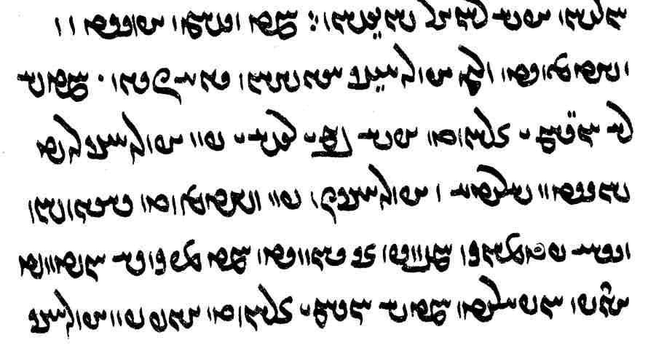
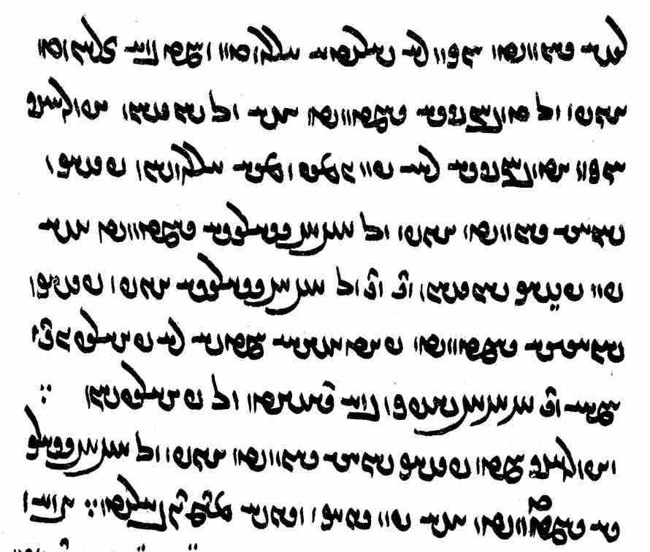
ka zan ābustan (nasāy) xwarēd ōy aburnāyīg ēg-išān dādestān čiyōn •
ka-š nē hangām ī zād u-š bīm ī rēš ī pad aburnāyīg nēst šustan pādixšāy
ud aburnāyīg-iz pad xward dārišn
nasāy paymānag hambun-iz ān bawēd ka mizag-iš dānēd ayāb ōbārēd
ka-š hangām ī zād ayāb pad aburnāyīg [516] rēš bawēd ō-nūn nē pādixšāy šustan
ud ka bē zād ayāb ō tuwānīgīh rasīd ā-š ōh šōyišn
aburnāyīg ō-nūn a-tuwānīgīh rāy pad gōmēz ud āb šōyišn
pišag-šnās bawēd ayāb ō 7-sālagīh rasīd ā-š pad pišag šōyišn tā
tā ō 7-sālagīh ayāb pišag-šnāsīh rasēd pādixšāy ka-š nē pahrēzēnd
hamē tā 9-šabag bē dāšt ōh pahrēzišn
ud aburnāyīg ka pišag-šnās bawēd ayāb ō 7-sālagīh rasēd ā-š pad gyāg Nasuš abar dwārēd

Text 19.3
From the Pahlavi Rivāyat (PR.25.1-6). Mss. BL ff. 38v-39r, Tc, pp. 79-80. – Z. asks Ohrmazd how much longer it will take until Renovation and is upset when Ohrmazd tells him 3000 years. Ohrmazd comforts him.

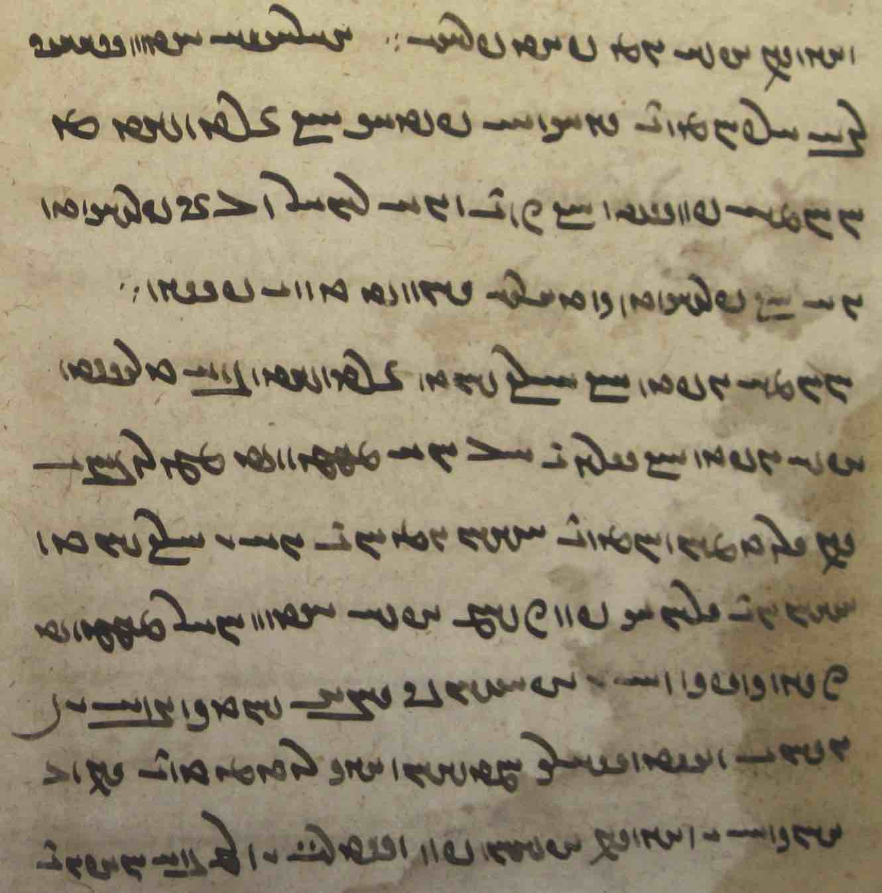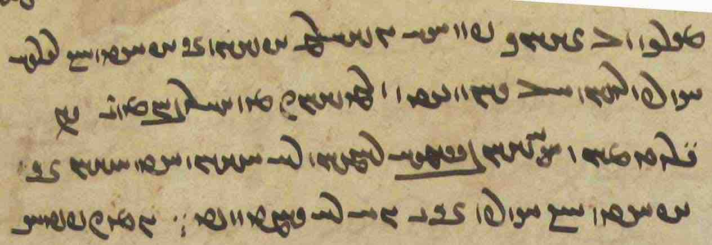
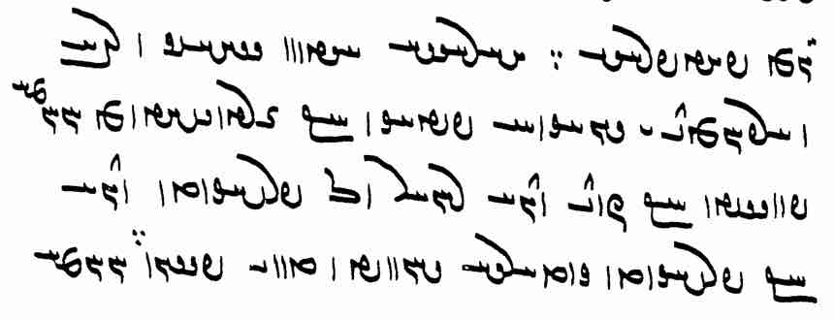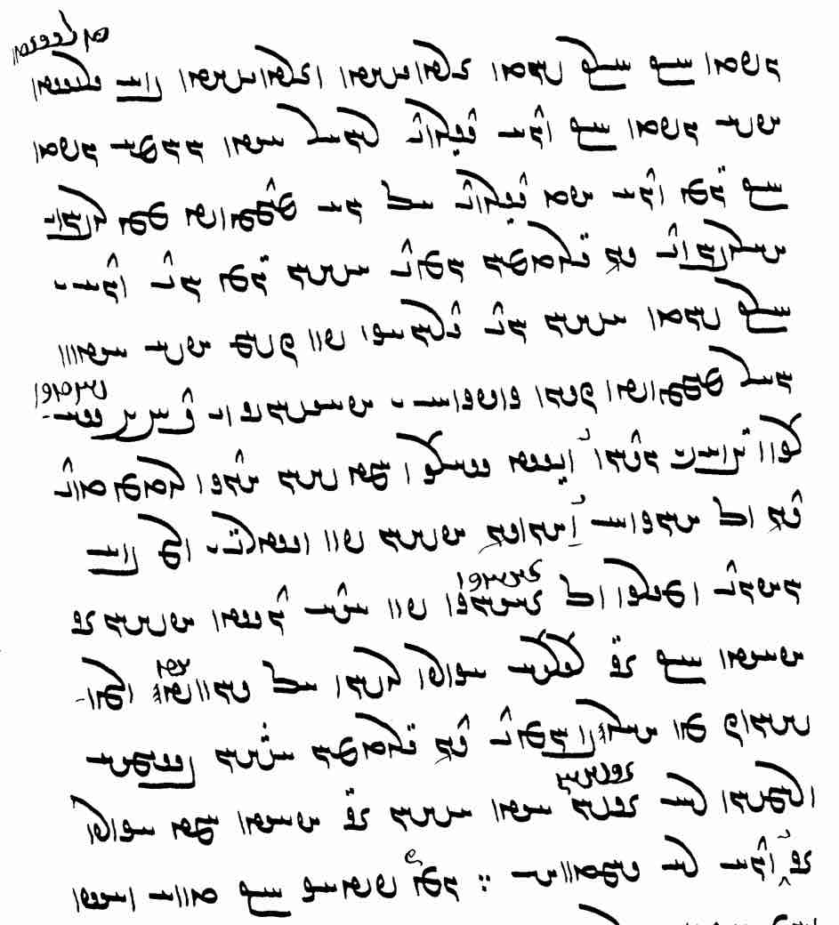

ahlāyīh ēdōn sahīg ud wazurg ud arzōmand ī gyāg ēw paydāg kū Zardušt az Ohrmazd pursīd kū
čand zamān abāz ō ⎡ ān fraškerd zamān kū ⎤ fraškerd-kerdārīh bawēd ud tan ī pasēn ∵
Ohrmazd [Tc80] guft kū 3000 sāl Zardušt
Zardušt bē grīst u-š guft kū ⎡ zamān dagrand abāz ast
Ohrmazd guft kū ēn zamān u-t ⎤ dagrand ma ē sahēd
čē ruwān ī ⎡ ahlawān tā ⎤ andar Garōdmān hēnd ā-šān ēn-and zamān ī 3000 sāl ā-šān and drahnāy pad čašm
u-š ēdōn xwār sahēd čiyōn kanīzag ēw abāyišnīg ī 15-sālag ud mard-ēw ī ǰuwān ī wīst-sālag
ka-šān ēk abāg did andar ō xānag ēw kunēnd
u-šān pad wastarg ī narm bē xwābēnd [BL39r]
ud mērag ō ziyānag pad gyān dōšāram
u-šān ān abāyēd kū ān šab haguriz rōšn ma bawād
awēšān-iz kē ahlaw hēnd andar Garōdmān ā-šān xwašīh ud rāmišn rāy ī-šān ast
ā-šān ān abāyēd kū haguriz ān zamān nē rasē ∵

Text 19.4
From the Mādayān ī hazār dādestān: MHDA.5.35 (p. 23, ch. MM., p. 170). – About timing in legal contexts.

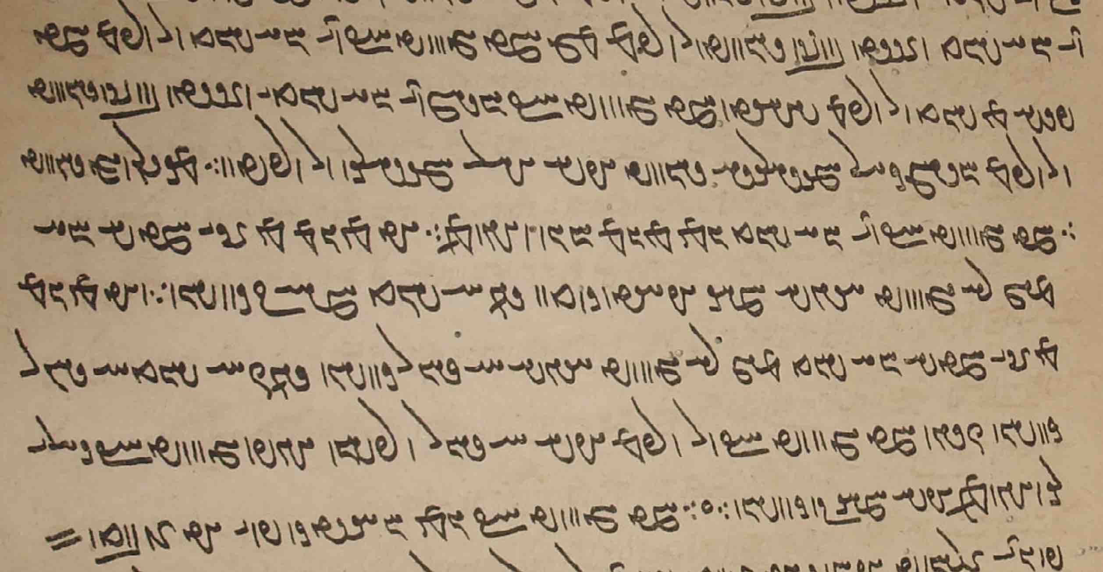

ka gōwēd kū tā ēw [ms. ēd] sāl ēn tis ōwōn kunam;
agar tis az ān ī ka-š ēd abar nē gōwēd ēg-iš hamāg abāyēd kerdan andar ēw sāl hamē ōh kunišn.
ud agar tis az ān ī ka-š ēd sāl abar nē gōwēd ēg-iš ēw ǰār kunišn andar-iz ēw sāl ēw ǰār kunišn
čiyōn ka gōwēd kū war warzam u-š ēw ǰār warzišn ayāb gōwēd kū kār ī tō kunam u-š hamāg ōh kunišn
“when one says: by this year I shall deal with this matter just as (necessary?);
if he says nothing about when he (shall have taken care of it), then he must take care of all of it, and it must be done within one year;
and if says nothing about when during this year, then he must do it once (= some time?) and once within one year;
just as when one says: I shall swear an oath, and he must do it once, or he says: I shall do this work of yours, and he must do it all in the usual way (= as promised?)”

Exercises 19

/WtDWWwaD ÂABwA AWK W WWT AWK WWP AWB ? aÒ ÂABwA Ä W WWT Ä WWP WKwaÅ W eaDW Y>wA NWY à WWtdA CNwY ? !

/ WTWWtjA µaDwA W WCwL Y>BK áÒ WwAV{ nÍPWW WwadATwAW WwaåD WWP WWwLwA ï¸K N lYtÒK LW ? 2

/ WtDWwAV ÍTP WtdlYKW áÂA WWT Y WTWplAK OW WKTWwLTW WWT Y E∂ÎÎ>¸W WWP y>lM N OaÅ MwY 3 ã 3

WKtHPW Ava¸ adM WWP W WKtjaÒW aåDtJWP AWWT q Y>UW WkAtJcÅ WkaÂA WwSC WwS NwY ? 4
/ WtÅWwmYWI WTWWtÅwA WtHPW AtdLK WcD> WWP WwAKcÅP Y laÅtJ x

WtdaDcdMwY EkaÅ ØW WWT elAkmAc¬P WWP nM WWTWwaD WtdAcÅ sAkA MwYN NwY WWP ? 23
/ WwÍW]J Q WCwL áÒ WwAV{ ˙dA AWK WtDWWwaD WwAV{ ØW ÂAtJcÅW

wABwL ` Y>Wwï>˜ elYpÍ NTwL WKPWK ` `Wwï>˜ ã ` LU WWP WthAW OW AWB WwABwlaÅ ` wABwL ? 33
/ tÎÂAwLP WkPWK nÍPW ˙∂¸ WiaÅTW WiaÅPW wa˜TP WWP KwAwLP

tÒwLP lAWkAcJ KwYW wßlaD> wßLwA WWP MwY Y>WC `>W à TnLP äL wajaJ KcÅPW ? 34
/WTWwa:¸ ÍcÅ :dßATwA W TWWwaD WWtJWcÅ KcDWK ã waÂY x äL WWTWWwaD tdAcÅ w˙daD. W

/ a:J Y WwÍWWK / lATK WItÒkßLP WwmÍwY> / WWwlaÒP Y WwÍWWK / lATK WItÒkßLP Y WtJwY> ? 44
/ KPWK Y lABwA / WtDPwÍW aÒ W WtdATP WItÒkßLP Y ã nM

WwAwßaD kaÂA Y WwßajGcÅ µAcÒP elAtDwsaÒ ÂAK W laDC WN - Wwa¬adßYK ? 333
WwaÔ∂¸ ÓDK MWt¬M WtjaÒP Y EIwaHwY> IwÍtÅWVA Íƒ wAtDwaD W eY>Wwl∑> W
/ tDWWwaD WTPwY AWB Íƒ EKwAcÒP tDWWwaD WTPwY WtåD q elAtDwsa¬ßwY>

IwÍPWwÍWW WIwÍƒCwA WIwÍcJ WkaÂA WtdaDWwsaD :ÅBtJwA Y cJ> Cx Y>BK CtÂA WWBC iAtJ ? º
WtDWW]¸W WwaåD Y CwY< W Y>Wwï˜ W˚ W aåDkmAkA aådY>WNwAkmAK IW˙jL WwaÔDwaÅ WwaÔDwA W˚
WtDWWVaD aådmlaHwY> aja¬aÅW aåDtåÒ WwAIwAc:Å Wwa:DfH W˚ ItååÒP WnMT
/ WwÍcjA aåDIwAtDwaD ã nM WtdaDCwA ETwS adM Íƒ ÂaD> aÅtJ Y>Wwï˜ kAwYcJ Y ã Q WPwïÅ

Translate

Additional readings 19

Additional reading 19.1
From the Dēnkard: Dk.6.200. – Ms. B, p. [404], K43 ff. 209r-v.
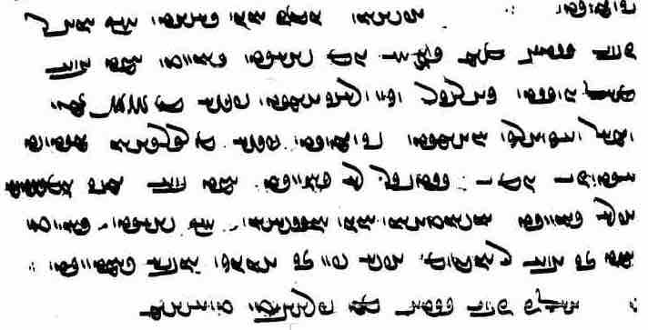
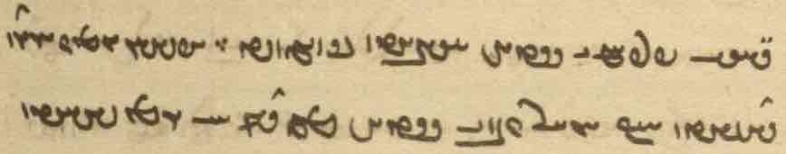
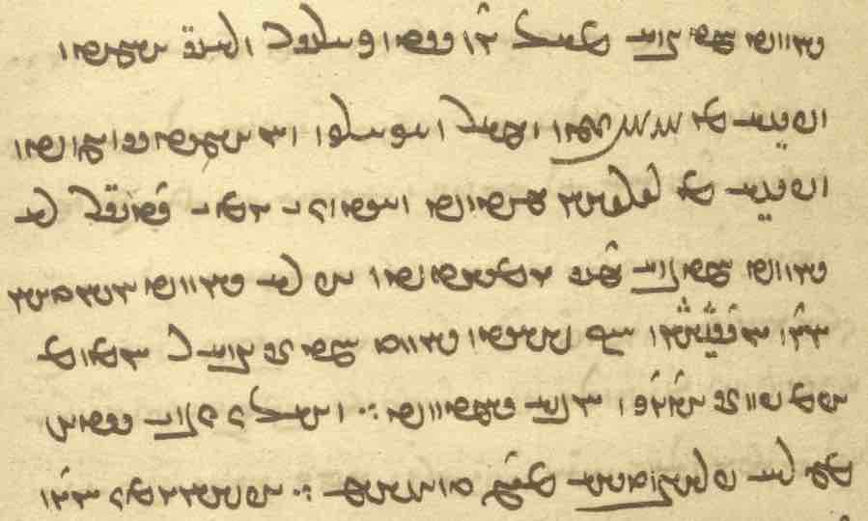
u-šān ēn-iz ōwōn dāšt kū xwār / xīr ī gētīy
čē andar ēw rōz šāyēd būd ka mard / (ī) fradāg drust ud kārīgar ud dūr-ēmēd
pēš az 6 zaman wēmār ud akārag ud anēmēd estēd ud pēš az šabān mīrēd
ud ast-iz ī rōz ī didīgar nē bawēd ka bē zamīg gumēxtēd xāk bawēd
mardōmān ōwōn handēšišn kū
šāyēd būd ka ān mard man ham u-m pad ān ēwēnag awiš rasēd
ud pas-iz xīr ī gētīy čē rāy frāybūdīhā abar tuxšēm
It happens that a man who yesterday was healthy, active, and with hopes for a distant (future),
and within six hours is sick, inactive, and without hope and dies before night time,
And sometimes it is not yet the next day when he is mixed with earth and becomes dust.
People should think as follows:
“Perhaps I am that man and it will happen to me just like that!
So then, why do I strive for things of this world so it will be more?”

Additional reading 19.2
From the Dēnkard: Dk.6D.4. – Ms. B, p. [452].
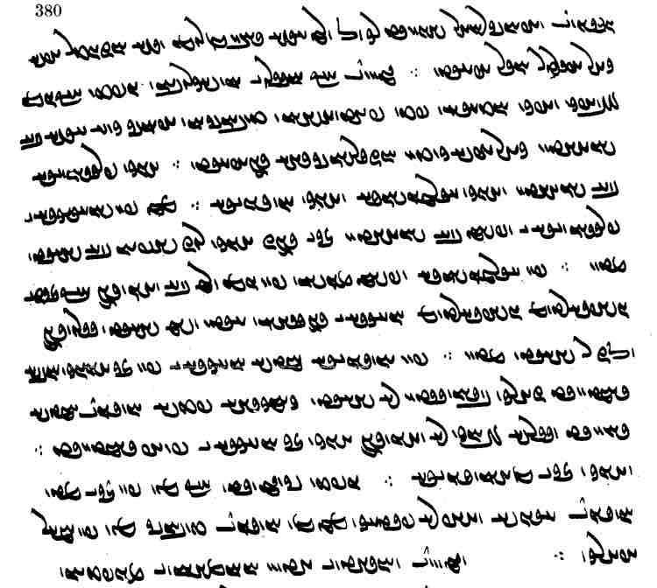
gōwēnd kū Husrōy Anōšag-ruwān guft kū
ēn 3 wāzag wāzag xwadāyān pāduxšāyān tuwānīgān abārīg-iz harw kas bē šnāxtan ud kār az-iš kerdan awizīrišnīgīhā andar abāyēd •
ēk frasāwandīh bē šnāxtan • ud ēk ēr-menišnīh • ud ēk hunsandīh ∵
čē pad šnāsagīh ī frasāwandīh ī xwēš bē šnāxtan (ī) ān ī andar-iz ēk rōz-šabān bē šāyēd madan
ud pad ēr-menišnīh xwēš menišn pad ēn warm bē kunēd kū
ān-iz ī / duščihrtom [duščihrtom] anāgīh ī andar gēhān ast <wsm> šāyēd burdan ō-iz man šāyēd madan
pad hunsandīh ka-š anāgīh ī pad ān ēwēnag awiš rasēd ī čārag xwāstan nē šāyēd
kāmagīhā pad-iš hunsand bawēd ud wad dōgānag bē nē kunēd
ēk ān ī az anāgīh ī frāz rasēd • ud ēk ān ī az ahunsandīh
guft estēd kū
kē pad ān ī mad estēd hunsand ēg-iš niyāz nē paydāg
čē kē hunsand tuwānīg ud kē pen-āmār ačārag

Additional reading 19.3
From the Bundahišn: Bd.5b.19–20. – Ms. TD1, f. 24r, TD2, p. 59. – Counting days and hours by the movement of the planets.
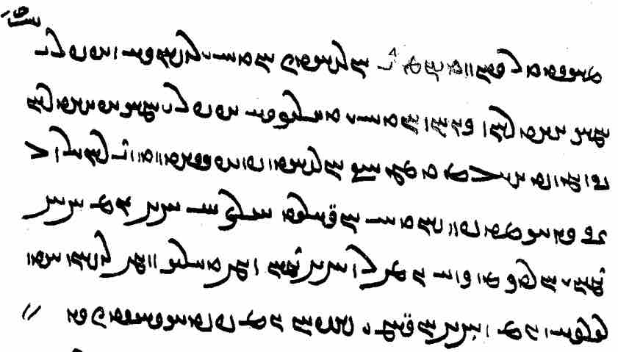
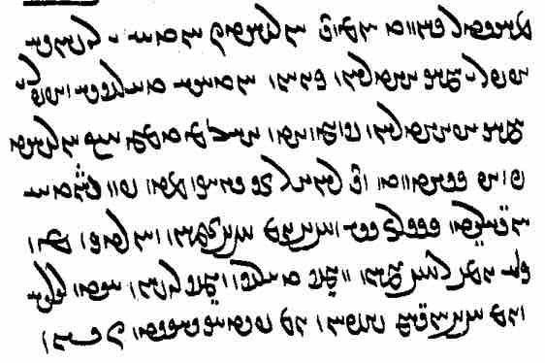

Additional reading 19.4
From the Dēnkard: Dk.3.166.1-3. – Ms. B, p. [138].
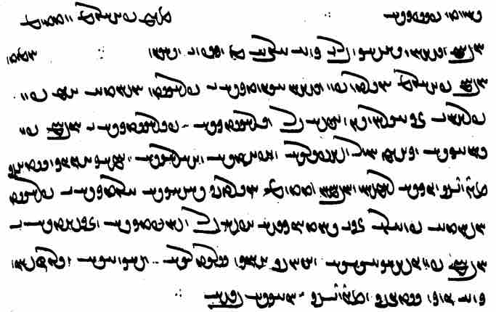

abar pahlom ud wattom / āwām nišān daxšag ud bar ī harw *dō [ms. <ALBA> čahār]
az nigēz ī weh-dēn ∵ hād /
āwām pahlom *hangerdīg pad nišān āsnūdagīh ī frayist mardōm xēm pad / frahang (ī) ān (ī) ērān dēn
u-š bar wirāstagīh payrāstagīh ī āwām pad / dānāgīh ud hammis hunar ud wehīh ud ābādīh ud ahlāyīh ud hamāg-ēwēnag gētīyīg / mēnōyīg nēkīh rāmišn
ud āwāmān wattom hangerdīg daxšagīh ālūdagīh ī frayist mardōm (ud) puhl ī ān ī yahūdān kēš
u-š bar wišuftagīh ud zištīh ī / āwām pad dušāgāhīh ud abārīg āhōg wattarīh ud škōhīh ud drōzišn / harw-gōnag gētīyīg ud mēnōyīg anāgīh bēš ∵

Additional reading 19.5
From the Rivāyat of Ēmēd son of Ašwahišt (REA.34). – Ms. TD2, pp. 303-4. – About how and when to wash to remove pollution.
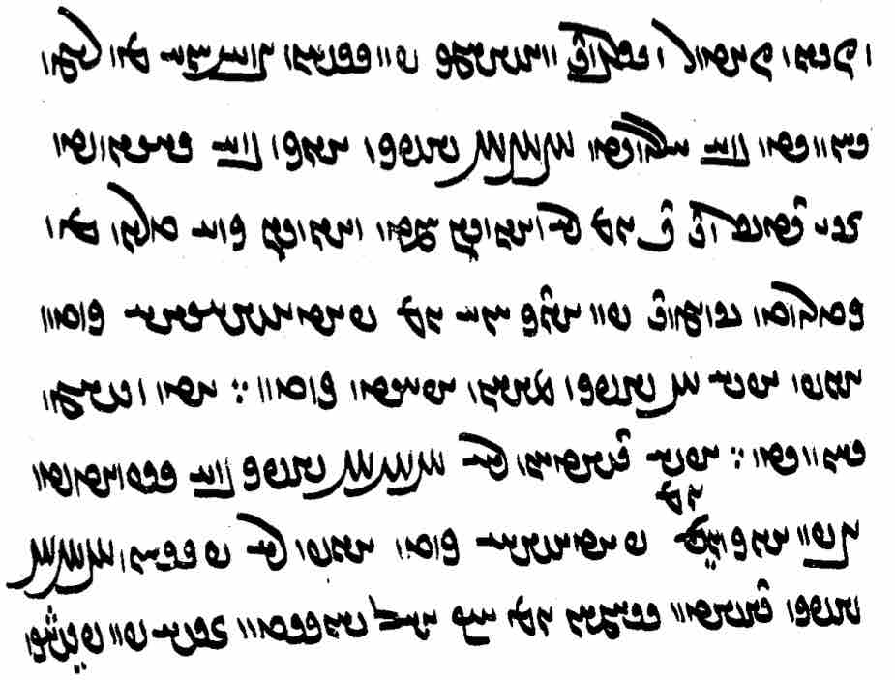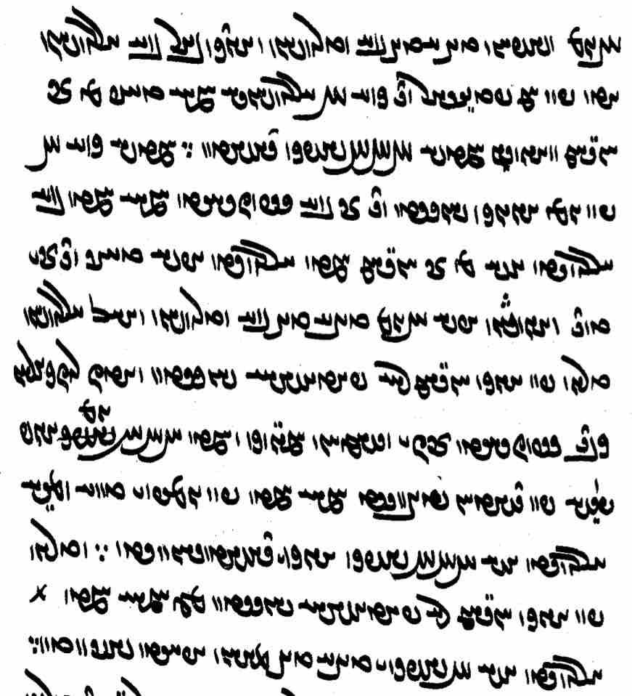

Additional reading 19.5
From Dēnkard III (Dk.3.267.4). – Ms. B, pp. [214–15]. – About limited and unlimited time.

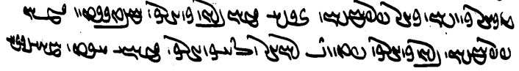
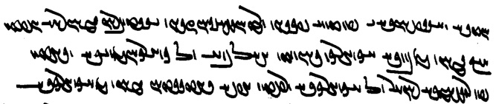

zamān-frazāmišn brīn-kanārag paywand abāz ō akanārag zamān
ī ast hamēyīgīh [B215] xwadīh ud a-sazišnīh ī pad tan ī pasēn ōy xwēšīgān
čiyōn dastwarān zamān rāy guft kū
zamān az bunīh akanārag būd
pas bē ō kanāragōmandīh wašt
ud pad sarīh abāz ō akanāragīh *wardēd

Glossary of words in the Texts and Exercises 19

Idioms
(abāg ...) hammis together with
abāz (ast) (there) is left (over)
ān abāyēd kū wish (impersonal) + subjunctive or optative
az ... est- cease
hamē tā all the time until
kār kerdan + az use
mērag ... ziyānag man and woman, often when referring to someone already mentioned
pad čašm
pad gyān dōšāram in love
pad xward dār- suckle (?)
ranǰ ud āwām dīdan experience
war warz- take an oath
xwēšān a-xwēšān one’s own (family) and those not one’s own
kāmagōmandīhā ud a-kāmagīhā willingly and not willingly, willy nilly

Nouns, adjectives, adverbs:
abōxtišnīg IwÍtÅWVA <’bwhtšnyk'> going to not be saved
akārag WklAkA <’k’lk'> inactive, helpless (?)
ālūdagīh EKTwlA <’lwtkyh> pollution; cf. NPers. āludagi-e havā “air pollution”
amarg-rawišnīh EwÍBwL y<lmA <’mlg lwbšnyh> renders Av. amərətatāt “non-dyingness”
ānāft-zōr LU WTpAwA <’n’pt' zwl> whose strength is frustrated/averted
andarak-gāh saDFkl„wA <’ndlkg’s> the place inbetween
anēmēd Wtdmï>ÅwA <’n’ymyt'> hopeless
arzōmand Y>WNwAc¬A <’lc’wmn'd> valuable
āsnūdagīh EKTwsA <’snwtkyh> being purified, nobility
āwām ÂaDwA <’wd’m> toil, trouble; distinguish <hng’m> “time”
dagrand Y>]J> <dglnd> long-lasting
daxšag WkßE <dhšk'> mark
dōšoxīgīh EIwaHwY <dwšhwykyh> being bound for hell
drang Y<]D>> <dlng> duration
drēm Âï¬Y <dlym> mucus, drivel (?); Av. driβi
dūr-ēmēd Wtdmï>ÅiaÒ <LHYK ’ymyt'> whose hope reaches far
duščihr laDcHwY <dwšcyhl> ugly
ēk-bar LBKwïÅ <’ywkbl> who carries (dead matter) alone
ēr :dA , lÄ <’dl> underneath, below
gām µE <y’m> step, stride
frasāwandīh eYWwajLP <pls’wndyh> transience
frayādīg WItådLP, WItååÒP <pl(y)yd’t'> helpful
frāybūdīh ETWvïåÒP <pl’ybwtyh> excess
frazāmgarīh ÂAcÒP <plc’m> ‘end game’
ganǰ WCwY <gnc'> treasure
hamāg-ēwēnag WKwYwïÅ kaÂA <hm’k ’ywynk'> all kinds of
hamāg-rawišn WwÍBwL kaÂA <hm’k-lwbšn'> renders Av. hauruuatāt “wholeness”
hambun-iz CWWbmA <hmbwnc> altogether; ~ ... nē “not ... at all”
hamgōnag WKWwïÂA <hmgwnk'> likewise
hampursagīh E∂JWWfÂA <hmpwrskyh> conversation
hanǰābišnīg WIwÍƒCwA <hnc’p̄šynk> bound to end
hazangrōzim µZKwL∑wz <hznglwkzm> millennium
hunušk WkÍWWwA <hwnwšk'> brood (offspring of evil beings)
ǰudīh EtDwY <ywytyh> separation; + ī “from”
ǰud-abzār la¸cÅ WtDwY <ywyt'’p̄z’l> separated from one’s tools/weapons
kārīgar LilAK <k’lykl> fit to work
kōxšēnīdārīh elAtDwïhAWK <kwhšynyt’lyh> incitement to fight
margōmand Y>WNwad<lM <mlg’wmn'd> mortal
mērag Wkl∑M <mylk'> man, husband; oppos. ziyānag “woman, wife”
narm E
nišān WwaHW <nš’n'> sign
ō-nūn WWKwA <’wKON> now, at present, currently
ōrrōn WWwLwA <’wlwn'> hither, on this side; az ... ~ “from ... until now”
paššixtag WKtåHP <pšhtk'> splattered
pen-āmār laÂA WWP <pn' ’m’l> niggard, miserly
pišag WkßYP <pyšk'> a rope with nine knots use to wash
pišag-šnāsīh esAwÍ WkßYP <pyšk' šn’syh> familiarity with the pišag
pišag-šnās sAwÍ WkßYP <pyšk' šn’s> familiar with the pišag
pōst WtJWP <pwst'> skin
puhl lAWP <pwhl> punishment
purr-dard Wt:D LWP <pwl dlt') full of pain
rōz-šabān WwAfH MwY <YWM šp’n'> day-and-night
rānišn WwÍwaÒ <l’nšn'> fight(ing)
rūdag WKTwL <lwtk'> plucked (hairless)
sard Wt:J <slt'> cold
sāmān WwaÂaJ <s’m’n'> limit, ‘parameter’
sazāgwār lAWkAcJ <sc’kw’l> fittingly, appropriately
sazišnīg WIwÍcJ <scšnyk'> fleeting, transient
tay-ā-tay 1YTA 1YT <tyḏ ’tyḏ> uninterruptedly, continuously
spurr-uzmūd WTnZwaÒWcJ <spwl’wzmwt'> completely tested
tāyag WiAT <t’yk'> time, period (e.g., menstrual)
wāzišn WwÍcÅW <w’cšn'> flight (also about the sun)
wināhkārīh (wināhgārīh) elAksAWW <wn’sk’lyh> act of a sinner
wīst-sālag WklaJ WtjGW <wyst' s’lk'> twenty-year-old
xākīh EkaÅ <h’kyh> dirt
zišt thï¸ , WthgZ <zyšt'> ugly

Names:
Kēwān WwAwYK <kyw’n> Saturn
Staxr laÅtJ <st’hl> Istakhr
Zardu(x)štān WwAtHWt¬Z , WwAthAWt¬Z <zltw(h)št’n'> of Zardušt/Zarduxšt

Verbs:
hangār- hangāšt WthaDwA , –laDwA <hng’l- hng’št> think, consider
hanǰāb- hanǰāft WTcÅCwA , -cÅCwA <hnc’p̄- hnc’p̄t'> finish, conclude (trans.)
ǰudāgēn- –wYkAtDwY <ywytyn-> separate
paššinǰ- paššixt WtåHP , –CwÍP <pšnc- pšht'> splatter, sprinkle
pattāy- pattūd WTWTP , –ÄTP <pt’y- ptwt'> last, endure
payrāy- payrāst Wtja¬YP –á¬YP <pyl’y-, pyl’st'> arrange, adorn, equip
pērōzīh- -ECwlYP <pylwcyh-> be overcome
spōxt- = spōzīh- –tÅWfJ <spwht-> be pushed back, be delayed
xwāb-īd –cÅwA <hw’p̄-> make sleep, ‘put to bed’

Lesson 20

Grammar 20

the Verb.

Politeness expressions with framūdan

ān ī-tān framūd nibištan abar ayāsišn ī ō ham-wēnišnīh ud ham-pursišnīh ī man mihrbānagīh ud dēn-dōstīh ī xwad “that which (as for that fact that) you wrote about longing for seeing one another and asking one another, (that was) your own friendliness and love of the dēn” (DD.0.4)

Constructions with dāštan expressing state resulting from a previous event
The verb dāštan “have, hold, keep” is sometimes found in constructions reminiscent of the English perfect “I have done,” but the use is restricted to a certain set of verbs, those that can express a state, It is found with past participles and perfect participles in -ag, e.g.:

With a past participle:
Srid abar šud ō wēšag dīd hēnd wasān parīgān kē-šān zafr wišād dāšt u-šān abar xrōsīd* kū ōzan ma abaxšāy
“Srid went to the thicket, (where) he saw many witches who kept their mouths wide open and howled: Kill (the bull)! Have no pity!”

mēnōy ī āsmān artēštār homānāg baxt kē ayōšustēn zrēy paymōxt dārēd
‘the divine sky was $$ like a warrior who has on a metal armor”

ud ka būd pad dād ī haft kišwarān ā-š* paymōxt dāšt kb’h ī az 7 pōst kē-š xwarrah ī 7 amahrspandān padiš būd $$

u-š āsmān pad ēwēnag ī warr-ēw nihuft dāšt
“and he wore the sky like a piece of clothing”

With a perfect participle:
2 šagr āmad kē *asp-ramagān az gyāg ī xwēš spōxtag dārēd

xwēš-tan pad brahmag xwarāsānīg ārāstag dāšt (KN.9.1/8.2)

dārēd expressing “being in a place”
This usage is also in modern Persian.

mayān ēn zrēy ī Frāxkerd ud ān ī Pūydīg pahlūg-ēw zrēy dārēd kē war ī Sadwēs xwānēnd “between this Fraxkerd Sea and Pūytīg Sea, to one side a lake is situated that they call Lake Sadwēs” (Bd.10.9)

Past participle + kun-

123 ān kē ōy tā-š būd ka hamāg ēn kārīhā guft kerd

Figura etymologica

Sometimes we find combinations of two forms of the same verb, e.g.:

u-mān ohrmazd mowbed {ān ī} ān xwānd xwānēm kē mēnōy-wēnišnīh andar amā paydāgīhist u-mān frāx-čārīh mēnōy-wēnišnīh gētīy handāzag nimāyišnīhā-iz harw 2 ēwēnag spurrīg az-išān xwāst xwāhēm (Dk.4.3.8c)

ud ān ī dahom zamestān ān mādayān wurrōyist u-šān ēdōn guft kū
menēm nūn kū-šān zad [ī] Až ī dahāg čē nē nūn wazēd abar ō harwist kišwar kē haft ud ān ī weh gōwišn ud ān ī wattar ā-iz nē gōwēd ud nē pad xwāyišn xwāhēd ān ī čarātīg ud ān-iz ī ārzōg xwāstag (Dk.9.21.12)

Ērānagān Frāsyāb pad xwāyišn xwāst (Bd.33.10a)

u-š haguriz nē xwāst xwāyišn az Ohrmazd “$$” (WZ.35.48)

harw čē wehtar dānēd guft gōwēd (Abar Stāyēnīdārīh ī Sūr Āfrīn 19)

andar ān ī ka gōwišn guft

Bd. 6A.3 pās pāyēnd
ŠGW.13.17 kū Adam andar ān bāγestān warz kunād ud pās pāyād
Dk.5.7.1 abar pād <NTLWNt'> ī pās passox

andar dāšt dāštan MHD.

winnird winnārdan Dk.5.7.5 B <wynlt">, D <ywlt'>.

ēwāz pas az wisēy āmad āyēd pad hixr ī zīndagān dārišn (ZFJ.468)

conjunctions 1. Coordinating

Connecting conjunctions

ud, u- W , cÅ <W, AP̄-> “and (then)”
ham ... ham “both ... and”
ēd ī ... ēd ī “both ... and, whether ... or”
ay Ä <’y> “that is”
ā- –A <’-> “then”
ān ã <ZK> “therefore”
-iz C <-c> “also, as well, even”

ud “and, then”
This conjunction is mostly coordinating, but is sometimes used to introduce the main clause after a subordinate clause, in which case it may be translated as “then” or left out in the translation. Sometimes one has the impression that the conjunction only has the function of supporting an enclitic pronoun.

ka ō ānōh frāz mad ham u-m dīd ān ī widardagān ruwān
“when I came to that place I saw the souls of the departed”(AW)

ka-šān nišast abar abārīg ruwānān u-šān kerbag asmān-bālāy estād
“when they sat above the other souls their good deeds stood as high as the sky” (AW)

ham ... (ud) ham

ham ān ī wahārān bar ud ham ān ī zamestān bar ud ham-iz az ān ī hāmīn pādēz bar ī was-ēwēnag ud purr sūd ī was-nēkīh kē ham hangad ham driyōš aziš zīyišn dārišn
(StS.7.4)

harw 2 mihr ast ham abar ahlawān ud ham abar druwandān
“he contract belongs to both: both upon the Righteous and upon the wicked” (AWN.52.3)

ka pēšēmāl pad tōzišnōmandīh gugāh ēw abāg ayāb dō ud pasēmāl nakkīrāy war kē warzišn ∵
ka az kustag ēw gugāh ēw az kustag ēw dārišn war kē warzišn ∵
pad harw dō dādestān pēšēmāl weh-dādestāntar ud ham ān kē nakkīrāy ud ham ān kē dārišn abāg
ham xwad pad war warzišn ud ham pad war abāz ō pasēmāl dāštan
(RAF.72)

ēd ī ... ēd ī

Dk.3.82.5

kūnmarz wēš-grāyīh rāy ēd ī pēš ēd ī pas ēwtom
“because anal intercourse is such a ‘heavy’ sin, both the one in front and the one in back is one and the same” (REA.29.8)

-iz

We are quite familiar by now with this enclitic particle. Not that it can also be used with negations and sometimes in slightly unusual ways, e.g:

ka abar nē wārēd ān ī sūdīmand wārān ī az tō Tištar rādīhā abar-wārišnīh
ēg-išān nē zargōnīh bawēd ī tāg warg ... nē-iz bar bowandag xwālom sazāgwār ī xwaš-mizag
“when that profitable rain (coming) from your generously raining it down, o Tištar, does not rain,
then branch (nor) leaf will not have (any) greenness, nor (any) sweet, suitable, sweet-tasting fruit” (StS.13.5)

ka pad kafš ud šalwār murd čiyōn ∵ kafš ud šalwār rēman band pāk •
ka pad šalwār bun band ī kafš murd estēd kafš-iz šalwār rēman
“How is it when he died with shoes and trousers? – The shoes and trousers are polluted, the band is clean.
When he is dead with the trousers and the bottom band of the shoes? – both shoes and trousers are polluted” (ZFJ, p. 511) – The exact reality of the description escapes us.

abar astīh ī harw dō azabar ān gugāyīh gugāy
az-išān yazdān mānāg-iz dānāg dēw ud druz mānāg ī duš-āgāh mardōmīhā
“about the existence of both (gods and demons) is a witness superior to the above (two) testimonies:
of them (= the two), similar to the gods (is) also the knowledgeable one, and similar to the Druz are various people with bad awarenes” (Dk.3.123.43)

Disjunctive

ayāb WPwïÅ <’dwp'> “or”
ayāb ... ayāb “either ... or”

ayāb ... ayāb

yazišn mayānag nē bawēd ayāb ō yazdān ayāb ō dēwān rasēd
“there is no middle (regarding) the sacrifice: it goes either to the gods or to the demons” (ŠnŠ.9.5)

ǰumbišn dō ēwēnag bawēd ayāb kāmīg čiyōn az mardōm ayāb čihrīg čiyōn az ātaxš
“movement is two kinds: either by will, as by people, or by nature, as by the fire” (Dk.3.147.5)

ān dō ayāb harw 2 hāwand-pāyag ayāb ēk meh ud ēk keh ud pāyag menēnd xwēš tan
“those two consider themselves either both of the same rank or one greater and one lesser” (Dk.3.381.7)

ka-š Nasuš abar abāz dwārēd ā-š čē kunišn kē pāk abāz bawēd •
ayāb-iš yōǰdahrgar hušnūd kunišn ayāb-iš abāz šōyēd
“when the Nasuš rushes upon him again, then what should he do so that (for kū) he becomes clean again? — he should either satisfy the purifier or one washes him again” (ZFJ, p. 643)

če ... čē “whether ... or”

ka mard-ēw xwāstag pad stūrīh ī xwēš paydāg kerd ud pad dāštan harw 2 sāl ēw sāl ō Farrox ēw sāl ō Mihrēn dād Farrox Mihrēn ǰud ǰud pad ān xwāstag yō hē pascaētā [Av. ‘he who (remains) after him”] ōh bawēd
čē ēd-iz pādixšāy ka frāz az xwēš bē dahēd ǰud ǰud zan padiš kerd xūb
čē ēd-iz pādixšāy ka bē ō zanān dahēd
(MHD.37.39, p. 47, ch. 19)

ēd kē ... ēd kē “whether ... or”

ka ō čand pus pad xwāstag-dārīh dahēd ēd ka pēš ud pas dahēd ud ēd ka pad ēw bār dahēd hamē hamāg-tōzišn hēnd
“when/if he gives several sons (a part of the heritage) ‘to hold as their property’, whether he gives one before and (one) after, or whether he gives (it) at once, (then) they will always have to pay all (of any debts owed)” (MHD.41.5, p. 60, ch. 23)

Adversative

bē AWB <BRA> “but”
ayāb WPwïÅ <’dwp'> “or else, otherwise”
ēnyā EwïÅ <’yny’> “or else, otherwise”
ayāb ēnyā EwïÅ WPwïÅ <’dwp' ’yny’> “or else’

bē “but”

nē (...) bē “not ... but”

andar deh nē bē pad kustag-ēw ī deh widard
“he passed, not through the village, but at one side of the village” (KN.3.17)

ān mard dušmen anāg-kāmag nē bē dōst ud nēkīh-kāmag bawēd
“that man does not become an ill-wishing enemy, but a friend and well-wisher” (Dk.6E.31g)

rāstīh ī dēn mazdēsn bē dānist ōšyārān pad uskārišn ōstīgīhā tuwān
bē pad gētīy dīd ud abartar abzōnīg ud pas-xrad būd mādayān nē pad uskār bē pad abēzagīh menišn gōwišn ud kunišn ud weh-mēnōy-wāzišnīh mānsrīg abēzagīhā-ēzišnīh ī yazdān šāyēd
(Dk.4.3.8b)

nē ēwāz ... bē “not only ... but”

nē ēwāz az warzāwendān ī čiyōn am ud Frēdōn ud was frazānag mardōm uzwēyīhist bē yazdān pad-iz uzwān ī gōspandān srūd
(Dk.7.2.61)

čim namāz nē ēwāz ō yazd bē ō-iz xwaršēd abārīg-iz was rōšnān barišn
(Dk.5.23.15)

ēnyā “or else, otherwise”

KN.9.12/18.5/121 [MK 95v]
ud mardōm ī diz harw čē ōzad ēnyā pad aweštābišn ud kōšišn ī kārēzār az diz ōbast hēnd
And the people in the fortress, all those killed or else fell from the fortress in the oppresion and killing of the battle ...

xōn ī az kār ī grāy ō waxš ud dašt ī hušk burdan šāyēd ēnyā ō sag dādan xūb saham
One can bring blood from an activity (producing) ‘heavier’ (hixr) to dry grass and fields. Otherwise, it seems OK to to give it (?) to a dog.
(RAF.97.3)

agar ... ēnyā
Macuch p. 576.
agar rōz Ohrmazd asp ō tō abespāram ēnyā tāwān daham
“(only) if I deliver the horse to you on the day of Orhmazd, otherwise I shall give (= pay) compensation”

ayāb “or else”:
rēmanīh rāy harw kē dast abar nihēd ēg-iš pad baršnūm bē abāyēd šustan ayāb pad yazišn ī yazdān ō ham-pursagīh ī wehān nē hilēnd
“As for pollution, everybody who places a hand (on it), then he must wash with the baršnūm, or else they will not allow him converse with the good (Zoroastrians) during the sacrifice to the gods” (?) (PT.11.1)

ayāb ēnyā “or else”:
Ahrimen ō Ohrmazd drāyīd kū gyān andar awēšān kunē ayāb ēnyā pašt nē āwāšam
“Ahrimen howled to Ohrmazd: You put a soul into them (the xrafstars), or else I shall not sign the agreement!” (Handarz ī Dastwarān ō Weh-Dēnān 13)

DD.42.11
ēnyā ka

ǰud az ... ēnyā Dk. Col. B.

ān “on account of that, therefore”

u-m pad ān spās ī-m pad yazdān ud šābuhr šāhān šāh kerd *ānād ān-im kunēd šābuhr šāhān šāh pad kerdagān ī yazdān ... kāmkār ud pādixšāy “And, for the service I had rendered to the gods and Šābuhr, king of kings, on account of that, Šābuhr, king of kings put me in absolute charge of all ministrations to the gods” (KKZ 1)

agar Zarduxšt frōd barēm abar ō astōmandān gēhān dahanōmand uzwānōmand ud frāz-guftār wīr-tangerd ēd paydāg tōhmag ōy ī man mard ī ahlaw rāy awēšān gōwēnd ān amāh ō ōy ō ham tāšēm andar āb andar damīg andar urwar andar gōspand “If we send Zarthustra down to the material cretures, equipped with a mouth, tongue, and speaking in a man’s body, (then) this origin will be apparent (as being) from me. They will say about him ‘The Righteous Man!’ Therefore we shall fashion him together in water, earth, plants, and animals” (Dk.7.2.20)

Phraseology

Expressions of Place, Direction, and Place or Time

“here, there, where”

ēdar nMtÒ <LTME> “here”
ānōh nMT <TME> “there”
kū à <AYK> “where”
harw kū à AWK <KRA AYK> “wherever”

ēdar “here”

ud ēdar paydāgīhist wazurg abdīh
“and here a great miracle was revealed” (Dk.7 passim)

ēn dašt nēk ud gōr ēdar was
“this plain is fine and wild asses are plentiful here” (KN.2.18/1.37)

az star-pāyag tā ō ēdar 34,000 frasang. ud az ēn gyāg tā ō āsmān ī azēr 69,000 frasang
“from the star-level to here is 34,000 parasangs, and from this place (here) to heaven below is 69,000 parasangs” (PR.46.7)

ēdar “here, in this case”:
ka xwāstag pad dād bē dahēd ka-iz-iš ō zan ēdar ēg-iz xwarišn ud dārišn ī zan abornāyīg abāz āwarišn
“if someone gives (his entire?) property as donation, also if it is to (his) wife, then, in this case, he still has to bring back (enough) for food and upkeep of his wife (and any) minor child’ (MHD.27.6)

ānōh “there”

ānōh kū ka ēd kanīg nišīnēd rōšntar kū ānōh kū ātaxš burz waxšēnēnd az rōšnīh ī az im tan bē tābēd
“there where that young woman is sitting, it is brighter than there where they light a tall fire from the light that shines out from this body” (Dk.7.2.8)

Ardaxšīr ka ān saxwan āšnūd menišn ō wirēxtan az ānōh nihād
“when Ardaxšīr heard that speech he set his mind on fleeing from there” (KN.3.9/2.8)

pad ham-ānōh pad Asnwand kōf frāz ātaxš-gāhīhā nišāst
“(Kay Husrōy) established (frāz ... nišāst) (various) fire temples there in that very place on Mount Asnwand” (Bd.18.8¹²)

kū “where, where?”

ānōh frāz mad hēnd kū 2 murw pad pus-xwāyišnīh nišast hēnd
“they arrived there where two birds were sitting (engaged) in ‘seeking a son’ (= having sex)” (Dk.7.2.24)

kū panǰom ēn zamīg āsāntom kū mēnōy ēn zamīg āsānīh az čē wēš
u-š guft Ohrmazd kū pad ān abar frāyist mēzēnd pah ud stōr ān gyāg kū padiš parwarēnd
“Where fifthly (in) this earth is it the most peaceful, i.e., from what is there most peace for the Spirit of the Earth?
And Ohrmazd said: whereone small and large cattle urinate the most (i.e.) in the place where they raise them” (PV.3.6bc)

kū fradom ēn zamīg an-āsāntom kū mēnōy ī ēn zamīg dušxwārīh az čē wēš
u-š guft Ohrmazd kū pad Arzūr grīwag Spitāmān Zardušt pad dar ī dōšox
“Where firstly (in) this earth is it the most unpeaceful, i.e., from what is there most discomfort for the Spirit of the Earth?
And Ohrmazd said: on the Ridge of Arzūr, Spitāmān Zardušt, at the gate of hell” (PV.3.7bc)

harw kū
$$

“hither”

awar (ōr) LwA , nMWcÒ <LPNE, ’wl> “hither, till now; come here!”
awarēd nMWcÒ <LPNE> “come here!” (plur.)

Weh-dēn ... ōr <’wl> az bun-dahišn pad Gayōmard mardōm tōhmag padiš raft
“from the first Creation and till now the Good Dēn proceeded in Gayōmard’s seed of men” (Dk.3.229.12)

This adverb functions as an imperative, even replacing the imperatives of āmadan “to come.”

Ādurbād ēn-iz guft kū awarēd tā xwēš tan arzānīg bē kunēd čē farrox ōy ī arzānīg
“Ādurbād said this too: ‘Come here! so that you may make yourselves worthy, for he who is worthy is fortunate” (Dk.6D.7d)

bē awar tā-t ganǰ ud xwāstag ī pidarān niyāgān (ī) tō awiš abespārom
“Come here, so that I can hand over to you the treasure and property of your fathers (and) grandfatehrs!” (AJ̌.16.46)

drīst/drust awar “welcome!”
drīst ud weh ud pad drōd awarēd
“welcome!”

ma drust awar sēmspār ī ǰādūg čē tō mād ǰādūg u-t pid ī drōzan būd
“you are not welcome, (you) magician sorcerer, for your mother was a sorcerer and your father a liar” (AZ.51)

“beyond”

tarist nMWcÒ <tlst'> “beyond”
hu-tarist “on all sides”

$$

“under and above”

ēr :dA , lÄ <’dl> “underneath, below”
azēr lYcÅ <’cdl> “underneath, below”
abar q , LcÅ <QDM, ’pl> “above, over”
azabar LPcÅ <hcpl> “above, over”

ud ka-iz-im wāy dād kē čašm-dīd pad wād nērōg ēr abar čiyōn kāmag wazēd
pad dast frāz nē šāyēd griftan
“and when I set in place the wind, which visibly blows below and above as is its wish by the strenght of the wind” (Bdh.34.5d) — The Ind. Bd. has ēr ō azabar.

u-š kōfīhā az ān gōhr bē rōyēnīd
1700 sāl azēr ud azabar harw dō hamē rust ud pas azēr bē estād
“and he made the (various) mountains grow from that ‘substance’; for 1700 years they kept growing both below and above, and then they stopped (growing) below” (Bd.46.5)

“high and low; up and down”

ul a¬aÒ <LALA> “up(ward)”
frōd WTwLP <plwt'> “down(ward)”

pas ul estād Wahuman amahrspand az gāh ī zarrēn-kerd
“then the amahrspand Wahuman stood up from his throne wrought from gold” (AWN.11.1.)

az Čagād ī Dāitīy rāh-ēw ī ašō’ān ō wahišt ud ēk ī druwandān ō dōšox
ēk ō ulīh ud ēk ō nigūnīh ud harw 2 az ēk mayānag
“from the Ridge of the Law one road, that of the Righteous, (that goes) to paradise, and one, that of the wicked, (that goes) to hell;
one upward and one downward, and both (go) from one (in?) the middle” (DD.33.1)

nigūn WWWKW <nkwn'> “down(ward)”
nigūnsār (nigūsār) laJWKW , laJWWKW <nkwns’l, nkws’l> “upside-down”
sar-nigūn WWWKwlS <slnkwn'> “headlong, head over heals”

ēn-iz kū ma-iz tō pad nigūn-ālagīh pad hammōzišn frēbēnd kū-t ēdōn bē frēbēnd ī ō ālag ī nigūn ōbadē ī ast dōšox
“there is this too: let them not deceive you with (their) teaching (so that you go) downward, i.e., they deceive you in such a manner that you fall to the downward side, i.e., hell” (Dk.9.41.11)

u-m dīd ruwān ī mardōm ēw čand ud zan ēw čand kē-šān nigūnsār andar dōšox āguxt estād
“and I saw the souls of several men and several women whom they had hung upside-down in hell” (AWN.37.1)

menišn ī (Kāyūs) wiyābānēnīd tā ō kārēzār ī asmān šud ud sar-nigūn ōbast xwarrah az-iš appār būd
(Kāy-Us’s) thought was distraught, so that he went to (do) battle with the sky; but he fell headlong, and the Xwarrah was taken from him” (Bd.33.8)

nišēb <nšyp̄'> “downward slope, descent, declivity”; (astr.) “dejection”
abrāz <’p̄l’c'> “upward slope, ascent, acclivity” (astr.) “exaltation”
purr <pwl> “flow”
ōgār <’wk’l> “ebb”

u-šān pad gardišn abrāz nišēb ud waxšišn ud nirfsišn ī dāmān bawād
ud purr ud ōgār ī zrēyān ud waxšišn ī rōymānān ud wālišn ī dāmān
“and by their (sun and moon’s) turning, there will be upward movement and downward movement and waxing and waning of the creations;
and flow and ebb of the seas and growing of growing things and nurturing of the creations” (DD.36.23)

sidīgar az āb zamīg dād gerd dūr-widarg ud anišēb anabrāz ud hamang drahnāy abāg pahnāy ud pahnāy abāg zahyāy rāst
“third, he made the earth from water: round, with passages in the distance, without downward or upward slopes and its lengthe the same as its width, and its width exactly the same as its depth” (Bd.1a.9)

zamānag ī-š rāyēnišn abrāz amaragānīhā pad frāz-āhangīg ud hangāmīhā ud kasīhā pad abāz-āhangīg
ān ī-š rāyēnišn nišēb amaragānīhā pad abāz-āhangīg ud hangāmīhā kasīhā pad frāz-āhangīg
“time whose management ‘goes upward’ is generally
that (= time) whose management’gows downward’ is generally by fbackward-inclined (personalities) and sometimes, depending on time and person, by foreward-inclined ones” (Dk.3.68.2)

“in, out, and around”

andar “in(side)”
andartar, andartom “further/furthest inside”
andarg glYwA <’ndlg> “in(side)”
andarrōn WWwLx <BYNlwn'> “inside”
mayān Wwaå˜ <mdy’n'> “middle, between”
pad mayānag
bē AWB <BRA> “out(side)”
bēgānag WKwAkYV <byk’nk'> “away, abroad; outsider, foreigner, stranger”
tōg WKWT <twk'> “inside”
pērāmōn Wnï¬YP , WWna¬YP <pyl’mwn, pylymwn> “around”
WnlYP < pylmwn>

Note: WWna¬YP <pyl’mwn> is more often than not spelled Wnï¬YP <pylymwn>, sometimes also WnlYP < pylmwn>;
it is rarely spelled with <-wn'> (rather than <-wn>), sometimes even with just <-mw>.

andarg
Dk.3.150.

čōb ud mōy ud šūk ud ast čiyōn frōd nē barišn •
nay ud ast ... ǰōrdāg ī abag xāk āmēxt estēd abāg zamīg frōd grift estēd čiyōn •
ka bē frōd nē barēd
ka tōg ēdōnīh ī wizārišnīh zamīg paydāg frōd barēd
kā mayānag nē dānam
“how is it (when there is polluted) wood, hair, nails, and bones? —there is no ‘carrying down’;
how (is it when) reeds, bones, (or) grain, which is mixed with dirt, is connected with the earth? —
when it is outside (the earth), it does not ‘carry down’;
when it is inside (the earth), (then it according to) how the manner (of being inside) is explained:
(when) the earth is visible, it carries down; when it is in between, I do not know” (ZFJ.485)

az ... bē “out from”:
ud andar ān az abāgīh bē ī mardōmān dēw bē wēzēnd
“and during that, they sift the demons out from being with humans” (Dk.7.4.53)

čiyōn dēn gōwēd kū az bawišn-rawišnīh bē bawišn-estišnīh frāz būd
“as the Dēn says: bawišn-estišnīh came from bawišn-rawišnīh” (Dk.3.194.7

More often az ... bē is found in expressions such as az man bē “as far as I know.”

bēgānag:
abar artēštār ī a-tōšag kē pad rawišn abar wāstar ud ǰōrdāy ud gōspand frāz rasēnd kē fšēy aziš
“about soldiers without provisions who arrive by going over hay, grain, and animals, from which the farmer is away/abroad” (Dk.8.22.6)

āgāhīh āmad kū ān mard kē pad bēgānagīh būd pēš az bē dād ham duxt ō šōy az dād ī weh-dēnīh ō dād ī ag-dēnīh šud būd
“information came that that man who was away (out of the country), before he had given said daughter to a husband, had gone over from being of the good dēn to being of an evil dēn ...” (REA.1.1)

“direction”
Direction is most commonly expressed by suffixing -rōn to adverbs and -nēmag “side” to nouns and adverbs; -ālag “side” is occasionally found with nouns.

With -rōn
The compounds in -rōn are very common from the inscriptions on.

... rōn WWwL ... < ... lwn'> “in the direction of”
ō ... rōn WWwL ... OW <OL ... lwn'> “toward, to (the direction of)”
az ... rōn WWwL ... N <MN ... lwn'> “from (the direction of)”
andarrōn WWwLx , WWwlYwA <’ndlwn', BYN-lwn'> “inside”
bērōn WWwlYB <bylwn'> “out(side)”
ōrrōn WWwLwA <’wlwn'> “hither, on this side”
az ... ōrrōn WWwLwA ... N <MN ... ’wlwn'> “from ... hither, from ... until now”
parrōn WWwLP <plwn'> “thither, on the farther side”
ulrōn WWwL a¬aÒ “upward”
frōdrōn WWwL WTwLP <plwtlwn'> “downward”

Note: ōrrōn was long thought to be ō-rōn.

Here probably also belong:

frārōn WWwlaÒP <pl’lwn'> “*forward” ⇾ “‘morally’ good”
abārōn WWwlApA <’p̄’lwn'> “*backward” ⇾ “‘morally’ bad”

... rōn “direction”:
ān bōy wād az rabihwintar rōn az nēmag ī yazdān bē āmad
“that scent and wind came from the north, from the dirction of the gods” (AWN.4.8)

pas ka ō Gayōmard mad Gayōmard ō nēmrōz rōn hōy ālag ōbast
“nest, when (Ahrimen) came to Gayōmard, Gayōmard fell toward the south, on his left side” (Bd.7.7)

ō ān rōn šaw
“Go in that direction!” (PV.21.4d; gloss to parrōn)

andarrōn “inside”:
u-š dām hamāg andarrōn ī āsmān bē dād
“and he placed the entire creation inside the sky” (Bd.1a.7a)

andarrōn + andar preverb, preposition:
ud pas J̌āmāsp ī pēšēnīgān sālār zūd andarrōn <BYNlwn> andar šud u-š ō Wištāsp-šā guft
“and then J̌āmāsp, chief of the noblemen, quickly went inside and said to King Wištāsp” (AZ.5)

ka andarrōn andar xumb andar may bē mīrēd
“when something dies inside, in the jar, in the wine ...” (ZFJ.2.31)

bērōn “out(side)”:
u-š guft mēnōy āsmān ō Gannāg Mēnōy kū-t bērōn nē nē hilam
“and the spirit of heaven said to the Evil Spirit: I will not let you ouside” (Bd.4.12)

pas Zarēr az wardyūn bērōn bē āmad ud wiyān kerd ud Ērān wiyān kerd hēnd
“then Zarēr came out of the chariot and pitched his tent and the Iranians pitched their tents” (AZ.33)

čiyōn wars abar sar pad homānāgīh ī zēndān-bānān kē az bērōn zēndān pāyēnd
ud dušmen az andarrōn parwast-sāmānān bērōn nē hilēnd āmad
“for instance, the hair on the head is like prison guards, who guard the prison from outside
and do not allow the enemies outside from inside the set limits” (WZ.3.3)

ōrrōn “hither, to here, until now”
Zarduxšt andar ān ī abēzag rōšnīh hāwand amahrspandān az bun-dahišn ōrrōn ham hangerdīg ham ōšmurdīg bowandag a-pargūd-azišīhā padīruftārīh rawāgēnīdārīh dēn andar gēhān rāy mēnōyīg tāšīd ud payrāst estād
“from the first establishment (of the cosmos) until now, Z. had been fashioned and put together in the pure ligh similar to the amahrspands, both assembled and counted, complete, with nothing lacking from him, in order to receive and propagate the dēn in the world of the living” (Dk.5.2.1)

ud ān ī guft kū pad winah kē pursišn-nāmag padiš kunišn āšnāgīh-iz ī šahr ud dusrawīh wizīr andar wizōyišn dārišn
čē pad-iz pursišn-nāmag ī az pēš ōrrōn kerd ōwōn nibišt kū mērag dusraw ud andar šahr wad-mardīhā raft estēd
“and as is said: as a crime for which a record of hearings is to be made shall also be regarded the decision of ‘familiarity in the town and ill fame’ (reached) during the examination;
for also in the records of hearing made from before until now it is so written: ‘a man of ill fame and who has behaved himself as a bad person’” (MHDA.8.26, Macuch chap. 8, lines 34-35)

parrōn “over there, thither, into the beyond”
parrōn bē nigerēd kū kas az amāh abāz wardēd
ayāb ō ham mōšēd kū sar frōd ō kanār dārēd
ayāb bē mōšēd kū kust-ēw bē nigerēd
ayāb bē xwaš ōftēd ud andar ān az abāgīh bē ī mardōmān dēw bē wēzēnd
“Look over there where one of us returns (from consulting the demons)!
Either he mōšēd ‘together’, i.e., holds his head down to (one) side, or he mōšēd ‘away’, i.e., he likes in some direction, or he falls xwaš, and, in that, they sift out the demons from company with humans” (Dk.7.4.53; several uncertain words and readings: mōš- “bend”, xwaš <BSYM = BYYYM> for <OYYYM> for <OYYYYMN> = <OSGDE> namāz?)

guft-iš Zarduxšt kū
bē-m ān nigerīd kē Spandarmad andar ān ī rōšn rōz ī an-abr ud ān man sahist Spandarmad hu-ōrrōn ud hu-parrōn ud hu-tarist kū hamāg gyāg nēk būd
pasīy frōd ward šnāsom agar tō hē Spandarmad
“Zarduxšt said: “I have looked at Spandarmad in broad day light with no clouds, and that Spandarmad seemed to me good on this side, good on that side, good all through, (i.e.) she was beautiful everywhere. Turn around so that I can know (you), whether you are Spandarmad!” (Dk.7.4.58)

ka ān tan frōd mīrēd tan ō zamīg gumēzēd ud ruwān abāz ō mēnōy šawēd
“when that body dies, the body mingles with the earth, and the soul goes back to the other world” (Bd.18.11)

ēn-iz kū ān ī duš-stahmag pad ān ī xwēš kunišn frōd murd bawēd
“this too: the harsh tyrant will have died by his own deeds” (Dk.9.39.7)

ōrrōn ud parrōn tarist
“hither, thither, and beyond” (FiO.3a.98, translation of Av. aorāca parāca tarasca)

*frōdrōn “downward”
Only ō frōd rōn (?):

u-š bun ī āsmān čand 3-ēk-ēw ō frōd rōn pad bandag-darbuštīh kerd

ulrōn “upward”:
Only Man. MPers.:

ēg hān xāyag ō dō bahr baxt, az hān yak bahr ī ōy xāyag ī ulrōn ī gugāft ud baxšīhist [winnārd?] āsmān
“then that egg was split into two parts; from the one part of that egg that (was) upward, which was split and divided (from the lower part), heaven [was set up?]” (from a Manichean text; hān = ān)

nēmag WkmYW <nymk'> “half, side”
ālag aÒtH , AWtH <ŠTRA, ŠTLA> “side”

nēmag
$$

Enclitic:

az andarrōn-/andarg-nēmag “inside, within”
ma-iz pas-iz mazdēsn ān zamīg kārēnd ud ma āb abar hilēnd kū pad ān abar sag ayāb mard bē widerd az andarrōn-nēmag ī sāl-drahnāy
“let not the Mazdayasnians till that earth, and let them not release water upon it, on which (kū pad ān abar) a dog or man has passed away inside a year” (PV.6.2a)

nē pēm panīr ud zōhr ud gōšt zōhrag ō barsom abar barišn az andarrōn-nēmag ī sāl-drahnāy
neither milk, cheese libations nor meat oblations should be brought onto the barsom inside (for the duration of) a year” (PV.7.77b)

See also examples under nigūn and rōn (above).

ān ālag$$ “in that direction” (ŠĒ.18)

Enclitic:
awēšān ēstēnd andar āb-xānīg ... andarg-ālag ī zrēy
“those (waters) stand in well-springs inside the ocean” (PV.5.19a)

awēšān pad zamīg bē ē dahēnd az andarg-ālag ī mān
“let them place then on the ground, inside the house!” (PV.6.43e)

pad ān ī armēštān gāh bē nišīnēd az andarg-ālag ī mān parrōntar az anyān mazdēsnān
“let him sit in a secluded place, inside the house, farther away from the other Mazdeans!” (PV.9.33a)

ēn-iz kū ma-iz tō pad nigūn-ālagīh pad hammōzišn frēbēnd kū-t ēdōn bē frēbēnd ī ō ālag ī nigūn ōbadē ī ast dōšox
“and this too: let them not deceive you by downward-ness by (their) teaching, i.e., they deceive you in such a way that you fall downward, that is, (to) hell” (Dk.9.41.11)

kōs “side”

ham dēnīg parwand dēnīg nīrangīhā pērāmōn ī tan azabar ī ān ī wahumanīg wastarg haspīhēd čiyōn ham-kōs-parwandišnīh ī xrad kē-š dēn tōmag
“that very (ham) girdle of the Dēn (the kusti) is fastened around the body above the garment of Wahuman (the shirt), like the girding of wisdom on all sides, which is the seed of the Dēn” (DD.38.22)

Phrases with gyāg “place”

abar/pad gyāg “on the spot”:
gōr abar gyāg murd
“the wild ass died on the spot” (KN)

kē margarzān ka ō dād weh-dēnān āyēd pad gyāg ahlaw bawēd
“he (someone) who is mararzān, when he comes to the law of those of the good Dēn, becomes Righteous on the spot” (PR.7.4)

pad gyāg “in (one’s proper) place, present, appropriate”
kanīzag pad gyāg nē būd
“the young woman was not in (her) place (present)” (KN.4.1/3.1)

Ahrimen-iz gētīy pahikārišnīg škastan nē tuwān
nē-iz mārīg-ēw andar abestāg ud zand pad hambasān-gōwišnīh ī ēk ō did paydāg kerdan ud drīst-dār(īh) ī ham saxwan pad gyāg
“neither is Ahrimen able to crush this world by (being) combative,
nor is there a single word in the Avesta and the Zand (or any) contradictory statement (hambasān-gōwišnīh ī ēk ō did) to be found (paydāg kerdan); and it is appropriate to regard said words (the Avesta and the Zand) as sound” (Dk.5.24.16a)

harw gyāg “everywhere”:
muhrag ī suxr kē dārēd harw gyāg abāyišnīg bawēd
“he who has a red precious stone, will be attractive everywhere” (PR.64.5)

kadām gyāg “where?”
ān wināhgār abāg ān ǰeh ī rōspīg kadām gyāg šud
“where did that criminal go with that whore of a prostitute?” (KN.3.5/3.5)

kū gyāg “where?”
u-š guft mēnōy āb kū ... nūn ka petyārag mad ān mizag kū gyāg estēd
“and the Spirit of Water said: now that the Adversary has come, where is that (good) taste?” (Bd.4.14)

āmār ī pad ruwān pad wināh ud kerbag kē kunēnd u-š kū gyāg abar kunēnd
ud ka-šān pādifrāh kerd ēg-išān gyāg kū bawēd
“who performs the accounting on the soul for (its) sins and good deeds? and where do they do it over it?
and when they have punished them, then where will their place be?” (DD.13.2)

ān gyāg “there, then, in that case”
ka brād 2 ud xwah-ēw ān gyāg xwah sālārīh pad brād ī meh
“when there are two brothers and one sister, in that case the guardianship of the sister is with the older brother” (MHD.25.15)

mardōm az ān gyāg tā ān (ī) ka Pišyōtan āyēd bē ō Ērān šahr nē āyēnd
“from that point (in time) until Pišyōtan comes, people will not come to Ērān šahr” (PR.49.17)

az ān gyāg paydāg ī Ohrmazd ō Zarduxšt guft kū
“from that place (in the Dēn) it is manifest that Ohrmazd said to Z.” (ŠnŠ.9.8)

rōd Dāitīy ān gyāg bē āyēd ī kār pad auuaēpaēm kunēnd
“the river Dāitīy comes (flows) in that place where they perform auuaēpaēm” (PV.1.2)

māh pad 1080 rōz abāz ō ān gyāg āyēd ī (IndBd. kē) az bunīh bē raft
“the moon comes back to that place (from which) it went in the beginning in 1080 days” (Bd.25.27)

Adverbs of time or place

“back and forth”

abāz lAwaÒ <LAWHL, ’p̄’c'> “back(ward)”
abāzīy elAwaÒ <LAWHLydy> “back”
frāz WcÅWP <pr’c'> “forward, forth”
frāzīh EcÅWP <pr’cyh> “prominence, future”

Note: the spelling WcåÒP < pl’c'> is found very occasionally.

u-š guft Zardušt kū namāz ō hōm ī Ohrmazd-dād weh hōm ī Ohrmazd-dād namāz hōm abāzīy ō namāz šud
“and Zardušt said: ‘Homage to Hōm, given by Ohrmazd! Good Hom given by Ohrmazd!’ He went back to (pay) homage” (PY.10.17)

abar mehīh ī ud frāzīh ī āsrōnīh abar artēštārīh wāstaryōšīh
‘about bing an āsrōn (priest) being greater and more prominent than being a soldier (or) husbandmand” (Dk.3.42.1)

“before, after”

pēš WwYwL , ˙DP , ßYP < pyš, LOYN'> “before”
pēšīy eßYP <pyšydy> “before, in front” (inscr. Ydyπyp <pyšydy>, Man. pyšyy)
pēšīhā aådßYP < pyšyh’> “before”
pas SP , oaÅ <AHL, ps> “after, afterward, then, next”
pasīy eoaÅ , eSP < psydy, AHLyh> “after(ward), behind” (inscr. Ydysp <psydy>, Man. psyy’)
LtÅB <BATL>
pasīhā aåDoaÅ <AHLyh’> “afterward”

pēš “before” (time)
ud anīz būd hēnd pēš az Zarduxšt waxšwar ī andar dēn mazdēsn a-guft nām
“and there were also other prophets before Zarduxšt whose names have not been spoken in the Mazdayasnian religion” (Dk.7.1.43)

kē wars ud nāxun pad nigerišn bē abganēd ēg-iš dēwēzagīh čiyōn kerd bawēd •
ān mardōm kē pad-iz sūdagīh kunēd ēg-iš dēwēzagīh ēdōn kerd bawēd čiyōn ō pēš gōwam

agar pad kustīg bastan kerbag bawēd ēg xarān ud uštarān ud aspān pēštar šawēnd ō wahišt kē šab ud rōz 7 bār ud did pad aškomb bastag dārēnd
“if there is kerbag in tying the kustīg, then the donkeys, camels, and horses, who night and day have (a girdle) tied around the belly seven times and again, will go to paradise sooner (than a Zoroastrian)” (GA.10.1)

pēš “before” (place)
Gōš-urūn čiyōn ruwān ī gāw ī ēk-dād az tan ī gāw bērōn āmad pēš ī gāw bē estād
“Gōš-urūn, that is, the sould of the Bull-established-alone, came out of the body of the bull (and) stood before the bull” (Bd.4a.2)

ud ān ī ēr ud ān ī abar ud ān ī pēšīhā ud ān ī pasīhā wād čiyōn-im abāyišnīgtar ō sūd- ud hayārīh-abāgīh ī man tēz ud pattāxt bē rasād
“and the wind that is below and above, and the one (coming from) in front and that from in the back, let it come bringing benefit and assistance to accompany me in the way I shall need it the most!” (StS.22.7)

pas “after, then, next” (time)
pas Ohrmazd Ahunwar frāz srūd
“after (that)/next Ohrmazd recited the Ahunwar” (Bd.1.28)

rōz māh waxšēd az xwaršēd pastar abar āyēd ud pastar frōd šawēd ud ān rāy wēš wēnīhēd
“during the day, the moon waxes (and) rises later than the sun and goes down later , and therefore it is seen more (often)” (DD.67.5)

pas-iz “even then”:
ōy ī duš-āgāh ud wad-xēm mard ka was-iz ō burzišn ud tuwāngarīh ud pādixšāyīh rasēd
pas-iz pad ān nēkīh ud pādixšāyīh burzīdan nē abāyēd
“the man who is ignorant and of bad disposition, even when he comes to much praise, wealth, and authority,
even then one should not praise (him) for that goodness and authority” (MX.56.32)

ān kē kār abāg wehān wehīh padīred ud kē abāg wattarān wattarīh bē pas-iz harw 2 pad uzmāyišn dārišn
“he whose work receives goodness with good people and he whose (work receives) badness with bad people—
but even then they should both should be put to the test” (MX.59.12)

ka-iz pad xwarrah-kārīh ud bōxt-pahikārīh ud harw ēwēnag ī paygāmbarān ud waxšwarān daxšag paydāgīh
ud ān ōwōn abāg ēwarīg gugāy wābarīgānīhist
pas-iz rām-šā Kay Wištāsp bīm ī dēn petyārag anīz būd wihān kē rāy-iš dēn-rawāgēnīdārīh ēg padīrift
ka-š dīd wazurg xwarrah ud rāz hammist
“even when (the dēn) was proved to be true by the actions of Xwarrah, by coming out of the battle safe and sound (bōxt-), and every kind of manifestation of signs by messengers and prophets and that kind of certain witness,
even then it was fear of another adversary of the dēn that King Wištāsp of peaceful rule that became the reason why he accepted to propagate the dēn, when he saw the great Xwarrah together with the secrets” (Dk.5.2.11)

pas pas:
abar čiyōn padīrēnd payγāmbarān ī pēš az Zarduxšt ēn dēn ud čiyōn āmad ī abēzag hu-fraward Zarduxšt ī Spitāmān. ud kē āyēnd pas pas āwurdārān ī ham abēzag weh-dēn
“about how the prophets before Z. will receive this Dēn and how the pure Z. Sitāman of good Fravashi came; and (about) those who shall bring said Dēn will come afterward one after the other” (Dk.5.1.7)

ēk ān ī pas pas az pēš-kēdīgīh ī Zarduxšt abar-gōwišnīh ī dēn ō Wištāsp ud kišwarīgān paydāgīhist
one (other thing) is that which became manifest later again and again from the prophesy of Z. that he told Wištāsp and those in his land about the Dēn” (Dk.7.5.6)

hu-wīr kū abāyišnīg ī purr-šnāsag pad ān ī pas pas abāyēd kerdan
“having good memory, i.e., seemly, fully recognizing what must be done later again and again (?)” (Ny.5.11d)

az pas (ī) “after, next after; from behind”:
az pas ī awēšān 18 rōd az ham bun-xān frāz tazīd hēnd
‘after those (two rivers) eighteen rivers flowed forth from the same source” (Bd.11.2)

ēn rōd ān was ars ast ī mardōmān az pas ī widerdagān az čašm bē hilēnd
“this river (is made of) those many tears that people let from their eyes after the departed” (AWN.16.4)

u-šān warrag-ēw ī abēr stabr az pas hamē dawīd ī az ān nēkōgtar būdan nē šāyist
“and a very sturdy ram ran after them than which there could not be any more handsome” (KN.4.11)

dēwān sang kand ud az pas hamē handāxtand
“the demons dug up stones and threw after (them) (AWN.49.1)

dēwān az pas pad mār ī šēbāg hamē zad
‘the demons struck (them) with slithering snakes from behind” (AWN.50.1)

Ādurbād guft kū margīh wattar az pas druwandīh
“Ādurbād said: Mortality is the worst next after wickedness” (Ādurbād ī Mahrspandān ud Šāhān šāh)

az ān pas “after that; consequently, therefore” (?):
ud az ān pas pad Ōšīdarmāhan hazangrōzim nazd frazāmīh abāz ō kōšišn mad ud škeft kōšīd
“and after that, in the millennium of Ōšīdarmāh, close to the end, he came back to fight and fought violently” (Dk.3.407.7a)

ēn-iz paydāg kū Ādurbād rāy frazend-ēw tanīg-zād nē būd ud az ān pas abestān ō yazdān kerd
“this too is manifest: Ādurbād had no child born from his loins and he therefore placed his trust in the gods”

pad pas “backward”:
u-š ruwān pad pas ō dōšox hamē dwārist
“and his (the slanderer’s) soul kept running backward into hell” (AWN.29.4)

pas “after, back” (place)
ēg ōy mar ā-š ō pasīy gaw abāz rānēnīd
“then that villain brought his hands (gaw: daēvic) backward” (Dk.)

pēš ... pas
Ohrmazd pēš az dām-dahišnīh nē būd xwadāy ud pas az dām-dahišnīh xwadāy ud sūd-xwāstār ud frazānag ud ǰud-bēš āškarag ud hamē-rāyēnīdār ud abzōnīg ud harwisp-nigerīdār būd
“before the creation was established, Ohrmazd was not lord; after the creation was established, he became lord, profit-seeker, foreknowing, harm-discarding, visible, ever-ruling, increasing, and watching all things” (Bd.1.33)

ud az pēš šud Srōš-ahlaw ud Ādur-yazd ud az pas abē-bīmīhā man Ardāy Wirāz
frāz ō ān ī tomīg dōšox andarrōntar šud ham
“and Srōš the Righteous and the divine Fire went in front and I, Ardāy Wirāz behind without fear” (AWN.53.4)

ǰāmag ud tis ī pad tan dārēd pēšīh ud pasīh nē āmār čē harw čē pēštar kunēd šāyēd
“do not count (= take into consideration) as being before and after of the garments and (other) things she is wearing (when she starts menstruating), for it is OK the sooner she does it” (ZFJ.566–7)

u-š ō ōy druz guft kū Zarduxšt ī Spitāmān *az awēšān amāh hēm kē mādagān nēkōg az pēšīy-nēmag ud duš-zišt az pasīy (<AHLyh>)
“and the lie-demon said to him: Spitama Zarduxšt, we are of those who (are) pretty females from the front and very ugly from the back” (Dk.7.4.59)

az-iz ēd dar pōryōtkēšān pēšīy xēm wirāstan pasīy xrad pursīdan čāšīdan
“and that, for this reason, the teachers of old taught that one should first cultivate one’s character, afterward consult one’s wisdom” (Dk.3.113.6)

Note pēš ‘the next” in the sense of what is before one and has not yet arrived:

andar J̌ud-dēw-dād haft ēwēnag tis guft estēd ka mard wihān ī margīh ān bawēd tā gāh ī pēš padiš andar āyēd Nasrušt abar nē dwārēd
“in the J̌ud-dēw-dād seven kinds of things are mentioned; when those become the cause of death of a man, the Nasrušt (demon of pollution) does not rush upon him until it comes into (it becomes) the next gāh (time of the day)” (ŠnŠ.10.32)

Phrases with gāh “(special) time”

gāh “(special) time”
See also Lesson 22 on the times of the day, etc.

kadāmiyān-iz mardōm andar harw gāh ud zamān tis ī mēnōy pad ayād dārišn
ud nēkīh ī wahišt ud anāgīh ī dōšox andar ān gāh ka āsānīh ud nēkīh ud rāmišn awiš mad estēd
“any person should, at every moment and time, remember (pad ayād dār-) the things of the other world;
and the goodness of paradise and the evil of hell at that time when rest, goodness, and peace have come to him” (Dk.6.16)

Ardawān hambun-iz nē pād aweštāft
ka ō anīy gyāg-ēw mad az mardōmān pursīd kū ān 2 aswār čē gāh bē widerd hēnd
“Ardawān did not linger at all, (but) made haste;
when he came to another place, he asked the people (there): “what time (of the day) did those two horsemen pass?” (KN.4.13–14)

ud pad hamāg gāh sagr ud padēx bē bawēnd ud tis-iz xwarišn ārzōg nē bawēd
ud gēhān abēzag bē bawēd ud mardōm apetyārag tā hamē ud hamē-rawišnīh ahōš bē bawēnd
“and at all times they will be satiated and prosperous, and there will be no desire for food;
and the world will be pure and people will have no adversaries; they will be immortal forever and ever” (Māh Frawardīn 47)

gāh gāh (ēw gāh gāh) “occasionally, once in a while” or “again and again”?:

ka sustīh ī gōšt ī dahān ēdōn bawēd ī andar xwarišn xwardan gāh gāh xōn āyēd
“when the softness of the gums is such that occasionally there is blood when he eats ...” (RAF.86.2)

mard ēw ka-š kāmag kū gāh gāh yašt ēw abāz wirāyēd u-š āhōg-uzwān ayāb nē-warmīh ī yašt rāy wirāstan nē sahēd dādestān čē
“when a man wishes to perform a ritual once in a while, but, because he has a speech impediment or he does not know the liturgy by heart, it does not seem (right); what is the legal position?” (RAF.145.1)

gāh “place, position”

pēš-gāh foremost seat, seat of the leader”

pēš-gāhīh ān ī man ud gāh ī man meh abāyēd dāštan
ud bawēd čē zand ud šāyist nē šāyist man weh dānam ud gāh ī man weh abāyēd būd čē ēn gāh ī dēn hamē ka bē ō mardōmān nē nimāyēm andar dēn nē bōzišn ham
ud ašmāh pad gāh ī man ma pahikārēd čē nē sazāg pahikārd
$$
(DD.46.2)

“near and distant, together, separate”

nazd ï¸W <nzd> “near”
nazdīy adï¸W <nzdydy> “near”
<’kynyn'> “āgenēn”
ǰud WtDwY <ywyt'> “separate”
ǰudīy 1YtDwY <ywytyD> “separate” (Man. jwdy)

nazd:
pas nazd ō hazārag sar ī Ōšīdarmāh Dahāg az band harzag bawēd
“then, close to the end of the millennium of Ōšīdarmāh, Dahāg comes loose from the chain” (Bd.33.40)

ēn-iz zrēyīhā sōr pad nazdīk gandāgīh rāy tā hāsr ō nazd nē šāyēd šudan
“and these salty (?) oceans, because (their) foulness is (so) close—one cannot go close(r to than) at (a distance) of a league” (Bd.10.18)

druz bun mayān-iz an-āgāh frazām u-š abesīhišnīh
pad nazd-frazāmīh ka-š kerdag ud abzār frayist wišuft bawēd āgāhīh ī-š az abesistan gāh *handēmānīg pad āhang ī az hamāg zōr škefttar kōšīdan paydāg
“the Lie (was) ‘beginning and middle’ (= completely?) unaware of (her) future and annihilation;
when (her) future (comes) near, when her achievements and tools will mostly be destroyed, (then) her awareness of the (allotted) time (gāh) of her annihilation will be manifest before (her/everybody’s) eyes (handēmānīg) in the inclination toward fighting (even) more fiercely with all (her) strength” (Dk.3.167.4)

xwaršēd pad ul-waxšišnīh nazdīy ka-š fradom frāšm wistarīhēd
“near the blazing up of the sun, when, first, its dawn light is spread out” (Dk.7.2.56)

ǰud

ud pad ēn and abē-gumān būdan kū pad ǰud az Sōšāns ud ān 7 kay harwīn kas ōšōmand
“and to be without doubt about this: except Sōšāns and the severn kays, all persons are mortal” (PN.15; cf. Pers. be-joz $$)

ǰudīy:
This rare form is used with kun- to mean “separate.” The formation is like wanīy kun-. In the followong passage, Mihrābān in the ms. L4 wrote 1YtDwY <ywytyD>, but in K1 he wrote the more common form ǰudāg.

pad-im kadār gōwišn wānē kū-m stōw bē kunē u-m pad kadār gōwišn bē ačārēnē kū-m az dām ǰudīy bē kunē
“With which utterance will you vanquish me, i.e., will you suppress me? And with which utterance will you disable me, i.e., will you separate me from the creation?” (PV.19.8b; the Foul Spirit speaking to Ohrmazd)

dagr “long”
Note the following expression:

dagr nē mad kū Ādurbād rāy frazend-ēw būd
“it did not take long before Ādurbād got a child” (Andarz ī Anōšag-Ruwan Ādurbād Mārspandān 1)

Sentences

Bastwar nigāh kunēd ud gōwēd kū druwand ī ǰādūg frāz ō pēš awar
čē man dāram bārag azēr rān bē tāxtan nē dānam
ud man dāram tigr andar kantigr bē wistan nē dānam
frāz ō pēš awar u-t ēn xwaš gyān appār kunam čiyōn-it ān tahm spāhbed Zarēr man pidar kerd .
(AZ.101)

mard ān nēkīh ī-š nē brēhēnīd estēd ā-š hagriz abar nē rasēd; az ān gyāg paydāg : gairi.masaŋhō aētahe :
ān ī-š abar brēhēnīd estēd ā-š pad tuxšāgīh pēš bē rasēd : aniiō arəduuō.zəṇgō x^{v}arənō :
PV.5.9

Text 20.$$
From the Dēnkard book III: Dk.3.21.2. Ms. B, p. [13].
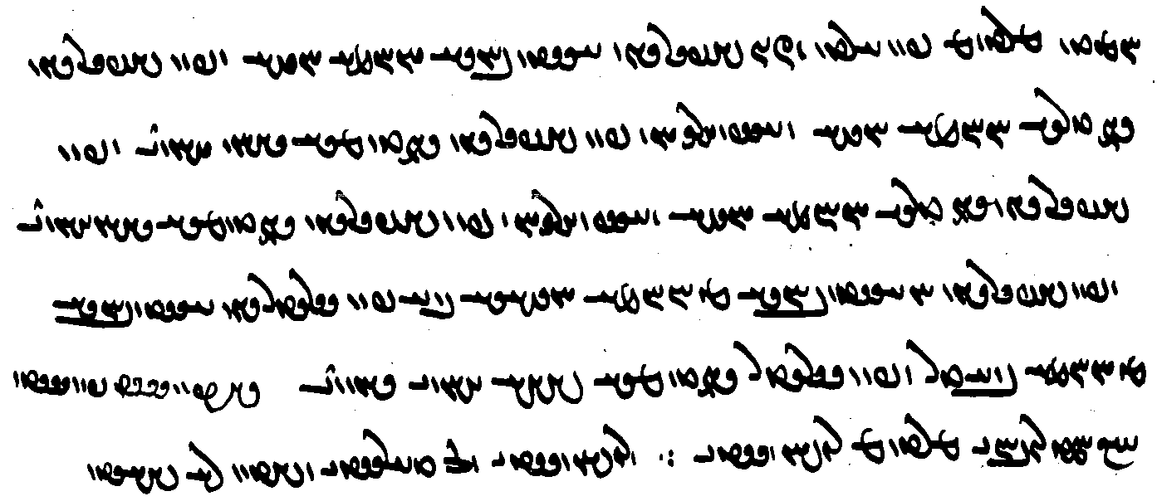
[passox] hād mardōm pad xrad wizīn weh-dēn āstawānīh Ohrmazd xwēš
ud pad weh-dēn andartarīh Ohrmazd xwēš wāspuhragān
pad weh-dēn andartomīh yazdān hāwand
ud pad weh-dēn anāstawānīh az Ohrmazd xwēšīh bē
pad wattar dēn āstawānīh az Ohrmazd bētar
ud pad wattar (dēn) andartomīh dēw hāwand bawēnd
[Answer] Yes, people belong to Ohrmazd by having faith in the Good Dēn by the choice (inspired) by (their) wisdom.
And (they) belong to Ohrmazd in particular by being more inside the Good Dēn.
By being most inside the Good Dēn, they are equal to the gods.
And they are outside belonging to Ohrmazd by not having faith in the Good Dēn.
And they are more outside Ohrmazd by having faith in the Worse (Dēn).
And by being most inside the Worse (Dēn), they are equal to the demons.

MHD.J.3-5

ud ān ī guft kū
ka pad zamīg ī-š ō Farrox ud āb ī-š ō Mihrēn pad handarz dād āsyāb kerd āsyāb pad handarz bē nē rasēd ∵ o ∵
abāg ān ī guft kū
ka pad handarz kerd kū dastīg ī man xwēš Farrox xwēš
abām ī-š andar ān-ēw pad kasān dād bawēd
ān ī pas pad abām bē dahēd pad handarz bē nē rasēd ∵ o ∵
ud ān ī guft kū
ka gōwēd kū xwāstag (ī) ō man rasēd tō xwēš
bar ī bun ī az xwāstag ī-š nūn xwēš w bawēd pad pas mad dārišn bē šawēd ∵ o ∵

abar ul-uzišnīh Ohrmazd ō petyārag ī gēhān dēn wānīdan hangām az nigēz ī weh-dēn ...
ēn hangāmīhā andar weh-dēn guft estēd ud andar anīy darag kē ham-ǰuxt abrāz nišēb hangām dēn mazdēsn paydāgēnīd
“about the moment of Ohrmazd’s rising up to vanquish the adversity against the Dēn of the world from the teaching of the Good Dēn ...
these moments are said in the Good Dēn and in other chapters in which are made manifest the time of the connected declivity and acclivity of the Mazdean Dēn” (Dk.368)

Lesson 21

Grammar 21

Subordinating conjunctions

agar (WtÅ HT') “if”
čē (nM ME) “because”
čiyōn ($$) “because”
ka (tÂA AMT) “when”
kū (à AYK) “that, than, where”
tā (YW , Y>W OD) “so that”
ma agar (WtÅ oA AL HT') “unless; lest (with verbs of fearing)”

ma agar az ēn hād kū agar ēw-bār ō ahlāyīh taft ham hagriz bē nē absard ham “unless it is for this reason: If once I became incensed for Righteousness, I never cooled off” (Dk.6D.10)
Ardašīr tarsīd kū ma agar mardōm ī deh wenēnd ud šnāsēnd ud griftār kunēnd “Ardashir was afraid that the people of the village might see, recognize, and (capture (them)” (KN)

kū ma pad wēš-zīyišnīh pad tuhīgīh ī az pahlomīh wināhād rasād ō wattom rāyēnišnīh ī ast druwandīh
(Dk.3.106.4)

The conjunctions ēg, ka, and kū commonly take enclitic pronouns:

ēg-im (MwsA), ka-t (TtÂA), kū-š (Íà), etc.

čiyōn ka:
dīd čiyōn ka xwaršēd az sar ī Sāsān bē tāft

Nominal—“that”—clauses
Note: kū is the most common Pahlavi conjunction and in addition to its local meanings has the very general meaning of “that,” “because,” and “so/in order that”; it also introduces explanations: “namely, that is.”

kū “that”:
čiyōn dēn gōwēd kū
ēn-iz guft kū
mowbedān mowbed ka-š dīd kū ... “when the supreme mowbed saw that ...”
u-š bē--z nigerīd kū
Pābag nē dānist kū
u-š čim ēn kū

ka dānēd kū kū ka-iz nē dānēd “When he knows where (it is) and when he does not know” (Dk.8.19.60)

bīm ī az ān rāy kū agar-išān frazendān sidōš nē framāyēnd “for fear that, if the children do not order a sidōš for them” (DD.80.8)

pad ān kū
ruwān ka ō ham rasēnd ān ī ōy ī nēk dastwar ī ruwān-dōst ruwān burzēnd pad ān kū-š nē rēšēnēd ud az dōšox pād
Dk.9.20.1

agar “whether”:
frōd ward šnāsam agar tō hē Spandarmad “come down (so) I may know whether you are Spandarmad”

Adverbial clauses of reason and cause

čē “because, for”:

čē Ohrmazd harw 2 ast mēnōy
u-š dād ō hayārīh ī āsmān urwāhmenīh čē-š urwāhmenīh padiš frāz brēhēnīd čē nūn-iz andar gumēzagīh dām pad urwāhmenīh andar estēd
ēd rāy star ī agumēzagīh xwānīhēd čē ka petyārag abar <mad> awēšān nē gumēxt hēnd
nazdist ō Harburz ī Baγbaxt pas abārīg kōfān mayān ī zamīg čē čiyōn Hariburz frāz waxšīd harwisp kōf ō rawišn estād hēnd čē hamāg az rēšag ī Hariburz frāz waxšīd hēnd
u-š dād ō hayārīh āb ud urwar čē-š andar gumēzišn zōr ud waxšišn az ēn bawēd

(az) ān čiyōn “for the reason that”
Pābag az ān čiyōn Ardawān meh kāmgārtar būd ǰud kerdan ud ān framān bē spōxtan nē šāyīd
didīgar ardīg āb kerd az ān čiyōn Tištar stārag pad karzang ī ābīg pad xwurdag ī hazrag xwānēnd ǰānān būd (Bd)
u-m ān čiyōn ul ō ān hōm nē handāzēd ān wan brīnišn (Dk)
az ān čiyōn Tištar stārag pad karzang ī ābīg pad xwurdag ī hazrag xwānēnd ǰānān būd. andar ham rōz ka ēbgad andar dwārist abāz ō āspārag pad kust ī xwarofrān abar ō paydāgīh āmad “” (Bd.6.7)
ham čiyōn gāw ī ēk-dād bē widerd az ān čiyōn-iš čihr ī urwarīg dāšt 50 ud 7 sardag jōrdāg 12 sardag urwar ī bēšaz az hannām hannām waxšīd hēnd (WZ.3.43)

pad ān ī “in that”
ān ī tanōmand bē wizārdan ī az mēnōyān yazdān pad ān ī mēnōyān-iz yazdān xwadāy
bē nē tanōmand hēnd (Dk.3.174.4)
ēd ī pad oxīh ǰud az gōspand pad ān ī gōspand-iz tanōmand nē oxōmand (Dk.3.209.8)

DD.23.2

čārag xwāhēd ī ān frazend andar aškamb margēnēd (DD.77.7)

az ān čē

az ān ī

ān abarwēzīh ud abar-ōzīh ī tištar abar dēw az ān ī xwēš meh-farroxīh ud az ān ī-š nērōgēnēd dādār ud ān ī-š hayārēnēnd amahrspandān (DD.92.13)

Adverbial clauses of purpose and result

kū

tā
hil- tā ...

kū tā “so that, in order that”:

pēš čašm mālīd kū tā-š az zanišn bazzag wizend ... kem bawēd
pad ēn kū tā
(GAb.50) $$

(9.7.9) ud ēn-iz kū ān ī tān xwarišn xwarē kū arzānīgīhā ∴
(9.7.10) ud kū-t xward sabuk bawād mā sangīg āy kū ka-t xward kirbag *kunēnd ud az wināh pahrēz ∴
(9.7.9) And this, too, you should eat that food, i.e. valuable ones.
(9.7.10) And so that you eat/ate it should be (done) lightly, (it should) not be a heavy one, so that, when it is eaten by you, they will do a good deed and there will be abstinence from sin.

ruwān ka ō ham rasēnd ān ī ōy ī nēk dastwar ī ruwān-dōst ruwān burzēnd pad ān kū-š nē rēšēnēd ud az dōšox pād (DK.9.20.1)

ud kū-t xward sabuk bawād mā sangīg āy kū ka-t xward kirbag *kunēnd ud az wināh pahrēz (Dk. 9.7.10)

Adverbial clauses of result

Subordinate clauses introduced by ī and kū
The relative particle is occasionally used where we might expect kū, most often in clauses of comparison, but sometimes elsewhere:

ōwōn (...) ī, ēdōn (...) ī

harw 2 ō nizārīh ōwōn rasēd (ī) az zīndagīh bē-ayās ō margīh frāz-ayās bawēnd

ōwōn wašt bawēd ī-šān ārzōgīhēd kū kāč nē zād būd-ēnd

andar mardōm ōwōn ī āzādag-iz abāg abartar-hunarīh az āhōg nē pāk ud wēs-iz abāg grāyīd-āhōgīh az hunar nē tuhīg “among men, in the same way that even the noble, in spite of (their) superior good qualities, are not free from sin, (thus) lowly persons, in spite of deteriorating in sinfulness, are not devoid of good qualities” (Dk.3.212.9)

ka māh ābān ī yazišnīg rōz xwar šnūman ī rōz ud māhīgān ēdōn ī-š padisār

u-š pahnāy ēdōn kunišn ī-š ēk ēk andar bē estēd “$$” (PV.17.8B)

ka ō bālišn ēdōn nišīnēd ī-š bōb ud bālišn harw 2 andar dārišn ā šādurwān pad tan-ēw rēman “when she sits down on the pillow in such a way that the cover blanket and the pillow were being ‘held’, then the bed covering alone becomes polluted” (ŠnŠ.3.3)

ōy ī framūdār az ān čiyōn-iš menišnīg-kerbagīh ēdōn ōstīgān ī-š xwāstag dād “the one who ordered the service, because his mental good deed was so firm that he paid the money, ...” (DD.81.3)

ēdōn handāxt kū-šān pad xān-ēw tōšag ēdōn hanzaft ī-šān tis-iz tis nē būd “$$” (Dk.6D.2)

kadag-xwadāy ka frāz az-iš xwāstag ō zan ud frazend ēdōn dahēd ī ka-šān pad abarmānd rasē ēg-išān ēdōn bawē ayāb-išān pad bahr dahēd xwāstag-dār bawēnd
“if a master of the house wills property to his wife and childred in such a way that, if it would come to them as inheritane, then it would be theirs in this way, or he wills it to them as their shares, (in either case) they become the holders of property” $$ (MHD. 41.10)

agar ēdōn kunīhēd ī ābustanīh nē bawēd
“if it is done so that there will be no pregnancy” (DD.77.13)

hamē ka dādwarān ēdōn gōwēnd ī-š gugāhīh frāz padīrēnd
“as long as the judges say thus that they accept his testimony” (RAF.61.2)

tō Ohrmazd ātaxš stān u-š pad warahrānīh andar mān nišān ēdōn ī-š amāh hayārōmandīh ōh kunam
(PR.18d.19)

az dōšox ī tārīk ī duš-wahāg rastan ēdōn šāyēd ī ka ka mēnōy ī xrad pad puštībānagīh gīrēnd ... pad ēn ēwēnāg az ... dōšox ī duš-wahāg bōxtan šāyēd
“escaping from the dark and dismal hell is possible in this way that, when they take the heavenly wisdom as support and helper, in this manner it is possible to escape from the dark and dismal hell” (MX.42.5-14)

and ... ī
čē-šān kāmag spitāmān zarduxšt awēšān ī widurdagān ruwān ān ī and husrawīh ud nāmagānīh ī pad gētīy
“$$” (RAF.75.7 [A. 5])

Other:

pad ān homānāg guft estēd ī čiyōn ka az ātaxš suxrīh ul hanǰīhēd (DD.22.2)

čim ī 3-bazišnīh ī dēn-*ōšmurišn nigēz ast ī wisp dānišn kār ud ēwēnag ī ham dēn dānišn ud kunišn ēd ī 3 ī nibišt
“The reason for the tri-partite exposition division of the ‘enumeration of the Dēn’ is that all knowledge, work, and manner of said knowledge of and action according to the Dēn are these three written (here)” (Dk.8.1.6)

Note also

az ān gyāg garzišn ud wāng ān āmad ī ī-m pad ēd dāšt kū haft kišwar zamīg čandēnd “from that place there came such (ān) complaining and howling that I thought the earth and its seven continents were shaking” (AWN.53.2)

harw čē “the -er ... the -er”
harw čē gušn meh mādag bar weh dahēd “the greater the male, the better fruit does the female conceive”
harw čē pāktar ud an-āhōgtar ēg-iš wāng xwaštar “the purer (metal cup is) and un-defiled, then the more pleasant its sound” (Dk.6.90)

Phraseology

Expressions of Size
On -masāy, -drahnāy, -pahnāy, see Lesson $$.

hambāstag $$

Expressions of quantity
For expressions with handāzag “measure,” see Lesson 18.

abēr lYcÅ <’p̄yl> “very”
abēragānīhā aåÅwAklYcÅ <’p̄ylk’nyh’> “in great quantity”
abērtar Lt¬YcÅ <’p̄yltl> “mostly, predominantly”

abēr “very”:
ka zamān ī zādan frāz mad aziš pus ī abēr abāyišnīg zād
“when the time for the birth came, a very handsome some was born from her” (KN.9)

nazdist āsmān dād rōšn paydāg ī abēr dūr-kanārag xāyag-dēs
“first he established the sky, bright, visible, with its borders very far away, in the shape of an egg” (Bd.1A.6)

u-šān gāh ud nišast abēr rōšn ud burz ud purr-xwarrah būd
“and their thrones and seats were very bright and tall and full of glory” (AWN.7.2)

With comparatives:

pad masādar mard afsōs ma kun čē tō-iz abēr masādar bawē
“Do not make fun of an older man, for you too will be much older!” (Handarz ī Anōšag-Ruwan Ādurbād Mārspandān 56)

pas abē-gumānīhā hunsand būdan čē pad tan ud ruwān abēr sūdīmandtar
“next: to be satisfied being without doubt, for it is much more profitable for body and soul” (Dārūg ī Hunsandīh 8)

ēk ēn kū pad ēn kār ī abēr *tuxšāgtar būdan
“one (thing is) this: to be much more diligent in this work” (WD.95.1)

Distinguish compounds with abēr as in NM.2.8.5 bē-m ... abēr-kāmagtar “I much more wish ...”

abērtar “mostly, predominantly, most of all”:
muhrag ī suxr kē dārēd harw gyāg abāyišnīg bawēd abērtar pad hanǰaman ī hamēmālān
“he who has a red precious stone, will be attractive everywhere, most of all in the gathering of his peers” (PR.64.24)

ēn-iz gōwam kū awēšān wēnišn ōwōn tēz kū ān ī arγandtom dōšox ōwōn wēnēnd
čiyōn mard-ēw kē čašm abēr wēnāg andar ēwēnag nigerē tan ī xwēš wēnē awēšān-iz weh abērtar wēnēnd
ADW.20-22 > Texts

abēragānīhā “in great quantity”:
kas-iz nēst kē rādīh ōwōn weh ud abēragānīhā ud bowandag kunēd čiyōn Tištar
“there is nobody who exercises generosity so well, in such great quantity, and so balanced as Tištar” (Dk.6.75)

amaragīhā aåDklmA <’mlkyh’> “in great numbers”
amaragānīhā aåDwAklmA <’mlk’nyh’> “commonly, universally”

a-maragīhā mardōm namāz-barišnīh ō yazd frēzwānīgtar dārēnd
“people, in great numbers, regard paying homage to god is a greater obligation” (DD.38.7)

and (... čand) YwA <’nd > “so much ... (as)”
and-čand(... čand) YWcDwA , YWC YwA <’nd-cnd> “as much as”
čand YWC <cnd> “(quite) a few; as much as”
ēw-čand, ē-čand YWcdA <’y-cnd , HD-cnd > “some, a few”

and (... čand) YwA <’nd > “so much ... (as)”
and-čand(... čand) YWcDwA , YWC YwA <’nd-cnd> “as much as”
and-ēw Dk. 7.1.43
andak WIwA <’ndk'> “a little”
čand YWC <cnd> “(quite) a few; as much as”
čāndtom (PV.4.2)
ēw-čand, ē-čand YWcdA <’y-cnd , HD-cnd > “some, a few”

Use of And and čand

Combinations with and and čand:

ēn-and, ēd-and “this much/many”
ān-and “that much/many”
ān-and ... čand “(x times) as much/many ... as”
ham-and ... čand “just as much/many ... as”
andak andak “little by little”
čand-ēw “several, a few”
ēw-čand “a little, a few, some”

gyāg-ēw frāz mad ham u-m dīd ruwān ī mardōm ēw-čand kē pad ham estād hēnd “I came to a place, and I saw some people who stood together” (AWN.6.1)

and čand (YWC YwA, YWcDwA <’nd-cnd>) “as/so much/many as,” and ... čand “as/so (much/many) ... as”

harw čand “however much”

Examples:

and “so much”:
az and sāl “for/since so many years”

ēn-and anāgīh ud saxtīh ō ruwān ī widerdagān ī ašmāh rasēd
“this much evil and hardship comes over the soul of your departed ones” (AWN.16.7)

ēd-and warz ud abdīh ō awēšān az-iš paydāg
“these many marvels and wonders were revealed to them from it” (Dk.7.6.14)

ud ō gētīyīgān bē gōw kū ašmāh ka pad gētīy šēwan mōyag ud grīyistan adādīhā ma kunēd
čē ēn-and anāgīh ud saxtīh ō ruwān ī widerdagān ī ašmāh rasēd
“and say to those in the world of the living: when you (are) in the world, do not wail, sob, and weep (lit.: do wailing, sobbing, and weeping)!
for this much evil and hardship comes upon the soul(s) of your departed” (AWN.16.7)

ān(-)and gyāg:
ān kē hixr murdagān abar rasīd ān and gyāg bē brīnišn abārīg pāk
“(as for) that (garment) onto which hixr (from) dead things has come, so much area (as the hixr covers) should be cut out, the rest is clean” (PV.7.12B)

ka rāst nišast estēd bē mīrēd ka-š az kust-ēw ōbastan bīm ān kust-ēw
ud ka az harw čahār kust bīm pad harw čahār kust frōd barēd
ud ka bē ōbast ān and gyāg čand ōbast frōd barēd
“when somebody is sitting and dies, when there is fear of his falling to one side, then that one side (is polluted by the corpse demon);
and when there is fear on all four sides, (then the pollution) ‘carries down’ on all four sides;
and when he has fallen, it ‘carries down’ that much area as he has fallen (upon)” (ŠnŠ.2.24)

ŠnŠ.2.33-24
ka garzag-ēw andar xumb-ēw kē may andar harw 2 a-kār ud rēman čē paywēšag kunēd
ud ka ǰōrdāy andar ā xumb rēman ud ǰōrdāy pāk
ud ka andarrōn ī xumb hambun-iz abāz ō xumb nē estēd
ǰōrdāy ān and gyāg čand garzag šēbēnīd [M51_65/158] mālišn ī garzag abar šud estēd
ay mālišn ī garzag šusr ast ān [K20_55r/107] mālišn bē stānišn bē abganišn

ŠnŠ.2.36
xišt ud xāk ud čārōg pad tis ī xwēš ǰud-kardag ud abāg zamīg ēw-kardag
ud pad tis ī xwēš ǰud-kardag būdan ēd kū ān and gyāg čand nasāy abar rasēd rēman
abāg zamīg ēw-kardag būdan ēd kū rēmanīh tā ō āb frōd barēd

ŠnŠ.2.16
ka sang abāg zamīg ast ī ēw-kardag ud ast ī ǰud-kardag ud abar bē mīrēd
sang ān-and gyāg čand nasāy abar mad rēman
ka-š bē hilēnd pad sāl drahnāy abāg zamīg pāk bē bawēd
ud ka bē kanēnd sang hamāg rēman andar zamān ōh šōyišn o
ka sang abāg zamīg nē grift estēd azabar zamīg sang hamāg rēman
andar zamān ōh šōyišn

and and “however much/many”
and and meh ōh bawēd pad čē-š xwēš paymānag
“however great (the fish normally is), so it becomes, according to that which it is measure” (Bd.15A.7)

and (...) ī “as much as, so much ... that”
and ī dānistan šāyēd
“as much as it is possible to know” (REA.17.11)

ud and xwarišn-iz ī may xward rāy pad menišn ud gōwišn kunišn frārōntar bawēd ayāb abārōntar nē bawēd
“and he should also drink so much (wine) that, because of drinking wine, he becomes a better person in thought, word, and deeds, or (at least) not becomes a worse person” (DD.50.5)

u-š and murw-māhīg ī xrafstar-xwār bē dād estēd ī agar nē ān rāy būd hē ēg xrafstar ī was kē būd hē hamāg mardōm pad wiš ud zahr tabāh būd hē
(ZFJ.664)

čand “how much/many?”:
Zarduxšt az Ohrmazd pursīd kū mihrdrōz čand ēwēnag ast
“Zarduxšt asked Ohrmazd: how many kinds of Contract-cheaters are there?” (PR.6.1)

Zarduxšt az Ohrmazd pursīd kū čand zamān abāz ō fraškerd-kerdārīh bawēd ud tan ī pasēn
“Zarduxšt asked Ohrmazd: how much time is there left till the Renovation and the Final Body?” (PR.25.1)

čand “as much as”:
az awēšān stāragān ān ī meh čand sang-ēw ī kadag-masāy ... ān ī keh čand sar ī gāw ī kadagīg
“of those stars the largest is a big as a stone the size of a house ... the smallest is as large as the head of a domestic cow” (Bd.2.16)

māh čand asprēs-ēw ī 2 hāsar
“the moon is as large as a two-mile race-course” (Bd.2.16)

Gōšurūn čiyōn ruwān ī gāw ī ēk-dād az tan ī gāw bērōn āmad pēš gāw bē estād čand 1000 mard ka pad ēk bār wāng dārēnd ō Ohrmazd garzīd
“Gōšurūn, that is the soul of the single-created bull, came out of the body of the bull, stood before the bull, and comlained to Ohrmazd as much (loudly) as when 1000 men shout at the same time” (Bd.4A.2)

ud wināh wizārišn rāy čand weh šāyēd kerbag warzīdan
“and to perform good deeds as well as one can in order to resolve (make up for) sins” (MX.52.9)

čand “some, several”:
ud čand dastwar ud dādwar ud hērbed ud mowbed ud dēn-burdār ud dānāg ī Ērān-šahr kušt hēnd
“and several religious leaders, judges, hērbeds, mowbeds, religious officials, and (other) learned men in Iran were killed”

čand-ēw sāl yašt nē kunēnd
“for several years they perform no sacrifices”

ēw-čand “a few, some”
ānōh wēnēm ruwān ī mardōm ēw-čand kē pad ham estād hēnd
“there I see several human souls, who stand together”

ka sāl ēw-čand būd kanīzag ō dād ī zanān mad
“when there had been a few years, the girl came to the age of women”

sāl-ēw čand dušpādixšāyīh kunēd
“he will exercise his evil rule for some years” (Bd.33.25)

harw čand (+ comparative) “the -er ... the -er”:

3 hend kē harw čand abar rawēnd xwārtar hammōzišn frahang ī abēsūd ud wad ud mardōm wad ud rāh tārīk bīmgen
“three are (the things) which, the more one undertakes them, (the) meaner (they become): useless and bad education, bad people, and dark and frightening roads” (Ōšnar.29)

harw čand wēš pursē nēktar ud rōšntar pad-čimīgtar wizārēd
“however much more you ask, the better, more clearly, and more reasonably he will explain it”
(GA.11.1)

dōst kahwan dōst ī nōg kun
čē dōst kahwan ōwōn homānāg čiyōn may kahwan
ka harw čand kahwantar pad xwarišn ī šahryārān wēš weh ud sazāgtar šāyēd
(AAM.101)

and čand “as/so (much/many) as”:
xwaršēd and čand Ērānwēz
“the sun is as big as Ērānwēz”

xwarišn ud mizag hazār ān-and čand ān ī nūn ast bawēd
“food and taste will be a thousand (times) as much as what it is now” (PR.48.59)

u-š pas az maγ ī pad gōmēz and bē nišīnišn čand 4 angust
“and after the hole with gōmēz, he should sit as much as 4 finger-breadths(?)” (ZFJ.628)

and-čand dānišn az hamīh ī rāmišn ōh kāhēd ān-and <lyt>īh rāmišn brādarōd abar rāmišn ōh *čērīhēd
“as much as knowledge decreases in this way from togetherness with happiness, so much will ...—which is happiness’ rival—become victorious over happiness” (Dk.3.64)

RAF.67. pursišn
67.1 mard ēw kē 200 drahm az mard ēw bē abāyēd stad ud ān [357/180b] mard gōwēd kū-m nēst u-m dādan nē tuwān
ud mērag gōwēd kū-š ast ud framān dah tā xānag bē wizōhēm
ud nēm ādānīh ī-š ast and-čand ī pad ān abām arzēd ēg ul stad pādixšāy ayāb nē
passox
67.2 mard kē abām az mard abāyēd stad bē pad framān ud wizīr ī dastwarān tā pad xwāstag ī xwēš az xwāstag ī mērag stad nē pādixšāy
ka barēd duzz bēd ayāb appar ∵
67.3 dādwarān wizīr ōwōn kunišn kū xwāstag az ēn ī pad xānag ī mērag bē ka-š tis and pad mērag bē hilēd kū-š az bar tā bar az margīh ud rištagīh bīm nēst tā pad stad ud burdan wizīr ⎡ nē pādixšāy pad-iš kerdan ⎤

ham-čand “just as much”

gēhān ham-čand ēn bawēd ayāb wēštar ud frāxtar bawēd
“will the world of the living be just as much as this (world), or will it be more and wider?” (DD.36.1)

Wazurg-mihr did-iz ham čand ān sāg ud bāǰ az <yyp̄yy’lm> stad
ud pad nēk ǰahišn wazurg abrang abāz ō Ērān šahr āmad
(WČ.36)

and ... čand “as/so (much/many) ... as”

u-š pahnā ud bālā rāst. u-š zahyā ī fragān ān and ast čand pahnā ī tuhīgīh
“and its (heaven’s) width and height were the same, and its depth to the foundation was as much as the width of the emptiness (empty space)” (PR.)

Ohrmazd ēn zamīg dō and drahnā ud pahnā čand ān ī nūn ast bē kunēd
“Ohrmazd makes this earth twice as much in length and width as what it is now”

ka pad gētīy šēwan mōyag ud grīstan adādīhā ma kunēd čē ēn-and anāgīh ud saxtīh ō ruwān ī widerdagān ī ašmāh rasēd
“when you (are) in the world, do not wail, sob, and weep (lit.: do wailing, sobbing, and weeping), thus breaking the law! for this much evil and hardship comes upon the soul(s) of your departed”

u-m dīd ān ī druwandān ruwān ka-šān andar ān 3 šab ī naxust and anāgīh ud wattarīh ō ruwān nimūd kē-šān hagriz pad gētīy čand ān saxtīh nē dīd estād
“and I saw the souls of the wicked as they showed their souls during those three first nights as much evil and badness that they had never seen in the world as much as that hadship” (AWN.17.2)

X ān-and ... čand “x times as much/many ... as,” čand ... ān-and “as much (as) ... so much”:

2 ān-and hāsr čand tačar
“a hāsr is twice as much as a tačar (race course?)” (FO.27a.742)

u-š ēn gēhān pad 3 bār ān-and bē kerd ...
ēn kū-š čiyōn kerd ā-m nē rōšnag
“and he (J̌am) made this world by three times as much (as it was before); as for how he did it, it is not clear to me” (PV.2.19C)

hōy šnūg ī ōy abar āšinǰēš azabar ēdōn čiyōn gašt estēd azēr bārīk
ast kē ēdōn gōwēd ay čand azabar ān-and azēr
(PV.9.23a)

ham-and ... čand “just as much as”
u-šān abām ī pēš az ān ī ka-š xwāstag bē dād stadan wizārišn u-šān ham-and wizārišn čand xwāstag dārēd
“... and they must resolve (any) debt (the testator) incurred before he gave (them) the property, and they must resolve exactly as much property as he has” (MHD. 41.11)

čand ... and
Word order imitating Avestan:

čand xwāstār ud tuwānīg ham ān-and hammōxtam xwāyišn ī ahlāyīh kār ud kerbag
“as much as I am seeking and have the strength, that much I learn the seeking of Righteousness, (i.e.) work and good deeds” (PY.28.4c)

čand + comparative/superlative “the ...-er the ...-er,” “as much as possible”:
This phrase often includes šāyēd “is possible,” e.g.:

čand wad-āmēzišnīh wēš wād ī bazag stahmagtar
“the greater the admixture of evil, the more violent the evil wind” (Bd.21e.9)

čand wēš wēnīhēd tō pad-iš stāyišnīgtar hē
“the more it (Ohrmazd’s wisdom) is seen, the more praiseworthy are you thereby” (StS.23.2)

čand dāšn purrtar dahīhēd kerbag meh-sūdīh wēš
“the more fully a gift is given, the greater the superior benefit of the good deed” (DD.84.2)

ud agar ka-š wēmārīh-ēw padiš wasān biziškān nigerīd dānāgān passandēnd čand abērtar pad yōǰdahrēnīdan ī az ōwōn wizendīg Nasuš dīd nē āhōg
“and if, when many doctors have noticed an illness on her, those knowledgable agree, (then there is) all the more no blemish (attached to a man) seeing in order to purify (her) from such a harmful Nasuš” (Dk.5.24.22) (about inspecting the genitals of a woman who has had a stillbirth)

ud wināh wizārišn rāy čand weh šāyēd kerbag warzīdan
“and in order to ‘resolve’ a sin, one is to do good dees as best as possible” (MX.52.9)

pad im rāh ān ī widardān tan čand awināhīhātar šāyēd drīstīhā pāyišn
“in this way, the bodies should be kept properly as little exposed to sin as possible” (DD.16.4)

ud ān ī and abzār ī az hamist weh-dahišnān čand abēzagīhātar šāyēd bē ō burdan rāy nērōgēnāg “and those so many (= all those) tools together with the good creations, (keeping) them as pure as possible, give the strength to remove (evil)” (DD.47.37)

mard kē kaygīh ud karbīh andar nēst ēg čand xwadāytom weh
“a man in whom there is nothing of a kayg or karg, the more he is lord, the better” (Dk.6.157)

mard čand wēšist ō mān ī ātaxšān šawišn
“going to the fire temple as much as possible” (ŠnŠSup.20.1=Dk.6.301)

ēk ēn kē arz ud spās ud ābādīh ī wehān čand bowandag menēd ud gōwēd
“one (other thing is) this: he who thinks and speaks gratitude to the good people and wishes them well as completely as possible” (Dk.6.302)

pad čand ... šāyēd ‘to the degree it is possible’$$
pahlom rāyēnišnīh ī mardōm pad čand andar gumēzagīh šāyēd spurr-wēnīh ī-š āsnxrad
(Dk.3.106.2)

ōy kē pad čand mardōm ō yazd mānāgīhistan šāyēd: yazd mānāg dānāg xwadāy mard ī ahlaw
“(as for) he who, to the degree a person can be likened to a god: a knowledgeable king (and) Righteous man is like a god” (Dk.3.126.5)

čē’īh, čiyōnīh, čandīh

abar gētīy čē’īh ud ō-čē-dahišnīh
“about what this world is and for what it was established” (Dk.3.123.1)

u-šān čiyōnīh ēk ēk frāztar gōwam
“and I shall say how they are, individually, later” (Bd.1a.29)

pad kay’īh kū’īh čandīh ud čiyōnīh
“with respect to when, where, how much/many, and how” (DD.36.14b)

frahīd, -ān WtdaåÒP <pl’hyt'> “many, numerous, very”
frahīdag WKtdaåÒP <pl’hytk'> “many, numerous, very”
frāyīhā aådaåÒP <pl’’yh’> “greatly, by far”
frayistān WwAtjaÒP <pl’st’n'> “mostly, for the most part”
frayistīhā aåDtjaÒP <pl’styh’> “mostly, for the most part”

ēn ī ōšmurd nihang-ēw ī az was ud frahīd tis ī az Abestāg pad bawēd-rasišn pas az Wištāsp tā hanǰābišn ī Ērān xwadāyīh az Ērān šahr paydāg
“this that has been enumerated is (but) a small part of the many and numerous things from the Avesta (that are) manifest about what came to pass after Wištāsp until the coming to en end of the kingship of the Iranians in the land of the Iranians” (Dk.7.7.38)

ud ēdōn-iz sag ī pasušhorw ... ī mēnōyīhā druz ī Nasuš ud abārīg was ud frahīd dēw ud druz ǰādūg gētīyīhā hamē zanēnd
“and thus also the shepherd dog (and ....) which the Nasuš and the other many and numerous demons and lie-demons in the other world (and) sorcerers in this world strike” (ZFJ, p. 664)

u-š kirrēnīd ō abārīg-iz ēwēnag ēwēnag dāmān petyāragīh frahīdān dēwān ud druzān
“and he whittled forth numerous dēws and druzes as opposition to the other various kinds of creatures”

grōh-ēw 1aÅwlY <glw’h-1> “one group, some”

grōh-ēw ham Mašīhā rāy gōwēnd kū murd ud grōh-ēw gōwēnd kū nē murd
“one group say about said Messiah that he died, and one group say he did not die” (DD.36.77)

hamāg, hāmāg WkaÂaÅ , WkaÂA <hm’k', h’m’k'> “all, entire, whole”
hamāgīhā “altogether, completely”
hāmōyēn WwïDnaÅ <h’mwdyn'> “all, in its entirety”

ud pas pad-iz ān ī frāz-tazāg āb ī yōǰdahr hamāgīhā tan šustan
“and afterward, (one is) to wash the body all over with clear running water” (DD.47.9)

ōwōn zōr andar zēn-abzār ī yazdān kū ān-iz ī fradom tam tār ī andar gēhān pad hambun-iz zōr-ēw ī xwaršēd spīzišn hamāgīhā ānābīhēd gēhān rōšnīhēd
“(there is) such a power in the armor of the gods that even the first darkness in the world is altogether removed by any single power at all of the shine of the sun (so that) the world is made light” (DD.36.71)

Astwihād hāmōyēn dām ōbārēd ud sagrīh nē dānēd
“Astwihād swallows the entire creation and knows no satiety”

abēzagān yazdān hamāg pahlom hēnd pad a-mōšišnīh ī az xwēškārīh
“the pure gods are the best of all in that they do not deviate from (their) proper duties” (Dk.3.371.6)

ēk abdīh ī xwad Abestāg ī pad hamāg-pahlom-ēwāzīh gēhān hangerdīgīh ī wisp-dānāgīh gōwišnān abartom
“one wonder is the Avesta itself, which by (their) speech being the best of all is the supreme utterance of every knowledge of the entire world” (Dk.7.5.11)

harw, -īn AWK <KRA> “every, all”
harw ... -ēw 1 ... AWK <KRA ... -1> “each and every”
harw kas ßÄ AWK , ßáÅWK <KRA[-]AYŠ> “everybody”
harw čē nM AWK <KRA ME> “everything”
harw ēk WKwïÅ AWK <KRA ’ywk'> “each”
harw dō (dō’ān/dō’īn) (WwY2 /WwA2) 2 AWK <KRA 2> “both”
harw kē “whoever”
harw čē “whatever”
harw čiyōn “however”
harw čand “however much” (see above)

petītīgīh hamē ka kunēnd harw čiyōn kunēnd ud pēš ī harw kē kunēnd hamē ka-š menišnīg hāmbun-iz ast ā-š petītīgīh kerd bawēd
“as long as one performs penance, however one does it and before whoever one does it, when it is in thought for him at all, then he will have performed penance” (ŠnŠ.8.13)

harw čē šāyēd
(RAF.52.1)

harw dō:
xēm xrad andar nēst ud xrad xēm andar ud dēn harw 2 andar xrad ud xēm
“there is no xēm in xrad, and in xrad there is xēm, and in dēn (there are both): xrad and xēm”
(Dk.6.5)

Note the word order in:

čē ān kē pad-dēn dōst ēdar ud ānōh harw 2 abāg
“for he who is a friend in the dēn (is) with (you) both here and yonder” (Dk.6.165)

ēn-iz paydāg kū harw pēšag-ēw ī mardōmān mēnōy-ēw xwēš
“this too is manifest that each and every limb of people belongs to a single entity in the other world” (Bd.28.22)

čē ān tis ī harw kas aziš hamē hušnūd ud čē ān ī kas-iz aziš nē hušnūd
“what is it that everybody is happy with? And what is it that nobody is happy with?” (MX.39.9–10)

wisp WcJW WfJW <wsp'> “every, all”
harwisp, -īn WwYfJwlA , WfJwAWK , WfJwlA <KRA-wsp', hlwsp'> “every, all”
harwist, -īn WwYtJwlA , WtJwlA <hlwst', hlwstyn'>

pad rawāg-garīh ī-š kām ō ōy wisp-weh dōst abēzag-stāyīdār ud abēzag spās-dār būdan
“by propagating his wish (one should) be pure praisers and pure thanks-givers (one should give pure praise and pure thanks) to that friend (who is) the best of all” (DD.2.13d)

wispgen <wsp̄kn'> NM.1.1.3 ?

“Alone” and “many”

ēwāz
ēw-tāg Nir.63.1
ēwīhā NM.1.6.5
tanīhā “alone”
pad tan-ēw
pad sar-ēw (ZFJ.572)

9.6.11 ??

ā-š yašt Mihr ī frāgōyōd ī hazār-goš ī bēwar-čašm
u-š frāgōyōdīh ēd kū ka ēw-tāg pad dašt šāyēd āmad ud šud pad rāh ī Mihr
(Ny.1.15)

ma kas mardōm barād ēw-tāg pad tan ēw ka rist kū murd
(PV.3.14)

“Much” and “little,” “more” and “less”

was, wasān WwaDBK , YBK <KBD, KBD’n'> “much, many, very; enough”
wasīhā aådYBK <KBDyh’> “greatly, in large numbers, to a large degree”
wasyār la∆DW , lA˝JW <wsyk’l, wsy’l> “much”
was-marag WklmYBK <KBDmlk'> “in large numbers”
pad was-maragīh “in large numbers”

wasān parīgān ī tamīgān
wasān zišt frazendān hēnd
pad zamīg homānāgīh ī čašmagīhā ī āb wasān gyāgān čašmag ātaxš ul uzēnd

paydāgīhist wazurg abdīh ō wasān čiyōn dēn gōwēd kū
(Dk.7.2.3)

hammistagān ... gumēzag ast bē anāgīh wasīhā ud frāyīhā wēš az nēkīh (DD.32.3)

ān-iz ī frāz-rōyišn wāstar ud jōrdāg ud dār ud draxt pad wasīh ō hayārīh ī ēn dām ud dahišn ī Ohrmazd
“$$” (StS.5.10)

was “enough”:
Although this is a common use of Perian bas, it is relatively rare in Pahlavi and found especially in the ZFJ, e.g.:
(ZFJ.489, 578, 667)

pad-iz čāštag ī Mēdyōmāhīg guft estēd kū ka ōy kē hamē šōyēd pišag šnāsēd ēg-iš yōǰdahrgar ēk was
And in the teaching of the followers of Mēdyōmān it is said that he who washes frequently(?) and knows the pišag, then one purifier is enough for him.” (NM.1.6.3)

pad was-maragīh “in large numbers”:
Tāzīgān pad was-maragīh ō Ērān šahr dwārist hēnd
“the Tāzīgs in large numbers overran the land of the Iranians” (Bd.33.25)

abzār “much, a lot”
wēš ßYW <wyš> “more, to a greater degree”
wēš ud kam (kem) “more or less”
wēšist WtjßYW <wyšst'> “most(ly)”
*wēšīy WißYW <wyš> more
wēšīgān ShSh Dk.6.23 n. 4.

kam, MK <km> “little, to a small degree”
kem µYK , MK <kym, km> “less, to a lesser degree”
kamist, kemist WtjmYK , WtjMK “least, at least”
kamak WkMK <kmk'> “a little”
*kamīy WiMK
nidom Mwt <nytwm> “least”

u-š aziš paydāgīhēd kū kē abzār ud kē kam ka-š tis andar nēst ī ān rāy ǰuttar
(DD.46.7)

Note word order in:
srišwadag ī rōz ud šab wēš nē xufsam
“a third of the day and night — more I do not sleep (I do not sleep more than a third of the day and night)”
(Ny.5.11b) – for wēš az srišwadag ...

pad wēšīh:
9 nāy drahnāy pad drahnāy ud 3 w pad pahnāy pērāmōn bē ē kanēd
ka pad wēšīh kanēd šāyēd pad kemīh nē šāyēd
“let him dig nine nāy in length and three in width all around;
when he digs it more, it is fine, less is not fine” (ZFJ, p. 622)

pad wēšistīh “at the most, at a maximum”:
ka parahōm xwarēd ā-š esm bōy ēw tāg az kust ī dašn bē nihišn
u-š hōm ud urwarām pad čandīh bē paydāgēnišn
hōm pad kamistīh 3 grih pad wēšistīh 30 grih urwarām andar ān ī pad nēmag
“when he drinks the parāhōm, he should place one twig of firewood and scent one the right side;
and he should advertise the hōm and the plant by (saying) how much:
hōm at a minimum of 3 knots, at a maximum 30 knots, the plant $$” (PNir.28.25)

tā pad baršnūm w šustan ā-š az āb ud ātaxš kamak pahrēzišn
“until washing with the baršnūm, (s)he should stay a little away from water and fire” (ZFJ.538)

pad kamist(īh) “at (the) least, at a minimum”
Cf. pad wēšistīh “at the most, at a maximum,” below.

pad kamist pad xīr ī mēnōy pad ēn and gumān nē bawēd kū harw gōnag tis-ēw ast
“at least he has no doubt regarding mattes of the other world about this much: every kind of thing exists” (Dk.6.241)

abar dād ī Ohrmazd harw ēk az urwarān pad kamistīh ō ēk wēmārīh ānāftārīh
“about how Ohrmazd established each of the plants for removing at least one illness” (Dk.8.37.15)

pad kemistīh NM.1.7.1
$$

kam ud wēš, wēš ud kam/kem “more or less”:

xwaršēd ... harw 3 māh pad 3 axtar wēš ud kam bē rasēd
(Bd.25.26)

ud az ān bē nē pad hāwand dahišnīh ud nē-iz pad wēš- ud kam-dahišnīh harw 2 pad āgenēn hušnud kerdan nē šāyēd
(Dk.3.381.8)

andar myazd ī weh-dēnān kē-š mard 50 ayāb 100 wēš ayāb kam čiyōn ka bawēd andar hēnd ud mard 7 kē-šān pad dēn-kerdārīh kerd estēd abāg awēšān ham-myazd hēnd
(DD.46.1)

pad nidomīh NM.1.7.1
$$

nihang-ēw 1Y<wSW <nsng-1> “a little, a small part”

harw mardōm dānag ī kerbag bē xwāyišn
u-š ka dānag-ēw kerbag pad mayān kerd az ān frāz kerbag was ud wināh nih*ang bawēd
u-šān kerbag dānag ēd guft dēn dastwar ī dānāg ud hamīh ī frārōn ī grift
“every person should seek a grain of good deeds;
and, when he has produced a grain of good deeds, from then on good deeds become much and sins little;
and they said ‘a grain of good deeds’ (is) this: a knowledgeable dastwar and the good company one has taken up” (Dk.6.53)

pad wināh ī kunēnd kūk zīyišn nihang rōz pādifrāh
“for the sins (these people) commit, the punishment is a short life and a small day” (Dk.6.206)

6om abar nihang-ēw ī az pōryōtkēšān kerd ud dāšt wābar gōwišn ī dēn ī mazdēsn
“Sixth: about a little of the true sayings of the Mazdayasnian Dēn made and held by the Teachers of Old” (Dk.6.0b)

tā šāyed “as much as possible, to the extent possible”:
ēk ēn kū zan ka ābestan bawēd tā šāyēd ātaxš xūb-pahrēzīhā andar mān dārišn
“one thing is this: when a woman becomes pregnant should, to the extent possible, keep the fire staying well away from it” (ŠnŠ.10.4)

mar, marag “number”

az ān mar “from that number, among them”
AWN.1.13

Various expressions expressing limitation:

pad nāmčist, pad nāmčišttar (Dk.5.19.6)
gōkān
mādagwar
mādayān
pad hangerdīg
hangerdīgān Dk.3.48.2
wāspuhragān
pad xūb kerdan “for good measure” (RAF.144.2f)
pad dagrandīh “for as long as, over the years” (RAF.145.2)

Expressions with sāmān “limit”:

tā čē sāmānag

ud widurd ōšmār az mar sāmānēnīd DD.36.69b

Expressions of reason and cause

čim kē rāy “the reason why”
abē-čim
az ham bun “for the same reason, from the same cause”
az/pad ān ī “because of the fact that”
(az) ān bahr rāy

ēd rāy “for this reason”
ēd rāy star ī agumēzagīh xwānīhēd “for this reason they are called ‘the unmixed stars’” (Bdh)

pad ān čim “for that reason”
pad ān čim Haftōring xwānīhēd “for that reason it is called Haftōring” (Bdh)

az ēn/ān mar “on that account”
hamāg nēst-tisīh ... bē ō mardōmān az ān mar mad (PR.8a.9)
Bd.9.45, MX.54.5, Dk. 6.71, MHD.4.10, AWN.1.13

pad ēd mar

pad hu-čašmīh mar pad kas-iz nē drōzē
“for the sake of benevolence, do not deceive anybody” (StS.18.3)

ē-mar?
D.5.24.22a

mar āyēd “is counted” (ZFJ, p. 586)

čē rāy “because of which”
Bd.21b.4-5

kē rāy “because of which”
Note: kē rāy can also simply be the relative pronoun + rāy:

kē rāy kunēd nē framāyēd ēg-iš dādestān čē ast
“what is the law for (him) who performs (a ritual, but) does not command (one to be performed)” (DD.79.1)

čē rāy “for what reason, why”
čē rāy xwarrah ī xwēškārīh pad gēhān was ast harw kē ān ī weh warzēd ud kunēd ā-š arz
(Bd.17A.1*)

Note also pad bahr ī xwēš “on his own account, for his own part” (Dk.6.71, 80)

az ān jādag (rāy) “for that reason”
az ān jādag rāy ōš pēštar ud margīh saxttar
“$$” (PT27. Handarz ī Dastwarān ō Weh-Dēnān 35)
az ān jādag ōš pēštar ud margīh saxttar “$$”
(WD.7.4)

Various phrases made by repetition
Repetition of a noun, adjective, or adverb is quite common. The list below is not complete.
On ēwēnag ēwēnag and gōnag gōnag “of various kinds,” see Lesson 17.

andak andak “little by little”:
andak andak hamē raft
“it went forward little by little” (KN.7.1)

ud ēn-iz kū andar gētīy mardōm kē sad sāl bē zīyēd kem kū ān kē sad sāl nē zīyēd
ud zīndagīh andak andak sazīhistan ud hanǰaft zīndagīh zan ud xwāstag <ud> abārīg gētīyīg ādān hamāg pad ēw-bār hištan ud ō anīy kas madan
And this too, that in this world, a person who lives a hundred years is less (rarer) than one who does not live a hundred years,
and that life passes little by little, and, once life is completed, that one leaves wife, property, and the other wordly wealth all of it at once and that it comes to someone else” (Dk.9.16.10) — (note the infinitives listing things)

āwām āwām “in various ages, from age to age”:
ud ristag-kunišn nišānīhā andar āwām āwām ō paydāgīh mad
“and sectarianism appeared in various ages” (Dk.5.3.5)

bāy bāy “repeatedly” (?):
abar zamānag bāy bāy druz ō spenāy-mēnōy dāmān škefttar kōšišn
“about the time of the Lie’s repeatedly fighting the more fiercely against the creations of Spenāg Mēnōy” (Dk.3.407.1)

dast pad dast “continously” (?) (NP. dast be dast):
u-š az dēwān garānīhā dast pad dast rasēd
“and various ‘heavy’ (sins) will continuously come upon him (the apostate) from the demons” (DD.40.4)

ēk ēk “one by one, individually”:
ēn kū gōspandān ud gāwān ud abārīg čahār-pāyān handām ēk ēk kadām yazd xwēš ud ǰud ǰud čiyōn abāyēd yaštan
“(as for) this: to what god does the individual members of sheep, cattle, and other quadrupeds belong and how should one sacrifice (them) individually?” (PR.59.1)

gyāg gyāg “(in/to) different places”:
mardōmān gyāg gyāg bē burd “people carried (the plant) to different places” (PR)
gyāg gyāg frāz burd hēm “I was brought to place after place” (AW)
ēn rōdīhā bun ēk ast ud pad šahr šahr ud gyāg gyāg pad nām nām xwānēnd “these rivers have one origin and are called in various lands and various places by various names (in each land, each place, by each their names)” (Bd.11a.31)

hangām hangām
harw čē škuftag hu-bōy andar warz ī mardōmān hangām hangām bawēd
(Bd.16.13)

tā māh Šahrīwar ī ka ō Šīrāz āmad ham u-m hangām hangām andak ī pardazišn būd u-m ham pursišn nigerīd
(DD.0.15)

huzārag huzārag “little by little”:
huzārag huzārag āhōg ī padiš wišēbīhēd
“little by little, the sins (caused) by it decline” 3.212.10 (see the Texts)$$

ǰār ǰār “every time, time and time again”:
ka xwāstag ī-išān kerd kū kas kē Mihrēn xwēš būd gōwēd xwēš
Mihrēn pad 3 ǰār ǰār ǰār pad 3 bahr ēw bahr Farrox xwēš būd guft
gōwišn harw 2 kār xwāstag hamāg Farrox xwēš
“when a property, (about) which they announced (kerd): ‘the person whom Mihrēn says it belongs to, (to him) it belongs, and Mihrēn has said three times, every time, that one third is to belong to Farrox,’ (then) both statements are valid (kār), (and) the entire property belongs to Farrox” (MHD.H4, Macuch chap. 40)

ēg-im dīd ruwān ī zan-ēw kē uzwān brīd ud čašm kand ... ud ǰār ǰār tan ī xwēš pad dandān grift ud gōšt hamē ǰūd
“then I saw the soul of a woman who cut her toungue and gouged out her eyes ... and, time and time again, she grasped her own body with her teeth and kept chewing the meat” (AWN.81.1)

ǰud ǰud, ǰud-iz ǰud tan “separately, individually”:
was dēw būd hēnd kē-šān ǰud ǰud duškunišnīh ī xwēš gōkānīg ōšmurd
“there were many demons, who enumerated separately in detail their evil-doings” (after Bd.4.3)

andar ān stardīh kamālīgān dēwān ǰud ǰud dawīd hēnd kū abar āxēz pid ī amāh
“during that unconsciousness (of the Evil Spirit), the demons with (demon) heads individually shouted: get up, our Father!” (Bd.4.2)

kadār-iz-ēw mardōm handāzišn ī ō ruwān-bōzišnīh sazēd ...
ǰud-iz ǰud tan dēn-burdārān abērtar pad rawāgīh ud wābarīgānīgīh ud rāst-paywandišnīh ī dēn mazdēsn
“it is proper for each and every person to plan for the salvation of his soul ...
for those bringing the dēn, individually, by propagating, validating, and transmitting it correctly” (Dk.3.54)

kardag kardag “piece by piece”:
ka nasāy ēdōn pūdag ī ka-š ēdōn bē tuwān āwurdan ī ka kardag kardag bē brīnēd ā pas-iz bē brīnēd bē āwarišn
“when the dead thing is (only) so rotted that, when one is able to bring it out in such a way that one cuts it piece by piece (and) then too one cuts it, (then) one should bring it out” (ŠnŠ.2.92)

mayānag mayānagīhā “in the very center”:
urwar pad ān ī mayānag mayānagīhā pahrēz ud dārišn ... čiyōn-iš niyābag
“(for) the plant, being in the very center (of the six creations, there is) care and uphold ... as is fitting for it” (Dk.5.19.25) (the 6 creations: man, beast, metal, earth, water, plants corresponding to the 6 amahrspands)

nē nē “not at all”
nē nē-iz (AZ.42).

nōg nōg “ever anew, again and again”:
Nōg-nōg dēw ān ī nōg nōg az wināh dāmān kunēnd awiš ǰahēnd
“the demon Again-and-again is the one who, from the sins the creatures commit, jumps upon then again and again” (Bd.27.53)

ān ī gōwēnd kū ka mard bē ō wināhgārīh wardēd ēg-iš nōg nōg ōš brēhēnēnd
“(about) that which they say that, when a man turns to committing sins, then they predestine a death for him again and again” (DD.70.2)

wārān (ī) az dādār čim niyāzōmandīh ī gēhān nōg nōg rasišn ī huškīh ō gēhān (rāy?) pad xwēdīh bēšāzēnīdār ud waxšēnīdār
“the reason for the rain from the Creator is, (because?) the drought comes upon living beings again and again, living beings’ need for humidity, which heals and makes grow” (Dk.3.112.2)

pēšag pēšag “limb by limb”:
u-š pas pas ka nē pēšag pēšag bē ēdōn čiyōn zan ī daštān pad gōmēz ud āb bē šōyēd ā-iz šāyēd
“and in every following instance, when one does not wash (the person to be cleansed) by individual limbs, but in the way a menstruant women, with gōmēz and water, then too it is appropriate” (ZFJ.629)

rōz rōz “day by day, daily”
ud tan-iz ud grīw wirāyišn pad ān čihr ī nē rōz rōz abāg paristārīh ōwōn wardišnīg būd sazāgīhā
“and also cultivating (one’s) body and ‘self’ by means of that ‘nature’ which will not change like that day by day with (= according to) the service (one performs, means acting) appropriately” (Dk.5.24.29)

tām tām “very little”:
ka kas xwarišn xwarēd ayāb pad xwarišn ayāb pad dandān dahān brīnēd xōn āyēd tām tām-iz sneh āgāhīh bawēd xwarišn ān ī andar dahān bē abganēd pad ān brīn nasāy šud pādixšāy ka (pad) pišag nē šōyēd
“when someone eats food (and) cuts (his) mouth with the teeth either on the food or with the teeth and blood comes (out), (but) he notices only a very little sore, and he throws out the food that is in the mouth, (then), for that piece of nasāy coming loose (šud), is he authorized not to wash (with) the pišag?” ZFJ (TD2, pp. 670–71)

ēn 3 wāzag wāzag xwadāyān ... bē šnāxtan ... andar abāyēd
“rulers need to know these three individual words” (Dk.6D.4)

wēš wēš “more and more”:
ud *kē ašmāh was yazēd drōzantar abar-menišntar bawēd
ud az ān drōzanīh ud abar-menišnīh mahist yazišn abzāyēnd kū wēš wēš ōh kunēnd
(Dk.9.32.4)

ōš ī mardōmān andar harw zaman zaman frāz rasēd “a person’s death comes in any given hour (in each his hour)” (Dk.6.236)

zamānag zamānag “at various time periods”:
abārīg wasān frahīdagān ēwēnagān ud ristagān ī andar āwām āwām zamānag zamānag
“and the many and numerous other customs and practices in the various ages and time periods (in each age and each time period)” (DD.36.14)

zūd zūd Dk.7.7.27

Numerals:

dō dō pad āb frōd šawēnd ud abāz āyēnd
“two and two they go down into the water and (then) come back (again)” (Bd.15a.2)

Present participles in -ān
nirfsān nirfsān $$

With connecting -ā-:

tay-ā-tay

9-šabag dāštan sāmān ēn kū pas šustan ī-š pad pišag 3 rōz-šabān tay-ā-tay bē pāyišn ud ēk bār bē šōyišn
(RAF.34.2)

cf.
u-š 3 rōz ī tay bē pāyišn
“and he should wait for three consecutive days” (ZFJ, p. 629)

sar-ā-sar

kamist pahnāy sē angust drust ōh abāyēd ka az kust-ēw sar-ā-sar 3 angust drust
(ŠnŠ.4.2; about the kustīg)

tarr ī rustag ka-š nasāy padiš gumēxt čiyōn bawēd
ast dastwar kē ēn guft hād sar-ā-sar bē brīd ud hamāg nasāy
(ZFJ, p. 345)

ka sar-ā-sar darrīd estēd ā nē šāyēd
“when (the seat of the fire [made of clay or gypsum]) is split [= has a crack] from top to bottom, it is not proper.
(Nir.28.33)

pāy-ā-pāy

pāy-ā-pāy nihādan kār-ēw nēst
(ZFJ, p. 672)

Rhyming/alliterating/synonym couples
tāyag pāyag
hudār ... hubār
xwarišn dārišn

kār ud kerbag
kār ud dādestān
gāh ud zamān

pahrēz ī az rēš ud ud bēš ī xwēš tan Dk.3.78.4
rēšīdārīh bēšīdārīh Dk.3.78.8

Measures
MacK. 143

Bundahišn 14.23-28 about Mašīy and Mašyānīy. — Mss. TD1, f. 42v, DH fols. 187v-188r

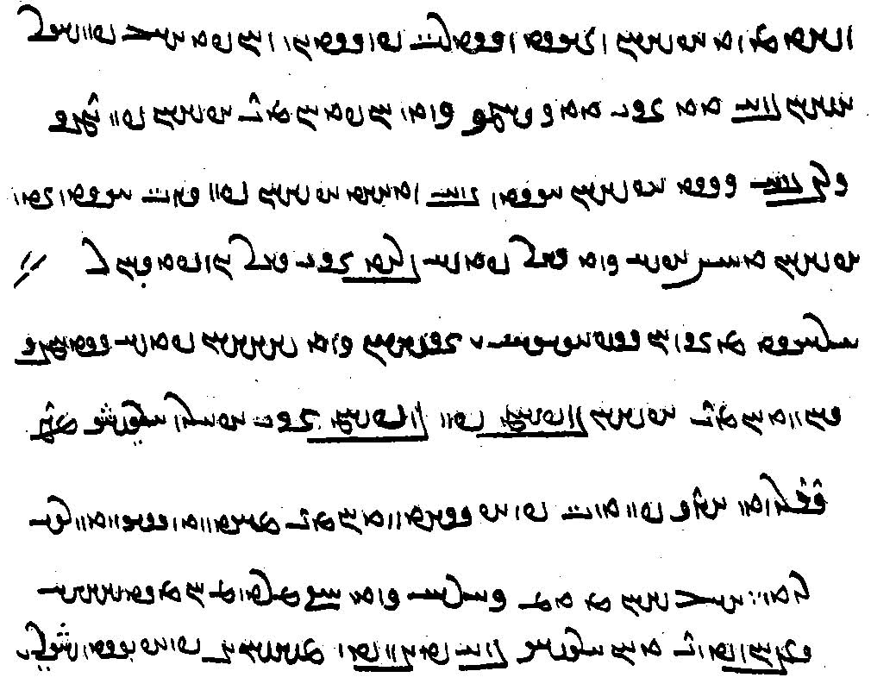
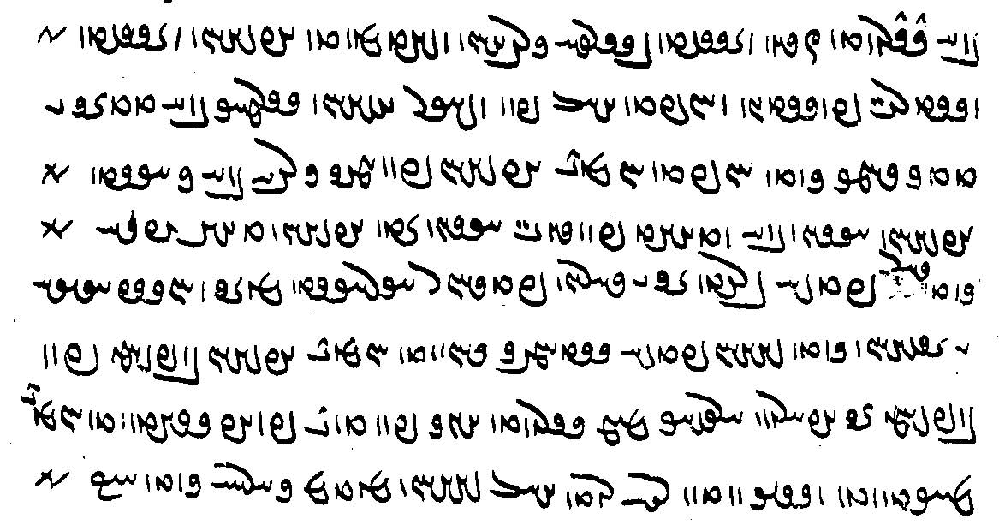
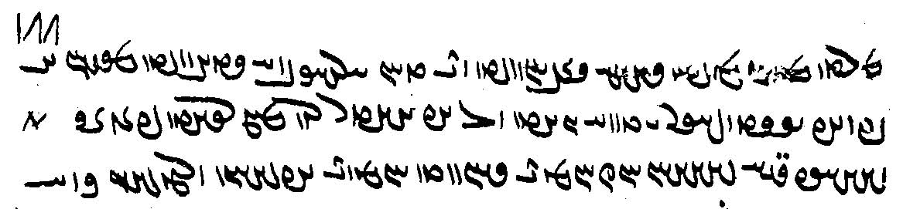

u-šān nazdist wastarg pōstēn nihuft. pas pad *wiškar ā-šān sarmāg bē tad. ān ī tadag ǰāmag kerd nihuft hēnd.
u-šān pad zamīg *kurba bē ...ª u-šān āhen bē widāxt u-šān pad sang āhen zad
u-šān tēx-ēw az-iš kerd dār pad-iš brīd ān dārēn padišwar ārāst.
az ān huspāsīh ī-šān kerd dēwān padiš stahmbag būd hēnd.
u-šān xwad pad xwad ān ī abārōn arešk abar burd. ēk pad did frāz raft hēnd zad ud darrīd wars rūd.
pas dēwān az tam wāng kerd kū mardōm hēd dēw yazēd tā-tān arešk bē nišīnēd.
a. Mss: TD1 <kst>, DH <k’st'>, TD2 <kwst'>; IndBd. K20 <HPLWNd>, M51 <HPLWNt>.

ārāy- ārāst Wtja¬A –á¬A <’l’d-, ’l’st'> arrange, equip, adorn
arešk WkßglA <’lyšk '> envy
dār laD <d’l> wood, piece of wood
dārēn Wwï¬aD <d’lyn> (made) of wood
kurba AbLWK <kwlb’> *ditch, hole in the ground
padišwar LwÍTP <ptšwl>
pōst WtJWP <pwst'> skin
pōstēn WwYtJWP <pwstyn'> made of skins
wars sLW <wls> hair
wastarg gLtJW <wstlg> garment, clothes
wiškar LkÍW <wškl> some kind of weavable grass?
nihumb- nihuft WTPwAW , -bMwAW <nhwmb-, nhwpt'> to cover, hide
tan- tanīd, tad WTT, WtDWT , -WT <tn-yt', tt'> to spin, weave
widāz- widāxt WtåÅTW , -WcÅTW <wt’c-, wt’ht'> to melt, smelt

Grammar 22

Negations $$

Adverbial clauses of time, place, and manner

čand “as much, as many”

čiyōn “as, when, because; that is”

čiyōn Hariburz frāz waxšīd harwisp kōf ō rawišn estād hēnd

ham-čiyōn Kirm zafar abāz y’p̄t kū xōn xward Ardaxšīr rōy widāxtag pad zafar ī Kirm andar rēxt ud Kirm čiyōn rōy ō tan mad pad dō škāft (KN 8.10-11)

ham čiyōn gāw ī ēk-dād bē widerd az ān čiyōn-iš čihr ī urwarīg dāšt 50 ud 7 sardag jōrdāg 12 sardag urwar ī bēšaz az hannām hannām waxšīd hēnd (WZ.3.43)

čiyōn ka “as if”

Pābag šab-ēw pad xwamn dīd čiyōn ka xwaršēd az sar ī Sāsān bē tāft ud hamāg gēhān rōšnīh kerd.
ud mār ān-iz ast kē zahr pad čašm dārēd ud pad nigerišn mardōm bē ōzanēd čiyōn ka gazīd estēd (Bd.22.19)

Adverbial clauses of time
andar ān-ēw ka “at the time when” (MHDA.5.3)
$$
ān ī ka tan xuftag ruwān bērōnīhēd “at the time when the body is asleep, the soul is made to go outside” (WZ.29.8)

andar ān ka
Bd.34.22

ōwōn būd čiyōn ān ī Weh-Šābuhr pad hanǰaman ī anōšag-ruwān Husrōy ī šahān šah ī Kawādān 21-ān bazišnīhā ōwōn nimūd ī mowān padiš ēstād hēnd
“It was just as when Weh-šābuhr showed in the assembly of Husrōy of immortal soul, king of kings, son of Kawād, the twenty-one divisions (of the Avesta) so that the mows abided by it” (NM.1.4.17)

ka andar ān tāyag ī – ka gyān bē šawēd (ZFJ.505) = ēn andar ān zamān āmār ka-š gyān bē šawēd (PV.7.2'A) = andar ān zamān ka gyān bē šawēd (ŠnŠ.2.1)

pad /zamān/tāyag/hangām ī “at the time when”
harw ǰār ī (DD 36.53)

az ān ī ka

az ān kū “from the time that”
az ān kū-šān dām dād pānagīh ī dāmān kerdan rāy xwaš nē xuft estēd (Bd.26.52)

tā ān ī ka

tā čē $$

mardōmān tā-šān hammōzišn abar nē barēnd ud was ranǰ ud uzēnag padiš nē kunēnd dānišn ī mardōmīh ayāftan ud dānistan nē tuwān .

pēš az ān ī ka-šān ān zōhr hamāg bē nē rēxt (PY.65.10)

ēwbār “once, as soon as”:

ēdōn gōwēnd kū ēwbār ahlaw Zarduxšt dēn ī padīrift andar gēhān rawāg bē kerd tā bowandagīh 300 sāl dēn andar abēzagīh ud mardōm andar abēgumānīh būd hēnd
“so they say: once Righteous Zarduxšt had propagated in the world the religion that he received, until the completion of 300 years the religion was in purity and people had no doubt about it”

harw bār-ēw ī
PR. 37b.18 ka čand-ēw sāl nē čīnēnd harw bār-ēw ī-š kār framāyēnd framān-ēw wināh

ka “when”

mowbedān mowbed ka-š dīd kū ... “when the supreme mowbed saw that ...”

Often Pahlavi uses ka where we would use “that”

bawēd ka, šāyēd būd ka “it happens when (that), there are occasions when”

čē šāyēd bawēd ka ān kē abāg wehān būd estēd ka ō wattarān rasēd wattar “for it is possible (and) it happens that someone who has been with the good people, when he comes to bad people (becomes) bad” (Dk.6.178)

Embedded ka-clauses:

ka clause embedded in ka clause:
ka-š – ka tāyag padiš bē šud – tis ān rasēd ī-š bē šustan nē tuwān ā-š dast ōh šōyišn u-š wāz ōh gīrišn
“when (= if) – when the time (= waiting period) has passed for her (-š ... padiš) — something (some menstrual matter) arrives that she cannot wash off (because of what she is doing), then she should wash the hands in the usual way and she should take the bāj in the usual way” (PV.16.11E)

ka andar ān tāyag ī – ka gyān bē šawēd ēg-iš sag ō pāy bast estēd
ayāb warāγ-ēw ēg-iš pad sar hamē parrēd – ēg-iš Nasuš abar dwārēd
When (= if) at the time, when the soul leaves, then a dog is tied to his (= the dead person’s) foot,
or (when) a crow then is flying onto his head, then (at that time) the Nasuš runs upon him” (ZFJ.505)
=
= ka-š sag-ēw andar pāy bast estēd u-š Nasuš abar ōh dwārēd pas ka-š dīd ā-š zanēd (PV.7.2'A) $$ > Texts
andar ān zamān ka gyān bē šawēd ka-š sag-ēw andar pāy bast estēd pas-iz nasuš abar ōh dwārēd (ŠnŠ.2.1)

ka clause embedded in relative clause:
gōwāgīh ēd bawēd kē ōy kas rāy ǰādag-gōwīh kunēd ī ka-š ān nē ǰādag-gōw kas-iz ǰādag-gōw nēst
“‘eloquence’ is this: someone who advocates for a person who, when (if) he is not his advocate, (then) he has no advocate at all” (Dk.6.91)

ān ī pas az widerdagīh kunīhēd nē pad āmār ī sidōš ud tarāzūg bē pad hangām ī kerbag rawāgīhēd bē ō rāmišn ī ruwān rasēd “that good deed which is performed (for him) after (his) passing, is not counted at the Third Dawn and the Balance, but, at the time when it is publicized, it comes to the joy of the soul” (DD.7.4)

Adverbial clauses of place
kū “where”:
dōšox andar mayānag ī zamīg ānōh kū Gannāg Mēnōy zamīg suft padiš dwārist

ka ēn kanīg andar ān ī andarōntar kadag nišīnēd
ānōh kū ka ēd kanīg nišīnēd rōšntar kū ānōh kū ātaxš burz waxšēnēnd az rōšnīh ī az im tan bē tābēd
nē ān ī ēdōn xwarrahōmand ǰādūg bawēd

ānōh frāz mad hēnd kū 2 murw pad pus-xwāyišnīh nišast hēnd
pad ān abar frāyist mēzēnd pah ud stōr ān gyāg kū padiš parwarēnd “” (PV.3.6)

stāyēm gar ī buland kū ānōh hōm rust estē “I/we praise the lofty mountain where you, Hōm, have grown”

kū “that is”:
ō ān ī amahrspandān huaxwīh mad kū garōdmānīg

pas az ān ka “after”

pēš “before”

pēš pad 10 sāl ka Sōšāns āyēd ō a-xwarišnīh estēnd ud nē mīrēnd “Ten years before Sōšāns comes, they will stop eating altogether and not die” (Bd.34.3)

pēš ka
tā pēš ka ēbgad mad hamēšag Nēmrōz būd “until the Invasion came it was always Midday” (Bd.3.25)

pēš tā
ka šōy pad zan stūrīh ōh xwāyišn kerd pēš tā gumārēnd šōy bē mīrēd zan pad ān stūrīh bē gumārišn (MHD.37.43)

tā “as long as, that, so that”

čiyōn mard-ēw kē tā pad gētīy būd aziš āsāndar ud xwaštar ud huramtar nē būd (AW)

bē āy tā ō tō nimāyēm wahišt ud dōšox (AW)
Gannāg Mēnōy abar ō dām ī man hayārīh bar ud stāyišn dah tā pad ān pādāšn amarg ud azarmān asōhišn ud apōhišn bawē (Bdh)
pad kār ud kerbag kerdan tuxšāg bawēd tā-tān man zīšn ī gētīy pad mayān kunam (PN)
dastwarīh ast tā ruwānīgān yazēm ud xwarišn xwarēm ud handarz kunēm (AW)

tā šāyēd

andar xwadāyīh šābuhr ī Ohrmazdān tāzīgān āmad hēnd u-šān *hurīy rōdbār grift. was sāl pad ēwār tāzišn dāšt tā šābuhr ō xwadāyīh mad awēšān tāzīgān spōxt šahr aziš stad was šāh tāzīgān abesihēnīd was-maragīhā-šān *kušt (Bd. 33.16)

tā “since, for,” expressing duration in the past (Germ. seit, Fr. depuis)

im rōz haft *māhīgān ast tā ābustan hēm “today I have been pregnant for seven months” (KN)

tā “until” + infinitive
ka arzag bawēd tā abāz griftan was anāgīh baxšēd “when she (Mūšparīg) gets loose, she will distribute much evil before being captured again” (Bd.5.5)

sag-ēw dīd kē 7 bck zād estād ud 8 rōz būd tā-š ēč* xwarišn nē ayāft.

tā (pēš) ka “until”
(AZ.77) $$
tā ka tan ī pasēn bawē (Bdh)
az ān ī ka kerbag bē ō rawāgīh rasēd waxš andar ō abzāyišn estēd tā ka zīndag (DD.9.2)

tā pēš ka ēbgad mad hamēšag Nēmrōz būd “until the Invasion came it was always Midday” (Bd.3.25)

PV.6.9

(MX.43.21-23) $$

hamē tā ka “until, for as long as”
hamē tā ka Pōrušāsp awēšān wastarg abar šust ēg hōm frāz raft az abartom srišwādag ān tā ō mayān wan (Dk.7.2.33)
hamē tā ka pad gyān zīyēd “for as long as one lives with soul” (FO.4e.244)

tā ān ī ka “until”:
(KN)

bē ... tā ... nē “except ... not ...; the only one ... is/was; the only way ... is ...”
bē huzārag ī pad Kāzrūn drayā bārīhā tā bē nē mānēd “except a small number (living/hiding) on the sea shores of Kāzerūn, no one will be left (alive) [the only ones left alive will be a small number ...]” (Bd.33.25)
xrafstar hamāg ǰādūg ud mār ǰādūgtar bē agar-iš ōzanēnd tā nē mīrēd “xrafstars are all sorecerers, and the snake is the most sorcerer of them all; except if one kills it it will not die [the only way it dies is if one kills it]” (Bd.22.18)

V.6.9
|a| u-š guft ohrmazd kū pad ān ī ō tanāpuhragānīh dō sad pad abar zanišnīh abar zanišn asp aštar dō sad srōšōcarnām
[|A| sōšyans guft ay ēn ān bawēd ka-š abar rasēd tā ka-š nē rasēd framān spōxtan rāy wēš nēst kū srōšōcarnām-ē |B| kayr-ādur-bōzīd guft ay ēn tanāpuhr-ē framān spōxtan rāy tā ka-š abar rasēd ā margarzān

See also kū tā.

ka (tÂA AMT) “when, if”
ka ... -iz
(MX.56.32) $$

pas “after(ward)”

pas Widrafš ǰādūg abar ō pāy estād “then Widrafš the sorcerer rose”
u-š pas mayānag ī zamīg suft “next he pierced the earth”
ān zand-āgāhīh nazdist abar bunyādīh ī Ohrmazd ud petyāragīh ī Gannāg Mēnōy pas abar čiyōnīh ī gēhān dām “that knowledge from the Zand (is) first about the primal establishment of Ohrmazd and the counteraction of the Evil Spirit, then about the nature of the creation of living beings”
dām-dahišnīh ī mēnōyīhā gōwam ud pas gētīyīhā “I shall talk about the creation of the creatures in the world of thought, and then in the material sphere.”
3 rōz abāz būd tā pas bē zād “3 days remained until he then was born”

az ān pas “after that, afterward”
gōwēd pad dēn kū nazdist kōf frāz rust Hariburz ī *baγbaxt ud az ān pas hamāg kōf frāz rust hēnd pad 18 sāl “it says in the Scripture that: The first mountain (that) grew up (is) Hariburz Baγbaxt. And from that, afterward, all the mountains grew up in 18 years.”

pasīy, ō pasīy “behind”
ēg ōy mar ā-š ō pasīy gaw abāz rānēnīd “then that villain turned his hands backward” (Dk)
pasīy frōd ward šnāsam agar tō hē Spandarmad “turn around (= your back to me) (and) I will know whether you are Spandarmad!” (Dk)
druz ō pasīy frōd wašt u-š ōy dīd Zarduxšt pasīy (BATL) “the demoness turned around, and Zarduxšt saw her from the back” (Dk)

pēš, ō pēš “before, in front”

Ardawān dānāgān ud axtarmārān ī pad dar būd ō pēš xwāst “Ardawān called before (him) the wise men and astrologers who were at the court”
pad ēd dārēd kū Ohrmazd andar ōy ačārag ēd rāy āštīh pēš dārēd “he thinks that Ohrmazd is powerless against him and for this reason is offering peace”

pēš(īy) ... pas(īy) “before ... after/behind”
andar dōšox harw druz dwārišn ō pēš ud druz ī spazgīh grān-wināhīh rāy dwārišn ō pas “in Hell every demoness will be running before (you), but the demoness of slander, because of its being such a heavy sin, will be running after (you)”
u-š ō ōy druz guft kū Zarduxšt ī Spitāmān kū awēšān amāh hēm kē mādagān nēkōg az pēšīy nēmag ud duš-zišt az pasīy ma man ō pasīy framāyē “and to him she said, the demoness [to Zarduxšt Spitāma]: We are (those) who are females (who are) beautiful from in front but very ugly from behind; do not ask us to turn around!” (Dk)

Adverbial clauses of condition

agar (tÅ HT) “if”
agar ōh(-iz) “even if” $$

ān driyōš mardōm agar ōh ag-dēn ayāb nē frārōn-rawišn ēg-iz-iš tis awiš dahišn (Dk.6.292)

ka xwadāy bandag pad bandagīh ō ādurān dahēd agar ōh-iz kū-š pad frazend ī bandag pādixšāyīh nēst pas-iz frazend ud āwādag ī bandag bawēnd ādurān bandag bawēnd (MHD I.14/41)

agar was-iz mēnōy-xwarišn ast pas-iz ān nam ud parwār ī āb ī pad sūrāgīhā ō tan šawēd (Bd.24d.21)

Complex clauses

Purs.57
ān kunišn ī ka kunēd kerbag wēš bawēd (MHD.29.10)

xwāstag ī — ka kadag-xwadāy pad baxt šawēd — pad kadag-xwadāy estād ō duxt ī keh rasēd (MHD.37.26)

az kerdan kerbag ayāb wināh agar tis az ān ī-š tuwān spōxtan ka nē kunēd u-š bē spōxt tuwān ā-š nē kunišn bē spōzišn (PR.71)

u-š Haftōring pad kust ī abāxtarān ānōh kū ka Ēbgad andar dwārist dōšox būd gumārd “and he appointed Haftōring in the northern direction, there where hell was when the Adversary ran in” (Bd.2.9)

Expressions of (un)willingness

pad kām, kāmīhā, kāmagīhā, kāmagōmandīhā “willingly, at will”
nē pad kām “unwillingly”
agāmāy “unwillingly”
andar a-kāmagīh ī “against the will of”
a-kāmagīhā, a-kāmōmandīhā, akāmagōmandīhā “unwillingly” (Man. agāmagīhā)
xwad-kāmagīhā, xwēš-kāmīhā, xwēš-kāmagīhā “of one’s own free will”
pad kām agāmāy “willingly unwillingly, willy nilly”
čē-gāmag etc., see Lesson 12.

Examples:
kāmag ... nē kāmag, kāmagōmandīhā ud a-kāmagīhā
“willingly, non-willingly = willy nilly”

ō ān ruwān gōwēd kū druwand ka-t kāmag ka-t nē kāmag abar ēn pad gām raftan abāyēd
“(its actions) say to that soul: O wicked one, whether you wish or not, you must step on this edge” (Bd.30.27)

ka-š anāgīh-ēw pad ān ēwēnag awiš rasēd ī čārag xwāstan nē šāyēd kāmagīhā pad-iš hunsand bawēd
“when an evil of that kind comes upon him, for which no remedy can be sought, he is willingly content with it” (Dk.6.6D.4)

petītīg būd rāy mādagwar tis ēn kū wināh nē kunēd xwēš-kāmīhā
“as for being repentant, the main thing is this: one does not sin of one’s own free will” (MX.51.16)

mard ān farroxtar kē čand šāyēd dōšox pad gētīy bē barēd bē ō ruwān nē spōzēd;
u-šān pad gētīy burdan ēd guft kū andar gēhān harg ud ranǰ ī mad nē wizīrēd bē ka ōh kunīhēd
ud mardōm pad čār kāmagīhā awiš nē šawēnd ǰud az frēzwān pad kām ī xwēš-kāmagīhā ul ō grīw padīrēd ud tuxšāgīhā kunēd
“that person is the most fortunate who, as much as possible (čand šāyēd), endures hell in this world (and) does not push it back onto (= leave it to) the soul (when dead);
and they said: ‘to endure in this life’ (means) that one does not avoid present toil and trouble in this world, except when it is done (= but rather do it) in the usual way,
and people do not, as best they can (pad čār) undertake it (awiš šawēnd) willingly, except when they, because it is a duty (frēzwān), accept it upon their neck willingly and by their free will, and perform it diligently” (Dk.6.305)

Gannāg Mēnōy wāng ō γarrānāg ō-iz wāng kuling 6-sālag ō-iz wāng ī xar ō-iz wāng ī mard ī ahlaw ka a-kāmagōmandīhā zanēd wāng kunēd mānēd
“the voice of the Foul Spirit resembles thunder, the sound of a six-year-old crane, the voice of a donkey, and the voice of a Righteous man when someone beats (him) against his will and he cries (out)” (Bd.27.51)

dēwān pad mehmānīh grift abar kōšēnd mardōmān agāmāy dēwān menišnīg ud gōwišnīg ud kunišnīg az xwēš tan ud gyān hammis bowandag-menišnīhā ud abardom-dōšāramīhā pad xwēšīh ī yazdān frāz dāštan ud yazdān padiš stāyīdan ud dēwān padiš nikōhīdan
“the demons strive to get a lodging (in humans); the humans, against the will of the demons, are to keep themselves in thoughts, words, and deeds together with (az ... hammis) their own body and soul, in all their thoughts and in supreme love, in the possession of the gods and praise the gods, thereby and scorn the demons thereby” (Dk.5.24.17)

ēk ēn kū ma an-ēmēd dārē kas-iz az wahišt ud ma ē nihēnd ōstīgānīhā menišn abar dōšox padisāy was-wināhīh ī-š pad kām agāmāy
“one thing is this: do not hold anybody hopeless about paradise, and let them not put their thoughts firmly to hell because of all the sins he has committed willy nilly” (ŠnŠSupp.12.28)

In compounds:
arešk-kāmagīhā tag abar kerd
“from the desire of envy, he attacked it” (Bd.4.10)

wināh wizārišn-kāmagīhā
“from desire to ‘resolve’ the sin” (REA.17.17)

pas Wizarš dēw ān ruwān ī druwandān gīrēd ud anāzarmīhā ud xešm-kāmagīhā zanēd ud wināhēd
“then the demon Drag-off seizes that soul of the wicked, and without showing respect and from the desire of wrath he strikes and sullies it” (MX.1.164)

Days and times of the day

im rōz MwY NwïÒ <LZNE YWM> “today”
[im šab adlïÒ NwïÒ <LZNE YWM> “tonight”]
dīg W˝J <dyk'> “yesterday”
[parēr lïÒP <plyl> “day before yesterday”]
dōš ÍwY <dwš> “last night”
fradāg la˜ <MHL> “tomorrow”
bāmdād WtådmAV <b’md’t'> “dawn”
bāmīy (kmAB , imAB) 1mAB <b’md (b’myk, b’mk)> “dawn”
ōš-bām, ōšībām µAV Y ÍwA ,µAvÍwA <’wšb’m, ’wš y b’m > “dawn”
nēmrōz WCwlmYW <nymlwc'> “noon”
ēbārag, ēwārag WklAWcjA , WklAwïÅ <’yw’lk', ’yyp̄w’lk', etc.> “evening”

From Avestan:
frayar lïåÒP <pl’yl> “before noon”
rabihwin WwYWPtDpL <lpytpyn'> “noon”
uzēr lï¸wA , lïå¸wA <’wz’yl, ’wzyl> “afternoon”
hū-frāšmō-dād WtåDKwmßaÒPwA <hwpl’šmwkd’t'> “sunset; lit. “setting of the sun”
hū-waxš ßAWwA <hwwhš> “sunrise; lit. “waxing of the sun”

The five gāhs of the day (from Avestan):
Ušahin <’wšhyn', ’wšsn'> from midnight until after dawn
Hāwan <h’wn'> from dawn to before noon
Rabihwin <lptpyn'> noon
Uzērin <’wz(‘)lyn'> afternoon
Ēbsrūsrim <’yyp̄slwslym> evening

The four seasons:
Adjective
wahār, wahārān wahārīg “spring”
hāmīn hāmīnīg “summer”
pādēz “autumn, fall”
zamestān zamčīg “winter”

The five seasons, gāhānbār (from Avestan):
Mēdōšim summer
Paitišah harvest time
Ayāsrim autumn, fall
Mēdyār winter
Hamāspahmaidim spring

sadōzim
hazangrōzim

az bun-dahišn tā im rōz anāgīh az ēn garāntar nē mad
“from the Creation until today, no evil heavier than this has come (upon Iran)” (Bd.33.27)
About the customs of the Arabs.

ēk uzmāyišn ēd-iz čiyōn ka az ul-āmad ī xwaršēd im rōz pēš-iz ōstīgān hēm abar ul āmad ī fradāg-iz xwaršēd
“one is ‘experience’ and this is just like when we are convinced, from the rise of the sun today and before, about the sun’s coming tomorrow, as well” (Dk.3.247.5)

gētīy pad buništag ma dārēd čē dīg nē būd
“do not regard this world as something primordial, for yesterday it was not” (Dk.3.199.9)

ka im rōz dānd kū dīg daštān būd ham ā-š hamkarzag az dānist frāz
“when she knows today: ‘I was menstruant yesterday’, then (she is) hamkarzag = (anything) in contact with her (is polluting) from the time of knowing” (PV.16.1E)

ka pad šab gyāg-ēw hamē šawēd ud fradāg ānōh abāz āyēd ud nasāy-ēw ānōh nibayēd nē dānēd kū dōš ka man bē mad ham ānōh būd ayāb nē ā-š pad ēd dārīšn kū nē ānōh būd
“when on goes somewhere at night and the next day comes back (to that place) and a nasāy lies there (and) he does not know: ‘when I came last night was it there or not?’ then he should consider that it was not there” (ŠnŠ.2.72)

ud ān ī sidīgar šab andar bāmīy ō Harburz gyāg ī āmār šawēnd
“and the third night, at dawn, they go to the Harburz, the place of reckoning” (DD.19.3)

pad ān ī sidīgar šab sar ā-š pad wizīhišnīh sahēd pad ōš-bām kē mard ī ahlaw ruwān kū andar urwar abar ud bōy ā-š bē dāšt sahēd tan ī xwēš
“‘at the end of the third night, at daybreak’, (i.e.) at dawn, ‘it seems’ (to him), ‘who is the Righteous man’, that, ‘among plants and fragrance, it seems’ to him that ‘he has held’ his own body” (HN.2.7)

xwaršēd (ī) bāmdād abāyēd yaštan tā nēmrōz ud ān ī nēmrōz abāyēd yaštan tā ēwārag-gāh ud ān ī ēwārag-gāh abāyēd yaštan tā šab
“the morning sun one should sacrifice to until noon, and the noon (sun) one should sacrifice to until the evening gāh, and the evening gāh (sun) one should sacrifice to until night(fall)” (ŠnŠ.7.1)

3 bār andar rōz pad hū-waxš ud nēmrōz ud hū-frāšmō-dād
“three times a day: at the waxing of the sun, at noon, and at the setting of the sun” (Dk.5.19.4)

tā pēš ka Ēbgad mad hamēšag nēmrōz būd ast ī rabihwin
“until before the Invasion came, it was always noon, that is Rabihwin” (Bd.3.25)

FiO.27b
aiiarə rōz °
kē aziš nēm-ēw fraiiar °
ud nēm ēw uzēr nām °
az uzēr nēm ēw rabihwin nām °
ud nēm ēw uzērin [K20_87v] °
ud pad zamestān bahr ī rabihwin abāz ō hāwan gumēxtēd °
*xšapa šab °
az šab 4 bahr
bahr ī fradom ° [F3c_70r]
hū frāšmō.dāitīm hufrāšmōdāt xwānēnd °
bahr ī didīgar °
ərəzauruuaēsāt̰ abēzagān wardišnīh xwānēnd °
ēn 2 bahr °
aiβisrūθrim °
bahr ī sidīgar °
ušąm sūrąm ōš ī abzār xwānēnd °
kē ušahin padiš andar āyēd °
bahr ī čahārom °
raocaŋhąm fragatōit̰ rōšnīh frāz-rasišnīh kē ōš ī bām
u-š hāwan-gāh-iz xwānēnd ° [M51_257]

az kū bē uzaiieirin gāh rad-franāmišnīh frāz rasēd kū yazišn ī *uzaiieirin pad čē hangām kunišn
“‘from when does the ‘pleasing of the rad of Uzaiieirin gāh arrive?’ i.e., at what time should the sacrifice for Uzaiieirin be performed?” (Nir.32.1)

Dk.6.89
u-šān ēn-iz ōwōn dāšt kū
mardōmān kāmag ī tan abārīg tis ī gētīy ī awiš rasēd
ka ō kāmag ī tan nē sāzēd pad ruwān sūdōmandtar
ēg čārag ēn abērtar ka ōwōn nimāyēd kū im rōz nē bē fradāg kunam
ud pas rōz ī didīgar ud az ān frāz ān tis pad ēmēd ī (...) frāz ō pēš spōzēd
ud kē ōwōn ǰahēd kū-š tuwān rōz rōz pad ān ēwēnag spōxtan ud nē kerdan
ēg ān mardōm ka az ēn gēhān bē šawēd dēwān druzān abēr tund ud duš-rām bawēd
ud ēn drāyēnd kū-š kirrōgīhā-iz kerd ka amāh tis pad-iš nē tuwān būd kerdan

Dk.3.247.1–5
abar wihān ī ōstīgān būd ī pad tis az nigēz ī weh-dēn hād
*wihān ī ōstīgān būd ī pad tis ēn-iz 3: ēk dānišn, ud ēk wurrōyišn, ēk uzmāyišn
ēk dānišn ēd-iz ī čiyōn ka az kardagīh (ī) gēhān ōstīgān dānēm kū ast ī kerdār ī gēhān
ēk wurrōyišn ēd-iz ī ka az gugāyīh (ī) purd kas abar nihuftag a-paydāg-iz {m} tis
ōstīgān wurrōyēm ēdōnīh ān ī gugāyīhēd padiš
ēk uzmāyišn ēd-iz čiyōn ka az ul-āmad ī xwaršēd im rōz
pēš-iz ōstīgān hēm abar ul āmad ī fradāg-iz xwaršēd

ka im rōz danēd kū dīg ayāb dōš daštān būd ēg-iš dādestān čiyōn
ham-karzagīhā az dānistan frāz
Pyšksyl gōwēnd kū abārīg tis (az) bunīh
ast kē ēdōn gōwēd kū-š tāyag az bunīh u-š abārīg tis az dānist frāz
“When she knows today that she was menstruant yesterday or last night, what is her legal position?
(She is) in a state of being hamkarzag (anything in close contact with her is polluted) from the time of knowing.
The Pišksils say: (All) other things have to start all over (whatever she has done since yesterday must be redone).
There is one who says: She (has to start) the period (tāyag) all over, and all other things from the time of knowing” (ZFJ, p. 570)

Bd.25.25
ēn kū māh ī Frawardīn ī wihēzagīg ud māh ī Urdwahišt ud māh ī Hordad wahār
māh Tīr māh ī Amurdād māh ī Šahrīwar hāmīn
māh ī Mihr māh ī Ābān māh ī Ādur pādēz
māh ī Day māh ī Wahuman ud māh Spandarmad zamestān ∵

Texts 22

ud kēšdārān kē yazd kāmag ō harw rōz ō sān-ēw waštan kēš
ān čiyōn wardišnīg ō anīy ud anīy wehīh ud wattarīh bawēd ī-šān būd kām-iz
yazdīh aziš bē pad hu-dōstīh ī-š kāmēd fradāg kām pašēmān im rōz kām *a-dōst guft estēd
“and the holders of (other) beliefs, whose belief is that god’s will for every day turns to an(other) kind,
— just as their wish too would change from one to another, goodness and badness—
they have denied him divinity for the good friendship he wishes: tomorrow he will regret his wish, (although) today his wish is being a good friend” (Dk.3.396.7)

pad Ušahin gāh abar estēd ōšōmandān mardōmān
dādīhā dast ud rōy pad gōmēz ī gōspandān šōyēd ud pad āb pāk šōyēd
ud dādīhā wastarg ī pāk pōšēd
ud pad nīrang dēn ī mazdēsnān ēbyānghan bandēd pad menišn ud gōwišn ud kunišn ī frārōn-menišnīgīhā
ruwān rāy kār ud kerbag kunēd ud ahlāyīh pursīdār bawēd
(PT.10.2)

ēk ēn kū pahrēz abērtar frēzānīg kū harw yōždahrgar-ēw ka pad paristišn andar ō gumbad ī ātaxš Warahrām šawēd hamēšag abāg nāywar bawēd ud pad gāh hāwan ud ušahin dah ud ēk pārag ēsm hušk ud drīdag pōst-tāšīdag abar nihēd ud pad gāh ī rabihwin ud uzērin ud aywisrūsrim haft *pārag pad dēn framūd estēd u-š pad hamāg kār tuxšāgtar bawēd (WD.36.3)

PY.19.20
Ohrmazd frāz guft čē-š rāy frāz guft ahlaw ī mēnōy ud gētīy nēkīh ī mēnōy ud gētīy rāy
čē-kāmagīh-iš rāy frāz guft čē abāyist rāy frāz-iš guft
kū tā ān ī waxšēnīdār pādixšāyīh bawād ud ōy ī kāmag-xwadāy ::
čand ahlawān rāy ōh abāyēd guft kū tā waxšēnīdār bawēd ān-iz ī a-kāmag-xwadāy
ay kē ēwāz ōh paydāgēnēnd kū xwarrah ī Kayān ēdōn čiyōn abāg xwadāyān ēdōn-iz abāg duš-xwadāyān
ay abāg hu-xwadāyān pad ēd kār kū tā nēkīh wēš kunēnd
ud abāg duš-xwadāyān pad ēd kār kū tā anāgīh kem kunēnd
‘Ohrmazd said forth. Why (čē ... rāy) did he (-š) say forth: the Righteous in that world and this world?’ (i.e.) for the sake of the goodness in that world and this world.
‘Because of what wish of his did he say it forth?’ (i.e.) because of what need did he say (it) forth?
So that he would be the one ‘to make his rule grow’, as well as the one ruling at will.
‘As much as’ (it is) for ‘the Righteous’ one should say thus in order that one becomes ‘the one who makes grow’, as well as the one who is ‘not one ruling at will’.
This means: those who manifest words (to the effect) that just as the Xwarrah of the Kays (is) with the (good) rulers, it is also with the bad rulers.
This means: (it is) with good rulers in order that they do more goodness and with bad rulers in order that they do less evil.

From the Selections of Zādspram: WZ.16.0–4. About Z. leaving his home to care for the poor. Ms. TD4a, p. 530, K35, f. 252r.
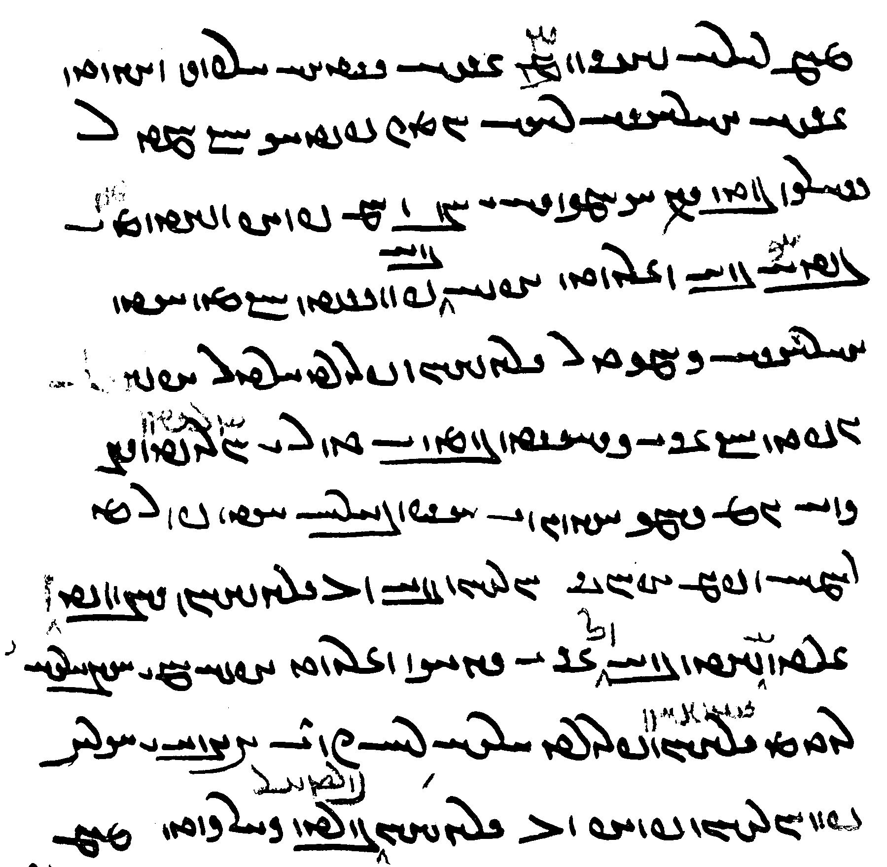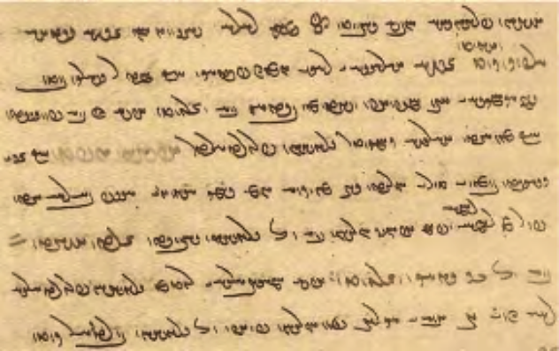

abar ul hišt ī-š gētīy ārzōg grift ī-š ahlāyīh rāh
ēn-iz paydāg kū ka 20-sālag būd andar a-kāmagīh ī pid ud mād frāz wašt az xānag bē šud
u-š bē pursīd kū kē ast ahlāyīh-kāmagtar driyōšān parwardārtar
u-šān guft kū ān ī kehist pus ī Tūr ī Urwaytīy kē harw rōz ǰāmag āhenēn ī asp-bālāy ast
purr az nān ud pēm abārīg xwarišn bē ō driyōšān dahēd
Zardušt bē ō ān gyāg šud
u-š ham-ayārīh abāg driyōšān parwardārīh rāy čand 2 mard ī aγrīy xwarišn frāz ō driyōšān burd kār kerd
About he (= Z.) relinquished this-wordly desire and took the road of Righteousness.
This too is manifest: When he was twenty-years old, against the will of his father and mother, he turned away (and) left the house.
And he asked: Who is the one who is (kē ast) more desirous of Righteousness (and) and the more caring for the poor?
And they said: That is the smallest son of Tūr ī Urwaytīy, who, every day, has an iron bowl, deep as the height of a horse, full of bread and milk and the other (usual) foods (and) gives the poor.
Zardušt went to that place.
And because he shared assistance with the poor and cared for them, he brought the poor as much food as two prima men (which) did the job.

Text 18.$$
From the Zand ī fragard ī J̌ud-dēw-dād (ZFJ, p. 589): commentary on Videvdad 8.26 about the sin of anal intercourse: whether done unwillingly or willingly.

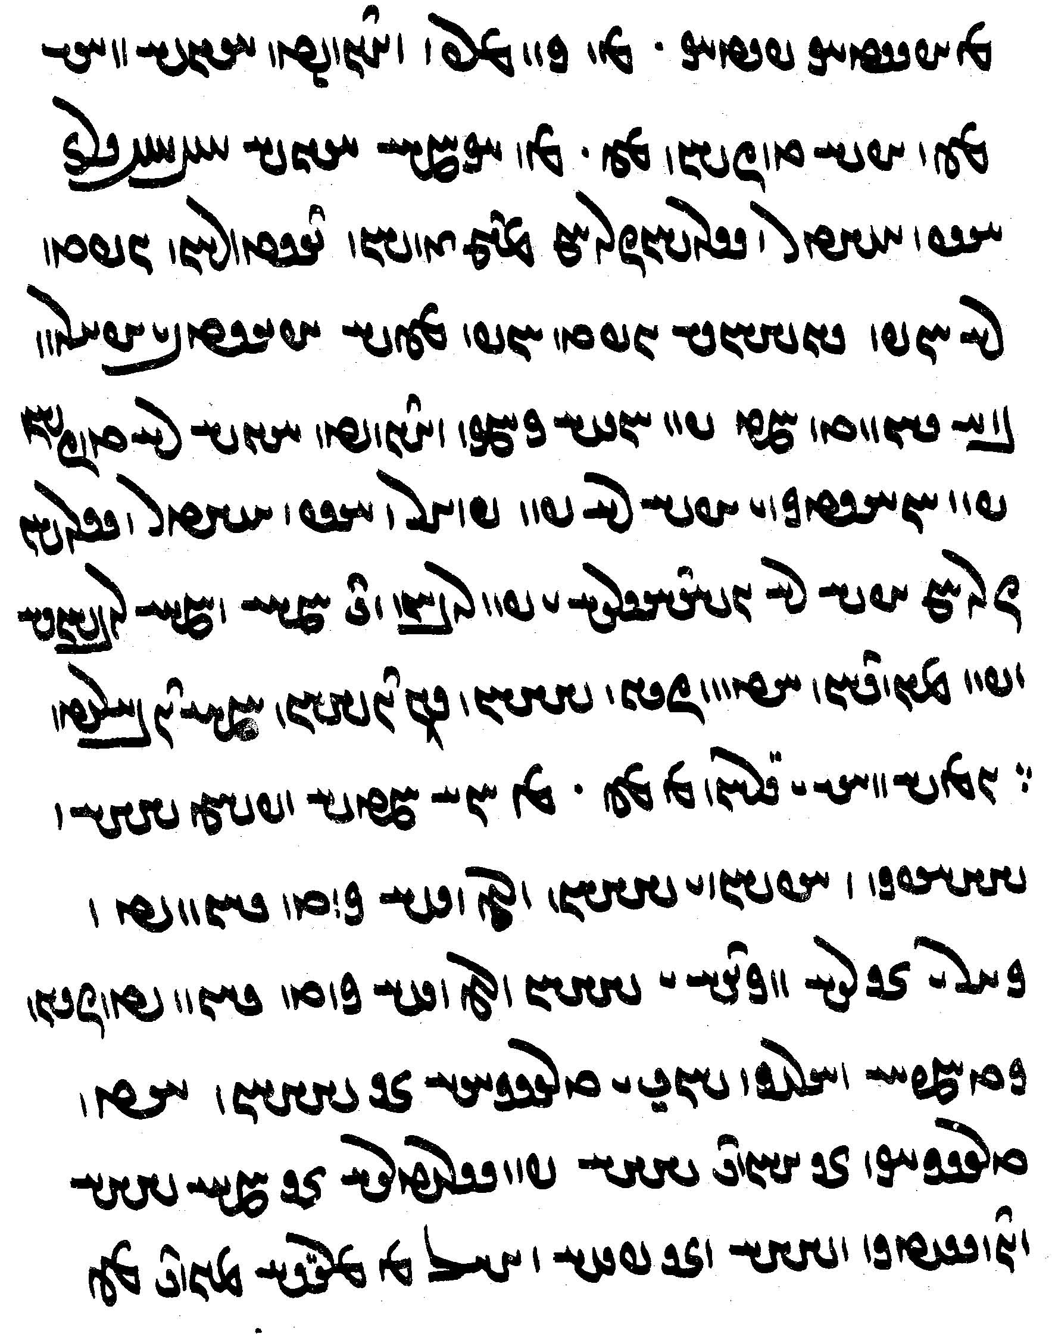
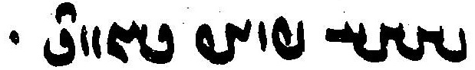
az Abestāg paydāg
kē kūnmarz kunēd ēg-iš wināh čē u-š tōzišn čē.
kē agāmāy ēg-iš 800 asp-aštar ud srōšōčaranām abar zanišn
dastwarān guft nē xūb
Sōšāns guft xūb čē-š abdast-ēw ī abārōn bē būd
ka pad xwēš kāmag kunēd ēg-iš nē tōzišn pad xwāstag u-š nē pad puhl ud asp-aštar ud srōšōčaranām
u-š nē yōjdahrīh ī pad ruwān tā hamē ud hamē-rawišnīh
ud pad mēnōyān ēdōn čiyōn dēwān andar dōšox hamē dwārēd.
ēn-iš wināh ī garān az čē.
az ēd ka-š xwēš dēw ud dēwēzag ud ēzišn ī dēwān ōy wēš kerd bawēd
ud kār ī narīh ud mādagīh ī dēwān ōy wēš kard bawēd
čiyōn kadām-iz-ēw nāyrīg ud šōy ī tarsagāh ān dēwān
ast tarsagāg ān hāwand dēw pad wattarīh ān hamē dēw ud dōyīdag w dēw
ud ān pēš ud pas az margīh mēnōy čē [590] dēw frāz bawēnd.

Text
From the Dādestān ī dēnīg: DD.31.3–6. — Mss. TD4a, pp. 230–31, T60, ff. 36v–37r, K35, ff. 129r–130v.

3. u-š *Wizarəš dēw sezdēnīhā bastag nayēd u-š nayēd bē ō dōšox
u-š abāg bawēnd mēnōy dēw ī hambūsīd az ān ī ōy wināh pad was čihrag ud dēs (TD <y’s>)
mānāg ī wimuštārān-iz rēšīdārān ōzanišngarān marnǰēnīdārān marān duš-kerbān bazag-ēwēnagān
ud an-abāyistān <’wcl’tYk’n'> rēmanān ud gazāgān darrāgān xrafstarān
gandagān wādān tārīkān gandagān sōzāgān <tšwyk’n'> duš-gannāgān anābuhlān
ud abārīg frayist [T60_37r] wināhēnāgān (TD, T <wn’yyn- or wn’sn->) ud dardēnāgān (TD, T <-yn’kyn">)
kē-š pad hangōšīdag ī gētīy bēš-kerdārān mēnōyīg abāg bawēnd
4. u-š ham-handāzag zōr nērōg ī-šān az ān ī ōy wināh <wy’yt'>
ān tā bē ō fraškerd zamān an-āsānīhā dardēnēnd ud bēšišnēnēnd
ud pad ān ī Wizarəš nīdārīh a-kāmagīhā āyēd bē ō dōšox handēmānīhēd ō druz ud Gannāy [K35_130v]
ud pašēmānīhēd az frēbišn ī <wlyk>īhā-kāmagīh
ud az dōšox abāz-ayāstār ō gētīy [TD4_231] ud škeft ārzōg (TD <’ltk'>) ō kerbag
5. u-š xwarišn pad handāzag ī ān ī andar (gētīy) gandagtom pūdagtom ud rēmantom ud a-xwašīhtom
u-š xward nē pad (not TD) urwāzišn ud frazāmišn bē pad niyāz ī-š az āz aweštābīhēd (TD <’c'št’p̄yhyt'>)
ud gursag ud tišnag dārēd

3. And the demon Drag-off cruelly leads (the soul) bound, and he leads him to hell.
And with him are the demons in that world, who were brought into existence from his sins, in many forms and shapes:
like those who wipe out and those who cause wounds, those who practice killing, destroyers, ill-shaped villains with sinful customs,
and the uncouth, the polluted, destroyers, biting and tearing evil animals,
foul winds, dark ones, foulsmelling ones, burning, and .?., foul-smelling, inexpiable oness,
and (all) the other many who cause (men) to sin and cause them pain,
who are (all) like those who harm in this world, are with (him) in the other world.
4. And in the same measure (as) the strength and power that was given to them from his sins,
they cause him pain and harm relentlessly until the time of the Fraškerd.
And by Wizarš leading him, he comes to hell (but) unwillingly (and) is brought into the presence of the Foul One.
And he is made to regret the deception from having desires *caused by lust.
And he longs for (going) from hell back to this world, and (has) a fierce desire for good deeds.
5. And his food (is) in the measure of that in (this world), (but) the foulest, most rotted, most polluting, and providing no pleasure in the highest degree.
And eating is not for pleasure and for becoming full(?), but from need (to) which he is impelled from greed and (which) keeps him hungry and thirsty.

gazāgān: T has <p’k’n'> with <p-> instead of <yc- = yp̄->, similarly in frēbišn, T <plpšn'>.
nayēd: 1st time TD <’yt'>, T <n’yt'>, 2nd time <YZLWNyt(') = DBLWNyt>.
Wizarəš: 1st time TD <yly’>, T <wyl’š>, 2nd time TD <wyzlw’>?, T <wyzl’š>, with the Av. ə spelled <-’->.
hambūsīd: TD <hmwwsyt'>, with only the down-stroke of the <-b->, as also in bēš-kerdārān.
handēmānīhēd: in T, the passive suffix <-yh-> is spelled usually spelled <-š->.
<wlyk>īhā: editors have read *waranīgīhā from waran “lust.”

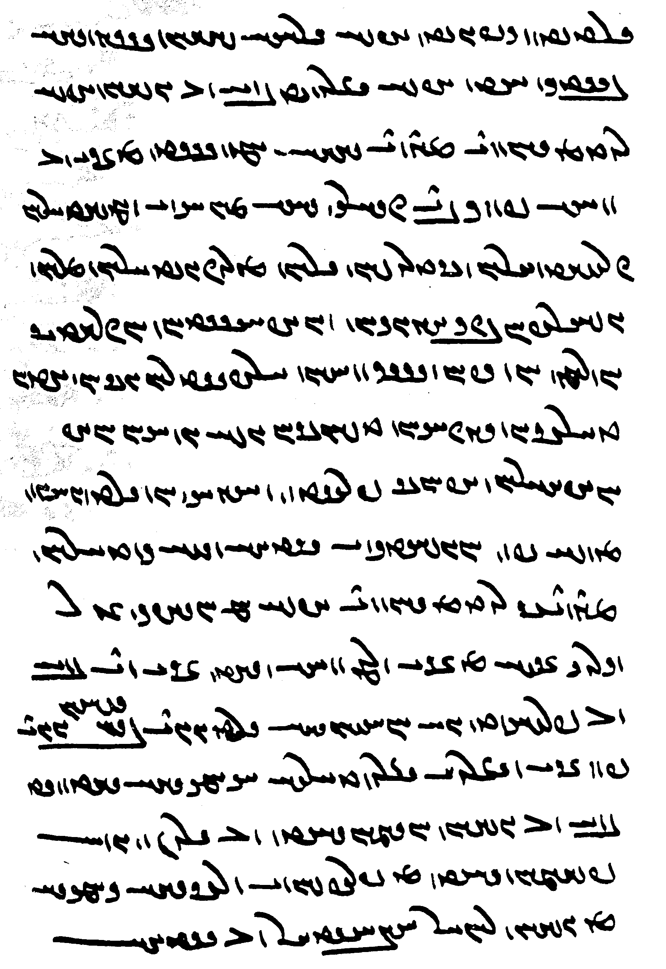
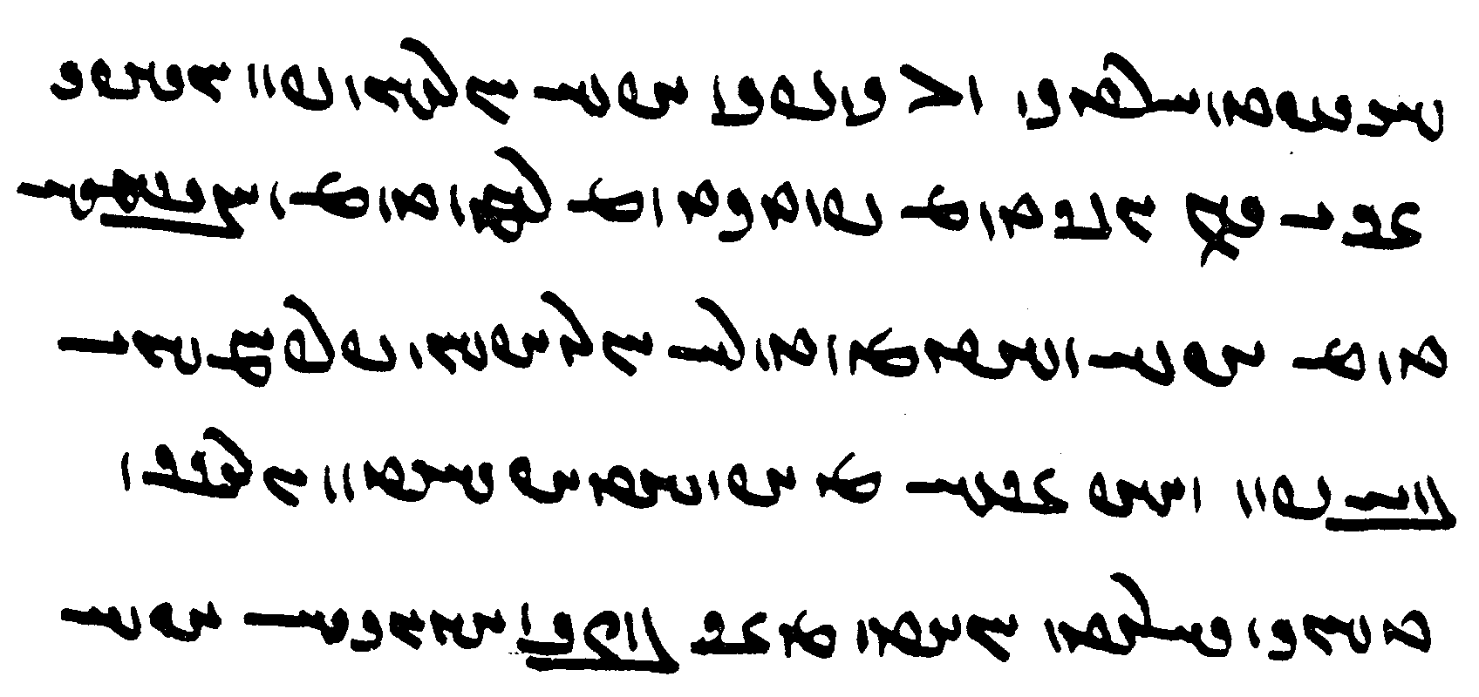
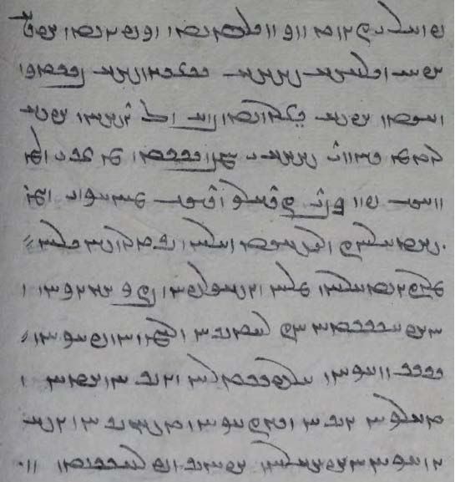
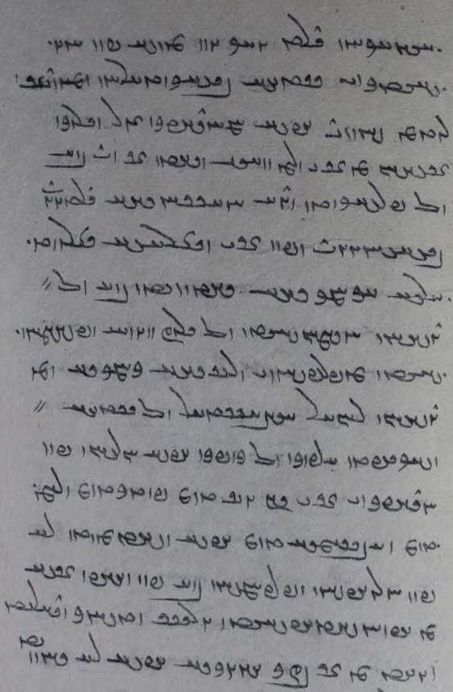

Lesson 23

The spelling of Avestan words 1. Vowels
Avestan words were adapted to the Pahlavi sound system to varying degrees. Some became common words, but some were only quoted in special contexts. Most of these words are proper names of gods, seasons, etc., but there are also other technical terms.
Sometimes the names are found in various forms. Quite commonly, a genuine Persian form is used next to the Avestan form. Occasionally, more than one learned Pahlavi form of an Avestan word was in use.
See Buyaner, 2009.

Short a is sometimes spelled ’ after y before consonants:

ï>ΩyM , ï>ΩadM <my’zd, myzd> myazd (a ritual meal) Av. miiazda-
WtjaDCwY <ywcy’st'> yuǰyast (a measure) Av. yujiiasti = 16 hāθra

More frequently, short a is spelled ’ before <-y-> when representing the Avestan diphthongs aii and aē:

ÂYP , ÂïÅP <p’ym, pym> pēm milk Av. paēma
WwïåJ <s’yn'> Saēn Av. Saēna
Wt:jAW <w’gylt'> Waēgird Av. vaēkərəta
–sïåD <d’ys-> daēs- ul daēs-, Av. uz.daēzaiia- “build up”
Wt¬MwïåD <g’ywmlt'> Gayōmard Av. Gaiiō marəta
Wt¬MKwïåD <g’ywkmlt'> Gayōmard
Wt¬MKwsaD <g’yywkmlt'> Gayōmard
Wwï:da¸wA <’wz’ylyn'> Uzaērin, Uzērin evening-time Av. Uzaiieirina-
WwahYtdAP <p’ytyšt’n'> paitištān leg Av. paitištāna-
[WwahYTP <ptyšt’n'> padištān]
á˜WwA <’nwm’y> anumay sheep Av. anumaiia-

Examples of <-’w-> for Av. ao and <-’wk-> for -aō- and -ō- are rarer and occasionally found in non-Avestan words:

WWTwadßYP , WWTwaåHP <pšyd’wtn', pyšy’wtn'> Pišyaotan, Pišyōtan Av. Pišiiiaoθna (PR.54)
WTPWwÍ for WTPWwaD <g’wnwpt'> gaonwad, gōnwad Av. gaonauuat- “with gut?” (Nir.)
WBwATKWY <dwkt’wb'> Dugdōw, Dugdaw Av. Duγδōuuī
WCwlYwAWWt˜ <mtr’wdlwc'> mihrōdruz A. miθrō.druj- “contract-breaker)
ÄPwahYP <pyš’wp’d> pēšōbāy “(religious) leader”
µAnLCwaHW;% <slwš’wcln’m> srōšōčaranām a punishment
ÍKwAcÅ <’p’wkš> Apaōš Av. Apaoša, demon of drought
Wt¬ATwlyYKwaHwY <gwš’wkslwt'hlt'> gōšōsrūd-xrad wisdom acquired through hearing;
Av. gaošō.srūta- xratu-

Occasionally, and Avestan long ā Ä is rendered as Ä <’y>, e.g.:

WTc:¥Ä <’yglpt> āgrift a degree of sin Av. āgərəpta-

Avestan initial i- and ī- are sometimes spelled with <y->, e.g.:

LtjAWtjG <ystw’stl> Isadwāstar Av. Isa.vāstar, son of Zarduxšt
YWwsY <yswnd> Iswand Iswand son of Warāz from the Turian towns, one of the sacrificers at the end of time
WthY <yšt'> išt Av. išti-, īšti- “wish”

Note the common Pahlavi form of Avestan Arəduuī Sūrā:

LwïDwYkLA <’ldywswl> Ardīwsūr

The word ǰeh, ǰahī(y) “whore” (Av. jahī), plur. ǰahīn, ǰehīn, which may be a distortion of Av. I ī or, perhaps, the plural in -īn. Imitations of the Avestan spelling as well as other spellings are also found. The initial <y-> often has the diacritic of <ǰ> or is written double, and the Avestan j is often added above the word. The scribes obviously had difficulties with this word, which they tended to identify with various other familiar words, e.g.:

îåD. , îåD <yhyd> ǰahīy YîD , îD <yyḏ(y)> ǰeh (?)
WwïåD. , WwïåD <yhyn', jhyn'> WwïåJ <yyhyn'> ǰehīn
WwïåJ , WwïåjY <yyyhyn', yyhyn'> (DH265v18-19) aJ <yyh> ǰeh (PY)
= WwaåJ , WwahA <’š’n', yyh’n'> (B362) aDîD < yyḏyh> ǰehīh “whoredom” (TD2, p. 255)
WwYcåÅwY <yw’’p̄yn'>, <jah-yn'> for Av. Iháj

Long vowels are often indicated by a <-k>. Most frequently we find <-wk> for ō or ū, but also <-yk> for ī (perhaps for older <-yd>:

YwSKwï¬YW <nylywksng> Nēryōsang Av. Nairiiō.saŋha-
WKwï¬YWkwaåÅtD <yt’-’hwkwylywk'> Yatā-ahū-wēryō Av. Yaθā ahū vairiiō
SwaHKwS <swkš’ns> Sōšāns
ItjA <’styk> astī = Av. “there is” (Pahl. Y.20.2)
WtÅKWtDM <mytwkht> mihōxt Av. miθaoxta

The spelling with k is sometimes found in Pahlavi words:

etc., ÍKwYW , - ßAKwYW <nywhk-š-, nywkš-> niyōxš-, niyōš- listen

It is also found in foreign words:

ÄPwsa¬YP <pyl’swkp’y> fīlāsōfāy philosopher

A <-k> is also found to express Avestan and foreign a (ā)

WtåDKPtÅ <’tpkd’t'> adwadād abandonment Av. *aδβadāta
(a kind of crime) literally: “left on the road”
WkaHWK WklAK <k’lk' kwš’k> kāla-koša kāla-kośa, a Sanskrit work

Note also the attempts to render Av. auuao/ōrišta-, auuao/ōirišta-, a degree of sin:

WtÔÌLWwA , WthLWwA <’wwl(y)št> awōrišt
WthlYWwA <’w(w)ylšt> awōyrišt, ōyrišt
WthlYWwA <’wwkylšt> awō’irišt (L4_59r.1, v.1)
WthLwïÅ <՚ywylšt> ayōyrišt (?) [ŠnŠ-Sup 11.1]

Example:
abar wizārišn ī ǰād bāzāy ud war ud arduš <’lkdwyh> ud ōyrišt <’wwly’t> ud agrift <’yglpt> ud adwadād <’tpkd’t> wināh pad *paššinǰagīh <pšncys> ud kār ud pādifrāh ud ēwēnag ī asp-aštar ud srōšōčaranam ud čiyōn †abāgizišnīh ī harw dō
“about the explanation of the sins (wināh) by ‘sprinkling’ (‘contamination’: paššinǰagīh) (by the categories of) ǰād, bāzāy, war, arduš <’lkdwš>, ōyrišt <’wwlšt>, agrift <’gylpt>, and adwadād”

The spelling of Avestan words 1. Consonants

Avestan b is spelled b or p:

WtDvïÅ <’ybgt'> ēbgad Av. aiβi.gati-
Âï:J]JvïÅ , Âï:J]JcdA <’yb/pslwslym> ēbsrūsrim Av. aiβisrūθrima-
ÂïÒT]JvïÅ <’ybslwtlym>
<’ybykgy’n> ēbgayān Av. aibigaiia- $$
WwaDwaDvïÅ , WwaDwaDcdA <’yb/py’nghn'> etc. ēbyānghan Av. aiβiiåŋhana-

Avestan and Psalter D <d> can be represented by K , K> (often a bit larger than regular K)or D , D> , e.g.:

MwYIWW <nwyḏynm> niwēyēnam I invite Av. niuuaēδaiiemi
IIWW <nwyḏyk> niwēyīg inviting (?)
ÍwYklA <’lkdwš> arduš a degree of sin Av. arəduš
º>Ó∆D , kÓ∆D <syšḏ, syšd> sīžd Av. sīžd-
º>ÍwlA , kÍwlA <hlwšḏ, hlwšd> xružd (xruǰd) Av. xrūžd-
ÍwLkLwA <hwlḏlwš> xurdruš epithet of Xešm Av. xruuīdruš “with the bloody club”
See DD.36.89 in all the manuscripts.

The name Ardwīsūr Av. Arəduuī sūra is spelled variously in the texts, e.g.:

LwïDIwï¬A <’ldwykswl> Ardwīsūr Av. Arəduuī sūra
LwïDwYkLA <’ldywswl> Ardīwsūr alUs,Ivdrla
LwïDWklA <’ldwswl>

Here, too, the K <k> may reflect an earlier form of <d>, as in the Psalter and Avestan D <d>, and the <yw> may be for Av. I ī.

Loan-words from Avestan often retain their t (also from θ), e.g,

ìtJ <gytyḏ> gētīy Av. gaēθiia-
WtDtDP , WtDTP <ptyt', pytyt'> patīt, petīt Av. paitīta

Avestan uu (= w) and β (= v) are often represented by <p>, e.g.:

WTPWwYC <cynwpt'> Činwad Av. Cinuuatō
WtåDcJtDwY < ywdtdypd՚t'> ud-dēw-dād

Avestan θβ (and δβ) is variously represented either as <sp> or <tp>, e.g.:

WwAIcjA <’sp̄yk’n'>,<’sp̄yd’n'> Āspīyān Av. Āθβiiāni-
WwYPtDpL <lpytpyn'> rabihwin Av. Rapiθβina-
WtåDKPtÅ <’tpkd’t'> adwadād Av. *aδβadāta (a sin): abandonment)

Note a few Avestan words in -sr from Avestan -θra-:

:Jwa˜ <m’nsl> mānsr Av. mąθra- “sacred utterance”
:jaÅ <h’sl> hāsr Av. hāθra- a length measure
:jYwY <šwysl> dōysr Av. dōiθra- “eye”
:jYwÍ <šwysl> šōysr Av. šōiθra- “settlement”
yōǰdahr

As well as in <-tl> for Avestan -dra-:

LTwÍ <šwtl> šuhr Av. xšudra- “seemen” (DD.77.13)

The number of times a text should be recited:

bišwadag
srišwadag
čahruswadag

Corresponding to the Avestan sound ṣ̌, which is originally from rt, we find <š>, <hl, hr>, or <rt>.
The forms with <hl, hr>, render the original quality of the sound ṣ̌, while the forms with <rt> rd are the original Persian forms:

Av. Aṣ̌a vahišta:
WthAwßA <’šwhšt'> = Ašwahišt WthAWTwA <’rtwhšt'> = Ardwahišt

Av. aməṣ̌a spəṇta:
YWfJahmA <’mš’spnd> = amešāspand YWfJwaÂA <’mhrspnd> = amahrspand

Av. frauuaṣ̌i, frauuašinąm:
ßAwLP <plw’š> = frawaš (as if frawaxš “growth”)
laÅwLP <plw’hl> = frawahr
WtÒwLP <plwlt'> = fraward WwYtÒwLP <plwltyn'> = frawardīn

Av. Maṣ̌iia, *Maṣ̌iiānī-:
îhM <mšyd> = Mašīy ìwaåhM <mšyd’nyd> = Mašyānīy
î¬a˜ <mhlyd> = Mahlīy ìwaå¬a˜ <mhlyd’nyd> = Mahlyānīy
ìWt˜ <mtryd> = Mahrīy ìwaÅWt˜ <mtryd’nyd> = Mahryānīy

Thus also:
MwßAP , MwÍP <p(’)šwm> = pašom, pāšom MwlaÅP <p’hlwm> = pahlom

Avestan -ž- spelled <-š->:

lsadÍwY <ywšd’sl> = yōždahr
aDkßïJ , kßïJ <syšk, syškyh> = sīžd, sīždīh, Av. sīžd-

Phraseology

expressions of possibility

čand čārīg

expressions of Intent, Neglect, and similar

pad wināhgārīh
~ a-wināhīh “by (deliberate) sinning: deliberately” (“for the heck of it”)
abāg wināh-ēw (PV.13.55a)

ān ī andar gētīy ō mard nē brēhēnīd estēd nē rasēd ān ī brēhēnīd estēd ast ī tuxšišn rāy pēš bē rasēd
ud ast ī pad wināhgārīh ud aǰgahānīh az-iš appārīhēd
“that which is not allotted to man in this world does not come; (as for) that which is allotted, some (of it) comes earlier by diligence, and some of it is taken from him because of sinful activities and sloth” (DD.70.4)

abar wināh ī nasāy pad wināhgārīh niganēnīdan čand zamān agārīh zamīg (ī) andar nigān kunīhēd
“about the sin of burying nasāy with sinful intent (i.e., deliberately); (and) how long (does) the uselessness of the earth (last in which) it is buried?” (Dk.8.44.11)

kas kē pad wināhgārīh nasāy-ēw ō āb abganēd pad gyāg margarzān
“someone who deliberately throws a nasāy into water is margarzān on the spot” (ŠnŠ.2.76)

abornāyīg kē-š pid pad wināhgārīh xwarišn ud dārišn nē dahēd kas bē parwarēd
parwardār pādixšāy ka kār ud windišn čand parwarišn guharīg ī parwarišn rāy abāz gīrēd
ka kār ud windišn pad parwarišn nē bowandag ān ī nē bowandag guharīg pid bē dahišn
“an underage child, which the father deliberately does not privide with food and upkeep, (but then) somebody (else) raises (it), is the one who raises (it) authorized to recover work and income as much as (the cost) of raising (the child) as substitute (= in return) for raising (it)? — when the work and income does not suffice for raising (the child), the father has to give (= pay) in return as much as the insufficient (amount)” (MHD.28.6, MM chap. 14)

mard warzīgar kē pēšag āb ō kišt ud warz burdan ud agar-iš andar āb pad a-wināhīh nasāy bē šawēd
nē tan rēman nē margarzānīh ō bun
“a farmer whose trade is to bring water to kišt ud warz and, if a nasāy gets into the water for him (but) not deliberately, (his) body is not polluted nor does ‘being margarzān’ accrue to him” (ZFJ.517)

Pyšksyl-ēw ēd ka (pad) wināhgārīh ud ēd ka pad a-wināhīh ā-š hamē frazend abāz nimāyēnd
“one (follower of) Pyšksyl (said): whether deliberately or not deliberately, they always show him a child again” (ZFJ.617; about saying the correct Avestan formulas when urinating and what happens at the end of time when they do or don’t) [on ēd ka ... ēd ka, see Lesson 10]

Both the literal and techinical meanings are assumed in the following:

kē nasāy pad a-wināhīh xwarēd ēg-iš rēmanīh ud wināhgārīh čiyōn. pad tan rēman
wināhgārīh nē dānam čē ka-š a-wināh guft wināhgārīh būd nē šāyēd
“someone who eats nasāy (but) ‘without sin(ful intent)’ not deliberately, what is the status of his being polluted and ‘having committed a sin’” — He is polluted in body. — As for his ‘having committed a sin’ I don’t know, for when he said ‘without sin’ it cannot be ‘having committed a sin’” (ZFJ.515)

pad nigerišn, pad abar-nigerišnīh “deliberately (“by inspection,” i.e., having seen it should not be done, yet does it)
pad sūdagīh “by neglect” (not caring, because cannot be bothered)

pad ēč rāh nasāy pad nigerišn ǰōyīdan nē dastwarīhā
“in no way is it according to the dastwars to ‘chew nasāy’ deliberately” (RAF.57.2)

kē-m tō bišt hāy hād harw kas and bišt estēd kū-š ēn tis a-dastwarīhā guft
kē pad menišn kē pad gōwišn kē pad kunišn
kē pad dōšišn pad nigerišn ud kē pad a-dōšišnīh pad sūdagīh
“you whom I may have harmed—that is, everybody (who) has been so much harmed that he said this is against the dastwars—whom (I may have harmed) in thought, speech, action, whom (I may have harmed) by choice.—i.e., deliberately,—and whom (I may have harmed) not by choice,—i.e., by neglect” (PY.1.21)

ǰeh kē abāg an-Ērān ud Ērān tan-gumēzišnīh kunēd dādestān čiyōn
kē šusr bē ō ham gumēzēd dahmān ud a-dahmān dēwēsnān a-dēwēsnān tanābuhlagān a-tanābuhlagān pad abar-nigerišnīh
3 ēk ābān ī srōdēnišn tagīgīh pādīrānēnēd
“the wicked woman who has intercourse with non-Iranians and Iranians, how is her legal position?
whoever mingles the sperm of good and bad Zoroastrians, demon-worshipers and non-demon-worshipers, those whose bodies are forfeit and those that are not, by looking at them, she stops one-third of (all) fast-flowing rivers from flowing” (ZFJ.619–20)

pad ēč rāh ud pad ēč tis sūdagīh

REA.12.9
ud agar-iš nīrang ∵ yōǰdahrgarīh hammōxt estēd dānēd kerdan nē pad nigerišn bē pad sūdagīh tis ēw aziš ǰuttar kunēd az ān ī abāyēd kerdan ēg-iz wināh pad sūdagīh wināh xwārtar

PR.18e.1 gyāg ēw paydāg kū
kē ātaxš ī warahrān nišānēd ātaxš ī a-dāštār ī a-pahrēz čand wēšist tuwān ā-š bē čīnišn
18e.2 būd dastwar [D21] kē-š ēdōn guft kū 1000 ud ēk bē čīnišn
18e.3 ud kē ātaxš-ēw bē čīnēd ud bē ō ādurōg ī ātaxš ī warahrān barēd ā-š 90 kerbag
18e.4 kē pad sūdagīh bē ōzanēd būd dastwar kē-š ēdōn guft kū marg-arzān bawēd
18e.5 ātaxš ī warahrān ēd ka pad sūdagīh ud ēd ka pad nigerišn harw čiyōn bē [T60²_36r] ōzanēd ēwarīhā marg-arzān bawēd

ŠnŠSup.14.2
kē dānišnīgīhā pad barsom ī a-pādyāb ayāb pad barsom kē tāg marag wēš ayāb kam
ud abārīg urwar ī ⎡ pad barsom ⎤ nē šāyēd drōn yazēd
ayāb barsom sar ō abāxtar dārēd nigerišnīg ud abestāg gōwēd ∵
ayāb kē pad sūdagīh ud an-āgāhīhā yazēd
ā-š nē pad guft dārišn o

kē wars ud nāxun pad nigerišn bē abganēd ēg-iš dēwēzagīh čiyōn kerd bawēd •
ān mardōm kē pad-iz sūdagīh kunēd ēg-iš dēwēzagīh ēdōn kerd bawēd čiyōn ō pēš gōwam
“he who throws (away) hairs and nails intentionally, then how will he have sacrificed to the demons?
that man who also does it by neglect, then he will he have sacrificed to the demons in the way I say before (= ‘above’)” (ZFJ.607, after PV.17.1b)

xwēškārīhā “when it is one’s business”
(when it is what one should do according to one’s station in life)
a-xwēškārīhā “when it is none of one’s business”
(when it is not what one should do according to one’s station in life)

kē a-xwēškārīhā andar awiš šawēd harw bār-ēw tan wastarg bē šōyišn u-š tanābuhl-ēw wināh o
ud ka xwēškārīhā andar šawēd nē kerbag ud nē wināh
“when someone goes into (a place where someone died) without ‘having (legitimate) business’ (there, then) each time, he has to wash body and clothing, and a sin of one tanābuhl (accrues ) to him;
and when he goes in, ‘having (legitimate) business’ (there), it is neither a good deed nor a sin” (ŠnŠ.2.53)

ēn ruwān ī ōy druwand zan kē az mard ī kasān a-xwēškārīhā ābustan būd u-š kōdak tabāh kerd
“this is the soul of that wicked woman who became pregnant from just any man (az mard ī kasān), which was none of her business, and destroyed the child” (AWN.64.4–5)

pursišn: dār ī a-kār kadār
passox: ān kē nasāy padiš barēnd ... ān kē mard padiš ō dār kunēnd ān kē handām ī zan ī daštān abar rasīd
ka bē kārēnd šāyēd ayāb nē – nē
ka a-xwēškārīhā bē rōyēd čē kunišn
passox: pad hamāg kār šāyēd
“Q.: which counts as a tree that cannot be used for anything (a-kār)?
A.: that which they bring a carcass upon .. that on which they hang a man, that which a limb of a menstruant woman has reached;
(Q.:) when they plant it (in that place?), is it appropriate or not? – (A.:) (it is) not!
(Q.:) when (a tree) grows up which ‘has no business’ (to be there), what shall one do?
(A.:) it can be used for everything” (ZFJ, 344–5; cf. PV.5.4C, PV.5.4E)

pad yazdān dušmenīh “deliberately” (“because of being an enemy of the gods”)

ka pad yazdān dušmenīh bē ō ātaxš ayāb āb abganēd margarzān
“when someone throws (hair and/or nails) onto the fire or water, (he is) margarzān” (ZFJ.608–9)

xwāyišnīg “deliberate” (“sought-after”)

ud šusr-wanīgārīh an-ešnōhrīhā ud yazdān tar-menišnīhā ud xwāyišnīg drāyišn-ǰōyišnīh ud abārīg ī druz-aziš-zāyišnīh guft estēd pad an-ēwēnīh ud a-dādīh dād ēwēn-šnāsān nē gumānīg
“and destroying semen in such a way as to show ingratitude and to scorn the gods, and deliberate chattering while chewing, and the other activities that have been said to cause the lie-demon to be born from them are not in doubt to those who know the law and the custom to be against custom and the law” (Dk.5.24.21)

wars ud nāxun kē pad nigerišn bē abganēd
ayāb pad ēd menišn bē abganēd kū ul stānam
ayāb ka-š pad sūdagīh bē abāzīh az-iš bē ōbadēd
ayāb kē nē pad ēn menišn bē abganēd kū ul stānam
ayāb pad a-wināhīh bē abganēd
ēg-iš dādestān čē •
(ZFJ.608, after PV.17.4A)

ka pad nigerišn bē abganēd ēg-iš dēwzagīh rāy tanābuhl pad bun ud pas wināh ī az wināh
ud ka nē pad nigerišn bē abganēd u-š tanābuhl pad bun
ka pad ēd menišn kū ul stānam wēš nēst kū sē srōšōčaranām
bē agar bē pōsēd ayāb ō āb rasēd bē ō xrafstar bawēd
čē ēg-iš tanābuhl ōh bun
pad sūdagīh wēš kū 3 srōšōčaranām
ka pad yazdān dušmenīh bē ō ātaxš ayāb āb abganēd margarzān
pad a-wināhīh čē tis-iz nēst •
(ZFJ.608–9, after PV.17.4A)

PV.7.23-24. – About eating nasāy.

dādār
čiyōn awēšān mard yōǰdahr hēnd ahlaw Ohrmazd kē nasāy frāz xwarēnd ī sag ī bē widerd ayāb mardōmān
u-š guft Ohrmazd kū a-yōǰdahr hēnd ahlaw Zardušt
awēšān-iz mard gilistag-kirrēnišn hēnd
Abarg guft ay gilistag-išān bē kanišn ud dil-kirrēnišn hēnd ...
ēn az Abestāg paydāg
ān bawēd ka-š nasāy pad wināhgārīh ǰūd estēd rēman margarzān u-š šōy nēst
pad ēn nīrang ī az Abestāg paydāg bē ōzanišn
ka-š pad a-wināhīh ǰūd estēd ā-š šōy ast u-šān pad kardag warr gōmēz ōh dahišn
Creator!
How can those men become pure, Righteous Ohrmazd, who eat dead matter from dead dogs or men?
And Ohrmazd said: they are impure, Righteous Z.!
And those men should have their dens cut down.
Abarg said: the meaning is (that) their dens should be dug out and their hearts should be cut out ...
This is manifest from the Avesta:
That is the case when he chewed dead matter deliberately; (he becomes) margarzān and there is no wash (by which he can become pure).
According to this ritual that is manifest from the Avesta, he shall be killed.
When he chewed it not deliberately, then there is a wash, and they should give him, as is the practice, ash and gōmēz in the usual way.

ZFJ, p. 670
kē nasāy pad wināhgārīh xwarēd rēman ī margarzān šōy nēst
ka a-wināhīh xwarēd rēman pad pišag šōyišn
He who eats dead matter deliberately, is polluted and mararzān and there is no wash.
When he eats it not deliberately, he shall be washed with the pišag.

ZFJ, p. 653
wināh ī nasāy-ǰōyišnīh čiyōn
nasāy pad xwēš kāmag ǰūd xwad paydāg čē dil kandan abāyēd
ān ī agāmāy ud nē pad kām andar ǰast rēman ud margarzān nē bawēd
How is the sin of ‘chewing dead matter’?
Chewing dead matter by his own free will is obvious, for one should tear out his heart.
He who did it unwillingly and not by free will—he incurred pollution, but does not become margarzān.

Additional reading 18.$$
From the ZFJ: about

ŠnŠ.2.105–6, cf. ZFJ.515–6 (Lesson 19$$)
zan ī ābustan kē nasāy pad wināhgārīh-iz ǰōyēd rēman ud margarzān u-š šōy nēst
ud abornāyīg ka pišag-šnās bē bawēd ā-š warr ud gōmēz ōh xwarišn u-š ōh šōyišn
abornāyīg ī az ēk-barān zāyēd ka-š pid ud mād harw 2 nasāy pad wināhgārīh ǰūd estēd ān ī zāyēd pad gyāg pāk čē zāyišn rēman nē bawēd
A pregnant woman who ‘chews’ nasāy deliberately is polluted and margarzān, and there is not ‘washing’ for her.
And when the child becomes (old enough) to ‘know the pišag’, then it should crink ash and gōmēz in the usual way, and it should wash in the usual way.
A child that is born from a ‘one child’ (?) (woman), when its father and mothe have both ‘chewed’ nasāy deliberately, that which is born is clean on the spot, for being born does not become polluted.

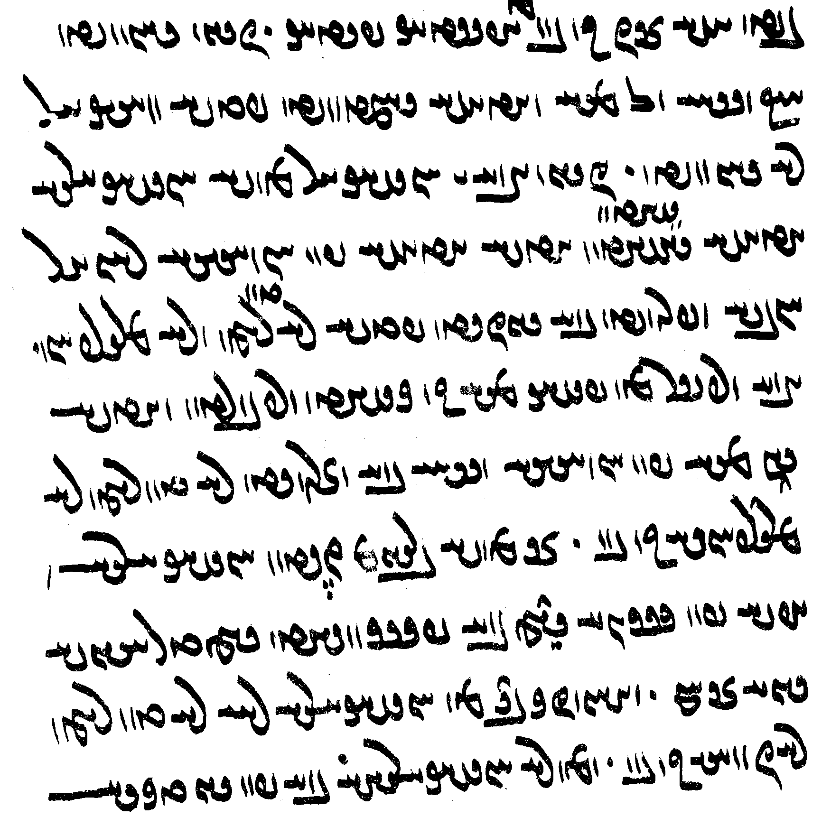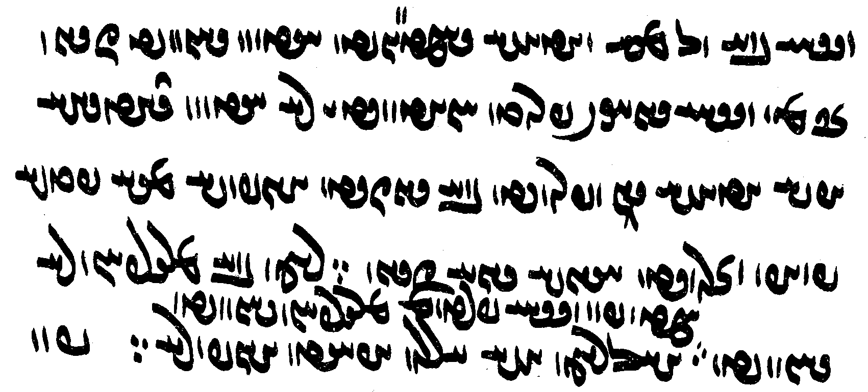
čiyōn bawēd kū nasāy ō āb ud ātaxš rasēd padiš wināhgār nē bawēd •
čiyōn mard ī xwēškār kē-š xwēškārīh ātaxš yaštan
agar-iš ātaxš pad a-wināhīh abāz awiš ōbadēd bē sōzēd pad-iš
nē tan rēman ud nē margarzān •
mard warzīgar kē pēšag āb ō kišt warz burdan
ud agar-iš andar āb pad a-wināhīh nasāy bē šawēd
nē tan rēman nē margarzānīh ō bun •
ān kē-š barsom čīdan xwēškārīh w /
u-š pad kārd dast bē brīnīhēd dast tarr
ēg-iš dādestān ān ham •
ud anīz was kē xwēškārīh rāy nē tan rēman nē-iz wināh ō bun •
ud kē nē xweškārīhā bē pad sūdagīh [518] nasāy bē ō āb ud ātaxš rasēnēd
ēdōn bawēd čiyōn ān kē nasāy gyāg-ēw frōd nihēd ī nē ēdōn dādīhā
u-š ātaxš andar ōbadēd bē sōzēd
ayāb-iš āb padiš frāz šawēd
ēg-iš dādestān čiyōn ∵
rēman bē margarzān nē bawēd ∵

Notes:
yaštan: <y’štn'> + <y̤štn'> added above.
Several <KN> for <OL>.
čīdan: <∵cytn'>, with diacritics of Pers. چ.
brīnīhēd: <PSKWNy’t'>.

Lesson 24

Orthography: special forms of letters

An unusual connection of <l> to the top of <y> is found in K43, e.g., 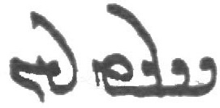 <SLYtl’n>.
In final position, especially at the end of lines, we also find letters written with an extra flourish, e.g.: òAK (J2) for lAK <k’l>; 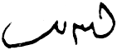 <LAWHL>, 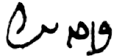 <krt’l> (K20b 12r); 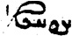 <’’yT '> (DD, T60).
Some scribes write final <-t> with a flourish like Avestan T (e.g., K20). See AWN.4.14 K20, 26.
For cD, we sometimes find ñÁ and ñD, differing from P and cD (e.g., M51); for C we find Ñ; and for <’c> very rarely a form looking like Avestan K.
In some manuscripts (e.g., J2), <k> is often written with an open “head,” and I <yk> sometimes looks like cÁ <yc> or P <p> (e.g., K20b); for <ZK>, Mihrābān often writes 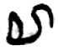 (e.g., K20a) which in K20b is read as c¸ <ZC> . In a few manuscripts (K43), kG <yk> is the standard spelling rather than I <yk>.
Some scribes often connect K <k> to the left, making it indistinguishable from <y>, but then fairly regularly distinguish the two by other features, e.g., the top of the “head”: T44 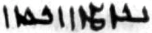 <YKOYMWNyt'>.
The ending aD <-yh> is frequently, especially at the end of lines, abbreviated as óD, in some mss. (e.g., K43) as -S. A similar abbrevation is occasionally found for wY,e.g, óÅ <’yn> (K20 f. 102r l. 6). A similar shape is very occasionally found for final <y/d>: óD /óD>.
There are some special ligatures with <-z->, e.g. z Š <yz>: 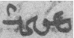 <myzd> (K35 162v), <mzd>: M51, 83/19, K18_43, TD23_26,

<YZLWNšnyh> with <-y-> connected to the upper part of the following <-z-> (e.g., <wyzl’š YZLWNt’lyh> K35 130r); note also 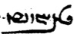 <YZBHWN->.

The actual shapes of the letters vary considerably among the various manuscripts, e.g., an <’> can be connected with a following letter from below:
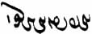 <’pytyd’lk'> apetyārag “without the Adversary” (Dēnkard ms. B:);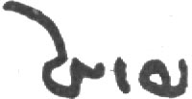 <pwhl> (K43 f. 192v).

the word <byš> is 2x in the first line, one with regular and one with pointed y
and at the beginning of the 2nd line with pointed y.
Note how these <yš> differ from <h’> in <ch’lyhwm> “14th"

Yt.1.8e
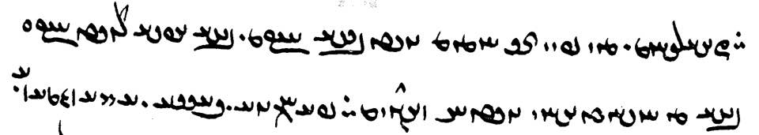

<ym, sm>
<nkylym>
µS µ˘∑

expressions of permission and ability

dastwarīhā, a-dastwarīhā “(not) according to the dastwars”
pad dastwar (Dk.9.13.2) “according to a dastwar”

ud-ka-iz-išān pad ān ī niyābag gugārd xwēš tan kē andar frēzwānīg sālārīh dāštan nē tuwān ahlawdād xwāstan dastwarīhā pad čār ud tuwān
az aǰgahānīhā zīyistan ayāb a-tuxšišnīhā xwēš tan kē andar sālārīh abē-zīyišn bē hišt nē dastwarīhā
“and also when they are not able to maintain themselves by what they have suitably digested, (then) it is according to the dastwars to ask for alms as best they can;
someone who has left himself (= leaving oneself) in guardianship without being provided with enough to live because of laziness of lack of diligence, is not according to the dastwars” (DD.45.7)

kē-iz a-dastwarīhā bē ō kas may dahēd u-š padiš māstīhēd harw wināh ī ōy mast az ān mastīh kunēd ham-wināh
“and he who gives wine to somebody against the rule of the dastwars and (the other) gets drunk from it, (then,) he (is) participant in every sin (harw wināh ... ham-wināh) the drunk person commits because he is drunk” (DD.50.4)

pādixšāy “authorized”
pādixšāyīhā, a-pādixšāyīhā “(not) authoritatively, because (not) having the authority to do so”

ka zan ābustan sarmāg saxt rēman bē bawēd ud bīm kū kōdag wizend rasēd
bē pādixšāy šustan ayāb nē •
bīm ī kōdag wināhīdan pad margarzānīh ī warōmand nē pādixšāy šustan
agar šōyēd wizend andar-iš ǰahēd margarzān
“when a woman is pregnant, there is strong heat, and she becomes polluted, (and there is) fear that harm may come to the child, is she authorized to wash or not? — (when there is) fear of damaging the child, because of potentially becoming margarzān, she is not authorized to wash; — if she washes and harms occurs (to the child), she is margarzān” (ZFJ.635-36)

harw čiyōn-iš weh bē tuwān āwurd pādixšāy stadan nihādan kešidan, ǰud az āb nē pādixšāyīhā burdan
“in whatever way he is best able to bring (the nasāy our (of the water) it is authorized: taking (up), putting down, dragging; (but) carrying it outside (i.e., above) the water is not by authority (not autorized)” (PV.6.29I)

gyāg-ēw nibišt kū ka-š pad xwēšīh būd ī dastwarān guft
ka-iz ēn nē gōwēd kū-m ka pad ān dastwarīh xwēš ēg-iz-iš pad dastwarīh ī ōy ī guft bawēd kū-m xwēš
čē anīy ēwēnag būd nē šāyēd
Wahrām guft kū ka pēšēmāl gōwēd kū ēn xwāstag Ādur-farnbay xwēš būd (az?) Ādur-farnbay ō Mihrēn az Mihrēn ō man mad ud man xwēš ud a-pādixšāyīhā Farrox dārēd
Farrox pad nakkīrāy pad nē ēdōnīh ī ān hamāg tis ēdōnīh ī xwēš abāz abāyēd guftan
“in one place it is written: when he spoke (= referred to) the ‘belonging’ (pad xwēšīh būd) of the dastwars (= what the dastwars said about ‘belonging’), (then) — even when he does not say this: ‘it belongs to me according to that decision of the dastwars, then, too, it will be for him according to the decision of the dastwars that he referred to: ‘it belongs to me’; for it can be in no other way;
Wahrām said: when the plaintiff said: ‘this property belonged to Ādur-farnbay; (from) Ādur-farnbay it came to Mihrēn, from Mihrēn it came to me, and it is (now) mine; and Farrox holds it (i.e., has it in his possession) without having the authority to do that’; (then), to counter this (abāz) and repudiate it (pad nakkīrāy), Farrox must speak to why that whole thing (what has just been explained) is not like this and to why it belong to him’” (MHD.20.6) — Note the difference between dārēd “holds/has in his possession” without it necessarily belonging to him (xwēš).

pad-dād, a-dādīhā “(not) according to the law, (not) appropriate, (not) deserved”

pad-dād “according to the law, appropriate, deserved”:
panǰom rawāg-dēnīh rāy kerbakkarān mizd bazakkarān tōzišn pad-dād nihādan
“the fifth (advice) is, for the sake of propagating the dēn, to assign, ‘according to the law’, reward to those who do good and repentance to those who do evil” (PT.30.11)

kē xwēš tan pad dādwarīh ud dādestān dārēd ēg sūd ī xwēš rāy ōy ī did ziyān ud ān-iz ī-š pad-dād nē nēk sahēd pad kasān nē kunēd
“someone who maintains himself in (observance of) justice and the law, then he does not do damage to another people for his own benefit, nor (does he do to him) that which does not seem good to him (even though it is something) he (should do) ‘according to the law’” (Dk.6C.73)

kē hu-srawtar – ān kē nēkīh pad mardōmān kerdan pad-dādtar dārēd
“who has the better reputation? – he who regards doing good to people is ‘more according to the law’” (AWM.141–2, PT.24)

a-dādīhā “against the law, inappropriate(ly)”
ēn ruwān ī awēšān druwandān kē-šān pad gētīy stōr gāw ud gōspand a-dādīhā ōzad kušt
“this is the soul of those wicked persons who, in the world of the living, killed and butchered kine and sheep against the law” (AWN.74.4)

ēn rōd ān was ars ast ī mardōmān az pas ī widerdagān az čašm bē hilēnd ud šēwan mōyag ud grīyistan kunēnd
ān ars a-dādīhā bē rēzēnd ud ō ēn rōd abzāyēd
“this river is all those tears which people shed after those departed and grieve, lament, and weep;
they pour out those tears inappropriately, and they add to this river” (AWN.16.4–5)

kār ud ranǰ bār ī garān a-dādīhā abar nišast ī wattarān nē framūdan ud a-dādīhā sālār nē hištan ud aboxšūdārīhā ud ēwēnīhā dāštan
“one should not order (animals to perform) work and labor (or to carry) heavy burdens, (or allow) bad people to sit on (= ride them), nore leave them to someone who guards them inappropriately, but keep them with mercy and according to custom” (Dk.5.19.14, cf. PV.15.22)

čāragōmandīhā, ačārag, ačārīg
pad čār, pad čār ud tuwān “when one can help it, deliberately”

The precise meanings of these phrases can be difficult to determine.
$$“when one can help it, deliberately”

ud wizend madan andar gumēzišn ōwōn ačārīg čiyōn nē-iz šāyēd andar gumēzišn ī ō nasāy rāy ōšmārdan ī gand
“and it is as inevitable (for) damage to come (to the creations) in the Mixture as it is also not possible to enumerate (~ evaluate?) the (amount of) stench on account of (= caused by) something being mingled with nasāy” (Dk.5.24.8)

u-š ačāragīhā petyārag a-kār kerdan rāy zamān frāz brēhēnīd
u-š čim ēn kū Ganāg Mēnōy ǰud pad kārēzār nē agārīhēd
kārēzār wizārišn ēn kū kār-ēw pad čār ud čāragōmandīhā kerdan abāyēd
“and having no other way out, in order to incapacitate the Adversary, he (= Ohrmazd) fashioned forth Time´
the reason for this (was) this: the Foul Spirit is not undone except by battle’,
the interpretation of ‘battle’ (kār-e-čār) is this: one should perform an action as best one can and according to one’s means” (Bd.1.36–7)

50om pursišn. ān ī pursīd kū weh-dēn kē may a-paymān xwarēd u-š az a-payman-xwarišnīh ziyān wizend rasēd
ēg-iš dādestān čē ...
pāsox ēd kū kē pad čār ud tuwān may a-paymān xwarēd purnāy ud ōšyār
ēg-iš pad harw ziyān wizend ī-š az ān a-paymān-xwarišnīh rasēd ayāb abar kas tis kunēd ēg-iš ān rēmanīh ō dām kerd ud andar xwēš rāmišn dardēnēd
(DD.50.1–3)

tuwān-sāmān, tuwān-sāmānīhā
tuwān-tuxšāgīhā

hambedīg az bun abē-čim a-kārīhā dwārist
pad tuwān-ǰumbāgīh ud nē nāmčištīg-xwāyišnīhā mad ō sāmān ī ēn rōšn gōhr
“the Opponent rushed (up) from the bottom for no reason and for no purpose
(only) because he could move and not because he sought something particular, and came the limit of this light”
(Dk.5.24.3)

Compass directions

nēmrōz WCwlmYW <nymlwc'> “noon, south”
abāxtar LtåÅcÅ <’p̄’htl> “north”
xwarāsān WwajaÒwA <hwl’s’n'> “east (sunrise)”
xwarōfrān, xwarnifrān WwaÒPwLwA , WwaÒPwaÒwA <hwl’wpl’n', hwlnpl’n'> “west (sunset)”
xwarwarān WwaÒwLwA <hwlwl’n'>

čiyōn gōwēd kū
Tištar Xwarāsān spāhbed Sadwēs nēmrōz spāhbed Wanand Xwarnibrān spāhbed Haptōring abāxtar spāhbed
“as it says: Tištar is the general of the East, Sadwēs the general of the South, Wanand the General of the West, Haptōring the general of the North” (Bd.2.6)

The seven continents

Arzah <’lzh> in the east
Fradadafš <plyt’pš> in the south(east?)
Widadafš <wydt’fš> in the south(west?)
Xwanīrah <hwnyls> in the middle
Sawah <sw’h> in the west
Wōurūbaršn <w’wlwblšn', w’wlwblšt'> in the north(west?)
Wōurūǰaršn <w’wlwclšn', w’wlwclšt'> in the north(east?)

az ānōh kū xwaršēd pad rōz ī mahist abar āyēd tā pad rōz ī keh abar āyēd Xwarāsān
kišwar Arzah
az ānōh kū pad rōz ī keh abar āyēd ✓ tā pad rōz ī keh bē šawēd kust Nēmrōz
kišwar ī Fradadafš ud Widadafš
az ānōh kū pad rōz ī keh andar šawēd tā pad rōz ī meh andar šawēd xwarwarān
kišwar ī Sawah
az ānōh kū pad rōz ī mahist abar āyēd tā ānōh kū pad rōz ī mahist andar šawēd kust ī abāxtar
ud kišwar ī Wōrūbaršn Wōrūǰaršn
(Bd.5b.7-10)

ka xwaršēd abar āyēd kišwar ī Arzah ud Fradadafš ud Widadafš nēm-ēw az Xwanīrah tābēd
ka pad ān kust ī Tērag andar šawēd kišwar ī Sawah ud Wōrūbaršn ud Wōrūǰaršn nēm-ēw az Xwanīrah tābēd
ka ēdar rōz ānōh šab čē kōf ī Tērag rāy šab paydāgīhēd
(Bd.5b.11)

Money and price

harw hamāg-dēn-ēw ī pad-zōhr ī pad būm ī pārs bē yašt hēnd ēg-iš dāšn 400 dram kamist (DD.87.1)

pad ayādagīh ī man “(as far as?) I can remember” (DD.87.7)

Persianisms

Occasionally we find the auxiliary šudan (as in modern Persian):

zad šud ān kas kē pas az im rōz pad ēč zan pad gēhān wistāx abēgumān bawēd “that person was destroyed (= will be destroyed) who after this day trusts and relies on any women in the world” (KN.9.7)

12 māh Frawardīn rōz ī Hordad Frēdōn baxšišn ī gēhān kerd o
13 Hrōm ō Salm dād ud Turkestān ō Tūz dād Ērān šahr ō Ēriǰ dād o
14 ud 3 duxtar Bōxt-husrō Tāzīgān-šā bē xwāst ud pad zanīh bē pusarān dād o
15 Salm ud Tūz andar pidar a-burd-framān šud hēnd ud Ēriǰ ī brād ī xwēš rāy bē ōzad hēnd o

LESSON 25

Enclitic pronouns after subordinate clauses
ka mard w zan az zanīh hišt bē čiyōn ān zan pad xwēš tan sālār pādixšāy kunēd ēnyā-š pad sālārīh ō kas nē dahēd (MHD.19.4)

Enclitic pronouns spelled with <AP-> or <ZY->
agar-iz gōwēd ān kē kanīg kū pus ay mard ī-t <GBRA ZYt> warzīd ay az tō ābustan ham “And if she, the young woman, says: “the child, O man, you made,” i.e., I am pregnant from you” (PV.15.13)
that

Gods and demons
$$

From the Bundahišn 5

à WTPwY WthE q EthA YWwï˜ WkAwY ī WklYTP OW a˜wAwA WwïDA
WWbE WwßgAtJ W WwlgY elAbsA L ī µE> OW q YWwï˜ WkAwY
/aÅWWwE WwßAWcÅ W WwßAwïDA W WwaÂlzA W glmA WwßEtÅP ã WWP īW
WwßgAtJ MWWbE âL elAbsA kL ī µE OW MWwlgY âL à YWwï˜ WkAwY Wtja¬Y>
EwÍBwláÂA áÂA īW MwYCwlM kL ī cdmE kL AWB
/ L ī EtJwY> kL ī EtJwï>Å OW kL ī µE> WcJwlA µYcåÅ AWB

ēg Ohrmazd ... ō padīrag ī Gannāg Mēnōy āštīh abar dāšt guft kū Gannāg Mēnōy abar ō dām ī man hayārīh bar ud stāyišn dah tā pad ān pādāšn amarg ud azarmān ud asōhišn ud apōhišn bawē.
drāyīd Gannāg Mēnōy kū nē baram ō dām ī tō hayārīh nē daham stāyišn bē tō dām-iz ī tō marnǰēnam tā hamē hamē-rawišnīh bē hāzēm harwisp dām ī tō ō adōstīh ī tō dōstīh ī man.

From the Mēnōy ī xrad 8

AbGK WWP ī eÄKwY ÍcÅ WTWK EWwÍWwïJwY WklAP W eLBWtåD AbGK WN WTWtjA # tÂA W
MNwA NwA WTPwY EWwlâLP W EtjâL ī WwÍCwlG> TcÅ βANwA WtJWWbGtD # wïDA WTWWbE
WTWK W WTPwY W WtDwï˜ tdZ WthLWwA W WtÅwA W Wt˜wA # ī AwA
MNwA WTWWwE Wima¬G tÂA W MNwA WTWK AWB LTIWwÍcÒWB TwïDA MNwA WTWWwE WIWwÍcÒWB tÂA nM
MNwA WTWK AWB CLTima¬G TwïDA
MNwA WTWK AWB LtDNwAnS MNwA WTWB ī>NwAnS tÂA W
WtdaŸÂâlaÅ q WthLWwA WWP LItJ W WtÅwA WWP LItD W Wt˜wA WWP µE MWtÒP oaÅ
WtDWWtÂE q elâwA kaÂA ī EWÍwL LSA ī ã OW AWB µE MwlaÅC W
ī ã N WwïDC à Y>wïJWWP ÍcÅ WwaJ W Y>WWtåD WklGTP OW WwE>WcJWwaÂA W WwaåD WwïDnaÅ ÍcÅ
βANwA Wt˜ WklaÅTpA ī WwAwaÅ WcŸjA ī NwY OW WwAwaÅ EkAwaJW ī ī>NwaÂGB ī ī>NwAcŸJ
WwïDwA ī WwÍWWKwA ī WwÍBwYwA ī WwÍwï˜wA ī WwEwY
WkAtDwY WWT imâlG ī ã N nM WtŸJWWP ÍcÅ EN oA Íà WtDWWWnG ÄTwA ī a˜wAwA oaÅ
WtDWnGWkG WTWWtåD sâL WWāµGB ī ã WWP W
ã N WwABwL WtdajA Íà WtDWwlg>G ÍBwA WwABwL .mərazōiiδiam. ī ã MWtÂïJB WwAwßLwA ÍcÅ
WcJwlA ī sE WWP ÍcÅ Wt˜ ÍBwA WwaåH WIwAcÅ W WtåÅWtjA N ßgZ lAWP WKpÍ 3 ī
MWtÂïJB EwßlGTW AWB N oaÅ ilÄW W Oā¸ WBwlaÅ à WkAtDP WwïDC WtDwaHW q WtŸŸJP
sE WWP ÍcÅ ī>Wwlg>Y ÍBwA [WwABwL .mərazōiiδiam. ī ã gZK] WwaåD WwE>Wwï˜ gZK WwAwßLwA N
NTwL WtDWnGWkG elAwA WcJwlA WWP EwÍBwL áÂA W áÂA ī>W Y>wYwAWWbGtD AWB WtŸŸJP WcJwlA ī
aåDwÍBwL ÄµA WwaåD WwE>Wwï˜

Glossary

Appendix: Adverbs, preverbs, Prepositions, postpositions, and ambipositions

abĀg (NTwL <LWTE>)
“with, together with”
Sāsān ... hamwār abāg gōspandān būd
“Sāsān was always with the (domestic) animals”

u-š Zarduxšt abāg rawēd
“and Zarduxšt walks with him”

ka Pišyōtan āyēd ēg-iš sad ud panǰāh mard abāg bawēnd
“When Pišyōtan comes, then 150 men will be with him”

ān mard ī-š abāg pad asp kē
“who is that man who is with him on the horse?”

kārēzār abāg Kirm kerdan rāy kas frēstīd Burzag ud Burzādur ō pēš xwāst abāg uskārd ud was drahm ud dēnār ud paymōzan stad
“for fighting the battle with Kirm, he sent somebody (to get) Burzag ud Burzādur (and he) asked them before him, discussed with (them), and (they) received much money and clothes” (KN.8.2)

“even with, in addition to, despite” MHD $$

abāg-iz ēd kū hamāg stahmag pas-iz andar ēn zamān stahmagtar bawēd
“in addition to the fact that (=in addition to the fact that) they are all fiercely (cold), after that, during this period, it is (even) more fierce” (PV.1.3)

nikōhēm dēw hād abāg-iz ēd kū ka-m ahlāyīh stāyīd ā-m dēw nikōhīd bawēnd ā-šān pas-iz pad ǰudāgīh bē nikōhēm
“I scorn the demons, i.e., in addition to the fact that, when I (already: in Y.11.19) praised Righteousness, the demons will also have been scorned, after that I scorn them separately” (PY.12.1)

abāg-iz škeft kōxšīdārīh ī druz ud garān wišōbišn ud zūrīh ī ō dēnīgān mad estēd pas-iz pad yazdān xwābarīh nūn-iz radān mowbedān ... pad cand gyāg hēnd kē pad-iz ōwōn dādestān šnāxtan ud dānistan ī rāh awēšān wišādag $$

abāg-iz ān ī zarduxšt az dēn abar wattarīh waštag-dēnīh ī zahag ī purr-marg karbān ī wištāsp anīz was kay ud karb ī abar dar ī wištāsp hamīh ī-šān abar ōš ī zarduxšt wirāstan ... āgāh būd (DK.7.4.64)

abāg-iz xwadāyīh ud pādixšāyīh ī-š abāg pas-iz ēd rāy čē mardōmān az wirrōyišn šud estēd nē abzāyēd $$ (Dk.6.21)

ān y juwān abāg-iz hunarāwandīh ō ān bowandagīh ī hunarāwand pad dād-mehīh bawēd nē mad estēd
“that youth, even in spite of having all the good qualities, has not arrived at that perfection that a person of good qualities has because having reached adulthood” (Dk.3.30)

abāg ... ham-čim:
5.19.24-25

abāg ... hammis:

az ... abāg:
xwēš-pāyagīhā kadār-iz-ēw hu-dēn; ka pad kām xwadāyīh ī-š abar xwēš gētīy ud mēnōy xūb dārēd rāyēnēd ēg-iš ān pahlomīh ī abar gētīy xwadāyīh az mēnōyīg burzišn abāg
“each and every one is hu-dēn according to his own station; when he governs at will the sovereignty he has over his own gētīy and mēnōy, then the excellence he has over the sovereignty of his gētīy (comes) with the approval of (his) mēnōy” Dk.3.389.10

abāg-iz ān ī nibišt kū ka gōwēd kū xwāstag ī ō xwēšīh ī amāh āgenēn ēd-iz čē ō xwēšīh ī amāh ǰud ǰud mad ān ī āgenēn mad ud ǰud ǰud mad rāy guft bawēd nigerīdan
“and together with = in addition to that which is written that, when he says that “the property that came to us together and this whatever came to us separately,” (then) one must look closely at that which came “together” and that which came ‘separately’” (MHD.20.12)

az ... abāgīh
“with, together with”
ābādīh az ahlāyīh abāgīh “prosperity together with rightousness” PY.28.2 (Av. āiiaptā aṣ̌ā hacā)

pad abāgīh ī, pad ... abāgīh
“with, together with”
pad awēšān zēy abāgīh ‘together with those weapons”

abar (q , Q <QDM>)
“on, onto, upon”:
This adverb/preverb expresses 1. upward movement, 2. movement onto or toward. In some cases abar may continue an OIr. preverb and have no specific meaning.

ō Ohrmazd tar menīd u-š pad ān tar-menišnīh ā-š zarmān abar ōbast
“he scorned Ohrmazd, and, for that scorn of his, old age fell upon him”

ān xwāstag abar awēšān pad xwēšīh mānēd
“that possession remains with them as their own”

abar artēštār ī a-tōšag kē pad rawišn abar wāstar ud jōrdāy ud gōspand frāz rasēnd kē fšēy aziš bēgānag “about soldiers without provisions, who, during their march, come across pastures, grains, and beasts, whose shepherd is absent” (Dk.8.22.6)

u-š mardōm kē xwarišn nēst abar frāz rasēnd
“and some people who have no food come upon him” (Dk.6E.31g)

abar “about, concerning”:
ān zand-āgāhīh nazdist abar bunyādīh ī Ohrmazd ud petyāragīh ī Gannāg Mēnōy pas abar čiyōnīh ī gēhān dām az bundahišnīh tā frazām
“that knowledge from the Zand (is) first about the original establishment of Ohrmazd and the adversity of the Foul Spirit, then about the nature of the creation of living beings, from the original creation to the end”

ud ašwahišt passox gōwēd kū tō ān-iz āgāh hē abzōnīg abar
“And ardwahišt answers: ‘You also are aware of that, O you who make increase’” (after Dk.7.2.18)

abar “in addition (to)”:
Ohrmazd pad ān gāh hangerdēnīd-dām bawēd kū kār-ēw abar nē abāyēd kerdan andar ān ka-šān rist wirāst
“at that time, Ohrmazd’s creation will be completed, that is, nothing in addition needs to be done when they have restored the dead” (Bd.34.22)

With ābustan:
pad ham šab abar Ohrmazd ī Šābuhrān ābestan būd (KN.13.22/12.23)

abar ō:
pas Widrafš ǰādūg abar ō pāy estād
“then Widrafš the sorcerer stood on his feet”

agar Zarduxšt frōd barēm abar ō astōmandān gēhān
“if I bring Zarduxšt down to the bony world of the living”

abar pad “at (the time of)”:
ēg abar pad ān zamān dēwān hanǰamanēnīd
“then at that time the demons gathered”

abar ... rāy “about”:
abar 5 xēm ī āsrō rāy
“about the five qualities of the priest” (Dk.8.28.5)

See also pad ... abar; ēr.

Preverb:
abar hištan “let get up” (AWN.54.6)
Sām abar āxēzēd “Sām rises”
Kāy-Us abar grift xwadāyīh ī haft kišwar “Kay Us took up the rule of the Seven Continents”

pas ō ātaxš abar mad “next he came upon the fire”

u-š zamīg xrafstarān abar hišt
“And he let loose noxious creatures upon the earth” (Bd.4.15).

pad marnǰēnīdan tag abar kerd
“he attacked in order to destroy (it)”

pādifrāh ī az yōǰdahrgarān abar rasēd
“the punishment that comes upon (them) from those who make (the world) ritually pure”

abar raft hēnd pad xwēškārīh u-šān kerd kām ī dādār
“they went about their duties and did the wish of the Maker”

abar raft ō zadan ī an-Ērān
“he went to crush the non-Iranians”

ēg frāz raft Pōrušasp u-š awēšān wastarg abar šust
“then Pōrušasp went forth and washed their garments”

ēn ān ast ān ī pahlom ēwēnag ī andar frārōn-tuxšīh abar xwarrah xwāyišn (Dk.3.135.3)

abāz “back”
This adverb/preverb expresses backward movement and “backward” action and return (local or temporal), repetition, remainder, and retention (hold back).

abāz ō xwēš buništ tābēnd “they (the heavenly lights) shine back toward their own place of origin”

ud tar-menišnīh ī dēn abāz-stāyišnīh “and the scorning of the Religion, foreswearing (it)”

pas abāz ō pēš ī Ardawān šud “then he went back to Ardaxšīr”
Ardawān ka-š pad ān ēwēnag āšnūd abāz wašt “when Ardawān heard that, he turned back”
az kū mad hēm ud abāz ō kū šawēm “from where did I come, and to where do I go back?”
Tērag ī Hariburz ān kē-š star māh ud xwaršēd padiš andar wardēnd padiš abāz āyēnd “the top of Hariburz (is) the one upon which the stars, moon, and sun turn around (and) come back to”

u-m ān zan ud ān frazend ī-š andar aškamb ī mādar abāz ayād būd “and I remembered again that woman and the child in the womb of the mother”

ēdōn čiyōn Ohrmazd pad bundahišn dād abāz bawēd “as Ohrmazd had established (it) at the original establishment, it will become again”
kanīzag ān saxwan čiyōn-iš ō Ardawān guft ... pēš ī Ardaxšīr abāz guft “the girl repeated to Ardaxšīr what she had told Ardawān”

3 rōz abāz būd tā pas bē zād “3 days remained until he then was born”
ka az 3,000 sāl gētīy-estišnīh anēbgatīg 330 sāl abāz būd “when 330 years were left of the 3000 years of being in material state without the Invasion”

ān sāl wārān bawēd. sāl ī fradom sē bār pad hāmīn sē bār pad zamestān abāz estēd “that year there will be rain; the first year it ceases three times in summer (and) three times in winter”
az dām petyāragīh abāz dārēd “he withholds the adversity from the creation”
pad frārōnīh bēš az dāmān abāz dāram “by doing good I keep harm away from the creatures”
ud ka 330 sāl abāz būd “and when 330 years remained”

andar (x <BYN>)
andar expresses movement inside (and similar) and is used idiomatically with some verbs.

“in, among; within”
Ohrmazd bālistīg ... andar rōšnīh hamē būd “Ohrmazd was up above in the light”;
mān mānāg kē harw tis andar pāyēd “like a house in which he guards everything.”
u-š kōšk asēmēn ud dandānag zarrēn u-š čahārdah kōf andar u-š haft rōd nāydāg andar u-š haft murw kē-š pānagīh pad xwadāyīh šāyēd kerdan andar “and it has a silver turret and golden crenelations, and there are 14 mountains inside it and seven deep rivers inside it, and there are seven birds inside it, which he can protect by his reign”
pad-iz kerbag ud kerdagān paristišn ī yazd ud stāyišn ī-š weh dahišnān kē andar mardōm ān ī madayān “serving god with good deeds and praising his good creations, among whom mankind is special” (Dk.5.24.26a)

“with respect to, toward”
Ohrmazd andar ōy ačārag “Ohrmazd (was) helpless with respect to (= against) him.”
andar hamahlān ērtan ud čarb ud hučašm būd “he was humble and amenable and benevolent with respect to (= toward) those of equal social standing!”

Dk.3.175.6
ēk ān ī pad aburd-framānīh ī andar xwadāyān margarzānīhēd
Dk.3.175.7
ēk ān ī zan ī kē pad a-tarsagāhīh andar šōy margarzānīhēd

“in, during”
andar ān kārēzār “in/during that battle.”
andar 3-šabag nē nigerišn (PV.16.11)
ud ēn-iz kū andar 57 sāl ōy bawēd abesihisn ī 2-zang-tōhmag (Dk.7.11.4)

“within”
ātaxš andar 3 gām ī nasā burdan tanābuhl-ēw wināh “..” (ŠnŠ.2.40)

“between”
hamē ka mard tis abārōn ul menēd ud gōwēd ud kunēd ēg tam-ēw az-iš ul āyēd ud andar mard ud dēn ul estēd ud mard dēn kam wēnēd (Dk.6.290)

With verbs:
ēbgad andar dwārēd “the Invasion runs inside.”
abzār-ēw ī-š pad kār andar abāyist “a tool which he needed for the work” (see Lesson 9)
gōš andar dārēd “listen!”
pad farrox abāyēd dāštan ān dad kē tar asp sar ī man andar tuwān widerdan “one must count that animal lucky that was able to pass in front of the head of my horse”
ān ī wirrōyišn andar ud ān ī nē wirrōyišn andar “that which one should believe in and that which one should not believe in” (after Dk.3.100)

andar ō “on, about”
band-ēw andar ō grīw abganēd “he throws a rope around (his) neck.”
az ān ī ka kerbag bē ō rawāgīh rasēd waxš andar ō abzāyišn estēd (DD.9.2)

andar ān-ēw ka “at the time when” (MHD.)

zūd andarrōn andar šud “he quickly went inside”
ka Ahrimen andar dwārist “when Ahrimen rushed inside”
Abestāg ud zand čiyōn abēzagīhā andar āmad estād “the Avesta and its commentary as (= to the extent) it had come down in pure form ...”
Ardaxšīr ud pus ī meh ī Ardawān az pas ī ān gōr taxt ud Ardaxšīr andar rasīd
Gannāg Mēnōy pad šnūg andar ōbast “The Evil Spirit fell on (his) knees”
pad tan saxt andar kerd estēd “it is firmly wrapped around the body”

abzār-ē ī-š pad kār andar abāyist “a tool that he needed for the deed”

Note andar abāyēd ... andar ... andar ...:
pad ān ī pad zīndagīh andar abāyēd tuxšāgīh
ud pad ān ī pad ruwān andar xwēš-kārīh ... sūdōmandtar (Dk.6E.32)

kār ī frazāmēnīdan nē šāyēd andar nē griftan “not to start something one cannot finish” (AyWM.46)

ANDARG (ylYwA , ylYwA <’ndlg>)

ud raft ī-š hammis awēšān ud andarg rāh ō ham rasīd ī ōy ī sūdōmand ī pērōzgar sōšāns “$$” (Dk.9.23.3)

andaRrōn, andarōn (WwLx , WwlYwA <BYNlwn', ’ndlwn'>), andaRrōntar
“in, among; within”

u-š dām hamāg andarrōn ī āsmān bē dād “”

az (N <MN>)
“from”
az ān zofr-pāyāg āxist “he rose up from that deep place”

“from, because of”
Ganāg Mēnōy az bīm pad šnūg andar ōbast “for fear, the Foul Spirit fell to his knees”

az ... abāz “since”
az 7 sālag abāz frazend az ōy pad nihān būd “since (it was) seven years old the child was hidden from him”
u-m az ēn and sāl abāz az ašmāh pad nihān dāšt “and since (az ...abāz) these many years I have kept (him) hidden from you”
hu-frawahrān hu-dēnān pēšōbāyān ī az dūdag ī hu-fraward Ādurbād ī Mahrspandān ī az 5 ud 6 āwādag abāz az abēzag dēn (ī) ast frahangān frahang ī harwist-pēsīd dānāgīh wizārd “$$” (Dk. col.)

az ... rāy
az bīm ī Ardaxšīr rāy ō ēn gyāg āwurd ham “for fear of Ardaxšīr I was brought to this place”
man čim ī ēn čatrang tā im-rōz az ān čim rāy bē nē wizārd tā ašmā ud harw kē pad ērān-šahr hēd bē dānēd kū andar ērān-šahr man mard ī dānagtar ham “For that reason, I have not explained the meaning of this Chess game so that you and all (of you) who are in Iran should know that I am the most knowledgable man in Iran”

az ... ōrrōn $$

With various verbs and adjectives:
pursīd az pērōzgar Srōš ahlaw “he asked the victorious, Righteous Srōš.”
āsmān az petyārag tarsīd čiyōn gōspand az gurg “the sky feared the Adversary like a sheep (fears) the wolf”
az wizend ī dāmān kerdan (bē) nē estēd “he will not refrain from (stop) doing harm to the creatures.” (Bdh.27.2[1])
Gannāg Mēnōy... az astīh ī Ohrmazd anāgāh būd “the Foul Spirit was unaware of the existence of Ohrmazd”
Pābag pus az šāh pad nihān dāšt “Pābag kept the boy hidden from the king”
xwēš-kārīh ī dēn tan az wināh puhl ud kirbag mizd āgāhēnīdan “the proper function (duty) of the dēn is to inform the body of the punishment for sins and the reward for good deeds”
xwēš-kārīh ī ham-pursagīh ī dānāg tan az waran ud xwad-dōšagīh pādan “ the proper function of the wise man is to protect the body from greed and self-indulgence”
ka-šān wēnēnd ōzanēnd ayāb aziš pahrēzēnd “when they see them, they kill (them) or stay away from (them)”
ka menišnīg abaxš ud pašēmān az wināh bawēd “when one is repentant of one’s sin”

az ... bē “from; because of”
az Wahman bē māh tāšīd estēd ... az māh bē gōšurūn tāšīd estēd (Ny.3.1)
awēšān kē nē ahlāyīh menēnd az awēšān bē dūr ast Wahuman “those who do not ‘think’ Righteousness, Wahuman is far away from them” (PY.34.8c)
az ān bē “because of that”? (PV.5.4K)
(az) petītīgīh bē rāh ī ō dōšox nēst “because of repentance, there is no road to hell” (REA.26.3)
ōy hamē pad-ōš kē harw čē menēd ud gōwēd ud kunēd az yazdān bē “$$” (Dk.6E.45g)
az ēd (ī) ka āgenēn ǰud-gōhr hēnd bē ēd bē abāyēd nigerīdan kū čē rāy ēdon “because they are of different gōhr together, one needs to look into the following: why is it like this?” (Dk.6.110)

az man bē “as far as I am concerned”

ān ī sag bē ka-š pōz ayāb <’cylw’y> pāy ayāb rēš wēnēd ēg-iš nē zad bawēd •
az man bē ka-š mōy
ēdōn guft
ō bē mōy (ī) pōst nē paydāg ēnyā-š Nasuš zad bawēd

(ZFJ, p. 505-6)

az bē ka ... az ham bē
“with the exception when / unless ... except that ...
(NM.2.2.3b)

az dast ī
u-tān nimāyēm kū čiyōn zad bawād dēw az dast ī yazdān “and I shall show you how the demon is struck down by the hand of the gods”
ud wad-gōhr ēd rāy wehān nē dōst bawēnd čē-šān zamān ī pad abesihēnišn zanišn az dast ī wehān bawēd “and good people will not be friends with (someone) of bad nature for this reason, (namely) because at the time of the destruction, there will be smashing for them (= the bad) at the hand of the good” (MX 54.6)

Note the expressions for “devoid of, free from, untainted by”:
abēzag az, āzād az, bē az (below), pāk az, tuhīg az.

az
guarding, avoiding (mōš-)

nōg-widurdān ān ī 3 rōz andar āmār az yazišn paristišn a-wizīrišnīg čiyōn nōg-zādagān-iz andar ān tarōgīh az parwarišn pāsbānīh abēr a-wizīrišnīgtar “the newly departed cannot do without the sacrifice and worship (during) the three days in the count, just as newly born one cannot do without care and watching even more” (DD.80.3)

azabar (LPcÅ <hcpl>)
“over, above”
u-m dīd ān ī rādān ruwān kē azabar ī abārīg ruwānān pad hamāg rōšnīh “and I saw the souls of the generous, who were above the other souls all in light”
ēg azabar awēšān starān ī agumēzišn winnārd “then, above (them), he arranged those unmixed stars”

azĒr ( lYcÅ <hcdl>)
“under, beneath, below”
azēr ēn zamīg hamāg gyāg āb bē estēd “under this earth, in every place, there stands water”

u-š azēr ī mayān = ud azēr ī mayān ī ōy Dk.9.20.3
u-š āsmān azēr ud azabar zamīg tom kerd “and he made the sky beneath and above the earth dark”

ud harw rōz azēr bāmdād (DH.8)

For azēr we also find ēr, contrasting with abar.

bĒ (AWB <BRA>)
“except”
ēč zīndag abāz bē nē mānēd bē ān ī ēk Arǰāsp “no one remains alive except that Arǰāsp only” (AZ)

bē az “without, devoid of”
rōšn gil ī (bē) az tārīkīh āb ī bē az zahr ud ādur ī bē az dūd “light clay without darkness, water without poison, and fire without smoke” (WZ.35.50).
nē-iz sazāg raftan abē-bandīhā bē az daxšag ī xwadāy bandagīh (DD.38.11)

harg ud ranj ī andar gēhān nē wizīrēd bē ka barīhēd ō grīw padīrift estēd “(he) has accepted upon his neck (himslef) the toil and trouble which, in this world, there is no way out other than that it is borne” = (Sh. Shaked:) “which one has no choice ... but to endure” (Dk.6.80)
az ān frāz nē xwad pādixšāy bē ka ān kunēd ī-š druz framāyēnd “from then on, one is not oneself authorized other than to do that which the druzes command” (DD.93.4)
drōw bē ka dānēd kū wazurg bōzišn ud sūd ī ahlawān aziš tā hamē hagriz nē guftan “unless one knows that it is (means) great deliverance and profit for the Righteous from it, one is never to speak a lie ever” (Dk.3.32.2)

bē ... tā “except”
bē man tā anī kas nē mānd estēd “no one is left except me”
pas az ān ī ka druz ō dām dwārist bē Zarduxšt tā az gētīyān kas-iz nē dīd haft kišwar “after the Druz rushed upon the world, no one of the people in the world except Zarduxšt had seen the seven continents” (PR)
ud pad ān dašt bē ǰōrdāg ud xwarišnīg tis ī kārēnd ud drūnēnd ud padiš zīyēnd tā anī drūnāy ud draxt ud urwar nēst “and on that plain, except grain and eatable things that they sow and reap and live from, there are no other reapables, trees, or plant” (MX.61.21)
ud ka-š abāz ō draxt ī mādagwar nē estēd bē ka-š az bē ōbastan bīm tā frōd nē barēd “and if the corpse does not reach back to the trunk (of the tree, then), except when there is fear of falling, it does not carry the (impurity) downward” (ŠnŠ.2.29)
ka-š murw-ē ēw-kardag abar bē abganēd bē pad rāh ī hamkarzag tā rēman nē bawēd “if a bird ‘throws’ (sth.) on it that is connected with it, it does not become unclean except by way of having a part in common with it” (PV.3.14|N|)
az kišwar ō kišwar be pad parwān ī yazdān tā šudan nē tuwān ast (PV.1.1)

... tā “except”
ka bē stad tā xwardan nē pādixšā “Unless he has taken it, he is not permitted to eat it” (H. 19.7)
andar warōmandīh-ēw tā ō šarmgāh pādixšāy ka nē nigerēd “Unless there is doubt, she is permitted not look (all the way) to the genitals.” (PV.16.2.3)
gōgušnasp guft hād mard ka hērbedestān wattar bē bawēd tā “Gōgušnasp said: hād, unless a man is worse off (?) [or worse equipped for?] for going to hērbedestān” (H. 1.3.2)

ēn ān bawēd ka-š abar rasēd tā ka-š abar nē rasēd framān-spōxtan rāy wēš nēst kū srōšōčaranām-ēw (PV.6.9)

nē anīy ... bē “no other ... than”
nē anīy čim bē pahrēz ī āb ud ātaxš rāy “no other reason than for the sake of the protection of water and fire” (Dk.8.19.56)

bē ... ēnyā
“except”
hamāg mardōm bē huzārag ēnyā bē abesihēnd “all people will be destroyed except a few” (Bdh.)
nūn bē ka rāst gōwē ēnyā hamdādestān nē bawēm “now we shall not be in agreement other than if (= unless) you speak the truth” (KN.)
bē ka pad mādayān tis wizōyīhēd ud šnāsīhēd ēnyā-š ēwāz tuwāngarīh ud was-xwāstagīh rāy az wehīh bē nē ōgārišn “$$” (Dk.6.71)
harw nihuft rāz bē xwad ōy ī harw-dānišn ī purr-āgāh ud wispān wisp ēnyā ēč az gētīyān ud mēnōyān ī an-espurr nē dānist “$$” (DD.36.2)

bē ... (ēnyā, tā) anīy kas
ān ī-tān pad dānistan ud šnāxtan rāh bē man ēnyā ō anīy kas nē būdan framūd nibištan (DD. 0.7)
nibišt kū mard zan ud frazend bē duxt-ēw anīy kas nēst (MM.25.2)
az haft frazend ī Mihrōg bē man tā anīy kas nē mānd estēd

bē ... ēnyā anīy tis
ēdar bē dard duš-xwārīh ud anāgīh ī-t padiš kunēnd ēnyā anīy tis nēst “$$” (PR.2.33)

bē ... rāy = bē or for pad ... rāy?
pad ān kōxšišn bē Wāy ī dērang-xwadāy rāy kū-š pad gāh ō hayārīh nē mad wād stard būd (Bd.21.5)

“out, away”

“outside”
daštānestān ka andarrōn <’nyl’n'> bē bawēd bē-m wirāstan pādixsāy ayāb nē •
bērōn pad āb pādixšāy wirāstan
andarrōn ka kand ayāb ǰud šāyēd

bē 3 gām ka pad bār ud tā wārestān pad rawišn āb abar gīrēd 15 gām nēst šāyēd ayāb nē

bē
This preverb is sometimes used in its original meaning of “out, away,” but more often it is a purely grammatical particle, whose exact function is not altogether clear. In most cases it probably indicates finished action.

bē “out(side), away (from)”
Pābag šab-ēw pad xwamn dīd čiyōn ka xwaršēd az sar ī Sāsān bē tāft ud hamāg gēhān rōšnīh kerd “one night Pābag saw in a dream as if the sun was shining from Sāsān’s head and made the whole world bright” (KN)
Ardaxšīr huram bē būd “Ardaxšīr was happy” (KN)
ud nē az tan bōy bē wardišnīh rāy az weh dēn ī mazdēsnān abāz nē estam “and not for the turning of the conscience out of the body will I stand back from the good Mazdayasnian religion” (PN)
mardōm-iz ka-šān murdan nazdist gōšt ud šīr ud pas az nān xwardan bē estēnd “And people, too, when they are to die, first desist from (= stop) eating meat and milk” (Bd.34.1)

Contrast andar and bē:
dēwān xwāhišn ud ōnāmišn ānōh kū Wourubaršn ud Vourujaršn kišwar ud az ānōh andar āyēd ud bē dwārēd (Bd.28.21)

bē, verbal particle
Pābag ka-š tan-bahr ud čābukīh ī Ardaxšīr bē dīd dānist kū “when Pābag saw the physique and agility of Ardaxšīr he knew that” (KN)
gurbag ud sag ī andar xānag būd hēnd xwarišn bē xward ud abar *gyāg murd hēnd “the cat and the dog who were in the house ate the food and died on the spot” (KN)

agar ātaxš ǰud frāz nazdīktar burdan tā bē nē šāyēd burdan (ZFJ.458)

bē gōw- “finish saying”
ka wāz dārēd u-š gumānīg ēg-iš ǰāmag xwēš tan čiyōn abāg kunišn
u-š wāz bē gōwišn ayāb nē
ud yašt čiyōn bawēd •
čiyōn gumānīg bawēd ēg-iš wāz bē gōwišn (ZFJ.569)

Note adverbs with -andar: bēdandar (Man.), nīyandar, ōrandar (Inscr.), pēš-andar.

bĒrŌn (WWwlYB <bylwn'>)
“out, outside”:
waččag ī murwān andar xāyag ud bērōn xāyag zīyēnd “the young of chicken live in the egg and outside the egg.”
az wardyūn bērōn bē āmad “he came out of the chariot”

Gōšurūn čiyōn ruwān ī gāw ī ēk-dād az tan ī gāw bērōn āmad pēš gāw bē estād čand 1000 mard “when the soul of the one-created bull came out of the bull’s body, Gōšurūn stood before the bull as tall as 1000 men” (Bdh)

“except”
ān xrafstarān ī zamīg hamāg pad ān wārān bē ōzad bērōn huzārag ī parrwar “Those evil animals of the earth were all killed by that rain, aside from some small winged ones” (Bd.6b.7)

Ēnyā “except (for)”

ēnyā ... bērōn “other than, except”

čiyōn-im nibišt a-wizīrišnīg andar abāyēd bē dād nē pādixšā ēnyā az ān ī nibišt bērōn “(which) as I wrote is unavoidably need, is not permitted except that which was written” (DD.53.6)

ǰud ... ēnyā “except (for)”

ǰud az nasāy ī zīndagān rōbāh ud rōbāh-iz ǰud-dādestānīh ēnyā pādyābīh pad 30 gām dārišn
“except for $$
ZFJ.455

frĀz “forth, forward”

Used to express forward movement, but is also idiomatic with several verbs (corresponding to Av. fra-).

pad dast frāz padīrēd “he receives (= takes) it with (his) hand”
nazdist kōf frāz rust Hariburz “The first mountain (that) grew up (is) Hariburz”
pas Ohrmazd Ahunwar frāz srūd “next Ohrmazd recited the Ahunwar”
ānōh frāz mad hēnd “there they came to ...”
nazdist Wahman frāz brēhēnīd “first he fashioned forth Wahman”
ka pid frāz rawēd ayōgēn ī brād “when the father passes away, (the daughter) is the ayōgēn (responsibility) of the brother” (MHD.25.16)
frāz widerd (Bd.4.20)
az xwēy frāz būd (Bd.4.23)

frĀz az
“aside from; after”:
frāz az yazdān harw nēkīh az ōy ast
“except the gods, all goodness (there is) is from him”

kē zan rāy čiyōn sālār ō šōy dād u-š xwāstag-ēw frāz ōy dād zan xwāstag frāz az ān ī šōy xwēš
“(the case of) someone who has given a women to her husband like a guardian and has given some possession to her, the possession belongs to the women separate from that of the husband”

ma ka-iz pad wiškar ka frāz az āškāragīh ud ma pad tangīh Spitāmān ān ī dušwaršt-kunišn warzād
“let him not perform evil deeds either when in a wilderness, when away from visibility, or when in a narrow place, O Spitāman!” (Dk.9.35.6)

kū-m xwāstag ī man xwēš frāz az man ō Ādur-farnbay dād
“that I have given the property belonging to me to Ādur-farnbay after me (after my death) (MHD.27.4)

frāz (ō)
hu-niyāyišnīhā wehān frāz aw-išān dīd
“good people are to look at them (the lights) reverently” (Dk.5.19.26)

ān mard-ēw <dw՚ns> nām abar 30 ud 3 deh pādixšāy būd u-š hagriz ēč kerbag nē warzīd bē hangām-ēw ka-š pad ān pāy-ēw wāstar frāz gōspand burd (ŠnŠ.12.29).

frōd
This expresses downward movement, but is also idiomatic with a few verbs.

andar zreh frōd šud “he went down into the ocean”
agar Zarduxšt frōd barēm abar ō astōmandān gēhān “if I bring Zarduxšt down to the material world of the living”
ēg abr āb frōd burd nōg nōg srišk srišk “then the cloud let down water again and again, drop by drop”

ēg ān frōd murd “then that one died”
frōd ward šnāsam agar tō hē Spandarmad “turn around (so) I may know whether you are Spandarmad”

frōd griftan

HAMMIS (nïÅK <KHDE >), AZ ... HAMMIS
“together with”

weh-dōst mard az hamāg ēn gēhān kerbag abar rasēd az ān ī xwad kunēd hammis (Dk.6.209)

hamwar
“side by side”
u-šān hamwar hamē raft “and he went side by side with them” (KN)

handāzag
“in the manner of”
$$

homĀnĀg (WkAwa˜wA <hwm’n’k'>)
“like, similar to”:
Gōčihr mayān ī āsmān bē estād mār homānāg “Gōčihr stood in the middle of the sky like a snake.”
xīr ī gētīy ō čē homānāg “$$”
homānāg ī $$

with čiyōn:
čiyōn šusr homānāg “like semen.”
ēdōn čiyōn wād homānāg “like the wind”
kē nē az frārōn tuxšāgīh ī xwēš bē az anī tis xwarēd ōy ēdōn homānāg čiyōn kē sar ī mardōmān pad dast dārēd ud mazg ī mardōmān xwarēd “he who does not eat from his own good diligence but from the stuff of others, he is like someone who holds people’s heads in his hands and eats people’s brains”

pad homānāg ī:
“like, similar to”:
sidīgar ēn spahr pad homānāg ī sāl-ēw nihād “thirdly, he placed this zodiac like one year.”
brēhēnīd zamīg pad homānāg ī mard-ēw ka-š ǰāmag ǰāmag hamāg kust pad tan saxt andar kerd estēd “”

MĀNĀG (ī) (WkAwa˜ <m’n’k'>)
“like”

mayĀn (ī)
“in the middle of, between”:
zamīg mayān ī ēn āsmān bē winnārd “he spread out and fastened the earth in the middle of this sky”
mayān zamīg ud star-pāyag hamēstagān “between the earth and the star sphere (is) the hamēstagān (limbo)”
u-šān mayān tuhīgīh būd “and between them was emptiness”

az mayān (ī)
“from the middle of”:
ud andar ān Zarduxšt ā-š az mayān āb ī hōmīgān burd “and in that (river) Zarduxšt took water mixed with hōm from the middle of it”

nīyandar “inside”
nīyandar āsmān Hariburz “inside heaven (is Mt) Hariburz” (PR)
kahas ī mard pad zamīg ī xwēš ayāb pad zamīg ī hmblk’n kunēd ka-š gōš-bālāy * kand ka-š pērāmōn hamāg zamīg ī kasān ēg-iz awēšān kē zamīg xwēš nīyandar-dašt mizd ī ān kahas bē pad hunsandīh ud bērōn-dašt mizd ī ān ks bē pad abē-zyānīh ī ōy [y] * kē kahas xwēš ēg-iš ks kand nē pādixšāy (MHD.85.1)

Ō “to”
Place “to’:
ō wimand ī dīdār ī rōšnān mad “he came to the border (of) seeing the lights”

ō padīrag “toward”:
u-mān ō padīrag āmad awēšān widardagān ruwān “and the souls of the departed came to meet us” (AW 10.2)

ō nazdīk(īh) ī “to” (lit. “into the vicinity of”)
ān kanīzag ō nazdīk(īh) ī Ardaxšīr raft “that young woman went to Ardaxšīr”

ō ... abar
2-buništagīh ōh-iz ī xīrān gēhān paydāg az-iz wihīrišnīgīh ī-šān ō ǰud-čihr abar “The fact that things in the world have two origins is also manifest from their tendency to change into something of different nature” (Dk.3.119.2)

ō ... rōn “to(ward)”
kū ān dō aswār ī ō ēn kustag rōn āmad “where are those two riders who came to this district” (KN)

Indirect object:
ō kanīzag guft kū “he said to the girl”

With verbs:
Gannāg Mēnōy wāng ō γarrānāg ō-iz wāng kuling 6-sālag ō-iz wāng ī xar
ō-iz wāng ī mard ī ahlaw ka a-kāmagōmandīhā zanēd wāng kunēd mānēd “the voice of the Foul spirit resembles thunder, the sound of a six-year-old crane, the voice of a donkey, and the voice of a Righteous man when someone beats (him) against his will and he cries (out)” (Bd.27.51)

pad:
• Local “on, at”:
Ardawān pad Staxr nišast “Ardawān resided in Staxr”
dānāgān ud axtarmārān ī pad dar būd “the wise men and astrologers who were at the court”
Spahān ud Pārs ... pad dast ī Ardawān sālār būd “Spahān and Pārs were in the hand of Ardawān’s chief commander”

Temporal “in, at, over”:
pad ham šab abar Ohrmazd ī Šābuhrān ābustan būd “in the same night she became pregnant with Ohrmazd, son of Shapur” (KN 12)
windišn ī az sālārān nē andar zamān bē pad rōzgār ... ēmēdēnišn “one should hope for gaining (something) from the chiefs not right away, but over time” (Dk.6E.43d)

Abstract “in”:
Ohrmazd bālistīg pad harwisp-āgāhīh ud wehīh ... hamē būd “Ohrmazd was up above in/with omniscience and goodness”

gugāyīh pad “testimony to” Dk.3.117

“in the case of”
war ēwāz pad nē xwēšīh ī Ādur-farnbay warzišn “a war should be performed only in the case it does not belong to Ādur-farnbay” (MHD.20.6)

Instrument, means “with, by means of”:
ān band nē pad mēnōy ī weh ud nē pad mēnōy ī wattar az grīw bē kerdan nē tuwān “that rope it is not possible to detach from (his) neck either by a good spirit or a bad spirit”
ān ī druwand pad ān ī ham band ō dōšox nayēnd “with that rope they lead the evil one to Hell”
Aliksandar ī hrōmāyīg pad grān syazd ud nibard ud yask ō ērān-šahr āmad “Alexander the Roman came to Iran with heavy damage, fighting, and pestilence” (AW 1.3)

8 māh frawardīn rōz ī hordad tahmōrab Ahrimen ī druwand pad bārag kerd 30 sāl

+ verbal noun or infinitive “for, in order to”:
dēwān ud ǰādūgān ānōh pad kōxšišn rasēnd “the dēws and the sorcerers come there to fight” (Bdh)
pad marnǰēnīdan tag abar kerd “he attacked to destroy (it)”
kē ān ī nē dānēd pad kerdan frāz gīrēd ast ī ka ān kār tabāh ud agār bawēd (MX.32.8)

“know, recognize as”
šnāxtan dāštan hangārdan $$
Dk.3.285

āb ō harw kū šawēd pad hixrōmand ēwar ud pad nasāy <p’ š / ’y> warōmand “wherever he goes (in the sauna) the water is certain to be containing hixr and to be tested as certain to containing nasāy” (REA.19.5)
ān kē kas ī pad harw sē čāštag nē rēman pad rēmanīh wizīr pad-iš kunēd pad dastwar nē šāyēd “he who, if somebody is not polluted according to three opinions, makes a judgement about it as being polluted should not be a dastwar” (REA.21.2)

pad .... estādan “remain with, remain the property of (?)

ka Farrox ō Mihrēn gōwēd kū xwāstag ī ō xwēšīh ī man rasēd tō xwēš
pas kas ō Farrox xwāstag dahēd ud Mihrēn andar nē abāyistan gōwēd ān xwāstag pad Farrox bē nē estēd (MHD.24.4)
zan (ī) pad windišn (pādixšāy) pādixšāy kerdan čē windišn pad zan bē estēd ō šōy nē rasēd (MHD.24.5)

“need” pad ... andar abāy-

to instruct in
frāz-hammōxtārīh ī abārīg ox ī astōmand pad wānīdārīh ī druz

pad ... abar:
pad ān wan abar “upon (in) that tree”
pad ān abar bē zanīhist hēnd wisp xrafstar “in that (bucket) all the evil animals were struck down”
pad ān drōzišn abar anōdag būd az rāy xwarrah “for that lying, he was alienated from rāy and xwarrah (DD.38.20)
Dk.7.6.8

pad ... abzār “by means of”
pad abr abzār abāg ham-kārān wārēnd “(these deities) together with the collaborators make rain by means of clouds” (Bd.3.21)

pad ... andar “inside”
ān xrafstar ī murdag pad zamīg andar mānd “those dead creeps remained in the earth”
pad sūrāgīhā ī zamīg andar šud hēnd “they went into the holes in the earth”
Gannāg Mēnōy pad šnūg andar ōbast “the Evil Spirit fell (doubled up) upon (his) knees”
harw ān ī pad bē burdan andar “everybody who is ‘into’ (set on?) removing (it)” (Dk.3.92.2)

pad dast ī

pad guharīg “instead of”

pad ... nazdīk
pad fraškerd zamānag nazdīk (DD.36.92)

pad rāh ī “on the path of; via”
pad rāh ī mowmardīh raft
ud hāmōyēn bahrōmandīh ud padēxwīh ī gēhān pad rāh ī Tištar
(MX.48.6)
pad rāh ī rasēd <kylyn> xwēš “by virtue of, because of (having said) ‘will come’, belongs to K.” (MHD.24.24)

pad ... rāy, see rāy

pad wihān ī “because of, on account of”
pad wihān ī petyārag gumēzišnīh būd (Bd.14.37)

pad + dāštan
pad ān abāyēd dāštan kū “one must assume that ...”

pad + dāštan, tuxšīdan + infinitive
pad-iz wēš awiš mad ēmēd nē dārēd “and he has no hope that more will come to him” (Dk.6E.31g)
pad ō xwēš kerdan nē tuxšēd “does not strive to make (it his) own” (Dk.6E.35a)

With adjectives:
pad kerdan hugartar “easier to do”

with bīm:
pad ān nasāy tan ud wastarg rēman kerdan bīm ayāb ān nasāy pad wišuft bīm (RAF.63.1)

PADISĀY “for the sake of, on account of”
$$

pĒŠ, pēš az “before”:
Ohrmazd pēš az dām-dahišnīh nē būd xwadāy ud pas az dām-dahišnīh xwadāy ... būd “before the establishment of the cosmos Ohrmazd was not ruling king, and after the establishment of the cosmos he became ruling king”

pēš, ō pēš “before, in front of, in the eyes of”:
pēš gāw bē estād “he stood before the bull”
pēš čašm mālīd “he smeared (it) before (its) eyes”
u-š Tūs pēš estēd “and Tūs stood before him”
ō pēš ī Šābuhr mad $$
kū-mān ... az ān bahrag pēš wehān ud hamahlān šarmgenīh abar rasēd
(MX.54.5)

pas (az) “after”:
pas az marg ī Alaksandar ī hrōmāyīg “after the death of Alexander the Roman”
pas az ān ī ka druz ō dām dwārist bē Zarduxšt tā az gētīyān kas-iz nē dīd haft kišwar “after the Druz rushed upon the world, no one of the people in the world except Zarduxšt had seen the seven continents” (PR)
pas az ān (ī) Ardaxšīr ān Kirm ōzad būd abāz āmad “after Ardaxšīr had killed that Kirm” (KN)

az pas ī “after”:
Ardaxšīr ud pus ī meh ī Ardawān az pas ī ān gōr tāxt “Ardaxšīr and the oldest son of Ardawān ran after that wild ass” (KN)
Dk.6.187$$
Bd.13.2-3

pasīy $$

pērĀmŌn “around” (often spelled <pylymwn, pylmwn> and <-mw>, rarely <-mwn'>)
pērāmōn ī Sāsān estēnd “they stand around Sāsān”
u-šān pērāmōn dēwār bē estēnīd “and around them a wall had been set up”

rĀy “on account of, concerning, for the sake of”
Gannāg Mēnōy pas-dānišnīh rāy az astīh ī Ohrmazd anāgāh būd “on account of (his) knowing (everything) after the event, the Evil Spirit was unaware of Ohrmazd’s existence”
Karisāsp bīm az tigr ī Tūs rāy dēn bē stāyīd “on account of (his) fear for Tūs’s arrow, Karisāsp praised the Religion”
Syāwaš ī Kayusān rāy paydāg kū “concerning Syāwaš, son of Kayus, it is revealed that”
gumān kerdan ī mardōmān pad ēn dēn rāy “in order to make people doubtful about this religion”
pādaxšāyīh rāy ī-š hast “on accont of the kingship he possesses (MX.57.2)

With infinitives or clauses:
ān ī xwēš hammōzgār pad ān ī drāztar čōb nē zadan ud nē bēšīdan rāy čē nē āšnawēd az xwēš hammōzgār pad-iš nām nē srawēnēd “in order that your teacher should not be beaten with the longest stick and be hurt, what you do not hear from your teacher, do not broadcast under his name!”
ān xwāstag pad paywand ī ōy mard bē rawēd kē pad ān ēwēnag dāštan rāy paydāg kunēd (MHD.26.5)

abāg-iz ān ī nibišt kū ka gōwēd kū xwāstag ī ō xwēšīh ī amāh āgenēn ēd-iz čē ō xwēšīh ī amāh ǰud ǰud mad ān ī āgenēn mad ud ǰud ǰud mad rāy guft bawēd nigerīdan (MHD.20.12)
wizīr ī mard andar zan ud frazend āwāšēd rāy abām ... kam nē tōzišn “(just) because a man has signed a decision regarding wife and children, a debt (...) is not to be repaid less” (MHD.27.8)
ka <syn'> ud malax kišt ud warz bē abesihēnād sahm bē āyēd mardōm ud urwar bē tabāhēnēd
ayāb zamestān stahmtar bawēd rāy mardōm ud gōspand bē tabāh bēd ā-š ān-iz *ō bun az abestāg paydāg. (ZFJ.517)

Indirect object with “to be”:
ud ōy Wirāz rāy haft xwah būd ud awēšān harw haft xwahān Wirāz čiyōn zan būd hēnd “and that Wirāz had seven sisters, and all of those seven sisters were like wives to Wirāz”

Direct object:
ud čand dastwarān ud dādwarān ud hērbedān ud mowbedān ud dēn-burdārān ud abzārōmandān ud dānāgān ī ērān-šahr rāy bē kušt “and he killed several Iranian teachers and judges and mowbeds and propagators of the religion and experts and scholars”

abar .... rāy
abar pahrēz ī az ēzišn ī Ganāg Mēnōy rāy anāstawān ī dēn (Dk.9.1.1)

pad ... rāy

ud man kartīr az ahīy ōrrōn pad yazdān ud xwadāyān ud xwēš ruwān rāy was ranǰ ud āwām dīd
“And, from the first until now, I Kartīr have endured much toil and trouble for the sake of the gods, the lords, and my own soul” (Kartir §14a)

čāh-ēw ī pad ēn kār rāy frōd kanēnd
“a well they dig for this purpose”

ruwān-iz ī mardōmān pad wināh kerbag rāy āmārēnēd
Bd.26.120

(different) from
agar-iš tis andar nēst ī ān rāy juttar “if there is nothing in it that differs from it (i.e., what has been alleged)”
ka-š tis andar nēst ī ān rāy juttar ōwōn saham kū ... “if there is nothing in it that differs from it, it seems to me that ...” (DD.48.2)

rāy with clauses
wizir ī mard andar zan ud frazend āwāšēd rāy abām tōzišn ī pas az ān xwāstag ī agar ēw-bār ān wizir āwišt * ān mard dāšt kam nē tōzišn (MHD.29.8)

was-iz wihān ī-š abar yašt abēr bawēd rāy az kerdan zyān-ēw nēst (ŠnŠ.12.26)

guharīg rāy “instead of”

ān rāy ... ī “for the reason that, because?

ān rāy guft estēd ī ka ...
NM.1.8.7.

tā
Time “until, for, within”
3 rōz abāz būd tā pas bē zād “3 days remained until he then was born”
tā ka tan ī pasēn bawēd “until when there will be the Final Body”
tā hamē ud hamē-rawišnīh “for ever and ever”
tā 3 rōz-šabān ruwān pad bālēn ī tan nišīnēd “for three days and nights the soul sits at the head end of the body”
amā Wirāz tā haft rōz tan-drust bē ašmā abespārēm “we will deliver Wirāz to you safe and sound within seven days” (AW 2.7)

gōspand ka nasāy bē xwarēd čiyōn tā sāl-drahnāy ā-š gōšt ud šīr ud sargēn ud mōy harw tis-ēw hixr ī grāy
ud pas az sāl pāk
“$$” (ZFJ.524)

tā ō “(all the way) to”
aweštāb tā ō drayāb “hurry to the sea!”

tā pēš “until before”
tā pēš ka ēbgad mad hamēšag nēmrōz būd “until before the Invasion came, it was always noon”

ǰud ... tā
az kišwar ō kišwar ǰud pad parwānagīh yazdān ud arzāwandīh tā šud nē šāyēd (Bd.8.4)
agar ātaxš ǰud frāz nazdīktar burdan tā bē nē šāyēd burdan (ZFJ.458)

tar (<LCDr, LCDR>), tarist Wt∆∂ÒT , Wt∆ÒT (turist Wt∆ÌLWT) “through, via”: $$
gyāg-ēw paydāg kū kadag-xwadā ud kadag-bānūg ka andar xānag bē mīrēnd tar dar ī bērōn bē nē abāyēd burdan čē-š xwarrah ī xānag abāg bē šawēd “in one place it is revealed that when a master or mistress of the house dies, they should not be carried out through the outer door, for the Xwarrah of the house will go out with him (or her)”
paydāg kū dādār Ohrmazd ān ī Zarduxšt frawahr tar hōm ō pidarān ī Zarduxšt widārd “it is revealed that the Maker, Ohrmazd, passed the fravashi of Zarduxšt through the hōm to Zarduxšt’s parents”

$$
Dk.7.4.77 u-š guft pad ān ī wīrān gōwišnīh ātaxš ī Ohrmazd kū ma tars čē-t nē abar tarsišn burzāwend Kay-Wištāsp nē-t ō mān tarist mad hēnd aštag ī abarkār payāmbar Arǰāsp
Dk.9.20.4 ēdōn ān tō gōwēm Spitāmān kū rāstīh mard franāmēd tarist Čēh-widarg ī dūr-nāmīg Čandōg puhl
Dk.7.3.17 ēk ēd ī paydāg kū *ō ōy abar raft hēnd ud Srōš-ahlī ud Wahman u-šān bē ō ōy kurušk ānīd u-š dāyagānēnīd hamāg turist šab
PV.18.5 kē nibast hamāg tarist šab a-yaštār ud a-srūdār [kū abestāg pad yazišn srāyišn mehmān nē gōwēd]. a-šmurdār a-warzīdār a-saxwan [u-š ō ǰahī kāmag pad gyān

TAY ( !YT , !AT , ÄT tyd) “following, after”
Wadargā Frānag ōzadan kāmist Frānag pad xwarrah az tay ī pidar šud “$$” (Bd.35.39)
ōšbām ān ī tay ī xwaršēd abar āyēd “Dāwn is that (deity) who comes up following the sun” (Bd.26.88)
u-š wēmār-iz ud wiyēb ī mardōman ud gōspandān-iz tay az zōrēnīdan ī an-ēr pad zanišn ī ērān “and the sickness and deception of men as well as beasts following upon the empowering of the non-Iranian to strike the Iranians (Dk.3.69.4)

u-š 3 rōz ī tay bē pāyišn ZFJ

tay-ā-tay “in succession”
3 rōz-šabān tay-ā-tay bē pāyišn “she should wait for three nights-and-days in succession” (REA.34.2).

ul
ul expresses upward movement, but is also idiomatic with a few verbs.

ul estād Dugdōw “up rose Dugdōw”

ul ō ān zād ō ān xānag mard ī rāyōmand “a magnificent man is born to him, to that house”
ul ēdar zāyēd abēzag ahlaw Zarduxšt “the pure, Righteous Zarduxšt is being born here”

Appendix 2

From the Pahlavi Rivayat (49.18)

YWwsE lAwaÒ WWtH Wwa¬Ä N WnÍwY W YWWwE NTwL AWbY ∞ ≠ ÍWwïDA WtDWWtåD WWTwaåHP tÂA
Y<WK OW lAwaÒ oaÅ W WtDWwaÅW AWB WwAÈLcÅWa WwïD W WtDWWbYtD WtåÅT OW lAwaÒ WwïD ī ÄTwA
/WtDWwlZW
/WtDWwlZW Y<WK OW lAwaÒ W Wtda¬YW W WtDWWtåD WWtja¬YW WtdAcÅ lAwaÒ ETPwïåD WwïD WN AWK W
WwÍwAW W WwÍU W WwEWcJwaÂA W a˜wAwA ī ECwlgP WtDWWwE nMT µE<wA WTWkßLP ī>W
/WwAKTwÍW W WwaååH W ‹ ī WwÍwïåjDcÅb W
a. Mss. WwAiLcÅ, which Williams takes as abarīgān “supreme.” He reads the following WtDWwaÅW as kunēd instead of gīrēd.
b. Mss. WwÍwYwScÅ .

Asūrestān “Syria”
āštīh “peace”
bāmbišn “queen”
bē-dēn “someone without religion”
duǰdēn “someone of evil religion, someone following a bad religion”
dušmen “enemy”
hrōmāyīg “Roman, Greek”
hučihr “pretty”
Husrōy, name
huwīr “intelligent”

/WTWWwE áÂA EwÍwL x WklAWkA ī WwaÂZ eEW W esAkAfJwlA WWP WItjRAB a˜wAwA
/a˜wAwA ī WkAwïD W aåD EwÍwL ã
/WTWWwE WkïÅpLPU EkmAklAt¸ W EwÍwE oaÅ WWP EilAT x ‹
/WIWUcÅ W ÄTwA EwßemE N oaÅ W ÄTwA WTWB aÒ EwßemE N WwYwL a˜wAwA

Word order. Emphatic word order
Word order can be relatively free. Thus, lowering of subject: direct object - verb - subject is relatively common. Sometimes it is necessary to know the context to decide which is which, and sometimes the sentence may lack a relative pronoun.

abar čē kerdan ī ka 2 mard-ēw ham-rāh hēnd ēk mard-ēw ī ahlaw bē zanēd ān ī did ka abē-bīm ka bīmōmand “about what to do when two men (walk, travel) on the same road and one is a Righteous man (and) the other kills him: (2 scenarios:) when there was no fear (it might happen) and when there was fear” (Dk.8.20.3)
or:
“... one is a Righteous man (whom) the other kills ...

abē-bīmīh ī-šān [az kerdan ī ān diz] az dušmenān
u-m az harw kas gyāg frāxtar hē
ān ēk ī pad gētīy bar nē wēnīhēd

Karišasp guft kū Ohrmazd wahišt u-m Garōdmān bē dah (PR.18f.16)

Measures

Money
stēr

drahm <ZWZN>

dāng <M>

Length

Time

pas-dānišnīh backward-knowledge, after-knowledge (after the fact?)

tÒ <lt> rad “ratu”
kmL <lmk> ramag “herd, flock”
la˜ <m’l> mār “snake”
LAk <k’l> kār “work”
LTW <wtl> wattar “bad, evil”
LWP <pwl> purr “full”
lAk <k’l> kār “work”
kßlA <’lšk> arešk “envy”
LKCB <bckl> bazzakkar “evil-doer”
LWP <pwl> purr “full”
fJW <wsp> wisp “all”
WtÒWcÅ <’pwlt'> appurd “stole”
lAT <t’l> tār “darkness”
WtHWK <kwšt'> kušt “killed”
LTW <wtl> wattar “bad, evil”
lAC <c’l> čār “able, capable”

WKCW <wck'> waččag “child”
WPT <tp'> tab “fever” WkmL <lmk'> ramag “herd, flock”
WPwA <hwp'> xūb “good” WkLwY <gwlk'> gurg “wolf”
WKPWK <krpk'> kerbag “good deed” WKCB <bck'> bazzag “evil deed”
WtÒ <lt'> rad “ratu” WCwA <’wc'> ōz “strength”
WtåÒ <l’t'> rād “generous” EKcDcÅ <’pyckyh> “purity”
WKtÒN <mwltk'> murdag “corpse” WcÒW <wlc'> warz “miraculous power”
MWt¬M <mltwm> mardōm “people” CWP <pnc> panǰ “five”

gōwēd pad dēn kū zan ka az daštān bē šōyēd tā dah šab ka-š ō nazdīkīh šawēnd pēš ābustan bawēd.
“It says in the dēn: When a women washes after menstruation, for ten nights, when they approach (one approaches) her, she becomes pregnant before (more quickly).”

Hariburz pērāmōn ī ēn zamīg ō āsmān paywast estēd “Harburz, (going) around this earth, is connected to the sky”

From the Pandnāmag 4

/ WwABWT âL WWTWK AWB nLWC N LtdlgY ī YWwï˜ WWP âL W EW ī YWwï˜ WWP âL YWB ã Äwa¬Y WkYWwï¸ YW
WtDTPwA AWB nLWC N YWB ã EwßlYTW AWB N oaÅ WBwlaÅ ī ã EwÍWWKwA nÍPW ī ã WWP AWB
/žWwlgZ WwaHwY OW YWB µA ī ã WWP YWwlY ī ã W

OD zywndk' dl’n’d ZK bnd LA PWN mynwd Y wyh W LA PWN mynwd Y SLYtl MN CWLE BRA krtn' LA twb’n'.
BRA PWN ZK Y NPŠE hwkwnšnyh ZK Y ’hlwb' AHL MN BRA wtylšnyh ZK bnd MN CWLE BRA ’wptyt'.
W ZK Y dlwnd PWN ZK Y hm bnd OL dwšhw' DBLWNx2.

tā zīndag drānāa ān band nē pad mēnōy ī weh ud nē pad mēnōy ī wattar az grīw bē kerdan nē tuwān.
bē pad ān ī xwēš hukunišnīh ān ī ahlawb pas az bē widerišnīh ān band az grīw bē ōftēd.
ud ān ī druwand pad ān ī ham band ō dōšox nayēnd.
a. tā ... drānā “for the length of ...” – b. “(for) the Righteous one.”

From the PandnĀmag 5

YWwSWwA WklEtDP WWP W lesAfJ EkwYW WWP W WwAtJtåDtDwY aÅWW WWP W WwAtJtådmA WKPWK WWP
/WtDWWwE WkahAWT Wwa¬AK WIwAWcdLP WWP W WwAtjlAB WKwAtjA WWP W
/WtDWWwE WtDTP WWP aÅWW WkaÂA N W
/WtDWWiÍ oA AWB :jaÅ x WtDWwlZW lAWP OW ī aÅWW W
/WtDWtda˜ AWB Wt¬A WWP WWwlAcÅ ī WKWc¬A W WwLW W
WWP EthAwA W eLWtDW WWP WcåÅW W emÍCwA WWP WkßlA W ÍwlS WWP µßA W eYWwSWwA WWP WcÅ
/WtDWtda˜ AWB EtjâL WWP EWCwlY W EthA

PWN krpk' hmd’dst’n' W PWN wn’h ywbt d’tst’n' W PWN nywkyh sp’sd’l W PWN pyty’lk' hwnsn'd W PWN ’st’nk' b’lst’n' W PWN plycp’nyk' k’l’n' twhš’k' YHWWNyt'.
W MN hm’k' wn’h PWN ptyt' YHWWNyt'.
W wn’h Y OL pwhl OZLWNyt' BYN h’sl BRA AL ŠBKWNyt'.
W wln' W ’lcwk' Y ’p̄’lwn' PWN hlt' BRA MHYTNyt'.
’c' PWN hwnsndyh W hšm PWN sglyh W ’lšk' PWN hwcšmyh W nyd’c' PWN wytwlyh W ’n’štyh PWN ’štyh W dlwcnyh PWN l’styh BRA MHYTNyt'.
a. The verbs here are 2 plur. imperative.

Gayōmard daxšagōmandīh ēd kū mardōm az ōy tōhmag pad ān hangōšīdag zād hēnd “Gayōmard’s ‘marked-ness’ (having a mark) (means) this: people were born from his seed in that form”

ēd wizend az ǰādūgīh ī ēd kanīg ō deh mad “this harm came (has come) to (our) village from the sorcery of this young woman”
u-š andar ān sē šab ān-and nēkīh ud āsānīh awiš mad estēd čand hamāg nēkīh ī pad gētīy “and in those three nights as much goodness and comfort has come upon him as (much as) all the goodness in the world” (after AW)

ud čand dastwarān rāy bē kušt “and he killed several teachers”

ēn-iz ast daxšag ī ardīg ud gumēzišn kū ēč abēzagīh andar nē bawēd
Sāsān az Pābag pušt ud zēnhār xwāst kū-m wizend ud zyān ma kun.
ast ka māhī ayāb wazaγ ayāb sang wārēd kē mardōmān abr xwānēnd.
sūd az zyān wināh az kerbag ud wehīh az wattarīh ud rōšnīh az tārīkīh ud mazdēsnīh az dēwēsnīh bē wizīdan.

was dēwān druzān pad bīm-nimāyišnīh *wišēgīhišnīh ... awiš āmad hēnd ud hamāg apadīrišnīhā ud zadagīhā stōwīhā aziš wašt hēnd pad ān ī ōy ī abēzag frāz gōwišnīh ī abestāg “many male and female demons came against him (Zarduxšt) to show him fear so that he should become despondent; and all turned back from him without having been received, having been smashed, and overcome by the pure one’s saying forth of the Avest” (Dk.5.2.6).

3 = sē 3 <3> three
50 = panǰāh ∞ <20-20-10> 50
7om MW34 <> seventh
ā- –A <’-> then; particle used to attach enclitic pronouns
abāg NTwL <LWTE> together) with
abāgīh EkAcÅ <’p̄’kyh> accompaniment; < abāg LWTE) “together with”
abārōn WwlAcÅ <’p̄’lwn> evil deeds, etc.); the oppositite of frārōn
abārōn-dādīh EtåDWwlAcÅ <’p’lwn' d’tyh> the fact of having evil laws
abarwēzīh EcDwLcÅ <’p̄lwycyh> superiority in battle, etc.)
abāyēd WtdAcÅ <’p̄’dt'> it behoves X, X should, must
abāyišnīg WIwßYAcÅ <’p̄’dšnyk'> pleasing, attractive
abāyist WtǰdAcÅ <’p̄’dst'> it behoved X, X should, must
abāz dāštan lAwaÒ <LAWHL> to withhold
abd Y>cÅ <’p̄d> marvelous, wonderful; + sahist impersonal) “seem wonderful to)”; + pad: “be impressed by”
abdīh a∂D>cÅ , a∂DcÅ , eY>cÅ , eYcÅ <p̄dyh> marvel, wonder
abdomīh eMwY>cÅ <’p̄dwmyh> pad abdomīh “in the end”
abēčim µYcDcÅ <’p̄ycym> for no reason
abēgumān Wwa˜wïDcÅ <’p̄y-gwm’n> having no doubts
abēgumānīh Ewa˜wïDcÅ <’p̄y-gwm’nyh> a state having no doubts
abesihēnišnīh WwÍwïåJcÅ <’p̄shynšnyh> destruction active)
abesihišn WwßaJcÅ <’pshšn'> destruction
abesihist –atŸJcÅ <’p̄syh-; many strange spellings> to be destroyed
abespār-, abespurd –lAfJcÅ <’p̄sp’l-, WtÒWfJcÅ <’p̄spwlt'> to deliver, render
abē-sūd WTwsYcÅ <’p̄yswt'> useless
abēzag kcDcÅ <’p̄yck> pure
abgan-, abgand –WtdmL LMYTN-> to throw away)
abōy YWbA <’bwd> unconscious
abr LcÅ , LbA <’bl, ‘p̄l> cloud
aburnāg WkwaÒWP <’p̄wln’k'> youth
abzār la¸cÅ <’p̄z’l> tool
abzārōmand YNwa¬a¸cÅ <’p̄z’l’wmnd> expert
abzōnīg WIW√cÅ <’p̄zwnyk'> increasing causing increase); renders Av. spən≥ta
abzōnīg WIW√cÅ <’p̄zwnyk'> increasing causing increase); renders Av. spən≥ta
ačārag WklACA <’c’lk'> helpless + andar “against”)
adbadād WtåDptÅ <’tpd’t'> Av. aδβadāti-, term of uncertain meaning
Ādurbādagān WwAKtÅPWWWtÅ <’twr'p’tk’n'> Azerbaijan
āfrāh saÒcÅ <’p̄l’s> instruction
āfrīn WwïÒcÅ <’p̄lyn'> blessing; + kun- “to bless”
āfrīn WwYWcÅ <’pryn'> blessing
āfrīn-, āfrid –wïÒcÅ <’p̄lyn-> to bless, create
āgāhīhišnīh EwßesAkA <’k’syhšnyh> the fact of becoming informed/aware
agār lAkA <’k’l> undone

agar WtÅ HT'> if
agar WtÅ HT'> if
agāragīh EklAkA <’k’lkyh> impotence
agārēn-, agārēnīd –wï¬AkA <’k’lyn-> to render powerless, undo
agārīh elAkA <’k’lyh> impotence
agārīh elAkA <’k’lyh> undoing, helplessness
agārīhist –elAkA <’k’lyh-> to be rendered powerless, be undone
agriftār lATplgA <’glpt’l> untouchable, intangible, “not concrete, abstract”
aguft WTPwï<Å <’gwpt'> unspoken
agumēzagīh EKcdMwïÅ <’gwmyckyh> unaffected by the period of mixture of good and evil
ahanūn-iz CWWwaÅ <’hnwnc> still
ahanūz CWwaÅ <’hnwc> not) yet: ~ ... nē
āhenēn WwYwsA <’snyn', WwYwaÅ <’hnyn' > of iron
ahlaw WbwlaÅ <’hlwb'> Righteous, blessed
ahlaw wßwlaÅ <’hlwb'> Righteous, blessed
ahlī ahlā) älaÅ <’hlydy> epithet of Srōš; Av. aṣ̌iia- “with the rewards” ?)
āhōgēn-, āhōgēnīd –wYKwaÅ <’hwkyn-> to soil, pollute
ahrāmīhistan –atŸµâlaÅ > to be brought upward
akanāragīh EklAWkA <’kn’lkyh> boundlessness
Alaksandar lYwïDkrA <’lksndl> Alexander the Great)
āmad > āy-
āmad, see āy-
āmadan āy- WWtåD YATWN-> to come; Av. āγmata- āii-
amāwand īWwaÂA <’m’wnd> powerful; Av. amauuan≥t-
amešāspand YWfJaHµA <’mš’spnd) = amahrspand
anabesihišn WwßatŸJcÅwA <’n’p̄syhšn'> imperishable

anāgīh EkAwA <’n’kyh> evil
anāg-kerdārīh elATWK kAwA <’n’k-krt’lyh> evil-doing
anāštīh EthAwA <’n’štyh> lack of peace
and YwA <’nd> so much
and čand YWC YwA, YWcDwA <’nd cnd> as much as
andak WI>wA <’ndk'> a little
Andar lYwA <’ndl> name of a mountain
andar x BYN> in
andar ō OW x BYN OL> onto, upon, around
andarōn < andar-rōn) WWwlYwA <’ndlwn> inner, interior
andarrōn WWwLx BYNlwn'> inside
andōhgen WWkAwYwA <’ndwhkn'> sad, sorrowful
anēbgatīg without before) the Invasion
anī WwaÅ AHRN> other
anumay á˜WwA <’nwm’y> sheep Av. anumaiia-)
apetyāragīh EklEtDpA <’pyty’lkyh> lack of adversity
appar LcÅ > robbery, theft
ārā-, ārāst –ga¬A, tja¬A <’l’d-, <’l’stk'> to equip, attire, adorn
ārāstag WKtja¬A <’l’stk'> adorned, attired
Ardašīr lgÍt¬A <’ltšyl> Ardashir
Ardawān WwAWtÒA <’ltw’n'> Ardawān, Artabanus
ardāyīh ajAt¬A <’lt’dyh> Righteousness
ardīg WIt¬A <’ltyk'> battle
ardīg Wit¬A <’ltyk'> battle

Ardwīsūr LwïDIwï¬A <’rdwykswl> Ardwīsūr
arešk WkßlA <’lšk'> envy
arešk-gōhrīh elAwY WkßlA <’lšk'-gwhlyh> having an envious, jealous nature
arwand YWwlA <’lwnd> fleet, fast Av. auruuan≥t-)
ārzūg WKWc¬A <’lcwk'> desire, longing
Arzūr LWc¬A <’lcwl> a mountain
āsānīh EwajA <’s’nyh> ease of mind), freedom from worry
asar LSA > endless
asar ÒjA <’sl> endless lit., headless), without beginning
āsāyistan dajA <’s’y-> to rest
asēmēn WwˆÂgsA <’symyn'> of silver
aškamb, aškomb bMWkßA , bMkßA <’šk w)mb> belly, womb
āškarag WklAkßA <’šk’lk'> visible; renders Av. haiθiia- “real, true”
āškārīh elAkßA <’šk’lyh> evidence; ō āškārīh ras- “to become clear”
āšnaw- āšnūd –WnmÍW OŠMEN-> to hear
āšnaw-, āšnūd WTWwßA <’šnwt'> heard
aspinǰ WCWfjA > hospitality
Āspīyān WwAIcjA <’sp̄yk’n'> ep. of Frēdōn; Av. Āθβiia-, epithet of Θraētaona
asprēs sgLfjA <’splys> race-course

astōmand YNwAtjA <’st’wmnd> consisting of bones, material
Astwihād WtåÅWtjA <’stwh’t'> the “bone-untier,” demon of death

aswār lABwïDA <’swb’l> horse-rider
āšyānag WKwaåhA <’šyd’nk'> nest
ātaxš ßAtÅ <’thš> fire cf. ādur)
āwām µABwA <’wb’m> time and) age
awar nMWcÒ LPNE> hither, come here!
āwar-, āwurd to bring here, there)
awēnāg-frazāmīh WemAcÒP WkAwYwA <’wyn’k' plc’myh> the fact of) not seeing the end
aweštāb- aweštāft –WcÅtHwA <’wšt’p̄-, WTcÅtHwA <’wšt’p̄t'> to hurry
awinast or aniwast WtJWwA <’wnst' or <’nwst'> immaculate
awiš ÍBwA <’wbš> to him, her, it
awisttom MWTtJwA <’wsttwm> invisible, literally “most not to be found”(?)
āxēz-, āxist –WnY>K KYMWN-> to rise
axwān WwAwaÅ > existence; Av. ahu-, aŋhu-
āy-, āmad –WWtåD YATWN-> come
ayāb WPwïÅ <’dwp'> or
az ... ōrōn WwlwA ... N MN ... <’wlwn'> from ... hither, from ... until now
āzarm µLcÅ <’clm> love, preference
āzarmīg WimLcÅ <’clmyk'> beloved
azēr lYcÅ hcdl> below + ī)
aziš ÍcÅ hcš> than him

Bābel lYcÅB b’pyl> Babylon
bād tÅB b’t> let it be!
bālā á¬AB b’l’y> height
bālēn Wwï¬AB b’lyn'> the head end of the bed
bālēn WwgrAB b’lyn'> head of the bed
bām µAß b’m> 1. light of dawn); 2. roof
band YWB bnd> rope
band YWB bnd> rope
band- bast –WwLJW OSLWN-> to tie, bind, close
Banīg Srāyēl lsa:J IWB bnyk sl’dyl> Banī Yi¢rā’īl, the Israelites
bār lAB b’l> shore, riverside
bār lAB b’l> time three times, etc.)
bar- burd –W]J YBLWN-> carry away), take away
bar-, burd YW]J, YWwlg>Y YBLWNd> they bear, carry
bārestān WwAtjlAB b’lst’n'> patient
baxš- baxt –WWklA HLKWN-> to divide, make into shares, share
bazzag WKCB bck'> evil deed
bazzag WKCB bck'> evil deed
bazzag-ēwēn WwYwïÅWKCB bck'-’dwyn'> whose custom is to do evil deeds, evil-doing
baγ W˚B bγ'> god, Av. baγa-
baγbaxt WtÅBKB <bkbht'> Av. “given by the distributer/god”
bē ō OW AWB BRA OL> to
bērōn < bē-rōn) WWwlYB bylwn'> out, outside + az)
bēš ßYB > harm, hostility; bēš burdan “harbor hostility”
bēš burdār lAtÒWB ßYB > he who harbors hostility
bēšāz zahYB byš’z> medicinal, healing
bēšīdan –ßYB > to harm; < bēš “harm,” Av. †baēšah-
bidaxš ßAtDB <bythš> a Sasanian military/administrativetitle
bīmōmand ī>NwaÂGB > frightful, fearful; < bīm “fear”
bowandag WkYWWB bwndk'> complete
bowandagīh EkYWWB bwndk'> completeness, completion
bowandag-menišnīh EwÍwï˜ WkYWWB bwndk' mynšnyh> full-mindedness; common rendering of Av. Ārmaiti-
bōxtārīh ElAtÅWB bwht’lyh> deliverance
bōy YWB bwd> consciousness, smell
brēhēn-, brēhēnīd –wïådLB blyhyn-> to fashion; + frāz “fashion forth”
buland YwLWB > high, tall
bun WWB bwn> bottom, origin; adv. at first

bundahišnīh EwßEWWB bwndhšnyh> first establishing
buništ WthYWWB bwnyšt'> place of origin
bunyādīh EtåDWWB bwnyd’tyh> first establishment
burdan bar- Wwlg>G YBLWN-> carry, bring; Av. bar- bərəta-
burz cÒWB bwlc> tall not a usual word)
burzīd –cÒWB bwlc-> to praise
čābukīh EKWcÅC c’p̄wkyh> agility
čahārdah 4ŋ 10 4> fourteen
čahārom MwlaÅC ch’lwm> fourth
čahār-pāy ÄpLaÅC ch’l-p’d> quadruped
čand YWC cnd> how much? as much as
čārag WklAC c’lk'> means, remedy, help
čarb WpLC clp'> smooth, amenable
čarb WpLC clp'> smooth, amenable
čē nM ME> because, as for

čim µYC cym> why? reason
Činēwar LwY>WC <cndwl> name of the bridge in the beyond
Činwad WTPWwYC cynwpt'> name of a bridge Av. Cinuuatō)
Činwad WTPWwYC cynwpt'> name of a bridge Av. Cinuuatō)
čiš or tis MwYN MNDOM> thing, something
čiyōn WWwYC cygwn'> as, like, in the way that; how?
čiyōn ka tÂA WwïDC cygwn AMT> as when, like when
čiyōnīh EWwYC cygwnyh> manner, qualitas
dādestān AwS> DYNA, WwAtJtåD d’tst’n'> law, judgement
dādestān AwS> DYNA> law, judgement
dādīhā aåDtåD d’tyh’> according to the law dād)
dādwar LBWtåD > judge; from *dāta-bara-
dādwar LBWtåD d’twbl> judge
dagr later dēr) lgY dgl> long, long-lasting
dah-, dād WWbE YHBWN-> to give
Dahāg WkaåD dh’k'> Dahāg, a giant dragon
dahībed WTPwïåD dhywpt'> ruler
dahībedīh ETPwïåD dhywptyh> overlordship
dahībedīh ETPwïåD dhywptyh> overlordship
dām µE d’m> creation, creature
dām-dahišnīh EwßemE d’mdhšnyh> creation of the creatures
dandānag WKwEwY dnd’nk'> crenelation
dānē EWtDwA YDOTNydy> you know
dānist WtJWtDwA YDOYTNst'> knew
dānist, dān- –WtDwA YDOYTN-> know
dar AßB BBA> chapter
dar AßB BBA> door, court; chapter
dār- dāšt WwïDE YHSNN-, WthE d’št'> hold
dār-, dāšt WwïDE YHSNN-, WthE d’št'> hold
Dārā älE d’l’y> Dārā ancestor of Sasan)
darag WklY> dlk'> door
Dārāyān WweâlE d’l’d’n'> son of Dārā
dard Wt¬Y dlt'> pain also of illness)
dārišn WwßlE d’lšn'> holding, upkeep
dāšn WwßE> > gift; < dādan dah- “to give”
dašt WthY dšt'> a plain
dast WtjD dst'> hand
dastwar LBWtjY dstwbl> dastur, guide of the religion
daw-, dawīdan –BwY dwb-> to run
dawīd –wY dw-> to shout about demons)
daxšag WkßE dhšk'> mark; az daxšag bē hištan “to forget”
daxšagōmand YNwAkßE dhšk’wmnd> having a sign, mark
daxšagōmandīh eYNwAkßE dhšk’wmndyh> the fact of) having a sign, mark
Dāytīy aÅtdE d’ytydy> name of a river in Ērānwēz
deh At˜ MTA> village
dehgānīh EwAkaJ dyhk’nyh) $$ the institution of) landed gentry
dehīg WiAt˜ MTAyk'> of the village
dēn-burdār lAtÒWBWwïD dyn'bwlt’l> propagators of the religion
dēwār lAwïD dyw’l> wall
dēw-ēzagīh EKcdaååH > demon-worshipping
dīd WtJ dyt'), WTWtjA HZYTNt'> saw
did YWT TWB> other, the other, one) another
dīdan WWtJ dytn'> good/bad) looks
dīdan wēn- WtjA HZYTN-> to see; OPers. dī- vaina-

didīgar LItD > second
diz AtdLK , cD <dc', KLYTA> fortress, castle
dōgānīg WIwADwY dwk’nyk'> in detail
dōst WtJwY dwst'> friend
drahnā, drānā Äwa¬Y dlhn’> length
dranǰīdan WwÍCwlG> > to recite; Av. drən≥jaiia-
drayāb Wcåå¬D> dlyd’p'> sea, ocean
driyōš ÍwïÒY> dlgwš> poor
driyōš ÍwïÒY> dlgwš> poor
drōw AbGK KDBA> lie; OPers. drauga
drōd WTwlY dlwt', MwÍ ŠRM> health, well-being
drōw-dādwarīh eLBWtåD AbGK > false judgment
drōzanīh EWCwlY dlwcnyh> falsehood
drubuštīh EtHWPwlY dlwpwštyh> fortress

dūr iâL LHYK> far; Av., OPers. dūra-
Dūrāsraw WBwlsaÒwY dwl’slwb'> proper name
dūrīh eLwY dwlyh> distance; < dūr “far”
dūr-kanārag WklAWKiâL LHYK-kn’lk'> with borders far away
duškām-kerdārīh elATWāµAkÍwY dwšk’m-krt’lyh> performing of evil wishes
dušmen WnÍwY dwšmn'> enemy
dušpādixšāyīh ajahAtÅpÍwY dwšp’thš’dyh> evil rule, misrule
duš-rawišnīh EwÍBwlÍwY dwšlwbšnyh> evilness, evil behavior
dušxwadāyīh eÄTwaHwY dwšhwt’dyh> evil rule, misrule
dušxwāhīh eÄwaHwY dwšhw’dyh> evil aspiration
dušzišt WthgzÍwY dwšzyšt'> very ugly
dwār-, dwārist –lABwY dwb’l-> run esp. about the movement of evil beings)
ēbgad WtDbïÅ <’ybgt'> the Invasion, attack of the Evil Spirit)
ēbgadīh EtDbïÅ <’ybgtyh> the period after the onslaught of the Evil Spirit
ēbsrūsrim mglSwlSbïÅ µglSwlScdA <’yb/pslwslym> a time of the day Av. aiβisrūθrima-)
ēbyānghan WwEwEbïÅ WwEwEcdA <’yb/py’nghn', or sim.> the sacred girdle Av. aiβiiåŋhana-)
ēč ... nē cdA .. âL <’yc ... LA> no, not any
ēd AwA [Ä] HNA [’y]> this here); pad ēd dār- “to think, consider”
ēdōn WWWtdA <’ytwn'> thus, in this way
ēg WwïDA ADYN'> then
ēgānag WKwAKwïÅ <’ywk’nk'> submissive, obedient
ēk WKwïÅ <’dwk'> one
ēk-dād uniquely made
ēnyā EwïÅ <’yny’> except bē ... ~)
ēr lÄ <’yl> Iranian
Ērānwēz WcDWwa¬Ä <’yl’nwyc'> Ērānwēz, the mythical homeland of the Iranians, where Zarduxšt was born and the Onslaught took place
Ēriǰ WcdlgA <’ylyc'> Ēriǰ son of Frēdōn); Pers. Iraj
ērtan WWtÒÄ <’dltn'> humble, deferent
esm µsgA , µsA <’ y)sm> firewood
estād, est- –WnYWkY YKOYMWN-> stand
estēn–, estēnīd –wYtJwA <’wstyn-> to set up
ēw Ä HD, ! 1> one, a certain)
ēwēn WwYwïÅ <’dwyn'> manner
ēwēnag WKwYwïÅ <’dwynk'> kind, sort
ēzišn kerdan WwÍcdA > to worship
Frā y)zišt WthgZbâLP pl’yzšt'> Av. *Frazarəša, a demon
fragān WwAkLP , WweLP plk’n', plg’n'> foundation, base
frāmōš ÍnâLP pl’mwš> + būdan “to be forgotten,” + kerdan “to forget”
franām-, franaft mAwLP WTPwLP pln’m-, plnpt'> to go forth
frārōn WwlAlP pl’lwn> good deeds, etc.)
frasang GwïDLP > one parasang, a “mile”
Frašāward WtÒwahLP <plš’wlt'> Wištāsp’s son
fraškerd WTWkßLP plškrt'> the Renovation
frawahr laÅwLP plw’hl> pre -existing) soul, Av. frauuaṣ̌i
fraward, frawardīn WtÒwLP , WwYtÒwLP plwlt, -yn') = frawahr
frawaš ßAwLP plw’š) = frawahr fravashi pre-existing, heavenly soul of living beings)
frayād WtååÒP plyd’t'> help
frāyēnīd –wïDaÒP pl’dyn-> to further
frāz cÅWP pr’c> forth
frāz-*payrōg WKwLTP cÅWP pr’c-ptlwk'> shining forth
frazām mAcÒP plc’m> end

frazīn WwYcÒP plcyn'> the Vizier = Queen of chess)
Frēdōn WWWtdLP plytwn'> Frēdōn; Pers. Feridun
frēftan frēb- –pgLP pldp-> deceive
freh eLP plyh> more, superior
frēst-, frēstīd or frēstād –WWwïH [–WWtH] ŠDRWN-> to send
frēstag WKtjgLP plystk'> messenger
frēzwānīg WiwAWcdLP plycw’nyk'> obligatory e.g., duties)
frēzwānīh EwAPWcdLP plycwp’nyh> obligations
frōd WTwLP plwt'> down ward)
frōdīhist –ETwLP plwtyh-> to be sent down
gad WtD gt'> mace Av. gaδa)
gām µE > step
ganāgīh EkAwY gn’kyh> stench, evil smell
gandag WkYwY gndk'> stinking, foul
gandagīh EkYwY gndkyh> stench, foulness
garān Wwa¬G gl’n'> heavy
garōdmānīg WIwa˜TwlY glwtm’nyk'> of Paradise, belonging to P., typical of P.
gāw AWWT TWRA> bull, cow
gaw WBwY gwb'> hand daevic)
gāy- gād –Wtδ:J SLYTN-> to f...
Gayōmard Wt¬MwïåD g’ywmlt'> name of the first man/human
gēhān WwaåJ gyh’n'> the world of living creatures)
gētīy ÄtJ gytydy> the world of living beings, the material world, this world opposite: mēnōy)
gētīy-estišnīh being in material state
gīr-, grift WTpLY glpt', –WwïÅW OHD@WN-> take, seize
gizistag WKtJcD gcstk'> asccursed about Ahrimen and Alexander)
Glossary 4
Gōčihr lECwY gwcyhl> Draco constellation)
gōr LwY gwl> wild ass
Gōšurūn WWwLwÍwY gwšwlwn'> a deity, Av. g@əuš uruuan-
gōw- guft –WwllmY –WWWnY YMLLWN-, YMRRWN- to say, speak
gōw-, guft –WWnY YMRRWN, gwb-, gwpt> to say
gōwišnīh EwÍBwY gwbšnyh> saying
grān-wināhīh EsAWW Wwa¬G <gl’n' wn’syh> committing a heavy sin, the fact of being a heavy sin
grift > gīr-
griftārōmand YNwa¬ATplG glpt’l’wmnd> touchable, tangible, “concrete”
grīw nLWC CWLE> neck, self
grīwag WKwï¬Y glywk'> neck, shoulder, mountain) ridge
grōh AwlY glwh> group
guft > gōw-
guft, gōw- WTPwY, -WBwY gwpt', gwb'-> speak, say
gugāhīh eÄKwY > testimony; from gugāh “witness”
gumān Wwa˜wY gwm’n'> doubtful
gumān Wwa˜wY gwm’n'> doubtful; + kerdan “harbor doubts, be in doubt” + gund YWwY gwnd> troop, battle force exact meaning uncertain)

gumārdag WKtÒâMwY gwm’ltk'> appointee

gumēzag WKcdMwY gwmyck'> mixture
gumēzagīh EKcdMwY gwmyckyh> the period of mixture of good and evil
gumēzišn WwÍcdMwY gwmycšn'> mixture
gurbag WKbLwY gwlbk'> cat
gurd WtÒwY gwlt'> hero, valiant fighter
Gušnasp WfJwÍwY gwšnsp'> name of a fire
Haftōring YwLWTcÅ <’p̄twlng> the Big Dipper, Ursa Major
hagriz ... nē âL ... cÒkA hklc ...LA> never
ham µA hm> same
hamāg WkâmA hm’k'> all, entire
hamāg-pursišnīh EwÍJWWP WkaÂA hm’k'-pwrsšnyh> knowing?) all the questions
hamahl laåÂA <hm’hl> of equal social standing
hamahl laåÂA hm’hl> someone of equal social standing
hambawīhist –EWbmA hmbwyh-> to be composed, come together
hamdwārišnīh EwßlABwˆÂA <hmdwb’lšnyh> running together
hamēmāl laÂYmA hmym’l> opponent

hamē-rāyēnīdār lAtDwïDaÒáÂA hmydy-l’dynyt’l> ever-ruling
hamēšag WkßgmA hmyšk'> always
hamēšag-menīdārīh elAtDwï˜ WkßgmA hmyšk' mynyt’lyh> the fact of) always thinking about)
hamēšag-sōz WCwS WkßgmA hmyšk' swc'> ever-burning
hamēstagān WwAKtjYmA hmystk’n'> limbo; place for those whose record shows equal amounts of good and bad thoughts, etc.
hamēstār lAtγjmA hmyst’l> opponent
hamēstārīh elAtγjmA hmyst’lyh> opposition
hammis t) nïÅK KHDE> together with az ... ~)
hammōz-, hammōxt –CnA hmwc-, WtÅnA hmwht'> to teach
hāmōyēn WwïDnaÅ h’mwdyn'> all, altogether
hampursagīh EkJWWpmA hmpwlskyh> conversation
hamtāg WkAtÂA hmt’k'> equal, peer
hamwār lAnA hmw’l> always

handāzag WKcåDwA hnd’ck'> similar to
handōxtan handōz- WtÅwY>wA > to accumulate
hangām mE<wA hng’m> time
hangōšīdag WKtdÍwYwA hngwšytk'> similarity, likeness, form, shape
hanǰamanēnīd –wYNCwA hncmnyn-> to gather, make an assembly
harw dō 2 AWK KRA 2> both
harw-ēwēnag WKwYwïÅAWK KRA-’dwynk'> every kind of
Hariburz cÒWblA hlbwlc> name of a mountain
Hariburz zLWbglA hlybwrz> a mountain
harw AWK KRA> every, all
harwisp-āgāh sAkAfJwlA hlwsp-’k’s> omniscient
harwisp-nigerīdār lAtdlYKWcJWAWK KRAwspnkylyt’l> watching all things
harwisp-pēsīd WtŸtŸJP WcJwlA > adorned with every adornment); < harwisp “every” + pēsīdan [to adorn”
hāsar :jaÅ h’sl> league a measure of distance)
hāwand, hāwend YWwaÅ h’wnd> equal, counterpart
hayār ayār) lAbsA hdyb’l> friend, helper
hayārīh ayārīh) elAβsA hdyb’lyh> help
hāz-, hāxt –cåÅ h’c-, WtååÅ h’ht'> to make sb.) a follower, convert
hazār laΩA hz’l, + LPÚ = 1000> thousand
hērbed WTplä hylpt'> religious) teacher
xešm mßA hšm> wrath, anger
xešmīh EmßA hšmyh> irrascibility; < xešm
hil- hišt –WWiÍ ŠBKWN-> let, leave, allow
homānāg WkAwa˜wA WkAwaÂA hwm’n’k', hm’n’k'> similar to, like
hōmīgān WwAiMwA hwmyk’n'> mixed with hōm
hōšīd –ÍwA hwš-> to dry out
hrōmāyīg Wiïå˜wlA hlwm’dyk'> Roman, Greek
huaxwīh EwaÅwA hw’hwyh> good existence
hubōy YWBwA > perfumed, fragrant; < hu- + bōy “smell”
hubōyīh eG>WBwA > fragrance, perfume; < hubōy
hučašm mÍCwA hwčšm> benevolent
hučašmīh emÍCwA hwčšmyh> benevolence
hučihr lECwA hwcyhl> pretty, beautiful
hudēn WwïDwA hwdyn'> of good religion
hugōwišn WwÍBWwYwA hwgwbšn'> of good speech
hukunišn WwÍWWKwA hwkwnšn'> of good actions
hukunišnīh EwÍWWKwA hwkwnšnyh> good action@
humat Wt˜wA > good thought; Av. humata-
hunar LWwA hwnl> skill
hunsandīh eYWwïDWwA hwnsndyh> contentment
huparistā ÄtjLPwA <hwplst’y> of good service (to)
hupassandīh EwSPwA hwpsndyh> satisfaction
huram mLwA <hwlm> happy, elated
Husrōy YwLJwA hwslwd> Husrōy, Xosrow
Husrōy YwLJwA hwslwd> Husrōy, Xosrow

im NwïÒ , Nwï>Ò LZNE> this
ǰādūgīh EKWtåD y’twkyh> sorcery
ǰah-, ǰast –E yh-, WtŸJ ystn'> jump, take one’s place, be
ǰāmag WkmE y’mk'> coat, garment
āmāsp fjâmE <y’m’sp̄> āmāsp (Av. Jāmāspa)
ǰōrdā kAtÒwY, AtÒwY ywlt’ k)> barley
ǰōrdā w) WkAtÒwY ywlt’k'> barley
ǰud WtDwY ywbt'> separate; ǰud az “apart from”
ǰud ǰud WtDwY WtDwY ywbt' ywbt'> separately, individually
ǰudāg WkAtDwY ywbt’k'> separated; < ǰud
ǰud-bēš ßYBtDwY ywbt-byš> harm-discarding; renders Av. vi†baēšah
ǰud-dādestān WwAtJtåDtDwY ywbt-d’tst’n'> in disagreement with pad), of different opinion
ka tÂA AMT> when
Kā⁄y-Us SwïÅK k’yws> Kay Us; Pers. Kābus, Qābus
kadag WKTK ktk'> house, room
kadag-bānūg WKWwABKTK ktk-b’nwk'> lady of the house
kadagīg WIKTK ktkyk'> domestic ?)
kadag-xwadāy ÄTwAKTK ktk-hwt’d> master of a house, petty ruler
kadār lATK kt’l> which of two)?
kāhišn WwßaÅK k’hšn'> detriment; < kāstan kāh- “to diminish”
kāmag WāmAK k’mk'> wish
kāmagōmand YNwAāµAK k’mk’wmnd> willing
kamālīg Wila˜K km’lyk'> having demon heads animal heads?)
kanāragōmand YWNwAklAWK kn’lk’wmnd> limited
kanāragōmandīh eYWNwAklAWK kn’lk’wmndyh> that which has limits
Kang Y<WK kng> name of a castle
kanīzag WKcDWK knyck'> girl
kay-gāh seYK <kd-g’h> throne of the kays, royal throne
kār lAK k’l> work
karb WpLK klp'> a karb, Av. karapa, kind of priest, adversary of Zarduxšt
Karisāsp fjajgLK klys’sp> proper name mythical), Pers. Garshasp
kār-nāmag WāµAWlAK k’ln’mk'> book of deeds
kas ßÄ AYŠ> person, somebody
kas ßÄ AYŠ> person, somebody
kas ... nē AL ... ßÄ AYŠ ... LA> nobody, no one
kay WtÂïÅ AYMT'> when?
kay YK kd> title Av. kauui)
kayg WIK kdk'> kayg, Av. kauui, kind of priest, adversary of Zarduxšt
kē WN MNW> who, whom, which, whose; who? whom? whose?
keh EK , SK kyh, ks> smaller
kēnēn- –wYwYK <kynyn-> to hate
kerb WpLK > form; Av. kəhrp-
kerbag WKPWK krpk'> good deeds
kerd WTWK krt'> did
Kerdīr lYtÒK kltyr> name of famous mowbed under Šābuhr I - Wahrām II
kēš ßYK kyš> teaching
Kirm Kerm) mLK klm> name of a ruler, but literally “worm”
kirrēnīd –wïÒK klyn-> to cut up, form by cutting, fashion evil)
kišwar LwßGK kyšwl> country, continent
kōdag WKTWK kwtk'> small
kōšk WkÍWK kwšk'> turret
kōxš-, kōxšīd –ßAWK kwhš-> to fight
kōxšīd –ßAWK kwhš-> to fight
kū à AYK> where, that; introduces direct speech
kūn-marz c¬MWWK kwnmlc> sodomy
kurdīg WItÒWK kwltyk'> mountain-dweller ?), Kurd ?)
kuš-, kušt –ßWK kwš-> kill
kust WtJWK kwst'> to grind
kust, kustag WtJWK kwst', WKtJWKkwstk'> side, direction
mādag YKW NKD> female
madār lAt˜ mt’l> coming
mādayān WwaÅtå˜ m’tgd’n'> in particular, in detail; book
māhīgān WwAiaå˜ m’hyk’n'> month
mahist Wtja˜ mhst'> greatest
Mahlīy aå¬a˜ mhlydy) = Mašīy
Mahlyānīy aÅwaå¬a˜ mhlyd’nydy) = Mašyānīy
Mahrīy aÅWt˜ mtrydy) = Mašīy
Mahriyānīy aÅwaÅWt˜ mtryd’nydy) = Mašyānīy
maiδiiōzarəm Av. mərazōiiδiam> spring butter
mālīd –la˜ m’l-> to smear
mālišn Wwßra˜ > perception; < mālīdan “to stroke”; Av. marəza-
mān Wwa˜ m’n'> house, dwelling
mān-, mānd –WwLTK KTLWN-> to dwell, remain
mān-, mānd –WwLTK KTLWN-> to dwell, stay behind, remian
mānāg WkAwa˜ m’n’k'> like, similar to
mang GN mng> hashish, bang
Mānušēr lgÍWwa˜ m’nwšyl> Mānušēr
mār la˜ m’l> snake
mar lM ml> 1. villain, Av. mairiia-; 2. number
marg glM mlg> death
margarzān WwAc¬A glM mlg-’lc’n'> guilty of a capital sin
margīh eglM mlgyh> death, mortality

marnǰēn- murnǰēn-) °nīd –wYCwlM, –wYCwLN m w)lncyn-> to destroy

marzbān WwAPcÒM mlcp’n'> margrave
-masāy ájM ms’y> the size of X
Mašī y) aåhM , eßM , 1YßM mšydy> Mašīy first human)
Mašīy aåHM mšydy> first mortal man
Mašyānīy aÅwaåHM mšyd’nydy> first mortal woman
may gZK KZY> mead
mayānag WKwaå˜ mdy’nk'> center
mayānǰīgīh EICwaå˜ mdy’ncykyh> mediation
mazg g√˜ mzg> brain
mazg gzM mzg> brain
meh sM , eM ms, myh> greater
mēnōy YWwï˜ , Y>Wwï>˜ mynwd> spirit; the world of thought
mēnōyīhā “in the world of thought”
mihrdrōz WCwlYWWt˜ <mt'dlwc'> contract-cheater
mīr-, murd –WtdmY YMYTN-> to die
mizd gZM mzd> fee, reward
mowbed WTPwï˜ mgwpt'> mowbed, high priest
mōy G>N mwd> hair
muhrag WklAN mwhlk'> precious stone
murdag WKtÒN mwltk'> dead body)
murw WwlN mwlw'> bird
mustōmand YNwAtJN mwst’wmnd> oppressed

namāz Wcå˜W nm’c', ngïJW <OSGDE> homage
namāz bar- WwlgY cµAW nm’c' YBLWN> bear homage to)
nām-burdār lAtÒWbmÍ ŠM-bwlt’l> carrier of his father’s) name
Names
nāmīg WimAW n’myk'> renowned
nar Oā¸ ZKL> male; Av. nar-
nārīg WilAW , WiläW n’ y)lyk'> wife Av. nāirikā-)
nasā áJW ns’y> corpse; Av. nasu-
nāydāg WkAtdAW n’yt’k'> deep
nazdist WtŸjZW , Wtǰ¸W nz d)st'> nearest, first
nēk WKwYW nywk'> good
nēkēn WwYKwYW nywkyn'> good; = nēk, OPers. naiba- “good”
nēkīh EKwYW nywkyh> goodness
nēkōg WKWKwYW nywkwk'> good, fine
nēmag WkmYW nymk'> side, direction one of two)
nēmrōz WCwlmYW nymlwc'> noon
nērang īwlYW nylng> spell, ritual
nērōg WKwlYW nylwk'> strength
Nēryōsang YwïDKwlYW nylywksng> Nēryōsang
nēst WtDwL LOYT'> there is not

nibard WtÒPW nplt'> fighting
nibištan, nibēs- WtHPW npšt'> to write
nigerīd –LKW, –lYKW nk y)l-> to look
nih-, nihād –WWtÅwA HNHTWN-> to lay down, place
nihang YwSW nsng> chapter
nihān-rawišn@ih EwÍBwL WwaåDW nyh’n'-lwbšnyh> secrecy, hiding
nimāy- nimūd –á˜W WTNW nm’d- nmwt'> show
nimāy-, nimūd –á˜W nm’d-, WTNW nmwt'> to show
nimūd > nimāy-
nišast WtjÍW nšst'> sat, resided
nišast WtjÍW nšst'> seat, residence
nišastan nišīn- –WWbYtD YTYBWN-> sit; bē ~ “subside”
nišīn-, nišast WtJWWbYtD , –WWbYtD YTYBWN-st'> to sit, be seated
nišīn-, nišast –WWbYtD YTYBWN-> sit down)

nīyandar nīndar) lYWwYW nywndl> inside
niyāz WcåÅW nyd’c'> need
niyōxš- - ßAKwïDW , - ßAKwYW ny d)wkhš-> listen
nōg WKWW nwk'> new; nōg nōg “ever anew, again and again”
nūn WWK KON> now
ōbār- –lAPwA <’wp’l-> to swallow
ōbast WtJPwA <’pst'> fell cf. ōft-, ōftād “fall”)
ōbay-, ōbast –WWwLPW NPLWN-> to fall
ōft-, ōftād –TPwA <’wpt-> to fall
ōftīdan –WwLPW NPLWN-> to fall
ōgrāy älGwA <’wgl’d> dipping
ōh W˚ KN> thus
ōrōn > az ... ōrōn
ōšmurišn WwßLnÍwA <’wšmwlšn'> reciting by heart
ōzan-, ōzad –WwLT¸ = –WwLTI Y/YKTLWN-> kill
Pābag WKcÅP p’pk'> Pabag
Pābagān WwAKcÅP p’pk’n'> son of Pabag
pad “about”)
pāddāšn WwßEtÅP p’td’šn'> reward
padēxwīh EwETP ptyhwyh> prosperity
Pād-husrō ]JwA <p’thwslw> a Mazdayasnian
padīr-, padīrift –WWwlY>KM <MKBLWN-> to receive
padīrag WklGTP > ō padīrag “toward, to meet”
padīrag WklGTP ptylk'> toward, against; = ō ~
padīriftārīh elATplYTP > reception; < padīriftan padīr- “to receive”
padīruftārīh elATPwlYTP ptylwpt’lyh> acceptance
padištān WwAthYTP ptyšt’n') =paitištān leg
pādixšā y) áhAtÅP p’thš’y> king, ruler
pādufrāh saÒPWtÅP p’twp̄l’s> punishment
padwāxtan padwāz- –cÅWTP > to answer; cf. Av. paitiiaoxta “answered”

pahlom MwlaÅP p’hlwm> foremost, best
pahnā ÄwaÅP > width
pahnāy ÄwaÅP > width; Av. paθana- “wide”
paitištān WwAthYTP ptyšt’n') = padištān leg
pāk EI DKYA> clean, pure
pānagīh EKwAP p’nkyh> protection
panǰāh ∞ 50> fifty
pānzdah-sālag WKTwÍ 23! 15-ŠNTk'> 15 year-old
pārag WklAP > bribe
pārag-stanišnīh EWwÍWwïJwY WklAP > taking bribes
paristag WKtjLP plstk'> service
paristišn WwÍtjLP plstšn'> service
parrōn WWwlP plwn'> beyond
Pārs slAP p’ls> Fars, Persis
parwar- parward –LwLP plwl-> to nurture, raise
pas oaÅ AHL> after, afterward
pas oaÅ AHL> after; pas az “after”
pas az N oaÅ AHL MN> after
pašēmānīh EwaÂgÍP pšym’nyh> repentance, regret; ō ~ madan “to repent, regret”
pasēn WwïJP psyn'> final; about the Final Body after the resurrection
pasēn WwïJP psyn'> final; especially tan ī pasēn “the Final Body”
pasīy aåJP psydy> behind
pasīy eSP psydy> after, behind
passox WwaJP pshw'> answer
patīt WtDTP ptyt'> repentance; pad patīt baw- “to repent”
patīt WtDTP ptyt'> repentance; pad patīt baw- “to repent”
pāy-, pād –WwLTW NTLWN-> wait; guard
paydāgīhist –EkAtDP pyt’kyh-> to be made to appear, be revealed@
paygām µAtDP pgt’m> message
pāygōs SWkÄP , SWKtÅP p’ykws, p’tkws> district
paymānag WKwaÂYP pym’nk'> pact
paymōxt –CnYP/TP py/tmwc-, WtÅnYP/TP py/tmwht'> to put on
paymōzan WWCnYP , WWCNTP py/tmwcn'> dress, garment
payrāy- payrāst –á¬YP pyl’y-, Wtja¬YP pyl’st'> to arrange, adorn, equip
pāŸšom MwßAP , MwÍP p ’)šwm) = pahlom best, excellent
paywast WtJWTP ptwst'> connected
paywastag WKtJWTP ptwstk'> continuously

pērāmōn ī) WWna¬YP pyl’mwn'> around
pērōzgar lYCwlYP pylwcgl> victorious
pērōzīh ECwlgP pylwcyh> victory
pēš WwYwL LOYN'> before, in front; ō pēš ī “into the presence of”
pēš wYwL LOYN> before, in front; pēš az “before”; ō pēš ī “into the presence of”
pēš dār- to offer
pēšdād WtådßYP pyšd’t'> Peshdadid epithet of Hōšang), lit. “established before all others),” Av. paraδāta
pēšīy eßYP pyšydy> before, in front
petyāragīh EklEtDP pyty’lkyh> adversity, opposition
petyāragīh EklEtDP pyty’lkyh> adversity, opposition of the Evil Spirit)
pīl rYP pyl> elephant
Pišyōtan WWTwaHP pyšydwtn'> Pišyōtan, son of Wištāsp

puhl lAWP pwhl> bridge; punishment
puhl sLWP lAWP pwls, pwhl> bridge
purr-xwarrah nï>D LWP pwlGDE> full of glory
pursīdan WWtDJWWP pwrsytn'> to ask + ō)
pušt WtHWP pwšt'> back, “loins”; backing, support
pus-xwāyišnīh WEwßgAwA SWP pws-hxw’dšnyh> act of trying to get children
rabihwin WwYPtDpL lpytpyn'> noon
rad WtÒ lt'> Av. ratu-
rāmēnīdār lAtDwˆÂaÒ l’mynyt’l> happy-maker
rāmišn WwÍmâL l’mšn'> joy, happiness; Av. rāman- “peace and prosperity”
rānēnīd –WwYwaÒ l’nyn-> to drive on), force
ras- rasīd –WWtÂE YHMTWN-> to arrives
ras-, rasīd –WWtÂE YHMTWN-> to arrive, come to
rasīd –WWtÂE YHMTWN-> to arrive, come to
rāst WtjâL l’st'> straight, truthful
rāst WtjaÒ l’st'> straight, equal
rāst-gōwišn WwÍBwY WtjaÒ l’st gwbšn'> truthful
rāstīh EtjâL l’styh> straightness, truth
raw- raft –WTWtdJ SGYTN-> to go about)
rawāgēnīd –wYkAbL lwb’kyn-> to propagate
rawāgēnīdārīh elAtDwYkAbL lwb’kynyt’lyh> propagation
rawišn@ WwÍBwL lwbšn'> motion, movement
rāy áÒ l’g> because of, for the sake of, etc. postposition)
rāyōmand YNweaÒ l’y’wmnd> wealth Av. raēuuan≥t-)
rēman WnïÒ lymn'> filthy, impure
rēman WnïÒ lymn'> filthy, impure
rēmanīh EWnïÒ lymnyh> filth, impurity
rēš ßgL lyš> beard
rēšag WkßgL lyšk'> root
ristag-kunišn WwÍWK WktjgL lystk' kwnšn'> sectarianism
ristāxēz cdaÅtjL lst’hyc> resurrection of the dead
rōšn WwÍwL lwšn'> bright, light adj.)
rōšnīh EwÍwL lwšnyh> light; + kerdan “to make light, illuminate”
rōšn-wēnāgīh EkAwYW WwÍwL lwšn' wyn’kyh> clear-sight
rōspīg WIfJwL lwspyk'> whore, prostitute
rōstāg WkAtJwL lwst’k'> province, rural community
rōy YwL lwd> face
rōyēn WwïDwL <lwdyn'> (made) of brass
rōz MwY YWM> day
rōz-šabān WwApÍ CwL lwc-šp’n'> day-and-night
rōγan WwABwL lwb’n'> butter, ghee
rust, rōy- YwL WtJwL lwd-, lwst'> to grow
ruwān WwABwL lwb’n'> breath) soul
šab elgL LYLYA> night
šabān WwApÍ šp’n'> shepherd
sad ≠ 100> hundred
sad = 100 ≠> 100
sag AbLK KLBA> dog
sagrīh elgS sglyh> satisfaction; from sagr “satisfied”
sagrīh elgS sglyh> satisfaction; from sagr “satisfied”
-šāh aåH -š’h> King + name)
sah-, sahist WtJWŒ , –WŒ MDMEN-st'> to seem to)
šahryār LEWWtH štr'd’l> prince
sāl TwÍ ŠNT> year
sāl WTwÍ ŠNT'> year
sālag WklaJ– -s’lk'> X-year old
sālār lEwïD srd’l> chief, leader
sang YwS sng> stone
sar nßYwL LOYŠE> head
sar baw- to come to an end
sarmāg WkaÂlS slm’k'> heat, warmth
sarōmand YNwAnßYwL LOYŠE’wmnd> having no head, beginning
šašom MwßÍ ššwm> sixth
šaw- –WwlZW OZLWN-> go
šaw-, šud –WwlZW OZLWN-> go
saxt WtåJ sht'> hard, firm ly)
saxtīh EtåJ shtyh> hardship
saxwan WwaJ shwn'> word
šāyēd, šāyist WtjdaH š’dt', š’dst'> it is/was possible, it is/was proper
sayist –WwABkÍ ŠKBHWN-> lie down)
sāz-, sāxt –WcåJ s’c-, WtåJ s’ht> to prepare, make
sazēd WtDcJ scyt'> it behooves, is possible
sēǰōmand ī>NwAcŸJ > dangerous; < sēǰ “danger,” Av. iθiiejah-
sē-šabag WKpÍ 3 3-špk'> lasting three nights; < sē + šab
sidīgar LItJ > third
sidīgar LItJ stykl> third
škoft WTPWkÍ škwpt') = škeft awesome, in awe, fearsom, hard, very
šnās-, šnāxt sAwÍ šn’s-, WtåÅwÍ šn’ht'> to know sb.) kennen, connaître)
Sōšāns SwaHwïD swš’ns> proper name
Sōšāns SwaHwïD swš’ns> proper name
šōy- šust –W]¬A HLLWN-> to wash
spāh aÅfJ sp’h> army

spāsdār lesAfJ sp’sd’l> grateful
spāsdārīh elesAfJ sp’sd’lyh> gratitude
spazgīh EgZfJ spzgyh> slander
spēd WtDfJ spyt'> white
Spitāmān WwaÂAtDfJ spyt’m’n'> epithet of Zarduxšt
srāy- srūd –á:J sl’d-, WT]J slwt'> to sing, recite
srāy- srūd –á:J WTwwlJ sl’d- slwt'> recite, sing
srišk WkßglS slyšk'> drop; srišk srišk “drop by drop”
srōš ÍwlS slwš> readiness to listen, obedience
srūd > srāy-
stadan stan- WwïJwY YNSBWN-> to take
stahm µAtJ > oppression, violence
stahm µAtJ sthm, µaÅtJ st’hm> oppression, violence
stan- stad –WwïJwY YNSBWN-> to take
star LtJ stl> star
stardīh EtÒtJ stltyh> stupor
stardīh EtÒtJ stltyh> unconsciousness
Staxr laÅtJ st’hl> Istakhr
stāy-, stāyīd –ÄtJ st’d-> to praise
stāy-, stāyīd –ÄtJ st’d-> to praise
stāyišn WwßÄtJ st’dšn'> praise
stūnag WKWWtJ stwnk'> column, spine
sturd WtÒWtJ stwlt'> faint
sturdīh EtÒWtJ stwltyh) = stardīh
šud > šaw-
sūdōmand YNwATwS swt’wmnd> profitable, useful
sūd-xwāstār lAtjAwA WTwS swt'-hw’st’l> profit-seeker; renders Av. səuuišta
sumb- suft –bMwS swmb-, WTPwS swpt'> to pierce, penetrate
sūrāg WkaÒwS swl’k'> hole
suxr-drafš ÍplY>LAwïD swhl-dlpš> with carrying) red banners
suxr-nišān WwaHwlAwïD swhl-nš’n'> with carrying) red signs
syā aåJ syd’> black
Syāwa x)š ÍwaåJ ≤ ßAwaåJ syd’w h)š> Syāwaš; Pers. Siyāvoš
syazd g√jD syzd> damage
tā YW , Y>W OD> until, up to
tā YW , Y>W OD> until, up to
tā YW OD> until, up to, so that, that
tāb-, tāft WTcÅT , –cÅT t’p̄t', t’p̄-> to shine
tag WKT tk'> attack; + abar kerd “to attack”
tagīg WkYKT tkyk'> fast, quick

tan WWT tn'> body
tan WWT tn'> body
tan-brāh aåÒB WWT tn'-bl’h> splendor ?) of body
tan-drust WtjYWwYWWT tn'-drwdst'> healthy
tangīh eYWT tngyh> narowness, constriction, dire straights
tar wYcÒ LCDr> through, etc.
tar kerdan WTWK LT > to despise, demean
tar menīd WtDwï˜ LT tl mynyt'> to scorn, despise
tarāzūg WKWcåÒT tl’cwk'> scales
tarāzūgēnīdārīh elAtDwYKWcåÒT tl’cwkynyt’lyh> weighing
tar-menišnīh

tāšīd –ßAT t’š-> to fashion, carve out
taxt WtåÅT t’ht'> throne
taz- –CT tc-> to run against), attack
tāz-, tāxt –cÅT t’c-, WtåÅT t’ht'> to run
taz-, taxt –CT WtåÅT tc-, t’ht'> to run against), attack
tāzīg WIcÅT t’cyk'> Arab
tērag WklYT tylk'> dark night)
tērag WklYT tylk'> peak mountain)
tigr later tīr) lYT tgl> arrow
tis or čiš MwYN MNDOM> thing, something
tis or čiš MwYN MNDOM> thing, something; matter
tōhmag WkµAWT twhmk'> seed, descent, family
tuhīgīh EiAWT twhykyh> emptiness
Tūs SWT tws> proper name mythical)
tuwān WwABWT twb’n'> it is possible for someone to do: + infinitive)
tuwān WwABWT twb’n'> it is possible for X); + infinitive
tuwānāg WkAwABWT twb’n’k'> able, mighty
tuxš-, tuxšīd –ßAWT twhš-> to strive, apply oneself to abar)
tuxšāg WkahAWT twhš’k'> diligent
tuxšāgīh EkahAWT twhš’kyh> diligence
ul âlâL , a¬aÒ LALA> up
ul-rōn WWwlâlâL LALAlwn'> upward
urwāhmenīh EnaÅ[wA <’wlw’hmnyh> bliss
urwar LwlwA <’wlwl> plant
ōš-bām mAbÍwA <’wš-b’m> dawn; from ōš ”dawn” + bām “brightness”
uzīd tDCwA <’wcyt'> go out; tan andar uzīd “collapsed” ?)
wābarīgān WwAiLcÅW w’p̄lyk’n'> true, trustworthy
waččag WKCW wck'> young, child
wād WtÅW w’t'> wind
wadag-dōšīh eÍwYKTW wtk-dwšyh> loving what is bad, being bent upon evil
wad-kunišnīh EwÍWWkelS SLYAkwnšnyh> evil-doing, evil deeds
Waēz WcdAW w’yc'> daughter ?) of Ēriǰ
Wahrām $$
wan WWW wn'> victorious
wanī WwYBwA HWBDWN> + būdan “to perish,” + kerdan “to destroy”
wanī-būdīh EWWwE WwYBwA HWBDWN YHWWNyh> annihilation, destruction passive)
wānišn WwÍwAW w’nšn'> conquering, overcoming
war LW wl> chest, ordeal
wārān Wwa¬AW w’l’n'> rain
waran WwLW waran> desire, concupiscence also a demon)
waranīgīh EIwLW> greed; + kerdan: be greedy
ward- wašt –WtÒW wlt-, WtHW wšt'> to turn around)
wardišnīh EwÍtÒW wltšnyh> turning; bē ~ : wrenching out, Av. vī.uruuišti-
wardyūn WWwYtÒW wltywn'> chariot
wars sLW wls> hair
warz- –zLW , –cÒW wlz/c-> to work, labor, perform, tend cattle)
warzīdārīh eleYcÒW wlcyd’lyh> cultivation, agriculture
warzīgar LkYcÒW wlcykl> farmer
was YBK , Y>BK KBD> much, many, a lot
was-anāgīh EkAwaJW > with much evil
was-ēwēnag WKwYwïÅ YBK KBD-’dwynk'> of many kinds, various
wastarg gLtJW wstlg> garment, clothes
wattar LtdlS SLYtl> bad people), worse
waxšēn- –wïhAW whšyn-> to make grow, make blaze, flame up
waxšišn WwßßAW whššn'> growth, act of growing
waxšwar LwßAW whšwl> prophet
way ÄW w’y> bird
wazurg AβL LBA> big, great
weh, wehān EW , E>W wyh) good people), better
weh, wehān EW , E>W wyh, lYpÍ ŠPYL> good people), better, best
wēn- dīdan –WtjA HZYTN-> to see
widār-, widārd –lATW wt’l-> to transmit, make pass
widardag WKtÒTW wtltk'> departed dead)
widerd, wider- –lYTW > pass
widerišnīh EwßlYTW wtylšnyh> passing away: bē)
Widrafš Íc¬gYW wydlpš> name of a sorcerer
wīdwarīh eLWtDW wytwlyh> resignation, contentment
wimand YnYW wymnd> border, limit
wināh aÅWW wn’h, sAWW wn’s> sin, harm
wināh aÅWW wn’h, sAWW wn’s> sin, harm

winnār-, winnārd –¬AwYW wyn’l-, Wt¬AwYW wyn’lt'> to arrange, fasten
wirāy-, wirāst –á¬YW wyl’d-, Wtja¬YW wyl’st'> to arrange, redress
Wirāz WcåÒW wl’c'> Wirāz
wirēg WkgLW wlyk'> flight
wirēz- wirēxt –WWilW OLYKWN-> to flee
wispuhrag klAWfjAW <wspwhlk> prince, nobleman
wišād-dwārišnīh WwßlABwY WtåHW wš’t'-dwb’lšn'> going about without tying the kusti
wištāsp WfjAtHW wšt’sp'> Wištāsp
wistāx WwaÅtJW wst’hw'> confident
wīst-ēk WKwïÅ L 20-’dwk'> 21
wišuftan, wišōb- disturb, destroy, tousle hair)
wizārišn WwßlACW wc’lšn'> explanation
wizend Y>wzYW wznd> harm
Wizišt WthgZW wzyšt'> Av. Vizarəša, a demon
xānag WKwaÅ h’nk', kAtÁB BYTAk> house
xandīd WtJwA hndyt'> laughed
xāyag WiaÅ h’dk'> egg
xāyag-dēs sïD>iaÅ h’dk'-dys> egg-shaped
xīr WBC CBW> things, stuff, property
xrad Wt¬A hlt'> intelligence, creative thought
xrafstar LtJplA hlpstl> creep, harmful animal
xšnāyišn WwßäwßA hšn’dšn'> propitiation
xurdruš ÍwlgLwA hwldlwš> Av. xruuidruš “with the bloody club”
xwābar LcÅwA hw’pl> munificent, Av. x√āpara-
xwad nÍPWB BNPŠE> my, your-, him-, etc.)self.
xwadāy ÄTwA hwt’d> lord, ruler
xwadāyīh eÄTwA hwt’dyh> over)lordship, kingship, rule
xwadīh ETwA hwtyh> selfdom, essence
xwamn WNwA hwmn'> sleep, dream
xwān- xwānd –WtdLK KLYTN-, –WtDWK KRYTN-> to call
xwar-, xward –WNtHW OŠTEN-> to eat, consume
xwārīh elâwA > bliss, joy
xwārīh elâwA > bliss; Av. x√āθra-
xwarišn WwßLwA > dish; Av. x√arəθa-
xwarišn WwßLwA hwlšn'> food
xwašn µ/JB BSYM> delicious
xwāstag WKtjAwA > property; < xwāstan “to seek”
xwāstan xwāh- WtJWWwEWB , WWwEWB BOYHWN-st'> seek, request, summon

xwēškārīh elAkßYwA hwyšk’lyh> duties all one’s duties as a good Zoroastrian)
xwurdag WKtÒwA hwltk'> small, tiny
xyōn WweA hywn'> Av. Xiiaona, perhaps) Chionite
yask WājD ysk'> pestilence
yašt WthY yšt'> yasna
Yatā-ahū-wēryō WKwï¬YwkwaåÅtD yt’-’hwkwylywk'> name of holy prayer; = Ahunwar
yaz- yašt –WwAbzY YDBHWN-> to sacrifice to)
yazišn WwÍcD yzšn'> performing the sacrifice
yōǰdahrgar lglseÍwY ywšd’slgl> who makes ritually pure

zahyā ea¸ zhy’> depth
zand YU , Y>U znd> the zand commentary to the Avesta)
zand-āgāhīh esAkA YU znd-’k’syh> knowledge taken) from the Zand = the Pahlavi Avesta and its commentary)
zanišn WwÍU znšn'> smashing
Zardušt, Zarduxšt WtHWt¬Z, WthAWt¬Z zltw h)št'> Zarduxšt
zarmān WwaÂlZ zlm’n'> old age
zarmān WwaÂlZ zlm’n'> old age; old
zāy-, zād Wtå¸ z’t', –WwaÒZ YLYDWN-> to be born
zāy-, zād –Wwa:¸ YLYDWN-> to be born
zāyišn WwßäZ z’dšn'> birth, being born
zēnāwand YWwAwï¸ zyn’wnd> attentive, vigilant
zīndag WI>Wwï¸ zywndk'> alive
zīndagīh EkY>Wwï¸ zywndkyh> life; from zīndag “alive”
zišt WthgZ zyšt'> ugly
zīy-, zīst –wï¸ zyw-, WtJwï¸ zywst'> to live
zofr LPU zwpl> deep
zōr LU zwl, Lwa¸ z’wl> power, might
zreh βglZ zlyh> ocean
zūd WT√ zwt'> quickly
zyān Wwaå¸ zyd’n'> harm, damage
škeft WTPkÍ <škpt'> terrible, fierce
handāzag WKcåDwA <hnd’ck'> like, in the manner of (+ ī )

xwēdōdah aåDKWtDwA <hwytwkd’h> next-of-kin “marriage” $$

Additional readings 9.5
From the Handarz ī dānāgān ō mazdēsnān

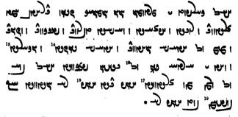
pas kālbod ī mardōmān ōwōn homānāg čiyōn draxt-ē ka kārēnd ud rōyēd ud abzāyēd ud waxšēd škenēnd ud brīnēnd ud wēzēnd ud abar ō ātaxš nihēnd ud ātaxš sōzēd ud gugārēd ud wād ī ardā {!} andar ō gēhān parganēd pas bē ō ōy kē kārēd ayāb dīd ēg-iz nē dānēd kū xwad būd ayāb nē.
h.

Enclitics with other words, e.g.,:

brāzīhēnd-išān ruwān “their souls shine”

? WwÍWwllA AWB MWwßLV WWP 2 AWK W WwÍW]J AWbY 2 WWP à WTPwY a˜wAwaDWWW WKtÒN Y WWtJWcÅ Y nßYW ? º
/ WwÍW]J aÒ lABKwïÅ WWP 2 áÒ WkßYWTP W ? WwÍWwïÅW WwLwA WwaΩA øW nßYwL YW]J AWB tÂA áJW W
zān ī ābustan murdag Wanand-ohrmazd guft kū pad dō mard barišn ud harw dō pad baršnūm bē šōyišn.
ud nasāy ka bē barēnd sar ō hazzān ōrōn kunišn. ud paywēšag rāy dō pad ēk-bār nē barišn

andar ēn 9000 sāl 3000 sāl hamāg kāmag ī ohrmazd rawēd “during these 9000 years, 3000 years Ohrmazd’s will goes (holds sway) entirely”

Ahrimen drāyīd kū gōw kū ān 3 tis čē.
Xešm drāyīd kū gāhānbār ud myazd ud xwēdōdah
Ahrimen drāyīd kū
andar gāhānbār bē ras agar az awēšān ēk tis-ēw bē duzīd gāhānbār bē škast ud kār bē kāmag ī tō.
pad myazd bē ras agar az awēšān ēk-ēw bē drāyīd myazd bē škast ud kār pad kāmag ī tō.
xwēdōdah bē hil čē-š man čārag nē dānam čē kē 3 bār ō nazdīk šud az xwēšīh ī Ohrmazd ud amahrspandān ǰudāg nē bawēd
à Wtja¬Y ÍcÅ wYwL ‹ OW WtjlABwY ÂßA à WtDWnYWI WTPwY WwS x
cdMwY< L WN WtDWnYWI WTWWvaD MwYN 3 ìtJ x ÄTwA Y a˜wAwA nM MWwlZW aÒ ìtJ x L
/ WwABWT aÒ WWTWK
/ nM MwYN 3 ã à WWWwmY à Wtja¬Y ‹
/ sY>WtDwA W Y>zadM W lABwaååD à Wtja¬Y ÂßA
à Wtja¬Y ‹
WtJWwLBT AWB lABwaååD WtDCwY AWB 1MwYN WkwïÅ WwaHnLW N tÅ ? WWtÂaD AWB lAVwaååD x
/ kL Y WkmAK WWP lAK W
WWP lAK W WtJWwLBT AWB YzadM Wtja¬Y AWB !WkwïÅ WwaHnLW N tÅ ? WWtÂaD AWB YzadM WWP
/ kL Y WkmAK
a˜wAwA Y eßYwA N WTWwlZW W˝∆¸W OW lAB 3 WN nM MWtDwA aÒ WklAC L ÍnM WWiÍ AWB sYWtDwA
/ WtDWWwaD aÒ WkAtDwY WwaDWcJwaÂA W
“It is said in the dēn: Wrath rushed in from of Ahrimen and howled:
‘I am not going into the world of the living, for the Lord Ohrmazd has placed three things in the world of the living that I can not mix (pollute).’
Ahrimen howled: ‘Tell me, what are those three things?’ Wrath howled: ‘Gāhānbār, the myazd, and xwēdōdah.’”

Text 14.2
Pand-nāmag 26-29

? WtDWnYWI WTWWtÅwA Wwa˜Wt¬M Y WWT x aåÒ 3 CNwY
? WtDWwsaD aåÒ WCwlY 3 W aåD< YWwï˜ 3 aåÒ 3 NwY WWP
? WtDWwsaD aåÒ ÂßïÅ aåD WNwAW WwÍwï˜ WWP
? WtDWwsaD aåÒ WwLW aåD Wt¬A WwÍBwY WWP
? WtDWwsaD aåÒ YWwï˜ WkAWwY aåD YWwï˜ WkAwYcJ WwÍWWK WWP
YWwï˜ Y yzM áÒ ìtJ Y WKWc¬A W W˝jAwA W WBC WwÍWnYWI WtåJ aåÒ 3 NwY WWP WwaÅTwÍwA
? WwÍWWiÍ aÒ AWB
WtDWwLTW AWB nÍPW Y WWT q WTWwllmY Âï¸ sAP 3 NwY ÍWN MWt¬M nM
? WthLWwaHwY N WwÍWWK W WtÅwaHwY N WwÍBwY W WtÂÍwY N WwÍwï˜
ēn-iz sē rāh andar tan ī mardōmān nihād estēd .
pad ēn sē rāh sē mēnōy gāh ud sē druz rāh dārēd.
pad menišn Wahman gāh xešm rāh dārēd.
pad gōwišn xrad gāh Waran rāh dārēd.
pad kunišn Spenāg Mēnōy gāh Ganāg Mēnōy rāh dārēd .
mardōmān pad ēn sē rāh saxt estišn xīr ud xwāstag ud ārzūg ī gētīy rāy mizd ī mēnōy bē nē hilišn .
čē mardōm kē-š ēn sē pās ī-m guft abar tan ī xwēš bē pāyēd
menišn az dušmat ud gōwišn az dušhūxt ud kunišn az dušxwaršt .

Text 14.3
Dēnkard 9.60.4-5
Exegesis on the Pahlavi gloss in Y.45.10: ahmāi stōi “for him to be”: ud ōy estēd “and for him stands” Spandarmad pad duxtarīh “and for him stands” (i.e.) “Spandarmad in daughterhood (= as daughter).” The commentator compares the xwēdōdah relationship between Ohrmazd and Spandarmad to that assumed between the xrad “wisdom” and bowandag-menišnīh “complete thinking,” where bowandag-menišnīh is the scholastic literal translation of Av. Ārmaiti < arəm maiti “appropriate thinking.” This exegesis combines this with the next strophe (Y.45.10), in which arəm-maiti “appropriate thinking” is contrasted with tarō-maiti “inappropriate thinking, scorn,” Pahl. tar-menišnīh.

ēn-iz kū-š Spandarmad pad duxtarīh ō Ohrmazd čāšt kē xrad pad bowandag-menišnīh.
ēd-iz rāy xrad bowandag-menišnīh andar kanārag hēnd ī Ohrmazd ud Spandarmad.
ud xrad ān ī Ohrmazd bowandag-menišnīh ān ī Spandarmad.
ud bowandag-menišnīh xrad zahag čiyōn Spandarmad Ohrmazd.
ud az ēd bē guftan čimīg kū kē bowandag-menišnīh ō xrad paywast ā-š Spandarmad pad duxtarīh ō Ohrmazd čāšt bawēd.
ud ēn-iz kū-š ēdōn ān duxtarīh kunišn čāšt bawēd kē ahlāyīh pad bowandag-menišnīh.
This too:
He has ‘assigned’ Spandarmad to Ohrmazd as his daughter who (has?) wisdom with complete thinking.
For this reason, wisdom and complete thinking are next to Ohrmazd and Spandarmad.
And wisdom belongs to Ohrmazd, complete thinking to Spandarmad.
And complete thinking is the child of wisdom, like Spandarmad (that of) Ohrmazd.
And from this it makes sense to say that, he who has connected complete thinking with wisdom, he will (at the same time) have ‘assigned’ Spandarmad to Ohrmazd as his daughter.
And this too:
In this way, he has ‘assigned’ that daughter-hood as worthy of being performed whose Righteousness is through/with complete thinking.

Exercises 14

/ YwYTcjLP aÒ WcÒkA YwcJwaÂA W a˜wAwA ? !
Ohrmazd ud amahrspand hagriz nē frēftēnd “Ohrmazd and the Amahrspands are never deceived”
/ WtjaDWWvaD Ewßad>maD> NTwL WwS à WtDWWWwmY WwS WWP ? 2
dēn abāg dām-dahišnīh dahīhist “the dēn was established together with the establishment of the world”
/ WthaD EWwlsA Y WkmaÒV W WtÅNTP WtDcJ Y WWCNTP nÍPWV a˜wAwA ? 3
ud Ohrmazd xwad paymōzan ī spēd paymōxt ud *brahmag ī āsrōnīh dāšt “and Ohrmazd himself donned a white garment and (thus) had the appearance of high-priesthood.”
/ YWWtÂaD aÒ nLW Y eßYwA OW lAwaÒ à WWTWK WwABWT aÒ WWWtdA a˜wAwA Y ÂaD ‹ ? 4
dām ī man ēdōn nē tuwān kerdan kū abāz ō xwēšīh ī man nē rasēnd “you cannot make it so that my creation does not return to being my property”
áÒ Y>T Y nLW WKwïÅ à YWWwaD AWB lATcdLP ATwÍwA WkaÂA WthAWt:¸ WwaÂATcJ ÂaDwA ã x ? 23
/ YWwaDWV adlS
andar ān hangām Spitāmān Zarduxšt hamāg mardōm frēftār bē bawēnd kū ēk ōy ī did rāy wad xwāhēnd
Ewaåd<ßA Y WCwlY ÍcÅ WtDWwïÅW WwßïåÅW ßAtÅ W WtDWwlZW WwahAtÅ Y Wwa˜ OW tÂA ? 33
/ WtDWWwaD WTWtda˜
ka ō mān ī ātaxšān šawēd ud ātaxš niyāyišn kunēd u-š druz ī aǰgahānīh zad bawēd “when he goes to the fire temple and says a hymn to the fire, the lie-demon of laziness is (will be) struck down by him”

WtåD MwA ã nM YwA Y NwïÅ W WklAwlïÅ W WwAwZwA AWB WtdaH Ä WtDWwAvzY âlâL äL Y>T WKwïÅ tÂA ? 34
/ ToanrlRlP,m1vzih / WkAtDP WwS N WwSC nÍPW
AMT ՚ywk TWB l՚d LALA YDBHWNyt ՚y š՚dt BRA ՚wzw՚n W ՚dlw՚lk W AYNE Y hwy ME ZK hwm yzdt NPŠE MN ZK gyw՚k pyt՚k hizuuąm frərənaot̰.
WwaÂsA tdA nÍPWV Y WtDWwsaD WwYtJwßAwïÅ Y î¬Z WN lAthYt¬A YWwlA Y ã WWwSC WwaÂsA YWwï˜ ? 44
/ Wt¬AWW AWB YWwï˜ WkAwY Y WklYTP
mēnōy āsmān čiyōn ān ī arwand artēštār kē zrēy ī ayōxšustēn dārēd ī xwad ast āsmān padīrag ī Ganāg Mēnōy bē winnārd “the divine sky, was set up against the Foul Spirit like a brave warrior who has a metal armor, that is, nothing but the sky itself”
/ WTWWwE WTPkÍ Y lAcdlAK AklM WwAWwïÅ Y WfjAc¬A NTwL WwAIwa¬ïÅ W AklM WpßAtHW ? 333

<wšt’sp' MLKA W ’yl’nyk’n' LWTE ’lc’sp' Y hywn’n' MLKA k’lyc’l Y škpt' YHWWNt' AHL ’yl’nyk’n'
pylwcgl YHWWNt' HWEd APš’n hywn’ MN štr' $$>
WKtJWK WkaÂA N WtDWnYWI WTPwAW EwÍnLT ÍWN WpLkÍwY Y WwïÂaJ WtDWWtÂaD WklYTP WpLKIWK YWT ? º
/ WtDWWtÂaD WwßsLT W ÂYB ÍcÅ WwABwL WN WwïÂaJ
did kanīg-kerb padīrag rasēd sahmgen ī duškerb kē-š tar-menišnīh nihuft estēd az hamāg kustag sahmgen kē ruwān aziš bīm ud tarsišn rasēd “then a shape in the form of a young woman comes toward (him), frightful and ugly, who is clothed in scorn, frightful from all sides, of whom the soul is overcome with fear and fright”

Sentences 14

1. Transliterate/transcribe and translate these sentences:

/ MWwAbzY Íƒ WwÍwï¸ WwaD W WWT WwAkaÂA WN nLW ? !
ōy kē amāgān tan ud ǰān zīyišn u-š yazam “’he who (is) life and soul’, living, ‘for ours, to him I sacrifice” (Y.37.3)
<OLE MNW ’m’k’n' tn' W y’n' zywšn' AP̄š YZBHWNm>
/ YwïhAWK nÍPW Y laÂïÂA WklYTP WtDWWtÂaD WtDbïÅ tÂA ? 2
ka ēbgad rasēd padīrag hamēmāl ī xwēš kōxšēnd “when the Attack comes, they (= the good deities) fight against their own (specific) opponent”
/ nÍPW Y 1Y>Wwï>˜ WwaÅTwÍwA Y 1WkßYP AWK à WkAtDP CNwY ? 3
<ZNEc pyt’k' AYK KRA pyšk'-1 Y ANŠWTA’n' mynwy-1 NPŠE>
ēn-iz paydāg kū harw pēšag-ēw ī mardōmān mēnōy-ēw xwēš “this too is evident that every single limb of men belongs to a single entity in the world of thought”
/ WcÅ WtdA nÍPWB Y ladlS WTpaÅcJ WtDCW OaÅ Íƒ ? 4
u-š pas wizīd spāhbed sālār ī xwad ast Āz “next he (Ahrimen) chose a chief general, who is none other than Āz (herself)”
/ WTNW Y>Wwï>˜ WkAwY OW AWB ... Y>Wwï>˜ WkAwY Y elAkA nÍPW Y ECwlYP maΩLP Íƒ ?23
<AP̄š plz’m pylwcyh Y NPŠE ’k’lyh Y yn’k’ mynwy ... BRA OL yn’k' mynwy nmwt'>
u-š frazām-pērōzīh ī xwēš agārīh ī Ganāg Mēnōy ... bē ō Ganāg Mēnōy nimūd “and he showed his own final victory and the undoing of the Evil Spirit to the Evil Spirit”
/ mïåDcDW AWB EkaDcÅwYW WWP kL N NwL aÒ ? 33
nē amāh az tō bē pad awēnābdāgīh bē wēzīhēm “we will not be separated from you other than by invisibility”
... Ywï¬ATW WKtåÅTW Y WwïåÅ x MwY 3 WwaD>WwlY> Y WwAwAB{ ã WCwlY> WtdaDwAW tÂA WKwaÂZ WTWkßLP WWP ? 34
/ Y>wïåDcÒnA MWtÒcÅwA WwaÒcÅwA Y elAtdßAWcÅ W eLcÅwA WWP W WKcjL WtjG< N Y>wïådlsaD>ÍwY AWB WwïåÅ WKtåÅTW Y ã WWP W
<PWN plškrt' zm’nk' AMT w’nyhyt' dlwc' ZK lwb’n’n' Y dlwnd’n' 3 YWM BYN ’hyn' Y wt’htk' wt’lynd ... W PWN ZK Y ’p̄ltwm šwdšnyh PWN ZK Y wt’htk' ’hyn' BRA ywšd’slyhynd MN gst' lyypk' W PWN hw’p̄lyh W ’p̄whšyt’lyh Y hw’p̄l’n' hw’p̄ltwm ’mwlcyhynd>
pad fraškerd zamānag ka wānīhēd ān druz ān ruwānān ī druwandān 3 rōz andar āhen ī widāxtag widārēnd ... ud pad ān ī abardom šōyišnīh pad ān ī widāxtag āhyn bē yōjdahrīhēnd az gast rēbag ud pad xwābarīh ud aboxšīdārīh ī xwābarān xwābar-tom āmurzīhēnd
/žWWIÍ q WwaÒtJc¬A Y WwÍwZ WWP WwaÒAW elyL kL LthYT W ? 44
/ WtdaDCwaÅ q adM WN WtHT AVL WtDwY WtDwY YNwA WTWB WwAkßylS W
/ YNwA WTW[ZW x WimZ Y WkaÒwS x WN WwaDwïdAW N Y<wSW AWB WwaÒtJc¬A WwAcJW YNwA WtjaDWwLT˝¸ q ã WWP
ud Tištar 30 šab wārān pad zanišn ī xrafstarān abar hišt . ud sreškān būd hēnd ǰud ǰud wazurg tašt kē āb abar āhenjīhēd . pad ān abar bē zanīhist hēnd wispān xrafstarān bē nihang az wayendagān kē andar sūrāg ī zamīg andar šud hēnd
/ YwYtådMwY WkAwS Ä x W YWwlZW WkAwS Ä OW AWB WkaÂA WKt:J Y<LwY< ? 333
<gwlg sltk' hm’k BRA OL HD gyw’k' OZLWNd W BYN HD gyw’k' gwmyhtynd>
gurg-sardag hamāg bē ō ēw gyāg šawēnd ud andar ēw gyāg gumēxtēnd “the wolf species will all go to one place and mingle in one place” (PR)
/ WwÍWWiÍ aÒ AWB YWwï˜ Y y>zM WwÍWwmYWI WtååJ aåÒ 3 ˜WY WWP Wwa˜Wt¬M ? º
mardōmān pad ēn sē rāh saxt estišn ... mizd ī mēnōy bē nē hilišn “people must stand firmly on these three paths; they must not relinquish the reward in the other world”

Text 14.1
Bundhišn 36A.1
“It is said in the dēn: Wrath rushed in front of Ahrimen and howled:
‘I am not going into the world of the living, for the Lord Ohrmazd has placed three things in the world of the living that I can not mix (pollute).’
Ahrimen howled: ‘Tell me, what are those three things?’ Wrath howled: ‘Gāhānbār, the myazd, and xwēdōdah.’”

Compound verbs: nouns + verb
There are numerous verbal expressions made with a nominal form plus a verb. The most common such auxiliary verbs are active kerdan, dāštan, griftan, burdan and passive būdan:

wanīy kerdan - wanīy būdan destroy - be destroyed
ǰudīy kerdan separate
tabāh kerdan - tabāh būdan damage, destroy - be damaged, be destroyed
ayād kerdan - ayād būdan - pad ayād dār- remember
namāz burdan do reverence (to: ō)

Bundahišn 33.1-13

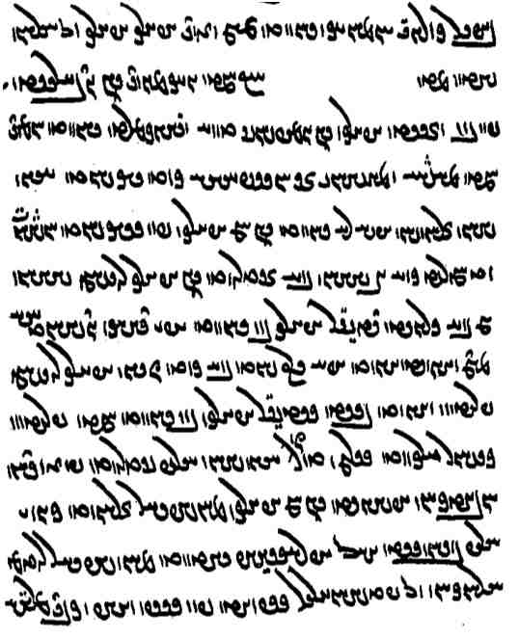
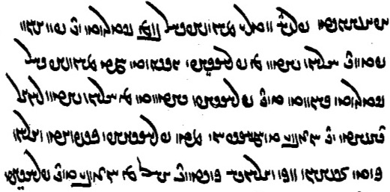

Missing line:
Wwa¬AW WTWK ÍTP Ewa:DwA W WwÍPwÍW YBK WWtHWwa:dA

abar wizend (ī) hazārag hazārag ō Ērānšahr mad kū
ka Ganāg Mēnōy andar dwārist pad bun nazdist hazārag ī andar *gumēzišnīh gāw ud Gayōmard būd hēnd.
ka Mašīy ud Mašyānīy ān huspāsīh kerd 50 sāl ēg-išān zāyišn aziš nē būd.
andar ham hazārag pad 70 sāl Hōšang ud Tahmūred harw 2 dēw bē ōzad (hēnd).
andar hazārag sar dēwān am kirrēnīd.
didīgar hazārag bun būd Ažidahāg dušxwadāyīh abar {kunēd} grift u-š 100 sāl bē kerd. čiyōn hazārag sar būd Frēdōn grift bast.
sidīgar hazārag bun būd ka Frēdōn kišwar baxt Salm ud Tūz ēg-išān Ēriǰ ōzad frazendān ud āwādagān *abesihēnīd.
andar ham hazārag Mānuščihr zād ud kēn ī Ēriǰ xwāst.
pas Afrāsyāb āmad. Mānuščihr abāg ērānagān ō Padišxwārgar spōxt pad seǰ niyāz ud was margīh *abesihēnīd
*Frīy ī Nōdar ī Mānuščihr pus ōzad tā pad anīy paywand Ērānšahr az Afrāsyāb stad.
ka Mānuščihr ōzad būd did Frāsyāb āmad <Ērānšahr was wišōbišn ud awērānīh padiš kerd.
wārān> az Ērānšahr abāz dāšt tā Uzaw ī Tōhmāspān mad Frāsyāb spōxt ud wārān kerd ī-šān nōg-wārānīh xwānēnd

abēzag WkcDcÅ <’p̄yck> pure
astīh EtjA <’styh> being, existence
awardāg WkAtÒwA <’wlt’k'> not turning away (from)
brīd-dumb WbMwY WtdLB <blyt'-dwmb'> with the tail cut off
bunag WKWWB <bwnk'> camp
drōzan WWCwlY <dlwcn'> liar, deceiver
ēk-dād WtåDKwïÅ <’ywk-d’t'> created as one; the single-created (Bull)
ērānag WKwa:dA <’yl’nk’n'> Iranian

huramīh emLwA <hwlmyh> happiness
huspāsīh esAfJwA <hwsp’syh> gratitude; good service
kēn WwYK <kyn'> revenge (kēn ī “for”); + xwāh- “seek revenge”
nēstīh EtDwL <LOYTyh> non-being, non-existence
niyāz WcåÅW <nyd’c'> need
pēm ÂïÅP , mYP <pym, p’ym> milk
purr-sardag WKt:jLWP <pwl-sltk'> of many species (Av. pouru.sarəδa-)
šagr :dÍ <šgl> lion
seǰ WcŸJ <syc'> danger
tarsagāy, tarsagāh aÅ˝jLT , Ä˝jLT <tlsk’d, tlsk’h> respectful
wēšag WkßYW <wyšk'> small forest
xurduš ÍwlïÒwA <hwldlwš> epithet of Srōš (many spellings); Av. xruuī.druš “wielding a bloody club”
xwār lâwA <hw’l> lowly, abject; pad xwār dār- “despise”
xwašīh emïJ| <BSYMyh> pleasantness
xwār lâwA <hw’l> lowly, abject; pad xwār dār- “despise”
xwašīh emïJ| <BSYMyh> pleasantness
zāyišn WwÍWwa:¸ <z’dšn'> birth, being born

Afrāsyāb WcååjaÒcÅ <’p̄l’syd’p̄'> Afrāsyāb; a Turanian, arch enemy of the early Iranians
Ažidahāg WkaåD ^cÅ <’cy dh’k'> Aǰdahāg
Ēriǰ WcÎ:dA <’ylyc> son of Frēdōn
Frāsyāb (WcåjaÒP) WcååjaÒP <pl’syd’p̄'> Frāsyāb = Afrāsyāb
Frīy ī Nōdar (ms. ßLP) LTWW Y adLP <plyd nwtl> son of Mānuščihr
Gušnasp WfJwÍwY <gwšnsp'> name of a fire
Hōšang `<waHwA , Y<wÍwA <hwš(’)ng>
Hutōs SWTwA <hwtws> Wištāsp’s sister and wife
Mānuščihr laDcHWwa˜ <m’nwšcyhl> Mānuščihr
Padišxwārgar :dlAwaHTP <ptšhw’lgl> a mountain in eastern Iran
Spandyād WtådYWfJ <spndd’t'> Wištāsp’s son
Tahmūraf, Tahmūred WtÌLnAT , WpLnAT <thmwlp', thmwlyt'>
Tōhmāsp WfjaÂAWT <twhm’sp̄>
Uzaw WBwZwA <’wzwb'>
gumār- gumārd -lâMwY <gwm’l-> appoint
kōst WtJWK < kws-> beat, pound, crush
nišān- nišāst WtJWWvYtD , -wAWWvYtD <YTYBWN’n-, -st' > set down, establish
WtjaHW <nš’st'>
niyōš- niyōšīd -ÍKwïDW , -ÍKwYW <ny(d)wkš-> listen

pad kār nē abāyēd have no need for

/ WtjaHW AWB WwAKtÅPWWWtÅ WWP WcJwÍwY WWWtÅ a˜wAwA øaÅ ? 23
pas Ohrmazd ādur Gušnasp pad Ādurbādagān bē nišāst

Wt˜ ÍBwA WthAt¬Z ^ lAwY< WWT WN ÂYP AWWT ã OW ÍcÅ WtJWK MwA ã WcjÍwLWP OaÅ ? 34
/ WtådMwY WtÅWnYWI
pas Pōrušasp ān hōm kōst u-š ō ān gāw pēm kē tan-gōhr ī Zarduxšt awiš mad estād gumēxt.

÷ WTW[YkM ÍcÅ WwS aå˜KWtDM W WthY cÅWP WcDWwa¬Ä x MWtÒP WTWwYtdaD WwS WthAWt¬Z ? 44
<zltwhšt' dyn' YHYTYWNt' pltwm BYN ’yl’nwyc' yšt' W mytwkm’h dyn' hcš MKBLWNt'>

÷ WTW[YkM ÍcÅ WwS aå˜KWtDM W WthY cÅWP WcDWwa¬Ä x MWtÒP WTWwYtdaD WwS WthAWt¬Z ? 44
<zltwhšt' AMTš dyn' YHYTYWNt' pltwm BYN ’yl’nwyc' yšt' W mytwkm’h dyn' hcš MKBLWNt'>

pad tis-iz ēd rāy nē dārišn čē wardišnīg ast ud bē hištan abāyēd “one should not consider (this world) to be anything (of worth), for it is bound to change and (we will) need to leave it” (Dk.6A.6a)

6E.30a
guft estēd kū gilag-ōbār ud wīdwar ud pad kerbag kerdan tuxšāg bawišn spās az mēnōyān xwāhišn nē az gētīyān [B460] ::

6A.6a ud ēn-iz guft kū
gētīy rāy *wāhak nē barišn [K43_223v] ud pad tis-iz nē dārišn ud az dast nē hilišn [M548]
ud *wāhag ēd rāy nē barišn čē harw ān ī brēhēnīd estēd bē rasēd ::
ud pad tis-iz ēd rāy nē dārišn čē wardišnīg ast ud bē hištan abāyēd ::
ud az dast ēd rāy nē hilišn čē mēnōy pad gētīy ō xwēš šāyēd kerdan ::

? WtDWWwaD LTkAtÒwA ÍcÅ W WkahAWT WWTWK WKPWK W lAK WWP ã sAkA WwS N WN MWkL N ÄcdlATK ã
WwÍtjyLP Íƒ lAtåD x Y eÄ˝jLT oW WtdA WKtJWTP WwÍtjyLP waHƒ WwaÒtD√A x Y eÄ˝jLT

WI>wï¸ ÂA W WvA ^>W AWvY nM ÍWWwaD lAtÒWV WwaÂLP W lAtdßAwYW W Ä˝jLT nÍPW ^ ÂA W WvA x ? 44
? Wt∆dLT aÒ C˙dA N WkßGW x tÂA :dÍ WwSC WkAwa˜wA
Ž>WwïJwY AWB ÍcÅ c˜wYN WN WKwYW ^ nßYW WwSC WkAwa˜wA WWwYwA tDwL ÂA W WvA WN nLW W
÷ WtDWwsaD lAwA WWP ˙dA AWK W WwABWT aÒ WWTWwïÅW MwYN ÍcÅ

ēw-bār lAbïÅ , lABwïÅ <’ywb’l, HDb’l> once; ka ēw-bār “once” (conjunction)
bowandagīh aDIWWB <bwndkyh> completion, completeness
wišuftan wišōb- WTPwÍW , -PwÍW <wšwp-> disturb, destroy, tousle (hair)

kāmagōmandīhā šawam ō ān gyāg ī ahlawān ud druwandān
“I shall go willingly to that place of the Righteous and the wicked” (AWN.1.20)

u-m dīd ān ī xwēdōdahān ruwān andar ān ī abzār brēhēnīd rōšnīh ka-š gar-bālāy rōšnīh aziš hamē waxšīd
u-m burzišnīg sahist
u-m dīd ān ī xūb xwadāyān ud pādixšāyān ruwān kē-šān mehīh ud wehīh ud amāwandīh ud pērōzgarīh aziš hamē waxšīd ka-šān rawēnd andar rōšnīh pad ān ī zarrēn rahīy ud wardyūn
u-m burzišnīg sahist
u-m dīd ān ī wazurgān ruwān ud rāst-gōwišnān kē-šān rawišn andar ān ī buland rōšnīh pad ān ī meh xwarrah
u-m burzišnīg sahist

Yasna 1.1. The passages not in italics are comments and glosses to the translation of the Avestan.

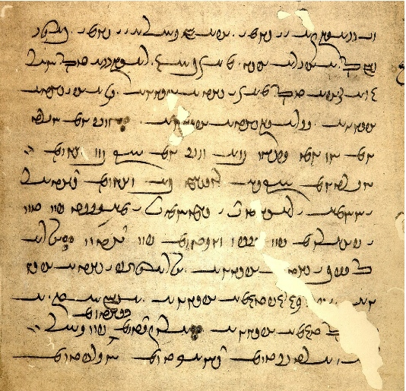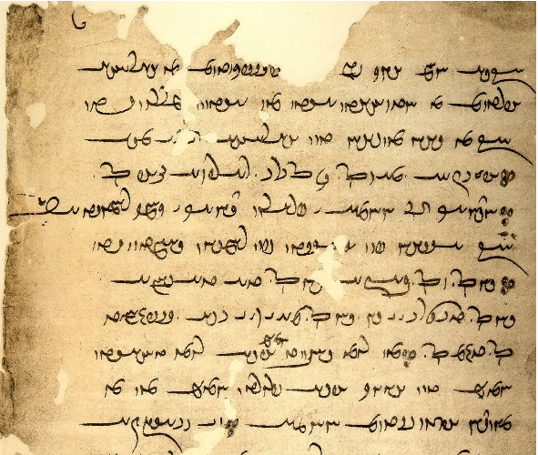
1
2
3
4
5
6
7
8
9
10
11
12

13
14
15
16

17
18
19
20
21
22
23

⁴niwēyēnam hangird⁵ēnam ō ēn yazišn; bē niwēyēnam kū bun kunam ⁶hangirdēnam kū-š sar bē kunam dādār ⁷ī Ohrmazd ī rāyōmand ī xwarrah-ōmand ī mahist pad tan
⁸ī pahlom pad arz nēktom pad dīdan

¹¹xruždtom *sāxtagtom pad kār ¹²ud dādestān xradīgtom dānāgtom hukerbtom

¹³kū-š hannām ēk andar did passazagtom
az ahlāyīh ¹⁴abardom az Ardwahišt ast kē ēdōn gōwēd ¹⁵kū az yazdān kē-šān tan ahlāyīh ān ī meh
¹⁶hudānāg ān Ohrmazd ī frārōn dānāg ī kāmag-rāmēnīdār ¹⁷kū kasān pad abāyist pad rāmišn rasēd

²¹kē amāh dād hēm u-š amāh tāšīd ²²hēm tan-ēwēnag u-š parward hēm kē az ²³mēnōyān abzōnīgtom Ohrmazd

Line 4 <nwyk-ynm> with <k> representing older <d>, Psalter D . — Line 6: <OBYDWNm> has a short line below the final <-m>, perhaps for older <wm>?? — Line 7: not the pulled out final <-d> in <l’y’wmnd>, and the way the “roof” is connected with the <-d> in <GDE’wmnd>. — Line 8: arz spelled <KSP>. Note the spelling of <dytn'>: WWtdY> , not WWtJ> .
Line 11: <shttwm> saxttom error for sāxtagtom. — kār has an Avestan ä ā. — Line 12: restore <DYNA> at the beginning of the line. — Line 13: MWTKcŸJP for MWTKcJP . —
Line 17: note the final <-l> in <l’mynyt’l>. — Line 18: note the way <-Y-> is connected to <-Š-> in waÔdA<AYŠ’n>.

From the mēnōy xrad 7

WtDWWwE ÄwaÅP lAWP ã kAwa˜wA GwïDLP AwA WtdlYTW lAWP ã WWP WwABwlaÅ ^ WwABwL tÂA W
/WtdlYTW AWB älaÅ ÍwlS ^ EkAcÅ WWP WwABwL WwABwlaÅ ^ ã W
Lt¬ECwA WwaåJ WWP ^ WIWK AWK N ^ WtDWWtåD WklGTP OW WfÒK IWK WWP WwÍWWK WKwYW nÍPW ^ ã ÍcÅ
/ lGpÍ W
aÅtJ WWP lYpÍ W Òt¬ECwA # N ^ WIWK cÒkA MWN ìNwA WN # à WtDWWWnY WwABwL WwABwlaÅ ^ ã W
/WTWtjA âL
WwÍBwYwA ^ WwÍwï˜wA ^ WwEwY MNwA # ^ WKwYW ^ WwÍWWK AWB WIWK âL à WfÒK WIWK ã WtDcÅWTP WwaJP WWP
WwïD>wA ^ WwÍWWKwA ^
/ WTWK WwaåD ^ WwÍcdA TcÅ ìNwA WtJWWvGtD # WwïDA WTWK EKcdaååH WN WTWtjA aÅtJ WWP tÂA # nM
WtÅwY>wA WKCB N WKtjAwA W WTWK LT W WtdßYB MWt¬M EW W WTWK LcÅ W µAtJ WN ˙©A WTWtjA TtÂA W
WCWfjA W WtDwï˜ MWt¬M lGpÍ TcÅ WthE lAwaÒ WwaÂE N nÍPW ^ LcÅ W µAtJ # WwïDA
N WKtjAwA TcÅ iâL N CWN W Wt˜ cÅWP Wāǰ>¸W N WN WTWWvE WwßE> TcÅ WTWK elATplYTP W
/WtÅwYwA EWwlaÒP

/ LtD>WBwA eG>WBwA WkaÂA N ^ WtDWWtåD WklGTP OW YWBwA ^ !WtÅW ÍwïDA WtDWtåJ cÅWP nMT N tÂA W
WWWtdA ^ WtÅW aÅtJ WWP cÒkA µgZ WtdA WtÅW nM NwY à ÍwlS N WwABwL WwABwlaÅ ^ ã WtŸJWWP
/Wt˜ âL Wwßra˜ OW Y>WBwA
/ Y>WBwA WWWtdA WN WtdA WthAW N WtÅW NwY à WtDcÅWTP WwABwL WwABwlaÅ ^ ã OW älaÅ ßwlS WwïDA

u-šān dušxwārīh ēdōn bawēd čiyōn ka-šān pad gētīy ayōxšust ī widāxtag awiš hišt “and their discomfort is such as when, in the world of the living, molten metal was released (i.e., poured) upon them” (PR.48.71)

Compound verbs
awēšān-iz gōwēnd kē ēd ī tō dēn ī mazdēstān ōšmurēnd . awēšān zardušt az tō ān-iz ī <lyšyn'> windišn ēd kū apparēnd ud tar ēd ī tō yazišn menēnd ud tar niyāyišn “$$” (Dk.9.32.20)

āwurdan
bē āwarēm kēn ī tāzīgān čiyōn rōdastahm āwurd 1-100 kēn ī siyāwaxšān

bun ... sar “beginning ... end”

ān ī pad hāsr padiš abarag bawēd ka pēš az hāsr sar abāz ō rāstīh āyēd “(the judgement) of the one who is (going away) at (the distance) of a hāsr is superior when he arrives at the truth before (he comes to) the end of the (distance of) a hāsr” (Dk.8.22.18)

agar dēn nē stāyē ud gad bē nē abganē ēg-it ēn tigr pahikāfom “if you do not praise the Religion and do not throw away (your) mace, then I shall drive this arrow throw you” (PR.48.50)

mardōmān kē-šān kerbag wēš u-šān gyāg andar wahišt “the people whose good deeds are more, their place is in Paradise = the place of the people whose good deeds are more is in Paradise” ($$)

čārag “way (out), means”
pad ēč čārag griftan nē tuwān “by no means was it possible to seize (them)” (KN.4.24)
u-š ačāragīhā petyārag a-kār kerdan rāy zamān frāz brēhēnīd “and, having no (other) way out, he fashioned forth Time in order to incapacitate (the Foul Spirit)” (Bd.36/37)

MX.12.9-18
az harw anāgīh ī gizistag Ganāy ī druwand pad dāmān ī Ohrmazd kard čahār {tis ēn wattar ud garāntar
ka-š kerbag mizd ud wināh} pādifrāh ud menišn ī mardōmān ud frazām ī kār bē nihumbīd
ud ham-čim rāy was kēš ud wurrōyišn ī [K43_145v] abārōn andar gēhān rawāg kard ::
ud mardōmān nē dānist ī kār ud kerbag rāy harw kas ān wēš wurrōyēd ud pad weh dārēd ī-š hammōzišn pad kēš abar būd estēd ::
ud pad nāmčišt ān kēš pādyāwandtar kē-š pādixšāyīh abāg bawēd ::
bē ān ēk xwadāyīh ud pādixšāyīh ī Wištāsp šāhān šāh
kē-š dēn drīst ud rāst ī pad gōwišn dādār Ohrmazd abē-gumānīh ud ēwarīhā dānist rāy az ēw-tāg Zarduxšt ī Spitāmān frāz padīrift
kē harw-ēwēnag xīr ī gētīy ud mēnōy az dēn ī weh ī mazdēsnān rōšn ud gōwizār ud a-gumān paydāgīhēd
ēg-iš ēč wurrōyišn nēst kē-š xīr ī gētīy ud mēnōy ēdōn gōwizār ud rōšn padiš šāyēd ayāftan ud dānistan
bē wēš wiyuftagīh rāy āγištag ud pēčīdag ōwōn hēnd kū-šān gōwišn ī bun ō mayān ud mayān ō frazām abēr a-homānāg ::

Bundahišn 33.32-37

ud pas šašom hazārag ī Ōšīdarmāh bun bawēd. xwānīhēd hazārag ī Ōšīdarmāh.
ud pad ān hazārag Ōšīdarmāh ī Zardušt pad paygāmbarīh az Ohrmazd āyēd čiyōn Zarduxšt dēn āwarēd andar gēhān rawāgēnēd.
20 rōz šab xwaršēd pad bālist ī āsmān estēd. 6 sāl ō urwarān zargōnīh dahēd. ān ī āz-tōhmag druz abesihēd. kū mār abāg xrafstarān bē abesihēd.
pas nazd ō hazārag sar ī Ōšīdarmāh Dahāg az band harzag bawēd Bēwarāsp was dām-dahišn pad dēw-kāmagīh wināhēd.
ud andar ān hangām Sōšāns ī Zarduxšt ō paydāgīh āyēd. 30 rōz ud šab xwaršēd pad bālist ī āsmān bē estēd.
nazdist az gētīyīgān rist Sāmān Garsāsp ul hangēzēnd Bēwarāsp pad gad zanēd ōzanēd az dāmān abāz dārēd.

hazārag ī Sōšāns bun bawēd čiyōn hazārag ī ōy tan-kerdār 55 sāl.
ān 3 pus ī Zarduxšt čiyōn Ōšīdar ud Ōšīdarmāh ud Sōšāns rāy gōwēd kū
pēš kū Zarduxšt bē guft ēg-išān xwarrah ī Zarduxšt andar zrēy ī Kayānsīy pad nigāhdārīh ō ābān xwarrah ī ast Anāhīd yazd abespārd.
nūn-iz gōwēnd kū 3 čarāg ī andar bun ī zrēy ī waxšīd pad šab hamē wēnēnd.
ud ēk ēk ka-šān zamānag xwad rasēd ēdōn bawēd kū kanīg-ēw sar šustan rāy ō ān āb ī Kayānsīy šawēd u-š xwarrah andar ō tan gumēzēd ābestan bawēd awēšān ēk ēk pad zamānag ī xwēš ēdōn zāyēnd.

andar ēn gēhān tis nēst ī ēdōn bē bawē čiyōn ān tis ī pad xrad kunīhēd
“there is nothing in this world that would be like that which is done by wisdom” (Dk.6.313)

kerd yašt pad homānāgīh ī J̌am ... abar xwānēd Sōšāns
“the sacrifice having been performed in the way Jam (did), Sōšāns calls out” (WZ.35.20)

/ WtdßAW áÂA ÍcÅ EwÍwL ÄlAB lY< ÍtÂA EwÍwL WtDwïåÒV la¸cÅ ī ã x WwABwL WwaåDWtDwA ī ã WTWtjA McÅ
/ WtJWœ WIwÍcÒWV McÅ
WtdßAW áÂA ÍcÅ elYCwlYP W eYWwaÂA W eaDW W eSM WwaHWwM WwABwL WwadahAtÅP W WwadATwA WPwA ī ã WTWtjA McÅ
/ WWwYtÒW W íaÒ WwïÅva¸ ī ã WWP EwÍwL x YWtåJ WwaHtÂA
/ WtJWœ WIwÍcÒWV McÅ
/ nS sM ī ã WWP EwÍwL Y>wLWB ī ã x WwÍBwL WwaHWwM WwAwÍBwY WtjaÒ W WwÍBwL WwaD<LWCW ī ã WTWtjA McÅ
’ WtJWœ WIwÍcÒWV McÅ

ka-š bīm bawēd kū-š āb *ayārdēnīdag abar rasēd ēg ātaxš bīm ōwōn dārēd čiyōn mardōm kē-š padīrag sneh ud tigr ayāb aštar ayāb *kar-sang sāxt estēd u-š harw zamān bīm kū-š bē awiš zanēnd .
ud ka-š āb abar rasīd ēdōn mānāg čiyōn ka-š ān sneh abar ī rasīd hē .
čē-š bīm spitāmān zardušt ātaxš ī ohrmazd az ān ī *ayārdēnīdag āb
mānāg ī ōy čiyōn ka mard sneh az nazdīk pad bē-zanišnīh abar zanē .
(Purs.20.2)

3.162.3 (1) ēwēnag-ēw petyārag az ān ēwēnag ī Gannāg Mēnōy āhang padiš būd bē *wardēnīdan [<blt->]
3.162.4 čiyōn ēd ī Gannāg Mēnōy pad hamēstārīg rasēnīdārīh
ī sardīh ō abēzag garmīh ī huškīh ō abēzag xwēdīh
garmīh pad sardīh ud xwēdīh pad huškīh sarōmandīhā ānāftan
zīndagān ī weh-bawišn agārēnīdan
dām dām-rawāgīh pādīrānēnīdan āhang būd ::

DD.36.
36.70 ēk ēn kū ān ī ōstīgāntom gōhr ī dēw xwad ast tārīkīh ī-š wattarīh ōwōn bowandag ī dēwān-iz ī tam-tōmagān xwānānd
36.71 ōwōn zōr andar zēn-abzār [TD4_261] ī yazdān kū ān-iz ī fradom tam tār ī andar gēhān pad hambun-iz zōr-ēw ī xwaršēd spīzišn [TdKT <yycšn'>] hamāgīhā ānābīhēd gēhān [D7_203] rōšnīhēd ::

Additional readings 15.5
From the Šāyist nē šāyist: ŠnŠ.2.15-16, about how a stone and the earth are polluted by nasāy. — Mss. K20 fols 54r-v, M51 pics. 155-6. Make a list of the differences between them.

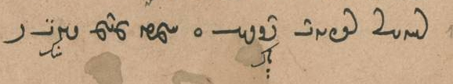
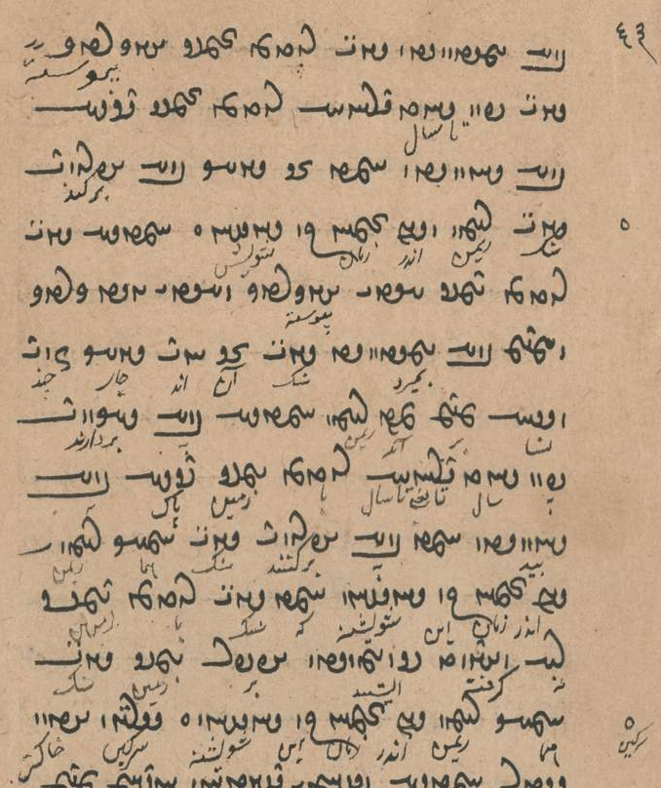

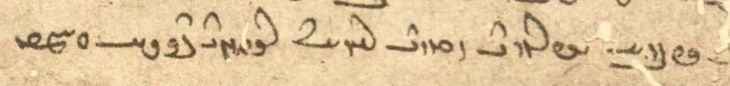
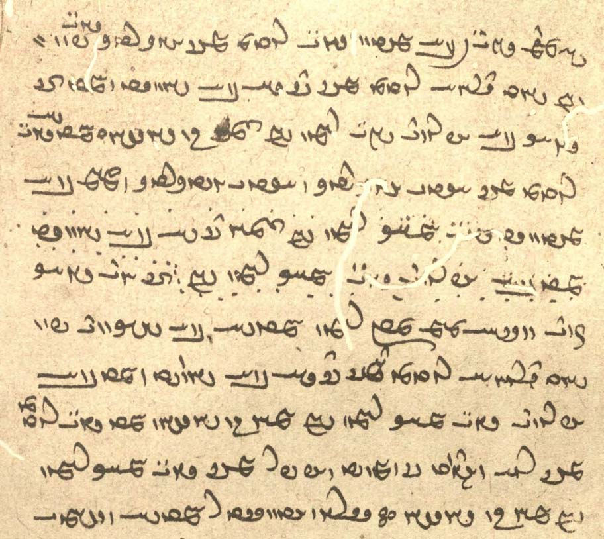
ka abar sang-ēw bē mīrēd sang abāg zamīg ēw-kardag sang pad andar sāl-drahnāy abāg zamīg pāk bē bawēd
ud ka ān gyāg bē kanēnd sang rēman ud andar zamān ōh šōyišn.
ka sang abāg zamīg ast ī ēw-kardag ud ast ī ǰud-kardag ud abar bē mīrēd sang ān-and gyāg čand nasāy abar mad rēman
ka-š bē hilēnd pad sāl drahnāy abāg zamīg pāk bē bawēd
ud ka bē kanēnd sang hamāg rēman andar zamān ōh šōyišn.
ka-š sang abāg zamīg nē kerd estēd azabar zamīg sang hamāg rēman andar zamān ōh šōyišn ::

Additional readings 15.2
Šāyist nē šāyist 10.4, about the importance of keeping a fire burning in a house where there is a pregnant woman. — Mss. K20 fol. 70v, M51 fol. 88v (http://daten.digitale-sammlungen.de/~db/0008/bsb00083791/images/ pic. 206)

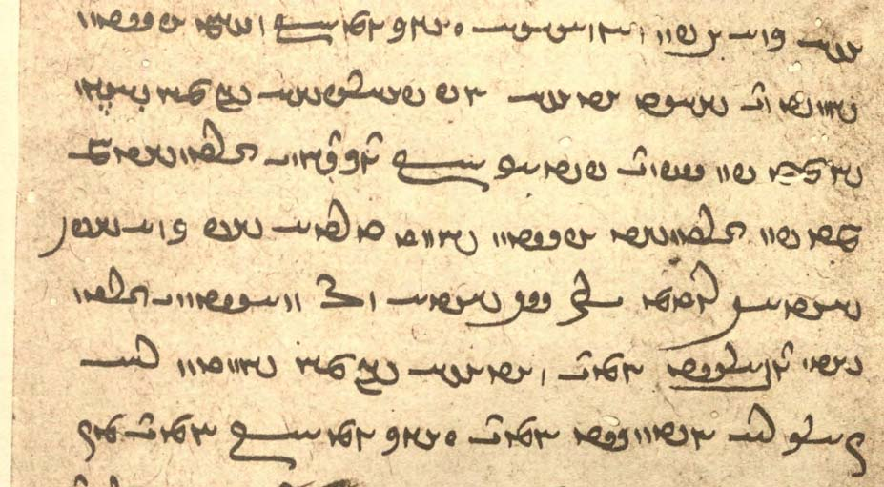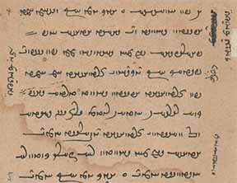

ēk ēn kū zan ka ābestan bawēd tā šāyēd ātaxš xūb-pahrēzīhā andar mān dārišn.
čē pad Spand paydāg kū Dugdōw ī Zarduxšt mād ka pad Zarduxšt ābestan būd 3 šab harw šab-ēw dēw-ēw abāg 150 dēw ō wināstan ī Zarduxšt dwārist hēnd ud ātaxš andar mān būdan rāy čārag kerdan nē dānist hēnd.
Note the Persianism dānist hēnd “they knew,” instead of u-šān nē dānist.

Text 16.4
From the Šāyist nē šāyist: ŠnŠ.2.118. – Mss. K20 fol. 60v, M51a pict. 175. – About how long moist firewood must wait to be used.

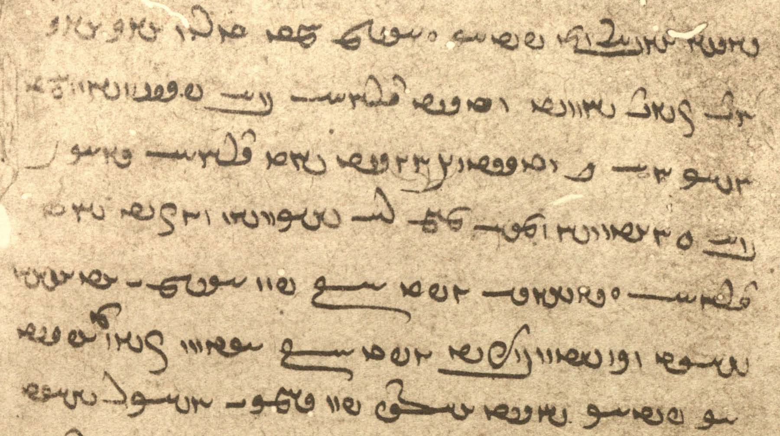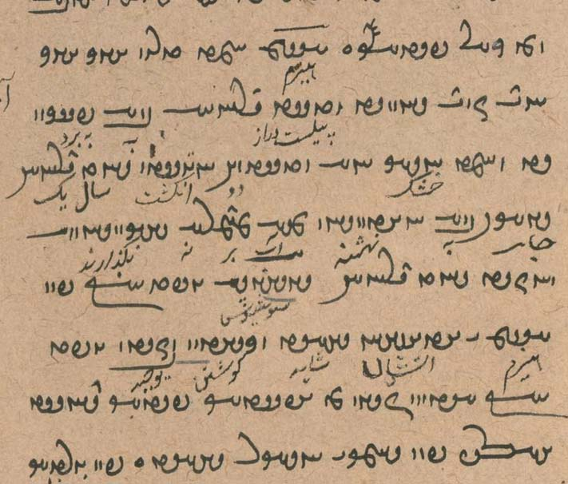

esm ka tarun ēk ēk and čand bawēd widest-drahnāy bē brinišn
ud ka hušk ēw widest ud 2 angust sāl-drahnāy gyāg-ēw bē nihišn ud āb abar nē hilišn
ud uzīd sāl-drahnāy Sōšyans guft kū pad esm ī ātaxšān šāyēd
ud Kay-ādur-bōzēd guft kū ēdōn čiyōn az Abestāg paydāg šust
pas-iz pad ǰāmag ī huškar šayēd

WTWWwE WTPkÍ Y lAcdlAK AklM WwAWwïÅ Y WfjAc¬A NTwL WwAKwa¬Ä W aHWpßAtHW ? 333
/WtÅWcJ WWtH N WwïÅ waHƒ Y>NwA WTWWwaD lYCwlYP WwAKwa¬Ä øaÅ

WKtJWK WkaÂA N WtDWnYWI WTPwAW EwÍnLT ÍWN WpLkÍwY Y WwïÂaJ WtDWWtÂaD WklYTP WpLKIWK YWT ? º
/ WtDWWtÂaD Ww˙jLT W ÂYB ÍcÅ WwABwL WN WwïÂaJ

tōxt dušmat dušhūxt dušxwaršt abāg frayādāg ud rāmēnāg mēnōy ī xwēš humat hūxt huwaršt bē ō garōdmān ayāb ō wahišt ayāb ō hamēstagān ī ahlawān ānōh kū-š andar ahlawīh gāh ast awiš franāmēd “his evil thoughts, etc., having been expiated, he proceeds together with the helping and pleasing spirit of his good thoughts, etc., to Garōdmān, the Best (Existence), the Intermediary place of the Righteous, to where his place is among the community of the Righteous” (DD.23.6)

mēnōytar LT Y>Wwï˜ <mynwdtl> closer to the other world

From the mēnōy xrad 5

/WtDWWwE aÒ WwYBwA YWwY¯ ī ã W WkcÂYcÅ aÅtJ ī WBC TcÅ WtDpgLP âL aåH WcÅ Tà WWwïÅW oA Eā≤AKWcÅ
/WtDWwE ÍnâLP WwaåD ī WwÍtjLP W nßYW W WKPWK W lAK ÍwsA WtDWWwïÅW µßA tÂA AWbG nM WWwïÅW oA EmßA
/µßA ī WWtJWWbYtD AWB Y>W WtDWwLPW WwÍwï˜ OW WKCB W sAWW WwïDnaÅ ÍcÅ
/WtDWnYWI WTPwY nlaÅ ī Y>WwaÅ µßA
WwßaÅK ÍcÅ WtDWWwE WwYBwA Y>Wwï˜ W aÅtJ ī WwßmâL lAtÒWB ßYB ī nLW nM Wwlg>Y oA ßYB
WtDWWtÂE âL EwA≤ïHP W Wwaå¸ WwÍWWK nÍPW N Tà WWwïÅW oA EIwLW WtDWwLPW WwABwL W WWT OW

AWN.54.1-6
u-m dīd ān ī sēǰōmand ī bīmgen ī sahmgen ī was dard ī purr-anāgīh ī gandag [ī] tār tom dōšox
ud pas handēšīd ham-ēdōn sahist čiyōn čāh-ēw kē hazār wāz ō bun nē rasēd
ud ka hamāg ēzm [ī] andar gēhān ast hamāg andar gandagtom ī tomīg dōšox abar ō ātaxš nihēnd hagriz bōy nē dahēd
ud did-iz az gōš tā čašm ud čand buš ī asp-ēw abar mōy dārēd ōwōn was-marag ruwān ī druwandān andar estēnd ud ēk ō ōy did nē wēnēnd ud wāng nē ašnawēnd
harw kas pad ēd dārēd kū tanīhā ham
u-šān *tomīh *ud tārīgīh ud gandagīh ud bīmgenīh ud zaxm ud pādifrāh ī gōnag gōnag ī dōšox kū kē *ēw rōz pad dōšox bawēd wāng kunēd kū *ahanūz nē bowandag ān noh-hazār sāl ka-mān az ēn dōšox abar nē hilēnd

az kišwar ō kišwar ǰud pad parwānagīh yazdān ud warzāwendīh tā šudan nē šāyēd.
čiyōn gōwēd kū mayān ī Sawah ud Arzah ud Xwanirah zrēy dārēd čē bahr-ēw az zrēy ī Frāxkerd pērāmōn bē dāšt az mayān ī Fradadafš <ud Widadafš> wēšag dārēd. mayān ī Wourubaršt ud Wouruǰaršt kōf ī buland bē rust kū tā az kišwar (ō kišwar) paywand bē bawād kū tā ēk tā did šud nē šāyēd.
8.6 az ēn 6 kišwar hamāg nēkīh andar Xwanirah wēš dād. Ganāg Mēnōy ō-iz Xwanirah wēš kōxšīd ud anāgīh ō Xwanirah wēš kirrēnīd zadārīh rāy ī-š aziš wēnēd čē kayān ud wīrān andar Xwanirah [76] dahēd.
dēn-iz weh ī māzdēsnān pad Xwanirah dahīhēd. pas ō abārīg kišwar barēnd.
Sōšāns-iz andar Xwanirah zāyēnd kē Ganāg Mēnōy abesihēnēnd ristāxēz ī tan ī pasēn kunēnd.

Usindām, Usindom MwYwïJwA , µaDwïJwA <’wsynd’m, ’wsyndwm> name of a mountain
axtarmār laÂLtåÅ <’htlm’l> astrologer

WtŸJWWP ÍcÅ WWwaJ oA Íà waåH ØW Y>WwïÂaÅwY< Wtja¬Y> W
/ WtDWnYWkY TWWtåD AWB `<LTW Ltåd;J Y ã WWP W kAtDwY WWT ky,ma¬Y< Y ã N WN
/ WtDWnYWkY Wt¬AwLP WwaHwY WWP ^ WwßLwA wAwßLwA N MWtÒtå∂LJ W MWtÂyL WtDW]∂>D> ÍBwA ÍAWB
/ Y>WWbaD WTWNtHW ÍcÅ / WwaHwY> WWP ^ LtJplA CWkY,wAcÅ W WMwY>cD< W la˜ Y laå¸ W ß*Y,W Y>WwYtdaD
/ WTWWwaD WtdAcÅ WwaHwY> WWP WKwYwïÅ WKwYwïÅ ^ áÒPtÅP W EkAwA SW WWP WwïJP ^ WWT W WcdaÅtjyL Y>W W
/ kAwa˜wA (WWwA) WKtdÍwY<wA WWP AWB WTWNtHW WtdaH WwßLwA ÚT à WtjïÒP W

/ xWwïÅW ÍTP ÍtÂA Ltd>NwATwS WwYwA xWwïÅW ÍTP WN nLW ^ xWwïÅW ã a˜wAwA ^ ÂaD x WN MwlaÅP AwA EtjaÒ
Wtdmï>Å aÒ WwßaDtÅP cdMwYN ìtJ WWP xWwïÅW ÍTP WN nLW N WN xWwïÅW ˙dA OW WwßaD WN MwlaÅP AwA EtåÒ
/ WtDWWtÂaD ÍBwA Íà

WwaHwY> Y EkAwA W WthAW Y EKwYW W WwßlaD> WtÅbsA WWP Y>Wwï>˜ Y NwYN WwaÂZ W saD< AWK x MWt¬M CwadmATK
WtDWnYWI Wt˜ ÍBwA WwßmaÒ W EKwYW W EwajA tÂA saD< ã x
/ WKwYW WWWtdA CnMtÒ tÂA WthAW WWP nMT WtÅNwA CWKwYW à WwßßS>wA CNwY

Additional Readings 12.4
From the Pahlavi Videvdad regarding the sin of breaking contract (mihr) (PV.4.10ab,FG). – Use mss. M3 and Bh11 at the ADA website.

čand awēšān mihr pad abar-drōzišnīh āstārēnēd deh-masāy
u-š guft Ohrmazd kū 1000 pad ast-tōzišnīh ō mardān nabāzdištān abar bard kū 1000 sāl bīm dārišn
3 ēn sāl-marag ud mard- ud xwāstag-marag paymānag āmār ud nāf-marag nē āmār
tā az ēn 3 ēk bē šawēd ayāb kas-ēw bē wizārēd harkēn bīm dārišn

Additional Readings 12.3
From the introduction to the Dādestān ī dēnīg by Mānuščihr (DD.0.8). – Mss. TD4, pp. 169–70, T60a, f. 2v, K35, f. 100v.

abāg-iz škeft-kōxšīdārīh ī druz ud garān wišōbišn ud zūrīh ī ō dēnīgān mad estēd
pas-iz pad yazdān xwābarīh nūn-iz radān mowbedān dastwarān dādwarān ud abārīg-iz dēnīgan ud dēnīgbedān ī kustag kustag
ud anīz hērbedān [TD4_170] ud mowmardān ī ōšmurd-mānsr ī dranǰēnīd-zand ī uskārd-dādestān ī āgāh-dēn ī nimūdār-čim ī wizīdār-kerbag pad čand gyāg hēnd
kē pad-iz ōwōn dādestān šnāxtan ud dānistan rāh awiš-išān wišādag

Even with the harsh struggle with the Lie and the heavy throwing into confusion and crookedness that befell those of the dēn,
even then, by the clemency of the gods, there are in several places even now, in several districts, rads, dastwars, judges, and the other adherents to the dēn and chiefs of the adherents to the dēn
and other hērbeds and mowbeds who have memorized the sacred words, have grasped the zand, and have studied the law, who are aware of the dēn, who show its meaning, and determine what are good deeds,
for whom, too, the road to being acquainted with and having knowledge of the law is open.
Note: kē ... rāh awiš-išān for kē-šān ... rāh awiš “for whom the road to (pad) ... ”

Text 12.1
From the Mēnōy xrad: MX.4.3. – Orthography as in ms. K43 fols. 140r-141v. — (az) means missing in ms.

/ LTWtåH ÂATK imY> / à Wt¬A Y Y>Wwï>˜ OW kAwaD> Wt∆DWWP
à WTWK WwaJP Wt¬A Y Y>Wwï>˜
? WtDWwï>ÅW ÍTP WwÍwa˜ WwÍBwY WtjaÒ ^ WBwlaÅ ^ AWbY ÍWwM LTWtåH ã WimZ
Y>WwïÅW ÍTP wahAtÅ ^ wa˜ WwM LI,tD>
/ Y>WwmlA ÍTP waD>fJwY< W WwaÅWWT ÍtÂA LI,tJ W
/ Y>WwYtdaD EwAtÅcÅ W WcÒW OW lAwaÒ tÂA ImY> wAtÅcÅwA W WtDcÒwA MwlaÅC
Y>WwLcÅ ÍcÅ waÒtjlA ^ WKtjy,lY< WN MWCWP W
/ WtDWWwaD q Wwa¬YcH ^ WtJWWvYtD W waåD ^ WwÍWWtÂaD W WwÍcdA WwM MwßÍ
/ Y>WwïÅW WwAtÅcÅ Wwa¬Y,wA ^ ã tÂA / MWTcÅ
/ WtDWWtÂaD Wwa¬YcH ^ eßYwA OW waÒtŸ:J ^ eßYwA wM tÂA MWthA
/ Y>WwïÅW laÅV WwAIwAc¬A W wa¬YcH W waåD WtDWWwaD ÍcÅ ^ WtDB W LB (wM) WwM MwAW
/ Y>WwïÅW ÍTP WwÍcdA W lAwZ WwM MwaD>

ēdōn gōwēd Pišyōtan ī bāmīg kū
zad bawād dēw ud zad parīg zad bawād dēw ud druzīh/druz ud wattarīh
ud zad bawānd tom-tōhmagān dēwān
ud abzāyād Ohrmazd ī xwadāy ī mahist dānāg abāg amahrspandān huxwadāyān ī hudahāgān ud xwarrah ī dēn ī mazdēsnān
ud abzāyād dūdag ī rādān ud rāstān ī huwaršt-warzīdārān
ud xūb-wirāstār(ān) bawād/bād gāh ī dēn ud xwadāyīh

xūb-xwēšīh eÍYwA WPwA , EnÍPW WPwA <hwp' NPŠEyh/hwyšyh> having as good possession

/ WwÍWW˝ÎH aÒ nS N W WwßlaD aÒ CMwYN WWP W WwÍW]J aÒ WkaÅW áÒ ëtJ à CNwY W
WtDWWtÂaD AWB WtdWnYWI WtDwïådLV Y ã AWK nM WwÍW]J aÒ áÒ AwA WkaÅW W
/ WtdAƒŽWW˝ÎH AWB W WtdA WIwÍtÒW nM WwßlaD aÒ áÒ AwA CMwYN WWP
/ WWTWK WtdaH nÍPW ØW ëtJ WWP Y>Wwï>˜ nM WwÍWW˝ÎH aÒ áÒ AwA WtjG> N W

ka-š ... tis ān rasēd ī-š bē šustan nē tuwān
“when that (= such a) thing happens to her that she cannot wash” (PV.16.11E)

pad paymāng “after the normal time period”

was frasang zamīg KN

From the Mēnōy Xrad 6

WtDwïÒK ÄW W AbLK áJW W WtDWWtÂE q eglM MwY>cÅ TnM ÍWWwE oA WwaÅtJW EkY>Wwï¸ WWP
/WtDWwLPW imY OW WKWWtJ W
/WtDWWbYtD WWT ī Wwï¬AB WWP WwABwL WwApÍ CwL 3 ī>W W
ī>WwaÂA ī µâlaÅW W lYpÍ ī ÄW W älaÅ ÍwLJ ī EkAcÅ WWP µAbÍwA x MwlaÅC ī MwY W
µßA ī elATWāÂAkÍwY> W aåH WthgZW W WthgZbâLP W LtdlS ī ÄW W WtåÅWtjA ī elAtŸjmA W
WtDWwlZW WWāÂaJ ī YwLWB ī lAWP LwY>WC OW ī>W ÍwlgLwA ī µßA ī elATWKkAwA ī
/ī>WnGWkG WTWwLTW nMT lAtǰdmA ī>ßK W lAt˜ ÍBwA ī>WwlY> W WBwlaÅ AWK WN
âL elïJ W WtdlAPwA µE> WwïD>naÅ WN WtåÅWtjA W Íwlg>LwA ī µßA ī EkmAK EkAwA WWP
WKWcåÒT WWP WtjâL ī WwßL ī elAtDwYKWcåÒT W WwßL W ÍwlS W WWt˜ ī EICwaå˜ W WWtDWtDwA
äL WweATwA âL WwE>WwlY> CâL W WwABwlaÅ âL WtDWWwïÅW âL älGwA WKtJWK cdA WN WwEWwï˜ ī
NTwL WTPwïåD W ÄTwA ī ã W WtDWwsE âL µLcÅ W WtDtÒW âL AWB WkAT 1G>N ī>WC WwATPwïåD ī ã CâL W
/WtDWwsE WtjaÒ AwS> WWP ATwÍwA MWTKtÒwA ī ã

Bundahišn 14A.1
guft-iš ohrmazd ka-š zan brēhēnīd kū dād-iz-im hē tō kē-t ǰehān sardag petyārag.
u-m nazdist kūn-dahān-ēw dād-iz-im hē tō kē-t māyišn ēdōn sahēd čiyōn pad dahān mizag ī xwarišnān ī šīrīntom.
u-m tō hayārīh čē-t mard aziš zāyēd. man-iz abārīg $$ kē ohrmazd-am.
bē agar-im windād hē ǰāmag kē mard aziš kunēm ā-m nē dād hē hagriz kē-t ān ī ǰeh sardag petyārag.
bē-m xwāst andar āb ud zamīg ud urwar ud gōspand ud bālist ī garān ud ān-iz ī zofr rōstāg nē ayāft ǰāmag kē mard ī ahlaw aziš bawēd ǰud zan kē ǰeh petyārag.

Glossary Ayādgār ī Zarērān

ayādgār a¬AKWtÅvsA <’byd’t'k’l> memory, story
Zarērān Wwa¬ˆ¬Z <zlyl’n'> of/about Zarēr
Wištāsp-šā aHWfjAtHW <wšt’sp'š’> King Wištāsp
Arzāsp WfjAc¬A <’lc’sp'> name of Chionian king
azd ˆ>ΩA <’zd> known; + mad “became known”
wispuhrag WklAWfjAW , WklAWfJW <w(‘)spwhlk'> prince
hamharz, hāmharz Wc:åÂaÅ , Wc:åÂA <hmhrc'> companion
dušxwārīh elAwaHwY <dwšhw’lyh> unhappiness

Wīdrafš Íf:∂>D,W <wydlpš> a sorcerer
Nāmxwāst tjAwaÂÍ* <ŠMhw’st> ~ ī Hazārān, a Chionian; who has sought/acquired a name (for himself)
bayāspān WwAf∆åDV <by’sp’n'> ambassador
bayāspānīh EwAf∆åDV <by’sp’nyh> embassy
J̌āmāsp fjaÂaD <y’m’sp'> King Wištāsp councilor
andarrōn WwLx <BYNlwn> inside
frēstag Kt∆d,LP <plystk'> envoy
frawardag KtÒwLP <plwltk'> letter
Abrāhīm µˆååÒcÅ <’pl’hym> name of a scribe
dibīr WwYfD> <dpywr'> scribe
bayān < bay WwaDV <by’n'> majesty
hamkēš ßYkM <hmkyš> following the same kēš (non-Z. teaching)
parist- –tjLP <plst-> serve
gāh aåD <y’h> time; position, status
šahriyārīh elaÅWWtH <štr'’’lyh> ‘lord’; a high position at the court
xwēd tDwA <hwyt> moist, wet
hušk kÍwA <hwšk> dry
wardag KtÒW <wltk> captive
bandag I>WB <bndk> slave
bandagīh EI>WB <bndkyh> slavery
kār framāy- make
tahm, tahmag kmAT , µAT <thm, thmk> brave
nēw Y<T <TB> brave
wišēg iÍW <wšyk> distressed
framāy- + inf. deign do
Hudōs SWTwA <hwtws> name of Wištāsp’s queen; name of a forest
razūr LWcÒ <lzwl> forest
marw (for [M) {N <mrw> plain
burz cÒWB <bwlc> tall, high
war LW <wl> sea, lake
hāmōn WwmaÅ <h’mwn'> even, flat
aspān < asp wa∆DwS <SWSYAn> for <SWSYA’n>
payg I,P <pyk'> footsoldier
wizār- wizārd –lACW <wc’l-> deploy
āwāš- āwišt –WnYtÅ <HTYMWN-> to seal
gar lY <gl> mountain
bašn wÍB <bšn> top (of mountain), mane (of horses)
mowmard t¬mYwˆ˜ <mgwymlt> magus, priest
... ēnyā aDwˆÅ <’yny’> except
xānag AtÁB <BYTA> house
dār laD <d’l> tree, wood, gallows
ham MNwA <HWEm> for <hm>
tumbak KbMWT <twmbk> drum
nay ÄW <n’y> flute
pazd- –ˆ>¸P <pzd-> blow
gāwdumb WbMwYcåD <g’p̄dwmb'> trumpet
kārwān wAwlAK <k’lw’n> caravan, military column
ēwarz kun- cÒwˆÅ <’ywlc> set in motion
pīlwān (for pīlbān?) wAwrYP <pyłw’n, pyłp’n > elephant-driver, mahout
stōrbān wAcÒWtJ <stwlp’n> groom
wardyūn WwYtÒW <wltywn> chariot
wardyūndār laDWwYtÒW <wltywnd’l> charioteer
rawand for rawēnd Y>WwL

