**GAME DESIGN DOC**

**Game Analysis**

The game challenges players to optimize motorcycle mobility while limited to budgets and navigating obstacles. Through sensors and cameras, players implement eco-friendly transportation solutions. Realistic scenarios educate players on green mobility, potentially influencing real-world actions. Targeting simulation enthusiasts, the game offers engagement and expansion opportunities.

**Mission**

The game is an applied game that lets players learn about sensors, cameras, and green mobility, where the player has 5 planned levels to play through where the difficulty will increase per level taking the user to better develop and train the model by changing its training parameters.

**Genre**

* Simulation
* Singleplayer
* Educational

**Platforms**

* PC and Mac

**Target Audience**

* Children
* Parents
* Students
* Players who enjoy any of the genres mentioned

**Control Scheme**

1. Mouse

The proposed game takes place in the city of Vila Real, Portugal, challenging players to optimize the mobility of a motorcycle across different levels of difficulty. The central theme is "green mobility," addressing environmental issues in a playful manner. The methodology involves navigating through various scenarios, recognizing objects with the aid of customizable sensors and cameras through machine learning models, while adhering to a defined budget. The objective is to achieve optimal performance under increasingly challenging conditions, fostering environmental awareness and player engagement.

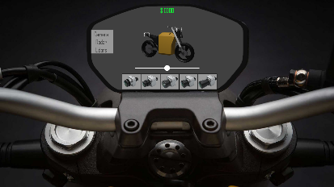

Game mechanics are designed to offer an immersive real-time experience, where players manage technological tools such as sensors and cameras to identify and avoid obstacles while staying within budgetary limits. This setup simulates technical challenges and focuses on sustainable transportation solutions. As the speed and complexity of levels increase, players are challenged to make quick and effective decisions, simulating real-life situations where sustainable practices must be balanced according to limitations.

Levels are designed to represent urban and rural environments of Vila Real, presenting theoretical challenges that mirror real-world obstacles in achieving green mobility. Players will face varied weather and environmental conditions that demand adaptive strategies. Interactive elements in the environments allow players to explore and implement green mobility solutions, such as optimizing energy consumption or utilizing renewable energy sources available within the game context.

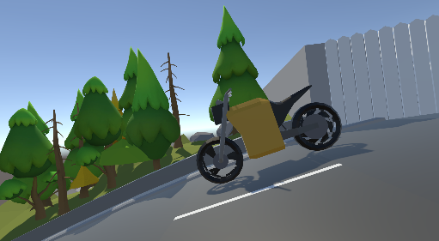

|  |  |
| --- | --- |
| Gameplay Mechanics | |
| Sensor Selection | The player can select and position sensors on the motorcycle. The sensors are the following:   * Radars * Cameras * LiDARs   For each type of sensor there will be multiple sensors with different specifications and costs. |
| AI Models/Algorithms Selection | The player can select AI models or algorithms to process the data collected by the sensors. |
| Dataset Selection | Depending on the selected sensor, datasets must be selected to simulate the training process of the selected AI model/algorithm. |
| Parameterization | The selected AI models/algorithms need to be parameterized to maximize performance of the system. |
| Overcoming obstacles/dangers | The player will have to overcome different obstacles/dangers:   * Static obstacles * Dynamic obstacles * Environmental challenges (weather) |
| Game Rules | |
| Gameplay Rules | The player can test their setup at any time, even if a sensor was not selected.  Each level can be reset as many times as the player wants.  Every obstacle/danger needs to me overcome, otherwise the level is failed.  Each level has a cost that cannot be exceeded. |
| Scoring | Points that are given for the overall solution (cost, accuracy and speed). |
| Levels and Progression | |
| Level Structure | Each level will get progressively harder. Whilst initially there are only static objects/dangers, with each passing level dynamic objects/dangers and environmental challenges will be added. |
| Progression | Players unlock new levels, sensors, AI models/algorithms and datasets by completing levels. |