Hi Professor,

I know that I have been a pain in your side for a while now.

And unfortunately, that is just how I am. So, I apologize, because I am going to complain one more time before ,y grades are final the professor removes half my grade because, well, I find her incompetence maddening, and I am okay with it being known.

I had let a lot go, and had just come to the conclusion that I wasted 1300 on something I could have got for free off YouTube. However, on one of the videos that I was listening to that had professor Deford speaking, he had mentioned to his class about the reading he had wanted them to do in the textbook.

I thought to myself that it was strange, as we were told there is no textbooks. We were, however given a list of 12 books that we were advised were open, optional supplemental material. 12. 12 textbooks to teach us, rather than her doing her job.

Hm, maybe a textbook explaining why we use this argument over that one, and explaining why we do this or that may have been helpful, rather than being graded on how well we can watch an

Rather than us seeing how well we can watch another Professor do the assignment and input the same values into our own sheet. That is mimicking, that is not teaching or learning.

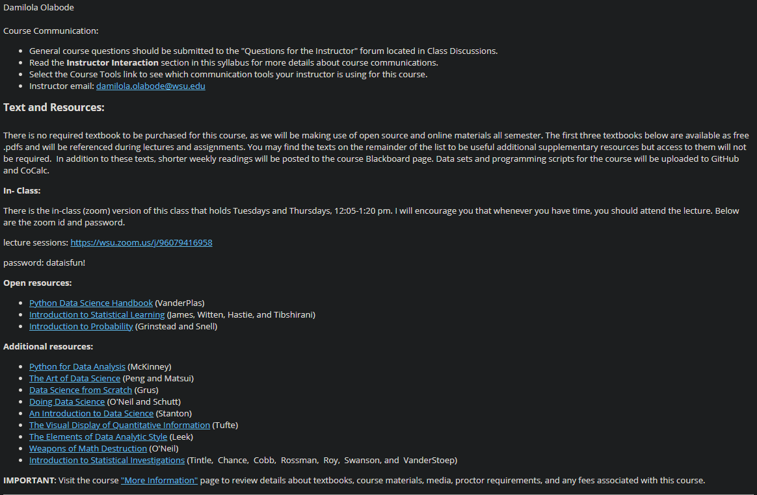Here is the syllabus we had, with all the books that were optional to look at.

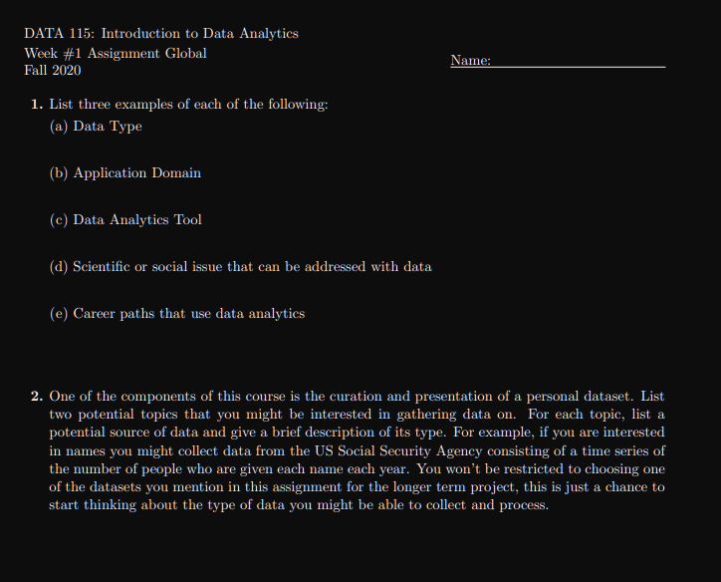Even more fun, is that the first week of class, we were told about our final project. Guess who started getting their data the next week as I had to have 6 different departments sign off on allowing me to remove the redacted PHI out of our SQL server at work.

Then, week 12, assignment was changed. We were then told that if we do anything else or use any other kinds of data, she would not accept it.

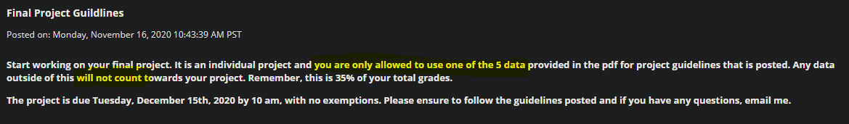The 5 options for data sets have been done to death.

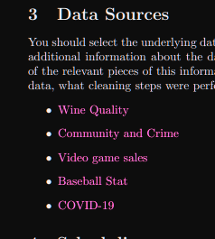I still set aside all the work I had already done, and grudgingly started working on a different final project.

I then went a little above and beyond with I wanted to analyze. And since, it is not what is approved data, then she is going to ignore it.

Deford’s class got to pick any option that they wanted to, and he even helped them find data. This project was explained to us that it was going to be something that we can show off as part of our portfolio. This removes this as a possibility.

Which is yet another reason that I am annoyed that they got such a good teacher, and I got… a warm body that will tell us to listen to the other teacher’s actual lesson plan.

My advisor basically hinted to me that since I have an issue with learning from this professor, maybe I need a new major.

And so, I am about done with this all program, as well as this school.

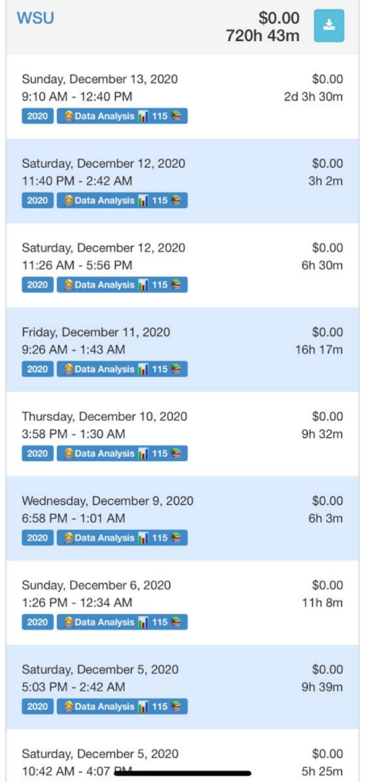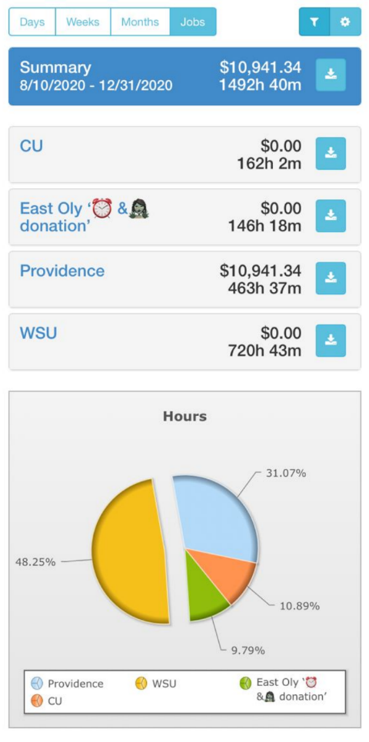So, this is my hour tracker for this class, and my others, and also my job. And I pulled the data for just this semester. That is a \*HUGE\* chunk of my time. and why is this so huge? Because I end up trying to spend hours trying to understand why we use one thing or another or figure out why data did not look like the one example, and so on. Oh, and the 2 day, 3 hours that was started on Sunday? That is not a type-o, yes that is accurate, and yes I am actually still awake, and have not slept yet.

<https://github.com/pickletinie/psychic-parakeet>

this is my git hub that I had made for my final. In there, you will 194 different sheets of data that I had pulled from one place or another, in an attempt to get my final completed

I would like it if you would look and read over what I had submitted, as I broke anaconda at the last minute, and was able to get it working again in the way I needed, and I would like if it someone would at least acknowledge some of the work I have done, as it seems everyone else is blowing me off. Which is just one more thing that has led to my disdain to the current situation. And as my advisor seems to refuse to lift the hold off me being able to schedule for next semester, then I guess it is what it is, and I will find a different school to attend. Hopefully that one would have less staff that is as useful as lipstick during a pandemic. Because wasting 1300$ on a class, and still not understanding anything about it is like the worst feeling. That could have been a rent payment, or a new set of tires for my vehicle. But instead, it literally went to waste.

-sorry-not-sorry for the rant

-Sasha o7