Figure 1: The MELD Dataset’s scope of labelled data illustrated.

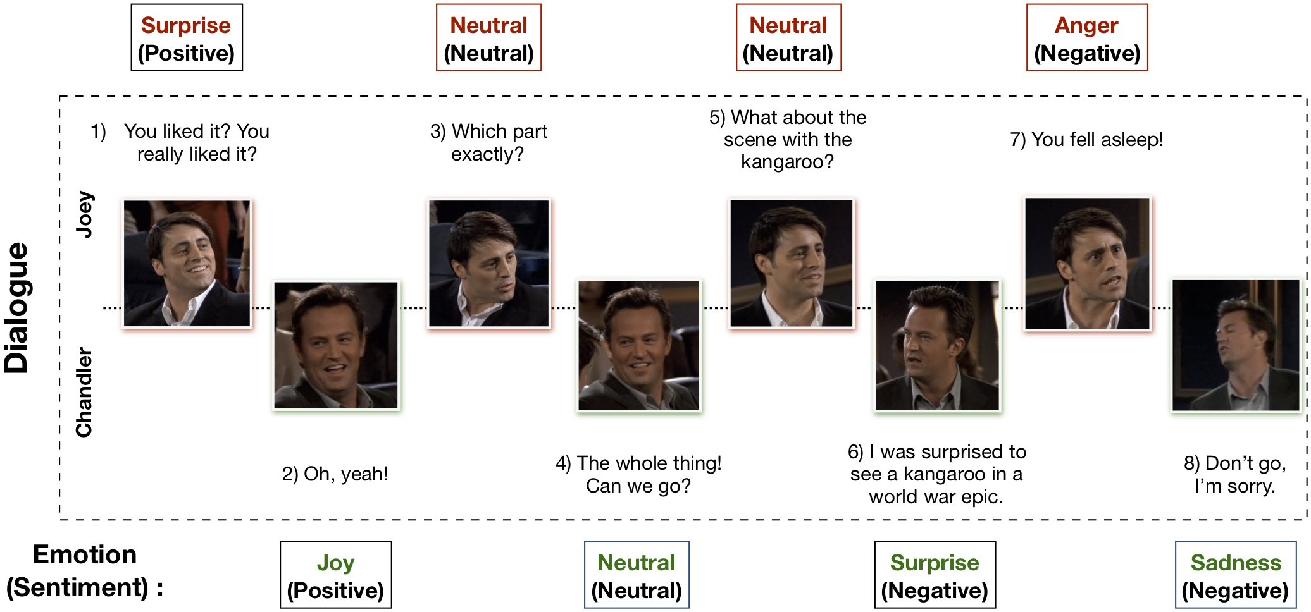

# **ConvoKit-Transformers: An applied study on Feature Classification in Conversations**

Project Proposal in Brief

Theophilus Lee*

NUS High School of Math and Science

20 Clementi Ave 1, Singapore 129957

[h1910153@nushigh.edu.sg](mailto:h1910153@nushigh.edu.sg)

*Introduction*

Feature Classification in Conversations is a subfield of Natural Language Processing that aims to extract discrete features from text in multi-speaker dialogue. Findings have shown that understanding of conversations yields better results in tasks involving multi-speaker data. Models tasked to understand conversations also provide contextual information that is absent in general use LLMs. Most previous works perform studies on emotion classification and dialog relation extraction. Some noteworthy works include the introduction of f1c accuracy metric for conversational data, proposal of BERTs in DialogRE for formatting relation inputs, prompt tuning approaches in GRASP and KnowPrompt, graph-based approaches. However, this field is still in its infancy, and has not made its way into mainstream demand.

*Problem Statement*

Design a solution to tackle these issues.

- Current resources for building models capable of comprehending conversations lack many critical components for efficient full stack development.

- Clear documentation is not available for many proposed models, greatly inconveniencing a developer’s workflow.

- Little work exists to demonstrate technical applications of conversational models to real world problems.

- Many implementations of conversational models lack sufficient testing, and are highly self-contained, limiting robustness in a development setting.[1]

*Proposed Work*

We reimplement TUCORE-GCN, a significant milestone of research in the field that has spawned several variants. This means that we will refactor the work of the official implementation to include critical infrastructure necessary for use in solution engineering. This will include testing, documentation, and an in-depth ablation study, among other aspects.

We investigate the core necessities of a Machine Learning developer in the work of implementing a conversational model, delving into the needs of differing real-life scenarios and technical requirements among other aspects. For instance, if we observe that it is common practice in some fields to use circle-ci for automated testing, we will evaluate the applicability of this technology to our work.

Lastly, we package our work with TUCORE-GCN in a developer toolkit curated for conversational model creation, testing and deployment, as a product of our research. This will be presented as a python package.

*Summary*

1. We adapt the TUCORE-GCN branch of models for developer use.
2. We investigate the necessities of an ML developer for utilizing conversational models in solving conversational problems.
3. Our research is unified into an accessible and extendable toolkit, ConvoKit-Transformers

1. Equal contribution