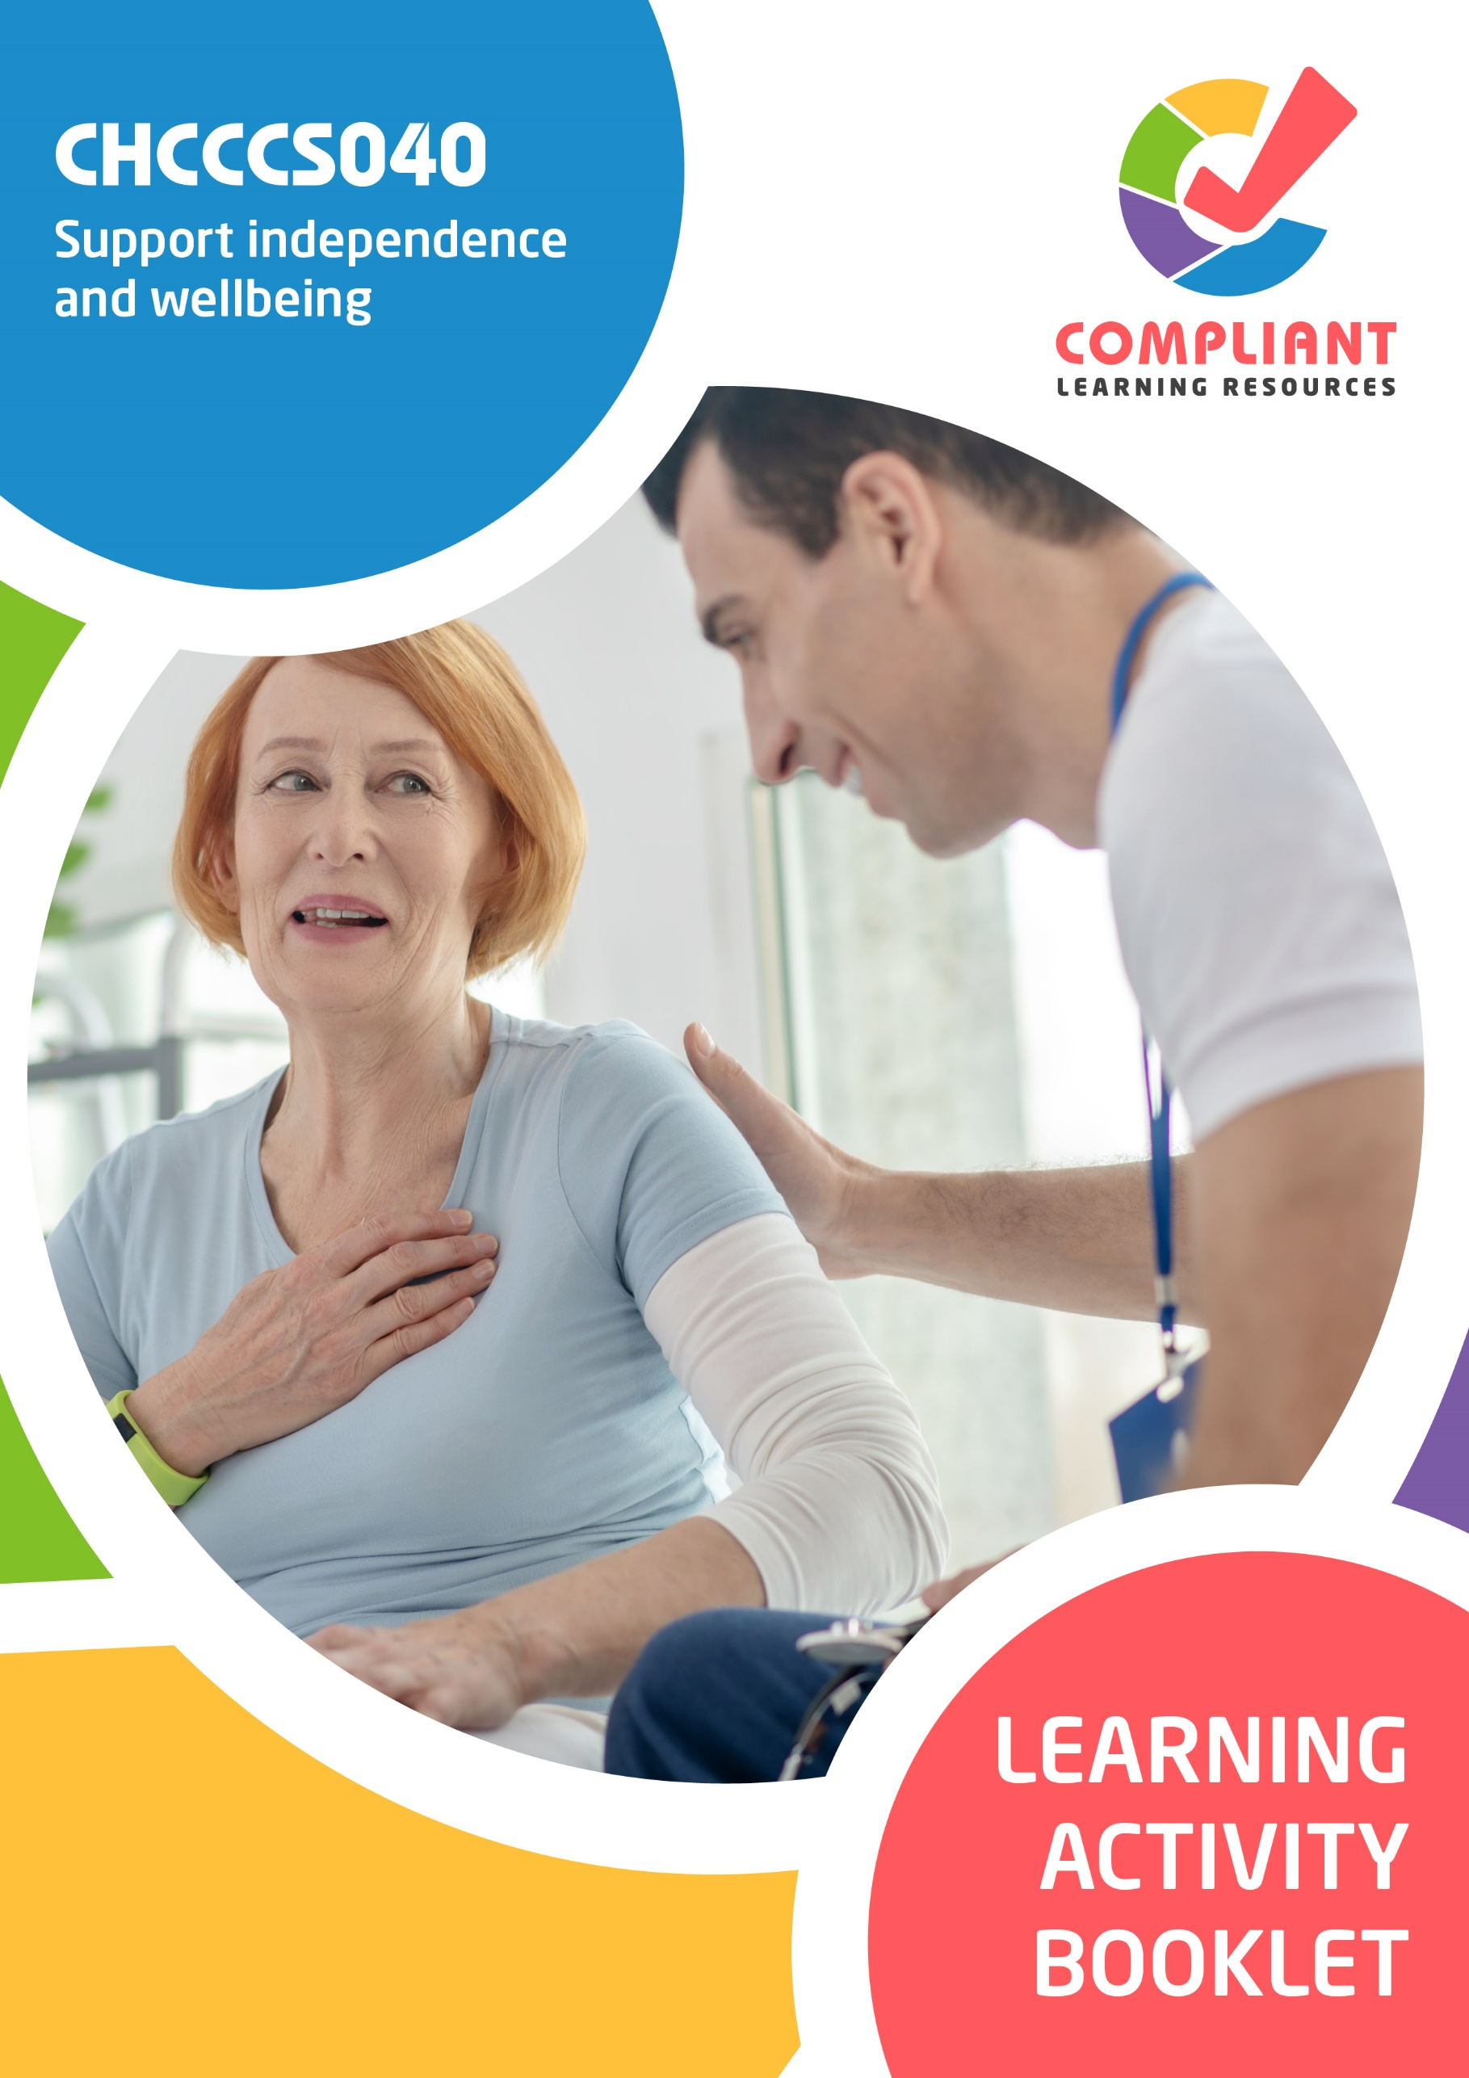

**Copyright**

This document was developed by Compliant Learning Resources.

© 2023 Compliant Learning Resources.

All rights reserved.

No part of this publication may be reproduced, stored in a retrieval system, or transmitted in any form or by any means, electronic, mechanical, photocopying, recording, or otherwise without the prior written permission of Compliant Learning Resources.

**Version Control & Document History**

|  |  |  |
| --- | --- | --- |
| **Date** | **Summary of Modifications** | **Version** |
| 22 December 2022 | Version 1.0 released for publishing | 1.0 |
| 25 May 2023 | Version 1.1 endorsed for use  Fixed minor wording and formatting issues | 1.1 |
| 22 August 2023 | Version 1.2 endorsed for use  Fixed wording issues | 1.2 |
| 06 November 2023 | Version 1.3 Contextualisation for IIET | 1.3 |

# Table of Contents

Overview 4

Learner Instructions 5

Learner Information 5

Trainer Information 5

Resources Required 6

Work Health and Safety 6

Reasonable Adjustment 7

Formative Activities 8

I. Recognise and Support Individual Differences 8

Activity 1.1 8

Activity 1.2 11

II. Promote Independence 12

Activity 2.1 12

Activity 2.2 13

III. Support Physical Wellbeing 14

Activity 3.1 14

Activity 3.2 15

Activity 3.3 16

IV. Support Social, Emotional and Psychological Wellbeing 18

Activity 4.1 18

Activity 4.2 18

Activity 4.3 19

# Overview

CHCCCS040 - Support independence and wellbeing (Release 1)

This unit describes the skills and knowledge required to provide individualised services in ways that support independence, as well as physical and emotional wellbeing.

This unit applies to workers in a range of community services contexts who provide frontline support services within the context of an established individualised plan.

The skills in this unit must be applied in accordance with Commonwealth and State/Territory legislation, Australian/New Zealand standards and industry codes of practice.

**A complete copy of the above unit of competency can be downloaded from the TGA website:**

<https://training.gov.au/Training/Details/CHCCCS040>

# Learner Instructions

This Learning Activity Booklet contains formative activities that learners will complete in the classroom or a similar environment.

These formative activities include knowledge questions to test your underpinning generic knowledge and practical activities to test your skills relevant to the unit/s of competency.

These formative assessments are used by your trainer to complement both the learning and training processes, and to evaluate how you are progressing throughout these processes.

You may reference your Learner Guide and other learning materials to complete the activities included in this workbook.

**IMPORTANT:**

**The completion of the formative assessments and learning activities included in this workbook DOES NOT lead to a Qualification or a Statement of Attainment (SOA).**

## Learner Information

|  |  |
| --- | --- |
| Learner name |  |
| Phone |  |
| Email |  |

## Trainer Information

|  |  |
| --- | --- |
| Trainer name |  |
| RTO name |  |
| RTO phone |  |
| RTO email |  |

# Resources Required

Resources needed to complete activities included in this workbook include:

* Computer with Internet, email access, and a working web browser
* Installed software: MS Word, Adobe Acrobat Reader
* Learner guide

# Work Health and Safety

Both the trainers and learners have duty of care in ensuring that the learning environment is free from hazards that may pose risks to their health and safety.

According to WHS legislation, trainers and learners must take reasonable care while undertaking the activities included in this workbook in the learning environment.

# Reasonable Adjustment

‘Reasonable adjustment’ in VET is the term applied to modifying the learning environment or making changes to the training delivered to assist a learner with a disability. A reasonable adjustment can be as simple as changing classrooms to be closer to amenities or installing a particular type of software on a computer for a person with vision impairment.

**Why make a reasonable adjustment?**

We make reasonable adjustments in VET to make sure that learners with disabilities have:

* The same learning opportunities as learners without disabilities, and
* The same opportunity to perform and complete assessments as those without disabilities.

**Reasonable adjustment applied to participation in teaching, learning, and assessment activities can include:**

* Customising resources and assessment activities within the training package or accredited course
* Modifying the presentation medium
* Learner support
* Use of assistive/adaptive technologies
* Making information accessible both before enrolment and during the course
* Monitoring the adjustments to ensure learner needs continue to be met

**Assistive/Adaptive Technologies**

Assistive/adaptive technology means ‘software or hardware that has been specifically designed to assist people with disabilities in carrying out daily activities’ (World Wide Web Consortium - W3C). It includes screen readers, magnifiers, voice recognition software, alternative keyboards, devices for grasping, visual alert systems, and digital note-takers.

*(Adapted Reasonable Adjustment in teaching, learning and assessment for learners with a disability - November 2010 - Prepared by - Queensland VET Development Centre)*

**IMPORTANT:**

**Reasonable adjustment made for collecting learner assessment evidence must not impact the standard expected by the workplace, as expressed by the relevant unit/s of competency. For example, if the assessment were gathering evidence of the learner’s competency in writing, allowing the learner to complete the assessment verbally would not be a valid assessment method. The method of assessment used by any reasonable adjustment must still meet the competency requirements.**

# Formative Activities

## I. Recognise and Support Individual Differences

### Activity 1.1

|  |
| --- |
| **SCENARIO**  You will play the role of an interviewer who has to help a person accomplish a form. In this scenario, the act of helping the person accomplish a form is addressed as an ‘interview’.  **Information About the Person**   * The person is unable to write, hence the need to help them with the form. The person also has difficulty reading, especially with the English language. They can, however, understand the language in speech. The form is only in English, so the person prefers that someone read it for them. * The person comes from a culture that bans handshakes. The person’s culture uses nods as a form of formal greeting. One is expected to nod back if a person nods at them in a conversation. * The person subscribes to a religion that requires them to pray alone at certain times of the day. For this scenario, the religion is called ‘Religion A’.   For simplicity, the form is just a piece of paper with the following questions:  **Form Questions**   1. What is your full name? 2. What name do you want to be addressed with? 3. How old are you? 4. What is your highest educational attainment? 5. Are you single, married, separated, or widowed? 6. If married, what is the name of your partner? 7. What is your religion if you have one? 8. What are your favourite leisure activities to do? |

|  |
| --- |
| The scenario should play out according to the timeline below:  **Scenario Timeline**   1. The interview will be conducted in the person’s place. The interviewer must approach the person as if they have never met. 2. The person must initiate a nod before they start accomplishing the form. 3. The interviewer initially addresses the person by their last name (for example, Mr or Ms Smith). 4. The interviewer will read the questions from the form one by one and in the order as shown. 5. The person will answer every question asked. The answers need not be true or factual. But the answers must comply with the Information About the Person. 6. The interviewer writes down the answers on the form. 7. After the last question, the person requests the interviewer to leave immediately. The person mentions that they have to conduct their personal prayer.   You will play the role of the interviewer. You must then be familiar with all of the information and instructions above.  Another person will roleplay the person. The person only needs to be familiar with the information and instructions from the following lists:   * Information About the Person * Scenario Timeline |

|  |
| --- |
| **Role Play Activity**  Role play the scenario with a volunteer to fill up a form for the person, while demonstrating the practical skills listed in the checklist on the next page.  Perform this activity while being observed by your trainer. If your trainer is not available to directly observe you, you may video record the role play activity and submit the recording to your trainer.  **Your role**  For this activity, you will take the role of the interviewer.  **The volunteer’s role**  For this activity, the volunteer will take the role of the person. |

|  |  |  |
| --- | --- | --- |
| **Role Play Checklist** (For trainer’s use only) | | |
| **During the role play activity:** | **YES** | **NO** |
| 1. The learner demonstrates respect towards cultural differences by not initiating a handshake with the person. |  |  |
| 1. The learner demonstrates respect towards cultural differences by nodding back to the person when the latter nods. |  |  |
| 1. The learner demonstrates respect towards social differences by addressing the person by their preferred name after knowing the latter. |  |  |
| 1. The learner demonstrates respect towards social differences by not belittling the person for their educational background. |  |  |
| 1. The learner demonstrates respect towards spiritual differences by not initiating a conversation about spirituality beyond those required by the form. |  |  |
| 1. The learner demonstrates respect towards spiritual differences by leaving the premises before the person conducts their personal prayer. |  |  |
| Trainer’s overall feedback on the learner’s performance during the role play activity: | | |

### Activity 1.2

|  |  |  |  |  |  |  |  |
| --- | --- | --- | --- | --- | --- | --- | --- |
| **Matching Type**  Identify the Individual Needs being described in each statement on the next page.   |  | | --- | | **Individual Needs** | | Physical | | Psychological | | Spiritual | | Cultural | | Sexual | | |
|  | |
| Description | |
|  | 1. These needs relate to a person’s effort to find meaning and purpose in life. Religion and mysticism often provide for these needs. But any conscious person will have ways to address these needs. |
|  | 1. Humans, like other creatures, have the natural tendency to reproduce. These needs are the body’s way to compel an individual to meet this tendency. |
|  | 1. These needs are the needs of the brain and consciousness. Humans are self-aware and social creatures. Because of this, humans have needs related to emotions, interaction, control and more. |
|  | 1. Some needs and preferences trace their origin to culture. These needs are those that a particular tradition or way of life has set. Different cultures have instilled different needs in their people. |
|  | 1. These needs refer to the biological requirements to sustain life. This can include air, drink, food, sleep, warmth, clothing, shelter and more. |

## II. Promote Independence

### Activity 2.1

|  |  |  |
| --- | --- | --- |
| **Matching Type**  Listed below are some of the important opportunity factors to discuss when you help a person find opportunities that use their strengths.   1. Cost 2. Schedule 3. Accessibility 4. Effect on needs 5. Services needed   Match each to their point of discussion below, by writing the letter that corresponds to your answer in the space provided. | | |
|  | | |
| Point of Discussion | | |
|  | 1. The person may need other services to join prospective opportunities. For instance, they may need translation services in social activities. | |
|  | 1. Always check if the opportunities selected are affordable to the person. | |
|  | | 1. It may be that some opportunities can affect the needs of the person. Make sure that no negative effects result from opportunities. | |
|  | | 1. Consider the person’s day-to-day activities and other important dealings. | |
|  | | 1. Make sure the opportunity is near the person’s location or at least accessible. | |

### Activity 2.2

|  |
| --- |
| **SCENARIO**  Jane is a 40-year-old who recently broke her right arm, which is her dominant hand. Her doctor projects that her arm will fully heal in 5-6 weeks. Jane also has monoplegia, where her right leg is permanently paralysed. To move around, she supposedly uses a single crutch on the right side of her body.  For much of her life, Jane has coped well with her situation. However, her broken arm compelled her to seek some help. |

|  |
| --- |
| Explain why Jane may have to use a wheelchair while having a broken arm. |
|  |
|  |

|  |
| --- |
| Enumerate three activities that may be difficult for Jane with her broken dominant arm. |
|  |
|  |
|  |
|  |

|  |
| --- |
| Explain how you will support Jane in filling up forms if she can supposedly only write with her right hand. The support given must maximise Jane’s self-management. |
|  |
|  |

## III. Support Physical Wellbeing

### Activity 3.1

|  |  |
| --- | --- |
| **True or False**  Review the statements below about some practices for some positive daily living habits. Indicate whether each statement is True or False.  Tick the box that corresponds to your answer. | |
|  | |
| TRUE  FALSE | 1. A healthy eating and drinking habit include setting up regular mealtimes. |
| TRUE  FALSE | 1. Using soiled clothes is part of healthy hygiene. |
| TRUE  FALSE | 1. A healthy sleeping habit includes providing a comfortable place to sleep. |
| TRUE  FALSE | 1. Having an irregular bath schedule is part of a healthy hygiene. |
| TRUE  FALSE | 1. Having no access to drinking water is part of a healthy eating and drinking habit. |

### Activity 3.2

|  |
| --- |
| **SCENARIO**  Nate is a 60-year-old living alone in his home. He has had a tough life for the past few years. You are a service worker tasked to conduct a simple hazard identification on Nate and his residence. You came to Nate’s residence to interview him and take a look at his house.  You got the following information after interviewing Nate:   * Nate’s hands and clothes were dirty from tending to his garden. He mentioned that it is often the case because he works in his garden most of the time. * Nate volunteers at the local community centre on the weekends. He says he loves helping people out. * Nate mentions that he loves to eat salted chips. He says their family has a history of hypertension, but he is yet to be diagnosed with one.   You got the following information after looking around Nate’s house:   * Nate has a well-managed garden in his backyard. He loves to grow vegetables that he can consume afterwards. * Nate’s toilet has had a leaky faucet for a while now. This leaves the floor wet most of the time. * Nate has a stash of newspapers in his living room. He says he prefers to read his news instead of watching the television. * Nate has multiple fire extinguishers around his house. He says that after nearly starting a house fire a couple of years ago, he was just being careful. |

|  |
| --- |
| Complete the hazard identification form below by identifying three hazards and their associated risks using the information provided in the scenario. |

|  |  |
| --- | --- |
| **Hazard identification form** | |
| **Hazard** | **Associated Risk** |
|  |  |
|  |  |
|  |  |

### Activity 3.3

|  |  |
| --- | --- |
| **Matching Type**  Listed below are some common health problems.   1. Stroke 2. Asthma 3. Hypertension 4. Heart Attacks 5. Type II Diabetes   Match each to their presentation below, by writing the letter that corresponds to your answer in the space provided. | |
|  | |
| Presentation | |
|  | 1. It is a lung condition described by narrowing of airways. The narrowing causes the symptoms such as:    * Coughing    * Wheezing    * Chest tightening    * Difficulty in breathing |
|  | 1. The common cause of this health problem is blood clots blocking the blood vessels in the brain. Common symptoms are sudden manifestations of any of the following:    * Loss of balance and coordination    * Severe numbness    * Severe headache    * Blurry vision    * Confusion |

|  |  |
| --- | --- |
| Presentation | |
|  | 1. This health problem happens when a blood vessel in the heart gets blocked. Cholesterol build-up is the most common cause. Common signs that may lead to this health problem are high cholesterol and hypertension. Symptoms include:    * Discomfort in the left-side arm, neck and back    * Tightness and pain in the chest region    * Dizziness and nausea    * Shortness of breath    * Vomiting |
|  | 1. This health problem has a person unable to use their body’s insulin. They will also have high amounts of sugar in their blood.   Symptoms may include the following:   * + Blurry vision   + Persistent fatigue   + Frequent urination   + Sudden weight loss   + Unquenchable thirst   + Slow healing of wounds |
|  | 1. This health problem is having one or both:    * A systolic blood pressure greater than or equal to 140 mmHg    * A diastolic blood pressure greater than or equal to 90 mmHg   People with this health problem usually do not experience any symptoms. A few have reported headaches, nosebleeds and shortness of breath. This health problem is in the presentations of heart attacks and stroke. It is also called high blood pressure or elevated blood pressure. |

## IV. Support Social, Emotional and Psychological Wellbeing

### Activity 4.1

|  |  |
| --- | --- |
| **True or False**  Review the statements below about some practices. If the statement does incorporate positive and supportive communication, indicate it as True. Otherwise, indicate the statement as False.  Tick the box that corresponds to your answer. | |
|  | |
| TRUE  FALSE | 1. Greet people by the name that you prefer. |
| TRUE  FALSE | 1. Be a passive listener when someone is communicating with you. |
| TRUE  FALSE | 1. Respond with empathy. Never one-up or downplay someone’s feelings. |
| TRUE  FALSE | 1. Acknowledge a person’s efforts and achievements. |
| TRUE  FALSE | 1. Do not show interest and purpose in the persons’ lives. |

### Activity 4.2

|  |
| --- |
| List three indicators of emotional concerns and issues. |
|  |
|  |
|  |
|  |

### Activity 4.3

|  |
| --- |
| Enumerate the steps to take when spotting signs of abuse. |
|  |
|  |
|  |
|  |
|  |
|  |
|  |
|  |
|  |

End of Document