Learning Activity Booklet Version 1.1 Produced 5 March 2024

© Harvard Management Institute Pty Ltd. **1**

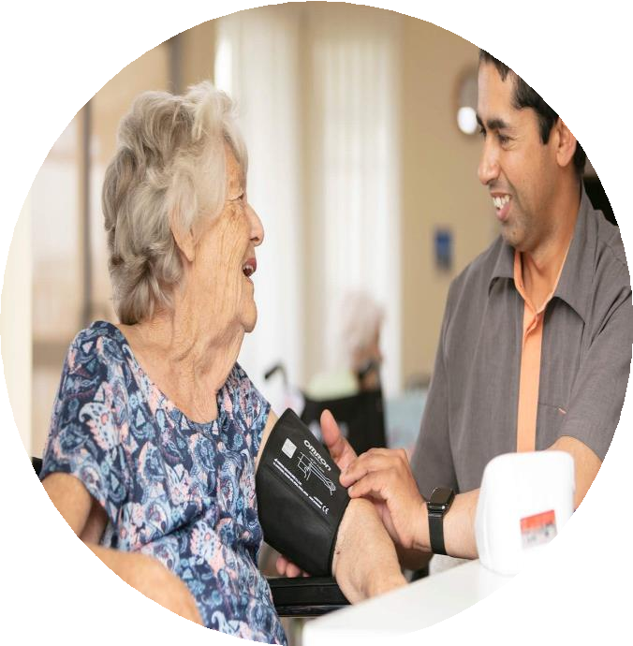

**CHCAGE009**

Provide services for older people

LEARNING ACTIVITY BOOKLET

CHCAGE009 - Provide services for older people (Release 1)

### Copyright

This document was developed by Harvard Management Institute Pty Ltd.

© 2023 Harvard Management Institute Pty Ltd. All rights reserved.

No part of this publication may be reproduced, stored in a retrieval system, or transmitted in any form or by any means, electronic, mechanical, photocopying, recording, or otherwise without the prior written permission of Harvard Management Institute Pty Ltd.

**Version Control & Document History**

|  |  |  |
| --- | --- | --- |
| **Date** | **Summary of Modifications** | **Version** |
| 20 January 2023 | Version 1.0 released for publishing | 1.0 |
| 5 March 2024 | Version 1.1 endorsed for use | 1.1 |

# Table of Contents

Overview 4

Learner Instructions 5

Learner Information 5

Trainer Information 5

Resources Required 6

Work Health and Safety 6

Reasonable Adjustment 7

Formative Activities 8

1. Deliver Individualised Services 8

Activity 1.1 8

Activity 1.2 9

Activity 1.3 10

1. Liaise and Negotiate with Others 11

Activity 2.1 11

Activity 2.2 12

1. Support Family and Carer 13

Activity 3.1 13

Activity 3.2 13

1. Coordinate Feedback 14

Activity 4.1 14

Activity 4.2 15

CHCAGE009 - Provide services for older people (Release 1)

# Overview

### CHCAGE009 - Provide services for older people (Release 1)

This unit describes the performance outcomes, skills and knowledge to provide services to an older person and to support their family, carer or others identified by the person. It involves following and contributing to an established individualised plan.

This unit applies to workers in a residential or community context, or those in personal care or support services that work with older people. Work performed requires some discretion and judgement and is carried out under regular direct, indirect or remote supervision.

The skills in this unit must be applied in accordance with Commonwealth and State/Territory legislation, Australian standards and industry codes of practice.

No occupational licensing, certification or specific legislative requirements apply to this unit at the time of publication.

### A complete copy of the above unit of competency can be downloaded from the TGA website:

<http://training.gov.au/Training/Details/CHCAGE009>

# Learner Instructions

This Learning Activity Booklet contains formative activities that learners will complete in the classroom or a similar environment.

These formative activities include knowledge questions to test your underpinning generic knowledge and practical activities to test your skills relevant to the unit/s of competency.

These formative assessments are used by your trainer to complement both the learning and training processes, and to evaluate how you are progressing throughout these processes.

You may reference your Learner Guide and other learning materials to complete the activities included in this workbook.

### IMPORTANT:

**The completion of the formative assessments and learning activities included in this workbook DOES NOT lead to a Qualification or a Statement of Attainment (SOA).**

## Learner Information

|  |  |
| --- | --- |
| Learner name | Sunil paudel |
| Phone | 0452050345 |
| Email | Sunil.chhetri22222@gmail.com |

## Trainer Information

|  |  |
| --- | --- |
| Trainer name |  |
| RTO name |  |
| RTO phone |  |
| RTO email |  |

CHCAGE009 - Provide services for older people (Release 1)

# Resources Required

Resources needed to complete activities included in this workbook include:

* Computer with Internet, email access, and a working web browser
* Installed software: MS Word, Adobe Acrobat Reader
* Learner guide

# Work Health and Safety

Both the trainers and learners have duty of care in ensuring that the learning environment is free from hazards that may pose risks to their health and safety.

According to WHS legislation, trainers and learners must take reasonable care while undertaking the activities included in this workbook in the learning environment.

# Reasonable Adjustment

‘Reasonable adjustment’ in VET is the term applied to modifying the learning environment or making changes to the training delivered to assist a learner with a disability. A reasonable adjustment can be as simple as changing classrooms to be closer to amenities or installing a particular type of software on a computer for a person with vision impairment.

### Why make a reasonable adjustment?

We make reasonable adjustments in VET to make sure that learners with disabilities have:

* The same learning opportunities as learners without disabilities, and
* The same opportunity to perform and complete assessments as those without disabilities.

### Reasonable adjustment applied to participation in teaching, learning, and assessment activities can include:

* Customising resources and assessment activities within the training package or accredited course
* Modifying the presentation medium
* Learner support
* Use of assistive/adaptive technologies
* Making information accessible both before enrolment and during the course
* Monitoring the adjustments to ensure learner needs continue to be met

### Assistive/Adaptive Technologies

Assistive/adaptive technology means ‘software or hardware that has been specifically designed to assist people with disabilities in carrying out daily activities’ (World Wide Web Consortium - W3C). It includes screen readers, magnifiers, voice recognition software, alternative keyboards, devices for grasping, visual alert systems, and digital note-takers.

*(Adapted Reasonable Adjustment in teaching, learning and assessment for learners with a disability -*

*November 2010 - Prepared by - Queensland VET Development Centre)*

### IMPORTANT:

**Reasonable adjustment made for collecting learner assessment evidence must not impact the standard expected by the workplace, as expressed by the relevant unit/s of competency. For example, if the assessment were gathering evidence of the learner’s competency in writing, allowing the learner to complete the assessment verbally would not be a valid assessment method. The method of assessment used by any reasonable adjustment must still meet the competency requirements.**

CHCAGE009 - Provide services for older people (Release 1)

# Formative Activities

## Deliver Individualised Services

Activity 1.1

|  |  |
| --- | --- |
| **True or False**  Review the statements below about goals that follow the S-M-A-R-T principle. Indicate whether each statement is True or False.  Tick the box that corresponds to your answer. | |
|  | |
| * TRUE ☐ FALSE | i. A *specific* goal is distinct from other goals. |
| ☐ FALSE | ii. A *measurable* goal’s progress may not be exact. |
| ☐ FALSE | iii. An *attainable* goal’s results are not achievable. |
| * TRUE | iv. A *relevant* goal addresses the needs. |
| ☐ FALSE | v. A *time-bound* goal has a start and no end. |

Activity 1.2

**Matching Type**

Identify the common health problem being described in each statement below.

|  |
| --- |
| **Health Problems** |
| Stroke |
| Allergies |
| Depression |
| Heart Attack |
| Type II Diabetes |

|  |  |
| --- | --- |
| Description | |
| Heart attack | 1. This happens when a blood vessel in the heart gets blocked. Cholesterol build-up is the most common cause. Symptoms may include:    * Discomfort in the left-side arm and back    * Tightness and pain in the chest region    * Shortness of breath |
| Depression | ii. This is a common mental disorder worldwide. Its symptoms are persistent sadness and a lack of interest in enjoyable activities. |
| Type ll diabetes | iii. This is a condition where a person is unable to use their body’s *insulin*. People with this problem have high amounts of sugar in their blood. |

CHCAGE009 - Provide services for older people (Release 1)

|  |  |
| --- | --- |
| Description | |
| Allergies | 1. These are reactions of the immune system to some substances. These substances can be:    * Dust    * Food    * Pollen    * Animals |
| Stroke | 1. This happens for any of the two reasons:    * The brain does not receive enough oxygen    * The blood vessels in the brain burst   The common cause of this problem is blood clots blocking the blood vessels in the brain. |

Activity 1.3

|  |
| --- |
| Enumerate the steps to take when spotting a sign of abuse. |
|  |
| i. Ask the older person about your observation. |
| 1. Inform the older person that you will make a report about this observation. |
| 1. Assure the older person that this report is for their safety. |
| 1. Make a written or digital record of the report. |
| 1. Send the report to your immediate supervisor. |
| 1. Forward the report to the appropriate authority. |
| 1. Take steps to investigate the incident as advised by your supervisor. |

## Liaise and Negotiate with Others

Activity 2.1

|  |  |
| --- | --- |
| **Matching Type**  Listed below are community support services and agencies applicable to older people.   1. Transportation services 2. Indigenous community groups 3. Interest groups in the community 4. Cultural and language interpreters 5. Aged Care Assessment Team (ACAT)   Match each to their description below by writing the letter that corresponds to your answer in the space provided. | |
|  | |
| Description | |
| A | i. They provide ways for the person to move from one place to another. |
| C | ii. They offer various activities that the person may join. These activities may include sports, art, music, cooking, charity and more. |
| D | iii. They help CALD persons communicate with other service providers. |
| E | iv. They help determine the needs of older Australians. They also help older people find government-subsidised services. |
| B | v. Aboriginal and Torres Strait Islanders may have small local service groups. They offer social services with the government’s help. |

CHCAGE009 - Provide services for older people (Release 1)

Activity 2.2

|  |
| --- |
| List down three reasons for a person’s needs, goals, and preferences to change over time. |
|  |
| 1. Manifestation of a serious illness |
| 1. The person moving to a different location |
| 1. The emergence of hazards that pose risks to the person |

## Support Family, Carer or Relevant Others

Activity 3.1

|  |  |
| --- | --- |
| **True or False**  Review the statements below about ways to provide support to the family and carers. Indicate whether each statement is True or False.  Tick the box that corresponds to your answer. | |
|  | |
| ☐ FALSE | i. You can get involved with family matters. |
| * TRUE | ii. You can provide reassurance to the family member or carer. |
| ☐ FALSE | iii. You can freely disclose personal information to everyone. |
| * TRUE | iv. You can promote the benefits of taking time for self-care. |
| ☐ FALSE | v. You can provide advice on matters not related to work. |

Activity 3.2

|  |
| --- |
| Answer the following questions about substitute carers. |
|  |
| 1. What type of service allows for a substitute carer?  * A substitute carer can help in personal care support, community access support and supported residential care service |
| ii. How long can a substitute carer work?   * A substitute carer can work for few hours to few weeks |
| 1. What is the goal of the substitute carer?  * The goal of substitute carer is to help and plan the provision of respite care |

CHCAGE009 - Provide services for older people (Release 1)

## Coordinate Feedback

Activity 4.1

|  |
| --- |
| Give one example of feedback on the plan’s effectiveness from the stakeholders provided below. |
|  |
| 1. From the older person-  * The person may point out the lack of skills of some workers. |
| 1. From the family members  * A family member may want to hire a carer to take their role. |
| 1. From the carer  * A carer may comment on the performance of workers. |
| 1. From the service providers  * The service provider may provide updates on changes that they have made. |
| 1. From relevant others  * Relevant others may communicate observations that they have seen. |

Activity 4.2

**Matching Type**

Identify the relevant health professionals being described in each statement below.

|  |
| --- |
| **Health Professionals** |
| Dentists |
| Specialists |
| Pharmacists |
| Psychologists |
| General Practitioners |

|  |  |
| --- | --- |
| Description | |
| Psychologists | i. They are the best professionals to help address mental health concerns. |
| General practitioners | ii. They are usually the first doctors to respond if the  person’s actual condition is unknown. |
| Pharmacists | iii. They can help educate the person on everything about their medications. |
| Dentists | iv. They help address dental and oral health concerns. |
| Specialists | v. They are doctors who can help address more specific health concerns. |

End of Document