CS 501 Mobile Application Development

Spring 2024

**Assignment 1 – Getting Setup and Design Challenge**

**Due**

Assignment is due **via Blackboard** by next class.

Do not email homework. Please submit via Blackboard.

Please write your answers clearly, or type and print them. For the hello world program, submit your java, xml layout file and screenshot of the output. You should submit the GitHub link.

No late or emailed assignments. Lowest grade will be dropped.

**This assignment has two parts (see below).**

**Part 1: setting up Android Studio and running Hello World, must be done individually, you may of course collaborate, but e*veryone must get their own environment working and submit their own Part 1.***

**Part 2: working on the in-class worksheet, may be done with others OR you may elect to do this on your own. *When submitting, only one person from your group needs to submit Part 2.***

***IMPORTANT FOR PART 2:***

1. ***Be sure to clearly indicate who worked with the team.***
2. ***Be sure your name only appears on one submission.***
3. ***Be sure to choose someone reliable to submit via hardcopy.***

**Readings**

Optional Pre-Read Chapters 1, 2, 3, 4, & 7 from the Textbook if you have it.

**Assignment (DO NOT WAIT UNTIL THE LAST MINUTE)**

**Part 1a. Setup and install Android Studio.**

Online References abound on installing Android Studio and some common errors. To get you started, you can download Android Studio from <https://developer.android.com/studio/index.html>. You may also need to install the Java SDK, though you may already have it. You may also need to add an environment variable, depending on how many Java versions you have on your machine. Every system is preconfigured differently. And you may need to do a little research on your own to get it to work on your computer.

**Part 1b. Setup a virtual device and/or connect your physical device.**

Once again, depending on your system/hardware this will differ. Please do the necessary research to achieve this. Videos on YouTube abound on how to do this as well.

Here are some examples on setting up a virtual device: <https://www.youtube.com/results?search_query=android+studio+setup+a+virtual+device>

Here are some examples on connecting a physical device and setting it up for debugging: <https://www.youtube.com/results?search_query=android+studio+connect+a+physical+device>

**Part 1c. Compile and Run the Hello World App implemented in lecture – OR – Write your own from scratch.**

As we did in lecture, implement a “Hello World” App. You have a choice here; implement one yourself from scratch or use the one we created in lecture. If you go with the latter option, you do not have to add any code, just compile, build and run. *This may sound easy, but, Android Studio can be quirky, and you may encounter unexpected configuration errors. Be patient.*

Submission:

1. Your Java Source Code (link to GitHub)
2. The layout XML.
3. Screenshots of your output running in either an emulator or on a physical device.’

**Your Simple App should look similar to the diagram below.**

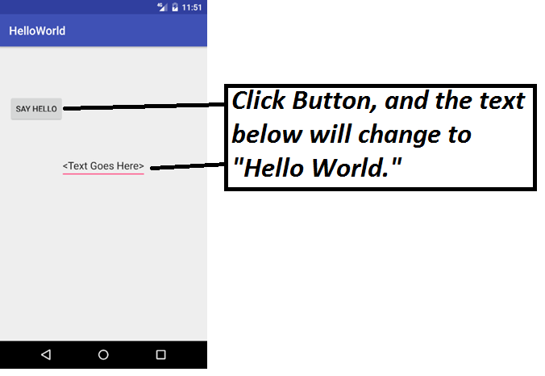

**Part 2. Complete the worksheet provided in lecture**

Notes:

The descriptions for all problems are purposefully vague. These are simple design challenges, feel free to design in any way you would like.

For the storyboard be sure to point out what the various widgets (views) do in your sketch. Be as detailed as possible, *Refer to the simple story board on the Tip Calculator above. Create a Primary Activity Screen and add a few sub pages that popup when something is done from this page. Be creative.*