**Topic B9**: IAQ in rapidly urbanizing cities

**Reduction in PM2.5 Levels at the International School of Beijing Due to Positive Building Pressurization and HEPA (H-14) Air Filtration Upgrades**

Alexander GUO1, Markus FENG1, Mark MCGARIGAL2*, Gerrick MONROE3 and Dane WESTERDAHL4

1 Students, International School of Beijing (ISB), Beijing, China; 2 Science Teacher, ISB, Beijing, China; 3Chief Operating and Financial Officer, ISB, Beijing, China; 4 Sibley School of Mechanical and Aerospace Eng., Cornell University, Ithaca NY, USA.

\**Corresponding email: mmcgarigal@isb.bj.edu*

**Keywords**: Indoor PM2.5 levels, Fresh air handlers, Pressurization, Filtration, Student research.

**SUMMARY**

While recent attention has been focused on outdoor PM2.5 levels, many people spend much of their time indoors in the city and indoor air quality in Beijing is largely unstudied. Some firms and private individuals have purchased and installed air purifiers in hopes of reducing their exposure, but the efficacty of these efforts is not documented. This study investigated the impact of upgrades to the air handling system at the International School of Beijing (ISB) on indoor concentrations of PM2.5. Part of ISB's air handling system was upgraded during June and July of 2013 to create positive building pressurization especially within at high use entrances and nearby stairwells and to improve the level of filtration in all 35 of the existing fresh air handlers. PM2.5 monitoring occurred in 24 indoor locations during three times per day over several weeks both before and after the implementation of the upgrades. Fluctuations in indoor PM2.5 concentrations were significantly lower after the upgrades, dropping from an average of 18 µg/m3 to 5 µg/m3 and maintained an average indoor PM2.5 level of below 12 µg/m3 even when outdoor PM2.5 values exceeded 200 µg/m3. Therefore, buildings in rapidly urbanizing and highly polluted cities such as Beijing can significantly improve indoor air quality through targeted air management improvements that focus on creating positive building pressurization and enhanced air filtration.

**INTRODUCTION**

PM 2.5 presents a public health problem in many areas worldwide, especially large cities in rapidly developing countries such as Beijing, China, where this study was conducted.

One specific type of substance causing poor air quality is particulate matter. Particulate matter is a major air pollutant that is composed of mixtures of extremely small particles and liquid droplets. Particle pollution is made up of a number of components, including certain products of combustion, acids (such as nitrates and sulfates), organic chemicals, metals, and soil or dust particles.

Particulate matter is categorized based on the size of the particles (coarse, fine and ultrafine). Coarse particles are classified as particles from 2.5 μm to 10 μm (PM10). These particles are found near roadways and other sources of dust such as construction sites and some factories. These particles are capable of being inhaled through normal bodies and may reach the lungs. Fine particles, on the other hand, are smaller than 2.5 μm (PM2.5), and are mainly formed as a product of combustion. In and around Beijing, this combustion is primarily associated with emissions from coal power plants, certain types of industries and factories, and automobiles. Since Beijing relies heavily on the use of coal for power generation and hot water production and has seen a rapid growth in automobile and truck traffic in the last decade, annual average PM 2.5 concentrations are currently some of the highest in the world. PM2.5 also can reduce visibility, producing haze and smog. Ultrafine particles (UFP) are smaller than 100 nanometers in diameter.

PM 2.5 can have serious consequences on the health of individuals. Exposure to such particles can affect both one’s lungs and heart. Numerous scientific studies have linked pollution exposure to a variety of problems, including premature death in people with heart or lung disease, heart attacks, irregular heartbeat, aggravated asthma, decreased lung function, lung irritation, coughing, and difficult breathing.

Along with aggravated negative health effects, particulate matter pollution also can have other consequences, such as reduced visibility, as shown in the recent heavy pollution in Beijing in January 2013, where the pollution level reached 755 on the Air Quality Index (AQI), which is significantly higher than the original upper limit of 500. Particulate matter pollution can also cause environmental damage as particles may enter bodies of water, including rivers, streams, and lakes, making them acidic. It can change the nutrient balance in coastal waters and large river basins, as well as depleting the nutrients in soil. This can affect the biodiversity of ecosystems in the affected area. Lastly, PM2.5 pollutants can stain or damage stone or other materials, including important objects such as statues and monuments.

Particulate matter is detrimental to both one’s health and the environment. Most often, concentration levels of PM2.5 and PM10 are one of the most dominant pollutants in major cities, due to the constant combustion occurring inside factories and automobiles. In this study, we will be focusing on PM2.5, a type of particulate matter that is commonly found in the location of study, Beijing, China.

This paper will on occasion reference air quality measures to a globally recognized standard for determining outdoor air quality developed by the US EPA and referred to as the Air Quality Index (AQI). Due to its relatively high levels, compared to other frequently monitored outdoor air pollutants, such as Ozone and NO2, PM2.5 is the predominant outdoor air pollutant used to determine the average hourly, 24-hour average and annual AQI levels in Beijing, China. The air quality issue has gained recent attention in Beijing due to widening public awareness of and access to hourly average values for PM2.5 from multiple monitoring sites run by the Chinese Ministry of Environmental Protection and at the US Embassy. Poor air quality events in Beijing are quite frequent and depending on weather conditions, can last up to a week with “Hazardous” PM 2.5 levels in excess of 300 µg/m3 and on some occasions have exceeded 500 µg/m3. Beijing has experienced a number of days with PM 2.5 concentrations in excess of 500 µg/m3, which have resulted in the AQI going above the AQI scale maximum of 500, and this has recently gained significant media attention and has resulted in a higher level of public concern regarding air quality. Prior to the end of the school year in 2013 at the International School of Beijing, high concentrations of PM2.5 in excess of 150 µg/m3 were detected using both the TSI AM510 Monitor and the DustTrak II in classrooms, hallways and other large spaces on days with exceptionally high outdoor PM 2.5 concentrations. These periods of poor indoor air quality were of growing concern to the students, parents, faculty and staff. It was determined how was this determined? that poor indoor air quality was the result of inadequate filtration of fresh air intakes by existing air handling units and periods of negative building pressurization resulting in a significant infiltration of polluted air into the building.

The air handling system upgrades at the International School of Beijing primarily consisted of change from a 2-stage to 3-stage filtration system, which allowed the installation of High-Efficiency Particulate Absorption (HEPA) H-14 air filters at the 3rd stage. HEPA is a type of air filter, or the collective group of air filters that meet the HEPA standard. The HEPA class H-14 filter implies that the filter separates > 99.995% of particles with the size as small as 0.3 µm.

The first phase of the planned upgrades included installing 35 new AHUs to affect a portion of the school, which targeted airflow to the classrooms and some other spaces. Certain high-traffic exits of the school were positively pressurized to reduce the amount of unfiltered air that would infiltrate the school from outside causing reduced indoor air quality.

The approximate cost of all of the upgrades, including the HEPA H-14 air filters and the positive pressurization is 10,737,055 RMB, or approximately 1,771,528 USD. Regular filter operations have the following cost for each type of filter1:

|  |  |  |  |
| --- | --- | --- | --- |
| Stage | Filter | Replacement | Cost |
| 1st | F6  or G3 | Weekly or Monthly, plus weekly spray wash | RMB 75-135 ($12-22 USD) /piece2  RMB 60-90 ($10-15 USD) /piece2 |
| 2nd | F8 | Monthly | RMB 96-180 ($16-30 USD) /piece2 |
| 3rd | H14 | Every 6-8 months | $≈$ RMB 800 ($132 USD) /piece2 |

1 F6, F8, and H14 filters are for the 35 upgraded Dunham-Bush CS3 Series Modular Central Station Air Handling Units with three-stage filtration (F6, F8, H14). F6 filters, the first stage of filtration, were later replaced in some machines by G3 filters to obtain a longer lifespan.

2 based on different sizes

All new air handler unites are controlled by variable frequency drives for maximum energy conservation. Given the increase in the air volume that these units have provided the facility, ISB has noted a positive pressure within the building. This increased air volume and positive pressurization has required roughly a 10 percent increase in the amount of energy use to support the increased air volume and greater air-filtration. The upgrades made during the summer of 2013 to the air handling system at ISB were expected to result in an improvement in indoor air quality as measured by a significant reduction in PM2.5levels within the building predicted

**METHODOLOGIES**

**Materials**

* 1 TSI AM510 PM2.5 Monitor
* 2 TSI DustTrak 2 model #s 8530 and 8532 (henceforth referred to as PM2.5 Monitors)

**Procedure**

1. Monitoring occurred before the implementation of the upgrades (during 17 days in Feb/Mar 2013) and after implementation (during 24 days in July/Aug 2013).
2. PM2.5 levels were recorded using the PM 2.5 Monitor once the readings stabilized, usually within 30 seconds, at 26 indoor and 1 outdoor monitoring site at three times during each day in the pre and post study.
3. The specific times of monitoring each day were at 09:00, 13:00 and 16:00 and were selected to represent times shortly following major movements of people into or out of the building at the start of school, following lunch and after school

  The two TSI DUSTTRAK II Aerosol Monitors (models 8530 and 8532) we used in our study were handheld monitors, which were operated with standard factory calibration factor of 1.0 being used. In addition, because Relative Humidity can impact the reliability of these PM 2.5 Monitors, results from outdoor readings by the PM 2.5 Monitors may also experience some inaccuracies during readings taken at higher humidity levels. Efforts to correct PM2.5 values at times with high levels of RH were not made since indoor and outdoor RH values were not measured, though conditioned indoor air RH levels were most likely below 50%.

**RESULTS AND DISCUSSION**

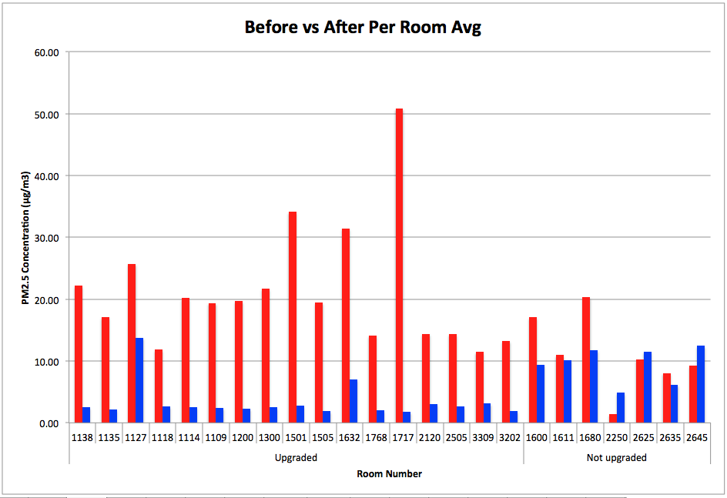The results of the monitoring of indoor air quality before and after the air handling system upgrades previously described can be demonstrated in the following 4 figures. Figure 1 represents a direct comparison between the average PM2.5 concentration of each room before and after implementation with rooms with upgraded air handlers separated from those without; Figure 2 and figure 3 individually represent the average indoor PM2.5 compared to the average outdoor PM2.5 on each data collection day of the period before and after implementation, respectively. Lastly, Table 1 presents the average indoor and outdoor concentrations observed the ratio for the two periods are compared.

Figure 1: PM2.5 concentration of each room during the before (red) and after (blue) implementation periods, respectively.

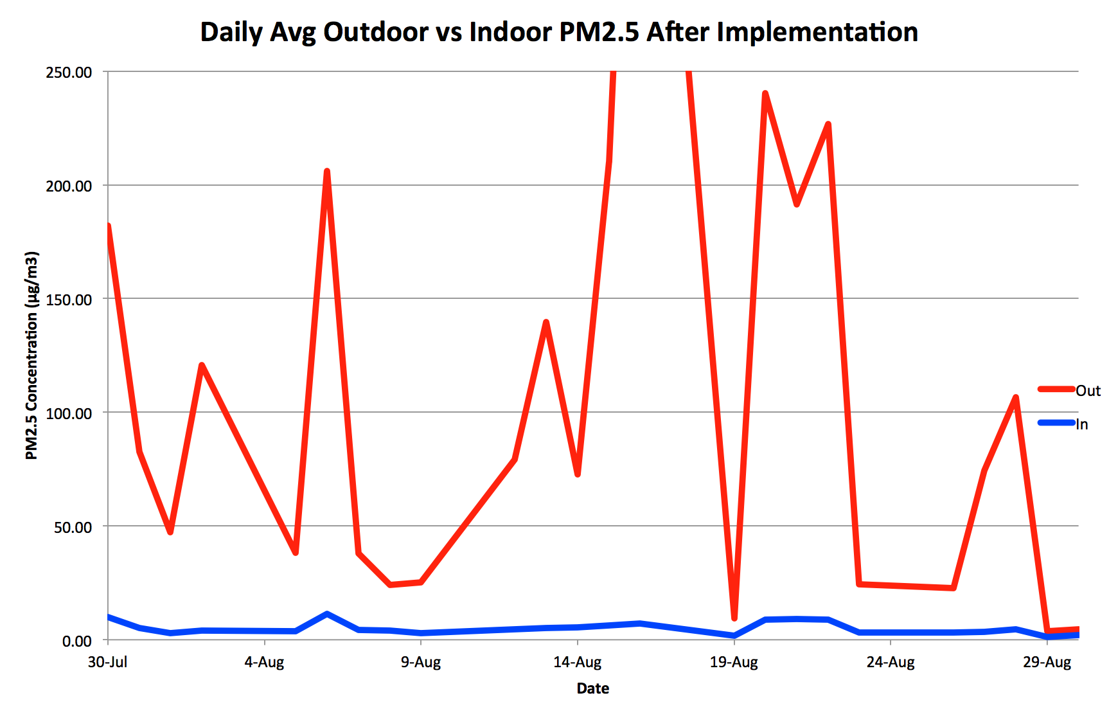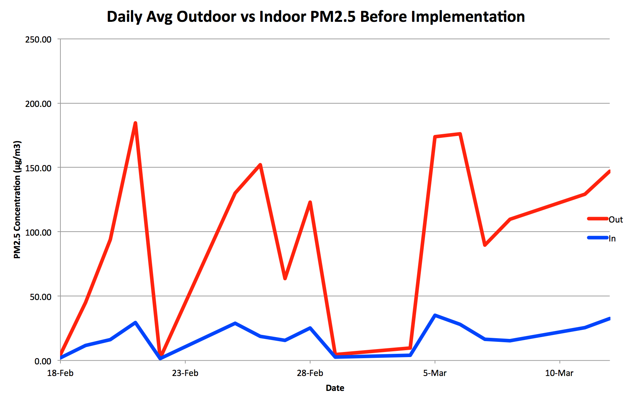

Figure 2: Daily average of outdoor (red) and indoor (blue) PM2.5 concentration before implementation of new filters.

Figure 3: Daily average of outdoor (red) and indoor (blue) PM2.5 concentration after implementation of new filters.

|  |  |  |
| --- | --- | --- |
|  | Before | After |
| Outdoor | 96.392 | 111.472 |
| Indoor | 18.185 | 5.149 |
| Ratio (in/out) | 0.189 | 0.046 |
| Figure 4: Comparison between indoor and outdoor average & ratio (in/out) of before and after implementation. | | |

As indicated in Table 1, the average indoor PM2.5 levels experienced an average of an 81% reduction compared to the average outdoor PM2.5 before implementation, while the indoor PM2.5 levels after implementation experienced a 95% reduction when compared to outdoor air quality measured during the same period. Fluctuations in indoor PM2.5 concentrations were significantly reduced after the upgrades and maintained an average indoor PM2.5 level of below 12 μg/m3 even though outdoor PM2.5 values fluctuated between 4 μg/m3 and 505 μg/m3. Indoor monitoring sites that were specifically targeted by the upgrades showed even greater reductions in PM2.5 concentrations.

The importance of monitoring indoor air quality has become increasingly important in developing nations that face air pollution problems like China, and so is relevant to many similar areas around the world. Results from this study could mitigate the health effects of air pollution on members of institutions by such use of air filters and positive building pressurization.

**CONCLUSIONS**

This study supports the effectiveness of air quality targeted upgrades to about half of the Air Handling Units at ISB. The installation of 35 new AHUs, which created positive building pressurization and 3-stage filtration, which included H-14 filters, were able to adequately address the issues of poor indoor air quality. These upgrades worked through fixing problems of infiltration of poor outdoor air at exits and operable windows due to negative building pressurization and inadequate filtration of fresh air intakes and the effects of these upgrades were most notable during days of very high PM 2.5 concentrations. Results show that with the upgrades described, the average PM2.5 concentration of indoor air dropped from 18% of the average outdoor PM 2.5 concentration to less than 5% of the average outdoor PM2.5 concentration. Therefore, schools in highly polluted cities can safeguard the health of students and staff through targeted air management improvements. The researchers also found that high school students could be trained to effectively conduct such studies.

**ACKNOWLEDGEMENTS**

To be added in subsequent updated version of this manuscript

**REFERENCES**

To be added to next updated version of this manuscript