# Add Pictext.app as context menu option on chrome

1. Download attached zip file and unzip.



1. Go to chrome Extensions.

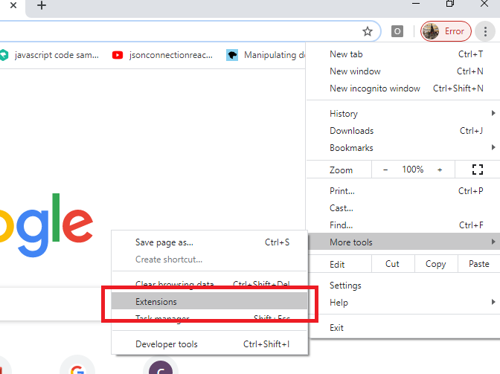

1. Click on “Load unpacked” button and select the unzipped folder from step1.
2. “Open in PicText” should now be appearing in the list of extensions.

Click refresh and enable the extension.

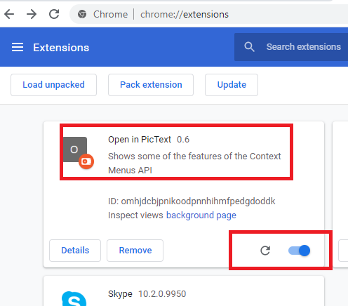

## Verify

Open any webpage with images in chrome and right click on image to see “Open in Pictext” option.

