Electricity. Components name.
- What is the component of the image?
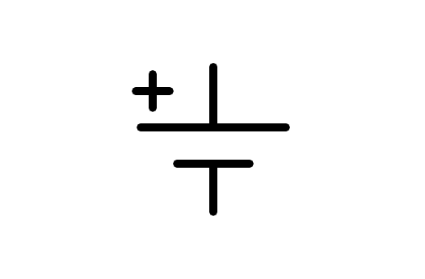
a) Motor
b) Earth
c) Battery
d) Altern current source
- What is the component of the image?
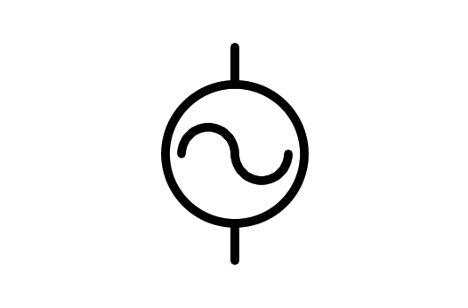
a) Altern current source
b) Battery
c) Light Bulb
d) Electric Motor
- What is the component of the image?
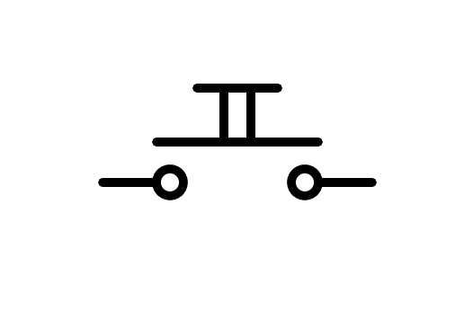
a) Battery
b) Two way Switch n.o.
c) Pushbutton n.o.
d) Switch n.o.
- What is the component of the image?
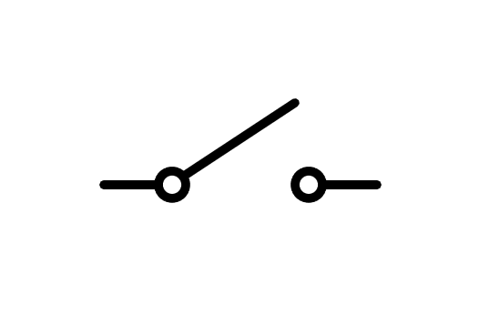
a) Pushbutton
b) Rele
c) Switch
d) Two way Switch
- What is the component of the image?
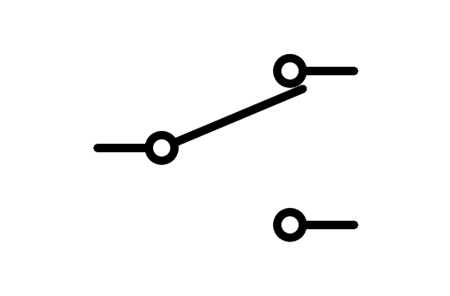
a) Pushbutton
b) Two way Switch
c) Switch
d) Fuse
- What is the component of the image?
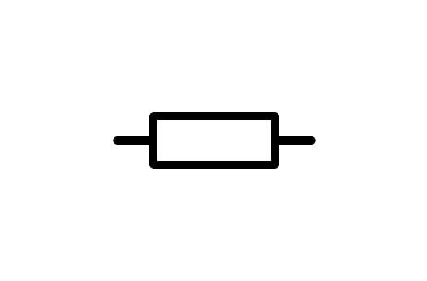
a) Resistor
b) Battery
c) Switch
d) Light Bulb
- What is the component of the image?
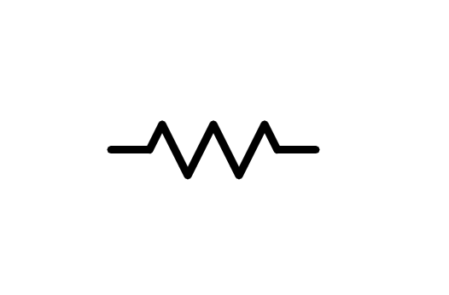
a) Battery
b) Switch
c) Resistor
d) Light Bulb
- What is the component of the image?
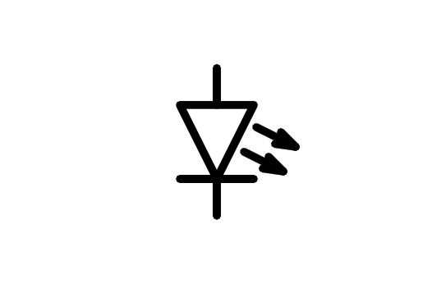
a) Light Bulb
b) Motor
c) Speaker
d) LED Diode
- What is the component of the image?
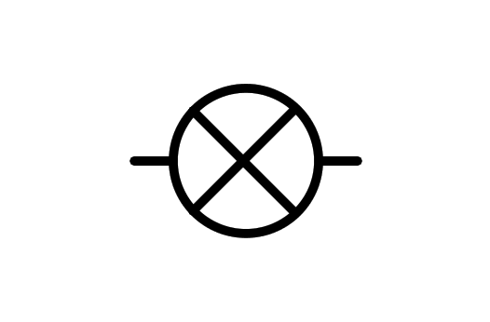
a) LED Diode
b) Light Bulb
c) Motor
d) X component
- What is the component of the image?
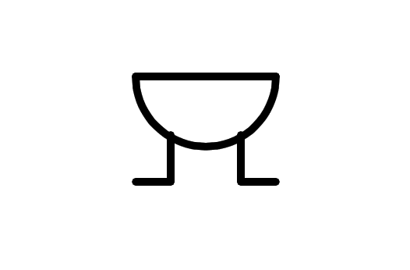
a) Motor
b) Speaker
c) Buzzer
d) Altern current source
- What is the component of the image?
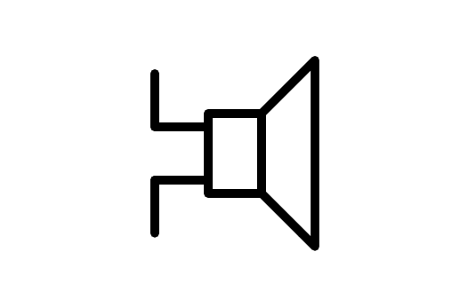
a) Direct current source
b) Altern current source
c) Buzzer
d) Speaker
- What is the component of the image?
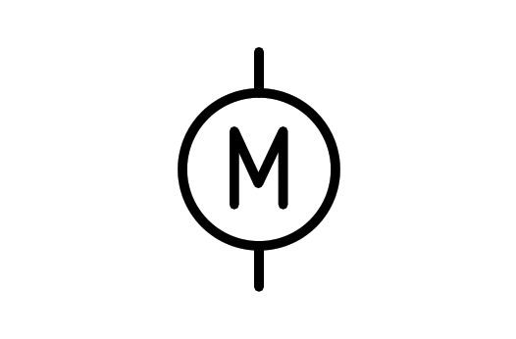
a) Light Bulb
b) Motor
c) Wattmeter
d) Buzzer
- What is the component of the image?
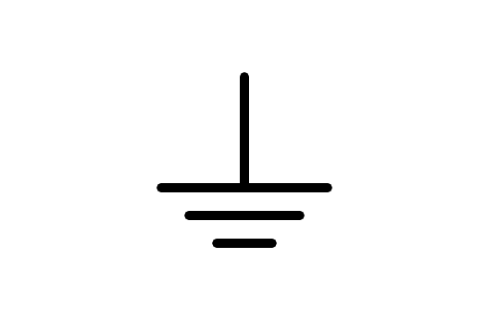
a) Battery
b) Receiver
c) Earth
d) Antenna
- What is the component of the image?
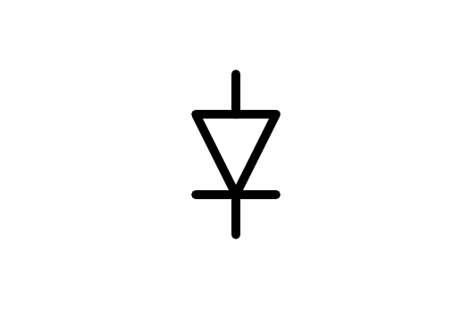
a) Diode
b) Battery
c) LED Diode
d) Transistor
- What is the component of the image?
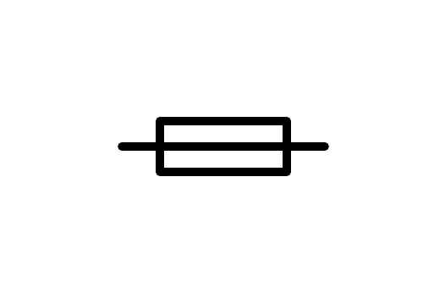
a) Relay
b) Generator
c) Resistor
d) Fuse
- What is the component of the image?
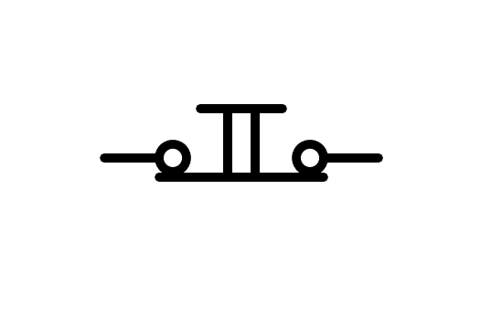
a) Distributor
b) Switch n.c.
c) Battery
d) Pushbutton n.c.
- What is the component of the image?
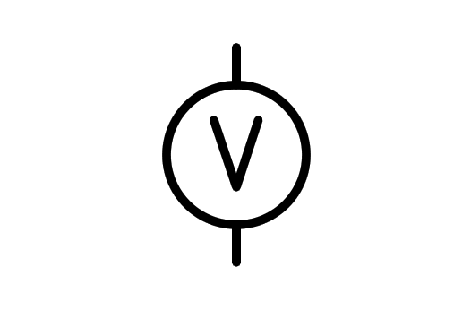
a) Power source
b) Battery
c) Voltmeter
d) Light Bulb
- What is the component of the image?
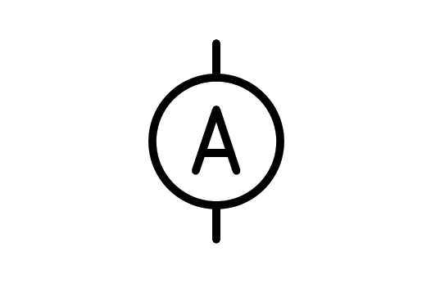
a) Battery
b) Aluminum
c) Ammeter
d) Current source
- What is the component of the image?
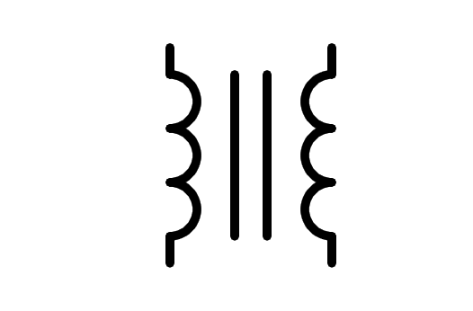
a) Coil
b) Transformer
c) Transistor
d) Double conductor
- What is the component of the image?
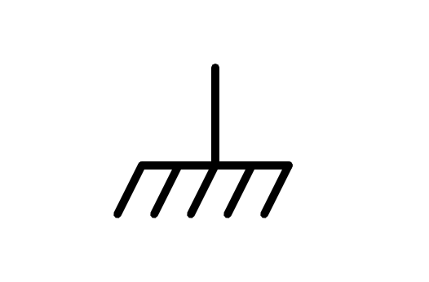
a) Brush
b) Ground plane
c) Earth
d) Battery
- What is the component of the image?
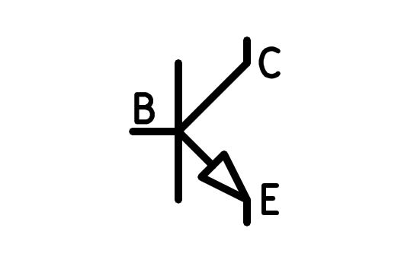
a) PNP Transformer
b) PNP Transistor
c) NPN Transformer
d) NPN Transistor
- What is the component of the image?
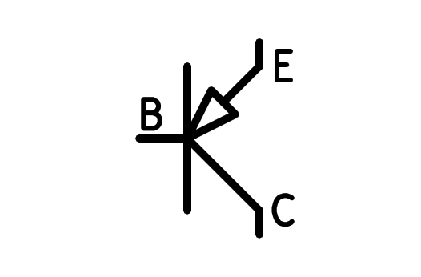
a) PNP Transistor
b) NPN Transformer
c) NPN Transistor
d) PNP Transformer
- What is the component of the image?
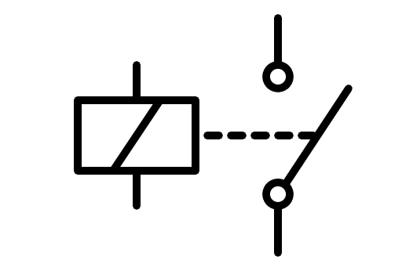
a) Double Switch
b) Double Pushbutton
c) Coil
d) Relay
- What is the component of the image?
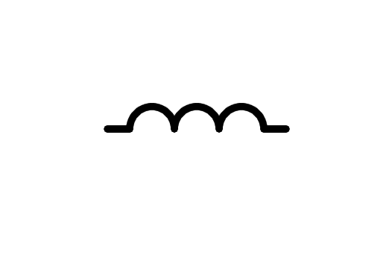
a) Cable
b) Fingers
c) Round Pushbutton
d) Coil
- What is the component of the image?
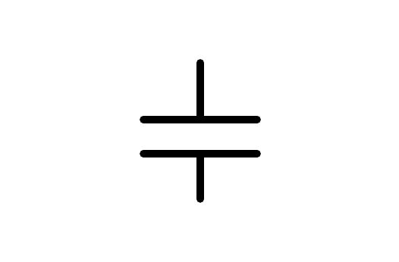
a) Battery
b) Capacitor
c) Small Battery
d) Congregator
- What is the component of the image?
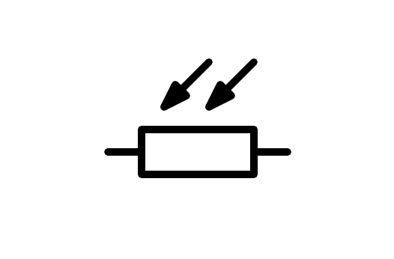
a) Variable Resistor
b) NTC Resistor
c) Resistor
d) LDR Resistor
- What is the component of the image?
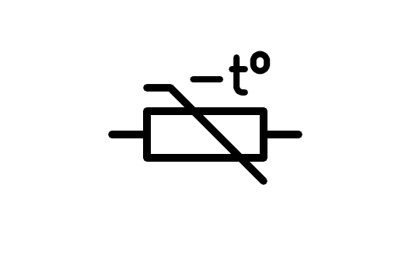
a) Resistor
b) NTC Resistor
c) LDR Resistor
d) Variable Resistor
- What is the component of the image?
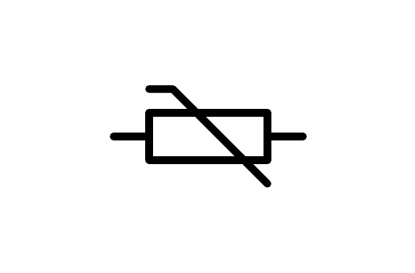
a) Variable Resistor
b) Resistor
c) NTC Resistor
d) LDR Resistor
- What is the component of the image?
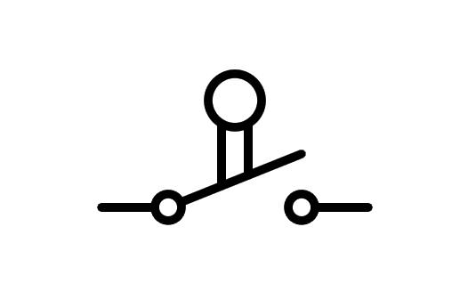
a) Pushbutton
b) Limit Switch
c) Pushbutton n.o.
d) Switch
- What is the component of the image?
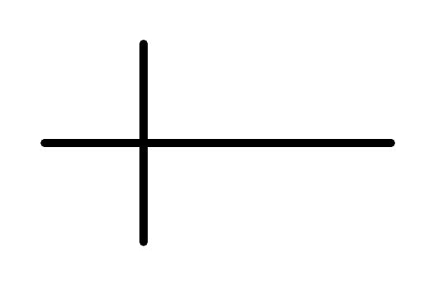
a) Crossover wire connected
b) Cross
c) Crossover wire not connected
d) Connected wire
- What is the component of the image?
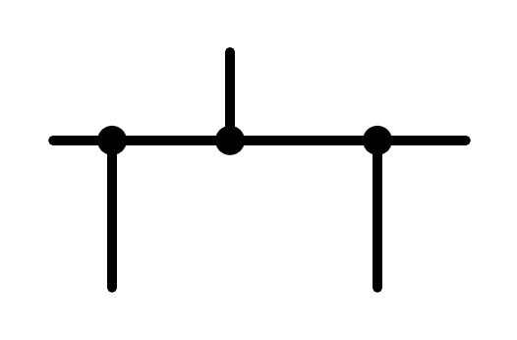
a) Connected and unconnected wire
b) Connected wire
c) Mass
d) Unconnected wire
- What is the component of the image?
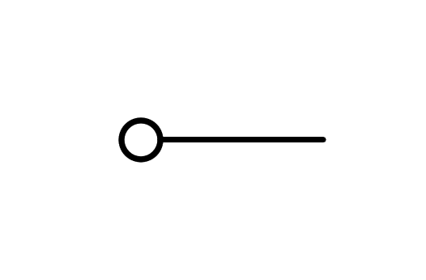
a) Squared
b) Connector
c) Mass
d) Ground plane
- What is the component of the image?
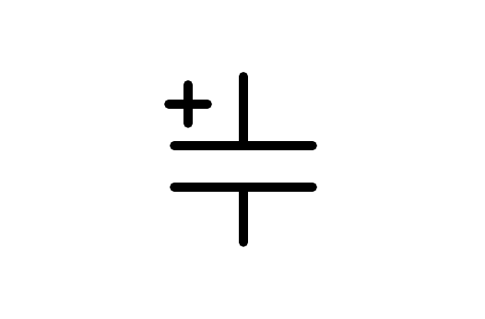
a) Battery
b) Capacitor
c) Polarized Capacitor
d) Small Battery

