Electricity. Color code 1.
- What is the value of this resistance?
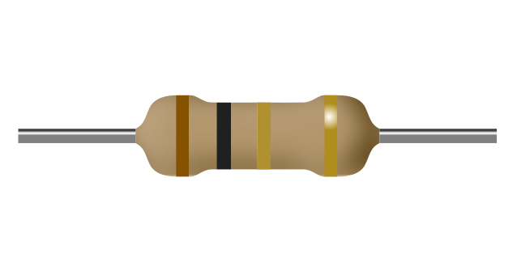
a) 10Ω
b) 1.0Ω
c) 1.0kΩ
d) 101Ω
- What is the value of this resistance?
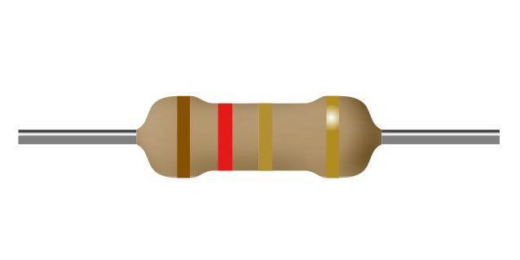
a) 1.2kΩ
b) 1.2Ω
c) 12Ω
d) 121Ω
- What is the value of this resistance?
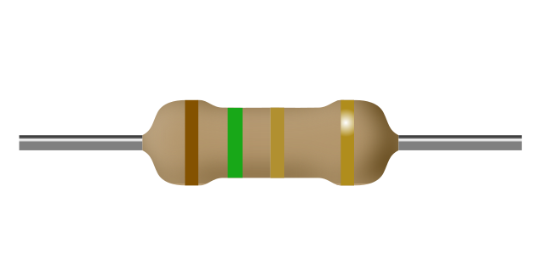
a) 1.5kΩ
b) 15Ω
c) 1.5Ω
d) 151Ω
- What is the value of this resistance?
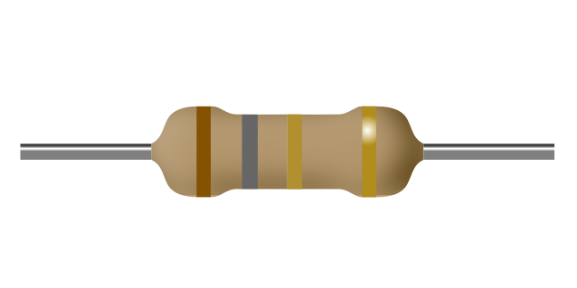
a) 181Ω
b) 1.8kΩ
c) 1.8Ω
d) 18Ω
- What is the value of this resistance?
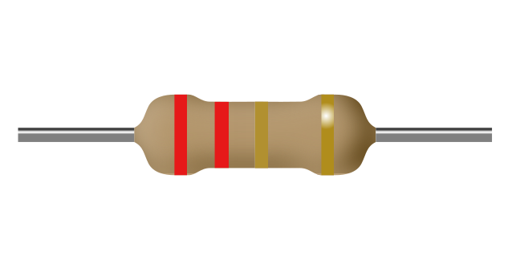
a) 2.2Ω
b) 22Ω
c) 221Ω
d) 2.2kΩ
- What is the value of this resistance?
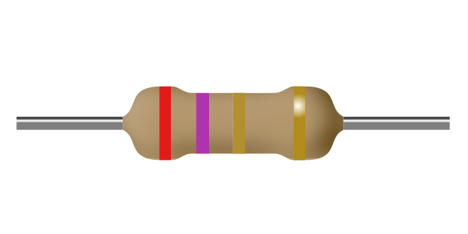
a) 2.7Ω
b) 271Ω
c) 2.7kΩ
d) 27Ω
- What is the value of this resistance?
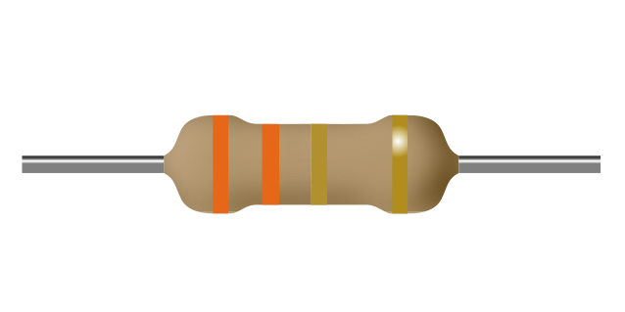
a) 3.3kΩ
b) 3.3Ω
c) 331Ω
d) 33Ω
- What is the value of this resistance?
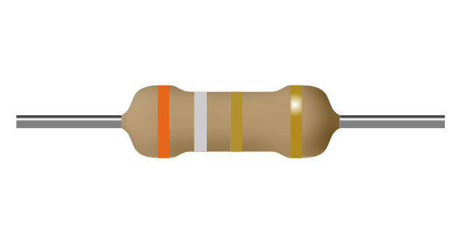
a) 391Ω
b) 39Ω
c) 3.9kΩ
d) 3.9Ω
- What is the value of this resistance?
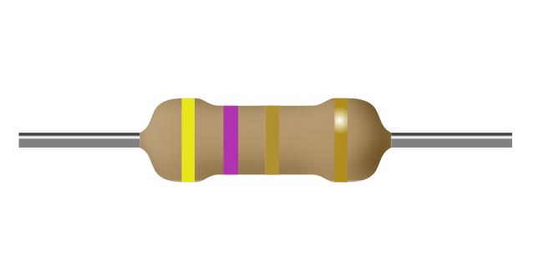
a) 4.7Ω
b) 4.7kΩ
c) 471Ω
d) 47Ω
- What is the value of this resistance?
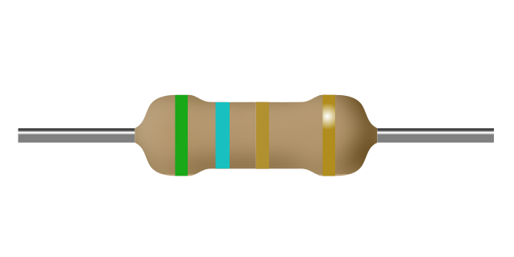
a) 5.6kΩ
b) 561Ω
c) 5.6Ω
d) 56Ω
- What is the value of this resistance?
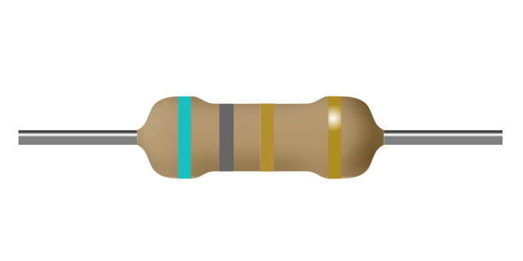
a) 681Ω
b) 6.8Ω
c) 6.8kΩ
d) 68Ω
- What is the value of this resistance?
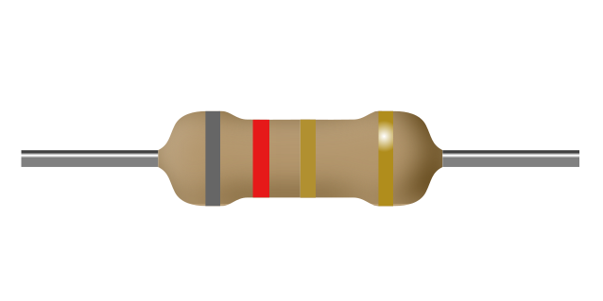
a) 8.2kΩ
b) 821Ω
c) 82Ω
d) 8.2Ω
- What is the value of this resistance?
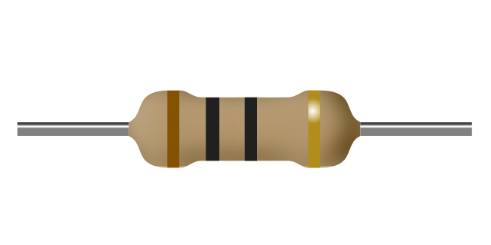
a) 1.0Ω
b) 100Ω
c) 10Ω
d) 10kΩ
- What is the value of this resistance?
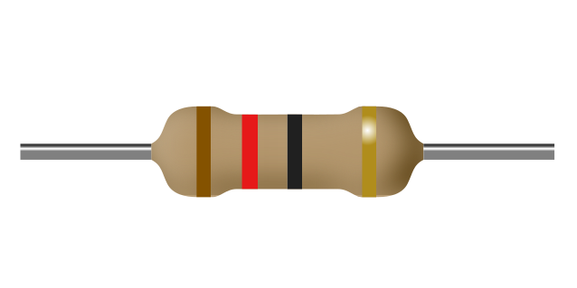
a) 120Ω
b) 1.2Ω
c) 12Ω
d) 12kΩ
- What is the value of this resistance?
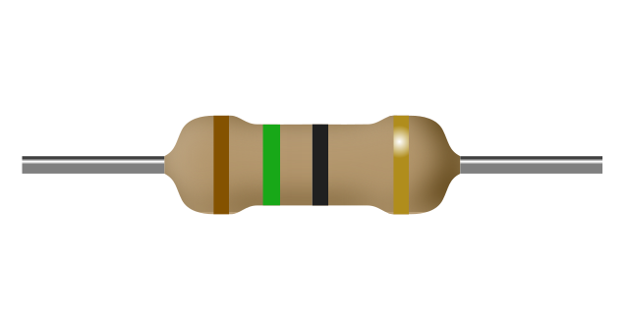
a) 1.5Ω
b) 15Ω
c) 150Ω
d) 15kΩ
- What is the value of this resistance?
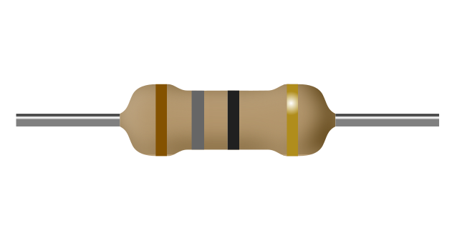
a) 18Ω
b) 18kΩ
c) 180Ω
d) 1.8Ω
- What is the value of this resistance?
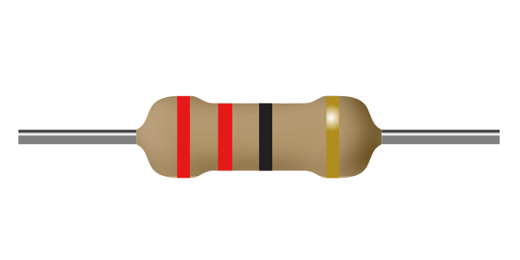
a) 2.2Ω
b) 22Ω
c) 220Ω
d) 22kΩ
- What is the value of this resistance?
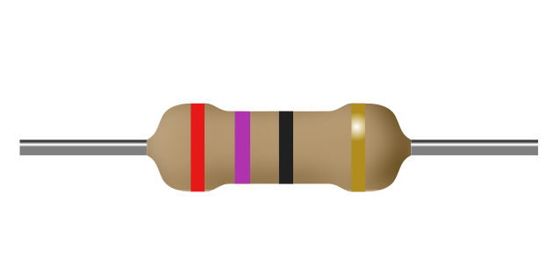
a) 27Ω
b) 27kΩ
c) 270Ω
d) 2.7Ω
- What is the value of this resistance?
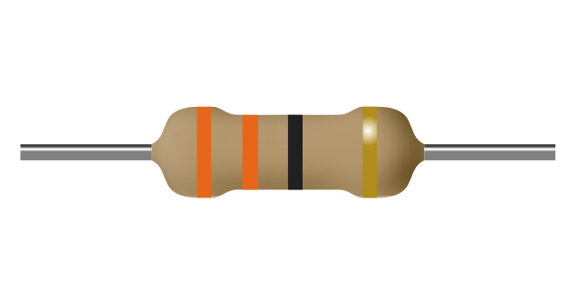
a) 330Ω
b) 33kΩ
c) 3.3Ω
d) 33Ω
- What is the value of this resistance?
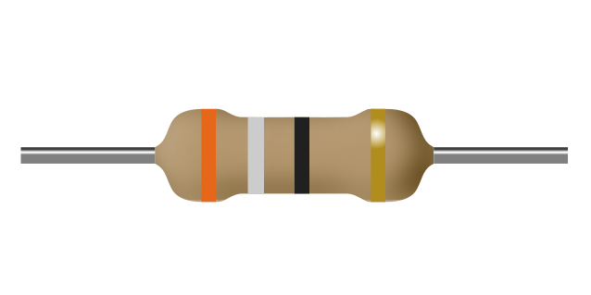
a) 39Ω
b) 39kΩ
c) 3.9Ω
d) 390Ω
- What is the value of this resistance?
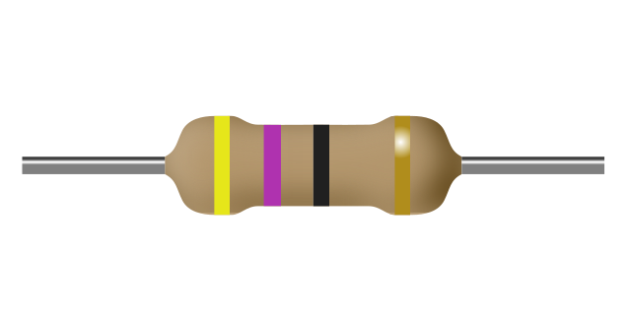
a) 47Ω
b) 470Ω
c) 4.7Ω
d) 47kΩ
- What is the value of this resistance?
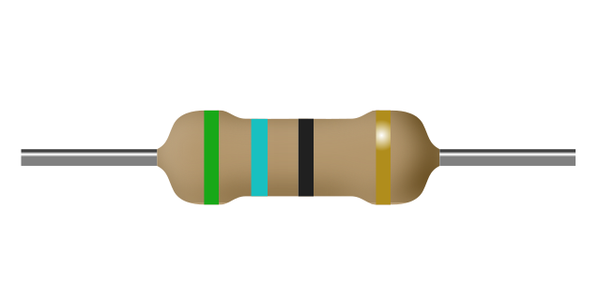
a) 5.6Ω
b) 56kΩ
c) 560Ω
d) 56Ω
- What is the value of this resistance?
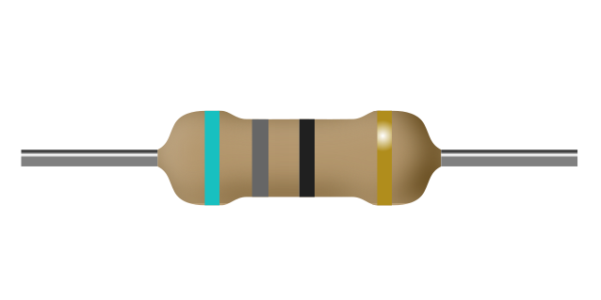
a) 6.8Ω
b) 68Ω
c) 68kΩ
d) 680Ω
- What is the value of this resistance?
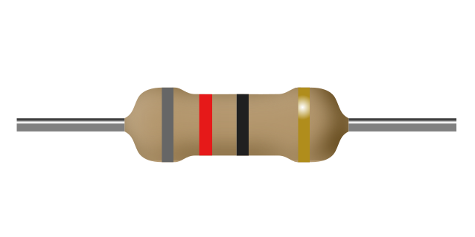
a) 82kΩ
b) 82Ω
c) 820Ω
d) 8.2Ω
- What is the value of this resistance?
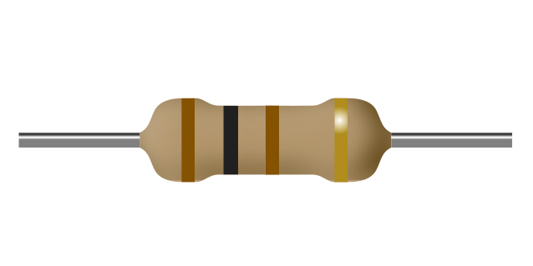
a) 10Ω
b) 101Ω
c) 100Ω
d) 10kΩ
- What is the value of this resistance?
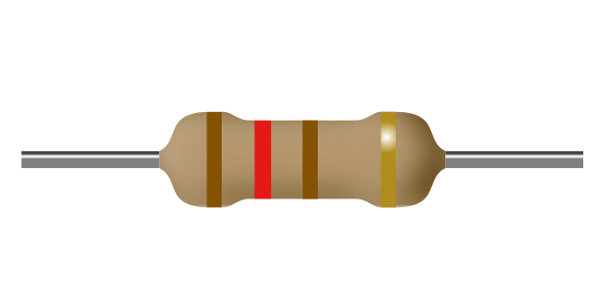
a) 120Ω
b) 121Ω
c) 12kΩ
d) 12Ω
- What is the value of this resistance?
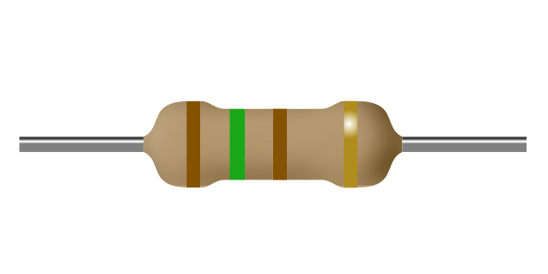
a) 150Ω
b) 151Ω
c) 15Ω
d) 15kΩ
- What is the value of this resistance?
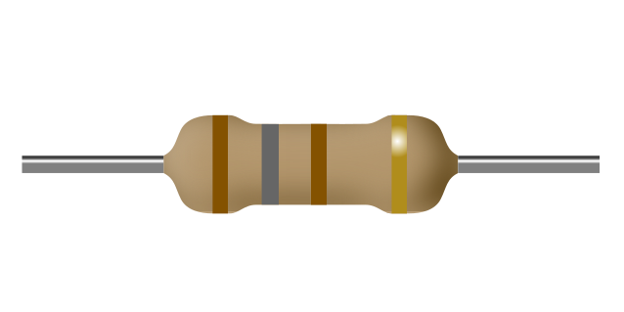
a) 18Ω
b) 180Ω
c) 18kΩ
d) 181Ω
- What is the value of this resistance?
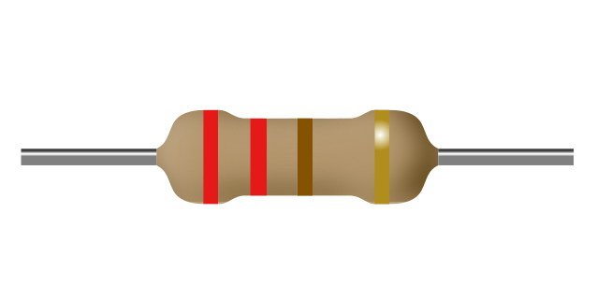
a) 22Ω
b) 22kΩ
c) 220Ω
d) 221Ω
- What is the value of this resistance?
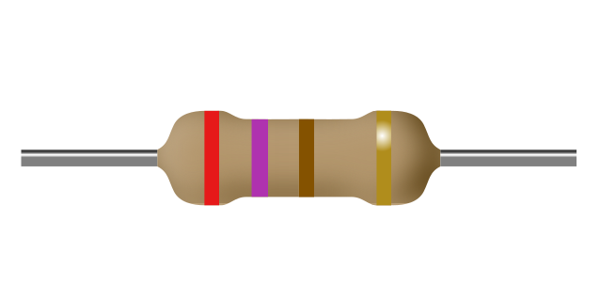
a) 270Ω
b) 27kΩ
c) 271Ω
d) 27Ω
- What is the value of this resistance?
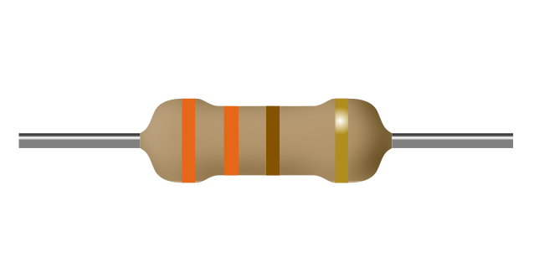
a) 33kΩ
b) 330Ω
c) 33Ω
d) 331Ω
- What is the value of this resistance?
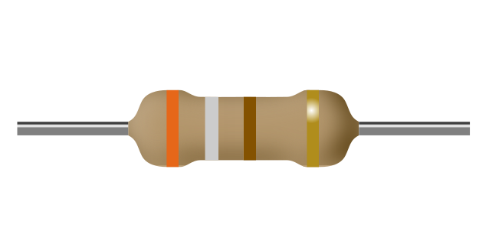
a) 39kΩ
b) 391Ω
c) 390Ω
d) 39Ω
- What is the value of this resistance?
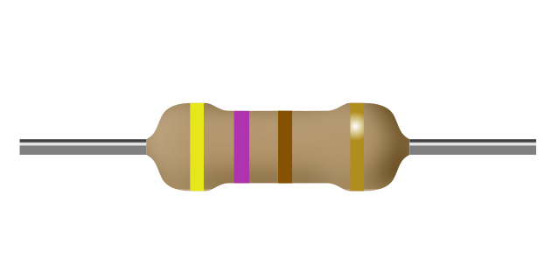
a) 470Ω
b) 47Ω
c) 47kΩ
d) 471Ω
- What is the value of this resistance?
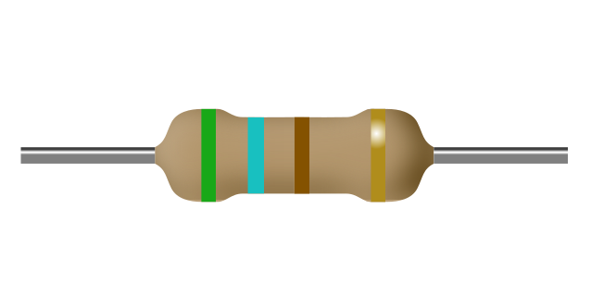
a) 56kΩ
b) 560Ω
c) 56Ω
d) 561Ω
- What is the value of this resistance?
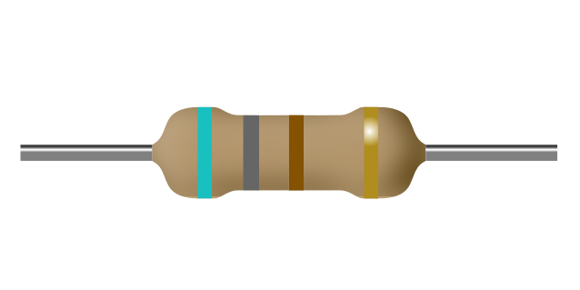
a) 68Ω
b) 681Ω
c) 680Ω
d) 68kΩ
- What is the value of this resistance?
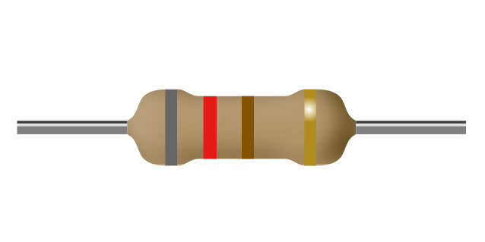
a) 821Ω
b) 82kΩ
c) 820Ω
d) 82Ω
- What is the value of this resistance?
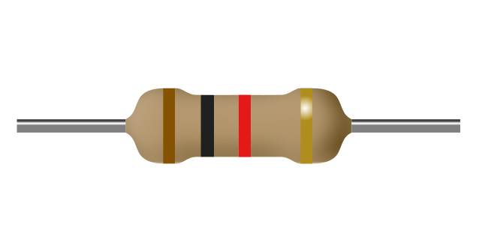
a) 10Ω
b) 102Ω
c) 1.0kΩ
d) 10kΩ
- What is the value of this resistance?
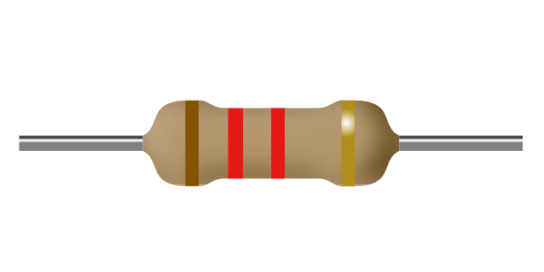
a) 12Ω
b) 12kΩ
c) 122Ω
d) 1.2kΩ
- What is the value of this resistance?
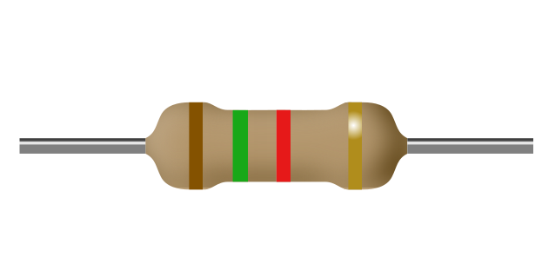
a) 152Ω
b) 15Ω
c) 1.5kΩ
d) 15kΩ
- What is the value of this resistance?
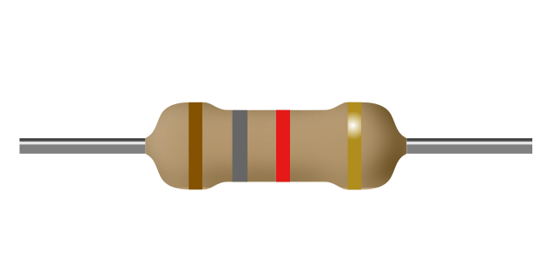
a) 18Ω
b) 182Ω
c) 18kΩ
d) 1.8kΩ
- What is the value of this resistance?
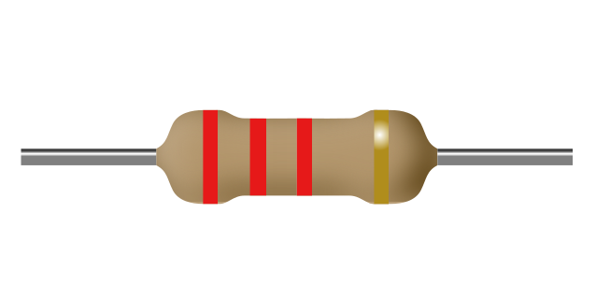
a) 22Ω
b) 22kΩ
c) 222Ω
d) 2.2kΩ
- What is the value of this resistance?
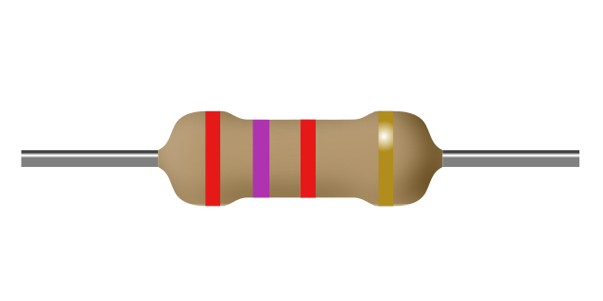
a) 27Ω
b) 2.7kΩ
c) 272Ω
d) 27kΩ
- What is the value of this resistance?
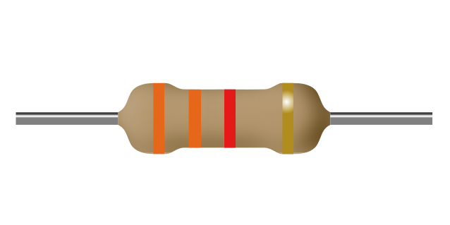
a) 332Ω
b) 33kΩ
c) 33Ω
d) 3.3kΩ
- What is the value of this resistance?
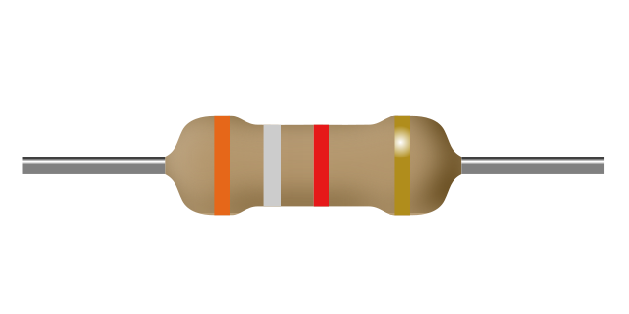
a) 39kΩ
b) 392Ω
c) 3.9kΩ
d) 39Ω
- What is the value of this resistance?
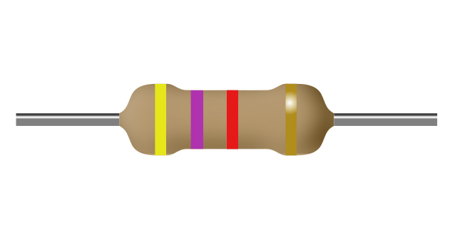
a) 47Ω
b) 472Ω
c) 47kΩ
d) 4.7kΩ
- What is the value of this resistance?
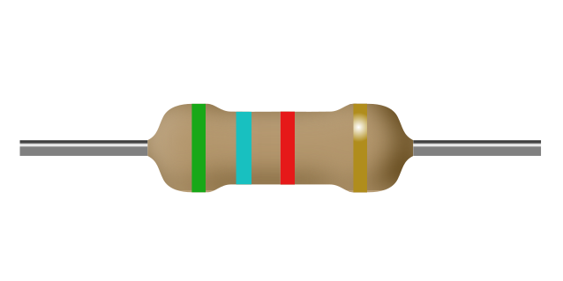
a) 56kΩ
b) 562Ω
c) 5.6kΩ
d) 56Ω
- What is the value of this resistance?
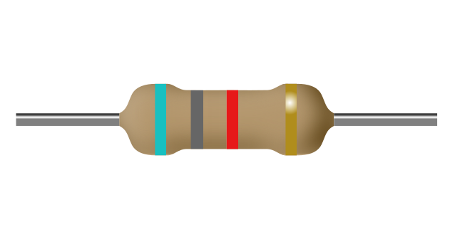
a) 68kΩ
b) 6.8kΩ
c) 682Ω
d) 68Ω
- What is the value of this resistance?
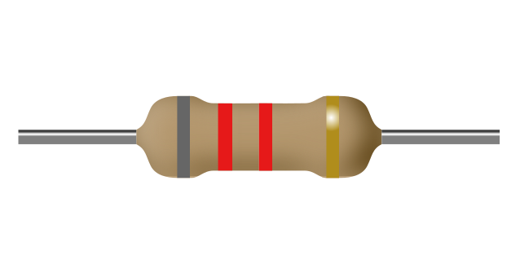
a) 8.2kΩ
b) 82Ω
c) 822Ω
d) 82kΩ
- What is the value of this resistance?
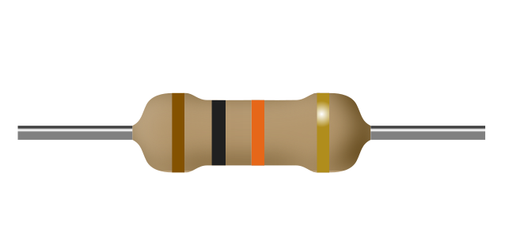
a) 10Ω
b) 103Ω
c) 1.0MΩ
d) 10kΩ
- What is the value of this resistance?
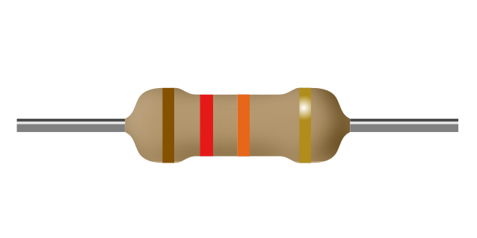
a) 12Ω
b) 12kΩ
c) 1.2MΩ
d) 123Ω
- What is the value of this resistance?
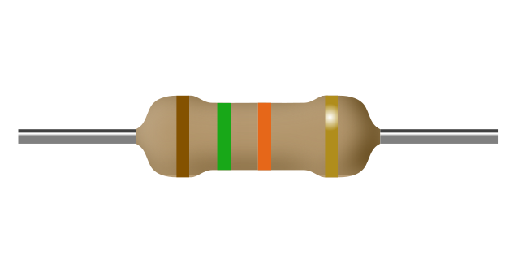
a) 1.5MΩ
b) 15Ω
c) 15kΩ
d) 153Ω
- What is the value of this resistance?
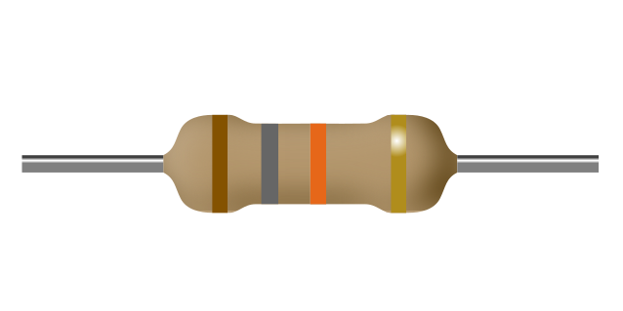
a) 18Ω
b) 18kΩ
c) 183Ω
d) 1.8MΩ
- What is the value of this resistance?
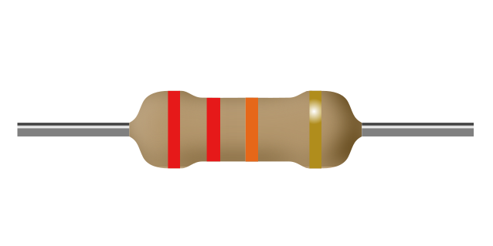
a) 2.2MΩ
b) 223Ω
c) 22Ω
d) 22kΩ
- What is the value of this resistance?
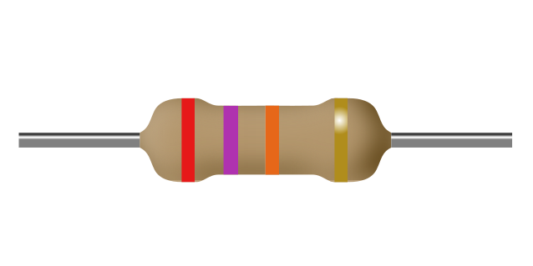
a) 273Ω
b) 27Ω
c) 27kΩ
d) 2.7MΩ
- What is the value of this resistance?
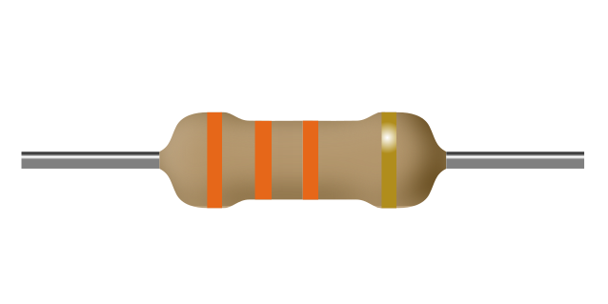
a) 3.3MΩ
b) 33kΩ
c) 333Ω
d) 33Ω
- What is the value of this resistance?
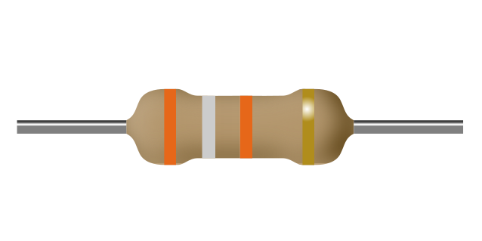
a) 39Ω
b) 3.9MΩ
c) 393Ω
d) 39kΩ
- What is the value of this resistance?
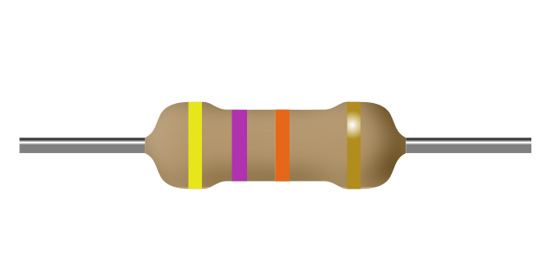
a) 473Ω
b) 47Ω
c) 4.7MΩ
d) 47kΩ
- What is the value of this resistance?
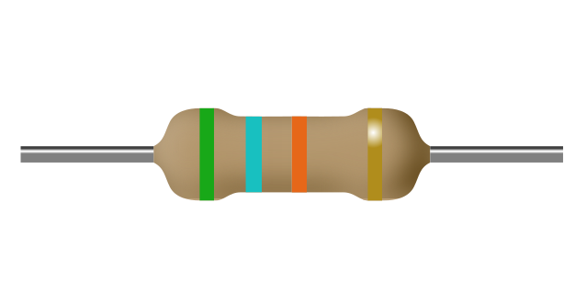
a) 56Ω
b) 5.6MΩ
c) 56kΩ
d) 563Ω
- What is the value of this resistance?
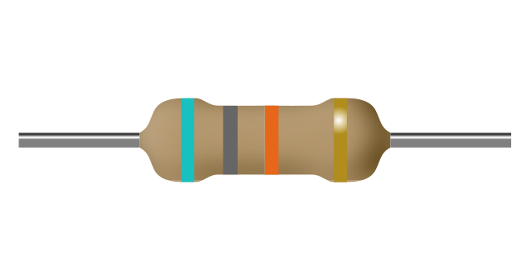
a) 6.8MΩ
b) 68kΩ
c) 68Ω
d) 683Ω
- What is the value of this resistance?
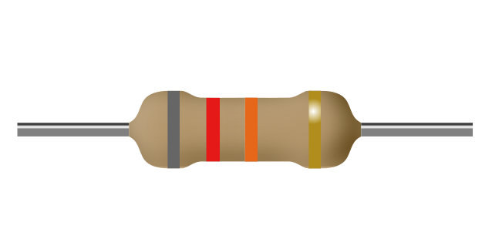
a) 8.2MΩ
b) 82kΩ
c) 823Ω
d) 82Ω
- What is the value of this resistance?
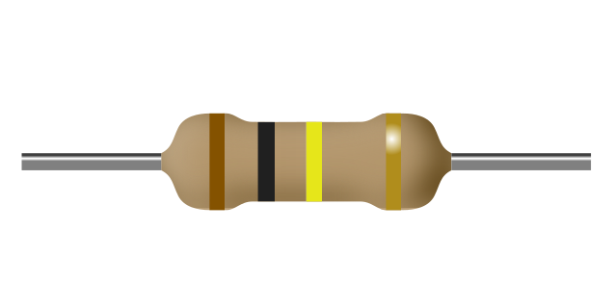
a) 100kΩ
b) 104Ω
c) 10kΩ
d) 100Ω
- What is the value of this resistance?
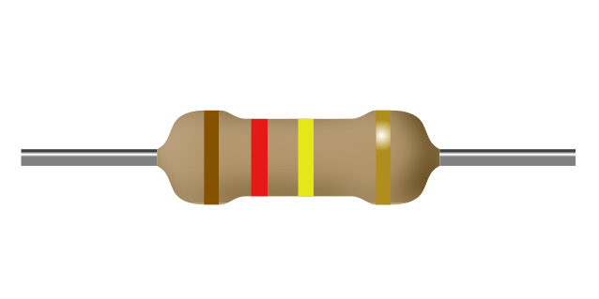
a) 120kΩ
b) 124Ω
c) 12kΩ
d) 120Ω
- What is the value of this resistance?
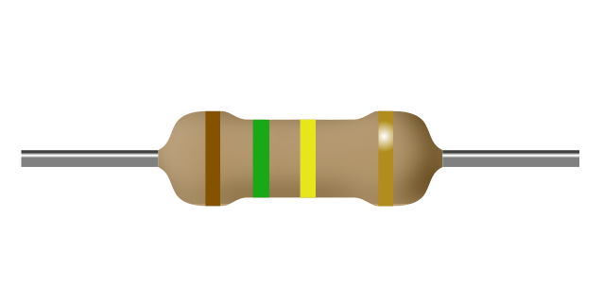
a) 154Ω
b) 150Ω
c) 150kΩ
d) 15kΩ
- What is the value of this resistance?
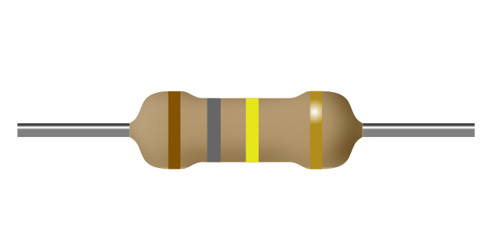
a) 180kΩ
b) 18kΩ
c) 184Ω
d) 180Ω
- What is the value of this resistance?
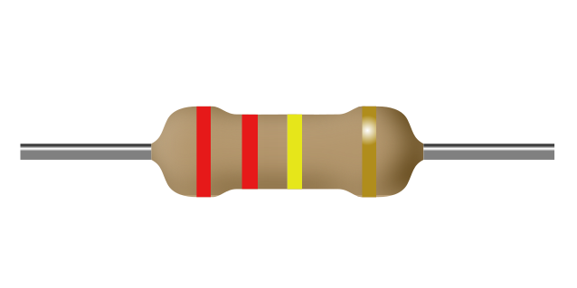
a) 224Ω
b) 22kΩ
c) 220kΩ
d) 220Ω
- What is the value of this resistance?
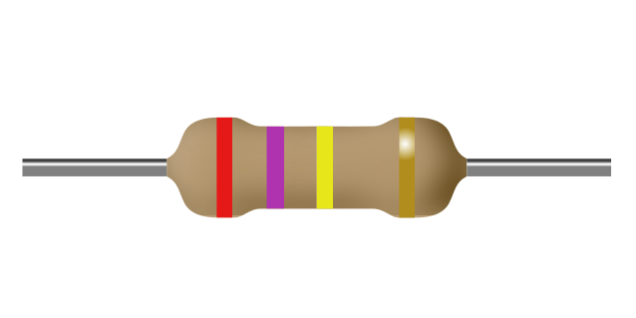
a) 270kΩ
b) 270Ω
c) 274Ω
d) 27kΩ
- What is the value of this resistance?
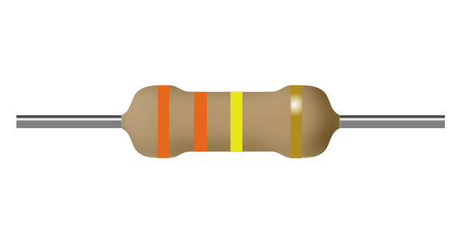
a) 330Ω
b) 330kΩ
c) 334Ω
d) 33kΩ
- What is the value of this resistance?
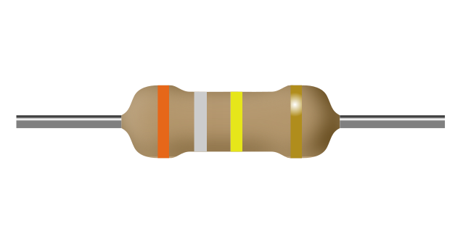
a) 394Ω
b) 390kΩ
c) 39kΩ
d) 390Ω
- What is the value of this resistance?
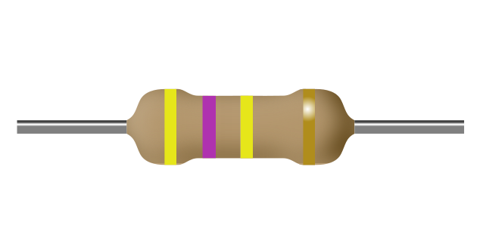
a) 47kΩ
b) 470kΩ
c) 474Ω
d) 470Ω
- What is the value of this resistance?
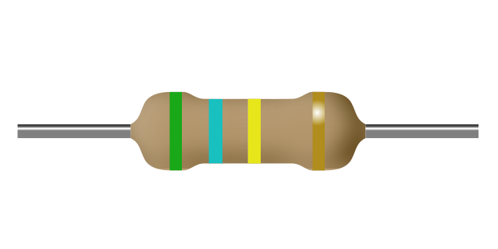
a) 560Ω
b) 564Ω
c) 560kΩ
d) 56kΩ
- What is the value of this resistance?
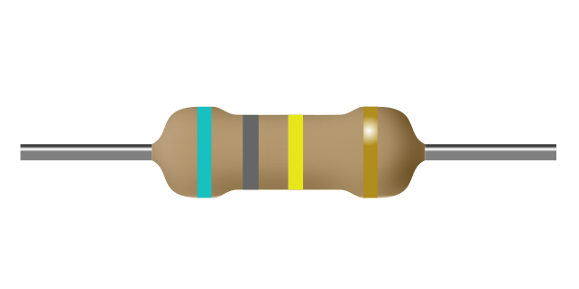
a) 68kΩ
b) 680kΩ
c) 680Ω
d) 684Ω
- What is the value of this resistance?
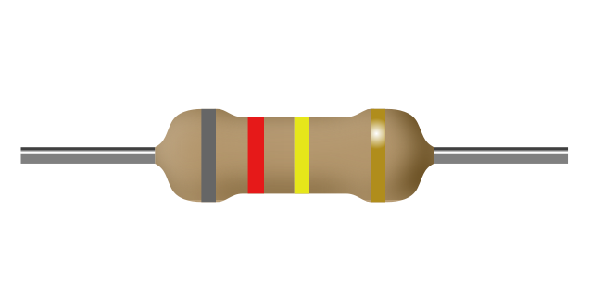
a) 820Ω
b) 824Ω
c) 820kΩ
d) 82kΩ
- What is the value of this resistance?
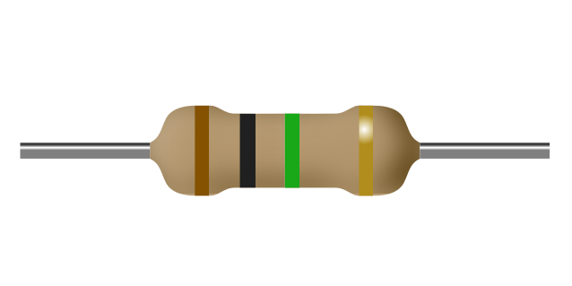
a) 1.0kΩ
b) 100kΩ
c) 1.0MΩ
d) 105Ω
- What is the value of this resistance?
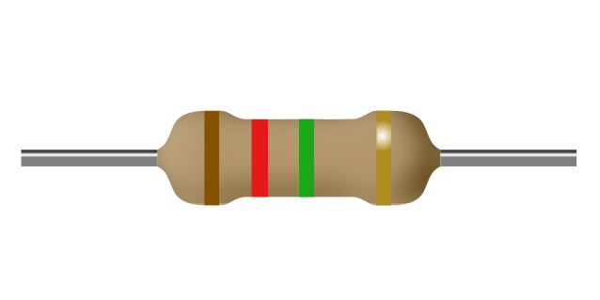
a) 1.2kΩ
b) 120kΩ
c) 125Ω
d) 1.2MΩ
- What is the value of this resistance?
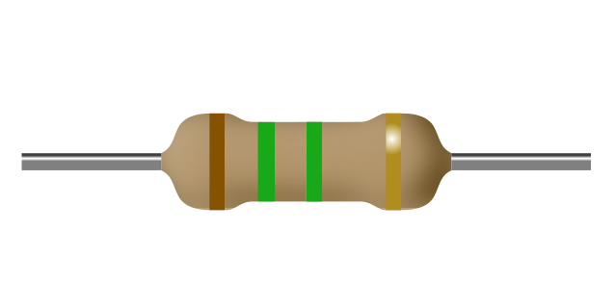
a) 1.5MΩ
b) 1.5kΩ
c) 155Ω
d) 150kΩ
- What is the value of this resistance?
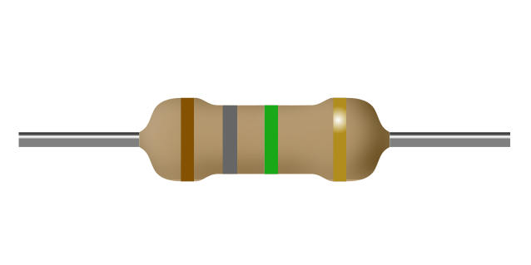
a) 1.8MΩ
b) 180kΩ
c) 1.8kΩ
d) 185Ω
- What is the value of this resistance?
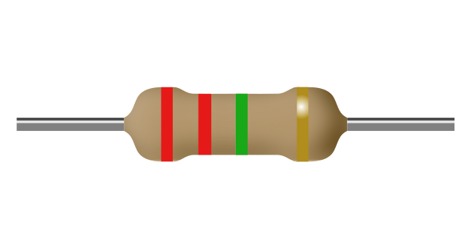
a) 220kΩ
b) 2.2MΩ
c) 2.2kΩ
d) 225Ω
- What is the value of this resistance?
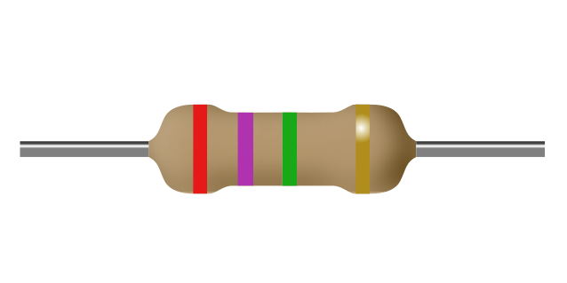
a) 2.7MΩ
b) 2.7kΩ
c) 270kΩ
d) 275Ω
- What is the value of this resistance?
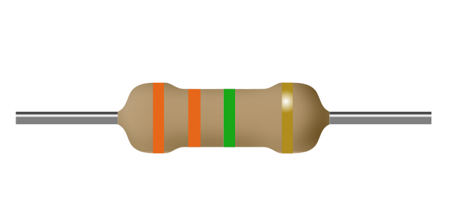
a) 330kΩ
b) 335Ω
c) 3.3MΩ
d) 3.3kΩ
- What is the value of this resistance?
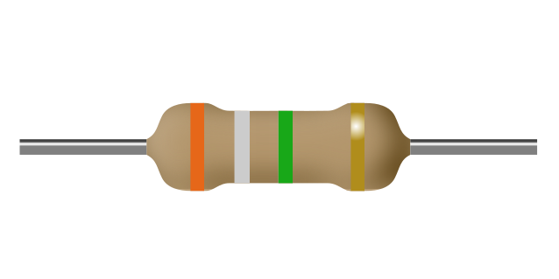
a) 390kΩ
b) 395Ω
c) 3.9kΩ
d) 3.9MΩ
- What is the value of this resistance?
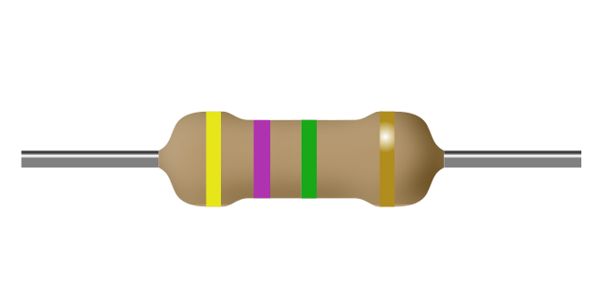
a) 4.7kΩ
b) 475Ω
c) 470kΩ
d) 4.7MΩ
- What is the value of this resistance?
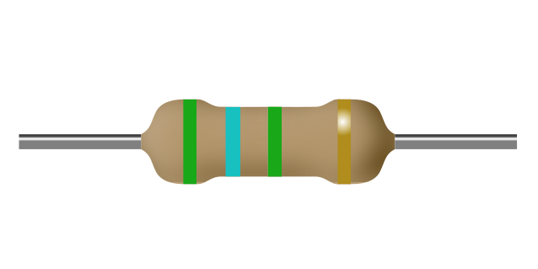
a) 560kΩ
b) 5.6kΩ
c) 565Ω
d) 5.6MΩ
- What is the value of this resistance?
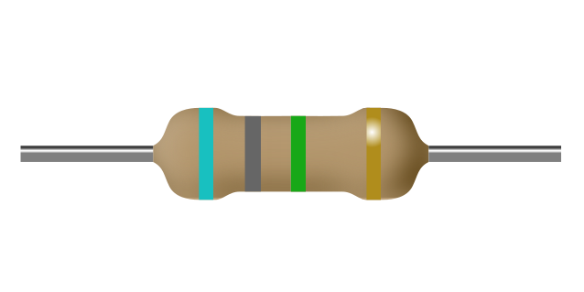
a) 680kΩ
b) 6.8MΩ
c) 6.8kΩ
d) 685Ω
- What is the value of this resistance?
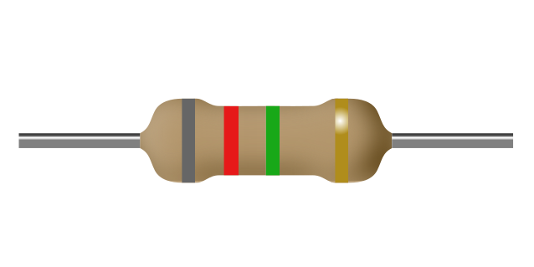
a) 8.2MΩ
b) 8.2kΩ
c) 820kΩ
d) 825Ω

