Electricity. Components name.
- What is the component of the image?
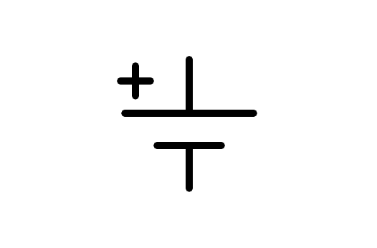
a) Motor
b) Earth
c) Altern current source
d) Battery
- What is the component of the image?
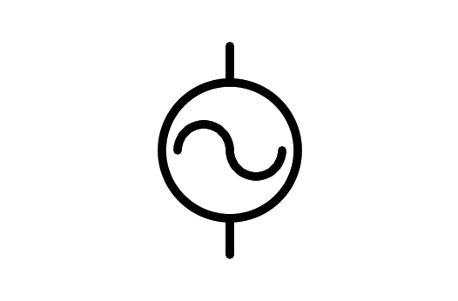
a) Altern current source
b) Battery
c) Electric Motor
d) Light Bulb
- What is the component of the image?
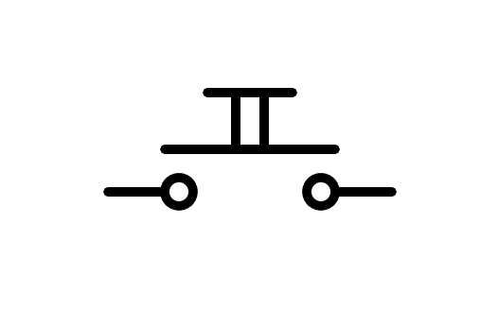
a) Two way Switch n.o.
b) Pushbutton n.o.
c) Switch n.o.
d) Battery
- What is the component of the image?
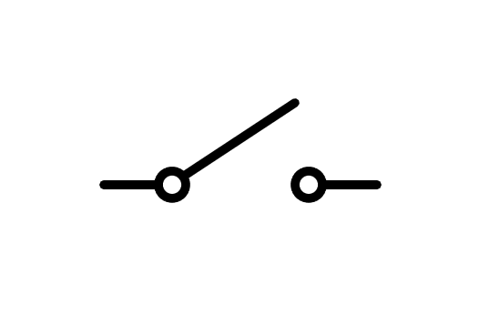
a) Switch
b) Two way Switch
c) Rele
d) Pushbutton
- What is the component of the image?
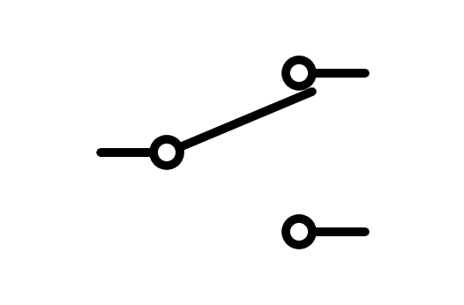
a) Pushbutton
b) Fuse
c) Switch
d) Two way Switch
- What is the component of the image?
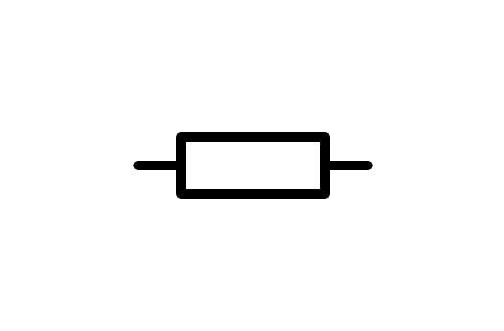
a) Switch
b) Resistor
c) Battery
d) Light Bulb
- What is the component of the image?
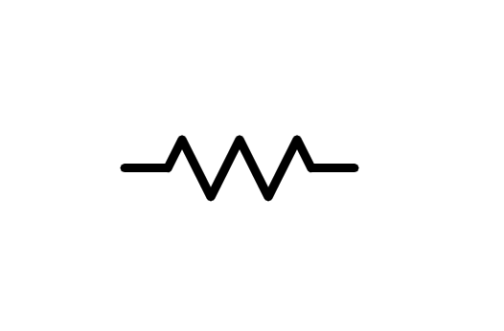
a) Light Bulb
b) Battery
c) Resistor
d) Switch
- What is the component of the image?
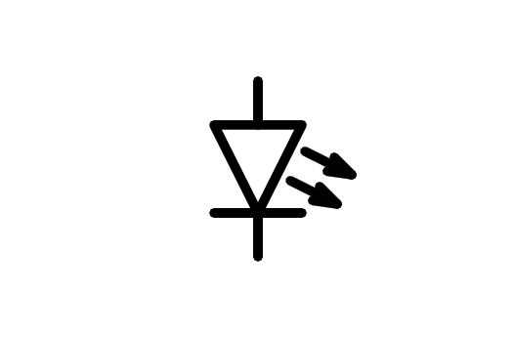
a) Speaker
b) Motor
c) LED Diode
d) Light Bulb
- What is the component of the image?
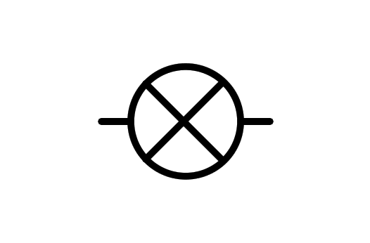
a) X component
b) Light Bulb
c) LED Diode
d) Motor
- What is the component of the image?
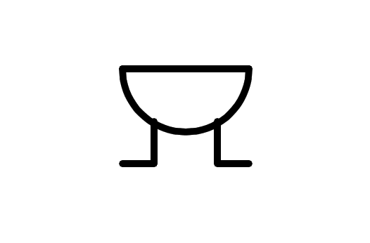
a) Altern current source
b) Speaker
c) Motor
d) Buzzer
- What is the component of the image?
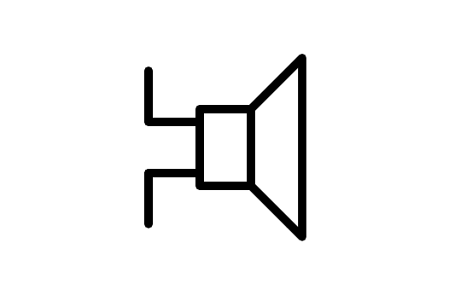
a) Direct current source
b) Altern current source
c) Buzzer
d) Speaker
- What is the component of the image?
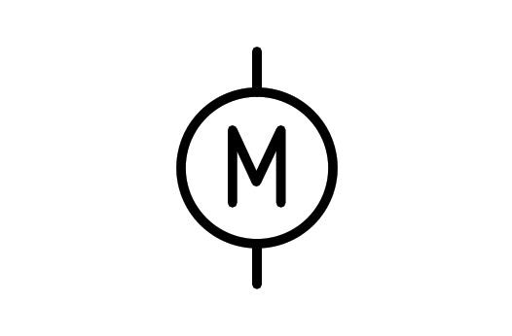
a) Wattmeter
b) Buzzer
c) Light Bulb
d) Motor
- What is the component of the image?
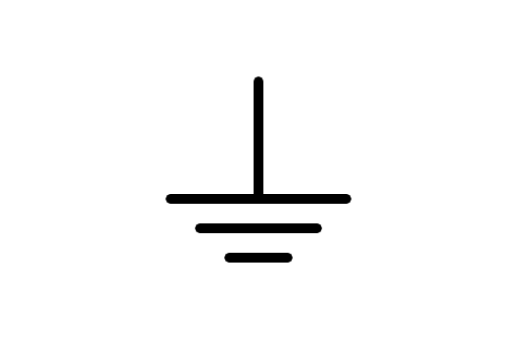
a) Earth
b) Battery
c) Antenna
d) Receiver
- What is the component of the image?
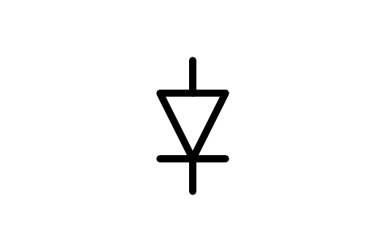
a) Diode
b) LED Diode
c) Transistor
d) Battery
- What is the component of the image?
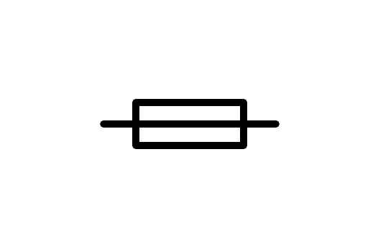
a) Generator
b) Fuse
c) Relay
d) Resistor
- What is the component of the image?
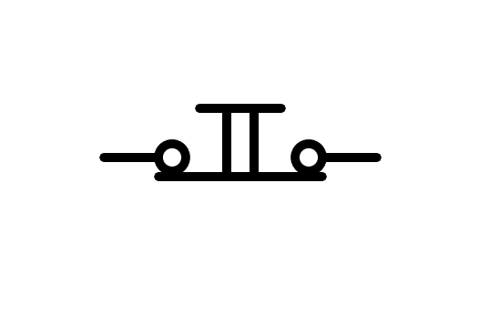
a) Switch n.c.
b) Distributor
c) Battery
d) Pushbutton n.c.
- What is the component of the image?
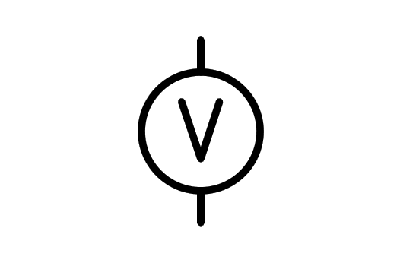
a) Voltmeter
b) Power source
c) Battery
d) Light Bulb
- What is the component of the image?
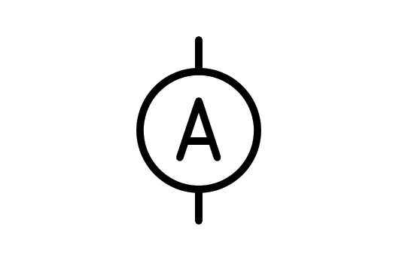
a) Current source
b) Ammeter
c) Battery
d) Aluminum
- What is the component of the image?
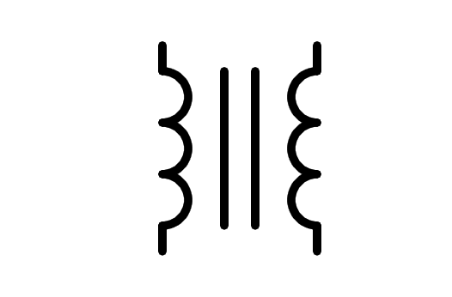
a) Double conductor
b) Coil
c) Transistor
d) Transformer
- What is the component of the image?
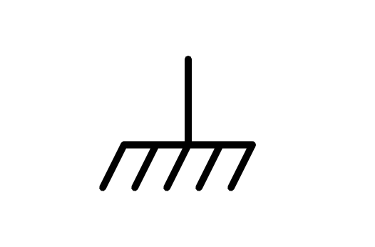
a) Earth
b) Battery
c) Brush
d) Ground plane
- What is the component of the image?
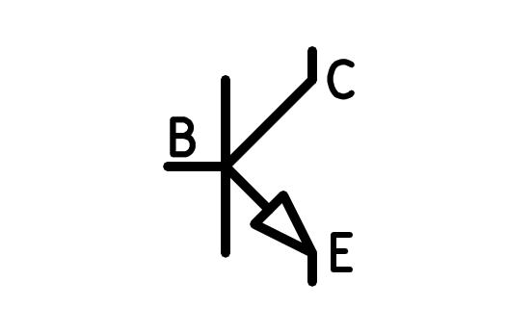
a) PNP Transistor
b) PNP Transformer
c) NPN Transistor
d) NPN Transformer
- What is the component of the image?
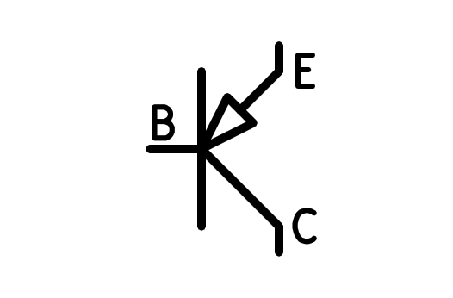
a) NPN Transistor
b) PNP Transformer
c) NPN Transformer
d) PNP Transistor
- What is the component of the image?
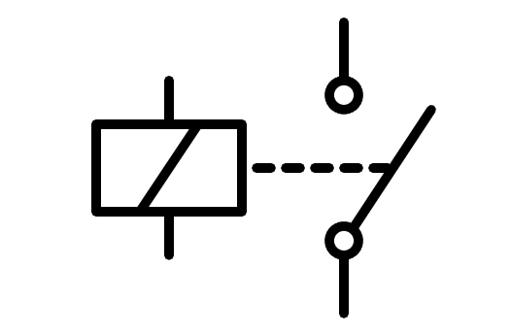
a) Double Pushbutton
b) Coil
c) Relay
d) Double Switch
- What is the component of the image?
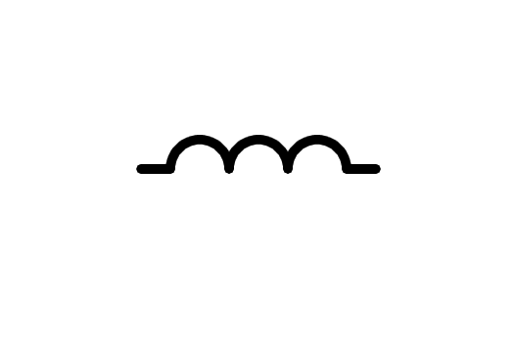
a) Round Pushbutton
b) Cable
c) Coil
d) Fingers
- What is the component of the image?
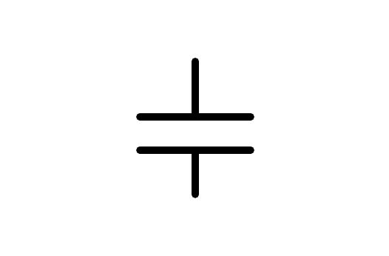
a) Congregator
b) Battery
c) Capacitor
d) Small Battery
- What is the component of the image?
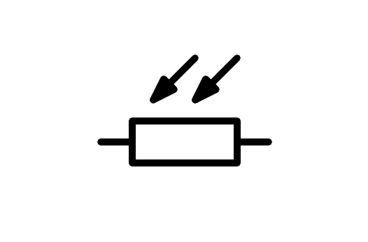
a) NTC Resistor
b) Variable Resistor
c) LDR Resistor
d) Resistor
- What is the component of the image?
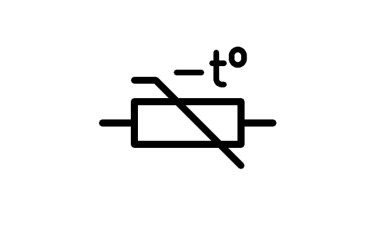
a) LDR Resistor
b) Variable Resistor
c) NTC Resistor
d) Resistor
- What is the component of the image?
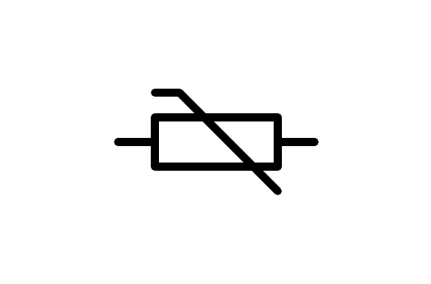
a) Resistor
b) NTC Resistor
c) LDR Resistor
d) Variable Resistor
- What is the component of the image?
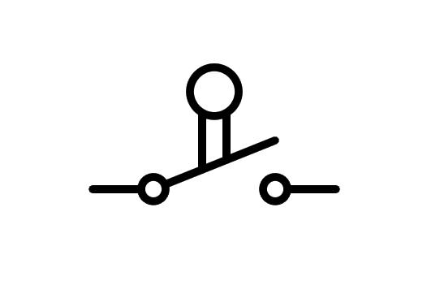
a) Limit Switch
b) Pushbutton n.o.
c) Switch
d) Pushbutton
- What is the component of the image?
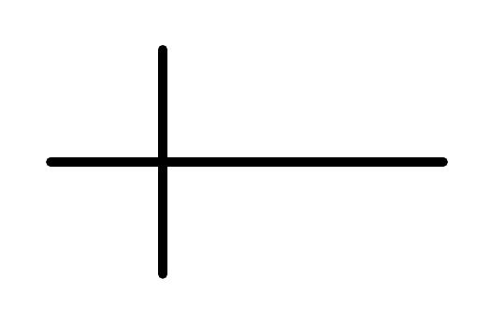
a) Crossover wire connected
b) Cross
c) Crossover wire not connected
d) Connected wire
- What is the component of the image?
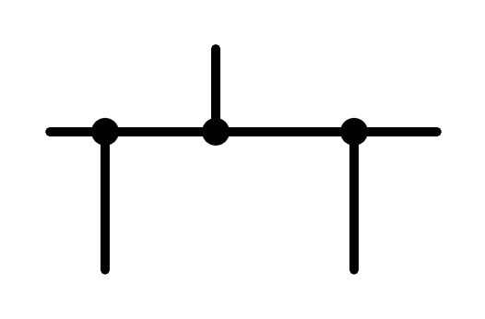
a) Connected wire
b) Unconnected wire
c) Mass
d) Connected and unconnected wire
- What is the component of the image?
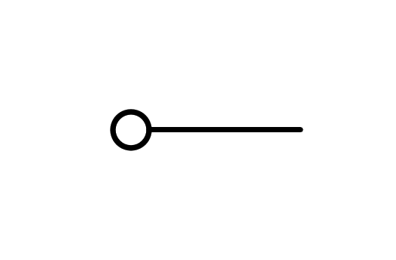
a) Connector
b) Squared
c) Mass
d) Ground plane
- What is the component of the image?
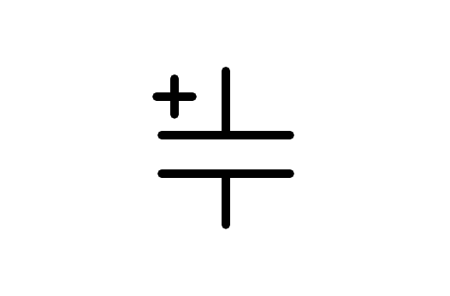
a) Small Battery
b) Battery
c) Polarized Capacitor
d) Capacitor

