Electricity. Identificar serie, paralelo, cortocircuito.
- How is the following circuit connected?
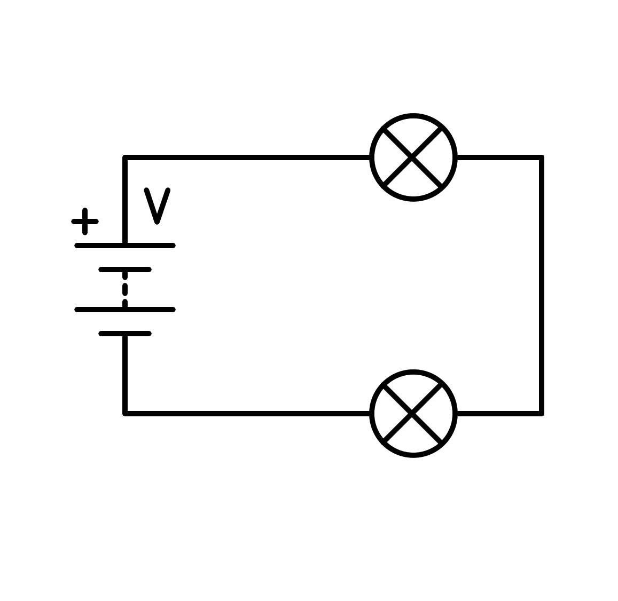
a) In series
b) In parallel
c) Short circuit in the battery
d) Short circuit in the light bulb
- How is the following circuit connected?
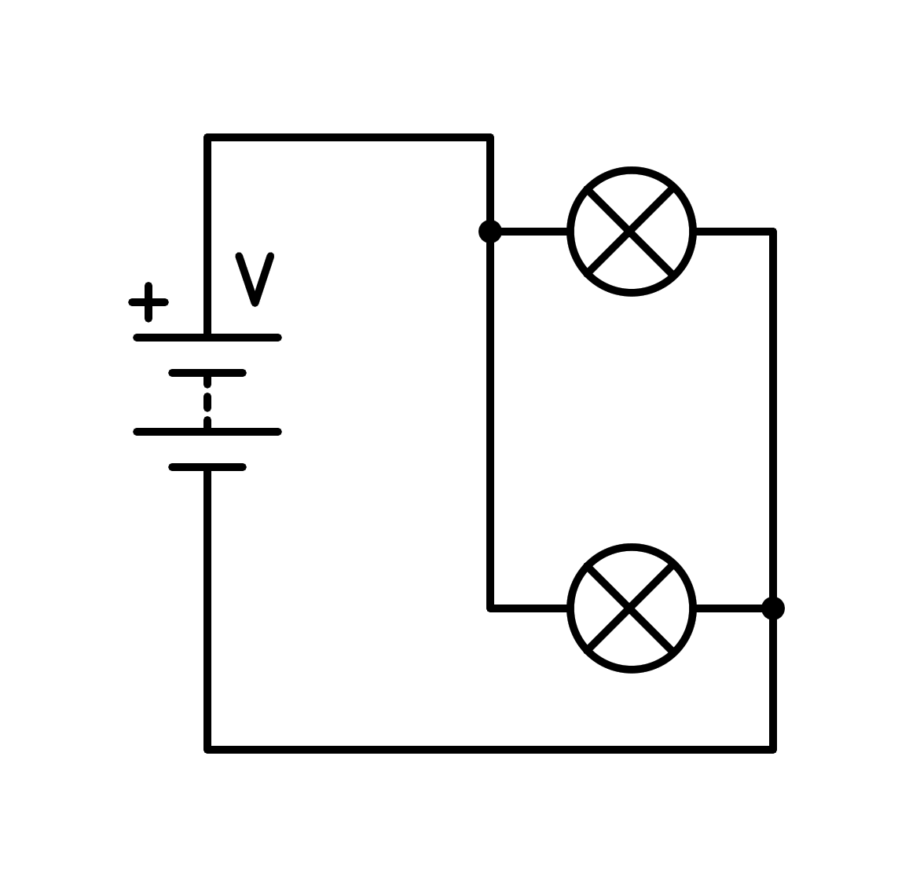
a) Short circuit in the light bulb
b) In series
c) Short circuit in the battery
d) In parallel
- How is the following circuit connected?
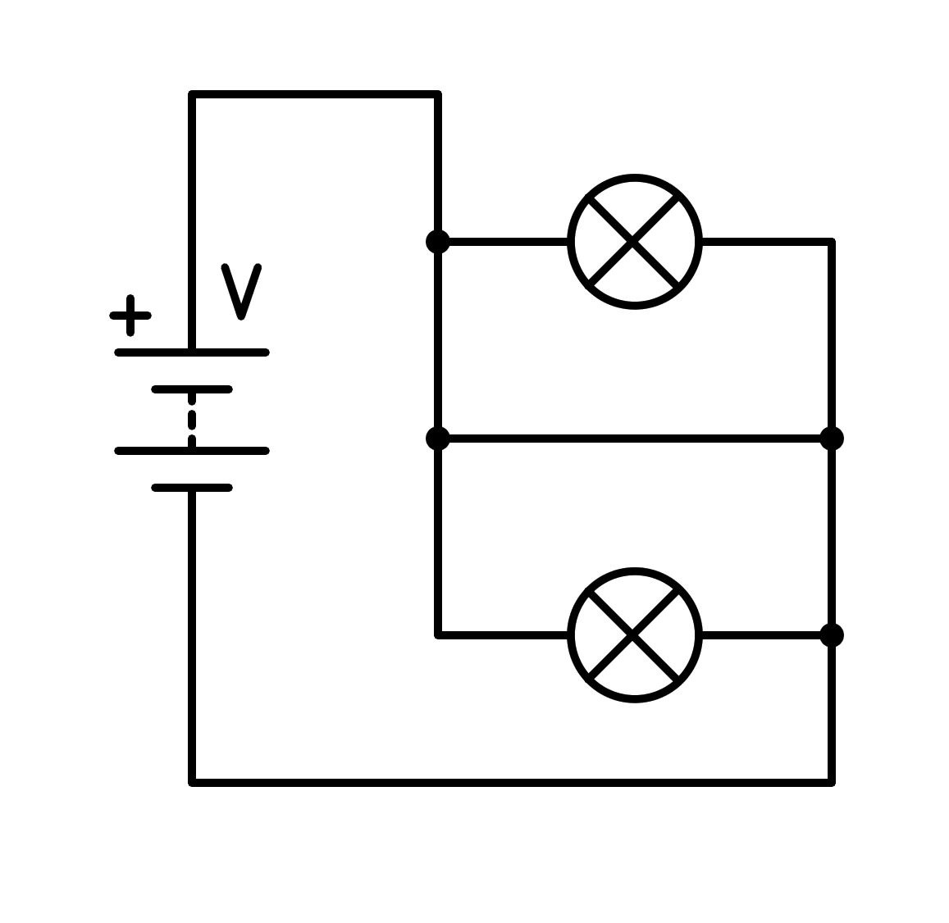
a) In series
b) Short circuit in the battery
c) In parallel
d) Short circuit in the light bulb
- How is the following circuit connected?
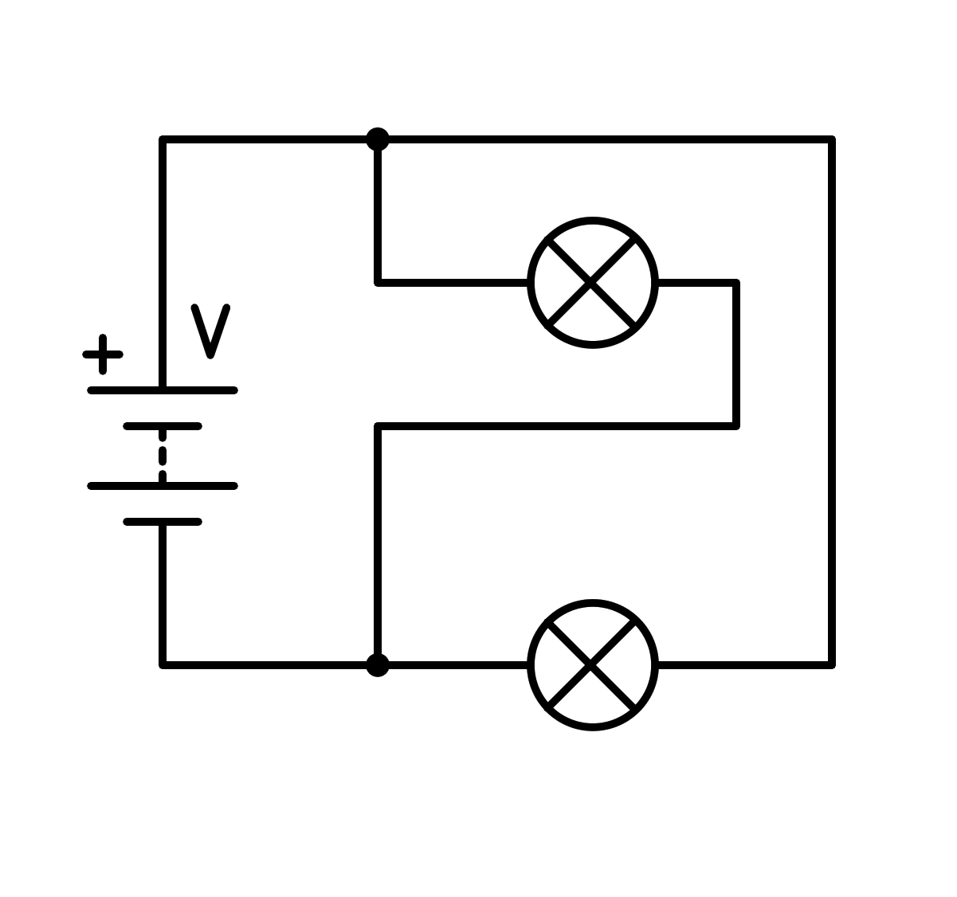
a) Short circuit in the battery
b) In parallel
c) In series
d) Short circuit in the light bulb
- How is the following circuit connected?
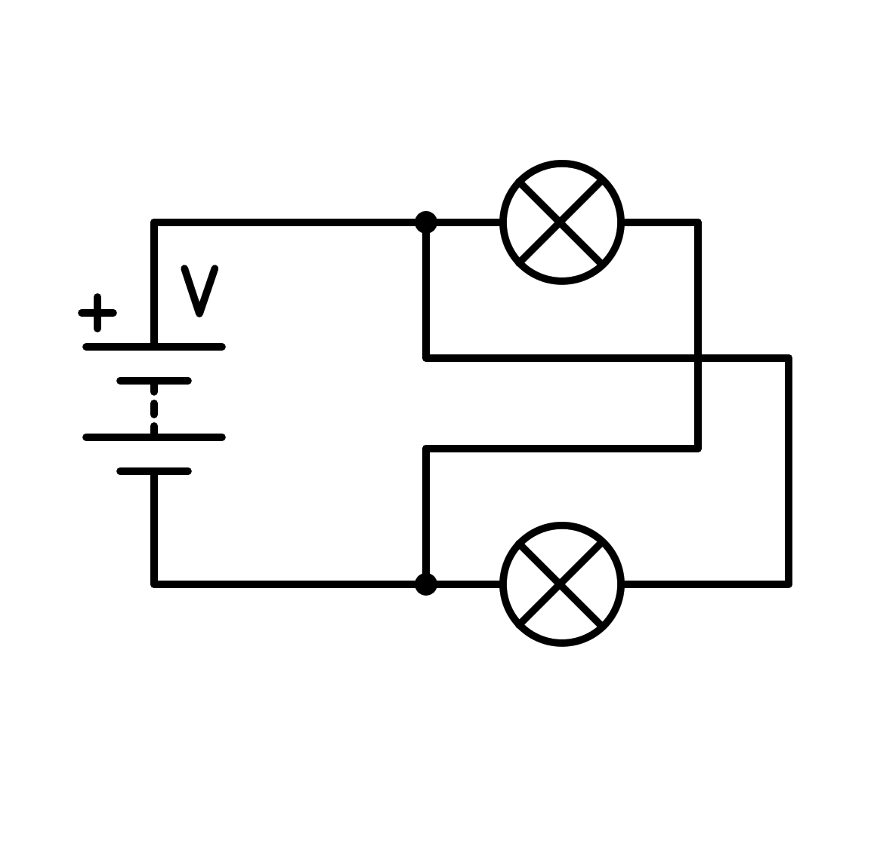
a) Short circuit in the battery
b) Short circuit in the light bulb
c) In parallel
d) In series
- How is the following circuit connected?
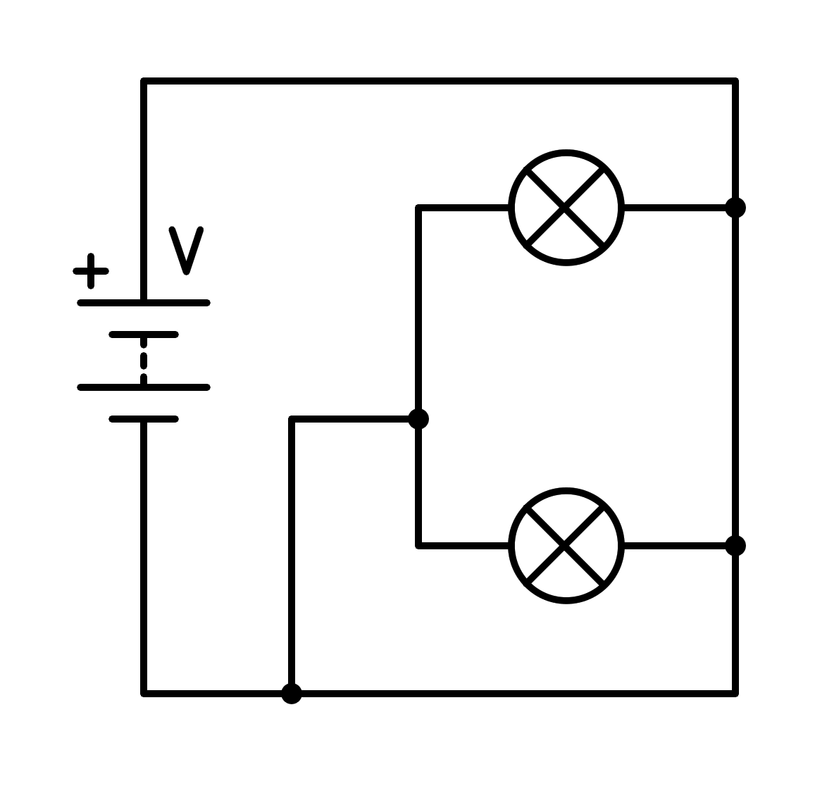
a) Short circuit in the light bulb
b) Short circuit in the battery
c) In series
d) In parallel
- How is the following circuit connected?
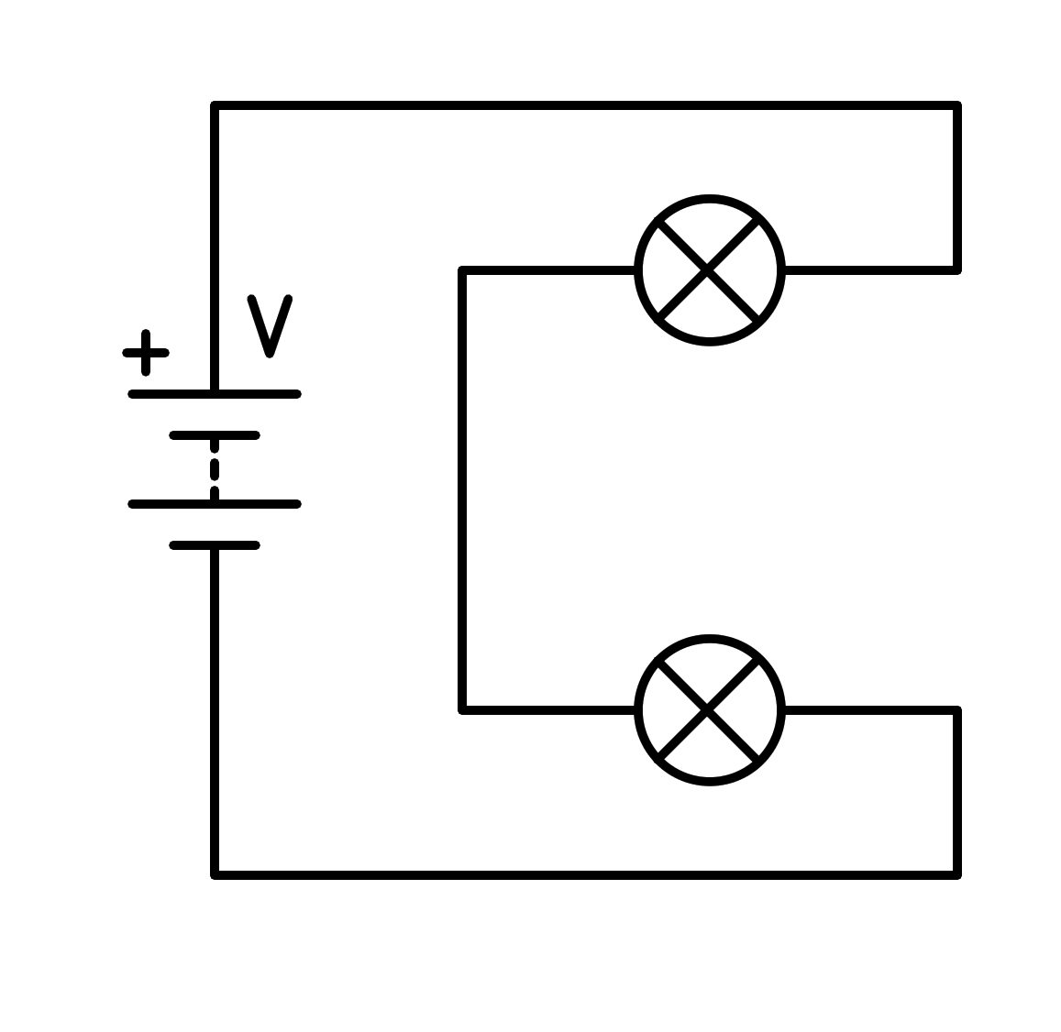
a) Short circuit in the light bulb
b) In series
c) In parallel
d) Short circuit in the battery
- How is the following circuit connected?
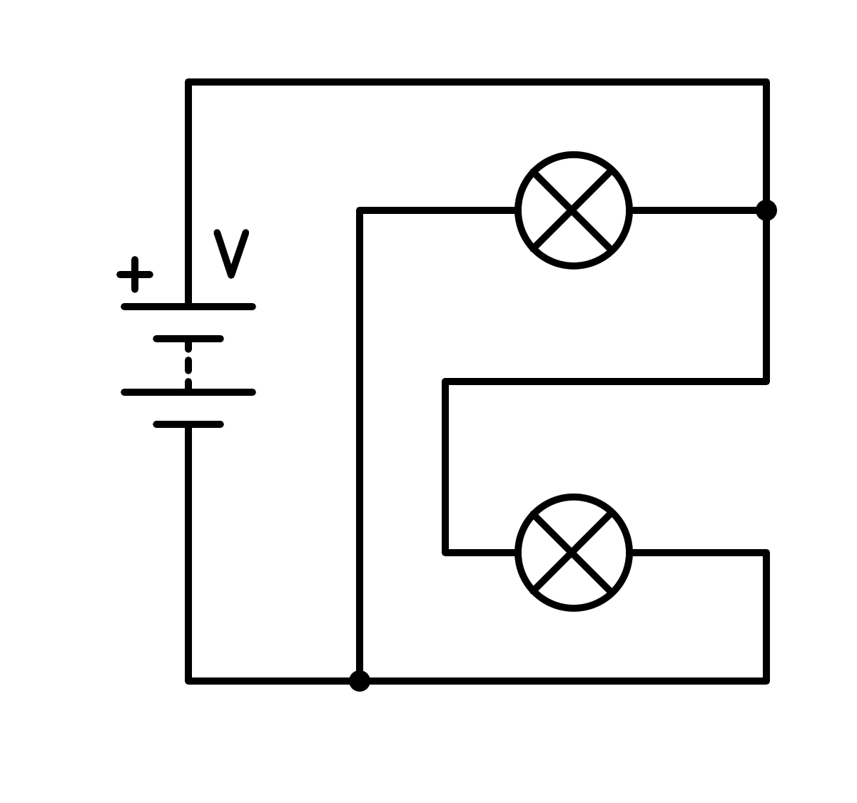
a) In parallel
b) In series
c) Short circuit in the light bulb
d) Short circuit in the battery
- How is the following circuit connected?
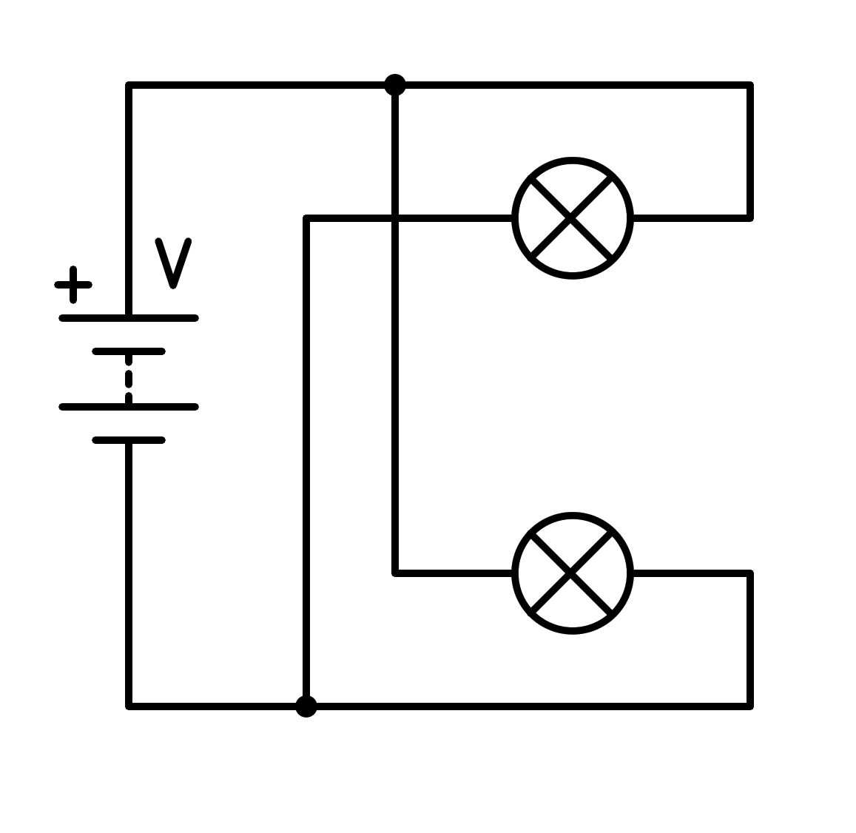
a) In series
b) Short circuit in the light bulb
c) In parallel
d) Short circuit in the battery
- How is the following circuit connected?
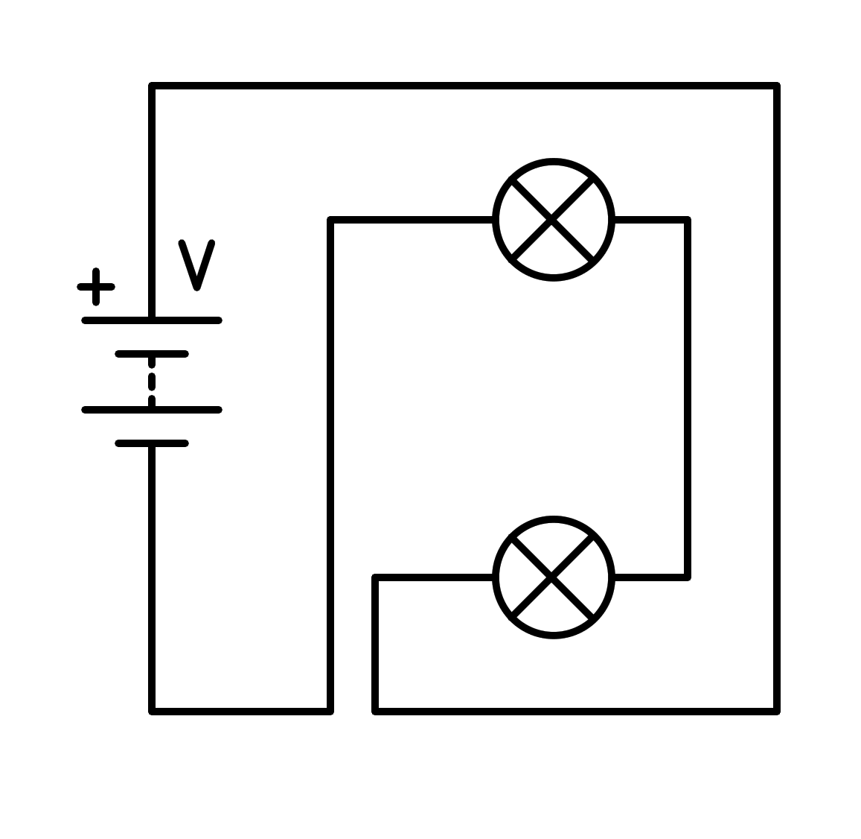
a) Short circuit in the battery
b) In parallel
c) Short circuit in the light bulb
d) In series
- How is the following circuit connected?
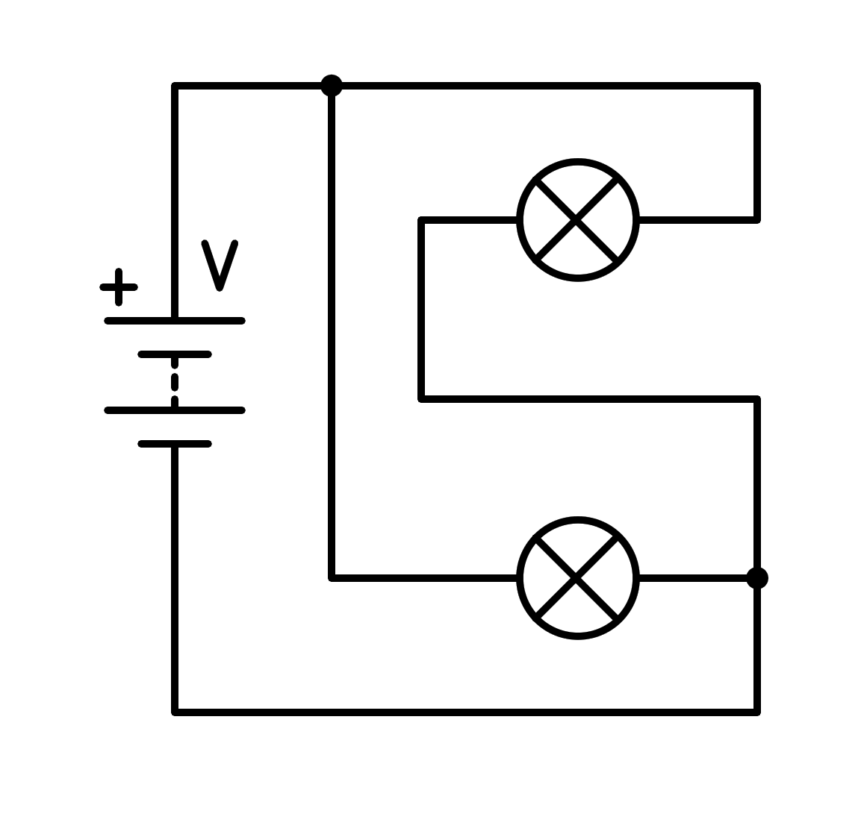
a) Short circuit in the battery
b) Short circuit in the light bulb
c) In series
d) In parallel
- How is the following circuit connected?
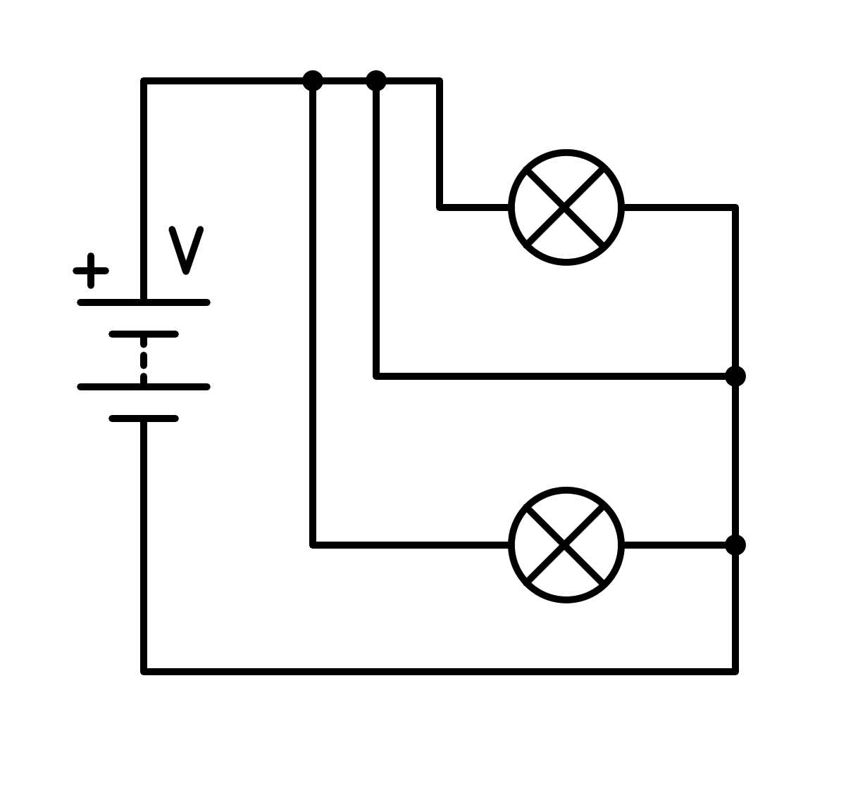
a) Short circuit in the light bulb
b) Short circuit in the battery
c) In series
d) In parallel
- How is the following circuit connected?
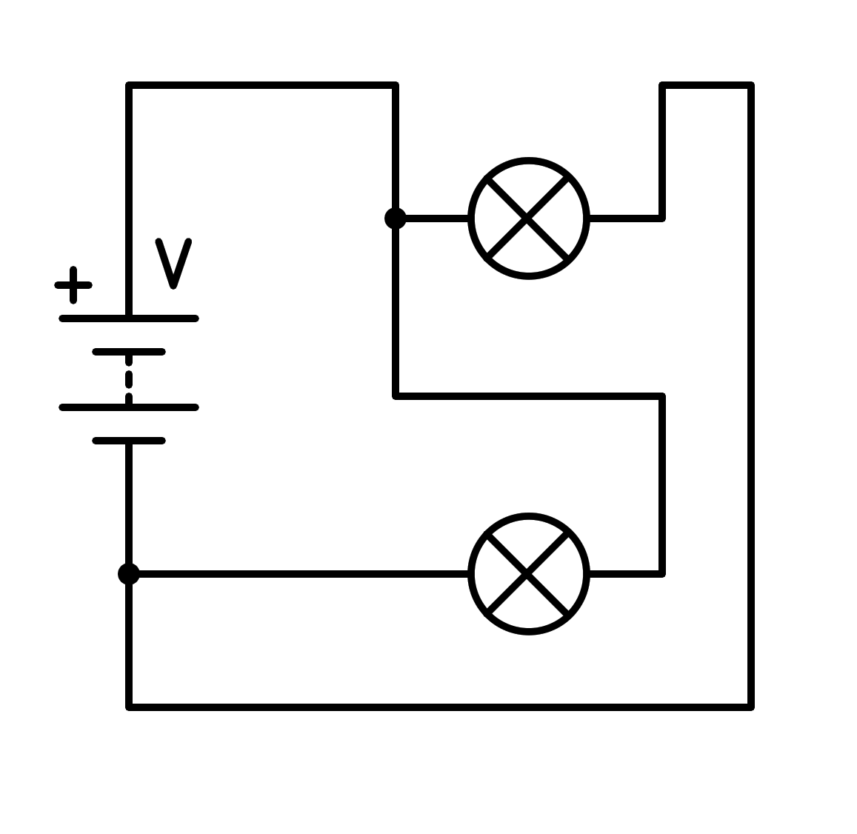
a) In parallel
b) Short circuit in the battery
c) In series
d) Short circuit in the light bulb
- How is the following circuit connected?
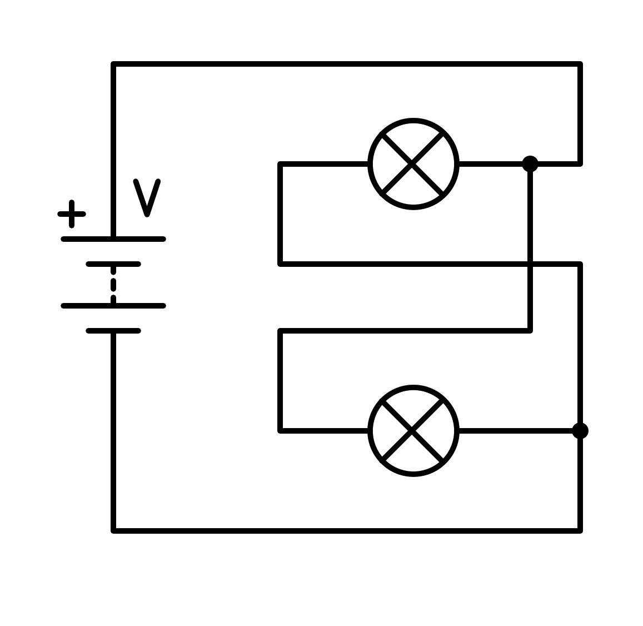
a) In parallel
b) In series
c) Short circuit in the battery
d) Short circuit in the light bulb
- How is the following circuit connected?
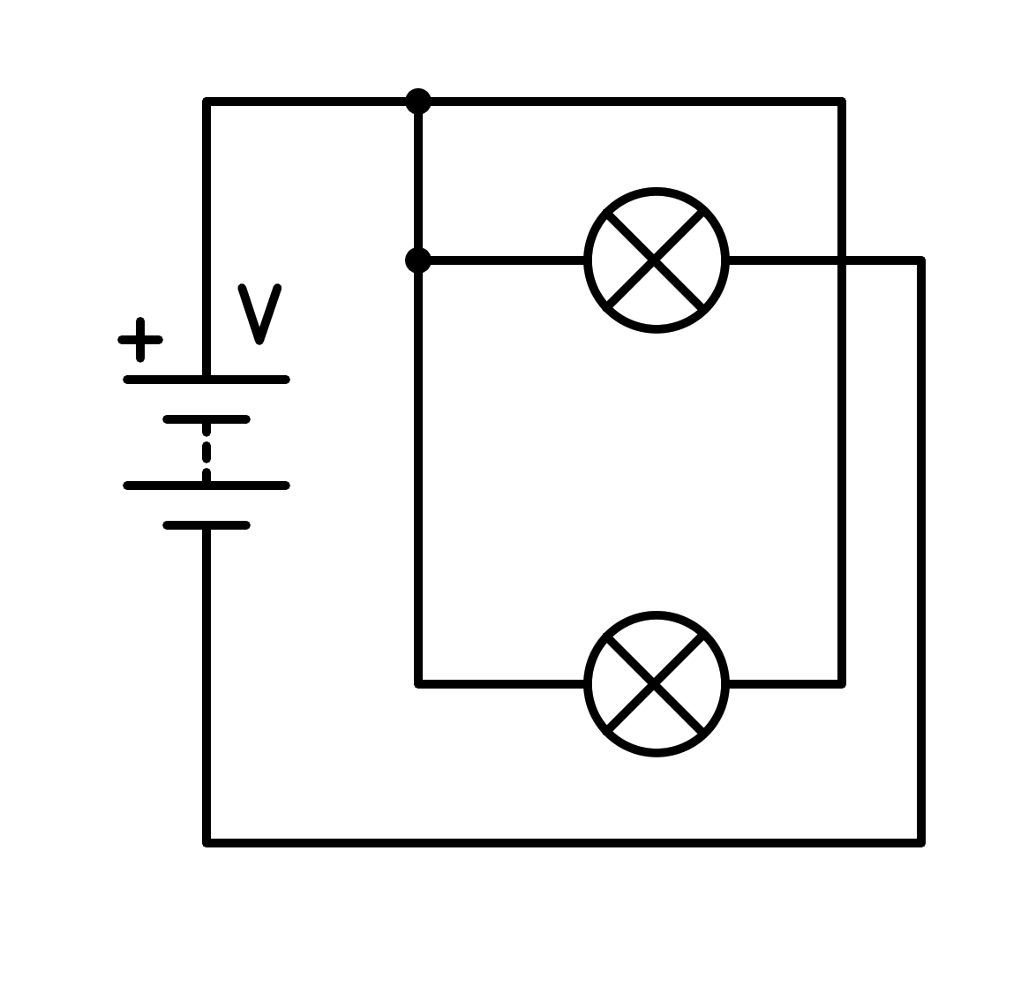
a) Short circuit in the battery
b) In series
c) In parallel
d) Short circuit in the light bulb
- How is the following circuit connected?
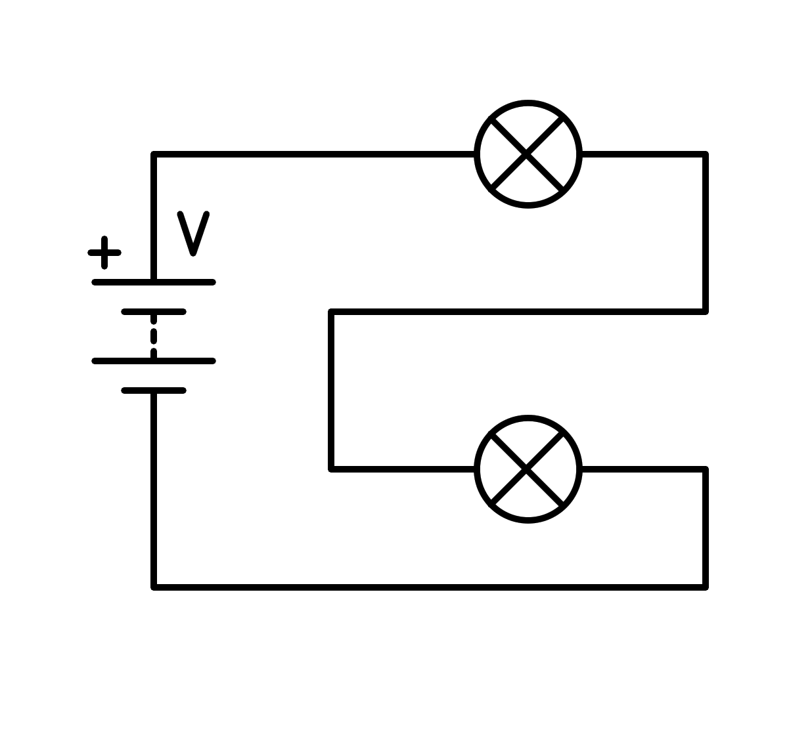
a) In series
b) Short circuit in the light bulb
c) In parallel
d) Short circuit in the battery
- How is the following circuit connected?
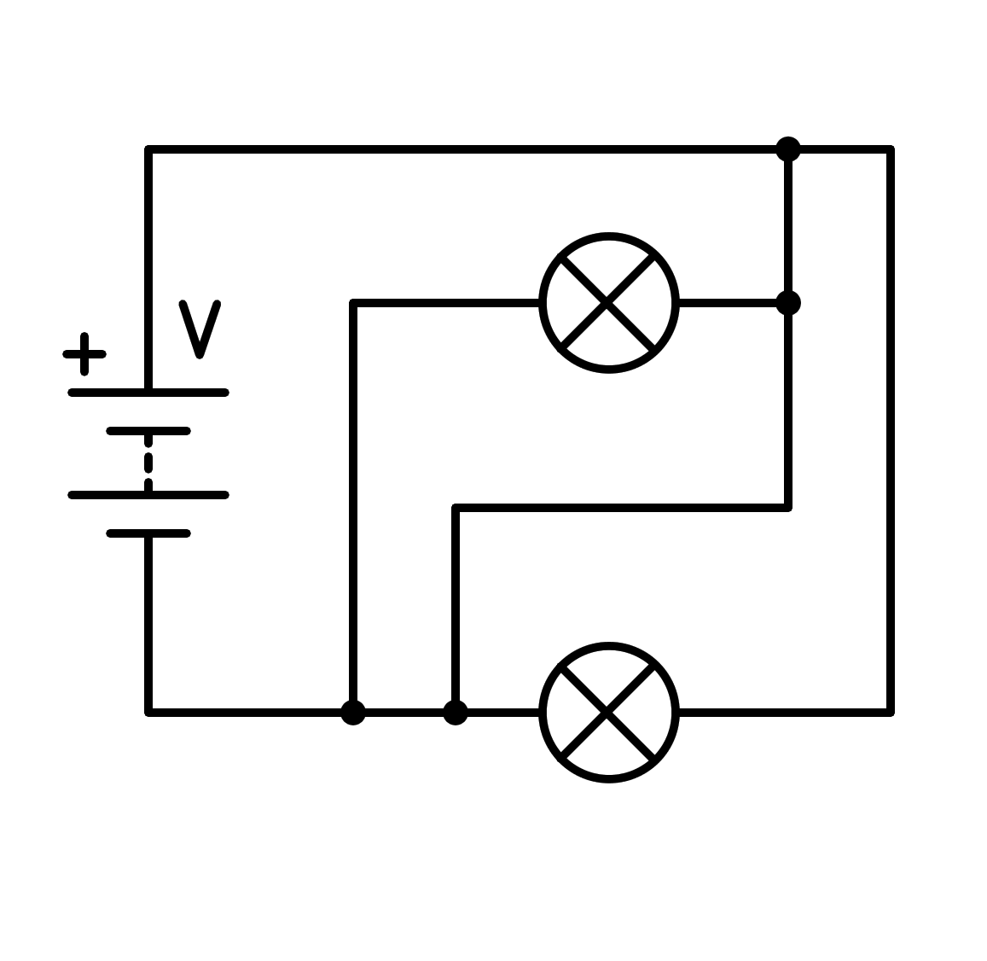
a) Short circuit in the light bulb
b) In parallel
c) Short circuit in the battery
d) In series
- How is the following circuit connected?
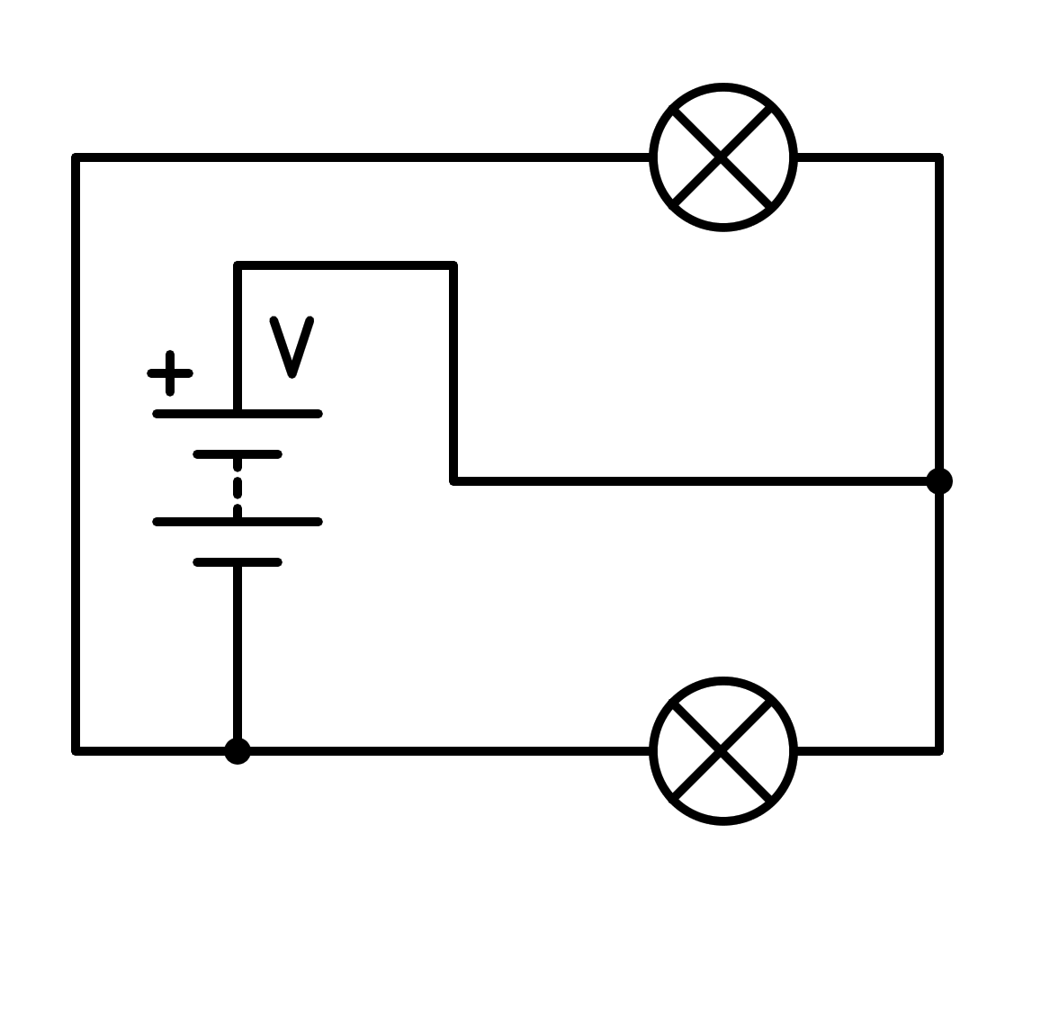
a) In parallel
b) Short circuit in the light bulb
c) Short circuit in the battery
d) In series
- How is the following circuit connected?
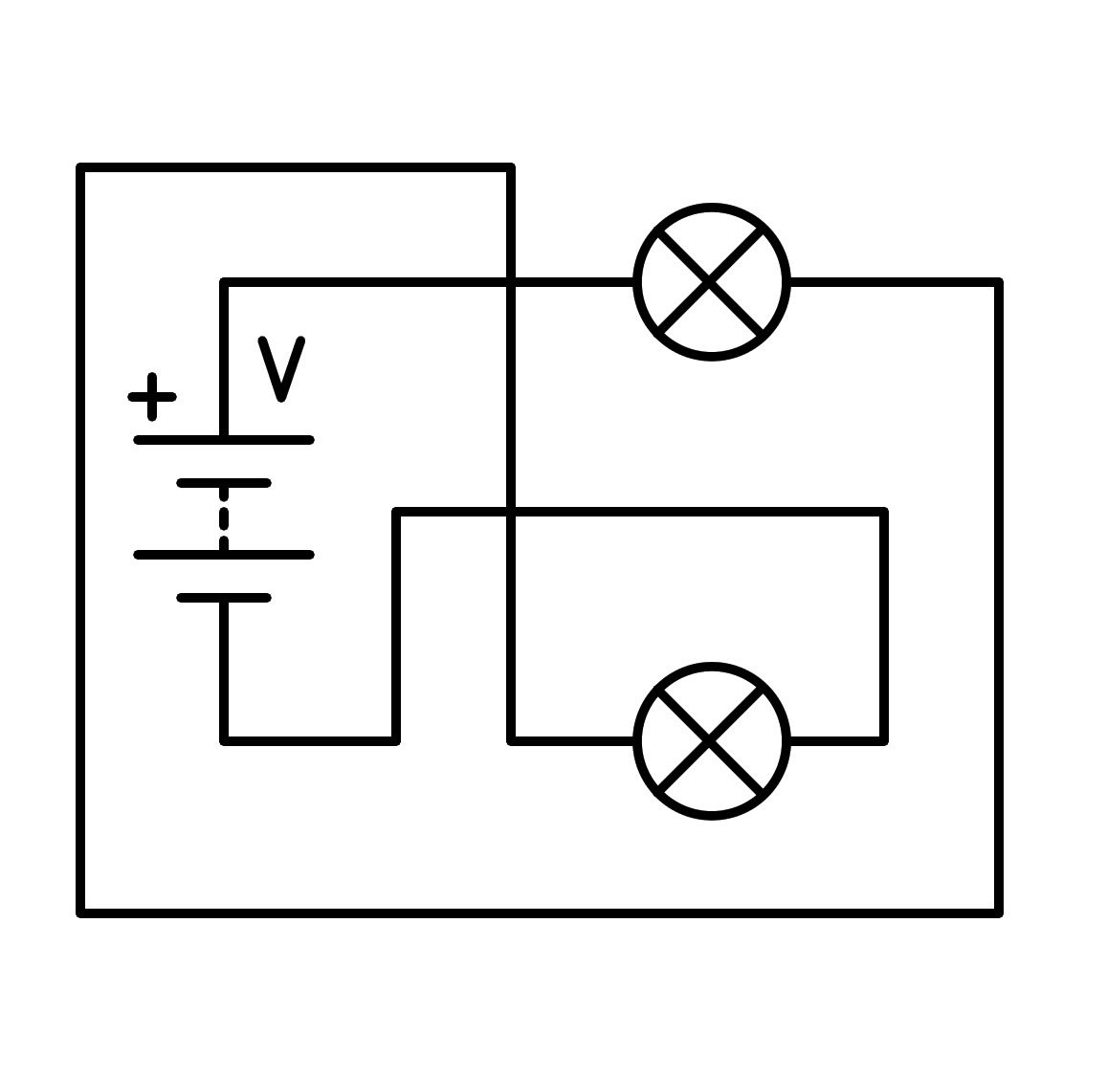
a) In series
b) In parallel
c) Short circuit in the light bulb
d) Short circuit in the battery
- How is the following circuit connected?
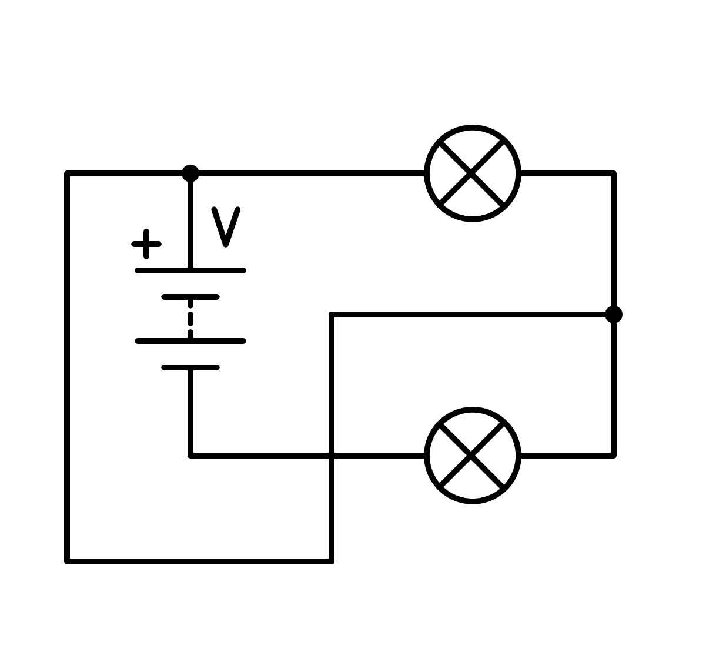
a) Short circuit in the battery
b) In parallel
c) In series
d) Short circuit in the light bulb
- How is the following circuit connected?
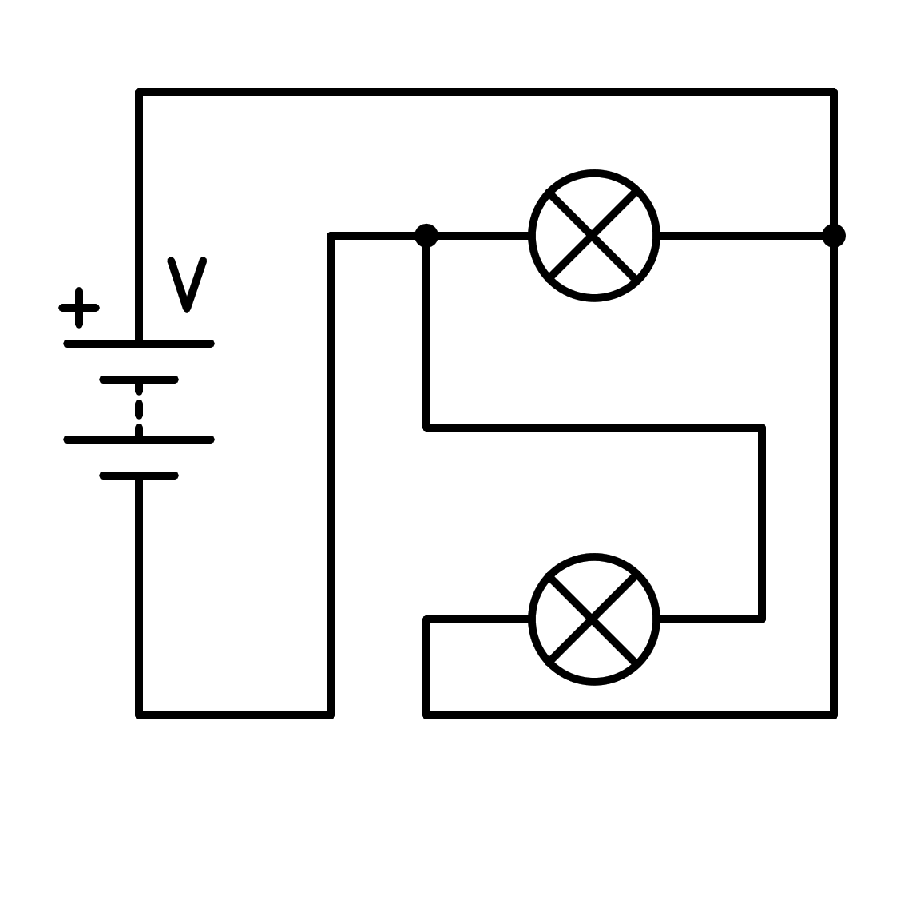
a) Short circuit in the battery
b) In series
c) In parallel
d) Short circuit in the light bulb
- How is the following circuit connected?
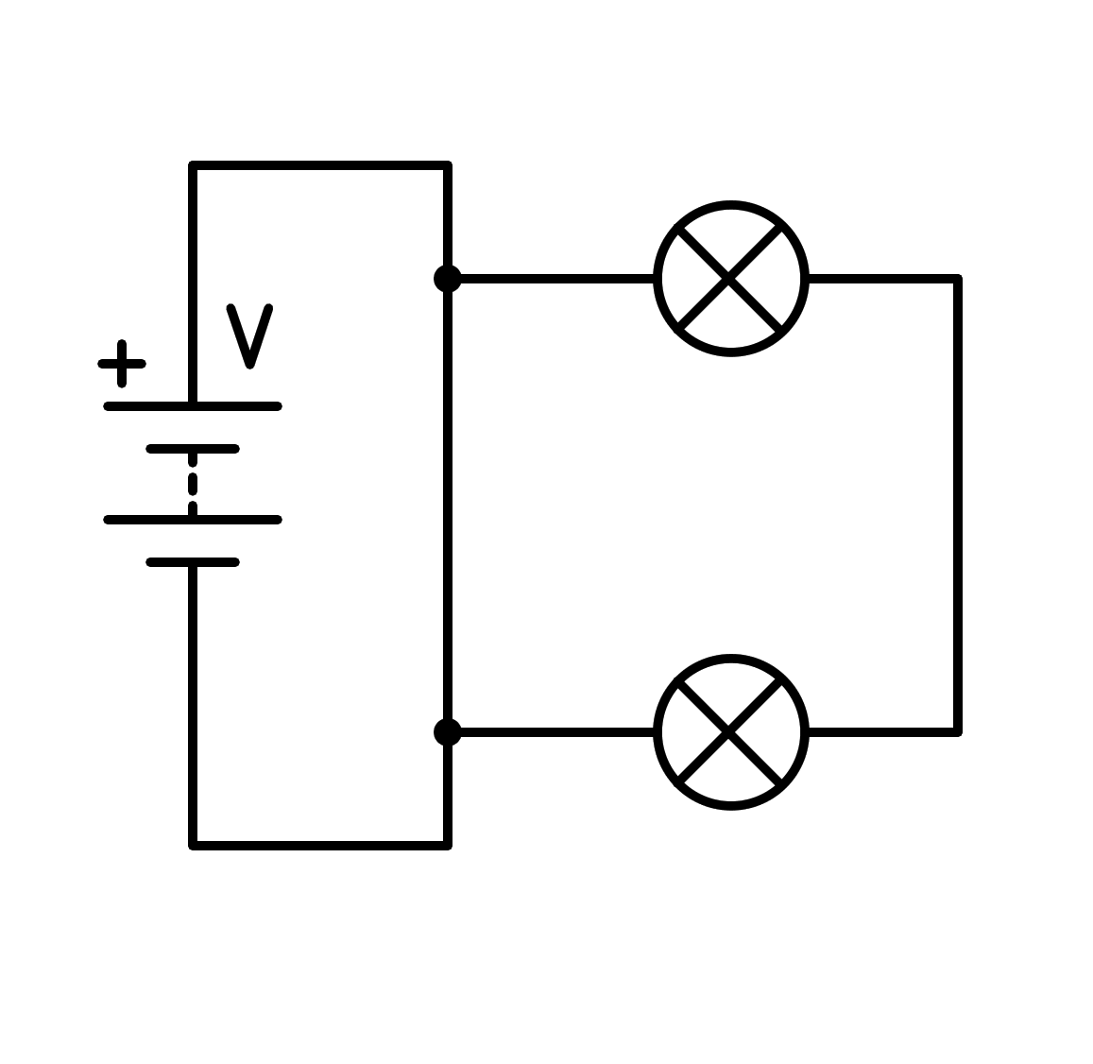
a) In series
b) Short circuit in the battery
c) In parallel
d) Short circuit in the light bulb
- How is the following circuit connected?
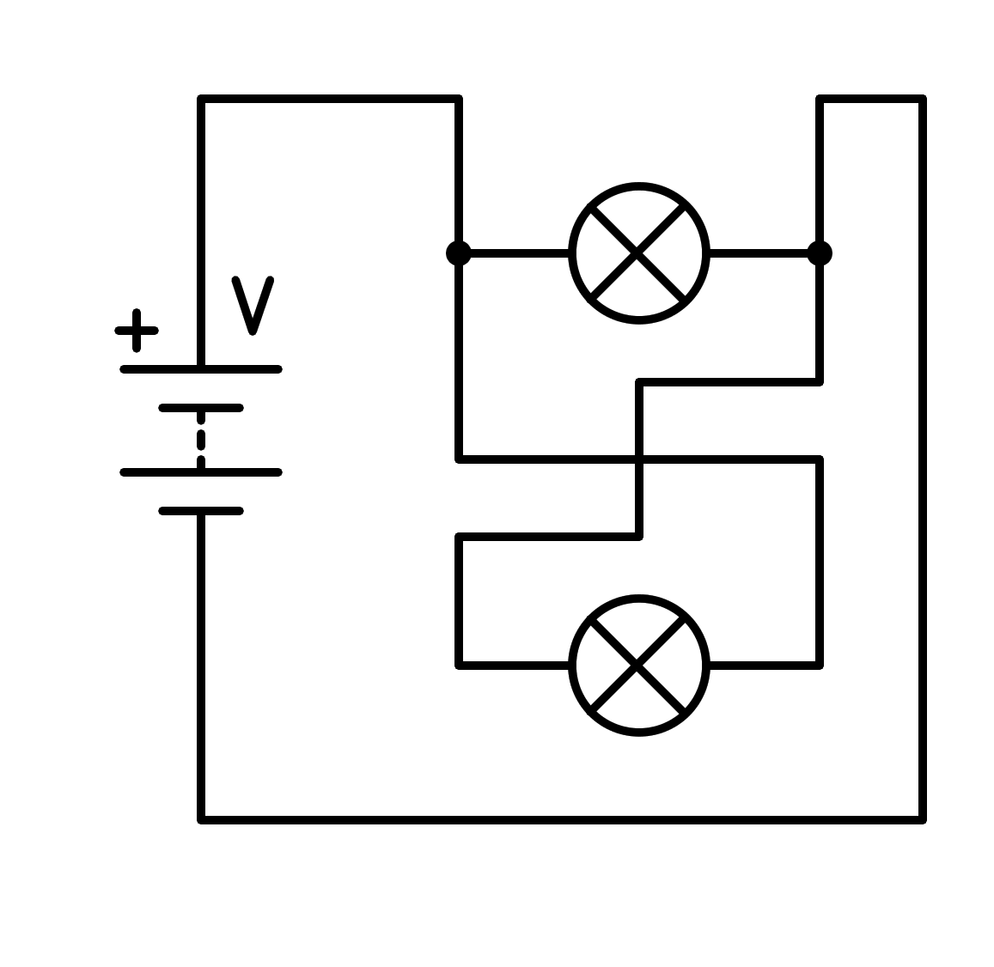
a) Short circuit in the battery
b) Short circuit in the light bulb
c) In parallel
d) In series
- How is the following circuit connected?
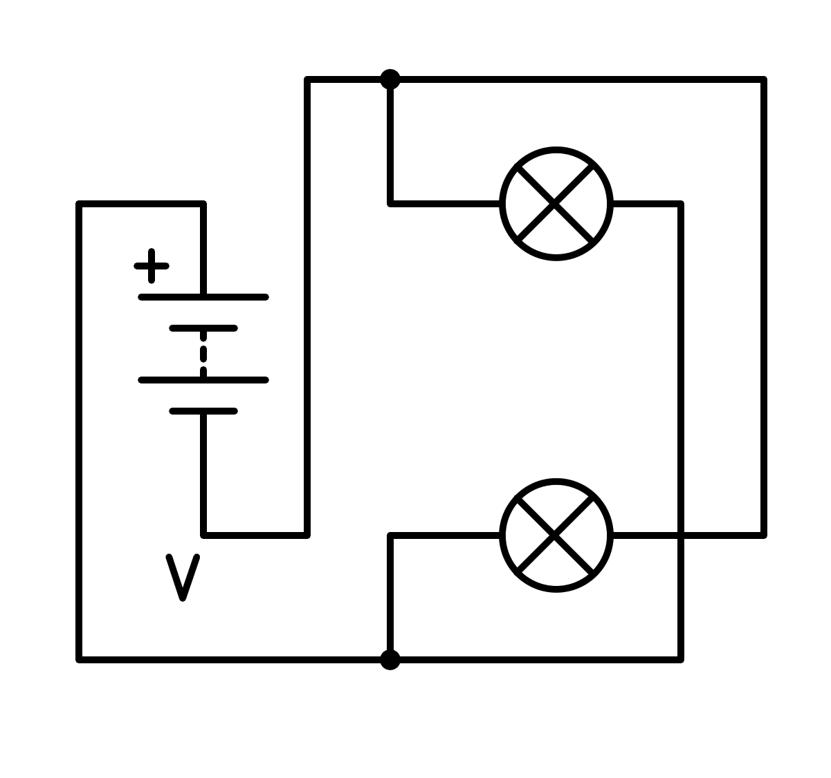
a) In series
b) Short circuit in the battery
c) Short circuit in the light bulb
d) In parallel
- How is the following circuit connected?
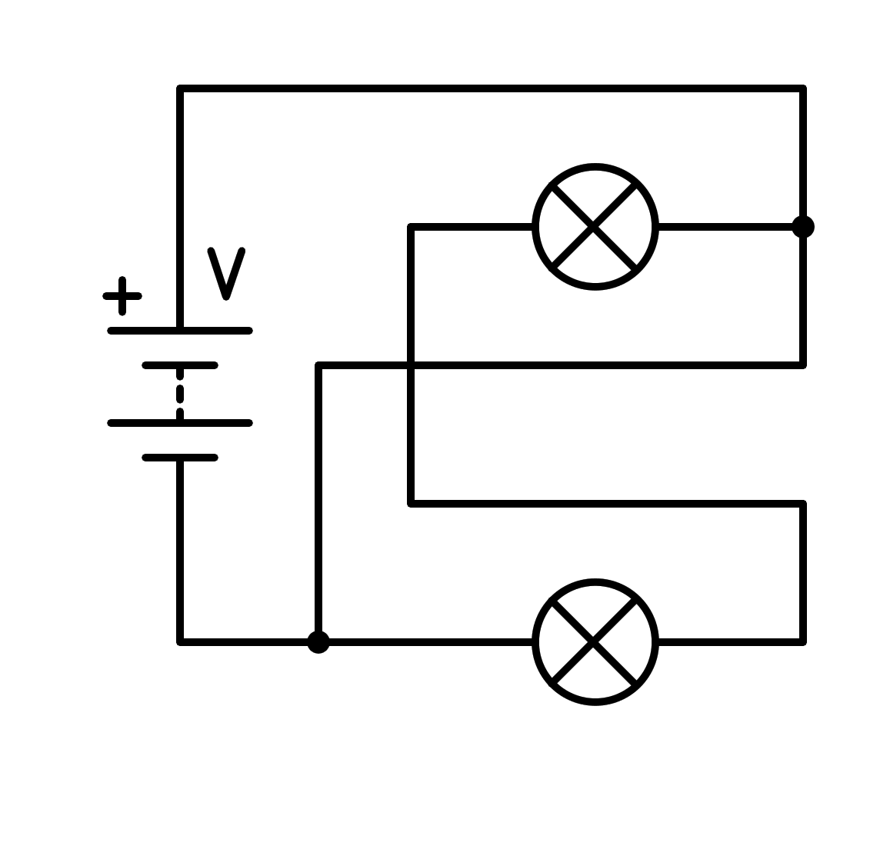
a) Short circuit in the battery
b) In series
c) In parallel
d) Short circuit in the light bulb
- How is the following circuit connected?
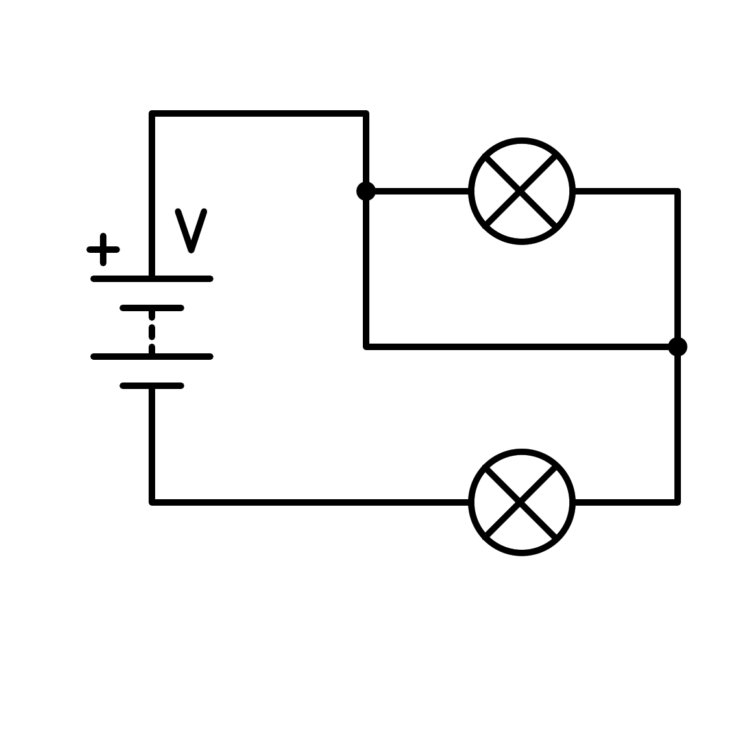
a) Short circuit in the battery
b) In parallel
c) In series
d) Short circuit in the light bulb
- How is the following circuit connected?
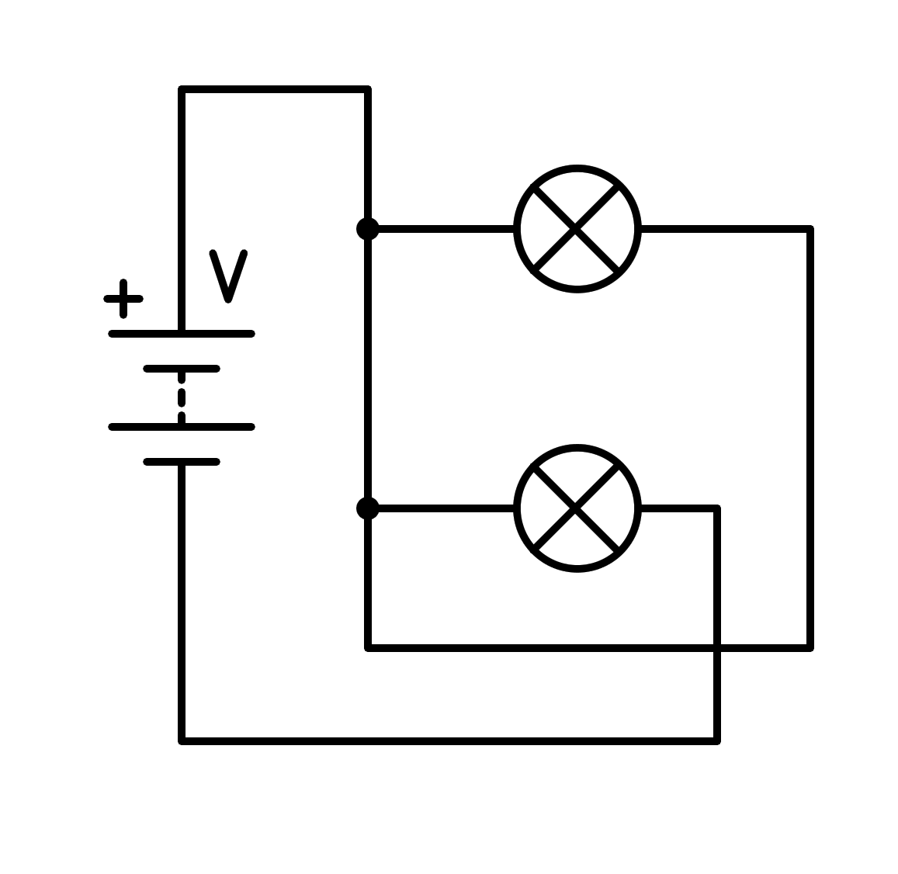
a) In parallel
b) Short circuit in the battery
c) In series
d) Short circuit in the light bulb
- How is the following circuit connected?
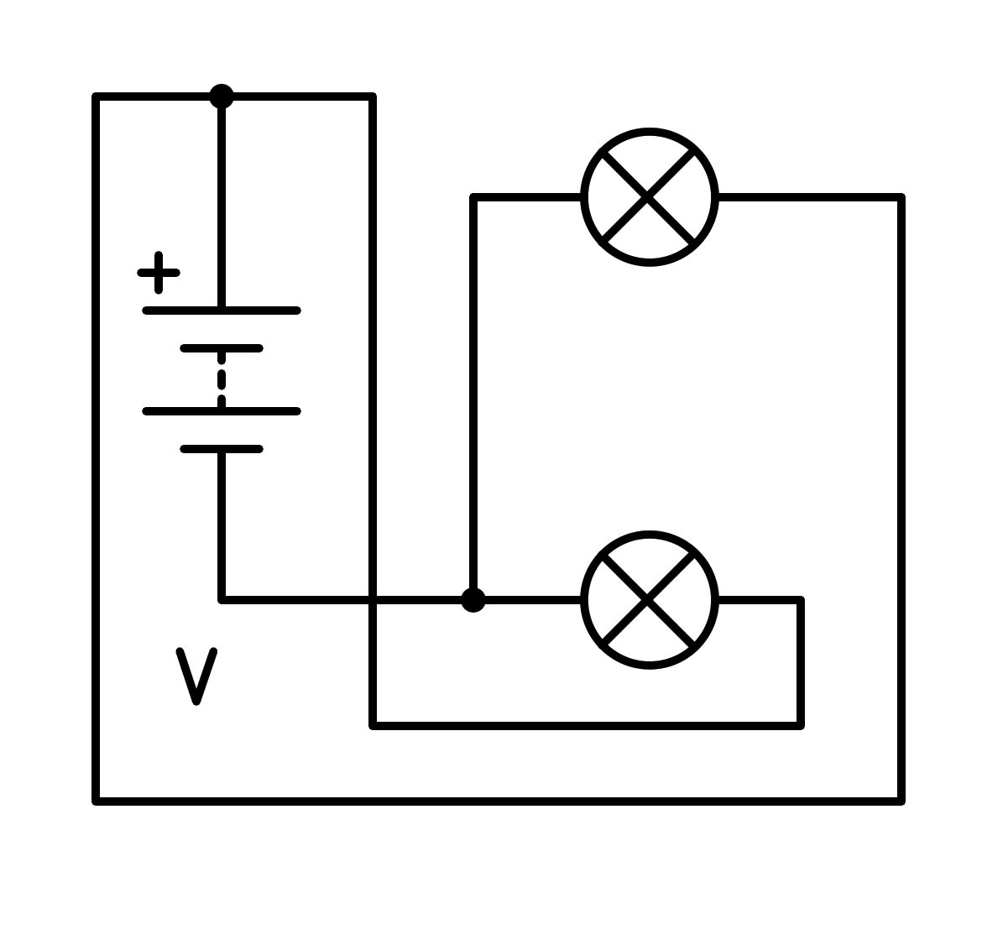
a) Short circuit in the light bulb
b) Short circuit in the battery
c) In parallel
d) In series
- How is the following circuit connected?
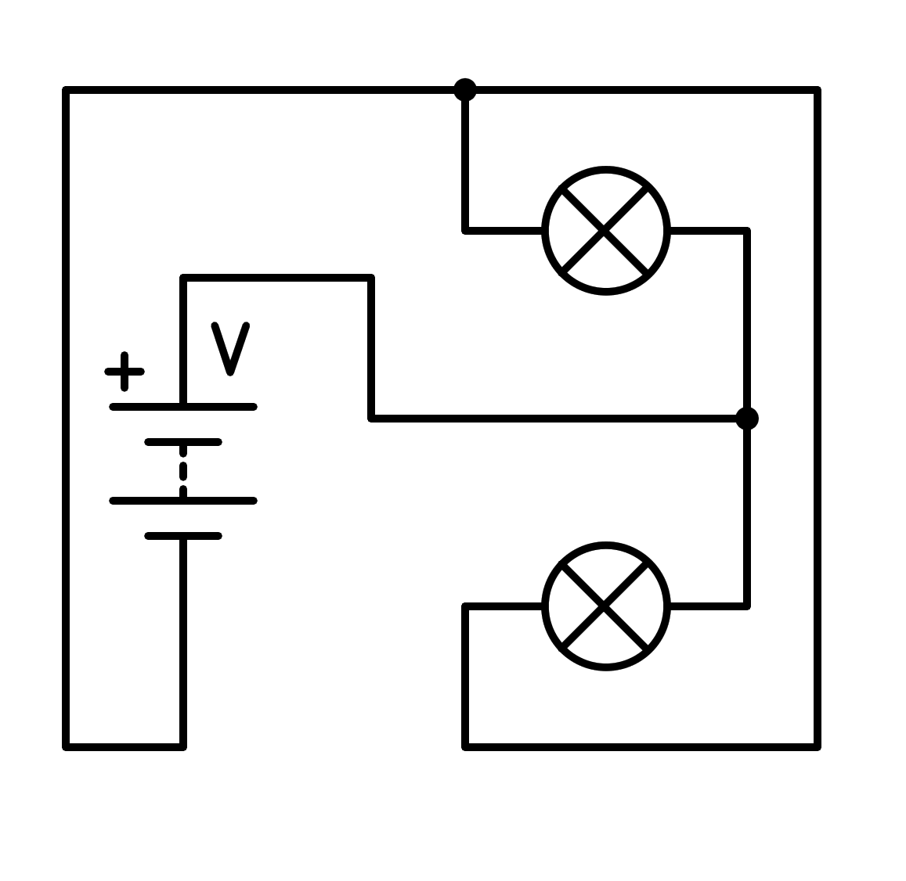
a) In series
b) Short circuit in the light bulb
c) Short circuit in the battery
d) In parallel
- How is the following circuit connected?
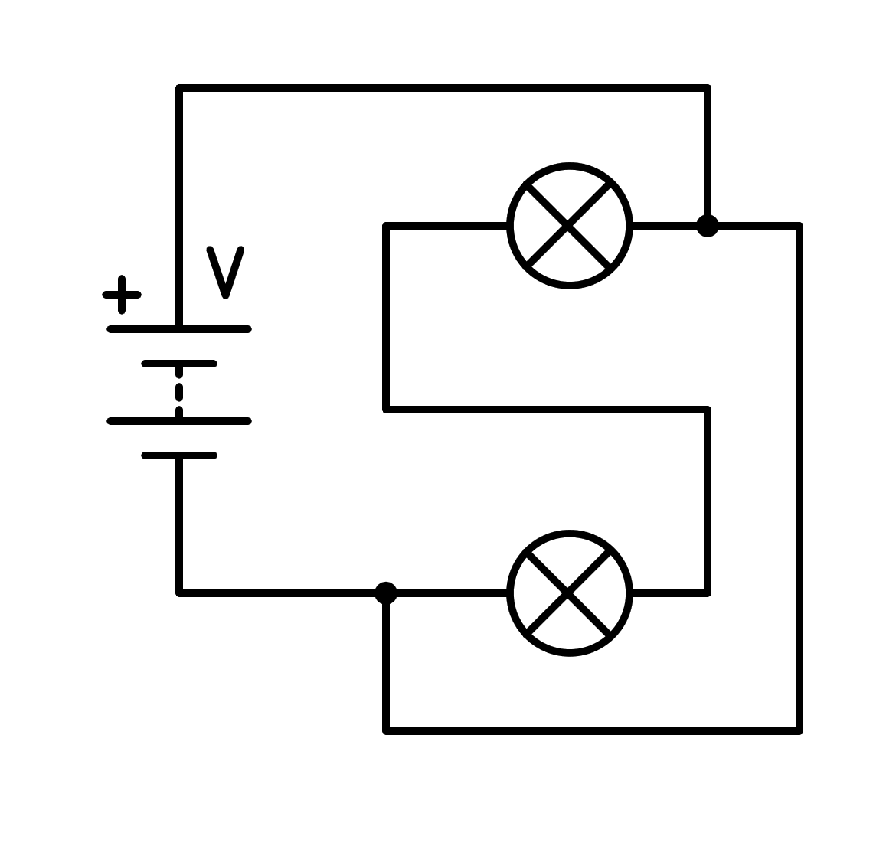
a) In parallel
b) In series
c) Short circuit in the battery
d) Short circuit in the light bulb
- How is the following circuit connected?
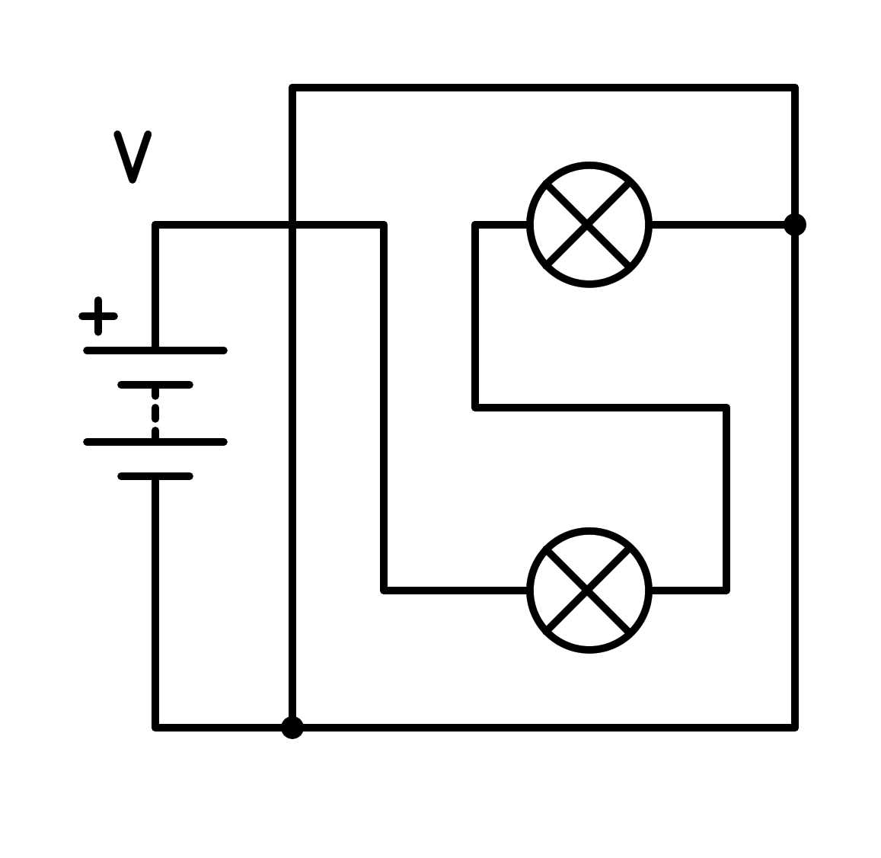
a) In parallel
b) In series
c) Short circuit in the battery
d) Short circuit in the light bulb
- How is the following circuit connected?
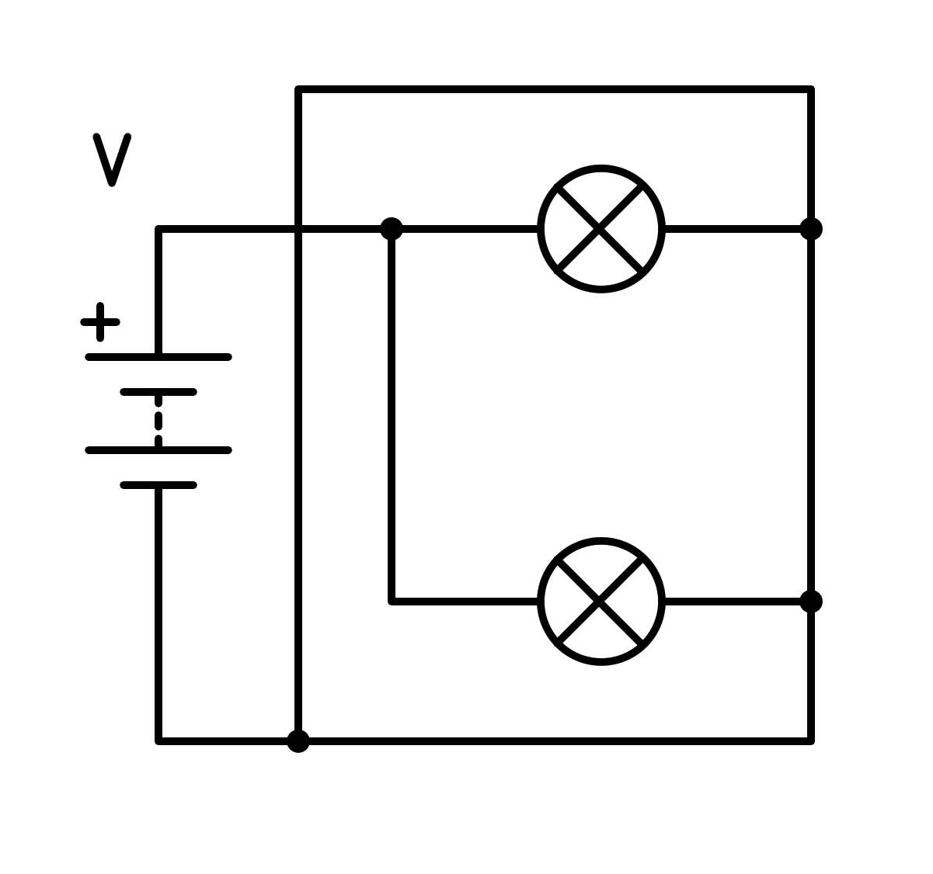
a) Short circuit in the light bulb
b) In parallel
c) In series
d) Short circuit in the battery
- How is the following circuit connected?
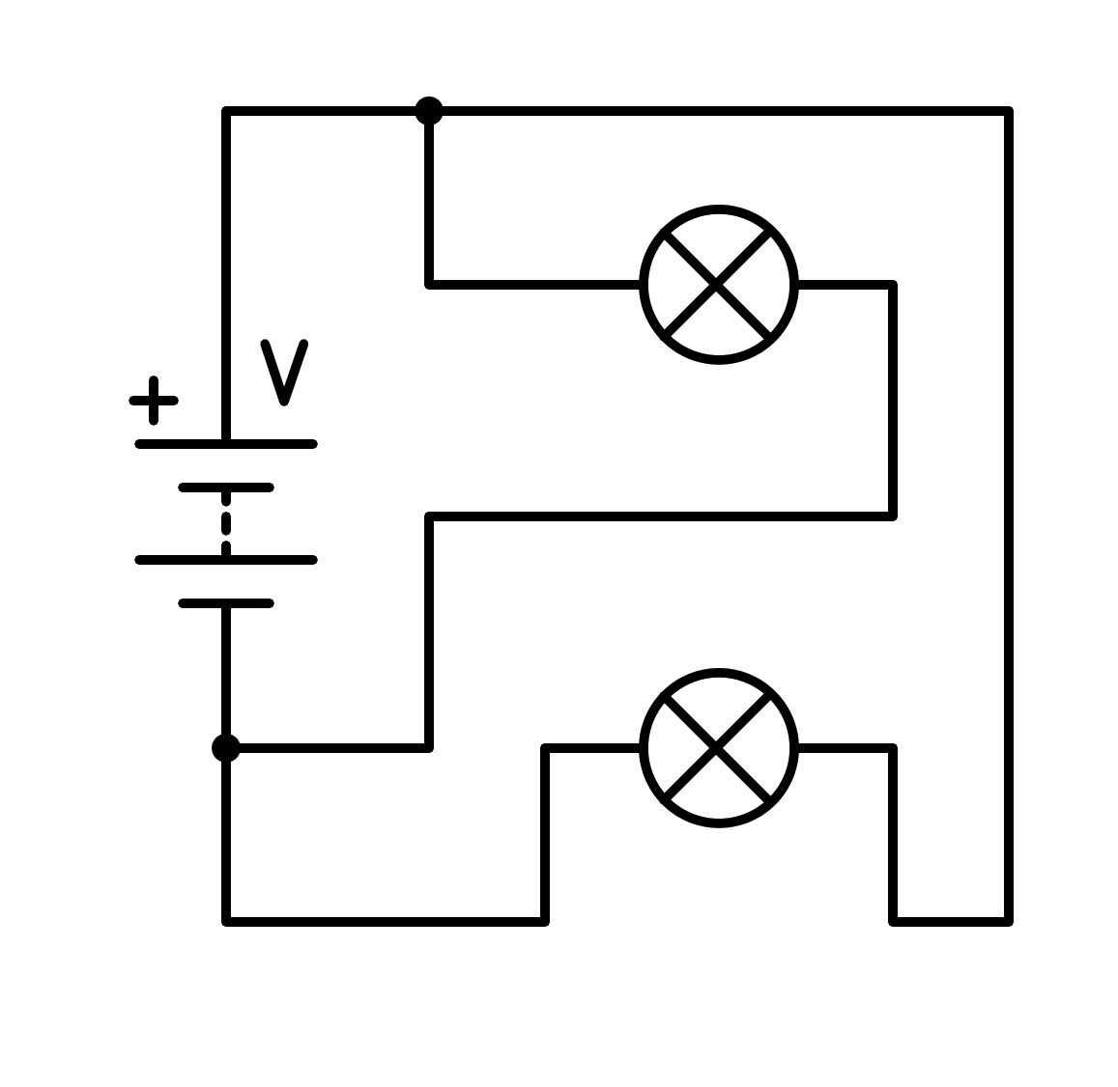
a) Short circuit in the battery
b) In series
c) Short circuit in the light bulb
d) In parallel
- How is the following circuit connected?
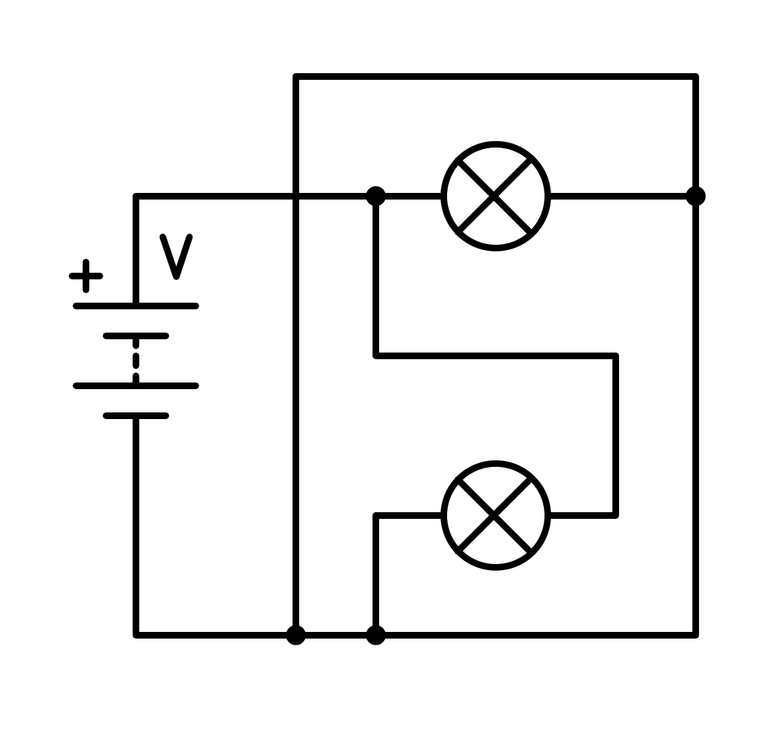
a) Short circuit in the light bulb
b) Short circuit in the battery
c) In series
d) In parallel
- How is the following circuit connected?
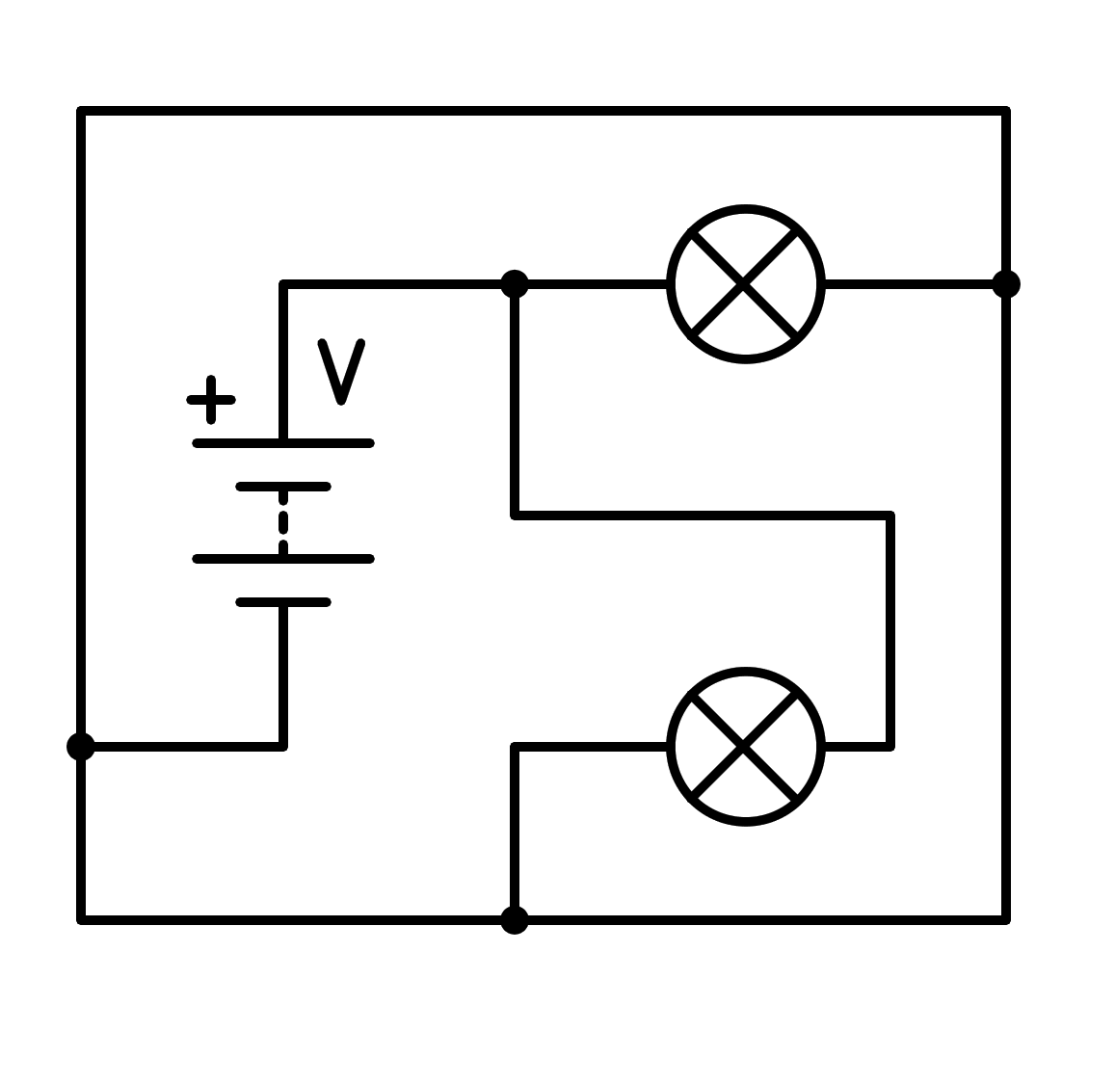
a) In series
b) Short circuit in the light bulb
c) Short circuit in the battery
d) In parallel
- How is the following circuit connected?
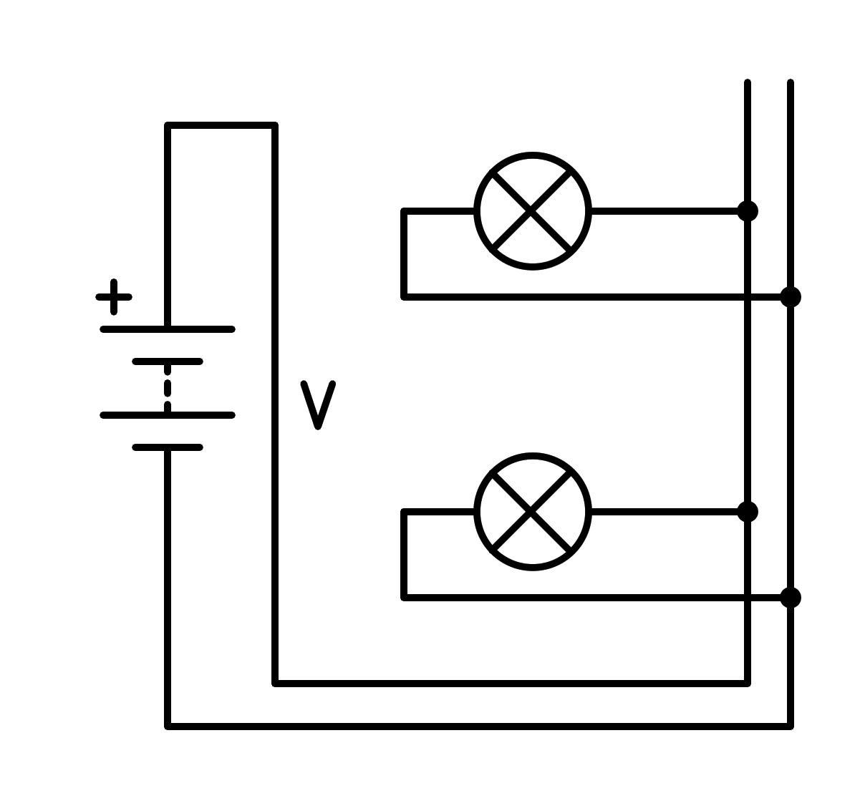
a) In series
b) Short circuit in the battery
c) In parallel
d) Short circuit in the light bulb
- How is the following circuit connected?
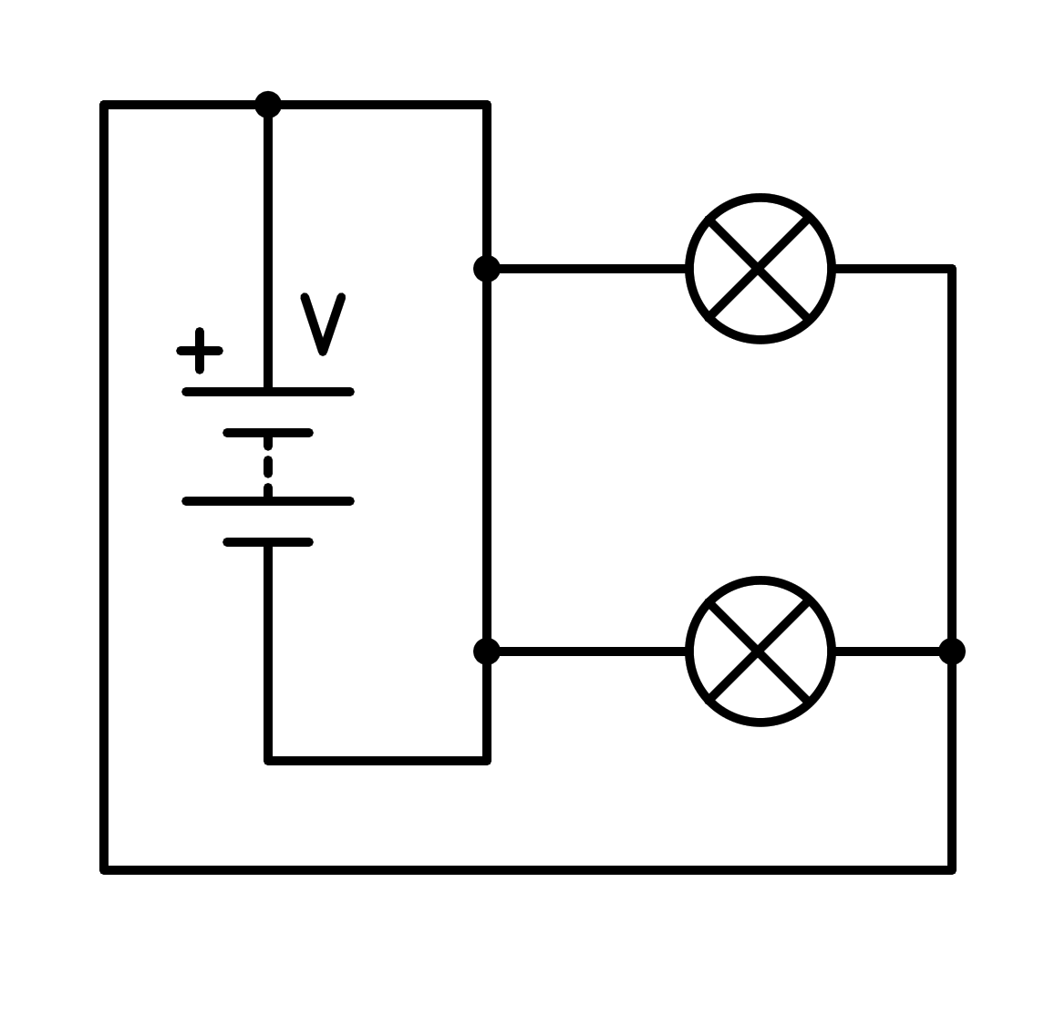
a) In parallel
b) In series
c) Short circuit in the battery
d) Short circuit in the light bulb
- How is the following circuit connected?
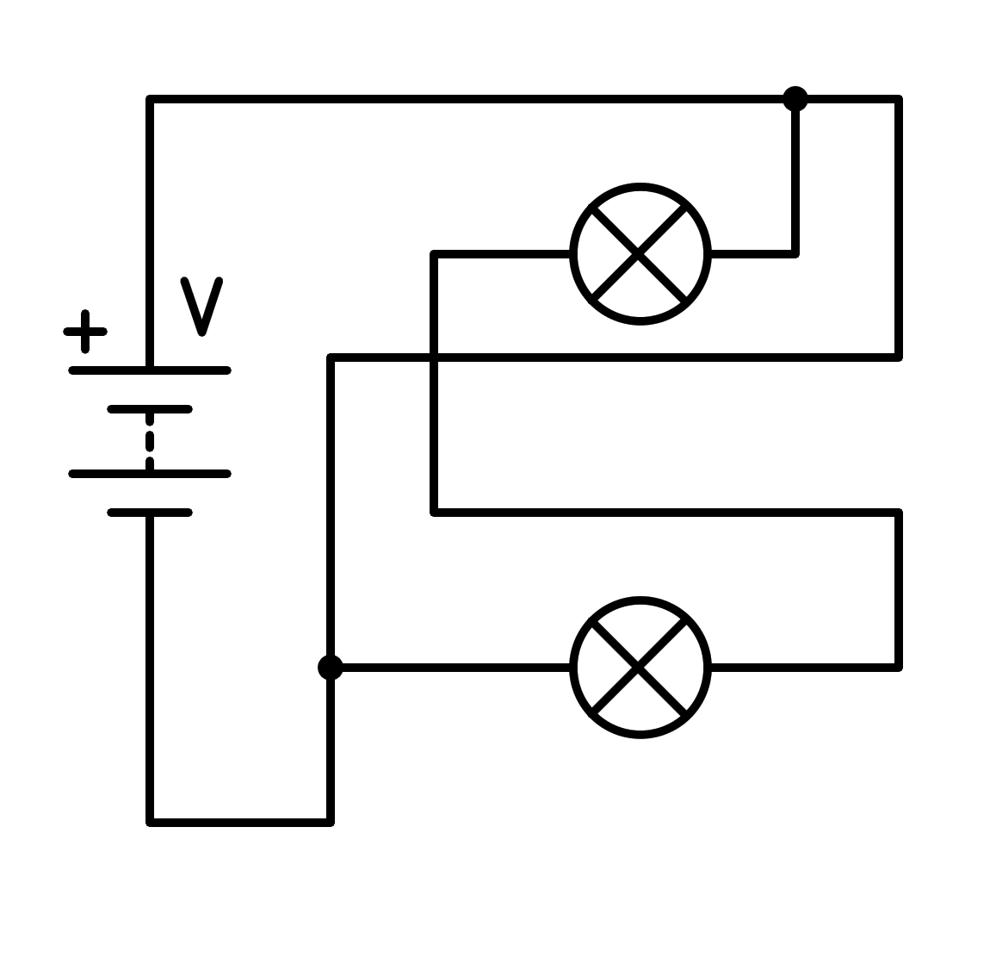
a) Short circuit in the light bulb
b) In parallel
c) In series
d) Short circuit in the battery
- How is the following circuit connected?
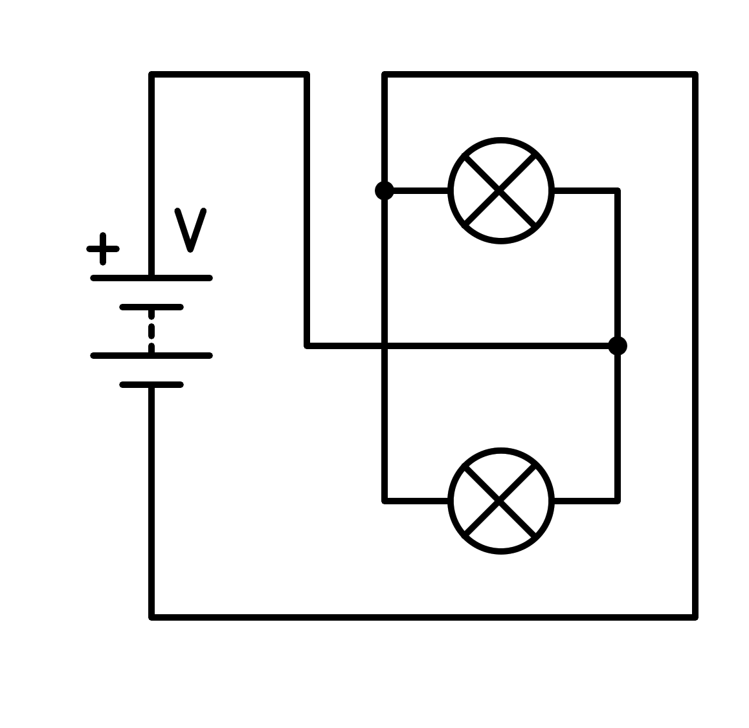
a) Short circuit in the light bulb
b) In series
c) Short circuit in the battery
d) In parallel
- How is the following circuit connected?
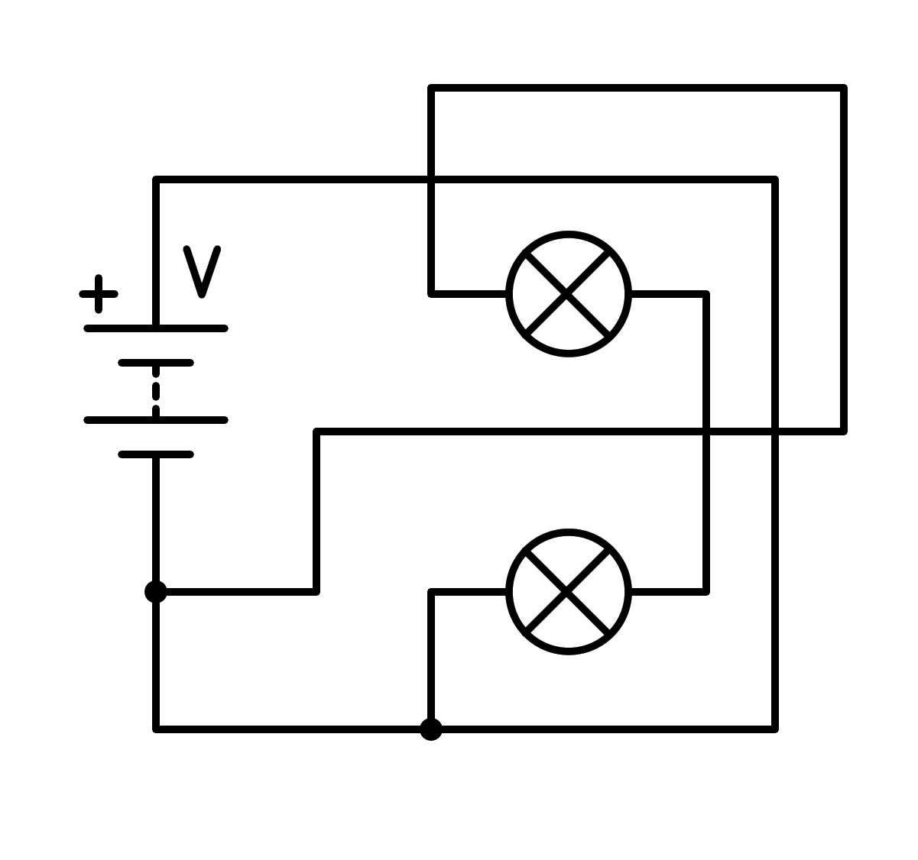
a) In parallel
b) In series
c) Short circuit in the battery
d) Short circuit in the light bulb

