# Electricity. Components name.

1. What is the component of the image?

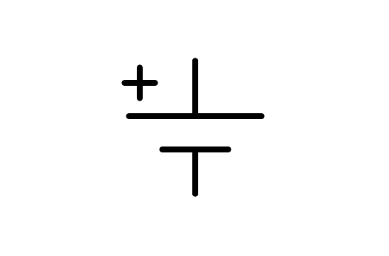

a) Motor

b) Earth

c) Altern current source

d) Battery

1. What is the component of the image?

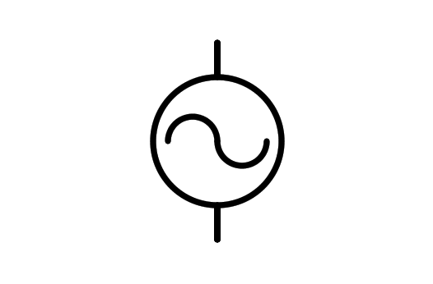

a) Alternator

b) Battery

c) Electric Motor

d) Light Bulb

1. What is the component of the image?

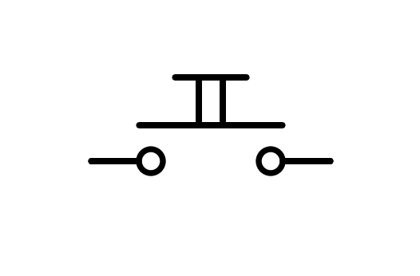

a) Two way Switch n.o.

b) Pushbutton n.o.

c) Switch n.o.

d) Battery

1. What is the component of the image?

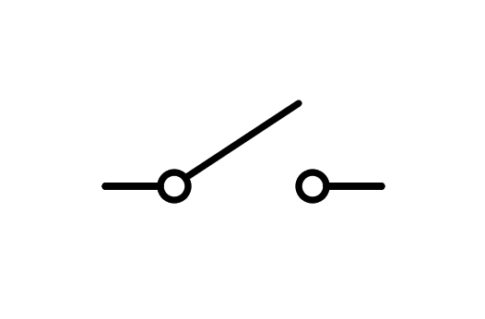

a) Switch

b) Two way Switch

c) Rele

d) Pushbutton

1. What is the component of the image?

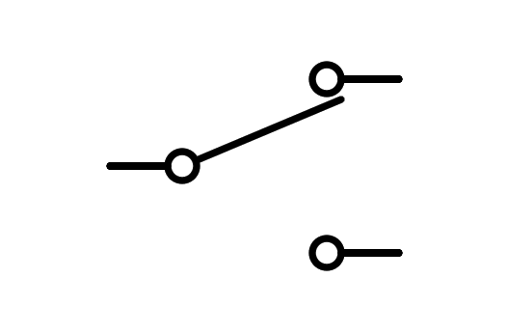

a) Pushbutton

b) Fuse

c) Switch

d) Two way Switch

1. What is the component of the image?

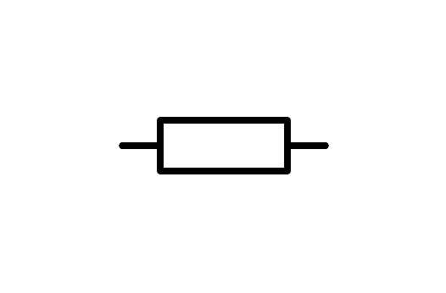

a) Switch

b) Resistor

c) Battery

d) Light Bulb

1. What is the component of the image?

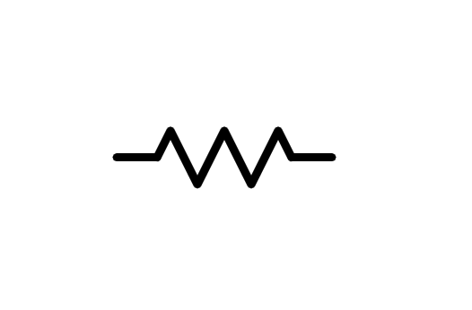

a) Light Bulb

b) Battery

c) Resistor

d) Switch

1. What is the component of the image?

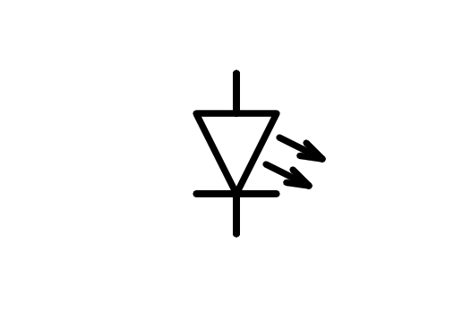

a) Speaker

b) Motor

c) LED Diode

d) Light Bulb

1. What is the component of the image?

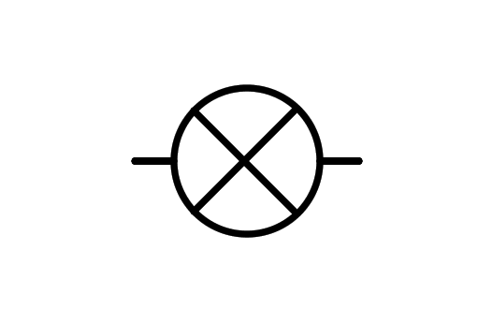

a) X component

b) Light Bulb

c) LED Diode

d) Motor

1. What is the component of the image?

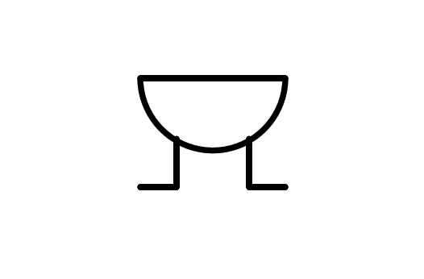

a) Altern current source

b) Speaker

c) Motor

d) Buzzer

1. What is the component of the image?

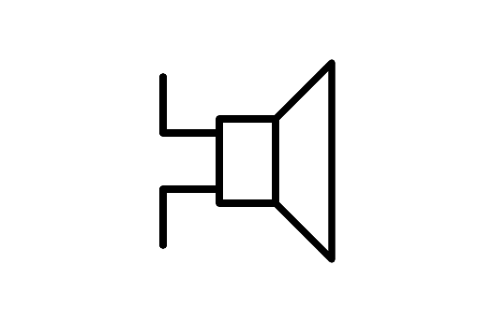

a) Direct current source

b) Altern current source

c) Buzzer

d) Speaker

1. What is the component of the image?

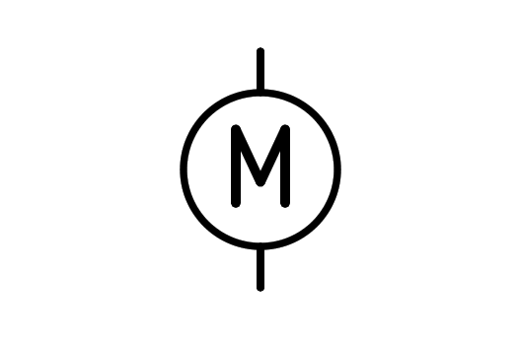

a) Wattmeter

b) Buzzer

c) Light Bulb

d) Motor

1. What is the component of the image?

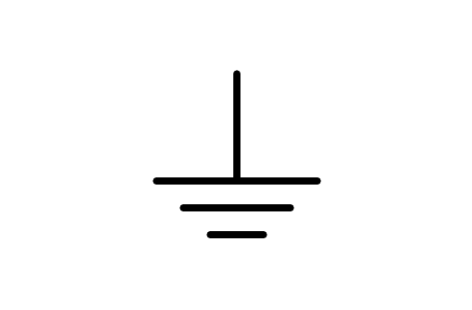

a) Earth

b) Battery

c) Antenna

d) Receiver

1. What is the component of the image?

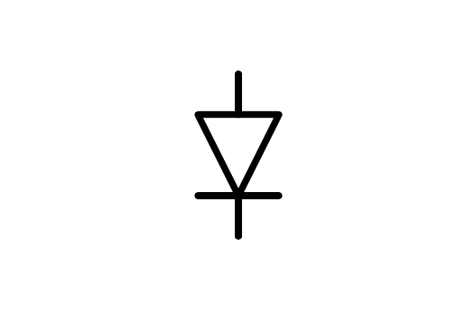

a) Diode

b) LED Diode

c) Transistor

d) Battery

1. What is the component of the image?

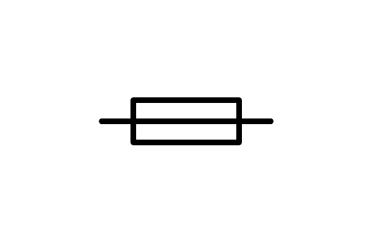

a) Alternator

b) Fuse

c) Relay

d) Resistor

1. What is the component of the image?

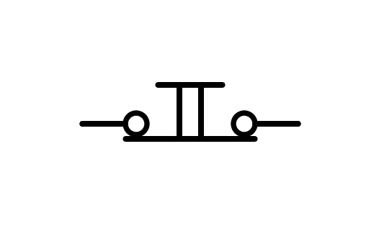

a) Switch n.c.

b) Distributor

c) Battery

d) Pushbutton n.c.

1. What is the component of the image?

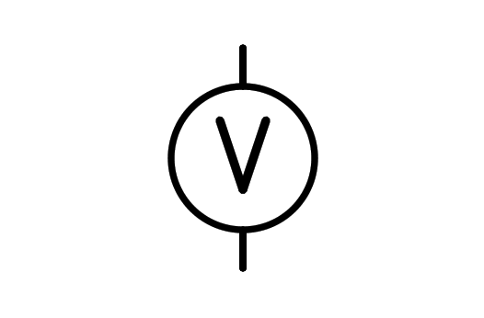

a) Voltmeter

b) Power source

c) Battery

d) Light Bulb

1. What is the component of the image?

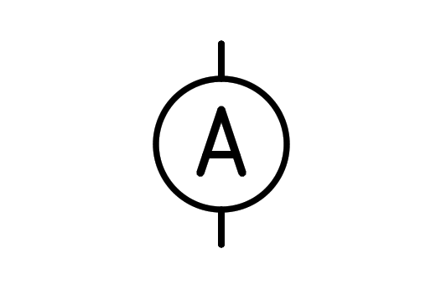

a) Current source

b) Ammeter

c) Battery

d) Aluminum

1. What is the component of the image?

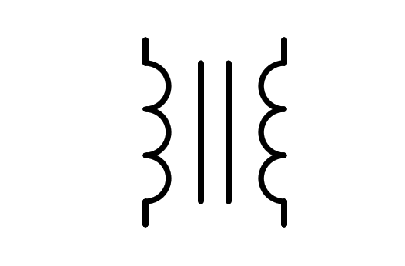

a) Double conductor

b) Coil

c) Transistor

d) Transformer

1. What is the component of the image?

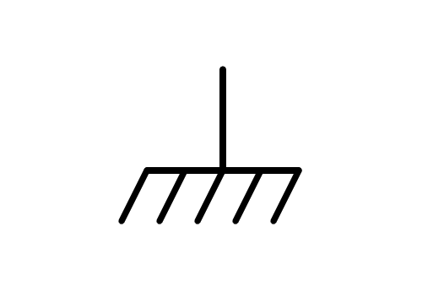

a) Earth

b) Battery

c) Brush

d) Ground plane

1. What is the component of the image?

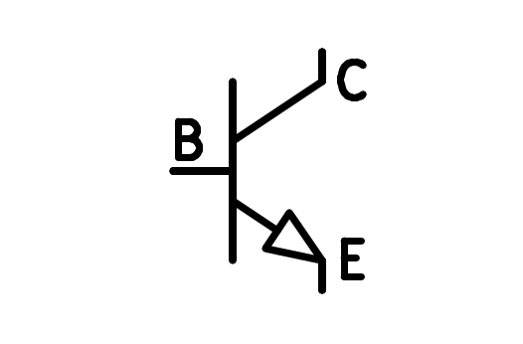

a) PNP Transistor

b) PNP Transformer

c) NPN Transistor

d) NPN Transformer

1. What is the component of the image?

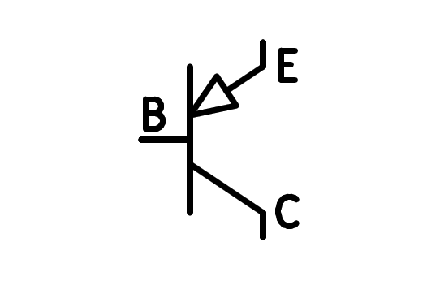

a) NPN Transistor

b) PNP Transformer

c) NPN Transformer

d) PNP Transistor

1. What is the component of the image?

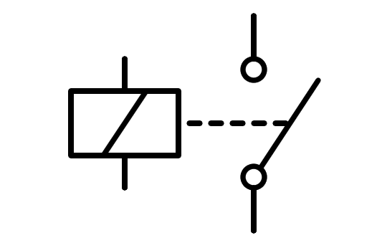

a) Double Pushbutton

b) Coil

c) Relay

d) Double Switch

1. What is the component of the image?

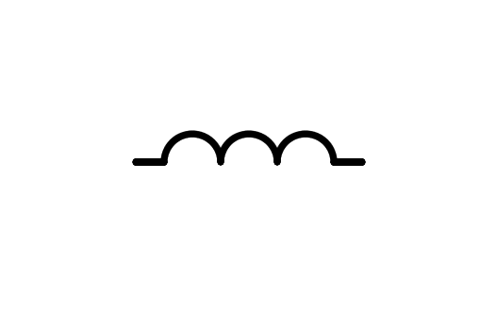

a) Round Pushbutton

b) Cable

c) Coil

d) Fingers

1. What is the component of the image?

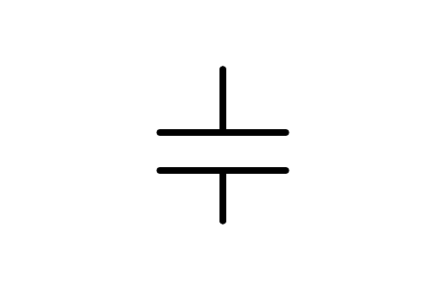

a) Congregator

b) Battery

c) Capacitor

d) Small Battery

1. What is the component of the image?

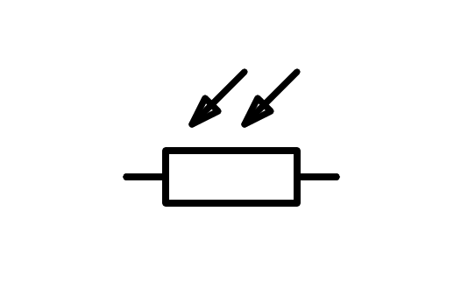

a) NTC Resistor

b) Variable Resistor

c) LDR Resistor

d) Resistor

1. What is the component of the image?

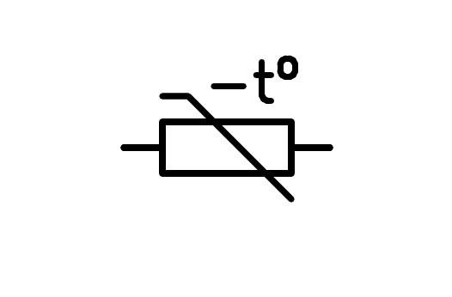

a) LDR Resistor

b) Variable Resistor

c) NTC Resistor

d) Resistor

1. What is the component of the image?

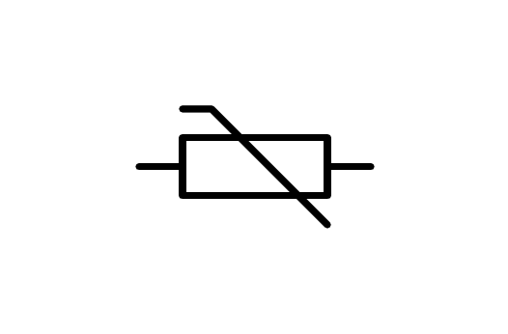

a) Resistor

b) NTC Resistor

c) LDR Resistor

d) Variable Resistor

1. What is the component of the image?

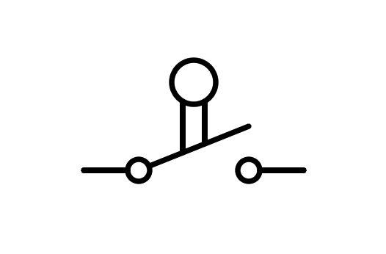

a) Limit Switch

b) Pushbutton n.o.

c) Switch

d) Pushbutton

1. What is the component of the image?

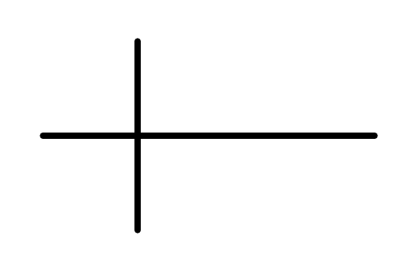

a) Crossover wire connected

b) Cross

c) Crossover wire not connected

d) Connected wire

1. What is the component of the image?

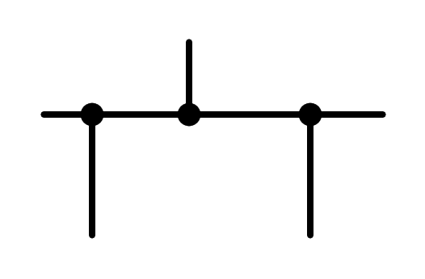

a) Connected wire

b) Unconnected wire

c) Mass

d) Connected and unconnected wire

1. What is the component of the image?

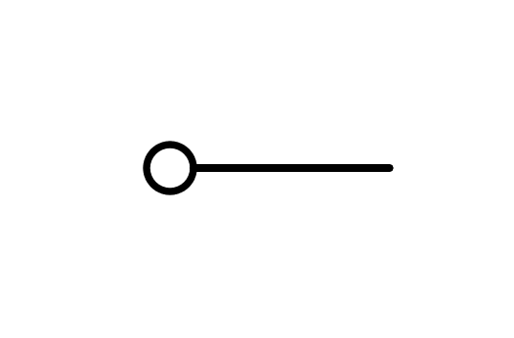

a) Connector

b) Squared

c) Mass

d) Ground plane

1. What is the component of the image?

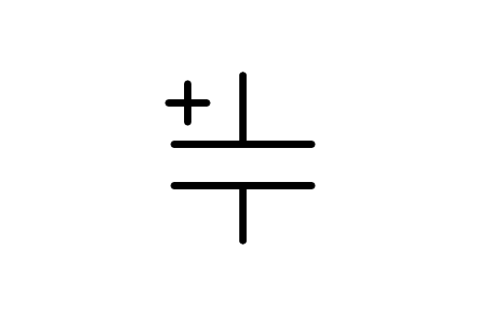

a) Small Battery

b) Battery

c) Polarized Capacitor

d) Capacitor