Difference between Algorithm and Flow chart

Algorithm and flowcharts both are used when creating new programs. An algorithm is a step-by-step analysis of the process, whereas the flowchart explains the steps in a graphical manner.

**What is a Flowchart?**   
Flowchart is a graphical representation of an algorithm. Programmers often use it as a program-planning tool to solve a problem. It makes use of symbols which are connected among them to indicate the flow of information and processing.   
The process of drawing a flowchart for an algorithm is known as “flowcharting”.

## Symbols Used In Flowchart

|  |  |  |
| --- | --- | --- |
| Symbol | Purpose | Description |
| Flowline symbol in flowchart of programming | Flow line | Indicates the flow of logic by  connecting symbols. |
| Terminal symbol in flowchart of programming | Terminal(Stop/Start) | Represents the start and the end of  a flowchart. |
| Input/Output symbol in flowchart of programming | Input/Output | Used for input and output operation. |
| Processing symbol in flowchart of programming | Processing | Used for arithmetic  operations and data-manipulations. |
| Decision making symbol in flowchart of programming | Decision | Used for decision making between  two or more alternatives. |
| On-page connector symbol in flowchart of programming | On-page Connector | Used to join different flowline |
| Off-page connector symbol in flowchart of programming | Off-page Connector | Used to connect the  flowchart portion on a different  page. |
| Predefined process symbol in flowchart of programming | Predefined Process/Function | Represents a group of statements performing one processing task. |

### Examples of flowcharts in programming

**1. Add two numbers entered by the user.**

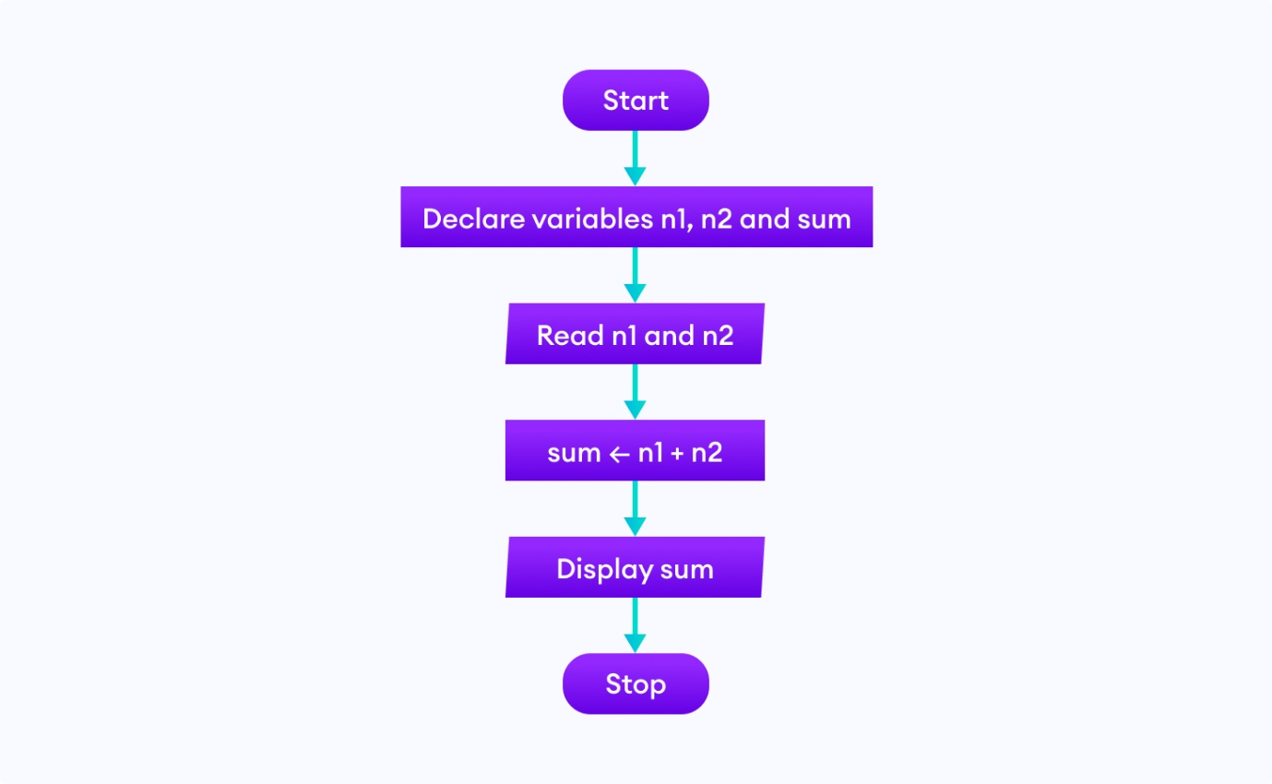

**2. Find the largest among three different numbers entered by the user.**

