# Collections in Java

The **Java Collections Framework** is a collection of interfaces and classes, which helps in storing and processing the data efficiently

## Collections Framework hierarchy

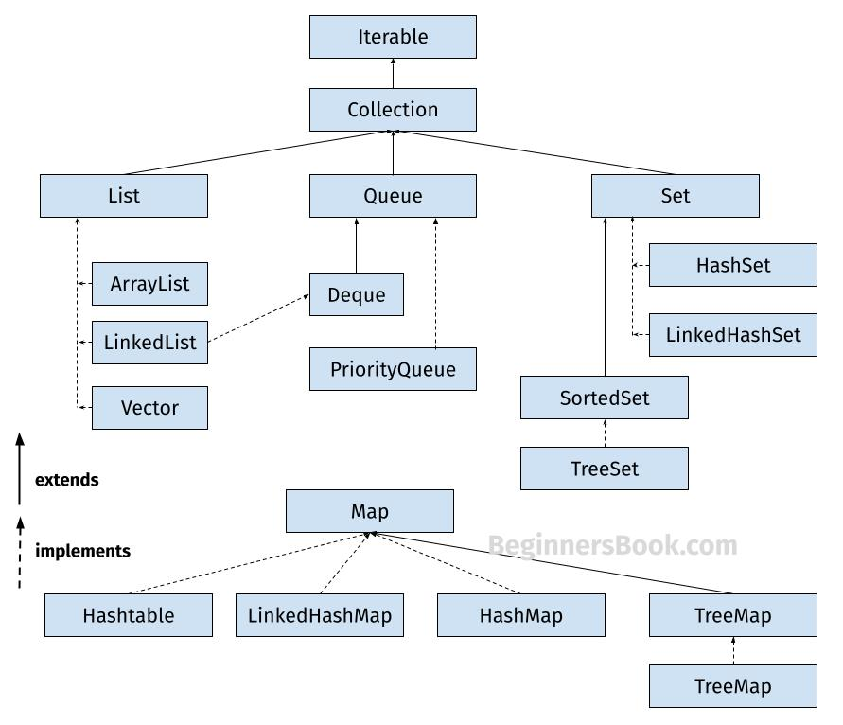

**1. List**

A List is an ordered Collection (sometimes called a sequence). Lists may contain duplicate elements. Elements can be inserted or accessed by their position in the list, using a zero-based index. The classes that implements List interface are:

* ArrayList
* LinkedList
* Vector
* Stack

**1.1 ArrayList**

ArrayList is a popular alternative of [arrays in Java](https://beginnersbook.com/2013/05/java-arrays/). It is based on an Array **data structure**. ArrayList is a resizable-array implementation of the List interface. It implements all optional list operations.

import java.util.*;

class JavaExample{

public static void main(String args[]){

//creating ArrayList of string type

ArrayList<String> arrList=new ArrayList<>();

//adding few elements

arrList.add("Cricket"); //list: ["Cricket"]

arrList.add("Hockey"); //list: ["Cricket", "Hockey"]

//inserting element at first position, index 0

//represents first element because ArrayList is based

//on zero based indexing system

arrList.add(0, "BasketBall"); //list: ["BasketBall", "Cricket", "Hockey"]

System.out.println("ArrayList Elements: ");

//Traversing ArrayList using enhanced for loop

for(String str:arrList)

System.out.println(str);

}

}

**Output:**  
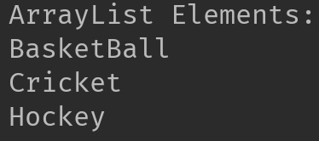

.

**1.2 LinkedList**

LinkedList is a linear data structure. However LinkedList elements are not stored in contiguous locations like arrays, they are linked with each other using pointers. Each element of the LinkedList has the reference(address/pointer) to the next element of the LinkedList.  
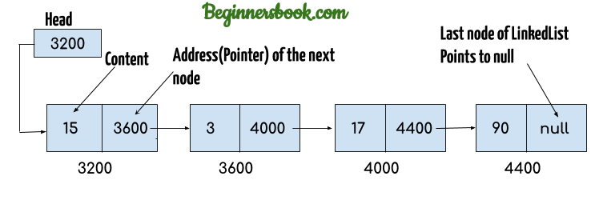

import java.util.*;

public class JavaExample{

public static void main(String args[]){

LinkedList<String> linkList=new LinkedList<>();

linkList.add("Apple"); //["Apple"]

linkList.add("Orange"); //["Apple", "Orange"]

//inserting element at first position

linkList.add(0, "Banana"); ////["Banana", "Apple", "Orange"]

System.out.println("LinkedList elements: ");

//iterating LinkedList using iterator

Iterator<String> it=linkList.iterator();

while(it.hasNext()){

System.out.println(it.next());

}

}

}

**Output:**  
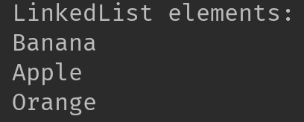

**1.3 Vector**

Here is the list of all the tutorials published on the Vector.

import java.util.*;

public class JavaExample{

public static void main(String args[]){

Vector<String> v=new Vector<>();

v.add("item1"); //["item1"]

v.add("item2"); //["item1", "item2"]

v.add("item3"); //["item1", "item2", "item3"]

//removing an element

v.remove("item2"); //["item1", "item3"]

System.out.println("Vector Elements: ");

//iterating Vector using iterator

Iterator<String> it=v.iterator();

while(it.hasNext()){

System.out.println(it.next());

}

}

}

**Output:**  
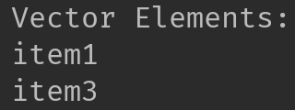  
Refer [this article](https://beginnersbook.com/2013/12/vector-in-java/) for more **guides on Vector**.

**1.4 Stack**

Stack class extends Vector class, which means it is a subclass of Vector. Stack works on the concept of Last In First Out (LIFO). The elements are inserted using push() method at the end of the stack, the pop() method removes the element which was inserted last in the Stack.

import java.util.*;

public class JavaExample{

public static void main(String args[]){

Stack<String> stack = new Stack<>();

//push() method adds the element in the stack

//and pop() method removes the element from the stack

stack.push("Chaitanya"); //["Chaitanya"]

stack.push("Ajeet"); //["Chaitanya", Ajeet]

stack.push("Hari"); //["Chaitanya", "Ajeet", "Hari"]

stack.pop(); //removes the last element

stack.push("Steve"); //["Chaitanya", "Ajeet", "Steve"]

stack.push("Carl"); //["Chaitanya", "Ajeet", "Steve", "Carl"]

stack.pop(); //removes the last element

System.out.println("Stack elements: ");

for(String str: stack){

System.out.println(str);

}

}

}

**Output:**  
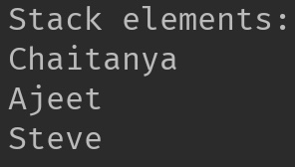

**2. Set**

A Set is a Collection that cannot contain duplicate elements. There are three main implementations of Set interface: HashSet, TreeSet, and LinkedHashSet.

**2.1 HashSet**

[HashSet](https://beginnersbook.com/2013/12/hashset-class-in-java-with-example/) which stores its elements in a hash table, is the best-performing implementation. HashSet allows only unique elements. It doesn’t maintain the insertion order which means element inserted last can appear at first when traversing the HashSet.

import java.util.*;

public class JavaExample{

public static void main(String args[]){

HashSet<String> set=new HashSet<>();

set.add("Paul");

set.add("Ram");

set.add("Aaron");

set.add("Leo");

set.add("Becky");

Iterator<String> it=set.iterator();

while(it.hasNext()){

System.out.println(it.next());

}

}

}

**Output:**

Aaron

Leo

Paul

Ram

Becky

**2.2 LinkedHashSet**

Unlike HashSet, the [LinkedHashSet](https://beginnersbook.com/2013/12/linkedhashset-class-in-java-with-example/) maintains insertion order.

import java.util.*;

public class JavaExample{

public static void main(String args[]){

LinkedHashSet<String> set=new LinkedHashSet<>();

set.add("Paul");

set.add("Ram");

set.add("Aaron");

set.add("Leo");

set.add("Becky");

Iterator<String> it=set.iterator();

while(it.hasNext()){

System.out.println(it.next());

}

}

}

**Output:**

Paul

Ram

Aaron

Leo

Becky

**2.3 TreeSet**

[TreeSet](https://beginnersbook.com/2013/12/treeset-class-in-java-with-example/) stores elements in a red-black tree. It is substantially slower than HashSet. TreeSet class implements SortedSet interface, which allows TreeSet to order its elements based on their values, which means TreeSet elements are sorted in ascending order.

import java.util.*;

public class JavaExample{

public static void main(String args[]){

TreeSet<String> set=new TreeSet<>();

set.add("Paul");

set.add("Ram");

set.add("Aaron");

set.add("Leo");

set.add("Becky");

Iterator<String> it=set.iterator();

while(it.hasNext()){

System.out.println(it.next());

}

}

}

**Output:**

Aaron

Becky

Leo

Paul

Ram

**3. Map**

A Map is an object that maps keys to values. A map cannot contain duplicate keys. There are three main implementations of Map interfaces: HashMap, TreeMap, and LinkedHashMap.

**3.1 HashMap**

**HashMap:** HashMap is like HashSet, it doesn’t maintain insertion order and doesn’t sort the elements in any order.

public class JavaExample{

public static void main(String args[]){

HashMap<Integer, String> hmap = new HashMap<>();

//key and value pairs

hmap.put(101, "Chaitanya");

hmap.put(105, "Derick");

hmap.put(111, "Logan");

hmap.put(120, "Paul");

//print HashMap elements

Set set = hmap.entrySet();

Iterator iterator = set.iterator();

while(iterator.hasNext()) {

Map.Entry m = (Map.Entry)iterator.next();

System.out.print("key is: "+ m.getKey() + " & Value is: ");

System.out.println(m.getValue());

}

}

}

**Output:**  
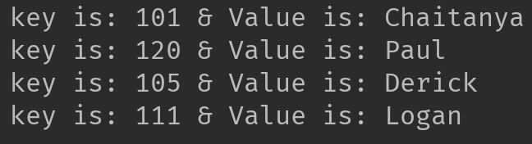

**3.2 TreeMap**

**TreeMap:** It stores its elements in a red-black tree. The elements of TreeMap are sorted in ascending order. It is substantially slower than HashMap.This is the same example that we have seen above in HashMap. Here, elements are sorted based on keys.

import java.util.*;

public class JavaExample{

public static void main(String args[]){

TreeMap<Integer, String> hmap = new TreeMap<>();

//key and value pairs

hmap.put(101, "Chaitanya");

hmap.put(105, "Derick");

hmap.put(111, "Logan");

hmap.put(120, "Paul");

//print HashMap elements

Set set = hmap.entrySet();

Iterator iterator = set.iterator();

while(iterator.hasNext()) {

Map.Entry m = (Map.Entry)iterator.next();

System.out.print("key is: "+ m.getKey() + " & Value is: ");

System.out.println(m.getValue());

}

}

}

**Output:**  
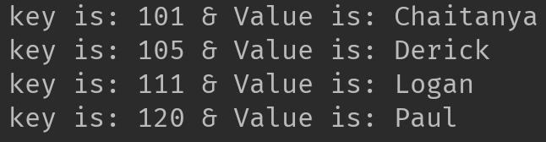

**3.3 LinkedHashMap**

**LinkedHashMap:** It maintains insertion order. Refer [this guide](https://beginnersbook.com/2013/12/linkedhashmap-in-java/), to learn LinkedHashMap in detail. As you can see: In the following example, the key & value pairs maintained the insertion order.

import java.util.*;

public class JavaExample{

public static void main(String args[]){

LinkedHashMap<Integer, String> hmap = new LinkedHashMap<>();

//key and value pairs

hmap.put(100, "Chaitanya");

hmap.put(120, "Paul");

hmap.put(105, "Derick");

hmap.put(111, "Logan");

//print LinkedHashMap elements

Set set = hmap.entrySet();

Iterator iterator = set.iterator();

while(iterator.hasNext()) {

Map.Entry m = (Map.Entry)iterator.next();

System.out.print("key is: "+ m.getKey() + " & Value is: ");

System.out.println(m.getValue());

}

}

}

**Output:**

key is: 100 & Value is: Chaitanya

key is: 120 & Value is: Paul

key is: 105 & Value is: Derick

key is: 111 & Value is: Logan

**ArrayList in Java With Examples**

**Arraylist** class implements List interface and it is based on an Array data structure. It is widely used because of the functionality and flexibility it offers. **ArrayList in Java**, is a resizable-array implementation of the List interface

**Array vs arraylist in java**

The main **difference between array and arraylist** is that arraylist can grow and shrink dynamically while an array cannot.

An array has a **fixed length** so if it is full you cannot add any more elements to it. Similarly, if number of elements are removed from ArrayList, the memory consumption remains same as it doesn’t shrink.

On the other hand, **ArrayList can dynamically grow and shrink** after addition and removal of elements. ArrayList class has several useful methods that can make our task easy.

**ArrayList in Java**

* ArrayList can grow and shrink automatically based on the addition and removal of elements.
* ArrayList can contain duplicate elements
* ArrayList maintains the insertion order, which means the elements appear in the same order in which they are inserted.
* ArrayList is non synchronized. However you can make it [synchronized](https://beginnersbook.com/2013/12/how-to-synchronize-arraylist-in-java-with-example/).

**Hierarchy of ArrayList class in Java**

ArrayList class implements List interface and List interface extends Collection interface.  
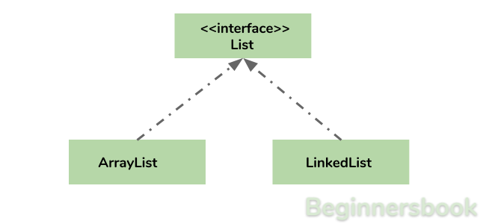

**Arraylist in Java declaration**

This is how you can declare an ArrayList of String type:

ArrayList<String> list=new ArrayList<>();

This is how you can declare an ArrayList of Integer type:

ArrayList<Integer> list=new ArrayList<>();

**Adding elements to Arraylist in java**

**Adding Element in ArrayList at specified position:**  
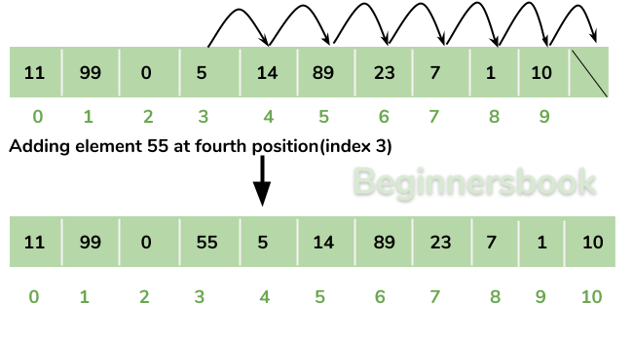  
You can add elements to an ArrayList by using [add() method](https://beginnersbook.com/2013/12/java-arraylist-add-method-example/). This method has couple of variations, which you can use based on the requirement.

**For example:** If you want to add the element at the end of the List then you can simply call the add() method like this:

arrList.add("Steve"); //This will add "Steve" at the end of List

To add the element at the specified location in ArrayList, you can specify the index in the add() method like this:

arrList.add(3, "Steve"); //This will add "Steve" at the fourth position

Lets write the complete code:

import java.util.*;

class JavaExample{

public static void main(String args[]){

ArrayList<String> arrList=new ArrayList<String>();

arrList.add("Steve");

arrList.add("Tim");

arrList.add("Lucy");

arrList.add("Pat");

arrList.add("Angela");

arrList.add("Tom");

//displaying elements

System.out.println(arrList);

//Adding "Steve" at the fourth position

arrList.add(3, "Steve");

//displaying elements

System.out.println(arrList);

}

}

**Output:**

[Steve, Tim, Lucy, Pat, Angela, Tom]

[Steve, Tim, Lucy, Steve, Pat, Angela, Tom]

**Note:** Since the index starts with 0, index 3 would represent fourth position not 3.

**Change an element in ArrayList**

You can use the **set method** to change an element in ArrayList. You need to provide the **index** and **new element**, this method then updates the element present at the **given index** with the **new given element**.

In the following example, we have given the index as 0 and new element as “Lucy” in the set() method. The method updated the element present at the index 0 (“Jim”) with the new String element “Lucy”.

import java.util.ArrayList;

public class JavaExample {

public static void main(String[] args) {

ArrayList<String> names = new ArrayList<String>();

names.add("Jim");

names.add("Jack");

names.add("Ajeet");

names.add("Chaitanya");

names.set(0, "Lucy");

System.out.println(names);

}

}

**Output:**  
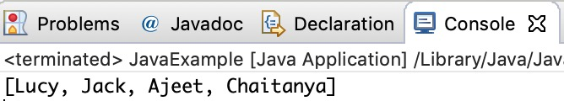

**How to remove element from Arraylist in Java?**

**Removing Element from ArrayList:**  
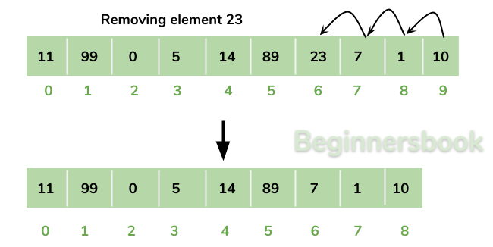  
You can use **remove() method** to remove elements from an ArrayList. Similar to add() method, this method also has couple of variations.

**For example:**

import java.util.*;

class JavaExample{

public static void main(String args[]){

ArrayList<String> alist=new ArrayList<String>();

alist.add("Steve");

alist.add("Tim");

alist.add("Lucy");

alist.add("Pat");

alist.add("Angela");

alist.add("Tom");

//displaying elements

System.out.println(alist);

//Removing "Steve" and "Angela"

alist.remove("Steve");

alist.remove("Angela");

//displaying elements

System.out.println(alist);

//Removing 3rd element

alist.remove(2);

//displaying elements

System.out.println(alist);

}

}

**Output:**

[Steve, Tim, Lucy, Pat, Angela, Tom]

[Tim, Lucy, Pat, Tom]

[Tim, Lucy, Tom]

**Iterating ArrayList**

Here, we are using enhanced for loop to iterate ArrayList elements. This one of the best ways to iterate an ArrayList of string type.

import java.util.*;

class JavaExample{

public static void main(String args[]){

ArrayList<String> alist=new ArrayList<String>();

alist.add("Gregor Clegane");

alist.add("Khal Drogo");

alist.add("Cersei Lannister");

alist.add("Sandor Clegane");

alist.add("Tyrion Lannister");

//iterating ArrayList

for(String str:alist)

System.out.println(str);

}

}

**Output:**

Gregor Clegane

Khal Drogo

Cersei Lannister

Sandor Clegane

Tyrion Lannister

**ArrayList Size**

We can use size() method of ArrayList to find the **number of elements in an ArrayList**.

import java.util.ArrayList;

public class JavaExample {

public static void main(String[] args) {

ArrayList<Integer> numbers = new ArrayList<Integer>();

numbers.add(1);

numbers.add(7);

numbers.add(5);

numbers.add(6);

System.out.println("Number of elements in ArrayList: "+numbers.size());

}

}

**Output:**  
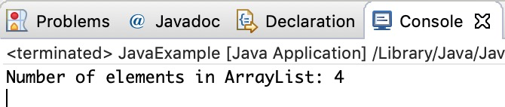

**Sort ArrayList**

You can use the **sort() method** of the **Collections utility class**to [sort an ArrayList](https://beginnersbook.com/2013/12/how-to-sort-arraylist-in-java/). This class is is a part of **java.util** package. In the following example we are sorting a list of String type **alphabetically.** This method also works on **numeric lists** (such as Integer type ArrayList).

import java.util.ArrayList;

import java.util.Collections;

public class JavaExample {

public static void main(String[] args) {

ArrayList<String> fruits = new ArrayList<String>();

fruits.add("Orange");

fruits.add("Apple");

fruits.add("Banana");

fruits.add("Pineapple");

Collections.sort(fruits);

for (String str : fruits) {

System.out.println(str);

}

}

}

**Output:**  
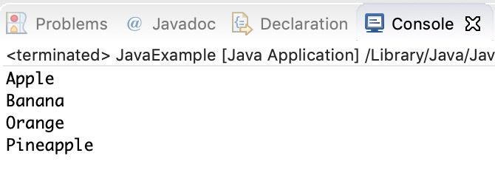

**ArrayList Example in Java**

This example demonstrates, how to **create**, **initialize**, **add** and **remove** elements from ArrayList. In this example we have an ArrayList of “String” type. We are adding 5 String element in the ArrayList using the method add(String E). This method adds the element at the end of the ArrayList.

We are then **adding** two more elements in the ArrayList using method add(int index, String E). This method adds the specified element at the specified index, index 0 indicates first position, 1 indicates second position and so on.

We are then **removing** the elements “Chaitanya” and “Harry” from the ArrayList. We again removed the second element of the ArrayList using method remove(int index).

import java.util.*;

public class JavaExample {

public static void main(String args[]) {

/* Creating ArrayList of type "String" which means

* we can only add "String" elements

*/

ArrayList<String> obj = new ArrayList<String>();

/*This is how we add elements to an ArrayList*/

obj.add("Ajeet");

obj.add("Harry");

obj.add("Chaitanya");

obj.add("Steve");

obj.add("Anuj");

// Displaying elements

System.out.println("Original ArrayList:");

for(String str:obj)

System.out.println(str);

/* Add element at the given index

* obj.add(0, "Rahul") - Adding element "Rahul" at first position

* obj.add(1, "Justin") - Adding element "Justin" at second position

*/

obj.add(0, "Rahul");

obj.add(1, "Justin");

// Displaying elements

System.out.println("ArrayList after add operation:");

for(String str:obj)

System.out.println(str);

//Remove elements from ArrayList like this

obj.remove("Chaitanya"); //Removes "Chaitanya" from ArrayList

obj.remove("Harry"); //Removes "Harry" from ArrayList

// Displaying elements

System.out.println("ArrayList after remove operation:");

for(String str:obj)

System.out.println(str);

//Remove element from the specified index

obj.remove(1); //Removes Second element from the List

// Displaying elements

System.out.println("Final ArrayList:");

for(String str:obj)

System.out.println(str);

}

}

**Output:**

Original ArrayList:

Ajeet

Harry

Chaitanya

Steve

Anuj

ArrayList after add operation:

Rahul

Justin

Ajeet

Harry

Chaitanya

Steve

Anuj

ArrayList after remove operation:

Rahul

Justin

Ajeet

Steve

Anuj

Final ArrayList:

Rahul

Ajeet

Steve

Anuj

**All methods of Arraylist in Java**

In the above examples, we have used methods such as add() and remove(). However there are number of other useful methods available in ArrayList class.

1) [**add**](https://beginnersbook.com/2013/12/java-arraylist-add-method-example/)**( Object o)**: This method adds an object o at the end of the arraylist.

obj.add("hello");

This statement would add a string hello in the arraylist at last position.

2) [**add**](https://beginnersbook.com/2013/12/java-arraylist-addint-index-e-element-example/)**(int index, Object o)**: It adds the object o at the specified index in the ArrayList.

obj.add(2, "bye");

It will add the string “bye” at the 2nd index (third element as array list starts with index 0) of array list.

3) [**remove**](https://beginnersbook.com/2013/12/java-arraylist-removeobject-method-example/)**(Object o)**: Removes the object o from the ArrayList.

obj.remove("Chaitanya");

This statement will remove the string “Chaitanya” from the ArrayList.

4) [**remove**](https://beginnersbook.com/2013/12/java-arraylist-remove-method-example/)**(int index)**: Removes element from a given index.

obj.remove(3);

It would remove the element of index 3 (4th element of the list – List starts with o).

5) [**set**](https://beginnersbook.com/2013/12/java-arraylist-set-method-example/)**(int index, Object o)**: Used for updating an element. It replaces the element present at the specified index with the object o.

obj.set(2, "Tom");

It would replace the 3rd element (index =2 is 3rd element) with the value Tom.

6)**int indexOf(Object o)**: Gives the index of the object o. If the element is not found in the list then this method returns the value -1.

int pos = obj.indexOf("Tom");

This would give the index (position) of the string Tom in the list.

7) **Object**[**get**](https://beginnersbook.com/2013/12/java-arraylist-get-method-example/)**(int index)**: It returns the object of list which is present at the specified index.

String str= obj.get(2);

This would return the string stored at 3rd position (index 2) and would be assigned to the string “str”. We are using string variable to store the get() result because the list is of string type. If the list is of int type then we can use int variable to store the returned element.

8) **[int size()](https://beginnersbook.com/2013/12/how-to-find-length-of-arraylist-in-java/)**: It returns the size of the ArrayList (Number of elements of the list).

int numberofitems = obj.size();

9) **boolean**[**contains**](https://beginnersbook.com/2013/12/java-arraylist-contains-method-example/)**(Object o)**: It checks whether the given object o is present in the array list. If the element is found it returns true else it returns false.

obj.contains("Steve");

It would return true if the string “Steve” is present in the list else we would get false.

10) [**clear**](https://beginnersbook.com/2013/12/how-to-empty-an-arraylist-in-java/)**():** It is used for removing all the elements of the array list in one go. The below code will remove all the elements of ArrayList whose object is obj.

obj.clear();

# LinkedList in Java with Example

Similar to arrays in Java, **LinkedList is a linear data structure**. However LinkedList elements are not stored in contiguous locations like arrays, they are linked with each other using pointers. Each element of the LinkedList has the reference(address/pointer) to the next element of the LinkedList.

## LinkedList representation

Each element in the LinkedList is called the **Node**. Each Node of the LinkedList contains two items: 1) Content of the element 2) Pointer/Address/Reference to the Next Node in the LinkedList.

**This is how a LinkedList looks:**  


**Note:**  
1. **Head** of the LinkedList only contains the Address of the **First element** of the List.  
2. The Last element of the LinkedList contains **null** in the pointer part of the node because it is the end of the List so it doesn’t point to anything as shown in the above diagram.  
3. The diagram which is shown above represents a **singly linked list**. There is another complex type variation of LinkedList which is called **doubly linked list**, node of a doubly linked list contains three parts: 1) Pointer to the previous node of the linked list 2) content of the element 3) pointer to the next node of the linked list.

## Why do we need a Linked List?

You must be aware of the arrays which is also a linear data structure but **arrays have certain limitations such as:**

3) **Inserting an element in an array is performance wise expensive** as we have to shift several elements to make a space for the new element. For example:  
Let’s say we have an array that has following elements: 10, 12, 15, 20, 4, 5, 100, now if we want to insert a new element 99 after the element that has value 12 then we have to shift all the elements after 12 to their right to make space for new element.

Similarly **deleting an element** from the array is also a performance wise expensive operation because all the elements after the deleted element have to be shifted left.

**These limitations are handled in the Linked List by providing following features:**

3. Insert and delete operations in the Linked list are not performance wise expensive because adding and deleting an element from the linked list does’t require element shifting, only the pointer of the previous and the next node requires change.

## Hierarchy of LinkedList class in Java

## Java Linked List example of adding elements

In the following example we are using add(), addFirst() and addLast() methods to add the elements at the desired locations in the LinkedList, there are several such useful methods in the LinkedList class which I have mentioned at the end of this article.

package com.beginnersbook;

import java.util.*;

public class JavaExample{

public static void main(String args[]){

LinkedList<String> list=new LinkedList<String>();

//Adding elements to the Linked list

list.add("Steve");

list.add("Carl");

list.add("Raj");

//Adding an element to the first position

list.addFirst("Negan");

//Adding an element to the last position

list.addLast("Rick");

//Adding an element to the 3rd position

list.add(2, "Glenn");

//Iterating LinkedList

Iterator<String> iterator=list.iterator();

while(iterator.hasNext()){

System.out.println(iterator.next());

}

}

}

**Output:**  
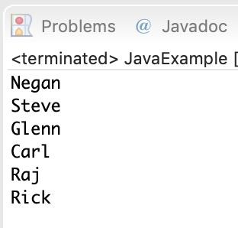

## Java example of removing elements from the LinkedList

In the following example we are checking out the few popular **remove methods** in the LinkedList that are used to remove elements from certain positions in the LinkedList

package com.beginnersbook;

import java.util.*;

public class JavaExample{

public static void main(String args[]){

LinkedList<String> list=new LinkedList<String>();

//Adding elements to the Linked list

list.add("Steve");

list.add("Carl");

list.add("Raj");

list.add("Negan");

list.add("Rick");

//Removing First element

//Same as list.remove(0);

list.removeFirst();

//Removing Last element

list.removeLast();

//Iterating LinkedList

Iterator<String> iterator=list.iterator();

while(iterator.hasNext()){

System.out.print(iterator.next()+" ");

}

//removing 2nd element, index starts with 0

list.remove(1);

System.out.print("\nAfter removing second element: ");

//Iterating LinkedList again

Iterator<String> iterator2=list.iterator();

while(iterator2.hasNext()){

System.out.print(iterator2.next()+" ");

}

}

}

**Output:**  
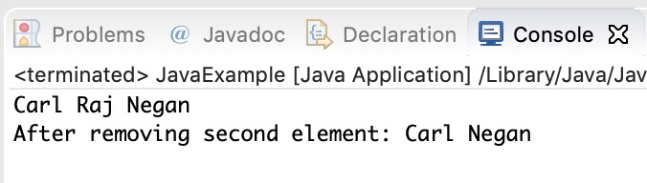

## Example of LinkedList in Java

import java.util.*;

public class LinkedListExample {

public static void main(String args[]) {

/* Linked List Declaration */

LinkedList<String> linkedlist = new LinkedList<String>();

/*add(String Element) is used for adding

* the elements to the linked list*/

linkedlist.add("Item1");

linkedlist.add("Item5");

linkedlist.add("Item3");

linkedlist.add("Item6");

linkedlist.add("Item2");

/*Display Linked List Content*/

System.out.println("Linked List Content: " +linkedlist);

/*Add First and Last Element*/

linkedlist.addFirst("First Item");

linkedlist.addLast("Last Item");

System.out.println("LinkedList Content after addition: " +linkedlist);

/*This is how to get and set Values*/

Object firstvar = linkedlist.get(0);

System.out.println("First element: " +firstvar);

linkedlist.set(0, "Changed first item");

Object firstvar2 = linkedlist.get(0);

System.out.println("First element after update by set method: " +firstvar2);

/*Remove first and last element*/

linkedlist.removeFirst();

linkedlist.removeLast();

System.out.println("LinkedList after deletion of first and last element: " +linkedlist);

/* Add to a Position and remove from a position*/

linkedlist.add(0, "Newly added item");

linkedlist.remove(2);

System.out.println("Final Content: " +linkedlist);

}

}

Output:

Linked List Content: [Item1, Item5, Item3, Item6, Item2]

LinkedList Content after addition: [First Item, Item1, Item5, Item3, Item6, Item2, Last Item]

First element: First Item

First element after update by set method: Changed first item

LinkedList after deletion of first and last element: [Item1, Item5, Item3, Item6, Item2]

Final Content: [Newly added item, Item1, Item3, Item6, Item2]

## Methods of LinkedList class:

Here I have mentioned the brief description of the LinkedList methods, I have covered each one of these methods in separate tutorials, links are provided at the end of this article.

For all the examples in the below methods, consider llistobj as a reference for LinkedList<String>.

LinkedList<String> llistobj  = new LinkedList<String>();

1) **boolean add(Object item)**: It adds the item at the end of the list.

llistobj.add("Hello");

It would add the string “Hello” at the end of the linked list.

2) **void add(int index, Object item)**: It adds an item at the given index of the the list.

llistobj.add(2, "bye");

This will add the string “bye” at the 3rd position( 2 index is 3rd position as index starts with 0).

3) **boolean addAll(Collection c)**: It adds all the elements of the specified collection c to the list. It throws NullPointerException if the specified collection is null. Consider the below example –

LinkedList<String> llistobj = new LinkedList<String>();

ArrayList<String> arraylist= new ArrayList<String>();

arraylist.add("String1");

arraylist.add("String2");

llistobj.addAll(arraylist);

This piece of code would add all the elements of ArrayList to the LinkedList.

4) **boolean addAll(int index, Collection c)**: It adds all the elements of collection c to the list starting from a give index in the list. It throws NullPointerException if the collection c is null and IndexOutOfBoundsException when the specified index is out of the range.

llistobj.add(5, arraylist);

It would add all the elements of the ArrayList to the LinkedList starting from position 6 (index 5).

5) **void addFirst(Object item)**: It adds the item (or element) at the first position in the list.

llistobj.addFirst("text");

It would add the string “text” at the beginning of the list.

6) **void addLast(Object item)**: It inserts the specified item at the end of the list.

llistobj.addLast("Chaitanya");

This statement will add a string “Chaitanya” at the end position of the linked list.

7) **void clear()**: It removes all the elements of a list.

llistobj.clear();

8) **Object clone()**: It returns the copy of the list.

For e.g. My linkedList has four items: text1, text2, text3 and text4.

Object str= llistobj.clone();

System.out.println(str);

Output: The output of above code would be:

[text1, text2, text3, text4]

9) **boolean contains(Object item)**: It checks whether the given item is present in the list or not. If the item is present then it returns true else false.

boolean var = llistobj.contains("TestString");

It will check whether the string “TestString” exist in the list or not.

10) **Object get(int index)**: It returns the item of the specified index from the list.

Object var = llistobj.get(2);

It will fetch the 3rd item from the list.

11) **Object getFirst()**: It fetches the first item from the list.

Object var = llistobj.getFirst();

12) **Object getLast()**: It fetches the last item from the list.

Object var= llistobj.getLast();

13) **int indexOf(Object item)**: It returns the index of the specified item.

llistobj.indexOf("bye");

14) **int lastIndexOf(Object item)**: It returns the index of last occurrence of the specified element.

int pos = llistobj.lastIndexOf("hello);

integer variable pos will be having the index of last occurrence of string “hello”.

15) **Object poll()**: It returns and removes the first item of the list.

Object o = llistobj.poll();

16) **Object pollFirst()**: same as poll() method. Removes the first item of the list.

Object o = llistobj.pollFirst();

17) **Object pollLast()**: It returns and removes the last element of the list.

Object o = llistobj.pollLast();

18) **Object remove()**: It removes the first element of the list.

llistobj.remove();

19) **Object remove(int index)**: It removes the item from the list which is present at the specified index.

llistobj.remove(4);

It will remove the 5th element from the list.

20) **Object remove(Object obj)**: It removes the specified object from the list.

llistobj.remove("Test Item");

21) **Object removeFirst()**: It removes the first item from the list.

llistobj.removeFirst();

22) **Object removeLast()**: It removes the last item of the list.

llistobj.removeLast();

23) **Object removeFirstOccurrence(Object item)**: It removes the first occurrence of the specified item.

llistobj.removeFirstOccurrence("text");

It will remove the first occurrence of the string “text” from the list.

24) **Object removeLastOccurrence(Object item)**: It removes the last occurrence of the given element.

llistobj.removeLastOccurrence("String1);

It will remove the last occurrence of string “String1”.

25) **Object set(int index, Object item)**: It updates the item of specified index with the give value.

llistobj.set(2, "Test");

It will update the 3rd element with the string “Test”.

26)**int size()**: It returns the number of elements of the list.

llistobj.size();

# How to loop LinkedList in Java

In the last tutorial we discussed LinkedList and it’s methods with example. Here we will see how to loop/iterate a LinkedList. There are four ways in which a LinkedList can be iterated –

1. For loop
2. Advanced For loop
3. Iterator
4. While Loop

#### Example:

In this example we have a LinkedList of String Type and we are looping through it using all the four mentioned methods.

package beginnersbook.com;

import java.util.*;

public class LinkedListExample {

public static void main(String args[]) {

/*LinkedList declaration*/

LinkedList<String> linkedlist=new LinkedList<String>();

linkedlist.add("Apple");

linkedlist.add("Orange");

linkedlist.add("Mango");

/*for loop*/

System.out.println("**For loop**");

for(int num=0; num<linkedlist.size(); num++)

{

System.out.println(linkedlist.get(num));

}

/*Advanced for loop*/

System.out.println("**Advanced For loop**");

for(String str: linkedlist)

{

System.out.println(str);

}

/*Using Iterator*/

System.out.println("**Iterator**");

Iterator i = linkedlist.iterator();

while (i.hasNext()) {

System.out.println(i.next());

}

/* Using While Loop*/

System.out.println("**While Loop**");

int num = 0;

while (linkedlist.size() > num) {

System.out.println(linkedlist.get(num));

num++;

}

}

}

Output:

**For loop**

Apple

Orange

Mango

**Advanced For loop**

Apple

Orange

Mango

**Iterator**

Apple

Orange

Mango

**While Loop**

Apple

Orange

Mango

# Vector in Java

Vector implements List Interface. Like ArrayList it also maintains insertion order but it is rarely used in non-thread environment as it is synchronized and due to which it gives poor performance in searching, adding, delete and update of its elements.

#### Three ways to create vector class object:

**Method 1:**

Vector vec = new Vector();

It creates an empty Vector with the default initial capacity of 10. It means the Vector will be re-sized when the 11th elements needs to be inserted into the Vector. Note: By default vector doubles its size. i.e. In this case the Vector size would remain 10 till 10 insertions and once we try to insert the 11th element It would become 20 (double of default capacity 10).

**Method 2:**  
Syntax: Vector object= new Vector(int initialCapacity)

Vector vec = new Vector(3);

It will create a Vector of initial capacity of 3.

**Method 3:**  
Syntax:

Vector object= new vector(int initialcapacity, capacityIncrement)

Example:

Vector vec= new Vector(4, 6)

Here we have provided two arguments. The initial capacity is 4 and capacityIncrement is 6. It means upon insertion of 5th element the size would be 10 (4+6) and on 11th insertion it would be 16(10+6).

## Complete Example of Vector in Java:

import java.util.*;

public class VectorExample {

public static void main(String args[]) {

/* Vector of initial capacity(size) of 2 */

Vector<String> vec = new Vector<String>(2);

/* Adding elements to a vector*/

vec.addElement("Apple");

vec.addElement("Orange");

vec.addElement("Mango");

vec.addElement("Fig");

/* check size and capacityIncrement*/

System.out.println("Size is: "+vec.size());

System.out.println("Default capacity increment is: "+vec.capacity());

vec.addElement("fruit1");

vec.addElement("fruit2");

vec.addElement("fruit3");

/*size and capacityIncrement after two insertions*/

System.out.println("Size after addition: "+vec.size());

System.out.println("Capacity after increment is: "+vec.capacity());

/*Display Vector elements*/

Enumeration en = vec.elements();

System.out.println("\nElements are:");

while(en.hasMoreElements())

System.out.print(en.nextElement() + " ");

}

}

Output:

Size is: 4

Default capacity increment is: 4

Size after addition: 7

Capacity after increment is: 8

Elements are:

Apple Orange Mango Fig fruit1 fruit2 fruit3