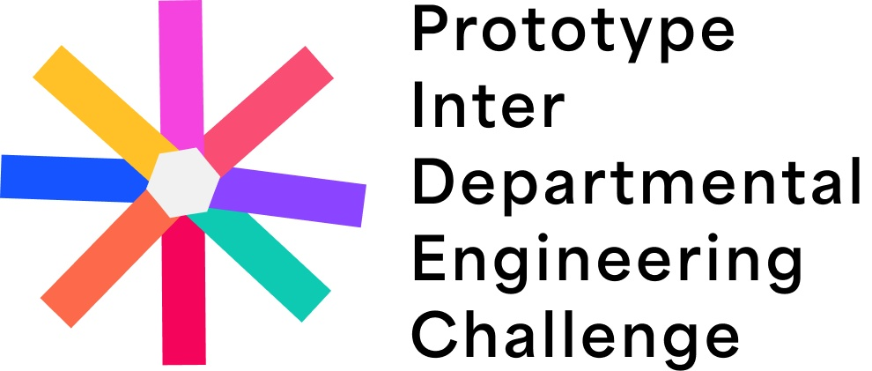

Stage 1 Proposal Template
Engineering for Impact: Building Inclusive Solutions for a Sustainable Future
Team name | Department
Team leader | Submission date

Team members
Name | Matric number | Level

Before you submit
☐ | Keep the proposal clear, practical, and grounded in your engineering discipline.
☐ | Show why the problem matters and who benefits from the solution.
☐ | Explain how your team can build or demonstrate the prototype during Stage 2.
☐ | Export this completed document as PDF or submit it as DOCX.

1. Problem Statement
Describe the practical problem, the people affected, and why this problem deserves an engineering response.

2. Proposed Engineering Solution
Explain your solution, the main components, the engineering principle behind it, and how it should work.

3. Theme Alignment
Show how the idea supports impact, inclusion, sustainability, and real world usefulness.

4. Preliminary Feasibility
Outline materials, tools, skills, timeline, possible risks, and how your team can prototype the solution.

5. Departmental Relevance
Explain how the proposal reflects your department and the engineering knowledge your team brings.

Team declaration
We confirm that this proposal is our original team work, that no external party authored the proposal for us, and that we have read and agree to the PIDEC 1.0 rules.

Team leader signature and date

